Case report

Comparative evaluation of the effectiveness of Silver-modified atraumatic restorative technique (SMART) with Atraumatic restorative treatment (ART) on dental caries: A split mouth technique Case Report

ABSTRACT

Aim: To compare the effectiveness of silver-modified atraumatic restorative technique (smart) and atraumatic restorative treatment (art) in managing early childhood caries using a split-mouth case study approach.
Study Design: A split-mouth case report on a 5-year-old child presenting with bilateral mandibular second molar caries.
Methods: On the left mandibular second molar, smart was performed by applying 38% silver diamine fluoride (sdf) followed by restoration with glass ionomer cement (gic). on the right mandibular second molar, art was carried out using gic alone. the patient was reviewed at 1, 3, and 6 months to evaluate restoration integrity, recurrence of caries, and clinical symptoms.
Results: At 6 months, the tooth treated with art developed secondary caries, while the smart-restored tooth remained caries-free and functional with no reported pain. smart demonstrated superior caries-arresting ability, bond strength, and long-term stability compared to art.

1. INTRODUCTION

The approach known as "silver-modified atraumatic restorative treatment" (SMART) includes first treating a dental caries with silver diamine fluoride (SDF) and sealing or restoring it with either high viscosity or conventional glass ionomer cement [1–3].
Application of Sliver Diamine Fluoride (SDF) and restoration with type VIII GIC are used in a new procedure i.e., SMART (Silver Modified Atraumatic Restorative Treatment). This innovative method combines the antibiotic-killing properties of SDF with the tooth-sealing and bacterial-growth-blocking properties of GIC. By preserving pulp vitality, SMART may improve enamel remineralization in addition to stopping cavities [4].
Silver Diamine Fluoride (SDF) plays a vital role in halting active caries as it has fluoride and silver which have remineralizing and antibacterial properties respectively [5]. Moreover, the bacterial that were killed by action of silver, when added to live bacterial, activation of silver takes place and it cause further killing, this is called a zombie effect [6]. When compared with other fluoride solutions, the fluoride in SDF enters the tooth more deeply and forms a reservoir of fluoride within the tooth structure [7]. The particular interest in SDF stems from its ability to reduce pain and infection, its non-invasive nature, its cost-effectiveness, ease of use and simplicity (paint on), and its low personnel and training requirements [8]. A colourless topical medication called 38% SDF solution is approved by the Central Pharmaceutical Council of Japan's Ministry of Health and Welfare as a dental therapy for cavities [5].
GIC is used to rebuild the tooth after ART viz. a minimally invasive procedure that involves hand instruments for caries excavation. Three main primary benefits of employing GIC for carious tooth restoration are its chemical bonding to the tooth, fluoride release, and pulp biocompatibility [9]. Although it takes a lot of time but use of hand instrument for digging the cavities causes less harm to the sound tooth tissue and preserves it and it gives the operator enough working time [10].
Nowadays, treating oral disorders, such as dental caries, is costly, intrusive, and financially taxing for both patients and healthcare professionals. Later-life dental anxiety has been linked to undergoing such operations. Conventional dental caries care involves surgery, which calls for skilled medical professionals and advanced equipment [10].
Atraumatic restorative treatment (ART) and silver diamine fluoride (SDF) fall under this category and are intended to preserve the tooth structure to the fullest extent while causing minimum negative psychological impact to patients. This approach enhancing children's oral health particularly in areas where regular dental check-ups and necessary dental treatment are not accessible. This painless and economical method repairs the injured tooth tissue, increases kid acceptability, reduces dental fear, and creates an excellent seal [10].
This case shows how the efficacy of atraumatic restorative treatment (ART) and silver-modified atraumatic restorative method (SMART) on the treatment of 5-year-old schoolchildren is compared.

2. Case Presentation

A five-year-old female presented with a chief complaint of decayed teeth in lower right and left back region of the jaw. There were no known allergies or systemic problems in her medical history, which was ordinary. The patient's previous dental history shows Glass Ionomer (GIC) restoration in mandibular left & right primary second molar a year ago. Caries in the mandibular left & right primary first molar are depicted in Figure 1. Caries was found on the lower left and right primary mandibular first molars (D) during the clinical examination. There was no pulpal involvement evident from the teeth's lack of percussive tenderness. Additionally, there were no indications of abscess formation or swelling.
After taking into account all of the symptoms, early disto-occlusal caries was the diagnosis. A treatment plan was created in light of the diagnosis to target long-term tooth preservation. This case study uses a split mouth technique, wherein the left primary mandibular second molar received Silver-modified atraumatic restorative technique (SMART) on one side of the oral cavity and the right primary mandibular second molar received atraumatic restorative treatment (ART) on the other side. For SMART on the left primary mandibular second tooth, a spoon excavator was used to prepare the cavity. Then, using an applicator tip, 38% SDF was administered directly to the lesion, allowed to sit for two minutes, and then restored using GIC. Using a spoon excavator, a cavity was created for the ART procedure on the right main mandibular second molar. GIC was then placed within, and surplus restorative material along the cusp slopes was removed using the finger-press technique. The possibility of blackish discoloration of carious tooth treated with SDF was explained to parents.
Advice on maintaining good oral hygiene was given, including avoiding sugary foods and beverages and brushing twice a day with fluoride-containing toothpaste. Figure 2 illustrates the use of a microbrush applicator tip to apply silver diamine fluoride, while Figure 3 provides a post-restorative image. At one, three, and six months, the patient was monitored. During the follow-up, the patient displayed secondary caries with the right primary mandibular second molar (ART) but did not report any more pain or secondary caries with the left primary mandibular second molar (SMART).
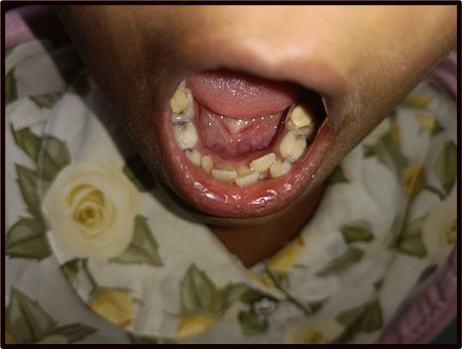
Figure 1: Caries in the lower left and right primary first molar
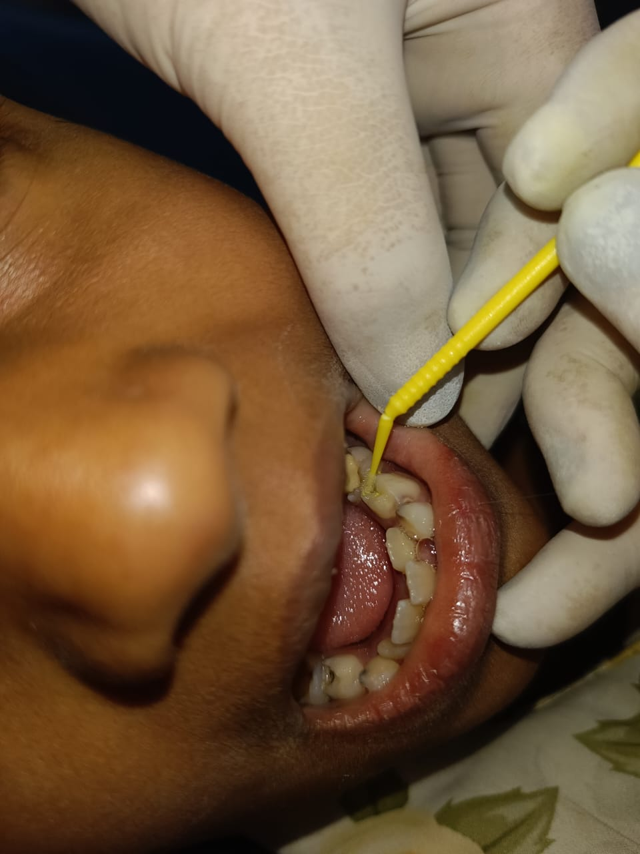
Figure 2: Application of silver diamine fluoride with micro brush applicator tip
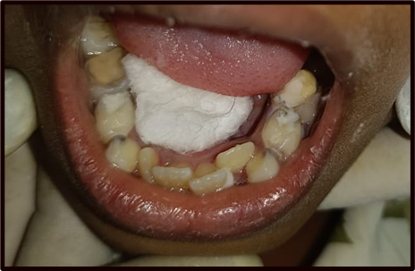
Figure 3: Post restorative image

3. discussion

This example demonstrates SDF application in combination with ART; i.e., SMART is a novel, minimally invasive technique that imparts bactericidal effects that result in caries arrest and restores tooth function. This painless and economical method repairs the damaged tooth tissue, increases kid acceptability, reduces dental fear, and creates a good seal. The benefits and drawbacks of SDF versus conventional restorations were discussed with the parent, and consent (verbal and written) was given to parents and collected before treatment began. The application of SDF made non-invasive caries arrest possible. As the GICs have less polymerisation shrinkage, biocompatible, release fluoride and are non-cariogenic making it appropriate material for restoration of primary teeth [11]. GICs are not suitable for proximal restoration because they have low fracture and wear resistance accounting for failure rate of 6.6 to 30% after 36 months post restoration [12].
According to the findings of Chu et al. (2012) [13] and Richards (2017) [14], the remineralisation process of enamel is fastened by SDF and it also halts the caries progress. Additionally, it has been demonstrated that SDF reduces the necessity of extensive restorative procedures in children, that may be in certain situations require general anaesthesia [15].
Because amalgam and composite resin fillings can restore both dental function and appearance, they have long been preferred restorative techniques for cavities. For these operations to reach the carious lesion, however, a large amount of healthy tooth material must frequently be removed. Instead, SDF offers a non-invasive way to stop cavities without requiring a lot of tooth preparation [16]. SDF has been demonstrated in numerous studies to be quite successful in stopping the development of carious; one study by Gao et al. (2016) [16] found that applying SDF every two years was 90% successful in stopping caries in primary teeth. Yee et al. (2009) [17] showed that over a two-year period, SDF was just as successful as conventional restorations at stopping the development of carious lesions in primary molars. Black staining of treated carious lesions is one of the main issues with SDF treatment. Comparing GIC to 38% SDF (44,800 ppm of fluoride), the fluoride release from GIC is extremely modest and merely stops the advancement of incipient caries. According to Chadwick and Evans (2016) [12], Glass ionomer cement has a low resilience to fracture. Other drawbacks of ART restoration is low retention and caries in areas of chipped off restoration.
According to a study by dos Santos Jr VE (2012) [28], 30% SDF was superior to ART in primary molars at 12 months.
Compared to glass ionomers without the SDF application, the SDF group exhibited the least amount of leakage, according to a study by Hassanen DH et al. (2022) [19].
The present investigation revealed that GIC restoration without application of SDF had lower shear bond strength. This was in line with another study by Pérez-Hernández J et al. (2018) [20] which examined the effects of photodynamic treatment and silver diamine fluoride on the durability of the resin-modified GIC bond to demineralized dentin. They discovered that application of 38% SDF and potassium iodide on dentin which is restored with GIC, shows great bond strength than other restorative procedures.

4. Conclusion

According to this study, the SMART technique, which included managing cavities in five-year-olds, was better than ART in terms of secondary caries development and the strength of the bond between the restorative material and the tooth surface. SMART fosters pulp vitality, maintains tooth structure, and lessens the perception of pain. Particularly in children, treating caries with affordable, minimally invasive techniques can enhance oral health results. In order to avoid cavities and preserve general health, it is imperative to increase knowledge and facilitate access to reasonably priced dental treatment. Children must receive preventive care and routine examinations in order to maintain the health of their teeth throughout time.

Consent (where ever applicable)

Written informed consent was obtained from the patient for their anonymized information to be published in this article.

Ethical approval (where ever applicable)

As per international standards or university standards written ethical approval has been collected and preserved by the author(s).
References

- Hu, S., Meyer, B., & Duggal, M. (2018). A silver renaissance in dentistry. Eur Arch Paediatr Dent, 19(4), 221–227. https://doi.org/10.1007/s40368-018-0355-3
- Alvear Fa, B., Jew, J. A., Wong, A., & Young, D. (2016). Silver modified atraumatic restorative technique (SMART): an alternative caries prevention tool. Stoma Edu J, 3(2), 18–24.
- Modasia, R., & Modasia, D. (2021). Application of silver diamine fluoride as part of the atraumatic restorative technique. BDJ Student, 28(2), 42–43. https://doi.org/10.1038/s41406-021-0220-4
- Bridge, G., Martel, A. S., & Lomazzi, M. (2021). Silver diamine fluoride: transforming community dental caries program. Int Dent J, 71(6), 458–461. https://doi.org/10.1016/j.identj.2021.02.013
- Mei, M. L., Li, Q. L., Chu, C. H., Lo, E. M., & Samaranayake, L. P. (2013). Antibacterial effects of silver diamine fluoride on multi-species cariogenic biofilm on caries. Ann Clin Microbiol Antimicrob, 12(1), 1–7. https://doi.org/10.1186/1476-0711-12-4
- Wakshlak, R. B., Pedahzur, R., & Avnir, D. (2015). Antibacterial activity of silver-killed bacteria: the "zombies" effect. Sci Rep, 5, 9555. https://doi.org/10.1038/srep09555
- Burgess, J. O., & Vaghela, P. M. (2018). Silver diamine fluoride: a successful anticarious solution with limits. Adv Dent Res, 29(1), 131–134. https://doi.org/10.1177/0022034517751348
- Crystal, Y. O., Marghalani, A. A., Ureles, S. D., Wright, J. T., Sulyanto, R., Divaris, K., et al. (2017). Use of silver diamine fluoride for dental caries management in children and adolescents, including those with special health care needs. Pediatr Dent, 39(5), 135E–145E.
- Frencken, J., Amerogen, E. V., Phantumvanit, P., Songpaisan, Y., & Pilot, T. (1997). Manual for the Atraumatic Restorative Treatment approach to control dental caries. Dental Health International Nederlant, Chapter 2, 12–16.
- Haworth, S., Dudding, T., Waylen, A., Thomas, S. J., & Timpson, N. J. (2017). Ten years on: Is dental general anaesthesia in childhood a risk factor for caries and anxiety? Br Dent J, 222(4), 299–304. https://doi.org/10.1038/sj.bdj.2017.190
- Sidhu, S. K., & Nicholson, J. W. (2016). A review of glass-ionomer cements for clinical dentistry. J Funct Biomater, 7(3), 16. https://doi.org/10.3390/jfb7030016
- Chadwick, B. L., & Evans, D. J. (2007). Restoration of class II cavities in primary molar teeth with conventional and resin modified glass ionomer cements: a systematic review of the literature. Eur Arch Paediatr Dent, 8(1), 14–21.
- Chu, C. H., Mei, L. E., Seneviratne, C. J., & Lo, E. C. (2012). Effects of silver diamine fluoride on dentine carious lesions induced by Streptococcus mutans and Actinomyces naeslundii biofilms. Int J Paediatr Dent, 22(1), 2–10. https://doi.org/10.1111/j.1365-263X.2011.01151.x
- Richards, D. (2017). The effectiveness of silver diamine fluoride in arresting caries. Evid Based Dent, 18(3), 70. https://doi.org/10.1038/sj.ebd.6401253
- Nguyen, T. M., Tonmukayakul, U., Hall, M., & Calache, H. (2022). Cost-effectiveness analysis of silver diamine fluoride to divert dental general anaesthesia compared to standard care. Aust Dent J, 67(4), 352–361. https://doi.org/10.1111/adj.12906
- Gao, S. S., Zhao, I. S., Hiraishi, N., Duangthip, D., Mei, M. L., Lo, E. C., & Chu, C. H. (2016). Clinical trials of silver diamine fluoride in arresting caries among children: a systematic review. JDR Clin Transl Res, 1(3), 201–210. https://doi.org/10.1177/2380084416661474
- Yee, R., Holmgren, C., Mulder, J., Lama, D., Walker, D., & van Palenstein Helderman, W. (2009). Efficacy of silver diamine fluoride for arresting caries treatment. J Dent Res, 88(7), 644–647. https://doi.org/10.1177/0022034509338671
- dos Santos, V. E. Jr., de Vasconcelos, F. M., Ribeiro, A. G., & Rosenblatt, A. (2012). Paradigm shift in the effective treatment of caries in schoolchildren at risk. Int Dent J, 62(1), 47–51. https://doi.org/10.1111/j.1875-595X.2011.00088.x
- Hassanen, D. H., Mostafa, M. H., & Hashem, S. N. (2022). The effect of silver diamine fluoride on microleakage and shear bond strength of glass ionomer. Al-Azhar Dent J Girls, 9(2), 341–347.
- Pérez-Hernández, J., Aguilar-Díaz, F. C., Venegas-Lancón, R. D., Gayosso, C. A., Villanueva-Vilchis, M. C., & de la Fuente-Hernández, J. (2018). Effect of silver diamine fluoride on adhesion and microleakage of a pit and fissure sealant to tooth enamel: in vitro trial. Eur Arch Paediatr Dent, 19(6), 411–416. https://doi.org/10.1007/s40368-018-0351-7

