Evaluation of the agronomic performance of three peanut varieties (Arachis hypogea L) and detection of diseases.

Abstract
Peanut (Arachis hypogea L) is a legume widely produced in West Africa. Peanuts are of agronomic interest to producers because they are able to fix atmospheric nitrogen, making crop associations possible, especially with cereals. In Benin, soils are increasingly poor due to leaching, acidification, overexploitation, and salinization. Peanut production in crop rotation can be an alternative solution. However, several diseases hamper its productivity, particularly fungal diseases that significantly reduce leaf areas and affect photosynthesis, leading to considerable yield reductions and rot, in addition to aflatoxin contamination. Although peanuts fix atmospheric nitrogen, they may also require the addition of mineral elements for their development. The objectives of this study are to detection diseases in peanut fields in southern Benin and to evaluate the agronomic performance of a variety. A Split Splot experimental design with 3 replicates was implemented, with 2 factors (Variety and fertilizer). The fertilizer factor is the fixed factor and the variety factor is the variable factor. Agromorphological parameters such as germination rate, emergence and population density, 50% flowering date, and yield parameters were evaluated. Disease identification was done according to symptomatology. The results show that the germination rate in real environment is very low (5.71%) for variety 55-437 and higher than 79% for the other two varieties (ICGV, RRB). The emergence at fourteen days after sowing varies from 91.67% to 98.30% and the population density at 90 days after sowing varies from 52.38% to 62.96%. A high mortality rate is recorded on all varieties. On all varieties, a group flowering was recorded. The best yields were recorded with cow dung and compost respectively 4.55 kg and 4.40 for 11.7m2. Five diseases were detected namely: early leaf spot, late leaf spot, rust, rosette and rots due to the genus Aspergilus. Our study has highlighted the various fungal and viral diseases that hamper peanut production in southern Benin with serious consequences on yields but also on the health of populations through aflatoxins produced by fungi of the genus Aspergilus. Studies will continue to propose environmentally friendly biological control methods.
Keyword: Arachis hypogea, disease, production, Benin
1.Introduction
The agricultural sector plays an important role in the growth of the national economy. It constitutes a strong support for the development of countries since it contributes to the gross domestic product and employs the working population (Sellam, 2020). The cultivated peanut (Arachis hypogaea L.) was introduced in West Africa in the 16th century. Peanut is the sixth most important oilseed crop in the world. It is one of the main cash crops in Benin (DSA, 2024). It contains 48-50% fat, 26-28% protein and is rich in fiber, minerals and vitamins.
More than 100 countries worldwide cultivate peanuts. Developing countries account for 94% of global peanut production. Peanut production is concentrated in Asia and Africa (56% and 40% of the area and 68% and 25% of global production, respectively) (AtlasBig, 2022). Benin is the leading peanut producer in the WAEMU for the 2024-2025 season, thanks to a spectacular 65.2% increase in its production, according to a BCEAO report.
In Benin, this crop occupies a strategic position in agricultural systems, particularly in southern departments such as Atlantique, Ouémé, Plateau, and Mono (Bakoye et al., 2019). It constitutes a major source of income for small producers, as well as an essential food rich in protein and vegetable oils (Fulmer et al., 2019). Despite its economic and nutritional importance, peanut production in Benin is frequently affected by biotic constraints. Among these, fungal diseases represent a major obstacle, leading to significant losses in yield and seed quality (Bakoye et al., 2019).
Furthermore, fertilization, whether organic or mineral, plays a crucial role in crop development and health. Several authors have demonstrated that the use of organic amendments can improve plant resistance to diseases by strengthening their natural immune system (Jia et al., 2022). Similarly, balanced nutrient fertilization allows for better plant growth and can reduce the severity of fungal infections (Kunta et al., 2022). However, the combined effect of fertilization practices on peanut plant health and agro-morphological performance remains poorly documented in the Beninese context. This study aims to identify diseases present in peanut fields in southern Benin, as well as to evaluate different types of fertilizers on agro-morphological parameters.
2. Material & Methods
2.1. Description of the study site
The experimental device was installed at the University of Abomey-Calavi, in the South of Benin, more precisely in the commune of Abomey-Calavi. This locality constitutes a strategic site for agronomic research due to its ecological conditions favorable to the cultivation of food crops, notably peanuts. Phytopathological analyses, in particular the macroscopic and microscopic identification of fungal diseases, were carried out at the Laboratory of Plant Physiology and Environmental Stress Study of the University of Abomey-Calavi.
The commune of Abomey-Calavi enjoys a tropical savannah climate with dry winters, classified Aw according to the Köppen-Geiger classification. The average annual temperature is approximately 26.5°C, with extremes generally between 24°C and 32°C, very rarely outside the 21–33°C range (Weatherspark, 2022). The average annual rainfall is estimated at 1342 mm, concentrated in the rainy season, which runs from April to October. This period is characterized by heavy cloud cover and high humidity, favorable to vegetative development but also to the proliferation of certain fungal diseases. The dry season, meanwhile, covers the months of November to March, with skies often clear or partly cloudy.
2.2. Plant material
Three peanut varieties were used for the experiment: 55-437, ICGV 86015, and RRB. These certified seeds were chosen due to their adaptation to the agroecological conditions of southern Benin and their availability from local seed organizations.
2.3. Fertilizers
The fertilizers used are both organic and mineral. These include poultry manure, cow dung, well-rotted compost, and NPK 15-15-15 mineral fertilizer. A control treatment without fertilization was included to serve as a reference.
2.4. Soil preparation and sowing
Before the trial was set up, preparatory work was carried out on the experimental plot to ensure optimal conditions for peanut germination, growth and development. The site was first cleared manually using simple agricultural tools (hoes, machetes), in order to eliminate spontaneous grasses and plant residues present on the soil surface. This operation freed up the growing space and facilitated the following steps.
The soil was then loosened by shallow plowing to a depth of about 20 to 25 cm. This work was carried out with a hoe to break the surface crust of the soil, improve its aeration, facilitate water infiltration and create a seedbed favorable to the rooting of young seedlings. The soil thus stirred was leveled using rakes, then divided into cultivation beds.
Fertilizer was applied at the following rates and in the following manner across all plots:
- Poultry manure at a rate of 4 t/ha,
- Cow dung at a rate of 4 t/ha,
- Compost at a rate of 4 t/ha,
- NPK 15-15-15 mineral fertilizer at a rate of 100 kg/ha,
- And a control that received no fertilizer.
Each fertilizer was applied to the soil in equal doses, adapted to the cultural needs of peanuts. The organic fertilizers (manure, dung, compost), previously well decomposed, were incorporated into the soil one week before sowing, while the mineral fertilizer was applied 15 days after emergence according to agronomic recommendations. The control treatment, for its part, received no amendment in order to serve as a basis for comparison in the analysis of vegetative performance.

2.5. Experimental Design
The experimental design is a split-plot with three replicates and two factors (fig.1). The first factor, fertilizer, is the fixed factor, consisting of five factors (poultry manure, cow dung, compost, NPK (15-15-15), and control), and the second factor, variety, is the variable factor, consisting of three factors (55-437, ICGV 86015, and RRB). Each row measures 1.95 m, with 0.15 m between the pockets, with 14 pockets per row. The distance between rows is 0.20 m, the distance between fertilizers is 0.5 m, the distance between varieties is 0.30 m, and the distance between replicates is 1 m. The design thus allows for a rigorous comparative evaluation of the interactions between varieties and types of fertilizer on peanut growth and development parameters.

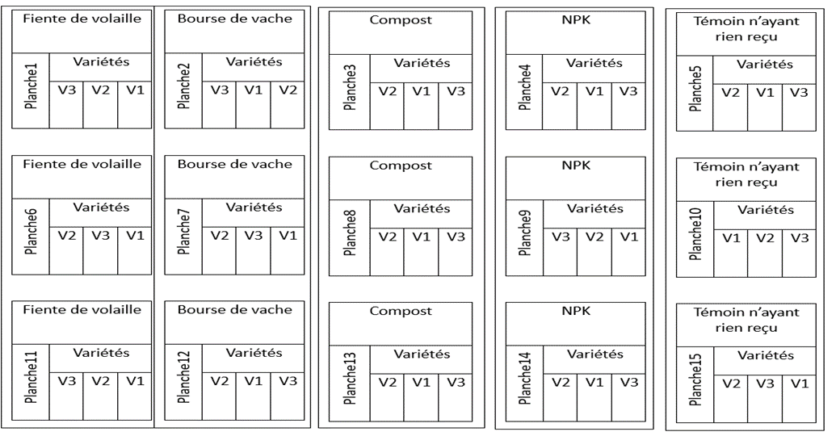
Board 5
Board 10
Board 15
Board 14
Board 9
Board 4
Board 13
Board 8
Board 3
Board 2
Board 7
Board 12
Board 11
Board 6
NPK

Witness

Witness

Variety
Variety
Variety
Variety
Variety
Variety
Variety
Variety
Variety
Cow dung

Variety
Variety
Variety
Variety
Variety
Variety
Board 1
NPK

Compost

Compost

Cow dung

Chicken droppings

Chicken droppings

Compost

NPK

Cow dung

Witness

Chicken droppings

Figure 1: Split-plot device in place
V: variety

2.6. Parameters Evaluated
Various parameters were evaluated during the trial:
- Germination rate was evaluated in two stages in a controlled laboratory environment and in a real-life trial environment by calculating the number of seeds sown relative to the number of germinated seeds, reduced to 100, from sowing to six days after sowing.
- Emergence at seven (7) and fifteen (15) days after sowing was evaluated, as was stand density at forty (40) and ninety (90) days after sowing. These two parameters were evaluated by calculating the ratio between the number of seeds sown and the number of plants present at the indicated time. - Date of 50% flowering: This consisted of counting the number of flowering plants up to the day when 50% of the plants had flowered
- Variability of pod and leaf yields depending on fertilizers: This is the mass of harvested products depending on the type of fertilizer
- Detection of diseases through leaf symptoms
3. Results
3.1. Germination Rate
In a Controlled Environment
A preliminary germination test was conducted to assess the seed viability of the three peanut (Arachis hypogaea L.) varieties selected for the experiment. Of ten seeds tested per variety, variety 55-437 (V1) had a germination rate of 20% (2/10 seeds germinated), indicating low germination capacity. Variety ICGV (V2) recorded a germination rate of 100% (10/10 seeds germinated), indicating good seed germination capacity. Variety RRB (V3) had a germination rate of 80% (8/10 seeds germinated), demonstrating relatively good germination capacity.
In a real-world setting
The results obtained show a variation in germination rates depending on the variety (table 1). Variety V2 (ICGV 86015) had the highest germination rate at 97.86%. This was followed by variety V3 (RRB), which reached 79.05%. In contrast, variety V1 (55-437) recorded a very low germination rate of 5.71%.
Table 1: Germination rates of peanut varieties tested in real environments
Variety | Seeds sown | Seeds germinated | Germination rate (%)
V1 (55-437) | 420 | 24 | 5,71
V2 (ICGV 86015) | 420 | 411 | 97,86
V3 (RRB) | 420 | 332 | 79,05

3.2. Emergence and Stand Density
Variety V2 (ICGV 86015) exhibited a very high emergence rate of 98.30%. Variety V3 (RRB) had an emergence rate of 92.77%. In contrast, variety V1 (55-437) showed a relatively satisfactory emergence rate among sprouted seeds (91.67%), despite a low germination rate; the sprouted seeds emerged well.
Analysis of stand density revealed marked differences between the three peanut varieties studied. Variety V1 recorded very low emergence, with only 21 plants, and a final stand limited to 11 plants, representing a 47.62% reduction between the number of sprouts and that of the established stand.
Variety V2 exhibited the best performance, with 405 emergences and a final stand of 255 plants. The loss recorded between emergence and stand was 150 plants, corresponding to a decrease of 37.04%. This performance, although marked by a significant reduction, remains the highest in terms of establishment, reflecting this variety's greater adaptability to local agroecological conditions.
Regarding variety V3, the data indicate 311 emergences for a final stand of 195 plants, representing a loss of 116 plants, corresponding to a reduction of 37.30%. Although superior to V1, this variety remains less efficient than V2, suggesting increased sensitivity to biotic factors such as soil-borne fungal diseases or abiotic stresses related to water availability and soil compaction.
Overall, the results show that all the varieties studied suffer from variable post-emergence mortality, but more pronounced in V1.
Figures 2 and 3 show emergence at 7 and 14 days after sowing.Figures 4 and 5 show stand density at 40 and 90 days after sowing.

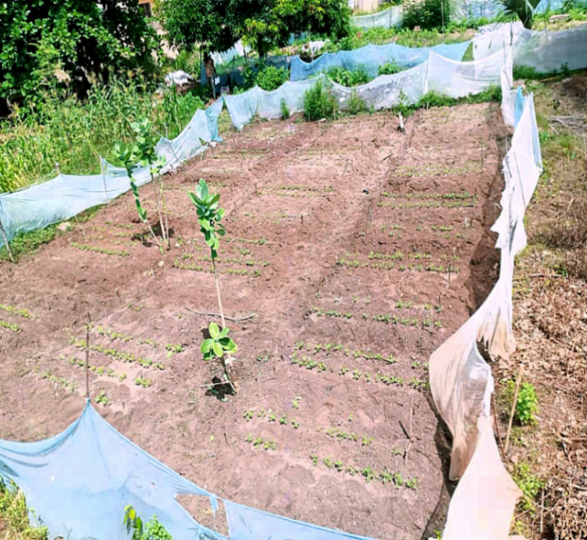
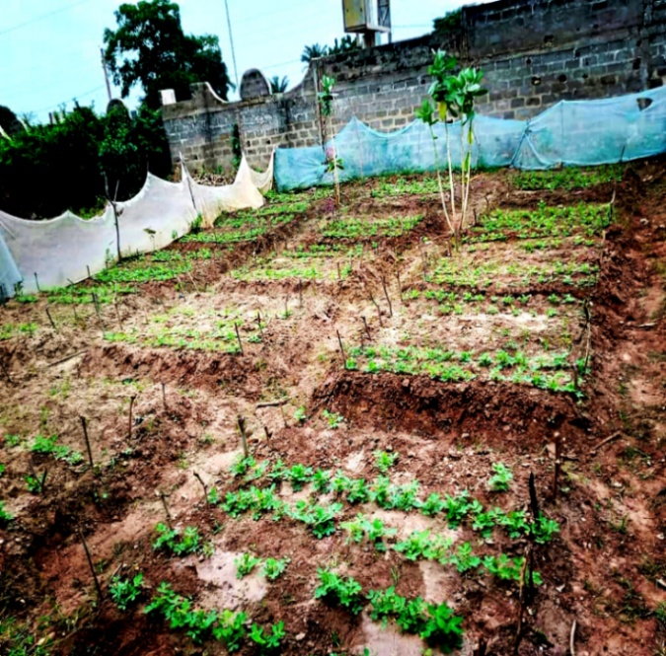
Figure 3 : Emergence 14 days after sowing

Figure 2 : Emergence 7 days after sowing

Figure 3 : Emergence 14 days after sowing
Figure 2 : Emergence 7 days after sowing

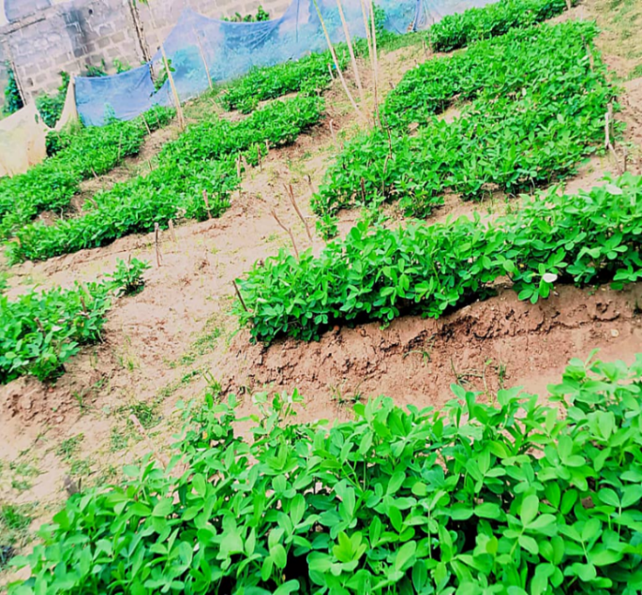
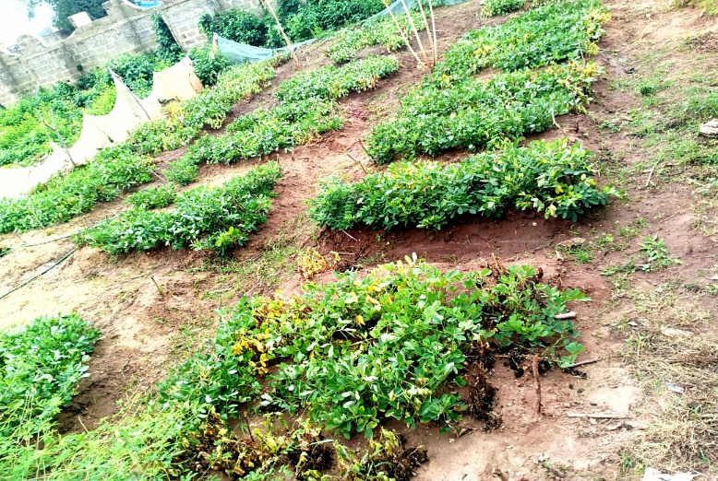

Figure 4 : Density at 40 days after sowing

Figure 5 : Density at 90 days after sowing

3.3. 50% Flowering Date and Maturation
Flowering observations showed that the three tested varieties reached 50% flowering at close intervals. Variety V2 (ICGV 86015) reached this stage on June 20, 2025 (fig. 8), followed by variety V3 (RRB) on June 21, 2025 (fig. 6), while variety V1 (55-437) reached its peak flowering on June 22, 2025 (fig. 7).

Number of flowers per plant

total number of plants

number of flowers per plant

Variety
Figure 6 : 50% flowering of V3 on 06/21/2025

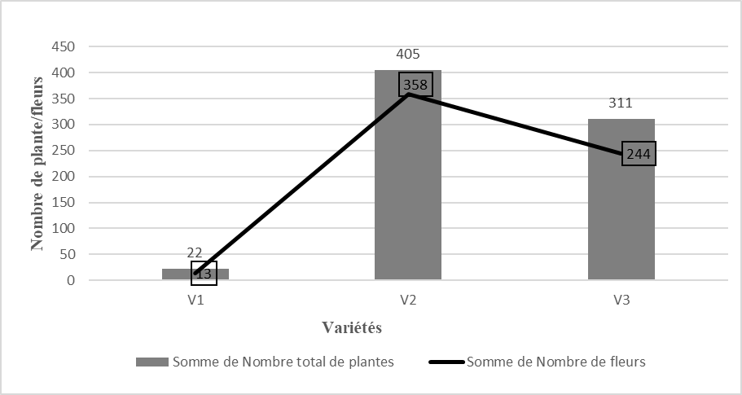
number of flowers per plant

total number of plants

Variety
Number of flowers per plant

Figure 7: 50% flowering of V1 on 06/22/2025

number of flowers per plant

total number of plants

Number of flowers per plant

Figure 8: 50% flowering of V2 on 06/23/2025

3.4. Yield as a function of fertilizers
Evaluation of the effect of different fertilizers applied to peanuts revealed notable differences in pod production. The NPK treatment yielded the highest yield at 4,700 kg on a total area of ​​11m² (fig.10), representing the best productive response. This result confirms the importance of mineral fertilizers in directly providing essential nutrients (N, P, K) to promote pod growth and filling.
Compost and cow dung also yielded significant yields, with 4,555 kg and 4,400 kg, respectively on a total area of ​​11m² (fig.10) (fig.9). These performances, similar to those obtained with NPK, reflect the fertilizing value of organic amendments, which, in addition to providing nutrients, improve soil structure and water retention capacity.
Poultry manure, although yielding less 3,800 kg, remains significantly higher than the control, confirming its agronomic effectiveness. Indeed, it is a rich source of easily assimilated nitrogen, although its rapid mineralization can sometimes limit its availability over a long period.
Finally, the unfertilized control yielded only 1,460 kg, the lowest value. This result highlights the crucial importance of fertilization in improving peanut yield, emphasizing that the natural poverty of the soil constitutes a major constraint to production without the addition of amendments.
Overall, the order of performance of the treatments is as follows: NPK superior to Compost, compost slightly superior to cow dung. Cow dung superior to poultry manure. And all fertilizers significantly superior to the Control, which demonstrates that the association of a high-performance variety with adequate fertilization constitutes an essential lever for increasing productivity in the conditions of southern Benin.
Analysis of leaf mass sums shows that variety V2 exhibits the highest values ​​across the various fertilizer treatments. Cow dung promotes maximum leaf growth with 6,280 kg, followed by NPK with 4,760 kg, and then compost with 4,700 kg on a total area of ​​11m² (fig.9). These results clearly indicate that organic matter of animal origin, in this case cow dung, significantly stimulates peanut leaf development, likely due to its richness in nutrients that are easily assimilated by the plant.
The use of cow dung therefore has a dual benefit: not only does it improve leaf biomass and, consequently, the crop's photosynthetic potential, but it also provides an accessible source of local fertilizer. Furthermore, harvested or surplus leaves can be considered as supplemental feed for cattle, thus providing synergy between plant production and livestock farming.

Variety
Weight

Figure 9: Pod and leaf weight per fertilizer

3.5. Disease detection through symptomatology
During the phytopathological observation, five types of symptoms were detected and associated with different pathogens. Small circular spots with a light brown center surrounded by a yellow halo were attributed to early leaf spot, while small circular spots with an almost black center that gradually became necrotic corresponded to late leaf spot. The presence of small rusty-brown pustules on the underside of leaves was associated with rust, and the progressive wilting of leaves, leading to dieback of dubious origin, was associated. Stunting of leaves with swelling and curling of young leaves was identified as a symptom of peanut rosette. Finally, the presence of powdery black mold on the surface of seeds or pods and the appearance of greenish-yellow mold on pods and seeds were attributed to black aspergillosis and yellow aspergillosis, respectively. Figures 11, 12, 13, 14, 15 allow a clear visualization of the symptoms observed. Among the five pathogens identified on peanuts during the study, four belong to the group of phytopathogenic fungi (85.7%) and only one is viral in nature (14.3%), in this case the peanut rosette.

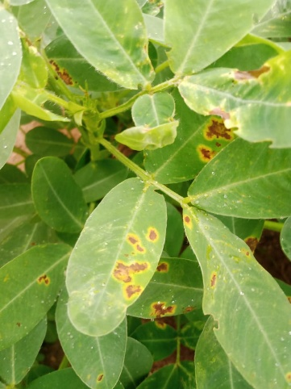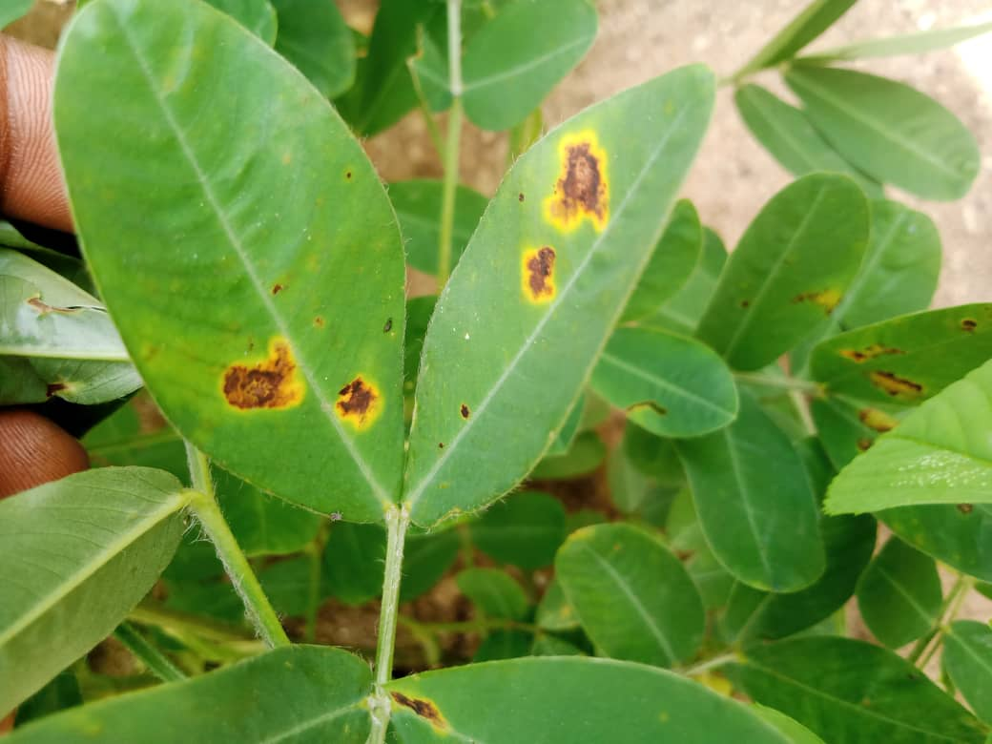
Figure 10: Early Sigatoka symptom Figure 11: Late Sigatoka symptom
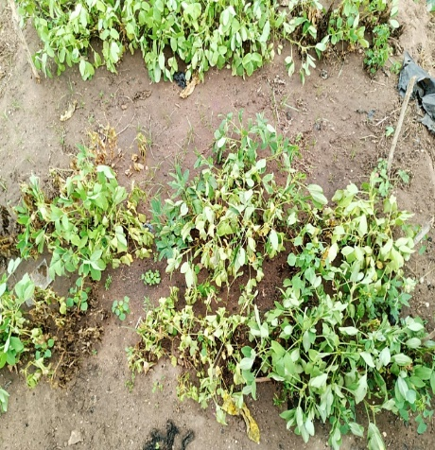
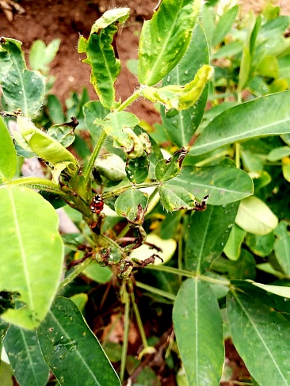

Figure 12: Symptom of wilting Figure 13: Rosette symptom

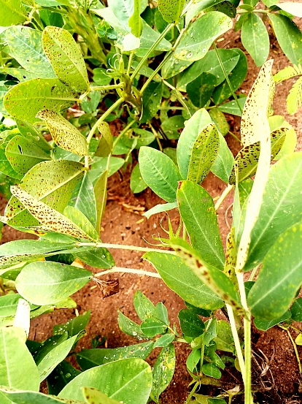
Figure 14: Symptom of rust

4. Discussion
All the results obtained during this study clearly show that fertilization exerts a decisive influence on the agromorphological development and yield of peanuts. The various diagrams and curves reflect that the tested varieties respond differently to the types of fertilizers, but that certain general trends can be identified.
First, the study of germination and emergence revealed that the three peanut varieties exhibited good emergence capacity, with rates above 79%. The plots that received fertilization showed more uniform emergence and slightly better vigor compared to the control, suggesting that initial nutrient availability promotes early seedling development. This finding is consistent with the work of Landry et al. (2020), who indicated that fertilizer application improves the vigor and establishment of leguminous crops. These results reveal significant heterogeneity in the germination quality of the seeds used. According to Liu et al. (2023), germination is an essential indicator of the physiological quality of seeds and reflects their growth potential under optimal conditions. Narasimha et al. (2021) also state that seed vigor strongly influences crop establishment in the field, particularly in tropical areas subject to various abiotic stresses. A high germination rate is essential to ensure uniform growth and high yields.
Overall, we observed clustered flowering. This small difference in time to reach mid-flowering reflects synchronization in the phenological development of the varieties. Such similarity is characteristic of cluster-ripening varieties, which facilitates cultivation operations and allows for simultaneous harvesting. Similar results were reported by Obasa and Haynes (2022) and Ousmane (2022), who emphasize that clustered flowering constitutes an important agronomic advantage, particularly for harvest management and reducing post-harvest losses.
Vegetative growth and leaf biomass accumulation were particularly influenced by fertilization types. The results show that cow dung produced the highest leaf mass. Variety V2 performed best in valuing inputs, probably reflecting a better physiological and photosynthetic capacity. These results confirm the observations of Allam et al. (2020), who showed that organic matter of animal origin promotes soil fertility and legume growth. The superiority of cow dung could be explained by its richness in rapidly assimilated nutrients, combined with its positive effect on soil microbial activity. In comparison, NPK provides concentrated nutrients that promote growth, but without improving the structure and biological life of the soil, while compost releases nutrients more gradually.
Regarding pod yield, the results show that NPK produced the highest yield, followed by compost, cow dung, and then poultry manure, while the unfertilized control produced the lowest results. This performance of NPK is linked to its direct and concentrated supply of essential minerals, particularly phosphorus and potassium, which promote fruit set and pod filling (Manizan et al., 2018). However, the results obtained with compost and cow dung remain very close to those of NPK, which demonstrates their effectiveness and potential as sustainable alternatives to chemical fertilizers.
A particularly interesting aspect concerns the recovery of leaf biomass produced under cow dung treatment. In addition to significantly increasing leaf biomass, this organic amendment offers the possibility of using excess leaves as supplemental feed for cattle. This synergy between crops and livestock helps strengthen the sustainability of the agricultural system by promoting local resources, reducing input costs and improving food and fodder security.
The presence of numerous diseases in the field demonstrates the important role of pathogen identification. All of these diseases contribute to reduced productivity and high mortality during production, resulting in lost income for producers (Soura et al., 2025).

These trends confirm the work of Subrahmanyam, Fall et al. (2020), who showed that varietal response is crucial in the spread of peanut foliar diseases. Barbossa (2021) emphasize that varietal selection is essential to reduce losses due to rust and Sigatoka in West Africa.

Conclusion
Evaluating the effect of different fertilizers on the agro-morphological parameters of peanuts highlighted the importance of soil fertility management in optimizing the performance of this crop. The results obtained show that fertilization positively influences germination, vegetative growth, flowering, leaf biomass, and pod yield. Among the fertilizers used, NPK was more effective in improving pod yield, while cow dung resulted in the best leaf biomass production, particularly in variety V2, which performed best across all the parameters studied. Compost, on the other hand, produced intermediate results, demonstrating its potential as a sustainable alternative to mineral fertilizers.
An important aspect of these results lies in the multiple uses of cow dung, which not only improves soil fertility and peanut growth, but also provides significant leaf biomass that can be used as supplemental feed for livestock. This dual function illustrates the value of an integrated approach combining agriculture and livestock farming from an agroecological perspective.
Ultimately, it appears that the rational combination of organic and mineral fertilizers constitutes an effective strategy for sustainably improving peanut productivity in southern Benin. These results support the promotion of integrated fertilization, which ensures not only optimal yields but also the sustainability of agricultural systems and food security for populations.
Disclaimer (Artificial Intelligence)
Author(s) hereby declare that No generative AI technologies such as Large Language Models (ChatGPT, COPILOT, etc.) and text-to-image generators have been used during the writing or editing of this manuscript.

References
AtlasBig. (2022). "Main peanut-producing countries." https://www.atlasbig.com/fr-lu/pays-par-production-d-39-arachide.
National Meteorological Agency. (2025). Ten-day Agrometeorological Bulletin. 5p. https://www.meteobenin.bj/documents/1140/BULL_JAN_I_2025.pdf
DSA. (2024). CircularICSC/CIRC/DSA/587. https://www.undp.org/sites/g/files/zskgke326/files/2024-04/DSA%20042024.PDF
Bakoye, O., Baoua, I., Sitou, L., Moctar, M. R., Amadou, L., Njoroge, A. W., Murdock, L. L., and Baributsa, D. (2019). “Groundnut Production and Storage in the Sahel: Challenges and Opportunities in the Maradi and Zinder Regions of Niger.” Journal of Agricultural Science (Toronto, ON) 11 (4).
Baborska, R. (2021). Monitoring Agricultural and Food Policies in Senegal 2021. Policy Analysis Report. Food and Agriculture Organization. 61 pp.
Fall, R., Cisse, M., Sarr, F., Brabet, C., and Dieme, E. (2020). “Cultivation practices and post-harvest management of sorghum in Senegal.” International Journal of Biological and Chemical Sciences 14 (3): 1001–13.
Fulmer, M. A., Mehra, L. K., Kemerait, jr, R. C., Brenneman, T. B., Culbreath, A. K., Stevenson, K. L., and Cantonwine, E. G. (2019). Relating peanut Rx risk factors to epidemics of early and late leaf spots of peanut, 103(12):3226-3233. https://doi.org/10.1094/pdis-10-18-1782-re.
Jia-li, G., Dong-li, S., Xing, W., and Xiao-Jun, W. (2022). Reaserch progress of peanut bacterial
wilt in china. Chinese journal of oil crop sciences, 44(6), 1159 10.19802/j.issn.1007-9084.2021298.
Kunta, S., Chu, Y., Levy, Y., Harel, A., Abbo, S., Ozias-Akins, P., and Hovav, R. (2022). Identification of a major locus for flowering pattern sheds light on plant architecture diversification in cultivated peanut. TAG. Theoretical and applied genetics. 135(5), 1767–1777.
Landry, D., González-Fuente, M., Deslandes, L., & Peeters, N. (2020). The large, diverse, and robust arsenal of Ralstonia solanacearum type III effectors and their in planta functions. Molecular plant pathology, 21(10), 1377–1388. https://doi.org/10.1111/mpp.12977.
Liu, J. Y., Zhang, J. F., Wu, H. L., Chen, Z., Li, S. Y., Li, H. M., Zhang, C. P., Zhou, Y. Q., and Lu, C. H. (2023). Proposal to classify Ralstonia solanacearum phylotype I strains as Ralstonia nicotianae sp. nov., and a genomic comparison between members of the genus Ralstonia. Frontiers in microbiology, 14, 1135872. https://doi.org/10.3389/fmicb.2023.1135872.
Manizan, A. L., Akaki, D., Metayer, I. P., Montet, D., Brabet, C., and Nevry, R. K. (2018). "Evaluation of postharvest practices favorable to peanut contamination by mycotoxins in three regions of Côte d'Ivoire." Journal of Applied Biosciences 124: 12446-54. 9 pp.
Narasimha, M. K., Soumya, K., Udayashankar, A. C., Srinivasc, C., and Jogaiash, S. (2021). Biological Control Agents and Secondary Metabolites: Applications and Immunization for Plant Growth and Protection. Woodhead Publishing (Elsevier): India. (153-154p) https://doi.org/10.1016/B978-0-12-822919-4.00007-7
Obasa, K., and Haynes, L. (2022). Two New Bacterial Pathogens of Peanut, Causing Early Seedling Decline Disease, Identified in the Texas Panhandle, APS publications, 106: 648-658 https://apsjournals.apsnet.org/doi/epdf/10.1094/PDIS-07-21-1555-RE
Ousmane, A. (2022). Survey on the conditions of use of plant protection products on durum wheat crops in Constantine and the lake (Chad). Master's thesis: Ecology and Environment. Constantine: University of the Mentouri Brothers, Constantine, 51 p. https://fac.umc.edu.dz/snv/bibliotheque/biblio/mmf/2022
Allam, A., Borsali, A.H., Kefifa, A., Zouidi, M., Gros, R. (2020). Effect of fires on certain properties of forest soils in western Algeria. Acta Technologica Agriculturae. 111–117. DOI: 10.2478/ata-2020-0018.
Sellam. (2020). Effect of fertilization on soil characteristics and the production of lettuce (lactuca sativa). Memory. 82p.
Soura, H., Dianda, I., Sama, H., Koita, K., Gnancadja, L., and Savadogo, A. (2025). Soilless Cultivation of Lettuce (Lactuca sativa): Impact of Fertilizers on Growth and Disease Reduction in Burkina Faso. Journal of Advances in Biology & Biotechnology. 28 (5): 424-434. DOI: 10.9734/jabb/2025/v28i52305.

