Co-application of Silicon and Beneficial Microbes Enhances Antioxidant Defense and Physiological Traits in Wheat

Abstract
Wheat (Triticum aestivum L.) is one of the world’s most important staple crops, but its productivity is increasingly threatened by soil degradation, excessive use of chemical fertilizers, and environmental stress. Sustainable alternatives such as silicon (Si) supplementation and the application of beneficial soil microorganisms, including silicon-solubilizing bacteria (SSB) and phosphate-solubilizing bacteria (PSB), offer eco-friendly solutions for enhancing crop growth and resilience. The present study investigated the combined effect of Si, SSB, and PSB on two wheat varieties, Golden Sharbati 306 and HD 2967, under pot culture conditions. Plants were subjected to five treatments, including control (basal NPK) and combinations of Si, SSB, and PSB at different concentrations. Physiological and biochemical parameters including relative water content (RWC), electrolyte leakage, photosynthetic pigments, chlorophyll stability index (CSI), and antioxidant enzyme activities (CAT, POX, SOD) were evaluated. Results revealed that Si in combination with SSB and PSB significantly improved RWC, chlorophyll pigments, carotenoids, and CSI, while reducing electrolyte leakage compared to control. Antioxidant enzyme activities were also enhanced, particularly in Golden Sharbati 306, indicating a stronger stress tolerance response than HD 2967. Overall, the findings suggest that Si supplementation, along with SSB and PSB, can mitigate oxidative stress, improve physiological performance, and strengthen defense mechanisms in wheat. These eco-friendly practices highlight the potential of Si and microbial inoculants as sustainable alternatives to chemical fertilizers for enhancing wheat productivity and soil health.
Introduction:
One of the main staple crops grown globally, primarily for human consumption, is wheat (Triticum aestivum L.) (Giraldo et al., 2019). The world is heavily dependent on wheat for food due to its growing population. Around 55% of the sugar produced worldwide and twenty-one percent of the daily calorie requirement comes from wheat (Kumar et al., 2011). According to some estimates, climate change, poor irrigation techniques, inadequate drainage systems, and chemical fertilizers will endanger over 60% of arable lands by 2050. During the years 1970–2020, fertilizer application has increased by nearly 13 times (FAI, 2020). Plant breeding, modern agronomy practices, and usage of agrochemicals in the form of fertilizers and pesticides have tremendously led to an increase in crop yield but also caused environmental and ecological damage at a large scale. Long-term usage of these fertilizers is changing the soil chemistry and resulting in soil degradation, soil compaction, a decrease in microbial diversity, and a reduction in soil organic matter.
According to the report of the Parliamentary Standing Committee of Agriculture (2015–2016) “Impact of Chemical Fertilizer and Pesticides on Agriculture and Allied Sectors in the Country,” soil fertility of states like Haryana and Punjab has decreased due to overuse of NPK fertilizers. Furthermore, ecosystems and human health are seriously threatened by the careless use of chemical pesticides and stimulants. To lessen the negative effects of agrochemicals, it is crucial to use environmentally safe techniques (Patil & Solanki, 2016; Poveda, 2021).
The use of soil microorganisms is considered an effective approach to boost crop productivity. Soil beneficial microorganisms such as silicate- and phosphate-solubilizing bacteria play an important role in solubilizing insoluble forms of silicates and phosphate, which are vital for crop growth. The addition of phosphate-solubilizing microbes results in an increase in phosphatase enzyme activity, ion exchange processes, and availability of phosphorus (Kaur et al., 2015; Yadav et al., 2017). Several phosphate-solubilizing bacteria including Pantoea, Burkholderia, Rhodococcus, Azotobacter, Xanthomonas, and Enterobacter have been identified. Rock phosphate, when incubated with PSB, has shown encouraging results (Mahanta et al., 2018).
Silicon fertilizers are environmentally friendly and play a significant role in improving soil health and providing resistance to plants under various abiotic and biotic stresses through diverse mechanisms. Application of silicon fertilizers has been shown to enhance soil fertility by improving physical and chemical properties, nutrient availability, and ultimately crop yield (Tayade et al., 2022). With 28% of the lithosphere made up of silicon, it is one of the most prevalent elements in the Earth’s crust. Si is referred to as a "quasi-essential" element by the International Plant Nutrition Institute (IPNI), which acknowledges its importance in plants under stress (Liu et al., 2019). By forming a silica film on the leaf’s epidermis, Si application reduces transpiration and enhances photosynthetic activity, thereby maintaining plant water status (Abdelaal et al., 2020). Moreover, Si supplementation has been identified as an eco-friendly method that improves antioxidant enzyme activity, sustains ROS balance, maintains ionic homeostasis, and enhances the K⁺/Na⁺ ratio in salt-stressed plants (Almeida et al., 2017).
In wheat grown under saline environments, Si supplementation enhances antioxidant defense mechanisms, relative water content (RWC), and nutrient balance while reducing electrolyte leakage (Ali et al., 2012). Wheat, being a Si accumulator, absorbs Si from the soil through its roots when it is available in soluble form (Broadley et al., 2012). Previous studies on salinity stress also indicate significant changes in ion regulation, osmotic adjustment, and proline accumulation in stressed plants (Ghoulam et al., 2002). Standard physiological methods such as chlorophyll estimation are often employed to evaluate stress responses (Hiscox & Israelstam, 1979), alongside biochemical assays for antioxidant enzymes like catalase (Aebi, 1984) and peroxidase (Hammerschmidt et al., 1982).
Therefore, a great deal of research has been undertaken to determine how Si supplementation, in combination with microbial nutrients, affects the regulation of antioxidant enzymes, photosynthetic pigments, electrolyte leakage, and RWC in different wheat genotypes.
2. Material and Methods
2.1. Experimental site :
The present study was carried out between October and November 2023 in the Department of Botany, Baba Mastnath University, Ashtal Bohar, Rohtak, Haryana, India. Ashtal Bohar village is situated in Rohtak district, covering an area of 1668 km², and lies between 28°40'30" N to 29°05'35" N latitudes and 76°13'22" E to 76°51'20" E longitudes. The region is characterized by hot summers and an arid to semi-arid climate. The soil of the study site was loamy sand in texture, slightly alkaline in reaction (pH 7.5), with low organic carbon content (0.12%). Nutrient availability included high potassium (321.0 kg/ha), medium phosphorus (22.2 kg/ha), and medium nitrogen (177 kg/ha).
The climate is semi-arid, with an average annual temperature of 24.8°C and an annual rainfall of 443 mm. Nearly 90% of this rainfall occurs from May to October due to the Southwest monsoon. The highest mean maximum temperature is observed in May, while the lowest is recorded in January. Humidity generally remains low, except during the monsoon months. Agriculture in the district is practiced during both the Rabi and Kharif seasons. The main Rabi crops include wheat, mustard, and peas.
2.1.Fertilizer treatment table:
Treatment | N (g) | P (g) | K (g) | Si (g) | SSB (g) | PSB (g) | Description
Control | 5 | 5 | 5 | – | – | – | Basal NPK only
Treatment 1 | 5 | 5 | 5 | 5 | 2.5 | – | NPK + Si + SSB
Treatment 2 | 5 | – | 5 | 5 | 5 | – | NK + Si + SSB
Treatment 3 | 5 | 5 | 5 | 5 | 7.5 | 7.5 | NPK + Si + SSB + PSB
Treatment 4 | 5 | – | 5 | 5 | 10 | 10 | NK + Si + SSB + PSB
Table 1. Fertilizer treatments table
Note: N( Urea for Nitrogen), P ( Diammonium Phosphate (DAP) for Phosphorus) K ( Potash for Potassium ) Si ( Silicon ) SSB ( Silicon solubilizing bacteria ) PSB ( Phosphate solubilizing bacteria).g ( g for gram in weight ).
2.2.Collection of wheat crop seeds
Golden Sharbati 306 was acquired from CCS Haryana Agricultural University, Hisar, and HD2967 was acquired from the Central Soil Salinity Research Institute (CSSRI), Karnal. In order to prevent contamination, seeds were kept in sterile bags made of polythene.
2.3 Fertilisers :
Basel fertilizer (Urea for nitrogen, Diammonium phosphate (DAP) for phosphorous and potash for potassium) was purchased from Indian farmer fertilizer cooperative limited , Delhi and Silicon fertilizer, was purchased from kisan chemical and fertilizer, Bhadra ,and SSB from Sonkul agro industries private Limited and PSB was purchased from Akshar chem. private limited,Mumbai.
2.4. Pot experiment
Local cultivars of wheat and different concentrations of all the 5 treatments including control was chosen for the pot experiment. The size of each pot was 11.5 cm in height 7.5 cm in diameter. Three duplicates of each treatment and control were made.The Si fertilizer along with SSB and PSB was thoroughly mixed with soil prior to potting. Basel fertilizers such as urea for nitrogen, Diammonium phosphate (DAP) for Phosphorus and Potash for Potassium was used as control. All the pots was kept weed free for the entire growing season by hand hoeing as weeds appeared. All the pots was irrigated as per requirement.. To prevent fungal infections, seeds were cultivated in earthen pots with 7.0 kg of sandy soil. Before being sown, they were treated with a 0.5% diluted sodium hypochlorite solution, and they were then rinsed with deionized water. In each pot, four seeds were cultivated. To supply nutrition following seed germination, Hoagland and Arnon's [59] nutrient solution was incorporated into the soil at various intervals. Fifty days after seed germination, leaves and roots have been collected for physiological, biochemical, and antioxidant analyses.
2.6.Methodology:
2.6(A)Water Content of Roots and Leaves
The technique outlined by Ghoulam et al. [60] was used to measure the RWC of leaves and roots. Three randomly selected plants from each treatment were used to provide fresh leaves and roots as a sample in triplicate. Initially, each sample's fresh weight was noted. Samples were divided into pieces and put in petri dishes with purified water. There was a turgid weight after four hours of dipping.
After that, samples were maintained for two days at 85 °C in an oven to maintain a consistent dry weight (DW). The RWC of leaves and roots was calculated using the following formula (by percentage):
RWC (%) = (FW− DW)/ (TW-DW)×100s
2.6.(B). Root and Leaf Electrolyte Leakage
Using the technique suggested by Dionisio-Sese and Tobita [61], the electrolyte leakage (EL) of leaves and roots was quantified (as a percentage). Fresh samples were stored in a test tube with 10 milliliters of distilled water after being thinly sliced. A conductivity meter (Microprocessor Conductivity/TDS Meter 1601, ESICO Company) was used to measure the initial electrical conductivity (EC1) after five hours. Following one hour of heating the samples in a water bath, the final electrical conductivity (EC2) was measured. The following formula was used to estimate electrolyte leakage:
EL (%) = EC1/ EC2 ×100
2.6(C) Photosynthetic pigments (Chlorophyll a, b and carotenoid)
The contents of various photosynthetic pigments were estimated using fresh leaves. With minor adjustments, the technique put forth by Hiscox and Israelstam [62] was applied to calculate the amount of chlorophyll.In short, leaves were cut into small pieces and placed in tubes containing DMSO in order to extract the chlorophyll.4–5 hours later, the absorbance Dimethyl Sulfoxide (DMSO) was measured at 665, 645, and 480 nm using a UV spectrophotometer (UV2450, Shimadzu).
2.6. (D)CSI, or the Chlorophyll Stability Index
The CSI was evaluated using the methodology put forth by Kaloyereas .In summary, the difference in the percentage of light transmission was used to estimate the CSI between samples of heated and non-heated leaves. There were two sets ready. 100 leaf samples were stored in test tubes with room temperature water in the first set, and leaf samples were stored in water at 55 degrees Celsius in the second set. Water was removed from each test tube after an hour, and DMSO was added. The samples were then allowed to wait for 4 hr. A UV spectrophotometer was used to measure absorbance at 652 nm following the full extraction of the chlorophyll pigment. The CSI was measured using the following formula:
CSI (%) = OD of heated sample/ OD of non heated sample
2.7. (E). Activity of Antioxidant Enzymes
Antioxidant enzymes such as POX, CAT, and SOD were measured using 0.1 g of fresh leaves and roots. The samples were centrifuged for 15 minutes at 15,000 rpm after being crushed with 2 mL of sodium phosphate buffer (pH 7.8) at 4 C. According to Abdelaal et al. , antioxidant enzyme activity was measured using a supernatant in a spectrophotometer. Aebi was used to estimate CATactivity. The absorbance was recorded at 240 nm every 15 seconds for 1 minute.
The Hammerschmidt et al. method was used to estimate POX activity. For one minute, the absorbance at 470 nm was recorded every two seconds. The expression for enzyme activity was min 1 mg 1 FW.
2.8. Analysis of Statistics
All the data will be subjected to statistical analysis (one-way ANOVA) using SPSS Software. Differences between the treatments will be performed by Duncan’s Multiple Range Test (DMRT) at 5% confidence interval.
3. Result and Discussion :
3.1. Effect of Si Supplementation along with SSB and PSB on RWC and Electrolyte Leakage of Leaves and Roots
The RWC of leaves and roots was significantly increased under supplementation of silicon and SSB and PSB in (Figure 1A,B).Supplementation of SSB and PSB affected both wheat varities when the concentration was increased from 2.5 to 10 g.
Compared with the control, root RWC in the Golden Sharbati 306 variety increased by 9.09% in T3, 5.19% in T1, 1.3% in T2, and 2.6% in T4. In the HD 2967 variety, the increase was 6.41% in T1, 1.28% in T2, 2.56% in T3, and a maximum of 8.97% in T4. Furthermore, the application of Si, SSB, and PSB improved leaf RWC, showing increments of 5.88% (T1), 7.06% (T2), 10.59% (T3), and 8.24% (T4) in HD 2967. In Golden Sharbati 306, leaf RWC increased by 14.65% (T1), 15.85% (T2), 10.98% (T3), and 9.76% (T4).
Moreover the electrolytic leakage of roots and leaves was increased by up to 97%(T1)and102% (T3) in Golden Sharbati 306 and 102% (T1)and 113% (T3) in HD 2967 under high concentration of SSB and PSB when compared to the control. However, Si supplementation along with SSB and PSB partially alleviated the electrolyte leakage of leaves and roots by up to 21% (T1)and 41%(T3) in Golden Sharbati 306 variety and 26%(T1)and 43% (T3) in HD 2967 variety.

- Relative Water Content ( Leaves) B. Relative Water Content (Roots)

.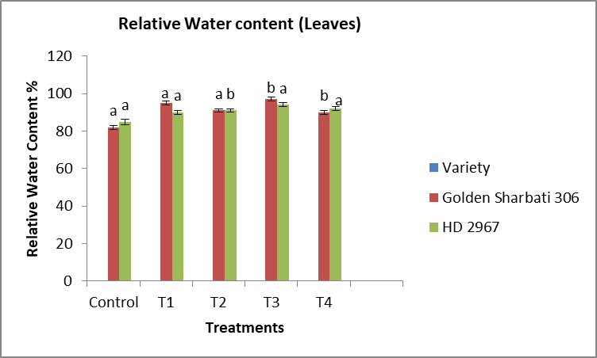 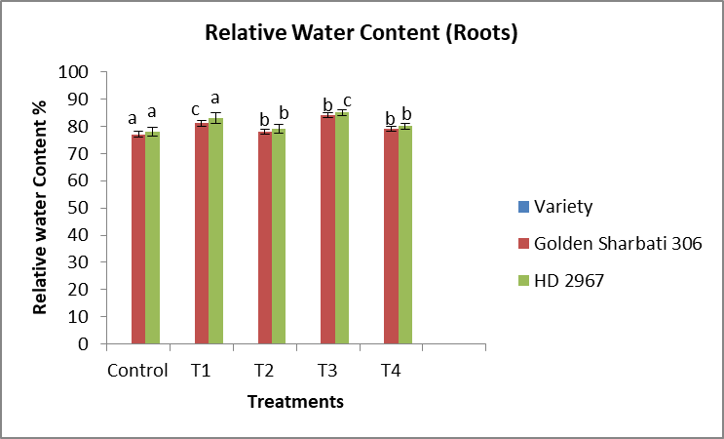

- Electrolytic Leakage (Leaves) D. Electrolytic Leakage (Roots)
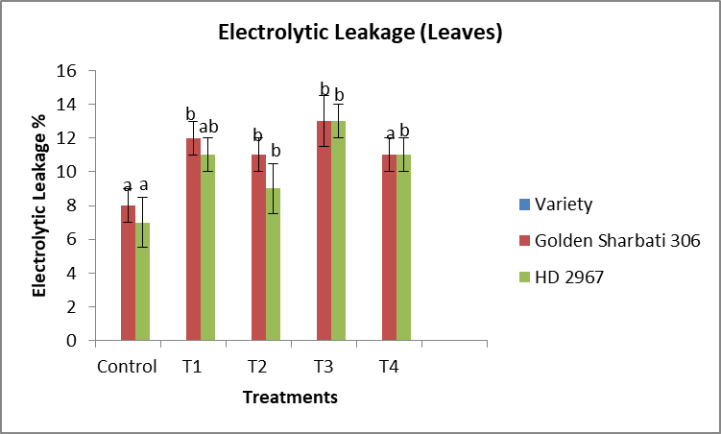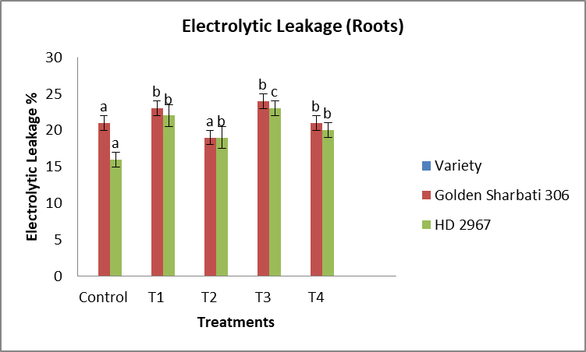

Figure1. Influence of Si, SSB and PSB on RWC of Leaves (A) RWC of Roots (B), Electrolytic Leakage of Leaves(C)and Electrolytic Leakage of Roots(D) of wheat plants . Data shown in the figure indicates Mean ± SE; One way ANOVA analysis by Duncan’s Multiple Range Test (DMRT) post hoc test; Each bar having different alphabets was significantly different between treatments (p < 0.05).The symbols in the figure represent Control: NPK (5g) each, T1: control +Si (5g) +SSB(2.5g) , T2: NK(5g) +Si(5g)+SSB(5g), T3: control+ Si (5 g) + SSB(7.5 g)+ PSB ( 7.5 g ), T4: NK (5g)+Si (5 g)+ SSB ( 10 g ) + PSB ( 10 g )

3.2. Effect of Si supplementation along with SSB and PSB on Chlorophyll ‘a’ and Chlorophyll ‘b’ Content
Results showed that chlorophyll ‘a’ and chlorophyll ‘b’ were significantly increased under SSB(10g) and PSB (10g) supplementation in both wheat varieties (Figure 2A,B).
Chlorophyll ‘a’ increased from 0.567±0.024 (T1) mg/g FW 0.642± 0.030 mg/g FW (T3) in Golden Sharbati 306 and 0.402± 0.012 (T1) to 0.567± 0.017 mg/g FW (T3) in WH-1105 variety as compared to control plants (Figure 2A). Similarly, a significant rise was observed in chlorophyll ‘b’ by up to 0.178 ± 0.005 mg/g FW (T3) in Golden Sharbati 306 and 0.120 ± 0.009 mg/g FW (T1) in HD 2967 when compared with control (Figure 2B).
- Chlorophyll ‘a’ Content B. Chlorophyll ‘b’ Content
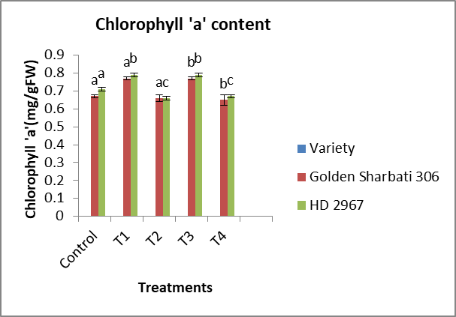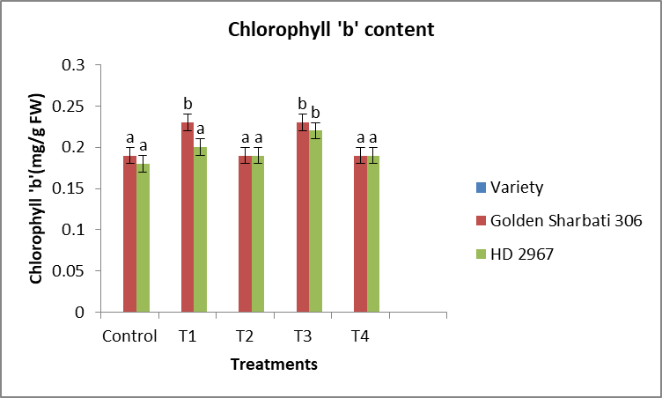
Figure 2. Influence of Si, SSB and PSB on Chlorophyll ‘a’ Content (A) Chlorophyll ‘ b ‘ Content (B) of wheat plants . Data shown in the figure indicates Mean ± SE; One way ANOVA analysis by Duncan’s Multiple Range Test (DMRT) post hoc test; Each bar having different alphabets was significantly different between treatments (p < 0.05).The symbols in the figure represent Control: NPK (5g) each, T1: control +Si (5g) +SSB(2.5g) , T2: NK(5g) +Si(5g)+SSB(5g), T3: control+ Si (5 g) + SSB(7.5 g)+ PSB ( 7.5 g ), T4: NK (5g)+Si (5 g)+ SSB ( 10 g ) + PSB ( 10 g )

3.3. Effect of Si supplementation along with SSB and PSB on Total Chlorophyll Content, Carotenoid Content,Chlorophyll Stability Index (CSI)
The total chlorophyll and carotenoid contents were also reduced by up to 35% and 22% in Golden Sharbati 306 and 42% and31%, respectively, in HD variety at the highest SSB and PSB concentration (T3) compared with the control (Figure 2A,B). Si application increased the total chlorophyll and carotenoid contents by up to 13.7% ( T1) and 31% (T3) in Golden Sharbati 306 and 19.5% (T1)and 35.7% (T3), respectively, in HD 2967 variety . Likewise, CSI was also decreased from moderate stress (T1), i.e., from 19.7%(T1) to 41%(T3), under high concentration of SSB and PSB (T3) in Golden Sharbati 306 , and from and 22% (T1) to 60% (S3) in HD 2967 when compared with the control (Figure 2 C).

- Total Chlorophyll Content B. Total Carotenoid Content
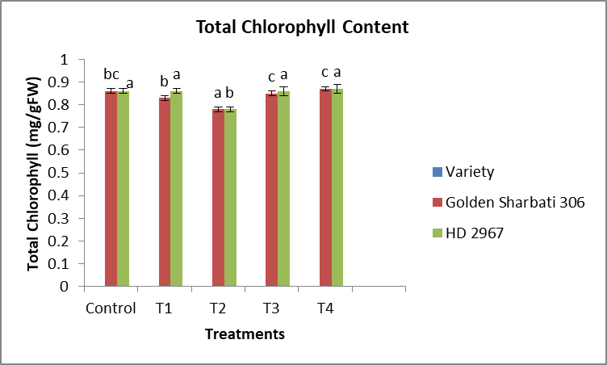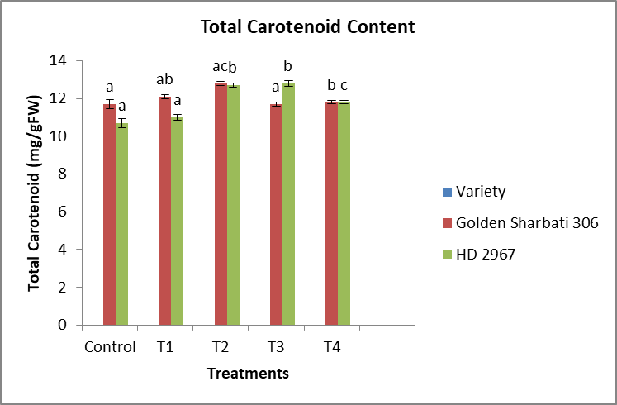
C. Chlorophyll Stability Index (CSI)
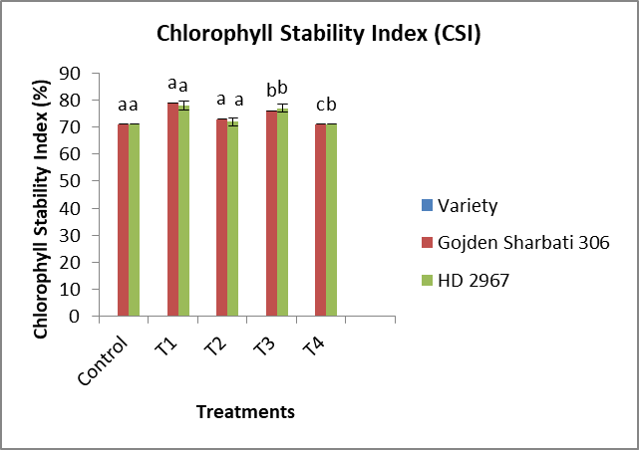
Figure3. Influence of Si, SSB and PSB on Total Chlorophyll Content (A) Total Carotenoid Content (B) Chlorophyll Stability Index(CSI) (C) of wheat plants . Data shown in the figure indicates Mean ± SE; One way ANOVA analysis by Duncan’s Multiple Range Test (DMRT) post hoc test; Each bar having different alphabets was significantly different between treatments (p < 0.05).The symbols in the figure represent Control: NPK (5g) each, T1: control +Si (5g) +SSB(2.5g) , T2: NK(5g) +Si(5g)+SSB(5g), T3: control+ Si (5 g) + SSB(7.5 g)+ PSB ( 7.5 g ), T4: NK (5g)+Si (5 g)+ SSB ( 10 g ) + PSB ( 10 g )
3.4. Effect of Si supplementation along with SSB and PSB on the Antioxidant Enzymes Activity (CAT, POX, and SOD)
The CAT activity of leaves and roots was found to increase with increased in Si supplementation along with SSB and PSB level (Figure 4A,B), i.e., in leaves and roots, improvements of 39.4% (T1) and 60.5% (T3 ) in Golden Sharabati 306 variety and 54.6% (T1) and 97%(T3) in HD 2967 variety were observed at the high concentration of SSB and PSB compared to the control.
Similarly, the POX activity of leaves and roots also increased in (Figure 4C,D) by up to 42% (T1) and 174% (T3) in Golden Sharbati 306 variety and91% (T1) and 288% (T3) in HD 2967 variety when compared with control.
- CAT Activity ( Leaves) B. CAT Activity (Roots)

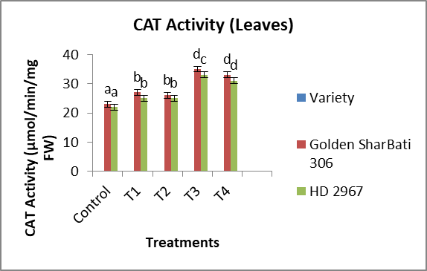
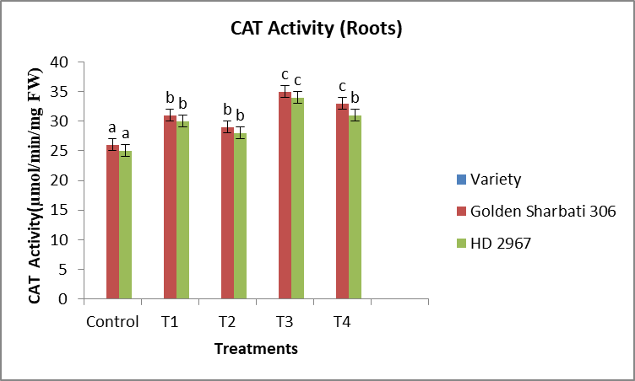
C. POX Activity ( Leaves) D. POX Activity ( Roots)
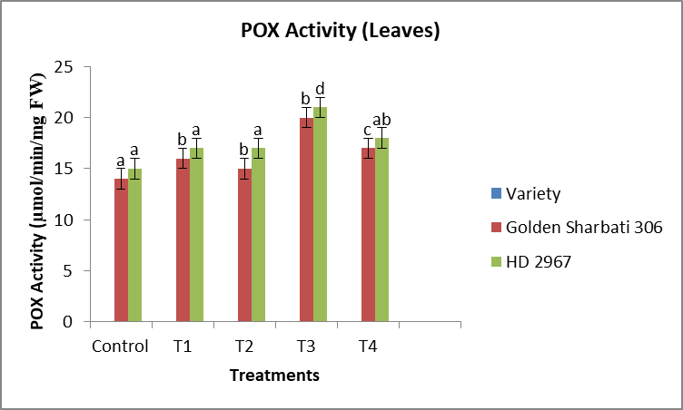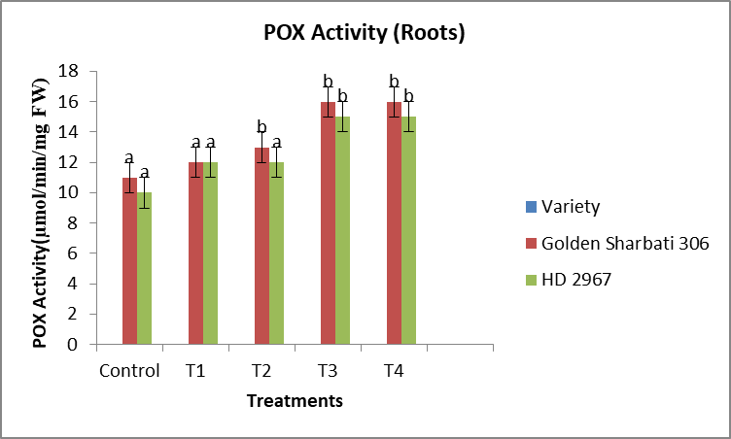
Figure 4. Influence of Si, SSB and PSB on CAT Activity of Leaves (A), CAT Activity of Roots(B), POX Activity of Leaves(C) and POX Activity of Roots (D) of wheat plants . Data shown in the figure indicates Mean ± SE; One way ANOVA analysis by Duncan’s Multiple Range Test (DMRT) post hoc test; Each bar having different alphabets was significantly different between treatments (p < 0.05).The symbols in the figure represent Control:NPK (5g) each, T1: control +Si (5g) +SSB(2.5g) , T2: NK(5g) +Si(5g)+SSB(5g), T3: control+ Si (5 g) + SSB(7.5 g)+ PSB ( 7.5 g ), T4: NK (5g)+Si (5 g)+ SSB ( 10 g ) + PSB ( 10 g )
5.Conclusion:
This study deepens our understanding of the beneficial role of Si supplementation along with SSB and PSB in on two wheat varieties. The Golden Sharbati 306 variety was more significantly affected by increasing the concentration of SSB and PSB than HD 2967variety. Si along with SSB and PSB increased the RWC, photosynthetic pigments, CSI and carotenoid contents, which were significantly reduced under control condition in both varieties. Si supplementation enhanced antioxidant enzyme activities by maintaining their levels in plants . Our findings allow us to conclude that Si application is more effective in Golden Sharbati 306 than HD 2967 showing that Si supports different defensive mechanisms in different plant species. The obtained results will be help- ful in increasing the defence machanisms of wheat plants under normal condition and improving crop production through the application of Si as a fertilizer.
References:
- Giraldo, P.; Benavente, E.; Manzano-Agugliaro, F.; Gimenez, E. Worldwide research trends on wheat and barley: A bibliometric comparative analysis. Agronomy 2019, 9, 352.
- Kumar, P.; Yadava, R.K.; Gollen, B.; Kumar, S.; Verma, R.K.; Yadav, S. Nutritional contents and medicinal properties of wheat: A review. Life Sci. Med. Res. 2011, 22, 1–10.
- Liu, B.; Soundararajan, P.; Manivannan, A. Mechanisms of silicon-mediated amelioration of salt stress in plants. Plants 2019, 8, 307.
- Abdelaal, K.A.; Mazrou, Y.S.; Hafez, Y.M. Silicon foliar application mitigates salt stress in sweet pepper plants by enhancing water status, photosynthesis, antioxidant enzyme activity and fruit yield. Plants 2020, 9, 733.
- Almeida, D.M.; Oliveira, M.M.; Saibo, N.J. Regulation of Na+ and K+ homeostasis in plants: Towards improved salt stresstolerance in crop plants. Genet. Mol. Biol. 2017, 40, 326–345.
- Ali, A.; Basra, S.M.; Iqbal, J.; Hussain, S.; Subhani, M.N.; Sarwar, M.; Haji, A. Silicon mediated biochemical changes in wheat under salinized and non-salinized solution cultures. Afr. J. Biotechnol. 2012, 11, 606–615.
- Broadley, M.; Brown, P.; Çakmak, I˙.; Ma, J.F.; Rengel, Z.; Zhao, F. Beneficial elements. In Marschner’s Mineral Nutrition of Higher Plants; Academic Press: Cambridge, MA, USA, 2012; pp. 249–269.
- Ghoulam, C.; Foursy, A.; Fares, K. Effects of salt stress on growth, inorganic ions and proline accumulation in relation to osmotic adjustment in five sugar beet cultivars. Environ. Ex Bot. 2002, 47, 39–50.
- Hiscox, J.D.; Israelstam, G.F. A method for the extraction of chlorophyll from leaf tissue without maceration. Can. J. Bot. 1979, 57, 1332–1334.
- Aebi, H. Catalase In Vitro. In Methods in Enzymology; Academic Press: Cambridge, MA, USA, 1984; Volume 105, pp. 121–126.
- Hammerschmidt, R.; Nuckles, E.M.; Kuc´, J. Association of enhanced peroxidase activity with induced systemic resistance of cucumber to Colletotrichum lagenarium. Physiol. Plant Pathol. 1982, 20, 73–82.
- FAO. (2020). Food security report. https://www.fao.org/publications/food-security-report-2020/en/ .
- Mahanta, D., Das, P., & Dutta, P. (2018). Phosphate solubilization potential. Journal of Microbiology, 56(3), 213-220.
- Yadav, H., Fatima, R., Sharma, A., & Mathur, S. (2017). Enhancement of applicability of rock phosphate in alkaline soils by organic compost. Applied Soil Ecology, 113, 80–85.
- Tayade, R., Ghimire, A., Khan, W., Lay, L., Attipoe, J. Q., & Kim, Y. (2022). Silicon as a Smart Fertilizer for Sustainability and Crop Improvement. Biomolecules, 12(8), Article 1027.
- Patil, H. J., & Solanki, M. K. (2016). Microbial inoculant: Modern era of fertilizers and pesticides. In D. P. Singh, H. B. Singh, & R. Prabha (Eds.), Microbial inoculants in sustainable agricultural productivity: Vol. 1. Research perspectives (pp. 319–343).
- Poveda, J. (2021). Trichoderma as biocontrol agent against pests: New uses for a mycoparasite. Biological Control, 159, 104634
- Kaur, G., Reddy, M. S., & Kumar, A. (2015). Phosphate-solubilizing microbes: An effective and alternative approach as biofertilizers. International Journal of Microbiology, 2015, 1–7.

