"East African Beauty Standards: Compliance Pathways for Cosmetic Products"

1. Abstract: The seven member states that make up the East African Community (EAC) have been progressively attempting to harmonise rules in order to promote economic growth and regional integration. This regulatory harmonisation is especially important in the cosmetics industry to guarantee product safety, advance fair trade, and improve cross-border consumer protection. With a focus on important regulatory organisations such national standards agencies and health ministries, this abstract examines the changing legal frameworks controlling cosmetics in the EAC. It explores regulations pertaining to ingredient safety, product registration, labelling, and import/export processes, highlighting both opportunities and difficulties for regional manufacturers and distributors. The EAC Secretariat's work and regional standardisation programs run by ARSO and EASC are given particular consideration. which aim to create a unified regulatory environment. By mapping out both national nuances and regional convergence strategies, this paper offers a practical guide for stakeholders seeking compliance and market entry in East Africa’s burgeoning beauty industry.
2. Keywords: East African Community (EAC), Regulatory Harmonization, Product Registration, Labelling Standards, Consumer Protection, ARSO (African Regional Standards Organization), EASC (East African Standards Committee), Market Entry, Cross-Border Trade, Regional Integration
3. INTRODUCTION
The United Republic of Tanzania, the Republic of Burundi, the Democratic Republic of the Congo, the Republic of Kenya, the Republic of Rwanda, the Federal Republic of Somalia, the Republic of South Sudan, the Republic of Uganda, and the Republic of Burundi collectively form the East African Community (EAC), a regional intergovernmental organisation with its headquarters located in Arusha, Tanzania.
On November 24, 2023, the Federal Republic of Somalia was accepted into the East African Community by the EAC Summit of Heads of State. On December 15, 2023, the Federal Republic of Somalia subsequently signed the Treaty of Accession to the EAC Treaty. When the Federal Republic of Somalia deposits her ratification document for the EAC Treaty with the EAC Secretary, she becomes a full member. General on 4th March, 2024.
An estimated 331.1 million people live in the EAC, with more than 30% of them living in cities. With a combined Gross Domestic Product of US$312.9 billion and a land size of 5.4 million square kilometres, its realisation holds significant geopolitical and strategic importance, as well as opportunities for the revitalised and revived EAC.
The Treaty that created the Community serves as a guide for the EAC's operations. It was signed on November 30, 1999, and after being ratified by the original three Partner States—Kenya, Tanzania, and Uganda—it came into effect on July 7, 2000. On June 18, 2007, the Republic of Rwanda and the Republic of Burundi signed the EAC Treaty, and on July 1, 2007, they were admitted as full members of the Community. While the Democratic Republic of the Congo joined the EAC Treaty on April 8, 2022, and became a full member on July 11, 2022, the Republic of South Sudan joined the Treaty on April 15, 2016, and became a full member on August 15, 2016.The Federal Republic of Somalia acceded to the EAC Treaty on 15 December, 2023, and became a full member on 4 March, 2024.
The EAC, one of the world's fastest-growing regional economic blocs, is expanding and strengthening cooperation between its member states in a number of crucial areas for their mutual advantage. Political, economic, and social are some of these domains.
The East African Customs Union's promising development, the Common Market's creation in 2010, and the East African Monetary Union Protocol's adoption all demonstrate how quickly the regional integration process is currently underway.

Vision: East Africa is to be rich, competitive, safe, stable, and politically united, according to the EAC's vision.

Objective: Through enhanced competitiveness, value-added manufacturing, trade, and investments, the Community seeks to improve the quality of life for East Africans by expanding and strengthening economic, political, social, and cultural integration.
4.The EAC's integration agenda is built on four pillars
Pillar 1: The Customs Union:
By removing internal tariffs and imposing a Common External Tariff (CET) on imports from non-member nations, the EAC Customs Union seeks to increase regional trade. The free flow of goods between EAC Partner States is encouraged, investment is encouraged, and economic efficiency is improved by this integration. In the end, it seeks to promote economic expansion and competitiveness in East Africa.
Pillar 2: The Common Market
By facilitating the free flow of capital, labour, products, and services across Partner States, the EAC Common Market seeks to establish a smooth economic environment throughout the region. This integration facilitates cross-border corporate and individual operations while fostering economic growth, investment, and job possibilities. In the end, the Common Market aims to raise East Africans' standard of living by promoting a more competitive and connected regional economy.
Pillar 3: Monetary Union
In order to eventually adopt a common currency among its member states, the EAC Monetary Union seeks to create a unified monetary system within the East African Community. In order to facilitate commerce and investment within the region, this integration aims to simplify transactions, lower currency rate risks, and promote price stability. The Monetary Union contributes to the larger objective of a stable and successful East African economy by enhancing economic and financial integration.
Pillar 4: Political Federation
The goal of the EAC Political Federation is to bring the Partner States together as a unified political entity with common governance frameworks. Through improved peace, security, and group decision-making, the region is better equipped to handle shared issues and defend shared ideals. Through improved regional representation and concerted leadership on the international scene, the Federation ultimately aims to empower East Africans.
Table 1: EAC countries along with their regulatory authority
S.no | country | Regulatory authority
1 | Burundi | Department of Pharmacy, Medicines, and Laboratories (DPML)
2 | Democratic Republic of the Congo (DRC) | Directorate of Pharmacy, Medicines, and Traditional Medicine
3 | Kenya | Pharmacy and Poisons Board (PPB)
4 | Rwanda | Rwanda Food and Drugs Authority (Rwanda FDA)
5 | Somalia | Interim National Medicines Regulatory Authority (NMRA)
6 | South Sudan | National Medicines and Poisons Board (NMPB)
7 | Uganda | National Drug Authority (NDA)
8 | Tanzania | Tanzania Medicines and Medical Devices Authority (TMDA)
5. COSMETIC REGULATIONS AND APPROVAL PROCESS IN EAC COUNTRIES
a) KENYA
Introduction: The Kenya Bureau of Standards (KEBS) and the Pharmacy and Poisons Board (PPB) are the two main Health Authorities (HAs) that oversee Kenya's strong regulatory framework for the cosmetics sector. By controlling the ingredients, labelling, and production methods of cosmetic items, these bodies guarantee consumer safety and market conformity.

To guarantee seamless product registration and market access, companies wishing to enter the Kenyan market must comprehend and abide by these requirements.

Defining and Classifying Cosmetic Products in Kenya
In Kenya, cosmetic products are broadly defined as substances or preparations intended for external application on the human body (such as the epidermis, hair system, nails, lips, and external genital organs) or with the teeth and mucous membranes of the oral cavity. These products aim to:
- Cleanse,
- Perfume,
- Change appearance,
- Correct body Odors, or
- Protect and maintain good condition of the application site.
The classification of cosmetics determines their regulatory requirements, particularly whether they fall under the purview of general cosmetics or are categorized as pharmaceuticals subject to stricter oversight.

Regulatory Requirements for Cosmetic Products in Kenya
Cosmetics sold in Kenya must comply with Kenya Standard KS 2937:2021, which lays out detailed guidelines on:
- Ingredient Safety: Prohibiting harmful substances and controlling permissible limits.
- Labelling Standards: Ensuring transparency and consumer safety.
- Claims Validation: Verifying that all claims on product labels are truthful and not misleading.
- Post-Marketing Surveillance: Ongoing evaluation to ensure continued safety and compliance.
Approval process: Kenya Standard KS 2937:2021, which specifies rules for ingredient safety, labelling, claims, and post-marketing surveillance, must be followed by all cosmetic products. According to international standards like ISO 17516:2014, products must meet microbiological safety requirements and not contain any hazardous materials. Cosmetics must go through Pre-export Verification of Conformity (PVoC), which entails testing, product documentation submission, and production facility inspection, before they may be sold in Kenya. Products are given the KEBS certification mark after being accepted.
Cosmetics may need to be registered (for PPB-regulated pharmaceutical or medicated cosmetics) or notified (for KEBS-regulated general cosmetics), depending on the product classification. Product name, manufacturer data, complete ingredient list, batch number, expiration date, usage guidelines, and cautions must all be included on labels that adhere to KS EAS 346. This legal framework guarantees the safety, accuracy, and superior quality of cosmetics sold in Kenya.

Regulatory Pathways for Market Entry

1. Pre-export Verification of Conformity (PVoC)
The PVoC program is the primary pathway for certifying cosmetic products in Kenya. It involves the following steps:
- Application Submission: Companies submit product documentation, including ingredient lists, safety reports, and testing data.
- Inspection: A KEBS officer may inspect the manufacturing facility to verify compliance with standards.
- Certification: Once approved, the product receives a KEBS certification mark, authorizing its sale in Kenya.
2. Registration and Notification
Depending on the product classification:
- Registration is mandatory for products classified as pharmaceuticals or those regulated by the PPB.
- Notification is required for general cosmetic products under KEBS, ensuring a streamlined process for low-risk products.

Labelling and Claims: Key Considerations
All cosmetic products must meet the labelling requirements outlined in KS EAS 346, which mandate the inclusion of:
- Product name and brand,
- Manufacturer details,
- Full ingredient list,
- Batch number,
- Shelf life or expiration date,
- Usage instructions, and
- Warnings or precautions.
Claims made on the label must be substantiated with scientific evidence, ensuring they are not exaggerated or misleading.
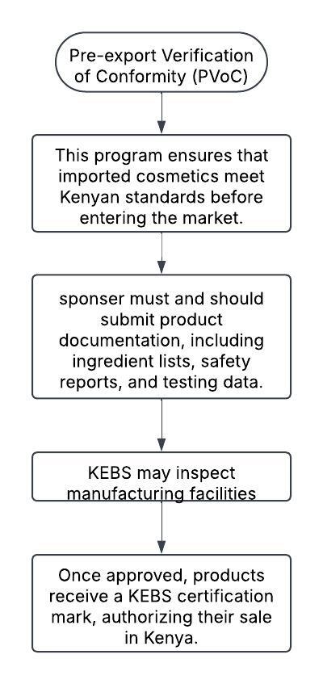
Figure 1: approval process of cosmetics in Kenya
b) TANZANIA
The Ministry of Health (MOH) oversees the Tanzania Medicines and Medical Devices Authority (TMDA), an Executive Agency. Following the passage of the Tanzania Food, Drugs and Cosmetics Act, Cap 219, by the Parliament, TMDA—formerly known as the Tanzania Food and Drugs Authority (TFDA)—was founded in 2003. When the Tanzania Bureau of Standards (TBS) took over responsibility for regulating food and cosmetics, this Act was later revised in 2019 to become the Tanzania Medicines and Medical Devices Act, Cap 219. The name change to TMDA was also a result of the legislative framework change brought about by the Finance Act, No. 8 of 2019.
The quality, safety, and efficacy of medications, medical equipment, diagnostics, biocidal, and tobacco products are currently governed by the TMDA. According to the Executive Agencies Act, Cap. 245 (which was further updated in 2009), TMDA is run as an Executive Agency to enhance the provision of public services.
Approval process: before going to the approval process the cosmetics int the Tanzania undergo classification.
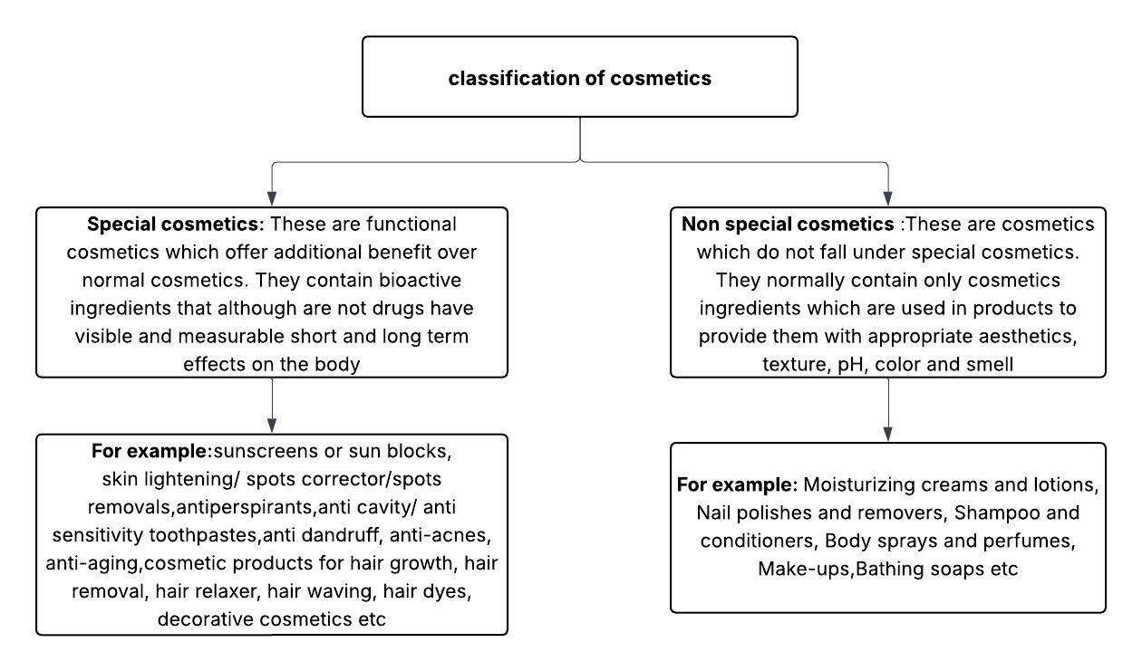
Figure 2: classification of cosmetics in Tanzania
Applicant :Applicant shall be a person who is a resident in Tanzania. If the applicant is not resident in Tanzania then he shall appoint a local responsible person who must be residing in Tanzania or a company incorporated in Tanzania. Proof of official appointment shall be submitted to TFDA.
Type of applications:
There are three types of applications as follow
- New application
- The purpose of this application is to register a cosmetic product that will be introduced to the Tanzanian market for the first time. Only the applicant may submit a new application, and he is the one who must sign the application.
- Except for identical items with differing box sizes and shapes, each cosmetic product must be applied separately. Nonetheless, a statement of the available pack shapes and sizes must be made.
- A product registration request must be made in a single application. Variants, on the other hand, could be charged half of the required fee and submitted in a different application.
- Products that are sourced from multiple manufacturing locations but have the same formulation and name will be recognised as distinct products and registered as such.
- A kit must be applied for as a single application. Such a kit will be categorised according to its components. The entire kit will be classified as exceptional if one of the parts is a unique cosmetic. The kit will be classified as normal if every component is a typical cosmetic. ^{[5]}
- Variation :If an applicant modifies any aspect of a registered cosmetic product for any reason, such as altering the packaging, labelling, or anything else, they must notify the Authority of the change and get their approval before the product is sold. The reason or reasons for the modification must be included with the notice to the Authority.
- Application for renewal: The registrant, who is in charge of the product's quality and safety, must submit an application for registration renewal at least thirty days before to the registration's expiration date.
How to submit an application: All applications shall be submitted through the online portal link www.tfda.go.tz/portal. Copy of print out of the same shall be submitted at TFDA offices. Applicant shall prior to submission of application request for appropriate categorization.
Submission of required documents
Payment of fees Every application shall be accompanied by appropriate fees as specified in the Fees and Charges Regulations in force at the time of application. The fees shall be paid to following account:-
- For foreign currency; Tanzania Food and Drugs Authority, Account No. 100380013 USD, Citibank, Tanzania Ltd. Dar es Salaam – Head office Peugeot House, 36 Upanga Road, P. O. Box 71625, Dar es Salaam Tanzania Swift Code: CITITZTZ.
- For local currency; Tanzania Food and Drugs Authority, Account No. 6503900110 National Microfinance Bank, Kariakoo Branch or by banker’s draft.
Processing of applications:
- Assessment and Requests: Applications are reviewed per guidelines. Additional documents may be requested to ensure the quality and safety of the cosmetic product.
- Application Expiry: If the applicant doesn't respond to raised issues within 30 days, the application expires, requiring a new submission.
- Compliance and Decisions: Decisions are based on submitted information. Non-compliance with guidelines leads to denial of marketing authorization.
- Granting Authorization: Authorization is granted if the product meets National or International Standards and guidelines, with a unique registration certificate issued.
- Rejection Notification: If the product fails to meet quality or safety requirements, the application is rejected, and the applicant is notified in writing.
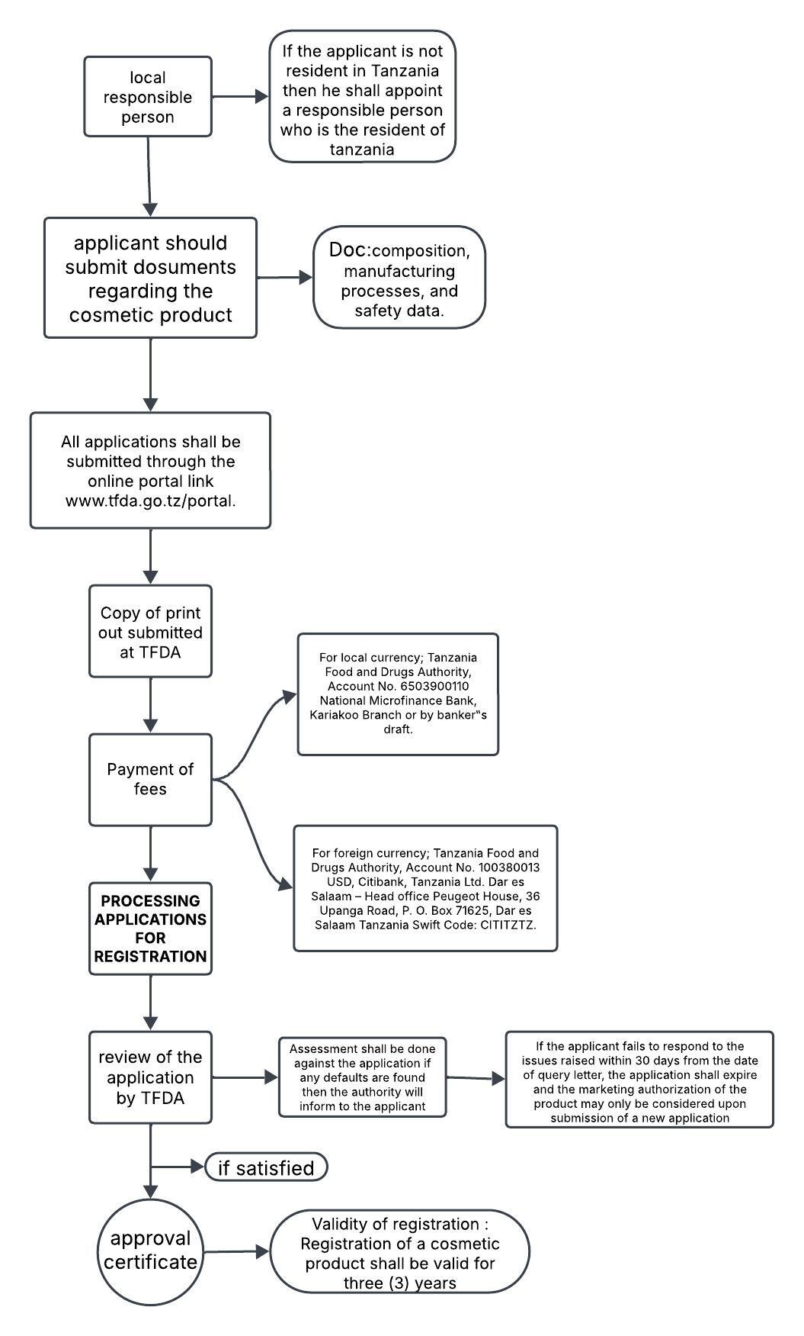
Figure 3: approval process of cosmetics in Tanzania
c) BURUNDI
Introduction: Through the Department of Pharmacy, Drug, and Laboratory, the General Inspection of Public Health, and the fight against AIDS, the Ministry of Public Health in Burundi oversees the regulation of the pharmaceutical industry. The nation has plans to establish a National Drug and Food Regulatory Authority (NDFRA) to supervise the nation's pharmaceutical laws.
Following its adoption, the NDFRA will be in charge of overseeing all facets of product safety and quality assurance, including prefabricated and packaged foods, pharmaceuticals, cosmetics, herbal remedies, pharmaceuticals for human and veterinary use, phytosanitary products, medical devices or materials or substances used in the manufacture of products whose consumption may be harmful to human and animal health.
Approval process: Both local and international regulations must be followed in order for cosmetic items to be approved in Burundi. The guidelines of ISO 22716, which describe Good Manufacturing Practices (GMP) for cosmetics and encompass topics including manufacturing, storage, quality control, and hygiene, must be followed by importers and manufacturers. Products must pass a Pre-Shipment Verification of Conformity (PVoC) supervised by the Burundi Bureau of Standards and Quality Control (BBN) prior to being imported. To make sure the goods fulfil safety and quality requirements, this involves testing, inspection, and documentation. Cosmetics must be labelled in French or Kirundi, with ingredients, usage directions, and manufacturer information plainly visible. Once in the country, they may also need to be registered with local authorities. Any treatment claims need to be supported by scientific data because they could lead to further regulatory scrutiny. This multi-step process ensures that cosmetic products entering the Burundian market are safe, properly manufactured, and transparently presented to consumers.
- Product Registration: All cosmetic products must be registered with the DPML before being marketed. Applicants are required to submit a dossier containing product details, including composition, safety assessments, and certificates of analysis.
- Compliance with Standards: Products must meet either national standards or international standards where national standards are unavailable.
- Labelling Requirements: Labels must include essential details such as product name, manufacturer information, batch number, expiration date, usage instructions, and warnings.
- Evaluation and Approval: The DPML evaluates the submitted dossier to ensure compliance with safety and quality standards. Once approved, the product is granted marketing authorization.
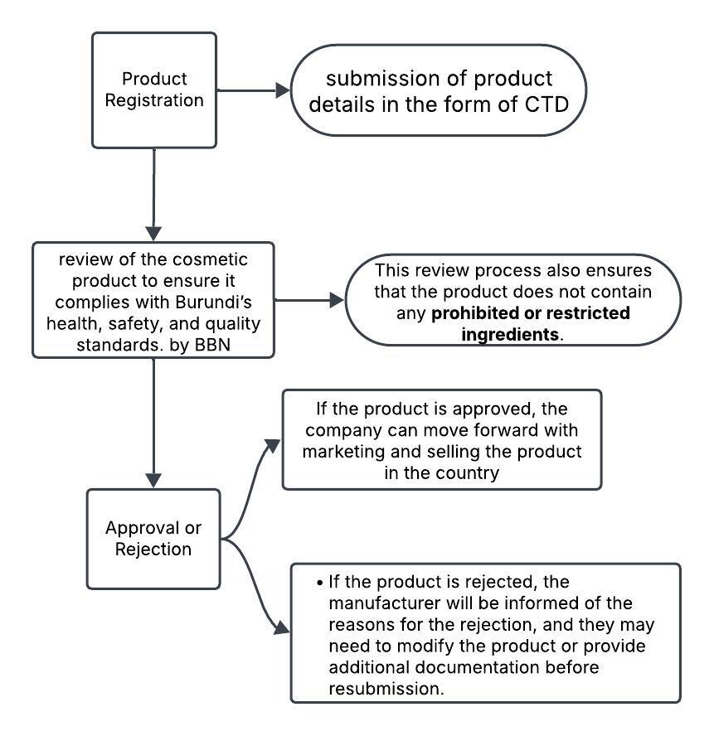
Figure 4: approval process of cosmetics in Burundi
d) CONGO:
Introduction: The drug regulatory body in charge of overseeing medicine, cosmetic regulation and maintaining the National Medicines Registry is the Directorate of Pharmacy, Medicines, and Traditional Medicine. The regulatory authority is also in charge of making sure the nation complies with the Prequalification of Medicines Program guidelines set forth by the World Health Organisation. This initiative helps guarantee that medications provided by global procurement organisations for distribution in underdeveloped nations fulfil acceptable requirements for efficacy, safety, and quality.
The Drug Regulatory Authority of the DRC received financial and technical support in December 2017 from the Global Health Supply Chain Technical Assistance Francophone Task Order to examine the Medicines Registry that was approved for use in the nation. Half of the 2,322 authorisations that were granted between January 2010 and September 2017 had expired, according to the assessment. According to the USAID Global Health Supply Chain Program (2018), 109 market authorisations were also found to be set to expire within three months of the study.
Additionally, SIAPS assisted the DRA in creating a thorough national pharmaceutical policy framework and putting in place a pharmaceutical regulatory structure. Thirteen life-saving items approved by the UN Commission on Life-Saving Commodities for Women's and Children's Health were added to the National Essential Medicine List (SIAPS, 2016).
By guaranteeing that drugs sold in the marketplace are both safe and effective, pharmaceutical regulations are essential to protecting the public's health. The implementation and enforcement of strict pharmaceutical regulations are crucial in the Democratic Republic of the Congo (DRC), where the healthcare system faces many obstacles because of things like poor infrastructure, restricted access to high-quality healthcare, and a high disease prevalence. In addition to protecting patients, these rules also help to increase trust in the healthcare system overall.
Preventing the distribution of fake and inferior medications is one of the main goals of DRC pharmaceutical legislation. Patients are seriously threatened by the widespread use of these illegal goods, which can result in treatment failures as well as higher rates of morbidity and fatality. Authorities can reduce the risks connected with subpar pharmaceuticals by enforcing strict regulations that effectively supervise the manufacturing, distribution, and sale of pharmaceuticals.

Approval process: Cosmetic product clearance in the Democratic Republic of the Congo (DRC) requires compliance with both national and international regulatory systems. ISO 22716, which describes Good Manufacturing Practices (GMP) for cosmetics, is one of the essential certifications needed. This standard guarantees that goods are produced, kept, and transported in a way that preserves their uniformity, quality, and safety.
The DRC requires a Certificate of Conformity for imported cosmetics, confirming that the goods fulfil the nation's safety and quality requirements. Authorised organisations, like Cotecna, work with the Congolese Agency for Standardisation and Quality (ACONOQ) to supervise this procedure. Depending on the exporter's profile, the conformance assessment consists of product inspection, paperwork review, and risk-based evaluation.
- Application Submission: Submit a registration application to the Directorate, including a dossier with product details such as composition, safety assessments, and certificates of analysis.
- Evaluation: The Directorate reviews the dossier to ensure compliance with safety, quality, and efficacy standards.
- Compliance Verification: Products must adhere to Good Manufacturing Practices (GMP) and labelling requirements. Prohibited and restricted ingredients are checked for compliance.
- Approval: Once the product passes evaluation, it is granted marketing authorization, which is typically valid for a specified period.
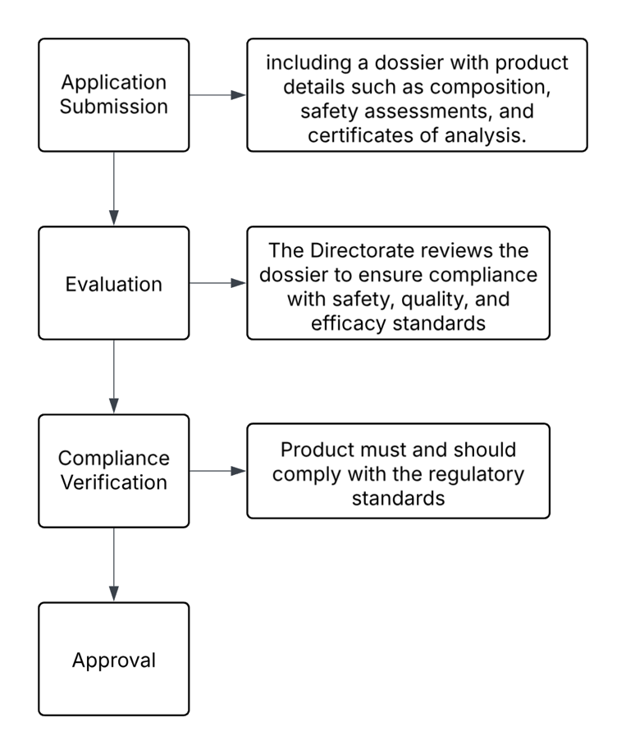
Figure 5:approval process of cosmetics in Congo
e)Rwanda
Introduction: Rwanda Food and Drugs Authority hereafter designated as the “Authority”, was established by the law Nº 003/2018 of 09/02/2018 determining its mission, organization and functioning. The mandate of the Authority is to protect public health through regulation of human and veterinary medicines, vaccines and other biological products, processed foods, poisons, medicated cosmetics, medical devices, household chemical substances, tobacco and tobacco products.
Submission of application An application for product registration for either locally manufactured or imported, shall be made in writing via a cover letter and application form dated and signed by the applicant. If the applicant is a foreign company, he/she shall appoint a local technical representative. The application shall be submitted through Rwanda FDA online portal
A reference number is automatically assigned to the application and it will be used in all subsequent correspondences relating to the application. An acknowledged receipt will be issued. Product samples should be submitted to Rwanda FDA Head Office. The samples should be accompanied with a cover letter (annex 1) to gather with a printed notification email clearly stating the application reference number generated from the portal at the time of submission.
Approval procedure: Under Law No. 003/2018, the Rwanda Food and Drugs Authority (Rwanda FDA) is in charge of approving and regulating cosmetics, particularly medicated cosmetics. To manufacture, import, export, or distribute medicated cosmetics, a person or business must first register with the Authority. Each product, regardless of variations in formulation, colour, scent, or intended purpose, needs its own complete registration file, and this application must be filed both electronically and in physical copy.
Detailed documentation, such as the product's composition, information on the manufacturing location, specifics about the packaging and labelling, and safety data, must be submitted as part of the registration procedure. Products must not include any ingredients that are prohibited or suspended in Rwanda or under international agreements that the nation has ratified.
A certificate of complete registration is granted upon approval and is good for five years; applications for renewal must be submitted at least ninety days prior to the certificate's expiration date. Any medicinal claims must be backed up by scientific data, and all goods must adhere to Rwanda's packaging and labelling regulations. These rules are intended to guarantee the quality, safety, and effectiveness of cosmetics sold in Rwanda.
Rwanda FDA Dossier Assessment Procedures
Product dossiers are evaluated by the Rwandan FDA using a methodical procedure. Applications are checked for completeness upon submission, and those with incomplete dossiers are rejected. Applicants are then instructed to furnish the necessary information within 30 days. The First In, First Out (FIFO) approach is used to schedule the evaluation of complete applications, and according to certain rules, items for uncommon diseases, emergencies, or unmet medical requirements are given precedence. Products qualifying under reliance procedures undergo a condensed evaluation. Two assessors examine each dossier to determine its efficacy, safety, and quality. The Rwanda FDA may ask for more information or samples during the evaluation, and in order to move forward, any questions must be satisfactorily answered. The application is denied if, after four rounds of questioning, the answers are still inadequate.
Compliance to the current Good Manufacturing Practices (cGMP): The procedure of registering a product includes the GMP inspection. Before a product is registered, the Rwandan FDA should inspect the facility or employ other methods to confirm that the production site conforms with cGMP rules and/or guidelines. Product registration is contingent upon the facility's compliance with cGMP.
Rwanda FDA Internal Scientific Review Committee for Product Registration: A final dossier assessment report will be submitted to the Internal Scientific Review Committee for evaluation and recommendation regarding the approval or denial of a marketing authorisation following the completion of the assessment. The application will remain pending until the issues mentioned are remedied if the committee determines that there are safety, quality, or efficacy concerns that need to be addressed. The application will be deemed withdrawn if the applicant does not submit the necessary information within the allotted period.
Timelines for product registration Product dossiers shall be scheduled for assessment according to the First in First out (FIFO) basis upon compliance of the requirements. A new application shall be processed within twelve (12) months of receipt of the application.

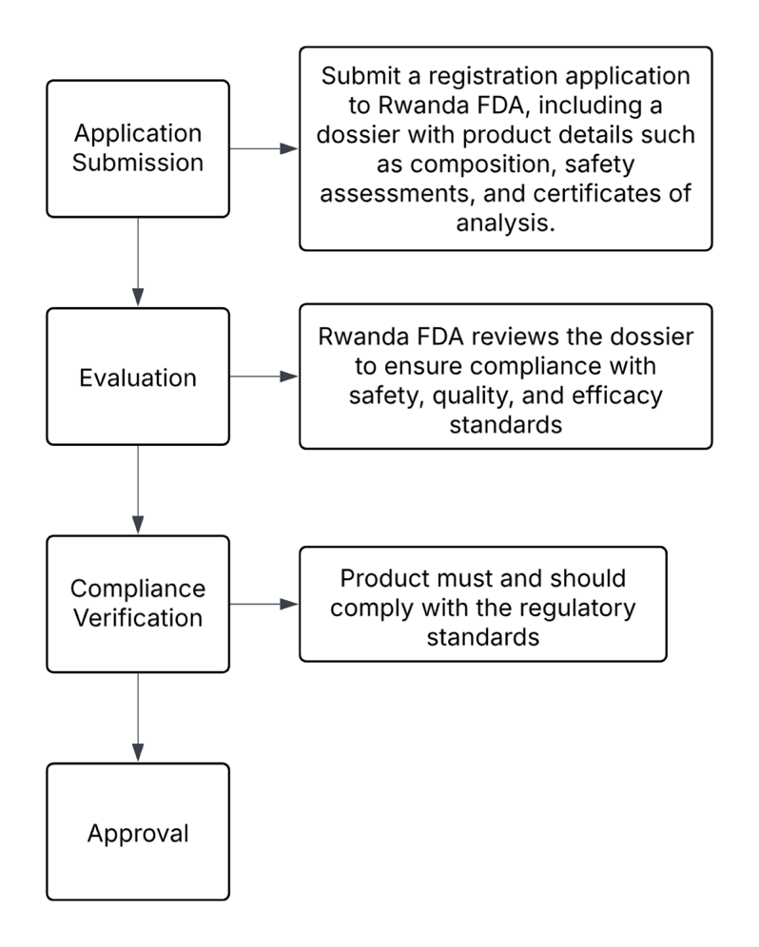
Figure 6:approval process of cosmetics in Rwanda
f) SOMALIA
Introduction: The Federal Ministry of Health and Human Services of the Federal Government of Somalia will serve as the temporary home of the Interim National Medicines Regulatory Authority (INMRA). Until a legal framework for regulating medical products is established, the INMRA is in charge of regulating and controlling medications, biologics, medical devices, herbal medicines, food safety, tobacco, and medicated cosmetics in accordance with international norms and standards. Using a reliance quality control strategy and established procedures, this interim regulatory authority will supply and carry out the primary regulatory responsibilities, such as medical product registration, inspection, pharmacovigilance, post-marketing monitoring, and quality control. ^{[10]}
Approval process: The National Medicines Regulatory Authority (NMRA), a division of the Ministry of Health, is in charge of approving cosmetics in Somalia. All health-related items, including medicated cosmetics, must adhere to safety, effectiveness, and quality requirements, which are enforced by the NMRA. A certificate of free sale, marketing authorisation, and a layout design of the manufacturing facility are among the documents that manufacturers and importers must submit as part of a formal application procedure in order to get a licence.
To stop fake or inferior products from reaching the Somali market, the NMRA performs inspections and post-market surveillance prior to a product's release onto the market. Technical standards for consumer goods, including cosmetics, are also developed and implemented in large part by the Somali Bureau of Standards (SOBS).
  - Registration and Licensing: Manufacturers and importers must register their products and obtain necessary licenses.
  - Quality Standards: Products must comply with established safety and quality standards.
  - Documentation Submission: Technical and safety documentation is required for evaluation.
  - Inspection and Testing: The NMRA conducts inspections and laboratory testing to ensure compliance.
  - Approval: Based on classification:
    - Class A and B: Approval is granted by the State Licensing Authority.
    - Class C and D: Approval requires application to the Central Licensing Authority. ^{[10]}

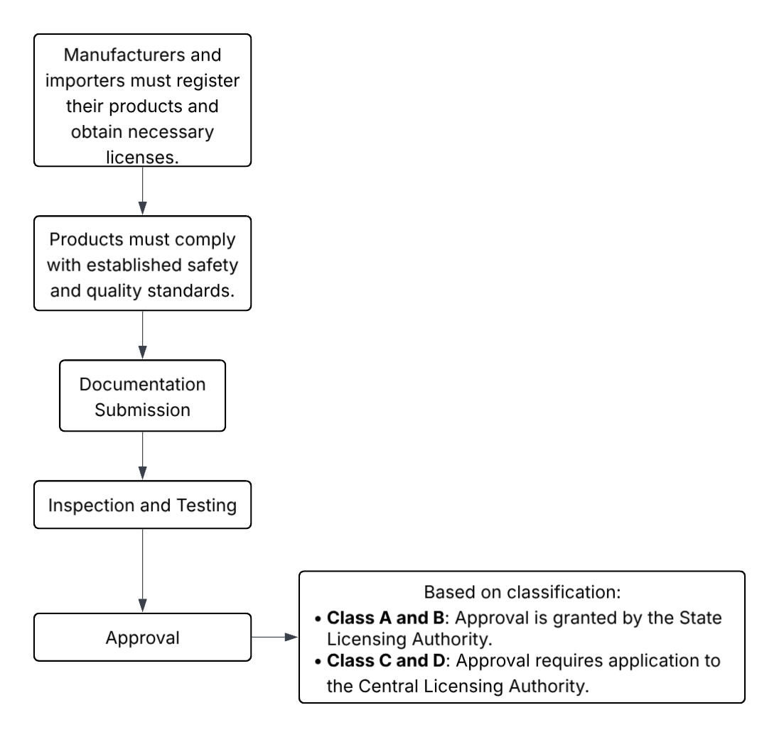
Figure 7: approval process of cosmetics in Somalia
g) SUDAN

Introduction: The regulatory agency in charge of ensuring the efficacy, safety, and quality of medications, food, chemicals, cosmetics, and medical equipment in South Sudan is the South Sudan Drug and Food Control Authority (south Sudan drug and food control authority). South Sudan drug and food control authority was established under the Drug and Food Control Authority Act, 2012 (Act No. 37) to protect public health by ensuring adherence to national and international standards.

The Drug and Food Control Authority Act, 2012, which gives it regulatory authority over the importation, production, distribution, marketing, and use of pharmaceuticals and food items in South Sudan, governs the activities of the South Sudan Drug and Food Control Authority. The Ministry of Commerce, the Ministry of Health, and the authority collaborate. The regulatory authority in South Sudan, under the MoH is the South Sudan Drug and Food Control Authority. The main objective of the authority is to exercise general supervision, control and co-ordination over all matters relating to the pharmaceutical industry and to be the principal instrument of Government in the implementation of all policies relating to drugs, poisons, chemicals, cosmetics, and foods meant for human or animal use. ^{[11]}

Approval process: Under the Pharmacy, Poisons, Cosmetics, and Medical Devices Act, the National Medicines and Poisons Board (NMPB) oversees the approval procedure for cosmetic items in Sudan. For cosmetics to be registered and sold lawfully, both domestic and foreign products must fulfil certain standards.
A Free Sale Certificate (FSC) from the nation of origin, verified by Sudan's Ministry of Foreign Affairs, is required of applicants for foreign cosmetic products. The composition formula must be full, including the percentages of active and inert substances, their uses, CAS numbers, and colour index codes. The product's artwork, packaging specifications, and any informational pamphlets must also be included. A documented agency agreement from the Sudan Registrar of Companies and a current importation licence are also requirements for the applicant.
The manufacturer of national products needs to possess a current licence to manufacture cosmetics. They have to conform with Sudanese legislative annexes, submit a thorough production technique, and provide a certificate of analysis for the final product and its constituents. Mouthwash products must not contain alcohol and must not contain pork derivatives. Payment of the required fees is required, and all documents must be in Arabic or English.

Determine Product Origin
- National Products: Manufactured within Sudan
- Foreign Products: Imported from outside Sudan
- submit required documents

Ensure Compliance with Sudanese Regulations
- No pork derivatives
- Alcohol-free mouthwash
- All documents in English or Arabic
- Product must comply with Sudanese legal annexes

Submit Application
- Fill out the official application form
- Submit documents to NMPB (electronically or in person)
- Pay prescribed registration fees

Review & Evaluation
- NMPB reviews product safety, composition, and labelling
- May request additional information or clarification

Approval & Listing
- Once approved, product is listed in NMPB records
- Manufacturer or importer receives registration certificate.
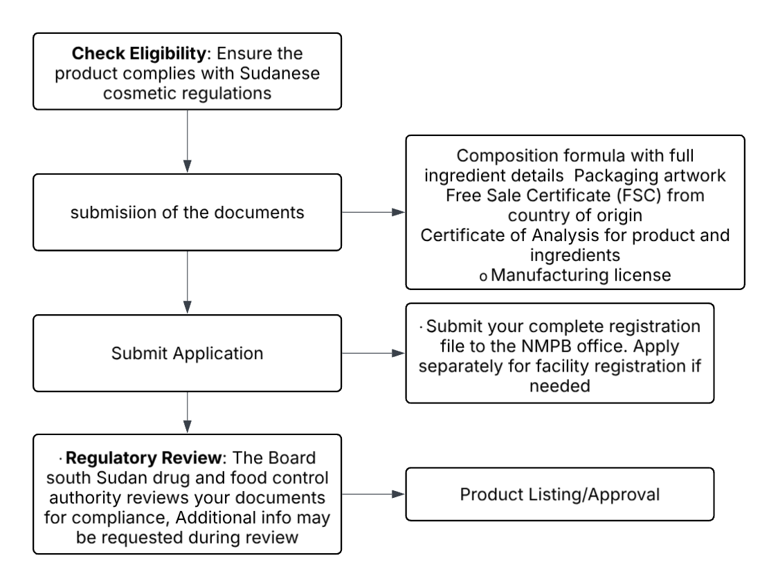
Figure 8: approval process of cosmetics in Sudan

6. Conclusion
As part of a larger commitment to regional integration and public health protection, the East African Community's (EAC) regulatory approval process for cosmetic items is experiencing a radical change towards harmonisation. Although every member state, including Burundi, Tanzania, Rwanda, Kenya, Uganda, and South Sudan, maintains its own national standards and regulatory body, programs like the EAC-Medicines Regulatory Harmonisation (EAC-MRH) program are setting the foundation for a united framework. Reducing redundancy, expediting product registration deadlines, and guaranteeing uniform safety and quality standards internationally are the goals of this harmonisation initiative.
This changing regulatory environment offers opportunities as well as problems to exporters and makers of cosmetics. On the one hand, strategic planning and regulatory knowledge are necessary to navigate the subtleties of each nation's needs. Conversely, conformity to standardised norms facilitates access to international markets, lowers compliance expenses, and boosts consumer confidence. Increasing disposable incomes, urbanisation, and changing cultural aesthetics are driving the growth of the beauty and personal care sector in East Africa, making regulatory compliance more than just a legal requirement but also a strategic advantage.
Harmonised regulations also encourage accountability and transparency, which helps to stop the spread of shoddy or fake goods. Regulators enable customers to make educated decisions and safeguard the public's health by regulating safety testing procedures, ingredient disclosure, and proper labelling. In this sense, a brand's dedication to ethical innovation, sustainability, and long-term credibility is reflected in its regulatory compliance, which is more than just a tick to tick.
In the end, producers, distributors, regulators, and consumers—all parties involved in the cosmetic value chain—stand to gain as the EAC area approaches a unified regulatory framework. East Africa is positioned as a promising centre for responsible cosmetic innovation, where safety and beauty coexist and growth is based on trust, thanks to the convergence of market dynamics, science, and policy.
7. Reference:
- AUDA-NEPAD AMRH. Tanzania Country Profile [internet]. Midrand: AUDA-NEPAD; [cited 2025 June 6]. Available from:https://trade.tanzania.go.tz/media/Cosmetics%20Registration%20Guidelines%20FNL.pdf
- AUDA-NEPAD AMRH. Burundi Profile [internet]. Midrand: AUDA-NEPAD; [cited 2025 June 14].Available from: https://amrh.nepad.org/amrh-countries/burundi
- Abdullah BJ, Nasreen R, Ravichandran N. A comparative study of cosmetic regulations in different countries of the world with focus on India. International Journal of Current Research and Review. 2012;4(11). Published: May 3, 2012. cited may16, 2025.Available from: https://ijcrr.com/uploads/1797_pdf.pdf
- B2B Cert. ISO 22716 Certification in Burundi. B2B Cert website. [internet] n.d. cited june16, 2025. Available from: https://www.b2bcert.com/iso-22716-certification-in-burundi/
- Cert-Ease. ISO 22716 Certification in Burundi. Cert-Ease website. [internet] cited april16, 2025. Available from: https://cert-ease.com/iso-22716-certification-in-burundi/
- East African Community. Overview of EAC[internet]. Arusha: EAC Secretariat; [cited 2025 May 6] Available from: https://www.eac.int/overview-of-eac
- East African Community. EAC Integration: 4 Pillars. [internet]. Arusha: EAC Secretariat; [cited 2025 May 6] Available from: https://www.eac.int/abouteacat25/eachistoryat25#
- Ferreira M, Matos A, Couras A, Marto J, Ribeiro H. Overview of cosmetic regulatory frameworks around the world. Cosmetics. 2022;9(4):72. Published: June 30, 2022. Available from: https://www.mdpi.com/2079-9284/9/4/72 Accessed August 16, 2025.
- Generis Online. Pharmaceutical Regulations in the Democratic Republic of the Congo: An In-Depth Overview [internet]. [cited 2025 June 23]. Available from:https://amrh.nepad.org/amrh-countries/democratic-republic-of-congo-drc
- Maven Regulatory Solutions. Navigating the Regulatory Landscape for Cosmetics in Kenya [internet]. Nairobi: Maven Regulatory Solutions; [cited 2025 May 16] Available from:https://www.mavenrs.com/Navigating-the-Regulatory-Landscape-for-Cosmetics-in-Kenya
- National Medicines and Poisons Board Sudan. Registration of Cosmetic Products [internet]. Khartoum: NMPB; [cited 2025 June 30]. Available from: https://nmra.gov.so/uploads/publications/66e58efd8c4ee.pdf
- National Medicines and Poisons Board. [internet]. Drug and Cosmetic Registration Guidelines. NMPB website. n.d. cited June 12 , 2025.
- Available from: https://nmpb.gov.sd/en/drug_cosmetic_natin.php?num=1
- National Medicines Regulatory Authority. Official Website of Somalia NMRA. [internet]. NMRA website. cited may 12, 2025. Available from: https://nmra.gov.so/
- OMC Medical. Cosmetic Registration in Sudan. OMC Medical website.[internet].[ cited June 18, 2025.].Available from: https://test.omcmedical.com/cosmetic-registration-in-sudan/
- Rwanda FDA. IRIMS Portal [internet]. [cited 2025 June 26]. Kigali: Rwanda FDA; Available from:https://rwandafda.gov.rw/wp-content/uploads/2024/02/Draft%20Guidelines%20for%20Registration%20of%20Pharmaceutical%20Products.pdf
- Rebbaniboni N, Amarapalli D, Parveen A, Prasanthi D. Comprehensive cosmetic regulations: Comparison of selected emerging markets with the US. International Journal of Drug Regulatory Affairs. 2024;12(4). Available from: file:///Users/ayeshaparveen/Downloads/714-Article%20Text-1761-2-10-20241225%20(1).pdf Accessed July 16, 2025.
- Rwanda rw/portal Cosmetic Regulations and Approval Process [internet]. [cited 2025 June 26].Kigali: Rwanda FDA; Available from: (https://www.irims.rwandafda.gov.rw/portal)
- Somalia DFCAS. Organization Overview [internet]. Mogadishu: DFCAS; [cited 2025 June 28]. Available from: https://nmra.gov.so/uploads/publications/66e58efd8c4ee.pdf
- Sudan FDA. Regulations Governing Control of Medicated Cosmetics [internet]. Khartoum: Sudan FDA; [cited 2025 July 5].Available from: https://dfcasouthsudan.org/#organization
- Sercons Group. TR CU 009/2011 on safety of perfumery and cosmetics. Sercons.org.[internet].[cited July 24, 2025].Available from: https://sercons.org/services/tr-cu-009-2011-on-safety-of-perfumery-and-cosmetics/
- Schmidt & Schmidt. EAC Declaration of Cosmetics. Schmidt-export.com.[internet].[cited July 14 2025].Available from: https://schmidt-export.com/eac-certification/eac-declaration-of-cosmetics
- Tanzania Food and Drugs Authority. Guidelines for Marketing Authorization of Cosmetic Products[internet]. [cited 2025 May 27]. Dar es Salaam: TFDA; Available from: https://www.tmda.go.tz/pages/tfda-profile
- Wiki Procedure. Somali – Obtain License or Permit for Cosmetic Product Manufacturing. WikiProcedure website.[internet].[cited may 23 2025] Available from: https://www.wikiprocedure.com/index.php?title=Somali_-_Obtain_License_or_Permit_for_Cosmetic_Product_Manufacturing&section=13

