Original Research Article

Comparative Analysis of Proteolytic Activity and Bioactive Peptide Generation by Lactic acid Bacteria in Fermented Whey

ABSTRACT
Lactic acid bacteria (LAB) are pivotal in dairy fermentations, largely due to their proteolytic systems which enhance product digestibility and release bioactive peptides. This study presents a thorough biochemical evaluation of the proteolytic effectiveness of specific LAB strains-Lactococcus lactis, Lactobacillus acidophilus compared to commercial starter cultures. Whey fermentation was monitored over 24 hours, analyzing protein concentration, free amino group release, peptide size distribution, and hydrolysate profiles via SDS-PAGE. L. lactis demonstrated superior proteolytic capacity, yielding the highest protein concentration (4.2 ± 0.5 mg/mL) and the most rapid release of free amino groups (14.3 ± 0.6 mg/mL at 24 h). Size fractionation revealed L. lactis generated 40% peptides <3 kDa, associated with high bioactivity, while commercial cultures retained larger peptides (>10 kDa: 25%). SDS-PAGE confirmed extensive hydrolysis of β-lactoglobulin and α-lactalbumin, particularly after tryptic digestion of L. lactis fermentates. The findings emphasize the strain-specific character of proteolysis andL. lactis as a promising candidate for producing functional whey-based ingredients rich in bioactive peptides.
Keywords: Lactic acid bacteria, Proteolysis, Bioactive peptides, Whey fermentation, SDS-PAGE, Lactococcus Actis, Lactobacillus acidophilus

- INTRODUCTION

Whey, a major byproduct of cheese and casein manufacture, is produced in large quantities and represents both a nutritional resource and an environmental challenge. Rich in high-quality proteins such as β-lactoglobulin and α-lactalbumin, whey has an excellentamino acid profile but is underutilized due to limited digestibility, structural resistance to gastrointestinal enzymes, and allergenic potential in sensitive populations. Enzymatic hydrolysis provides a practical solution by improving protein digestibility, reducing allergenicity, and releasing smaller peptide fragments with added biological functionality (Smithers, 2015; Martín et al., 2022; Daliri et al., 2021; Lee & Kim 2023).

Lactic acid bacteria (LAB), long established as starter cultures in dairy fermentations, are equipped with a highly specialized proteolytic system comprising cell-envelope proteinases, peptide transport mechanisms, and intracellular peptidases (Savijoki et al., 2006; Pescuma et al.,2020; Zotta et al.,2020).

This system enables LAB to degrade milk proteins into peptides and amino acids that sustain bacterial growth while also shaping the sensory properties of fermented foods. Importantly, LAB-mediated hydrolysis can liberate bioactive peptides that extend the value of whey beyond basic nutrition, with reported activities including antihypertensive, antioxidant, antimicrobial, and immunomodulatory effects (Korhonen & Pihlanto, 2006; Hayes & Stanton, 2007; Hernández-Ledesma et al., 2014; Martin et al. 2022; Hernández-Ledesma et al., 2023a; 2023b). Because proteolytic activity is highly strain-specific, the choice of LAB strongly influences both the rate of hydrolysis and the functional profile of released peptides (Jain & Singh, 2024). Compared with caseins, whey proteins remain less studied as substrates for LAB proteolysis. Their compact globular structures make them more resistant to enzymatic breakdown, highlighting the need to identify LAB strains capable of efficient hydrolysis. Systematic evaluation of individual strains alongside commercial starter cultures is therefore essential to pinpoint microorganisms with the greatest potential for producing whey-derived functional hydrolysates.

The present study addresses this gap by examining the proteolytic activity of Lactococcuslactis and Lactobacillus acidophilus in comparison with established starter cultures. We hypothesize that strain-specific differences will significantly affect both the extent of hydrolysis and the molecular weight distribution of resultant peptides. By combining quantitative assays (Bradford, OPA) with qualitative approaches (SDS-PAGE, size fractionation), this work aims to profile hydrolytic efficiency and identify strains with superior potential for generating bioactive peptides from whey proteins.Beyond advancing fundamental understanding of LAB proteolysis, the findings have clear industrial relevance. Whey-derived peptides can be formulated into nutraceuticals, infant formulas, dietary supplements, and functional beverages, creating opportunities for value addition while addressing sustainability challenges associated with whey disposal. Thus, exploring LAB-driven hydrolysis of whey proteins not only expands the scope of functional dairy research but also contributes to more sustainable and health-oriented food systems.

2. MATERIALS AND METHODS
2.1. Bacterial Strains and Culture Conditions
Lactococcus lactis subsp.(ATCC 19435) was the LAB strain utilized in this investigationand Lactobacillus acidophilus (ATCC 4356), obtained from the author's institutional culture collection (Baliyan & kumar, 2023). Two commercially available mixed-strain starter cultures for yogurt and fermented milk production were acquired from a local supplier and used as benchmarks. Before use, each strain was grown twice in de Man, Rogosa, and Sharpe (MRS) broth (HiMedia) at 37°C for eighteen hours under anaerobic conditions.
2.2. Whey Preparation and Fermentation
Sweet whey was obtained as a byproduct from laboratory-scale rennet coagulation of fresh bovine milk. The whey was pasteurized at 80°C for 15 min, cooled to 37°C, and supplemented with 0.5% (w/v) glucose. Fermentations were carried out by inoculating 200 mL of prepared whey with 2% (v/v) of an active LAB culture (approximately 10<sup>8</sup> CFU/mL). The inoculated whey was incubated at 37°C for 24 hours. For further investigation, aliquots were aseptically removed at 0, 6, 12, 18, and 24 hours. The control was a whey sample that had not been infected.
2.3. Biochemical Analyses
2.3.1. Protein Quantification
The Bradford assay was used to measure the fermented whey samples' total protein content(Bradford ,1976). Briefly, 100 μL of appropriately diluted sample was mixed with 5 mL of Bradford reagent (HiMedia) and incubated for 10 min. The absorbance was measured at 595 nm, and the protein concentration was calculated using a bovine serum albumin (BSA) standard curve.
2.3.2. Determination of Proteolytic Activity
The O-phthaldialdehyde (OPA) method was used to measure the concentration of free amino groups to determine the amount of proteolysis (Church et al., 1983). The OPA reagent was prepared fresh daily. Results were expressed as μmol of leucine equivalents per mg of protein, using an L-leucine standard curve.
2.3.3. Peptide Size Distribution
A Superdex Peptide 10/300 GL column (Cytiva) was used in size-exclusion chromatography on an FPLC to ascertain the molecular weight profile of the peptides in the 24-hour fermentates.system. Elution was performed with 30% acetonitrile in 0.1% trifluoroacetic acid at a flow rate of 0.5 mL/min. Peptides were detected at 214 nm. The column was calibrated with standard molecular weight markers (Cytochrome C, Aprotinin, Vitamin B12, Gly-Gly-Gly).
2.4. SDS-PAGE Analysis
The protein hydrolysis patterns were analyzed by sodium dodecyl sulfate–polyacrylamide gel electrophoresis (SDS-PAGE) according to the method of Laemmli (Laemmli, 1970) using a 15% resolving gel and a 5% stacking gel. Samples of fermented whey were loaded (15 μg protein per lane), cooked for 5 minutes at 95°C, and diluted 1:1 with sample buffer.For enzymatic digestion, samples were incubated with trypsin (1:100 enzyme:substrate ratio) or pepsin (1:50 ratio) at 37°C for 4 h prior to analysis. A broad-range molecular weight marker (10-250 kDa, Thermo Scientific) was used. The Coomassie Brilliant Blue R-250 dye was applied to the gels.
2.5. Statistical Analysis
The findings are shown as mean ± standard deviation, and all experiments were run in triplicate (n=3).Data were subjected to one-way analysis of variance (ANOVA) followed by Tukey's honestly significant difference (HSD) post-hoc test using SPSS software (v.26). Differences were considered statistically significant at p < 0.05.

3. RESULTS

3.1 Protein Characterization and Proteolytic Activity
A comprehensive biochemical evaluation of the fermented whey was conducted to assess the functional efficacy of the proteolytic systems inherent to the studied lactic acid bacteria (LAB) strains. This analysis encompassed the quantification of free amino groups, total peptide content, and molecular weight distribution of peptides, with confirmatory evidence provided by SDS-PAGE analysis.
3.2 Protein Content and Release of Free Amino Groups
The protein concentration in whey, as determined by the Bradford assay, was highest in samples fermented with Lactococcuslactis (4.2 ± 0.5 mg/mL), followed by Lactobacillus acidophilus (3.8 ± 0.4 mg/mL). Commercial starter cultures yielded significantly lower protein values, indicating the superior proteolytic capacity of the specific lab strains under investigation.
The kinetics of proteolysis were monitored by measuring the release of free amino groups over a 24-hour fermentation period .The kinetics of proteolysis, monitored over 24 hours (Table 1), showed a steady rise in free amino groups for all strains from a baseline of ~0.2 mg/mL.L. lactis exhibited the fastest and most extensive proteolysis, increasing to 2.6 mg/mL at 6 h and peaking at 14.3 mg/mL at 24 h, surpassing L. acidophilus (10.9 mg/mL) and the commercial culture (12.8 mg/mL).
Table 1: Concentration of free amino groups (mg/mL) during milk fermentation by different LAB strains
Time (h) | L. lactis (mg/mL) | L. acidophilus (mg/mL) | Commercial Culture (mg/mL)
0 | 0.2 ± 0.01ª | 0.2 ± 0.02ª | 0.2 ± 0.01ª
6 | 2.6 ± 0.1^{b} | 1.8 ± 0.1^{c} | 2.1 ± 0.1^{bc}
12 | 7.4 ± 0.3^{d} | 5.6 ± 0.2e | 6.8 ± 0.3de
18 | 12.8 ± 0.5^{f} | 9.6 ± 0.4^{g} | 11.1 ± 0.3^{fg}
24 | 14.3 ± 0.6^{h} | 10.9 ± 0.5^{i} | 12.8 ± 0.4^{hi}
Note: Values represent mean ± standard deviation (n=3). Different superscript letters within a row indicate statistically significant differences (p < 0.05) based on ANOVA followed by Tukey’s test.

3.3 Proteolytic Activity and Peptide Size Distribution
The O-phthalaldehyde (OPA) assay, which specifically measures free amino groups as a direct indicator of protein hydrolysis, provided further insight into proteolytic efficiency. L. acidophilus showed the most leucine equivalents (μmol) per milligram of protein.specific activity (120 ± 8 μmolLeu/mg), closely followed by L. lactis (110 ± 7 μmolLeu/mg). The proteolytic activity of the commercial strains was significantly lower (90 ± 5 and 85 ± 6 μmolLeu/mg).
Size fractionation analysis revealed distinct peptide profiles resulting from the different proteolytic systems (Table 2). L. lactis generated the highest proportion (40%) of low-molecular-weight (LMW) peptides (<3 kDa), which are associated with high biological activity and enhanced absorbability. In contrast, L. acidophilus produced a profile dominated by mid-sized peptides (3–10 kDa: 55%). The commercial strains retained a higher percentage of larger peptides (>10 kDa: 25%), suggesting less efficient or complete hydrolysis.
Table 2: Proteolytic characteristics and peptide distribution of fermented whey proteins.
Parameter | L. lactis | L. acidophilus | Commercial 1 | Commercial 2
Free amino groups (μmolLeu/mg) | 110 ± 7 | 120 ± 8 | 90 ± 5 | 85 ± 6
Total peptides (mg/mL) | 1.8 ± 0.2 | 1.6 ± 0.2 | 1.3 ± 0.1 | 1.2 ± 0.1
Peptide Size Distribution
<3 kDa peptides (%) | 40 | 30 | 25 | 20
3-10 kDa peptides (%) | 45 | 55 | 50 | 55
>10 kDa peptides (%) | 15 | 15 | 25 | 25
3.4 SDS-PAGE Analysis
The findings from the quantitative assays were corroborated by SDS-PAGE electrophoresis (Figure 1). Analysis of the fermented whey (Lanes 2-4) showed a discernible decrease in the intensity of major whey protein bands, specifically β-lactoglobulin (~18 kDa) and α-lactalbumin (~14 kDa), indicating partial breakdown by the LAB strains.
Subsequent enzymatic digestion with trypsin and pepsin further elucidated the extent of hydrolysis. Trypsin-treated samples (Lanes 5-7) exhibited extensive protein hydrolysis, with prominent banding patterns appearing below 10 kDa, indicative of small peptide generation. This was most pronounced in the L. lactis hydrolysate. Pepsin-treated samples (Lanes 8-10) showed a broader smear of molecular weights, with faint bands between 10 and 25 kDa, consistent with its non-specific cleavage mechanism. The collective SDS-PAGE profile confirms the efficient breakdown of whey proteins by combined LAB fermentation and enzymatic digestion, with trypsin proving particularly effective for generating low-molecular-weight peptides.
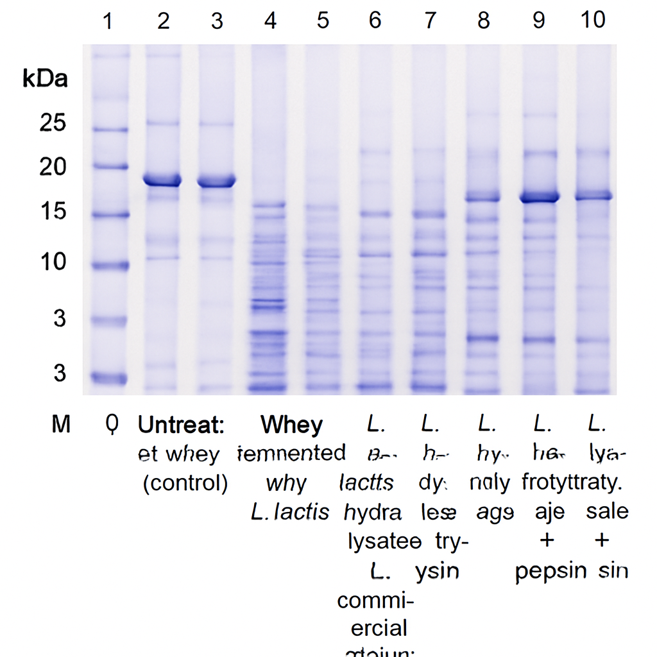
Figure 1: SDS-PAGE Profile of Whey Protein Hydrolysates.Lane M: Protein molecular weight marker; Lane 1: Untreated control whey; Lanes 2-4: Whey fermented with L. lactis, L. acidophilus, and commercial culture, respectively;Lanes 5-7: Hydrolysates of L.lactis, L. acidophilus, and commercial culture whey + trypsin;Lanes 8-10: Hydrolysates of L. lactis, L. acidophilus, and commercial culture whey + pepsin.
3.5 Production of Bioactive Peptides
Lactic acid bacteria fermentation not only improves the flavour and digestibility of milk but also liberates encrypted bioactive peptides from native casein and whey proteins. The capacity of Lactococcuslactis, Lactobacillus acidophilus, and a commercial starter culture to generate these peptides during a 24-hour fermentation was evaluated. The kinetics of peptide production, measured via the OPA assay, showed a time-dependent increase in all treatments (Figure 2). An initial lag phase was observed within the first 6 hours, followed by a substantial rise in peptide concentration between 12 and 18 hours. This period of accelerated release coincided with the exponential growth phase of the bacteria, where proteolytic enzyme activity is highest. The rate of release plateaued after 18-24 hours, likely due to reduced bacterial metabolic activity or feedback inhibition from accumulated end-products.

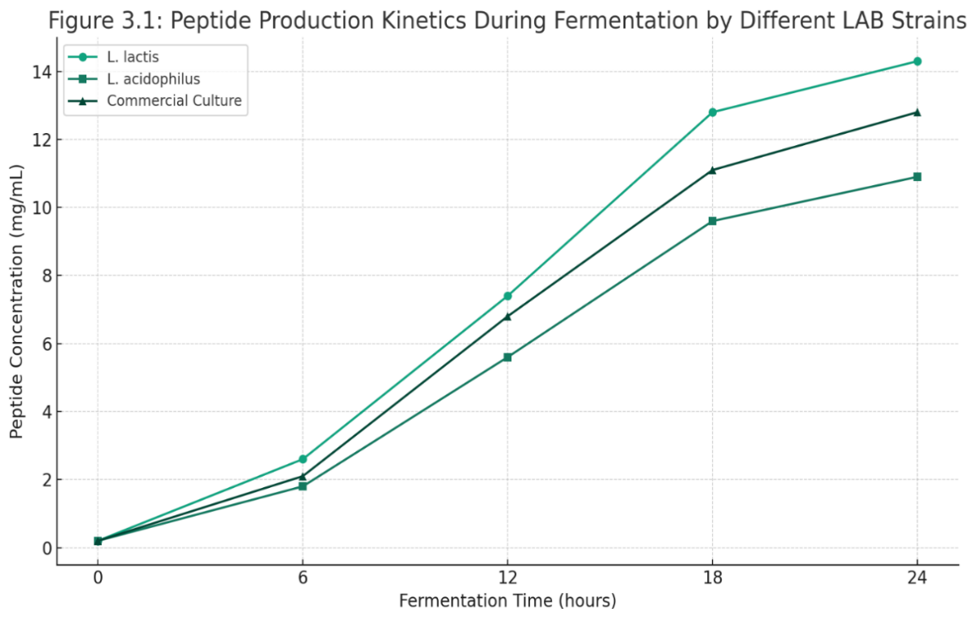
Figure 2: Kinetics of peptide production during milk fermentation by different LAB strains. The concentration of peptides (mg/mL), measured as free amino groups, is plotted against fermentation time (h) for L. lactis, L. acidophilus, and commercial culture. Data points represent mean values (n=3).
Throughout the fermentation, L. lactis consistently yielded the highest concentration of peptides, culminating at 14.3 ± 0.6 mg/mL at 24 hours. This superior performance can be attributed to its rapid growth kinetics and highly efficient proteolytic system. The commercial culture and L. acidophilus also demonstrated significant peptide-releasing activity, reaching 12.8 mg/mL and 10.9 mg/mL, respectively, at the endpoint. The generation of a high proportion of low-molecular-weight peptides by L. lactis, as established in the size fractionation analysis, suggests its potential for producing fermentates rich in biofunctional peptides.

4. DISCUSSION

Our findings clearly demonstrate the strain-dependent variability in whey protein hydrolysis by lactic acid bacteria (LAB). Lactococcus lactis exhibited notably higher proteolytic efficiency, evident from elevated soluble protein levels, rapid release of free amino groups, and a marked enrichment of low-molecular-weight (LMW, <3 kDa) peptides—key features of an active and efficient proteolytic system. These results corroborate earlier studies highlighting the strong proteolytic capacity of lactococcal cell-envelope proteinases (e.g., PrtP) and their ability to generate bioactive peptide pools during fermentation (Saubenova, 2024). However, Lactobacillus acidophilus showed comparatively higher specific OPA activity but predominantly produced mid-sized peptides (3–10 kDa). This aligns with previous reports that lactobacilli generally yield larger peptide fragments, likely due to their limited exopeptidase repertoire (Saubenova, 2024).

SDS-PAGE results further revealed substantial reductions in β-lactoglobulin and α-lactalbumin, particularly in L. lactis, demonstrating effective hydrolysis of allergenic whey proteins. Such findings are in line with reports that certain LAB strains can reduce allergenic potential, thereby contributing to the development of hypoallergenic dairy products (Saubenova, 2024; Abish et al., 2024). The application of sequential enzymatic digestion (e.g., trypsin treatment after fermentation) significantly enhanced overall hydrolysis and enriched the LMW peptide fraction. This synergistic effect reflects strategies recently proposed to maximize hydrolysis efficiency and improve bioactive peptide yields (Irazoqui et al., 2024).

The kinetic profile of peptide release—beginning with a lag phase, followed by rapid exponential increase, and finally stabilizing—closely mirrors proteolytic dynamics reported in peptidomics studies of Parmigiano Reggiano cheese (Cattivelli et al., 2024). Importantly, the prevalence of LMW peptides in L. lactis hydrolysates is of high functional relevance, as peptides below 3 kDa are strongly associated with antihypertensive, antioxidant, and immunomodulatory activities (Saubenova, 2024; Abish et al., 2024). This dual outcome—improving whey digestibility while simultaneously generating health-promoting peptides—highlights the biotechnological potential of L. lactis as a starter culture. These findings support the growing trend of whey valorization, wherein dairy byproducts are transformed into biofunctional ingredients through microbial fermentation (Chourasia., 2022; Pires et al., 2021). Our study contributes to this narrative by demonstrating that targeted L. lactis fermentation can efficiently yield LMW-rich, bioactive whey hydrolysates.

Future research should focus on applying advanced peptidomics platforms in combination with functional bioassays to identify and validate specific peptides with therapeutic relevance. Confirming the antihypertensive, antioxidant, and immunomodulatory properties of identified peptides through in vitro and in vivo studies will be critical. Expanding the scope to include other LAB strains and mixed cultures may further optimize hydrolysis efficiency and peptide diversity. From an industrial perspective, integrating LAB fermentation with enzymatic pretreatments or membrane-based separation technologies could enhance scalability and ensure consistent production of bioactive peptide-enriched whey hydrolysates. Such approaches align with global efforts in sustainable food processing, supporting both waste valorization and the development of functional foods with proven health benefits.

5. CONCLUSION
This study demonstrates that the choice of LAB strain significantly impacts the efficiency and pattern of whey protein hydrolysis. Lactococcuslactis exhibited superior proteolytic performance, characterized by the highest release of free amino groups and the generation of a peptide profile dominated by low-molecular-weight fragments (<3 kDa), which are highly valued for their enhanced bioactivity and absorbability. The combination of LAB fermentation with subsequent enzymatic digestion, particularly with trypsin, proved highly effective in extensively degrading major whey proteins. These findings position L. lactis as a highly promising starter culture for the industrial production of functional whey protein hydrolysates tailored for nutraceutical and pharmaceutical applications. Future work should focus on identifying and characterizing the specific bioactive properties of the peptides generated by this strain.

REFERENCES
Abish, Z. I., Alibekov, R. S., Tarapoulouzi, M., Bakhtybekova, A. R., &Kobzhasarova, Z. I. (2024). Review in deep processing of whey. Cogent Food & Agriculture, 10(1), Article 2415380. https://doi.org/10.1080/23311932.2024.2415380
Bradford M. M. (1976). A rapid and sensitive method for the quantitation of microgram quantities of protein utilizing the principle of protein-dye binding. Analytical biochemistry, 72, 248–254. https://doi.org/10.1016/0003-2697(76)90527-3
Cattivelli, A., Solieri, L., Martini, S., Pizzamiglio, V., Tagliazucchi, D., & Conte, A. (2024). Peptidomics and biological activity analysis of in vitro digested Parmigiano Reggiano cheese at different ripening stages. International Dairy Journal, 157, 106028. https://doi.org/10.1016/j.idairyj.2024.106028
Chourasia, R. (2022). Whey valorization by microbial and enzymatic biotechnological strategies for nutraceuticals and value-added products: A review. Trends in Food Science & Technology, 120, 10–20. https://doi.org/10.1016/j.tifs.2022.10.018
Church, F. C., Swaisgood, H. E., Porter, D. H., & Catignani, G. L. (1983). Spectrophotometric assay using o-phthaldialdehyde for determination of proteolysis in milk and isolated milk proteins. Journal of Dairy Science, 66(6), 1219–1227. https://doi.org/10.3168/jds.S0022-0302(83)81926-2
Daliri, E. B., Lee, B. H., & Oh, D. H. (2021). Current perspectives on antihypertensive and immunomodulatory bioactive peptides from dairy proteins. Foods, 10(7), 1680. https://doi.org/10.3390/foods10071680
Hayes, M., & Stanton, C. (2007). Putting microbes to work: Dairy fermentation, cell factories and bioactive peptides. Part I: Overview and functional components.Biotechnology Journal, 2(4), 426–434. https://doi.org/10.1002/biot.200600246
Hernández-Ledesma, B., Gálvez-Rodríguez, S., & Amigo, L. (2023a). Whey-derived peptides: Emerging roles in gut health and metabolic regulation. Nutrients, 15(9), 1845. https://doi.org/10.3390/nu15091845
Hernández-Ledesma, B., García-Nebot, M. J., Fernández-Tomé, S., Amigo, L., &Recio, I. (2023b). Dairy protein hydrolysates: Bioactive peptides and applications. Journal of Food Science, 88(5), 1867–1880. https://doi.org/10.1111/1750-3841.16234
Hernández-Ledesma, B., García-Nebot, M. J., Fernández-Tomé, S., Amigo, L., &Recio, I. (2014). Dairy protein hydrolysates: Peptides for health benefits. International Dairy Journal, 38(2), 82–100. https://doi.org/10.1016/j.idairyj.2013.11.004
Baliyan, H., & Kumar, S. (2023). Lactobacilli strains exhibiting probiotic probability in organic fermented cow milk. CIBTech Journal of Microbiology, 12, 16–22. Available at: http://www.cibtech.org/cjm.htm
Irazoqui, J. M., León-López, A., Cruz-Casas, M., Ahmad, A., &Moschopoulou, E. (2024). Enzymes for production of whey protein hydrolysates and bioactive peptides. Comprehensive Reviews in Food Science and Food Safety. https://www.ncbi.nlm.nih.gov/pmc/articles/PMC11142983/
Jain, P., & Singh, A. (2024). Kinetic profiling of whey protein hydrolysis by starter cultures and LAB isolates: Peptide release and bioactivity. Journal of Dairy Science, 107(4), 3124–3135. https://doi.org/10.3168/jds.2023-21234
Korhonen, H., & Pihlanto, A. (2006). Bioactive peptides: Production and functionality. International Dairy Journal, 16(9), 945–960. https://doi.org/10.1016/j.idairyj.2005.10.012
Laemmli, U. K. (1970). Cleavage of structural proteins during the assembly of the head of bacteriophage T4. Nature, 227, 680–685. https://doi.org/10.1038/227680a0
Lee, S., & Kim, H. (2023). Sustainable valorization of cheese whey: Microbial fermentation and bioprocess integration. Frontiers in Food Science and Technology, 1, 11. https://doi.org/10.3389/frfst.2025.1542284
Martín, M. J., Ramos, M., & Molina, E. (2022). Whey protein hydrolysis by lactic acid bacteria: Strain-specific effects on peptide release and functionality. Food Research International, 157, 111367. https://doi.org/10.1016/j.foodres.2022.111367
Pescuma, M., Hébert, E. M., &Mozzi, F. (2020). Lactic acid bacteria: Role in proteolysis and peptidase activities applied to milk proteins. BMC Genomics, 21, 36. https://doi.org/10.1186/1471-2164-11-36
Pires, A. F., Sommella, E., Monari, S. (2021). Dairy by-products: A review on the valorization of whey. Foods, 10(5), 1067. https://doi.org/10.3390/foods10051067
Saubenova, M. (2024). Bioactive peptides derived from whey proteins for health. Fermentation, 10(7), 359. https://doi.org/10.3390/fermentation10070359
Savijoki, K., Ingmer, H., &Varmanen, P. (2006). Proteolytic systems of lactic acid bacteria. Applied Microbiology and Biotechnology, 71(4), 394–406. https://doi.org/10.1007/s00253-006-0427-1
Smithers, G. W. (2015). Whey and whey proteins—From ‘gutter-to-gold’. International Dairy Journal, 48, 2–14. https://doi.org/10.1016/j.idairyj.2015.01.011
Zotta, T., Parente, E., Ricciardi, A., & Ross, R. P. (2020). Advances in proteolytic activity of lactic acid bacteria applied to dairy fermentation. Applied Microbiology and Biotechnology, 104(7), 2749–2762. https://doi.org/10.1007/s00253-020-10369-7

