Heteropneustes fossilis (Stinging Catfish): Bridging Ethno-medicine and Biomedical Potential

Abstract
Heteropneustes fossilis, commonly known as the stinging catfish, has long been used in traditional medicine systems inmany South Asian countries for its therapeutic properties. H. fossilis is consumed and used for treating anaemia, respiratory conditions, inflammation, and general debility and holds a dual role as both nutritional and a medicinal resource. Modern Biomedical research now increasingly validates these traditional claims, linking the fish’s therapeutic properties to its nutritional richness in protein, iron, and omega-3 fatty acids, along with bioactive compounds with medicinal importance. This review bridges traditional ethno-medicinal knowledge with modern scientific studies, presenting insights into its biochemical composition, pharmacological potential, and applications in nutraceuticals and pharmaceuticals. While several studies highlight anti-inflammatory, antimicrobial, immunomodulatory, and regenerative properties, there is critical research gaps in clinical validation, bioactive compound characterization and quantification, and sustainable resource management. This paper provides an interdisciplinary approach to unlock thetherapeutic potential of H. fossilis, thereby preserving indigenous knowledge while advancing biomedical research.
Keywords: Traditional knowledge, Bio-medical potential, Pharmacological activity, Bioactive compounds, Indigenous health practices

1. Introduction
Heteropneustes fossilis, commonly known as stinging catfish (Ngachik in Manipuri), is a freshwater catfish widely distributed across South and Southeast Asia (Fig. 1). This species is known for its adaptability to low-oxygen environments and resilience in degraded habitats, and widely cultivated for food security and livelihood support (Shaikh et al., 2025). Traditional medical systems such as Ayurveda, Siddha, and Unani, attribute therapeutic value to H. fossilis, recommending it for anaemia, postpartum recovery, asthma and arthritis (Nasreen & Borah, 2023).
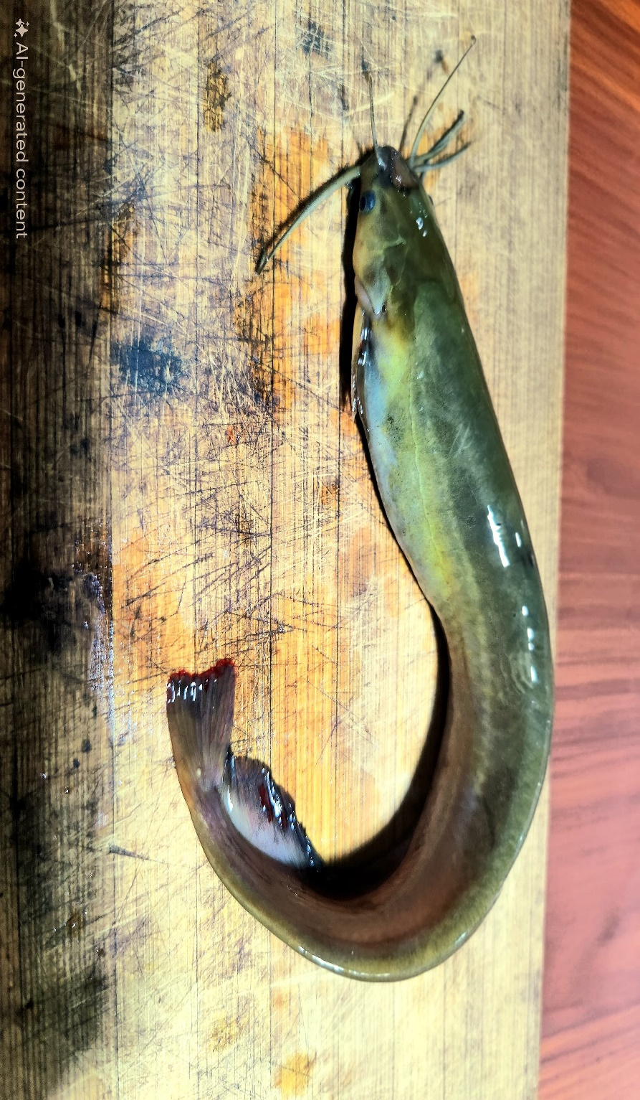
Figure 1. H. fossilis (Ngachik in Manipuri), a freshwater species valued for food and traditional medicine.
Rural and tribal communities used this in ethnomedicine, preparing decoctions, oils, boiling and powders to treat several human ailments such as respiratory disorders, inflammation, and wound infections (Basumatary et al., 2023; Nasreen & Borah, 2023). Despite its uses in indigenous and traditional healing, in depth biomedical studies of H. fossilis has only recently gained momentum, exploring its proteins, micronutrients, antimicrobial peptides, and wound-healing enzymes (Lima et al., 2024; Sultana et al., 2022).This review combines evidence on H. fossilis taxonomy, traditional knowledge, biochemical composition, and biomedical potential and also highlighting research gaps, sustainability issues, and future opportunities in pharmaceutical industry.

2. Taxonomy and Biological Profile
H.fossilis belongs to the order Siluriformes and is the only representative of the family Heteropneustidae. It is a medium-sized fish, mucus-covered, scale-less fish morphologically, with pointed pectoral fin spines capable of inflicting painful stings (Islam et al., 2021; Sultana & Farha, 2022). Its dual respiratory system with gill and accessory air-breathing organs, helps survival in oxygen depleted waters such as swamps and shallow stagnant ponds (Islam et al., 2021).
It is mainly distributed across India, Bangladesh, Nepal, Sri Lanka, and Myanmar geographically, with introduced populations in Southeast Asia (Rahman et al., 2019). This species contributes to nutrient cycling and have high market demand due to its used in traditional medicinal systems, especially for the convalescent patients, children and the elders (Nasreen & Borah, 2023; Samad et al., 2017).

3. Traditional Knowledge and Ethno-medicinal Applications
Several tribal communities in Assam, Odisha, and Chhattisgarh depend on this species for treating asthma, skin ailments, and weakness (Altaf et al., 2020; Nasreen & Borah, 2023; Prakash & Prakash 2021). Cultural practices are also reported such as serving H. fossilis dishes to postpartum women for recovery and lactation support (Basumatary et al., 2023). There are reports of using this fish species by folk healers for applying fish oil or paste for the treatment of common cold (Kumar et al., 2015).
The preparation methods vary across cultures and tradition such as boiled or curried for systemic use, oil and paste for topical application, and powdered formulations for treating several human ailments (Kumar et al., 2015; Nasreen & Borah, 2023; Prakash & Prakash 2021). From the traditional and biomedical point of view, H. fossilis clearly demonstrates its advantages compared to other fishes. Across many traditions, the fish represents the symbolic importance of providing strength, vitality, and healing.

4. Nutritional and Biochemical Composition

H. fossilis with its high protein content, is considered a high-quality source of essential amino acids including lysine, leucine, and methionine (Doloi & Basumatari, 2022; Sultana et al., 2024). Lipids with around 3–5% and include omega-3 and omega-6 fatty acids, which is important for cardiovascular health and inflammation control (Hossain et al., 2024). H. fossilis also has high iron, calcium, sodium and phosphorus contents ( further highlights its relevance maintaining overall nutritional balance.

5. Pharmacological and Biomedical Studies
Studies on H. fossilis indicates its pharmacological potential, particularly its immune-modulatory and antimicrobial properties. Mucus and immune tissues of H. fossilis are known contain antimicrobial peptides, which show strong activity against several bacterial pathogens (Zaccone et al., 2022). Studies have also reported that fish mucus has wound-healing property through epithelial regeneration and antimicrobial action (Sakthi & Rajeswari, 2021. Although, it is generally regarded as safe, detailed toxicological study remain limited, and caution is advised for sensitive groups of people such as renal patients. H. fossilis muscle and mucus is generally considered a good source of antioxidant peptides and antimicrobial compounds, thereby enhancing stress resistance and wound repair (Vaseem, 2024). Mucus enzymes of this fish such as lysozyme and proteases provide antimicrobial and regenerative properties (Zaccone et al., 2022).

6. Comparative Insights with Other Medicinal Fish

H. fossilis showed stronger antimicrobial properties when compared to other fish such as Clarias batrachus, due to the presence of mucus peptides, however studies reports that Channa striatais more effective in wound healing thorough albumin and collagen precursors (Bhatnagar et al., 2023; Nasreen, & Borah,, 2023) (Table 1). Hence, H. fossilis occupies a distinct niche, thereby balancing systemic and topical therapeutic roles.
Table 1. Comparative overview of H. fossilis and other medicinal fish species in traditional and biomedical contexts
Parameter | H. fossilis | Clarias batrachus | Channa striata
Major Traditional Uses | Anaemia, inflammation, postnatal care, respiratory ailments | Anaemia, fever, weakness, post-operative recovery | Wound healing, joint pain, post-surgical recovery
Key Nutrients | High iron, protein, omega-3 fatty acids | Iron, protein, omega-3 | Albumin, glycine, proline, essential amino acids
Bioactive Compounds | Antimicrobial peptides, antioxidants, immunomodulators | Antioxidant peptides, moderate immune enhancers | Collagen-enhancing peptides, wound-healing factors
Antimicrobial Activity | Strong (against Gram+/- bacteria, fungi) | Moderate | Mild
Tissue Regeneration | Moderate to strong (wound healing, epithelialization) | Moderate | Strong (skin repair, muscle regeneration)
Respiratory Adaptability | Very high (air-breathing, low O₂ tolerance) | High | Moderate

7. Research Gaps and Challenges, Future Directions

H. fossilis faces many challenges despite its growing biomedical interest. The absence of studies on human clinical trials limits validation of its ethno-medicinal claims, while less studies on molecular characterization restricts the identification of bioactive compounds of medicinal importance. Future opportunities include developing peptide-based drugs and nano-formulations, nutraceuticals for anaemia and malnutrition, and conservation via captive breeding, aquaculture and genetic improvement. Interdisciplinary research for translating traditional knowledge into validated biomedical applications will be crucial.

8. Conclusion
H. fossilis brings together traditional knowledge and modern science. Its role in ethno-medicine for anaemia, respiratory disorders, and wound healing treatment is now corroborated by new biomedical findings, highlighting its proteins, fatty acids, antimicrobial peptides, and immunomodulatory agents. Despite the available preliminary and promising laboratory evidence, clinical validation, sustainable harvesting, and ethical frameworks remain critical challenges.Bridging these gaps requires will require multidisciplinary approach, policy support, and conservation strategies. By harnessing the biomedical potential of H. fossilis, indigenous knowledge can be preserved while supporting the development of natural medicines and functional foods for global health needs.

References
- Ali Shaikh, K. H., Nighot, R., & Mishra, S. (2025). Effect of hypoxia on physiological-biochemical blood parameters in the catfish, Heteropnuestes fossilis. Journal of Experimental Zoology India, 28(1). DOI: 10.51470/jez.2025.28.1.807
- Altaf, M., Abbasi, A. M., Umair, M., Amjad, M. S., Irshad, K., & Khan, A. M. (2020). The use of fish and herptiles in traditional folk therapies in three districts of Chenab riverine area in Punjab, Pakistan. Journal of Ethnobiology and Ethnomedicine, 16(1), 38.
- Basumatary, G., Narzary, B., & Khangembam, B. K. (2023). Diversity and traditional ethnozoological uses of ichthyofauna by the Bodo Tribes of Kokrajhar, Assam, Northeast India. Nusantara Bioscience, 15(1).
- Bhatnagar, A., Kumari, S., & Tyor, A. K. (2023). Assessment of bactericidal role of epidermal mucus of Heteropneustes fossilis and Clarias batrachus (Asian cat fishes) against pathogenic microbial strains. Aquaculture and Fisheries, 8(1), 50-58.
- Doloi, D., & Basumatari, D. (2022). A Comparative Study on Total Muscle Protein Content of Anabas testudineus, Labeo gonius, Labeo rohita and Heteropneustes fossilis and to analyze their Electrophoretic Banding Pattern using SDS-PAGE. (2020). Int. J. Life Sci. Pharma Res, 10(3), L46-50.
- Hossain, M. B., Islam, R., Hossain, M. K., Parvin, A., Saha, B., Nur, A. A. U. & Arai, T. (2024). Minerals and fatty acid profile of small indigenous fish species from homestead ponds within a Sub-tropical coastal region. Heliyon, 10(2).
- Islam, M. A., Hossain, M. Y., Rahman, M. A., RAhman, O., Sarmin, M. S., Khatun, D., ... & Parvin, M. F. (2021). Some biological aspects of Asian stinging catfish, Heteropneustes fossilis (Bloch, 1794) (Teleostei: Siluriformes) in a wetland ecosystem. Iranian Journal of Ichthyology, 8(1), 52-61.
- Kumar, P., Verma, S. K., & Subba, B. R. (2015). Traditional use of fish based ethnomedicine in the treatment of some diseases in Eastern Tarai of Nepal. Nepalese Journal of Biosciences, 5(1), 61-64.
- Lima, M. A., Hossain, M. A., Islam, M. R., Mukul, M. N. A., & Akter, T. (2024). Dietary zinc requirement of juvenile stinging catfish Heteropneustes fossilis based on growth performance, haematology, and tissue mineral composition. Heliyon, 10(7).
- Nasreen, S. & Borah, G.A. (2023). A Review on the Use of Heteropneustes fossilis and Clarias magur in Assamese Traditional Medicine. Asian Journal of Biological and Life Sciences, 12(1),18-21. DOI:10.5530/ajbls.2023.12.3
- Prakash, S., & Prakash, S. (2021). Ethnomedicinal use of fishes by tribal communities in India: A review. Pharma Innov, 10(5), 1315-1321.
- Rahman, M. A., Hasan, M. R., Hossain, M. Y., Islam, M. A., Khatun, D., Rahman, O. & Khatun, H. (2019). Morphometric and meristic characteristics of the Asian stinging catfish Heteropneustes fossilis (Bloch, 1794): A key for identification. Jordan Journal of Biological Sciences, 12(4), 467-470.
- Sakthi, R. S., & Rajeswari, S. U. (2021). Use of fish epidermal mucus as an antimicrobial agent–a review. Uttar Pradesh Journal of Zoology, 42(21), 1-13.
- Samad, M. A., Nahiduzzama, M., Ashrafuzzaman, M., Rashid, M. A., & Akter, M. (2017). Culture of indigenous catfish Shingi, Heteropneustes fossilis (Bloch, 1794), with available low cost formulated feed in earthen ponds of Bangladesh. Journal of Coastal Life Medicine, 5(7), 288-292.
- Sultana, S., & Farha, F. (2022). A Male Hormone-Induced Changes in Growth Performance and Histopathology in the Stinging Catfish Heteropneustes fossilis (Siluriformes: Heteropneustidae) Under Laboratory Conditions. Journal of Bio-Science, 30(1), 131-141.
- Sultana, S., Khan, M. N., Hossain, M. S., Dai, J., Rahman, M. S., & Salimullah, M. (2022). Community structure and functional annotations of the skin microbiome in healthy and diseased catfish, Heteropneustes fossilis. Frontiers in Microbiology, 13, 856014.
- Sultana, N., Rana, M. J., & Khan, M. A. (2024). Analysis of Proximate Composition of Shingi Fish (Heteropneustes fossilis) Fed with Poultry Offal Protein-Rich Formulated Feed under Captive Conditions. Asian Journal of Biology, 20(11), 64-72.
- Umamageshwari, M., Rajeswari, S. & U. Sivasakthi, R. (2022). Biochemical Composition, Mineral Content and FTIR analysis on five different tissues of fresh water fish Heteropneustes fossilis in Tenkasi district. Journal of Xi’an Shiyou University, 18 (8). 556-570
- Vaseem, H. (2024). Investigation of antioxidant defense system, digestive enzymes and histopathological alterations in intestine of catfish, Hetropneustes fossilis exposed to antibiotic norfloxacin. Ecological Frontiers, 44(4), 839-849.
- Zaccone, G., Capillo, G., Fernandes, J. M. O., Kiron, V., Lauriano, E. R., Alesci, A. & Aragona, M. (2022). Expression of the antimicrobial peptide piscidin 1 and neuropeptides in fish gill and skin: A potential participation in neuro-immune interaction. Marine drugs, 20(2), 145.

