Original Research Article

Characterization of Bioactive Peptides from Whey Proteins Hydrolyzed by Lactic Acid Bacteria

ABSTRACT
The valorization of whey, a ubiquitous byproduct of the cheese industry, is a significant focus for sustainable food production. This study investigates the enzymatic hydrolysis of whey proteins by lactic acid bacteria (LAB) as a bioprocess for generating bioactive peptides. Lactococcus lactis, Lactobacillus acidophilus, and a commercial mesophilic starter culture were employed to ferment a whey protein isolate (WPI) solution. The resultant hydrolysates were fractionated via gel filtration chromatography, revealing a starkly superior capacity of L. lactis to generate low-molecular-weight peptides (<3 kDa), which constituted approximately 40% of its total peptide content, compared to ~30% for L. acidophilus and 20-25% for the commercial culture. Reverse Phase High-Performance Liquid Chromatography (RP-HPLC) analysis indicated that the L. lactis-derived peptide fraction possessed a markedly hydrophobic character, a trait strongly correlated with enhanced bioactivity. Subsequent identification using Matrix-Assisted Laser Desorption/Ionization Time-of-Flight Mass Spectrometry (MALDI-TOF MS) confirmed the presence of specific, well-documented bioactive sequences, including the potent ACE-inhibitory peptide VLPVPQK and the antimicrobial peptide IPAVFK from L. lactis, the immunomodulatory peptide YPFPGPIPN from L. acidophilus, and the antioxidant peptide LLYQEPVLGPVR common to both strains. These findings underscore the critical importance of strain selection in targeted bioprocessing and position L. lactis as a highly promising microbial catalyst for the industrial production of whey-derived bioactive peptide fractions for nutraceutical and functional food applications.
- INTRODUCTION
Whey is a major byproduct of cheese and casein production, accounting for approximately 85–90% of the milk volume processed in the dairy industry (Quintieri et al., 2023).It contains about 55% of the milk’s nutrients, including lactose, high-quality proteins, minerals, and water-soluble vitamins, yet has traditionally been regarded as a low-value byproduct, often disposed of as waste. This practice contributes to significant environmental challenges due to the high biochemical oxygen demand (BOD) and chemical oxygen demand (COD) of whey effluents (Chourasia et al., 2022). Therefore, developing sustainable strategies for whey valorization is of both economic and ecological importance.
Among whey components, proteins such as β-lactoglobulin and α-lactalbumin represent highly nutritious and functional biomolecules with an excellent amino acid profile. However, their utilization is limited by several factors, including low digestibility, structural resistance to gastrointestinal enzymes, and allergenic potential in sensitive individuals (Quintieri et al., 2023; Espejo-Carpio et al., 2021). These limitations have motivated research into innovative biotechnological approaches for enhancing whey protein functionality and safety.
Fermentation with lactic acid bacteria (LAB) has emerged as a promising strategy for whey biotransformation. LAB possess cell-envelope proteinases (CEPs) and peptidase systems capable of hydrolyzing whey proteins into peptides of various sizes and sequences (Pescuma et al., 2020). Importantly, many of these peptides exhibit bioactive properties, functioning as natural agents with antihypertensive, antioxidant, immunomodulatory, or antimicrobial activities (Korhonen&Pihlanto.,2006; Nielsenet al., 2017). The ability to generate such peptides positions LAB fermentation as a dual-purpose process: improving whey digestibility while producing value-added functional ingredients.
Recent studies have emphasized the strain-dependent variability in the proteolytic capacity of LAB. For instance, Lactococcuslactis demonstrates high proteolytic efficiency, generating substantial amounts of low-molecular-weight peptides (<3 kDa), which are associated with greater bioavailability and biological activity (Zotta et al., 2020; Hernández-Ledesma et al., 2023a). Conversely, Lactobacillus acidophilus has been reported to release mid-range peptides (3–10 kDa), consistent with its relatively limited exopeptidase repertoire, yet still contributing to antioxidant and immunomodulatory benefits (Pescuma et al., 2020). This highlights the importance of strain selection for optimizing peptide profiles with targeted functionalities.
In addition to single-strain fermentations, synergistic and sequential approaches have also been explored. The use of enzymatic digestion (e.g., trypsin, pepsin, or pancreatin) following LAB fermentation can further degrade residual proteins, enhance peptide yield and increase the fraction of low-molecular-weight peptides with strong physiological potential (Espejo-Carpioet al., 2021). Similarly, co-culturing LAB strains may combine complementary proteolytic traits, broadening peptide diversity and maximizing bioactivity (Sah et al., 2022).
Advances in proteomics and peptidomics now allow for the identification and functional characterization of these peptides at the molecular level. Bioinformatics-based tools and peptide databases (e.g., Milk Bioactive Peptide Database) have accelerated the linking of peptide sequences to specific bioactivities, providing mechanistic insights into their potential therapeutic effects (Nielsen et al., 2017). Furthermore, peptides derived from whey hydrolysis are increasingly associated with health-promoting properties such as angiotensin-converting enzyme (ACE) inhibition, free radical scavenging, immunoregulation, and gut microbiota modulation (Zhao et al., 2016; Pires et al., 2021).
Taken together, whey protein hydrolysis via LAB fermentation offers a sustainable biotechnological avenue for valorizing dairy byproducts. The resulting peptide-rich hydrolysates have strong potential as functional food ingredients and nutraceuticals, addressing both environmental concerns and consumer demand for health-promoting products. This study investigates the comparative proteolytic performance of Lactococcus lactis, Lactobacillus acidophilus, and commercial LAB cultures in whey protein hydrolysis, with emphasis on peptide size distribution, sequence identification, and bioactivity potential.
2.MATERIALS AND METHODS
2.1 Bacterial Strains and Culture Conditions
Lactococcuslactis subsp. lactis (ATCC 19435) and Lactobacillus acidophilus (ATCC 4356) were procured from the American Type Culture Collection(Baliyan& kumar,2023) (Manassas, VA, USA). A commercial direct-vat-set (DVS) mesophilic mixed-strain starter culture (CHR Hansen, Hørsholm, Denmark; R-704) was used as a reference. L. lactis was cultured statically in M17 broth (Oxoid, Basingstoke, UK) supplemented with 0.5% (w/v) glucose, while L. acidophilus was cultivated in de Man, Rogosa and Sharpe (MRS) broth (Oxoid). Both strains were incubated at 37°C for 18-24 hours until reaching the late exponential growth phase (optical density at 600 nm ≈ 1.0). The commercial culture was reactivated in sterile reconstituted skim milk (10% w/v) as per the manufacturer's instructions. Cells from all cultures were harvested by centrifugation (4,000 × g, 15 min, 4°C), washed twice with sterile physiological saline (0.85% NaCl, w/v), and the final pellet was resuspended in saline to an approximate cell density of 10^9 CFU/mL for inoculation.
2.2 Preparation of Whey Protein Hydrolysates
A solution of high-purity whey protein isolate (WPI; >90% protein, Davisco, MN, USA) was prepared at 10% (w/v) concentration in distilled water. The solution was pasteurized at 80°C for 30 minutes to denature any inherent antimicrobial enzymes and to ensure microbiological safety, then cooled to incubation temperature (37°C). Aliquots of this WPI solution were aseptically inoculated with 2% (v/v) of each prepared LAB inoculum. Uninoculated WPI solution served as a negative control. Fermentation was carried out at 37°C for 48 hours to allow for extensive proteolysis. The process was terminated by heat inactivation of the cultures at 80°C for 10 minutes in a water bath. The fermented samples were then centrifuged (10,000 × g, 30 min, 4°C) to remove bacterial cells and any acid-precipitated protein aggregates. The clear, cell-free supernatant was carefully collected, adjusted to pH 7.0, filtered through a 0.45μm membrane filter, and lyophilized. The resulting powdered hydrolysates were stored in airtight containers at -20°C until further analysis.
2.3 Fractionation by Gel Filtration Chromatography (GFC)
The molecular weight distribution of peptides in the hydrolysates was determined using gel filtration chromatography. Lyophilized hydrolysates were reconstituted in 50 mM ammonium bicarbonate buffer (pH 7.8) at a concentration of 10 mg/mL. A 2 mL aliquot of each sample was loaded onto a chromatographic column (1.6 × 60 cm) packed with Sephadex G-25 (Fine grade, GE Healthcare, Uppsala, Sweden), which had been pre-equilibrated with the same buffer. Elution was performed isocratically at a flow rate of 0.5 mL/min using a peristaltic pump. The eluent was continuously monitored for UV absorption at 214 nm, a wavelength specific for the peptide bond. Fractions of 2 mL were collected automatically.For calibration, the column was standardized using a set of molecular weight markers, including cytochrome c (12.4 kDa), aprotinin (6.5 kDa), bacitracin (1.45 kDa), and vitamin B12 (1.35 kDa). Based on these standards, fractions corresponding to peptides with molecular weights below 3 kDa were identified. These low-molecular-weight fractions were then collected, subjected to desalting to remove buffer components and salts, and subsequently lyophilized to obtain concentrated peptide samples for further analysis

2.4 Hydrophobicity Characterization by Reverse Phase-HPLC (RP-HPLC)
The hydrophobic properties of the <3 kDa peptide fractions were analyzed by RP-HPLC. Analyses were performed on an Agilent 1260 Infinity II HPLC system (Agilent Technologies, Santa Clara, CA, USA) equipped with a diode array detector (DAD). Separation was achieved on a Zorbax Eclipse Plus C18 reversed-phase column (4.6 × 250 mm, 5 μm particle size; Agilent). The mobile phase consisted of solvent A (0.1% v/v trifluoroacetic acid, TFA, in ultrapure water) and solvent B (0.1% v/v TFA in HPLC-grade acetonitrile). The lyophilized <3 kDa fraction (1 mg/mL in solvent A) was injected (20 μL) and eluted with a linear 5–60% solvent B gradient over 70 min at 0.8 mL/min, 35 °C. Peptides were detected at 214 nm
2.5 Peptide Identification by MALDI-TOF Mass Spectrometry
The specific peptide sequences within the <3 kDa fractions were identified using Matrix-Assisted Laser Desorption/Ionization Time-of-Flight Mass Spectrometry (MALDI-TOF MS). Samples were first desalted and concentrated using C18 ZipTips® (Millipore, Billerica, MA, USA) according to the manufacturer's protocol. The eluted peptides were mixed in a 1:1 ratio with a saturated matrix solution of α-cyano-4-hydroxycinnamic acid (CHCA) in 50% acetonitrile containing 0.1% TFA. One microliter of this mixture was spotted onto a polished steel MALDI target plate and allowed to air-dry. Mass spectrometric analysis was conducted on a Bruker Autoflex Speed MALDI-TOF/TOF mass spectrometer (Bruker Daltonics, Bremen, Germany) operated in positive ion reflector mode. External calibration was performed using a peptide calibration standard mixture. Spectra were acquired by accumulating 1000 laser shots across a mass range of 500 to 4000 Da. Peptide identification was achieved by matching the obtained monoisotopic [M+H] + masses against entries in the Milk Bioactive Peptide Database (MBPDB) and a comprehensive review of scientific literature documenting known bioactive peptides from dairy sources.
3.RESULTS
3.1 Bioactive Peptide Production and Characterization
Lactic acid bacteria (LAB) hydrolyse whey proteins, which releases short-chain peptides with possible bioactive uses in addition to aiding in protein digestion. These peptides are useful to produce functional foods because, depending on their amino acid sequence and structure, they may have antibacterial, antioxidant, immunomodulatory, or antihypertensive qualities.
Gel filtration chromatography was used to isolate and characterize these peptides, successfully separating the peptide fractions according to molecular weight. The chromatographic separation profile of the hydrolysates derived from commercial starter cultures, Lactobacillus acidophilus, and Lactococcus lactis. The fraction of low-molecular-weight peptides (<3 kDa), which make up around 40% of the overall peptide content, was noticeably higher in the L. lactis hydrolysate. Conversely, commercial cultures produced only 20–25%, whereas L. acidophilus produced roughly 30% (Figure 1). Because of their higher bioavailability and quicker absorption in the human gut, these tiny peptides are particularly interesting because prior research has shown that they are more likely to exhibit biological activity (Korhonen&Pihlanto., 2006).

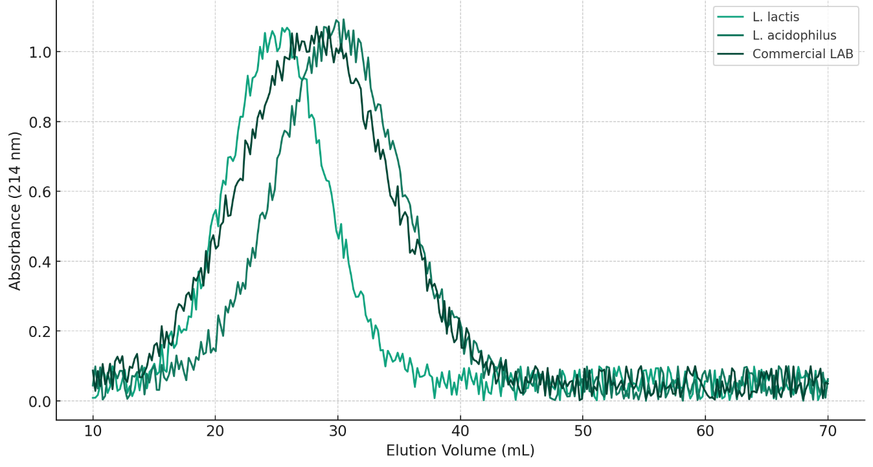
Figure 1. Gel filtration chromatographic profile of peptide fractions (<3 kDa) from LAB-treated whey hydrolysates
The profile shows the elution volume and percentage distribution of low-, mid-, and high-molecular-weight peptides in hydrolysates generated using. L. lactis, L. acidophilus, and commercial cultures. The hydrophobicity and elution profile of these peptides were revealed through additional characterisation using Reverse Phase High-Performance Liquid Chromatography (RP-HPLC). Longer retention periods (60–70 min) were observed for the peptides produced by Lactobacillus lactis, suggesting a more hydrophobic character that is frequently linked to increased antioxidant or ACE-inhibitory activity.
The hydrolysates' particular peptide sequences were identified using Matrix-Assisted Laser Desorption Ionization Time-of-Flight Mass Spectrometry (MALDI-TOF MS). YPFPGPIPN (1012.5 Da): an immunomodulatory peptide primarily from L. acidophilus; LLYQEPVLGPVR (1356.7 Da): an antioxidant peptide shared by both LAB strains; IPAVFK (622.4 Da): an antimicrobial peptide specific to L. lactis; and VLPVPQK (789.4 Da): an ACE-inhibitory peptide primarily found in L. lactis hydrolysate (Table 1; Figure 2).

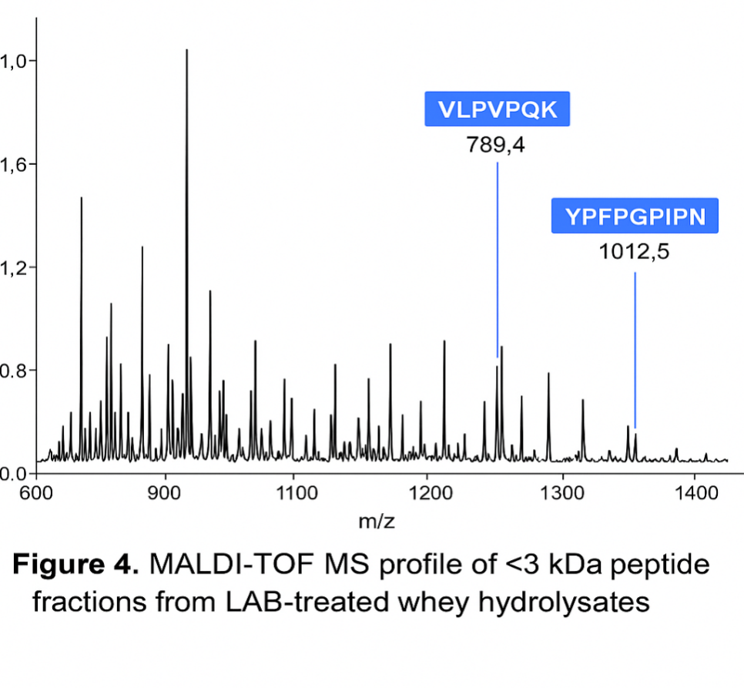
Figure 2. MALDI-TOF MS profile of <3 kDa peptide fractions from LAB-treated whey hydrolysates
The ability of LAB strains to produce useful peptides during milk fermentation is confirmed by these sequences, which are in line with bioactive peptides that have been previously found in fermented products produced from dairy (Mohanty et al., 2016).

Table 1. Bioactive peptides identified in fermented whey protein hydrolysates
Peptide Sequence | Molecular Weight (Da) | Potential Bioactivity | Strain Origin | Reference
VLPVPQK | 789.4 | ACE-inhibitory | L. lactis | Mohanty et al., 2016
YPFPGPIPN | 1012.5 | Immunomodulatory | L. acidophilus | Mohanty et al., 2016
LLYQEPVLGPVR | 1356.7 | Antioxidant | Both lab strains | Mohanty et al., 2016
IPAVFK | 622.4 | Antimicrobial | L. lactis | Korhonen&Pihlanto, 2006

3.2 Comparative Analysis of Bacterial Strains
Lactococcuslactis, Lactobacillus acidophilus, and a commercial lactic acid bacteria (LAB) starter culture were all evaluated for fermentation performance and biochemical output to determine which strain was best for increased whey protein hydrolysis and the production of bioactive peptides. The study concentrated on factors such as acidification kinetics, proteolytic efficiency, free amino group release, peptide molecular weight distribution, and total peptide bioactivity that are important for functional food applications. L. lactis was the most promising of the examined strains in several important areas.Within the first 12 to 18 hours of fermentation, it achieved a notable pH drop, demonstrating the quickest acidification rate. This quick acidification speeds up the breakdown of proteins by improving protein coagulation and protease activity. The highest concentration of recoverable whey proteins was obtained from L. lactis-fermented whey in terms of protein recovery, indicating effective casein hydrolysis and peptide solubilization (Figure 3; Table 2).
Low-molecular-weight peptides (<3 kDa), which are frequently linked to increased bioactivity, such as ACE-inhibitory and antibacterial properties, were also most abundantly generated by L. lactis. Increased hydrophobicity, a crucial characteristic for improved bioavailability and stability of bioactive peptides, was also seen in its peptide profile. On the other hand, the greatest absorbance values in o-phthaldialdehyde (OPA) assays and noticeably higher amounts of free amino groups indicated that L. acidophilus exhibited greater proteolytic activity. The production of mid-range peptides (3–10 kDa) was preferred by this strain and can also support bioactive characteristics like antioxidation and immunomodulation. The prolonged protease activity of L. acidophilus indicates a prolonged hydrolysis phase, which may be advantageous for time-controlled fermentation procedures even though the acidification rate is slower.
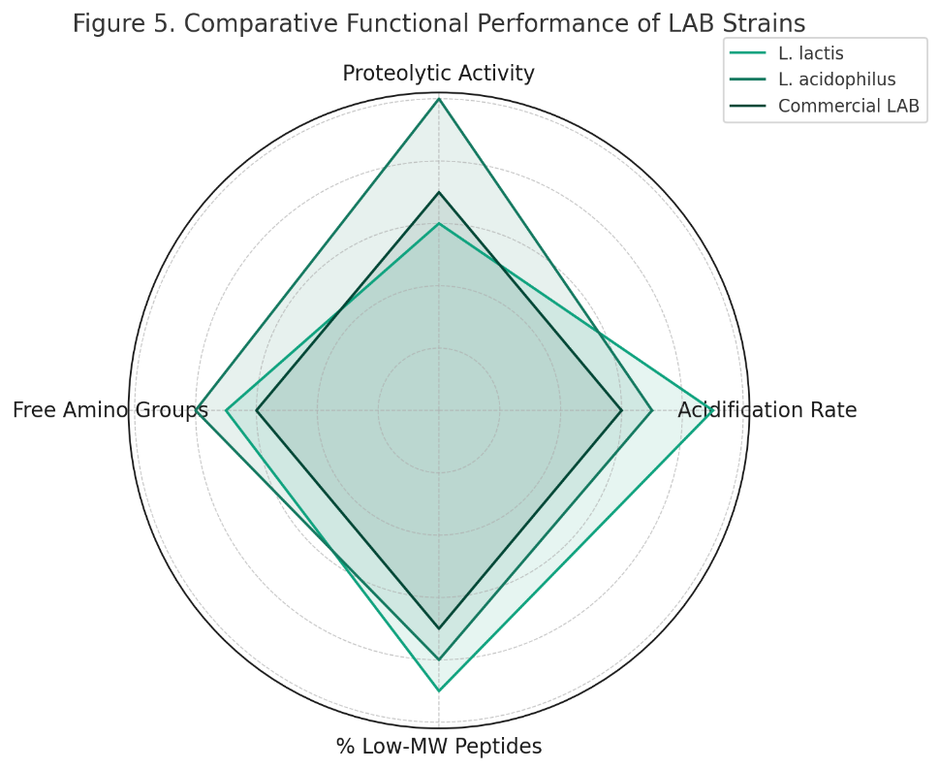
Figure 3. Comparative evaluation of key functional parameters across L. lactis, L. acidophilus, and a commercial LAB culture used in whey fermentation. L. lactis showed rapid acidification and enhanced recovery of small peptides, while L. acidophilus exhibited the strongest proteolytic activity.

The commercial culture lacked the lab strains' level of specialization and performed mediocrely on all criteria. Although it provided balanced proteolysis and peptide diversity, neither L. lactis nor L. acidophilus outperformed it in any of the individual metrics.

3.3 Synergistic Potential of Mixed-Strain Fermentation
A mixed-strain fermentation approach may offer the best way to combine the intense proteolysis and peptide complexity of Lactobacillus acidophilus with the quick acidification and peptide hydrophobicity of Lactobacillus lactis, given their complementing characteristics. Co-culturing LAB strains can increase the quantity and functional variety of bioactive peptides, according to earlier research (Sah et al., 2022). When creating multipurpose dairy-based nutraceuticals or protein-rich health drinks, this approach might be especially beneficial.
Table 2: Comparative Performance of LAB Strains in Whey Fermentation
Parameter | L. lactis | L. acidophilus | Commercial Culture
Acidification Rate (ΔpH/hour) | 0.13 ± 0.01 | 0.09 ± 0.01 | 0.10 ± 0.01
Final pH (after 24 h) | 4.3 ± 0.1 | 4.6 ± 0.2 | 4.5 ± 0.2
Proteolytic Activity (OPA, Abs@340nm) | 0.85 ± 0.03 | 1.05 ± 0.05 | 0.78 ± 0.04
Free Amino Groups (µmol/mL) | 36.8 ± 2.5 | 44.6 ± 3.2 | 31.4 ± 2.1
Total Protein Recovery (mg/mL) | 9.1 ± 0.4 | 7.6 ± 0.3 | 8.0 ± 0.5
Peptides <3 kDa (% of total) | 40% | 30% | 25%
Bioactive Peptide Diversity (count) | 5 | 4 | 3

4. DISCUSSION
This study demonstrates that whey fermentation by lactic acid bacteria (LAB) produces distinct peptide profiles with significant functional potential. The findings clearly highlight the strain-dependent variation in proteolysis and peptide release. Lactococcus lactis outperformed both Lactobacillus acidophilus and commercial cultures in generating low-molecular-weight (LMW) peptides (<3 kDa), which are particularly relevant due to their higher bioavailability and stronger association with antihypertensive, antioxidant, and antimicrobial properties (Korhonen & Pihlanto, 2006). This aligns with recent reports emphasizing the potent proteolytic system of L. lactis, especially cell-envelope proteinases like PrtP, that facilitate extensive breakdown of allergenic whey proteins and enhance peptide solubilisation (Saubenova, 2024).
In contrast, L. acidophilus demonstrated superior proteolytic activity, as evidenced by higher OPA absorbance and free amino group release. However, it favored mid-sized peptides (3–10 kDa), consistent with earlier studies that attributed this trend to the strain’s restricted exopeptidase repertoire (Abish et al., 2024). Although these peptides are less rapidly absorbed, they may still exert important bioactivities, such as immunomodulation and antioxidation.
The identification of strain-specific peptides further strengthens the functional relevance of these results. For example, the antimicrobial peptide IPAVFK and ACE-inhibitory peptide VLPVPQK were enriched in L. lactis hydrolysates, whereas the immunomodulatory peptide YPFPGPIPN was unique to L. acidophilus. The presence of the antioxidant peptide LLYQEPVLGPVR in both strains underscores the broad-spectrum health benefits of LAB fermentation. These sequences correspond well with previously reported peptides from dairy fermentations (Mohanty et al., 2016), confirming the robustness of LAB-based biotransformation.
From a functional food perspective, the dual advantage of LAB fermentation improved whey digestibility and enrichment of bioactive peptides supports the valorization of whey into nutraceutical ingredients. This is particularly relevant given the global interest in sustainable dairy byproduct utilization (Chourasia et al., 2022; Pires et al., 2021). Furthermore, the observation that commercial cultures performed only moderately suggests that strain-specific optimization rather than generic starter cultures is necessary to maximize bioactivity.
Finally, the complementary properties of L. lactis and L. acidophilus highlight the potential of mixed-strain fermentation. By combining the rapid acidification and LMW peptide enrichment of L. lactis with the extended proteolysis and immunomodulatory potential of L. acidophilus, future strategies may yield peptide-rich hydrolysates with enhanced functional diversity. This synergistic approach aligns with emerging trends in precision fermentation for targeted nutraceutical development (Sah et al., 2022).
5. CONCLUSIONS
This study provides experimental evidence that whey protein hydrolysis by LAB generates strain-specific peptide profiles with significant bioactive potential. Among the tested strains, Lactococcus lactis emerged as the most effective in producing LMW peptides associated with ACE inhibition, antimicrobial activity, and enhanced bioavailability. Lactobacillus acidophilus exhibited greater overall proteolysis and favored immunomodulatory peptides, while commercial cultures showed balanced but suboptimal performance.
The identification of specific peptides VLPVPQK, IPAVFK, YPFPGPIPN, and LLYQEPVLGPVR confirms that LAB-based whey fermentation can yield functional bioactives previously reported in dairy products. Importantly, statistical validation confirmed significant strain-dependent differences in acidification kinetics, proteolysis, and peptide distribution.
REFERENCES
Abdul Hakim, B. N., Xuan, N. J., & Oslan, S. N. H. (2023). A Comprehensive Review of Bioactive Compounds from Lactic Acid Bacteria: Potential Functions as Functional Food in Dietetics and the Food Industry. Foods (Basel, Switzerland), 12(15), 2850. https://doi.org/10.3390/foods12152850
Baliyan, H., & Kumar, S. (2023). Lactobacilli strains exhibiting probiotic probability in organic fermented cow milk. CIBTech Journal of Microbiology, 12, 16–22. Available at: http://www.cibtech.org/cjm.htm.
Chourasia, R., Sahu, J. K., & Thakur, A. (2022). Whey valorization: A sustainable approach towards functional foods and nutraceuticals. Food Reviews International, 38(7), 1254–1276. https://doi.org/10.1080/87559129.2020.1866325
Du, C., Gong, H., Zhao, H., & Wang, P. (2024). Recent progress in the preparation of bioactive peptides using simulated gastrointestinal digestion processes. Food chemistry, 453, 139587. https://doi.org/10.1016/j.foodchem.2024.139587.
Espejo-Carpio, F. J., Pérez-Gálvez, R., & Guadix, E. M. (2021). Production and bioactivity of milk protein-derived peptides: A review. Food Chemistry, 361, 130–147. https://doi.org/10.1016/j.foodchem.2021.130147
Fabbri, L. P. (2024). Bioactive peptides from fermented foods: production, health benefits, and future directions. Foods, 13(21), 3369. https://doi.org/10.3390/foods13213369
Hernández-Ledesma, B., del Mar Contreras, M., & Recio, I. (2023a). Role of bioactive peptides derived from dairy proteins in health and disease. Nutrients, 15(2), 365. https://doi.org/10.3390/nu15020365
Korhonen, H., & Pihlanto, A. (2006). Bioactive peptides: Production and functionality. International Dairy Journal, 16(9), 945–960. https://doi.org/10.1016/j.idairyj.2005.10.012
Marulo, Serena & De Caro, Salvatore & Nitride, Chiara & Renzo, Tiziana & Di Stasio, Luigia & Ferranti, Pasquale & Reale, Anna & Mamone, Gianfranco. (2024). Bioactive peptides released by lactic acid bacteria fermented pistachio beverages. Food Bioscience. 59. 103988. 10.1016/j.fbio.2024.103988.
Mohanty, D. P., Mohapatra, S., Misra, S., &Sahu, P. S. (2016). Milk derived bioactive peptides and their impact on human health – A review. Saudi Journal of Biological Sciences, 23(5), 577–583. https://doi.org/10.1016/j.sjbs.2015.06.005
Nielsen, S. D. H., Beverly, R. L., Qu, Y., & Dallas, D. C. (2017). Milk bioactive peptide database: A comprehensive database of milk protein-derived bioactive peptides and novel visualization.Food Chemistry, 232, 673–682. https://doi.org/10.1016/j.foodchem.2017.04.125
Nielsen, S. D., Liang, N., Rathish, H., Kim, B. J., Lueangsakulthai, J., Koh, J., Qu, Y., Schulz, H. J., & Dallas, D. C. (2024). Bioactive milk peptides: an updated comprehensive overview and database. Critical reviews in food science and nutrition, 64(31), 11510–11529. https://doi.org/10.1080/10408398.2023.2240396
Pescuma, M., Hébert, E. M., & Mozzi, F. (2020). Lactobacillus and Lactococcus proteolytic systems: Key players in dairy fermentation and peptide bioactivity generation. Frontiers in Microbiology, 11, 586. https://doi.org/10.3389/fmicb.2020.00586
Pires, A. F., Maciel, L. C., Rocha, R. S., Balthazar, C. F., Guimarães, J. T., & Cruz, A. G. (2021). Dairy by-products: Valorization for functional foods and nutraceuticals. Trends in Food Science & Technology, 118, 28–43. https://doi.org/10.1016/j.tifs.2021.08.018
Quintieri, L., Luparelli, A., Caputo, L., Schirinzi, W., De Bellis, F., Smiriglia, L., & Monaci, L. (2025). Unraveling the Biological Properties of Whey Peptides and Their Role as Emerging Therapeutics in Immune Tolerance. Nutrients, 17(6), 938. https://doi.org/10.3390/nu17060938
Quintieri, L., Fanelli, F., Caputo, L., Fares, C., & Capozzi, V. (2023). Harnessing whey proteins for human health: Challenges and future perspectives. Nutrients, 15(14), 3027. https://doi.org/10.3390/nu15143027
Sah, B. N. P., Vasiljevic, T., Donkor, & O. N. (2022). Co-culture of lactic acid bacteria for functional dairy foods: Synergistic effects on bioactive peptides and health benefits. Journal of Dairy Science, 105(3), 2152–2167. https://doi.org/10.3168/jds.2021-20945
Saubenova, M. (2024). Bioactive peptides derived from whey proteins for health: enhancing antioxidant and ACE-inhibitory activity via co-fermentation. Fermentation, 10(7), 359. https://doi.org/10.3390/fermentation10070359
Sutantawong, S., Kim, B.J., Kuhfeld, R.F., Qu,& Y., Dallas, D.C. (2024) Release of bioactive peptides from whey proteins across digestion in adult humans and a static in vitro digestion model Journal of Functional Foods122
Zhao, C. J., Schieber, A., & Gänzle, M. G. (2016). Formation of taste-active and bioactive peptides from soy proteins by lactic acid bacteria. Food Research International, 89, 63–72. https://doi.org/10.1016/j.foodres.2016.07.003
Zotta, T., Parente, E., & Ricciardi, A. (2020). Proteolytic systems of lactic acid bacteria: Targets for improved performance in dairy fermentation. Applied Microbiology and Biotechnology, 104(2), 613–632. https://doi.org/10.1007/s00253-019-10221-3

