Review Article

An Overview of Custom Hiring Centers in Indian Agriculture

Abstract
Agricultural mechanization plays a vital role in enhancing farm productivity and efficiency, particularly in India, where agriculture continues to support a large share of the population despite relatively low mechanization levels (40-45%). The evolution of farm power in India reflects a remarkable transition from 97% reliance on animate sources in 1960-61 to 91.5% dependence on mechanical and electrical power by 2018-19. However, the high cost of modern machinery and fragmented landholdings (average 1.1 ha) make individual ownership unaffordable for most small and marginal farmers. To address this gap, Custom Hiring Centers (CHCs) have emerged as an important mechanism, enabling farmers to rent advanced equipment. This paper reviews the development of agricultural mechanization in India and highlights the role, objectives, advantages, and limitations of CHCs. It also identifies constraints such as limited awareness, machinery unavailability during peak periods, and high rental charges. The historical evolution of CHCs, from their beginnings in 1912 to their institutionalization under schemes like the Sub-Mission on Agricultural Mechanization (SMAM), demonstrates sustained government commitment. With 75,915 CHCs currently operating across India, supported by initiatives such as the FARMS mobile app, these centers have effectively reduced cultivation costs, increased farm profitability, and lowered labor dependency. Moving forward, strengthening CHCs requires wider dissemination of technical knowledge, enhanced government support, diversification of available equipment, farmer training, and better alignment between machinery supply and demand. Such efforts are essential to democratize access to mechanization, promote sustainable agricultural growth, and ensure food security.
Keywords: CHCs, farm mechanization, SMAM, FARMS mobile app, rural entrepreneurship,

Introduction
Agriculture has undergone a remarkable transformation, shifting from the use of simple manual tools to advanced mechanized equipment that has significantly improved productivity and efficiency (Arya, 2022). With the global population rising, the demand for higher food production and sustainable farming practices has intensified. In India, the reliance on animate power declined from 93% in 1960-61 to an estimated 4.1% by 2032-33 (Singh & Sahni, 2019). Despite this progress, modern machinery remains unaffordable for many small and marginal farmers, especially as 63% of farms are below one hectare (Tiwari et al., 2019). The problem is further aggravated by land fragmentation, with the average farm size shrinking from 2.82 ha in 1970-71 to just 1.1 ha in 2010-11 (Tiwari et al., 2019).
Custom Hiring Centers (CHCs) have emerged as a practical solution to these challenges by providing farmers access to advanced machinery on a rental basis (Singh & Kisku, 2022). These centers bridge the gap between affordability and technology adoption, ensuring that modern farming practices reach even small-scale farmers (Sukhpal & Kingra, 2013; Ganavi et al., 2024). The effectiveness of CHCs, however, depends largely on farmers’ perceptions, positive attitudes promote adoption, while misconceptions limit their use (Reddy et al., 2022).
Although the debate between ownership and hiring of farm machinery continues, CHCs provide a flexible and cost-effective alternative, particularly when supported by subsidies and technological innovations (Singh et al., 2021). By facilitating access to mechanization, they improve farm efficiency, reduce labor dependency, and enhance productivity (Kumar et al., 2021). CHCs also contribute to sustainability through precision farming and efficient resource management (Nissa et al., 2017). As Indian agriculture balances tradition with innovation, CHCs represent a promising pathway for ensuring food security, rural development, and long-term sustainability (Mehta et al., 2022; Tayade & Jogdand, 2022).
Mechanization in Indian Agriculture: An Overview
Agricultural mechanization in India has become a vital component of modern farming, aimed at improving efficiency, reducing drudgery, and enhancing productivity. Despite nearly 58% of the population depending on agriculture, the level of mechanization in India remains relatively low at 40-45% (Rajkhowa & Kubik, 2021). This figure contrasts sharply with highly mechanized countries such as the USA (95%), Brazil (75%), and China (80%) (Agricultural Machinery Manufacturer’s Association, 2022).
Historically, the sources of farm power in India have undergone a dramatic shift. In 1960-61, nearly 97% of farm power came from animate sources such as humans and animals. By 2018-19, mechanical and electrical power accounted for 91.5% of the total, reflecting a strong transition toward modern mechanization (Mehta et al., 2024). Farm power availability also rose from 2.02 kW/ha in 2013-14 to 2.49 kW/ha in 2018-19, with notable progress in states like Uttar Pradesh, Rajasthan, Madhya Pradesh, and Andhra Pradesh (Mechanization & Technology Division, Ministry of Agriculture & Farmers Welfare, 2019).
Mechanization plays a comprehensive role across all stages of farming. It begins with soil preparation through mechanized tillage and continues with efficient crop establishment via improved sowing and planting. It also supports precise nutrient management, irrigation, and plant protection, followed by mechanized harvesting and post-harvest activities such as threshing, cleaning, and drying. These technologies not only reduce labor requirements but also improve timeliness and resource efficiency, thereby minimizing post-harvest losses and enhancing produce quality.
However, the adoption of mechanization in India remains uneven across states. Punjab and Haryana demonstrate high levels of mechanization, while regions such as Odisha, West Bengal, Assam, and Chhattisgarh lag behind, reflecting disparities in accessibility and adoption (Mechanization & Technology Division, Ministry of Agriculture & Farmers Welfare, 2019).
Despite clear benefits, mechanization faces persistent challenges. Fragmented landholdings make individual ownership of costly machinery uneconomical for small and marginal farmers. High initial investment requirements further worsen the issue. Inadequate repair and maintenance facilities, limited access to institutional credit, and shortages of trained personnel for operating and servicing equipment also hinder adoption. Moreover, awareness and technical knowledge about efficient machinery use remain limited among farmers, creating additional barriers (Tiwari et al., 2019).
Custom Hiring Centre (CHCs):
A Custom Hiring Centre (CHC) is a local facility that provides farm machinery and equipment on a rental basis. These centers are typically managed by farmer producer organizations (FPOs), individual entrepreneurs, or farmer groups. By offering access to costly machinery, CHCs reduce drudgery, ensure timely farm operations, and enhance the earnings of small and marginal farmers who cannot afford to purchase such equipment outright.
Objectives of CHCs
The primary objectives of CHCs are as follows (Santosh et al., 2023):
- To make various types of farm machinery and implements accessible to small and marginal farmers.
- To overcome the economic limitations of individual ownership caused by high machinery costs.
- To promote mechanization in regions with low farm power availability.
- To expand mechanized farming during peak cropping seasons, especially in areas dominated by small and fragmented holdings.
- To provide hiring services for high-value, crop-specific machinery used for different farm operations.
Advantages of CHCs:
CHCs provide several benefits that support sustainable agricultural development (Rajan et al., 2024):
- Cost-effective farming practices
- Increased productivity
- Timely completion of farm operations
- Reduced dependence on human labor
- Improved quality of farm work
- Enhanced economic opportunities for farmers
- Transfer of technical knowledge
- Government support through subsidies and schemes
- Opportunities for income diversification
Disadvantages of CHCs:
Despite their advantages, CHCs face certain drawbacks (Rajan et al., 2024):
- Limited accessibility in remote areas
- Competition among operators
- Technological gaps in available machinery
- High transportation costs for equipment movement
- Underutilization of machinery
- High operational and maintenance costs
Constraints and Challenges in the Functioning of CHCs:
Studies have reported several constraints affecting both farmers and Custom Hiring Service Providers (CHSPs). For instance, Das et al. (2024) identified key issues in Vijayapur District, Karnataka, including:
- Non-availability of machinery during peak agricultural seasons (81.42%)
- Shortage of adequately trained technical manpower (57.14%)
- Inefficient service delivery mechanisms (56.42%)
- High hiring charges are unaffordable for small and marginal farmers (40.71%)
A 2022 post-pandemic study also highlighted new challenges such as declining adoption rates, rigid operational rules, reduced profit margins for providers, disruptions in service delivery, and increasing farmer dissatisfaction. Similarly, Kisku et al. (2022) found that in Jabalpur District, Madhya Pradesh:
- 81.25% of farmers lacked awareness about CHCs.
- 75% reported machinery unavailability during peak periods.
- 72.50% noted soil degradation from heavy machinery use.
- 60% cited inadequate government-supported CHCs.
- 41.22% faced substandard machinery quality.
- 36.25% reported frequent maintenance and repair needs.
- 25% experienced unaffordable hiring costs.
Evolution of CHCs:
The history of CHCs in India dates back to 1912, when a steam thresher was introduced for custom hiring in Punjab. During the 1960s, Agro-Industries Corporations were established to promote the shared use of farm machinery. In 1971, agro-service centers were launched in states such as Punjab, Haryana, and Rajasthan, offering custom hiring services alongside equipment sales, repairs, and inputs. Post-1990s, government schemes further institutionalized CHCs. A major milestone came with the launch of the Sub-Mission on Agricultural Mechanization (SMAM) under the Twelfth Five-Year Plan (2012–2017), which emphasized support for small and marginal farmers while encouraging rural entrepreneurship through CHCs and implement banks. Continued policy support, including credit-linked subsidies and expansion initiatives, has since accelerated the growth and outreach of CHCs (Santosh et al., 2023).
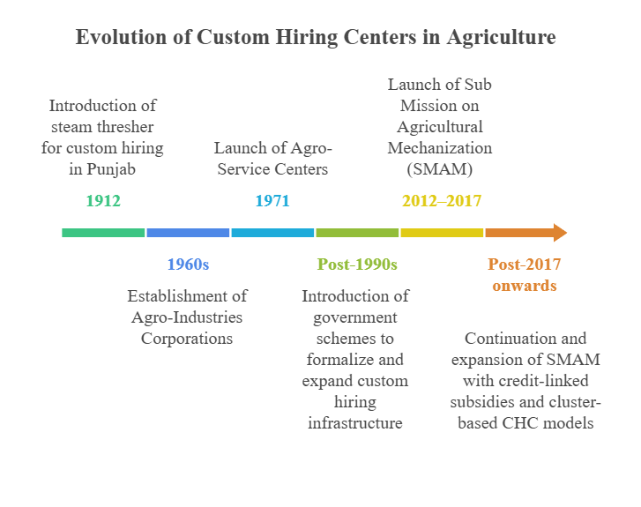
Figure 1: Evolution of CHCs
2.6. Current scenario of CHCs:
As of 2025, India hosts a total of 75,915 Custom Hiring Centres (CHCs). Punjab leads with 11,148 CHCs, followed by Andhra Pradesh (8,472) and Haryana (8,260), reflecting strong institutional and state-level support for farm mechanization. In contrast, smaller states and union territories such as Daman and Diu (1), Chandigarh (5), and Arunachal Pradesh (9) have minimal CHC presence.
Table 1: State-wise No. of CHCs Registered
Rank | State/UT | No. of CHCs
1 | Punjab | 11,148
2 | Andhra Pradesh | 8,472
3 | Haryana | 8,260
4 | Telangana | 6,579
5 | Tamil Nadu | 6,298
6 | Nagaland | 5,616
7 | Kerala | 4,868
8 | Uttar Pradesh | 4,539
9 | Chhattisgarh | 3,514
10 | Madhya Pradesh | 3,328
11 | Gujarat | 2,476
12 | Rajasthan | 1,742
13 | Maharashtra | 1,605
14 | Uttarakhand | 1,215
15 | Odisha | 1,028
16 | Karnataka | 938
17 | Assam | 885
18 | Bihar | 832
19 | Jharkhand | 787
20 | West Bengal | 424
21 | Sikkim | 402
22 | Meghalaya | 381
23 | Tripura | 193
24 | Himachal Pradesh | 129
25 | Goa | 84
26 | Mizoram | 62
27 | Manipur | 47
28 | Delhi | 26
29 | Jammu and Kashmir | 17
30 | Arunachal Pradesh | 9
31 | Chandigarh | 5
32 | Andaman and Nicobar Islands | 5
33 | Daman and Diu | 1
 | Total (India) | 75,915
Source: Department of Agriculture and Farmers Welfare, Ministry of Agriculture and Farmers Welfare, Government of India; accessed on 16.07.2025 (https://agrimachinery.nic.in/GraphReport/SMAMFmtti/SMAMFmtti.aspx)
Table 2: Category-wise CHCs Registered
Category | CHCs Registered
Farmer | 45590
Societies | 25293
Entrepreneur | 5032
Source: Department of Agriculture and Farmers Welfare, Ministry of Agriculture and Farmers Welfare, Government of India; accessed on 16.07.2025 (https://agrimachinery.nic.in/GraphReport/SMAMFmtti/SMAMFmtti.aspx)
The data highlights that the majority of CHCs in India are farmer-led, accounting for 45,590 centers (60.07%). Societies, including cooperatives and farmer producer organizations (FPOs), operate 25,293 centers (33.31%), while private entrepreneurs run 5,032 centers (6.63%). This distribution indicates a strong farmer-driven ownership model with significant contributions from organized groups, although entrepreneurial involvement remains comparatively limited.
FARMS Mobile App
In September 2019, the Government of India launched the FARMS (Farm Machinery Solutions) mobile application, developed by the National Informatics Centre (NIC), to improve farmers’ access to mechanization services. The app connects small and marginal farmers with nearby Custom Hiring Centres (CHCs) and enables them to locate farm machinery within a radius of 5–50 km.
Through this platform, farmers can view the availability of equipment, rental rates, photographs of machinery, and directly book services using their mobile devices. The app also allows CHC operators, including farmers, societies, and entrepreneurs, to register their services by uploading geo-tagged images and machinery details.
In addition, the FARMS app serves as a marketplace for buying and selling second-hand farm equipment, ensuring greater transparency and efficiency through built-in feedback mechanisms. By integrating with government mechanization schemes, the app has become a key digital tool for bridging the gap between machinery providers and smallholder farmers, thereby enhancing accessibility and service delivery (NIC, 2019).
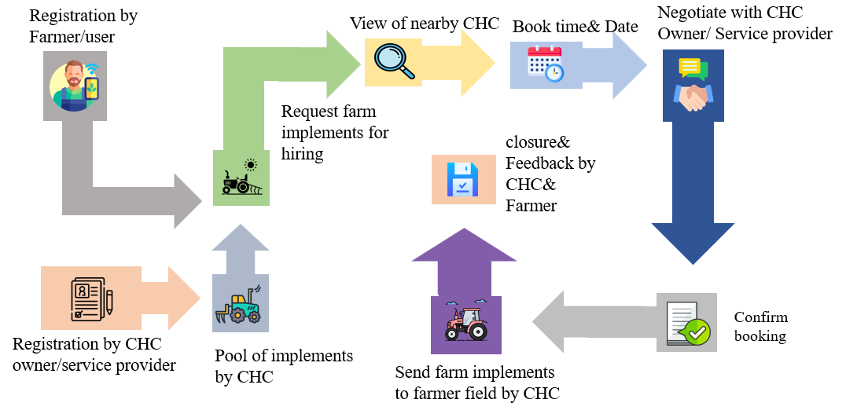
Figure 2: Workflow of the FARMS mobile app
Sub-Mission on Agricultural Mechanization (SMAM)
The Sub-Mission on Agricultural Mechanization (SMAM) was launched in 2014-15 to increase the availability of farm power from 2.02 kW/ha in 2014 to 2.50 kW/ha by 2022 and ultimately to 4.0 kW/ha by 2030. The mission promotes widespread adoption of mechanization by creating awareness, providing financial support through subsidies, and enabling machinery procurement via State Agriculture Departments.
SMAM built upon interventions from the 11th Five-Year Plan, including training, testing, and demonstration of agricultural machinery, advancement of post-harvest technology, and financial assistance for equipment acquisition. It also introduced new components such as:
- Establishment of Farm Machinery Banks (FMBs) for custom hiring.
- Creation of Hi-Tech and High-Productivity Equipment Centres.
- Targeted support for small and marginal farmers, especially in Eastern and North-eastern India.
Custom Hiring Centres (CHCs) and FMBs were incorporated into components 4, 5, 6, and 8 of the SMAM framework. During the 12th Five-Year Plan, the mission was allocated a budget of ₹3,500 crore.
As per the 2024 SMAM guidelines, the following financial assistance is provided:
- Up to 40% subsidy per machine under approved projects.
- For Kisan Drone CHCs operated by agricultural graduates: 50% subsidy or up to ₹5 lakhs, whichever is lower.
- For village-level FMBs: 80% subsidy for projects costing up to ₹30 lakhs.
SMAM functions as a vital component of the broader National Mission on Agricultural Extension and Technology (NMAET). By expanding access to mechanization, it plays a critical role in improving farm productivity, reducing drudgery, and strengthening rural entrepreneurship (Ministry of Agriculture & Farmers Welfare, 2024).
Registration Process for CHC establishment under SMAM:
The registration process for establishing a Custom Hiring Centre (CHC) under the Sub-Mission on Agricultural Mechanization (SMAM) involves multiple steps and varies slightly for farmers, entrepreneurs, and societies.
- Online Registration
- Applicants (farmer, entrepreneur, or society/FPO/SHG) must register on the designated SMAM portal to receive a login ID and password.
- Document Submission
- Farmers: Required to upload documents such as proof of being an agriculture graduate, domicile certificate, and date of birth.
- Societies: Must register as a fixed group or special category and add details of at least five members (for components 4 and 5) or eight members (for components 6 and 8).
- Entrepreneurs: Follow a similar process and must also provide details of the proposed CHC.
- Project Creation
- Once logged in, applicants must create a project by either selecting a pre-designed CHC package offered by the state or choosing individual machinery.
- Submission and Approval
- Applicants accept the terms and conditions, submit the project online, and forward it to the State Agriculture Department for approval.
- Post-Approval Process
- After approval, applicants must upload bill details, invoices, and machine numbers.
- For projects exceeding ₹25 lakhs, loan and bank account details are mandatory.
- Verification and Subsidy Release
- Physical verification and re-verification of machinery are conducted.
- After successful verification, subsidy approval is granted, making the CHC project fully operational.
This structured process ensures transparency, accountability, and systematic implementation of CHCs under SMAM (Ministry of Agriculture & Farmers Welfare, 2024).
Impact of CHCs:
Custom Hiring Centres (CHCs) have emerged as a transformative intervention in Indian agriculture, delivering measurable economic, productivity, and resource-use benefits.
Economic Impact
CHCs reduce the cost of cultivation by approximately 15.71% compared to private machinery services. This cost efficiency translates into a 24% increase in net returns and a 4.90% rise in overall yields. In terms of energy efficiency, CHCs supply mechanical energy at a cost of ₹2.48 per megajoule (MJ), which is lower than the ₹3.13 per MJ incurred through private alternatives. These improvements collectively allow farmers to earn an additional ₹6,165 per acre (Chinnappa et al., 2018).
Productivity Gains
CHCs significantly improve crop yields. For instance:
- Rice: Yield increased by 14.70% in Kharif and 16.49% in Rabi.
- Chickpea: Yield rose by 23.11%.
- Wheat: Yield increased by 21.16%.
- Groundnut: Yield rose by 15.62%.
- Maize: Yield improved by 6.97% (Rameshwar et al., 2024).
Labour Savings
Mechanization through CHCs has significantly reduced labor requirements:
- Human labor declined by 16.29%.
- Bullock labor use dropped by 68.30% (Chinnappa et al., 2018).
Crop-specific reductions in labor requirements were also reported:
- Rice: 42.55% reduction in Kharif and 42.85% in Rabi.
- Wheat: 37.50% reduction.
- Groundnut: 33.33% reduction.
- Chickpea: 28.57% reduction.
- Maize: 26.00% reduction (Rameshwar et al., 2024).
Overall, CHCs have not only enhanced agricultural efficiency and productivity but have also contributed to resource optimization and improved farmer livelihoods.
Conclusion
Custom Hiring Centres (CHCs) have emerged as an effective solution for small and marginal farmers who cannot afford modern machinery. By providing affordable access to equipment, CHCs help reduce cultivation costs, improve productivity, and lower labor dependence. Supported by schemes like SMAM and digital tools such as the FARMS mobile app, they have expanded their reach across India. To address challenges like limited awareness and seasonal shortages, stronger policy support and better implementation are needed. Strengthening CHCs will make mechanization more inclusive, thereby promoting sustainable agricultural growth and improving rural livelihoods.
Suggestions
Key measures to strengthen CHCs include:
- Capacity Building: Provide technical training and awareness on machinery use (Parashunath et al., 2016; Singh, 2005).
- Infrastructure Expansion: Set up more CHCs in underserved areas, especially through cooperatives (Shoba et al., 2018).
- Policy and Financial Support: Ensure subsidies, easy credit, and fair hire rates (Verma et al., 2015; Singh et al., 2013).
- Supply-Demand Alignment: Focus on high-demand equipment for better utilization (Kumar et al., 2021; Tayade et al., 2022).
- Standardization: Promote quality-marked and durable machinery (Singh, 2005).
Strengthening CHCs through these measures will enhance mechanization and improve farm productivity.

COMPETING INTERESTS DISCLAIMER:
Authors have declared that they have no known competing financial interests OR non-financial interests OR personal relationships that could have appeared to influence the work reported in this paper.

References
Agricultural machinery manufacturer’s association (AMMA), India, 2022. Retrieved from https://ammatn.in
Chinnappa, B., Kumar, K., Patil, R., & Sowmya, H. S. (2018). Economic Impact of Custom Hiring Service Centres in Maize Cultivation: A Case Study from Karnataka. Indian Journal of Agricultural Economics, 73(4), 478-500.
Category Wise CHCs Registered, No. of CHCs Registered State Wise, http://agrimachinery.nic.in
Das, C., & Patil, S. B. (2024). Constraints of Custom Hiring Services Utilization & Suggestions for Advancing Farm Mechanization in Vijayapur District of Karnataka, India. Journal of Experimental Agriculture International, 76(9), 555-562.
Department of Agriculture and Farmers Welfare retrieved from https://agriwelfare.gov.in
FARMS Mobile App. retrieved from https://farms.nic.in
Kisku U, & Singh, A. K. (2022). A Review on Custom Hiring Services under Indian Conditions: Farmer’s Perception, Associated Factors, Constraints, and Suggestions, Asian journal of agricultural extension, 40(11), 8-27.
Kisku, U., Bisht, K., Singh, A. K., & Naberia, S. (2022). Farmers’ Perception Regarding Custom Hiring Services in Jabalpur District of Madhya Pradesh. Indian Journal of Extension Education, 58(4), 19-22.
Kumar, K., Meena, H. R., Kadian, K. S., Meena, B. S., Bhandari, G., & Kaur, J. (2021). Farmers’ attitude towards Custom hiring centers: an exploratory study in Punjab. Current Journal of Applied Science and Technology, 40(21), 70-8.
Parashunath, Hiremath, G. M., Prashanth, J. (2016). Constraints of farmers in utilizing custom hiring service of tractor based farm machineries - An analysis. International Journal of Agricultural Science and Research, 6(1), 227-220.
Rameshwar, Sengar, R. S., & Minz, A. D. (2024). Impact assessment of custom hiring centres on farm mechanization: A quantitative research in Chhattisgarh state. International Journal of Agriculture Extension and Social Development, 7(11), 11-14.
Shoba, H., Rajeshwari, N., & Yogeeshappa, H. (2018). A study on farm mechanization level of farmers in North Karnataka, India. International Journal of Current Microbiology and Applied Sciences, 7(2), 652-7, doi: 10.20546/ijcmas.2018.702.080
Singh J. (2006). Scope, progress and constraints of farm mechanization in India. Status of Farm Mechanization in India. Indian Agricultural Statistics Research Institute, ICAR, New Delhi, 48-56.
Singh, R. S., & Sahni, R. K. (2019). Transformation of Indian agriculture through mechanization. Economic Affairs, 64(2), 297-303.
Singh, S, Kingra, H. S., & Sangeet. (2013). Custom hiring services of farm machinery in Punjab: Impact and policies. Indian Research Journal of Extension Education, 13(2), 45-50.
Tiwari, P. S., Singh, K. K., Sahni, R. K., & Kumar, V. (2019). Farm mechanization–trends and policy for its promotion in India. Indian Journal of Agricultural Sciences, 89(10), 1555-1562.
Verma, M., & Tripathi, A. (2015). Perspective of agricultural mechanization in Supaul district of North Bihar - A research. IOSR Journal of Agriculture Veterinary Science, 8(8), 4-12.
Arya, A. R. (2022). Agricultural transformation in Asia: Experiences and emerging challenges. Asian Journal of Agriculture and Development, 19(2), 11-24.
Ganavi, N. R., Kumar, N. R., & Kambale, P. (2024). Impact of custom hiring centers on cost, profitability, and efficiency in crop production in Anantapur district of Andhra Pradesh, India. Journal of Scientific Research and Reports, 30(5), 580-587.
Rajkhowa, P., & Kubik, Z. (2021). Revisiting the relationship between farm mechanization and labour requirement in India. Indian Economic Review, 56(2), 487-513.

