Original Research Article

AEROBIC ENTERIC BACTERIA ASSOCIATED WITH RETAIL BOILED EGG CONSUMED BY STUDENTS OF THE FEDERAL UNIVERSITY OTUOKE, BAYELSA STATE, NIGERIA

ABSTRACT
Eggs are one of the most nutritious and convenient foods to eat. They contain high amounts of essential amino acids, vitamins, and minerals, as well as high-quality protein. However, foodborne diseases are a major public health issue as they are the main cause of diarrhoea that affect people in both developed and developing countries. In this investigation a total of eight (8) table shell eggs were examined for bacterial contamination. Results showed that all egg samples were contaminated with varying percentage of bacterial. The total number of bacterial cells identified where eighteen (18) isolates, which include Staphylococcus aureus, (11%), Escherichia coli (22), Salmonella gallinarum (17%), Salmonella schlerasius (17%), Streptococcus pneumonia (17%) and Bacillus spp (22%). The antibiotic resistant and susceptibility pattern of isolates to antibiotics demonstrated multidrug resistant to antibiotics. levofloxacin (LEV) and Rifampicin (RD) was the antibiotics that Staphylococcus aureus was susceptible to, while Salmonella spp, it was only Levofloxacin (LEV) and Gentamycin (CN) that the cell was susceptible, Streptococcus pneumonia was susceptible to Levofloxacin (LEV) and Gentamycin (CN), and Bacillus spp was susceptible Levofloxacin (LEV) only. This reveals that table egg harbours potential pathogens some of which are even life threatening. Therefore, in order to minimize the number of bacteria present in commercial chicken eggs produced in Bayelsa, poultry farms must adhere to the highest level of hygiene.
Key words: Boiled eggs, Bacteria, Pathogens, Antibiotic resistance

1. INTRODUCTION
Foodborne illness is a major public health problem and the main cause of diarrhoeal diseases affecting all developed and developing countries (Akbar and Anal 2014; Akbar and Anal 2013b). Meat and eggs are examples of animal foods that are thought to be the most common source of foodborne illnesses. Salmonella, Campylobacter, Listeria monocytogenes, Staphylococcus aureus, and Escherichia coli O157 are the most often found foodborne pathogens linked to animal-derived foods (Akbar and Anal, 2013a; Ghasemian, 2011; Akbar and Anal, 2011). Numerous microorganisms, including Campylobacter jejuni, Listeria monocytogenes, Escherichia coli, Yersinia enterocolitica, and particularly Salmonella, can contaminate eggs at both the egg shell and egg contents (Ricke et al., 2001; Board and Tranter, 1995). Staphylococci are the most prevalent bacteria that contaminate eggshells. Contamination is more commonly associated with cracked eggs, soiled shells, and storage in contaminated environments. It might become polluted during the formation and laying processes (Abdullah 2010). Elliott (1954) discovered that stored or old eggs are more likely to become infected than fresh eggs due to the breakdown of natural defensive mechanisms in the egg over time. The eggshell contamination increases the likelihood of egg content contamination through penetration (Messens et al., 2006). Bacterial contamination can occur in three different regions of the egg: the yolk, the albumen, and the shell membrane / egg shell (Bahrouz, 2005). Salmonella enteritidis can penetrate follicular cells before to ovulation and multiply after 2 hours of infection (Howard et al., 2005). Eggs are regarded as a food item with a medium to low risk of causing a foodborne disease due to the possibility of bacterial contamination with enteric pathogens, including Salmonella (Chousalkar et al., 2010). The aim of this Research work is to access the microbiological quality of table eggs sold by vendors at the Federal University Otuoke environs.
2. MATERIALS AND METHOD
2.1 Location of the Study
The sample was bought at the small kiosk shops at the school gate of the Federal University Otuoke. It lies between latitude of 4051’05.23” N, longitude 6020’19.8” E. It is bounded to the North by Elebele community, to the East by Emeyal 1 and to the South by Onuobum and Otuogiri and to the South by Otuaba and Ewoi communities. These vending sites were chosen because they are very popular among those who patronize such eating places.
2.2 Sample Collection
Eight (8) shell eggs in total were chosen at random from two distinct kiosk stores. The samples were purchased from two distinct kiosk shops near the school gate of Federal University Otuoke. Within two hours after collection, samples were placed in zippered sterile polythene bags, appropriately labelled and transported to the microbiology lab for investigation.
2.3 Isolation and Identification of Aerobic Bacteria
The surface of the entire egg was aseptically swabbed with a sterile cotton swab for the purpose of counting the number of bacteria on its surface. After that, the swab method of Loongyai et al., 2010 was slightly modified and dipped into tryptone soy broth (TSB). After that, 0.1 mL) of the pre-inoculated TSB was incubated at 37°C for 24 hours. A loopful of TSB was added to eosin-methylene blue agar and Salmonella shigella agar (SSA), and the mixture was incubated for 24 hours at 37 °C. Lactose and non-lactose fermentation were both observed, with reddish-pink colonies with or without a black center being presumed to be Salmonella and greenish metallic sheen on EMB being presumed to be E. coli. All of these colonies were subjected to biochemical confirmation in accordance with the bacteriological analytical manual (FDA, 2001). The isolates were further confirmed to genus and species level with the help of biochemical test such as, catalase, oxidase, cagulase, methyl red, voges-proskauer, urease, indole, citrate utilization, motility, hydrogen sulfide and glucose, lactose fermentation tests. All the isolates were identified according to bergeys manual of determinative bacteriology.
2.4 Antibiotic Susceptibility Test
Antibiotics susceptibility test of all the isolates was determined by the disk diffusion method and interpreted as susceptible, intermediate and resistant as described by CLSI, (2014). Gram negative and gram positive pathogens were tested against the following antibiotics; levofloxacin (30μg), Amoxicillin (10μg), Gentamicin (30μg), Streptomycin (30μg), Rifampicin (300μg), Erythromycin (25μg), Ampiclox (10μg) Ciprofloxacin (30μg) and chloramphenicol (25μg). The fresh bacterial culture adjusted to Mcfallands standard were spread over mueller-hinton agar using cotton swab stick and incubated at 37ºC for 24 h. Each plate was examined after 24 hours of incubation. The diameters of the zones of complete inhibition were measured to the nearest whole millimeter, using a ruler and compared with the zone interpretation chart based on CLSI guidelines (2020).
3. RESULTS AND DISCUSSION
In this investigation, a total of 8 table shell eggs were examined for bacterial contamination. Results showed that all egg samples were contaminated with varying percentage of bacterial. Table 1 shows the total number bacterial cells identified, 18 isolates, which include Staphylococcus aureus, (2), Escherichia coli (4), Salmonella gallinarum (2), Salmonella schlerasius (3), Streptococcus pneumonia (3) and Bacillus spp (40)
Table 1: Number of isolates identified
BACTERIA | No of isolates | Percentages
Staphylococus aureus | 2 | 11
Escherichia coli | 4 | 12
Salmonella gallinarum | 2 | 11
Salmonella schlerasius | 3 | 17
Streptococus pneumonia | 3 | 17
Bacillus spp | 4 | 22
TOTAL | 18 | 100

Presented on figure 1 below is thebiochemical identification, a total of 18 isolates where identified which include two (2) Salmonella galinarium, two (2) Staphylococus aureus, four (4) Esscherichia coli, three (3) Salmonella schlerasius, three (3) Streptococus pneumonia and four (4) Bacillus spp

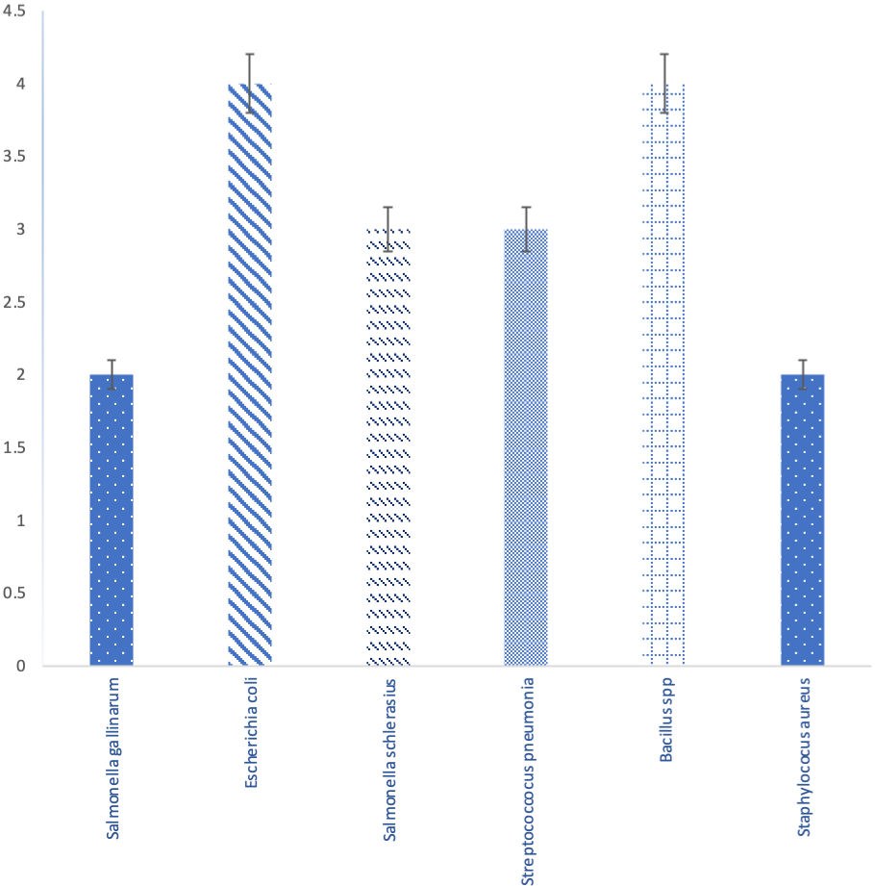

Figure 1: Bar chart showing the number of cells identified using Biochemical test

In figure 2 below, the result of isolated bacteria cells presented in percentages which include, 22% for Escherichia coli and Bacillus spp, which were the highest followed by Salmonella Schlerasius and Streptococcus pneumonia 17%, Staphylococcus aureus and Salmonella gallinarum 11%.

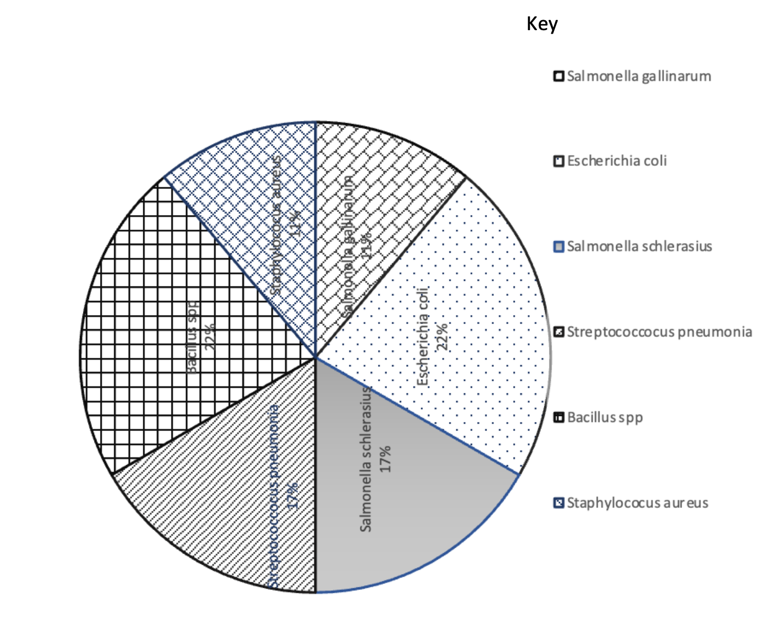
Figure 2: A chart showing the percentages of bacteria cell identified.

Presented on table 2 below is the antibiotic resistant and susceptibility pattern of isolates to antibiotics, bacteria were multi resistant to antibiotics, for Staphylococus aureus it was levofloxacin (LEV) and Rifampicin (RD), Salmonella spp it was only Levofloxacin (LEV) and Gentamycin (CN) that the cell was susceptible, Streptococus pneumonia was susceptible to Levofloxacin (LEV) and Gentamycin (CN), and Bacillus spp was susceptible Levofloxacin (LEV). This reveals the multidrug resistant pattern of identified pathogens
Table 2. Multidrug resistant pattern of bacteria isolated
BACTERIA | Number of isolates | Number of antibiotics | Resistant antibiotics | Susceptible antibiotics
Staphylococus aureus | 2 | 10 | APX, CN, AMX, X, S, NB, CH, CPR | LEV, RD
Escherichia coli | 4 | 9 | APX, RD, S, CN, NB, CH, E | LEV AMX
Salmonella spp | 5 | 10 | APX, RD, AMX, S, NB, CH, CN, E | LEV, CN
Streptococus pneumonia | 3 | 9 | CPX, S, E, CH, APX, AMX, NB | LEV, CN
Bacillus sp | 4 | 8 | AMX, CPX, S, E, CN, RD, AMX | LEV

LEV= Levofloxacin, AMX= Amoxicillin, CN= Gentamycin, S=Streptomycin, RD=Rifampicin, E=Erythromycin, APX=Ampiclox, CPR=Ciprofloxacin, CH=Chloramphenicol
Microbial contamination of egg is a major public health problem globally. The seriousness of the hazard and symptoms of this problem in humans can vary from mild to life threatening situation (Kaneko et al., 1999). The egg components are an important source of nutrients for human diet and are good nutrients for microorganisms. Although there are antibacterial factors in egg components which reduces growth of microorganisms, egg can be infected with different species of bacteria such as Salmonella sp, Campylobacter jejuni, Escherichia coli and Listeria monocytogens. Salmonella and Campylobacter which are the most common cause of food borne diseases. (Douye et al, 2013; Zige and Ayibakeme, 2023) E. coli is the most common bacteria species in egg which cause diarrhea especially in children. Many studies and researches around the world reported the outbreaks and contamination of egg by the Salmonellas sp, C. jejuni, L. monocytogens and E. coli (Cox et al., 2002; Davies and Breslin, 2003). De Reu et al. (2006a; 2006b) reported that Gram-positive Staphylococcus sp is the major natural egg shell contaminant. Staphylococcus sp. was the major isolated species from the air of the poultry houses (De Reu et al., 2005a), this finding however does not agree with our results as Staphylococcus aureus was the least isolated species. The contamination of this bacteria is wide through packaging and marketing of table egg. A study also found that many of Gram-negative bacteria species such as Escherichia coli and Salmonella sp. were isolated from poultry products (Zige and Omeje, 2023). This agrees with our findings as well. This study also identified Gram-positive bacteria species including, Staphylococcus spp, Bacillus sp and Streptococcus sp and corresponds with the finding of (De Reu et al., 2005b). Isolated gram positive and gram-negative organism are pathogenic to man, most of which are implicated in diarrhoea, community acquired infection, typhoid and even other life-threatening diseases such as pneumonia, osteomyelitis, endocarditis and sepsis. (Zige and Omeje, 2023).
The multi drug resistant pattern obtain in this study is alarming, all isolates were resistant to most commonly used antibiotics, while Salmonella spp, Streptococus pneumonia, Escherichia coli, Staphylococus aureus and bacillus sp were all susceptible to levofloxacin, Gentamycin, Salmonella sp and Streptocoocus sp where the only antibiotics that was susceptible respectively. This multidrug resistant pattern observed in this study agrees with finding of Akinyemi et al, 2005, who report study of multidrug resistant pattern of Salmonella and also Adesina et al., 2009 failure of antibiotics in the treatment of typhoid fever. Resistant of this isolate to commonly used antibiotics is also in agreement with (Osuntokun and Akele, 2018).
4. CONCLUSION AND RECOMMENDATION
This study however concludes that retail eggs harbours potential pathogens some of which are even life threatening and many predominantly Gram’s negative bacteria. These pathogenic microorganisms shown widespread resistance to conventional antibiotics. Given that the source of the contamination is probably human faeces, merchants should take further precautions to maintain acceptable hygiene standards at all their retail locations, as demonstrated by the isolation of bacteria that are exclusively human pathogens. Touching of eggs by buyers should be controlled, as that can be a means of transmission of potential pathogen.

Declaration: This study did not involve any animal or human participant and thus ethical approval was not applicable.
DISCLAIMER (ARTIFICIAL INTELLIGENCE)
Authors hereby declare that NO generative AI technologies and text-to-image generators have been used during the writing or editing of this manuscript.

REFERENCES
Abdullah, I.N. (2010). Isolation and identification of some bacterial isolates from table egg. Journal of Veterinary Science. 3(2): 59–67.
Adesina, O. G, Nonyelum, O. O, Clair l. E, Joseph, O. E and Rebecca, O. B. (2009). Prevalence and susceptibility of Salmonella Typhi and Salmonella Paratyphi in Zaria, Nigeria. International Journal of Health Research 2(4): 355-360.
Akbar, A and Anal, A.K (2011). Food safety concerns and food-borne pathogens, Salmonella, Escherichia coli and Campylobacter. FUUAST Journal of Biology. 1(1): 5–17.
Akbar, A and Anal, A.K (2013a). Prevalence and antibiogram study of Salmonella and Staphylococcus aureus in poultry meat. Asian Pacific Journal of Tropical Biomedicine. 3(2): 163–168.
Akbar, A and Anal, A.K (2013b). Occurrence of Staphylococcus aureus and evaluation of anti- staphylococcal activity of Lactococcus lactis subsp. lactis in ready-to-eat poultry meat. Annals of Microbiology (online first). 013-0641
Akbar, A and Anal, K.A (2014). Zinc oxide nanoparticles loaded active packaging a challenge study against Salmonella typhimurium and Staphylococcus aureus in ready-to-eat poultry meat. Food Control. 38: 88–95.
Akinyemi, K. O, Smith, S. I, Oyefolu, A. O, and Coker, A. O. (2005). Multidrug resistance in Salmonella enterica serovar typhi isolated from patients with typhoid fever complications in Lagos, Nigeria. Public Health 119 (4), 321-327.
Bahrouz, M.A and Al-Jaff. (2005). The risk of bacterial contamination in hen eggs of Sulaimani poultries. Journal of Zankoy Sulaimani. 8A (1): 63–71.
Board, R.G and Tranter, H.S (1995). The microbiology of eggs. In: W. J. Stadelman and Coterill O. J. (eds). Egg Science and technology. 4th ed. Haworth Press Inc. New York.

Chousalkar, K.K, Flynn, P, Sutherland, M, Roberts, J.R and Cheetham, B.F (2010). Recovery of Salmonella and Escherichia coli from commercial egg shells and effect of translucency on bacterial penetration in eggs. International Journal of Food Microbiology. 142: 207–213.
Clinical and Laboratory Standard Institute, (2014). Analysis and Presentation of Cumulative Antimicrobial Susceptibility Test Data; Approved Guideline (Fourth Edition. LS). Document M39-A4.Wayne, PA: Clinical and Laboratory Standards Institute.
Clinical and Laboratory Standard Institute, (2020). Performance Standard for Antimicrobial Susceptibility Testing. (30th Edition). Document M100-S20. Wayne, PA: Clinical and Laboratory Standards Institute.
Cox, S.N.J, Wilson, J.L, Musgrove, M.T, Buhr, R.J and Hiett, K.L (2002). Isolation of Campylobacter Spp. from semen samples of commercial broiler breeder roosters. Avian Dis., 46: 717-720.
Davies, R.H. and Breslin, M (2003). Investigation of Salmonella contamination and disinfection in farm egg-packing plants. J. Appl. Microbiol., 94: 191-196.
De Reu, K, Grijspeerdt, K and Heyndrickx, M, Uyttendaele, M and Herman, L. (2005b). The use of total aerobic and Gram-negative flora for quality assurance in the production chain of consumption eggs. Food Cont., 16: 147–155.
De Reu, K, Grijspeerdt, K, Heyndrickx, M, Uyttendaele, M, Debevere, J and Herman, L. (2006a). Bacterial eggshell contamination in the egg collection chains of different housing systems for laying hens. British Poultry Sci., 47: 163–172.
De Reu, K, Grijspeerdt, K, Heyndrickx, M, Zoons, J, De Baere, D, Uyttendaele, M, Debevere, J and Herman, L (2005a). Bacterial eggshell contamination in conventional cages, furnished cages and aviary housing systems. British Poultry Sci., 46: 149–155.
De Reu, K, Grijspeerdt, K, Messens, W, Heyndrickx, M, Uyttendaele, M, Debevere, J and Herman, L. (2006b). Eggshell factors influencing eggshell penetration and whole egg contamination by different bacteria, including Salmonella enteritidis. Int. J. Food Microbiol., 112:253–260.
Douye V. Z, Elijah I. O and Sridhar, K. C. M (2013). Enteric Bacteria from ready to eat food vended in Amassoma community in Niger Delta and its health implication. IOSR Journal Of Environmental Science, Toxicology And Food Technology (IOSR-JESTFT) 6(4) 62-65.
Elliott R.P. (1954). Spoilage of shell eggs by pseudomonads. Applied Microbiology. 2: 158–163.
Ghasemian, S (2011). The prevalence of bacterial contamination of table eggs from retails markets by Salmonella spp., Listeria monocytogenes, Campylobacter jejuni and Escherichia coli in Shahrekord, Iran. Jundishapur Journal of Microbiology. 4(4): 249–253.
Howard Z.R, Moore, R.W, Zabala-Diaz, I.B, Landers, K.L, Byrd, J.A, Kubena, L.F, Nisbet D.J, Birkhold, S.G and Ricke, S.C. (2005). Ovarian laying hen follicular maturation and in-vitro Salmonella internalization. Veterinary Microbiology, 108: 95–100.
Kaneko, K.I, Hayashidani, H, Ohtomo, Y. (1999). Bacterial contamination of ready- to-eat foods and fresh products in retail shops and food factories. J. Food Prot., 62: 644-649
Messens, W, Grijspeerdt, K and Herman, L (2006). Eggshell penetration of hen’s eggs by Salmonella enteric serovar enteritidis upon various storage conditions. British Poultry Science. 47: 554–560.
Osuntokun, O.T, Akele O.E. (2018) Resistance profiling of bacterial isolate from cut and sliced ready- to-eat polyethylene packed watermelon (citrullus lanatus) sold in akoko communities. J Bacteriol Infec Dis. 2(2):12-15
Ricke, S.C, Birkhold, S.G and Gast R.K (2001). Eggs and egg products. In compendium of methods for the microbiological examination of foods, 4thed. Downes F. P. and Ito K. eds. American Public Health Association, Washington, D.C. pp 473–479.
Zige, D. V & Ayibakeme, A. (2023). Occurrence of Potential Bacterial Pathogens in Food from Local Restaurants in Azikoro Town, Bayelsa State, Nigeria. International Research Journal of Gastroenterology and Hepatology, 6(1), 40-45.
Zige, D.V and Omeje, F. I (2023) Antibiotics Profile and Public Health Implication of Pathogenic Enteric Bacteria Associated With Poultry Stool. International Journal of Pathogen Research, 12 (2). pp. 9-15

