Short Research Article

A Comparative Linguistic Perspective on AI Language Use: Examining Gemini and Claude Beyond Technical Performance

.
ABSTRACT

This article aims to analyze the language use of AI models Gemini and Claude from a comparative linguistic perspective. Instead of being limited to evaluating technical performance, such as accuracy or speed, it focuses on examining characteristics related to vocabulary and grammar, the organization of discourse and coherence, as well as pragmatic strategies and stylistic features. This study used a descriptive analysis method by creating illustrative cases from the same prompt to compare the results. The key finding is that Gemini tends to generate highly academic text, using abstract vocabulary, complex sentence structures, and logical connectors. Meanwhile, Claude focuses on a semi-conversational tone, uses easy-to-understand language, and organizes text in a step-by-step manner to promote practical application. This difference clearly reflects each model's distinct discourse identity.
In terms of language pedagogy, the analysis indicates that Gemini is suitable for developing academic writing skills and for practicing theoretical language use. In contrast, Claude is suitable for interactive activities, reviewing writing, and providing immediate, practical feedback. Using both models together therefore has the potential to foster balanced learning in both the formal and accessible aspects of language. This article helps to fill a research gap that focuses solely on evaluating technical performance, and proposes an analytical framework that can be applied to design English language teaching activities in an era where AI is playing a more significant role.

Keywords: AI Language Use; Comparative Analysis; Gemini; Claude; Applied Linguistics

1. INTRODUCTION

In recent years, the rapid development of language-based artificial intelligence has profoundly shaped academic research and society, particularly through the emergence of Large Language Models (LLMs) capable of producing grammatically accurate and contextually coherent texts (Floridi & Chiriatti, 2020). The success of ChatGPT by OpenAI has heightened scholarly interest in evaluating technical performance such as accuracy, reasoning ability, and hallucination mitigation (Bang et al., 2023; Zhang et al., 2024). Yet, an exclusive emphasis on technical dimensions risks overlooking the equally important linguistic dimension—how these models actually use language to communicate with users (Cantone et al., 2025).
Newer systems such as Google’s Gemini and Anthropic’s Claude have recently attracted considerable attention due to features like multilingual capability, contextual reasoning, and ethical safeguards (Google DeepMind, 2024; Anthropic, 2025). While these models have been assessed in terms of speed, accuracy, and safety, little research has addressed their applied linguistic features, including lexical choice, discourse cohesion, pragmatic strategies, and stylistic variation (Dayan et al., 2025; Zhao et al., 2025).
This gap raises a critical question: To what extent can AI models be considered language users? Restricting evaluation to accuracy and efficiency neglects the socio-cultural nature of language, which is always shaped by context, society, and interaction (Ushioda, 2020; Kasneci et al., 2023). Analyzing AI’s language use therefore requires attention to discourse and pragmatic dimensions that go beyond surface-level correctness.
A comparative focus on Gemini and Claude may reveal distinct discourse styles with direct pedagogical implications. For example, Gemini often produces academic-style texts, whereas Claude tends toward conversational outputs—differences that could influence instructors’ choices when integrating AI into classroom activities.
Accordingly, this article proposes a comparative linguistic framework for analyzing the language use of Gemini and Claude, with emphasis on lexical choice, discourse organization, pragmatic strategies, and stylistic register, rather than solely on technical competence. Findings from this conceptual analysis are expected to fill an underexplored research gap and provide significant implications for English language pedagogy in contexts where learners increasingly interact with AI as both tool and interlocutor.

2. Comparative Linguistic Framework
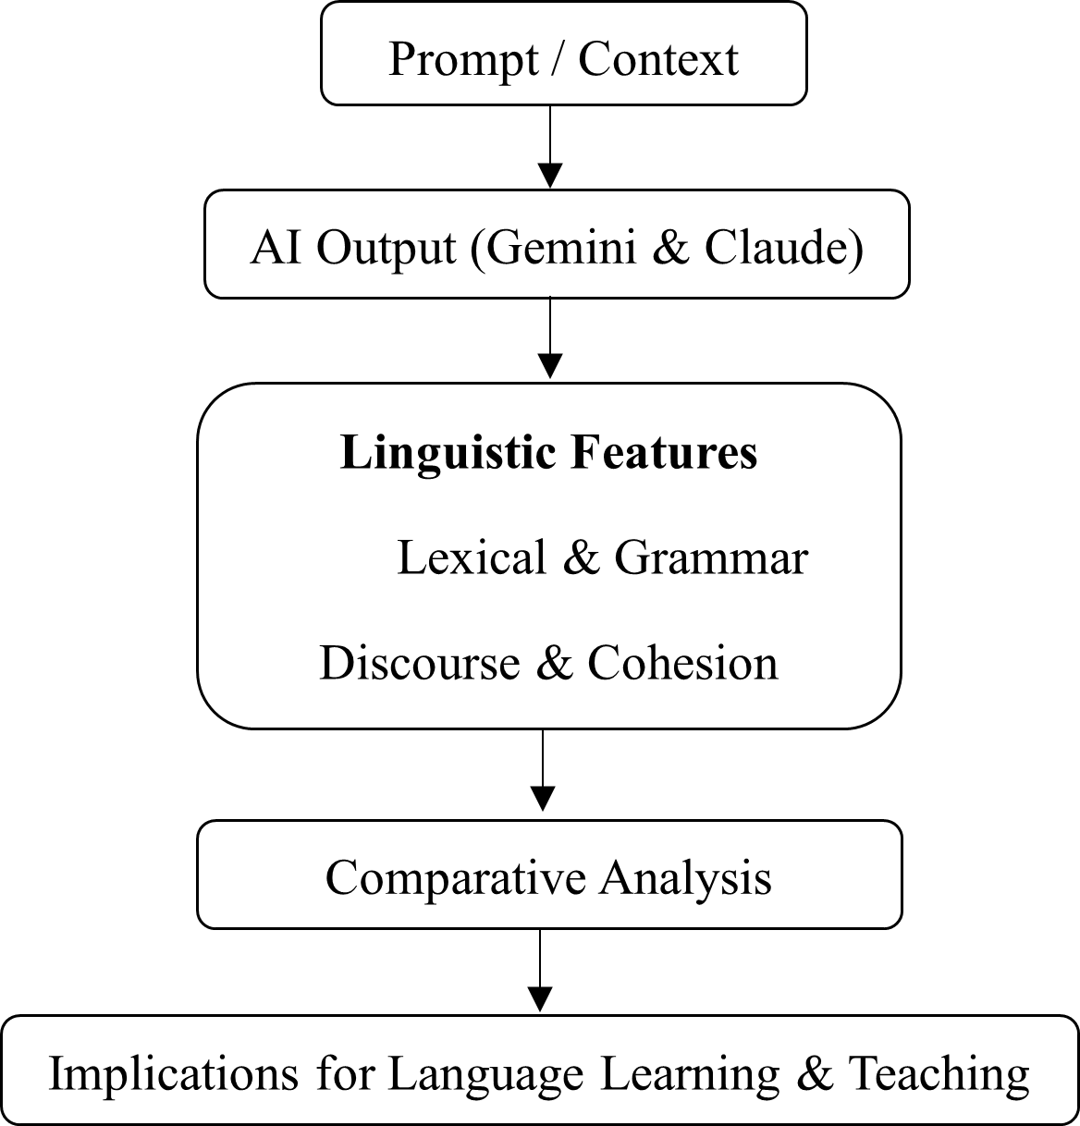

Fig. 1. The conceptual framework for comparative linguistic analysis of AI language use

The process begins with the prompt or context provided by users, which directs the style of language generation, whether academic or conversational. The outputs produced by Gemini and Claude are treated as textual data forming the basis for linguistic analysis.
The analysis focuses on three core dimensions: (1) lexical and grammatical features, (2) discourse organization and cohesion, and (3) pragmatic strategies and stylistic variation. The latter includes the use of politeness markers, hedging, and register adjustment to fit communicative contexts. Once examined across these dimensions, the data are subjected to a deeper comparison to identify differences in how Gemini and Claude employ language and to highlight the discourse identity of each model.

This framework underscores that linguistic analysis reveals more than technical competence. It also opens perspectives on how AI’s language use can influence pedagogy, for instance, by informing teachers’ choices between models that produce more academic prose or those that generate more conversational outputs. Overall, the framework emphasizes that evaluation of AI should not be confined to what AI can do in technical terms but must also consider how AI uses language, which is critical for applied linguistics research and for the design of language learning activities.

3. LANGUAGE USE: BEYOND TECHNICAL PERFORMANCE

Although numerous studies on Large Language Models (LLMs) have emerged in recent years, most have concentrated on technical performance, such as reasoning accuracy, processing speed, and benchmark problem-solving (Bang et al., 2023; Zhang et al., 2024). For instance, Bang et al. (2023) evaluated ChatGPT across multiple languages and tasks, focusing primarily on reasoning and factual correctness while overlooking discursive and paraphrasing strategies in the generated text.

Scholars have argued that such a narrow focus is insufficient, since LLMs are not merely “calculating devices” but language producers that shape social interaction and influence language learning (Floridi & Chiriatti, 2020). This calls for analyzing models from both perspectives: technical efficiency and linguistic features of communication.

In education, recent work has examined AI primarily as a tool to support learning rather than as a subject of linguistic analysis. Kasneci et al. (2023) observed that studies often emphasize functionality while neglecting dimensions such as discourse or register. Similarly, Ushioda (2020) underscored that language use is not universal but socially and culturally constructed through context and interaction. Evaluating AI as a language user therefore requires attention to these socio-cultural dimensions rather than reducing analysis to sterile measures of performance.

In sum, existing studies lack coherence between technical and linguistic perspectives. While Gemini and Claude are promoted for reasoning and contextual understanding (Google DeepMind, 2024; Anthropic, 2025), research on their discourse patterns and stylistic tendencies remains limited. Bridging this gap is essential to capture not only “what AI can do” but also “how AI uses language”.

4. COMPARATIVE PERSPECTIVES BETWEEN GEMINI AND CLAUDE

4.1 BACKGROUND AND KEY CHARACTERISTICS OF THE MODELS
Gemini and Claude are recent LLMs designed to support multilingual and multi-context capabilities, including long-context processing and contextual reasoning. Gemini 1.5 was considered a major step in advancing multimodal functions and supporting context lengths over 1 million tokens (Google, 2024a; Google DeepMind, 2024). Release notes further highlight the ongoing development of the Gemini line in 2024–2025, reflecting efforts to enhance synthesis and applied use (Google, 2024b).

By contrast, Claude 3.5 Sonnet improved accuracy, long-context retention, and comprehensive text generation (Anthropic, 2025). It was also designed for organizational contexts, emphasizing both performance and bias mitigation, which distinguishes its trajectory from Gemini (Anthropic, 2025).

Thus, a comparative linguistic analysis of these models is significant to reveal how texts generated under similar system designs can display different discourse identities with implications for language education and applied linguistics.

4.2 METHODOLOGICAL APPROACH FOR PERFORMING A DESCRIPTIVE COMPARISON

This article employs narrative analysis with illustrative case studies, using identical prompts to elicit outputs from Gemini and Claude. The goal is not quantitative ranking but exploring linguistic characteristics and discourse tendencies.

The approach assumes that LLMs are not only technical tools but also language users (Floridi & Chiriatti, 2020). Hence, the comparison considers vocabulary and grammar, discourse coherence, and pragmatic and stylistic strategies. Research shows textual coherence remains a persistent challenge requiring closer evaluation (Guo et al., 2024; Tran et al., 2025). At the same time, pragmatic factors such as politeness and hedging influence perceived text quality (Shen et al., 2024; Wang & Zhou, 2025).

Accordingly, the analysis of case studies focuses on lexical, discourse, and pragmatic dimensions to highlight each model’s discourse identity and prepare for pedagogical discussion.

4.3 CASE STUDY 1: SUMMARIZATIONS AND DISCUSSIONS FROM ACADEMIC ARTICLES

To distinguish linguistic characteristics, the models were asked to summarize and discuss task-based language teaching (TBLT) within a word limit. Gemini produced texts with high lexical density, abstract vocabulary, and complex syntax with many logical connectors, resembling academic prose and theoretical synthesis (Biber et al., 2021). Claude, in contrast, generated more conversational outputs, mixing sentence lengths and emphasizing practical readability.

For discourse cohesion, Gemini followed a linear structure, summary, controversies, theoretical accounts, synthesis, reflecting sequential academic prose (Halliday & Hasan, 2014). Claude’s structure moved from overview, to controversies, to practical directions, resembling classroom discourse and aligning with evidence that LLMs can generate macro-structures suited to real-world communication (Guo et al., 2024).

In pragmatics and style, Gemini relied on hedging (“it is proposed that…”) to maintain theoretical caution (Hyland, 2018), while Claude adopted a coaching tone with soft imperatives (“try using…,” “add…”). This difference reflects varied politeness strategies consistent with findings on LLM training and fine-tuning effects (Shen et al., 2024; Wang & Zhou, 2025). Overall, Gemini appears more suited to theoretical writing, whereas Claude supports feedback and interactive learning.

4.4 CASE STUDY 2: PROVIDING WRITTEN FEEDBACK TO STUDENTS

This case explored academic feedback. Prompted as teaching assistants, the models produced distinct feedback styles. Gemini employed academic terminology such as claim–evidence–warrant and relied on complex sentences with multiple embedded clauses, aligning with a theoretical framing of feedback (Hyland, 2018). Claude, by contrast, preferred simpler vocabulary and organized its responses into immediately actionable steps, such as “add examples” or “shorten sentences.” This finding is consistent with research indicating that clear and concise feedback can reduce students’ cognitive load and enhance comprehensibility (Shute, 2008).

In terms of discourse organization, Gemini typically structured its responses by first identifying the strengths of the text, then pointing out weaknesses, proposing possible solutions, and finally offering a conclusion. This sequential arrangement reflects the linearity and formality characteristic of academic discourse (Halliday & Hasan, 2014). Claude, however, tended to begin with affirming the student’s stance, followed by providing specific steps for improvement, and concluding with practical advice. This approach resonates with research on textual coherence, which emphasizes that feedback framed in a goal-oriented manner helps learners develop a clearer understanding of global coherence (Guo et al., 2024).

From a pragmatic and stylistic perspective, Gemini softened its recommendations by using hedging devices such as “should try” or “may consider,” a practice aligned with the conventions of academic caution (Hyland, 2018). Claude, in contrast, adopted a coaching tone and expressed recommendations through softened but direct imperatives such as “add” or “summarize.” This difference reflects variation in politeness strategies and registers selection, which recent studies suggest can emerge from differences in training and fine-tuning among LLMs (Shen et al., 2024; Wang & Zhou, 2025). Overall, Gemini demonstrates a preference for formal academic feedback structures, while Claude emphasizes practical, stepwise guidance, thereby shaping learners’ perceptions and use of feedback in distinct ways.

4.5 COMPARATIVE SYNTHESIZE: TREND OBSERVATIONS

Based on the case examples presented earlier, it was found that despite responding to the same prompt, Gemini and Claude created texts that reflect distinctly different discursive identities. Gemini tends to use academic lexis and construct complex sentences, making its content formal and focused on theoretical synthesis. In contrast, Claude emphasizes a conversational tone and organizes its content with a practical orientation. This aligns with recent research showing that LLMs differ in their pragmatic and politeness strategies, which in turn reflects each model's unique communication persona (Shen et al., 2024; Wang & Zhou, 2025).

This comparative synthesize indicates that the differences are not merely at the lexical or grammatical level, but also encompass the establishment of a register and the use of discursive strategies to build credibility or rapport with the reader. Therefore, viewing AI as a "language user" with a unique discursive identity is appropriate and opens up new dimensions for research in applied linguistics.

4.6 IMPLICATIONS FOR LANGUAGE PEDAGOGY

The linguistic differences that can be seen from Gemini and Claude provide implications for language instruction, especially AI usage for learning activity supports. For example, if an instructor wants students to learn academic writing that emphasizes the use of abstract vocabulary and complex sentence structures, Gemini might be a suitable tool. In contrast, if the goal is to practice communication or writing that is clear, easy to understand, and practical, Claude may be a better fit.

Research on textual coherence indicates that LLMs can generate texts with varying degrees of unity, but the differences between models affect the clarity of reasoning and reader comprehension (Guo et al., 2024; Tran et al., 2025). This implies that instructors should consider each model's "discursive strengths" when using them in instruction. This approach not only helps students become aware of the diversity of language forms but also allows for the design of learning activities that align with specific skill-development goals.

4.7 RESEARCH LIMITATIONS AND RECOMMENDATIONS

Although the descriptive comparison of Gemini and Claude offers interesting insights into their discursive identities, it has several limitations. First, the texts analyzed were small and did not cover all types of prompts, so the findings cannot be generalized. Second, LLM outputs are sensitive to prompt design and the politeness level of the query, which can affect the quality and style of the language produced. Research on the pragmatics of LLMs confirms that query tone and politeness can alter language usage patterns (Shen et al., 2024; Wang & Zhou, 2025).

Therefore, future research should be conducted as a corpus-based comparative study. This would involve collecting a large number of texts from different models while controlling for variables such as prompt type, level of formality, and content domain. This type of study would help produce more accurate and comprehensive conclusions, as well as provide an opportunity for systematic statistical analysis and hypothesis testing.

5. COMPARATIVE ANALYSIS

Once the analysis results from three main dimensions, the lexical and grammatical dimension, the discursive and coherence dimension, and the pragmatic and stylistic dimension, are obtained, this data can be used to systematically conduct a comparative analysis between Gemini and Claude.

Table 1. Comparative Linguistic Features of Gemini and Claude

Analysis Dimension | Gemini | Claude
Lexical & Grammar | A style characterized by the use of academic lexis, high lexical density, and complex, multi-clausal sentences (Biber et al., 2021). | Uses simple vocabulary, a mix of short and long sentences, and a step-based structure to prioritize clarity and easy comprehension (Shute, 2008).
Discourse & Cohesion | Linear structure that begins with a summary, then identifies points of contention, raises a theory, and synthesizes the information, while using logical connectors (Halliday & Hasan, 2014). | Practical structure that confirms a stance, provides step-by-step recommendations, and concludes with a practical summary, with an emphasis on global coherence (Guo et al., 2024; Tran et al., 2025).
Pragmatics & Style | Uses hedging (e.g., "may...", "should try...") to soften claims, maintaining an academic tone and a formal register (Hyland, 2018). | Uses a coaching tone with softened imperatives (e.g., "add..." or "summarize...") and a semi-conversational register that emphasizes friendliness (Shen et al., 2024; Wang & Zhou, 2025).

According to the summary in Table 1, it is found that Gemini tends to select academic texts and a more complex sentence structure, while paying more attention on the use of logical connectors and the maintenance of conceptual accuracy. This conforms to the study on register variation mentioned that an academic-style language often shows highly grammatical density and uses logical connection to build credibility (Biber et al., 2021). On the other hand, Claude likely focuses on a simple structure language that is easy to understand, using conversational tone text and step-based organization. This makes it easy to access learners or readers, which is accord with the study approach indicated that a “user-friendly” text generally influences more engagement (Shute, 2008).

When considering discourse cohesion, Gemini usually creates a linear content structure with a clear logical sequence, starting from summarizing the overview, identifying points of contention, citing theories, and synthesizing the key issues. While Claude often organizes its content with a practical focus, for instance, by providing step-by-step recommendations for immediate use, research on textual coherence confirms that LLMs may differ in how they create local and global coherence. This has an impact on communication effectiveness (Guo et al., 2024; Tran et al., 2025).

Regarding pragmatics and style, Gemini uses hedging and academic structure to maintain neutrality and reduce excessively definitive judgment. Meanwhile, Claude tends to apply a direct coaching tone communication, with a use of clear, directive commands and user-friendly language. This difference aligns with research which has found that language models adapt their politeness strategies and register levels based on training and fine-tuning (Shen et al., 2024; Wang & Zhou, 2025).

Consequently, this narrative comparison provides not only a result confirmation between Gemini and Claude, reflecting different linguistic identities, but also considers AI as a unique “language user”, likewise humans with stylistic and discursive differences.

6. PEDAGOGICAL IMPLICATIONS

The comparative analysis between Gemini and Claude discloses a pedagogical opportunity beyond their technical performance. The discursive differences of these two models show that instructors can select the models that best suitable for different instructional activities. Gemini offers academic lexis with complex grammatical structure and explicit logical connector, which can be used as a tool to develop learners’ academic writing skill. Exposure to this type of text helps learners observe the characteristics of a formal register, the use of hedging, and metadiscoursal markers, which are all essential components of academic communication (Hyland, 2018; Biber et al., 2021).

In contrast, Claude usually provides conversational-style text in step-by-step structure and practical feedback, which is suitable for interactive activities, i.e., peer review of writing, engaging in conversational activities, and providing concrete feedback. Research on formative assessment has found that feedback using accessible and practical language is more likely to increase student motivation and implementation (Shute, 2008).

Using Gemini and Claude can foster learners’ autonomy. They can employ Gemini for practicing the analysis of academic texts and emulating complex discursive strategies, while communicating with Claude to boost their confidence in using language for real-world and practical application. Therefore, instructors should not view the two models as interchangeable. They should be used in a complementary way to help students develop a wide range of language skills.

Ultimately, instructors and learners should be aware of ethical issue and instruction role. Excessive dependence on AI may deduct learners’ text generation. Thus, instructor’s role is crucial in framing the use of AI as a “supplement to”, not a “replacement for”, authentic language learning (Kasneci et al., 2023). When used appropriately, Gemini and Claude can be valuable learning resources that increase the variety of text examples, feedback methods, and opportunities for linguistic reflection.

7. CONCLUSION

This article indicates that a comparative linguistic analysis of Gemini and Claude can complete the gaps of preceding studies, which mainly focuses on their technical competencies. The analysis makes it clear that although both language models were developed to respond to prompts in a similar manner, their language use patterns reflect distinct discourse identities.

Therefore, this academic article has three main contributions as follows:
1. It proposes a conceptual framework for studying AI as a language user, not merely a technical tool.
2. It demonstrates that Gemini and Claude possess distinct linguistic identities at the level of lexis, discourse structure, and pragmatic strategies.
3. It links the findings to implications for language pedagogy by suggesting a complementary use of the two models for the benefit of learning.

However, this study still has its limitations, such as relying on illustrative cases that do not cover all contexts of language use. Additionally, it is subject to the sensitivity of prompt design and the user's politeness level.

In consequence, approach for future study should expand to corpus-based studies that contain massive amount of data and various contexts, including cross-linguistic analysis, to examine cross-linguistic discursive differences. Additionally, the changes on pragmatic variation and the designs of classroom-based experiments should be advertent in order to test the actual effects of using language models on the development of learners' skills.

In conclusion, this article reaffirms that studying the language of AI is crucial for both a theoretical and practical understanding. It also highlights the potential of linguistic comparative analysis to generate new knowledge that transcends traditional technical evaluations.

References

Anthropic. (2025). Introducing Claude 3.5 Sonnet. Anthropic. https://www.anthropic.com/news/claude-3-5-sonnet.

Bang, Y., Cahyawijaya, S., Lee, N., et al. (2023). A multitask, multilingual, multimodal evaluation of ChatGPT on reasoning, hallucination, and interactivity. arXiv. https://doi.org/10.48550/arXiv.2302.04023.

Biber, D., Gray, B., & Poonpon, K. (2021). Grammar of spoken and written English (2nd ed.). Cambridge University Press.

Floridi, L., & Chiriatti, M. (2020). GPT-3: Its nature, scope, limits, and consequences. Minds and Machines, 30(4), 681–694. https://doi.org/10.1007/s11023-020-09548-1.

Google. (2024a). Introducing Gemini: Our next-generation model. Google Blog. https://blog.google/technology/ai/google-gemini-next-generation-model-february-2024/

Google. (2024b). Gemini release notes. Google. https://gemini.google/release-notes/

Google DeepMind. (2024). Gemini 1.5: Unlocking new capabilities. DeepMind. https://deepmind.google/models/gemini.

Guo, J., Li, Z., & Chen, Y. (2024). Evaluating coherence in large language models: A discourse perspective. In Proceedings of the 2024 International Conference on Language Resources and Evaluation (LREC) (pp. 2335–2346). European Language Resources Association. https://aclanthology.org/2024.lrec-main.314.

Halliday, M. A. K., & Hasan, R. (2014). Cohesion in English. Routledge.

Hyland, K. (2018). Metadiscourse: Exploring interaction in writing (2nd ed.). Bloomsbury Academic.

Kasneci, E., Sessler, K., Küchemann, S., Bannert, M., Dementieva, D., Fischer, F., ... & Kasneci, G. (2023). ChatGPT for good? On opportunities and challenges of large language models for education. Learning and Individual Differences, 103, 102274. https://doi.org/10.1016/j.lindif.2023.102274.

Shen, X., Park, J., & Liu, Q. (2024). Politeness strategies in LLM-generated responses: A pragmatic analysis. In Proceedings of the 38th Pacific Asia Conference on Language, Information and Computation (PACLIC) (pp. 987–996). Association for Computational Linguistics. https://aclanthology.org/2024.paclic-1.86.

Shute, V. J. (2008). Focus on formative feedback. Review of Educational Research, 78(1), 153–189. https://doi.org/10.3102/0034654307313795.

Tran, M., Roberts, T., & Huang, S. (2025). LLMs as tools for evaluating textual coherence: A comparative analysis. ResearchGate. https://www.researchgate.net/publication/385938814.

Ushioda, E. (2020). Language learning motivation. Oxford University Press.
Wang, L., & Zhou, K. (2025). Hedging and pragmatic variation in AI-generated texts. arXiv preprint. https://arxiv.org/abs/2506.09391.

Zhang, Z., Chen, J., Shen, Y., Wang, Y., & Li, X. (2024). Evaluating the performance of large language models on cross-linguistic tasks. Computational Linguistics, 50(2), 321–345. https://doi.org/10.1162/coli_a_00512.

Cantone, G. G., Zheng, E. T., Tomaselli, V., & Nightingale, P. (2025). Estimation of Disciplinary Similarity with Large Language Models. Scientometrics, 1-29.

Dayan, R., Uliel, B., & Koplewitz, G. (2024). Age Against the Machine—Susceptibility of Large Language Models to Cognitive Impairment: Cross Sectional Analysis. BMJ, 387.

Zhao, F. F., He, H. J., Liang, J. J., Cen, J., Wang, Y., Lin, H., ... & Cen, L. P. (2025). Benchmarking the Performance of Large Language Models in Uveitis: A Comparative Analysis of Chatgpt-3.5, Chatgpt-4.0, Google Gemini, and Anthropic Claude3. Eye, 39(6), 1132-1137.

