Review Article

Breaking the Cycle: Cultural, Economic, and Policy Barriers to Advancing Girl-Child Education in Northern Nigeria.

Abstract

A complicated mix of cultural, economic, and policy impediments keeps females from getting an education in Northern Nigeria. Even if there are attempts on a national and international level, a deeply ingrained patriarchy, religious beliefs, and damaging cultural traditions like early marriage make it hard for girls to get an education. These problems are made worse by economic problems, child labor, and a lack of school infrastructure. Policy gaps and bad execution make girls' chances of getting an education even worse. This review combines information from other studies to show how these overlapping hurdles make it harder for females to get an education, which makes gender inequality worse and slows down socio-economic progress. This report offers specific solutions to these problems, including gender-sensitive education policy, tactics for getting communities involved, and new ways to pay for girls' education. It also calls for important changes to the law to make it easier to implement rules that protect girls' entitlement to an education. The assessment says that to end the cycle of exclusion, we need to modify policies, get people involved in their communities, and use smart finance. Finally, it shows how technology is becoming more important in breaking down these barriers, with digital learning giving girls in distant locations new methods to learn. This report calls on politicians, communities, and foreign organizations to work together to remove the hurdles that keep girls in Northern Nigeria from getting an education. Subsequent study should concentrate on assessing the efficacy of digital education efforts and the enduring socio-economic ramifications of educating and empowering girls.

I. Introduction

Overview of the Issue
In Northern Nigeria, it is still quite hard to get girls to go to school. There are big differences in how easy it is for boys and girls to get a good education. Even though people are trying to make education better in Nigeria, many girls in the North still don't go to school because of cultural conventions, poverty, and safety concerns[1]. Enrollment rates are especially low in the North-East and North-West, where many girls are taken out of school to do family chores or get married young. Traditional gender norms, a lack of educational resources, and early marriage all play a role in the cycle of educational exclusion, which keeps gender inequality going and slows down socio-economic advancement in these places[2].

Objective of the Review
This review seeks to critically evaluate the cultural, economic, and policy impediments obstructing girl-child education in Northern Nigeria. By integrating current material, the paper will elucidate the interplay of these barriers and identify critical gaps, providing a thorough knowledge of the difficulties and proposing potential solutions to disrupt the cycle of exclusion.

Scope of the Paper
The review will concentrate on Northern Nigeria, particularly areas exhibiting the most pronounced gender discrepancies in education, including the North-East and North-West regions. It will look at cultural views, economic problems, and educational regulations to see how these things all work together to make it harder for girls to get an education and make problems in society as a whole.

II. Theoretical and Conceptual Framework

Cultural Barriers Framework
Cultural factors are very important in determining how well students do in school. Social Reproduction Theory and other theories say that social norms, traditions, and family structures keep educational inequity going from one generation to the next. In Northern Nigeria, patriarchy and gender traditions put boys' education first. Girls are frequently seen as future brides and mothers instead of prospective professionals. These cultural attitudes limit females' chances to get a formal education and grow as people[3].

Economic Barriers Framework
Economic theories, including Human Capital Theory, emphasize the enduring advantages of investing in education. In Northern Nigeria, though, females often can't go to school because of money problems like poverty, not having enough money, and the opportunity cost of their education. Families that are having trouble making ends meet may put more money into their boys' education because they think girls' education is less of an investment. Child labor makes these economic problems much worse, keeping girls out of school.

Policy and Governance Framework
The Policy Implementation Framework checks to see how well government policies are working to make sure everyone has equal access to education. Policies like the National Policy on Education and the Child Rights Act have been hard to put into action in Northern Nigeria because of a lack of money, bad governance, and insufficient enforcement mechanisms. These institutional flaws make it hard for girls to get an education and make it hard to meet their individual requirements[4].

III. Review of Cultural Barriers

Patriarchal Norms
Patriarchal standards have a big impact on the education of girls in Northern Nigeria. Studies show that traditional gender roles prioritize male education over female education, with girls often expected to stay home and care for household chores. In many rural places, people think that a woman's main job is to be a mother and a wife. This makes them think that teaching girls is not as important as teaching boys[5]. This cultural expectation, together with the fact that there aren't many schools in remote places, makes the gender gap in education even bigger. This stops girls from going to school or finishing their education[3].

Religious Interpretations
In Northern Nigeria, where Islamic traditions are strong, religion has a big effect on how well students do in school. Islam promotes the acquisition of knowledge for all genders; yet, specific conservative interpretations of Islamic texts deter the education of girls, especially beyond fundamental religious instruction. Some experts contend that religious leaders, despite their influence, occasionally misread religious doctrines, thereby perpetuating the notion that girls should remain at home and concentrate on household responsibilities rather than seek formal education. This misunderstanding of religious doctrine has caused a lot of females in the area to not get enough education, even though religion as a whole supports female education[6].

Impact of Local Traditions and Practices
In Northern Nigeria, cultural norms including early marriage have a big effect on girls' education. Many girls are married while they are quite young, sometimes even before they start high school, since many think this will make their lives more stable socially and financially. Early marriage not only limits their educational goals, but it also frequently results in early pregnancies and health risks for mothers. Girls drop out of school at a high rate because of local customs that favor marriage over education. These long-standing customs in communities make it so that girls are forced out of school and into adult roles too soon[7].

Community Perceptions
Long-standing cultural beliefs and local leaders impact how people in the community think about girls' education. In many areas of Northern Nigeria, community leaders and elders, who have a lot of power, typically think that teaching girls is less important than educating boys. These ideas are shaped by a belief in gender norms that don't see the value in educating girls. While some communities are slowly starting to promote girls' education, others still believe that girls should stay at home and take care of things. It is hard to modify deep-seated gender norms and enhance girls' educational performance in these areas since the community does not support girls' education[8].

IV. Review of Economic Barriers

Poverty and Household Economic Decisions
One of the biggest problems with girls' education in Northern Nigeria is still poverty. Research shows that a lot of families who are having trouble meeting their fundamental necessities regard education as a luxury instead than a need. In these homes, males are often given more importance when it comes to school because they are seen as the future breadwinners. People typically regard girls as a short-term investment whose main job is to take care of the house. Because of this, girls' education is frequently the first thing to go when money is tight. This leads to low enrollment and high dropout rates among girls[9].

Child Labour and Economic Necessity
Child labor is common in Northern Nigeria since many kids, especially females, have to work to help their families make ends meet. Girls in rural areas sometimes have to labor at home or in family enterprises, which keeps them from going to school. The problem is made worse by the idea that girls' work is necessary for the family's economic existence. Research shows that the pressure of unpaid work and the requirement for females to make money through informal jobs directly affect their capacity to stay in school. Because of this, girls have a lot of trouble getting an education because their employment obligations are more important than their school goals[10].

Access to Educational Infrastructure
A big problem in Northern Nigeria, especially in rural areas, is that the education system isn't good enough. Many schools don't have the fundamental things that make a good learning environment, such clean bathrooms, good classrooms, and enough teaching resources. These problems are considerably worse for girls because they face even more problems, like not having enough female teachers and schools that aren't safe. The lack of girls-only schools or safe ways to get to current schools makes the gender gap in education even worse. These problems with infrastructure not only keep girls from going to school, but they also make it more likely that girls will drop out once they are enrolled, which makes educational disparity even worse[11].

Microeconomic Barriers
Microeconomic constraints are also a big reason why females in Northern Nigeria can't go to school. For families with poor incomes, the costs of going to school, such as tuition, uniforms, transportation, and learning materials, are sometimes too high. There have been attempts to offer scholarships and subsidies, but they are still not enough and not available to everyone. A lot of families don't know about these support programs or find them hard to use. Because of this, girls from poor families often can't take advantage of these chances. The cost of education for families is still a major barrier to making sure that girls in the area have equitable access to it[12].

V. Review of Policy Barriers

Policy and Legal Framework
The Nigerian government has made a number of rules to help everyone get an education. These include the National Policy on Education (NPE) and the Child Rights Act. These regulations stress that every kid has the right to an education, no matter what gender they are, and they call for girls to have the same access to school. But even with these laws, the policy situation in Northern Nigeria is still difficult. Cultural traditions and weak local enforcement often make these policies less effective. The policies are a good start for getting more girls to go to school, but they don't always work because of differences between regions and a lack of political will[12].

Implementation Gaps
There is a big difference between what educational policies say they want to do and what they actually do. Even though the government is trying to enhance education, girls in Northern Nigeria still have poor enrollment and high dropout rates. This difference is due to poor governance, a lack of monitoring and accountability, and not enough local competence to carry out policies. Many times, local governments don't follow national education programs because they don't have the money, the situation is politically unstable, or they have other priorities. So, even while there may be policies on paper, they don't always lead to real changes that make it easier for girls to get an education[5].

Inadequate Funding for Education
A lack of funding for schools is a big problem that makes it hard for girls in Northern Nigeria to get an education. Even though education is a constitutional right, schools often don't have enough money, which leads to packed classrooms, inadequately prepared teachers, and not enough learning materials. Because there isn't enough money for education, many schools in Northern Nigeria don't have the resources to provide a good learning environment. These budget limits hurt females even more because they often have to deal with extra problems, such schools that aren't safe and not enough female teachers. The lack of financial support for education keeps gender inequality going and slows down economic growth[13].

International and NGO Interventions
International and non-governmental organizations (NGOs) have done a lot to help girls in Northern Nigeria go to school despite the problems they face. The UK government and other global organizations have assisted programs like the Girls' Education Project (GEP) get more girls into school and keep them there. To change how people think about girls' education, these outside efforts frequently focus on scholarships, school infrastructure, and campaigns to raise awareness[14]. These initiatives, on the other hand, may not be able to last because they often rely on outside funding and may not always fit with the needs and conditions of the area. These programs are helpful, but they also show how poorly national policies are being carried out.

VI. Novel Synthesis and Emerging Themes

Intersectionality of Barriers
The obstacles to girls' education in Northern Nigeria are intricately linked, with cultural, economic, and policy elements intersecting and strengthening one another. Patriarchal norms that limit females' positions in society lead to economic choices that put boys' schooling first. At the same time, policymakers don't always do a good job of addressing these cultural and economic barriers. For example, government efforts that encourage gender equality in school don't work as well in areas where girls' educational chances are limited by cultural norms like early marriage and gendered economic responsibilities. This intersectionality means that fixing one problem, like making schools better, could not be enough if we don't also question deeply held cultural views and make sure families have enough money to live on[15]. The table below shows the main cultural, economic, and policy hurdles that are making it hard for girls to get an education in Northern Nigeria. It also shows how each barrier affects girls' education and what steps should be taken to fix each one.

Novel Synthesis and Emerging Themes - Table of Barriers
Barrier Type | Description | Impact on Girls' Education | Recommended Intervention
Cultural Barriers | Patriarchal norms, early marriage, religious interpretations restricting girls’ education. | Limited access to education, high dropout rates, early marriages. | Gender-sensitive educational programs, community engagement, religious leader involvement.[16]
Economic Barriers | Poverty, child labor, opportunity costs of girls' education. | Decreased enrollment, girls pulled out for economic reasons. | Financial incentives for families, microfinancing, scholarships for girls, conditional cash transfers.[17]
Policy Barriers | Inadequate implementation of education policies, insufficient government funding, weak enforcement. | Limited school infrastructure, unequal access to education. | Increased government investment in education, stronger enforcement of existing laws, local capacity building[18].
Technological Barriers | Limited access to technology and digital resources, especially in rural areas. | Lack of access to modern learning tools, especially for remote areas. | Expand access to digital learning, virtual classrooms, mobile education platforms.[19]
Intersectionality | How cultural, economic, and policy barriers overlap, exacerbating the exclusion of girls. | A reinforced cycle of exclusion, where one barrier fuels the others. | Holistic policy reforms addressing multiple barriers simultaneously, coordinated efforts across sectors.[20]
Table 1: Interconnected Barriers to Girls' Education in Northern Nigeria. This table outlines the primary cultural, economic, and policy barriers contributing to the exclusion of girls from education in Northern Nigeria. It highlights how these barriers overlap and reinforce each other, creating a cycle of educational deprivation. Additionally, the table provides a comprehensive overview of the impact of each barrier on girls' access to education and suggests targeted interventions to address these challenges effectively.

Regional and Ethnic Variations
In Nigeria, there are different things that make it hard for girls to go to school. The North-East and North-West are two northern areas that are more resistant to culture and have greater economic problems than the more urbanized South. Also, ethnic and religious distinctions make people see and do things differently when it comes to girls' education. Some groups are more open to change than others[21].

The Role of Technology and Innovation
Technology is a promising way to get around the problems that females face when they try to go to school in Northern Nigeria. Digital platforms and mobile learning programs can help people in rural locations where there aren't many schools get an education. Innovations like virtual classrooms and online materials also provide students more choices about how to learn, which is especially helpful for girls who are limited by cultural and economic circumstances[11]. Figure 1 shows how these cultural, economic, and policy hurdles overlap to make the cycle of educational exclusion stronger. It also shows some ways to fix the problem.
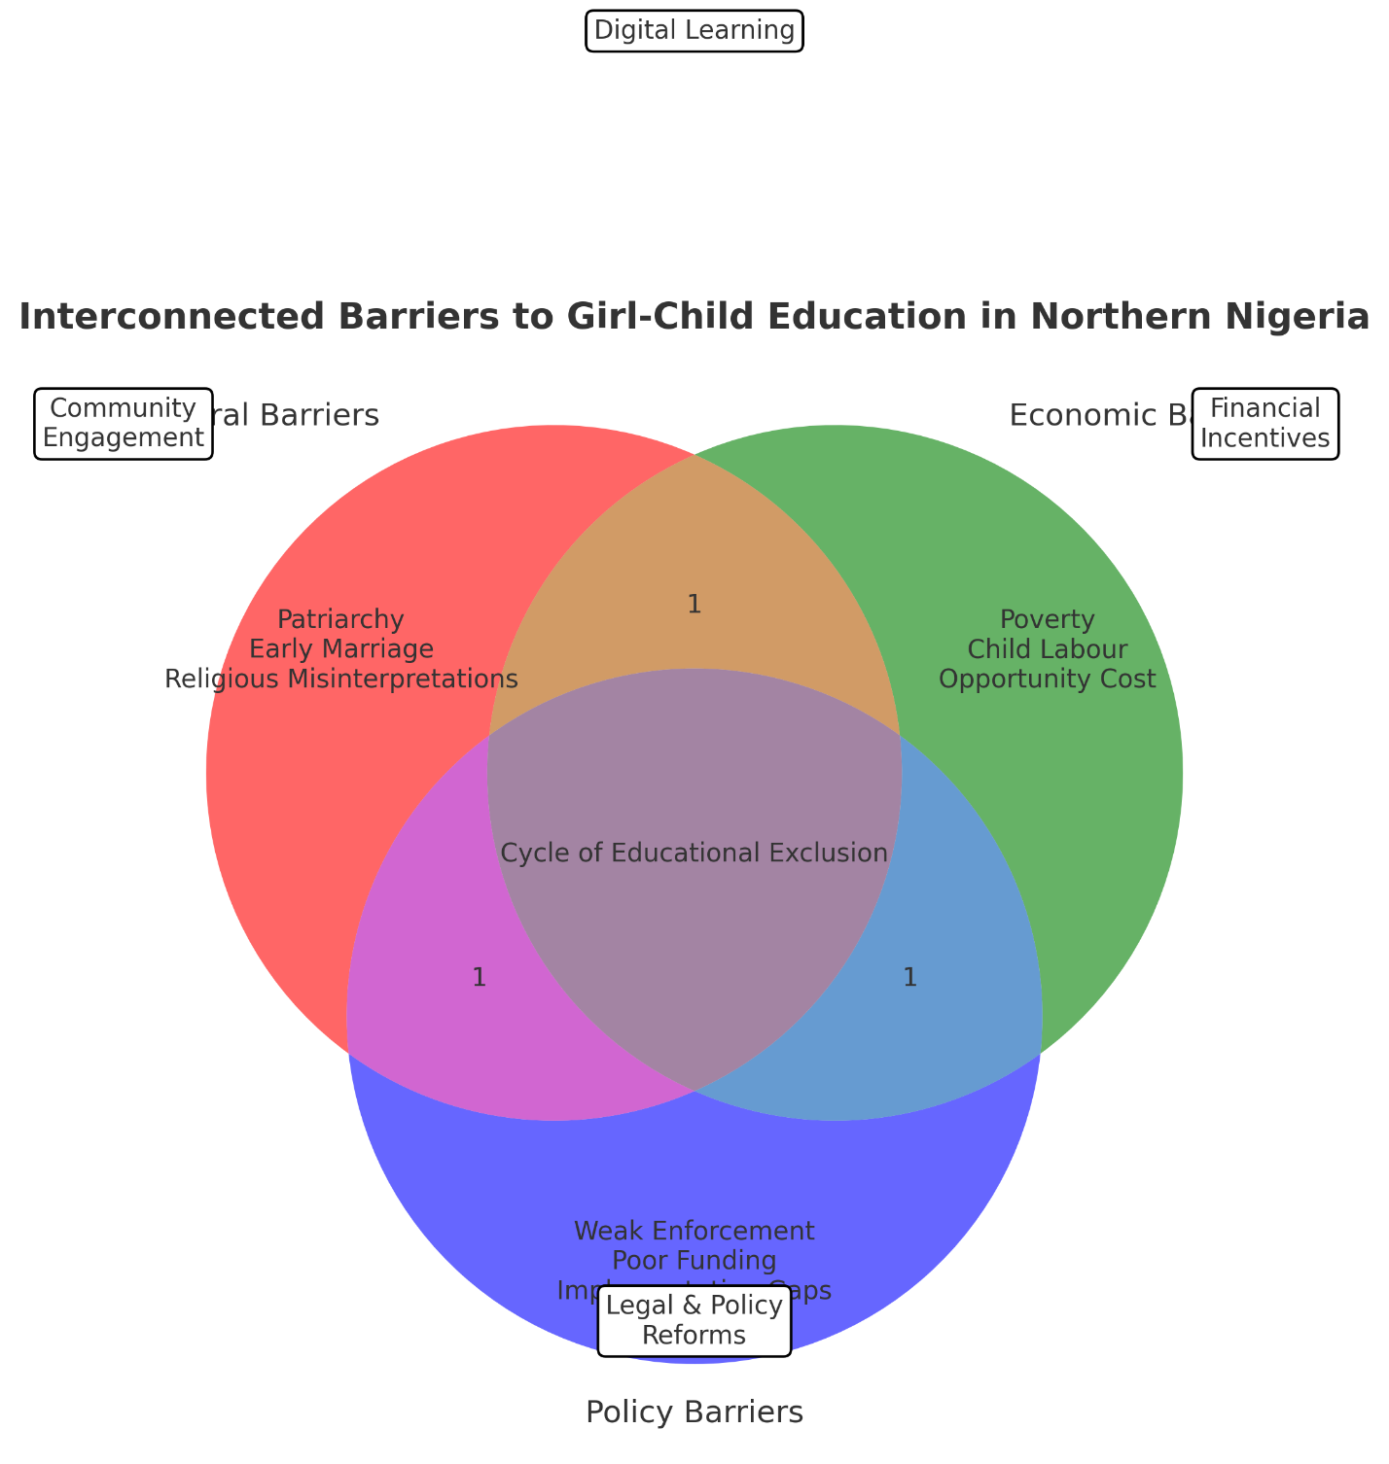
Figure 1. Conceptual framework of interconnected barriers to girl-child education in Northern Nigeria.
This figure shows how cultural, economic, and policy hurdles work together to keep girls from getting an education. The concept reveals how patriarchal attitudes, poverty, and poor policy execution all work together to keep gender inequity going. There are focused initiatives around the framework, such as community involvement, financial incentives, digital learning, and regulatory changes, that can assist break the cycle and provide females better chances to learn.

VII. Policy Implications and Recommendations

Targeted Interventions
Policy improvements should focus on specific actions that would help females in Northern Nigeria get over the problems they confront. Some of these are more gender-sensitive education programs that go against cultural conventions, giving families money to send their girls to school, and mobile education programs that can reach distant places. Localized solutions are necessary for success[5].

Engagement with Local Communities
Getting local communities involved is important for influencing how people think about girls' education. Community leaders, religious leaders, and parents should all be involved in policy efforts to promote girls' education. By putting together awareness campaigns and community dialogue sessions, people would be able to better grasp the benefits of educating females and get rid of detrimental cultural practices[22].

Financing Education
To help education, we should look into new ways to pay for it, like public-private partnerships, targeted international funds, and microfinancing for families. Conditional payment transfers to families that keep their daughters in school could help with the money problems. Also, for long-term sustainability, the government needs to give more money to schools, especially in areas that don't get enough[20].

Legal and Institutional Reforms
To make sure that rules guaranteeing girls' right to education are followed, legal frameworks need to be changed. To close the implementation gap, we need to make schools more capable, improve teacher training, and require gender-sensitive policies in school curriculums. The government must also make sure that education is delivered in a way that is open and honest[23].

VIII. Conclusion

Summary of Key Findings
This research finds that there are major obstacles to girls' education in Northern Nigeria, such as patriarchal norms, poverty, poor infrastructure, and gaps in policy implementation. These impediments are very closely related, which makes it hard for girls to get an education. The ongoing gender gap in education is caused by cultural norms, economic choices, and poor governance.

Future Research Directions
Future study should investigate the efficacy of digital education efforts, analyze regional disparities in educational access, and assess the long-term socio-economic consequences of enhanced education for females in Northern Nigeria.

Call to Action
Policymakers, community leaders, and foreign organizations must prioritize breaking the cycle of exclusion by implementing focused, sustainable solutions to enhance girls' education in Northern Nigeria.

REFERNCES

1. Department of History, Ahmadu Bello University, Zaria, Nigeria, Nasidi N. ‘MUST THEY GO TO SCHOOL?’ NORTHERN NIGERIA AND THE CHALLENGES OF GIRL CHILD EDUCATION, 1999-2015. jhs. 2024 Sep;60–9.
2. Azeez FA, Osiesi MP, Aribamikan CG, Doh Nubia W, Odinko MN, Blignaut S, et al. Exclusion of the female child from primary education: exploring the perceptions and experiences of female learners in northern Nigeria. Education 3-13. :1–20.
3. Olonade OY, Oyibode BO, Idowu BO, George TO, Iwelumor OS, Ozoya MI, et al. Understanding gender issues in Nigeria: the imperative for sustainable development. Heliyon. 2021 Jul 18;7(7):e07622.
4. Kruk ME, Gage AD, Arsenault C, Jordan K, Leslie HH, Roder-DeWan S, et al. High-quality health systems in the Sustainable Development Goals era: time for a revolution. Lancet Glob Health. 2018;6:e1196–252.
5. Azeez FA, Osiesi MP, Aribamikan CG, Nubia WD, Odinko MN, Blignaut S, et al. Exclusion of the female child from primary education: exploring the perceptions and experiences of female learners in northern Nigeria. Education 3-13 [Internet]. 2024 Jul 11 [cited 2025 Aug 17]; Available from: https://www.tandfonline.com/doi/abs/10.1080/03004279.2024.2308307
6. Ardo AM, Muhammad AA, Muhammed YZ. Islamic Perspectives on Girl Child Education: A Lesson to Nigerian Hausa Communities. JENTIK : Jurnal Pendidikan Teknologi Informasi dan Komunikasi. 2024 Jun 30;3(1):33–44.
7. Yoosefi Lebni J, Solhi M, Ebadi Fard Azar F, Khalajabadi Farahani F, Irandoost SF. Exploring the Consequences of Early Marriage: A Conventional Content Analysis. Inquiry. 2023 Apr 19;60:00469580231159963.
8. Eboyem SN. The Impact of Culture on the Girls’ Education: A Case Study of Kaduna State, Nigeria. European Journal of Humanities and Social Sciences. 2024 Aug 9;4(4):1–9.
9. Kazeem A, Jensen L, Stokes CS. School Attendance in Nigeria: Understanding the Impact and Intersection of Gender, Urban-Rural Residence and Socioeconomic Status. Comp Educ Rev. 2010 May;54(2):295–319.
10. Adewumi S, Bwowe P. Child Labour Challenges and Security Implications in Selected Local Government Areas in Ondo State, Nigeria. Social Sciences. 2024 Oct;13(10):512.
11. Olanrewaju GS, Adebayo SB, Omotosho AY, Olajide CF. Left behind? The effects of digital gaps on e-learning in rural secondary schools and remote communities across Nigeria during the COVID19 pandemic. Int J Educ Res Open. 2021;2:100092.
12. Nwoke C, Oyiga S, Cochrane L. Assessing the phenomenon of out-of-school children in Nigeria: Issues, gaps and recommendations. Review of Education. 2024;12(3):e70011.
13. Nwozor A, Okhillu B. Child’s Rights and the Challenges of Educating the Girl-Child: Assessing the Contributions of UNICEF in Nigeria. The Age of Human Rights Journal. 2022 Jun 23;(18):285–309.
14. Education sector analysis: the Federal Republic of Nigeria: assessing the status of education in the federation and Oyo, Adamawa and Katsina States - UNESCO Digital Library [Internet]. [cited 2025 Aug 17]. Available from: https://unesdoc.unesco.org/ark:/48223/pf0000379618
15. Eboyem SN. The Impact of Culture on the Girls’ Education: A Case Study of Kaduna State, Nigeria. European Journal of Humanities and Social Sciences. 2024 Aug 9;4(4):1–9.
16. Sharper S, Evans CS, Mwiya MS, Bowa M, Mutengo E, University KN. The effects of early marriages on academic performance of marginalized girls in secondary schools of central province in Zambia. BMC Public Health. 2025 Aug 16;25(1):2815.
17. Heath R, Jayachandran S. The Causes and Consequences of Increased Female Education and Labor Force Participation in Developing Countries. In: Averett SL, Argys LM, Hoffman SD, editors. The Oxford Handbook of Women and the Economy [Internet]. Oxford University Press; 2018 [cited 2025 Aug 17]. p. 0. Available from: https://doi.org/10.1093/oxfordhb/9780190628963.013.10
18. Yele WB, Specioza A. Decoding barriers and failures in Liberia’s educational policy implementation. World Journal of Advanced Research and Reviews. 2024;23(1):495–508.
19. Haleem A, Javaid M, Singh RP, Suman R. Telemedicine for healthcare: Capabilities, features, barriers, and applications. Sens Int. 2021;2:100117.
20. Lwamba E, Shisler S, Ridlehoover W, Kupfer M, Tshabalala N, Nduku P, et al. Strengthening women’s empowerment and gender equality in fragile contexts towards peaceful and inclusive societies: A systematic review and meta‐analysis. Campbell Syst Rev. 2022 Mar 8;18(1):e1214.
21. Enyioko (PhD) N. Gender Equality and Educational System in Nigeria [Internet]. Rochester, NY: Social Science Research Network; 2021 [cited 2025 Aug 17]. Available from: https://papers.ssrn.com/abstract=3825028
22. Entongwe D. Encouraging girl child education in my village. Journal of Comparative Social Work. 2011 Oct 3;6(2):137–46.
23. Psaki S, Haberland N, Mensch B, Woyczynski L, Chuang E. Policies and interventions to remove gender‐related barriers to girls’ school participation and learning in low‐ and middle‐income countries: A systematic review of the evidence. Campbell Syst Rev. 2022 Jan 19;18(1):e1207.

