Original Research Article
Genetic Divergence Analysis Using Mahalanobis D² Statistics in Black Gram [Vigna mungo (L.) Hepper]

ABSTRACT
Black gram (Vigna mungo (L.) Hepper), popularly referred to as urdbean or mash, is a grain legume domesticated from Vigna mungo var. silvestris. Esteemed for its exceptional nutritional profile, it is notably abundant in phosphoric acid and calcium. The aim of the study is to diversity analysis in Black gram. The present investigation was conducted at the Field Experimentation Centre, Department of Genetics and Plant Breeding, Naini Agricultural Institute, SHUATS, Prayagraj, Uttar Pradesh during the Zaid season of 2019. Fifty diverse genotypes of black gram were evaluated under field conditions to assess character association and contribution of yield-attributing traits through correlation and path coefficient analyses. The experimental site, benefited from institutional support for resources and management, ensuring successful trial execution. Results revealed highly significant genotypic differences (p ≤ 0.05) across all 17 studied traits, indicating substantial genetic variability with potential for crop improvement. Based on Mahalanobis’ D² statistics, fifty genotypes of black gram were stratified into seven well-defined clusters, reflecting considerable genetic diversity. Cluster I encompassed the largest number of genotypes (30), followed by Cluster III with 12 genotypes. Cluster II housed four genotypes, while Clusters IV, V, VI, and VII were monotypic, each comprising a single genotype. Intra-cluster D² distances ranged from 0.00 to 24.11, with Cluster III exhibiting the highest intra-cluster divergence (24.11), indicative of significant genetic heterogeneity within this group. The inter-cluster D² values among genotypes spanned from 33.17 to 168.17, underscoring marked genetic variability across clusters. The most substantial genetic divergence was recorded between Clusters IV and VI (168.17), followed by Clusters II and VI (137.92), and Clusters IV and VII (115.80), suggesting these combinations may be particularly promising for hybridisation to exploit heterosis and broaden the genetic base. It was also reported that plant height, number of branches per plant, number of clusters per plant, number of pods per plant, number of seeds per pod, biological yield per plant, 100-seed weight, harvest index and seed yield per plant—together accounted for approximately 86.90% of the total genetic divergence.

Keywords: Vigna mungo,, Genetic divergence; Black gram; Diversity; Analysis; genotypes
Introduction
Blackgram (Vigna mungo) is one of the important pulse crops. The food legumes, particularly the grain or pulses, are important foodstuffs in all tropical and subtropical countries. It is grown throughout India. Blackgram is a widely grown grain legume and belongs to the family
“leguminosae” and genus “vigna” and assumes considerable importance from the point of
food and nutritional security in the world. It is also known as urdbean, udad dal, urad dal or
urad (Sasidhar et al., 2022; Nair et al., 2024). It is popularly referred to as urdbean or mash, is a grain legume domesticated from Vigna mungo var. silvestris. Esteemed for its exceptional nutritional profile, it is notably abundant in phosphoric acid and calcium. Owing to its remarkable fermentative capacity, black gram occupies a central role in the culinary preparation of various fermented delicacies. This versatile crop is cultivated both in monoculture and in intercropping systems, thereby serving as a pivotal element in diversified agricultural practices. Predominantly cultivated in India, this fast-maturing, short-duration pulse is an indispensable dietary staple, lauded for its provision of highly digestible, superior-quality protein. Beyond its nutritional merits, black gram contributes significantly to agro-ecological sustainability through its capacity for atmospheric nitrogen fixation in symbiosis with soil microflora, thereby enhancing soil fertility. From a compositional standpoint, it constitutes an impressive reservoir of essential nutrients, encompassing approximately 20–25% protein—nearly thrice the protein concentration found in cereal grains—alongside 40–47% starch. Additionally, it comprises fats, ash, carbohydrates, and vital micronutrients, rendering it a holistic dietary constituent. The seeds, primarily consumed as a staple, are typically processed by dehulling and splitting into dhal, a fundamental component of Indian cuisine. Taxonomically, black gram belongs to the family Leguminosae, subfamily Papilionoideae. It is an annual, self-pollinated, leguminous crop with a diploid chromosome number of 2n = 2x = 22. India, regarded as its centre of origin, continues to be the foremost producer and consumer of black gram globally (Khan et al. 2020). Yield, being a polygenic and multifactorial trait, is governed by a network of interrelated physiological processes. Due to its complex inheritance and association with multiple yield-contributing components, direct genetic enhancement of yield is often challenging. Instead, indirect selection through the improvement of correlated traits offers a more viable strategy. However, the systematic germplasm collections of black grams have revealed limited genetic variability for both biotic and abiotic stress tolerance. It is postulated that the dominant influence of natural selection may have eroded genes conferring high productivity (Roopalakshmiet al. 2003), resulting in a narrow genetic base in modern germplasm. The assessment of germplasm is perhaps one of the most significant natural resources for providing the necessary traits to produce high-yielding, input-responsive cultivars that are tolerant to a variety of abiotic and biotic stresses (Yadav et al., 2024). Furthermore, the autogamous nature of black gram restricts the effectiveness of hybridisation for creating variability, as it is prone to flower abscission and poor cross-pollination success (Deepalakshmi and Anandakumar, 2004). The significance of genetic variability was first highlighted by Vavilov (1935), who emphasised that a broader genetic base enhances the probability of selecting desirable genotypes (Garg et al. 2017). To quantify genotypic divergence and assess the contribution of different traits to total variability, multivariate analysis using Mahalanobis’ D² statistic serves as a powerful tool. This analysis facilitates the grouping of germplasm collections into relatively homogeneous clusters, thereby streamlining the evaluation process. The D² statistic is particularly effective in identifying divergent genotypes, which can be utilised to exploit heterosis and introgress desirable alleles into breeding populations (Mahalanobis, 1936). The success of hybridisation programs largely hinges on selecting genetically diverse parents with significant variability for traits of interest. The genetic diversity among genotypes may stem from geographical separation or genetic barriers to crossability. The D² technique effectively measures differentiation at intra- and inter-cluster levels, aiding breeders in selecting genetically divergent parents. When applying D² statistics, three factors should be considered: the relative contribution of each trait, the statistical distance between clusters, and the selection of elite genotypes from distant clusters. This technique was effectively employed by Kumar et al. (2022) in predicting mungbean diversity.
MATERIALS AND METHODS
At the Field Experimentation Centre of the Department of Genetics and Plant Breeding, Naini Agricultural Institute, Sam Higginbottom University of Agriculture, Technology and Sciences (SHUATS), Prayagraj, Uttar Pradesh, a series of three experiments was conducted during Zaid-2019. The university is conveniently accessible due to its strategic location along the Prayagraj–Rewa National Highway, about 5 kilometres from Prayagraj City. Through field preparation, the provision of necessary inputs, irrigation facilities, and labour resources, the Department of Horticulture provided unwavering support throughout the experimental period, ensuring the smooth and effective execution of this scientific endeavour. During Zaid-2019 (first year), 50 genotypes of black gram were evaluated under field conditions to identify the divergent lines based on the D² statistic (Mahalanobis, 1936). The Fisher and Yates (1963) method was used to statistically analyse the data. The characters studied comprised of days to 50% flowering; days to 50% maturity; plant height (cm); number of branches per plant; number of clusters per plant; number of pods per plant; pod length (cm); number of seeds per pod; seed index (g); biological yield (g); seed yield per plant (g); harvest index (%).
RESULTS AND DISCUSSION
Analysis of Variance
Mean sum squares data for 12 characters of black gram studied in the first season during Zaid-2019 were subjected to analysis of variance for experimental design. The analysis of variance for different characters is presented in Table 1. The analysis of variance showed highly significant differences (α=0.05) among 50 genotypes for all characters studied, indicating the presence of a considerable amount of genetic variability among black gram germplasms. It also indicated the scope of selection for the genetic improvement of black gram. This variability can be harnessed to improve yield and other agronomic traits through systematic breeding, making it possible to develop high-yielding and resilient black gram cultivars suited to different agro-climatic conditions. Hence, the findings justify further genetic studies and selection efforts for crop improvement. These findings are consistent with previous research by Khan et al. (2020), Patel and Bala (2020), Saran et al. (2022), Yergude et al. (2021) and Bharathi et al. (2022).
Genetic Diversity
Genetic diversity plays a pivotal role in plant breeding, as hybrids derived from genetically divergent parental lines often exhibit greater heterosis compared to those originating from closely related genotypes. To quantify genetic divergence, Mahalanobis' D² statistic (Mahalanobis, 1936) has proven to be an effective multivariate tool, facilitating the estimation of divergence both within clusters (intra-cluster) and between clusters (inter-cluster). This statistical approach is instrumental in identifying genetically diverse parents, thereby enhancing the efficiency of hybridisation programmes aimed at broadening the genetic base. In the present study, D² analysis was performed to evaluate the magnitude of genetic divergence among 50 black gram (Vigna mungo) genotypes for first-season trials, during Zaid-2019. The genotypic clustering was executed using Tocher’s method (Rao, 1952), which categorises genotypes into homogeneous groups based on D² values. The significance of variation among genotypes across the seventeen traits studied was tested using Wilk’s lambda (V) statistic, where a computed value of 115 indicated statistically significant differences among genotypes. The corresponding significance of the V-statistic was validated using the Chi-square distribution at 588 degrees of freedom, affirming the presence of substantial multivariate variability. The application of the D² metric not only quantified the extent of genetic divergence but also elucidated the relative contribution of individual traits toward total divergence. This information is crucial for identifying traits contributing most to genetic differentiation. It was observed that genotypes clustered singly exhibited minimal divergence, whereas genotypes distributed across multiple clusters displayed pronounced genetic separation. Notably, maximum divergence was recorded between the clusters with the greatest inter-cluster D² values, suggesting that these genotypic groups are the most genetically distinct and, therefore, the most promising candidates for exploitation in heterotic breeding programmes.

Table 1 Analysis of Variance (ANOVA) for 12 characters in 50 genotypes of black gram. (Tripathi et al. 2025)
ANOVA Summary
Sl. No. | Source | Mean Sum of Squares (MSS)
Sl. No. | Source | Replications | Genotypes | Error
Sl. No. | Degrees of freedom | n=2 | n=49 | n=98
1 | Days to 50% flowering | 1.56 | 18.60** | 3.74
2 | Days to 50% maturity | 8.91 | 14.67** | 5.12
3 | Plant height (cm) | 39.17 | 311.84* | 13.55
4 | Number of branches per plant | 0.01 | 13.06** | 0.92
5 | Number of clusters per plant | 0.27 | 11.66** | 1.13
6 | Number of pods per plant | 6.43 | 208.89* | 10.38
7 | Pod length (cm) | 0.02 | 0.78** | 0.11
8 | Number of seeds per pod | 0.34 | 1.47** | 0.18
9 | 100 seed weight (g) | 0.03 | 0.80** | 0.08
10 | Biological yield per plant | 2.16 | 72.74* | 4.78
11 | Seed yield per plant (g) | 0.87 | 8.44** | 1.01
12 | Harvest Index (%) | 8.90 | 59.89** | 7.86
**,* Significant at 1% and 5% level of significance respectively

- Cluster Composition
Fifty black gram genotypes were classified into seven distinct clusters [Table 2& Figure 1] based on Tocher’s method (Rao, 1952) utilising Mahalanobis' D² statistics. Cluster 1 comprised the highest number of genotypes, with 30 entries, followed by cluster 3 with 12 genotypes. Cluster 2 contained four genotypes, while clusters 4, 5, 6, and 7 each included a single genotype. Similar findings were reached by Vyas et al. (2018) in their work with black gram, reporting 5 clusters from 22 genotypes, and Rajasekhar and Lal (2020) in their report on 6 clusters from 38 genotypes. Mallikarjuna et al. (2021) reported partitioning into 7 clusters of a total of 40 genotypes of black gram. While Reni et al. (2022) grouped 59 genotypes of black gram into seven distinct classes based on their genetic diversity using D² statistics.
- Average intra and inter-cluster divergence
Table 3 and Figure 2 present the average intra- and inter-cluster D² values for black gram genotypes. The average intra-cluster D² values ranged from 0.00 to 24.11. Among the clusters, Cluster 3, which comprised 12 genotypes, exhibited the highest intra-cluster divergence (24.11), followed by Cluster 1 with 30 genotypes (19.55) and Cluster 2 with four genotypes (12.44). In contrast, Clusters 4, 5, 6, and 7 each contained a single genotype, resulting in intra-cluster D² values of zero. The average inter-cluster D² values among black gram genotypes varied from 33.17 to 168.17. The greatest genetic divergence was observed between Clusters 4 and 6 (168.17), followed by Clusters 2 and 6 (137.92), and Clusters 4 and 7 (115.80). Other notable distances included 102.98 between Clusters 5 and 7, 91.99 between Clusters 5 and 6, and 81.13 between Clusters 5 and 2. The D² value between Clusters 1 and 6 was 80.64, while Cluster 3 showed a distance of 75.05 from Cluster 4 and 61.67 from Cluster 5. Additionally, Clusters 2 and 3 recorded a D² value of 59.20, followed by 55.13 between Clusters 6 and 7, 54.55 between Clusters 1 and 7, and 51.88 between Clusters 2 and 7. The D² value between Clusters 4 and 5 was 49.18, between Clusters 3 and 4 was 46.83, and between Clusters 3 and 6 was 45.92. Clusters 3 and 7 shared a D² value of 41.27, while the values for Clusters 5 and 1, and Clusters 1 and 2 were 39.83 and 39.20, respectively. Clusters 1 and 4 had a D² value of 34.52.

Table 2: Composition of clusters in black gram genotypes
Cluster Group | No. of Genotypes | List of Genotypes
Cluster 1 | 30 | No-1314, PLU-250, PLU-93-52, IPU-2K-88-221, No-40, PLU-294, IC-10703, PLU-429, UH-85-5, IPU-2K-22, PDU-2E, PLU-59, No-236818, UH 85-2, PLU-4815, PKRU 03, PLU-708, No 7368-1 5, PLU-110, BGP 21-28, PLU-302, PLU 570, SN 2115, TU-99-2, PLU-98-10, PDU-3, IPU-1070, PL-416, SPS-40 and SPS-42
Cluster 2 | 4 | PDU-1, NG-2118, Shekher-2 and PLU-7S1
Cluster 3 | 12 | LBG 20, TAU-1, T-9, Co-6, DPU-88-31, UG-27, IPU-02-43, NP-16, IPU-94-1, H-1, PLU 856 and JU-2
Cluster 4 | 1 | IPU-95-13
Cluster 5 | 1 | PLU 557
Cluster 6 | 1 | LBG-752
Cluster 7 | 1 | Uttara

Table 3 Average Intra Cluster (Bold) and Inter Cluster D² value in black gram genotypes
Cluster Distances
 | Cluster 1 | Cluster 2 | Cluster 3 | Cluster 4 | Cluster 5 | Cluster 6 | Cluster 7
Cluster 1 | 19.55 | 39.20 | 33.17 | 34.52 | 39.83 | 80.64 | 54.55
Cluster 2 |  | 12.44 | 59.20 | 46.83 | 81.13 | 137.92 | 51.88
Cluster 3 |  |  | 24.11 | 75.05 | 61.67 | 45.92 | 41.27
Cluster 4 |  |  |  | 0.00 | 49.18 | 168.17 | 115.80
Cluster 5 |  |  |  |  | 0.00 | 91.99 | 102.98
Cluster 6 |  |  |  |  |  | 0.00 | 55.13
Cluster 7 |  |  |  |  |  |  | 0.00

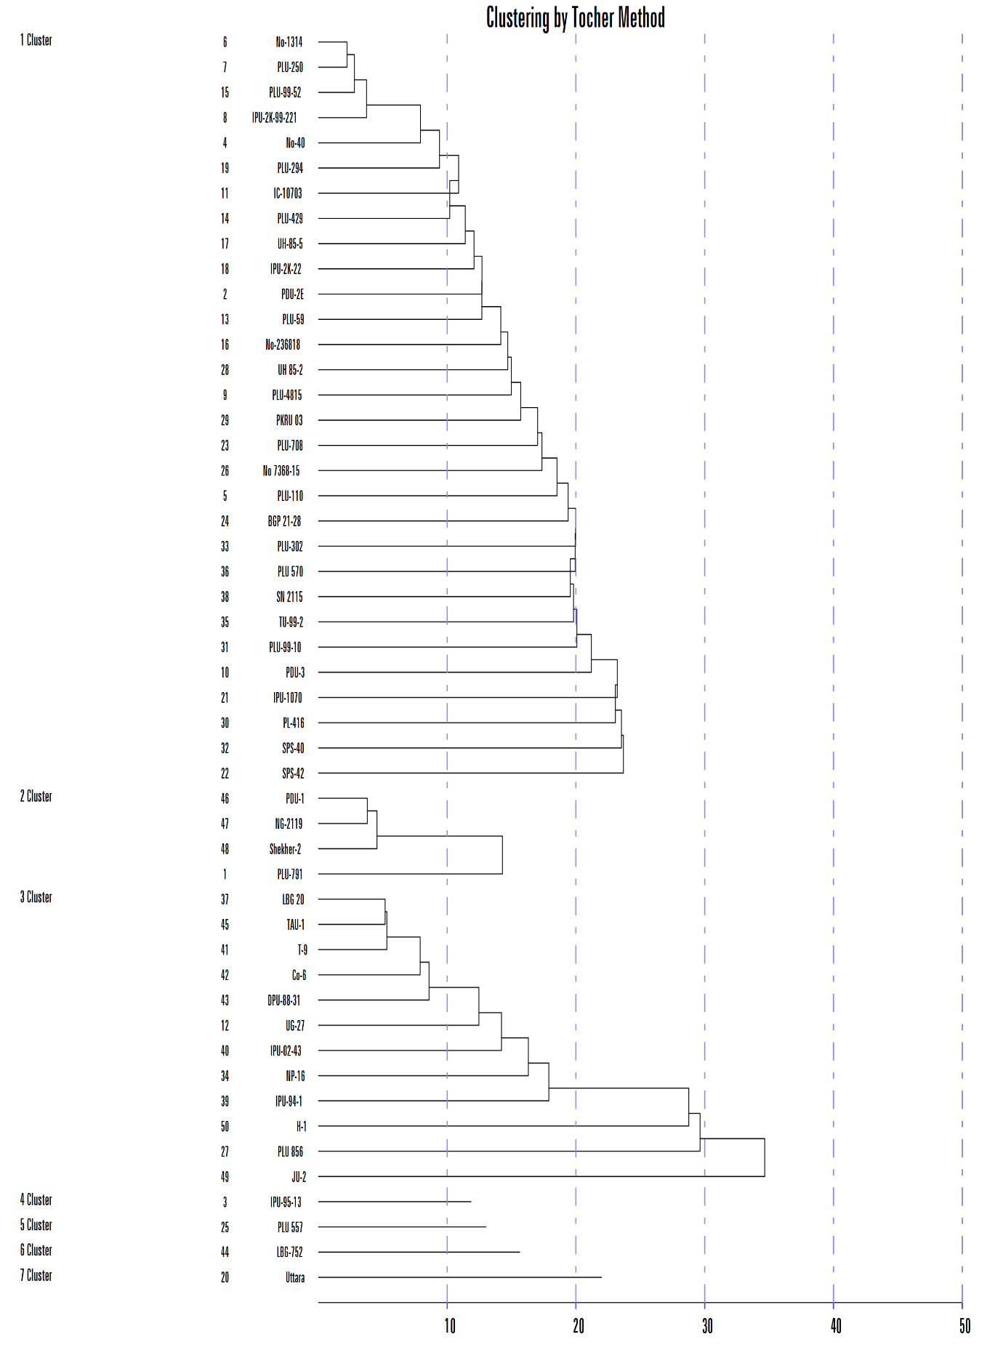
Figure 1 Cluster composition of 50 genotypes represented in Dendrogram using Tocher’s Method.

The minimum inter-cluster distance was observed between Clusters 1 and 3 (33.17), indicating the highest degree of genetic similarity between these two groups. Similar findings were reported in black gram by Saran et al. (2022), who aimed to use a total of 36 black gram genotypes, and by Suchitra et al. (2023), working with 45 black gram genotypes to study diversity.
3 Cluster mean for observed characters
The mean cluster values for twelve agronomic traits of black gram genotypes are presented in Table 4. A comparative analysis of these mean values revealed notable inter-cluster variability. Cluster 6, represented by a single genotype, recorded the highest values for several key yield-contributing traits, including seed yield per plant (14.31 g), harvest index (45.02%), biological yield per plant (26.64 g), 100-seed weight (5.72 g), number of seeds per pod (7.20), pod length (5.48 cm), and number of pods per plant (46.33). Additionally, this genotype exhibited the second-highest plant height (74.86 cm), while the days to 50% flowering (43.33) and days to maturity (63.33) were moderate, indicating a balanced phenological profile. Cluster 7, also represented by a single genotype, was the earliest to reach 50% flowering (37.00 days) and maturity (57.00 days), highlighting its potential for early maturing conditions. This genotype also ranked second for number of branches per plant (16.67), number of pods per plant (45.07), 100-seed weight (4.90 g), seed yield per plant (12.20 g), and harvest index (44.41%), while it exhibited the highest number of clusters per plant (17.58), suggesting a compact and prolific plant type. Cluster 2, containing four genotypes, showed the highest value for number of branches per plant (17.05) and ranked second in earliness to flowering and maturity (62.17 days), number of clusters per plant (16.60), and pod length (4.97 cm), indicating its potential for both early maturity and robust plant architecture.
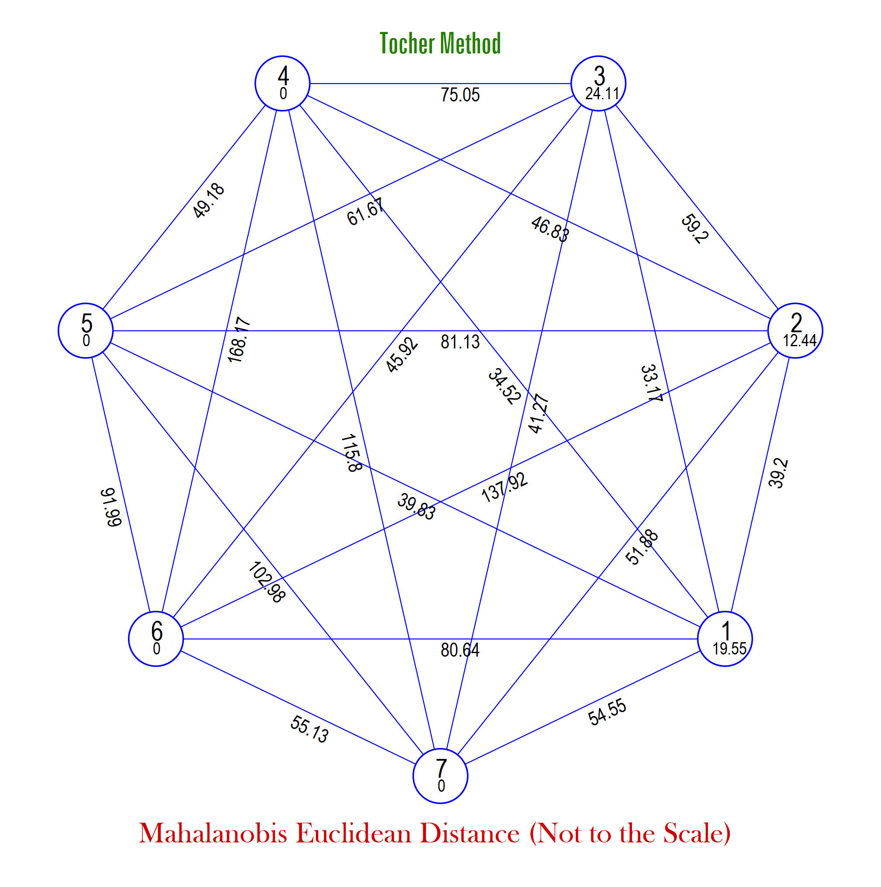
Figure 3 Cluster Diagram using Tocher’s method.

Table 4 Cluster mean value for various seed yield characters in different clusters of black gram genotypes.
Cluster Means: Tocher Method
Clusters | Days to 50% flowering | Days to 50% maturity | Plant height (cm) | Number of branches per plant | Number of clusters per plant | Number of pods per plant | Pod length (cm) | Number of seeds per pod | 100 seed weight (g) | Biological yield per plant | Seed yield per plant (g) | Harvest Index (%)
Cluster 1 | 42.81 | 63.90 | 53.08 | 13.67 | 12.97 | 26.21 | 4.30 | 6.08 | 4.27 | 20.47 | 9.92 | 38.09
Cluster 2 | 39.25 | 62.17 | 41.23 | 17.05 | 16.60 | 30.86 | 4.97 | 4.79 | 3.63 | 16.94 | 9.09 | 29.02
Cluster 3 | 44.28 | 65.03 | 56.02 | 12.84 | 13.41 | 39.76 | 4.62 | 6.33 | 4.31 | 26.06 | 11.88 | 37.93
Cluster 4 | 40.67 | 62.00 | 48.73 | 14.00 | 9.20 | 15.22 | 3.55 | 5.31 | 3.40 | 20.33 | 6.37 | 33.05
Cluster 5 | 43.33 | 65.33 | 81.41 | 13.17 | 12.23 | 21.33 | 4.67 | 5.40 | 3.73 | 18.03 | 9.98 | 44.17
Cluster 6 | 43.33 | 63.33 | 74.86 | 12.22 | 13.00 | 46.33 | 5.48 | 7.20 | 5.72 | 26.64 | 14.31 | 45.02
Cluster 7 | 37.00 | 57.00 | 49.53 | 16.67 | 17.58 | 45.07 | 4.70 | 5.85 | 4.90 | 23.13 | 12.20 | 44.41

4 Contribution of various characters towards total divergence
The contribution of individual traits to the total genetic divergence in black gram germplasm was assessed following the method outlined by Singh and Chaudhary (1985), and the results are presented in Table 5 and Figure 4. The percentage contribution of individual traits toward total genetic divergence in black gram, along with their frequency of being ranked first, is summarised in the table. Among the twelve traits evaluated, seed yield per plant exhibited the highest contribution (14.43%) and was most frequently ranked first (180 times), underscoring its pivotal role in overall genetic divergence. This was closely followed by biological yield per plant (13.47%, ranked first 168 times), number of branches per plant (11.67%, 146 times), and number of pods per plant (9.88%, 124 times), highlighting their substantial influence on diversity among genotypes. Other traits that significantly contributed included plant height (9.23%), harvest index (8.51%), and number of clusters per plant (7.43%). Traits such as number of seeds per pod (6.21%), 100-seed weight (6.07%), and pod length (5.14%) also showed moderate contributions. Meanwhile, days to 50% maturity (5.38%) and days to 50% flowering (2.58%) had relatively lower influence, though their contributions remain relevant in the context of crop earliness. Notably, nine traits—plant height, number of branches per plant, number of clusters per plant, number of pods per plant, number of seeds per pod, biological yield per plant, 100-seed weight, harvest index and seed yield per plant—together accounted for approximately 86.90% of the total genetic divergence. Collectively, these findings suggest that traits directly associated with yield components—such as seed yield, biological yield, and number of branches and pods per plant—should be prioritised in selection strategies aiming at broadening genetic diversity and enhancing productivity in black gram breeding programs. Similar findings were reported by Suchitra et al. (2023), who observed significant contributions of biological yield per plant, harvest index and seed yield per plant towards overall productivity. Prasanna et al. (2024) highlighted the role of the number of pods per plant and 100-seed weight in yield enhancement. Furthermore, Reni et al. (2022) emphasised that the number of seeds per pod, plant height and pod length were major contributors to genetic divergence in black gram. These studies collectively support the notion that improvements in any of these key traits could lead to a concurrent enhancement in seed yield due to the correlated response among them. Such findings reinforce the utility of indirect selection strategies in crop improvement programs, especially when direct selection for yield is constrained by its polygenic nature and environmental interactions.
.
Table 5. Percent contribution of individual traits towards total divergence
Sl. No. | Source | Contribution % | Times ranked 1st
1 | Days to 50% flowering | 2.58 | 32
2 | Days to 50% maturity | 5.38 | 67
3 | Plant height (cm) | 9.23 | 115
4 | Number of branches per plant | 11.67 | 146
5 | Number of clusters per plant | 7.43 | 93
6 | Number of pods per plant | 9.88 | 124
7 | Pod length (cm) | 5.14 | 64
8 | Number of seeds per pod | 6.21 | 78
9 | 100 seed weight (g) | 6.07 | 76
10 | Biological yield per plant | 13.47 | 168
11 | Seed yield per plant (g) | 14.43 | 180
12 | Harvest Index (%) | 8.51 | 106

Figure 4 Histogram of percentage contribution of individual traits towards total divergence

CONCLUSION
On the basis of Mahalanobis’ D² statistics fifty black gram genotypes were classified into seven distinct clusters. Cluster 1 comprised the highest number of genotypes, with 30 entries, followed by cluster 3 with 12 genotypes. Cluster 2 contained four genotypes, while clusters 4, 5, 6, and 7 each included a single genotype. The average intra-cluster D² values ranged from 0.00 to 24.11. Among the clusters, Cluster 3, which comprised 12 genotypes, exhibited the highest intra-cluster divergence (24.11). The average inter-cluster D² values among black gram genotypes varied from 33.17 to 168.17. The greatest genetic divergence was observed between Clusters 4 and 6 (168.17), followed by Clusters 2 and 6 (137.92), and Clusters 4 and 7 (115.80). A comparative analysis of these mean values revealed notable inter-cluster variability. Cluster 6, represented by a single genotype, recorded the highest values for several key yield-contributing traits, including seed yield per plant (14.31 g), harvest index (45.02%), biological yield per plant (26.64 g), 100-seed weight (5.72 g), number of seeds per pod (7.20), pod length (5.48 cm), and number of pods per plant (46.33). Additionally, this genotype exhibited the second-highest plant height (74.86 cm), while the days to 50% flowering (43.33) and days to maturity (63.33) were moderate, indicating a balanced phenological profile. It was also reported that plant height, number of branches per plant, number of clusters per plant, number of pods per plant, number of seeds per pod, biological yield per plant, 100-seed weight, harvest index and seed yield per plant—together accounted for approximately 86.90% of the total genetic divergence.

Disclaimer (Artificial intelligence)
Option 1:
Author(s) hereby declare that NO generative AI technologies such as Large Language Models (ChatGPT, COPILOT, etc.) and text-to-image generators have been used during the writing or editing of this manuscript.
Option 2:
Author(s) hereby declare that generative AI technologies such as Large Language Models, etc. have been used during the writing or editing of manuscripts. This explanation will include the name, version, model, and source of the generative AI technology and as well as all input prompts provided to the generative AI technology
Details of the AI usage are given below:
1.
2.
3.

References

Bharathi, D., Reddy, K. H., Reddy, D. M., Latha, P., and Reddy, B. R. (2022). Genetic variability studies for yield, its attributes and quality traits in black gram [Vigna mungo (L.)]. Journal of Research ANGRAU.50(4): 27-36.
Deepalakshmi, A. J., Anandakumar, C. K. (2004). Creation of genetic variability for different polygenic traits in black gram (Vigna mungo (L.) Hepper) through induced mutagenesis. Legume Research.3:188-192.
Fisher, R. A. and Yates, F. (1963). Statistical Tables for Biological, Agricultural and Medical Research. Oliver and Boyd, London: 143 p.
Garg, G.K., Verma, P.K., Kesh, H., and Kumar, A. (2017). Genetic divergence for seed quality traits in mungbean (Vigna radiata (L.) Wilczek). Indian Journal of Agricultural Research,51(6): 521-528.
Khan, T., Dubey, R. B., Nagar, K. K., and Bairwa, L. L. (2020). Studies on Genetic Variability in Genotypes of Black gram [Vigna mungo (L.) Hepper]. International Journal of Current Microbiology and Applied Sciences. 9(3): 2736-2741.
Kumar, S., Kumar, A., Abrol, V., Singh, A.P., and Singh, A.K. (2022). Genetic variability and divergence studies in mungbean (Vigna radiata) under rainfed conditions. Indian Journal of Agricultural Sciences.90(5): 905–908.
Mahalanobis, P. C. (1936). On the Generalized Distance in Statistics. Proceeding of the National Institute of Science of India. 2: 49- 55.
Mallikarjuna, G., Rao, K. N., Srinivas, T., Ramesh, D., and Tushara, M. (2021). Genetic diversity studies in black gram. The Pharma Innovation Journal.10(11): 1160-1164.
Patel, R. N., and Bala, M. (2020). Genetic variability study for yield and its components in black gram [Vigna mungo (L.) Hepper]. Journal of Pharmacognosy and Phytochemistry.9(4): 2061-2064.
Prasanna, G. S. Shai, Muraleedharan, A., and Joshi, J. L. (2024). Studies on genetic divergence analysis in black gram (Vigna mungo L. Hepper) genotypes. Annual Research and Review in Biology. 39(3): 58-63.
Rajasekhar, D., and Lal, G. M. (2020). Genetic diversity studies of black gram genotypes growing in Northern India. Journal of Experimental Biology and Agricultural Sciences.8(3): 265-268.
Rao, C.R. (1952). Advanced Statistical Methods in Biometrical Research. John Wiley and Sons Inc., New York: 383 p.
Reni, Y. P., Ramana, M. V., Rajesh, A. P., Madhavi, G. B., and Prakash, K. K. (2022). Genetic divergence studies in black gram (Vigna mungo L.) genotypes. The Pharma Innovation Journal. 11(2): 2153-2158.
Roopalakshmi, K., Kajjidoni, S. T. and Salimath, S. M. (2003). Effect of irradiation and matting schemes on native of association of seed yield and its components in black gram. Legume Research. 26(4):288-291.
Saran, S., Somya, M., Surya Kirupa, M., Surya S., Nair, and Nagalakshmi, R. M. (2022). Studies on genetic diversity, variability, correlation and path analysis in black gram (Vigna mungo). Journal of Pharmacognosy and Phytochemistry.11(6): 90-94.
Singh, R. K and Chaudhary, B. D. (1985). Biometrical Methods in Quantitative Genetic Analysis. Kalyani Publishers, New Delhi: 318 p.
Suchitra, C., and Lal, G. M. (2023). Study on genetic diversity in black gram (Vigna mungo L. Hepper). International Journal of Plant and Soil Science.35(20): 302-311.
Vavilov, N. I. (1936) Origin and geography of cultivated plants. Archives of natural history, 21(1): 142.
Vyas, D., Joshi, A., and Kedar, O. P. (2018). Genetic diversity analysis of black gram (Vigna mungo L.). Journal of Pharmacognosy and Phytochemistry.7(3): 2535-2538.
Yergude, P., Rakshe, M. B., and Ujjainkar, V. V. (2021). Genetic variability analysis in Blackgram [Vigna mungo L. Hepper]. The Pharma Innovation Journal.10(9): 1447-1451.
Sasidhar, P., Singh, S., & Sanodiya, L. K. (2022). Effect of spacing and biofertilizer on growth and yield of black gram (Vigna mungo L.). The Pharma Innovation Journal, 11(2), 2866-2869.
Nair, R. M., Chaudhari, S., Devi, N., Shivanna, A., Gowda, A., Boddepalli, V. N., ... & Somta, P. (2024). Genetics, genomics, and breeding of black gram [Vigna mungo (L.) Hepper]. Frontiers in plant science, 14, 1273363.
Yadav, M., Kumari, J., Gantait, A., Kumar, V., & Maxton, A. (2024). Assessment of Genetic Diversity for Yield Component Traits and Grain Yield of Blackgram [Vigna mungo (L.) Hepper]. Journal of Experimental Agriculture International, 46(9), 426–433.
Tripathi, Avneesh Mani, and Gaibriyal M. Lal. 2025. “Integrative Genetic Association and Path Coefficient Analysis for Dissecting Complex Trait Architecture in Black Gram (Vigna Mungo L. Hepper)”. Journal of Advances in Biology & Biotechnology 28 (6):807-18. https://doi.org/10.9734/jabb/2025/v28i62444

