Review Article

Rethinking Nigeria’s Basic Education Curriculum for the Future Amidst Global Competency Standard: Integrating 21st-Century Skills

Abstract.
Because technology, the economy, and society are changing rapidly, there is growing global demand for schools to teach 21st-century competencies such as critical thinking, creativity, teamwork, communication, digital literacy, and global citizenship. These skills are central to sustainable development and competitiveness, as highlighted in the Partnership for 21st Century Learning, UNESCO’s Education 2030 Agenda, and the OECD Global Competence Framework. This review examines the extent to which Nigeria’s basic education curriculum aligns with international standards and explores strategies for integration. Drawing on peer-reviewed literature, comparative case studies, and policy documents, the study reveals a wide gap between Nigeria’s content-heavy, exam-driven curriculum and global competency-based models. Lessons from Kenya, India, Finland, and Singapore demonstrate the importance of flexible curricula, skill integration, formative assessment, and strong teacher development. Unlike prior studies that primarily describe curriculum deficits, this paper uniquely synthesizes international lessons, Nigerian policy realities, and a context-sensitive integration framework. Its novelty lies in proposing an actionable model tailored to Nigeria’s socio-cultural and infrastructural context, bridging global best practices with local needs. Key strategies include targeted teacher training, stronger policy commitment, equitable ICT access, and coordinated partnerships with government, NGOs, and international organizations. This study offers both a conceptual and practical framework for incorporating 21st-century skills into Nigeria’s basic education while advancing policy dialogue and comparative education scholarship. By linking theory, evidence, and measurable reforms, it provides a roadmap for aligning Nigeria’s curriculum with global standards and preparing learners for the demands of the future.
Keywords: 21st-century skills, competency-based education, curriculum reform, Nigeria, global education standards, teacher training

1. Introduction
Around the world, schools are moving away from rote memorization and content-heavy models and toward competency-based learning. This provides students the skills they need to do well in a world that is growing more connected and changing quickly. This transition is happening because people have realized that the problems of the 21st century, such as climate change and changes in the job market, need a workforce that can think critically, solve complex problems, cooperate with people from other cultures, and adapt to new environments(Darling-Hammond et al., 2020). International groups like the OECD and UNESCO have stressed the need for educational systems that include digital literacy, socioemotional skills, and global competency as important parts of basic education(Erstad et al., 2024).
Nigeria, which has the most people in Africa and is a developing economy, is under a lot of pressure to modernize its basic education curriculum to reflect these developments in the globe. The National Policy on Education and other policy papers say that it's important to get students ready for the digital economy, yet the current curriculum is still mostly focused on content and tests. Teaching, learning, and testing do not do a good job of addressing core 21st-century abilities like creativity, problem-solving, digital literacy, and global citizenship(Luise, 2023). Due to this imbalance, Nigerian students may not be prepared to compete on the global stage or make significant contributions to their country's development.
The goal of this review is to gather the finest ways from across the world to teach 21st-century skills in basic education and see how they might be adapted to Nigeria's social, cultural, and policy setting. The project will utilize national policy analysis, comparative case studies, and international frameworks to identify the potential and systemic barriers affecting curricular change in Nigeria.(Okonkwo, 2025)
2. Understanding 21st-Century Skills in Global Education
The term "21st-century skills" refers to a set of abilities, attitudes, and character traits that are believed to be necessary for students to successfully navigate and make a substantial contribution to the demands of the modern workforce and society. A widely acknowledged framework encompasses six interrelated domains: critical thinking, creativity, collaboration, communication, digital literacy, and global citizenship; nevertheless, definitions vary across organizations and contexts(Thornhill-Miller et al., 2023). Students with critical thinking skills can look at different points of view, look at information objectively, and make good decisions. Creativity helps people come up with new ideas and be flexible when tackling problems. Collaboration and communication are the keys to working well together in companies that are becoming more multicultural and virtual. In a world where technology is everywhere, digital literacy helps students find, evaluate, and create content in the right way. Global citizenship promotes intercultural understanding, empathy, and engagement with global issues such as sustainability, equity, and peace(Kalukar et al., 2024).
International organizations have made these skills into standards that guide improvements to curricula all across the world. According to the OECD Global Competence Framework, global competence is the ability to think about local, global, and intercultural issues, understand and appreciate different points of view, and act responsibly for the good of everyone and the environment(Zhou et al., 2025). The UNESCO Education 2030 Agenda is based on Sustainable Development Goal 4 and emphasizes the importance of digital literacy, civic involvement, and environmental awareness. It also focuses on providing high-quality, inclusive, and fair education and helping people build skills for lifelong learning. The Partnership for 21st Century Learning (P21) combines these four important skills into the "4Cs" model: critical thinking, communication, cooperation, and creativity. These are supported by skills in media, information, and life and work(Saini et al., 2023).
The addition of 21st-century skills to schools around the world shows a definite move away from rote memorization and toward competency-based models. Countries like Finland, Singapore, and Canada have changed their curricula to focus on problem-solving across disciplines, project-based learning, and formative assessment methods that test how well students can use what they've learned instead of how well they can remember it. Emerging economies like Kenya and Malaysia have used competency-based curricula to be culturally relevant while adjusting to changes in the global economy. As this pattern shows, being able to learn, unlearn, and relearn is just as crucial in a knowledge-driven economy as being an expert in a certain field(Drake & Reid, 2020).
These global standards and trends are both a model and a warning for Nigeria. To make sure that the adoption of 21st-century skills is both important and long-lasting, successful integration needs not only a new curriculum but also a change in the way teachers teach, grade, and prepare for teaching(Zou et al., 2025).

3. Nigeria’s Basic Education Curriculum: Current State

Policy Background
The Universal Basic Education (UBE) program, which started in 1999, is the basis for Nigeria's basic education system. It provides nine years of free, required schooling, including three years of junior high school and six years of primary school. The Nigerian Educational Research and Development Council (NERDC) has made many changes to the curriculum to make it better and more useful. These changes are based on the National Policy on Education. The 2012 Basic Education Curriculum employed a thematic and cross-disciplinary approach in the lower years to teach entrepreneurial skills and reduce the amount of work students had to do. Even after these changes, there are still gaps in how well the curriculum aligns with 21st century goals and global competency frameworks(Opara, 2011).
The Structure of the Current Curriculum
Reading, math, science, social studies, and vocational education are the primary areas of the curriculum, which keeps its discipline-based framework. One of its best features is that it includes business, ICT as a subject, and civic education that teaches people about national values. Learning goals and evaluation criteria don't clearly cover skills like creativity, critical thinking, teamwork, and global awareness. Digital literacy is not very useful for solving problems because it is often taught on its own instead of as part of other subjects. Curricula's content-heavy design also makes it hard to do project-based, hands-on learning that builds higher-order skills(Haleem et al., 2022). Figure 2 demonstrates how the basic education curriculum in Nigeria focuses on the most important 21st-century skills based on the results of curriculum analysis and policy documents. Moreover, the current structure tends to promote subject isolation rather than interdisciplinary connections. For example, while ICT is taught as a separate subject, its potential for integration into mathematics through coding, or into science through data visualization, remains largely untapped. Similarly, civic education lessons rarely involve collaborative community projects that could foster teamwork and problem-solving. Embedding such cross-disciplinary links would allow the curriculum to move beyond knowledge acquisition to the application of skills in real-life scenarios(Timotheou et al., 2022).

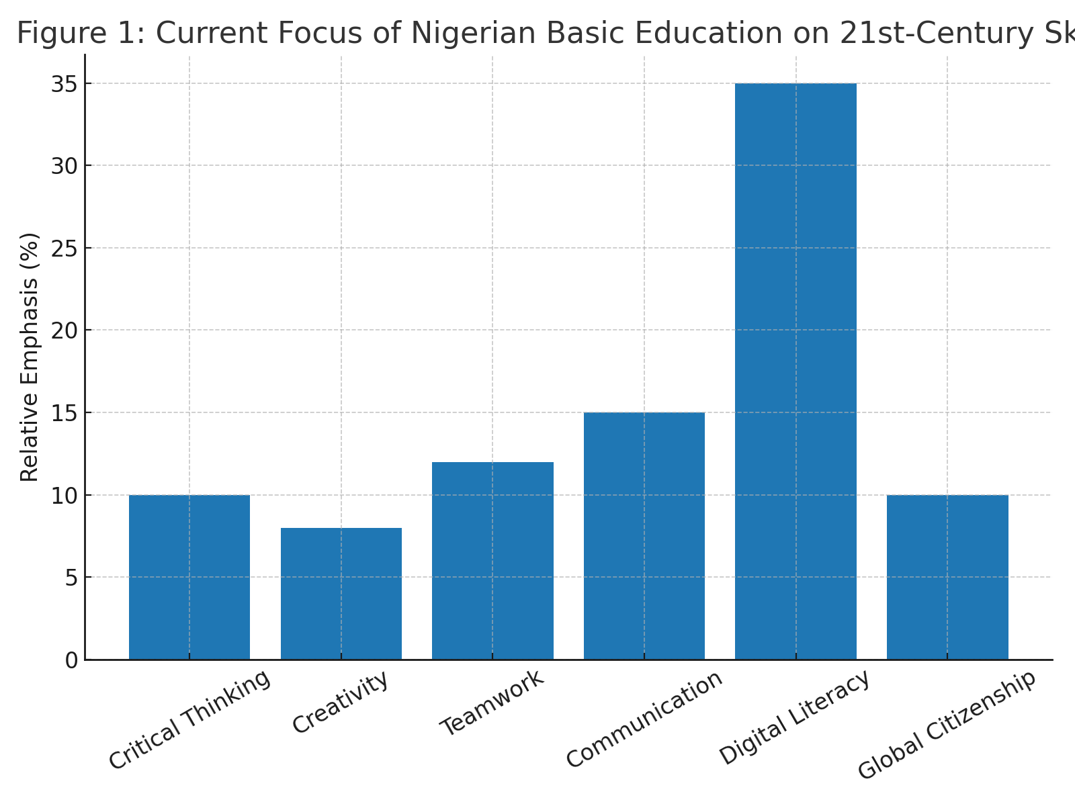
Figure 1: The current focus of Nigerian Basic Education on skills needed in the 21st century.
The projected percentage of emphasis placed on six essential qualities in Nigeria's basic education curriculum—critical thinking, creativity, teamwork, communication, digital literacy, and global citizenship—is shown in this chart. The information is made up of reviews of policies and evaluations of curricular content that are relevant. The distribution focuses on digital literacy as a separate subject, with less emphasis on integrating abilities like creativity, teamwork, and global citizenship.
How to Test
In Nigeria, examinations are still the main way to judge students. The Basic Education Certificate Examination (BECE) and other high-stakes standardized tests are the most important ones. These assessments put more emphasis on remembering facts and knowing how to do things than on showing off talents. There are certain parts of continuous assessment, but they are not always used in the same way, and they often don't have the rigor needed to test abilities like creativity, critical thinking, and teamwork. This focus on summative evaluation makes it hard to use competency-based teaching methods, and it also encourages students to memorize things(Amoako, 2019).
Preparing teachers and building infrastructure
To teach modern skills well, teachers need to be well-trained and skilled in active, learner-centered methods. However, professional development for teachers who are already working is not regular, and many Nigerian instructors don't learn about competency-based education until they start working. Infrastructure problems including crowded classrooms, bad ICT equipment, and inconsistent energy make it much harder to use technology and participatory methods. Differences between rural and urban places make these problems worse by keeping a lot of students from getting to learning environments that help them improve their skills(Uzorka et al., 2023).
In conclusion, structural constraints in curriculum design, evaluation, teacher preparation, and infrastructure continue to impede the comprehensive integration of 21st-century skills, notwithstanding modest advancements in the modernization of Nigeria's basic education curriculum. These deficiencies must be corrected so that Nigerian students can meet national and international standards for competence(Herlinawati et al., 2024).

4. Lessons from Comparative Contexts

Case Studies
Nigeria may learn a lot from the big changes to the curriculum that many countries have made to include skills for the 21st century. Kenya's Competency-Based Curriculum (CBC), which was put into effect in 2017, focuses more on building basic abilities like critical thinking, problem-solving, communication, and citizenship than on learning about specific subjects. It puts flexible learning paths, constant assessment, and instruction that is oriented on the learner first. Kenya's experience illustrates that competency-based reform is possible in Africa, even though there are still problems with implementation, especially when it comes to getting teachers ready and having enough resources(Mogere & Mbataru, 2023).
India, one of Asia's growing economies, has put into effect the National Education Policy (NEP) 2020. This policy encourages flexible, all-encompassing curricula that teach skills like environmental awareness, multilingual communication, and coding from the very first grades. In the same way, Malaysia's Education Blueprint (2013–2025) includes six important student traits, such ethics, leadership, and bilingualism, in every topic instead of considering them as separate subjects. These examples show how national vision documents can change the curriculum over time(Kulal et al., 2024).
Finland has garnered international reputation in OECD contexts for its high-trust teacher profession that supports innovation in the classroom and its phenomenon-based learning method, which dissolves topic boundaries to address real-world concerns. Singapore, on the other hand, strikes a balance between high academic standards and programs like "Thinking Schools, Learning Nation," which teach critical and creative thinking skills across the curriculum and spend a lot of money on teachers' ongoing professional development. Table 1 provides a concise comparative overview of the curricular models, skill integration strategies, and assessment methodologies discussed above, illustrating how select nations have integrated 21st-century abilities into their foundational education systems(Schaffar & Wolff, 2024).

Table 1: Comparative Overview of 21st-Century Skills Integration Across Selected Countries
Country | Curriculum Model | 21st-Century Skills Integration | Assessment Approach
Nigeria | Content-heavy, exam-oriented | Partial, ICT as standalone subject | Standardized exams, limited continuous assessment(Ajah & Chigozie-Okwum, 2019)
Kenya | Competency-Based Curriculum (CBC) | Core competencies across subjects | Continuous & formative assessment(Wanyama, 2025)
India | Holistic & flexible (NEP 2020) | Coding, environmental awareness, multilingualism | Formative + high-stakes exams(“New Education Policy 2024,” 2025)
Malaysia | Skills-embedded across subjects | Leadership, bilingualism, ethics | Balanced formative & summative((PDF) Implementing Classroom Assessment In Malaysia, 2025)
Finland | Phenomenon-based learning | Interdisciplinary, real-world problems | Formative, project-based evaluation(Hietamäki et al., n.d.)
Singapore | Integrated critical & creative thinking | Critical thinking across curriculum | Performance-based and formative(Shaber et al., 2025)
Table 1 compares how well a few selected countries have integrated 21st-century capabilities. This table shows how Nigeria, Kenya, India, Malaysia, Finland, and Singapore are integrating 21st-century skills into their schools, including the curriculum frameworks, evaluation techniques, and the level and type of integration. It highlights important differences in how national education systems teach skills like creativity, critical thinking, cooperation, and digital literacy, as well as how well formative and summative evaluation methods function together.
Practices that can be used in different situations
Several behaviors emerge as relevant to Nigeria from these diverse contexts. Curriculum flexibility allows for local adaptation while maintaining national coherence, which makes relevance and responsiveness possible. Integrated skills development teaches 21st-century skills in real-life scenarios by include them in subject education instead of treating them as extras. Ongoing evaluation that focuses on formative feedback and real-world use helps students learn more and gain skills((PDF) EXPLORING CULTURAL INFLUENCES ON CURRICULUM AND EDUCATION REFORMS: LESSONS FOR NIGERIA’S FUTURE, n.d.).
Challenges of Contextual Adaptation
But Nigeria's unique social, cultural, and infrastructure conditions must be considered during the adaptation process. Some strategies may not be adopted right away because of traditions that stress on exams, unequal access to ICT, and high student-teacher ratios. In Kenya, India, and Finland, policy changes have often been followed by ongoing investment, good teacher training programs, and strong support from stakeholders. These are conditions that Nigeria may need to purposefully create. So, the lesson is to choose and change parts that fit with national goals, available resources, and cultural values, rather than copying them exactly(Lwamba et al., 2022).

5. Barriers to Integration in Nigeria

Systemic and Policy Barriers
Even while the government's rhetoric recognizes the need of 21st-century skills, Nigerian curriculum reform is hindered by a persistent gap between policy and reality. Policies like the National Policy on Education spell out what skills should be developed first, but there are still no ways to put these plans into action. UNESCO says that the education sector should get 15–20% of the national budget, but it doesn't, which makes it hard to buy teaching materials, build schools, and educate teachers. Frequent changes to policies that are based more on political changes than on planning based on evidence can hurt stakeholder trust and the continuity of change(The Role of Civic Education, n.d.).
Barriers to Learning
Even though many teachers don't have formal training in competency-based education (CBE) principles, they are very important for the successful integration of modern capabilities. In pre-service teacher education, the transmission of subject knowledge often takes precedence over active learning, problem-solving, and collaborative pedagogy. In-service professional development rarely focuses on integrating 21st-century skills. As a result, teaching methods that center on lectures and tests are still the most common in the classroom, even if the curriculum encourages creativity and critical thinking(Janssens et al., 2023).
Technological Obstacles
The digital divide makes it even harder to learn new skills. Many schools, especially those in distant areas, don't have adequate computers, internet access, or reliable electricity. Teachers may not know how to use technology in interesting lessons or feel comfortable doing so when it is available. This technology gap limits students' chances to learn digital literacy, online collaboration, and media production abilities, which are becoming more and more important for global competitiveness(Kormos & Wisdom, 2023).
Social and Cultural Factors
When changing the curriculum, it's also important to think about Nigeria's many languages and cultures. New teaching methods may not work as effectively in some places because of the language, the community's goals, and the local beliefs. Parents and teachers may sometimes appreciate less concrete skills like creativity or teamwork more than more traditional measures of academic success, like high exam scores. Social inequities, like differences in educational chances for boys and girls, make skill development even less fair. Girls in rural areas are often the most affected(Courtois et al., 2024).
Figure 1 displays a readiness profile encompassing five essential indicators derived from literature and policy study, illustrating the comparative strengths and shortcomings of Nigeria's preparedness for the integration of 21st-century capabilities. All things considered, these problems reveal that sociocultural, pedagogical, technological, and structural factors all work together in a multifaceted way. To create a conducive environment for the integration of 21st-century skills, we need constant financing, stakeholder involvement, and policy alignment in addition to curriculum creation.
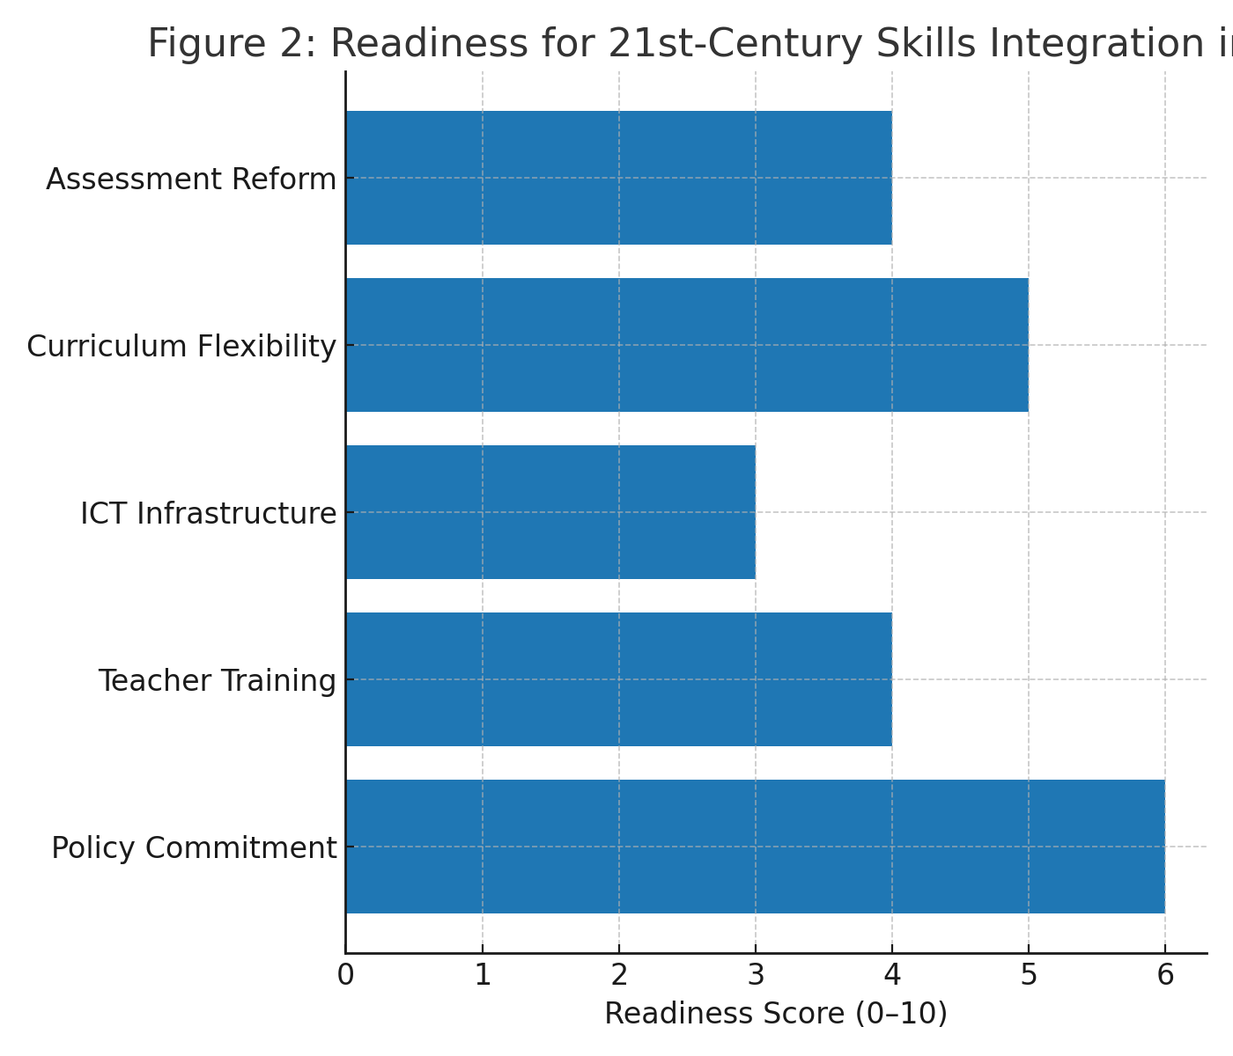
Figure 2: Readiness for 21st-Century Skills Integration in Nigeria.
This figure presents a comparative rating (on a 0–10 scale) of Nigeria’s readiness across five dimensions: policy commitment, teacher training, ICT infrastructure, curriculum flexibility, and assessment reform. The scores are based on synthesized findings from national policy documents, comparative education reports, and relevant scholarly studies. Higher scores indicate stronger readiness, while lower scores highlight priority areas for intervention.

6. Proposed Framework for Integration

Core Competencies for Nigeria
Nigeria's incorporation of 21st-century skills should prioritize competencies that directly advance national development objectives, considering both domestic priorities and global standards. These include the following: critical thinking for efficient problem-solving in entrepreneurship and governance; creativity and innovation to promote economic diversification; digital literacy to improve participation in the global knowledge economy; cooperation and communication to fortify social cohesion in a multiethnic setting; and global citizenship to promote responsible engagement with transnational issues like public health and climate change(Zamiri & Esmaeili, 2024).
Principles for Redesigning the Curriculum
The curriculum should be changed to include more than one subject so that students can use what they learn in real life circumstances. The major thing to focus on should be project-based learning (PBL), which lets students come up with, carry out, and present ideas that blend what they know with how things work in the real world. It is important that the curriculum is culturally relevant. This means that it should include global perspectives while also showing Nigeria's history, values, and current events. This two-pronged strategy guarantees that students will keep their cultural identity while also learning the skills they need to be involved in the world(Zhang & Ma, 2023). To operationalize these principles, the framework emphasizes three pillars: (i) Curricular integration, where every subject embeds one or more core competencies; (ii) Pedagogical innovation, where teachers employ methods such as inquiry-based learning, debate, and design thinking; and (iii) Contextual adaptation, ensuring that skills development reflects Nigeria’s socio-cultural realities. A practical example could involve students in rural areas using project-based learning to design low-cost water filtration systems, combining science knowledge, teamwork, creativity, and civic responsibility in a single learning experience(Morris, 2025).
Plan for putting it into action
The first stage in reform should be to run pilot initiatives in a few urban and rural schools. This would help test ideas, gather local evidence, and build trust among stakeholders. It is important to make teacher professional development a priority. In-service programs should teach teachers how to use active pedagogy and technology in the classroom, and pre-service courses should be modified to include CBE ideas. A staggered deployment that starts in lower primary and goes up makes it possible to make iterative improvements based on feedback, mobilize resources, and adapt progressively. Working with foreign organizations, NGOs, and businesses can help you get money and technical help(Hardman & Sandi, 2024).
Checking and Evaluating
In addition to keeping track of how well students are doing, good monitoring and evaluation (M&E) systems should also look at how well students are learning, how well teachers are accepting new teaching methods, and how ready the infrastructure is. Mixed-method evaluation, which uses performance tasks, portfolios, observational data, and standardized tests, can provide you a whole picture of development. Regular reporting to stakeholders will keep accountability and political will strong(Levy-Feldman, 2025).
Nigeria may build a generation of students ready for the challenges of the twenty-first century by putting these parts together in a way that makes sense and fits its basic education system with both local needs for growth and worldwide standards for skills.

7. Implications for Policy and Practice
Suggestions for Changing Policies
To bring Nigeria's basic education up to worldwide competency levels, policy changes must put the integration of 21st-century skills into curricular objectives, learning outcomes, and assessment frameworks at the top of their list of things to do. This necessitates unwavering budgetary commitments, continuity throughout political cycles, and explicit national objectives for competency acquisition. Policies should also promote curriculum flexibility to make it easier for states and cities to adjust to different situations(González-Pérez & Ramírez-Montoya, 2022).
In addition to broad policy directions, specific measurable action points are critical for implementation. The government should progressively increase education sector funding to at least 15–20% of the national budget, in line with UNESCO benchmarks, with a designated portion earmarked for ICT infrastructure and teacher capacity building. A National Skills Assessment Framework should be developed to measure students’ proficiency in critical thinking, creativity, digital literacy, and global citizenship, ensuring progress can be tracked against defined benchmarks. Furthermore, states and local governments should be mandated to align curricular reforms with this framework, with annual reporting mechanisms to monitor compliance and progress(UNESCO Member States Unite to Increase Investment in Education, n.d.).

Top Priorities for Teacher Training
Teachers need to be ready for reform to work. Pre-service programs should include active pedagogy, technology integration, and competency-based education as required modules. In order to give teachers the skills they need to help students learn together, ask tough questions, and come up with new ways to solve problems, in-service professional development must be planned, ongoing, and focused on practice. Teacher incentive programs including career development, performance-based incentives, and recognition should stimulate the use of new ideas(Berisha & Vula, 2021).
The function of partnerships
Strategic relationships can help fill in gaps in expertise and resources. For trial initiatives and establishing capacity, the government can work with NGOs, businesses, and international organizations like UNESCO and UNICEF to get money, digital infrastructure, and technical know-how. Community involvement is just as crucial as cultural tolerance and endurance. Local leaders and parent-teacher associations can help push for changes and help schools put them into action(Rajabi et al., 2021).
Nigeria can create a supportive environment for incorporating 21st-century skills into its basic education system, fostering local growth and enhancing international competitiveness, through robust policy guidance, empowered educators, and well-coordinated collaborations.
8. Conclusion
Nigeria’s basic education curriculum must be revised to fully integrate 21st-century skills. In an era of rapid technological change, evolving labor markets, and increasingly complex global challenges, Nigerian students require competencies such as critical thinking, creativity, digital literacy, and global citizenship to thrive. This is not only vital for the country’s development but also for global competitiveness.
This study contributes a novel, locally adaptable yet globally informed framework that moves beyond identifying curriculum gaps to proposing measurable and actionable reforms. Specifically, it recommends increasing education sector funding to at least 15–20% of the national budget, in line with UNESCO benchmarks, with dedicated allocations for ICT and teacher training. It also calls for the establishment of a National Skills Assessment Framework to monitor proficiency in critical thinking, creativity, collaboration, digital literacy, and global citizenship. These benchmarks, coupled with continuous teacher development and assessment reforms, provide a clear pathway for systemic change.
By situating Nigeria’s reform needs within international best practices while tailoring strategies to local socio-cultural and infrastructural realities, this paper makes a dual contribution: to Nigerian educational policy discourse and to global comparative education scholarship. The proposed framework offers a replicable model for other developing nations confronting similar challenges. Reform, therefore, is not just necessary but urgent—an investment in Nigeria’s future human capital that will enable its learners to participate productively in a knowledge-driven, interconnected world(Folorunsho et al., 2024).

Disclaimer (Artificial intelligence)
Option 1:
Author(s) hereby declare that NO generative AI technologies such as Large Language Models (ChatGPT, COPILOT, etc.) and text-to-image generators have been used during the writing or editing of this manuscript.

REFERENCES
Ajah, I. A., & Chigozie-Okwum, C. C. (2019). ICT and administrative effectiveness of University in Nigeria: A connect between leadership and knowledge. AFRREV STECH: An International Journal of Science and Technology, 8(2), 64–85. https://doi.org/10.4314/stech.v8i2.5
Amoako, I. (2019). What’s at Stake in High-Stakes Testing in Ghana: Implication for Curriculum Implementation in Basic Schools. International Journal of Social Sciences & Educational Studies, 5(3), 72–82. https://doi.org/10.23918/ijsses.v5i3p72
Berisha, F., & Vula, E. (2021). Developing Pre-service Teachers Conceptualization of STEM and STEM Pedagogical Practices. Frontiers in Education, 6. https://doi.org/10.3389/feduc.2021.585075
Courtois, S. L., Ezeugwu, C. R., Fajardo-Tovar, D. D., Nowack, S. K., Okullo, D. O., Bayley, S., Baker, S., & Ramchandani, P. (2024). Learning through play in Global Majority countries: Reflections from the PEDAL centre on understanding and adapting the concept in four different contexts. International Journal of Play, 13(3), 228–253. https://doi.org/10.1080/21594937.2024.2388952
Darling-Hammond, L., Flook, L., Cook-Harvey, C., Barron, B., & Osher, D. (2020). Implications for educational practice of the science of learning and development. Applied Developmental Science, 24(2), 97–140. https://doi.org/10.1080/10888691.2018.1537791
Drake, S. M., & Reid, J. L. (2020). 21st Century Competencies in Light of the History of Integrated Curriculum. Frontiers in Education, 5. https://doi.org/10.3389/feduc.2020.00122
Erstad, O., Černochová, M., Knezek, G., Furuta, T., Takami, K., & Liang, C. (2024). Social and Emotional Modes of Learning Within Digital Ecosystems: Emerging Research Agendas. Technology, Knowledge and Learning, 29(4), 1751–1766. https://doi.org/10.1007/s10758-024-09775-w
Folorunsho, S., Ajayi, V., & Abdulrazaq, O. (2024). Juvenile delinquency as a contemporary issue in Nigeria: Understanding the impacts of parenting styles, single parenting and marital discord. African Journal of Social Issues, 7(1), Article 1. https://doi.org/10.4314/ajosi.v7i1.8
González-Pérez, L. I., & Ramírez-Montoya, M. S. (2022). Components of Education 4.0 in 21st Century Skills Frameworks: Systematic Review. Sustainability, 14(3), 1493. https://doi.org/10.3390/su14031493
Haleem, A., Javaid, M., Qadri, M. A., & Suman, R. (2022). Understanding the role of digital technologies in education: A review. Sustainable Operations and Computers, 3, 275–285. https://doi.org/10.1016/j.susoc.2022.05.004
Hardman, F., & Sandi, A. M. (2024). School Improvement in Rural Settings: A Review of International Research and Practice. In Y. Zhao & J. Liu (Eds.), Rural School Improvement in Developing Countries (pp. 1–35). Springer Nature. https://doi.org/10.1007/978-981-97-4917-1_1
Herlinawati, H., Marwa, M., Ismail, N., Junaidi, Liza, L. O., & Situmorang, D. D. B. (2024). The integration of 21st century skills in the curriculum of education. Heliyon, 10(15), e35148. https://doi.org/10.1016/j.heliyon.2024.e35148
Hietamäki, U., Harju-Luukkainen, H., & Maunula, M. (n.d.). Multidisciplinary learning assessment in Finland – a phenomenographic approach on teachers’ perceptions. Education 3-13, 1–14. https://doi.org/10.1080/03004279.2024.2409246
Janssens, O., Embo, M., Valcke, M., & Haerens, L. (2023). When theory beats practice: The implementation of competency-based education at healthcare workplaces. BMC Medical Education, 23, 484. https://doi.org/10.1186/s12909-023-04446-3
Kalukar, V. J., Krobo, A., Pessireron, M. F., Suhendra, S., & Yudistira, S. (2024). Enhancing Critical Thinking Skills Through Collaborative Learning in Modern Educational Practices. The Journal of Academic Science, 1(8), 1145–1153. https://doi.org/10.59613/2dx5zr09
Kormos, E., & Wisdom, K. (2023). Digital divide and teaching modality: It’s role in technology and instructional strategies. Education and Information Technologies, 1–19. https://doi.org/10.1007/s10639-022-11488-5
Kulal, A., N, A., Dinesh, S., Bhat, D. C., & Girish, A. (2024). Evaluating the Promise and Pitfalls of India’s National Education Policy 2020: Insights from the Perspectives of Students, Teachers, and Experts. SAGE Open. https://doi.org/10.1177/21582440241279367
Levy-Feldman, I. (2025). The Role of Assessment in Improving Education and Promoting Educational Equity. Education Sciences, 15(2), 224. https://doi.org/10.3390/educsci15020224
Luise, O. E. (2023). The Quality of Educational Development in Nigeria. Educational Research, 1–3.
Lwamba, E., Shisler, S., Ridlehoover, W., Kupfer, M., Tshabalala, N., Nduku, P., Langer, L., Grant, S., Sonnenfeld, A., Anda, D., Eyers, J., & Snilstveit, B. (2022). Strengthening women’s empowerment and gender equality in fragile contexts towards peaceful and inclusive societies: A systematic review and meta‐analysis. Campbell Systematic Reviews, 18(1), e1214. https://doi.org/10.1002/cl2.1214
Mogere, V. B., & Mbataru, D. P. (2023). Determinants of Competence-Based Curriculum Implementation in Selected Public Primary Schools in Nairobi County, Kenya. Journal of Public Policy and Governance, 3(1), 39–50. https://doi.org/10.70619/vol3iss1pp39-50
Morris, D. L. (2025). Rethinking Science Education Practices: Shifting from Investigation-Centric to Comprehensive Inquiry-Based Instruction. Education Sciences, 15(1), 73. https://doi.org/10.3390/educsci15010073
New Education Policy 2024. (2025, July 30). Proctur Blog. https://proctur.com/blog/new-education-policy-2024/
Okonkwo, D. I. J. & D. C. O. (2025). Integrating 21st Century Skills into Secondary Education: Preparing Students for a Productive Society. https://doi.org/10.5281/zenodo.14879702
Opara, J. A. (2011). A Comparative Analysis of Universal Basic Education Programme in Nigeria (UBE) and the “Grundskola” Education Programme of Sweden. Mediterranean Journal of Social Sciences, 2(7), 79.
(PDF) EXPLORING CULTURAL INFLUENCES ON CURRICULUM AND EDUCATION REFORMS: LESSONS FOR NIGERIA’S FUTURE. (n.d.). Retrieved August 13, 2025, from https://www.researchgate.net/publication/382039272_EXPLORING_CULTURAL_INFLUENCES_ON_CURRICULUM_AND_EDUCATION_REFORMS_LESSONS_FOR_NIGERIA'S_FUTURE
(PDF) Implementing Classroom Assessment In Malaysia: An Investigation. (2025, February 26). ResearchGate. https://www.researchgate.net/publication/348355621_Implementing_Classroom_Assessment_In_Malaysia_An_Investigation
Rajabi, M., Ebrahimi, P., & Aryankhesal, A. (2021). Collaboration between the government and nongovernmental organizations in providing health-care services: A systematic review of challenges. Journal of Education and Health Promotion, 10, 242. https://doi.org/10.4103/jehp.jehp_1312_20
Saini, M., Sengupta, E., Singh, M., Singh, H., & Singh, J. (2023). Sustainable Development Goal for Quality Education (SDG 4): A study on SDG 4 to extract the pattern of association among the indicators of SDG 4 employing a genetic algorithm. Education and Information Technologies, 28(2), 2031–2069. https://doi.org/10.1007/s10639-022-11265-4
Schaffar, B., & Wolff, L.-A. (2024). Phenomenon-based learning in Finland: A critical overview of its historical and philosophical roots. Cogent Education. https://www.tandfonline.com/doi/abs/10.1080/2331186X.2024.2309733
Shaber, N., Shah, S. K., Imran, M., & Almusharraf, N. (2025). Exploring the Relationship Between Critical Thinking and Creativity in University Students: Gender Differences and the Assessment of Skills. Education Sciences, 15(4), 464. https://doi.org/10.3390/educsci15040464
The Role of Civic Education. (n.d.). Retrieved August 13, 2025, from https://civiced.org/papers/articles_role.html
Thornhill-Miller, B., Camarda, A., Mercier, M., Burkhardt, J.-M., Morisseau, T., Bourgeois-Bougrine, S., Vinchon, F., El Hayek, S., Augereau-Landais, M., Mourey, F., Feybesse, C., Sundquist, D., & Lubart, T. (2023). Creativity, Critical Thinking, Communication, and Collaboration: Assessment, Certification, and Promotion of 21st Century Skills for the Future of Work and Education. Journal of Intelligence, 11(3), 54. https://doi.org/10.3390/jintelligence11030054
Timotheou, S., Miliou, O., Dimitriadis, Y., Sobrino, S. V., Giannoutsou, N., Cachia, R., Monés, A. M., & Ioannou, A. (2022). Impacts of digital technologies on education and factors influencing schools’ digital capacity and transformation: A literature review. Education and Information Technologies, 28(6), 6695. https://doi.org/10.1007/s10639-022-11431-8
UNESCO Member States unite to increase investment in education. (n.d.). Retrieved August 19, 2025, from https://www.unesco.org/en/articles/unesco-member-states-unite-increase-investment-education
Uzorka, A., Namara, S., & Olaniyan, A. O. (2023). Modern technology adoption and professional development of lecturers. Education and Information Technologies, 1–27. https://doi.org/10.1007/s10639-023-11790-w
Wanyama, B. W. (2025). Competency based curriculum in Kenya: Taking stock of implementation process at early years education. Culture, Education, and Future, 3(1), 135–158. https://doi.org/10.70116/2980274199
Zamiri, M., & Esmaeili, A. (2024). Strategies, Methods, and Supports for Developing Skills within Learning Communities: A Systematic Review of the Literature. Administrative Sciences, 14(9), 231. https://doi.org/10.3390/admsci14090231
Zhang, L., & Ma, Y. (2023). A study of the impact of project-based learning on student learning effects: A meta-analysis study. Frontiers in Psychology, 14. https://doi.org/10.3389/fpsyg.2023.1202728
Zhou, M., Wang, X., & Wang, R. (2025). Foreign language learning’s role in the development of global competence: A latent profile analysis. Acta Psychologica, 254, 104850. https://doi.org/10.1016/j.actpsy.2025.104850
Zou, Y., Kuek, F., Feng, W., & Cheng, X. (2025). Digital learning in the 21st century: Trends, challenges, and innovations in technology integration. Frontiers in Education, 10, 1562391. https://doi.org/10.3389/feduc.2025.1562391

