Challenges and Strategies for Integrating Sustainability and Environmental Education in Higher Education

Abstract:
The world’s environmental challenges, including climate change and resource depletion, underscore the urgent need for higher education institutions to lead in promoting sustainability and environmental stewardship. This review article examines the integration of Sustainability and Environmental Education (SEE) in universities by highlighting key barriers and proposing actionable solutions. Using a literature review methodology, the study synthesizes current research to identify challenges such as curricular integration, resource constraints, governance and policy misalignments, limited student engagement, and the implementation of sustainable campus practices. Findings reveal that universities struggle to embed SEE due to departmental silos, insufficient funding, and lack of institutional support, yet they hold immense potential to foster environmental responsibility. The paper proposes comprehensive strategies, including interdisciplinary collaboration, stakeholder involvement, innovative funding models like external grants, leadership development programs for student engagement, and sustainable operations exemplified by case studies. These solutions aim to align academic, operational, and policy frameworks with sustainability goals. This study contributes to the field by offering a holistic framework to overcome SEE integration barriers, positioning universities as pivotal agents in addressing global environmental challenges.
Keyword: Sustainability; Environmental Education; Higher Education; Curricular Integration; Resource Constraints;

Introduction
In recent years, the world has experienced clear and pressing environmental challenges that compel universities to support and engage with sustainability and environmental stewardship [1], [2]. Universities, through research, teaching, and community engagement, can offer unique solutions to some of the most significant global challenges, including habitat loss, resource depletion, and climate change [3]. A substantial area of higher education's curriculum, sustainability and environmental education (SEE) focuses on positioning students with the values, knowledge, and skills to anticipate and resolve environmental challenges [4]. Environmental education is about more than just providing information; it creates commitment, skills, and working together towards a shared goal of conservation in complex environmental contexts, creating synergistic spaces where various stakeholders are addressing dynamic environmental issues [5]. However, there are several challenges and barriers to incorporating SEE into higher education, including challenges with engaging students, organizational structures, governance and policy, integrating SEE into the curriculum, and ensuring sufficient resources. The role of SEE in higher education is fundamental. The need for informed individuals capable of advocating for sustainable practices and policies has never been greater, as the planet experiences more complex environmental challenges [6]. Universities, as institutions are uniquely positioned to engage the next generation of professional and social leaders to infuse sustainability within their core functions [1]. Educating students about

environmental challenges is only one area, but developing a sustainable culture that permeates every aspect of the university experience is equally important: from academic activities to university operations [7].
Though SEE's role is increasingly acknowledged, integrating sustainable practices into the core role of higher education institutions remains a significant challenge [2]. Several complicated factors include student engagement, availability and budgetary resources, policy and governance structure, curricular integration, and institutional sustainability [8]. To ensure that SEE programs are successfully delivered, several key areas will need to be addressed. For curricular integration, an important factor is collaboration between disciplines and eliminating departmental boundaries. For universities to implement sustainability across disciplines, they need to develop common goals and strategies. Projects that include multiple disciplines from environmental sciences, social sciences, and humanities, or that integrate sustainability principles into introductory required courses, could achieve this goal [9]. This process may allow academic institutions to provide students with a comprehensive understanding of sustainability issues and the necessary skills to address them, as demonstrated in Figure 1. Sourcing and acquiring large financial and human resources continue to stifle the establishment and execution of SEE programs in various universities.
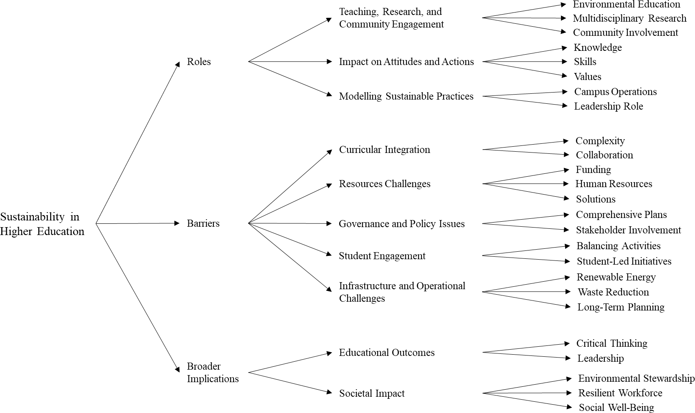
Figure 1: Taxonomy of Sustainability in Higher Education
Institutions could explore external funding opportunities through grants and collaborative projects with governments and business organizations to alleviate resource challenges. The approach applied by the University of Bristol in integrating sustainability into their courses shows the value of training and professional development programs for staff and helps build voluntary regulatory [10]. Sustainability initiatives must be integrated within the university’s overall purpose and approach to governance for a holistic approach to governance and policy issues[11]. Reflexive governance and stakeholder engagement are critical for responding to amalgamated demands. Colleges and universities should implement sustainable practices in

campus operations with sustainable procurement policies and work with local communities and businesses to diminish their institutional impact on the environment at the same time [12]. The purpose of this review paper is to provide a complete and detailed overview of the current state of SEE in higher education with a focus on barriers and possibilities for the more successful implementation of SEE. This literature review paper will sum up the literature, find gaps and obstacles in the current literature, and offer possible ways to overcome such barriers. The study will contextualize the many areas in which sustainability could be undertaken in higher education while specifically addressing how important it is that SEE exists to educate the next generation of leaders and professionals to deal with vital environmental issues today. The evaluation of the literature will also extend to the broader implications for sustainability on institutional reputation, performance, and influence over space and time, along with rationalizing the need for a more holistic and integrated sustainable approach.

Literature Review
  - The Role of Higher Education in Sustainability
Higher education institutions can play a significant role in addressing international and global- scale environmental challenges through teaching, research, and community engagement [13]. Universities are positioned to impact people’s attitudes and actions around environmental issues [14]. They argue that by bringing together environmental education through research, daily operations of campuses, and traditional academic courses, higher education can foster a sustainable culture. It is this tripartite of environmental integration that provides children with the knowledge, skills, and values to manage and mitigate the environmental issues they face. Multidisciplinary research and education are necessary to prepare students to address complex environmental issues [15]. Interdisciplinary approaches can foster the development of comprehensive solutions and a greater understanding of the complexity of environmental challenges [16].
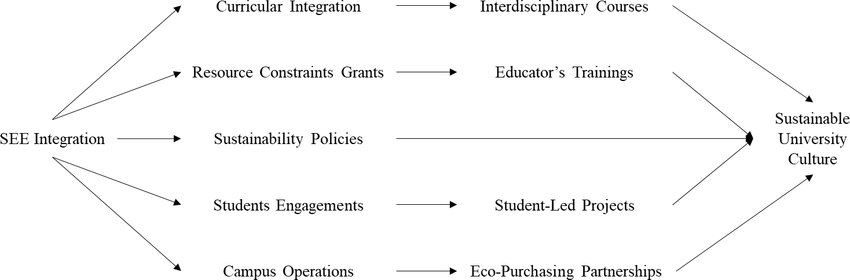

Figure 2: Pathways to Sustainable University Culture: Integrating SEE Across Campus Initiatives
Thus, universities can promote a deeper understanding of sustainability challenges as well as enhance creative approaches to moving forward through collaborations across disciplines. Higher education institutions can also model environmentally sustainable practices. Universities can demonstrate the feasibility and benefits of sustainable development through the incorporation of sustainable practices into their operations and by sharing with other

businesses and communities. This leadership role is critical to building a culture of environmental stewardship and facilitating a more widespread adoption of sustainable practices
[17] as demonstrated in Figure 2 and Table 1.
Table 1: Key Aspects of SEE in Higher Education
Aspect | Description | Impact
Teaching & Research | Educate via interdisciplinary study | Build skills for environmental solutions
Campus Operations | Model sustainable practices | Lead communities in green practices
Student Involvement | Foster student-led initiatives | Grow environmental awareness
Policy Integration | Embed sustainability in mission | Drive institutional change

Societal Influence Shape public views on the
environment

Barriers to the Implementation of SEE
Promote a resilient and sustainable society

The integration of sustainability is complex and varies from institution to institution. Barriers to sustainability integration arise at multiple levels and are not limited to curricular integration, limited fiscal resources, and the alignment of differing institutional policies. Curricular integration is complex in and of itself due to the autonomy of traditional academic disciplines that can limit a unified approach to bringing sustainability into a broad sense of diverse fields of study. Sterling and Thomas [4] acknowledge that developing multidisciplinary collaboration and resolving siloed departmental hierarchies presents significant challenges. Boarin and Martinez-Molina [18] suggest that universities develop all-encompassing SEE programs that facilitate sustainability across disciplines as they come together to create collective goals and frameworks to enable interdisciplinary collaboration. Resource challenges compounded by a lack of resources, including human resources and funding, are barriers to the implementation of SEE. Many institutions are unable to fund SEE projects sufficiently to prepare faculty, enrol students, and provide research opportunities for students [19]. Further, the shallow pool of trained faculty in the area of sustainability was also an issue.
Nonetheless, to work through these challenges, universities should align with external funding, including research grants and industry and government partnerships when possible; in addition, they should ensure existing faculty development is embraced through professional growth and training [20]. Policy and governance issues are central to universities to engage in meaningful and substantive change, as standardized governance structure resists changes towards sustainable practices and policies. Universities need to recognize sustainability in comprehensive plans and incorporate it into their mission and governance structures [21]. Involving all groups of stakeholders in the development and implementation of sustainability strategies will be beneficial as they can develop their governance structure through policies and initiatives to incorporate sustainability through students, staff, and faculty initiatives. Working together helps ensure the needs and preferences of all stakeholders are relevant to the sustainability initiative. Engaging students in sustainability initiatives is important for building a culture of environmental responsibility; however, balancing academic and extracurricular

activities needs to be achieved [22]. The impact of student-led initiatives and campaigns is critical and supports the development of environmental awareness and action [23].
Universities should support student-led projects with resources such as finances, mentoring, and interaction. Sustainability can be included in extracurricular activities and student-led initiatives by offering sustainability-oriented clubs, organizations, and activities. By allowing students opportunities to become engaged with sustainability initiatives outside the classroom, universities can facilitate student involvement and promote the development of an environmentally conscious culture. Deploying sustainable solutions within or in the operations and infrastructure of a university's facilities is a challenging and costly undertaking. It is difficult to make an impact on waste reduction initiatives, utilizing renewable energy sources, and integrating green-building standards [24]. Universities can utilize existing technologies, such as buildings designed to reduce energy usage via upgrades rather than retrofits for existing buildings, and/or develop a phased approach to creating sustainability for the institution. Long- term sustainability planning for sustainability-based operational and infrastructure goals may include sustainability-based goals for energy-use reduction, waste diversion rates, and renewables [19]. By implementing sustainability in their operations, universities can lead the way for other institutions and contribute to sustainable communities, as illustrated in Table 2.
Table 2: Challenges and Solutions in Implementing Sustainability in Higher Education

Aspect Description Challenges Solutions Outcomes

Curricular Integration

Resource Challenges

Policy and Governance

Student Engagement

Operational and Infrastructure

Interdisciplinary Collaboration

Stakeholder Involvement

Student-Led Initiatives

Integrating sustainability into the curriculum

Limited fiscal resources and trained faculty

Resistance to change in standardized governance structures

Balancing academic and extracurricular activities
Implementing sustainable solutions in university operations Developing multidisciplinary collaboration Involving all stakeholders in sustainability strategies
Impact of student-led initiatives and
campaigns

Complexity due to academic discipline autonomy
Insufficient funding, shallow pool of trained faculty
Standardized governance resists sustainable practices

Overwhelmed students

Costly and challenging to implement
Siloed departmental hierarchies
Differing institutional policies

Balancing activities
Develop interdisciplinary programs, collective goals, and
frameworks
Align with external funding, professional development, and training
Recognize sustainability in
comprehensive plans, and involve stakeholders
Support student-led projects, offer sustainability- oriented clubs
Use existing technologies, a phased approach, and long-term planning
Develop collective goals and frameworks
Develop policies and initiatives, and include students and staff
Provide resources, mentoring, and interaction

Unified approach to SEE

Sufficient support for SEE projects

Meaningful and substantive change

Enhanced student involvement

Sustainable operations and infrastructure

Comprehensive solutions

Relevance to sustainability initiatives
Development of environmental
awareness

Sustainability in Operations
Deploying sustainable solutions
in university facilities

Challenging and costly
Utilize existing technologies, a phased approach
Leading by example, sustainable communities

Broader Implications
The challenges related to implementing SEE have broader consequences for service impact, institutional legitimacy, and educational effectiveness. SEE should improve student academic outcomes and support the promotion of students' critical and problem-solving skills [21]. By placing the emphasis on integrating sustainability within their degree program curriculum, universities may be preparing students to be better leaders and practitioners when it comes to addressing environmental topics. Colleges hold an essential role in shaping how society views environmental issues. Institutions of higher education, through examples of environmental stewardship and sustainability, can nurture a more resilient and sustainable society [4]. In addition, the effectiveness of SEE may be beneficial to society when colleges show a commitment to sustainability and being responsible stewards of the environment [25]. Colleges can set a standard for environmental conditions that may have benefits for many facets of society. By preparing students to grapple with environmental challenges, colleges can foster a workforce that is more resilient and sustainable. These improvements in sustainable practices may also increase social well-being, economic growth, and better environmental quality.

Discussion
  - Addressing Curricular Integration
In order to be effective in integrating SEE into the curriculum, a degree of curricular integration must be established concerning SEE, which may involve establishing a collaborative, multi- disciplinary approach and overcoming departmental, siloed practices wherever possible. Furthermore, universities should generate general frameworks and goals towards curricular integration in the way they consider the one embedded in projects, while they engage in SEE [26]. In addition, universities can enhance a student's understanding and adopt a more comprehensive view of sustainability through, for example, problem-based learning, project- based learning, and service learning [27]. The subject of curricular integration in higher education emerged as having international relevance for how graduates are prepared for the workforce. However, there is considerable recognition of curricular integration's purported advantages in the development of students' holistic learning. Barriers such as routines and institutional resistance, time factors, and financial capacity. While environmental challenges may require unique approaches due to regional variation, employers branded curricular integration as essential in their drive to improve graduates' employability skills [28]. Undergraduates appreciate curricular integration for its engagement and its application. Findings indicate that regional collaborations and targeted faculty development would improve curricular integration in order to enhance graduate employability. Table 3 outlines comprehensive strategies for SEE integration across key areas.
Table 3: Strategies for Sustainability in Environmental Education Integration Success
Strategy | Action | Outcome | Stakeholder Role | Scalability
Collaborative | Blend disciplines | Holistic student | Faculty lead, | High: Adaptable
Curriculum | via projects | learning | students contribute | across disciplines

Resource Optimization | Tap grants, use OERs | Scalable SEE programs | Admin secures funds, student aid | Medium: Grant- dependent
Sustainable | Align policies with | Transformative | Leadership drives, | High: Policy-
Governance | SDGs | institutional change | all engage | driven change

Student-Led Initiatives

Green Operations
Fund sustainability campaigns

Adopt eco-friendly practices
Engaged, responsible students Reduced environmental impact
Students lead, faculty mentor
Facilities management, community ties
Medium:
Resource-intensive

High: Phased
implementation

Resource Constraints
Dealing with human and financial resources is an essential barrier to addressing SEE in the context of higher education, as illustrated in Figure 3. All universities struggle to find funding and trained faculty to implement SEE. Institutions can access funding through grants and partnerships with the government and the private sector to overcome these barriers. For example, Canada's Social Sciences and Humanities Research Council (SSHRC) offers funding for interdisciplinary sustainability projects to enable universities to support curriculum and research development [29]. Another form of partnership identified was with organizations like the David Suzuki Foundation, which could provide experience and co-funded programs aimed at developing campus sustainability programs to enhance community engagement [14].
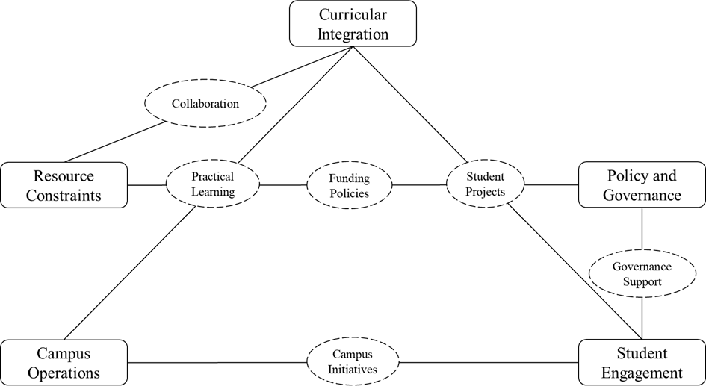
Figure 3: Sustainability and Environmental Education Integration Network in Higher Education
The University of Bristol's framework is an example of innovative resource steering by embedding sustainability across its teaching programs, engaging both students and staff. This collaboration ensured consistency across their curriculum for sustainability, while fostering a culture of collaboration where 200 faculty had been trained in sustainability integration since 2020, which increased sustainability courses by 15% [30]. The University of Toronto's Sustainability Pathways program is another model of using students as volunteers to co- develop teaching materials, while decreasing the workload for faculty, and enhancing student

engagement [31]. Starting in 2012, public universities in Kenya began using environmental sustainability performance contracts, including 72.7% of institutions actively developing environmental policies, while 63.6% institutions facilitated stakeholder collaboration to raise environmental awareness. However, some barriers still exist, including a lack of resources and baseline data [32]. These types of stakeholder-enhanced collaboration initiatives show how institutions can reallocate their human resources without a significant additional cost. Websites like UNESCO's Open Educational Resources Commons allow faculty bots to access free sustainability modules in an editable form, and faculty to integrate SEE, without the burden of having to create anything new [33].

Alignment of Policy and Governance
An all-encompassing approach to align their institutional policies with sustainability priorities is required. Universities should have sustainability plans that support their natures, priorities, and systems of governance. All stakeholders should be involved in developing and implementing these plans [20]. Students, staff, faculty, and external collaborators contribute to this collaborative decision-making process. Reflexive governance, including feedback loops and continuous learning, is also necessary to respond to prevailing social and environmental pressures. An exploratory research development proposes a framework of criteria to assess how different sustainability frameworks may be used to support sustainability in higher education course units [34]. The criteria acknowledged the requirement for change that is both transformative and progressive, as well as the competing demands of a sustainable framework. The study examines three sustainability frameworks: a capitals approach, the three-pillar framework, and the Sustainable Development Goals (SDGs). Each framework has benefits and drawbacks, and the authors suggest that colleges select frameworks that suit their contextual needs.

Enhancing Student Engagement
An integrated approach is necessary to enhance student engagement with environmental initiatives. Colleges should provide resources and support for student-led initiatives and campaigns. Colleges should embed sustainability into student extracurricular activities and provide students with opportunities to engage in sustainability activities [35]. For instance, universities can provide a very active Student Sustainability Coalition that leads a variety of sustainability initiatives on campus. Research demonstrates that participation in ecology clubs and community-oriented educational initiatives relating to the environment significantly improves students' environmental literacy through the development of students' knowledge, attitudes, and pro-environmental behavior, and values student involvement in these programs [36]. Colleges can also promote responsibility and ownership by providing leadership development programming and platforms for students to showcase their sustainability initiatives. More recently, literature notes the importance of sustainability and environmental education in teacher education research [37]. Although research in this area is increasing, there remain a number of gaps in the literature, especially about international research trends and methodology. The authors argued that universities should strive to create comprehensive teacher education programs emphasizing sustainable education practices to prepare future teachers better.

Implementing Sustainable Campus Operations

Campaigning sustainable practices in campus operations requires a significant amount of time and effort. Universities should create gradual action plans and use available technologies. Colleges/Universities should prioritize sustainable practices in any operation and infrastructure. Sustainable purchasing practices, such as using green cleaning products, energy-efficient devices, or other kinds of equipment, can significantly reduce a university's impact on the environment. Additionally, engaging with businesses and local communities to complete collaborative sustainability increases a university's impact and sustainability work. The authors' analytical framework for sustainable governance is based on five pillars, which include: the environment, policy issues, key issues and drivers, key strategies, and the policy cycle. These five pillars will facilitate future conceptual, comparative, and empirical work, in addition to assisting institutions in their sustainability work.

Recommendations and Conclusion
A plethora of obstacles to helping facilitate the adoption of SEE in higher education have been extensively reviewed in this paper. The implementation of SEE is an essential component of training the next generation of professionals and leaders in addressing the pressing environmental problems facing our world, going beyond a conventional scholarly approach. To address the barriers to strong SEE within the greater community, a comprehensive and collaborative strategy that engages all stakeholders, both in and outside of the university community, will be essential. To enact strong SEE programs, it will be imperative to ensure that SEE is embedded into various disciplinary contexts. In order to achieve this objective, it will be important to engage interdisciplinary collaboration, as departments traditionally work within silos. Collectively, universities should establish common goals and frameworks for SEE integration. Development of multidisciplinary courses, problem-and project-based learning, as well as service learning, could help achieve these objectives. Suppose the university sector is serious about building strong, educated citizens who can positively affect change. In that case, students must graduate with a mindful vision of sustainability issues and with the practical skills involved in addressing these problems.
One additional significant barrier facing institutions adopting SEE is addressing resource limitations. The lack of available funding or human capital can severely inhibit SEE institutions from developing or implementing SEE initiatives. Creative solutions can be considered by supporting industry and governments with their SEE efforts while seeking alternative funding sources from grants. The development of academic skills through professional development and training exercises is also a valuable opportunity to contribute to a supportive network of professional development in higher education institutions. The University's framework for sustainability in teaching and learning demonstrates how improving competence for teaching staff and assuring the engagement and relevance of students can include both teaching staff and students in the process. Academic institutions can leverage online tools and Open Educational Resources to enhance their sustainability initiatives with minimal financial resources. A significant yet essential obstacle is in embedding SEE, revamping institutional policies to align with sustainability objectives, and the importance of involving every stakeholder in the development and implementation of sustainability initiatives. Universities need to have a robust sustainability strategy aligned with broader institutional policies and governance. Universities need to be reflexive in their governance when changing to meet environmental and societal needs, with feedback loops and continuous learning built in. There are trade-offs for each model; therefore, academic institutions should choose the model that

best meets their unique needs and contexts. An important initial step needed to reduce the environmental footprint of colleges is demonstrating sustainable approaches to all aspects of campus functioning. Colleges must recognize the importance of incorporating sustainable practices into their operations and infrastructure, thinking through the lens of sustainability first. Colleges and universities can develop joint sustainability programs with companies and municipalities and develop sustainable purchasing and procurement policies. The authors showed the need for organized strategies to advance research and policy development, presented a very useful model on sustainable governance, and provided a long-term response to sustainability issues.
In conclusion, there is a need for a comprehensive strategy to embed Sustainability and Environmental Education (SEE) within higher education that considers curriculum infusion, resourcing issues, aligning policy, student voice and actions, and operating sustainably. Through comprehensive SEE, curricula, and bringing sustainability as an infused curriculum appropriate across subject areas, universities can engage students to develop engagement as a holistic approach to sustainability. Additionally, provide innovative approaches to the funding and initiate staff development to create conditions that relate to the current resourcing problems, together, for sustained progression on SEE. A coordinated approach to policy as it relates to sustainability and involving all stakeholders in the process to create a welcoming institutional process. When students are prioritised in relation to participating via implementing support and encouragement for student-led activities and leadership focus, this leads to increased participation and developing responsibility. Implementing operations on campus to advise, influence, and mitigate impacts on the environment, while also showing, in practice, sustainability ideas and practice, reinforces the real-world aspect. Future research should build on developing new strategies and frameworks for the implementation of SEE, allowing academic institutions to be leaders in addressing environmental challenges globally. This assessment has brought into focus the need for collaboration and holistic engagement to address the barriers to successfully implementing SEE, and to address and support a more sustainable and resilient future more broadly.
Disclaimer (Artificial intelligence)
Option 1:
Author(s) hereby declare that NO generative AI technologies such as Large Language Models (ChatGPT, COPILOT, etc.) and text-to-image generators have been used during the writing or editing of this manuscript.
Option 2:
Author(s) hereby declare that generative AI technologies such as Large Language Models, etc. have been used during the writing or editing of manuscripts. This explanation will include the name, version, model, and source of the generative AI technology and as well as all input prompts provided to the generative AI technology
Details of the AI usage are given below:
1.
2.
3.

Competing Interests
Authors have declared that no competing interests exist.

References:
- J. C. Stephens, M. E. Hernandez, M. Román, A. C. Graham, and R. W. Scholz, “Higher education as a change agent for sustainability in different cultures and contexts,” 2008. doi: 10.1108/14676370810885916.
- A. G. Abo-Khalil, “Integrating sustainability into higher education challenges and opportunities for universities worldwide,” Heliyon, vol. 10, no. 9, p. e29946, May 2024, doi: 10.1016/j.heliyon.2024.e29946.
- A. Reid, “Climate change education and research: possibilities and potentials versus problems and perils?,” 2019. doi: 10.1080/13504622.2019.1664075.
- S. Sterling and I. Thomas, “Education for sustainability: The role of capabilities in guiding university curricula,” 2006. doi: 10.1504/IJISD.2006.013735.

- N. M. Ardoin, A. W. Bowers, and E. Gaillard, “Environmental education outcomes for conservation: A systematic review,” Biol Conserv, vol. 241, 2020, doi:
10.1016/j.biocon.2019.108224.
- R. S. Malik, “EDUCATIONAL CHALLENGES IN 21ST CENTURY AND SUSTAINABLE
DEVELOPMENT,” Journal of Sustainable Development Education and Research, vol. 2, no. 1, 2018, doi: 10.17509/jsder.v2i1.12266.
- J. Blewitt and C. Cullingford, The sustainability curriculum: Facing the challenge in higher education. 2013. doi: 10.4324/9781849773287.
- H. M. Alshuwaikhat and I. Abubakar, “An integrated approach to achieving campus
sustainability: assessment of the current campus environmental management practices,” J Clean Prod, vol. 16, no. 16, 2008, doi: 10.1016/j.jclepro.2007.12.002.
- M. Yarime et al., “Establishing sustainability science in higher education institutions: Towards an integration of academic development, institutionalization, and stakeholder
collaborations,” Sustain Sci, vol. 7, no. SUPPL. 1, 2012, doi: 10.1007/s11625-012-0157-5.
- S. Cicmil, G. Gough, and S. Hills, “Insights into responsible education for sustainable
development: The case of UWE, Bristol,” International Journal of Management Education, vol. 15, no. 2, 2017, doi: 10.1016/j.ijme.2017.03.002.
- C. Mader, G. Scott, and D. Abdul Razak, “Effective change management, governance and policy for sustainability transformation in higher education,” Sustainability Accounting, Management and Policy Journal, vol. 4, no. 3, 2013, doi: 10.1108/SAMPJ-09-2013-0037.
- R. Adams, S. Martin, and K. Boom, “University culture and sustainability: Designing and implementing an enabling framework,” J Clean Prod, vol. 171, 2018, doi:
10.1016/j.jclepro.2017.10.032.
- C. Rolleston, J. Nyerere, L. Brandli, R. Lagi, and T. McCowan, “Aiming Higher? Implications for Higher Education of Students’ Views on Education for Climate Justice,” Sustainability
(Switzerland), vol. 15, no. 19, 2023, doi: 10.3390/su151914473.
- A. Uzorka, O. Akiyode, and S. M. Isa, “Strategies for engaging students in sustainability initiatives and fostering a sense of ownership and responsibility towards sustainable
development,” Discover Sustainability, vol. 5, no. 1, p. 320, Oct. 2024, doi: 10.1007/s43621- 024-00505-x.
- R. Čiegis and D. Gineitien, “The Role of Universities in Promoting Sustainability,” Engineering Economics, vol. 48, no. 3, 2006.
- M. Fanea-Ivanovici and H. Baber, “Sustainability at Universities as a Determinant of
Entrepreneurship for Sustainability,” Sustainability (Switzerland), vol. 14, no. 1, 2022, doi: 10.3390/su14010454.
- B. Roxas and A. Coetzer, “Institutional Environment, Managerial Attitudes and Environmental Sustainability Orientation of Small Firms,” Journal of Business Ethics, vol. 111, no. 4, 2012, doi: 10.1007/s10551-012-1211-z.
- P. Boarin and A. Martinez-Molina, “Integration of environmental sustainability considerations within architectural programmes in higher education: A review of teaching and
implementation approaches,” 2022. doi: 10.1016/j.jclepro.2022.130989.

- M. Obrecht, Z. Feodorova, and M. Rosi, “Assessment of environmental sustainability
integration into higher education for future experts and leaders,” J Environ Manage, vol. 316, 2022, doi: 10.1016/j.jenvman.2022.115223.
- P. B. Corcoran and A. E. J. Wals, “The Problematics of Sustainability in Higher Education: An Introduction,” in Higher Education and the Challenge of Sustainability, 2004. doi: 10.1007/0- 306-48515-x_1.
- Barth, “Higher Education for Sustainable Development: Students’ Perspectives on an Innovative Approach to Educational Change,” Journal of Social Sciences, vol. 7, no. 1, 2011, doi: 10.3844/jssp.2011.16.26.
- D. J. Shernoff, Optimal Learning Environments to Promote Student Engagement. New York, NY: Springer New York, 2013. doi: 10.1007/978-1-4614-7089-2.
- P. Mittal and R. Bansal, “Student-Led Organizations and Initiatives for Environmental Impact,” in Community Engagement for Sustainable Practices in Higher Education, Cham: Springer
Nature Switzerland, 2024, pp. 71–87. doi: 10.1007/978-3-031-63981-4_5.
- L. Cole and T. Wright, “Assessing sustainability on Canadian University campuses:
development of a campus sustainability assessment framework,” Unpublished master’s thesis, Royal Roads University, Victoria, BC, 2003.
- D. Gallardo-Vázquez, J. A. Folgado-Fernández, F. Hipólito-Ojalvo, and L. E. Valdez-Juárez, “Social responsibility attitudes and behaviors’ influence on university students’ satisfaction,” Soc Sci, vol. 9, no. 2, 2020, doi: 10.3390/socsci9020008.
- Y.-H. Shih, M. C. Hsu, and C. L. Chang, “Sustainability Transformations in Higher Education: Global Perspectives on The Challenges and Solutions,” International Journal of Education and Humanities, vol. 5, no. 1, pp. 126–139, Jan. 2025, doi: 10.58557/(ijeh).v5i1.290.
- L. Espino-Díaz-, R. Luque-González, G. Fernández-Caminero, and J.-L. Álvarez-Castillo, “Exploring the Impact of Project-Based Learning on Sustainable Development Goals Awareness and University Students’ Growth,” European Journal of Educational Research, vol. 14, no. 1, pp. 283–296, Jan. 2025, doi: 10.12973/eu-jer.14.1.283.
- M. U. Tariq, “Sustainability of Quality Processes in Higher Education,” 2024, pp. 305–334. doi: 10.4018/979-8-3693-6765-0.ch011.
- SSHRC, “2023 to 2027 Departmental Sustainable Development Strategy, Social Sciences and Humanities Research Council,” Social Sciences and Humanities Research Council. Accessed:
May 27, 2025. [Online]. Available: https://www.sshrc-crsh.gc.ca/home-accueil-eng.aspx
- N. Gornall, “Environmental Sustainability Annual Report, University of Bristol,” University of Bristol.
- UofT, “Sustainability Pathways Program, University of Toronto,” University of Toronto. Accessed: May 27, 2025. [Online]. Available: https://sustainability.utoronto.ca/ceccs- subcommittees/teaching-and-learning/sustainability-pathways-program/
- D. N. Mungai, “Tracking Environmental Sustainability Performance of Public Universities in Kenya,” Universal Journal of Educational Research, vol. 5, no. 11, 2017, doi:
10.13189/ujer.2017.051103.

- UNESCO, “HLPF 2024: Advancing Sustainable Development Through Education and Innovation,” UNESCO. Accessed: May 27, 2025. [Online]. Available:
https://www.unesco.org/en/articles/hlpf-2024-advancing-sustainable-development-through- education-and-innovation
- D. Scheer et al., “No easy way out: towards a framework concept of long-term governance,”
Energy Sustain Soc, vol. 15, no. 1, p. 9, Jan. 2025, doi: 10.1186/s13705-025-00513-3.
- K. L. McNeill and M. H. Vaughn, “Urban High School Students’ Critical Science Agency: Conceptual Understandings and Environmental Actions Around Climate Change,” Res Sci Educ, vol. 42, no. 2, 2012, doi: 10.1007/s11165-010-9202-5.
- J. Cincera, R. Kroufek, and F. X. Bogner, “The perceived effect of environmental and
sustainability education on environmental literacy of Czech teenagers,” Environ Educ Res, vol. 29, no. 9, 2023, doi: 10.1080/13504622.2022.2107618.
- R. Blom and D. D. Karrow, “Environmental and sustainability education in teacher education research: an international scoping review of the literature,” International Journal of
Sustainability in Higher Education, vol. 25, no. 5, 2024, doi: 10.1108/IJSHE-07-2023-0288.

