ORIGINAL RESEARCH ARTICLE

ROAD INFRASTRUCTURE AS AN INDEX FOR RURAL DEVELOPMENT IN
IMO STATE NIGERIA

ABSTRACT
The study examines road infrastructure as a basis for assessing rural development in Imo State. The specific objectives that guided this study are to (i) evaluate the nature and spatial organization of road infrastructure; (ii) assess the contributions of road infrastructure to the development of rural communities; and (iii) determine the effects of poor road network on the development of rural communities in Imo State. This study is built on null hypothesis that there is no significance difference in the distribution of road infrastructure in rural areas of Imo State. The study area was stratified into three stratum, comprising Orlu, Okigwe, and Owerri geo- political zones of Imo State. A total of 44 rural communities were randomly selected from 11 sampled Local Government Areas (LGAs) with a targeted population of 627 people. Primary data were generated from the 627 respondents using structural questionnaire, oral interview and direct field observation. Data were analyzed using descriptive and inferential statistics. A comparative assessment of the road infrastructure traversing sampled local government and communities reveals that Orlu zone attracted a highest scenario, followed by Owerri zone, while Okigwe zone attracted the least proportion in the series. The disparities are partly attributed to the immensity and geographical spread of the zones. The Gini index and student t-test were used to test hypothesis one and the result reveals that, there is fairly even distribution of state roads in Imo State, while a test of the degree of inequality indicates statistically insignificant. Also, there were no Federal Government Roads in most of the communities while very few state government roads were tarred. The study recommends that frantic efforts should be directed to the regular repairs and maintenance of state and rural roads for improve access and sustainable development in various communities within the sampled zones.
Keywords: Road, infrastructure, index, zonation of Imo State, rural development.

INTRODUCTION

The spatial organization of vital infrastructural facilities and amenities within the society usually influenced local, regional, and national socio-economic development. Road infrastructure is the artery along which basic socio-economic infrastructure such as markets, health centers/ hospitals, schools, and electricity are provided. Lack of easy access to common rural services, can lead to under-utilization of such facilities. In context of road infrastructure, the state and absence of feeder roads in many parts of Nigeria have created problems for rural development yet research efforts to cover gap are rather limited. Such neglect especially rural road infrastructures constitute serious hindrance to the socio-economic development and actualization of the 2030 United Nation Sustainable Development Goal 9.1; which emphasized thus: “Develop quality, reliable, sustainable and resilient infrastructure, including regional and trans-border infrastructure, to support economic development and human well-being, with a focus on affordable and equitable access for all” UNSDG [1] .
According to Chen et al. [2], road transport also plays a critical role in the maximization of the social welfare of the people. For example, while transport services enhance the process of the economic growth in rural areas by making products and market function more efficiently, they also enable the rural people to commute regularly to places where other essential social services, such as health, education, employment and allied establishment are located.
The structure of road infrastructure in Nigeria is stratified into three structural networks, comprising the federal, state and local government roads. Despite the vitality of importance of rural roads, the past government‟s concern was marginal until 1986, when the Directorate of Food, Roads, and Rural Infrastructure (DFRRI) was established. Before then, the attitude was that of neglect as various national development plans have shown. Kadiri [3] points out that feeder‟s roads in the rural areas were neither the responsibility of the federal nor state governments while the financial involvement for their development was beyond the executive capacity of local government. Thus, poorly designed and maintained road infrastructure has been an issue of concern to many.
Akpan [4] is of the opinion that a well maintained and paved road should last for about 10 – 15 years before major renovation work is require, but poor maintenances coupled with the used of

substandard facilities in their construction at some vital locations in Nigeria within the recent past has accelerated severe deterioration shortly after commissioning. To Kadiri [3], though there are over 200,000 kilometers of all categories of roads, not all settlements are adequately served. This inadequacy may be the reason for emphasis on road development by the different tiers of government.
In Imo State, road network is categorized as local, state and Federal Government roads. The efforts of previous administrations at road reconstruction were concentrated in the urban areas while most of the rural inhabitants who are mainly traders and farmers were having problems accessing markets and allied amenities in the urban areas where they can supply their goods and have guaranteed sustenance through their occupation (Ekwurumadu [5]. The a past Governor of the state, Ikedi Ohakim, in consideration of the inability of the local government areas to build tarred roads, created mini-public works department through Imo Roads Maintenance Agency (IROMA) concept in 2008 for an all year round intervention to make the roads motorable and markets accessible [5].
Retrospectively, though many achievements were recorded by IROMA at the urban areas, most of the initiatives were unsustainable due to poor maintenance culture and lack of continuity by the successive administrations. As further observed in [6], some of the roads projects were latter or sooner washed off by the rains, while only grading of the existing poor roads were carried out in some communities which were equally eroded by rains leaving the roads worse than it was before the grading. Presently, the state of road networks that traverse many communities in Imo State are not clearly known, while researches on the role of communities, individuals, groups and government road construction and maintenance are rather obscured. Hence, this study attempt to foreclosed the lacuna and create awareness on the nature of road infrastructure in Imo State.

Aim and Objectives
The aim of this study is asses the contribution of road infrastructure as surrogate for rural development in Imo State. In consideration of the aim, the following specific objectives are investigated.
    - To evaluate the nature and spatial organization of road infrastructure in Imo State.

    - To examine the contributions of road infrastructure to the development of rural communities in Imo State.
    - To determine the effects of poor road network on the development of rural communities in Imo State

2.0. DESCRIPTION OF THE STUDY AREA
Imo State is located between Latitudes 4⁰ 4¹ and 7⁰ 15¹ North of Equator and Longitudes 6⁰ 5¹ and 7⁰ 25¹ East of Greenwich Meridian. Relatively, it is bounded by Anambra State in the East,
Abia State in the West, and Rivers State in the South. The State has a total land area of 5,100
km² Figure 1 [6, 7].
Figure 1 : Map
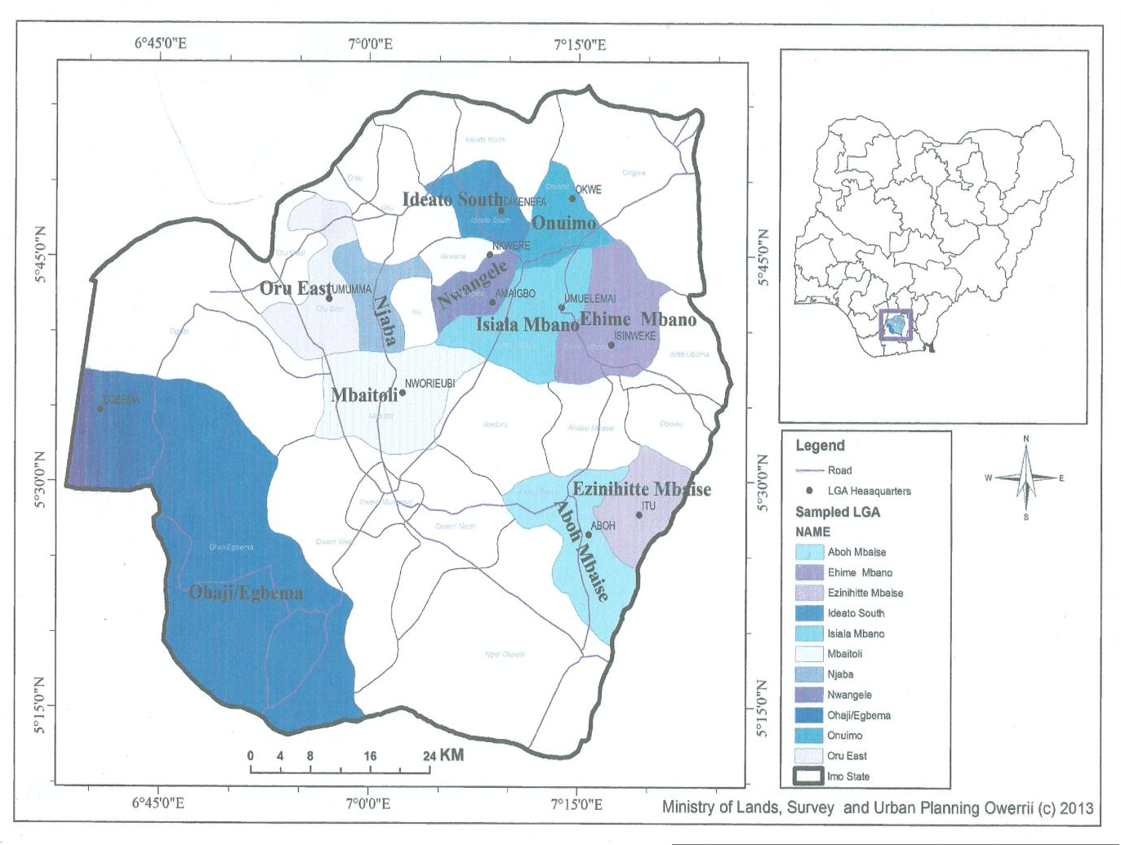
showing Study area
Politically, the State has a total of 27 Local Government Areas with three senatorial zones (comprising Okigwe, Owerri and Orlu) respectively. Imo State has 360 autonomous communities, but later increase to over 640 in 2016. From the dimension of geology, the

geological formations of the area study comprise cretaceous, Paleocene, Eocene, Pleistocene for Okigwe and Orlu zones, while Owerri zone is dominated by the Coastal Plains Sand Deposits of Tertiary Times [9].
The climate of the study area is humid Tropical (Af) Climate based on Köppen‟s classification scheme. The climatic season is classified into four comprising short dry season, long dry season, short rainy season and long rainy season (Umo, Enwereuzor, Asiegbu [9]. The mean annual rainfall is over 2250 mm with a mean temperature above 26.7⁰ [6, 9]. The relative humidity varies within the range of between 75 percent for dry season and 90 percent for rainy seasons. Recently, there are marked evidences of rising temperature and rainfall in the area due to global warning. The state lies within the rainforest belt of Nigeria with the varying forest patterns enrich with proportion of humus contents soils induced by vegetation materials.

MATERIALS AND METHODS
This study is empirical in nature with survey design. The secondary data for this study were generated from published and unpublished documents, while primary data were generated through structure questionnaire, oral interview, and direct field observations. Multi-stage samplings were used in sampling techniques. First, selection of Local Government Areas through stratified sampling. Second, selection of communities for study was based on random sampling and third, selection of respondents from households was done using systematic sampling.
In the selection of the LGAs, the urbanized LGAs were excluded because of the availability of strategic infrastructural facilities and amenities as reported in Enwereuzor, Umo and Charles- Akalonu [7], will negatively affect respondents‟ level of objectivity and the aims of this study. Finally, 11 LGAs are selected from the 22 rural LGAs by choosing the ones that fall under odd numbers in the alphabetical order of their names. The LGAs selected are Ehime Mbano (Eh), Isiala Mbano and Onuimo from Okigwe zone. From Orlu zone, the LGAs include Ideato South, Njaba, Nwangele, Ohaji/Egbema and Oru East, while from Owerri zone, Aboh Mbaise, Ezinihitte Mbaise, and Mbaitoli, LGAs are selected Enwereuzor [6].
The communities are selected by random sampling called “hat and draw” method. The names of the communities in the sampled LGAs are written on pieces of paper, rolled into balls, shuffled thoroughly in a black polythene bag and four communities per LGA as a base stem from the fact

that one of the sampled LGAs, Onuimo, has four communities. Therefore, to maintain the principle of equality among the LGAs, four communities are drawn from each of the Local Government Areas as demonstrated in Enwereuzor et al [7].
The demographic characteristics of 44 communities covered in this study have the information from them collated according to their respective LGAs and the following acronyms are used in all the tables and presented in what follow. Where: Ehm = Ehime Mbano; Ism = Isiala Mbano; Onu = Onuimo; Ids = Ideato South; Nja = Njaba; Nge = Nwangele; Ohe = Ohaji/Egbema; Oue = Oru East; Abm = Aboh Mbaise; Ezm = Ezinihitte Mbaise; and Mba = Mbaitoli as evidenced in Enwereuzor et al [6, 7].

RESULTS AND DISCUSSION

Assessment of the Nature and Characteristics of Roads Infrastructure
Transportation is a very important element in the development process. To assess road infrastructure as a development index, the respondents were asked to indicate the number of federal roads that traverse their communities. The responses are shown in Table 1.

Table 1: Number of Federal Roads that Traverse the Sampled Communities/LGA

FREQUENCY
 | Okigwe Zone |  |  |  | Orlu Zone |  |  |  | Owerri Zone
Fed.  Roads | Ehm | Ism | Onu | Ids | Nja | Nge | Ohe | Oue | Abm | Ezm | Mba | To  t | %
None | 12  (42.9) | 49  (74.2  ) | 23  (31.9  ) | 49  (96.1  ) | 18  (62.1  ) | 39  (46.4  ) | 26  (42.6  ) | 47  (65.3  ) | 31  (38.3  ) | 15  (65.2  ) | 43  (71.7  ) | 35  2 | 56.  1
1 | 15  (53.6) | 13 | 45  (62.5  ) | 2  (3.9) | 9 | 43  (51.2  ) | 32  (52.5  ) | 20 | 38  (46.9  ) | 4 | 14 | 23  5 | 37.  5
2 | 1 | 2 | 3 | 0 | 1 | 2 | 1 | 3 | 11 | 1 | 0 | 25 | 4.0
3 | 0 | 2 | 1 | 0 | 1 | 0 | 0 | 0 | 0 | 0 | 0 | 4 | 0.6
4 | 0 | 0 | 0 | 0 | 0 | 0 | 0 | 1 | 0 | 3 | 0 | 6 | 1.0
Abov e 4 | 0 | 0 | 0 | 0 | 0 | 0 | 2 | 0 | 0 | 3 | 0 | 5 | 0.8
Total | 28 | 66 | 72 | 51 | 29 | 84 | 61 | 72 | 81 | 23 | 60 | 627 | 100
Source: Authors‟ Analysis (2025).

A total of 352 out of 627 respondents, representing 56.1 percent, reported that there are no federal roads in their communities while 235 or 37.5 percent say that one federal road traverses their communities. Those that indicated two federal roads account for 4.0 percent of the respondents. Three and above federal roads are collectively recorded by 2.4 percent of the respondents. The inference is that federal roads are scanty in rural areas of Imo State.
On local government basis, 42.9 percent of the respondents in Ehime Mbano say no federal road traverses their communities while 53.6 percent says one federal road traverses their communities. In Onuimo LGA, 62.5 percent indicated one federal road and 31.9 percent says none. 96.1 percent of respondents in Ideato South strongly agree that there are no federal roads in their communities, while only 3.9 percent indicated one federal road. In Aboh Mbaise, 38.3 percent indicated none while 46.9 percent indicated one federal road in the LGA.
A study of the distribution pattern in Table 1 shows that five LGAs out of the eleven sampled local government areas indicated one federal road and these LGAs are Ehime Mbano 53.6 percent; Onuimo 62.5 percent; Nwangele 51.2 percent; Ohaji/Egbema 52.5 percent and Aboh Mbaise 46.9 percent while the remaining six LGAs say there are no federal roads in their communities. They are; Isiala Mbano 74.2 percent of its respondents; Ideato South 96.1 percent; Njaba 62.1 percent; Oru East 65.3 percent; Ezinihitte 65.1 and Mbaitoli 71.7 percent. The assumption is that communities with federal roads could be said to be more developed than those communities that do not have such roads. Using federal roads as an index for assessing rural development, the data in Table 4.42 show that federal roads are not equitably distributed in rural communities in Imo State as their presence is lacking in most communities as indicated by high frequency of 352 out of 627 respondents in Table 1. To ascertain the number of state government roads in each community in Imo State, the respondents were asked to indicate the number of state government roads in their community. Their responses are recorded in Table 2.
The distribution of state government roads as shown in Table 2 reveals that 129 or 21.5 percent of the respondents indicated that there are no state government roads in their communities. 309 or 51.4 of the respondents say that one state government road can be found in their communities. Those that indicated two state government roads account for 13.3 percent of the respondents. Four state government roads are recorded by just 2.2 percent and they are deemed negligible

since their percentage score is not up to 5. A total of 39 or 6.5 percent of the respondents claim to have more than five state government roads in each community in the sampled LGAs.

Table 2: Number of State Government Roads in the Study Area

FREQUENCY
 | Okigwe Zone |  |  |  | Orlu Zone |  |  |  | Owerri Zone
No. of State  Roads | Ehm | Ism | Onu | Ids | Nja | Nge | Ohe | Oue | Abm | Ezm | Mba | Tot | %
None | 9 | 8 | 24 | 8 | 7 | 16 | 8 | 5 | 25 | 4 | 15 | 129 | 21.5
1 | 10 | 34 | 26 | 40 | 15 | 41 | 39 | 36 | 33 | 9 | 36 | 309 | 51.4
2 | 3 | 6 | 7 | 3 | 1 | 20 | 10 | 13 | 11 | 3 | 3 | 80 | 13.3
3. | 1 | 5 | 12 | 0 | 1 | 4 | 0 | 4 | 2 | 2 | 0 | 31 | 5.1
4. | 1 | 1 | 0 | 0 | 2 | 0 | 0 | 4 | 2 | 0 | 3 | 13 | 2.2
Above 4 | 3 | 2 | 0 | 0 | 0 | 1 | 5 | 10 | 11 | 4 | 3 | 39 | 6.5
Total | 27 | 56 | 69 | 51 | 26 | 82 | 62 | 72 | 74 | 22 | 60 | 601 | 100
Source: Authors‟ Analysis (2025).

A careful look at Table 2 shows that the highest frequency for one state government road in each sampled community is recorded in the eleven sampled LGAs. Nwangele LGA tops the frequency distribution for two state government roads with 20 respondents or 24.4 percent. From the foregoing discussion, the data are suggestive of equitable distribution of at least one state government road in each community in the study area. What needs to be ascertained is the condition of the state government roads in these rural areas of Imo State. To ascertain the number of local government roads in each community, the respondents were asked to indicate the number of such roads in their communities. Their responses are shown in Table 3.
71 respondents out of 611 representing 11.6 percent claim that there are no local government roads in their communities, 138 or 22.6 percent say that they have one local government road while 122 or 20.0 percent of the respondents say there are two local government roads in their communities. Those that indicated three local government roads account for 19.3 percent of the respondents; 47 or 7.7 percent say that four local government roads exist in each of the sampled communities. A total of 115 out of 611 respondents or 18.8 percent have more than five local government roads their communities.

Table 3: Number of local government roads in the study area

FREQUENCY
 | Okigwe Zone |  |  |  | Orlu Zone |  |  |  | Owerri Zone
No. of LG  Roads | Ehm | Ism | Onu | Ids | Nja | Nge | Ohe | Oue | Abm | Ezm | Mba | Tot | %
None | 6 | 8 | 8 | 0 | 4 | 6 | 7 | 4 | 8 | 6 | 14  (23.3) | 71 | 11.6
1 | 5 | 10  (15.4) | 19  (27.5) | 7 | 8  (28.6) | 18 | 10  (15.6) | 10 | 14  (19.4) | 4 | 33  (55) | 138 | 22.6
2 | 2 | 5 | 9 | 22  (43.1) | 6 | 26  (31.7) | 7 | 16  (22.9) | 22  (30.6) | 6  (27.3) | 1 | 122 | 20.0
3. | 1 | 30  (46.2) | 23  (33.3) | 19  (37.3) | 4 | 4 | 9 | 11 | 13 | 2 | 2 | 118 | 19.3
4. | 5 | 3 | 7 | 3 | 1 | 8 | 5 | 4 | 3 | 2 | 6 | 47 | 7.7
5 and  above | 9  (32.1) | 9 | 3 | 0 | 5 | 20  (24.4) | 26  (40.6) | 25  (35.7) | 12 | 2 | 4 | 115 | 18.8
Total | 28 | 65 | 69 | 51 | 28 | 82 | 64 | 70 | 72 | 22 | 60 | 611 | 100
Source: Authors‟ Analysis (2025).

From the perspective of each LGA, 15.4 percent of respondents in Isiala Mbano have one local government road in each of the sampled communities in the LGA while 46.2 percent says there are three local government roads; in Onuimo LGA, 33.3 percent says that there are three local government roads in each of the sampled community and 27.5 indicated just one; in Nwangele LGA, 31.7 percent indicated two while 24.4 percent indicated more than five local government roads. However, in Mbaitoli LGA, 23.3 percent indicated none while 55 percent have one local government road in their communities.
The highest frequency for one local government road in each LGA is recorded by Njaba, 8 or
28.6 percent and Mbaitoli, 33 or 55 percent. The LGAs with the highest frequency of two local government roads are Ideato South, 22 or 43.1 percent; Nwangele, 26 or 31.7 percent; Aboh Mbaise, 30.6 percent and Ezinihitte, 6 or 27.3 percent. No local government area has its highest frequency as four roads. However, Ehime Mbano, 32.1 percent; Nwangele, 24.4 percent; Ohaji/Egbema, 40.6 percent and Oru East, 35.7 percent are areas where more than five local government roads are indicated by the respondents from the LGAs while Isiala Mbano, 30 or
46.2 percent and Onuimo, 23 or 33.3 percent have their highest frequency of respondents from three local government roads in each of the sampled communities within the study area.

The results are suggestive of inequitable distribution of roads infrastructure in communities within the sampled LGAs. Using local government roads as an index for assessment, it can be inferred that many local government areas in Imo State are underdeveloped. Thus, affirming Kadiri [3], notion that though there are over 200,000 kilometers of all categories of roads, not all settlements are adequately served. To assess communal efforts in rural development in Imo State, the respondents were asked to indicate the number of roads, routes and pathways constructed by the community. Their responses as summarized in Table 4 differ across Local Government Areas and communities in Imo State.

Table 4: Number of roads/routes/pathways constructed by communities

FREQUENCY
 | Okigwe Zone |  |  |  | Orlu Zone |  |  |  | Owerri Zone
No. of Comm  . Built Roads | Eh m | Ism | Onu | Ids | Nja | Nge | Ohe | Oue | Ab m | Ezm | Mb a | Tot | %
None | 10  (37) | 12 | 8 | 6 | 5 | 22  (27.2  ) | 19 | 18 | 13 | 4 | 21 | 138 | 22.7
1 | 3 | 6 | 13 | 3 | 2 | 12 | 4 | 8 | 10 | 2 | 11 | 74 | 12.2
2 | 2 | 1 | 9 | 3 | 4 | 20 | 8 | 6 | 7 | 6 | 1 | 67 | 11.0
3. | 5 | 4 | 2 | 12 | 4 | 5 | 5 | 10 | 14 | 3 | 0 |  | 10.6
4. | 4 | 36  (55.4  ) | 27  (39.1  ) | 14  (30.4) | 2 | 3 | 1 | 11 | 11 | 2 | 3 |  | 18.8
5 and Above | 3 | 6 | 10 | 8 | 11  (39.  3) | 19 | 26  (41.  3) | 18  (25.4  ) | 19  (25.7  ) | 6  (26.1  ) | 24  (40) |  | 24.7
Total | 27 | 65 | 69 | 46 | 28 | 81 | 63 | 71 | 74 | 23 | 60 |  | 100
Source: Authors‟ Analysis (2025).
The information in Table 4 indicates that communal efforts in road construction in the sampled communities seem not to be encouraging as 138 or 22.7 percent of the respondents say that there is no community built roads in their area. 74 or 12.2 percent of the respondents indicated just one road/path/route that is constructed by the community while 67 or 11.0 percent indicated two roads. Those that indicate three to four roads collectively account for 29.4 percent of the respondents while 150 out of 607 representing 24.7 percent say more than five roads are constructed by the communities.

The highest frequency of more than five roads/pathways/routes constructed by the community in each LGA is recorded in Njaba, 11 or 39.3 percent; Ohaji/Egbema, 26 or 41.3; Oru East, 18 or
25.4 percent; Aboh Mbaise, 19 or 25.7 percent; Ezinihitte, 6 or 26.1 percent and Mbaitoli, 24 or
40 percent. The LGAs that have the highest frequency of respondents indicating four roads/pathways/routes are Isiala Mbano, 36 or 55.4 percent; Onuimo, 27 or 39.1 percent and Ideato South, 14 or 30.4 percent while the highest frequency of none is recorded by Ehime Mbano 10 or 37 percent and Nwangele 22 or 27.2 percent. The data in Table 4 show that the rural communities know the importance of roads in any form of development. Consequently, they communally construct their own roads hoping that a tier of government may one day take them over. This explains why four or more roads/pathways/routes are constructed by the communities. This goes to show that communal efforts are employed in rural development rather than waiting for the governments.
In the literature, it is held that travel and transport in most rural areas in Nigeria still take place with great difficulty. Where motorable roads exist in rural areas in Nigeria, they are mostly of unpaved surfaces with narrow width, clad with either potholes or by depression and sagging. Such unsurfaced roads are hardly passable during the rainy season. To ascertain the mode of transportation in the sampled communities, the respondents were asked to indicate the mode of transport in their communities. Their responses are recorded in Table 5.

Table 5: Mode of Transportation in the Study Area

FREQUENCY
 | Okigwe Zone |  |  |  | Orlu Zone |  |  |  | Owerri Zone
Transport Mode | Eh m | Ism | Onu | Ids | Nj a | Nge | Oh e | Oue | Abm | Ez m | Mb a | Tot | %
Foot | 5 | 2 | 11 | 15 | 1 | 6  (7.3) | 2 | 7 | 4 | 3 | 6 | 62 | 10.0
Bicycle | 4 | 2 | 2 | 3 | 3 | 5 | 12 | 22  (28.6) | 11  (14.7) | 2 | 12 | 78 | 12.5
Motocycle  (inaga) | 18 | 55  (84.6) | 45 | 31 | 22 | 67  (81.7) | 40 | 45  (58.4) | 50  (66.7) | 17 | 36 | 426 | 68.4
Buses | 2 | 5  (7.7) | 2 | 2 | 2 | 0 | 8 | 1 | 4 | 0 | 6 | 32 | 5.1
Pick up | 0 | 0 | 11 | 0 | 0 | 0 | 0 | 0 | 1 | 0 | 0 | 12 | 1.9
Taxis | 0 | 1 | 0 | 0 | 0 | 4 | 0 | 2 | 5 | 1 | 0 | 13 | 2.1
Total | 29 | 65 | 71 | 51 | 28 | 82 | 62 | 77 | 75 | 23 | 60 | 623 | 100
Source: Authors‟ Analysis (2025).

The mode most widely used for transportation as shown in Table 5 is motorcycle, otherwise known as „inaga‟. This is indicated by 426 or 68.4 percent of the respondents. Movement on bicycle is recorded by 78 or 12.5 percent while movement on foot is recorded by 62 or 10.0 percent of the respondents. Those that make use of buses account for 5.1 percent of the respondents. Taxi and pickup as means of transportation are collectively identified by 4.0 percent of the respondents. Within the local government areas, 84.6 percent of respondents in Isiala Mbano LGA say the mode of transportation in the communities is the motorcycle (inaga) while
7.7 says it is the buses.

In Nwangele, 81.7 percent indicated motorcycle while 7.6 percent says that they move on foot.
28.6 percent indicated bicycle as mode of transportation in Oru East while 66.7 percent of the respondents say motorcycle (inaga) is the mode of transportation in their communities. In Aboh Mbaise, 14.7 percent indicated bicycle while 66.7 percent claim that motorcycle is their mode of transportation. From the results, the major mode of transportation recorded by the highest frequency of respondents in all the sampled local government areas is the motorcycle (inaga), followed by movement on bicycle and then foot.
  - Evaluation of the Contributions of Road Infrastructure to Communities Development To assess the contribution of roads to the development of rural areas in the study area, the respondents were asked to indicate the greatest contribution of roads to the development of their communities. Their reactions are shown in Table 6.
The data in Table 6 indicate that enhancement in the evacuation of farm products to the market in the communities is the greatest contribution of roads in rural development in Imo State. 246 out of 585 representing 42.1 percent of the respondents said so. It should be noted that without good roads in the rural areas, agricultural products for which the rural communities are noted for will not get to urban markets. The consequence may be scarcity of food stuff in urban areas. 138 or 23.5 percent say roads with good drainage system help in reducing flooding when it rains. Attracting other socio-economic activities into the communities is recorded by 20.8 percent of the respondents. Those that are of the opinion that road infrastructure increases movement of people in the community account for 7.4 percent while 6.2 percent says road infrastructure

increases social interaction within the community. It can be inferred that the evacuation of farm products is seen by the ruralites in Imo State as the most valued role of roads.
In Isiala Mbano LGA, 48.4 percent of the respondents say enhancement in the evacuation of farm product to the market is the main contribution of roads in the development of their communities while 33.9 percent claims that roads bring other socio-economic activities into their communities. In Oru East, 47.8 percent indicated evacuation of farm product to the market while
25.4 percent of the respondents say that roads help in reducing flood when it rains. In Aboh Mbaise, 45.8 percent indicated enhancement in evacuation of farm products to the market while
19.4 percent says bringing in other socio-economic activities is the greatest contribution of road infrastructure to the development of rural communities.

Table 6: Contribution of road infrastructure to the development of the sampled Areas

FREQUENCY
 | Okigwe Zone |  |  |  | Orlu Zone |  |  |  | Owerri Zone
Contribution  of Roads | Eh  m | Ism | Onu | Ids | Nja | Nge | Oh  e | Oue | Abm | Ez  m | M  ba | Tot | %
Enhancing the evacuation of farm products  to the market | 12 | 30  (48.4) | 29 | 13 | 6 | 26  (32.1) | 29 | 32  (47.8) | 33  (45.8) | 10 | 26  (50.  9) | 246 | 42.1
Increasing movement of people into the  community | 5 | 2 | 2 | 1 | 2 | 11 | 2 | 4 | 8 | 1 | 5 | 43 | 7.4
Reducing flooding when  it rains | 2 | 7 | 13 | 23  (45.1) | 7 | 24  (29.6) | 14 | 17  (25.4) | 13 | 3 | 15 | 138 | 23.5
Attracting other socio-economic activities | 3 | 21  (33.9) | 20 | 2 | 9  (34.6) | 16 | 14 | 12 | 14  (19.4) | 6 | 5 | 122 | 20.8
Social interaction within the Community | 0 | 2 | 4 | 12 | 2 | 4 | 3 | 2 | 4 | 3 | 0 | 36 | 6.2
Total | 22 | 62 | 68 | 51 | 26 | 81 | 62 | 67 | 72 | 23 | 51 | 585 | 100
Source: Authors‟ Analysis (2025).
The highest frequency for enhancing the evacuation of farm products to the market as the greatest contribution of road infrastructure to the development of rural communities is recorded by nine out of the eleven sampled Local Government Areas except in Ideato South that has its highest frequency of 23 or 45.1 for reducing flooding when it rains and Njaba LGA with its

highest frequency of 9 or 34.6 percent for other socio-economic activities that are attracted into the community as the greatest contribution of road infrastructure to the development of their communities. From the foregoing, it is seems safe to conclude that the greatest contribution of roads in rural development in Imo State is, its enhancement in the evacuation of farm products to the market.
  - Perceived Negative Effects of Poor Road Infrastructure the Sustainable Development Having examined the contribution of roads to the development of rural areas, it is pertinent to ascertain the number of tarred roads in rural communities in Imo State. Consequently, the respondents were asked to indicate the number of tarred roads in their communities. Their responses are distributed in Table 7.

Table 7: Number of Tarred Roads and those under Construction in the Sampled LGAs

FREQUENCY
 | Okigwe Zone |  |  |  | Orlu Zone |  |  |  | Owerri Zone
No. of Tarred Roads | Eh m | Ism | Onu | Ids | Nja | Nge | Ohe | Oue | Abm | Ezm | Mba | Tot | %
None | 10  (35.  7) | 5 | 19  (27.5) | 3 | 4 | 20  (24.4) | 13 | 8 | 13 | 3 | 28  (47.5) | 126 | 20.9
1 | 6 | 48  (72.7) | 25  (36.2) | 9 | 8  (27.6  ) | 25  (30.5) | 22  (34.9) | 28  (40) | 26  (35.1) | 2 | 18  (30.5) | 217 | 35.9
2 | 9 | 9  (13.6) | 13 | 24  (58.5) | 8 | 22  (26.8) | 8 | 15 | 17 | 12  (52.2) | 8 | 145 | 24.0
3. | 0 | 1 | 1 | 2 | 3 | 9 | 7 | 4 | 10 | 2 | 1 | 40 | 6.6
4. | 1 | 2 | 6 | 2 | 4 | 5 | 1 | 4 | 2 | 2 | 1 | 30 | 5.0
Above  4 | 2 | 1 | 5 | 1 | 2 | 1 | 12 | 11 | 6 | 2 | 3 | 46 | 7.6
Total | 28 | 66 | 69 | 41 | 29 | 82 | 63 | 70 | 74 | 23 | 59 | 604 | 100
Source: Authors‟ Analysis (2025).

The distribution of tarred roads in Table 7 shows that 126 out of 604 respondents representing
20.9 percent say that there are no tarred roads in their communities. The highest frequency of 217 or 35.9 percent claims to have one tarred road in their communities. Those that indicated two tarred roads account for 24.0 percent of the respondents while the response for four tarred roads and above is collectively recorded by 12.6 percent of the respondents.

The details from the LGAs show that, 72.7 percent of respondents in Isiala Mbano indicated one tarred road in each of the community while 13.6 percent have two tarred roads. In Nwangele LGA 24.4 percent says no tarred road in their communities while 30.5 percent indicated one tarred road. In Mbaitoli 47.5 percent indicated no tarred road while 30.5 percent indicated one tarred road.
The highest frequency of one tarred road in each LGA is recorded by Isiala Mbano, 48 or 72.7 percent; Onuimo, 25 or 36.2 percent; Njaba, 8 or 27.6 percent; Nwangele, 25 or 30.5 percent;
Ohaji/Egbema, 22 or 34.9 percent; Oru East, 28 or 40 percent; Aboh Mbaise, 26 or 35.1 percent and Mbaitoli, 18 or 30.5 percent. Two tarred roads have their highest frequency recorded in Ideato South, 24 or 58.5 percent and Ezinihitte, 12 or 52.2 percent of its respondents. The highest frequency of none is recorded by Ehime Mbano, 10 or 35.7 percent and Mbaitoli, 28 or 47.5 percent. From the results, majority of the communities has at least one tarred road. However, since there are communities without tarred roads, the data are suggestive of uneven spread of tarred roads among communities in rural areas in Imo State.
With high temperature, high humidity and heavy rainfall characteristics of Imo State, untarred roads are easily eroded. For durability, the roads need to be tarred. Absence of tarred roads has negative consequences. To check if such negative effects are noticeable, the respondents were asked to state the highest negative effect of the absence of tarred/access roads on their communities. Their responses are shown in Table 8.
The highest negative effect of absence of tarred/access roads in rural development in Imo State is lack of other social amenities in communities as shown in Table 8. This is indicated by 163 out of 618 respondents which represents 26.4 percent. This shows that road infrastructure is a fundamental parameter for facilitating industrial, agricultural and other socio-economic development in an area. Reduced interaction with other communities is indicated by 121 or 19.6 percent of the respondents while farm produce decay in farms is recorded by 101 or 16.3 percent of the respondents. Flooding when it rains and erosion being pronounced are indicated by 16.0 percent and 12.1 percent of the respondents respectively. Increase in rural migration with 9.6 percent of the respondents is rated last.

The highest negative effect of absence of tarred/access roads tends to vary from community to community. The highest frequency of lack of other social amenities in the area is noted in Isiala Mbano, 30 or 45.5 percent; Onuimo, 22 or 31.4 percent; Ideato South, 22 or 43.1 percent;
Ohaji/Egbema, 21 or 33.3 percent; Oru East, 21 or 29.6 percent and Mbaitoli, 14 or 23.3 percent. The highest frequency of flooding when it rains is recorded in Ehime Mbano, 8 or 27.6 percent and Njaba, 9 or 30 percent; while reduced interaction with other communities has its highest frequency of respondents in Nwangele, 21 or 26.6 percent; Aboh Mbaise, 20 or 27.0 percent and Ezinihitte, 7 or 31.8 percent.

Table 8: Negative Effect of Absence of Tarred/Access Roads in Sampled LGA

FREQUENCY
 | Okigwe Zone |  |  |  | Orlu Zone |  |  |  | Owerri Zone
Negative effects of untarred  Roads | Eh m | Ism | Onu | Ids | Nj a | Ng e | Ohe | Ou e | Abm | Ez m | Mb a | Tot | %
Farm produce rot away in  farms | 4 | 10 | 17 | 3 | 2 | 11 | 9 | 14 | 16 | 7 | 8 | 101 | 16.3
Reduced | 5 | 6 | 13 | 14 | 7 | 21 | 11 | 8 | 20 | 7 | 9 | 121 | 19.6
interaction with other  Communiti |  |  |  |  |  | (26.  6) |  |  | (27.0) | (31  .8)
es
Flooding | 8 | 5 | 5 | 2 | 9 | 9 | 7 | 17 | 17 | 6 | 14 | 99 | 16.0
when it  rains | (27.  6) |  |  |  | (3  0)
Erosion is pronounced in the  community | 3 | 11 | 5 | 2 | 5 | 13 | 8 | 6 | 11 | 2 | 9 | 75 | 12.1
Lack of | 7 | 30 | 22 | 22 | 4 | 16 | 21 | 21 | 6 | 0 | 14 | 163 | 26.4
other social amenities in the area |  | (45.5) | (31.4) | (43.1) |  |  | (33.3) | (29.  6) |  |  | (23.3)
Increase in rural migration | 2 | 4 | 8 | 8 | 3 | 12 | 7 | 5 | 4 | 0 | 6 | 59 | 9.6
Total | 29 | 66 | 70 | 51 | 30 | 82 | 63 | 71 | 74 | 22 | 60 | 618 | 100
Source: Authors‟ Analysis (2025).

Testing of the Hypothesis
The hypothesis states that Road Infrastructural are not equitably distributed among the rural communities in the study area. The spirit of the hypothesis hinges on the belief that equitable distribution of development parameters such as road will usher in equal development among the communities in Imo State. To measure equality, and by implication inequality, a statistical tool that readily calls to mind is the Gini Coefficient also known as the Gini Index [10]. Development in rural communities becomes meaningful only when its tenets are aimed at improving the societal welfare of the citizens within the communities.
The Gini Index, in its computation, has a base magnitude whose data are graphed on the x-axis on the Lorenz Curve, while the y-axis takes the variables used for the analysis. There are two possible options that can be used as the base magnitude when assessing equitable distribution of infrastructural facilities among rural communities [6, 10]. One can use the area of the communities/Local Government Areas (L.G.As) or the population of the people in such L.G.As. In this study, population is taken as the base magnitude. The rationale is that development is for people. Human beings are at the vortex of all development. The degree of development can be estimated by measuring the quality of life of the citizenry supposedly brought about by infrastructural facilities.
Thus, broad-based development occurs when each individual in a community is placed on a pedestal that affords him the opportunity to optimize his welfare. Having made a case for the choice of the population of the eleven Local Government Areas sampled for this study as the base magnitudes, the data in Tables 2 is used to compute the Gini Indices
The Gini Index can be computed mathematically using the formula,
G = 1-Σ^{N}(σY_{i–1} + σY_{i}) (σX _{i–1} + σY_{i}) eqn 1
i = 0
Where; σX and σY are the cumulative percentages of Xs and Ys.

Variables (in fractions) N is the number of elements (observations). Σ is the summation symbol.

As stated earlier, Gini Coefficient is also derivable from Lorenz Curve. This technique is used here to test the degree of inequality in the distribution of state government roads. The population data for the eleven sampled Local Government Areas covered in this study are shown in Table 9. To verify if the causal observers‟ assessment is credible the data on road network are used as a

surrogate for the analysis. The results of the cumulative percentages for population and road infrastructure presented in Table 9 vary based on local government areas

Table 9: Population Data of the Local Government Areas used in this Study
Local Government  Area | Population | Cumulative Percentage  of Population | Cumulative percentage  of state roads
Ezinihitte Mbaise | 165,593 | 9.6 | 3.9
Ehime Mbano | 130,931 | 17.2 | 8.4
Njaba | 115,110 | 23.9 | 12.9
Ideato South | 159,879 | 33.2 | 21.4
Mbaitoli | 237,555 | 47.0 | 30.8
Ohaji/Egbema | 182,538 | 57.6 | 40.8
Isiala Mbano | 198,736 | 69.1 | 51.1
Onuimo | 99,247 | 74.7 | 62.5
Oru East | 111,822 | 81.2 | 74.5
Aboh Mbaise | 195,652 | 92.5 | 86.7
Nwangele | 128,472 | 100 | 100
Grand Total | 1,725,535
Source: Modified from the National Population Commission [11] Census Data.

The Lorenz Curve resultant from the data in Table 9 is shown in Figure 2
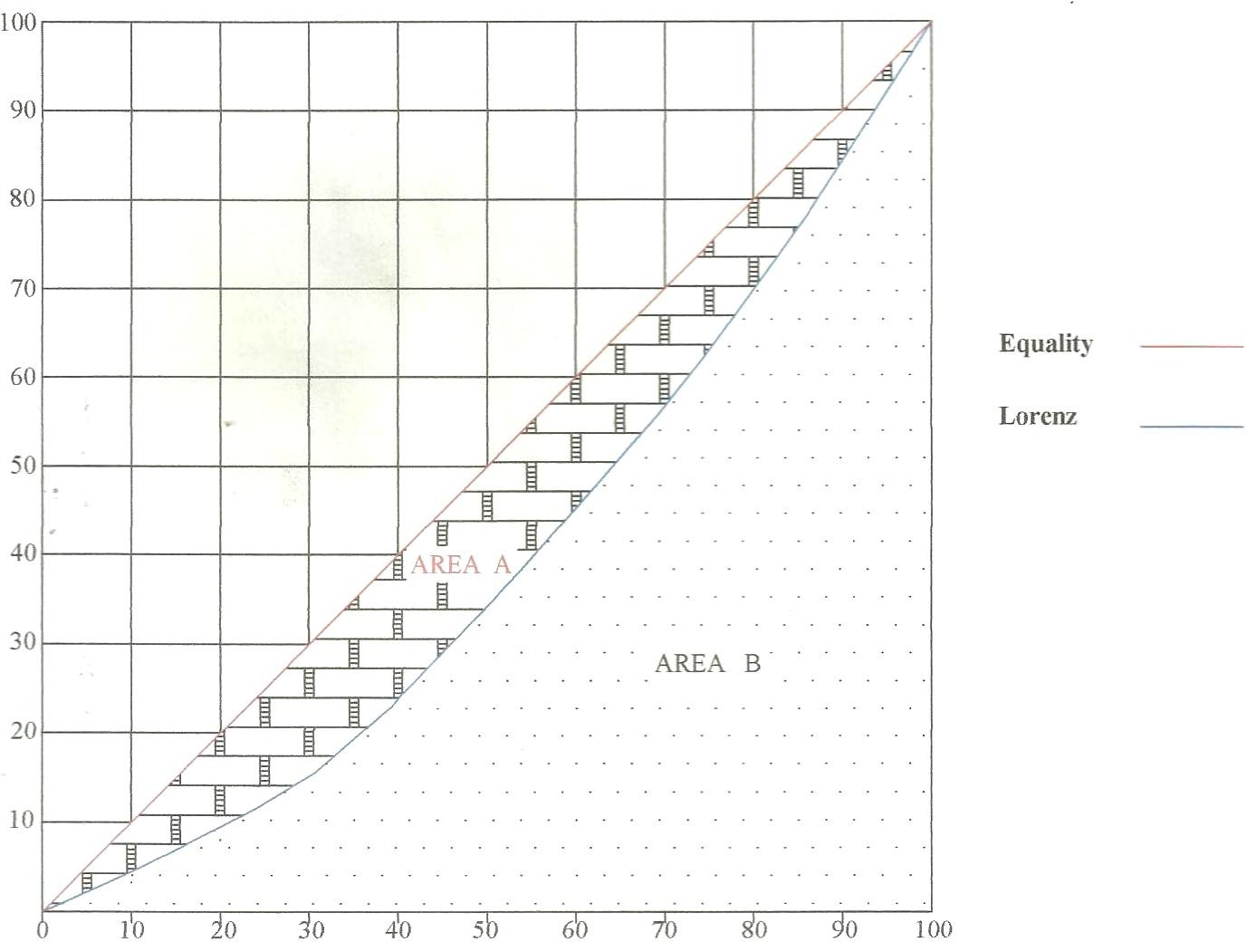
LORENZ CURVE
Figure 2: Lorenz Curve based on the data from Table 9; number of State roads in communities within the study area

Inferring from Figure 2, the area of the Lorenz curve under the diagonal is computed as 18.9958 square centimetres. From the result, the Gini Index is found to be 0.3799. It is pertinent to recall that Gini Index registers the degree of departure from the line of equality. Unless the Lorenz curve coincides with the line of equality, there is inequality but what is deemed relevant is the magnitude. Here, the Gini Coefficient of 0.3799 indicates a small departure from equality. It is found that there is inequality in the distribution of state roads among the Local Government Areas in Imo State. Stated differently, the revelation is that there is fairly even distribution of state roads in Imo State. The degree of inequality is analyzed to be statistically insignificant.

CONCLUSION AND RECOMMENDATION
This study assess road infrastructure as a basis for rural development. Both field and statistical analysis show that road infrastructure is not equitable distributed in all the sampled Local Government Areas. This study reveals that, there are no Federal Government Roads in most communities while very few state government roads are tarred but not seriously maintained. Local Government and community constructed roads are not easily accessible during the rainy seasons.
The study recommends that all rural roads should be tarred to improve accessibility and accelerate development in the rural areas. Also routine maintenances of road infrastructure should be carried out by governments and other stakeholders in development sectors to make them sustainable.
Disclaimer (Artificial intelligence)
Option 1:
Author(s) hereby declare that NO generative AI technologies such as Large Language Models (ChatGPT, COPILOT, etc.) and text-to-image generators have been used during the writing or editing of this manuscript.
Option 2:
Author(s) hereby declare that generative AI technologies such as Large Language Models, etc. have been used during the writing or editing of manuscripts. This explanation will include the name, version, model, and source of the generative AI technology and as well as all input prompts provided to the generative AI technology
Details of the AI usage are given below:
1.
2.
3.

Competing Interest
The authors declared that no conflicting interest exist in this paper.

REFERENCES
- United Nation Sustainable Development Goal Global indicator framework for the Sustainable Development Goals and targets of the 2030 Agenda for Sustainable Development. Official Statistics. 2015: A/RES/71/313
- Chen, X., Yin, M., Song, M., Zhang, L., & Li, M. (2014). Social welfare maximization of multimodal transportation: Theory, metamodel, and application to Tianjin Ecocity, China. Transportation Research Record, 2451(1), 36-49.

- Enwereuzor, A.I Distribution of infrastructure as a basis for difference in rural development in Imo State Nigeria. 2016: Unpublished thesis, Imo State University, Owerri
- Charles-Akalonu C.A.; Umo, I.S.; Amadi, J.C. The determinants of sustainable utilization of primary health care facilities in Isiala Mbano, Imo, Nigeria. NIPES Jour. Energy, Techn, and Environ: 2021. 3(4), 83 – 96. https://doi.org/10.37933/nipes.e/3.4.2021.10
- Federal Republic of Nigeria. The National Population Commission: 2006. Lagos, Government Press
- Ghosh, M. (2017). Infrastructure and development in rural India. Margin: The Journal of Applied Economic Research, 11(3), 256-289.
- BRYZHKO, V. G., & BRYZHKO, I. V. (2019). Comprehensive assessment of the impact of road infrastructure development in a rural municipal area (Russia). Revista Espacios, 40(37).
- Zhou, Y. (2020, January). Research on Evaluation Index of rural roads development level. In 2020 International Conference on Intelligent Transportation, Big Data & Smart City (ICITBS) (pp. 154-161). IEEE.
- De, U. K. (2018). Road infrastructure and agricultural development: A policy intervention in a backward rural economy. De, UK (2018),“Road Infrastructure and Agricultural Development: A Policy Intervention in a Backward Rural Economy”, Society & Change, 12(2), 45-75.
- Kamaludin, A. S., & Qibthiyyah, R. M. (2022). Village road quality and accessibility on transforming rural development. AGRARIS: Journal of Agribusiness and Rural Development Research, 8(2), 160-180.

