Original Research Article
A Qualitative Study to Explore Cultural Beliefs and Structural Challenges Affecting Healthcare Access among Indigenous Women in Guatemala

ABSTRACT
The issues of Guatemalan people in accessing healthcare originate from complex cultural beliefs and historical legacies, with no apparent social explanation. This research examines how cultural beliefs, and structural challenges collectively influence healthcare access for Indigenous women in Guatemala, with a particular focus on traditional medicine. Indigenous populations often seek traditional practices, such as herbal remedies and spiritual support, as they provide physical and psychosocial relief, and linguistic, cultural, and social barriers that lead to disparities in health outcomes. While the study also explores physical treatment, including herbal remedies, massage, and other traditional interventions, comparing how these practices affect Indigenous women who have no access to modern healthcare services, the study also explores inequality of women and healthcare-seeking pattern of women through analyzing quantitative data from surveys with 100 participants and a review of existing literature, with the investigation on the complex interaction between cultural/traditional beliefs and modern healthcare structures that affects the healthcare access of Indigenous women in Guatemala. The accumulated survey data was reported as a percentage among the answers. The findings reveal that a significant number of Indigenous women are experiencing male-dominated decision-making, still visit traditional healers, use traditional remedies at home, and believe their religious beliefs are crucial in their approach to health and healing.

Keywords: Traditional medicine, massage therapies, geographic isolation, Indigenous communities

INTRODUCTION
Among countries in Central America, Guatemala has the most cultural diversity, with 43% of the total population identifying themselves as Indigenous, with 20 Indigenous groups [1]. Within these indigenous communities, especially women remain the most underserved group in the country, even though they have contributed historically and culturally [2, 3]. Indigenous women are suffering from severe poverty, illiteracy, and limited access to healthcare, and those are intensified by racial discrimination, gender inequality, and geographic isolation [4, 5, 6]. Although effective interventions have been understood for decades, they remain insufficiently accessible and available in many developing nations [7].
The issues of Guatemalan people in accessing healthcare are caused by complex cultural beliefs and historical legacies, rather than simple availability [8]. Furthermore, many women in Indigenous communities understand health through holistic systems that integrate physical, emotional, and spiritual aspects [9]. Due to these reasons, traditional medicines, such as herbal remedies, massage therapies, midwifery, and spiritual rituals, are widely practiced and trusted [10]. Also, some Indigenous women think the modern healthcare system has challenges in receiving effective care due to cultural insensitivity, linguistic inaccessibility, or physical unreachability [11, 12].
In addition to these cultural factors, structural factors also prevent Indigenous women from accessing healthcare and receiving proper care. Structural factors that hinder Indigenous women from seeking healthcare include male-dominated decision-making that leads to limited autonomy in healthcare choices, and inconvenience in communicating health issues with healthcare providers due to cultural and linguistic reasons [13, 14]. Moreover, religious beliefs also play a crucial role in how diseases are comprehended and treated.
This study explores various factors that affect the healthcare-seeking behaviors of Indigenous women in Guatemala: cultural beliefs, traditional healing practices, inequalities, gender roles, and religion. Through interviews with 100 Indigenous women from rural areas in Guatemala and literature reviews, this research explores culture-based understanding of healthcare access in Indigenous communities, in addition to traditional practices of Indigenous women. By examining how cultural beliefs and structures challenge shape the access to healthcare of Indigenous women in Guatemala, this study emphasizes the need for improvement in health policies and culturally competent care that integrates Indigenous epistemologies while addressing systemic barriers to equity.

METHODOLOGY & DATA COLLECTION
The surveyed data were collected from women in rural and suburban communities in Guatemala, including Sacapulas, which is significantly distant, 188km away, from the capital of Guatemala, with limited data on the population [15]. The survey was conducted with 100 Indigenous women from rural regions of Guatemala, focusing on questions about gender equity in the context of seeking healthcare, preferred medical professions, the use of traditional remedies, the impact of spiritual or religious beliefs on healthcare choices, and perceptions on discussing health issues with medical professionals. Participants were selected from visitors to temporary medical facilities established by a medical volunteer team, and the survey questions were translated into Spanish with the assistance of trained interpreters.
In addition to the survey, the study also utilized a literature review of previous studies related to cultural healthcare behavior and traditional medicine among the Indigenous population in Guatemala. The review of literature involved key terms, including "Indigenous women," "traditional healers," and "Mayan medicine."
Survey data were analyzed to highlight trends and support qualitative insights into recurring patterns related to cultural health beliefs, barriers to healthcare access, and perceptions of the formal healthcare system. The literature review provided a contextual background and supported an understanding of the healthcare context for Indigenous women. Overall, this dual-focused review of the literature and survey provided valuable insights into how cultural beliefs and structures influence healthcare for Indigenous women in Guatemala.

RESULTS
Empirical Data Through Survey
Through surveying 100 Indigenous women in Guatemala, the research team was able to collect empirical information. The questionnaire created before the participants’ recruitment was used to gain insight into their perspectives on gender equity, preferred medical professions, treatment, and religion within the healthcare access context. Participants were selected from visitors to temporary medical facilities, and the questions were translated into Spanish or K’iche’ or Quiché, the Mayan language spoken by Indigenous people in rural Guatemala [16].

Gender Roles and Autonomy in Healthcare Decisions
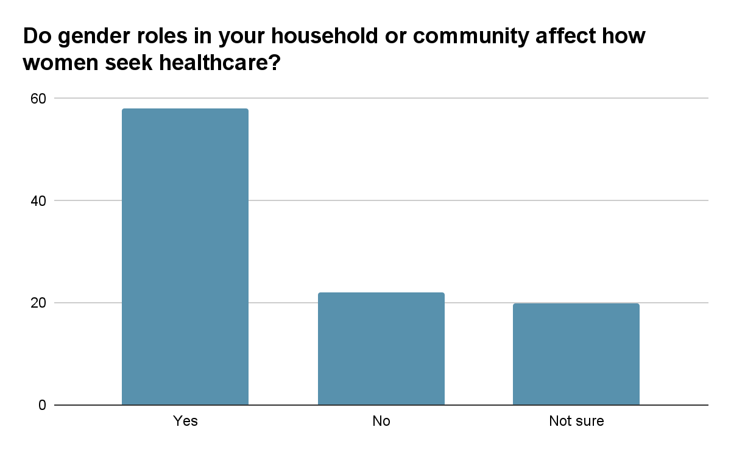
Figure 1. Survey results from question 1

Figure 1 represents data from a survey of Indigenous women’s perspectives on gender roles in making healthcare decisions. This question was designed to collect data on whether women have autonomy over healthcare. 58% (n = 58) of the participating women indicated that their healthcare decision on when and how to seek medical services is affected by gender roles in the household or community. On the other hand, only 22% (n = 22) indicated that gender roles have no impact on how women seek healthcare. Gender roles often restrict women’s autonomy, which results from male-dominated decision-making behavior within Indigenous communities. This finding highlights the fact that women prioritize patriarchal decisions and need approval from them in order to visit or seek healthcare.

Healthcare Professions Preferences
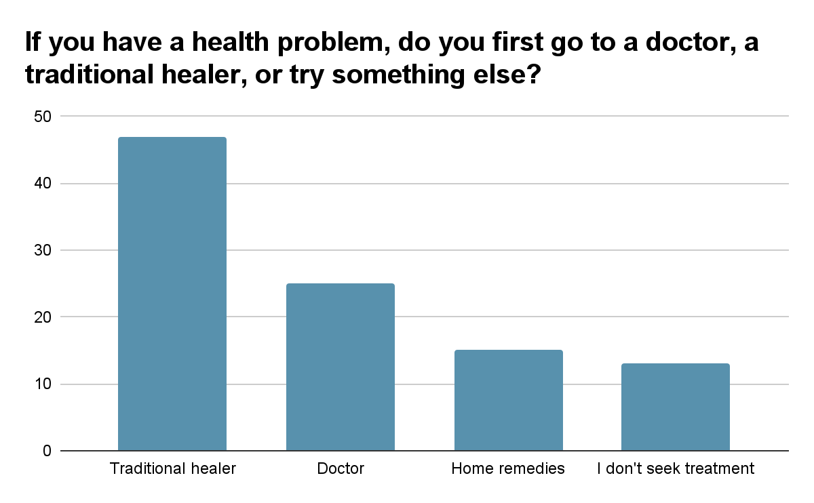
Figure 2. Survey results from question 2
Figure 2 depicts the findings from the second question regarding Indigenous women’s preferred medical profession when facing a health concern, and the question asked to understand healthcare-seeking behavior. Most respondents, 47% (n = 47), indicated that they go to a traditional healer first when experiencing a health issue, and 25% (n = 25) of participants reported that they go to doctors. A smaller percentage, 15% (n = 15), answered that they use home remedies instead of going to care providers, while 13% (n = 13) stated they do not seek any treatment. These results show a preference for traditional care among many respondents while demonstrating that formal healthcare is also a significant and trusted source of care. Factors such as cultural familiarity, accessibility, and linguistic mistreatment of biomedical institutions may contribute to the continued use of traditional practices.

Use of Traditional Remedies in the Household
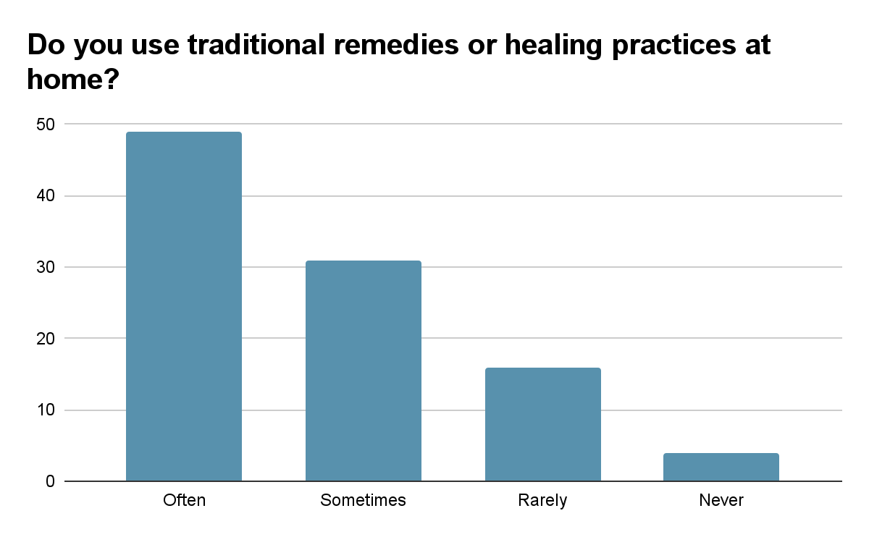
Figure 3. Survey results from question 3
Figure 3 illustrates how often traditional remedies are used in Indigenous people’s households. This question was included to understand how deeply Indigenous healing practices remain part of everyday health management. Among the 100 women who participated, 49% (n = 49) reported using traditional remedies often, and 31% (n = 31) stated they use them sometimes. On the other hand, only 4% (n = 4) said they never used traditional treatments, which indicates that Indigenous practices such as herbal medicine, massage, and ritual healing continue to play a central role in treating illness.

Spiritual and Religious Beliefs in Health
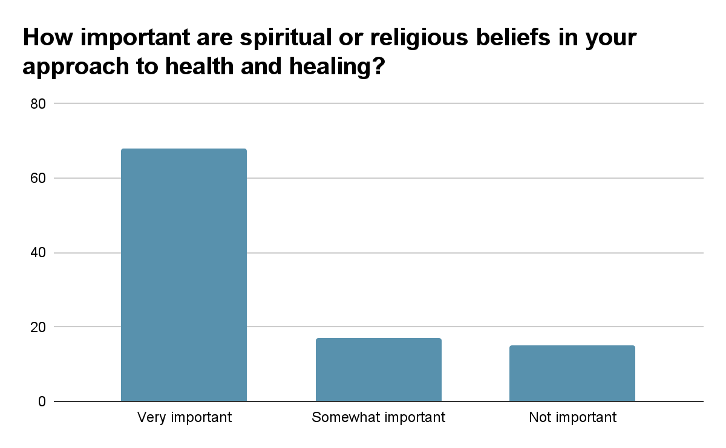
Figure 4. Survey results from question 4
Figure 4 illustrates the impact of spiritual and religious beliefs on women's healthcare-seeking behaviors/perspectives. This question sought to understand how spirituality affects health decisions and perceptions of illness. More than half of the respondents, 68% (n = 68), answered that their spiritual or religious beliefs are fundamental, while only 32% (n = 32) stated that religious beliefs are somewhat important or not necessary in their approach to health and healing. Many participants also believe that illness is a spiritual imbalance, ancestral discontent, or divine punishment. Due to these beliefs, women often approach healthcare through prayer, rituals, or guidance from spiritual leaders, highlighting the importance of culturally grounded approaches to healing.

Cultural Communication with Medical Professionals
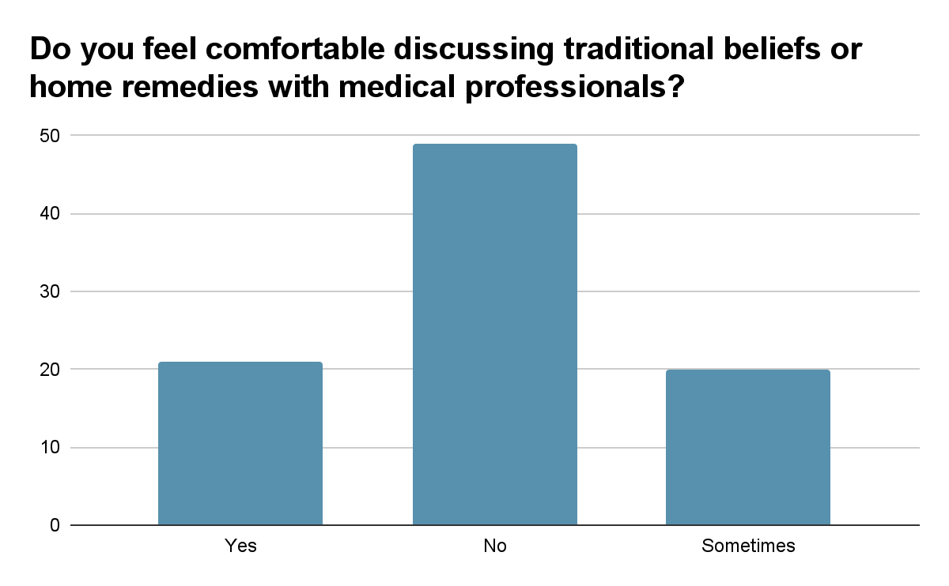
Figure 5. Survey results from question 5
Figure 5 shows responses regarding women’s comfort in discussing traditional or home-based remedies with medical professionals—this question aimed to understand whether cultural practices are openly communicated during healthcare facility visits. About half of the participants, 49% (n = 49), indicated that they feel uncomfortable discussing these practices with healthcare providers. 31% (n = 31) of respondents said they are comfortable. 20% (n = 20) of participants reported feeling comfortable sometimes. The survey findings highlight that this reality is rooted in fear of judgment, previous experiences of being dismissed, or language barriers. Many women reported intentionally withholding cultural information to avoid disrespect or misunderstanding during medical consultations.

Traditional Medicine Interventions of Indigenous Women
Traditional medical practices utilized by Indigenous people include a wide range of interventions, such as herbal remedies, traditional healers, and spiritual healing to heal not only the body, but also the mind and spirit [17]. Their holistic approaches to medical intervention are deeply rooted in their lifestyles.
One of the most prevalent interventions is the utilization of plants. Indigenous people possess knowledge about medicinal plants, including their functions, which has been passed down from generation to generation [18]. With this knowledge, they develop a special bond with local plants, and healers interpret these characteristics to derive their medicinal value. Furthermore, most of the time, traditional healers believe the cause of illness is rooted in an imbalance of bodily temperature and provide plants that will restore the imbalance [19]. Also, herbal remedies are preferred due to economic reasons, as Western medicine is challenging to access and expensive [20]. For this reason, Guatemala’s women still rely on traditional medicine as their primary treatment, which is also shown in the chart above.
Other than herbal remedies, spiritual healing is also another traditional medical intervention among Indigenous women. Due to their strong belief in the connection of body and spirit, religious ceremony is a crucial part of their healing, and healers lead it at a sacred place [21]. For instance, the Mayan Cacao Ceremony is the most well-known ceremony in the Lake Atilan region of Guatemala, which is led by the Shaman, and is used to eliminate toxins both physically and spiritually [22, 23].
In addition to a spiritual ceremony, Indigenous women also directly receive treatment from a traditional female healer called a Curandera. A Curandera practices folk medicine, utilizing knowledge of herbs, spiritual practices, and healing rituals passed down from their ancestors [24]. Curanderas specialize in addressing infermas mujeres (disease of women) and have a significant impact on health outcomes for women and children [25, 26].

Barriers to Modern Health
Even today, Indigenous women go to traditional healers or use home remedies when they have a health problem, rather than going to see a doctor for Western medicine. Barriers that hinder Indigenous women from accessing health care would be systemic discrimination, geographic distance (or proximity to a healthcare facility), and cultural and linguistic barriers [27].
Guatemala’s national budget pays little attention to health promotion activities [28]. Furthermore, most of the healthcare system is located in the metropolitan area of Guatemala City, where individuals with high income get medical services from private facilities [29]. However, in rural areas, where the Indigenous population lives and has no access to healthcare, they are getting medical services from volunteers or rural health workers with limited resources [30].
In addition, as many Indigenous communities are located far from healthcare facilities, accessing healthcare is more challenging due to transportation difficulties and limited resources. Some women often lose their appointments due to their inability to get transportation to the healthcare facilities [31].
Beyond the geographic isolation, cultural and linguistic barriers also hinder women from seeking formal healthcare. For instance, when Indigenous women visit a healthcare facility, health providers might not speak Mayan Indigenous language, Quiché, which causes individuals to communicate their condition effectively or clearly. Moreover, culturally incompetent healthcare providers lead to misunderstanding patients’ culture and might provide culturally inappropriate care that causes patients to mistrust the healthcare providers [32].

Why are they seeking Traditional Medicine Intervention
Due to these various reasons, Indigenous women in Guatemala tend to seek traditional healers who are easily accessible, unbiased, and culturally familiar. The healing method of Guatemalan Indigenous people incorporates the Mesoamerican aspect, which is holistic care that heals not only physically but also mentally and spiritually [33]. Traditional medicine intervention is deeply related to Indigenous cultures and beliefs, and it is a way to be connected with their cultural identity that is part of the healing process. Also, traditional medicine intervention includes getting treatment from a Curandera, a traditional female healer. By seeking a Curandera, Indigenous people can prioritize their own health decisions and have autonomy when they need to seek healthcare.

DISCUSSION
This study highlights the various factors that shape Indigenous women’s healthcare access and seeking behaviors in rural Guatemala. Nearly half of the survey participants indicated they preferred traditional healers and medicine, which reflects deep-rooted cultural beliefs and trust in holistic healing. Curanderas, traditional female healers, and their practices still have a significant role in women’s healthcare.
Spiritual and religious beliefs also play a significant role, as shown by 68% of women who answered that they are important in health decisions. This finding highlights the culturally competent healthcare approaches that align with Indigenous women’s perspectives of disease, often translated as spiritual imbalance.
Gender role also limits Indigenous women’s access to healthcare. More than half, 58%, answered that healthcare decisions are made by males, which shows the male-dominant decision-making behavior in Indigenous households. This result proves that improving gender equity in the Indigenous community is required.
Furthermore, barriers to formal medicine, such as geographic isolation, cultural and linguistic barriers, and systemic discrimination, have a significant impact on Indigenous women’s healthcare access. Many participants answered discomfort discussing traditional practices with formal healthcare providers was uncomfortable, and this fact highlights the need for the accommodation of Indigenous languages and beliefs.
This study underscores that traditional medicine represents cultural resilience and self-determined health practices. The traditional care is both more accessible and respectful of their identity for Indigenous women in rural Guatemala. The healthcare system in Guatemala must improve culturally competent care, train healthcare providers, support the community, and combine both traditional and current practices. Structural reform and equitable resources are essential to improve healthcare access for Indigenous women in Guatemala.

CONCLUSION
This research shows that Indigenous women in Guatemala face significant challenges in accessing healthcare due to both cultural beliefs and structural inequalities. Traditional medical interventions, such as herbal medicine, spiritual rituals, and the guidance of Curanderas, continue to significantly influence individuals' health decisions, as these traditional approaches offer holistic care that integrates the physical, emotional, and spiritual aspects. These practices are culturally prevalent care that provide familiarity, trust, and accessibility compared to today's health care. Findings also highlight the impact of gender roles, with over half of the participants indicating limited autonomy in making healthcare decisions due to male-dominated household structures. Combined with linguistic barriers, geographic isolation, and cultural insensitivity from formal healthcare providers, these factors discourage many Indigenous women from seeking biomedical care and from openly discussing traditional beliefs within clinical settings. Addressing these barriers for Indigenous women needs a culturally competent approach that incorporates both Indigenous women's preferences and integrates traditional practices. Not only local community leaders, but also the Guatemalan national government should collaborate with Indigenous communities to improve health care access and build systems that are accessible, equitable, and respectful of cultural identity.
Disclaimer (Artificial intelligence)
Author(s) hereby declare that NO generative AI technologies such as Large Language Models (ChatGPT, COPILOT, etc.) and text-to-image generators have been used during the writing or editing of this manuscript.

REFERENCES
[1] Exploring the rich diversity of Guatemalan ethnic cultures. (n.d.). Ixchel School. Retrieved from https://www.ixchelschool.com/exploring-the-rich-diversity-of-guatemalan-ethnic-cultures/
[2] Progress on hunger and poverty hinges on empowering Indigenous women – UN agriculture chief. (2018, January). Sustainable Development, United Nations. Retrieved from https://www.un.org/sustainabledevelopment/blog/2018/01/progress-hunger-poverty-hinges-empowering-indigenous-women-un-agriculture-chief/
[3] In praise of matriarchal environmental wisdom. (n.d.). Earth Commons, Georgetown University. Retrieved from https://earthcommons.georgetown.edu/all/in-praise-of-matriarchal-environmental-wisdom/
[4] Indigenous women: The backbone of society. (n.d.). Joint SDG Fund. Retrieved from https://jointsdgfund.org/article/indigenous-women-backbone-society
[5] United Nations. (n.d.). Briefing notes: Gender and Indigenous women. UNPFII. Retrieved from https://www.un.org/esa/socdev/unpfii/documents/Briefing%20Notes%20Gender%20and%20Ind
[6] Rodriguez-Lonebear, D. (2019). Discrimination in the healthcare system. PubMed Central. Retrieved from https://www.ncbi.nlm.nih.gov/pmc/articles/PMC6347580/
[7] IJRPR: Volume 5 Issue 7. (n.d.). International Journal of Research and Peer Review. Retrieved from https://ijrpr.com/uploads/V5ISSUE7/IJRPR31339.pdf
[8] Kennesaw State University theses and dissertations. (n.d.). Digital Commons. Retrieved from https://digitalcommons.kennesaw.edu/cgi/viewcontent.cgi?article=1477&context=etd
[9] Equity in Indigenous maternal health care. (n.d.). PubMed Central. Retrieved from https://www.ncbi.nlm.nih.gov/pmc/articles/PMC9115923/
[10] Community-based healthcare in Guatemala. (n.d.). PubMed Central. Retrieved from https://www.ncbi.nlm.nih.gov/pmc/articles/PMC10444970/
[11] Modernizing traditional maternal care in Guatemala. (n.d.). Think Global Health. Retrieved from https://www.thinkglobalhealth.org/article/modernizing-traditional-maternal-care-guatemala
[12] Perceptions of comadronas in Guatemala. (n.d.). PubMed Central. Retrieved from https://www.ncbi.nlm.nih.gov/pmc/articles/PMC9683411/
[13] Reproductive healthcare among Indigenous women. (n.d.). PubMed Central. Retrieved from https://www.ncbi.nlm.nih.gov/pmc/articles/PMC10693143/
[14] Maternal mortality in Indigenous communities. (n.d.). PubMed Central. Retrieved from https://www.ncbi.nlm.nih.gov/pmc/articles/PMC6008191/
[15] Municipio Sacapulas, Quiché. (n.d.). Aprende Guatemala. Retrieved from https://aprende.guatemala.com/historia/geografia/municipio-sacapulas-quiche/
[16] K’iche’ language overview. (n.d.). MustGo.com. Retrieved from https://www.mustgo.com/worldlanguages/kiche/
[17] Ecological knowledge and healing. (n.d.). PubMed Central. Retrieved from https://www.ncbi.nlm.nih.gov/pmc/articles/PMC11104771/
[18] Medicinal plants of Guatemala: An approach to ethnobotany. (n.d.). FLAAR Mesoamerica. Retrieved from https://fla-ar-mesoamerica.org/2021/11/30/medicinal-plants-of-guatemala-an-approach-to-ethnobotany/
[19] Berry, N. L., et al. (2018). Biomedicine vs. traditional medicine in Guatemala. SpringerLink. Retrieved from https://link.springer.com/chapter/10.1007/978-3-319-71538-4_31
[20] Culture-specific healers. (n.d.). PubMed Central. Retrieved from https://www.ncbi.nlm.nih.gov/pmc/articles/PMC2175294/
[21] Key role of ceremony. (n.d.). Native Voices, U.S. National Library of Medicine. Retrieved from https://www.nlm.nih.gov/nativevoices/exhibition/healing-ways/medicine-ways/key-role-of-cere
[22] Zoritomova. (n.d.). Mayan spirituality: Shamanic ritual healing experiences at Lake Atitlán, Guatemala. Medium. Retrieved from https://zoritomova.medium.com/mayan-spirituality-shamanic-ritual-healing-experiences-at-lake-atitlan-guatemala-b2e4e2681e7e
[23] Shamanic ceremonies. (n.d.). Earth Lodge Guatemala. Retrieved from https://www.earthlodgeguatemala.com/experiences/shamanic-ceremonies/
[24] Curandero healers in Guatemala. (n.d.). YouTube. Retrieved from https://www.youtube.com/watch?v=0We59qH4su4
[25] Mayan massage: Ancient wisdom for modern women. (n.d.). The Herban Alchemist. Retrieved from https://theherbanalchemistdr.myshopify.com/blogs/medicines-of-the-world/mayan-massage-ancient-wisdom-for-modern-women
[26] Breaking down barriers in Indigenous health. (n.d.). Number Analytics. Retrieved from https://www.numberanalytics.com/blog/breaking-down-barriers-in-indigenous-health
[27] Culturally responsive care in Indigenous communities. (n.d.). PubMed Central. Retrieved from https://www.ncbi.nlm.nih.gov/pmc/articles/PMC8414027/
[28] Guatemala healthcare system. (n.d.). Expat Financial. Retrieved from https://expatfinancial.com/healthcare-information-by-region/central-america-healthcare-system/guatemala-healthcare-system/
[29] World Health Organization. (2010). Monitoring the building blocks of health systems: A handbook of indicators and their measurement strategies. WHO. Retrieved from https://iris.who.int/bitstream/handle/10665/44369/9789241564014_eng.pdf
[30] Structural barriers to healthcare. (n.d.). PubMed Central. Retrieved from https://www.ncbi.nlm.nih.gov/pmc/articles/PMC5832539/
[31] Indigenous peoples’ reproductive health. (n.d.). Number Analytics. Retrieved from https://www.numberanalytics.com/blog/indigenous-peoples-reproductive-health
[32] Relationships that heal: Going beyond the patient-healer dyad in Mayan therapy. (n.d.). ResearchGate. Retrieved from https://www.researchgate.net/publication/291425736_Relationships_That_Heal_Going_Beyond
[33] Doemel, J. (2013). Traditional healing practices in Guatemala (Master's thesis, University of Wisconsin–Madison). University of Wisconsin–Madison. Retrieved from https://minds.wisconsin.edu/bitstream/handle/1793/66629/Doemel_Thesis.pdf

