Case report
Integrating Tobacco Cessation with Early Diagnosis and Habit Intervention in the Clinical Management of Oral Potentially Malignant Disorder: A Case Report

.
ABSTRACT

This case report presents the early diagnosis and comprehensive management of mild epithelial dysplasia in a 22-year-old chronic tobacco user. Clinical findings were supported by histopathology, and treatment included medications along with structured tobacco cessation counselling. For tobacco cessation counselling, behavioral models specifically the 5A’s (Ask, Advise, Assess, Assist, Arrange), 5R’s (Relevance, Risks, Rewards, Roadblocks, Repetition), and 5D’s (Delay, Distract, Drink water, Deep breathe, Discuss) used, which provided a thorough structure to help the patient overcome their tobacco dependence and encourage long-term quitting. Remarkable clinical and behavioral improvement was observed during follow-up. This case emphasizes the role of early intervention, interdisciplinary care, and dentist-led tobacco cessation in preventing malignant transformation of oral potentially malignant disorders (OPMDs) in young adults.

Keywords: Oral cancer, Leukoplakia, Oral Medicine, Mild dysplasia, Public Health Dentistry.

1. INTRODUCTION

Oral cancer causes around 9 million deaths annually and is the sixth most common type of cancer (Akashanand et al, 2024). While the estimated global incidence of oral cancer increased from 354,864 reported by GLOBOCAN 2018 to 377,173 predicted by GLOBOCAN 2020, the number of new deaths remained stable at almost 177,000 (Sun H et al, 2020). About 5% of all malignancies worldwide are oral cancers, however in India, they comprise almost 40% of all cancers. An estimated 60,000 new instances of oral cancer are recorded each year in India. The fact that more than five persons in India lose their lives due to oral cancer every hour of the day is depressing and shows how deadly the disease is. (National Oral Cancer Registry)
An elevated risk of oral cancer is linked to both smoking and drinking, both separately and in combination, and the hazards tend to rise with higher exposure frequency (Morse et al, 2007). In India, 27% of all cancer diagnoses in 2020 were attributable to tobacco use (Pahari at al, 2023). It is well recognized that the carcinogens that exist in tobacco smoke, including benzene, formaldehyde, and nitrosamines, harm oral cells' DNA and cause mutations that may eventually lead to cancer (Natarajan et al 2024).
About 4.47% of people worldwide, primarily in South Asia, suffer from oral potentially malignant disorders, which are strongly associated with tobacco usage. Since OPMDs have a 7.9% malignant transition rate and cause almost 80% of oral malignancies, their significance for public health cannot be overestimated (Kumari et al, 2021). Oral cancer is best detected early; however late discovery usually results in a poor prognosis. Treatment decisions for oral cancer are misleading since the clinical manifestation of the disease cannot accurately predict its status, course, or level of dysplasia (Vinay et al, 2025). Although receiving a cancer diagnosis can be a powerful incentive to stop smoking, quitting rates can be increased even more when combined with specific tobacco cessation programs. As a result, smoking cessation programs are advised as a normal part of cancer treatment (Singh et al, 2020)
This case report highlights the early detection of mild dysplasia in a tobacco user and the integration of tobacco cessation counselling as part of comprehensive care. It emphasizes the role of public health dentists in early diagnosis, behavior change, and prevention of malignant transformation through timely intervention.

2. case presentation

A 22-year-old male patient reported to Sinhgad Dental College and Hospital, Pune (Maharashtra) with the chief complaints of blackish discoloration on both the left and right buccal mucosa, which he had first noticed six months prior. The lesion first developed on the left side and grew progressively until it reached its current size. Two months before the visit, he noted similar discoloration on the right buccal mucosa. The patient did not report any associated pain and ulceration. The patient had no significant medical and family history.

Since the age of 17, the patient has smoked cigarettes, and throughout the last seven years, their daily habit has been between 10 and 15 cigarettes. Additionally, he stated that he has been eating gutkha once or twice a day for the past four years. Although he had previously occasionally consumed alcohol, he had not consumed any for the previous 12 months. Given that his father was a frequent smoker and drinker, there was a favourable family history of alcohol and tobacco use. The patient has tried to stop smoking twice before without success. He stated that he wanted to stop throughout the assessment, and it was determined that he was in the contemplation stage of the behavioural change cycle.

The patient's lips were competent and their facial profile was straight upon extraoral examination. No palpable lymph nodes or abnormalities in the temporomandibular joint were detected. Intraoral examination revealed generalized poor oral hygiene. Hard tissue examination showed multiple dental caries, advanced crown destruction in teeth 11 and 21, occlusal caries in teeth 36 and 45. Tooth 14 was missing. Generalized chronic gingivitis was observed, confirmed by a moderate score on the Loe and Sillness Gingival Index (Löe, 1967)

Soft tissue examination of the buccal mucosa showed diffuse greyish-white, non-scrapable plaques with blackish pigmentation bilaterally. On the left buccal mucosa, a greyish-white plaque extended from the corner of the mouth to the retromolar area, measuring approximately 6 × 3 cm. blackish pigmentation was noted from the upper to the lower buccal vestibule. Similar blackish pigmentation with white radiating striae was seen in the buccal mucosa on the right. Both lesions were non-tender and non-scrapable on palpation. Additional findings included reticular greyish-white and black striae on the palatal gingiva in the 15–17 and 25–27 regions, measuring approximately 3 × 1 cm and 3 × 1.5 cm respectively, suggestive of healing lichen planus. [Figure 1, 2 and 3]

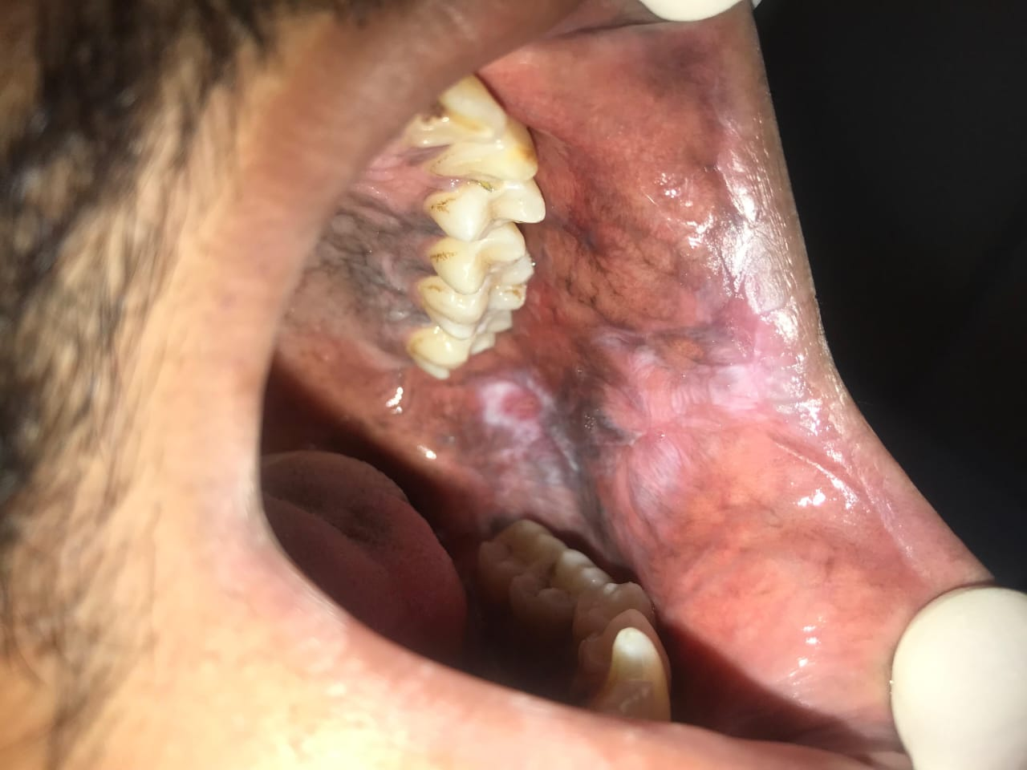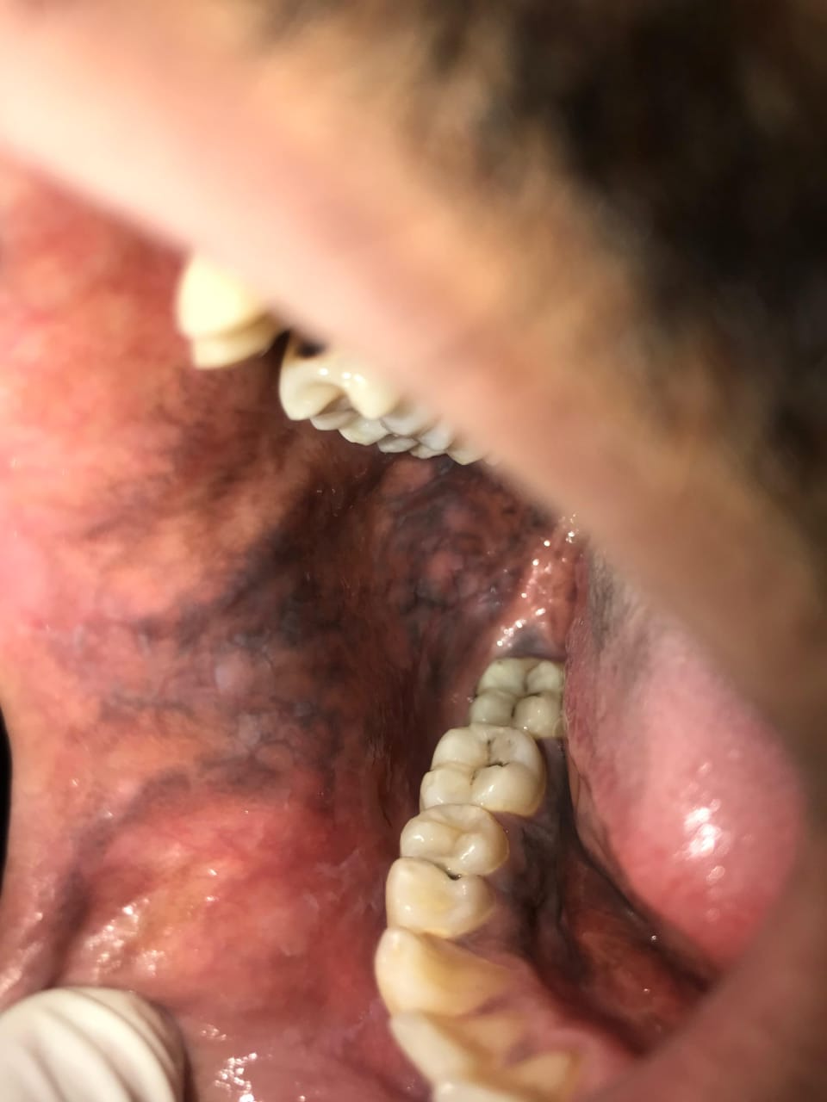
Fig. 1 Fig. 2
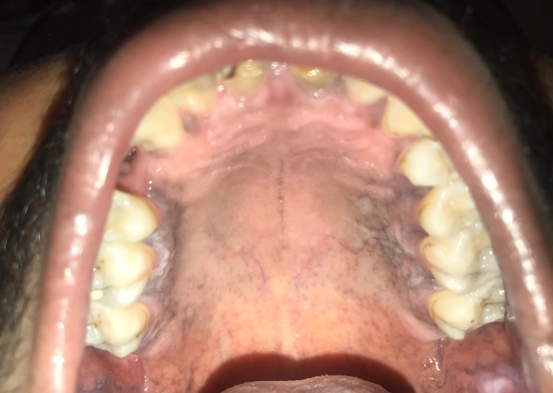
Fig. 3

Figure 1, 2 and 3: Clinical images of the left and right buccal mucosa and the hard palate.

Based on clinical findings, a provisional diagnosis of leukoplakia on the left buccal mucosa and healing lichen planus on right buccal mucosa and palatal gingiva was made. Differential diagnoses included hyperplastic candidiasis and lichenoid reaction. Baseline blood investigations including complete blood count, bleeding and clotting time, and random blood glucose were within normal limits. A vital staining done with toluidine blue, and the site for biopsy was selected on the left posterior buccal mucosa.
Under local anaesthesia with lidocaine and adrenaline (1:200,000), an incisional biopsy was performed. The biopsy specimen was fixed in 10% formalin and submitted for histopathological examination. The specimen measured approximately 0.4 × 0.3 × 0.2 cm, was creamish-white, firm, and had smooth, non-ulcerated borders. Microscopic evaluation under 10X and 40X magnification confirmed the histological diagnosis of mild epithelial dysplasia.

An interdisciplinary treatment plan was initiated with awareness regarding oral hygiene maintenance and medication with Cap. Antoxid OD for 30 days and topical application of Retino-A 0.025% ointment three times daily for 15 days. The patient was counseled on the harmful effects of tobacco use and motivated to cease the habit through behavioral guidance and support.

A structured tobacco cessation counselling program was also implemented. The Fagerström Test for Nicotine Dependence (Fagerström, 1978) indicated a high level of dependence. The 5 A’s (Ask, Advise, Assess, Assist, Arrange), the 5 R’s (Relevance, Risks, Rewards, Roadblocks, Repetition), and the 5 D’s (Delay, Distract, Drink water, Deep breath, Discuss) were all used in the delivery of counselling sessions. [Figure 4] Individual face-to-face counselling was conducted in sessions of 20–30 minutes. Motivational videos were shown at alternate sessions, and the WHO "Quick Start" app was demonstrated to enhance patient engagement. When the patient was unavailable for in-person visits, telephonic counselling was conducted.

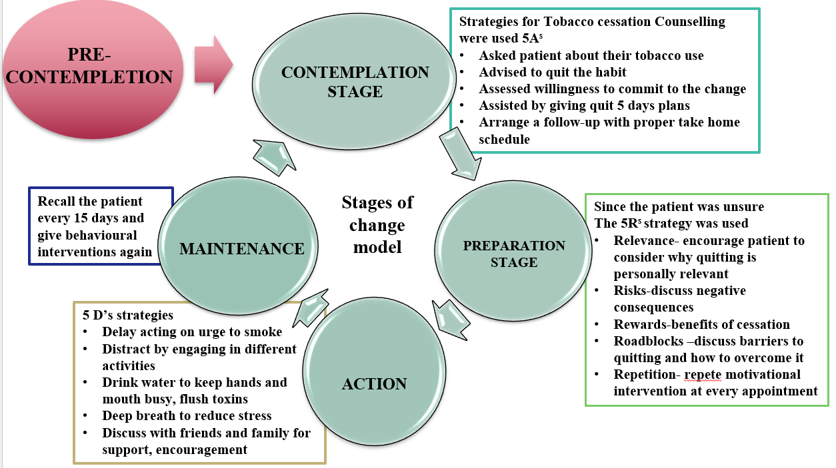

Figure 4: Application of the Stages of Change model during structured tobacco cessation counselling using behavioural techniques and motivational interventions.

The patient progressed from the contemplation to the preparation stage. A quit date was set, and a personalized 5-day quit plan was initiated, focusing on habit awareness, lifestyle modification, and reinforcement of support systems. During follow-ups at 7, 15, and 30 days, the patient showed notable clinical and behavioural improvement. Lesion size and pigmentation reduced, and the patient reported a decrease in tobacco consumption. [Figure 5]

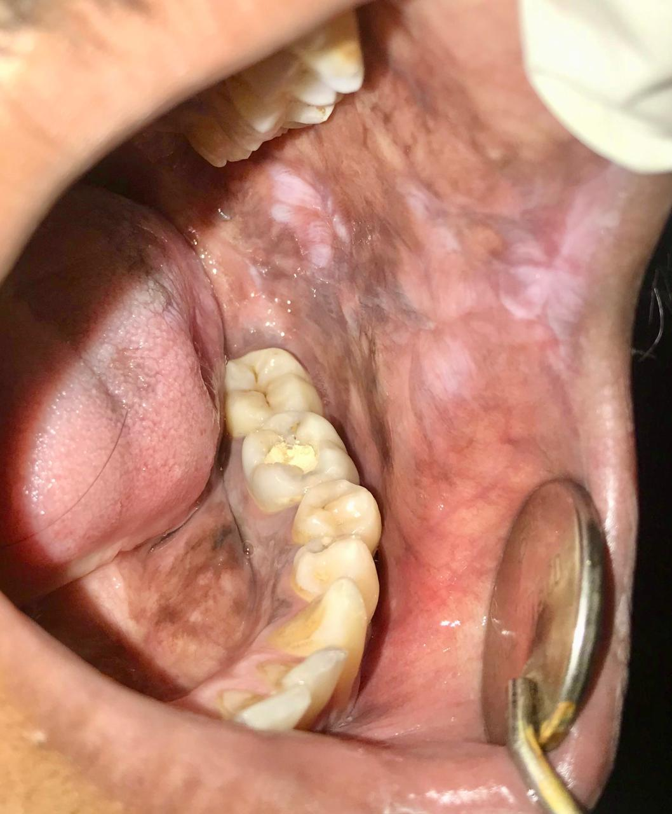

Figure 5: Post-treatment clinical image showing regression of lesion and pigmentation following medication and tobacco habit cessation.

This case illustrates the importance of early identification and interdisciplinary management of OPMDs. It highlights how combining clinical treatment with structured tobacco cessation counselling can lead to positive outcomes both clinically and behaviourally in young tobacco users.

3. discussion

Oral potentially malignant disorders (OPMDs) represent a crucial intervention point in the prevention of oral cancer, particularly in countries like India where tobacco usage is endemic. In this case, the early diagnosis of mild epithelial dysplasia in a young adult tobacco user highlights the importance of proactive screening and timely biopsies in detecting premalignant lesions before they progress.
Histopathological alterations associated with oral epithelial dysplasia range from mild dysplasia to carcinoma in situ. Precancerous lesions like this are typically linked to a higher chance of developing into oral squamous cell carcinoma, which is a serious worldwide health concern (Jerjes et al, 2012)

Compared to non-smokers, smokers have a six-fold increased risk of developing mouth cancer. Because the risk is dose-dependent, your risk increases with the amount of smoking you do. Additionally, the danger is greatly increased when alcohol and tobacco are used together since alcohol can function as a solvent, increasing the absorption of tobacco carcinogens in the tissues of the mouth (Natrajan et al, 2024) Up to 75% of oral cancers could be avoided by quitting smoking and consuming less alcohol. Recurrence or second primary risks would also be decreased. Within three to five years, quitting smoking alone reduces risk by 50% (Jerjes et al, 2012). Beyond lowering the risk of cancer, quitting also improves general oral health, healing and quality of life. We can significantly lower the incidence of oral cancer and promote healthier communities by addressing smoking habits and supporting cessation (Natrajan et al, 2024). Similar to findings reported by Ashwini and Krishnan, who noted that homogenous types of oral leukoplakia were most prevalent in the right and left buccal mucosa in individuals with chronic smoking, our case also highlight the same association. (Ashwini, K., & Krishnan, R. P., 2022)

Through the integration of behavioural therapies into routine care, dentists play a critical role in helping people quit smoking. They are important advocates because of their knowledge of oral health, regular encounters with patients of all ages, and capacity to identify early indicators of oral cancer. Dentistry professionals may greatly improve tobacco-control initiatives by educating patients, setting an example, and encouraging behaviour change (M Priya, H Lando, 2014).

4. Conclusion

In conclusion, this case highlights the impactful synergy of early detection of OPMD, targeted tobacco cessation, and team-based clinical management in modifying the trajectory of oral dysplastic lesions. The integration of these components significantly alters the clinical course of dysplastic lesions, promoting their regression and reducing the risk of malignant transformation. This case reinforces the idea that timely biopsy and histopathological evaluation are essential for accurate diagnosis, while behavioural change, particularly tobacco cessation serves as a cornerstone of treatment.

Consent

Written informed consent was obtained from the patient for their anonymized information to be published in this article.

Ethical approval

As per international standards or university standards written ethical approval has been collected and preserved by the author(s).

Disclaimer (Artificial intelligence)
Author(s) hereby declare that NO generative AI technologies such as Large Language Models (ChatGPT, COPILOT, etc.) and text-to-image generators have been used during the writing or editing of this manuscript.

References

Akashanand, Zahiruddin, Q. S., Jena, D., Ballal, S., Kumar, S., Bhat, M., et al. (2024). Burden of oral cancer and associated risk factors at national and state levels: A systematic analysis from the global burden of disease in India, 1990–2021. Oral Oncology, 159, 107063.

Ashwini, K., & Krishnan, R. P. (2022). Prevalence of Leukoplakia among Patients Visiting a Private Dental Hospital- An Institutional Study. Journal of Pharmaceutical Research International, 34(28B), 87–95. https://doi.org/10.9734/jpri/2022/v34i28B36040

Fagerström, K. O. (1978). Measuring degree of physical dependence to tobacco smoking with reference to individualization of treatment. Addictive Behaviors, 3(3–4), 235–241.

Indian Dental Association. (2025). National Oral Cancer Registry. Available from: https://nocr.org.in/NOCR/OralCancerinIndia

Jerjes, W., Hamdoon, Z., Rashed, D., & Hopper, C. (2025). Advancing non-invasive diagnosis of oral epithelial dysplasia: Comparative insights from in vivo optical coherence tomography and histopathology. Journal of Clinical Medicine, 14(4), 1118.

Jerjes, W., Upile, T., Radhi, H., Petrie, A., Abiola, J., Adams, A., et al. (2012). The effect of tobacco and alcohol and their reduction/cessation on mortality in oral cancer patients: Short communication. Head & Neck Oncology, 4, 6.

Kumari, A., Marya, C., Oberoi, S. S., Nagpal, R., Bidyasagar, S. C., Taneja, P. (2021). Oral hygiene status and gingival status of the 12- to 15-year-old orphanage children residing in Delhi State: A cross-sectional study. International Journal of Clinical Pediatric Dentistry, 14(4), 482–487.

Löe, H. (1967). The gingival index, the plaque index and the retention index systems. Journal of Periodontology, 38(6), 610–616.

Morse, D. E., Psoter, W. J., Cleveland, D., Cohen, D., Mohit-Tabatabai, M., Kosis, D. L., et al. (2007). Smoking and drinking in relation to oral cancer and oral epithelial dysplasia. Cancer Causes & Control, 18(9), 919–929.

Natarajan, P. M., Swamikannu, B., Bhavani, L., Kamaraj, B., Kamaraj, L., Veerakumar, R. (2024). Smoking and its role in oral cancer. Journal of Pharmacy and Bioallied Sciences, 16(Suppl 5), S4242–S4244.

Natarajan, P. M., Swamikannu, B., Rahe, R., Kamaraj, B., Kamaraj, L., Ramachandran, V. (2024). The crucial role of smoking cessation in preventing oral cancer. Journal of Pharmacy and Bioallied Sciences, 16(Suppl 5), S4245–S4247.

Pahari, S., Barman, D., & Talukdar, R. (2023). Tobacco usage in India: A meta‐analysis of evidence drawn from regional studies between 2010 and 2022. Tropical Medicine & International Health, 28(9), 699–709.

Priya, M., & Lando, H. A. (2014). Tobacco control: An issue twinned with oral cancer control. International Dental Journal, 64(5), 229–232.

Singh, L., Arora, R., Tikka, S. K., Shukla, A., Singh, S., Mahant, S., et al. (2020). Brief intervention for tobacco when diagnosed with oral cancer (BITDOC): Study protocol of a randomized clinical trial studying efficacy of brief tobacco cessation intervention, Chhattisgarh, India. Tobacco Prevention & Cessation, 6(January). Available from: http://www.journalssystem.com/tpc/Brief-Intervention-for-Tobacco-when-Diagnosed-with-Oral-Cancer-BITDOC-Study-protocol,115028,0,2.html

Sun, H., Luo, F., & Wan, Q. (2021). The application of fluoride in dental caries. In: Zabokova Bilbilova E, editor. Dental Caries [Internet]. IntechOpen. Available from: https://www.intechopen.com/books/dental-caries/the-application-of-fluoride-in-dental-caries

Vinay, V., Jodalli, P., Chavan, M. S., Buddhikot, C. S., Luke, A. M., Ingafou, M. S. H., et al. (2025). Artificial intelligence in oral cancer: A comprehensive scoping review of diagnostic and prognostic applications. Diagnostics, 15(3), 280.

