Case report

Early Schizophrenia with Possible Cerebral Autosomal Dominant Arteriopathy with Subcortical Infarct Leukoencephalopathy (CADASIL): A Case Report

Abstract
Background: CADASIL is an autosomal dominant disease of small vessels with associated psychiatric disorders and cognitive impairment ultimately progressing to dementia seen in 25% to 30% and 60% of patients respectively.
Case Presentation: The patient was a 45-year-old, single, male, unemployed vagrant who was brought to our facility on account of hearing of voices of unseen people discussing about him, odd belief that family members were against him and physical aggression, twenty-nine years prior presentation. He had also been wandering for thirteen years. There was no family history of stroke, dementia, CADASIL and mental illness, neither was there history of chronic medical conditions. There was marked cognitive decline with impairment in activities of daily living, while MRI showed white matter abnormalities in keeping with CADASIL. A diagnosis of early schizophrenia with CADASIL was entertained. Patient was managed appropriately with moderate improvement in symptoms and eventually discharged to a supervised home.
Conclusion: CADASIL is an under-diagnosed phenomenon in Psychiatry. The co-occurrence of schizophrenia-like symptoms and marked cognitive decline with white matter MRI changes should raise concern of a rather complex disease entity.
Key words: CADASIL, White Matter Hyperintensity, MRI, Schizophrenia

Introduction
Cerebral autosomal dominant arteriopathy with subcortical infarct leukoencephalopathy (CADASIL) is a rare autosomal dominant small vessel disease which stems from the mutation of NOTCH 3 gene with a prevalence of 5 per 100,000 people.¹ There is no gender predominance in CADASIL, however, severity of symptoms tends to be slightly more in males than in females with Asian descends having the highest prevalence.^{2,3}
Major clinical symptoms of CADASIL are migraine with aura, transient ischemic attacks, psychiatric symptoms, and cognitive decline coupled with vascular dementia.⁴ There are variations in the symptoms and onset of the disease. It typically occurs between ages 20 and 40, while some occur later in life.⁵
Cognitive impairment is the second leading symptom in this condition, occurring in 60% of cases, which subsequently get worse, progressing to vascular dementia. Common psychiatric diagnoses seen are depression, panic disorder, bipolar disorder, schizophrenia and apathy, manifesting in 25% to 30% of patients.²
In Psychiatry, CADASIL has not gained a significant recognition in spite of its prominent neuropsychiatric features. Therefore, we present a case report of a man with symptoms of schizophrenia who was later diagnosed with CADASIL, bringing to the fore the importance of considering an organic etiology, particularly when psychotic symptoms are not resolving despite adequate psychopharmacological intervention.

Methods
This is a case report of a 45-year-old male admitted in 2020 at Southwest Nigerian Health institution and was managed as a case of Cerebral autosomal dominant arteriopathy with subcortical infarct leukoencephalopathy (CADASIL).
Biodata of the patient were obtained from hospital records. Relevant literatures were searched on important search engines such as PubMed, google scholar and research gate using the search words “Schizophrenia, or CADASIL”. The patient gave express permission and consent for the publication.
Case Presentation
The patient was a 45-year-old, single, male unemployed vagrant who was brought to our facility on account of wandering away from home, hearing of voices of unseen people discussing about him, odd belief that family members were against him and physical aggression. Although all these started twenty-nine years prior to presentation, however, wandering was thirteen years. Both parents were late, and patient seemed to have been deserted by relatives. No known chronic medical illness. Family history of mental illness, stroke, dementia or migraine could not be ascertained.
A mental state examination revealed, poor attention and concentration, impaired immediate recall but fair short-term and longa well-groomed and kempt man, calm but with abnormal motor movement characterized by sluggishness, reduced arm swinging and intention tremors. It also revealed reduced stream of thoughts, circumstantiality, derailment and thought blocking, persecutory delusion, third person auditory hallucination discussing-term memory, poor abstraction impaired judgement and no insight. The general physical examination revealed a shuffling gait, an area of hyperpigmentation on the left shin and healed gluteal scars. Systemic examinations were not remarkable.
An initial diagnosis of Schizophrenia with drug-induced parkinsonism was made. Patient had been taken to some places (traditional centers) before presenting, however, the medication history was not known. The investigations for baseline functions of the systems (which included E/U/Cr, FBC, LFT) were essentially normal. He was admitted and initially placed on oral olanzapine tablet 10mg but later increased to 20mg after two weeks with no improvement.
Six weeks into treatment, there was no significant improvement with associated confusion, intermittent disorientation and regressive behaviors like self-soiling, drinking water from the toilet bowl. As a result of all these, we entertained a diagnosis of schizophrenia-like organic psychosis, consequent to which fasting lipid profile, serology screening, electrocardiography ECG and cranial magnetic resonance imaging MRI scan were ordered.
The MRI findings showed generalized cerebral atrophy, multiple non-enhancing low T1 and high T2 signal lesions seen in the deep white matter as well as the periventricular areas with lacuna infarcts in the basal ganglia (figure1 and 2). Other results of investigations were not remarkable. Therefore, diagnosis of early schizophrenia with CADASIL was entertained; the patient was further co-managed with the neurology team. He was placed on oral Artovastatin 20mg daily, oral Vasoprin 75mg daily and oral Pentoxifylline 400mg thrice daily.
An attempt at a comprehensive cognitive assessment was not successful because of the confusion and florid psychotic symptoms. However, one completed attempt at mini mental state examination (MMSE) yielded 13/30. While on admission, patient needed to be assisted with activities of daily living such as brushing of teeth, bathing and other aspect of grooming. Daily living skills training and regular exercises were introduced into his care. Environmental modification was proposed for his post-discharge management.
Subsequently, a gradual but marginal improvement was noted; he could only carry out basic activities all under supervision. Although the psychotic symptoms later subsided, nevertheless he was not well composed for a holistic cognitive testing. Patient was eventually discharged to a supervised home care and referred to another tertiary teaching hospital for follow up base on proximity of care.

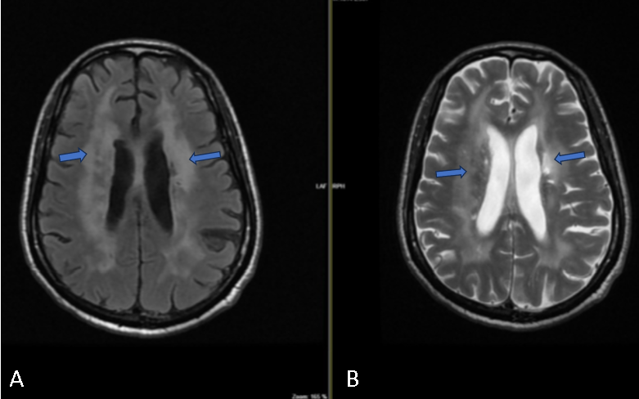
Figure 1: Axial FLAIR (A) and T2W (B) brain MRI scans at the level of corona radiata, with blue arrows showing widespread confluent bilateral periventricular and deep white matter hyperintensities, sparing the subcortical U-fibers.
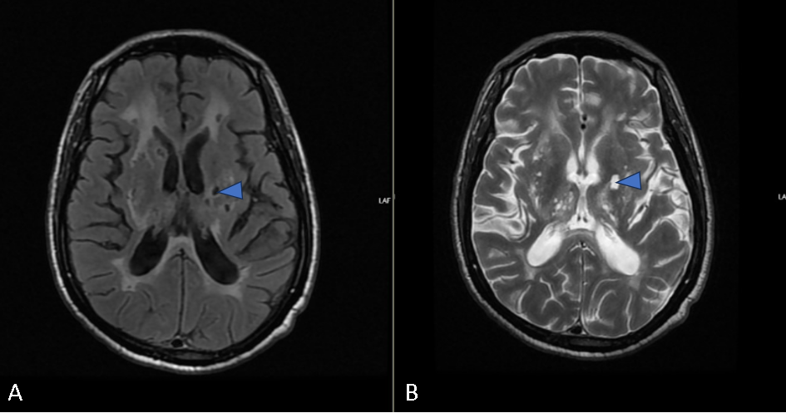
Figure 2: Axial FLAIR (A) and T2W (B) brain MRI scans at the level of the basal ganglia with blue arrowheads showing lacuna infarct in the left basal ganglia. Of note are the presence of perivascular spaces of Virchow Robbins in the thalami.

AT PRESENTATION
Wandering away from home, hearing voices of unseen persons, odd belief that family members were against him and physical aggression.
MSE: sluggishness, reduced arm -swing, tremor, derailment, third person auditory hallucination discussing, persecutory delusion, poor cognition and lack of insight.
Baseline investigations: Normal
Diagnosis: Schizophrenia
Treatment: oral olanzapine 10mg daily

AFTER 6 WEEKS
No significant improvement, confusion, intermittent disorientation and regressive behaviors like self-soiling, drinking water from the toilet bowl.
Treatment: oral olanzapine 20mg daily
Diagnosis: schizophrenia-like organic psychosis,

FURTHER INVESTIGATIONS
FLP, ECG and Serology screening not remarkable.
MRI findings + MSE (13) + impairment in basic activity of daily living + neurologist’s review
Diagnosis: CADASIL
Treatment: oral Artovastatin 20mg daily, oral Vasoprin 75mg daily and oral Pentoxifylline 400mg thrice daily.

OUTCOME
A gradual but marginal improvement was noted
Basic activities all under supervision.
Psychotic symptoms later subsided, nevertheless he was not well composed for a holistic cognitive testing. Patient was eventually discharged to a supervised home care and referred to another tertiary teaching hospital for follow up base on proximity of care.

FIG 3: Investigations and outcome
Discussion
CADASIL occurs when there is a distortion to the mechanism that maintains the vascular smooth muscle cells due to mutation in NOTCH3 gene on chromosome 19p13.1 encoding for transmembrane receptor NOTCH3. The diagnosis of CADASIL can be made by MRI (showing symmetrical and bilateral white matter hyperintensities (WMHs) and lacunar infarcts). Other methods are genetic testing of NOTCH3 mutation, and electron microscopic study of skin biopsy.⁶
Due to financial constraint, our patient was only able to do MRI. The findings on the MRI are in keeping with CADASIL, coupled with the clinical symptoms. The common clinical features of CADASIL are migraine with aura, transient ischemic attacks or strokes, psychiatric symptoms and cognitive decline with vascular dementia.⁴ In this patient, psychiatric symptoms were mainly psychotic with disorganized behavior; however, the decline in activities of daily living, the score of 13/30 on MMSE and the generalized cerebral atrophy on MRI may underscore the severity of cognitive decline and possible dementia which is the second most dominant presentation of CADASIL. Moreover, there was no history of migraine, hypertension, diabetes and transient ischemic attacks; likewise, family history of CADASIL, dementia or hypertension. Therefore, the absence of hypertension and other medical conditions rules out small vessel cerebrovascular diseases.
Although non- affective psychotic presentation is rare in this condition, nonetheless some cases have been reported.^{7,8} For example, Farenza et. al reported a 32-year-old Asian female who had first episode of schizophrenia symptoms in the absence of cardiovascular and other risk factors for CADASIL.⁷ In this case, the initial diagnosis was schizophrenia, but later changed after the MRI findings were in keeping with CADASIL. Contrary to this, in our patient, the symptoms of schizophrenia had started since he was 16 years but the exact time the cognitive decline started could not be ascertained. Considering the typical age of onset of CADASIL (20-40 years), this entity might not have been suspected at his age. It will not be far-fetched in this scenario to infer that both conditions; CADASIL and schizophrenia co-existed as at the time we saw him. Another explanation could be that of common etiology. Schizophrenia, like CADASIL is also associated with the alteration in NOTCH-dependent transcription which is pivotal to biological mechanisms.⁹
Previous reports have shown that CADASIL could mimic multiple sclerosis (MS) and could be misdiagnosed for each other.^{10,11} While we considered the possibility of multiple sclerosis (MS) because of its overlapping clinical and imaging features with CADASIL, in this patient, however, there was no involvement of the optic nerve and spinal cord. Other mimickers of CADASIL such as mitochondrial encephalopathy, lactic acidosis, and stroke-like episodes (MELAS), and Fabry’s disease,¹² were not applicable in this case. Also, considering generalized cerebral atrophy on MRI and the marked cognitive decline, entertaining a diagnosis of an early onset Alzheimer’s disease would not be out of place. However, cerebral atrophy can also be seen in other neurodegenerative diseases.
Currently, there is no effective treatment for CADASIL. However, due to the associated high risk of stroke in people with this condition, focus has been on prevention of stroke by controlling high blood pressure, cholesterol and sugar; receiving antiplatelet treatment when required, and abstaining from other risk factors.¹³ The use of omics technologies offers some prospects as it has aided better understanding of the biological mechanisms, neuroimaging, and clinical manifestations in CADASIL which could be key factors in finding potential drug targets.¹⁴
We note that other investigations (electron microscopic study of skin biopsy and genetic testing for NOTCH 3 gene mutation) which would have further confirmed the diagnosis were not done due to financial constraint, nonetheless, from the MRI findings and the clinical presentation, we consider the diagnosis of CADASIL relevant in this patient.
Conclusion
CADASIL is a rare condition and can be missed because of its complex presentation. The co-occurrence of schizophrenic psychotic symptoms and marked cognitive decline with white matter MRI changes should raise concern of a rather complex disease entity. As psychiatrists, it is important to be open-minded as to organic etiological basis for conditions, particularly when patients do not respond despite adequate dose and trial of neuroleptics. Thus, we are of the opinion that future studies should explore risk factors associated with the development of CADASIL in people diagnosed with schizophrenia.

Disclaimer (Artificial intelligence)
Option 1:
Author(s) hereby declare that NO generative AI technologies such as Large Language Models (ChatGPT, COPILOT, etc.) and text-to-image generators have been used during the writing or editing of this manuscript.
Option 2:
Author(s) hereby declare that generative AI technologies such as Large Language Models, etc. have been used during the writing or editing of manuscripts. This explanation will include the name, version, model, and source of the generative AI technology and as well as all input prompts provided to the generative AI technology
Details of the AI usage are given below:
1.
2.
3.

References
- Joshi S, Yau W, Kermode A. CADASIL mimicking multiple sclerosis: The importance of clinical and MRI red flags. Journal of Clinical Neuroscience. 2017;35:75-7
- Di Donato I, Bianchi S, De Stefano N, Dichgans M, Dotti MT, Duering M, Jouvent E, Korczyn AD, Lesnik-Oberstein SA, Malandrini A, Markus HS, Pantoni L, Penco S, Rufa A, Sinanović O, Stojanov D, Federico A. Cerebral Autosomal Dominant Arteriopathy with Subcortical Infarcts and Leukoencephalopathy (CADASIL) as a model of small vessel disease: update on clinical, diagnostic, and management aspects. BMC Med. 2017 Feb 24;15(1):41.
- Locatelli M, Padovani A, Pezzini A. Pathophysiological Mechanisms and Potential Therapeutic Targets in Cerebral Autosomal Dominant Arteriopathy With Subcortical Infarcts and Leukoencephalopathy (CADASIL). Front Pharmacol. 2020;11:321.
- Sangle N, Baringer JR, Majersik J, DeWitt LD. CADASIL with Multiorgan Involvement: a Complete Autopsy Examination Report. Can J Neurol Sci. 2016;43(1):202-5.
- Chabriat H, Joutel A, Dichgans M, et al. CADASIL. Lancet Neurol. 2009 Jul;8(7):643-53.
- Markus HS, Martin RJ, Simpson MA, Dong YB, Ali N, Crosby AH, et al. Diagnostic strategies in CADASIL. Neurology. 2002;59(8):1134-8.
- Farzena Modarezi, et al. Early Diagnosis of Schizophrenia and Secondary Diagnose of Cerebral autosomal Dominant Arteriopathy with Subcortical Infarcts and Leukoencephalopathy: A Case Report. Journal of Advanced Biomedical Science. 2022 sep.13(2).
- Göy D, Onur ÖŞ, Yesilkaya U. Schizophrenia likely related to be with cadasil: A case report. European Psychiatry. 2021;64(S1):S810-S.
- Lagas PA, Juvonen V. Schizophrenia in a patient with cerebral autosomally dominant arteriopathy with subcortical infarcts and leucoencephalopathy (CADASIL disease). Nordic journal of psychiatry 2001; 55(1): 41-2.
- O’Riordan S, Nor AM, Hutchinson. CADASIL imitating multiple sclerosis: the importance of MRI markers. MultScler J. (2002) 8:430-2
- Carone DA. CADASIL and multiple sclerosis: a case report of prolonged misdiagnosis. Appl Neuropsychol. (2017) 24:294-7
- Canavero I, Rifino N, Montano V, Pantoni L, Gatti L, Pollaci G, Potenza A, Carrozzini T, Finsterer J, Bersano A. Cognitive aspects of MELAS and CARASAL. Cereb Circ Cogn Behav. 2022 Mar 21;3:100139.
- Xiao Shuyue , Ke Man , Cai Kaiwei , Xu Anding , Chen Menglong. Treatment options for patients with CADASIL and large-scale cerebral infarction: mechanical thrombectomy and antiplatelet therapy—A case report. Frontiers in Neurology.2024 vol. 6
14. Muiño E, Fernández-Cadenas I, Arboix A. Contribution of "Omic" Studies to the
Understanding of Cadasil. A Systematic Review. Int J Mol Sci.2021 Jul 8;22(14):7357.

