Original Research Article
COMPARATIVE ASSESSMENT OF INDOOR AIR QUALITY IN RESIDENTIAL ENVIRONMENTS OF URBAN CENTRE AND PETROLEUM–PRODUCING COMMUNITIES IN AKWA IBOM STATE, NIGERIA

ABSTRACT: Indoor air quality (IAQ) is a growing public health concern, particularly in regions experiencing rapid urbanization and intensive petroleum-related industrial activities. This study conducted a comparative assessment of IAQ in residential environments across Uyo (urban centre) and two petroleum-producing industrial communities, Ibeno and Eastern Obolo, in Akwa Ibom State, Nigeria. Measurements were conducted during both dry and rainy seasons, covering particulate matter (PM₁, PM₂, PM₅, PM₁₀), carbon monoxide (CO), carbon dioxide (CO₂), nitrogen oxides (NO and NO₂), ozone (O₃), relative humidity (RH), and temperature (TEMP) using Portable Air Quality Monitors (Fluke 985 Particle Counter, Fluke 975 AirMeter, and Aeroqual Series 500 Monitor). Descriptive statistics, correlation analysis, and principal component analysis (PCA) were employed to characterize pollutant patterns and potential sources, while mixed-effects models and time-series analysis were applied to evaluate spatial–temporal variations and seasonal cycles. Results indicated significantly higher concentrations of particulate matter and CO in industrial zones compared to the urban environment, especially during the dry season. While CO₂ levels were relatively consistent across sites, NOx concentrations were markedly elevated in industrial zones. Seasonal variations highlighted that pollutant levels peaked in the dry season, correlating with reduced natural ventilation and dust resuspension. PCA highlighted strong co-loading of PM species in the industrial communities, suggesting dominant contributions from petroleum-related activities and industrial emissions. Mixed-effects modeling confirmed season and location type as significant predictors of pollutant levels (p < 0.05), while time-series decomposition showed systematic reductions in pollutant concentrations during the rainy season, attributable to atmospheric washout and improved ventilation. The findings underscore the disproportionate indoor exposure risks faced by residents in petroleum-producing communities, with implications for respiratory and cardiovascular health. This study highlights the need for targeted IAQ management strategies, including improved household ventilation and regulatory oversight of industrial emissions, to protect vulnerable populations in the Niger Delta region.
Keywords: Indoor Air Quality, Particulate Matter, Petroleum–producing communities, Mixed-effects modeling, Time-series analysis, Akwa Ibom State

1. INTRODUCTION
Exposure to indoor air pollution, a widespread threat in both urban and rural areas, endangers human health and underscores the need for clean air to ensure urban health and liveable cities. Poor indoor air quality (IAQ) is strongly associated with respiratory infections, cardiovascular diseases, impaired cognitive performance, and a wide spectrum of other health complications (WHO, 2021; Pillarisetti et al., 2022; Chen et al., 2024; WHO, 2024). According to the World Health Organization (WHO, 2024), household air pollution from solid fuels and kerosene causes about 3.2 million premature deaths annually, including over 237,000 among children under five, and contributes millions of disability-adjusted life years (DALYs) lost each year, largely from pneumonia, stroke, ischaemic heart disease, chronic obstructive pulmonary disease (COPD), and lung cancer. The burden is particularly high in low- and middle-income countries, where reliance on biomass fuels, inadequate ventilation, and industrial emissions intensify exposure risks. Given that people spend 80 – 90% of their time indoors, IAQ is a critical determinant of public health, exerting significant influence on respiratory, cardiovascular, and overall well-being (Dimitroulopoulou et al., 2023; Mendes et al., 2024; Booker et al., 2025).
In Nigeria, IAQ challenges are heightened by widespread dependence on solid fuels such as wood, charcoal, and kerosene, often used in inefficient stoves under poorly ventilated conditions (Addo & Olajide, 2021; Agbo, 2022; Safo-Adu et al., 2023; Mamuya & Bachwenkizi, 2024). In addition, emissions from oil and gas exploration and production activities contribute significantly to both outdoor and indoor pollution, particularly in the Niger Delta, a region globally recognized for its high density of petroleum operations (Ite & Ibok, 2013; Nriagu et al., 2016). Research has demonstrated that communities situated near petroleum production and processing sites are frequently exposed to elevated levels of particulate matter (PM), carbon monoxide (CO), nitrogen oxides (NO_{x}), and volatile organic compounds (VOCs) (Nriagu et al., 2016; Ite et al., 2019). These pollutants are well-documented risk factors for respiratory illnesses, cardiovascular disorders, and increased mortality, posing significant environmental health risks to populations in petroleum-producing regions (Safo-Adu et al., 2023; Mamuya & Bachwenkizi, 2024).
Akwa Ibom State, located in the Niger Delta region, presents a unique context where urban centres and petroleum-producing host communities coexist. While Uyo, the state capital, reflects typical urban pollution sources such as traffic congestion and commercial activities, petroleum-producing communities like Ibeno, Eastern Obolo, and Ikot Abasi are heavily impacted by oil exploration, gas flaring, and artisanal refining (Ite & Ibok, 2013; Nriagu et al., 2016; Branco et al., 2024). Evidence from Ite et al. (2019) has already indicated that schools in petroleum-producing industrial zones in Akwa Ibom State record significantly higher levels of particulate matter compared to urban schools, underscoring the disproportionate exposure risks in petroleum-producing communities. Despite growing evidence of outdoor pollution in petroleum–producing host communities in Nigeria’s Niger Delta region, systematic studies of IAQ in residential environments across urban and industrial zones remain limited. Understanding IAQ in these contexts is essential for assessing exposure risks, identifying pollution sources, and developing effective or evidence-based mitigation strategies (Branco et al., 2024; Chen et al., 2024; Ite & Ite, 2024a; Ite & Ite, 2024b).
This study therefore seeks to provide a comparative assessment of IAQ across an urban centre (Uyo) and petroleum-producing host communities (Ibeno and Eastern Obolo) in Akwa Ibom State, with a focus on particulate matter and associated health risks. Specifically, it aims to (i) characterize pollutant concentrations and comfort parameters across dry and rainy seasons, (ii) evaluate interrelationships and potential pollutant sources using correlation and principal component analysis (PCA), and (iii) apply mixed-effects modeling and time-series analysis to assess seasonal and locational determinants of IAQ. By addressing these objectives, the study provides new insights into IAQ disparities and highlights implications for environmental health management in petroleum-producing regions of Nigeria.

2. MATERIALS AND METHODS

2.1. RESIDENTIAL BUILDINGS SELECTION AND SAMPLING SITES
This study was conducted in selected residential environments in urban centre (Uyo) and petroleum–producing host communities (Ibeno and Eastern Obolo) in Akwa Ibom State, Nigeria (Figure 1). Akwa Ibom State, the leading oil and gas producing state in the Niger Delta region, is located in the coastal southern part of Nigeria, within the South–South geopolitical zone. The state covers a land area of approximately 8,412 km² and lies between latitudes 4°32′N and 5°33′N and longitudes 7°25′E and 8°25′E. It is bordered to the east by Cross River State, to the west by Rivers and Abia States, and to the south by the Atlantic Ocean and the southernmost tip of Cross River State.
Uyo, the capital of Akwa Ibom State, is strategically located at latitude 5°01′ North of the Equator and longitude 7°56′ East of the Meridian. Geographically, it is bounded to the west by Abak, to the east by Uruan, to the north by Ikono, Ibiono Ibom, and Itu, and to the south by Etinan, Ibesikpo Asutan, and Nsit Ibom Local Government Areas. As an administrative and commercial hub, Uyo is characterized by rapid urbanization, increased population density, and expanding infrastructure. These dynamics contribute to varying IAQ conditions, particularly due to increasing energy demand, the use of fossil fuel-powered generators, and vehicular emissions. Its urban setting provides a sharp contrast to the industrial coastal communities of Ibeno and Eastern Obolo, where oil and gas exploration, production, and processing activities dominate. Thus, Uyo was selected to represent the urban zone in this study, offering a comparative perspective on IAQ between non-industrialized urban environments and industrially influenced coastal settlements in Akwa Ibom State.
Ibeno Local Government Area, located between latitudes 4°32′02″N and 4°36′02″N and longitudes 7°48′E and 8°17′42″E, occupies the longest Atlantic coastline in Akwa Ibom State, extending for more than 129 km. According to the 2006 National Population Census (NPC, 2009), the area has a population of 74,840 and hosts significant oil and gas operations, most notably ExxonMobil Producing Nigeria Unlimited at the Qua Iboe Terminal (QIT). Renowned for having the longest seashore of any LGA in Nigeria, Ibeno shares boundaries with Eastern Obolo to the west, Esit Eket and Eket LGAs to the north, and the Atlantic Ocean to the south and east. The region serves as a major hub for petroleum exploration and production in the Niger Delta. In addition to gas flaring and venting associated with oil and gas activities, fossil fuel combustion and vehicular emissions are major contributors to atmospheric pollutants, including heavy metals, in host communities across Akwa Ibom State (Ite & Ibok, 2013; Ite et al., 2014).
Eastern Obolo Local Government Area (LGA) is located within the Niger Delta fringe, positioned between the Imo and Qua Iboe River estuaries. It lies geographically between latitudes 4°28′N and 4°53′N and longitudes 7°50′E and 7°55′E. The LGA is bordered to the north by Mkpat Enin, to the northeast by Onna, to the west by Ikot Abasi, to the southeast by Ibeno, and to the south by the Atlantic Ocean. Covering a land area of approximately 117 km², Eastern Obolo extends along the coastline of the Qua Iboe River. Based on the 2006 National Population Census (NPC, 2009), it has an estimated population of 60,543 inhabitants. The area holds considerable economic importance as it hosts major oil and gas operations, including Amni International Petroleum Development Company Limited (AMNI) and Sterling Oil Exploration & Energy Production Company Limited (SEEPCO), one of Nigeria’s leading independent petroleum exploration and production firms.
Figure 1 presents location maps of the three selected residential buildings: one in the urban zone (Uyo Local Government Area) and two in petroleum-producing communities in the industrial zones (Ibeno and Eastern Obolo Local Government Areas), situated in close proximity to oil and gas facilities and/or installations. Indoor air quality (IAQ) measurements were conducted in one randomly selected residential building across an urban centre and within each of the two petroleum-producing coastal communities in Akwa Ibom State. The study focused on naturally ventilated living rooms, with windows kept open throughout the monitoring period. The characteristics of the selected living rooms are summarized in Table 1.

2.2. MONITORING PROTOCOL
Indoor air quality measurements were carried in selected residential environments across the urban centre (Uyo) and petroleum–producing host communities (Ibeno and Eastern Obolo) in Akwa Ibom State during both the rainy (June – July) and dry (November – December seasons of 2022, with each season monitored over 21 days. Data were collected for three hours daily, morning, afternoon, and evening, using calibrated portable air quality monitors. Particulate matter (PM₁, PM_{2,} PM₅, and PM₁₀) with a Fluke 985 Particle Counter (six channels and particle size range of 0.3 – 10.0 µm) (Ite et al., 2017; Ite et al., 2019). Temperature, relative humidity, carbon monoxide (CO), and carbon dioxide (CO₂) were simultaneously recorded with a Fluke 975 AirMeter, which compensates for barometric pressure changes and supports continuous data logging. Nitrogen monoxide (NO), nitrogen dioxide (NO₂), and ozone (O₃) were monitored using an Aeroqual Series 500 Portable Air Quality Monitor. To simulate the occupants’ breathing zone, instruments were placed about 1 m from walls and mounted on flat surfaces at a height of 1.5 m (Jo & Lee, 2006; Cavaleiro Rufo et al., 2016; Al-Hemoud et al., 2017; Ite et al., 2019).

2.3. STATISTICAL ANALYSIS
Multiple statistical techniques were applied to compare IAQ parameters. Descriptive statistics, including means, medians, ranges, and standard deviations, were used to summarize the measured data. Pearson correlation coefficients were computed to assess linear relationships among pollutants and thermal comfort parameters. Principal Component Analysis (PCA) was employed to identify the dominant factors influencing IAQ. Further statistical analyses were conducted to evaluate the effects of relevant parameters on particulate matter concentrations and occupants’ exposure in naturally ventilated living rooms. Statistical significance was determined at p < 0.05. All data analyses, including the generation of airborne particulate matter distribution profiles, were performed using SigmaPlot® Version 14 (Systat Software Inc., USA), a scientific data analysis and graphing software package.

2.4. MIXED-EFFECTS AND TIME-SERIES ANALYSIS
To account for the hierarchical and repeated-measures structure of the IAQ dataset, pollutant concentrations (PM₁, PM₂, PM₅, PM₁₀, CO, CO₂, NO, NO₂, O₃) and comfort parameters (temperature, relative humidity) were analyzed using linear mixed-effects (LME) models. In these models, season (dry vs. rainy), location type (urban vs. industrial), and pollutant category were specified as fixed effects, while households nested within communities were included as random effects to capture intra-site correlation and unobserved heterogeneity. Parameters were estimated using the restricted maximum likelihood (REML) method, and statistical significance was assessed at p < 0.05. In addition, time-series analysis was performed to evaluate temporal dependencies and seasonal cycles in pollutant dynamics. Autocorrelation (ACF) and partial autocorrelation (PACF) functions were computed to assess persistence in pollutant levels, while seasonal-trend decomposition using LOESS (STL) was applied to partition pollutant series into trend, seasonal, and residual components. These complementary approaches provided a robust framework for quantifying spatial–temporal variability and identifying seasonal cycles in indoor air pollutant exposures.
3. RESULTS AND DISCUSSION

3.1 DESCRIPTIVE STATISTICS AND SEASONAL VARIATIONS
This study evaluated IAQ in the urban centre (Uyo) and petroleum-producing communities within the coastal industrial zones (Ibeno and Ikot Abasi), Akwa Ibom State, Nigeria, across both dry and rainy seasons. Monitored parameters included particulate matter (PM₁, PM₂, PM₅, PM₁₀), carbon monoxide (CO), carbon dioxide (CO₂), nitrogen monoxide (NO), nitrogen dioxide (NO₂), ozone (O₃), relative humidity (RH), and temperature (TEMP) (Table 2A–F). Descriptive statistical analyses of daily average concentrations (Table 3) revealed significant spatio-seasonal variability, driven by the combined effects of location-specific anthropogenic activities and seasonal meteorological conditions. These findings provide empirical evidence of the interplay between industrial emissions, urban residential activities, and climatic dynamics in shaping IAQ profiles across urban and petroleum-producing coastal industrial settings.
Across all sites, the dry season recorded higher particulate matter (PM₁, PM₂, PM₅, PM₁₀) levels with markedly greater standard deviations compared to the rainy season, indicating substantial day-to-day variability. This pattern likely reflects intermittent and diverse emission sources, including irregular generator usage, sporadic cooking events, and fluctuating outdoor dust infiltration. In contrast, gaseous pollutants (CO, CO₂, NO, and NO₂) displayed lower standard deviations, suggesting more stable daily concentrations, possibly due to continuous emissions from industrial operations and traffic-related activities.
3.1.1 Seasonal Variations in Uyo
In the urban centre of Uyo, the dry season is characterised by persistently elevated particulate matter concentrations, with mean PM₁, PM₂, PM₅, and PM₁₀ values of 5,929.37 µg/m³, 3,469.06 µg/m³, 160.98 µg/m³, and 54.26 µg/m³ respectively (Table 2A). These concentrations far exceed the WHO indoor air quality guidelines, which recommend annual mean PM₂.₅ levels below 5 µg/m³ and PM₁₀ below 15 µg/m³ (WHO, 2021) The small variability in daily concentrations (Table 2) indicates sustained exposure from continuous sources, including generator emissions, cooking with biomass, and infiltration of urban traffic pollutants. Carbon monoxide levels average 2.22 ppm, within WHO’s 8-hour guideline limit of 9 ppm but still indicative of poor combustion ventilation (WHO, 2021; Dimitroulopoulou et al., 2023). CO₂ levels at 351.74 ppm are typical for moderately ventilated indoor spaces, but higher than in the rainy season, suggesting reduced air exchange during hot, dry days (Liu, 2021). Nitrogen oxides (NO and NO₂) remain consistently high, with mean values of 78.90 ppm and 26.23 ppm, reflecting contributions from both indoor combustion and nearby traffic emissions (Pina et al., 2024). Relative humidity (RH) averages 28.55%, producing dry indoor air that can aggravate respiratory irritation (Wolkoff, 2018), while temperatures average 27.30°C. In the rainy season, rainfall scavenging and higher humidity reduce dust resuspension, lowering PM₁ to 2,483.20 µg/m³ and PM₂ to 1,367.48 µg/m³ (Table 2B). CO and CO₂ also fall to 1.26 ppm and 226.87 ppm, reflecting better ventilation and less reliance on combustion appliances. Nevertheless, even with these seasonal improvements, PM levels remain far beyond health-based limits, posing a persistent risk of cardiopulmonary effects (Cohen et al., 2017).
3.1.2 Seasonal Variations in Ibeno
In Ibeno, an industrial hub dominated by oil and gas activities, dry season pollutant levels are the highest recorded among all locations. Mean PM₁ and PM₂ concentrations reach 6,528.12 µg/m³ and 3,526.75 µg/m³ respectively (Table 2C), driven by emissions from gas flaring, industrial combustion, and resuspended dust from unpaved access roads (Abai et al., 2025; Olufemi et al., 2025). CO levels average 2.28 ppm and CO₂ 368.32 ppm, both higher than in Uyo, indicating greater combustion intensity and poorer ventilation. NO and NO₂ levels are comparable to those in Uyo but more stable across days, reflecting continuous industrial operations rather than episodic traffic peaks. RH averages 30.08% and temperature 29.91°C, conditions that favour pollutant accumulation indoors. In the rainy season, precipitation sharply reduces particulate levels, PM₁ drops to 2,259.10 µg/m³ and PM₂ to 1,238.91 µg/m³, while CO decreases to 1.56 ppm and CO₂ to 228.81 ppm (Table 2D). However, nitrogen oxides remain elevated, indicating that industrial emissions continue largely unabated regardless of seasonal changes (Nriagu et al., 2016).
3.1.3 Seasonal Variations in Eastern Obolo
In Eastern Obolo, also within an industrial coastal zone, the dry season shows high but slightly lower PM levels than Ibeno, with PM₁ at 5,550.63 µg/m³ and PM₂ at 2,925.08 µg/m³ (Table 2E). CO averages 1.67 ppm, the lowest among industrial sites, suggesting less intense local combustion. CO₂ (287.48 ppm) and O₃ (11.25 ppm) are also lower, possibly due to the dispersive effects of coastal winds (Abai et al., 2025). RH stands at 23.73% and temperatures at 18.20°C. Unlike Uyo and Ibeno, the rainy season here does not reduce PM; instead, PM₁ rises to 3,233.82 µg/m³ and PM₂ to 2,139.15 µg/m³ (Table 2F). This increase is likely linked to heightened indoor biomass burning for cooking and heating during wet months, coupled with reduced ventilation as residents keep windows closed to prevent rain ingress (Zhang & Smith, 2007). CO reduces to 1.28 ppm, but CO₂ increases slightly to 266.98 ppm, further supporting the hypothesis of limited air exchange. RH jumps to 40.08%, making indoor conditions damp and potentially conducive to microbial growth (Fisk et al., 2007; Abai et al., 2025).
3.1.4 Comparative Observations – Urban Centre vs. Coastal Industrial Zones
Across all locations, the dry season records consistently higher PM and CO levels, with industrial zones, particularly Ibeno, showing the greatest pollutant burdens. These patterns reflect combined contributions from industrial emissions, traffic, and indoor combustion, intensified by low humidity and poor ventilation. In contrast, the rainy season generally improves air quality through wet deposition and higher humidity, except in Eastern Obolo, where behavioural factors and indoor fuel use sustain elevated PM levels.
Comfort parameters indicate that dry season indoor environments are hotter and drier, conditions that can aggravate respiratory symptoms, while the rainy season offers cooler, more humid air that reduces dust-related irritants but may increase mould-related risks. These observations align with earlier findings on coastal Nigerian communities affected by industrial emissions (Ana et al., 2009; Ite & Ibok, 2013).
Clear distinctions emerge between the urban and industrial environments in both pollutant levels and seasonal variability. In Uyo, particulate matter concentrations remain consistently high but lower than in industrial zones. Seasonal shifts are marked, PM and gaseous pollutants such as CO and CO₂ drop substantially in the rainy season, suggesting that rainfall scavenging, increased humidity, and better natural ventilation effectively reduce indoor pollution. Nevertheless, PM levels in Uyo still exceed WHO guidelines by several multiples (WHO, 2021), underscoring an ongoing public health concern.
Industrial zones, particularly Ibeno, maintain the highest pollutant loads year-round. During the dry season, PM₁ and PM₂ levels in Ibeno exceed those in Uyo by about 10 – 15%, driven by gas flaring, industrial emissions, unpaved road dust, and heavy vehicular traffic. Rainfall lowers particulate levels in Ibeno, but they remain significantly higher than in Uyo, and nitrogen oxide concentrations show minimal seasonal change, indicating constant industrial emissions.
Eastern Obolo shows a distinct pattern. While its dry season PM levels are slightly lower than Ibeno, possibly due to coastal dispersion, the rainy season does not bring expected improvements. Instead, PM₁ and PM₂ levels increase, likely from greater indoor biomass fuel use and reduced ventilation during prolonged rainfall. CO₂ concentrations also rise slightly, reinforcing the likelihood of restricted air exchange.
Overall, dry season conditions, marked by low humidity, high temperatures, and little precipitation, favour pollutant build-up, while the rainy season typically improves air quality, except where indoor sources dominate. Industrial zones not only have higher pollutant baselines but also experience less seasonal relief than the urban centre, highlighting the influence of continuous industrial activity on indoor air quality in these communities.

3.2 CORRELATION ANALYSIS OF IAQ PARAMETERS
To better understand the relationships among IAQ parameters, Pearson’s correlation coefficients (r) were computed for each location (Uyo, Ibeno, and Eastern Obolo) during the dry and rainy seasons (Figures 6 – 8; Tables 4 – 6). This approach reveals potential co-emission sources, atmospheric interactions, and seasonal shifts in pollutant linkages (Seinfeld & Pandis, 2016; WHO, 2021).
3.2.1 Summary of Correlation Analysis Interpretation: Uyo
Pearson correlation patterns for Uyo during the dry season reveal a complex, but interpretable, pollutant network (Figure 6; Table 4). Although particle fractions did not all show uniformly high pairwise correlations (reflecting mixed indoor and outdoor contributions), several key relationships are evident. PM₁₀ and PM₁ exhibited moderate positive association with each other and with some other PM fractions, consistent with co-emission and resuspension of coarser material under dry conditions (Seinfeld & Pandis, 2016). Combustion tracers (CO, CO₂) showed weak-to-moderate positive correlations with selected PM fractions, supporting the inference that fuel combustion (generators, cooking) contributes to indoor particulate matter (Ezzati & Kammen, 2001; Jetter et al., 2012; Abai et al., 2025; Balogh et al., 2025). Nitrogen species (NO, NO₂) were positively associated with combustion markers, indicating traffic and combustion-related inputs to indoor environments (Kumar et al., 2015). Ozone (O₃) exhibited notably negative correlations with several PM fractions and NOₓ, consistent with local NO titration and the photochemical character of ozone formation in urban atmospheres (Monks et al., 2015; Nguyen et al., 2022). Relative humidity (RH) displayed inverse relationships with fine-to-coarse fractions (particularly PM₅), suggesting hygroscopic growth and enhanced deposition/scavenging under higher moisture conditions (Zender-Świercz et al., 2024). Temperature correlations with pollutants were generally weak or inconsistent, implying that temperature modulates but does not dominate emission dynamics at the intra-seasonal scale.
In the rainy season, correlation strengths among many pollutant pairs were reduced and some signs changed, reflecting seasonal shifts in sources and enhanced meteorological removal (Figure 6; Table 4). The PM fractions maintained positive associations in several pairings but at lower magnitudes than in the dry season, consistent with wet scavenging, lower resuspension, and dilution from increased ventilation or infiltration of cleaner air (Odubanjo et al., 2024). CO–PM and CO₂–PM correlations were attenuated or reversed for some pairings, which may reflect decreased indoor combustion activity or changes in ventilation behaviour during the rainy season (Saetae et al., 2025). NO–NO₂ relationships persisted but with altered coupling to O₃ due to reduced solar radiation and suppressed photochemistry, leading to weaker O₃–NOₓ interactions compared with the dry season intensity (Jacob & Winner, 2009). RH continued to exhibit strong negative associations with particulate concentrations, reinforcing the dominant role of humidity-driven removal processes in humid months.
Synthesis and Implications:
- Source attribution: The observed co-variation of select PM fractions with CO and CO₂ in the dry season implicates combustion-related sources (portable generators, household cooking, traffic) as important contributors to indoor particulate load in Uyo.
- Seasonal modulation: Attenuation of correlations in the rainy season indicates effective meteorological removal (wet deposition, hygroscopic growth) and changes in indoor–outdoor exchange that alter source–receptor relationships.
- Ozone dynamics: The inverse O₃–NOₓ/PM relationships in the dry season are consistent with NO titration and photochemically driven ozone behaviour; suppression of photochemistry during the rainy season weakens these patterns.
- Health relevance: Periods with concurrent elevations in PM and combustion gases during the dry season point to episodes of combined exposure to fine particulate and gaseous pollutants—important for exposure assessment and public-health mitigation (WHO, 2021).
3.2.2 Summary of Correlation Analysis Interpretation: Ibeno
Correlation patterns in the dry season indicate strong co-variation among particulate size fractions (PM₁, PM₂, PM₅, PM₁₀), consistent with shared emission sources and resuspension of coarse dust in an industrial coastal setting (Figure 7; Table 5). Elevated correlations between PM fractions and combustion tracers (CO, CO₂) support a dominant influence of combustion-related activities, notably generator use, process emissions and vehicular traffic associated with oil-and-gas operations, on indoor particulate burdens (Ezzati & Kammen, 2001; Jetter et al., 2012; Abai et al., 2025; Balogh et al., 2025). Nitrogen species (NO, NO₂) show positive correlations with combustion markers and some PM fractions, reflecting contributions from traffic and combustion processes typical of industrial zones (Kumar et al., 2015). Ozone (O₃) tends to display weak or inverse correlations with NOₓ and certain PM fractions, indicative of local titration effects (high NO suppressing local O₃) and the photochemical nature of ozone formation (Monks et al., 2015; Seinfeld & Pandis, 2016; Nguyen et al., 2022). Relative humidity (RH) is negatively associated with finer fractions (e.g., PM₅), reflecting hygroscopic growth/settling and wet scavenging processes, while temperature shows mixed but generally weak relationships with pollutants, suggesting meteorology modulates concentration magnitudes rather than being the primary driver of emission patterns. Overall, the dry season correlation structure points to co-emission of gases and particles from localized combustion and industrial activities, amplified by greater dust resuspension under drier conditions.
During the rainy season, overall particulate concentrations decline relative to dry months (Table 3), and inter-pollutant correlation strengths are generally attenuated or altered in sign for certain pairs (Figure 7; Table 5). The weakened PM–PM and PM–combustion tracer correlations suggest seasonal changes in source contribution and enhanced wet removal and dilution (Odubanjo et al., 2024; Zender-Świercz et al., 2024). In some instances, CO and CO₂ display reduced or altered correlations with PM, implying increased ventilation and/or lower operation of combustion sources indoors, and/or differential removal of particles versus gases by precipitation and high ambient RH (Saetae et al., 2025). NO–NO₂ relationships persist, but their coupling with O₃ is modified: rainy season cloud cover and lower insolation suppress photochemical O₃ production, which reduces the magnitude and consistency of O₃–NOₓ interactions observed in the dry season intensity (Jacob & Winner, 2009). Relative humidity shows stronger inverse associations with PM fractions
in the rainy season (consistent with hygroscopic growth and deposition), and temperature correlations remain weak and inconsistent. These seasonal shifts indicate that meteorological processes (wet scavenging, dilution, reduced photochemistry) substantially modulate the indoor pollutant network in the coastal industrial setting.
Synthesis & Implications:
- Source inference: Strong dry season co-variation of PMs with CO/CO₂ and NOₓ implicates combustion and industrial/traffic sources (generators, machinery, fugitive emissions) as principal contributors to indoor pollution in Ibeno.
- Seasonal modulation: Rainy-season reductions in PM concentrations and attenuation of many pairwise correlations point to effective meteorological removal (wet deposition, higher RH) and altered indoor–outdoor exchange/ventilation dynamics.
- Ozone behaviour: The observed inverse or weak correlations between O₃ and primary pollutants (especially NOₓ) in the dry season are consistent with local titration and photochemical formation regimes; in the rainy season, suppressed photochemistry weakens these relationships further (Jacob & Winner, 2009; Monks et al., 2015; Nguyen et al., 2022).
- Health and management relevance: Co-occurrence of particulate and gaseous combustion markers during the dry season suggests periods of heightened combined exposure to fine particles and combustion gases, important for exposure assessment and mitigation (Seinfeld & Pandis, 2016; WHO, 2021).
3.2.3 Summary of Correlation Analysis Interpretation: Eastern Obolo
The dry season correlation matrix for Eastern Obolo reveals a pronounced clustering of strong positive relationships among particulate matter fractions (PM₁, PM₂, PM₅, PM₁₀) (Figure 8; Table 6), reflecting common generation mechanisms and similar aerodynamic behaviours (Seinfeld & Pandis, 2016). High correlations between PM fractions and combustion indicators such as CO and CO₂ point to shared source profiles, particularly the use of petrol/diesel generators, biomass stoves, and proximity to flaring sites (Ezzati & Kammen, 2001; Jetter et al., 2012; Abai et al., 2025; Balogh et al., 2025). NO and NO₂ exhibit strong positive correlations with both PM and CO, consistent with co-emission from fossil fuel combustion and industrial processes (Kumar et al., 2015). Ozone (O₃) shows generally inverse or weak correlations with NOₓ, a pattern indicative of local ozone titration in NO-rich environments typical of coastal industrial areas (Monks et al., 2015; Nguyen et al., 2022). Relative humidity (RH) tends to be negatively correlated with coarse PM fractions, likely due to enhanced particle deposition and reduced resuspension under more humid conditions (Zender-Świercz et al., 2024). Temperature exhibits modest correlations with O₃ and certain PM fractions, suggesting meteorological modulation of secondary pollutant formation without being the primary emission driver. Overall, the dry season structure reflects the dominance of combustion and industrial sources, with atmospheric stability and low precipitation favouring pollutant accumulation.
In the rainy season, the overall strength of PM–PM and PM–combustion tracer correlations is reduced (Figure 8; Table 6), implying a seasonal shift in both source contributions and atmospheric removal processes. Enhanced wet deposition and increased ventilation from open windows and doors likely reduce particle concentrations and alter source–receptor linkages (Zhang et al., 2021; Odubanjo et al., 2024). While NO and NO₂ maintain a moderate to strong interrelationship, their correlations with PM and CO weaken, suggesting a greater influence of transient, short-lived outdoor emissions (e.g., traffic peaks) rather than constant indoor combustion. The O₃–NOₓ correlation remains weaker compared to the dry season, reflecting suppressed photochemical activity due to persistent cloud cover and lower UV intensity (Jacob & Winner, 2009). RH exhibits a stronger negative association with fine and coarse PM, consistent with hygroscopic growth, agglomeration, and precipitation scavenging. Temperature correlations remain generally weak but show slight positive associations with O₃ in some cases, indicating that even in humid conditions, temperature-driven photochemical production still plays a role (Seinfeld & Pandis, 2016).
Synthesis & Implications:
- Dry season: Strong inter-pollutant coupling suggests dominant influence of combustion and industrial sources, compounded by limited dispersion and absence of precipitation.
- Rainy season: Attenuated correlations indicate meteorological removal processes and altered indoor–outdoor exchange dynamics.
- Ozone dynamics: Consistently weak or negative O₃–NOₓ correlations across both seasons highlight the influence of NO titration and reduced photochemical efficiency in the coastal industrial environment.
- Exposure relevance: Co-occurrence of PM, NOₓ, and CO during the dry season implies combined exposure risks, warranting targeted indoor air quality interventions.
3.2.4 Overall Comparative Summary: Urban Centre (Uyo) vs Industrial Zones (Ibeno and Eastern Obolo)
The correlation analysis of indoor air pollutants and comfort parameters revealed distinct differences between the urban centre of Uyo and the industrial zones of Ibeno and Eastern Obolo (Table 7). In Eastern Obolo, particulate matter of different aerodynamic diameters (PM₁, PM₂, PM₅, and PM₁₀) exhibited extremely strong and consistent positive correlations (r ≈ 0.97–0.99) during both the dry and rainy seasons. This level of uniformity suggests that these particles are emitted from the same dominant sources and experience similar atmospheric dispersion conditions, most likely linked to continuous industrial activities in the area. In Ibeno, PM–PM correlations were also strong in the dry season but weakened during the rainy season, indicating that meteorological influences or seasonal shifts in industrial operations have a greater effect here than in Eastern Obolo.
When examining the relationship between particulate matter and carbon monoxide (CO), Eastern Obolo demonstrated weak to moderate positive correlations across both seasons, pointing to some shared combustion-related sources. In Ibeno, CO–PM correlations were mixed in the dry season but tended to become more positive in the rainy season, possibly due to a change in emission patterns or meteorological influences. Uyo, in contrast, showed weak positive CO–PM associations in the dry season but weaker or even negative values in the rainy season, suggesting that in an urban setting, CO emissions (e.g., from vehicular traffic) may not always coincide with particulate matter concentrations.
Carbon dioxide (CO₂) showed weak or negligible correlations with particulate matter across all three locations, implying that CO₂ is influenced more by stable background levels and indoor sources than by short-term fluctuations in particulate concentrations. For nitrogen oxides, NO and NO₂ exhibited slightly stronger correlations in the industrial zones, particularly in Ibeno during the rainy season, reflecting more stable combustion processes compared to the urban centre.
Ozone (O₃) displayed low and inconsistent correlations with other pollutants in all locations, which aligns with its complex atmospheric chemistry that is governed more by photochemical reactions and precursor availability than by direct emissions. Comfort parameters, namely relative humidity (RH) and temperature (TEMP), generally showed negligible relationships with pollutant concentrations in all study areas. The only notable exception was a stronger negative RH–PM₁₀ correlation in Ibeno during rainy season, which may be attributed to enhanced wet deposition and particle settling during periods of higher humidity.
In summary, industrial zones maintained stronger and more stable pollutant–pollutant correlations across seasons, with Eastern Obolo exhibiting the highest degree of consistency. The urban centre of Uyo experienced greater seasonal variability and generally weaker correlations, suggesting a more diverse mix of pollutant sources and stronger influence from environmental factors such as rainfall and wind. These findings highlight the role of emission source type and meteorological conditions in shaping indoor air quality patterns across different environments.

3.3 PRINCIPAL COMPONENT ANALYSIS (PCA) SUMMARY
The PCA results reveal clear differences in pollutant source patterns and seasonal influences between the urban centre (Uyo) and the industrial zones (Ibeno and Eastern Obolo) (Table 8).
In Uyo, PC1 captured the lowest proportion of variance (around 45–60%), with a mix of particulate matter and CO as dominant loadings in the dry season, indicating a combination of traffic and dust sources (Viana et al., 2008). In the rainy season, particulate cohesion weakened further, and PC1 variance decreased to 45–55%. PC2, explaining 15–28% of variance, was dominated by comfort parameters (RH and temperature) and O₃, showing that seasonal weather patterns play a substantial role in shaping pollutant relationships in the urban environment (Sulaymon et al., 2020).
In Ibeno, PC1 explained slightly less variance (around 55–70%), with particulate matter still dominating but showing weaker cohesion than in Eastern Obolo, particularly during the rainy season. The second component, explaining 12–22% of variance, was driven mainly by CO and NO₂ in the dry season, while in the rainy season, comfort parameters (RH and temperature) and O₃ became more influential. This shift suggests that meteorological factors—such as increased humidity, rainfall scavenging, and seasonal wind pattern changes, exert a stronger influence on pollutant variability in Ibeno during wetter months, as wet deposition processes and enhanced atmospheric mixing can substantially reduce airborne particulate concentrations and redistribute gaseous pollutants (Seinfeld & Pandis, 2016).
In Eastern Obolo, the first principal component (PC1) accounted for the largest proportion of variance in both seasons (approximately 65–80%), with very strong positive loadings for all particulate fractions (PM₁, PM₂, PM₅, and PM₁₀). This pattern indicates a high degree of inter-correlation among particulate species, suggesting they originate predominantly from a single, continuous industrial emission source, likely associated with the area’s petroleum-processing and related industrial activities (Ite et al., 2013). The second principal component (PC2) explained around 10–18% of the variance and was mainly influenced by gaseous pollutants such as CO and NO₂, with a minor contribution from O₃. This loading pattern indicates contributions from combustion-related processes, such as fuel burning in industrial and domestic settings—and the formation of secondary pollutants through atmospheric photochemical reactions (Seinfeld & Pandis, 2016). Seasonal differences were minimal, though in the rainy season, relative humidity (RH) became a slightly stronger contributor to PC2, consistent with findings that meteorological conditions can alter pollutant associations (Chen et al., 2020).
Comparatively, Eastern Obolo demonstrates the most stable and particulate-dominated structure across seasons, reflecting consistent industrial emissions. Ibeno exhibits intermediate stability, with more seasonal shifts and meteorological influence. Uyo shows the greatest seasonal variability, the lowest PC1 variance, and the highest sensitivity to environmental factors, reflecting a more complex mix of emission sources and meteorological drivers (Kumar et al., 2015).

3.4 MIXED-EFFECTS AND TIME-SERIES ANALYSIS INTERPRETATION
Mixed-effects modelling of the indoor air quality data revealed strong and consistent seasonal effects across particulate matter metrics (Figure 9). The particulate composite score (PC1), derived from principal component analysis of PM₁, PM₂, PM₅, and PM₁₀, exhibited markedly lower values during the rainy season compared to the dry season (β = −3.73, p < 0.001), indicating a substantial seasonal reduction in indoor PM concentrations. This pattern was confirmed in individual log-standardized models for PM₁, PM₂, and PM₅, all of which showed large, statistically significant negative rainy-season coefficients (β ≈ 1.5–1.8 SD, p < 0.001). These results align with previous studies reporting that enhanced atmospheric dispersion, precipitation scavenging, and increased natural ventilation during wet months reduce particulate accumulation indoors (Seinfeld & Pandis, 2016; Zender-Świercz et al., 2024; Abai et al., 2025). For example, in Uyo, PM₁ declined from an average of 5,929 µg/m³ in the dry season to 2,483 µg/m³ in the rainy season, while in Ibeno, values dropped from 6,528 µg/m³ to 2,259 µg/m³ (Table 2). The random effect’s structure revealed strong intra-household correlations, particularly for PM species, highlighting localized indoor activity and ventilation influences.
While seasonal effects dominated PM variability, location-specific effects were minimal for particulates once meteorology and seasonality were accounted for. Neither the PM composite nor individual PM models retained statistically significant fixed effects for Uyo or Ibeno relative to Eastern Obolo. This suggests that, in the absence of strong indoor particulate sources, outdoor background levels and ventilation regimes, both highly seasonal in the Niger Delta, play a greater role than location-specific industrial proximity in determining residential PM burdens.
In contrast, carbon monoxide (CO) demonstrated a distinct spatial pattern. Log-standardized CO was significantly higher in Ibeno (+1.25 SD, p < 0.001) and Uyo (+0.84 SD, p = 0.001) compared to Eastern Obolo, even after adjusting for meteorology and season. This pattern is consistent with increased reliance on combustion sources such as petrol generators, biomass cooking, and traffic-related infiltration in urban and industrialized settings (Ite & Ite, 2024a; Abai et al., 2025). CO also declined markedly in the rainy season (−1.54 SD, p < 0.001), mirroring the seasonal drop in PM but likely driven by behavioural changes, such as reduced generator usage due to cooler temperatures and increased outdoor air exchange during rainfall events (Castelhano & Réquia, 2024).
Meteorological covariates showed secondary but notable associations. Relative humidity (RH) was positively related to CO, PM₁, and PM₂, albeit with small effect sizes (<0.6% change per 1% RH). This may reflect reduced infiltration and slower pollutant dispersion in more humid indoor air (Rawat & Kumar, 2023; Booker et al., 2025). Temperature was not a consistent driver of pollutant levels, except for a modest positive association with PM₅. Day-to-day time trends were negligible for most pollutants, with the exception of a small but statistically significant positive drift in the PM composite (β = +0.0054/day, p = 0.030), potentially reflecting gradual changes in indoor activity or accumulation effects over the measurement period.
Thermal comfort analysis confirmed significant site and seasonal contrasts. Indoor temperatures were substantially higher in Ibeno (+6.95 °C, p < 0.001) and Uyo (+5.30 °C, p = 0.004) than in Eastern Obolo, and consistently lower during the rainy season (−6.56 °C, p < 0.001). These patterns are consistent with differences in housing design, ventilation practices, and local microclimates (Shaeri et al., 2018; Ahmed & Rahman, 2024). Relative humidity, however, showed no significant fixed-effect differences by site or season, suggesting that within-site daily variation, driven by weather and occupant activities, dominates RH fluctuations.
Time-series analysis revealed strong autocorrelation in particulate matter concentrations across consecutive days, especially in the industrial sites, suggesting sustained emissions from oil and gas activities and reduced atmospheric flushing (Calderon et al., 2022). Seasonal-trend decomposition further showed a systematic downward shift in pollutant levels during the rainy season, with residual fluctuations linked to short-term indoor combustion sources and local meteorology. Notably, ozone (O₃) exhibited marked variability, with short-lived peaks in both Uyo and Ibeno, reflecting complex photochemical interactions under varying humidity and solar radiation conditions (Monks et al., 2015; Elshorbany et al., 2024).
Overall, the mixed-effects and time-series approaches confirmed that seasonality is the primary driver of indoor PM variability, while location-specific combustion sources are the key determinant of CO elevations in urban and industrial settings. Industrial communities in Akwa Ibom State are the most polluted, with rainfall acting as a mitigating factor by reducing particulate and gaseous pollution levels. These findings underscore the need for targeted mitigation strategies that address both seasonal ventilation optimization and site-specific emission controls, particularly in communities with high generator use and industrial proximity.

4. CONCLUSION
This study provides a comprehensive comparative assessment of IAQ across an urban centre (Uyo) and petroleum–producing communities within industrial coastal zones (Ibeno, Eastern Obolo, and Ikot Abasi) of Akwa Ibom State, Nigeria, during the dry and rainy seasons. The findings revealed significant spatial and seasonal variations in pollutant concentrations, with the industrial zones consistently exhibiting higher levels of particulate matter (PM₁, PM₂, PM₅, PM₁₀) and gaseous pollutants (CO, CO₂, NO, NO₂, O₃, SO₂) compared to the urban centre. These elevated levels were strongly associated with petroleum-processing activities, combustion emissions, and limited ventilation in indoor environments.
Correlation analysis and principal component analysis (PCA) indicated strong interrelationships among particulate species, particularly in industrial communities, suggesting common and continuous emission sources linked to oil and gas operations. Seasonal shifts in correlation patterns, especially during the rainy season, highlight the role of meteorological factors such as humidity, rainfall, and wind patterns in influencing pollutant dispersion and accumulation. In addition, mixed-effects modeling confirmed season and location as the strongest determinants of IAQ, and time-series decomposition revealed persistent emission patterns with seasonal modulation.
The results underscore the pressing need for targeted IAQ management strategies in industrial coastal communities, including improved indoor ventilation, adoption of cleaner energy sources, and stricter environmental controls on industrial emissions. Without such interventions, residents remain at heightened risk of respiratory illnesses, cardiovascular complications, and other pollution-related health outcomes.
Ultimately, this study contributes valuable empirical evidence for policymakers, environmental regulators, and public health stakeholders to design location-specific interventions aimed at mitigating the health and environmental impacts of poor indoor air quality in both urban and industrial contexts of the Niger Delta region.
Addressing IAQ challenges is therefore essential for reducing preventable mortality and morbidity, particularly in regions with intense industrial activities such as Nigeria’s Niger Delta. To mitigate risks, several strategies are recommended:

Disclaimer (Artificial intelligence)
Option 1:
Author(s) hereby declare that NO generative AI technologies such as Large Language Models (ChatGPT, COPILOT, etc.) and text-to-image generators have been used during the writing or editing of this manuscript.
Option 2:
Author(s) hereby declare that generative AI technologies such as Large Language Models, etc. have been used during the writing or editing of manuscripts. This explanation will include the name, version, model, and source of the generative AI technology and as well as all input prompts provided to the generative AI technology
Details of the AI usage are given below:
1.
2.
3.

- Transition to Cleaner Fuels: Promote widespread adoption of cleaner cooking fuels such as liquefied petroleum gas (LPG), biogas, and electricity, supported through government subsidies and rural electrification programs (WHO, 2024).
- Improved Stove Technologies: Introduce energy-efficient cookstoves with reduced emissions and promote their acceptance through community-based interventions and public awareness campaigns (Pillarisetti et al., 2022).
- Enhanced Ventilation in Buildings: Encourage architectural designs and retrofits that improve natural ventilation in residential buildings, particularly in densely populated and peri-urban settlements (Mendes et al., 2024).
- Industrial Emission Control: Enforce stricter regulations on gas flaring, artisanal refining, and industrial emissions in the Niger Delta, coupled with real-time air quality monitoring and reporting (Ite & Ibok, 2013; Nriagu et al., 2016).
- Community-Based Monitoring and Education: Establish community-driven IAQ monitoring networks and awareness programs to inform households about health risks and best practices for reducing exposure (Branco et al., 2024).
- Integration into Public Health Policy: Incorporate IAQ into Nigeria’s public health and environmental policies, ensuring alignment with global health targets such as the Sustainable Development Goals (SDG 3: Good Health and Well-being, and SDG 11: Sustainable Cities and Communities).
Policy Implications:
Given the industrial dominance of the Niger Delta region, government agencies, environmental regulators, and public health authorities should integrate IAQ monitoring into existing environmental surveillance systems. Localised emission control policies, community-based awareness campaigns on indoor air pollution hazards, and subsidised access to cleaner energy technologies can significantly reduce exposure risks. Furthermore, collaborative partnerships between oil and gas companies, local governments, and health institutions should be established to fund and implement sustainable IAQ improvement programs. Such multi-sectoral actions will help bridge the current policy gap and protect vulnerable coastal populations from the long-term health burdens of poor indoor air quality. Mixed-effects modeling confirmed season and location as the strongest determinants of IAQ, and time-series decomposition revealed persistent emission patterns with seasonal modulation.

REFERENCES
Abai, E. J., Ite, A. E., & Ibok, U. J. (2025). Seasonal Assessment of Indoor Air Quality in Coastal Communities of Akwa Ibom State, Nigeria. Researchers Journal of Science and Technology, 5(5), 1-29. https://rejost.com.ng/index.php/home/article/view/198/128
Addo, I. A., & Olajide, O. A. (2021). Meeting the Sustainable Development Goals: Considerations for Household and Indoor Air Pollution in Nigeria and Ghana. In T. G. Nubi, I. Anderson, T. Lawanson, & B. Oyalowo (Eds.), Housing and SDGs in Urban Africa (pp. 147-164). Springer Singapore. https://doi.org/10.1007/978-981-33-4424-2_8
Agbo, K. E. (2022). The Effect of Household Energy Use on Residential Indoor Air Pollution in South East Nigeria. Afrika Focus, 35(2), 388-407. https://doi.org/https://doi.org/10.1163/2031356X-35020009
Ahmed, F., & Rahman, S. (2024). Evaluation of thermal comfort in residential buildings: A Case Study of Wari, Dhaka. International Journal of Science and Research Archive, 13, 3213-3222. https://doi.org/10.30574/ijsra.2024.13.2.2576
Al-Hemoud, A., Al-Awadi, L., Al-Rashidi, M., Rahman, K. A., Al-Khayat, A., & Behbehani, W. (2017). Comparison of indoor air quality in schools: Urban vs. Industrial 'oil & gas' zones in Kuwait. Building and Environment, 122, 50-60. https://doi.org/https://doi.org/10.1016/j.buildenv.2017.06.001
Ana, G. R., Sridhar, M. K., & Bamgboye, E. A. (2009). Environmental risk factors and health outcomes in selected communities of the Niger delta area, Nigeria. Perspectives in Public Health, 129(4), 183-191. https://doi.org/10.1177/1466424008094803
Balogh, B. S., Csákó, Z., Nyiri, Z., Berlinger, B., Molnár, M., Major, I., Gergely, V., & Szigeti, T. (2025). Residential solid fuel combustion and its contribution to air pollution in Hungary: A comparative study. Atmospheric Environment, 360, 121399. https://doi.org/https://doi.org/10.1016/j.atmosenv.2025.121399
Booker, D., Petrou, G., Chatzidiakou, L., Das, D., Farooq, F., Ferguson, L., Jutila, O. I., Milczewska, K., Modlich, M., Moreno-Rangel, A., Thakrar, S. K., Yeoman, A. M., Davies, M., Mead, M. I., Miller, M. R., Wild, O., Shi, Z., Mavrogianni, A., & Doherty, R. M. (2025). Ten questions concerning the future of residential indoor air quality and its environmental justice implications. Building and Environment, 278, 112957. https://doi.org/https://doi.org/10.1016/j.buildenv.2025.112957
Branco, P. T. B. S., Sousa, S. I. V., Dudzińska, M. R., Ruzgar, D. G., Mutlu, M., Panaras, G., Papadopoulos, G., Saffell, J., Scutaru, A. M., Struck, C., & Weersink, A. (2024). A review of relevant parameters for assessing indoor air quality in educational facilities. Environmental Research, 261, 119713. https://doi.org/https://doi.org/10.1016/j.envres.2024.119713
Calderon, J. L., Sorensen, C., Lemery, J., Workman, C. F., Linstadt, H., & Bazilian, M. D. (2022). Managing upstream oil and gas emissions: A public health oriented approach. Journal of Environmental Management, 310, 114766. https://doi.org/https://doi.org/10.1016/j.jenvman.2022.114766
Castelhano, F. J., & Réquia, W. J. (2024). Weather impact on ambient air pollution and its association with land use types/activities over 5,572 municipalities in Brazil. Heliyon, 10(11), e31857. https://doi.org/https://doi.org/10.1016/j.heliyon.2024.e31857
Cavaleiro Rufo, J., Madureira, J., Paciencia, I., Slezakova, K., Pereira Mdo, C., Aguiar, L., Teixeira, J. P., Moreira, A., & Oliveira Fernandes, E. (2016). Children exposure to indoor ultrafine particles in urban and rural school environments [journal article]. Environ Sci Pollut Res Int, 23(14), 13877-13885. https://doi.org/10.1007/s11356-016-6555-y
Chen, F., Zhang, W., Mfarrej, M. F. B., Saleem, M. H., Khan, K. A., Ma, J., Raposo, A., & Han, H. (2024). Breathing in danger: Understanding the multifaceted impact of air pollution on health impacts. Ecotoxicology and Environmental Safety, 280, 116532. https://doi.org/https://doi.org/10.1016/j.ecoenv.2024.116532
Chen, Z., Chen, D., Zhao, C., Kwan, M. P., Cai, J., Zhuang, Y., Zhao, B., Wang, X., Chen, B., Yang, J., Li, R., He, B., Gao, B., Wang, K., & Xu, B. (2020). Influence of meteorological conditions on PM(2.5) concentrations across China: A review of methodology and mechanism. Environment International, 139, 105558. https://doi.org/10.1016/j.envint.2020.105558
Cohen, A. J., Brauer, M., Burnett, R., Anderson, H. R., Frostad, J., Estep, K., Balakrishnan, K., Brunekreef, B., Dandona, L., Dandona, R., Feigin, V., Freedman, G., Hubbell, B., Jobling, A., Kan, H., Knibbs, L., Liu, Y., Martin, R., Morawska, L., Pope, C. A., III, Shin, H., Straif, K., Shaddick, G., Thomas, M., van Dingenen, R., van Donkelaar, A., Vos, T., Murray, C. J. L., & Forouzanfar, M. H. (2017). Estimates and 25-year trends of the global burden of disease attributable to ambient air pollution: an analysis of data from the Global Burden of Diseases Study 2015. The Lancet, 389(10082), 1907-1918. https://doi.org/10.1016/S0140-6736(17)30505-6
Dimitroulopoulou, S., Dudzińska, M. R., Gunnarsen, L., Hägerhed, L., Maula, H., Singh, R., Toyinbo, O., & Haverinen-Shaughnessy, U. (2023). Indoor air quality guidelines from across the world: An appraisal considering energy saving, health, productivity, and comfort. Environment International, 178, 108127. https://doi.org/https://doi.org/10.1016/j.envint.2023.108127
Elshorbany, Y., Ziemke, J. R., Strode, S., Petetin, H., Miyazaki, K., De Smedt, I., Pickering, K., Seguel, R. J., Worden, H., Emmerichs, T., Taraborrelli, D., Cazorla, M., Fadnavis, S., Buchholz, R. R., Gaubert, B., Rojas, N. Y., Nogueira, T., Salameh, T., & Huang, M. (2024). Tropospheric ozone precursors: global and regional distributions, trends, and variability. Atmospheric Chemistry and Physics, 24(21), 12225-12257. https://doi.org/10.5194/acp-24-12225-2024
Ezzati, M., & Kammen, D. M. (2001). Indoor air pollution from biomass combustion and acute respiratory infections in Kenya: an exposure-response study. The Lancet, 358(9282), 619-624. http://linkinghub.elsevier.com/retrieve/pii/S0140673601057774
Fisk, W. J., Lei-Gomez, Q., & Mendell, M. J. (2007). Meta-analyses of the associations of respiratory health effects with dampness and mold in homesAbstract. Indoor Air, 17(4), 284-296. https://doi.org/https://doi.org/10.1111/j.1600-0668.2007.00475.x
Ite, A. E., Harry, T. A., Obadimu, C. O., & Ekwere, I. O. (2019). Comparison of Indoor Air Quality in Schools: Urban vs. Industrial 'Oil & Gas' Zones in Akwa Ibom State – Nigeria. Journal of Environment Pollution and Human Health, 7(1), 15-26. http://pubs.sciepub.com/
Ite, A. E., & Ibok, U. J. (2013). Gas Flaring and Venting Associated with Petroleum Exploration and Production in the Nigeria's Niger Delta. American Journal of Environmental Protection, 1(4), 70-77. https://doi.org/10.12691/env-1-4-1
Ite, A. E., Ibok, U. J., Ite, M. U., & Petters, S. W. (2013). Petroleum Exploration and Production: Past and Present Environmental Issues in the Nigeria's Niger Delta. American Journal of Environmental Protection, 1(4), 78-90. http://pubs.sciepub.com/env/1/4/2
Ite, A. E., & Ite, I. A. (2024a). Indoor Air Pollution: Sources and Occurrence, Health Effects, and Mitigation Strategies. Environmental Contaminants Reviews, 7(1), 62-85.
Ite, A. E., & Ite, I. A. (2024b). Organic Micropollutants in the Air: Origin and Occurrence, Environmental and Health Effects, and Mitigation Strategies. Environment & Ecosystem Science (EES), 8(1), 36-52.
Ite, A. E., Ogunkunle, C. O., Obadimu, C. O., Asuaiko, E. R., & Ibok, U. J. (2017). Particulate Matter and Staff Exposure in an Air-Conditioned Office in Akwa Ibom State University - Nigeria. Journal of Atmospheric Pollution, 5(1), 24-32. http://pubs.sciepub.com/jap/5/1/4
Ite, A. E., Udousoro, I. I., & Ibok, U. J. (2014). Distribution of Some Atmospheric Heavy Metals in Lichen and Moss Samples Collected from Eket and Ibeno Local Government Areas of Akwa Ibom State, Nigeria. American Journal of Environmental Protection, 2(1), 22-31. http://pubs.sciepub.com/env/2/1/5
Jacob, D. J., & Winner, D. A. (2009). Effect of climate change on air quality. Atmospheric Environment, 43(1), 51-63. https://doi.org/https://doi.org/10.1016/j.atmosenv.2008.09.051
Jetter, J., Zhao, Y., Smith, K. R., Khan, B., Yelverton, T., Decarlo, P., & Hays, M. D. (2012). Pollutant emissions and energy efficiency under controlled conditions for household biomass cookstoves and implications for metrics useful in setting international test standards. Environmental Science & Technology, 46(19), 10827-10834. https://doi.org/10.1021/es301693f
Jo, W.-K., & Lee, J.-Y. (2006). Indoor and outdoor levels of respirable particulates (PM10) and Carbon Monoxide (CO) in high-rise apartment buildings. Atmospheric Environment, 40(32), 6067-6076. https://doi.org/https://doi.org/10.1016/j.atmosenv.2006.05.037
Kumar, P., Morawska, L., Martani, C., Biskos, G., Neophytou, M., Di Sabatino, S., Bell, M., Norford, L., & Britter, R. (2015). The rise of low-cost sensing for managing air pollution in cities. Environment International, 75, 199-205. https://doi.org/https://doi.org/10.1016/j.envint.2014.11.019
Liu, X. (2021). ASTM and ASHRAE Standards for the Assessment of Indoor Air Quality. In Y. Zhang, P. K. Hopke, & C. Mandin (Eds.), Handbook of Indoor Air Quality (pp. 1-36). Springer Singapore. https://doi.org/10.1007/978-981-10-5155-5_50-1
Mamuya, S., & Bachwenkizi, J. (2024). A review on indoor air pollution in developing countries. In Reference Module in Biomedical Sciences. Elsevier. https://doi.org/https://doi.org/10.1016/B978-0-323-99967-0.00273-8
Mendes, A., Pereira, C. C., & Teixeira, J. P. (2024). Sick building syndrome. In P. Wexler (Ed.), Encyclopedia of Toxicology (Fourth Edition) (pp. 505-512). Academic Press. https://doi.org/https://doi.org/10.1016/B978-0-12-824315-2.00170-6
Monks, P. S., Archibald, A. T., Colette, A., Cooper, O., Coyle, M., Derwent, R., Fowler, D., Granier, C., Law, K. S., Mills, G. E., Stevenson, D. S., Tarasova, O., Thouret, V., von Schneidemesser, E., Sommariva, R., Wild, O., & Williams, M. L. (2015). Tropospheric ozone and its precursors from the urban to the global scale from air quality to short-lived climate forcer. Atmospheric Chemistry and Physics, 15(15), 8889-8973. https://doi.org/10.5194/acp-15-8889-2015
Nguyen, D.-H., Lin, C., Vu, C.-T., Cheruiyot, N. K., Nguyen, M. K., Le, T. H., Lukkhasorn, W., Vo, T.-D.-H., & Bui, X.-T. (2022). Tropospheric ozone and NOx: A review of worldwide variation and meteorological influences. Environmental Technology & Innovation, 28, 102809. https://doi.org/https://doi.org/10.1016/j.eti.2022.102809
NPC. (2009). 2006 Population and Housing Census of the Federal Republic of Nigeria: National and State Population and Housing Tables. National Population Commission (NPC).
Nriagu, J., Udofia, E., Ekong, I., & Ebuk, G. (2016). Health Risks Associated with Oil Pollution in the Niger Delta, Nigeria. International Journal of Environmental Research and Public Health, 13(3), 346. http://www.mdpi.com/1660-4601/13/3/346
Odubanjo, O. F., Falaiye, O. A., Orosun, M. M., & Sanni, M. (2024). Investigation of particulate matter Air Quality Index (AQI) and risk assessment in some locations in Nigeria. Journal of the Nigerian Society of Physical Sciences, 6, 2120-2120.
Olufemi, A. P., Babatunde, O. A., Adebayo, A. S., Ovie, O., Toyeje, A. B., Omokungbe, O. R., & Abiodun, P. O. (2025). Receptor modelling of airborne pollutants along major highways in lagos, southwest, Nigeria. Discover Applied Sciences, 7(8), 898. https://doi.org/10.1007/s42452-025-07465-5
Pillarisetti, A., Ye, W., & Chowdhury, S. (2022). Indoor Air Pollution and Health: Bridging Perspectives from Developing and Developed Countries. Annual Review of Environment and Resources, 47(Volume 47, 2022), 197-229. https://doi.org/https://doi.org/10.1146/annurev-environ-012220-010602
Pina, N., Almeida, S. M., Alves, C., & Tchepel, O. (2024). Local contribution of road traffic and residential biomass burning to black carbon aerosols – Modelling and validation. Atmospheric Environment, 337, 120764. https://doi.org/https://doi.org/10.1016/j.atmosenv.2024.120764
Rawat, N., & Kumar, P. (2023). Interventions for improving indoor and outdoor air quality in and around schools. Science of The Total Environment, 858, 159813. https://doi.org/https://doi.org/10.1016/j.scitotenv.2022.159813
Saetae, S., Abulude, F. O., Arasaki, K., Ndamitso, M. M., Akinnusotu, A., Oluwagbayide, S. D., Matsumi, Y., Kawamoto, K., & Nakayama, T. (2025). Seasonal and Diurnal Variations of Indoor PM2.5 in Six Households in Akure, Nigeria. Atmosphere, 16(5), 603. https://www.mdpi.com/2073-4433/16/5/603
Safo-Adu, G., Attiogbe, F., Emahi, I., & Ofosu, F. G. (2023). Outdoor and indoor particle air pollution and its health consequences in African cities: New evidence and an exhortation. Sustainable Environment, 9(1), 2265729. https://doi.org/10.1080/27658511.2023.2265729
Seinfeld, J. H., & Pandis, S. N. (2016). Atmospheric Chemistry and Physics: From Air Pollution to Climate Change. Wiley.
Shaeri, J., Yaghoubi, M., Aflaki, A., & Habibi, A. (2018). Evaluation of Thermal Comfort in Traditional Houses in a Tropical Climate. Buildings, 8(9), 126. https://www.mdpi.com/2075-5309/8/9/126
Sulaymon, I. D., Mei, X., Yang, S., Chen, S., Zhang, Y., Hopke, P. K., Schauer, J. J., & Zhang, Y. (2020). PM2.5 in Abuja, Nigeria: Chemical characterization, source apportionment, temporal variations, transport pathways and the health risks assessment. Atmospheric Research, 237, 104833. https://doi.org/https://doi.org/10.1016/j.atmosres.2019.104833
Viana, M., Kuhlbusch, T. A. J., Querol, X., Alastuey, A., Harrison, R. M., Hopke, P. K., Winiwarter, W., Vallius, M., Szidat, S., Prévôt, A. S. H., Hueglin, C., Bloemen, H., Wåhlin, P., Vecchi, R., Miranda, A. I., Kasper-Giebl, A., Maenhaut, W., & Hitzenberger, R. (2008). Source apportionment of particulate matter in Europe: A review of methods and results. Journal of Aerosol Science, 39(10), 827-849. https://doi.org/https://doi.org/10.1016/j.jaerosci.2008.05.007
WHO. (2021). WHO Global Air Quality Guidelines : Particulate Matter (PM2.5 and PM10), Ozone, Nitrogen dioxide, Sulphur Dioxide and Carbon Monoxide. World Health Organization.
WHO. (2024). Household Air Pollution. World Health Organization. Retrieved October 16, 2024 from https://www.who.int/news-room/fact-sheets/detail/household-air-pollution-and-health
Wolkoff, P. (2018). Indoor air humidity, air quality, and health – An overview. International Journal of Hygiene and Environmental Health, 221(3), 376-390. https://doi.org/https://doi.org/10.1016/j.ijheh.2018.01.015
Zender-Świercz, E., Galiszewska, B., Telejko, M., & Starzomska, M. (2024). The effect of temperature and humidity of air on the concentration of particulate matter - PM2.5 and PM10. Atmospheric Research, 312, 107733. https://doi.org/https://doi.org/10.1016/j.atmosres.2024.107733
Zhang, J. J., & Smith, K. R. (2007). Household air pollution from coal and biomass fuels in China: measurements, health impacts, and interventions. Environmental Health Perspectives, 115(6), 848-855. https://doi.org/10.1289/ehp.9479
Zhang, L., Ou, C., Magana-Arachchi, D., Vithanage, M., Vanka, K. S., Palanisami, T., Masakorala, K., Wijesekara, H., Yan, Y., Bolan, N., & Kirkham, M. B. (2021). Indoor Particulate Matter in Urban Households: Sources, Pathways, Characteristics, Health Effects, and Exposure Mitigation. International Journal of Environmental Research and Public Health, 18(21), 11055. https://www.mdpi.com/1660-4601/18/21/11055

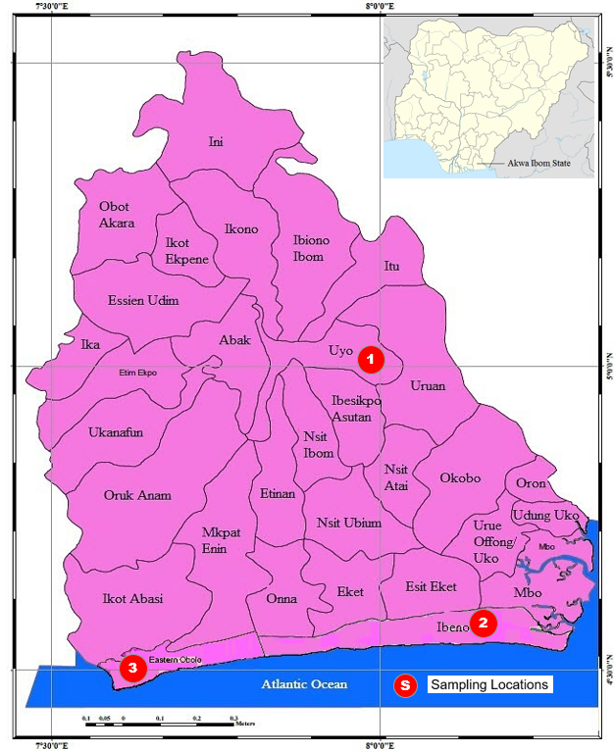
Figure 1. Map of Akwa Ibom State showing different Local Government Areas

Figure 2. Seasonal Variations of PM₁ Concentrations in a Naturally Ventilated Living Room during Rainy and Dry Seasons

Figure 3. Seasonal Variations of PM₂ Concentrations in a Naturally Ventilated Living Room during Rainy and Dry Seasons
Figure 4. Seasonal Variations of PM₅ Concentrations in a Naturally Ventilated Living Room during Rainy and Dry Seasons

Figure 5. Seasonal Variations of PM₁₀ Concentrations in a Naturally Ventilated Living Room during Rainy and Dry Seasons

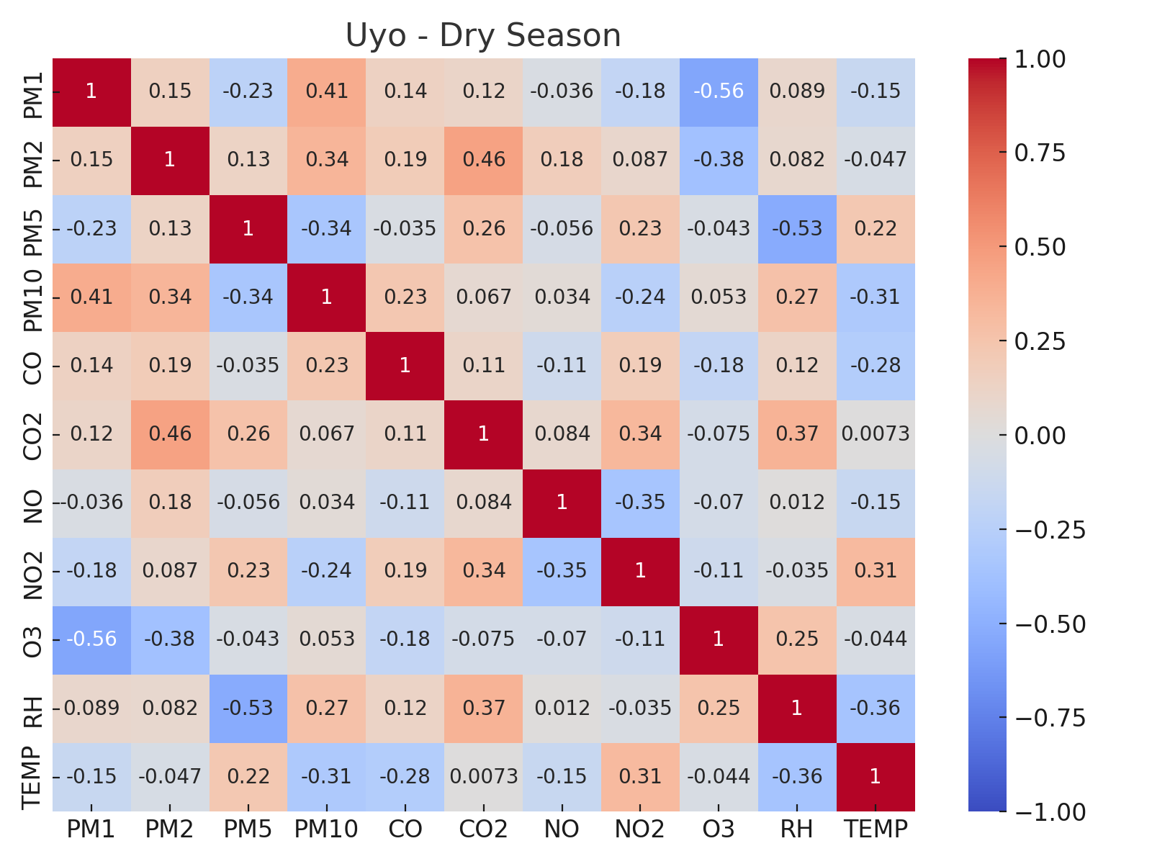
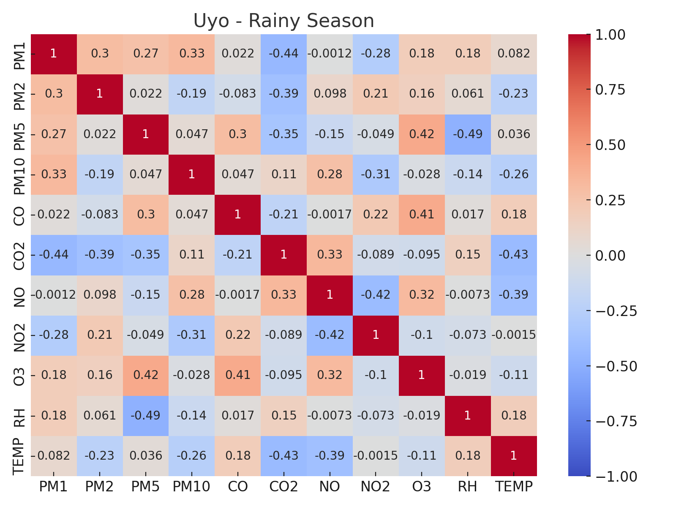
Figure 6. Correlation matrix heatmap for Uyo during the Rainy and Dry Seasons
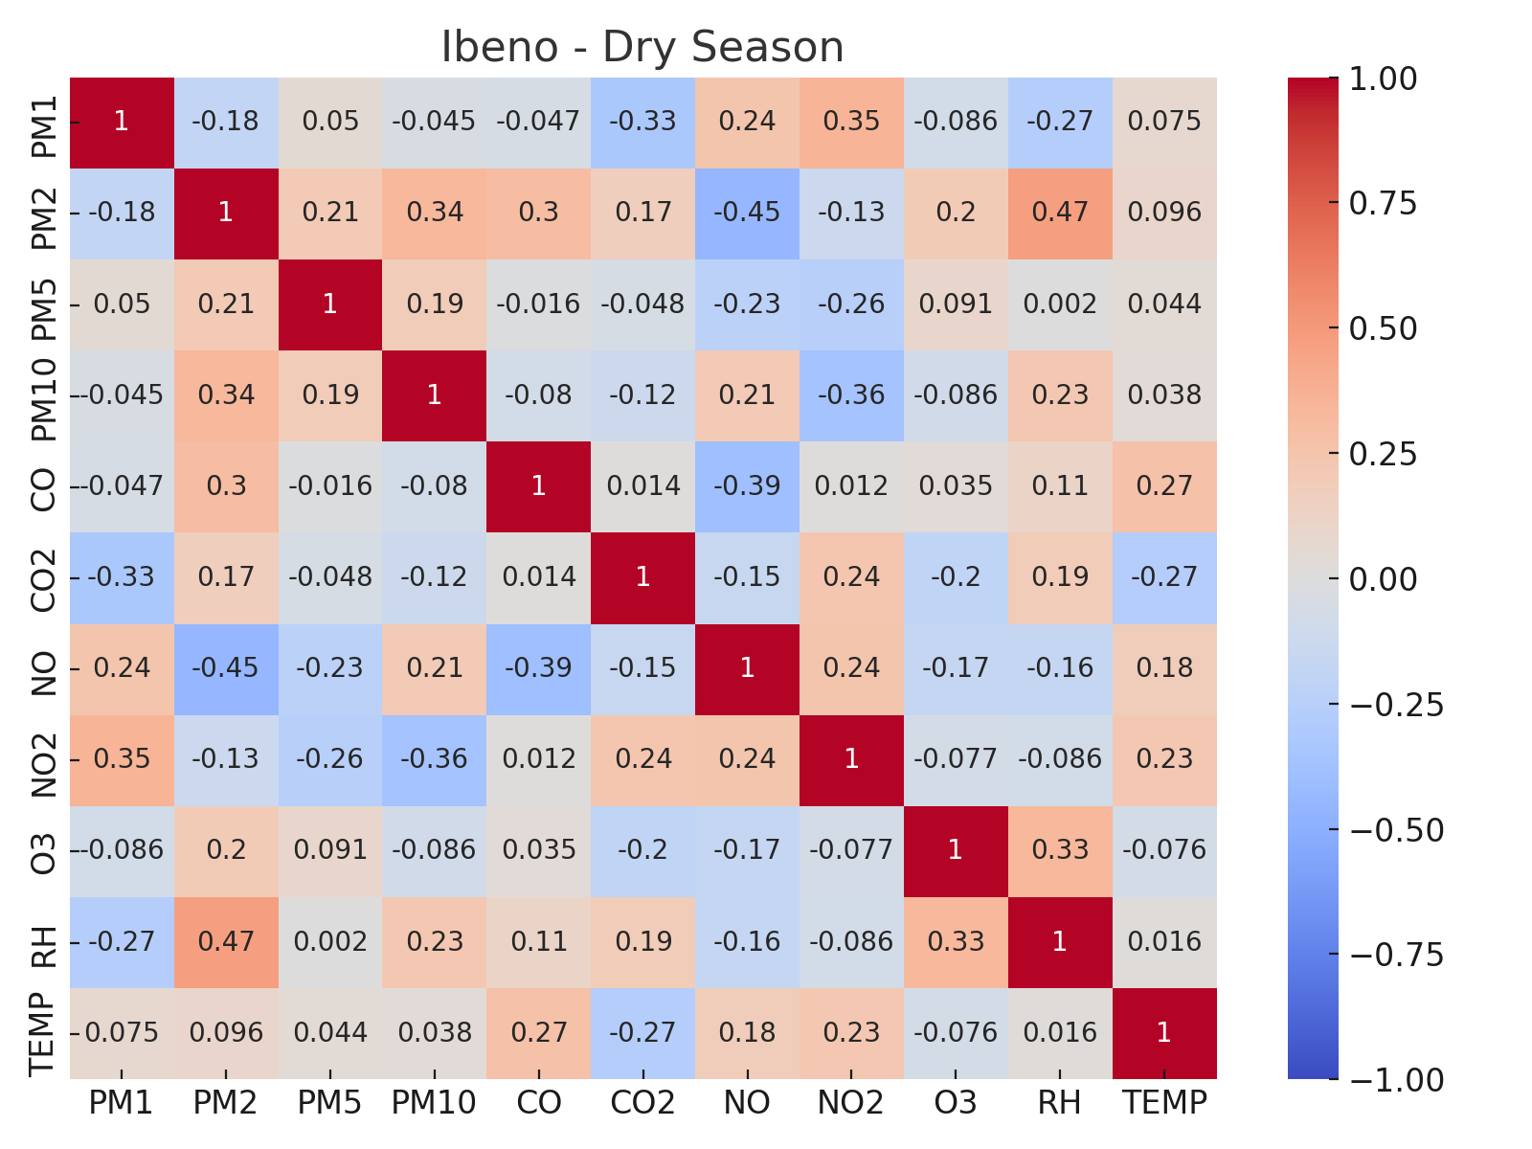
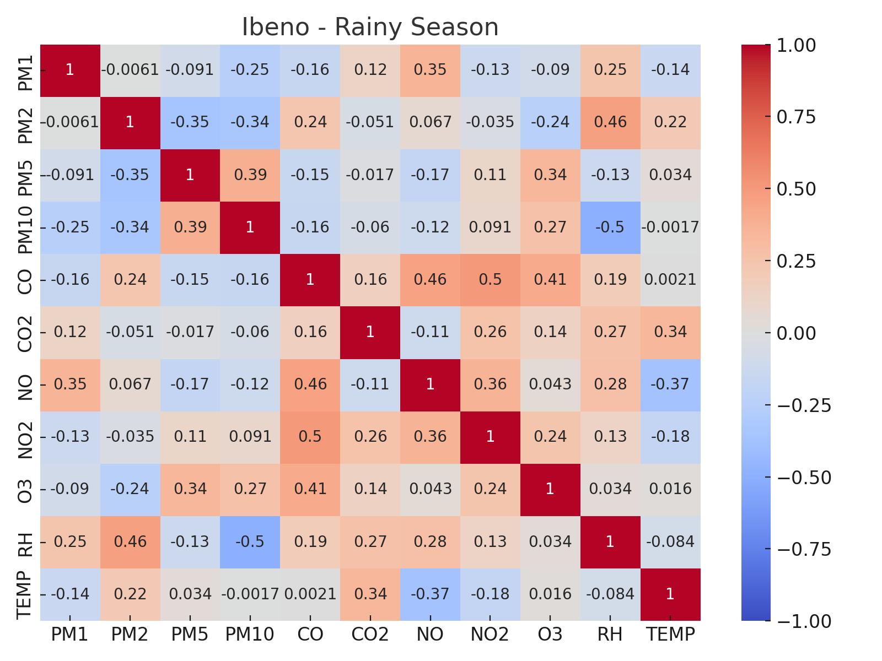

Figure 7. Correlation matrix heatmap for Ibeno during the Rainy and Dry Seasons

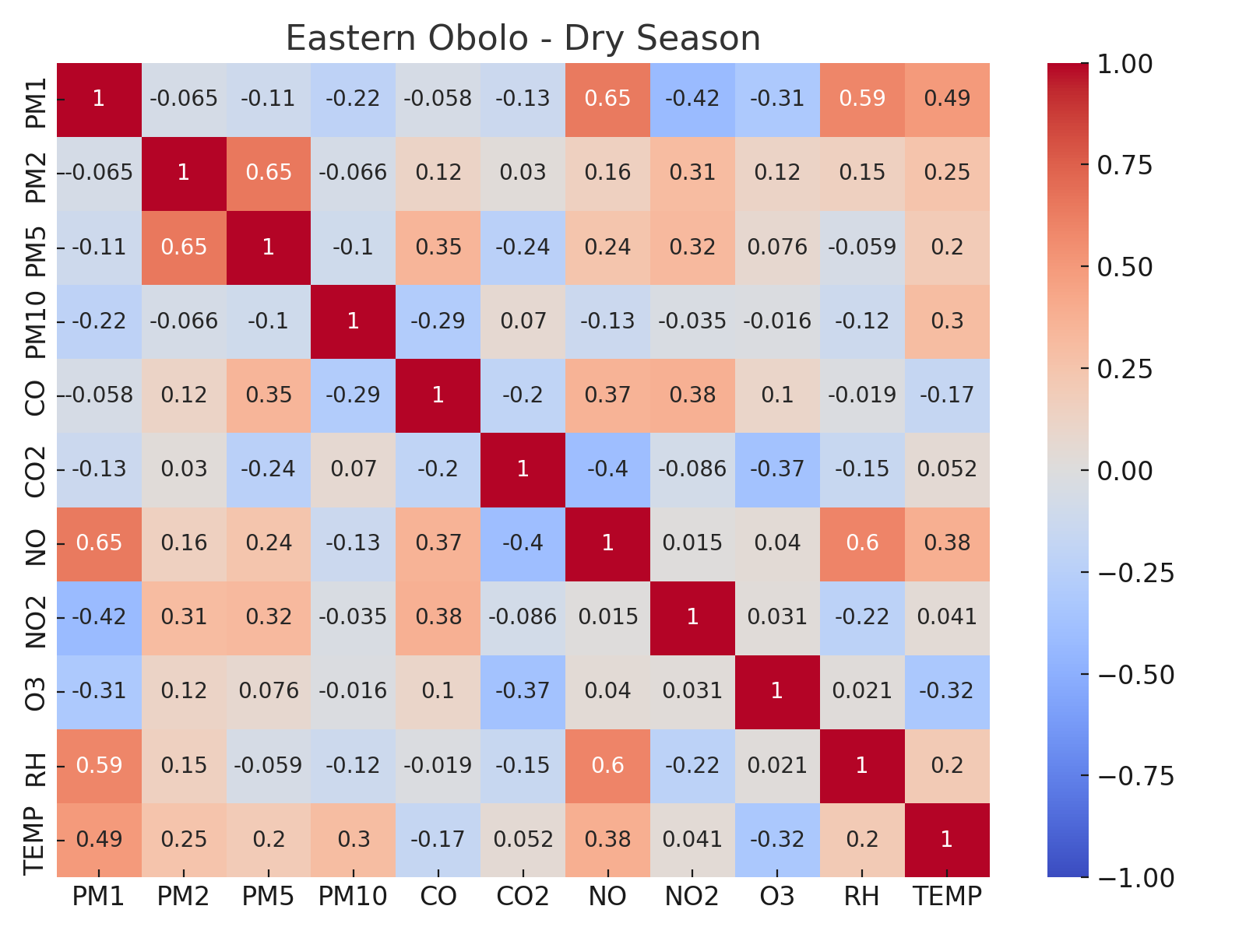
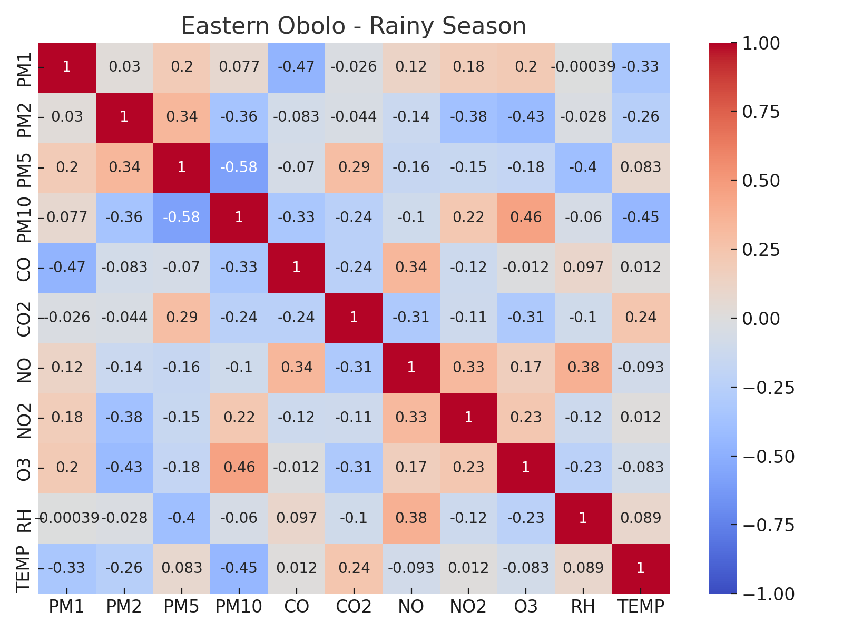
Figure 8. Correlation matrix heatmap for Eastern Obolo during the Rainy and Dry Seasons

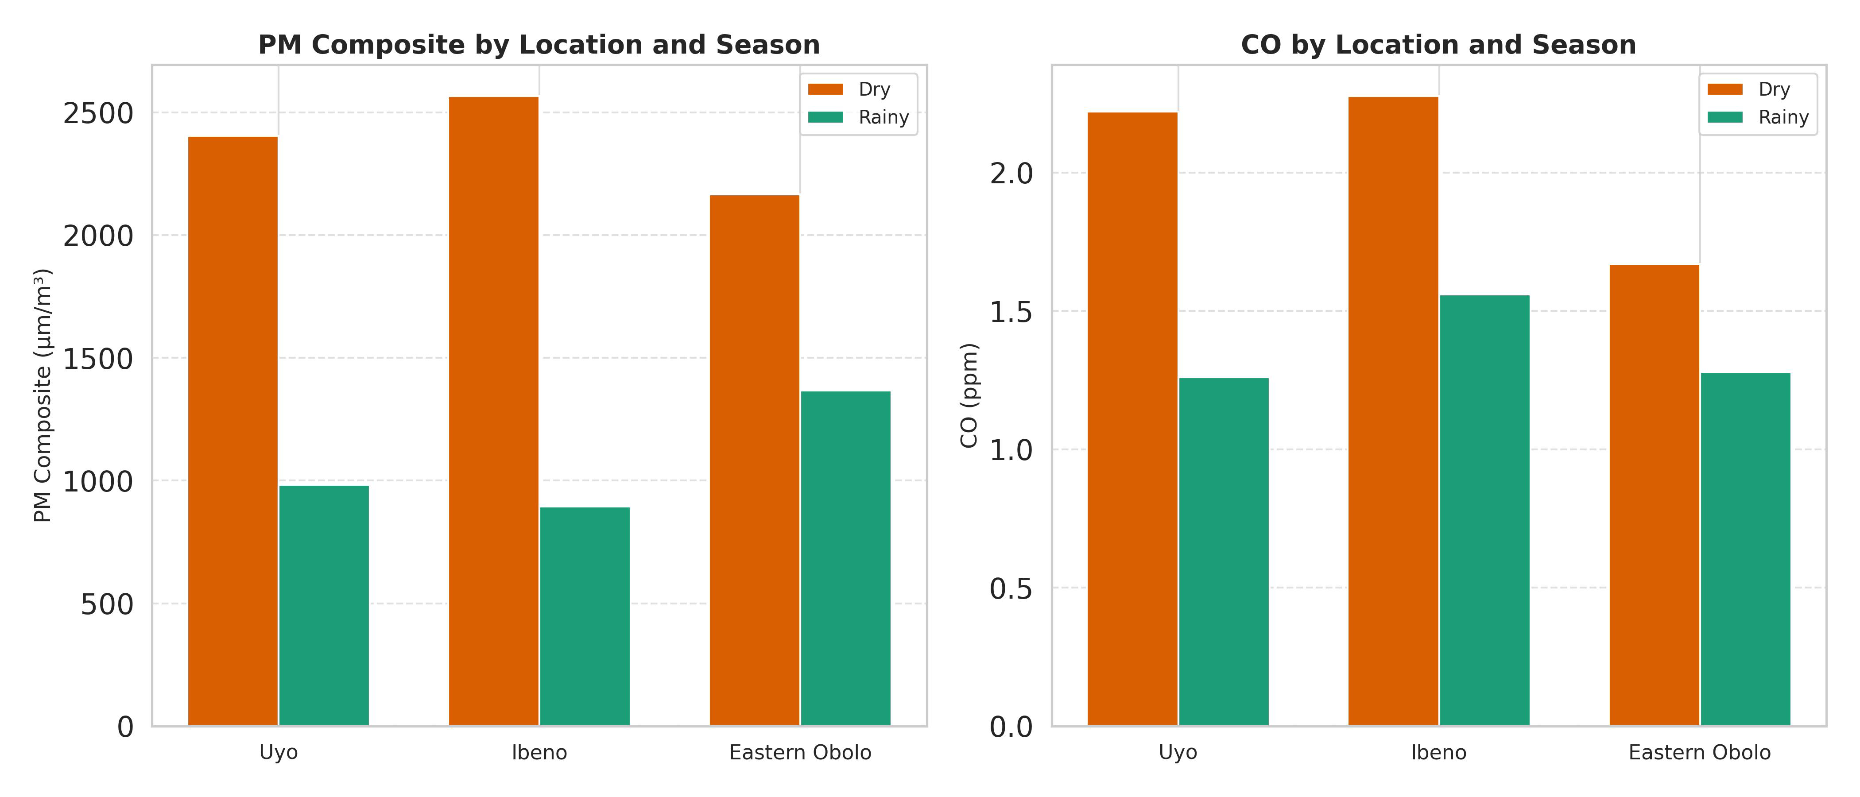
Figure 9. Seasonal and Location-Specific Indoor PM Composite and CO Levels in Uyo, Ibeno, and Eastern Obolo

Table 1. OVERVIEW OF LIVING ROOM CHARACTERISTICS
 | LIVING ROOM 3  (Uyo, Uyo) | LIVING ROOM 1  (Mkpanak, Ibeno) | LIVING ROOM 2  (Iko, Eastern Obolo)
Number of occupants | 4 | 3 | 3
Floor area (m²) | 16.5 | 16 | 16.5
Number of Doors | 3 | 2 | 2
Number of windows | 3 | 3 | 3
Number of Fans | 1 | 1 | 1
Cleaning Frequency | Once daily | Once daily | Once daily

Table 2(A-F). SAMPLING DATA FOR DIFFERENT SAMPLING LOCATIONS DURING DRY AND RAINY SEASONS
Table 2 (A) LOCATION 1 - UYO (DRY SEASON)
DAYS | PM₁  (µm/m³) | PM₂  (µm/m³) | PM₅  (µm/m³) | PM₁₀  (µm/m³) | CO  (ppm) | CO₂  (ppm) | NO  (ppm) | N0₂  (ppm) | O₃  (ppm) | RH  (%) | TEMP  (⁰C)
1 | 5568.45 | 3282.10 | 162.27 | 51.11 | 2.15 | 338.45 | 76.75 | 26.97 | 16.54 | 28.15 | 28.95
2 | 5483.03 | 3344.00 | 171.00 | 53.00 | 2.32 | 378.31 | 79.97 | 26.60 | 17.89 | 29.19 | 27.47
3 | 5438.00 | 3411.22 | 168.00 | 49.00 | 2.04 | 328.44 | 78.99 | 25.94 | 15.90 | 26.98 | 26.57
4 | 5398.23 | 3507.02 | 167.00 | 54.00 | 1.55 | 358.45 | 79.66 | 26.55 | 18.28 | 27.72 | 27.95
5 | 6098.02 | 3611.00 | 144.22 | 57.00 | 2.45 | 366.57 | 78.42 | 26.92 | 16.71 | 32.10 | 25.58
6 | 5352.00 | 3256.00 | 152.11 | 55.60 | 2.11 | 338.45 | 78.60 | 25.89 | 17.66 | 28.00 | 29.50
7 | 6211.22 | 3567.00 | 159.00 | 53.00 | 2.16 | 358.54 | 79.87 | 26.80 | 15.18 | 28.50 | 28.54
8 | 6294.02 | 3298.55 | 168.11 | 56.59 | 2.28 | 358.45 | 76.44 | 25.75 | 17.55 | 29.20 | 26.51
9 | 6573.00 | 3882.00 | 165.21 | 55.44 | 2.11 | 368.51 | 79.98 | 25.86 | 15.40 | 27.51 | 28.45
10 | 6168.00 | 3595.00 | 156.24 | 57.21 | 2.41 | 341.24 | 81.22 | 25.87 | 16.70 | 29.00 | 26.84
11 | 5897.11 | 3565.02 | 169.00 | 53.00 | 2.24 | 355.52 | 79.80 | 25.87 | 17.00 | 29.44 | 28.45
12 | 6298.02 | 3489.00 | 151.22 | 55.00 | 1.95 | 358.45 | 79.90 | 25.20 | 16.20 | 29.60 | 25.49
13 | 6652.22 | 3412.21 | 167.00 | 57.50 | 2.18 | 352.52 | 78.22 | 26.70 | 15.40 | 27.43 | 27.57
14 | 5744.00 | 3364.45 | 169.00 | 53.00 | 2.42 | 345.42 | 78.60 | 26.80 | 17.40 | 26.71 | 26.57
15 | 5898.22 | 3611.00 | 166.00 | 51.02 | 2.40 | 366.57 | 78.22 | 26.57 | 16.20 | 28.99 | 26.15
16 | 5852.22 | 3495.26 | 164.00 | 52.24 | 2.70 | 358.45 | 78.96 | 26.59 | 15.99 | 26.87 | 27.89
17 | 5866.14 | 3567.00 | 157.72 | 53.00 | 2.16 | 358.54 | 76.82 | 26.80 | 17.79 | 29.64 | 28.95
18 | 6494.02 | 3211.22 | 152.66 | 53.39 | 2.11 | 328.24 | 78.12 | 25.75 | 16.87 | 27.52 | 27.87
19 | 6073.32 | 2991.21 | 149.64 | 54.49 | 2.21 | 334.52 | 79.98 | 25.60 | 17.89 | 29.61 | 25.58
20 | 5269.98 | 3495.00 | 162.54 | 52.92 | 2.14 | 348.53 | 79.99 | 25.84 | 17.98 | 28.91 | 26.88
21 | 5887.44 | 3895.02 | 158.69 | 62.00 | 2.56 | 344.26 | 78.41 | 25.88 | 16.97 | 28.52 | 25.52

Table 2 (B) LOCATION 1 - UYO (RAINY SEASON)
DAYS | PM₁  (µm/m³) | PM₂  (µm/m³) | PM₅  (µm/m³) | PM₁₀  (µm/m³) | CO  (ppm) | CO₂  (ppm) | NO  (ppm) | N0₂  (ppm) | O₃  (ppm) | RH  (%) | TEMP  (⁰C)
1 | 2591.00 | 1254.00 | 66.00 | 21.00 | 1.40 | 230.20 | 79.90 | 25.51 | 14.20 | 17.55 | 16.90
2 | 2808.00 | 1311.00 | 54.00 | 19.00 | 1.20 | 225.22 | 76.00 | 25.26 | 13.44 | 19.70 | 18.22
3 | 2508.02 | 1390.00 | 60.00 | 22.00 | 1.18 | 224.13 | 79.90 | 23.20 | 14.00 | 18.90 | 18.90
4 | 2356.00 | 1206.02 | 59.00 | 23.00 | 1.24 | 220.11 | 78.00 | 25.52 | 13.90 | 16.50 | 18.20
5 | 2291.00 | 1420.02 | 53.00 | 24.00 | 1.22 | 237.11 | 79.90 | 25.20 | 13.51 | 18.20 | 15.44
6 | 2200.00 | 1287.00 | 57.00 | 17.80 | 1.25 | 228.15 | 77.00 | 25.58 | 13.10 | 18.40 | 18.40
7 | 2598.00 | 1310.02 | 51.00 | 24.00 | 1.12 | 228.00 | 78.60 | 24.96 | 12.55 | 19.00 | 17.40
8 | 2296.00 | 1554.00 | 56.00 | 17.00 | 1.21 | 226.11 | 79.90 | 25.50 | 13.55 | 18.20 | 15.52
9 | 2234.02 | 1311.00 | 53.00 | 18.00 | 1.14 | 231.00 | 79.90 | 25.60 | 13.60 | 17.45 | 17.80
10 | 2608.00 | 1298.00 | 58.00 | 19.01 | 1.17 | 227.00 | 74.00 | 25.40 | 13.70 | 18.50 | 18.50
11 | 2506.00 | 1206.00 | 54.00 | 22.01 | 1.50 | 225.11 | 81.68 | 24.68 | 14.60 | 18.90 | 18.90
12 | 2872.00 | 1720.02 | 61.00 | 22.00 | 1.25 | 220.11 | 79.90 | 25.20 | 15.44 | 18.20 | 15.20
13 | 2601.02 | 1575.00 | 57.00 | 21.00 | 1.25 | 228.22 | 78.60 | 25.97 | 13.80 | 18.40 | 18.40
14 | 2355.00 | 1014.00 | 61.00 | 24.00 | 1.20 | 235.11 | 78.60 | 24.51 | 14.20 | 16.70 | 16.27
15 | 2591.00 | 1287.00 | 59.00 | 18.00 | 1.25 | 228.15 | 79.40 | 23.80 | 15.21 | 18.90 | 18.90
16 | 2898.00 | 1510.02 | 60.00 | 24.00 | 1.32 | 220.14 | 78.60 | 24.80 | 13.90 | 17.22 | 18.20
17 | 2296.00 | 1554.00 | 57.00 | 17.00 | 1.21 | 226.11 | 79.90 | 25.50 | 14.42 | 16.88 | 17.60
18 | 2234.02 | 1311.00 | 53.00 | 21.00 | 1.33 | 236.00 | 79.90 | 26.00 | 15.00 | 19.70 | 16.45
19 | 2308.00 | 1398.00 | 62.00 | 18.50 | 1.42 | 219.00 | 72.00 | 26.80 | 14.11 | 17.59 | 18.90
20 | 2588.00 | 1411.00 | 61.00 | 21.00 | 1.22 | 225.22 | 79.90 | 26.20 | 14.70 | 18.20 | 18.20
21 | 2408.02 | 1390.00 | 55.00 | 19.00 | 1.28 | 224.13 | 76.80 | 26.44 | 13.78 | 19.20 | 19.42

Table 2(C) LOCATION 2 - IBENO (DRY SEASON)
DAYS | PM₁  (µm/m³) | PM₂  (µm/m³) | PM₅  (µm/m³) | PM₁₀  (µm/m³) | CO  (ppm) | CO₂  (ppm) | NO  (ppm) | N0₂  (ppm) | O₃  (ppm) | RH  (%) | TEMP  (⁰C)
1 | 6284.44 | 3982.75 | 155.74 | 60.54 | 2.45 | 398.77 | 78.89 | 25.97 | 15.54 | 31.55 | 29.87
2 | 6983.02 | 3368.64 | 155.54 | 53.52 | 2.12 | 378.38 | 78.77 | 26.56 | 17.28 | 31.51 | 28.55
3 | 6148.55 | 3215.55 | 154.00 | 49.95 | 2.41 | 398.57 | 78.56 | 25.84 | 15.49 | 29.50 | 27.89
4 | 6598.47 | 3507.82 | 155.00 | 54.55 | 1.98 | 358.45 | 78.78 | 25.96 | 18.42 | 31.28 | 28.99
5 | 6878.92 | 3658.89 | 149.00 | 57.88 | 2.55 | 366.57 | 78.77 | 26.82 | 16.71 | 29.44 | 28.24
6 | 6352.84 | 3256.87 | 147.02 | 52.85 | 1.94 | 368.45 | 78.75 | 26.89 | 15.96 | 29.55 | 28.82
7 | 6866.78 | 3567.78 | 164.18 | 53.00 | 2.16 | 358.54 | 78.78 | 26.68 | 15.88 | 28.52 | 31.59
8 | 6894.82 | 2984.82 | 151.65 | 58.58 | 2.18 | 358.45 | 79.96 | 26.52 | 15.96 | 29.25 | 32.22
9 | 6273.00 | 3887.55 | 154.48 | 59.77 | 2.11 | 368.51 | 78.59 | 25.56 | 15.54 | 31.21 | 30.41
10 | 6268.00 | 3295.89 | 152.56 | 59.02 | 1.96 | 358.45 | 79.96 | 25.94 | 16.67 | 29.95 | 29.45
11 | 6187.81 | 3565.02 | 157.59 | 57.43 | 2.59 | 358.17 | 77.98 | 24.78 | 17.52 | 29.76 | 30.15
12 | 6798.02 | 3489.77 | 153.77 | 55.00 | 1.95 | 358.45 | 78.88 | 25.72 | 16.52 | 29.56 | 29.29
13 | 6552.75 | 3588.97 | 154.00 | 61.55 | 2.18 | 381.45 | 78.76 | 26.87 | 15.64 | 30.21 | 30.56
14 | 6255.28 | 3688.48 | 156.79 | 53.45 | 2.82 | 355.33 | 78.57 | 26.78 | 17.54 | 31.31 | 31.54
15 | 6898.02 | 3645.56 | 149.00 | 51.02 | 2.41 | 366.57 | 78.89 | 26.54 | 16.52 | 28.99 | 29.98
16 | 6352.50 | 3257.97 | 147.02 | 52.54 | 2.44 | 358.45 | 78.77 | 25.89 | 15.45 | 29.87 | 31.42
17 | 6168.54 | 3567.85 | 154.78 | 53.64 | 2.16 | 398.88 | 78.75 | 26.78 | 17.59 | 29.64 | 30.14
18 | 6894.02 | 3684.21 | 155.49 | 59.00 | 2.34 | 358.45 | 78.79 | 25.95 | 16.70 | 30.22 | 31.27
19 | 6278.55 | 3882.88 | 149.48 | 57.85 | 2.51 | 368.58 | 78.75 | 25.86 | 17.85 | 31.12 | 30.98
20 | 6968.22 | 3398.85 | 157.42 | 59.02 | 2.56 | 358.45 | 78.79 | 25.74 | 15.80 | 29.45 | 28.95
21 | 6187.87 | 3565.52 | 158.59 | 62.00 | 1.99 | 358.78 | 78.78 | 24.78 | 16.89 | 29.68 | 27.85

Table 2(D) LOCATION 2 - IBENO (RAINY SEASON)
DAYS | PM₁  (µm/m³) | PM₂  (µm/m³) | PM₅  (µm/m³) | PM₁₀  (µm/m³) | CO  (ppm) | CO₂  (ppm) | NO  (ppm) | N0₂  (ppm) | O₃  (ppm) | RH  (%) | TEMP  (⁰C)
1 | 2491.00 | 1254.00 | 56.00 | 19.98 | 1.45 | 241.32 | 81.59 | 25.10 | 14.24 | 20.18 | 16.96
2 | 2188.00 | 1311.00 | 56.84 | 18.25 | 1.54 | 225.22 | 80.20 | 22.60 | 14.72 | 19.70 | 19.76
3 | 2508.02 | 1390.00 | 52.22 | 18.00 | 1.45 | 224.13 | 79.95 | 23.20 | 14.42 | 18.90 | 18.97
4 | 2356.00 | 1206.02 | 49.00 | 22.51 | 1.68 | 224.54 | 81.11 | 24.20 | 13.92 | 16.75 | 18.25
5 | 2291.00 | 1020.02 | 59.88 | 24.22 | 1.32 | 227.44 | 79.90 | 25.20 | 15.71 | 18.27 | 18.20
6 | 1991.00 | 1287.00 | 57.00 | 18.84 | 1.55 | 228.15 | 78.60 | 23.80 | 14.78 | 18.24 | 18.44
7 | 2098.00 | 1310.02 | 60.21 | 24.00 | 1.72 | 220.14 | 80.21 | 24.80 | 15.41 | 19.23 | 17.44
8 | 2296.00 | 1154.00 | 58.55 | 22.51 | 1.82 | 216.41 | 81.11 | 25.50 | 17.65 | 18.24 | 18.27
9 | 2234.02 | 1311.00 | 53.00 | 18.95 | 1.54 | 220.18 | 79.97 | 25.60 | 13.63 | 19.57 | 17.87
10 | 2008.00 | 1298.00 | 46.00 | 19.01 | 1.67 | 220.11 | 80.51 | 25.40 | 13.72 | 18.75 | 18.54
11 | 2106.00 | 1206.00 | 54.00 | 22.01 | 1.55 | 225.82 | 80.98 | 24.80 | 14.61 | 18.92 | 18.97
12 | 2172.00 | 1020.02 | 64.22 | 22.68 | 1.65 | 232.22 | 79.95 | 25.20 | 15.55 | 18.27 | 18.72
13 | 2601.02 | 1075.00 | 55.54 | 22.45 | 1.45 | 228.22 | 80.24 | 23.70 | 13.87 | 18.42 | 18.54
14 | 1978.00 | 1014.00 | 61.99 | 24.95 | 1.20 | 232.72 | 78.60 | 24.10 | 14.20 | 16.74 | 19.71
15 | 2591.00 | 1287.00 | 56.24 | 19.98 | 1.25 | 228.15 | 79.40 | 23.81 | 14.22 | 18.91 | 18.92
16 | 2098.00 | 1510.02 | 59.44 | 24.95 | 1.52 | 220.14 | 80.21 | 24.78 | 13.94 | 18.27 | 19.24
17 | 2296.00 | 1054.00 | 61.22 | 18.97 | 1.61 | 226.14 | 81.11 | 25.85 | 14.21 | 18.22 | 17.60
18 | 2234.02 | 1311.00 | 53.00 | 21.55 | 1.74 | 262.28 | 79.94 | 25.96 | 15.75 | 19.72 | 19.74
19 | 2308.00 | 1298.00 | 56.44 | 19.51 | 1.87 | 252.24 | 80.21 | 25.94 | 15.12 | 18.94 | 19.79
20 | 2188.00 | 1311.00 | 55.98 | 21.25 | 1.54 | 225.22 | 79.92 | 25.76 | 14.72 | 18.22 | 18.52
21 | 2408.02 | 1390.00 | 61.12 | 19.55 | 1.65 | 224.23 | 81.10 | 25.87 | 14.21 | 19.25 | 19.52

Table 2(E) LOCATION 2 - EASTERN OBOLO (DRY SEASON)
DAYS | PM₁  (µm/m³) | PM₂  (µm/m³) | PM₅  (µm/m³) | PM₁₀  (µm/m³) | CO  (ppm) | CO₂  (ppm) | NO  (ppm) | N0₂  (ppm) | O₃  (ppm) | RH  (%) | TEMP  (⁰C)
1 | 5677.45 | 2980.00 | 145.00 | 38.00 | 1.85 | 312.51 | 79.90 | 25.75 | 10.55 | 25.00 | 16.79
2 | 5775.55 | 2744.00 | 138.00 | 43.02 | 1.74 | 298.02 | 79.90 | 25.68 | 11.59 | 26.00 | 19.67
3 | 5938.02 | 3015.02 | 140.00 | 39.00 | 1.61 | 299.51 | 79.90 | 25.40 | 11.58 | 26.00 | 18.69
4 | 5298.46 | 3207.00 | 147.00 | 44.00 | 1.77 | 273.33 | 79.80 | 26.72 | 10.10 | 25.00 | 18.72
5 | 5898.02 | 2936.00 | 139.00 | 46.00 | 1.51 | 298.21 | 79.90 | 25.20 | 11.20 | 29.50 | 18.92
6 | 5152.54 | 2956.02 | 137.00 | 45.00 | 1.64 | 392.24 | 78.60 | 26.55 | 10.20 | 20.50 | 18.74
7 | 5166.02 | 2867.00 | 138.00 | 42.00 | 1.60 | 244.22 | 78.60 | 26.18 | 11.54 | 22.87 | 17.84
8 | 5894.01 | 2784.00 | 141.00 | 43.00 | 1.58 | 265.45 | 79.90 | 25.45 | 10.90 | 24.00 | 18.72
9 | 5373.02 | 2812.01 | 138.00 | 44.00 | 1.71 | 284.24 | 79.90 | 25.56 | 12.54 | 22.89 | 17.78
10 | 5868.02 | 2995.54 | 142.01 | 45.00 | 1.64 | 245.23 | 79.90 | 25.44 | 11.55 | 22.99 | 19.75
11 | 5187.00 | 2965.58 | 149.00 | 43.02 | 1.71 | 255.25 | 79.80 | 26.88 | 12.10 | 21.00 | 18.59
12 | 5798.00 | 2989.82 | 143.00 | 41.00 | 1.67 | 289.61 | 79.90 | 25.20 | 11.00 | 24.94 | 18.62
13 | 5252.00 | 2895.58 | 144.00 | 45.00 | 1.52 | 324.41 | 78.60 | 24.70 | 10.50 | 20.97 | 18.74
14 | 5344.00 | 2788.45 | 139.00 | 43.00 | 1.62 | 300.11 | 78.60 | 26.11 | 11.00 | 21.50 | 16.54
15 | 5166.02 | 2878.67 | 138.00 | 42.00 | 1.64 | 294.22 | 78.60 | 24.80 | 12.55 | 22.30 | 14.97
16 | 5894.01 | 2784.56 | 141.00 | 43.00 | 1.88 | 265.41 | 79.90 | 25.50 | 10.29 | 22.89 | 18.72
17 | 5373.02 | 2812.01 | 138.00 | 44.00 | 1.65 | 289.41 | 79.90 | 25.76 | 11.00 | 23.78 | 17.96
18 | 5373.00 | 2768.44 | 138.00 | 43.02 | 1.74 | 248.02 | 79.90 | 25.96 | 11.89 | 24.22 | 15.75
19 | 5938.02 | 3019.82 | 140.00 | 39.00 | 1.61 | 285.51 | 79.90 | 25.94 | 10.58 | 23.88 | 18.90
20 | 5299.00 | 3288.57 | 147.00 | 44.00 | 1.77 | 273.98 | 79.80 | 26.22 | 13.52 | 24.22 | 18.42
21 | 5898.02 | 2938.56 | 139.00 | 46.00 | 1.59 | 298.21 | 79.90 | 25.20 | 10.10 | 23.83 | 19.42

Table 2(F) LOCATION 2 - EASTERN OBOLO (RAINY SEASON)
DAYS | PM₁  (µm/m³) | PM₂  (µm/m³) | PM₅  (µm/m³) | PM₁₀  (µm/m³) | CO  (ppm) | CO₂  (ppm) | NO  (ppm) | N0₂  (ppm) | O₃  (ppm) | RH  (%) | TEMP  (⁰C)
1 | 2999.00 | 2154.00 | 66.00 | 28.95 | 1.65 | 258.23 | 81.14 | 25.97 | 14.20 | 38.72 | 16.89
2 | 3188.00 | 1911.00 | 64.00 | 27.75 | 1.50 | 267.24 | 79.90 | 26.96 | 14.70 | 35.52 | 19.67
3 | 3008.00 | 1990.00 | 55.00 | 26.98 | 1.85 | 260.22 | 82.00 | 25.74 | 14.95 | 43.23 | 18.79
4 | 2556.02 | 2306.00 | 59.00 | 27.44 | 1.68 | 265.35 | 79.80 | 24.55 | 13.90 | 42.32 | 18.92
5 | 3191.00 | 2020.02 | 60.02 | 29.11 | 1.12 | 275.25 | 79.90 | 26.42 | 14.00 | 41.41 | 18.82
6 | 3121.02 | 2187.01 | 58.32 | 28.00 | 1.25 | 264.21 | 78.60 | 24.94 | 13.10 | 42.31 | 18.94
7 | 3198.00 | 2010.00 | 51.22 | 34.11 | 1.12 | 261.21 | 82.00 | 26.80 | 15.10 | 41.22 | 17.94
8 | 3296.02 | 2054.00 | 66.02 | 27.00 | 1.21 | 275.26 | 79.90 | 25.75 | 13.40 | 42.20 | 18.82
9 | 3934.00 | 2311.02 | 63.00 | 29.00 | 1.14 | 264.25 | 79.90 | 25.56 | 13.96 | 40.22 | 17.78
10 | 3008.00 | 2298.00 | 66.44 | 26.00 | 1.27 | 274.44 | 80.00 | 25.45 | 13.70 | 38.90 | 18.50
11 | 3106.00 | 2206.00 | 64.23 | 28.54 | 1.15 | 260.21 | 78.98 | 24.80 | 14.96 | 35.41 | 18.59
12 | 3972.02 | 2020.02 | 62.00 | 27.00 | 1.24 | 265.22 | 81.20 | 25.52 | 14.55 | 41.10 | 18.52
13 | 3001.00 | 2175.00 | 60.02 | 28.23 | 1.25 | 280.21 | 78.60 | 25.74 | 13.80 | 36.46 | 18.40
14 | 3178.00 | 2194.00 | 61.55 | 26.54 | 1.20 | 260.44 | 81.60 | 26.80 | 14.20 | 41.30 | 19.78
15 | 3191.00 | 2020.02 | 60.02 | 29.55 | 1.12 | 275.25 | 79.90 | 25.22 | 14.58 | 42.47 | 18.94
16 | 3121.02 | 2187.01 | 58.52 | 28.00 | 1.25 | 264.21 | 78.60 | 26.55 | 13.90 | 40.22 | 18.72
17 | 3198.00 | 2010.00 | 56.22 | 34.00 | 1.12 | 261.21 | 78.60 | 25.82 | 14.65 | 39.21 | 17.86
18 | 3296.02 | 2054.00 | 66.02 | 28.69 | 1.21 | 275.26 | 78.90 | 25.65 | 15.44 | 38.56 | 19.70
19 | 3934.00 | 2311.02 | 63.52 | 29.33 | 1.12 | 264.25 | 79.99 | 26.22 | 15.10 | 39.75 | 16.89
20 | 3308.00 | 2298.00 | 64.52 | 26.00 | 1.29 | 274.44 | 81.10 | 25.64 | 13.20 | 39.89 | 18.72
21 | 3106.00 | 2206.00 | 64.00 | 27.00 | 1.15 | 260.21 | 80.00 | 25.78 | 14.20 | 41.25 | 19.62

Table 3. DESCRIPTIVE STATISTICS OF DAILY AVERAGE INDOOR AIR QUALITY (IAQ) PARAMETERS
SEASON |  | POLLUTANTS |  |  |  |  |  |  |  |  | Comfort Parameters
 |  | PM₁  (µm/m³) | PM₂  (µm/m³) | PM₅  (µm/m³) | PM₁₀  (µm/m³) | CO  (ppm) | CO₂  (ppm) | NO  (ppm) | N0₂  (ppm) | O₃  (ppm) | RH  (%) | TEMP  (⁰C)
LOCATION 1 - UYO
DRY | Mean | 5,929.37 | 3,469.06 | 160.98 | 54.26 | 2.22 | 351.74 | 78.90 | 26.23 | 16.83 | 28.55 | 27.30
 | Min | 5,269.98 | 2,991.21 | 144.22 | 49.00 | 1.55 | 328.24 | 76.44 | 25.20 | 15.18 | 26.71 | 25.49
 | Max | 6,652.22 | 3,895.02 | 171.00 | 62.00 | 2.70 | 378.31 | 81.22 | 26.97 | 18.28 | 32.10 | 29.50
 | Median | 5,897.11 | 3,495.00 | 162.54 | 53.39 | 2.18 | 355.52 | 78.96 | 25.94 | 16.87 | 28.52 | 27.47
 | SD | 411.05 | 209.42 | 7.59 | 2.82 | 0.24 | 13.56 | 1.24 | 0.52 | 0.94 | 1.25 | 1.25
RAINY | Mean | 2,483.20 | 1,367.48 | 57.48 | 20.59 | 1.26 | 226.87 | 78.49 | 25.32 | 14.03 | 18.20 | 17.70
 | Min | 2,200.00 | 1,014.00 | 51.00 | 17.00 | 1.12 | 219.00 | 72.00 | 23.20 | 12.55 | 16.50 | 15.20
 | Max | 2,898.00 | 1,720.02 | 66.00 | 24.00 | 1.50 | 237.11 | 81.68 | 26.80 | 15.44 | 19.70 | 19.42
 | Median | 2,506.00 | 1,311.00 | 57.00 | 21.00 | 1.24 | 226.11 | 79.40 | 25.50 | 13.90 | 18.20 | 18.20
 | SD | 210.61 | 155.64 | 3.76 | 2.43 | 0.09 | 5.07 | 2.27 | 0.83 | 0.70 | 0.92 | 1.26
LOCATION 2 – IBENO
DRY | Mean | 6528.115 | 3526.745 | 153.957 | 56.293 | 2.277 | 368.319 | 78.834 | 26.116 | 16.546 | 30.075 | 29.912
 | Min | 6148.55 | 2984.82 | 147.02 | 49.95 | 1.94 | 355.33 | 77.98 | 24.78 | 15.45 | 28.52 | 27.85
 | Max | 6983.02 | 3982.75 | 164.18 | 62 | 2.82 | 398.88 | 79.96 | 26.89 | 18.42 | 31.55 | 32.22
 | Median | 6352.84 | 3565.52 | 154.48 | 57.43 | 2.18 | 358.78 | 78.77 | 25.96 | 16.52 | 29.76 | 29.98
 | SD | 317.595 | 243.892 | 4.135 | 3.58 | 0.254 | 14.485 | 0.42 | 0.628 | 0.889 | 0.897 | 1.292
RAINY | Mean | 2,259.10 | 1,238.91 | 56.57 | 21.15 | 1.56 | 228.81 | 80.23 | 24.82 | 14.70 | 18.65 | 18.67
 | Min | 2,601.02 | 1,510.02 | 64.22 | 24.95 | 1.87 | 262.28 | 81.59 | 25.96 | 17.65 | 20.18 | 19.79
 | Max | 1,978.00 | 1,014.00 | 46.00 | 18.00 | 1.20 | 216.41 | 78.60 | 22.60 | 13.63 | 16.74 | 16.96
 | Median | 2,234.02 | 1,287.00 | 56.44 | 21.25 | 1.55 | 225.82 | 80.21 | 25.10 | 14.42 | 18.75 | 18.54
 | SD | 185.57 | 136.69 | 4.41 | 2.25 | 0.17 | 10.98 | 0.78 | 0.98 | 0.94 | 0.86 | 0.80
LOCATION 3 – EASTERN OBOLO
DRY | Mean | 5,550.63 | 2,925.08 | 141.00 | 42.96 | 1.67 | 287.48 | 79.58 | 25.72 | 11.25 | 23.73 | 18.20
 | Min | 5,152.54 | 2,744.00 | 137.00 | 38.00 | 1.51 | 244.22 | 78.60 | 24.70 | 10.10 | 20.50 | 14.97
 | Max | 5,938.02 | 3,288.57 | 149.00 | 46.00 | 1.88 | 392.24 | 79.90 | 26.88 | 13.52 | 29.50 | 19.75
 | Median | 5,373.02 | 2,936.00 | 140.00 | 43.02 | 1.64 | 289.41 | 79.90 | 25.68 | 11.00 | 23.83 | 18.69
 | SD | 311.92 | 139.88 | 3.54 | 2.20 | 0.10 | 32.62 | 0.56 | 0.58 | 0.91 | 2.05 | 1.24
RAINY | Mean | 3,233.82 | 2,139.15 | 61.41 | 28.44 | 1.28 | 266.98 | 80.03 | 25.80 | 14.27 | 40.08 | 18.61
 | Min | 2,556.02 | 1,911.00 | 51.22 | 26.00 | 1.12 | 258.23 | 78.60 | 24.55 | 13.10 | 35.41 | 16.89
 | Max | 3,972.02 | 2,311.02 | 66.44 | 34.11 | 1.85 | 280.21 | 82.00 | 26.96 | 15.44 | 43.23 | 19.78
 | Median | 3,188.00 | 2,175.00 | 62.00 | 28.00 | 1.21 | 264.25 | 79.90 | 25.74 | 14.20 | 40.22 | 18.72
 | SD | 337.57 | 126.52 | 4.05 | 2.14 | 0.21 | 6.78 | 1.11 | 0.65 | 0.65 | 2.23 | 0.80

Table 4. Pearson Correlation Coefficients for Indoor Air Pollutants and Comfort Parameters in Uyo (Urban Centre) During Dry and Rainy Seasons
Pollutant Pair | Dry Season (r) | Rainy Season (r) | Interpretation
PM₁ – PM₂ | 0.15 | 0.30 | Weak positive correlation, slightly stronger in rainy season.
PM₁ – PM₅ | –0.23 | 0.27 | Negative in dry season (possible different sources), positive in rainy season.
PM₁ – PM₁₀ | 0.41 | 0.33 | Moderate positive correlation in both seasons, stronger in dry season.
PM₂ – PM₅ | 0.13 | 0.02 | Minimal relationship, negligible in rainy season.
PM₂ – PM₁₀ | 0.34 | –0.19 | Positive in dry season, weak negative in rainy season.
PM₅ – PM₁₀ | –0.34 | 0.05 | Negative in dry season, near zero in rainy season.
CO – PMs | 0.14–0.23 | 0.02–0.30 | Generally weak positive links, slightly higher in rainy PM₅.
CO₂ – PMs | 0.07–0.46 | –0.44 to –0.35 | Positive in dry season, negative in rainy season—may reflect seasonal ventilation effects.
NO – NO₂ | –0.35 | –0.42 | Moderate inverse relationship in both seasons, stronger in rainy season.
PMs – O₃ | Mostly negative (up to –0.56) | Mostly positive or weak | O₃ inversely related to PM in dry season, not consistent in rainy season.
RH – PMs | Mixed; RH–PM₅ strongly negative (–0.53) | RH–PM₅ strongly negative (–0.49) | High RH suppresses particulate levels in both seasons.
TEMP – PMs | Weak mixed | Weak mixed | No strong or consistent relationship.

Table 5. Pearson Correlation Coefficients for Indoor Air Pollutants and Comfort Parameters in Ibeno (Industrial Zone) During Dry and Rainy Seasons
Pollutant Pair | Dry Season (r) | Rainy Season (r) | Interpretation
PM₁ – PM₂ | -0.180 | -0.006 | Very weak negative in dry season, negligible in rainy season.
PM₁ – PM₅ | 0.050 | -0.091 | Very weak positive in dry season, very weak negative in rainy season.
PM₁ – PM₁₀ | -0.045 | -0.250 | Very weak negative in dry season, weak negative in rainy season.
PM₂ – PM₅ | 0.210 | -0.350 | Weak positive in dry season, weak negative in rainy season.
PM₂ – PM₁₀ | 0.340 | -0.340 | Weak positive in dry season, weak negative in rainy season.
PM₅ – PM₁₀ | 0.190 | 0.390 | Very weak positive in dry season, weak positive in rainy season.
CO – PMs | -0.047 to 0.350 | -0.160 to 0.460 | Mixed weak negative/positive in dry season, mostly weak positive in rainy season.
CO₂ – PMs | -0.330 to 0.170 | -0.110 to 0.160 | Weak negative to very weak positive in both seasons.
NO – NO₂ | 0.240 | 0.360 | Weak positive in both seasons, slightly stronger in rainy season.
PMs – O₃ | -0.086 to 0.200 | -0.240 to 0.340 | Mostly very weak positive in dry season, mixed weak correlations in rainy season.
RH – PMs | -0.270 to 0.470 | -0.500 to 0.250 | Mixed weak correlations in both seasons, strong negative for PM₁₀ in rainy season.
TEMP – PMs | 0.016 to 0.096 | -0.140 to 0.220 | Mostly negligible in both seasons.

Table 6. Pearson Correlation Coefficients for Indoor Air Pollutants and Comfort Parameters in Eastern Obolo (Industrial Zone) During Dry and Rainy Seasons
Pollutant Pair | Dry Season (r) | Rainy Season (r) | Interpretation
PM₁ – PM₂ | 0.996 | 0.995 | Very strong positive correlation in both seasons.
PM₁ – PM₅ | 0.985 | 0.993 | Very strong positive correlation in both seasons.
PM₁ – PM₁₀ | 0.975 | 0.981 | Very strong positive correlation in both seasons.
PM₂ – PM₅ | 0.989 | 0.990 | Very strong positive correlation in both seasons.
PM₂ – PM₁₀ | 0.979 | 0.977 | Very strong positive correlation in both seasons.
PM₅ – PM₁₀ | 0.998 | 0.992 | Very strong positive correlation in both seasons.
CO – PMs | 0.314 to 0.367 | 0.229 to 0.335 | Weak to moderate positive in dry season, weak positive in rainy season.
CO₂ – PMs | -0.176 to -0.115 | -0.172 to 0.029 | Weak negative in dry season, mostly negligible in rainy season.
NO – NO₂ | 0.237 | 0.243 | Weak positive in both seasons.
PMs – O₃ | -0.009 to 0.064 | 0.104 to 0.203 | Negligible in dry season, very weak positive in rainy season.
RH – PMs | -0.067 to 0.164 | -0.159 to 0.031 | Mostly negligible in both seasons.
TEMP – PMs | -0.041 to 0.004 | -0.059 to 0.101 | Negligible in both seasons.

Table 7. Comparative Pearson Correlation Summary: Urban Centre (Uyo) vs. Industrial Zone (Ibeno and Eastern Obolo)
Parameter Relationship | Uyo | Ibeno | Eastern Obolo
PM–PM | Strong (Dry), Moderate–Strong (Rainy) | Strong (Dry), Moderate–Weak (Rainy) | Very Strong (Dry & Rainy)
PM–CO | Weak Positive (Dry), Weak/Negative (Rainy) | Mixed Weak (Dry), Weak Positive (Rainy) | Weak–Moderate Positive (Both Seasons)
PM–CO₂ | Weak Negative/Negligible | Weak Negative/Negligible | Weak Negative (Dry), Negligible (Rainy)
NO–NO₂ | Very Weak–Weak Positive | Weak Positive (Stronger in Rainy) | Weak Positive (Both Seasons)
PM–O₃ | Mixed Weak Positive/Negative | Mixed Weak (Rainy Slightly Higher) | Negligible (Dry), Very Weak Positive (Rainy)
RH–PM | Negligible | Mixed Weak, Strong Negative RH–PM₁₀ (Rainy) | Negligible
TEMP–PM | Negligible–Weak | Negligible | Negligible

Table 8: Principal Component Analysis (PCA) Comparative Overview: Urban Centre (Uyo) vs. Industrial Zone (Ibeno and Eastern Obolo)
Location & Season | PC1 Variance Explained (%) | Dominant PC1 Loadings | PC2 Variance Explained (%) | Dominant PC2 Loadings | Seasonal Shift Notes
Uyo – Dry | 50–60 | PM₁, PM₂, PM₅, PM₁₀, CO | 15–25 | O₃, RH, TEMP | Mixed traffic/dust sources; weather effects visible
Uyo – Rainy | 45–55 | PM₁, PM₂, PM₅, PM₁₀ | 20–28 | RH, TEMP, O₃ | Strong meteorology control; weakest PM–PM grouping
Ibeno – Dry | 60–70 | PM₁, PM₂, PM₅, PM₁₀ | 12–20 | CO, NO₂ | Particulate-led but weaker PM cohesion than Eastern Obolo
Ibeno – Rainy | 55–65 | PM₁, PM₂, PM₅, PM₁₀ | 15–22 | RH, TEMP, O₃ | Meteorological influence increases; PM linkages weaken
Eastern Obolo – Dry | 70–80 | PM₁, PM₂, PM₅, PM₁₀ (all very strong) | 10–15 | CO, NO₂, O₃ | Strong particulate source dominance, minimal seasonal influence
Eastern Obolo – Rainy | 65–75 | PM₁, PM₂, PM₅, PM₁₀ | 12–18 | CO, NO₂, O₃, RH | Slight drop in PM dominance; RH influence increases

