Chrysophyllum albidum Seed Shell-derived Activated Carbon: A Novel Adsorbent for Basic Red 9 (BR9) Dye Adsorption
ABSTRACT
This study aimed at the valorization of African star apple (Chrysophyllum albidum) seed shell into activated carbon as a sustainable, cost-effective adsorbent for Basic red 9 (BR9) dye removal from aqueous solutions. Chrysophylum albidum seed shell activated carbon (CASSAC) was synthesized after washing and drying the seed shell, it was carbonized and chemically activated with phosphoric acid. The adsorbent was characterized using BET, SEM, XRD, and pHpzc analyses, and batch adsorption experiments were conducted to evaluate the influence of pH, adsorbent dosage, initial dye concentration, contact time, and temperature of adsorption of the adsorbate onto the adsorbent. The prepared adsorbent had a surface area of 329.46 m²/g with a heterogeneous structure with irregular patterns of pore and achieved maximum BR9 dye removal efficiency of 96% at a pH of 8. Adsorption followed a pseudo-second-order kinetic model (R² = 0.983) and fitted the Freundlich isotherm (R² = 0.9513), suggesting multilayer chemisorption on a heterogeneous surface. Thermodynamic studies gave a positive ΔH (24.99 kJ/mol), and ΔS (55.89 J/mol·K) and negative Gibb’s free energy values at all studied temperature [-18.03 kJ/mol (323 K), -18.59 kJ/mol (333K), -19.15 kJ/mol (343 K), and -19.71 kJ/mol (353 K)], revealing spontaneous and endothermic adsorption process. Compared to other adsorbents, CASSAC provides a cost-effective solution, supporting the valorization of agricultural waste.
Keywords: Activated carbon, Adsorption, African star apple, Agricultural waste, Basic Red 9 (BR9), Chrysophyllum albidum, Valorization.
- INTRODUCTION
The rapid rise in urbanization and industrialization, particularly in the textile sector, has led to a significant increase in wastewater production, making it the primary source of global aquatic ecosystem pollution (Karri et al., 2021). Numerous synthetic dyes, heavy metals, and organic chemicals found in textile effluents are hazardous, non-biodegradable, and persistent in the environment (Dhruv and Bhatt, 2022; Mani et al., 2018). Basic red 9 is a cationic triphenylmethane dye with of 323.8 g/mol as its molecular mass and 268–270°C as its melting point range, Basic Red 9 (BR9), also called Pararosaniline Hydrochloride, is one of these contaminants that is frequently employed in textiles, leather, paper, and cosmetics due to its vibrant color and affinity for negatively charged fibers such as wool and acrylics (Vo, et al., 2022; Kowalska and Jeżewska, 2019). However, its discharge into water bodies poses severe environmental and health risks. BR9’s intense colouration reduces light penetration, disrupting photosynthesis and increasing biochemical and chemical oxygen demands (BOD and COD), which deplete oxygen levels and threaten aquatic ecosystems (Periyasamy, 2024). Furthermore, its complex aromatic structure renders it resistant to microbial degradation, leading to bioaccumulation and potential mutagenic and carcinogenic effects in humans through the formation of toxic aromatic amines (Gungor, 2014). BR9 is only recommended for laboratory use as a chemical. In analytical chemistry, BR9 is used for determining bromates, formaldehyde, ozone, and sulfur dioxide. It is not advisable for use in food, drug, pesticide or biocidal products. Before use it is advisable to put on personal protective equipment in a well-ventilated environment. It should not be disposed of in an open environment, but in an approved waste disposal plant to avoid soil and water pollution (Kowalska and Jeżewska, 2019). Wastewater conventional treatment techniques, like coagulation, flocculation, biological treatment, and membrane filtering, frequently prove inadequate in eliminating persistent dyes like BR9 due to their chemical stability and limited biodegradability (Khan et al., 2023; Sathya et al., 2022). Biological therapies face challenges due to the resistance of dyes to microbial metabolism, whereas sophisticated oxidation mechanisms, while efficient, are energy-intensive and produce secondary pollutants (Kusumlata et al., 2024). Adsorption provides a straightforward, economical, and adaptable method for treating various pollutants, such as dyes, heavy metals, and pharmaceuticals, without generating harmful byproducts (Alaqarbeh, 2021). Activated carbon is a widely recognized adsorbent with properties like extensive surface area, porous architecture, and numerous surface functional groups that necessitate adsorption of contaminants as a result of activation by physical or chemical methods (Yang, 2019; Lima, et al., 2019). Nonetheless, the elevated expense of commercially manufactured activated carbon, generally sourced from non-renewable materials like coal, limits its application in developing countries and large-scale wastewater treatment systems (Tarikuzzaman, 2023; Saleh, 2023). Recent research has concentrated on creating economical, sustainable adsorbents derived from agricultural and biomass waste to tackle this difficulty (Ukanwa et al., 2019). Agricultural byproducts, such as rice husks, coconut shells, and fruit seed shells, are plentiful, renewable, and rich in lignocellulosic material, making them ideal raw materials for producing activated carbon (Yahya et al., 2015). Utilizing these residues minimizes their environmental impact, enhances cost-effective wastewater treatment, and aligns with the circular economy principle (Khan et al., 2022). Among these residues, African star apple (Chrysophyllum albidum), a widely cultivated fruit tree in West Africa, particularly Nigeria, generates substantial seed shell waste. These shells, rich in carbon and possessing a naturally porous structure, have shown promise as precursors for activated carbon in preliminary studies. Their local availability and low economic value make them an attractive, sustainable commercial adsorbent alternative (Adebisi et al., 2022; Shuaib et al., 2024). In the treatment of industrial effluents, the use of activated carbon is most commonly used in the tertiary stage treatment as a polishing step to remove residual pollutants after primary and secondary treatment to remove organic compounds (phenols, pesticides), dyes, and odours and reduce COD and BOD, to enable water reuse.
Recent research has thoroughly investigated adsorption as an eco-friendly approach for treating wastewater. Ezeh et al., (2021), assessed the application of African star apple seed shells as an alternative adsorbent for the removal of Pb²⁺ and Cu²⁺ ions from simulated wastewater. The experimental data exhibited optimal correlation with the Langmuir isotherm model, indicating monolayer adsorption capacities of 16.67 mg/g for Cu²⁺ ions and 18.52 mg/g for Pb²⁺. Iwuozor et al., (2021) emphasized the effectiveness of adsorption in eliminating myriad water contaminants, like dyes, organic and inorganic substances like chlorine, heavy metals, and medicines, crediting its success to the extensive surface area and porous pores available in the adsorbents. The choice of precursor significantly influences activated carbon’s properties. Agricultural wastes, such as rice husks, coconut shells, and fruit seeds, are increasingly utilized owing to their prevalence, renewability, and elevated carbon content (Gupta et al., 2023). Amuda et al., (2011) in their study, investigated an African star apple seed shells activated carbon, which attained a 93% uranium absorption from contaminated groundwater, highlighting its capability for not only heavy metal adsorption alone but also dyestuffs. Similarly, Abatan et al., (2019) documented an efficient extraction of heavy metals from wastewater utilizing African star apple seed husk activated carbon, highlighting its adaptability. The adsorption of dyes, particularly cationic dyes like BR9, has been studied using various biomass-derived adsorbents. Côrtes et al., (2019) examined biochar derived from bovine bone and fish scales, with 49.5 mg/g and 52.3 mg/g adsorption capacities for BR9, respectively, due to their large surface area and diverse functional groups. Caponi et al., (2022) reported a higher capacity (56.8 mg/g) using subcritical water-hydrolysed soybean husk, attributed to enhanced porosity. Duman, et al., (2015) examined Vermiculite, a clay adsorbent characterized by its porous nature, for BR9 dye adsorption, with 7.65 mg/g as its adsorption capacity. However, these adsorbents often require complex preparation methods or costly precursors, limiting their economic feasibility. In contrast, African star apple Chrysophyllum albidum seed shells, an abundant agricultural waste in West Africa, particularly Nigeria, offer a low-cost, locally available alternative.
- MATERIAL AND METHODS
2.1 Materials
Chrysophyllum albidum shells were obtained from Enugwu-Agidi, a town in Anambra State, Nigeria. Basic Red 9 (chemical formula C₁₉H₁₈ClN₃, molecular mass = 323.82 g/mol, and maximum absorbance of 545 nm), Sodium hydroxide (NaOH), Phosphoric acid (H₃PO₄), Basic red 9 dye, Sodium bicarbonate (NaHCO₃), Sodium carbonate (Na₂CO₃), Hydrochloric acid (HCl), Deionized water, KCl, Phenolphthalene Indicator, were procured from Bridge Head Market, Onitsha, Anambra State, Nigeria. Fig. 1 illustrates the Chemical structure of BR9.
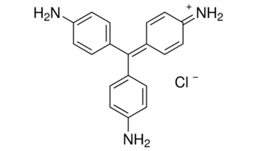

Fig. 1: Basic Red 9 (BR9) chemical structure
2.2 Preparation of Activated Carbon
The CASSAC was prepared using a procedure used by Usman et al., (2022). Initially, the precursor underwent thorough cleaning by tap water, followed by double-distilled water to eradicate impurities. The cleaned seed was subjected to air drying for a 7-day period. Subsequently, the seed was extracted, and the shell component was pulverized. The pulverized material underwent carbonization in a muffle furnace at 400 °C for 2 hours, and was allowed to cool for several hours. 10 g portion of the carbonized material was combined with 50 cm³ of 1 M phosphoric acid and homogenized using an electric stirrer. The homogenized mixture was positioned centrally within a muffle furnace and heated for 1 hour to achieve activation of the carbonized material. Following activation, it was allowed to cool in an ice bath and rinsed with double-distilled water to a pH of 6.25. Afterwards, it was dried in an oven at 105°C for 20 minutes. The resulting product was filtered through a 150 µm mesh sieve to enhance adsorption efficiency due to increased surface area and greater accessibility of active sites of the adsorbent by the adsorbate.
2.3 Characterization of CASSAC
To assay the surface chemistry of CASSAC, its pH point of zero charge (pHpzc) was determined as thus: A 0.01 M KCl solution was prepared, and 50 mL portions were placed into several sealed glass containers. The pH was adjusted from 2 to 10 in 0.5 increments using 0.1 M HCl or 0.1 M NaOH. Initial pH values, labelled pHinitial, were measured with a calibrated pH meter. Next, 0.15 g of powdered activated carbon was added to each container, which was then sealed. The mixtures were agitated for 48 hours, and the final pH values, recorded as pHfinal, were measured. A graph was plotted with the difference between pHinitial and pHfinal (ΔpH) on the y-axis against pHinitial on the x-axis, as described by Nnaji et al., (2023). The pH point of zero charge was identified where the curve intersects the x-axis, as shown in Fig. 4, which illustrates ΔpH versus pHinitial.
The specific surface area and porosity of CASSAC and BR9-adsorbed CASSAC were measured using the Brunauer-Emmett-Teller (BET) method with nitrogen gas at varying pressures and temperatures, employing Quantachrome NovaWin Instruments v11.03.
The surface morphology of CASSAC and BR9-adsorbed CASSAC was examined through scanning electron microscopy (SEM) using equipment from Phenom-World BV, Netherlands.
The crystalline structure of CASSAC and BR9-adsorbed CASSAC was analyzed via X-ray diffraction (XRD) with an Empyrean XRD system, utilizing Cu Kα radiation (λ = 1.54105 Å, 45 kV, 40 mA per second).
2.4 Adsorption batch experiments
BR9 were used as the subject textile dye. A 1000 mg/L stock solution of BR9 was prepared by dissolving analytical-grade BR9 in double-distilled water. Various concentrations were prepared through serial dilution of the stock solution, and their absorbance was measured using a UV/Visible spectrophotometer (Model UV1902) at a wavelength of 545 nm. A calibration curve was generated by plotting absorbance against concentration. The effects of the experimental parameters, including initial dye concentration (10, 40, 70, and 100 mg/L), adsorbent dosage (0.4, 0.6, 0.8, and 1.0 g), pH (2, 4, 6, and 8), temperature (50, 60, 70, and 80 °C), and contact time (20, 60, 100, and 120 minutes), were investigated. Pressure, stirring speed, and volume were held constant across batches. Solutions of 0.1 M NaOH and HCl were used to adjust the pH. A volume of 100 mL of each solution was placed in conical flasks and stirred on a magnetic stirrer. The solutions were then removed, filtered using Whatman No. 1 filter paper, and the adsorption of BR9 onto CASSAC was assessed by measuring absorbance relative to the calibration curve.
To get the adsorption capacity at various time intervals, equation 1 was used.
$q_{t}= \left(C_{O}- C_{t}\right)\frac{V}{m}$ 1
Co and Ct represent the initial and subsequent concentrations of Basic Red 9 (BR9), measured in mg/L, at different time intervals, respectively. V indicates the volume of the dye solution used, expressed in litres, while m denotes the mass of the adsorbent, measured in grams.
The equilibrium adsorption capacity was calculated using equation 2.
$q_{e}= \left(C_{O}- C_{e}\right)\frac{V}{m}$ 2
Where C_{e} is the equilibrium dye concentration (mg/L).
- RESULTS AND DISCUSSION
  - CASSAC characterization
3.1.1 BET analysis
The BET analysis serves as a systematic method for assessing the activated carbon's specific surface area, a critical factor that significantly affects its adsorption capabilities and performance. The results of the Brunauer-Emmett-Teller (BET) analysis are presented in Table 1. The surface area was 329.46 m²/g before adsorption, decreasing to 171.13 m²/g after adsorption, with pore sizes of 2.093 nm and 2.112 nm, respectively. These values confirm a mesoporous structure (2–50 nm), ideal for dye molecule adsorption due to enhanced accessibility of active sites (Herath et al., 2022). The reduction in surface area post-adsorption suggests pore filling by BR9 molecules, consistent with findings by Abatan et al., (2019) for biomass-derived carbons.
Table 1: BET results of CASSAC and CASSAC adsorbed BR9 dye
Parameter | CASSAC | BR9 dye adsorbed to CASSAC
Surface area (m²/g) | 329.46 | 171.13
Micropore volume (cm³/g) | 0.210 | 0.083
Pore size (nm) | 2.093 | 2.112

The International Union of Pure and Applied Chemistry (IUPAC) categorizes porous materials by pore diameter into micropores (0–2 nm), mesopores (2–50 nm), macropores (50–7500 nm), and mega pores (>7500 nm) (Adeniyi et al., 2024).
3.1.2 SEM
Scanning electron microscopy (SEM) was used to examine the morphological features of the activated carbon material. Figures 2a and 2b display SEM images of unmodified CASSAC and CASSAC with incorporated BR9 dye molecules, respectively.

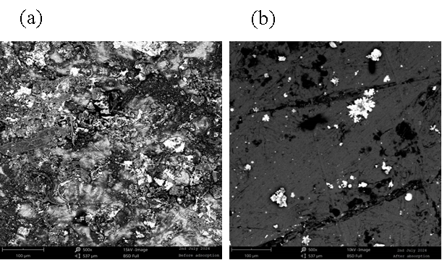
Fig 2: SEM photographs of (a) CASSAC and (b) CASSAC loaded with BR9 dye.
In Fig. 2a, the CASSAC surface showed a heterogeneous structure with irregular and rough patterns of pores, suggesting that the carbonization and activation process has effectively transformed the adsorbent (Iwuozor et al., 2025). In Fig. 2b, the surface showed a hierarchical pore structure with a plane surface, unlike in Fig. 2a, which has a complex, irregular and rough pattern of pores. Suggesting that the pores have been loaded and/or adsorbed with the BR9 dye molecules and that CASSAC is a suitable adsorbent for the adsorption and/or sequestration of BR9 dye molecules (Yang, et al., 2017).
3.1.3 XRD analysis
X-ray Diffraction (XRD) analysis provides definitive information regarding the structural configuration of materials, specifically elucidating whether the activated carbon exhibits crystalline or amorphous characteristics. Fig. 3a and Fig. 3b present the XRD spectra for fresh CASSAC and BR9-adsorbed CASSAC, respectively. In Fig. 3a, the XRD spectrum showed a broad, diffuse bump around 15° and 30° on the 2Ɵ axis without sharp, well-defined peaks, which is a characteristic feature of amorphous structure. This facilitates the formation of numerous void spaces within the carbon matrix. These interstices serve as accommodation sites for dye molecules, thereby enhancing the material's adsorption capacity through increased availability of internal surface area and potential binding sites (Streit et al., 2019).

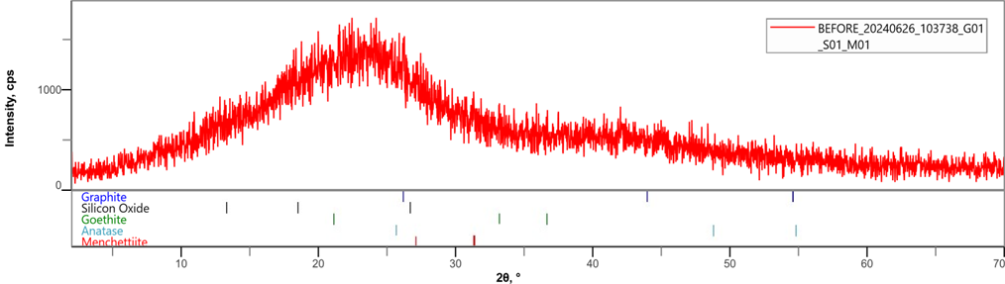
(a)

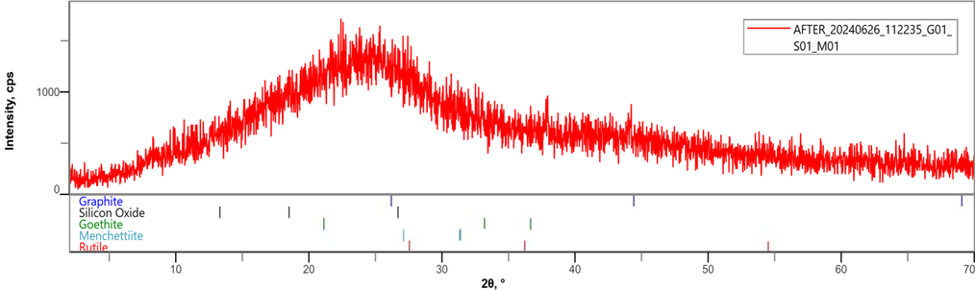

(b)

Fig. 3: XRD spectrum for (a) CASSAC, and (b) CASSAC adsorbed with BR9 dye.
3.1.4 pH point zero-point-charge (pHpzc)
The pHpzc serves as a crucial parameter that signifies the level of pH by which a surface exhibits a sum total neutral charge. The pHpzc of carbonaceous materials, including activated carbons, can differ markedly based on the activation method used (Hoang et al., 2022). This parameter significantly influences the adsorption behaviour of activated carbons of different dyestuffs and chemical species. In a solution where the pH is below the pH point of zero charge (pHpzc), the adsorbent’s surface becomes positively charged, promoting the adsorption of anionic species. Conversely, when the pH is above the pHpzc, the surface acquires a negative charge, which favours the adsorption of cationic species; it creates a negative environment that hinders the adsorption of cations (Mitrogiannis et al., 2017). The plot of pHpzc for CASSAC is shown in Fig. 4. In the graph, the pHpzc is 3.8 and a pH of 6.2. Therefore, the adsorption of BR9 in a cationic species will be favoured.
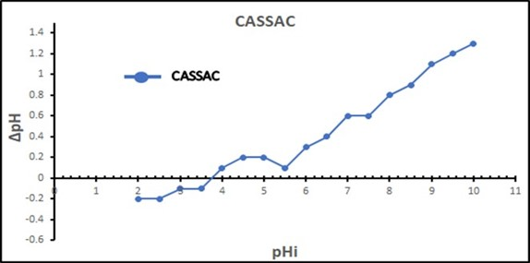
Fig. 4: pHpzc for CASSAC

3.2. Effect of initial concentration and isotherm studies
The concentration of dye is affected by the direct interaction between dye molecules and the available sites for binding on the adsorbent’s surface (Dutta et al., 2021). Fig. 5 illustrates the influence of initial dye concentration on the adsorption process. The study examined concentrations ranging from 10 mg/L to 100 mg/L. At 10 mg/L, adsorption reached equilibrium at 95%. However, as concentrations increased, adsorption capacity gradually decreased due to the limited availability of active binding sites. Consequently, removal efficiency dropped, reaching 91% at 40 mg/L, 79% at 70 mg/L, and 71% at 100 mg/L.
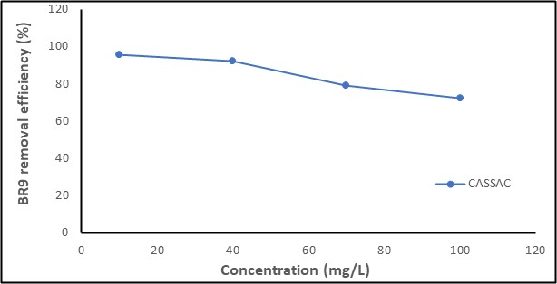
Fig. 5: Effect of concentration on BR9 dye adsorption onto CASSAC
To comprehensively analyze the adsorption of BR9 dye molecules onto the CASSAC surface at equilibrium, the linear forms of the Langmuir, Freundlich, Temkin, and Dubinin-Radushkevich isotherm models were assessed using equilibrium data collected at 50 °C. The equations for these four isotherm models are described below in equations. 3-6 (Alafnan et al., 2021; Iwuozor et al., 2021; Dada et al., 2019; Al-Ghouti and Da’ana, 2020):
$\frac{C_{e}}{q_{e}}= \frac{1}{K_{L}q_{m}} + \frac{1}{q_{m}}C_{e}$ 3
$In\left(q_{e}\right)=InK_{F}+ \frac{1}{n}InC_{e}$ 4
$q_{e}= BInA+ BInC_{e}$ 5
${Inq}_{e}= {Inq}_{m}-βε²$ 6
Where $q_{e}$ is the maximum adsorption capacity (mg/g), $C_{e}$ is the equilibrium concentration (mg/L) of the dye molecule, $K_{L}$ is the Langmuir constant (L/mg), and $q_{m}$ is the theoretical maximum monolayer coverage (mg/g), $K_{f}$ represents the Freundlich constant, $1/n$ represents the heterogeneity factor. $1/n$ and $K_{f}$ are obtained as slope and intercept, R is the gas constant (8.314 J/mol.K), T is the absolute temperature (K), A is the Temkin constant, and B is the Temkin constant related to the heat of sorption (J/mol). In this context, $\frac{RT}{b}$ = B. B and A are obtained from the slope and intercept, respectively. k and β (mol²/J²) are Dubinin-Radushkevich constants related to the adsorption energy, and $ε$ is the Polanyi potential.
The Langmuir isotherm posits that sorption occurs in a single-layer surface characterized by adsorption sites that possess equal energy values, which are analogous and do not interact with one another (Alafnan et al., 2021). From Fig.6a, these values were calculated; K_{L} and $q_{m}$ are 0.107 L/mg and 3.879 mg/g, calculated from the slope and intercept, respectively, R² = 0.925. and does not best describe the isotherm study because of its lower coefficient of determination, which is farther away from unity, unlike the Freundlich model. The separation factor R_{L} (a dimensionless constant) is given by equation 7:
$R_{L}= \frac{1}{1+ K_{L}C_{o}}$ 7
The calculated R_{L} value, ranging between 0 and 1, indicates favourable adsorption of BR9 onto CASSAC.
The Freundlich isotherm model describes multilayer adsorption on a heterogeneous surface with a non-uniform distribution of adsorption sites and/or binding energies. Fig. 6b represents the Freundlich plot with a Freundlich constant (K_{f}) of 0.78 mg/g and an n value of 1.909 g/L, determined from the intercept and slope, respectively. The high R² value of 0.9513 reflects an excellent fit for the adsorption of BR9 onto CASSAC using this isotherm model. This model elucidates CASSAC’s improved adsorption capacity attributed to its heterogeneous characteristics, which offer sites with varying energy levels (Fung, et al., 2021). The favourability of the adsorption process is further supported by the Freundlich adsorption intensity (n), which exceeds unity for the activated carbon. An adsorbent is considered favourable for pollutant uptake if n ranges between 1 and 10 (Rosli, et al., 2019).
The Temkin isotherm model suggests that the heat of adsorption for all molecules decreases linearly with coverage due to interactions between the adsorbent and adsorbate (Dada et al., 2019). Fig. 6c represents the Temkin isotherm model plot, which yielded the constants B = 7.346 g/L and A = -0.58 g/L, with a coefficient value R² of 0.8769, which means that this model does not best fit the isotherm, due to the value of R² being farther away from unity.
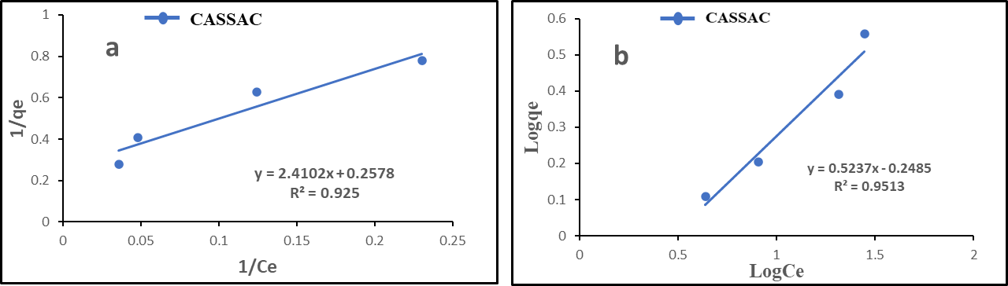
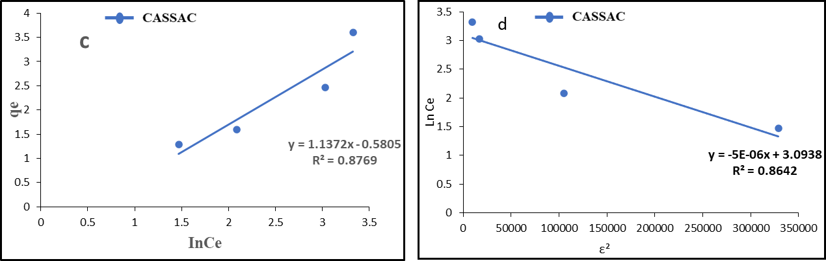
Fig. 6: (a) Langmuir, (b) Freundlich, (c) Temkin, and (d) Dubinin-Radushkevich isotherm model plot of BR9 dye adsorption onto CASSAC
The Dubinin-Radushkevich isotherm model suggests that adsorption takes place within micropores, considering the distribution of adsorption potential energy in the porous material (Al-Ghouti and Da’ana, 2020). Fig. 6d represents the Dubinin-Radushkevich isotherm model plot, which gave a β value from the slope, while the intercept gives the $q_{m}$ value. β = 5 × 10⁻⁶ mol²/J² and $q_{m}$ = 22.061 mg/g, with a coefficient of determination, R² = 0.8642. which means that this model does not best fit the isotherm, due to its value farther away from unity.
3.3. Effect of adsorbent dosage
The adsorbent dosage significantly influences the removal efficiency of dyestuff from aqueous solutions. The effect of Chrysophyllum albidum seed shell-derived activated carbon (CASSAC) dosage on Basic Red 9 (BR9) dye adsorption was investigated, as depicted in Figure 7. At a dosage of 0.4 g, CASSAC achieved a maximum adsorption efficiency of 92.61%, which decreased to 83.54% and 67.63% at dosages of 0.6 g and 0.8 g, respectively. A slight increase in adsorption efficiency to 72% was observed at a dosage of 1.0 g. These results indicate a non-linear relationship between adsorbent dosage and BR9 removal efficiency. The enhanced adsorption at 1.0 g is likely attributable to the increased availability of surface area and active binding sites for BR9, as supported by previous studies (Bülbül et al., 2025; Egbosiuba et al., 2020).
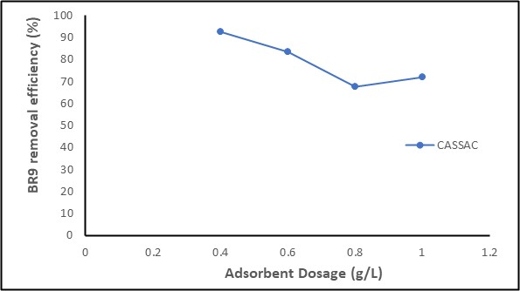
Fig. 7: Effect of Adsorbent dosage on BR9 dye adsorption onto CASSAC.
3.4. Effect of initial pH
Understanding the pH point of zero charge (pHpzc) is crucial for the adsorption of BR9 dye onto CASSAC. According to Nnaji et al., (2023), the electrostatic interactions between the surface of the adsorbent and adsorbate ions depend on pH. When the pH is below the pHpzc, the adsorbent surface becomes positively charged, promoting enhanced adsorption of anionic species. Conversely, a pH higher than the pHpzc results in a negatively charged surface, which promotes the adsorption of cations. In Fig. 8, the pHpzc of CASSAC was found to be 3.8, and the pH of the solution is thus 6.2. Consequently, the adsorption of BR9 dye onto CASSAC is anticipated to be enhanced in conditions with elevated basic pH, given that BR9 is a cationic dye. The data presented in Fig. 8 indicate that adsorption rises as pH levels increase from 2 to 8. The highest adsorption occurs at a pH of 8, achieving a removal percentage of 96%. As a result, the adsorption of BR9 onto CASSAC varies with pH levels.
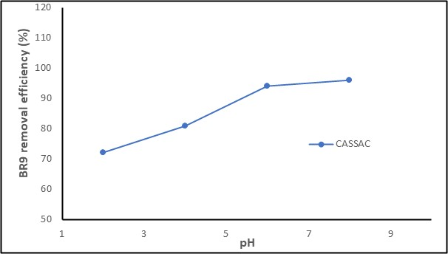
Fig. 8: Effect of pH on BR9 dye adsorption onto CASSAC.
3.5. Effect of Contact time and kinetics of BR9 adsorption
The influence of time on the removal of adsorbate by CASSAC was investigated over a period ranging from 20 to 120 minutes, with the findings illustrated in Fig. 9. The findings indicated that the adsorbent exhibited a time-dependent behaviour, with the removal efficiency progressively increasing and achieving equilibrium at approximately 120 minutes, reaching a level of 93%. After this point, any additional increase in contact did not lead to a notable enhancement in the removal efficiency of the activated carbon. (Egbosiuba et al., 2020).
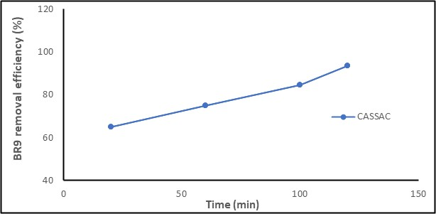
Fig. 9: Effect of contact time on BR9 dye adsorption onto CASSAC.
The adsorption kinetics of BR9 onto CASSAC were evaluated using the pseudo-first-order, pseudo-second-order, intraparticle diffusion, and Elovich kinetic models, as represented by their respective equations in equations 8-11, respectively:
$In\left(q_{e}-q_{t}\right)= In{ q}_{e }{- k}_{1}t$ 8
$\frac{t}{q_{t}}= \frac{1}{k_{2}q_{e}^{2 }}+ \frac{1}{q_{e}}t$ 9
$q_{t}= k_{i}t^{1/2}+C$ 10
$q_{t} = \frac{1}{β}In\left(αβ\right)+ \frac{1}{β}In t$ 11
Here, k₁, k₂, and k_{i} denote rate constants for pseudo-first-order, pseudo-second-order, and intraparticle diffusion models, respectively. The constant C provides insight into the boundary layer thickness, $q_{e}$ and $q_{t}$ (mg/g) represent the amounts of compound adsorbed at equilibrium and at time t (min), respectively.
The pseudo-first-order kinetics model assumes that the adsorption rate is proportional to the number of available adsorption sites on the adsorbent surface (Ezzati et al., 2024). The values of $q_{e}$ and $K_{1}$, The calculation can be derived from the slope and intercept of the graph. According to the graph, $K_{1}$ = 0.00875 min⁻¹, $q_{e}$= 3.252 mg/g and R² = 0.2514.
The pseudo-second-order model suggests that the adsorption rate is proportional to the square of the residual solute concentration in the solution. The values of $q_{e}$ and $K_{2}$ it can be calculated from the slope and intercept of the plot. $K_{2}$ = 0.0129 mg/min, $q_{e}$ = 4.681 mg/g, and R² = 0.983, This high R² value indicates that the pseudo-second-order model best describes the adsorption of BR9 onto CASSAC, likely due to chemisorption involving electron sharing or exchange between the adsorbent and adsorbate (Saleh, 2022).
The intraparticle diffusion kinetics model posits that intraparticle diffusion is the rate-limiting step in the adsorption process, describing the movement of adsorbate molecules from the solution into the adsorbent’s pores via diffusion. $K_{dif}$ and $C$ values are obtained from the slope and intercept, respectively $K_{dif}$ = 0.2082 mg/g/min^{1/2}, C = 2.2492, and R² = 0.9529. The intraparticle diffusion model is employed to ascertain the rate-controlling step. The rate-limiting step is singular if the plot is linear and intersects the origin (Ofomaja, et al., 2020). The rate-limiting stage is characterized by a larger concentration of C governed by the film diffusion model, while a lower concentration of C is ascribed to intraparticle diffusion.
The Elovich kinetics model characterizes chemical adsorption processes on heterogeneous surfaces, wherein the adsorption rate diminishes exponentially over time as surface coverage increases, and is frequently utilized in systems exhibiting a broad spectrum of activation energies. Where α represents the initial adsorption rate (mg/g/min), and β denotes the desorption constant (g/mg). A plot of $q_{t}$ versus $In(t)$ allows for the determination of β and α from the slope and intercept, respectively. β = 0.968 g/mg, α = 1.082 mg/g/min, and R² = 0.7746. The Elovich model is often used for systems where the adsorption rate decreases over time (Umeh et al., 2023). These results are in Table 2.

Table 2: Kinetics parameters for CASSAC adsorbed BR9 dye
Kinetics | Parameters | CASSAC
Pseudo-first-order | K₁ | 0.0087 min⁻¹
 | qe (exp.) | 3.252 mg/g
 | qe (cal.) | 1.19 mg/g
 | R² | 0.251
Pseudo-second-order | K₂ | 0.0129 mg/min
 | qe (exp.) | 4.681 mg/g
 | qe (cal.) | 5.053 mg/g
 | R² | 0.983
Intraparticle diffusion | K_{dif} | 0.208 mg/g/min^{1/2}
 | C | 2.249
 | R² | 0.9529
Elovich | β | 0.968 g/mg
 | α | 1.1178 mg/g/min
 | R² | 0.7746

3.6. Effect of Temperature and Thermodynamics of Adsorption
The impact of temperature on the adsorption of BR9 (100 mg/L dye) from aqueous solutions by CASSAC was examined and depicted in Figure 10. As solution temperature increases, viscosity decreases, enhancing the mobility and diffusion of adsorbate molecules (Emenike et al., 2023). At 323 K, CASSAC achieved an equilibrium removal efficiency of 77.69% for BR9; however, the adsorption capacity gradually declined due to the limited binding sites and/or increased diffusion of BR9 at higher temperatures (Wang et al., 2020).
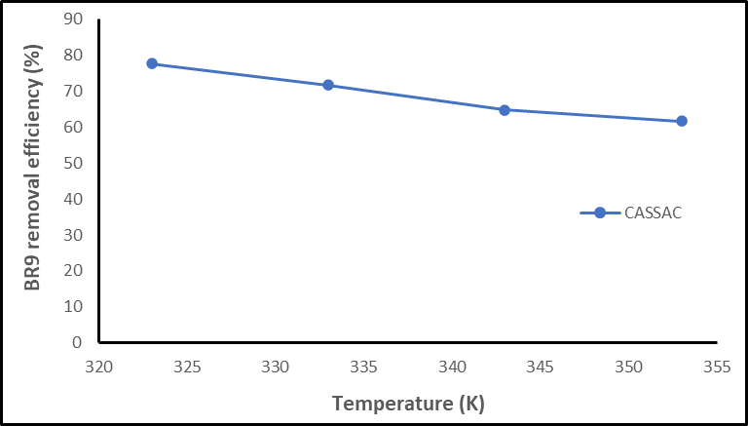
Fig. 10: Effect of temperature on BR9 dye adsorption onto CASSAC
Thermodynamic analysis was conducted by adjusting the temperature and evaluating parameters including Gibbs free energy (ΔG), enthalpy change (ΔH), and entropy change (ΔS). These calculations were carried out using equations 12–14.
${InK}_{c}= \frac{-ΔH}{RT}+ \frac{ΔS}{R}$ 12
$K_{c}= \frac{qe}{C_{e}}$ 13
And,
$∆G=∆H-T∆S$ 14
Where Kc denotes the distribution coefficient, qe represents the amount of dye adsorbed (mg/g), Ce indicates the dye concentration at equilibrium (mg/L), R is the universal gas constant (8.314 J·K⁻¹·mol⁻¹), and T is the temperature in Kelvin. These thermodynamic parameters are critical for assessing the feasibility, spontaneity, and interaction mechanisms between the adsorbent and adsorbate (Iwuozor et al., 2023). The entropy change (ΔS) and enthalpy change (ΔH) values are determined from the intercept and slope of the plot, respectively. Table 3 presents the calculated results for BR9 dye adsorption. The negative ΔG values observed across all temperature ranges for BR9 adsorption onto CASSAC suggest that the adsorption process is both spontaneous and feasible. The ΔG values exhibit a trend of becoming more negative with an increase in temperature, transitioning from 323 K to 353 K, with values spanning from -18.03 kJ/mol to -19.71 kJ/mol. The increasingly negative ΔG values at higher temperatures suggest that the adsorption process becomes more favourable and spontaneous at elevated temperatures (Chen et al., 2019). However, spontaneity decreases with endothermic reactions, except at higher values of entropy. The positive ΔH value of 24.99 kJ/mol indicates an endothermic adsorption process. Additionally, the positive ΔS value of 55.89 J/mol·K reflects an increase in disorder at the solid-liquid interface during adsorption (Zhu et al., 2019).
Table 3: Thermodynamic parameters regarding the adsorption of BR9 dye onto CASSAC
Sample | Temperature (K) | ΔG (kJ/mol) | ΔH (kJ/mol) | ΔS (J/mol. K)
CASSAC | 323 | -18.03 | 24.99 | 55.89
 | 333 | -18.59
 | 343 | -19.15
 | 353 | -19.71
3.7 Mechanism of Adsorption
The surface area as shown in BET results in Table 1, supports the structure on Fig. 11 as a mechanism for the adsorption of BR9 onto CASSAC. Moreso, CASSAC is an amorphous with high surface area and adsorption capacity that encourages chemisorption interaction between porous CASSAC with heterogeneous structure and a cationic BR9 molecule. The proposed adsorption mechanism in Fig. 11 involves chemisorption of BR9 molecules transfer onto the CASSAC surface, as predicted in the kinetics studies.
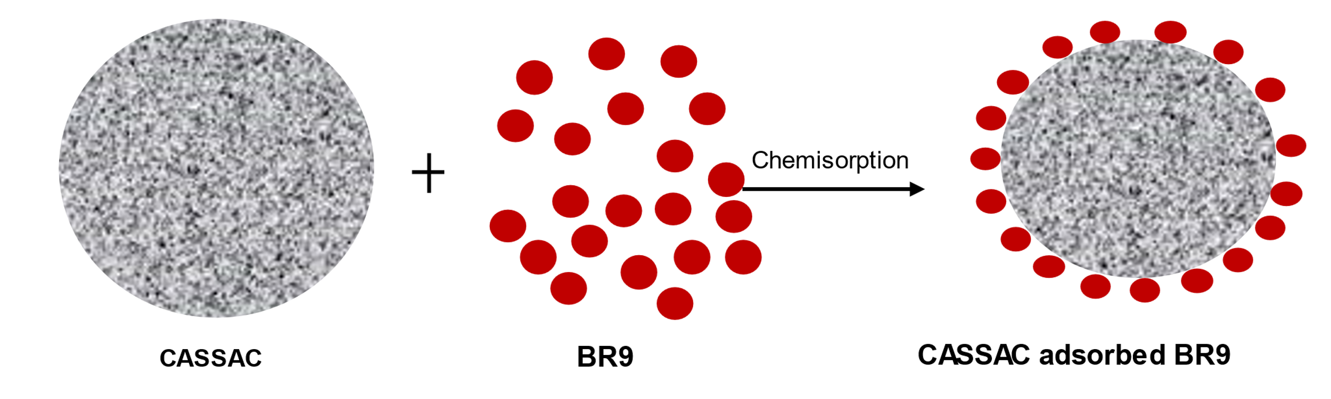
Fig. 11: Proposed mechanism of adsorption

3.8 Desorption Experiment
Regeneration of activated carbon is important considering it economic viability and application in an industrial scale. Results obtained from CASSAC reusability or BR9 desorption is shown in Fig.12. In Fig. 12, ethanol is a better desorbing agent of BR9 than water. The removal of BR9 by water ranged from 82.8 – 68.4% from cycle 1 to cycle 3, but 91.5 – 79.8% range was obtained when BR9 was removed from CASSAC using ethanol.
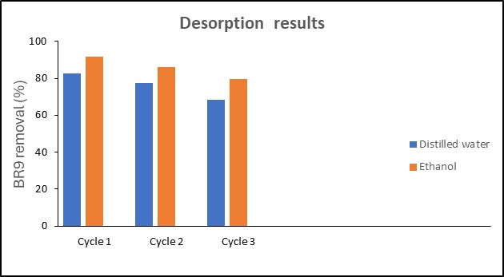
Fig. 12: BR9 desorption results
3.9 Comparison with other adsorbents
The adsorption capacities of CASSAC for BR9 dye removal, compared to other reported adsorbents, are presented in Table 4. Other adsorbents exhibit higher adsorption capacities than CASSAC, likely due to variations in carbonization and activation methods. Nevertheless, CASSAC demonstrates potential as a cost-effective adsorbent for removing BR9 in wastewater treatment applications by its maximum adsorption capacity $q_{max}$. Due to the acidified method of chemical activation under higher temperature used in the production of CASSAC possibly impacted its lower adsorption capacity compared to Subcritical water hydrolyzed Soybean husk, Bovine bone biochar, Fish scale biochar, Calcined mussel shell and Expanded vermiculite, however, the removal efficiency of BR9 by CASSAC was 96% at pH 8.

Table 4: Comparison of adsorption capabilities of several adsorbents for the elimination of BR9.
Adsorbent | $q_{max}$ (mg/g) | References
Subcritical water hydrolyzed Soybean husk | 56.8 | (Caponi, et al., 2022)
Bovine bone biochar | 49.5 | (Côrtes, et al., 2019)
Fish scale biochar | 52.3 | (Côrtes, et al., 2019)
Calcined Mussel Shell | 141.65 | (El Haddad, 2016)
Expanded Vermiculite | 7.65 | (Duman, et al., 2015)
CASSAC | 3.6 | This study

- CONCLUSION
This study highlights the capability of activated carbon derived from Chrysophyllum albidum seed shells (CASSAC) as an effective and eco-friendly adsorbent for removing Basic Red 9 (BR9) dye from aqueous solutions. With a surface area of 329.46 m²/g, CASSAC’s mesoporous structure that enabled a 96% dye removal efficiency at pH 8. The adsorption process was characterized by multilayer chemisorption, as supported by the Freundlich isotherm (R² = 0.9513) and the pseudo-second-order kinetic model (R² = 0.983). Thermodynamic analysis revealed a spontaneous and endothermic process, with Gibbs free energy values ranging from -18.03 to -19.71 kJ/mol and an enthalpy of 24.99 kJ/mol. By converting agricultural waste into a cost-effective adsorbent, CASSAC mitigates water pollution and supports a circular economy, aligning with the UN Sustainable Development Goals, specifically SDG 6 (Clean Water and Sanitation) and SDG 12 (Responsible Consumption and Production). These results pave the way for sustainable wastewater treatment, particularly for challenging textile dyes in areas with limited resources, and open doors for further research to enhance biomass-based adsorbents for broader environmental applications.
COMPETING INTEREST
The authors declared that there are no known financial conflicts of interest or personal relationships that could have impacted the research discussed in this paper.
DISCLAIMER (ARTIFICIAL INTELLIGENCE)
Author(s) hereby declares that no generative AI technologies such as Large Language Models (ChatGPT, COPILOT, etc.) and text-to-image generators have been used during the writing or editing of this manuscript.

AUTHORS’ CONTRIBUTIONS
This research was carried out in collaboration between all authors. OSM designed and conceptualized and interpreted the data, NAC and NNK, anchored the field study and performed data analysis, OUT, managed the literature searches and produced the initial draft. All authors read and approved the final manuscript.
REFERENCES
- Karri, R.R., Gobinath, R. and Dehghani, M.H. eds., 2021. Soft computing techniques in solid waste and wastewater management. Elsevier. https://doi.org/10.1016/B978-0-12-824463-0.00001-X
- Dhruv Patel, D. and Bhatt, S., 2022. Environmental pollution, toxicity profile, and physico-chemical and biotechnological approaches for treatment of textile wastewater. Biotechnology and Genetic Engineering Reviews, 38(1), pp.33-86. https://doi.org/10.1080/02648725.2022.2048434
- Mani, S., Chowdhary, P. and Bharagava, R.N., 2018. Textile wastewater dyes: toxicity profile and treatment approaches. In Emerging and eco-friendly approaches for waste management (pp. 219-244). Singapore: Springer Singapore. https://doi.org/10.1007/978-981-10-8669-4_11
- Vo, H.N., Go, A.W., Gunarto, C., Agapay, R.C., Quijote, K.L., Angkawijaya, A.E., Santoso, S.P. and Alivio, R.K.O., 2022. Removal of pararosaniline hydrochloride (basic red 9) from aqueous system with lignocellulose fraction of sugarcane bagasse as adsorbent. Industrial Crops and Products, 188, p.115573. https://doi.org/10.1016/j.indcrop.2022.115573
- Kowalska, J. and Jeżewska, A., 2019. Determination of pararosaniline hydrochloride in workplace air. Environmental monitoring and assessment, 191, pp.1-9.
- Periyasamy, A.P., 2024. Recent advances in the remediation of textile-dye-containing wastewater: prioritising human health and sustainable wastewater treatment. Sustainability, 16(2), p.495. https://doi.org/10.3390/su16020495
- Gungor, A.A., Nadaroglu, H. and Celebi, N., 2014. Fenton process for basic red 9 degradation: immobilised apolaccase on a nanomagnetite system. Environmental and Experimental Biology, 12, pp.121-129.
- Khan, M.D., Singh, A., Khan, M.Z., Tabraiz, S. and Sheikh, J., 2023. Current perspectives, recent advancements, and efficiencies of various dye-containing wastewater treatment technologies. Journal of Water Process Engineering, 53, p.103579. https://doi.org/10.1016/j.jwpe.2023.103579
- Sathya, K., Nagarajan, K., Carlin Geor Malar, G., Rajalakshmi, S. and Raja Lakshmi, P., 2022. A comprehensive review on comparison among effluent treatment methods and modern methods of treatment of industrial wastewater effluent from different sources. Applied Water Science, 12(4), p.70. https://doi.org/10.1007/s13201-022-01594-7
- Kusumlata, Ambade, B., Kumar, A. and Gautam, S., 2024. Sustainable solutions: reviewing the future of textile dye contaminant removal with emerging biological treatments. Limnological Review, 24(2), pp.126-149. https://doi.org/10.3390/limnolrev24020007
- Alaqarbeh, M., 2021. Adsorption phenomena: definition, mechanisms, and adsorption types: short review. RHAZES: Green and Applied Chemistry, 13, pp.43-51. https://doi.org/10.48419/IMIST.PRSM/rhazes-v13.28283
- Yang, X., Wan, Y., Zheng, Y., He, F., Yu, Z., Huang, J., Wang, H., Ok, Y.S., Jiang, Y. and Gao, B., 2019. Surface functional groups of carbon-based adsorbents and their roles in the removal of heavy metals from aqueous solutions: a critical review. Chemical Engineering Journal, 366, pp.608-621. https://doi.org/10.1016/j.cej.2019.02.119
- Lima, S. S. A., Filho, H. J. B. L., Paiva, S. C. de, & Messias, A. S. (2019). Saline Waters Treatment Using Activated Carbon Filled Filter. Current Journal of Applied Science and Technology, 37(5), 1–7. https://doi.org/10.9734/cjast/2019/v37i530306
- Tarikuzzaman, M., 2023. A review on activated carbon: Synthesis, properties, and applications. European Journal of Advances in Engineering and Technology, 10(1), pp.114-123.
- Ukanwa, K. S., K. Patchigolla, R. Sakrabani, E. Anthony and S. Mandavgane (2019). "A review of chemicals to produce activated carbon from agricultural waste biomass." Sustainability 11(22): 62-74. https://doi.org/10.3390/su11226204
- Saleh, A. (2023). Analysis of Activated Carbon from Bituminous Coal as the Primary Battery Cathode Potential Using Fluoric Acid. Archives of Current Research International, 23(1), 34–43. https://doi.org/10.9734/acri/2023/v23i1553
- Yahya, M.A., Al-Qodah, Z. and Ngah, C.Z., 2015. Agricultural bio-waste materials as potential sustainable precursors used for activated carbon production: A review. Renewable and sustainable energy reviews, 46, pp.218-235. https://doi.org/10.1016/j.rser.2015.02.051
- Khan, M.M., Siddiqi, S.A., Farooque, A.A., Iqbal, Q., Shahid, S.A., Akram, M.T., Rahman, S., Al-Busaidi, W. and Khan, I., 2022. Towards sustainable application of wastewater in agriculture: a review on reusability and risk assessment. Agronomy, 12(6), p.1397. https://doi.org/10.3390/agronomy12061397
- Adebisi, E.U., Adebisi, A.A., Okechukwu, V.U., Omokpariola, D.O. and Umeh, T.C., 2022. Adsorption potential of Lead and Nickel ions by Chrysophyllum albidum G. Don (African Star Apple) seed shells. World Scientific News, 166, pp.132-145.
- Shuaib, M.M., Musah, M. and Mathew, J.T., 2024. PREPARATION AND CHARACTERIZATION OF ACTIVATED CARBON FROM AFRICA STAR APPLE (Chrysophyllum albidum) SEED SHELL. FUDMA JOURNAL OF SCIENCES, 8(3), pp.194-199. https://doi.org/10.33003/fjs-2024-0803-2485
- Ezeh, E. C., P. O. Ukoha, H. Bulus and J. C. Attah (2021). "Novel Immobilized Ligand on Polymer Matrix as Adsorbent for Water Purification." Materials Performance and Characterization 10(1): 658-673.
- Iwuozor, K.O., Ighalo, J.O., Ogunfowora, L.A., Adeniyi, A.G. and Igwegbe, C.A., 2021. An empirical literature analysis of adsorbent performance for methylene blue uptake from aqueous media. Journal of environmental chemical engineering, 9(4), p.105658. https://doi.org/10.1016/j.jece.2021.105658
- Gupta, A.P., Upadhyay, P., Sen, T. and Dutta, J., 2023. Agricultural waste as a resource: the lesser travelled road to sustainability. Agriculture waste management and bioresource: The circular economy perspective, pp.1-20. https://doi.org/10.1002/9781119808428.ch1
- Amuda, O.S., Amoo, I.A. and Hung, Y., 2011. Radioactive element removal from contaminated groundwater by agricultural waste-based activated carbon. Int J Water Resour Arid Environ, 1, pp.71-82.
- Abatan, O.G., Oni, B.A., Agboola, O., Efevbokhan, V. and Abiodun, O.O., 2019. Production of activated carbon from African star apple seed husks, oil seed and whole seed for wastewater treatment. Journal of Cleaner Production, 232, pp.441-450. https://doi.org/10.1016/j.jclepro.2019.05.378
- Côrtes, L.N., Druzian, S.P., Streit, A.F.M., Godinho, M., Perondi, D., Collazzo, G.C., Oliveira, M.L.S., Cadaval Jr, T.R.S. and Dotto, G.L., 2019. Biochars from animal wastes as alternative materials to treat colored effluents containing basic red 9. Journal of Environmental Chemical Engineering, 7(6), p.103446. https://doi.org/10.1016/j.jece.2019.103446
- Caponi, N., Schnorr, C., Franco, D.S., Netto, M.S., Vedovatto, F., Tres, M.V., Zabot, G.L., Abaide, E.R., Silva, L.F. and Dotto, G.L., 2022. Potential of subcritical water hydrolyzed soybean husk as an alternative biosorbent to uptake basic Red 9 dye from aqueous solutions. Journal of Environmental Chemical Engineering, 10(6), 108-203. https://doi.org/10.1016/j.jece.2022.108603
- Duman, O., Tunc, S. and Polat, T.G., 2015. Adsorptive removal of triarylmethane dye (Basic Red 9) from aqueous solution by sepiolite as an effective and low-cost adsorbent. Microporous and Mesoporous Materials, 210, 176-184. https://doi.org/10.1016/j.micromeso.2015.02.040
- Usman, K., H. Abba and O. Iyun (2022). "Preparation and Characterization of African Star Apple Seed Shell (Chrysophyllum Africanum) For The Removal of Acid Red 9." Communication in Physical Sciences 8(1).
- Nnaji, N.J., Sonde, C.U., Nwanji, O.L., Ezeh, G.C., Onuigbo, A.U., Ojukwu, A.M., Mbah, P.C., Adewumi, A.O., Unoka, E.C., Otedo, J.O. and Onuegbu, T.U., 2023. Dacryodes edulis leaf derived biochar for methylene blue biosorption. Journal of Environmental Chemical Engineering, 11(3), p.109638. https://doi.org/10.1016/j.jece.2023.109638
- Herath, A., Navarathna, C., Warren, S., Perez, F., Pittman Jr, C.U. and Mlsna, T.E., 2022. Iron/titanium oxide-biochar (Fe2TiO5/BC): A versatile adsorbent/photocatalyst for aqueous Cr (VI), Pb²⁺, F-and methylene blue. Journal of Colloid and Interface Science, 614, 603-616. https://doi.org/10.1016/j.jcis.2022.01.067
- Adeniyi, A.G., Emenike, E.C., Agbana, S.A., Iwuozor, K.O. and Saliu, O.D., (2024). Evaluation of the properties of solid biofuel produced from coconut fibre. Indian Chemical Engineer, 66(2), pp.184-195. https://doi.org/10.1080/00194506.2023.2297186
- Iwuozor, K.O., Odimayomi, K.P., Emenike, E.C., Okoro, H.K., Emmanuel, S.S., Amusa, V.T. and Adeniyi, A.G., 2025. Valorisation of bamboo stalk waste: eco-friendly synthesis and characterisation of activated carbon monolith. Indian Chemical Engineer, 67(2), pp.217-230. https://doi.org/10.1080/00194506.2024.2392205
- Yang, X.Y., Chen, L.H., Li, Y., Rooke, J.C., Sanchez, C. and Su, B.L., 2017. Hierarchically porous materials: synthesis strategies and structure design. Chemical Society Reviews, 46(2), pp.481-558. https://doi.org/10.1039/C6CS00829A
- Streit, A.F., Côrtes, L.N., Druzian, S.P., Godinho, M., Collazzo, G.C., Perondi, D. and Dotto, G.L., 2019. Development of high quality activated carbon from biological sludge and its application for dyes removal from aqueous solutions. Science of the Total Environment, 660, 277-287. https://doi.org/10.1016/j.scitotenv.2019.01.027
- Hoang, A.T., Kumar, S., Lichtfouse, E., Cheng, C.K., Varma, R.S., Senthilkumar, N., Nguyen, P.Q.P. and Nguyen, X.P., 2022. Remediation of heavy metal polluted waters using activated carbon from lignocellulosic biomass: An update of recent trends. Chemosphere, 302, p.134825. https://doi.org/10.1016/j.chemosphere.2022.134825
- Mitrogiannis, D., Psychoyou, M., Baziotis, I., Inglezakis, V.J., Koukouzas, N., Tsoukalas, N., Palles, D., Kamitsos, E., Oikonomou, G. and Markou, G., 2017. Removal of phosphate from aqueous solutions by adsorption onto Ca (OH) 2 treated natural clinoptilolite. Chemical Engineering Journal, 320, pp.510-522. https://doi.org/10.1016/j.cej.2017.03.063
- Dutta, S., Gupta, B., Srivastava, S.K. and Gupta, A.K., 2021. Recent advances on the removal of dyes from wastewater using various adsorbents: A critical review. Materials Advances, 2(14), 4497-4531. DOI: 10.1039/D1MA00354B
- Alafnan, S., A. Awotunde, G. Glatz, S. Adjei, I. Alrumaih and A. Gowida (2021). "Langmuir adsorption isotherm in unconventional resources: Applicability and limitations." Journal of Petroleum Science and Engineering 207: 109-172. https://doi.org/10.1016/j.petrol.2021.109172
- Dada, A. O., J. Ojediran, A. A. Okunola, F. Dada, A. Lawal, A. Olalekan and O. Dada (2019). "Modeling of biosorption of Pb (II) and Zn (II) ions onto PaMRH: langmuir, freundlich, temkin, dubinin-raduskevich, jovanovic, flory-huggins, fowler-guggenheim and kiselev comparative isotherm studies." International Journal of Mechanical Engineering and Technology (IJMET) 10(2): 1048-1058.
- Al-Ghouti, M. A. and D. A. Da'ana (2020). "Guidelines for the use and interpretation of adsorption isotherm models: A review." Journal of hazardous materials 393: 122-183. https://doi.org/10.1016/j.jhazmat.2020.122383
- Fung, V., Hu, G., Ganesh, P. and Sumpter, B.G., 2021. Machine-learned features from density of states for accurate adsorption energy prediction. Nature communications, 12(1), 88. https://doi.org/10.1038/s41467-020-20342-6
- Rosli, M.A., Daud, Z., Ridzuan, M.B., Abd Aziz, N.A., Awang, H.B., Adeleke, A.O., Hossain, K. and Ismail, N., 2019. Equilibrium isotherm and kinetic study of the adsorption of organic pollutants of leachate by using micro peat-activated carbon composite media. Desalination and Water Treatment, 160, 185-192. https://doi.org/10.5004/dwt.2019.24247
- Bülbül, A., Delibaş, A. and Coşkun, R., 2025. Development and characterization of activated charcoal adsorbent derived from oak for efficient removal of methylene blue: functionality vs surface area. Biomass Conversion and Biorefinery, pp.1-16.
- Egbosiuba, T.C., Abdulkareem, A.S., Kovo, A.S., Afolabi, E.A., Tijani, J.O., Auta, M. and Roos, W.D., 2020. Ultrasonic enhanced adsorption of methylene blue onto the optimized surface area of activated carbon: Adsorption isotherm, kinetics and thermodynamics. Chemical engineering research and design, 153, 315-336. https://doi.org/10.1016/j.cherd.2019.10.016
- Ezzati, R., Azizi, M. and Ezzati, S., 2024. A theoretical approach for evaluating the contributions of pseudo-first-order and pseudo-second-order kinetics models in the Langmuir rate equation. Vacuum, 222, p.113018. https://doi.org/10.1016/j.vacuum.2024.113018
- Saleh, T.A., 2022. Kinetic models and thermodynamics of adsorption processes: Classification. In Interface science and technology (Vol. 34, 65-97). Elsevier. https://doi.org/10.1016/B978-0-12-849876-7.00003-8
- Ofomaja, A.E., Naidoo, E.B. and Pholosi, A., 2020. Intraparticle diffusion of Cr (VI) through biomass and magnetite coated biomass: A comparative kinetic and diffusion study. South African Journal of Chemical Engineering, 32(1), 39-55. https://hdl.handle.net/10520/EJC-1d7a4c6819
- Umeh, C.T., Nduka, J.K., Iwuozor, O.K., Omokpariola, O.D., Dulta, K., Ezeh, S.C. and Emeka, R.N., 2023. Adsorption modelling on the removal of ciprofloxacin antibiotic from aqueous solution by acid-modified corn cob. International Journal of Environmental Analytical Chemistry, 1-26. https://doi.org/10.1080/03067319.2023.2263383
- Emenike, E.C., Adeniyi, A.G., Iwuozor, K.O., Okorie, C.J., Egbemhenghe, A.U., Omuku, P.E., Okwu, K.C. and Saliu, O.D., 2023. A critical review on the removal of mercury (Hg2+) from aqueous solution using nanoadsorbents. Environmental Nanotechnology, Monitoring & Management, 20, 100-816. https://doi.org/10.1016/j.enmm.2023.100816
- Wang, J., X. Tang, Y. Xu, X. Cheng, G. Li and H. Liang (2020). "Hybrid UF/NF process treating secondary effluent of wastewater treatment plants for potable water reuse: Adsorption vs. coagulation for removal improvements and membrane fouling alleviation." Environmental Research 188: 109-833. https://doi.org/10.1016/j.envres.2020.109833
- Iwuozor, K.O., Umeh, C.T., Emmanuel, S.S., Emenike, E.C., Egbemhenghe, A.U., Ore, O.T., Micheal, T.T., Omoarukhe, F.O., Sagboye, P.A., Ojukwu, V.E. and Adeniyi, A.G., 2023. A comprehensive review on the sequestration of dyes from aqueous media using maize-/corn-based adsorbents. Water Practice & Technology, 18(12), 3065-3108. https://doi.org/10.2166/wpt.2023.214
- Chen, S., Qin, C., Wang, T., Chen, F., Li, X., Hou, H. and Zhou, M., 2019. Study on the adsorption of dyestuffs with different properties by sludge-rice husk biochar: adsorption capacity, isotherm, kinetic, thermodynamics and mechanism. Journal of Molecular Liquids, 285, 62-74. https://doi.org/10.1016/j.molliq.2019.04.035
- Zhu, G., Cheng, G., Wang, P., Li, W., Wang, Y. and Fan, J., 2019. Water compatible imprinted polymer prepared in water for selective solid phase extraction and determination of ciprofloxacin in real samples. Talanta, 200, 307-315. https://doi.org/10.1016/j.talanta.2019.03.070
- El Haddad, M., 2016. Removal of Basic Fuchsin dye from water using mussel shell biomass waste as an adsorbent: Equilibrium, kinetics, and thermodynamics. Journal of Taibah University for Science, 10(5), 664-674. https://doi.org/10.1016/j.jtusci.2015.08.007

