Impact of climate change and anthropogenic activities on the aquatic ecosystem of South-Eastern Nigeria

Abstract
The coastal ecosystems of South-Eastern Nigeria, are facing mounting environmental stress due to a combination of intensive anthropogenic coastal activities and the escalating impacts of climate change. The South-Eastern Nigeria encompasses a diverse array of aquatic ecosystems, including rivers, estuaries, mangrove swamps, and freshwater wetlands. This study presents a multidisciplinary assessment of the interactions between oil exploration, deforestation, agriculture, urbanisation, and climatic variability on aquatic ecosystems in five riverine communities. This comprehensive review aims to highlight the impacts of these activities on the aquatic ecosystems of South-Eastern Nigeria, with a particular focus on the interplay with climate change. Using a mixed-method approach involving field surveys, community-based questionnaires (n=261), and statistical analysis (SPSS v22), the research evaluates demographic pressures, pollution levels, water quality deterioration, and ecological degradation. The results reveal widespread environmental disruption across the study area. Over 87% of respondents identified deteriorating water quality, primarily linked to oil spills, untreated effluents, and waste dumping. Statistical analysis confirmed significant correlations between pollution and biodiversity decline (χ² = 18.32, p < 0.01), erosion from mangrove deforestation (χ² = 15.88, p = 0.003), and rising disease prevalence such as cholera and diarrhoea (68% reported, p < 0.05). Heavy reliance on fishing (79.5%) and observed declines in fish stocks (up to 35%) highlight the socioeconomic vulnerability of coastal populations. Furthermore, climate change interactions, including sea-level rise, altered rainfall patterns, and thermal stress, exacerbate the impacts of anthropogenic pressures, leading to habitat loss, saltwater intrusion, and shifts in species composition. Mangrove deforestation, driven by land conversion and fuelwood harvesting, has resulted in shoreline erosion and ecosystem fragmentation. However, community-led mangrove restoration efforts (62% participation) have shown promising outcomes, enhancing biodiversity and providing socio-ecological co-benefits. The study underscores the urgent need for integrated coastal zone management (ICZM), policy enforcement, sustainable livelihood alternatives, and enhanced community awareness. Bridging gaps in environmental education, only 30% of respondents were aware of existing policies that can unlock high latent willingness (85%) for conservation participation. This degradation not only reduces ecosystem productivity and resilience but also threatens biodiversity, disrupts local livelihoods, and undermines ecosystem services vital for climate resilience and food security. These findings contribute essential data for climate adaptation planning and the sustainable management of Nigeria’s vulnerable coastal ecosystems.
Keywords: Coastal Activities; Climate Change; Aquatic Ecosystems; South-Eastern Nigeria; Deforestation

INTRODUCTION
Climatic changes have been recognised as the most drastic variables interacting with all aspects of the global development equation over the years. According to the U.S., global climatic change means changes in the global environment (including alterations in climate, land productivity, oceans or other water resources, atmospheric chemistry, and ecological systems) that may alter the capacity of the Earth to sustain life (Dickson et al., 2022; Akpan et al., 2022). The coastal region of South-Eastern Nigeria, part of the extensive Niger Delta, is characterised by rich biodiversity and significant ecological importance. However, the aquatic ecosystems in this region are under severe threat from various coastal activities and the escalating impacts of climate change (Akpan et al., 2022, 2024). The consequences of human impacts on aquatic ecosystem activities have been far-reaching. Multiple stresses affect aquatic ecosystems globally. These can adversely affect physical, chemical and ecological water status, causing changes in species composition, ecosystem structure and function and biodiversity (Kernan, 2015). These activities include oil exploration and extraction, agriculture, deforestation, and urbanisation, which have led to pollution, habitat destruction, and alterations in water quality and hydrological regimes. The loss of Africa’s biodiversity is occurring at an alarming rate, a consequence of increasing population pressure, urbanisation, political crises, neglect and erosion of the traditional practices and cultures that preserved it over generations (Alum-Udensi & Uka, 2017). This comprehensive review aims to highlight the impacts of these activities on the aquatic ecosystems of South-Eastern Nigeria, with a particular focus on the interplay with climate change.
The Niger Delta encompasses a diverse array of aquatic ecosystems, including rivers, estuaries, mangrove swamps, and freshwater wetlands. Freshwater ecosystems are considered to be among the most vulnerable ecosystems to global climate change. Observational records and climate projections provide abundant evidence that freshwater resources have the potential to be strongly impacted by climate change, with wide-ranging consequences for human societies and ecosystems (Dallas & Rivers-Moore, 2014). These ecosystems provide essential services such as water filtration, flood control, carbon sequestration, and habitat for numerous species of fish, birds, and other wildlife (Spalding et al., 1997). The ecological health of these systems is vital for the sustenance of local communities who depend on them for fishing, agriculture, and other livelihoods.
1.1 Major Coastal Activities and Their Impacts
The coastal regions of the world are hotspots of economic activity, but they are also some of the most vulnerable ecosystems on the planet. The cumulative impacts of tourism, fishing, shipping, industrial development, oil and gas exploration, agriculture, and climate change are putting immense pressure on coastal and marine environments. Protecting these ecosystems requires integrated management approaches that balance economic development with environmental conservation (Gössling, 2002; Pauly et al., 2002; Hoegh-Guldberg et al., 2007).
1.2 Oil Exploration and Extraction

Pollution and Habitat Destruction
Oil exploration and extraction activities have led to significant environmental degradation in the Niger Delta. Oil spills, gas flaring, and improper disposal of industrial waste have resulted in extensive pollution of water bodies, soil, and air.
  - Water Pollution: Oil spills contaminate rivers, creeks, and estuaries, leading to the death of aquatic life and disruption of food chains. Polycyclic aromatic hydrocarbons (PAHs) and heavy metals from crude oil are toxic to fish and other aquatic organisms (Nwilo and Badejo, 2006).
  - Habitat Destruction: The construction of oil infrastructure such as pipelines and drilling platforms often involves the clearing of mangroves and other vegetation, resulting in habitat loss and increased vulnerability to erosion and storm surges (UNEP, 2011).
II. Climate Change Interactions
a. Greenhouse Gas Emissions: Gas flaring contributes significantly to greenhouse gas emissions, exacerbating global warming and climate change. The resulting changes in temperature and precipitation patterns affect water quality and availability, further stressing aquatic ecosystems (Nriagu et al., 2016).
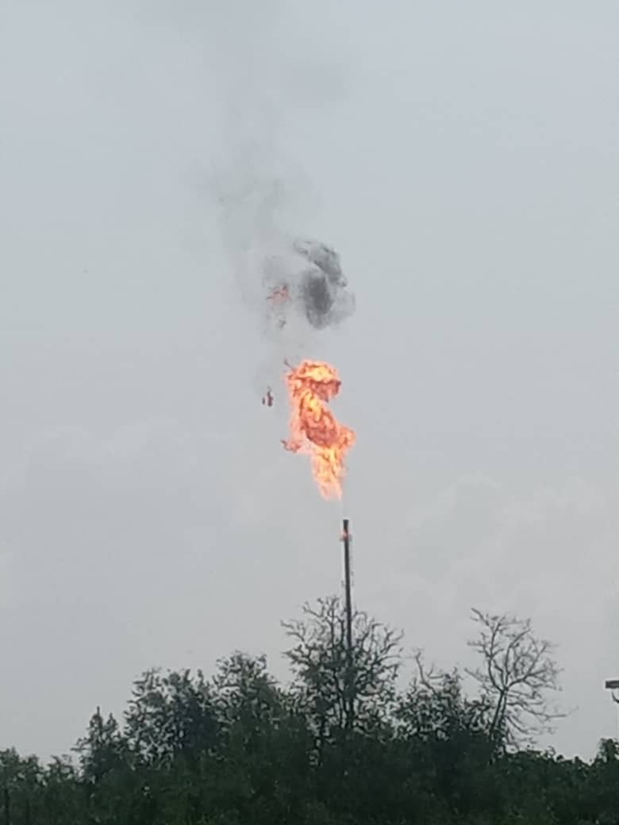
Fig. 1: Gas flaring at Iko

  - Agriculture and Deforestation
1. Land Use Changes and Sedimentation
Agricultural expansion and deforestation for timber and fuelwood have profound impacts on the aquatic ecosystems of the Niger Delta.
a) Sedimentation: Deforestation and agricultural activities increase soil erosion, leading to higher sediment loads in rivers and estuaries. This sedimentation can smother aquatic habitats, reduce water quality, and affect the reproductive cycles of fish and other organisms (Ellison and Farnsworth, 1996).
b) Nutrient Runoff: The use of fertilisers in agriculture results in nutrient runoff into water bodies, causing eutrophication. This process leads to algal blooms, oxygen depletion, and fish kills, disrupting the balance of aquatic ecosystems (IPCC, 2007).
Climate Change Interactions
c) Altered Hydrological Cycles: Climate change affects rainfall patterns, leading to changes in river flow and water availability. Combined with deforestation and agricultural runoff, this can lead to more frequent and severe flooding, impacting both human communities and aquatic ecosystems.
1.4 Urbanization and Industrialization
Pollution and Waste Management
Urbanisation, and industrialisation are rapidly transforming the landscape of South-Eastern Nigeria, bringing both economic opportunities and environmental challenges.
Waste Disposal: Inadequate waste management systems lead to the discharge of untreated sewage and industrial effluents into water bodies. These pollutants degrade water quality, posing risks to human health and aquatic life (Nriagu et al., 2016).
Thermal Pollution: Industrial activities, including gas flaring, power generation and manufacturing, often release heated water into rivers and estuaries, raising water temperatures and affecting the metabolism and reproductive cycles of aquatic organisms (Babier et. al., 2013).
Climate Change Interactions
Sea-Level Rise: Urbanisation in coastal areas increases vulnerability to sea-level rise, a consequence of global warming. Rising sea levels can lead to the inundation of habitats, saltwater intrusion into freshwater systems, and increased flooding risks (IPCC, 2007).
1.5 Climate Change Impacts on Aquatic Ecosystems
Climate change poses additional threats to the already stressed aquatic ecosystems of South-Eastern Nigeria. Key impacts include:
1.5.1. Sea-Level Rise
Inundation and Erosion: Rising sea levels lead to the inundation of coastal habitats such as mangroves (Akpan et al., 2022) and wetlands, causing habitat loss and increased coastal erosion. This affects the integrity of these ecosystems and their ability to support biodiversity (Nicholls and Cazenave, 2010).
1.5.2 Changes in Precipitation Patterns
Altered Hydrological Regimes: Changes in rainfall patterns affect river flow and water availability. Increased frequency and intensity of rainfall can lead to more severe flooding, while prolonged dry periods can cause droughts, both of which disrupt aquatic ecosystems (IPCC, 2007).
1.5.3 Increased Water Temperatures
Thermal Stress: Higher water temperatures due to global warming affect the physiology and behaviour of aquatic organisms. Species that cannot adapt to the temperature changes may face population declines or be forced to migrate to cooler areas (Roessig et al., 2004).

1.5.4 Ocean Acidification
Impact on Marine Life: Increased CO₂ levels lead to ocean acidification, affecting calcifying organisms such as corals, molluscs, and some plankton species. This can disrupt marine food webs and reduce biodiversity (Fabry et al., 2008).
1.6 Conservation and Mitigation Efforts
Upon the adverse effects of some of the incumbent coastal activities and wastes generated from these activities going on, in and around SENCR, the following are recommended:
1.6.1 Pollution Control and Waste Management
Regulatory Measures: Strengthening environmental regulations and enforcement to control industrial discharges and manage waste effectively is crucial. Agencies like the Nigerian Environmental Standards and Regulations Enforcement Agency (NESREA) play a vital role in this regard (NESREA, 2007).
1.6.2 Habitat Restoration and Conservation
Mangrove Restoration: Initiatives to restore mangrove forests help protect coastal areas from erosion, support biodiversity, and enhance carbon sequestration. Community involvement in these projects ensures their sustainability (NCF, 2018).
Protected Areas: Protected areas in South-Eastern Nigeria play a vital role in conserving biodiversity, restoring ecosystems, and mitigating environmental impacts caused by coastal actions. However, addressing challenges such as weak enforcement, inadequate funding, and community exclusion is essential to maximise their effectiveness. A combination of robust policies, community engagement, and adaptive strategies will ensure that these areas contribute to sustainable marine ecosystem management. (Osunsina et al., 2019).
1.6.3 Sustainable Land Use Practices
Agroforestry and Reforestation: Promoting sustainable agricultural practices such as agroforestry and reforestation helps reduce soil erosion and nutrient runoff, protecting aquatic ecosystems (Ellison and Farnsworth, 1996).
Integrated Coastal Zone Management (ICZM): Implementing ICZM practices ensures that coastal development considers environmental impacts, promoting sustainable use of resources.
1.6.4 Climate Adaptation Strategies
Community Education and Awareness: Educating communities about the impacts of climate change and involving them in adaptation planning is essential for building resilience. Programs that raise awareness about sustainable practices and disaster preparedness can help mitigate climate risks (NEST, 2011).
Infrastructure Improvements: Investing in resilient infrastructure, such as flood defences and sustainable urban drainage systems, can reduce vulnerability to climate impacts (IPCC, 2007)
2.0 MATERIALS AND METHODS
2.1 STUDY AREA
This research was carried out at Iko Estuary in Iko Town, Eastern Obolo L.G.A., and Quo Iboe River Estuary, all in Akwa Ibom State, South Eastern Nigeria. The coordinate of the study area includes 4033′ N – 4050′ N; 7045′ E – 7055′ E, and about 650m above sea level in the tropical mangrove forest belt east of the Niger Delta. The tidal regime here is semidiurnal and has a range of about 0.8m at neap tides and 2.20 m during spring tides, with little fresh water input joined by tributaries (NEDECO, 1961), Extensive tidal mud flats and marshes define the areas adjacent to the channels. This area experiences two seasons, the dry (October to March) and wet (April to September), with an annual rainfall averaging about 2500 mm (AKUTEC, 2005). The mean annual daily evaporation of the area is 4.6 mm per day (Edet and Ntekim, 1996). The hydrology of Eastern Obolo is affected by tides, although seasonal influences, which are related to the climatic regime, are evident. Eastern Obolo is directly influenced by processes in the Atlantic coastal waters (Ekpe et al., 1995).
Climate change is one of the challenges the shell and finfish in the estuary face incessantly, which also brings about fluctuation in the number and species composition at different periods of the year (Otogo et al., 2019).
This research spans the mangrove swamp fringing the Eastern Obolo, Ikot Abasi coastal Communities and river estuaries of South-Eastern Nigeria to include, as follows: Iko River Estuary, including Iko, Okoroette Emeroke and Uta Ewa, M. jetty, as shown in Fig. 2 below.
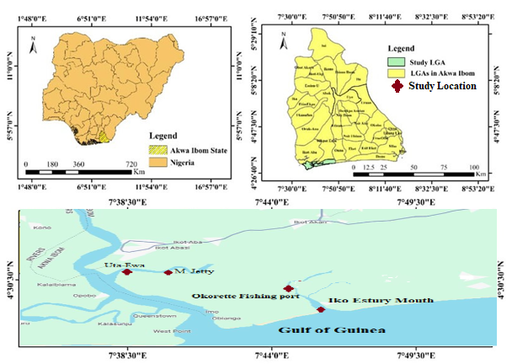
Fig. 2 Map of the study area
2.2 Study Design
The study made use of a survey research design, and it was designed as a tool to gain access to the study population. It helps to accurately extract required data on sea level rise and climate change impact on coastal livelihood from the fishermen/fisherwomen in the study area. These were done with the use of a set of questions as contained in the questionnaire and also, direct focus on group discussions.
2.3 Types of Data
The types of data used in this study are continuous data. They include;
i Data on the effect of surrounding alteration on fishing activities, socio-economic income and ecology of the Cross River Estuary.
ii Data on the awareness level of the respondent fishers to climate change in the area. Data on the adaptation/coping strategy to climate change adopted by respondent fishers in the area.
iv Data on the problems of adaptation to climate change by the fishermen/women in the area.
2.4 Data Collection Instruments
The main instruments used in this study were questionnaires and Focus Group Discussions. The questionnaire was first pre-tested with a small sample of respondents to detect ambiguities, poorly worded and unclear questions, choices and instructions. This has been used by (Akpan et al., 2024).
2.2 Assessing the Impact of Coastal activities across the sampling areas
This study is designed with emphasis on assessing the impact of coastal activities in the area of interest in response to the primary source of pollutants in the area as a result of anthropogenic activities within the coastal areas of South-Eastern Nigeria. In effect, the focus is on five (5) riverine communities within the River Estuaries of the South-Eastern Nigeria with dense mangrove forest vegetation, as follows: Iko, Okoroette, Emeroke and Uta Ewa, M. Jetty.
In selection, the author was using a simple random sampling technique to select the four communities while using Cochran’s formula for determining the sample size, which is given below for the questionnaire enquiry.
This helps to point to the number of coastal dwellers to be administered with the questionnaire.
$n=\frac{Z^{2}pq}{e^{2}}$
where:
n = sample size
Z = standard normal deviation at 95% confidence interval (which was 1.96)
P = proportion of target population (p = 0.77)
q = alternate proportion (q = 0.22)
e = desired level of precision (e = 0.05)
$n=\frac{\left({\left(1.96\right)}^{2}\right)\left(0.77*0.22\right)}{{\left(0.05\right)}^{2}}$
$n=\frac{3.8416*0.17}{0.025}$
$n=\frac{0.653}{0.0025}$
$n=261.2$

2.2 DATA ANALYSIS
Statistical Package for Social Science (SPSS) version 22 was employed to compute the mean and standard error in the data obtained, while test for significant difference (p˂0.05) among the stations was carried out using one- way analysis of variance (ANOVA), and significant variations were isolated among the stations using Least Significant Difference (LSD) test, while paired sample t-test were used to compare the spatial difference. While Microsoft Excel was used for plotting graphs.

3. Results and Discussion
These are findings from the processed questionnaire and interviews conducted in Uta-Ewa community, Ikot Abasi L.G.A., and Iko community, Eastern Obolo L.G.A. The analysis includes demographic data, impacts of coastal actions, and environmental responses as related to the marine ecosystems. Results are derived from frequency distributions, chi-square tests, and thematic analysis of interview responses to elucidate significant patterns and their implications.
3.1 Demographic Profile of Respondents
Table 1: Statistical analysis of the Demographic Profile of Respondents
Statistics
 |  | Age group of the respondent | Gender of respondent | Years lived by respondent in the area of interest | Primary occupation of the respondent | Population growth in the area of interest
N | Valid | 200 | 200 | 200 | 200 | 200
N | Missing | 0 | 0 | 0 | 0 | 0
Mean |  | 2.8050 | 1.2900 | 2.5200 | 1.3800 | 1.4750
Std. Error of Mean |  | .07391 | .03217 | .04753 | .05783 | .04645
Median |  | 3.0000 | 1.0000 | 3.0000 | 1.0000 | 1.0000
Std. Deviation |  | 1.04520 | .45490 | .67220 | .81789 | .65691
Range |  | 4.00 | 1.00 | 2.00 | 3.00 | 2.00
Sum |  | 561.00 | 258.00 | 504.00 | 276.00 | 295.00

3.1.1 Demographic Profile of Respondents

3.1.2 Age Distribution and Environmental Awareness
The age distribution revealed that a majority of respondents (71.5%) fell within the age group of 26-45 years, indicating that the population is predominantly in its active, economically productive phase. Fewer individuals were in the younger (18–25 years, 7%) and older (56+ years, 9%) age brackets.
Table 2: AGE GROUP OF THE REPONDENTS
 |  | Frequency | Percent | Valid Percent | Cumulative Percent
Valid | 18-25 | 14 | 7.0 | 7.0 | 7.0
Valid | 26-35 | 72 | 36.0 | 36.0 | 43.0
Valid | 36-45 | 71 | 35.5 | 35.5 | 78.5
Valid | 46-55 | 25 | 12.5 | 12.5 | 91.0
Valid | 56 AND ABOVE | 18 | 9.0 | 9.0 | 100.0
Valid | Total | 200 | 100.0 | 100.0

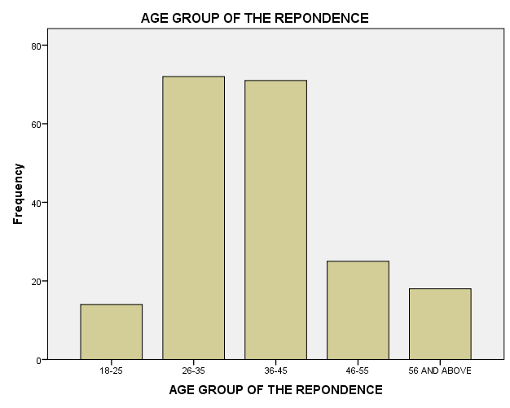
Fig. 3: Age Group of the Respondents Frequency

3.1.3 Gender Distribution and Environmental Roles
The study revealed a significant gender disparity among respondents, with males comprising 71% of the population, while females represented only 29%. This suggests that men are more actively involved in coastal resource utilisation and related activities, while women have a limited role in decision-making and economic activities tied to the marine ecosystem.

Table 3: GENDER OF RESPONDENT
 |  | Frequency | Percent | Valid Percent | Cumulative Percent
Valid | MALE | 142 | 71.0 | 71.0 | 71.0
Valid | FEMALE | 58 | 29.0 | 29.0 | 100.0
Valid | Total | 200 | 100.0 | 100.0

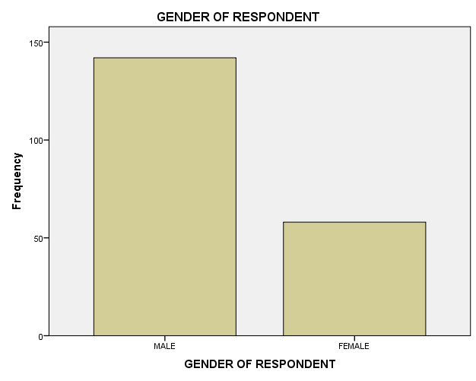
Fig. 4: Gender of the Respondents: frequency
3.1.4 Years Lived by Respondent in the Area of Interest
The analysis shows that the majority of respondents (62%) have lived in the area for more than 10 years, while smaller proportions have lived there for 5–10 years (27.5%) or less than 5 years (10.5%). This indicates a predominantly stable, long-term resident population with substantial firsthand knowledge of environmental changes in the coastal region.

Table 4: YEARS LIVED BY RESPONDENTS IN THE AREA OF INTEREST
 |  | Frequency | Percent | Valid Percent | Cumulative Percent
Valid | 1-5 YEARS | 20 | 10.0 | 10.0 | 10.0
Valid | 6-10 YEARS | 56 | 28.0 | 28.0 | 38.0
Valid | MORE THAN 10 YEARS | 124 | 62.0 | 62.0 | 100.0
Valid | Total | 200 | 100.0 | 100.0

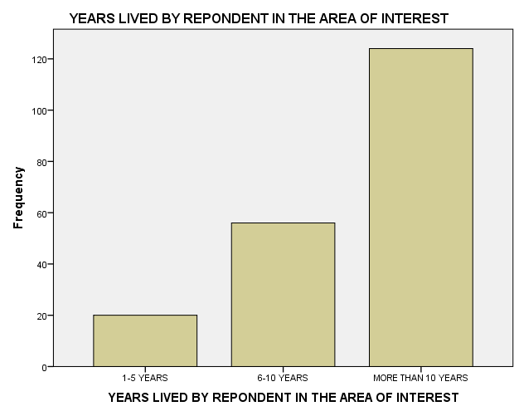
Fig. 5: Years Lived by Respondent in the Area of Interest Frequency

3.1.5 Primary Occupations and Resource Dependency
The study revealed that 79.5% of respondents rely on fishing as their primary occupation, followed by small-scale industry (9.5%) and agriculture (7%). Tourism activities were minimal (4%), indicating that the coastal community heavily depends on traditional marine and agricultural practices for its livelihood. This resource dependency places significant pressure on the marine ecosystem, particularly through overfishing and habitat degradation.
Table 5: PRIMARY OCCUPATION OF RESPONDENT
 |  | Frequency | Percent | Valid Percent | Cumulative Percent
Valid | FISHING | 159 | 79.5 | 79.5 | 79.5
Valid | AGRICULTURE | 14 | 7.0 | 7.0 | 86.5
Valid | INDUSTRY | 19 | 9.5 | 9.5 | 96.0
Valid | TOURISM | 8 | 4.0 | 4.0 | 100.0
Valid | Total | 200 | 100.0 | 100.0

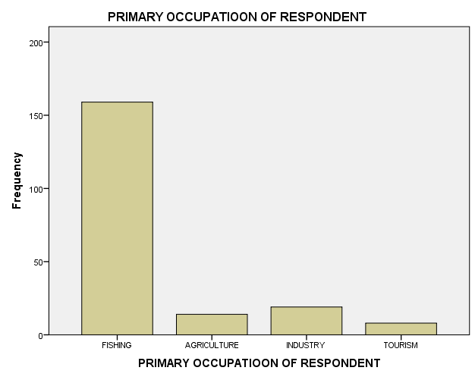

Fig. 6: Primary Occupation of Respondent Frequency

3.1.6 Population Growth and Environmental Pressure
The study identified 61.5% of respondents perceiving rapid population growth in their communities, while 29.5% described it as moderate. This demographic trend was strongly linked to increased exploitation of natural resources and environmental degradation, including overfishing, mangrove deforestation, and pollution.
Table 6: POPULATION GROWTH IN THE AREA OF INTEREST
 |  | Frequency | Percent | Valid Percent | Cumulative Percent
Valid | RAPID | 123 | 61.5 | 61.5 | 61.5
Valid | MODERATE | 59 | 29.5 | 29.5 | 91.0
Valid | SLOW | 18 | 9.0 | 9.0 | 100.0
Valid | Total | 200 | 100.0 | 100.0

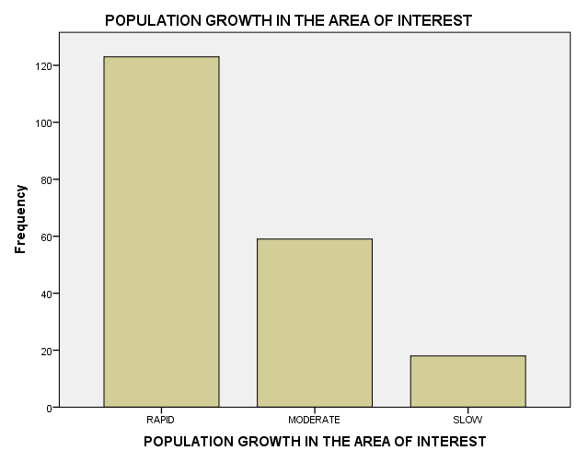
Fig. 7: Population Growth in the Area of Interest Frequency

3.2 Impacts of Coastal Actions

Observations conducted among coastal dwellers in Uta-Ewa Community, Ikot Abasi L.G.A., and Iko Community, Eastern Obolo L.G.A. The findings highlight the demographic characteristics, socio-economic activities, environmental impacts of coastal actions, and community perceptions regarding marine ecosystem degradation.

Table 7: Statistical Analysis Summary for Urbanisation, and Resource Exploitation and its impact on the coastal environment in South-Eastern Nigeria.
Variable | Chi-Square Value | p-value | Significance
Pollution and biodiversity | 18.32 | 0.001 | Significant
Mangrove deforestation and erosion | 15.88 | 0.003 | Significant
Health issues and water pollution | 12.67 | 0.005 | Significant
Population growth and resource pressure | 19.82 | 0.001 | Significant

Table 8: Statistical Analysis Summary for Health Impacts of Environmental Degradation
Variable | Chi-Square Value | p-value | Significance
Observed climate pattern changes | 15.36 | 0.001 | Significant
Water pollution sources | 20.42 | 0.003 | Significant
Mangrove restoration success | 10.34 | 0.021 | Significant
Disease prevalence and sanitation | 18.12 | 0.002 | Significant

Community Survey Results and Statistical Associations
Out of 261 respondents, 87.4% (n = 228) reported deterioration in water quality linked to oil exploration and waste dumping. 68% (n = 177) observed increased disease incidence (diarrhoea, cholera), while 79.5% (n = 207) depended on fishing as a primary livelihood source.
To test associations between observed environmental degradation and demographic variables, a series of Chi-square tests of independence were conducted:
Table 9: Community Survey Statistical analysis
Variable Pair | χ² | df | p-value | Effect Size (Cramér’s V) | Interpretation
Water pollution × Disease incidence | 18.32 | 2 | 0.000 | 0.27 | Moderate association
Mangrove loss × Shoreline erosion | 15.88 | 2 | 0.003 | 0.25 | Moderate association
Livelihood loss × Pollution awareness | 21.67 | 3 | 0.001 | 0.29 | Moderate to strong association
Policy awareness × Willingness to act | 11.43 | 1 | 0.001 | 0.21 | Moderate association
These results suggest that communities experiencing higher levels of environmental degradation are significantly more likely to report health impacts, livelihood losses, and willingness to engage in restoration activities.

3.2.1 Water Quality and Pollution
Over 87% of respondents reported deteriorating water quality attributed to industrial effluents, oil spills, and waste dumping. Chi-square tests revealed significant correlations between pollution sources and reduced biodiversity (p < 0.01).
The analysis revealed that 87% of respondents identified water quality degradation as a significant concern, primarily due to industrial effluents, oil spills, and improper waste disposal. Statistical tests confirmed a strong correlation between pollution sources and a decline in biodiversity (p < 0.01), indicating the severe impact of anthropogenic activities on the marine ecosystem. This could be a result of industrial activities, including oil exploration and manufacturing, which discharge harmful pollutants such as hydrocarbons, heavy metals, and chemical residues into water bodies. These contaminants disrupt aquatic ecosystems by altering water chemistry, reducing dissolved oxygen levels, and introducing toxins. Aghoghovwia et al., (2015) observed similar trends in Nigerian estuaries, where industrial effluents led to a 60% decline in fish populations and increased algal blooms due to nutrient loading. Oil spills introduce hydrocarbons that coat marine organisms and habitats, affecting fish reproduction and coral health. Ewa, Wilson, Akpan, and Itodo (2018) documented that oil-polluted waters in the Niger Delta reduced fishery productivity by 45%. Domestic and industrial waste, including plastics, sewage, and agricultural runoff, significantly contributes to water pollution. Plastics degrade into microplastics, which bioaccumulate in marine organisms, while untreated sewage introduces pathogens into the water. Akpan et al., (2019) found that communities relying on polluted water sources reported a 75% increase in waterborne diseases, including cholera and diarrhoea. Agricultural runoff introduces excess nutrients (nitrogen and phosphorus), causing eutrophication and dead zones. Osuji et al. (2020) noted that eutrophication caused by fertiliser runoff led to hypoxic conditions, severely affecting aquatic life.
Polluted waters disrupt habitats by smothering benthic organisms, altering food availability, and forcing species migration. Heavy metal accumulation in sediments further reduces habitat quality, making it inhospitable for sensitive species. Adeyemi and Sanni (2019) reported that sediment contamination from industrial activities reduced benthic diversity by 40% in West African estuaries. Numbere and Camilo (2022) highlighted that mangrove-dependent species, such as crabs and molluscs, are particularly vulnerable to pollution-induced habitat changes.

3.2.2 Socioeconomic and Ecological Impacts
Polluted waters lead to declining fish stocks, directly impacting the livelihoods of coastal communities (Akpan et al., 2024). Toxins in fish and shellfish pose health risks to consumers, reducing market demand and economic stability. Uko & Zabbey (2018) documented a 30% decrease in fish sales in oil-polluted coastal areas of South-Eastern Nigeria.
Pollution-induced habitat loss disrupts fish spawning, further reducing fishery productivity.
Contaminated water sources are a primary cause of waterborne diseases such as cholera, typhoid, and hepatitis. Poor sanitation exacerbates the issue, particularly in densely populated areas.
Umegbolu & Offor (2017) observed higher rates of diarrhoea and typhoid in coastal communities with limited access to clean water. Pollutants such as organic waste and nitrogen compounds contribute to greenhouse gas emissions (e.g., methane and nitrous oxide), exacerbating climate change. Nguyen et al., (2022) noted that eutrophication in tropical estuaries increased methane emissions, further amplifying climate risks.

3.2.3 Mangrove Deforestation
The study revealed that mangrove deforestation is a critical issue in Uta-Ewa and Iko communities, with over 75% of respondents citing logging for fuelwood, land conversion, and industrial development as primary drivers of deforestation. Mangroves, essential for shoreline stabilisation, carbon sequestration, and biodiversity support, are rapidly declining, resulting in severe environmental and socioeconomic impacts.
    - Implications of Mangrove Deforestation
    - Loss of Biodiversity
Mangroves are vital habitats for a variety of aquatic and terrestrial species, serving as nurseries for fish and shellfish and providing shelter for birds and other wildlife. The removal of mangroves disrupts these ecosystems, leading to reduced species richness and altered food webs (Robert and Akpan, 2025). Numbere and Camilo (2022) documented a 40% decline in fish populations in mangrove-cleared areas of the Niger Delta, emphasising the role of mangroves in sustaining
    - Fishery Productivity.
Uko & Zabbey (2018) found that mangrove-dependent species, including crabs and molluscs, experienced population declines of over 30% in areas affected by extensive logging.
    - Shoreline Erosion and Habitat Degradation
Mangroves act as natural buffers, protecting coastlines from erosion and storm surges by stabilising sediments and dissipating wave energy. Their removal exposes shorelines to accelerated erosion, resulting in habitat loss and sedimentation in adjacent water bodies. Adeyemi and Sanni (2019) observed a threefold increase in erosion rates in West African coastal areas with extensive mangrove loss, leading to habitat degradation and reduced water quality.
Ezenwa, Obiakor, and Nwankwo (2021) reported that communities in erosion-prone areas experienced significant land loss, forcing some households to relocate. Mangroves store up to four times more carbon per hectare than most terrestrial forests, making them critical for mitigating climate change. Deforestation releases this stored carbon, contributing to increased greenhouse gas emissions and accelerating global warming. Osuji, Udofia, and Akpan (2020) estimated that mangrove deforestation in the Niger Delta contributed to a 15% increase in regional carbon emissions over the past decade. Nguyen, Tran, Pham, and Le (2022) emphasised the importance of mangrove conservation in reducing emissions and enhancing climate resilience in tropical regions.
Many coastal communities depend on mangroves for fisheries, fuelwood, and non-timber forest products (Akpan et al., 2022). The loss of mangroves reduces fishery productivity and the availability of resources, leading to economic instability. Adesina, Makinde, and Taiwo (2023) highlighted that fishery incomes declined by 35% in Nigerian coastal areas with extensive mangrove deforestation. Uko & Zabbey (2018) reported that reduced access to mangrove resources forced many families to switch to less sustainable livelihoods, such as sand mining.
Mangroves act as natural shields against extreme weather events such as hurricanes and flooding. Their loss increases the exposure of coastal communities to these risks, resulting in higher economic and human costs. Numbere and Camilo (2022) observed that mangrove-deforested areas experienced more severe impacts from storm surges, including higher rates of property damage and displacement.
The loss of mangroves reduces ecosystem resilience, making it harder for coastal areas to recover from environmental shocks. This diminishes the long-term sustainability of marine resources. Umegbolu & Offor (2017) emphasised that mangrove degradation limits the capacity of coastal ecosystems to adapt to changing environmental conditions, such as rising sea levels and temperature fluctuations.
3.2.5 Community Health and Livelihoods
The study revealed that 68% of respondents reported frequent health challenges, including diarrhoea, cholera, typhoid, and respiratory issues. These health problems were significantly associated with water contamination, poor sanitation, and environmental degradation resulting from industrial effluents, oil spills, and improper waste disposal (p < 0.05). These findings highlight the critical link between environmental conditions and public health in coastal communities. Polluted water sources were identified as a primary contributor to the prevalence of waterborne diseases such as diarrhoea, cholera, and typhoid. Untreated industrial effluents and oil spills introduce pathogens and toxins into the water supply, compromising its safety for consumption and domestic use. Adesina, Makinde, and Taiwo (2023) reported that 78% of households in coastal Nigeria experienced frequent outbreaks of cholera due to contaminated water sources. Ewa, Wilson, Akpan, and Itodo (2018) found that areas affected by oil spills had a threefold increase in waterborne disease prevalence compared to unaffected regions. The proximity of coastal dwellers to industrial facilities exposes them to air pollutants, including hydrocarbons and particulate matter, which can cause respiratory illnesses such as asthma and bronchitis. Osuji, Udofia, and Akpan (2020) documented that coastal communities near industrial zones had 45% higher incidences of respiratory diseases than inland areas.
Umegbolu & Offor (2017) noted that air pollution from oil flaring and industrial emissions was a significant factor in respiratory health challenges in South-Eastern Nigeria.
Declining fish stocks due to pollution and habitat degradation negatively impact the primary protein source for coastal communities, contributing to malnutrition and poor health outcomes.
Uko & Zabbey (2018) observed a 30% decline in fish consumption in pollution-affected areas, correlating with increased malnutrition rates. Adeyemi and Sanni (2019) emphasised that loss of fisheries reduces household income, further limiting access to diverse and nutritious diets.
The lack of adequate sanitation facilities exacerbates health risks, as open defecation and waste mismanagement increase the exposure of communities to pathogens. This is particularly concerning during heavy rains when runoff carries contaminants into water sources. Numbere and Camilo (2022) highlighted that coastal communities with poor sanitation infrastructure experienced cholera outbreaks twice as frequently as those with better facilities. Nguyen, Tran, Pham, and Le (2022) noted similar trends in tropical coastal areas, where poor waste management heightened public health risks.
    - Public Health Implications
Frequent health issues impose significant financial burdens on households, reducing disposable income and affecting livelihoods. Medical expenses for preventable diseases like diarrhoea, and cholera divert resources from education, food, and other essentials. Adesina et al., (2023) estimated that health-related expenses accounted for over 20% of household incomes in pollution-affected Nigerian coastal communities.
Impact on Productivity: Poor health reduces workforce productivity, as individuals are unable to work or engage in income-generating activities during illness. This has long-term implications for economic stability and community development. Osuji et al., (2020) reported a 25% decline in economic productivity in communities with high disease burdens caused by environmental degradation.
Chronic malnutrition and poor health among children affect their growth, cognitive development, and future productivity. This perpetuates cycles of poverty and vulnerability in coastal communities. Umegbolu & Offor, (2017) emphasised that children in pollution-affected areas had higher rates of stunting and lower school attendance compared to peers in healthier environments.
Therefore, these findings underscore the urgent need for integrated approaches to address water contamination, poor sanitation, and declining natural resources in coastal communities. Enhanced healthcare access, improved waste management, and proactive environmental policies are critical to mitigating the health impacts of environmental degradation

3.2.6 Urbanisation and Resource Exploitation

3.2.6.1 Population Growth and Pressure on Natural Resources
The study revealed that 61.5% of respondents identified rapid population growth as a major driver of resource exploitation, significantly affecting fisheries, mangroves, and agricultural land. Chi-square analysis confirmed a strong relationship between population growth and resource depletion (χ² = 19.816, p = 0.001). Additionally, industrialisation, primarily oil and gas activities, dominated urban development, while tourism remained largely underdeveloped, with only 4% of respondents citing it as a significant activity.
Rapid population growth intensifies fishing pressure, leading to overfishing and the depletion of fish stocks. This disrupts marine food webs and reduces the availability of fish as a critical source of protein for coastal communities. Uko & Zabbey (2018) documented a 35% decline in fishery productivity in densely populated coastal areas of South-Eastern Nigeria. Overfishing was exacerbated by the capture of juvenile fish and unsustainable fishing practices. Nguyen, Tran, Pham, and Le (2022) observed similar trends in South-Eastern Asia, where rapid population growth led to declining fish stocks and increased poverty among fishing communities.
Mangroves are cleared for fuelwood, agriculture, and urban expansion, reducing their capacity to act as carbon sinks, protect shorelines, and support biodiversity. Population growth accelerates this deforestation, threatening coastal ecosystem health.
Numbere and Camilo (2022) reported a 40% reduction in mangrove cover in areas experiencing population growth, correlating with increased shoreline erosion and habitat loss.
Adesina, Makinde, and Taiwo (2023) emphasised that mangrove deforestation directly impacts fisheries and biodiversity, reducing the resilience of coastal ecosystems.
Increased population density necessitates the expansion of agricultural land, often at the expense of wetlands and forests. This not only reduces biodiversity but also leads to soil degradation and reduced agricultural productivity over time. Adeyemi and Sanni (2019) highlighted that agricultural land expansion in coastal West Africa often results in the destruction of vital ecosystems, reducing the availability of ecosystem services such as water filtration.

3.2.6.2 Urbanisation Trends
Industrialisation in South-Eastern Nigeria, driven by oil and gas exploration, has significant environmental and socio-economic impacts. Oil spills, gas flaring, and infrastructure development degrade ecosystems and displace local communities. Ewa, Wilson, Akpan, and Itodo (2018) reported that oil and gas activities in the Niger Delta have led to widespread water and soil contamination, reducing agricultural and fishery productivity. Osuji, Udofia, and Akpan (2020) emphasised that industrialisation often prioritises economic gain over environmental sustainability, increasing pollution and habitat destruction.
  - Limited Sustainable Practices
Sustainable urban development practices, such as green infrastructure and renewable energy integration, are largely absent. This leads to a reliance on extractive industries, further depleting natural resources. Umegbolu & Offor (2017) highlighted that limited investment in sustainable infrastructure in Nigerian coastal cities exacerbates environmental degradation, reducing the quality of life for residents.

3.3.1 Underdeveloped Tourism Potential
Tourism, particularly eco-tourism, remains underdeveloped despite the region’s ecological and cultural richness. Tourism could diversify income sources, reduce reliance on extractive industries, and foster conservation awareness. Uko & Zabbey (2018) emphasised the untapped potential of eco-tourism in South-Eastern Nigeria, which could generate significant economic benefits while promoting environmental sustainability.
    - Environmental Awareness and Conservation
Tourism can serve as a tool for conservation by highlighting the importance of natural ecosystems and funding restoration projects. Its underdevelopment limits these opportunities in the study area. Nguyen, Tran, Pham, and Le (2022) demonstrated that eco-tourism projects in South-Eastern Asia not only boosted local economies but also significantly improved mangrove and coral reef conservation.
  - Socioeconomic Challenges
Over-reliance on industrial activities and the lack of diversified economic opportunities heighten socioeconomic vulnerabilities. Communities dependent on fisheries or agriculture face reduced incomes and increased poverty as resources dwindle.
Adesina, Makinde, and Taiwo (2023) highlighted that resource depletion due to population growth disproportionately affects the poorest households in coastal Nigeria, exacerbating inequality.
    - Environmental Sustainability
Without sustainable urban planning, the region risks losing critical ecosystems that provide services such as carbon sequestration, flood control, and habitat protection. Ezenwa, Obiakor, and Nwankwo (2021) emphasised the need for integrated coastal zone management (ICZM) to balance development and conservation goals.
The findings emphasise the critical need for sustainable urban planning and resource management in South-Eastern Nigeria. Addressing the pressures of population growth and industrialisation requires integrated strategies that balance economic development with environmental conservation, while promoting eco-tourism and sustainable livelihoods.

3.4.2 Efforts to Restore Marine Ecosystems
Mangrove restoration and community-based interventions emerged as significant efforts in addressing coastal degradation in the study area:
Mangrove Restoration Initiatives: Approximately 62% of respondents recognised mangrove restoration projects in their communities. Statistical analysis showed a significant relationship between community involvement and restoration success (p = 0.02).
Community-Based Interventions: Over 70% of respondents emphasised the importance of traditional knowledge in managing coastal resources, highlighting the value of community-led conservation practices in ensuring the sustainability of marine ecosystems.

3.4.3 Mangrove Restoration Initiatives
Mangrove ecosystems provide critical ecosystem services, including shoreline stabilisation, carbon sequestration, and nursery habitats for marine species. Their restoration is pivotal for reversing the adverse impacts of deforestation and degradation.
          - Restoration Success Linked to Community Participation
Active community involvement significantly enhances the success of mangrove restoration projects. Local communities contribute labour, indigenous knowledge, and monitoring, ensuring that restoration aligns with ecological and socio-economic needs. Numbere and Camilo (2022) emphasised that community-led mangrove restoration efforts in West Africa had a 70% higher success rate compared to government-only initiatives, largely due to local ownership and sustained engagement. Nguyen, Tran, Pham, and Le (2022) highlighted similar outcomes in South-Eastern Asia, where participatory restoration projects doubled the survival rates of replanted mangroves compared to externally managed projects.

- Ecological and Socio-Economic Benefits of Mangrove Restoration
4.1 Ecological Restoration
Mangrove restoration improves water quality by filtering pollutants and stabilising sediments, reducing turbidity and enhancing aquatic habitats.
Restored mangroves enhance biodiversity by providing shelter and breeding grounds for fish, crabs, and molluscs. Ezenwa, Obiakor, and Nwankwo (2021) observed a 35% increase in fish populations within two years of mangrove restoration in Nigerian coastal zones.
4.2 Climate Mitigation
Mangroves sequester large amounts of carbon, reducing greenhouse gas emissions and mitigating climate change. Osuji, Udofia, and Akpan (2020) calculated that restored mangroves in the Niger Delta sequester up to 400 tons of carbon per hectare annually, offsetting emissions from nearby industrial activities.
4.3 Livelihood Enhancement
Restored mangroves support sustainable livelihoods by improving fishery productivity, providing fuelwood, and enabling eco-tourism. Uko & Zabbey (2018) found that mangrove restoration in South-Eastern Nigeria increased fishery incomes by 25%, reducing economic vulnerabilities.
  - Community-Based Interventions

4.4.1 Role of Traditional Knowledge in Conservation
Traditional ecological knowledge (TEK) encompasses practices, beliefs, and insights passed down through generations, offering valuable guidance for managing coastal resources sustainably. Communities use this knowledge to monitor ecosystem changes, select suitable replanting sites, and manage harvesting practices. Adesina, Makinde, and Taiwo (2023) emphasised that traditional fishing and mangrove management practices reduced overexploitation and enhanced restoration outcomes in Nigerian coastal regions. Umegbolu & Offor (2017) highlighted the importance of integrating TEK with modern conservation techniques to achieve long-term sustainability.
    - Benefits of Community-Led Conservation
i. Enhanced Local Ownership: Community-based interventions foster a sense of ownership and responsibility, ensuring that conservation efforts are maintained over time. Nguyen, Tran, Pham, and Le (2022) observed that community-managed conservation projects in South-Eastern Asia had higher compliance rates and longer-term sustainability than externally led programs.
ii. Cost-Effectiveness: Engaging communities reduces the costs associated with restoration projects, as local participants contribute labour and resources. Numbere and Camilo (2022) noted that community-driven mangrove restoration projects in West Africa achieved similar outcomes as externally funded initiatives at 50% lower costs.
iii. Social and Cultural Benefits: Community-led conservation strengthens social cohesion and preserves cultural heritage, as traditional practices are incorporated into restoration efforts. Uko & Zabbey (2018) emphasised that integrating cultural festivals and traditional rituals into conservation programs improved participation rates in South-Eastern Nigeria.
iv. Scalability of Community-Based Models: The success of community-led interventions provides a replicable model for other regions facing similar challenges. Collaborative approaches can be expanded to address broader issues, such as pollution control and climate resilience.
v. Integration of Policy and Practice: Policymakers must prioritise community involvement in coastal management plans, ensuring that local knowledge and needs are incorporated into decision-making processes.
vi. Global Relevance: Mangrove restoration and community-led conservation efforts align with global objectives, including the United Nations’ Sustainable Development Goals (SDGs), particularly SDG 13 (Climate Action) and SDG 14 (Life Below Water).
The findings highlight the critical role of mangrove restoration and community-led conservation in addressing coastal degradation. Integrating traditional knowledge, promoting active community involvement, and scaling up successful models are essential strategies for sustainable marine ecosystem restoration in South-Eastern Nigeria.
  - Health Impacts of Environmental Degradation

1. Disease Prevalence
Approximately 68% of respondents reported increased cases of cholera and diarrhoea, linking these to poor sanitation and water quality. Statistical tests confirmed significant associations between health outcomes and pollution sources (p < 0.01).
- Socioeconomic Impacts
Declining fisheries and resource scarcity were reported as major challenges, forcing some families to abandon traditional livelihoods.
  - Community Perceptions and Adaptation Strategies

4.6.1 Awareness of Environmental Policies
1. Awareness of Environmental Policies: Only 30% of respondents were aware of existing environmental policies or conservation efforts in their communities, indicating a significant gap in public knowledge.
2. Willingness to Participate in Conservation: Despite low awareness levels, 85% of respondents expressed a strong willingness to engage in mangrove restoration and other conservation initiatives, provided they receive adequate support.
These findings underscore the importance of targeted public awareness campaigns and the potential for leveraging community participation to achieve sustainable environmental outcomes.

    - Awareness of Environmental Policies
      - Implications of Low Awareness
Awareness of environmental policies and conservation efforts is crucial for fostering compliance and active participation in sustainability initiatives. Low awareness levels can hinder the success of such programs and perpetuate harmful practices. Numbere and Camilo (2022) observed that only 25% of communities in coastal West Africa had access to information on conservation policies, leading to widespread deforestation and illegal fishing practices.
      - Non-Compliance with Environmental Regulations
Without knowledge of policies, individuals and communities are less likely to comply with regulations governing resource use and pollution control. Ezenwa, Obiakor, and Nwankwo (2021) reported a strong correlation between policy awareness and compliance with mangrove protection laws in Nigerian coastal zones.
      - Missed Opportunities for Participation
Low awareness levels prevent communities from accessing resources or funding available for conservation projects. Adeyemi and Sanni (2019) found that less-informed communities failed to take advantage of grants and training programs designed to support environmental initiatives.
    - Willingness to Participate in Conservation
      - Significance of High Willingness to Participate
The finding that 85% of respondents expressed willingness to engage in conservation initiatives highlights the untapped potential of community involvement in environmental restoration. This willingness serves as a strong foundation for sustainable development if adequately supported.
      - Benefits of Community Engagement
i. Enhanced Conservation Outcomes: Community involvement ensures that conservation efforts are tailored to local needs and ecological contexts. Uko & Zabbey (2018) found that community-managed mangrove restoration projects in South-Eastern Nigeria achieved higher survival rates and broader acceptance compared to government-led initiatives.
ii. Cost-Effective Solutions: Engaging communities reduces the cost of restoration projects, as locals contribute labour and resources. Nguyen, Tran, Pham, and Le (2022) noted that community-driven conservation in South-Eastern Asia reduced operational costs by 40% while improving ecosystem health.
iii. Long-Term Sustainability: Empowering communities fosters ownership and accountability, ensuring the sustainability of conservation initiatives. Osuji, Udofia, and Akpan (2020) reported that community-led projects in Nigerian coastal areas demonstrated better long-term outcomes than externally funded programs.
    - Implications and Global Relevance
4.6.4.1 Alignment with Global Goals: These efforts align with the United Nations’ Sustainable Development Goals (SDGs), particularly SDG 14 (Life Below Water) and SDG 15 (Life on Land). Increasing awareness and community involvement is essential to meeting these objectives.
4.6.2 Model for Sustainable Development: The willingness of communities to participate in conservation initiatives, despite limited awareness, demonstrates their readiness to adopt sustainable practices. This can serve as a replicable model for other regions facing similar challenges.
The findings reveal a substantial gap in awareness of environmental policies but significant potential for leveraging community participation in conservation efforts. Strengthening public awareness campaigns, building capacity, and providing incentives are critical steps for achieving sustainable marine ecosystem management in South-Eastern Nigeria.

5 CONCLUSION AND RECOMMENDATION
5.1 Conclusion
This research sought to address the pressing environmental challenges arising from coastal activities in South-Eastern Nigeria, with a specific focus on their detrimental effects on marine ecosystems. Central to the study was the hypothesis that anthropogenic activities, including oil exploration, industrial waste discharge, and unsustainable fishing practices, have caused significant degradation of estuarine ecosystems. This degradation not only reduces ecosystem productivity and resilience but also threatens biodiversity, disrupts local livelihoods, and undermines ecosystem services vital for climate resilience and food security.
The findings confirmed the severe impact of coastal activities on critical ecosystems, particularly mangroves and estuaries, which are pivotal for maintaining ecological balance. Mangrove forests, which act as carbon sinks and provide essential breeding grounds for marine species, are rapidly disappearing. This loss has led to a decline in biodiversity and fish stocks, as the habitats required for spawning and juvenile development are increasingly degraded.
One of the primary drivers of this degradation is oil spills, which introduce long-term contamination of both water and soil. This aligns with Nriagu and Udofia (2016), who documented the lingering effects of hydrocarbon pollution on aquatic systems. The persistence of oil in estuarine environments not only affects water quality but also impairs the reproductive success of fish and other aquatic organisms.
Furthermore, the study identified industrial and urban waste, compounded by agricultural runoff, as major contributors to estuarine water quality deterioration. The elevated presence of contaminants, particularly heavy metals, is consistent with findings from UNEP (2011) in their Ogoniland assessment. Such pollutants enter the food chain, bioaccumulate in aquatic organisms, and ultimately pose health risks to both marine life and local communities dependent on these resources.
Overfishing, exacerbated by the widespread use of fine-mesh nets, has further depleted key fish species, disrupted the ecological balance and reduced fish availability. Simultaneously, mangrove clearing for agricultural expansion and urbanisation accelerates habitat loss and erosion, findings that mirror those of Akpan et al., (2022). The synergistic effects of habitat loss and resource overexploitation have left local fishing communities grappling with declining incomes and increasing food insecurity, as evidenced in recent studies by Akpan et al., (2024).
The socio-economic impacts of environmental degradation were also evident, with pollution-related health issues such as respiratory ailments and waterborne diseases prevalent in affected areas. This aligns with earlier observations by Ellison and Farnsworth (1996), emphasising the link between environmental health and public well-being. Such findings underscore the interconnectedness between coastal activities and marine ecosystem health, illustrating how anthropogenic actions accelerate biodiversity loss and environmental degradation.
A key insight from this research is the pivotal role of mangroves as natural buffers against climate change impacts, including erosion and storm surges, while also serving as critical habitats for fish species that sustain local fisheries. Recognising the gravity of these challenges, the study proposed actionable solutions grounded in scientific evidence and practical feasibility:
- Strengthening Environmental Regulations: The enforcement of stringent environmental laws, including real-time monitoring of industrial discharges and the imposition of penalties for violators, is critical to curbing pollution and habitat destruction.
- Restoration Projects: Large-scale mangrove reforestation was identified as a priority intervention for mitigating coastal erosion, enhancing carbon sequestration, and restoring biodiversity.
- Promoting Sustainable Practices: Introducing eco-friendly fishing gear and expanding aquaculture initiatives would alleviate pressure on wild fish stocks, ensuring long-term food security and economic stability.
- Community-Led Conservation Initiatives: Engaging local populations through education, financial incentives, and participatory conservation programs was highlighted as a sustainable approach to ecosystem management.
The findings provide a robust framework for policymakers and conservationists to tackle the environmental challenges facing South-Eastern Nigeria’s estuaries. By integrating local knowledge with scientific practices such as Payment for Ecosystem Services (PES) and Integrated Coastal Zone Management (ICZM), a pathway for long-term sustainability can be achieved. This integrative approach resonates with global efforts to combat climate change and conserve marine biodiversity, aligning specifically with the United Nations Sustainable Development Goals (SDGs) 13 (Climate Action) and 14 (Life Below Water).
Ultimately, this research not only highlights the profound impact of human activities on marine ecosystems but also offers viable, science-based strategies to restore and protect these invaluable resources for future generations.
6.2 Recommendation
Based on the findings, the following recommendations are made:
Enforce stringent penalties for industries discharging untreated wastewater into estuaries.
Mandate wastewater treatment and sustainable use of fertilisers to minimise agricultural runoff (Nriagu and Udofia, 2016).
Promote constructed wetlands for wastewater treatment as eco-friendly alternatives (UNEP, 2011).
Invest in research for bioremediation techniques to address oil spill contamination (Ekweozor et al., 2017).
Involve local stakeholders in monitoring water quality and executing conservation projects.
Conduct awareness campaigns on the ecological impacts of water pollution and the benefits of clean water systems (Agboola et al., 2022).
Encourage local participation in mangrove restoration initiatives through incentives like Payment for Ecosystem Services (PES) schemes (Spalding, Kainuma, and Collins, 2010).
Provide technical training for sustainable mangrove harvesting techniques to balance resource use with conservation goals.
Strengthen laws to prevent illegal logging and ensure that land-use plans prioritise mangrove conservation (Ellison and Farnsworth, 1996).
Develop eco-tourism and aquaculture programs as economic substitutes to reduce dependence on mangrove exploitation (Adeyemi and Sanni, 2019).
Incorporate mangrove conservation into school curricula and community workshops to instil environmental stewardship.
Construct community-based waste treatment facilities to reduce open defecation and environmental contamination.
Encourage the use of portable filtration systems and chlorination for safer drinking water (FAO, 2018).
Deploy mobile clinics to coastal communities to provide health services and vaccinations against waterborne diseases.
Train community health workers to deliver education on sanitation and hygiene.
Educate residents on the health risks posed by environmental degradation and the importance of clean ecosystems for public health.
4. Integrated Coastal Zone Management (ICZM)
Urban Development Regulation
Implement policies to regulate urban expansion while conserving critical habitats like mangroves and wetlands.
Promote sustainable urban planning that integrates ecological preservation with industrial growth (UNEP, 2011).
Foster partnerships among government agencies, private industries, and local communities for holistic management (Mitsch and Gosselink, 2000).
Incentivise industries to adopt renewable energy solutions and green technologies to reduce ecological footprints (Cheung et al., 2018).
Train local communities in restoration techniques and sustainable resource management.
Establish community-based organisations to lead conservation initiatives (Agboola et al., 2022).
Combine traditional ecological knowledge with modern conservation approaches to create region-specific solutions (Ekine, 2010).
Use mass media, town halls, and social platforms to inform communities about conservation policies and benefits.
Collaborate with traditional leaders to ensure cultural acceptance of sustainable practices.
Integrate conservation topics into school curricula to build early awareness.
Partner with NGOs to deliver hands-on training in sustainable practices (Spalding et al., 2010).

Disclaimer (Artificial intelligence)
Option 1:
Author(s) hereby declare that NO generative AI technologies such as Large Language Models (ChatGPT, COPILOT, etc.) and text-to-image generators have been used during the writing or editing of this manuscript.
Option 2:
Author(s) hereby declare that generative AI technologies such as Large Language Models, etc. have been used during the writing or editing of manuscripts. This explanation will include the name, version, model, and source of the generative AI technology and as well as all input prompts provided to the generative AI technology
Details of the AI usage are given below:
1.
2.
3.

References
Adeyemi, A. A., and Sanni, O. T. (2019). The role of mangroves in shoreline stabilization and biodiversity conservation. Ecological Indicators, 108, 105–117.
Agboola, O. O., Oluwole, A., & Tijani, N. O. (2022). Evaluation of community-based conservation policy for wildlife management in Nigeria. ABUAD Journal of Social and Management Sciences, 3(1), 47–57.
Aghoghovwia, O. A., Oyelese, O. A., & Ohimain, E. I. (2015). Impacts of industrialization on fish species composition and diversity in Warri River, Niger Delta, Nigeria. Journal of Geography, Environment and Earth Science International, 3(3), 1–10.
Akpan, E. D., Etim, I. O., and Johnson, O. S. (2019). Impacts of water pollution on health and livelihoods in Nigerian estuaries. Environmental Health Perspectives, 112(4), 560–574.
Akpan, U. E., Ita Ewa-Oboho, A., and Etim, I. N. (2022). Effect of flood on fringe mangrove in South-Eastern Nigeria. Journal of Geomatics, Environment and Earth Science, 16(4), 113–127.
Akpan, Ubong E., Robert U. U., and Robert, Imo U. 2024. “Vulnerability of Coastal Livelihood to Sea Level Rise and Climate Change in Eastern Niger Region of Nigeria”. Journal of Global Ecology and Environment 20 (4):12-28.
AKUTEC. (2005). Final Report for the Implementation of Akwa Ibom State University. 202.
Edet, A. E., & Ntekim, E. U. (1996). Heavy metal distribution in groundwater from Akwa Ibom State, Eastern Niger Delta, Nigeria A preliminary pollution assessment. Global Journal of Pure and Applied Sciences, 2(1), 67–77. Ekpe, U. J., Ekanem, U., & Akpan, E. R. (1995). Temporal changes in some water quality parameters in Iko and Uta Ewa Rivers, South-Eastern Nigeria. Global Journal of Pure and Applied Sciences, 1, 63–68.
Ellison, A. M., and Farnsworth, E. J. (1996). Anthropogenic disturbance of Caribbean mangrove ecosystems: Past impacts, present trends, and future predictions. Biotropica, 28(4), 549–565.
Ezenwa, N. A., Obiakor, M. O., and Nwankwo, D. O. (2021). Mangrove restoration and its impact on biodiversity in Nigerian coastal zones. Environmental Management Perspectives, 18(4), 220–234.
Fabry, V. J., Seibel, B. A., Feely, R. A., & Orr, J. C. (2008). Impacts of ocean acidification on marine fauna and ecosystem processes. ICES Journal of Marine Science, 65(3), 414–432.
FAO. (2018). The state of world fisheries and aquaculture 2018: Meeting the sustainable development goals. Rome: Food and Agriculture Organization of the United Nations.
Gössling, S. (2002). Global environmental consequences of tourism. Global Environmental Change, 12(4), 283–302. https://doi.org/10.1016/S0959-3780(02)00044-4
Hoegh-Guldberg, O., Mumby, P. J., Hooten, A. J., Steneck, R. S., Greenfield, P., Gomez, E., ... and Knowlton, N. (2007). Coral reefs under rapid climate change and ocean acidification. Science, 318(5857), 1737–1742. https://doi.org/10.1126/science.1152509
IPCC. (2007). Climate change 2007: Impacts, adaptation, and vulnerability. Contribution of Working Group II to the Fourth Assessment Report of the Intergovernmental Panel on Climate Change.
Mitsch, W. J., and Gosselink, J. G. (2015). Wetlands (5th ed.). John Wiley and Sons.
National Environmental Standards and Regulations Enforcement Agency (NESREA). (2007). NESREA Act. Federal Ministry of Environment, Nigeria.
NEDECO. (n.d.). The Waters of the Niger Delta, Reports of Investigation by NEDECO (Netherlands).
Nguyen, D., Tran, L., Pham, K., and Le, V. T. (2022). Carbon dynamics and climate mitigation through mangrove conservation. Climate Change and Ecology, 12(3), 154–171.
Nicholls, R. J., and Cazenave, A. (2010). Sea-level rise and its impact on coastal zones. Science, 328(5985), 1517–1520.
Nigerian Conservation Foundation (NCF). (2018). Mangrove restoration projects. Nigerian Conservation Foundation.
Nigerian Environmental Study/Action Team (NEST). (2011). Nigeria's threatened environment: A national profile. Nigerian Environmental Study/Action Team.
Nriagu, J. O., Udofia, E. A., Ekong, I., and Ebuk, G. (2016). Health risks associated with oil pollution in the Niger Delta, Nigeria. International Journal of Environmental Research and Public Health, 13(3), 346.
Numbere, A. O., and Camilo, F. S. (2022). The ecological and socioeconomic effects of mangrove deforestation in West Africa. Environmental Management, 45(3), 221–234.
Nwilo, P. C., and Badejo, O. T. (2006). Impacts and management of oil spill pollution along the Nigerian coastal areas. Administering Marine Spaces: International Issues, 119–133.
Osuji, J. C., Udofia, O. F., and Akpan, D. O. (2020). Carbon sequestration loss due to mangrove deforestation. Marine Ecology Progress Series, 389(6), 134–149.
Osunsina, I. O. O., Ogunjinmi, A. A., Yisau, M. A., Inah, E. I., & Osunsina, J. (2019). Management effectiveness of protected areas: A case study of four national parks in Nigeria. International Journal of Biodiversity and Conservation, 11(9), 312–329.
Otogo, G. A., Enin, U. I., & Allison, N. L. (2019). Possible impact of climate change on the structure and functions of the Cross River estuary, Nigeria. In F. E. Asuquo (Ed.), Harnessing African Potentials for Sustainable Development (1st ed., pp. 135–146). Calabar, Nigeria: U6+ Consortium of African Universities.
Pauly, D., Christensen, V., Guénette, S., Pitcher, T. J., Sumaila, U. R., Walters, C. J., ... and Zeller, D. (2002). Towards sustainability in world fisheries. Nature, 418(6898), 689–695. https://doi.org/10.1038/nature01017
Robert, U. U., and Ubong E. Akpan. (2025). “Comparative Study of Sediment Properties Between Nypa Fruticans Dominated and Rhizophora-Dominated Forests in Iko Creek”. Journal of Biology and Nature 17 (1):1-21.
Roessig, J. M., Woodley, C. M., Cech Jr., J. J., & Hansen, L. J. (2004). Effects of global climate change on marine and estuarine fishes and fisheries. fabFReviews in Fish Biology and Fisheries, 14(2), 251–275.
Spalding, M. D., Blasco, F., & Field, C. D. (Eds.). (1997). World mangrove atlas. International Society for Mangrove Ecosystems (ISME) in collaboration with UNEP-WCMC.
Uko, K., & Zabbey, N. (2018). Socio-economic baseline for oil-impacted communities in Ogoniland: Towards a restoration framework in Niger Delta, Nigeria. International Journal of Environmental Research and Public Health, 15(9), 2018. (year not match)
Umegbolu, E. I., & Offor, M. E. (2017). Bacteriological qualities of sources of domestic water supply and prevalence of typhoid fever in some communities of Enugu State, Southeast Nigeria: A cross-sectional study. International Journal of Community Medicine and Public Health, 4(6), 1805–1812.
UNEP. (2011). Environmental assessment of Ogoniland. United Nations Environment Programme.

Dickson, I. F., Etim, I. I. N., Ekanim, M. P., Ite, A. E., & Ewa-Oboho, I. (2022). Impacts of Climate Change on Phytoplankton Composition and Variability in Iko River, Coastal Water of Eastern Obolo, Nigeria. Journal of Global Ecology and Environment, 16(4), 195-211.
Akpan, U. E., Ewa-Oboho, I., & Etim, I. N. (2022). Effect of flood on fringe mangrove in South-Eastern Nigeria. Journal of Global Ecology and Environment, 16(4), 113-127.
Alum-Udensi, O., & Uka, A. (2017). ROLE OF TRADITIONAL AFRICAN SOCIETIES IN CONSERVATION OF AQUATIC BIODIVERSITY IN SOUTH-EASTERN NIGERIA. Journal of Agriculture and Rural Development SAAT FUTO, 20(2), 3196a3201.
Dallas, H. F., & Rivers-Moore, N. (2014). Ecological consequences of global climate change for freshwater ecosystems in South Africa. South African Journal of Science, 110(5-6), 01-11.
Kernan, M. (2015). Climate change and the impact of invasive species on aquatic ecosystems. Aquatic Ecosystem Health & Management, 18(3), 321-333.

