Original Research Article
Re-semiotization Strategies in the Multimodal Translation of Zhuang Medicine: A Case Study of a Color Atlas

Abstract: As an important component of the Chinese nation’s excellent traditional culture, Zhuang medicine is significant in terms of its translation and transmission to the world, particularly in promoting the globalization of Chinese culture. In the face of diverse communication media demands, traditional single-modal language and text translation is ineffective for spreading knowledge of traditional Chinese medicine. The study examines the knowledge re-semiotization strategies employed in the English translation of the Zhuang medical monograph Commonly Used Zhuang Medicinal Herb Color Atlas. By analyzing the transformation of semiotic modes, including images and texts and producing a text integrating word and image elements by re-semiotization strategies, this study reveals how Zhuang medical knowledge is reproduced through new symbols. The study identifies three common translation issues that require resolution in the target text: register reconstruction, academic semantic gaps, and symbol substitution. The results of the study focus on specific strategies to address these issues: symbol transference, symbol supplementation and symbol reconstruction in a multimodal environment. Such translation not only strengthens the communication between Chinese nation and world, but also provides a model for the international transmission of traditional medicine.
Keywords: Zhuang medicine; multimodal translation; re-semiotization strategies.

1. INTRODUCTION
In the contemporary context of globalization, the transmission and exchange of ethnic medicine which is both a distinctive cultural heritage and an autonomous knowledge system, have assumed heightened significance (Khayru, 2022). Not only does ethnic medicine embody the health concepts and therapeutic practices of a nation, it also represents a shared cultural heritage of humanity. Given the growing international interest in alternative and traditional medicine, the global transmission of ethnic medicine has become a key issue (Remali & Aizat, 2024). Among the various ethnic medical systems, Zhuang medicine is the traditional medicine of the Zhuang ethnic minority in China and has a long history and rich practical experience. However, the transmission of Zhuang medical knowledge faces many challenges due to differences in language, culture and symbolic systems. Translation plays a crucial role in overcoming these challenges by facilitating cross-cultural communication (Almashhadani & Almashhadani, 2023). Translation enables Zhuang medical knowledge to cross language barriers and be understood and applied in other cultures.
Against the backdrop of the rapid development of information transmission technologies, the multimodal trend in knowledge transmission and its effects have created an unprecedented landscape that has gained widespread popularity. Consequently, there has been a surge in multimodal translation research within the field of translation studies. Multimodal translation involves the transformation not only of language and text, but also of different symbolic systems, such as images, sounds, and gestures (Yang et al., 2022). The multimodal nature of Zhuang medicine means that translation must accurately convey linguistic information and consider the transmission of non-linguistic elements, such as visual and auditory components. Multimodal translation can reproduce the knowledge and practices of Zhuang medicine more comprehensively, thereby increasing the effectiveness of its transmission. Notably, the re-semiotization of source language knowledge is a particularly important aspect of this process.
However, academic research on multimodal translation has mainly concentrated on areas such as film and television, illustrated texts, advertising and literature, while the field of ethnic medicine and re-semiotization has received relatively little attention. This study explores re-semiotization strategies in the multimodal translation of Zhuang medicinal knowledge, examining how multiple semiotic resources can collaborate to reconstruct and represent this knowledge, facilitating its cross-cultural transmission. By analyzing cases of multimodal translation in the English version of the Commonly Used Zhuang Medicinal Herb Color Atlas, this research will reveal knowledge re-semiotization strategies in multimodal translation. This will provide theoretical support and practical guidance for the international transmission of Zhuang medicine and other ethnic medical traditions.

2. TRANSLATION OF ZHUANG MEDICINE
The translation of ethnic medicine involves converting the medical knowledge, terminology and literature of different ethnic groups from one symbolic system to another. This transformation encompasses textual modalities as well as multiple symbolic modalities, such as sound, visuals, and images.
Ethnic medicine and pharmacology have not been systematically researched or compiled for a long time, resulting in incomplete theoretical frameworks and underdeveloped basic theories. Consequently, translation studies in this field have been lacking for a long time. The existing literature on the multimodal translation of ethnic medicine has primarily focused on ethnic medical culture, international translation and Yi ethnic medicine. However, there is no systematic clustering, suggesting that research in this area is fragmented. There is yet to be a theoretical consensus within the research community, and most studies are too general to address practical translation issues. For example, there is a classification framework for ethnic medicine, which is important for understanding the characteristics of Zhuang medicine and cultural differences in translation (Zhang & Liu, 2009). Scholars have provided an overview of translation research in ethnic medicine, considering research fields, theoretical approaches, research methods, and cross-regional interdisciplinary collaboration (Hu & Liang, 2022). They concluded that significant gaps exist in the translation of ethnic medical culture.
Currently, academic research on the translation of Zhuang medicine is relatively scarce and fragmented. By searching and analyzing literature resources related to the translation of Zhuang medicine, the author found that relevant studies mainly focus on issues such as the English translation of Zhuang medical terminology, disseminating Zhuang medical culture, communicating with foreign audiences culturally, and translation principles and methods. For example, there have some suggestions for the English translation of Zhuang medical terminology, emphasizing the importance of maintaining its accuracy and cultural distinctiveness (Jiang et al. 2022). On the other hand, analyzed the English translation of Zhuang medical culture for international transmission from a memetic perspective, highlighting the dynamic and adaptive nature of cultural communication (Li & Wang, 2019). Studies have examined the importance of translating Guangxi Zhuang and Yao medical culture in the context of the Belt and Road Initiative (Zhou, 2018). Then scholar used the cultural schema theory to analyze translation strategies for Zhuang medical cuisine, highlighting the effect of cultural differences on translation practices (Pan, 2023).
In summary, while relevant studies have focused on linguistic transformation and cultural transmission issues in the translation of ethnic medicine, they have neglected the cross-symbolic transformation of ethnic medical knowledge and paid little attention to multimodal translation issues. Specifically, there is a conspicuous absence of multimodal translation research on Zhuang medicine. Multimodal translation research and re-semiotization studies in the translation of ethnic medicine are therefore of great importance. For example, the translation of Zhuang medicine requires attention not only to the transformation of language and text, but also to the re-semiotization of non-linguistic symbols such as images and sounds. This study therefore explores ways to effectively disseminate Zhuang medical knowledge through multimodal translation strategies, focusing particularly on re-semiotization methods.

3. MULTIMODAL TRANSLATION AND RE-SEMIOTIZATION
This article will explore the re-semiotization of knowledge in the phenomenon of the translation of Zhuang medical knowledge from a multimodal perspective. To facilitate the discussion of the problem, it is necessary to clarify the basic cultural connotations of multimodal translation and re-semiotization.
3.1 Multimodal Translation
Modal refers to various symbolic resources or means of communicating events used in discourse, including language, sound, images, gestures and other forms. Multimodal refers to the way in which information is expressed, communicated and understood using two or more different forms or channels of perception, typically including visual, auditory, textual, tactile and other sensory input and output methods. With the development of technology, modern communication information is no longer limited to pure language texts, but is increasingly presented in multimodal forms such as cartoons, videos and so on. In the early 19th century, multimodal translation as the comprehensive use of multiple semiotic modalities during the translation process to produce an integrated semiotic product (Kress, 2001). The phenomenon of multimodality has a long history, accompanying human production and life, but its importance has only recently gained attention in the academic world.
The concept of multimodal translation has two meanings. In a narrower sense, some scholars argue that it refers to cross-modal transformation activities that achieve meaning reconstruction across different modalities (Wu, 2022). Examples include transforming a text into images or vice versa, or translating a purely textual novel into an illustrated children’s picture book. Conversely, translating a purely English novel into a purely Chinese novel involves transformation within the same linguistic modality. In a broader sense, multimodal translation encompasses translation teaching and practice within the field of multimodal translation. As we all knows, effective environments formed by the combination of multiple symbols and one or more real-world domains, which known as “multimodal contexts” (Li, 2021). These contexts can be reflected in translated texts, as well as in teaching or practice scenarios.
Multimodal translation can be divided into two main approaches: multimodal static translation and multimodal dynamic (we also can call audio-visual) translation (Zhang, 2023). Multimodal static translation primarily concerns the translation of printed texts, currently limited to specialized scientific texts or popular children’s picture books combining language and images. The lexical style varies according to the type of text. In contrast, multimodal dynamic (audio-visual) translation involves cultural products intended for a global audience, such as films, dramas, animations and radio programs.
In the modern era, translation is no longer limited to the conversion of traditional texts, but increasingly involves multimodal translation. Indeed, most translations are a form of transformative semiotic activity that goes beyond the mere transmission of linguistic meaning to encompass the generation of comprehensive texts capable of transcending cultural barriers. Translation is essentially an activity that makes extensive use of multimodal signs (Kaindl, 2019). In the context of diverse media and semiotic resources, the translation of Zhuang medicine should take advantage of the strengths of different media by combining static and dynamic translation to disseminate knowledge and culture through rewriting and transformation. This process not only involves the transformation of linguistic modalities, but also the organization and configuration of non-linguistic and linguistic semiotic resources so that can achieve effective communication.
This study will explore re-semiotization strategies suitable for the multimodal translation of Zhuang medicine. These strategies may include translation approaches such as domestication and foreignization, as well as the specific translation methods and techniques guided by them. This comprehensive approach to dealing with linguistic and non-linguistic modalities has significant reference value for disseminating Zhuang medicine in multimodal contexts.
3.2 Re-semiotization
Before considering the concept of re-semiotization, it is necessary to clarify the definitions of “symbol” and “symbolization”. Symbols are concrete information elements that can contain or convey certain signals or information (Wang, 2022). They can also be understood as a form of identification, representing a particular meaning or attribute; different symbols can represent different meanings. For instance, a set of Zhuang costumes conveys information about ethnic cultural characteristics and represents a concrete embodiment of ethnic culture. Similarly, a building, once endowed with a specific meaning and value, can convey a particular cultural message. Even when existing purely as a building, it contains and carries specific meanings by its nature.
From a macro perspective, symbols can be divided into two broad categories: linguistic and non-linguistic. Linguistic symbols are an organized and conventional system of signs that express the experiences and culture of a specific regional community. This includes both spoken and written language; the latter has symbolic functions through the form of written characters. Non-linguistic symbols encompass all symbolic systems beyond language and can be divided into three broad categories:
(1) Paralinguistic symbols, include the font, size and weight of text, as well as the pitch and volume of sounds.
(2) Physical symbols, include actions, gestures and labels, which may be used independently or in conjunction with language.
(3) Materialized, activated and programmed symbols, including badges, architecture, music, art, consumption patterns and others.
Symbols are the only transformative mechanism that connects the conceptual and real worlds. If not incorporated into human cultural practices, any symbol remains merely an ordinary objective existence. However, once they are integrated into specific cultural practices of signification, they become the cornerstone of shared experiences, meanings, and the construction of consensus and belief.
Symbolization is the process of representing complex entities with simple, singular symbols, which forms the basis for generating meaning. re-semiotization highlights the creation of new meaning that occurs when symbolic resources are transferred from one context to another or from one practice to another. Translation is essentially an act of re-semiotization, whereby the meaning of one cultural symbol is represented through another cultural symbol, a process commonly referred to as “translation”.
The concept of re-semiotization was first proposed by Iedema (2003), who argued that it involves transforming symbols from one form to another to adapt to social activities. Jakobson (1959) meanwhile pointed out that it involves changes in symbolic resources that lead to shifts in meaning. There are three types of re-semiotization: intralingual symbolic transformation, interlingual symbolic transformation and non-linguistic symbolic transformation. In the context of translation, re-semiotization involves the processing and recreation of the source text with the aim of reproducing the meaning or knowledge of the original through symbolic transformation, which is essentially a re-semiotization activity. Multimodal translation involves re-semiotization activities that make use of multiple symbolic resources, which involving strategies for selecting, configuring and optimizing symbols, that is re-semiotization strategies.

4. ANALYSISI OF RE-SEMIOTIZATION STRATEGIES
This chapter will explore the re-semiotization strategies in the context of Zhuang medicine, analyzing their application in the transformation across different modalities, and examining how these strategies facilitate the cross-cultural transmission of Zhuang medical culture. Through a review of existing literature and case studies, we will reveal the importance and usefulness of these strategies in the international transmission of Zhuang medicine, offering theoretical backing and practical advice.
4.1 Significance of re-semiotization in multimodal translation of Zhuang medicine
Traditionally, Zhuang medicine was transmitted through oral teaching and the circulation of handwritten manuscripts. This method was very limited in terms of the efficiency and scope of information transmission. Today, however, the transmission of Zhuang medicine is achieved through the collaboration of multiple semiotic resources, not just language and text. Consequently, re-semiotization strategies in the multimodal translation of Zhuang medicine connect tradition with modernity and locality with globalization.
The core of the re-semiotization strategy in this process lies in renewing the expression of Zhuang medicine in new symbolic forms to ensure its accurate transmission across cultural contexts. This requires a deep understanding of Zhuang medicine and a keen insight into different cultural semiotic systems. This strategy enables us to transform the knowledge of Zhuang medicine into easy to understand, multimodal cultural products, thereby promoting Zhuang medical culture globally and facilitating its inheritance and development in modern society. Multimodal translation of Zhuang medical literature is a complex process involving the transmission of images, texts, sounds, and videos related to historical texts, medicinal diets, therapeutic principles, and prescriptions. Due to the traditional lack of a systematic written tradition among the Zhuang people, early Zhuang medical knowledge was primarily transmitted orally. This necessitates more careful and comprehensive consideration of semiotic configuration in the multimodal translation process.
At present, most of the available literature on Zhuang medicine is presented in the form of Chinese text accompanied by pictures. However, with the spread and development of economic culture and the changing reading habits of the public, contemporary multimodal translation of Zhuang medicine should keep pace with the times. It’s important to focus on the linguistic modality as the core, supplemented by the synergistic effects of non-linguistic symbols, and use various re-semiotization strategies to create multimodal cultural products that are faithful to the original text while being understandable and acceptable to the readers of the target language. The English translation of the Commonly Used Zhuang Medicinal Herb Color Atlas is a vivid example of such multimodal translation practice.
4.2 Introduction to the Source Text
Commonly Used Zhuang Medicinal Herb Color Atlas was published by Guangxi Science &Technology Publishing House Co., Ltd in November 2017, as the fourth volume in the “Practical Zhuang Medicine Series”. In a bilingual Zhuang-Chinese format, it provides detailed descriptions of 160 commonly used Zhuang medicinal herbs in eight categories, covering key information such as source, properties, functions, uses, dosage and common prescriptions. The text is complemented by authentic color photographs of the medicinal herbs, providing an essential tool for clinical reference, disease prevention and treatment by practitioners. This series represents the culmination of over two decades of dedicated research by scholars at the Baise Institute of Ethnic Medicine, which was located on Youjiang district, Baise city, Guangxi Zhuang autonomous region.
Commonly Used Zhuang Medicinal Herb Color Atlas (hereafter referred to as the Atlas) contains rich multimodal elements in its bilingual Chinese-Zhuang text. For example, in the herb of “Go’nyaenhhenj 千里光” (Figure 1), the authors provide a textual elaboration of its source, properties and functions, uses, dosage, and common prescriptions, while deliberately avoiding detailed morphological descriptions. Instead, they skillfully incorporate comparative images to present information through intuitive text-image pairing, enabling readers to grasp the content with clarity and ease. This approach not only demonstrates the subtle use of multimodal elements, but also highlights how re-semiotization strategies fundamentally serve as a crucial means of knowledge representation in the original compilation. The translator of this study was granted the first translation rights to this text and completed its full English rendering. Various re-semiotization strategies were employed in the translation process, highlighting the importance of selecting, configuring and optimizing symbolic resources in multimodal translation practices.
Using a multimodal translation strategy, the authors made the English version of medicine by retrieving the most detailed pictorial resources available and aligning them with the concise features of the corresponding diagrams (the translated version is shown in Figure 2). All relevant pharmaceutical terms are checked against authoritative terminological portals such as Termonline, Wikipedia and the A+ Medical Site as well as other tools. If divergent entries appear across databases, the translator consults English–English dictionaries and selects the term with the greatest frequency and public familiarity for symbolic transfer. For develop the practice of multimodal re-semiotisation, the translator conducts extensive research into the herb’s applications, habitats and morphological traits across domains, presenting the findings through a video integrated with audio, visual, graphic, words, which will hold by video plus QR code. Thereby making multimodal re-semiotisation feasible and innovating translation channels for disseminating medical culture.
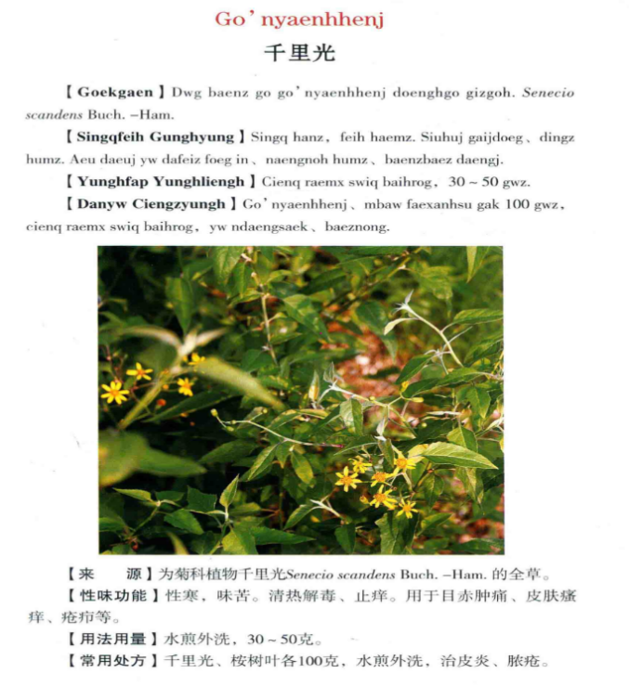
Fig. 1. The original text of Atlas- Go’nyaenhhenj
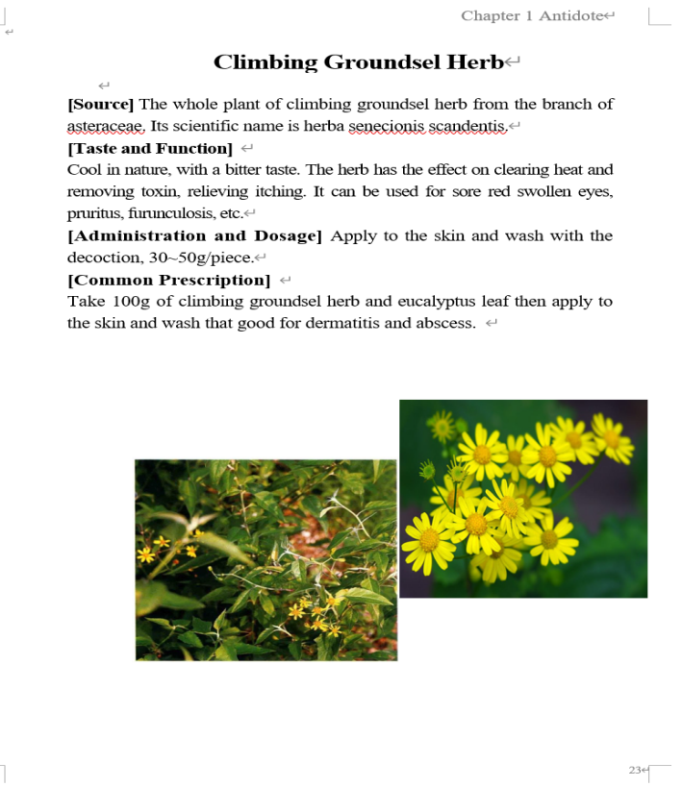
Fig. 2. The English translated version of Altas

4.3 Re-semiotization Strategies
O’Halloran (2016) and others believe that our understanding of the world is formed through the combined action of multiple symbols, each of which has a unique internal structure. The research mainly focuses on the semantic variation that occurs between different symbol resources. The Atlas is characterized by its integration of text and illustrations, its multi-dimensional interactivity, its wealth of medical terminology and its culturally rich connotations. In translating this work, the translator faced the challenge of conveying these unique cultural elements accurately and vividly to English-speaking readers. To tackle this challenge, the translator holds three main strategies: symbol transference, symbol reconstruction and symbol supplementation, then facilitate the cross-cultural transmission of Zhuang medical knowledge.
4.3.1 Symbol transference
Symbol transference refers to the use of existing, officially recognized and documented standard vocabulary and terminology to translate the original terms. Due to advances in knowledge and the rapid development of science and technology, terms recorded in English translations many years ago may be considered obscure and outdated compared to contemporary usage, rendering them unsuitable for association with contemporary culture. Therefore, it is necessary to identify and select terms that are widely recognized and frequently used in academia for application.
The Atlas features medicinal herbs whose names carry deep medical knowledge and cultural significance. When translating these names, translators must make a crucial decision: should they use transliteration with annotations, or retain the pre-labelled Latin scientific names provided in the source text? Although transliteration with annotations can preserve some cultural specificity, it can create comprehension barriers for English readers, particularly those without sufficient linguistic or cultural familiarity, as transliterated terms can be difficult to understand, and annotations can disrupt reading fluency.
After careful consideration, author adopted a zero-translation strategy, also names symbol transference, that is preserving existing official English translations of herb names sourced from multiple academic websites and dictionaries. This strategy mainly based on the interlingual aspect, that is, the transformation of symbols from Chinese to English, particularly from text to text. The approach is “target-reader-orientation”, indicating the translator strives to align with the cognitive and cultural background of the target audience to facilitate their natural acceptance of China’s ethnic minority medical culture (Xiong, 2014). Schleiermacher (2006) observed translators should try not to disturb the reader but bring the original author to the reader. This approach not only demonstrates respect for the target audience but also highlights translation’s inclusivity and adaptability as a cultural communication tool. In practice, the methods can avoid nomenclatural confusion and ensures each herb maintains a unified, scientifically recognized academic name.
Example 1:
Source text: Golwgluengh 叶下珠
English translation: Underleaf Pearl.
Underleaf Pearl also known as “Qian Gencao” in Zhuang regions, which belongs to the Euphorbiaceae family. This herb has a cool nature and sour flavour. It has the functions of clearing heat, promoting diuresis, detoxifying and reducing swelling. It is used to treat conditions such as diarrhoea and scabies. When translating this term, the author identified existing official English translations through academic websites such as Wikipedia and the A+ Medical Site, as well as other tools, thereby using symbol transference to ensure target language and cultural integrity.
However, it must be noted that while emphasizing the transfer of medical knowledge, the most fundamental medical information should not be overlooked. To ensure readers comprehend the specific functional details of underleaf pearl, basic information about the herb’s origin and its applications in modern medicine can be appended to provide a deeper understanding. This section also involves combining the symbol supplementation strategy with re-semiotization.
When encountering different expressions of a herb term on a website, in a dictionary or in another terminology inventory, the author uses online English dictionaries such as “The Free Dictionary” or “Oxford Learner’s Dictionary” to check the frequency and field of use of different vocabulary. Ultimately, the version with the higher frequency of use and recognition is chosen.
The symbol transference strategy also demonstrates respect and inheritance of professional knowledge. In the medical field, scientific terminology serves as the common language of international communication, representing global consensus and standards in medical research. By retaining these scientific terms, the author not only ensures accurate information transmission but also promotes the integration of Zhuang medical knowledge into the international medical knowledge system. This integration facilitates the global transmission of Zhuang medicine while offering valuable references for international exchanges of other ethnic medicines.
4.3.2 Symbol supplementation
Symbol supplementation means when it is necessary to describe the appearance of the herb for readers to identify and study it, the translator needs to discuss this in the translation. However, given that the page design of this text should be concise and clear, it is not necessary to present all the information in the text. This can be achieved by replacing symbol resources and combining visual cues to convey the appearance features of the medicine. This saves a large amount of text layout space. If the existing image symbols in the source text are unclear and do not meet contemporary reader’s need, they should be replaced and updated. However, for some herbs, it is necessary to provide historical background to their names to help readers understand and remember them.
This atlas contains a wealth of Zhuang medicinal slang names, which not only constitute an important part of Zhuang medical culture but also represent a critical component of re-semiotization translation and a significant opportunity to showcase Zhuang culture to the world. Therefore, the author decided to delve into the profound cultural connotations behind these names through the supplementation of textual and graphic symbols, provide readers with richer cultural background knowledge.
Example 2: Cape Jasmine Fruit
Let’s take the common herb “cape jasmine fruit” (Figure 3) as an example. We can see that in the original text, the image quality is poor, making it difficult to see the shape of the herb’s branches and leaves and the appearance of its fruit clearly. Therefore, symbol supplementation strategy needs to be adopted to guide multimodal translation practice. Besides, we knew the herb’s tender branches of cape jasmine fruit are cylindrical in shape and grey in color, with short hairs. The leaves are oblong-lanceolate or ovate-oblong in shape. The fruit is spherical or elliptical in shape and yellow or orange-red in color. The seeds are mostly round and slightly angular.
If directly translating the above shape features would lead to excessive text length, affect the layout of the original version and cause readers to experience reading fatigue and an inferior aesthetic experience. Therefore, describes the strategy of updating the translation with a new, high-definition image. This illustration allows people to intuitively understand the appearance and characteristics of a cape jasmine fruit without having to read long texts (the translated version is shown in Figure 4).
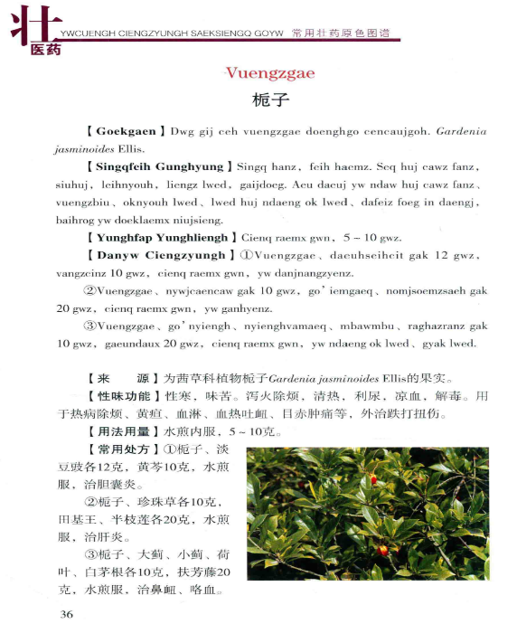
Fig. 3. The original text of Atlas- Vuengzgae
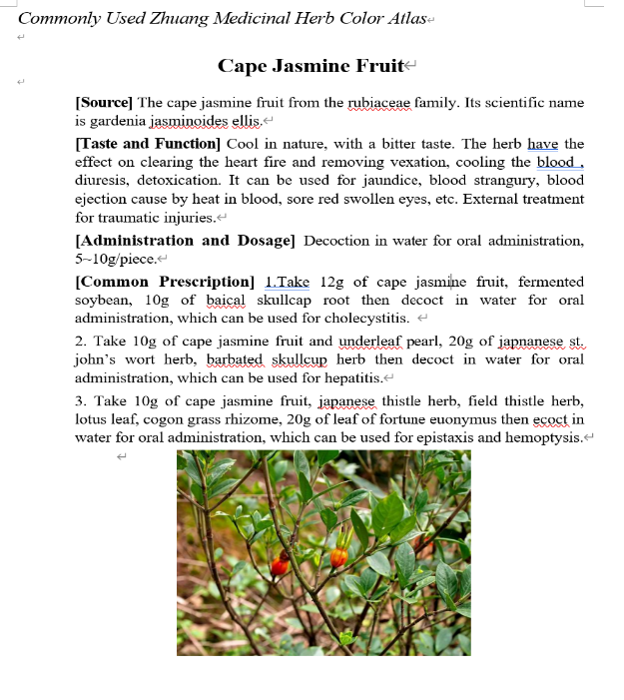
Fig. 4. The English translated version of Altas
The naming system of Zhuang medicine is complex and diverse, usually based on multiple dimensions such as the origin of the herbs, its growing environment, growth characteristics, medicinal parts, shape, color, odor, efficacy, sound, dosage, and so on. For example, those named after the growing environment include fruit-spike of common selfheal, root of meadowrue corydalis, grassleaf sweelflag rhizome, rhizome typhonii flagelliformis and others; those named after growth characteristics include shinyleaf pricklyash root, Chinese lobelia herb, Indian trumpetflower seed, ardisia japonica and so forth; those named after medicinal parts include bigleaf beautyberry leaf, fruit of caoguo; those named after the shape of the medicinal material like sword jackbean seed and those named after the color of the medicinal material include suberect spatholobus stem, yerbadetajo herb, purple common perilla and so on.
However, throughout the long course of history, the application of the names of Zhuang medicines has given rise to phenomena of “same name but different substances” and “same substance but different names”. A single name may represent a variety of different medicines; for instance, the name of Chinese pulsatilla root encompasses more than a dozen distinct medicines. Conversely, a particular Zhuang medicine may have several different names. For example, rough-leaved holly herb is also known as “Bai Diancheng”, “Tian Xinggen”, “Tu Gancao”, “Qi Xingyun”, “Cheng Gangen”, and “Shan Meigen” (Zhu, 2006). This confusion in nomenclature has once led to the mixing up of Zhuang medicine varieties, thereby affecting their use and transmission. Yet, these names all have their origins and meanings, describing the characteristics of Zhuang medicines from different perspectives. The translator should pay attention to the cultural background and the depth behind it.
Example 3:
Source text: 徐长卿
English translation: Paniculate Swallowwort Root (A nameless herb is named after a person. In ancient times, a folk doctor named Xu Changqing was called to the palace to treat emperor Taizong of Tang, Li Shimin, with a herb known as “Herba Hedyotis”. To avoid the taboo homophone of “snake” in Chinese, Xu did not reveal the name of the herb to the emperor, then named the herb as “paniculate swallowwort root”, which also transliteration for “Xu Changqing”).
Taking a common herb “paniculate swallowwort root” as an example, it is also known as “Liao Diaozhu” “Xiao Yaozhu” “Yao Shanzhu” “Dui Jielian”. It was first recorded in the “Shennong’s Classic of Materia Medica” and has the effects of dispelling wind and dampness, relieving pain and itching (Wu, 1982). It can be used to treat rheumatic pain, stomach pain and bloating, toothache, backache, injuries from falls, urticaria, and eczema. There are two explanations for the historical origin of the name “paniculate swallowwort root”: one is based on the record in “Compendium of Materia Medica” where Xu Changqing was the name of an ancient physician who often used this plant to treat diseases, and later people named the herb after him (Li, 1975). The other is a folk legend that tells of emperor Taizong of Tang, Li Shimin, who was bitten by a venomous snake and was cured by a folk doctor named Xu Changqing using “She Licao” (a herb can treat with snake diarrhea), after which the emperor named this herb as “Xu Changqing”. When translating this herb name, if text symbols are used as the main form of expression, the translation would appear lengthy and confusing. Therefore, author also chooses to add footnotes after the commonly used English translation of the herb name.
Overall, the naming culture of Zhuang medicine has many similarities with the common Chinese medicine culture, but Zhuang medicine differs and has its unique characteristics in terms of herb compatibility and treatment methods. Therefore, the classical Zhuang medicine formulas mentioned in the original text need to be handled flexibly to ensure the accuracy of the translation and the integrity of the culture.
4.3.3 Symbol reconstruction
Symbol reconstruction refers to the integration of existing symbol resources through new means of secondary innovation, translation again and re-semiotization, to generate a new symbol product. This strategy is significant as when insufficient herb information is available to optimize the allocation of symbolic resources, it provides an alternative approach: combining images and text to generate audio and video. This helps Zhuang medicine culture meet the needs of contemporary cultural dissemination and provides readers with convenience. In this process, sound and color evolve simultaneously, which creating new cultural artefacts. Compared with pictures and text, dynamic video makes it possible to spread Zhuang medicine more efficiently and effectively.
Kress and Leeuwen (2006) believe that there is a connection between images and textual descriptions. However, they do not rely on the latter because the former are organized and structured. This requires us to conduct in-depth research into the complementary effects of the two parts. Furthermore, they warn us that visual structures are not just replicas of “real” structures. On the contrary, the various images of the real world that they generate are closely linked to the interests of the social institutions that create, spread and interpret these images. They express ideology. Visual structures also important semantically. This means that, like language, images have both a replicative and a reconstructive effect on social and psychological reality.
The significance of multimodal translation lies in its ability to integrate language with other related semantic resources (Gibbon, 2000). Not only can it good for the language system in the process of meaning exchange, but it can also take an effect on other symbol systems, such as images, music and colors, in this process. This makes the interpretation of discourse meaning more comprehensive and accurate and reveals how humans can use multiple modalities to achieve social communication goals. The symbol reconstruction strategy can effectively achieve this goal by combining image, text, audio, and video translation practices.
In Zhuang medicine, many herbs not only have remarkable therapeutic effects in terms of their medicinal value, but also have unique functions in other fields. The multidimensional efficacy varies across different medicinal parts, offering vast potential for the comprehensive application of these medicines.
Take ovateleaf holly bark (in Chinese “救必应” ) as an example, which is the bark of ilex rotunda thunb, an plant from the aquifoliaceae family. In medicine, it is mainly valued for its heat clearing, detoxifying, dampness removing and relieving pain. However, the other uses of this herb are also worthy of note. In the timber industry, the branches and leaves of ovateleaf holly bark can be used as a higher quality raw material for papermaking. Its bark can be used to extract dyes and tannins. In terms of ecological value, ovateleaf holly bark can also be used as a tree species for firebreaks due to its leathery leaves, which are not easily flammable. This expanded knowledge will not only broaden the horizons of readers, but also inspire those interested in Zhuang medicine to further explore relevant knowledge, thereby promoting the transmission of knowledge about Zhuang medicine culture.
However, when preserving this extended knowledge, translator need to consider the overall layout and typesetting of the page. Excessive text content can make the translation seem long and detract from the reading experience. As the source text is an atlas, the most important feature of the typesetting is that the information for each medicine is concentrated on a single page for easy reading by the reader. Therefore, when taking symbols reconstruction, translator need to carefully select and configure other symbolic resources or provide a concise summary of the other uses of the medicine. For the background information on ovateleaf holly bark, the author needs to simplify the content and place a QR code next to its picture. Readers can scan the code to watch the English video introduction of ovateleaf holly bark and get the background knowledge in a more intuitive and convenient way (the final translated version is shown in Figure 5, 6, 7). In this way can preserve the multidimensional value of the medicine, and ensure the readability and practicality of the translation, so that it can better serve the target readers.
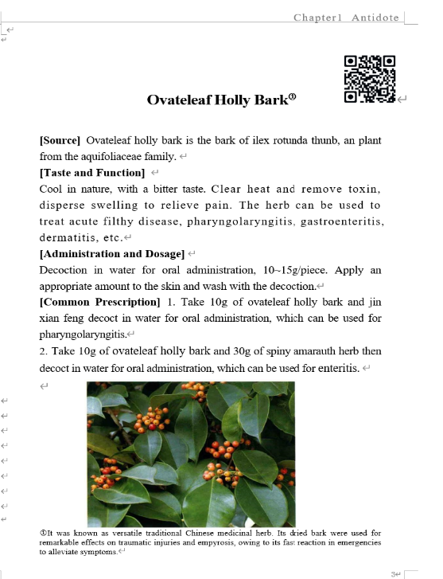
Fig. 5. The final translated version of Altas
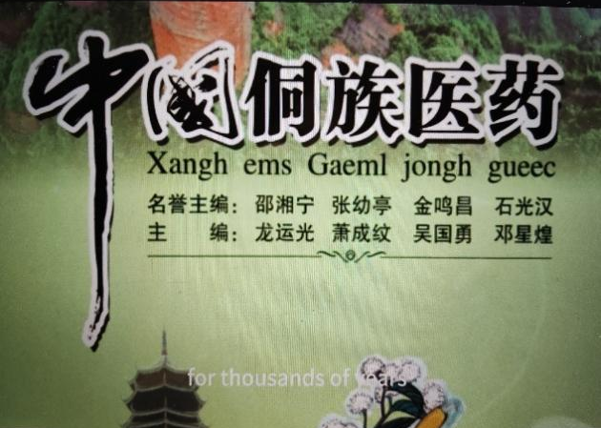  Fig. 6. Screenshot of the symbol reconstruction video(a) | 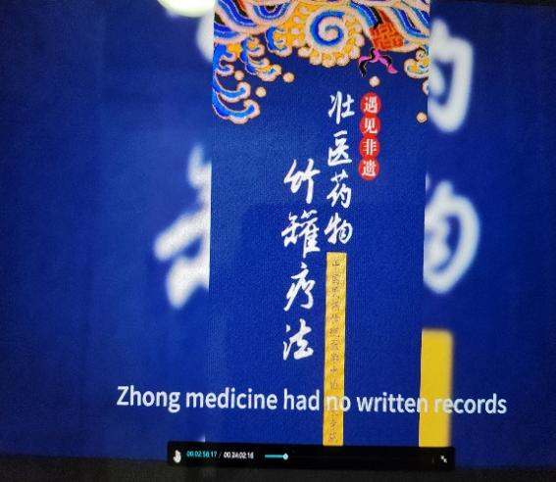  Fig. 7. Screenshot of the symbol reconstruction video(b)
In the multimodal translation process, the strategy of re-semiotization is not only a macro-principle, but also a bond closely connected with the participants in the translation activity, as well as the original author, the translator and the target audience. When using re-semiotization translation on the Atlas, the translator is both the executor of the translation work and the recipient of the text content. In the process of interpreting the original text and producing the English translation, translator must adopt appropriate translation strategies based on the specific content of the original text that maximize the reproduction of the meaning of the discourse. This process requires the translator to carefully coordinate and balance the linguistic, textual and cultural levels. This includes, but is not limited to consideration of the reordering and layout of images and text, the overall choice of color and aesthetic embellishment of the translation, the choice of translation style, and the in-depth interpretation of the cultural connotations behind the local names of herbs in the Zhuang region.

5. CONCLUSION
This article analyses the development potential of multimodal re-semiotization translation based on the current state of ethnic medicine translation. To keep up with the times and promote the development of multimodal translation of Zhuang medicine in China, it is necessary to update and improve this section to cope with the future development of international and multicultural exchanges. A creative practice for re-semiotization strategies in the multimodal translation of Zhuang medicine based on a color atlas, providing relevant re-symbolization strategies on symbol transference, supplementation and reconstruction. Problems encountered include searching for and unifying professional terminology, creating videos using different symbol resources and attaching them to QR codes or updating symbol resources and so do forth. This article elaborates on the use of re-semiotization strategies based on multimodal translation theory to guide this field’s translation practice.
Through such re-semiotization strategies, Zhuang medicine knowledge can able to transcend linguistic and cultural barriers and is presented to global readers in an entirely new multimodal form. This not only helps to preserve and promote Zhuang medicine culture, but also enriches and expands the diversity of human medicine. The strategies involve focusing on the specific needs of the translation task, which is producing a text that is functionally equivalent to the source material, while taking account into the constraints and context of the target audience, purpose, and medium (Nord, 2014). The re-semiotization strategy of multimodal translation of Zhuang medicine is not only a translation practice, but also a cultural innovation. It combines the ancient wisdom of Zhuang medicine with modern communication technology, contributing unique wisdom and power to the cause of human health.

DISCLAIMER (ARTIFICIAL INTELLIGENCE)
Author(s) hereby declare that NO generative AI technologies such as Large Language Models
(ChatGPT, COPILOT, etc.) and text-to-image generators have been used during the writing or
editing of this manuscript.

COMPETING INTERESTS DISCLAIMER:
Authors have declared that they have no known competing financial interests OR non-financial interests OR personal relationships that could have appeared to influence the work reported in this paper.

REFERENCES

Almashhadani, M., & Almashhadani, H. A. (2023). English translations in project management: Enhancing cross-cultural communication and project success. International Journal of Business and Management Invention, 12(6), 291-297.
Gibbon, Dafydd, Inge Mertins & RogerK. Moore. (2000). Handbook of Multimodal and Spoken Dialogue Systems. Boston: Kluwer Academic Publishers.
Hu, W. W., & Liang, J. Y. (2022). Review and prospect of ethnic medicine translation research (1984—2021). Minority Translators Journal, (5), 54-62.
Iedema, R. (2003) Multimodality, resemiotization: Extending the analysis of discourse as multi-semiotic practice (2th ed., pp. 29-57). Visual Communication.
Jakobson, B. (1959). On linguistic aspect of translation. Brower R A. On Translation. Cambridge, MA：Harvard University Press (pp. 232-239).
Jiang, J. C., Fu, Y. Q., … & Cen, S. Y. (2022). A discussion on the English translation of specific terms in Zhuang medicine. Global Traditional Chinese Medicine, 15(1), 137-140.
Kaindl, K. (2019). A theoretical framework for a multimodal concept of translation. In M. Boria, A. Carreres, M. Noriega-Sanchez & M. Tomalin(eds.). Translation and Multimodality: Beyond Words (49-70). New York: Routledge.
Khayru, R. K. (2022). Globalization and the Reconfiguration of Traditional Medicine Across Cultures and Healing Systems. Journal of Social Science Studies, 2(1), 253-258.
Kress, G. & Van Leeuwen, T. (2001). Multimodal discourse: The modes and media of contemporary communication (20). London: Arnold.
Kress, G. & Van Leeuwen, T. (2006). Reading Images: The Grammar of Visual Design. London: Routledge.
Li, S. Z. (1975). Compendium of Materia Medica. Beijing: People’s Medical Publishing House.
Li, X. H., & Tang, Q. Y. (2021). A visualized overview of domestic research on multimodal translation: Status quo, problems and suggestions. Journal of University of Science and Technology Beijing. (5), 534-542.
Li, X. Y., & Wang, H. (2019). Translation studies of intercultural communication of Zhuang medicine culture from the perspective of memetics: With the general rules of treatment of Zhuang medicine as a case. Chinese Journal of Ethnomedicine and Ethnopharmacy, 28(22), 1-4.
Nord, C. (2014). Translating as a purposeful activity: Functionalist approaches explained (2nd ed.). Routledge.
O’ halloran, K. L., Tan. S., & Wignell, P. (2016). Intersemiotic translation as resemiotisation: a multimodal perspective. Special Issue on Translating: Signs, Texts, Practices, 7(7): 199-229.
Pan, G. Q. (2023). Research on the translation strategy of Zhuang medicated food under the theory of cultural schema. Overseas English, (21), 29-31.
Remali, J., & Aizat, W. M. (2024). Medicinal plants and plant-based traditional medicine: Alternative treatments for depression and their potential mechanisms of action. Heliyon, 10(20).
Schleiermacher, F. (2006). On the different methods of translation. In Robinson, D. (ed.). Western Translation Theory: From Herodotus to Nietzsche. Beijing: Foreign Language Teaching and Research Press.
Wang, W. P., & Zhang, N. (2022). The triple interpretation of Marx’s concept of nature: Practicality, historicity, and concreteness. Studies in Ideological Education, (5), 78-84.
Wu, B. & Mou, Y. W. (2022). Research on multimodal national translation strategies for Chinese stories. Foreign Language Education, (1), 76-82.
Wu, P. (1982). Shennong’s Classic of Materia Medica. Beijing: People’s Medical Publishing House.
Xiong, B. (2014). Conceptual confusion in translation studies: Translation strategy, translation method and translation technique. Chinese Translators Journal, (3), 82-88.
Yang, B., Shao, B., Wu, L., & Lin, X. (2022). Multimodal sentiment analysis with unidirectional modality translation. Neurocomputing, 467, 130-137.
Zhang, H. B., & Liu, T. J. (2009). Discussion on the connotation and classification of ethnic medicine. Journal of Medicine & Pharmacy of Chinese Minorities, (4), 71-73.
Zhang, W. H., & Kang, L. M. (2023). Multimodal translation and international communication of Chinese Wushu. Journal of Wuhan Sports University, 57(10),55-62.
Zhou, F. (2018). Research on the translation of Zhuang and Yao medical culture under the background of the “Belt and Road” in Guangxi. Chinese Journal of Ethnomedicine and Ethnopharmacy, 27(10), 1-4.
Zhu, H. & Wei, S. J. (2006). Pharmacology of Zhuang Medicine. Guangxi: Guangxi Nationalities Publishing House.

