Original Research Article
Screening of Brassica spp Genotypes against Sclerotinia Stem Rot under Natural Epiphytotic Conditions
Abstract
Sclerotinia stem rot, caused by Sclerotinia sclerotiorum (Lib.) de Bary, is a major fungal disease affecting mustard (Brassica spp.), leading to significant yield losses, especially under cool and humid conditions. The present investigation was conducted during the Rabi 2024-25 at the Zonal Agricultural Research Station, Morena, RVSKVV, Gwalior, Madhya Pradesh, India, to evaluate seventy-three mustard genotypes for putative resistant to Sclerotinia stem rot under natural epiphytotic conditions. The experiment was laid out in a Randomized Block Design with two replications, and disease severity was assessed at 60 days after sowing employing a 0–4 lesion length-based disease rating scale. Significant genetic variability was observed among the genotypes for disease reaction. Out of the 73 genotypes screened, 51 (approximately 70%) were found to be completely resistant (rating 0), displayed no visible disease symptoms. Nineteen genotypes were found moderately tolerant (rating 1), with lesion lengths ranging between 0.1 to 2.0 cm. Two genotypes exhibited moderate susceptibility (rating 2), while none was categorized as susceptible (rating 3). Only one genotype namely GSC-6 was found to be highly susceptible (rating 4), displaying lesions greater than 6.0 cm in length. The results underscore the availability of diverse resistance sources within the mustard germplasm and highlighted the potential of resistant and moderately tolerant genotypes for further use in breeding programmes aimed to breed Sclerotinia-resistant cultivar (s). The study confirms the effectiveness of field-based screening under natural disease pressure and supports the integration of host plant resistance as a core strategy in sustainable disease management. The identified resistant genotype (s) hold promises for future genetic improvement and development of high-yielding, Sclerotinia stem rot -resilient mustard varieties.
Keywords: Disease screening, Mustard (Brassica spp.), Resistance breeding, Sclerotinia stem rot, Sclerotinia sclerotiorum
1. Introduction
Mustard (Brassica spp.), belonging to the family Brassicaceae, is one of the most important and widely cultivated oilseed crops across the world, particularly in South Asia (Baghel et al., 2020; Szőllősi, 2020). Brassica species account for approximately 14% of global oilseed production and represent the second most significant source of vegetable oil worldwide (Vemana et al., 2023; Tripathi et al., 2025). Indian mustard (Brassica juncea), commonly referred to as rai, raya, or laha, occupies a major share of the Brassica oilseed cultivation in India, contributing over 85% to the country's total rapeseed-mustard production (Yadav et al., 2021). India is one of the foremost global producers of rapeseed-mustard, ranking third in significance after soybean and oil palm. The country contributes approximately 19.8% to the global rapeseed-mustard production and accounts for 28.3% of the total cultivated area worldwide. The crop is grown over 6.45 million hectares, with an annual production of 7.28 million tonnes and an average yield of 1128 kg per hectare (Rai et al., 2024). The seeds typically contain 36–42% oil, 17–25% protein, 8–10% fibber, 6–10% moisture, and 10–12% extractable substances, making it a crucial source of edible oil for human consumption and oilseed cake for animal feed (Barfa et al., 2017; Yadav et al., 2021). In addition to its economic significance, mustard plays an important role in crop diversification and sustainable agriculture, as it is often integrated into cereal-based cropping systems like rice-mustard or maize-mustard rotations (Das et al., 2020; Rajpoot et al., 2020; Jaiswal et al., 2024). It is well adapted to the subtropical climate of the Indian subcontinent and is typically grown during the Rabi (winter) season under both irrigated and rainfed conditions (Rajpoot et al., 2022). Its short growing period, low input requirements, and suitability for cultivation on marginal and semi-arid lands make it an ideal crop for small and marginal farmers (Shekhawat et al., 2012; Singh et al., 2025). However, despite its agronomical potential, mustard productivity is often limited by an array of biotic and abiotic stresses (Yadav et al., 2019; Verma et al., 2021; Shrivastava et al., 2023a; Shrivastav et al., 2023b; Shrivastava et al., 2023c). Among the biotic stresses, fungal diseases pose a significant challenge, with Sclerotinia stem rot emerging as one of the most destructive diseases in recent years (Rakesh et al., 2016; Pippal et al., 2022; Shrivastava et al., 2023d; Shrivastava et al., 2023e; Rai et al., 2024; Shrivastav et al., 2024).
Sclerotinia stem rot, caused by Sclerotinia sclerotiorum (Lib.) de Bary, is a serious soil- and air-borne disease that affects a wide range of host plants, including economically important crops like mustard, sunflower, soybean, chickpea and groundnut (Hossain et al., 2023). In rapeseed-mustard it begins as water-soaked lesions on the stem, later covered by white mycelial growth. The disease spreads through infected flower petals, leading to leaf necrosis, stem shredding, and defoliation. Severely infected plants wilt, dry prematurely, and ripen earlier, appearing whitish and distinct among healthy green plants (Rakesh et al., 2016). Under favourable conditions for disease development, yield losses in rapeseed-mustard typically ranged between 20–35%; however, instances of severe outbreaks have been documented, resulting in losses exceeding 50%, and in certain regions, even reaching up to 80–100% (O’Sullivan et al., 2021). Moreover, early-stage infections of Sclerotinia sclerotiorum are highly destructive, with post-flowering infections reducing Brassica juncea yield by up to 51%, and flowering-stage infections potentially causing complete yield loss. The disease can also reduce oil content by 35% and protein content by 40% (Gupta et al., 2025). The disease is particularly favoured by cool and humid conditions, with temperatures ranging between 20-25°C and relative humidity above 80%, especially during the flowering to pod-filling stages. The survival of sclerotia in the soil for multiple seasons and the pathogen’s ability to infect a wide range of hosts make its management extremely difficult (Peltier et al., 2012; Markell et al., 2015). Chemical control measures, though available, are often not economically viable or environmentally sustainable, especially for resource-poor farmers (Tripathi et al., 2015; Shyam & Tripathi, 2019). Biological control and cultural practices offer limited and inconsistent results (Shyam et al., 2020). Therefore, the deployment of resistant cultivars remains the most effective, eco-friendly, and long-term solution for managing Sclerotinia stem rot in mustard (O’Sullivan et al., 2021; Shyam et al., 2021a; Shyam et al., 2021b; Han et al., 2023).
Breeding for resistance is challenging due to the quantitative nature of resistance, environmental interactions and limited availability of identified resistant sources (Shyam et al., 2021c; Shyam et al., 2021d). In this context, field-based screening under natural epiphytotic conditions plays a vital role in identifying promising genotypes exhibiting stable resistance (Bisoriya et al., 2025; Jhariya et al., 2025; Gautam et al., 2025). Such genotypes can serve as valuable genetic resources for incorporation into breeding programmes aimed to develop stem rot-resistant mustard cultivars. Given the importance of enhancing disease resistance in mustard, the present investigation was undertaken to evaluate seventy-three mustard genotypes, under natural field conditions for their response to Sclerotinia sclerotiorum. The study aimed to categorize the genotypes based on their disease reaction employing a standardized rating scale, thereby identifying potential resistant sources for future crop improvement efforts.
2. Material & Methods
2.1 Experimental site
The field investigation was conducted during the Rabi, 2024-25 at the Research Farm, Zonal Agricultural Research Station Morena, RVSKVV, Gwalior, Madhya Pradesh, India (Fig. 1). The site is geographically situated at 26.5°N latitude and 78.0°E longitude, at an altitude of 177 meters above mean sea level. The region experiences a semi-arid subtropical climate characterized by cool and dry winters, which is well-suited for mustard cultivation. The experimental field comprised medium-black soils with uniform topography and adequate drainage, free from waterlogging, thereby creating favourable edaphic conditions for field experimentation. According to agrometeorological data (Table 1) recorded during the crop growth period (October 2024 to March 2025), the maximum and minimum temperatures ranged between19.8°C to 34.0°C and 5.9°C to 19.7°C, respectively. Morning and evening relative humidity levels fluctuated between 57.1%–90.4% and 43.5%–71.2%, correspondingly. Intermittent light rainfall (0.4–2.1 mm) during December and January contributed to the development of favourable microclimatic conditions conducive to the natural incidence and progression of Sclerotinia sclerotiorum. These climatic and soil conditions provided an appropriate environment for the effective field screening of mustard genotypes for putative resistant to Sclerotinia stem rot under natural epiphytotic conditions.

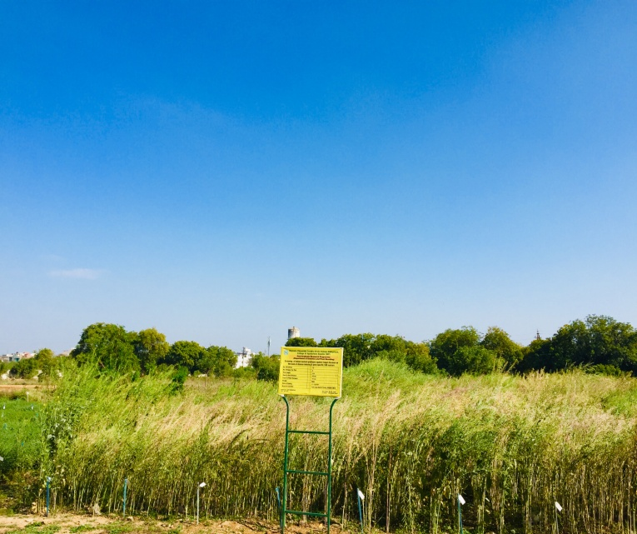
Fig. 1: View of experimental field
Table 1 Weekly meteorological data for the crop growing period
No. of week | Date | Temperature (⁰C) |  | Humidity (percent) |  | Rainfall (mm)
No. of week | Date | Max. | Min. | Morning | Evening | Rainfall (mm)
1 | Oct 23-29 | 34.0 | 19.0 | 64.7 | 50.4 | 0
2 | Oct 30-Nov5 | 32.4 | 19.7 | 63 | 43.1 | 0
3 | Nov 6-2 | 31.3 | 18.0 | 66.4 | 49.1 | 0
4 | Nov 13-19 | 29.5 | 14.8 | 71.7 | 52.7 | 0
5 | Nov 20-26 | 27.3 | 11.6 | 70.7 | 56.8 | 0
6 | Nov 27-Dec 3 | 26.7 | 10.5 | 65.2 | 49.2 | 0
7 | Dec 4 -10 | 25.7 | 9.2 | 72.2 | 49.2 | 0
8 | Dec 11-17 | 22.1 | 5.9 | 72.4 | 44.2 | 0
9 | Dec 18-24 | 22.9 | 8.3 | 78.5 | 48.5 | 0
10 | Dec 25-Dec 31 | 21.2 | 9.5 | 84.2 | 58.8 | 2.1
11 | Jan 1-7 | 19.8 | 8.0 | 79.7 | 60.8 | 0
12 | Jan 8-14 | 19.8 | 8.0 | 89.7 | 71.2 | 0.6
13 | Jan 15-21 | 19.8 | 9.7 | 90.4 | 67.1 | 0.9
14 | Jan 22-28 | 23.9 | 9.5 | 72.5 | 57.1 | 0
15 | Jan 29-Feb 4 | 24.7 | 9.9 | 70.2 | 60.0 | 0
16 | Feb 5-11 | 25.5 | 10.1 | 71.7 | 54.7 | 0
17 | Feb 12-18 | 28.4 | 12.2 | 72.1 | 53.5 | 0
18 | Feb19-25 | 26.9 | 13.0 | 62.4 | 43.5 | 0.4
19 | Feb 26-Mar.4 | 30.2 | 15.4 | 72.7 | 51.1 | 0
20 | March 5-11 | 30.7 | 13.9 | 62.8 | 47.7 | 0
21 | March12-18 | 34.0 | 17.7 | 57.1 | 43.5 | 0
22 | March19-25 | 33.0 | 16.6 | 62.4 | 43.5 | 0
Source: Agrometrology observatory, ZARS, Morena, RVSKVV, Gwalior
2.2. Experimental details
A total seventy-three mustard genotypes (Table 2) acquired from diverse sources were evaluated to assess their response to Sclerotinia sclerotiorum under natural field conditions. The experiment was laid out in a Randomized Block Design with two replications to ensure statistical validity and minimize environmental variability. Each genotype was sown in plots with a spacing of 30 cm between rows and 10 cm between plants, allowing for proper crop stand and disease expression. Standard agronomic practices were followed uniformly throughout the experimental period to ensure optimal crop growth and development. This experimental setup facilitated the effective evaluation of genetic variability among mustard genotypes for resistant against Sclerotinia stem rot.
Table 2 List of genotypes with their parentage/source
S. No. | Genotypes | Parentage/Source | S. No. | Genotypes | Parentage/Source
1. | Pusa Bold | Varuna x BIC1780 | 37. | PC-6 | Acquired from ZARS, Morena, RVSKVV, Gwalior
2. | Varuna | Selection from Varansi Local | 38. | RP-9 | Acquired from ZARS, Morena, RVSKVV, Gwalior
3. | Rohini | Selection from natural population of Varuna | 39. | Kiran | Acquired from ZARS, Morena, RVSKVV, Gwalior
4. | Kranti | Selection from Varuna | 40. | JTC-1 | Acquired from ZARS, Morena, RVSKVV, Gwalior
5. | Krishna | GBPUAT, Pantnagar | 41. | JM-1 | Pusa Bold X L 6
6. | Maya | Varuna x KRV 11 | 42. | JM-2 | Mutant of RL9
7. | Vardan | Derived through biparental mating involving Varuna Keshari, CSU 10 and  IB 1775, IB 1786& IB 1866 | 43. | JM-3 | Varuna x YRT 3
8. | Vasundhara | RH 839 x RH 30 | 44. | RVM-1 | ZARS, Morena, RVSKVV, Gwalior
9. | Swarna Jyoti | Selection from germplasm line RC1670 | 45. | RVM-2 | Selection from Chambal growing region
10. | Pusa Jagannath | Varuna x Synthetic juncea | 46. | RVM-3 | ZARS, Morena, RVSKVV, Gwalior
11. | Pusa Mahak | Acquired from IIRMR, Bhartpur | 47. | PM-25 | Sej-8 x Pusa Jagannath
12. | Pusa Jai Kisan | Somaclone of Varuna | 48. | PM-26 | VEJ Open x Pusa Agrani
13. | Albeli | Acquired from ZARS, Morena, RVSKVV, Gwalior | 49. | PM-27 | Derived from the cross [(Divya x Pusa Bold) x (PR 666EPS) x PR 704EPS-2xB85)]
14. | Sej-2 | Derived from a cross of B. juncea to an amphidiploid | 50. | PM-28 | SEJ8 × Pusa Jagannath
15. | Shraddha | Acquired from ZARS, Morena, RVSKVV, Gwalior | 51. | PM-30 | Bio 902, X ZEM 1
16. | DMH 1 | CMS based hybrid | 52. | Pusa Vijay | Synthetic Brassica juncea x VSL
17. | L – 4 | Canada | 53. | PDZM-31 | Acquired from IIRMR, Bharatpur
18. | L – 6 | Canada | 54. | NPJ-253 | Acquired from IIRMR, Bhartpur
19. | JMWR-908-1 | ZARS, Morena, RVSKVV, Gwalior | 55. | JMM-927 | ZARS, Morena, RVSKVV, Gwalior
20. | RGN-73 | RGN8 x Pusa Bold | 56. | JMM-991 | ZARS, Morena, RVSKVV, Gwalior
21. | NRC-HB-101 | BL4 x Pusa Bold | 57. | RMM-10-1-1 | ZARS, Morena, RVSKVV, Gwalior
22. | NRC-HB-506 | MJA 05 x MJR 1 | 58. | RMM-12-1-18 | ZARS, Morena, RVSKVV, Gwalior
23. | DRMR-1165-40 | ICAR-IIRMR Bharatpur | 59. | RMM-12-2-18 | ZARS, Morena, RVSKVV, Gwalior
24. | RH-406 | CCS HAU, Hisar | 60. | RMM-12-3-18 | ZARS, Morena, RVSKVV, Gwalior
25. | RH-725 | CCSHAU, Hisar | 61. | JMWR-945-2-2-75k | ZARS, Morena, RVSKVV, Gwalior
26. | RH-749 | RH-781 xRH-9617 | 62. | Bio-Y-SR | Acquired from IIRMR, Bharatpur
27. | NRCDR-2 | MDOC43 x NBPGR36 | 63. | JMTA-06-1 | Acquired from IIRMR, Bharatpur
28. | Giriraj | ICAR-IIRMR Bharatpur | 64. | Banarasi Rai | Acquired from IIRMR, Bharatpur
29. | RB-50 | Laxmi X RH-9617 | 65. | Pro-Agro-5232 | Crystal Crop Protection Ltd.
30. | YSH-401 | ICAR-IIRMR Bharatpur | 66. | Pro-Agro-5235 | Crystal Crop Protection Ltd.
31. | NC-1 | ICAR-IIRMR Bharatpur | 67. | Pioneer 44-S-36 | Exmark Company
32. | China Cabbage | Acquired from IIRMR, Bharatpur | 68. | NMH 90M 01 | Nuziveedu Seeds, an Indian Agricultural Company
33. | GSL-1 | Punjab Agricultural University, Ludhiana | 69. | Brijraj | Acquired from IIRMR, Bharatpur
34. | GSC-6 | Punjab Agricultural University, Ludhiana | 70. | Radhika | Acquired from IIRMR, Bharatpur
35. | GSC-7 | Punjab Agricultural University, Ludhiana | 71. | RMM - 19-06 | ZARS, Morena, RVSKVV, Gwalior
36. | PC-5 | Acquired from ZARS, Morena, RVSKVV, Gwalior | 72. | RMM - 19-12 | ZARS, Morena, RVSKVV, Gwalior
 |  |  | 73. | RMWR - 09-01 | ZARS, Morena, RVSKVV, Gwalior

2.3 Screening of genotypes against stem rot disease
For the assessment of putative resistance to Sclerotinia sclerotiorum, all seventy-three Brassica spp. genotypes were evaluated under natural field conditions. Disease incidence and severity were recorded at 60 days after sowing (DAS) to capture the critical stage of disease progression. To assess disease severity, a 0–4 disease rating scale (Table 3), as proposed by Sansford (1995), was employed. This scale quantifies the lesion length on the stem and categorizes genotypes based on their degree of susceptibility or resistance. The disease intensity rating criteria were as follows:
Table 3 Disease rating scale for stem rot in mustard (Sansford, 1995)
Rating | Disease incidence per cent and symptoms | Disease reaction
0 | Healthy or no visible symptoms | Resistant
1 | 0.1-2 cm lesion length on stem | Moderately tolerant
2 | 2.1-4 cm lesion length on stem | Moderately susceptible
3 | 4.1-6 cm lesion length on stem | Susceptible
4 | >6 cm lesion on stem | Highly susceptible
Disease severity observations were recorded from five randomly selected plants per replication and genotype. This method ensured reliable phenotyping of genotypes for resistance or susceptibility against Sclerotinia stem rot under natural epiphytotic conditions.
3. Results & Discussion
The disease severity was assessed at 60 days after sowing using a 0–4 disease rating scale based on lesion length on the stem (Table 4, Fig. 2). The results revealed presence of considerable genetic variability among the genotypes in their response to stem rot disease. Out of the 73 genotypes, 51 genotypes (approximately 70 %) exhibited complete resistance (rating 0), showed no visible symptoms or lesion formation on the stem. These genotypes, which included Shraddha, RVM-1, Pro Agro 5235, Pusa Mahak, Radhika, Brijraj, JMWH-908-1, Pusa Vijay, RH-725, NPJ-253, Kranti, NRCHB-101, Pusa Bold, Sej-2, and many others, demonstrated strong inherent resistance, possibly due to the presence of stable genetic factors conferring resistance against S. sclerotiorum. Such genotypes serve as promising donors for introgression of resistance in susceptible along with high-yielding lines (Singh et al., 2022; Gupta et al., 2025).
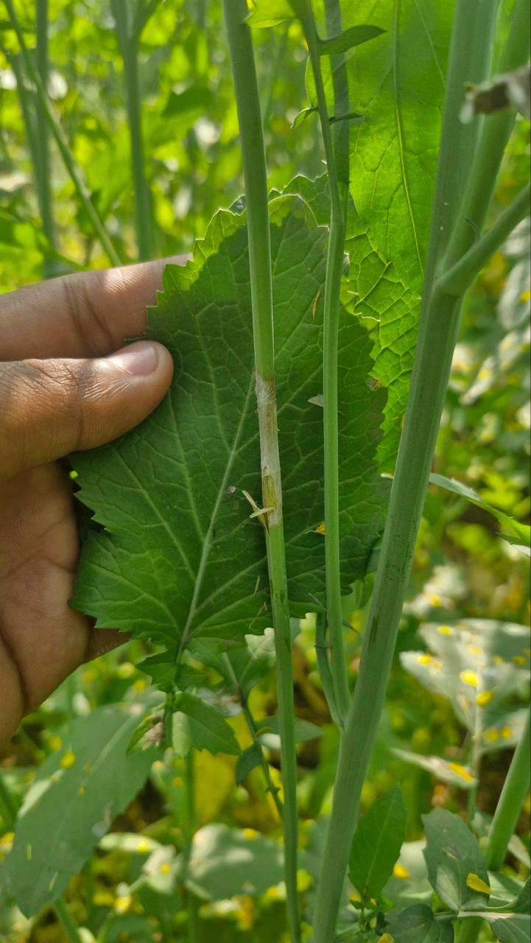 | 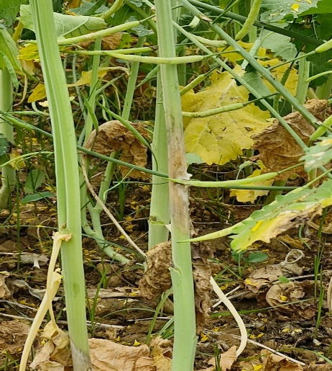 | 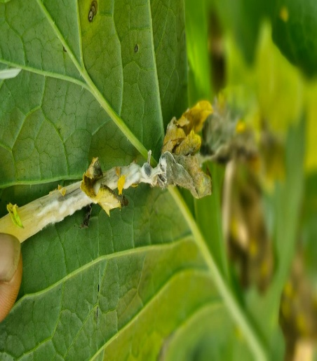
Fig. 2: Symptoms of Sclerotinia stem rot in mustard
Additionally, 19 genotypes were categorized as moderately tolerant (rating 1), exhibiting lesion lengths ranged from 0.1 to 2.0 cm. These genotypes were included RH-749, Krishna, Vasundhara, China Cabbage, RB-50, PM-28 and PM-30 and others as they displayed restricted pathogen colonization and symptom expression. Their partial resistance could be due to structural barriers such as thickened cell walls or biochemical responses that limit lesion expansion. Although not immune, such genotypes may still be proved useful in resistance breeding programmes, especially when combined with favourable agronomical traits (Gill et al., 2022; Nain et al., 2023; Shang et al., 2024). Only two genotypes viz., NRCDR-2 and Pro-Agro 5232 were found moderately susceptible (rating 2), demonstrated lesion lengths between 2.1 and 4.0 cm, while none of the tested genotypes fell into the susceptible category (rating 3).
Only one genotype namely GSC-6, was identified as highly susceptible (rating 4), with lesions exceeding 6.0 cm in length, indicating its high vulnerability to S. sclerotiorum. This genotype could serve as a susceptible check in future screening trials. The predominance of resistant and moderately tolerant genotypes in the current investigation is highly encouraging, as it highlights the presence of considerable genetic variation for stem rot resistance within the mustard genotypes as earlier reported by Singh et al. (2021), Singh et al. (2022) and Singh et al. (2023). These results are consistent with earlier findings that emphasized significant genotypic differences in resistance to Sclerotinia among Brassica species, attributed to both monogenic and polygenic inheritance patterns (Rana et al., 2017; Naher et al., 2018; Choudhary et al., 2021; Khan et al., 2023).
Moreover, the absence of genotypes in the fully susceptible range suggests that prior breeding efforts and germplasm conservation may have contributed to a gradual elimination of highly susceptible material from the gene pool (Bisht et al., 2015; Singh et al., 2021). The observed resistance under natural disease pressure also indicates the robustness of field-based phenotyping for identifying durable resistance. This study underlines the importance of deploying resistant genotypes in integrated disease management strategies and suggested that identified resistant and moderately tolerant genotype (s) can serve as valuable resources for developing high-yielding and disease-resistant mustard cultivars through marker-assisted selection and conventional breeding approaches (Mundt, 2014; Sharma et al., 2018; Singh et al., 2019; Mishra et al., 2024; Anushree et al., 2025).
Table 4 Categorizations of mustard genotypes against stem rot
Rating | Lesion length on stem (cm) | Disease reaction | Number of genotypes | Name of genotypes
0 | 0 | Resistant | 51 | Shraddha, RVM-1, RGN-73, Pusa Mahak, Radhika, Brijraj, Swarna Jyoti, Pusa Jagannath, JM1, Pusa Vijay, Bio-Y-SR, JMWR-945-2-2-75k, PM-27, JMM-991, RH-725, JM3, NPJ-253, Kranti, PM-25, RMM-12-2-18, RMM-10-1-1, Albeli, NRC-HB-101, Vardan, Rohini, JM-2, PM-26, RMM 12-1-18, RMM 12-3-18, DMH-1, RMM-19-12, Maya, NRC-HB-506, RMWR-09-01, Giriraj, RMM-19-06, Pusa Bold, Sej-2, Pusa Jai Kisan, L-4, RH-406, YSH-401, NC-1, PC-5, PC-6, RP-9, Kiran, GSC-7, JTC-1, Banarasi rai, Pro-Agro-5235
1 | 0.1-2.0 | Moderately Tolerant | 19 | Varuna, DRMR-1165-40, RH-749, Krishna, Vasundhara, L-6, JMWR-908-1, RB-50, China Cabbage, GSL-1, RVM-2, RVM-3, PM-28, PM-30, PDZM-31, JMM-927, JMTA-06-1, Pioneer 44S36, NMH 90 M 01
2 | 2.1-4.0 | Moderately Susceptible | 2 | NRCDR-2, Pro Agro 5232
3 | 4.1-6.0 | Susceptible | 0 | -
4 | >6 | Highly Susceptible | 1 | GSC-6
Conclusion
The present study successfully identified a wide range of variability in mustard genotypes for resistance to Sclerotinia stem rot under natural field circumstances. Out of seventy-three genotypes evaluated, fifty-one exhibited complete resistance (lesion length = 0 cm), while nineteen genotypes showed moderate tolerance, suggesting strong potential for use in resistance breeding. The absence of genotypes in the susceptible category and identification of only a single highly susceptible entry namely GSC-6 further indicate the predominance of resistance in the studied germplasm. These findings provide a valuable genetic resource for future breeding programmes pointing to breed mustard cultivar (s) with durable resistance to Sclerotinia stem rot. Incorporating these resistant and moderately tolerant genotypes into breeding pipelines can significantly contribute to sustainable mustard production and disease management strategies under changing climatic conditions.
Disclaimer (Artificial Intelligence)
Author(s) hereby declares that no generative AI technologies such as Large Language Models (ChatGPT, COPILOT, etc.) and text-to-image generators have been used during the writing or editing of this manuscript.
References
- Anushree, Kumar, V., & Nagarjun, P. (2025). Unlocking the genetic potential of Indian mustard (Brassica juncea L.): A review on advances in breeding approaches. Agricultural Science Digest. https://doi.org/10.18805/ag.D-6254
- Baghel, R., Sharma, A.K., Tiwari, S., Tripathi, M.K., & Tripathi, N. (2020). Genetic diversity analysis of Indian mustard (Brassica spp.) germplasm lines using SSR molecular markers. Int J Curr Microbiol App Sci. 9(12):137-143.
- Barfa, D., Tripathi, M.K., Kandalkar, V.S., Gupta, J.C., & Kumar, G. (2017). Heterosis and combining ability analysis for seed yield in Indian mustard [Brassica Juncea (L) Czern & Coss]. Eco. Env. & Cons., 23 (Suppl): 75-83.
- Bisht, K. S., Rana, M., Gairola, K., Sharma, B. C., Tewari, A. K., & Awasthi, R. P. (2015). Screening of Brassica germplasm for resistance to major diseases of rapeseed-mustard. The Bioscan, 10(Suppl. 4), 2111–2120.
- Bisoriya, A., Tripathi, M. K., Mishra, R., Parihar, P., Tripathi, N., Rajpoot, S. S., & Sharma, S. (2025). Integrative evaluation of pearl millet restorer lines for blast resistance using phenotypic screening and gene specific SSR markers. Plant Cell Biotechnology and Molecular Biology, 26(7–8), 322–339. https://doi.org/10.56557/pcbmb/2025/v26i7-89497
- Choudhary, C. S., Arun, A., Minnatullah, M., Singh, R. S., Bharati, V., Choudhary, R. K., Mukherjee, U., & Pandey, A. (2021). Screening of oilseed brassica varieties/entries against sclerotinia rot disease. Agrica, 10(2), 132–134. https://doi.org/10.5958/2394-448X.2021.00019.5
- Das, T. K., Nath, C. P., Das, S., Biswas, S., Bhattacharyya, R., Sudhishri, S., Raj, R., Singh, B., Kakralia, S. K., Rathi, N., Sharma, A. R., Dwivedi, B. S., Biswas, A. K., & Chaudhari, S. K. (2020). Conservation agriculture in rice-mustard cropping system for five years: Impacts on crop productivity, profitability, water-use efficiency, and soil properties. Field Crops Research, 250, 107781. https://doi.org/10.1016/j.fcr.2020.107781
- Gautam, Y., Tripathi, M. K., Mishra, R., Bishnoi, L., Mohbe, G., Singh, J., Sharma, S., Mahkul, A., & Sharma, A. (2025). Screening of soybean genotypes against yellow mosaic virus disease under field conditions. Plant Cell Biotechnology and Molecular Biology, 26(7–8), 224–234. https://doi.org/10.56557/pcbmb/2025/v26i7-89449
- Gill, R., Sandhu, P. S., Sharma, S., & Sharma, P. (2022). Biochemical responses associated with resistance to Sclerotinia sclerotiorum, the causal agent of stem rot in Brassica juncea. Indian Phytopathology, 75(3), 731–739. https://doi.org/10.1007/s42360-022-00525-5
- Gupta, N. C., Ashraf, S., Bouqellah, N. A., Hamed, K. E., & Nayana R.U.K. (2025). Understanding resistance mechanisms and genetic advancements for managing Sclerotinia stem rot disease in oilseed Brassica. Physiological and Molecular Plant Pathology, 136, 102480. https://doi.org/10.1016/j.pmpp.2024.102480
- Han, V.C., Michael, P.J., Swift, B., & Bennett, S.J. (2023). Biological control of Sclerotinia sclerotiorum: Modes of action of biocontrol agents, soil organic amendments, and soil microbiome manipulation. Biological Control, 186, 105346. https://doi.org/10.1016/j.biocontrol.2023.105346
- Hossain, Md. M., Sultana, F., Li, W., Tran, L. S. P., & Mostofa, M. G. (2023). Sclerotinia sclerotiorum (Lib.) de Bary: Insights into the pathogenomic features of a global pathogen. Cells, 12(7): 1063. https://doi.org/10.3390/cells12071063
- Jaiswal, P., Dwivedi, S. K., Kashyap, D. R., & Porte, C. (2024). Advances in agronomic management of rice-mustard cropping system: A review. International Journal of Research in Agronomy, 7(7S): 568–577. https://doi.org/10.33545/2618060X.2024.v7.i7Sh.1143
- Jhariya, R., Tripathi, M. K., Mishra, R., Solanki, R., & Sharma, S. (2025). Field based disease indexing of soybean genotypes against yellow mosaic virus. Journal of Scientific Research and Reports, 31(6): 719–728. https://doi.org/10.9734/jsrr/2025/v31i63167
- Khan, M. A., Cowling, W. A., Banga, S. S., Barbetti, M. J., Cantila, A. Y., Amas, J. C., Thomas, W. J. W., You, M. P., Tyagi, V., Bharti, B., Edwards, D., & Batley, J. (2023). Genetic and molecular analysis of stem rot (Sclerotinia sclerotiorum) resistance in Brassica napus (canola type). Heliyon, 9(9), e19237. https://doi.org/10.1016/j.heliyon.2023.e19237
- Markell, S. G., Harveson, R. M., Block, C. C., & Gulya, T. J. (2015). Sunflower diseases. In Sunflower (pp. 93–128). Elsevier. https://doi.org/10.1016/B978-1-893997-94-3.50010-6
- Mishra, R., Tripathi, M. K., Shrivastava, M. K., Amrate, P. K., Singh, J., & Singh, Y. (2024). From conventional to modern plant breeding: how far have we come? In M. K. Tripathi & R. Mishra (Eds.), Recent Advances in Plant Breeding (Vol. 1, pp. 1–20). Cornous Publications LLP. https://doi.org/10.37446/volbook102024/1-20
- Mundt, C. C. (2014). Durable resistance: A key to sustainable management of pathogens and pests. Infection, Genetics and Evolution, 27, 446–455. https://doi.org/10.1016/j.meegid.2014.01.011
- Naher, N., Shamsi, S., Ali, M. R., & Bashar, M. A. (2018). Screening of sclerotinia stem rot resistance in Bangladesh mustard germplasm using cotyledon assay method. Dhaka University Journal of Biological Sciences, 27(1), 85–92. https://doi.org/10.3329/dujbs.v27i1.46414
- Nain, M. Z., Khan, R. U., Singh, V. P., & Sayyeda, S. (2023). In vitro Evaluation of Antifungal Activity of Different Trichoderma spp. and Plant Extracts against Sclerotinia sclerotiorum (Lib.) de Bary Causing Stem Rot of Mustard. International Journal of Plant & Soil Science, 35(15), 40–47. https://doi.org/10.9734/ijpss/2023/v35i153072
- O’Sullivan, C. A., Belt, K., & Thatcher, L. F. (2021). Tackling control of a cosmopolitan phytopathogen: Sclerotinia. Frontiers in Plant Science, 12. https://doi.org/10.3389/fpls.2021.707509
- Peltier, A. J., Bradley, C. A., Chilvers, M. I., Malvick, D. K., Mueller, D. S., Wise, K. A., & Esker, P. D. (2012). Biology, yield loss and control of Sclerotinia stem rot of soybean. Journal of Integrated Pest Management, 3(2), 1–7. https://doi.org/10.1603/IPM11033
- Pippal, S. S., Sharma, M., Tiwari, S., Gupta, N., & Tripathi, M. (2022). Impact of biochemical constituents of varieties against mustard aphid (Lipaphis erysimi Kalt.) infestation. International Journal of Pharmacognosy and Pharmaceutical Sciences, 4(1):66-70.
- Rai, D., Siddiqui, S., Singh, A. K., Pandey, M. K., Singh, A., & Singh, D. P. (2024). A comprehensive review of sclerotinia stem rot in Indian mustard (Brassica juncea). International Journal of Plant and Environment, 10(01): 107–113. https://doi.org/10.18811/ijpen.v10i01.14
- Rajpoot, N.S., Tripathi, M.K., Tiwari, S., Tomar, R.S., & Kandalkar V.S. (2020). Characterization of Indian mustard germplasm on the basis of morphological traits and, SSR markers. Curr J Appl Sci Technol. 39:300-311. 11.
- Rajpoot, N.S., Tripathi, M.K., Tiwari, S., Tomar, R.S., Tripathi, N., & Sikarwar, R.S. (2022). Morphological and molecular characterization of Indian mustard germplasm lines. In book Research Developments in Science and Technology;4(17):151-165. https://doi.org/10.9734/bpi/rdst/v4/2307B
- Rakesh., Rathi, A. S., Kumar, P., Kumar, A., & Kumari, P. (2016). Sclerotinia rot of rapeseed mustard: A comprehensive review. Journal of Applied and Natural Science, 8(4), 2325–2336.
- Rana, K., Atri, C., Gupta, M., Akhatar, J., Sandhu, P. S., Kumar, N., Jaswal, R., Barbetti, M. J., & Banga, S. S. (2017). Mapping resistance responses to Sclerotinia infestation in introgression lines of Brassica juncea carrying genomic segments from wild Brassicaceae B. fruticulosa. Scientific Reports, 7(1): 5904. https://doi.org/10.1038/s41598-017-05992-9
- Sansford, C. E. (1995). Oilseed rape: Development of stem rot (Sclerotinia sclerotiorum) and its effect on yield. In D. Murphy (Ed.), Proceedings of the 9th International Rapeseed Congress (pp. 634–636).
- Shang, Q., Jiang, D., Xie, J., Cheng, J., & Xiao, X. (2024). The schizotrophic lifestyle of Sclerotinia sclerotiorum. Molecular Plant Pathology, 25(2). https://doi.org/10.1111/mpp.13423
- Sharma, P., Singh, S., Singh, V. V., Gupta, N. C., Prasad, L., Meena, P. D., Ambawat, S., & Rai, P. K. (2018). Identification and characterization of new resistance sources against Sclerotinia stem rot (Sclerotinia sclerotiorum) in oilseed Brassica. Journal of Mycology and Plant Pathology, 48(1), 35–44.
- Shekhawat, K., Rathore, S. S., Premi, O. P., Kandpal, B. K., & Chauhan, J. S. (2012). Advances in agronomic management of Indian mustard (Brassica juncea (L.) Czernj. Cosson): An overview. International Journal of Agronomy, 2012: 1–14. https://doi.org/10.1155/2012/408284
- Shrivastava, A., Tripathi, M.K., Solanki, R.S., Tiwari, S., Tripathi, N., & Singh, J. (2023a). Genetic correlation and path coefficient analysis of yield attributing parameters in Indian mustard. Current Journal of Applied Science and Technology. 42(7):42-58. DOI: 10.9734/CJAST/2023/v42i74079
- Shrivastav, A., Tripathi, M. K., Tiwari, S., Tripathi, N., Tiwari, P. N., Bimal, S.S., Rajpoot, P., & Chauhan, S. (2023b). Evaluation of genetic diversity in Indian mustard (Brassica juncea var. rugosa) employing SSR molecular markers. Plant Cell Biotechnology &Molecular Biology, 24(3-4): 10-21
- Shrivastava, A., Tripathi, M. K., Tiwari, S., Tripathi, N., Tiwari, P. N. Singh, P., Parihar, P., Yadav, R. Chauhan, S., & Singh, J. (2023c). Selection of powdery mildew resistant Brassica genotypes based on disease indexing and microsatellite markers. Current Journal of Applied Science and Technology, 42(16): 54-66.
- Shrivastava, A., Tripathi, M.K., Singh, P., Tiwari, S., Tripathi, N., Tiwari, P. N., Parihar, P., Singh, J., & Chauhan, S. (2023d). Disease indexing of Indian mustard genotypes against Alternaria blight disease. The Pharma Innovation Journal, 12(4): 8-13.
- Shrivastava, A., Tripathi, M.K., Tiwari, S., Singh, P., Tripathi, N., Tiwari, P.N., Parihar, P., Singh, J. & Chauhan S. (2023e). Screening of Indian mustard genotypes against white rust disease based on disease indexing. Biological Forum – An International Journal, 15(4): 268-272
- Shrivastav, A., Tripathi, M. K., Tiwari, P. N, & Singh, P. (2024). Biochemical changes: their potential role against fungal disease resistance development in mustard. Journal of Advances in Biology & Biotechnology, 27(5); 13-31
- Shyam, C., & Tripathi, M.K. (2019). Biochemical studies in Indian mustard [Brassica juncea (Linn) Czern & Coss] for fatty acid profiling. Int. J Chem. Stud. 7(4):338-343.
- Shyam, C., Tripathi, M.K., Tiwari, S., Tripathi, N., & Ahuja, A. (2020). Molecular characterization and identification of Brassica genotype(s) for low and high erucic acid content using SSR markers. Global J Biosci Biotechnol. 9(2):56- 66.
- Shyam, C., Tripathi, M.K., Tiwari, S., Ahuja, A., Tripathi, N., & Gupta N. (2021a). In vitro regeneration from callus and cell suspension cultures in Indian mustard [Brassica juncea (Linn.) Czern & Coss] International Journal of Agricultural Technology. 17(3):1095-1112.
- Shyam, C., Tripathi, M.K., Tiwari, S., Tripathi, N, Solanki RS, Sapre S, Ahuja A, & Tiwari, S. (2021b). In vitro production of somaclones with decreased erucic acid content in Indian mustard [Brassica juncea (Linn.) Czern & Coss. Plants. 10:1297. Available: https://doi.org/ 10.3390/plants10071297
- Shyam, C., Tripathi, M.K., Tiwari, S., Ahuja, A., Tripathi, N., & Gupta, N. (2021c). Plant regeneration in Indian mustard [Brassica juncea (Linn.) Czern & Coss]: Experimental investigation. In book: Current Topics in Agricultural Sciences. 3:120-135. DOI: 10.9734/bpi/ctas/v3/2118C
- Shyam, C., Tripathi, M.K., Tiwari, S., & Tripathi, N. (2021d). Genetic components, and diversity analysis in Indian mustard [Brassica juncea (Linn.) Czern & Coss] based on different morpho-physiological traits. Current Journal of Applied Science and Technology. 40 (20):34-57. DOI: 10.9734/CJAST/2021/v40i2031462
- Singh, M., Avtar, R., Singh, V. K., Mahavir, M., & Kumari, N. (2021). Genetic diversity in Indian mustard (Brassica juncea) genotypes for Sclerotinia stem rot (Sclerotinia sclerotiorum) using SSR markers. The Indian Journal of Agricultural Sciences, 91(6):914–919. https://doi.org/10.56093/ijas.v91i6.114299
- Singh, M., Avtar, R., Kumar, N., Punia, R., Pal, A., Lakra, N., Kumari, N., Kumar, D., Naruka, A., Bishnoi, M., Khedwal, R. S., Choudhary, R. R., Singh, A., Meena, R. K., Dhillon, A., & Singh, V. K. (2022). Genetic analysis for resistance to sclerotinia stem rot, yield and its component traits in Indian mustard [Brassica juncea (L.) Czern & Coss.]. Plants, 11(5), 671. https://doi.org/10.3390/plants11050671
- Singh, M., Avtar, R., Kumar, N., Ghanghas, M. S., Redhu, N., Loyal, A., Dhillon, A., & Redhu, M. (2023). Evaluating the effects of sclerotinia rot resistant genotypes on different Indian mustard traits and yield using generation analysis. International Journal of Environment and Climate Change, 13(11), 2983–3000. https://doi.org/10.9734/ijecc/2023/v13i113468
- Singh, S. P., Mahapatra, B., Kumar, A., Meena, V. S., & Joshi, N. (2025). Sustainable intensification of Indian mustard: integrating irrigation, planting, and mulching for enhanced yield and soil health in the Shivalik Himalayas, India. Environment, Development and Sustainability. https://doi.org/10.1007/s10668-025-06530-8
- Singh, V., Priyamedha, Sharma, P., Dubey, M., Paliwal, P., Garg, P., Rani, R., & Rai, P. (2019). Molecular characterization of oilseed brassica reference set for stem rot disease. Indian Journal of Plant Genetic Resources, 32(1), 85. https://doi.org/10.5958/0976-1926.2019.00012.3
- Szőllősi, R. (2020). Indian mustard (Brassica juncea L.) seeds in health. In Nuts and Seeds in Health and Disease Prevention (pp. 357–364). Elsevier. https://doi.org/10.1016/B978-0-12-818553-7.00025-5
- Tripathi, M. K., Tomar, S. S., Tiwari, V. K., Awasthi, D., & Gupta, J. C. (2015). Heterosis in Indian mustard (Brassica juncea (L.) Czern. and Coss). Progressive Research, 10(Special-VI), 3376–3379.
- Tripathi, M.K., Singh, J., Yadav, R., Tomar, S. S., Tomar, S. S. and Mishra, R. (2025). Assessment of heterosis in Indian mustard [Brassica Juncea (L.)] cross combinations. Plant Cell Biotechnology & Molecular Biology 26 (7-8):399-413. https://doi.org/10.56557/pcbmb/2025/v26i7-89539
- Vemana, K., Rao, G. P., Kalita, M. K., Esmaeilzadeh-Hosseini, S. A., Azadvar, M., & Li, Z. (2023). Update on phytoplasma diseases associated with oil seed crops in Asia. In Phytoplasma Diseases of Major Crops, Trees, and Weeds (pp. 105–124). Elsevier. https://doi.org/10.1016/B978-0-323-91897-8.00006-X
- Verma, K., Tripathi, M.K., Tiwari, S., & Tripathi, N. (2021). Analysis of genetic diversity among Brassica juncea genotypes using morpho-physiological and SSR markers. Int J Curr Microbiol App Sci. 10(01):1108-1117.
- Yadav, H., Meena, P. K. P., Koli, N. R., Meena, B. S., & Yadav, D. L. (2021). Assessment of selection parameters for yield and oil content in Indian mustard [Brassica juncea (L.) Czern & Coss.]. The Pharma Innovation Journal, 10(9): 377–381.
- Yadav, R., Pandya, R.K. Tiwari, S., Tripathi, M.K., & Singh B. (2019). Genetic variability in Albugo candida pathogen isolates collected from Indian mustard in Northern Madhya Pradesh using RAPD marker analysis. IJCS, 7(2): 237-241

