Styrofoam as a substitute for wax in the sprue method of Benin bronze casting

Article type: Original Research Article
Abstract
The bronze-casting tradition of Benin, founded upon the lost wax (cire perdue) technique of ancient times, remains an important icon of Nigeria's cultural and metallurgical heritage. Material and environmental constraints in modern times have brought about material modifications in the casting technique. In this paper, Styrofoam is explored as a viable alternative to wax in the Benin City bronze casting sprue system. The paper employs studio-based research, results of the experimenter's tests, interview of local casters, and comparative technical investigation to explore the effects of material substitution on form fidelity, burnout efficiency, and quality of the cast. Although Styrofoam offers economic advantage and logistical convenience, it also offers challenges to residue control and aesthetic verisimilitude simultaneously. The paper places this innovation in the context of broader discussions of sustainable practice, material culture, and the flexibility of indigenous artistic processes. Although Styrofoam presents a viable and creative alternative to wax used in the sprue method of Benin bronze casting, its use must be considered in good faith not just its advantages but its drawbacks as well.
Graphical Abstract
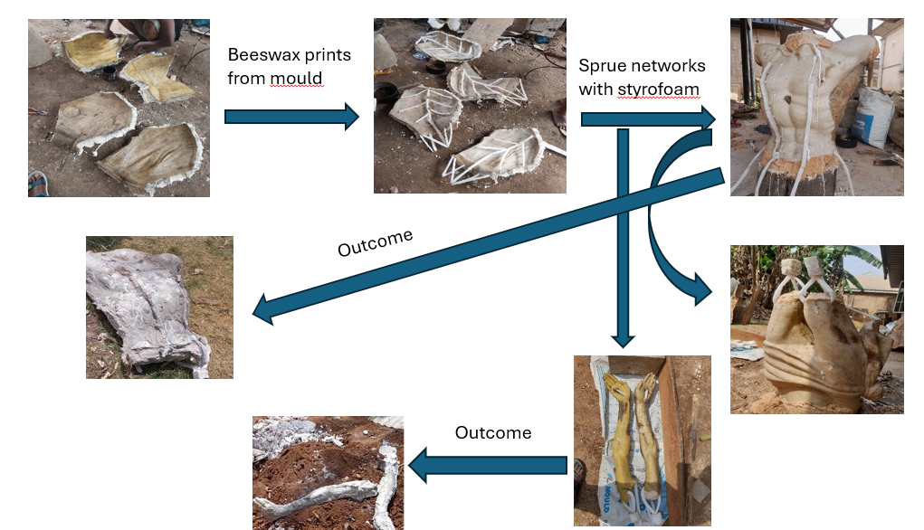
Keywords: Benin bronze casting, Styrofoam, Lost-wax process, Material innovation, Sprue system
1. Introduction
Benin bronze casting tradition is one of the quintessential forms of pre-colonial African technology, art, and representation. Internationally celebrated for their unique commemorative heads, relief plaques (Plate 1) and ceremonial objects. The tradition employs the cire perdue or lost-wax method; a method with which to attain an exceptional form accuracy and surface intricacy. Archaeological evidence and written records date the initial utilization of this method in Benin to at least the 13th century, although there are those who ascribe earlier impact by way of trans-saharan contact and regional art networks [1,3]. Throughout the centuries, the art has been sustained by dynastic guilds, particularly those on Igun Street in Benin City, who still utilize and innovate these methods to address emerging socio-economic realities [3,4].
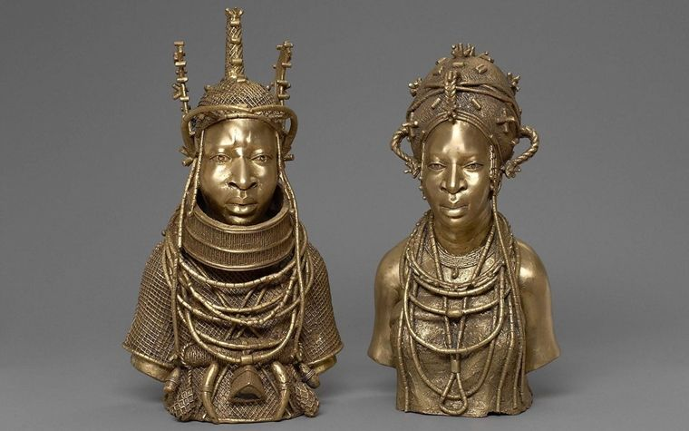
Plate 1: Pair of Busts: King (Oba) and Queen, 2006. Edo, Nigeria. Brass. Weltmuseum Wien, Vienna (184.376 a, b) https://www.metmuseum.org/about-the-met/conservation-and-scientific-research/conservation-stories/2020/benin-horn-player, retrieved June 16, 2025.

At the centre of this metallurgical operation is a sprue and vent complex mould system, which regulates the flow of molten metal into the mould cavity. The sprue system, typically constructed from wax, creates an essential channel through which the molten bronze is conveyed in the casting process. In conventional method, the artist builds up a model in beeswax or paraffin wax (Plate 2) covers it with a refractory clay investment, and subjects the mould to a firing process, causing the wax to melt and be evacuated; this is known as "wax burnout." The process therefore creates a void into which molten metal is subsequently poured. The control and accuracy provided by wax enable the sculptor to determine not only the ultimate shape of the sculpture but also the fluid dynamics of the metal and released of gasses (Plates 2-7).
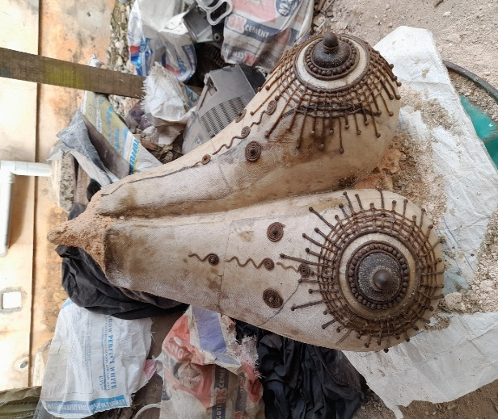
Plate 2: Beeswax and paraffin wax combinedin the design of a piece. Source: the author’s foundry, June 2023, Benin City.
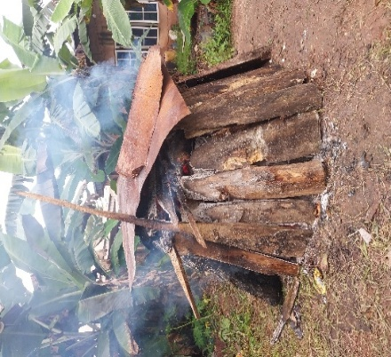
Plate 3: Controlled firing process during burning- out. Source: the author’s Foundry, May 2024, Benin City.
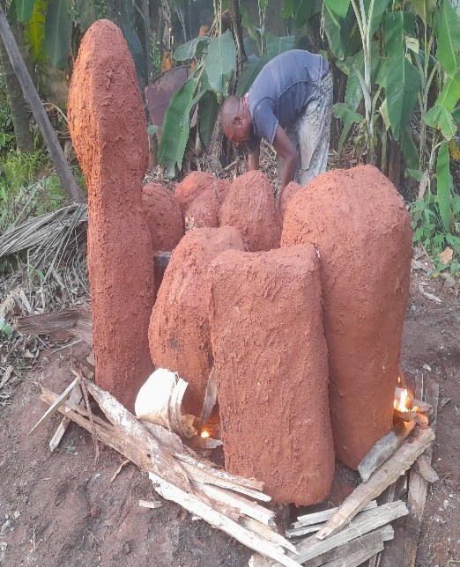
Plate 4: Moulds covered with a refractory clay investment, being ignited for dewaxing. Source: the author’s foundry, June 2023, Benin City.
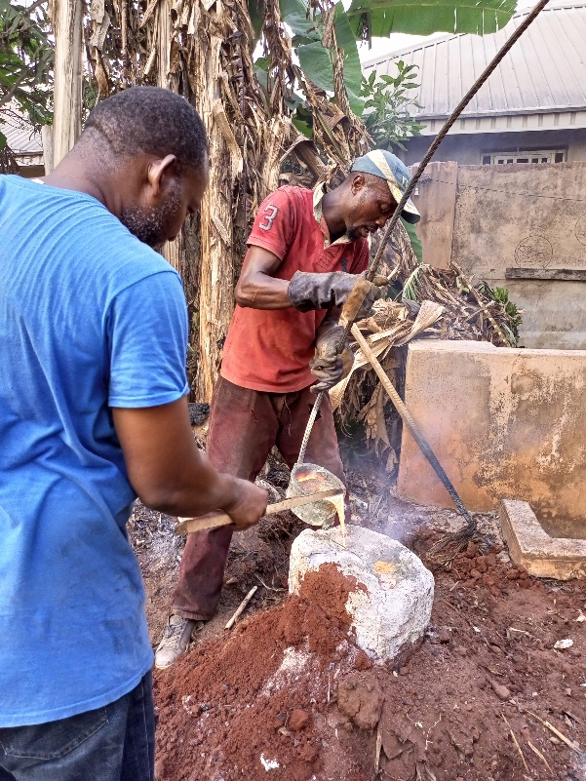 Plate 5. the author(left) engaged in the purring process of molten metal into a mould (casting); source: the authors foundry June 2023. Benin City.
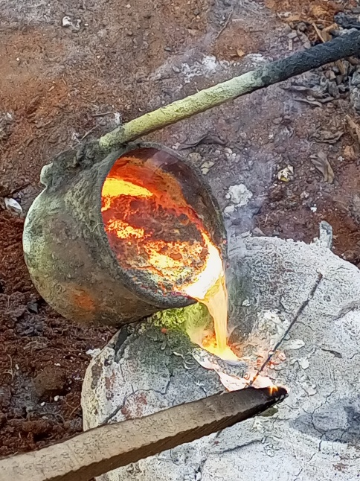
Plate 6. A zoomed session (Crucible) during casting. June 2023.: the author’s foundry, June 2023, Benin City.
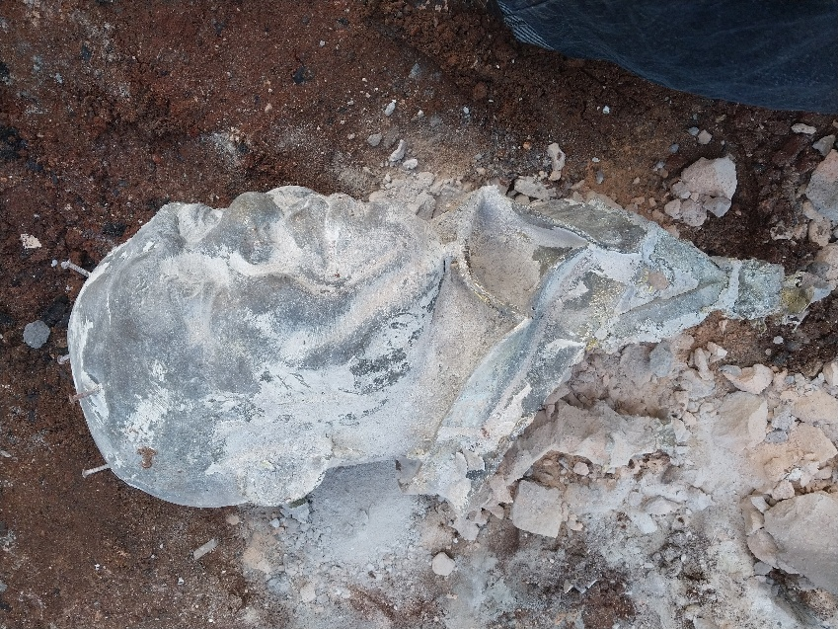Plate 7: The revealed bronze piece after breaking of the mould. Source: the author’s foundry, June 2023. Benin City.

The researcher in 2013 was confronted with the use of Styrofoam (expanded polystyrene foam) (Plate 8) as a substitute for wax in constructing the sprue systems in experimental and challenging bronze casting exercise in Benin city. The change is principally driven by economic reasons, the scarcity of materials, and the general challenge of sustaining traditional methods amidst a progressively modernizing setting [7,8]. In comparison to wax, Styrofoam is a more accessible source for recycled packing material, easier to carve for sprues, and does not need pre-heating prior to the modelling process. Styrofoam basically vaporizes almost entirely when subjected to high heat from the mould firing, theoretically leaving channels behind like wax.
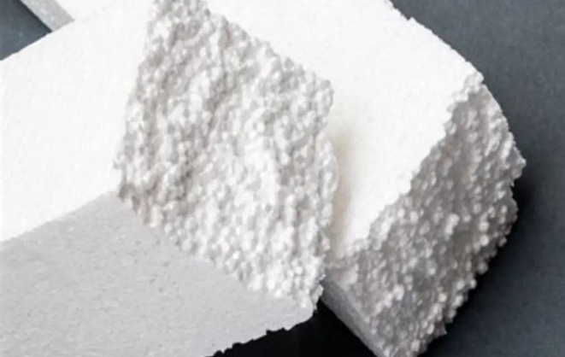
Plate 8: Image samples of Styrofoam https://epsole.com/how-to-make-styrofoam/retrieved July 4th, 2025
Usage of Styrofoam in this case has its pros and cons. To one side, it reduces production costs and the need for heating devices, making it attractive to beginner or financially constrained casters. To the other side, Styrofoam burns hotter than wax, with possible risks being moulds breakages, carbonising, or health risks from toxic fumes, especially in sculptural applications where operating in teeny details is called for. Therefore, this material breakthrough provokes inquiry into how conventional methods adapt when confronted with economic limitation, environmental demand, and developing new materials [9,10].
This project investigates the substitution of wax with Styrofoam in Benin bronze casting sprue technique by employing a practice-led research approach combining technical observation and experiential experimentation. The project works under an epistemology of practice-led research that acknowledges creative practice as a means of producing and theorizing kinaesthetic knowledge [11,12]. The paper measures the haptic, visual, and cultural ramifications of material replacement through comparative Styrofoam and wax casting experiments.
This study goes beyond concern in the technical efficacy of Styrofoam, such as its symbolic and conceptual worth in a valued culture practice respected for ritual and ancestral origins. Within Benin's historical context, bronze items transcended material form; they were repositories of memory, power, and cosmological understanding. Any change in casting, therefore, has ramifications extending far beyond the workshop setting. They dictate how tradition is interpreted, communicated, and valued within a modern African culture [13,14]. The change from wax to Styrofoam, therefore, is more than a mere example of innovation or need; it is an example of a larger negotiation of cultural heritage and survival.
Furthermore, this discussion contributes to current arguments within the field of material culture studies and African art historiography, which are progressively recognizing the dynamic quality of "tradition" and the validity of locally developed technologies [15,16]. Far from considering the utilization of Styrofoam to be a disruption of authenticity or purity, this article argues that one must recognize Styrofoam use as a powerful adaptation, echoing African creative agency within the transforming world. Lastly, this research extends an invitation for a critical re-examination of the ways in which the selection of materials intersects with heritage, sustainability, and artistic integrity in African art making. As the world of art grows more conscientious of the environmental and social impacts of production, the application of Styrofoam in Benin casting extends an invitation for essential inquiry into the ways that traditional artists negotiate transformation and cultural relevance with conceptual richness.
1.2 Benin Bronze Casting Historical Context
The historical development of bronze casting in the Kingdom of Benin represents a synthesis of indigenous technical creativity, religious symbolism, and royal authority. By the 13th century, Benin had established a hierarchical political structure under the Oba (king), who wielded both temporal and spiritual powers. Within this sociopolitical framework, the bronze casters, organized into the hereditary guild known as Igun Eronmwon, served exclusively at the behest of the Oba. Their primary role was to produce artworks that documented royal life and embodied visual expressions of power, spirituality, and continuity [17,18].
Central to Benin’s metalwork tradition is the sophisticated use of the cire perdue or lost-wax casting technique. This method enabled the creation of complex ceremonial and commemorative forms like ancestral heads, plaques, and royal regalia that served vital functions in rituals related to ancestor veneration, royal succession, and historical remembrance [19].
The Igun Eronmwon guild structure ensured that both technical skills and cultural responsibilities were passed down from generation to generation. Situated on Igun Street in Benin City, the guild continues to operate today, preserving the tradition while adapting to contemporary demands and material innovations. Members of the guild regard their practice as sacred, with rituals marking the initiation and completion of each casting process [20,21]. This spiritual dimension highlights how bronze casting in Benin is deeply interwoven with ancestral veneration and divine kingship.
The 1897 British Punitive Expedition marked a catastrophic rupture in the trajectory of Benin art. Thousands of artworks were looted from the royal palace and dispersed into European and American collections. This dispersal initiated a long-standing global fascination with Benin bronzes. In recent years, the cultural restitution debate has intensified, with institutions in Germany, the United Kingdom, and the United States beginning to repatriate these looted artifacts. Organizations such as the Benin Dialogue Group have played crucial roles in advocating for these returns, reframing the bronzes not just as aesthetic masterpieces but as cultural testaments to the rights and dignity of their makers [22-24]. The restitution movement offers a pivotal moment for cultural re-engagement and the revitalization of living traditions.

The artistic excellence achieved through Benin's casting techniques and guild systems enabled an impressive range of visual expressions, from stylized abstraction to lifelike naturalism. These qualities are evident in heads, plaques, and ritual objects excavated from the palace by British forces (Plates 9–12). Now scattered across major Western museums, these objects continue to attract scholarly attention due to their aesthetic, historical, and cultural value [19,20]. Importantly, bronze casting in Benin was never a purely artistic or economic pursuit; it was embedded in a cosmological worldview. Finished bronze objects were often consecrated and placed on royal altars, serving as spiritual mediators between the living and the ancestral dead. In Edo cosmology, the manipulation of fire and metal was not only a technical process but a sacred act that symbolized divine transformation and the endurance of historical memory [20,31].

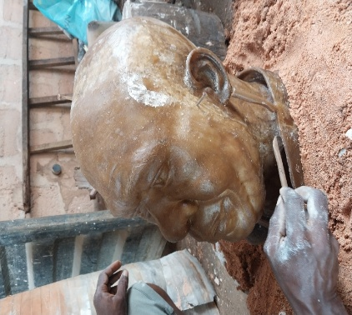
Plate 9: Modelling a head in beeswax. Courtesy: the authors foundry, July 2025. Benin city.

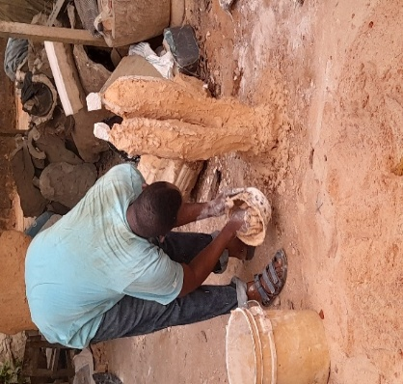
Plate 10: Investing wax work. Courtesy: the authors foundry, July 2025. Benin city.

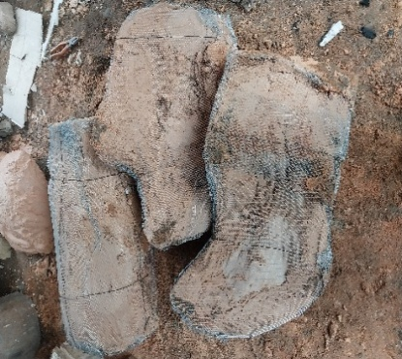
Plate 11: Invested moulds ready for burn out. Courtesy: the authors foundry, July 2025. Benin city.

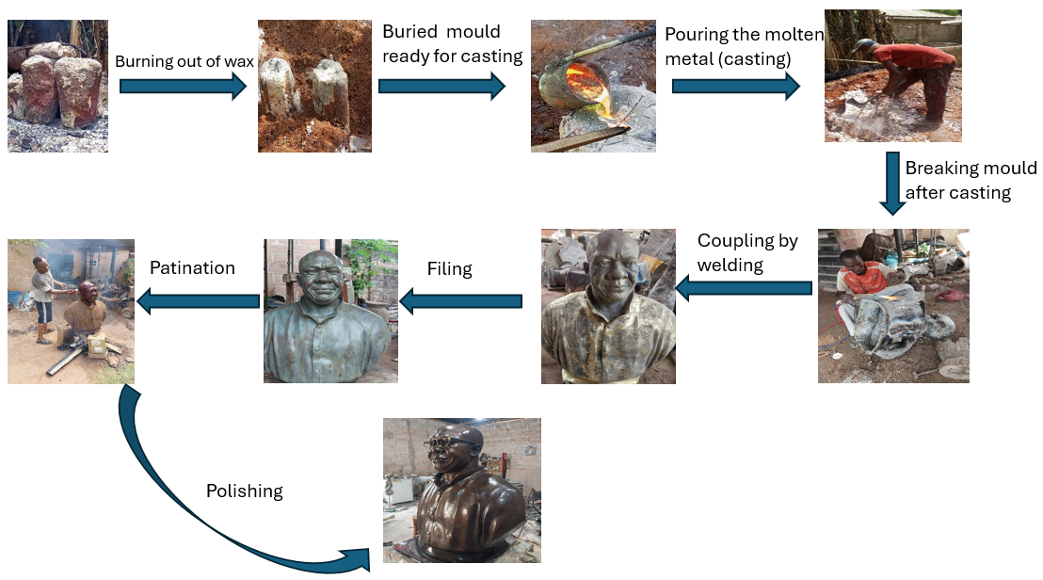
Plate 12: Procedural casting processes

The Impact of Colonialism
Colonialism and its aftermath introduced profound challenges to Benin’s casting tradition. Christian missionary activities, colonial laws, and the economic marginalization of indigenous practices disrupted the patronage systems that sustained traditional workshops. Despite these pressures, the casters of Igun Street maintained their craft, adapting to new conditions. By the mid-20th century, many artisans shifted from royal commissions to the production of smaller, collectible pieces for tourists and private collectors [17]. The casting process often began with a wax model integrated with sprues and vents. The model was then coated with fine clay, fired to expel the wax, and filled with molten bronze or brass. Once cooled, the mould was broken to reveal the finished object, which was then polished or further embellished [25].
Material adaptation became a key strategy for survival and innovation. The substitution of paraffin wax for beeswax in the 20th century marked a significant shift due to availability and affordability. Similarly, artisans began using industrial tools like gas burners, angle grinders, and rubber moulds to increase efficiency while retaining core traditional practices [25]. The recent incorporation of Styrofoam into the sprue system represents a further development in this lineage of material innovation. Although Styrofoam diverges from organic materials, it serves the same functional role in lost-wax casting and reflects the community's enduring commitment to innovation within tradition.
These material transitions prompt deeper questions about authenticity, preservation, and the transmission of knowledge. While global attention often centers on historic bronzes and their restitution, there is less recognition of the contemporary casters actively sustaining and reinterpreting this heritage. These artists are not merely custodians of the past, they are innovators negotiating a complex dialogue between continuity and change, tradition and sustainability [20,23]. Understanding the early history of Benin bronze casting is not merely about honoring a past achievement. It is essential for grasping the significance of current adaptations such as the use of Styrofoam, as part of a sustainable continuum of technological evolution and cultural relevance. The vitality of Benin bronze casting today affirms that this tradition remains a living, adaptive force within the artistic and spiritual life of Nigeria.
The Benin bronze casting is not only an indicator of expertise; it is also a powerful symbol of cultural vigour, continuity of tradition, and the quest for identity in the modern world and history. The casting techniques and guild systems structure enabled Benin artisans to attain great levels of realism, abstraction, and iconographic detail, as can be seen in the various heads, plaques, and ritual objects dug up from the Benin Palace by the British Punitive Expedition of 1897 (Plate 13-17). These objects, now scattered among Western major museums, still garner scholarly interest due to their aesthetic, historical, and cultural value [2,19]. Notably, Benin bronze casting was not merely an economic or artistic exercise; it was firmly situated in ritual and cosmological frameworks. Bronze objects were regularly consecrated and put on royal altars as spiritual intermediaries between the living and the ancestors.

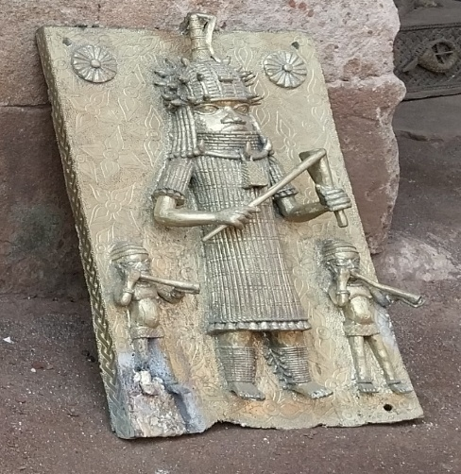
Plate 13: Iconographic details of Benin bronze sculptures. Isiagbon foundry Benin City, April 2023. 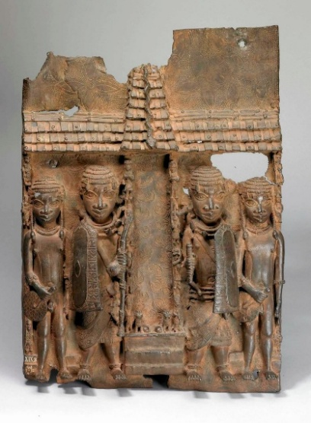Plate 14. Plaque depicting an audience hall, 16th-17th century, 55 $×$ 39 cm, Edo peoples, Benin, Nigeria (photo: British Museum, CC BY-NC-SA-4.0) https://www.khanacademy.org/humanities/art-africa/west-africa/nigeria/a/the-kingdom-of-benin. Retrieved 30th June 2025
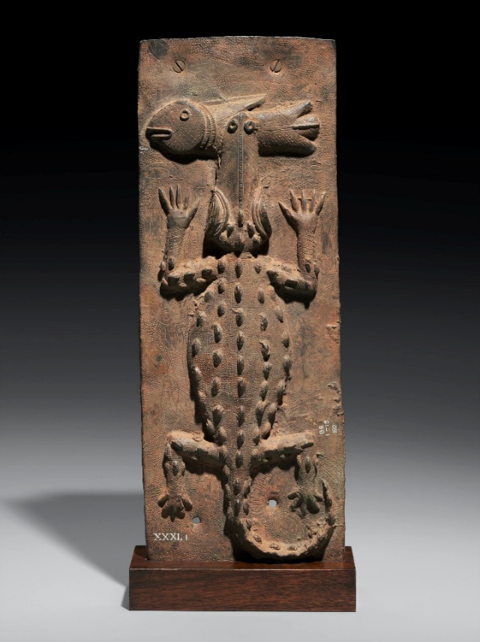
Plate 15. Artist Unidentified, Relief plaque showing a crocodile with mudfish, c. 1530-1570, copper alloy (Robert Owen Lehman Collection, Courtesy Museum of FineArts, Boston) https://smarthistory.org/benin-bronzes-theft-artistry/ Retrieved 30th June 2025

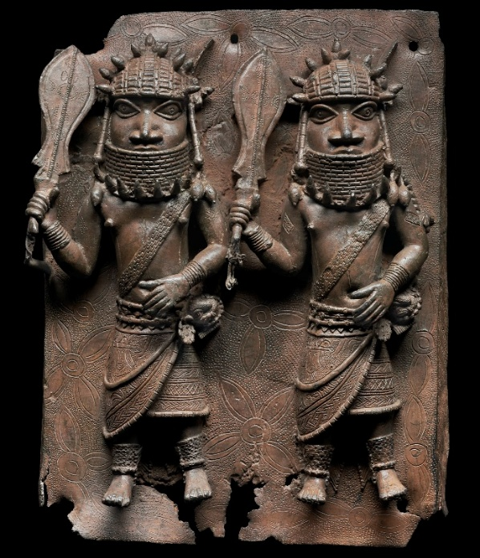
Plate 16. Artist Unidentified, Relief plaque showing two officials with raised swords, c. 1530-1570, copper alloy (Robert Owen Lehman Collection, Courtesy Museum of Fine Arts, Boston) https://smarthistory.org/benin-mfa/ retrieved 30th June 2025.
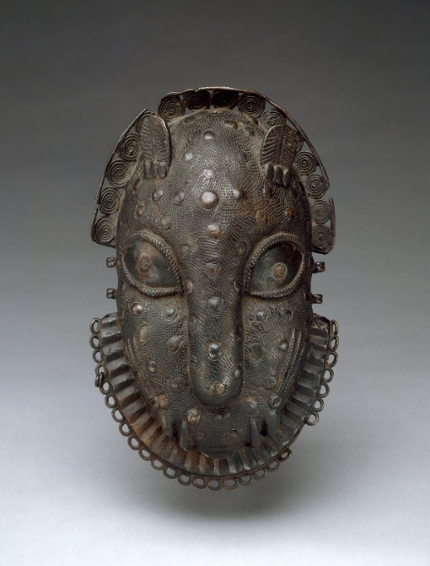
Plate 17. Leopard-head hip ornament, 16th - 19th century, 19.1 $×$ 12.1 $×$ 5.4 cm, Edo peoples, Benin, Nigeria (The Metropolitan Museum of Art). https://smarthistory.org/benin-mfa/ Retrieved 30th June 2025
The use of fire and metal was understood in Edo cosmology as transformative but perdurable acts, representing divine agency and the continuity of history [14,26]. For this reason, materials and processes involved in the bronze-casting process were not just technologically significant but also culturally and symbolically significant. The Benin tradition is distinct from other African metalwork sites such as Ife and Nok, although it does have some shared regional techniques and motifs. While Ife artists in present-day southwestern Nigeria produced naturalistic terracotta and bronze heads dated between the 11th to 15th centuries, Benin's artistic canon was slightly more stylized and ideologically focused, with courtly narratives instead of individual portraiture [6,27]. Scholars have disagreed over the nature of artistic exchange between these regions, with some proposing direct influence from Ife to Benin and others proposing parallel evolution within broader West African artistic systems [28].
During the colonial and postcolonial eras, bronze casting continued in Benin amidst profound interruptions. Colonial legislation, Christian missionary zeal, and economic marginalization of indigenous expressions altered the organization and patronage of traditional ateliers. Nevertheless, Igun Street's community of casters continued to function, modifying their practice in response to shifting markets and material possibilities. By the mid-20th century, artists started producing smaller-sized, portable pieces destined for collectors and tourists, changing from palace commission to commercial output [8,29].
1.4 Adaptation to Foreign Tools and Materials
The adaptation of the materials to meet evolving socio-economic demands is not new to the Benin casters. For instance, the introduction of paraffin wax as a substitute for beeswax in the 20th century was among the initial documented pattern material changes, primarily due to availability and cost. In the same manner, casters began incorporating industrial tools such as gas burners, angle grinders, and rubber moulds to mechanize production without altering essential traditional processes [7]. The new inclusion of Styrofoam into the casting process (specifically in the design of the sprue system) is a benchmark advancement in the ongoing tradition of innovation. Although a diversion from natural organic materials, Styrofoam is employed for the same purpose in the lost-wax method and must be viewed as part of a lineage of functional solutions. The development of modern bronze casting to address economic demands and environmental concerns shows the incorporation of alternative materials such as Styrofoam, indicating both the enduring character and the fertile evolution of this ages-old process.
Moreover, this shift in materials sheds light on more general issues of authenticity, preservation, and transmission of traditional knowledge. Global discussions about the restitution of Benin bronzes have underlined their historical and cultural significance; yet too little attention has been paid to contemporary artisans continuing this artistic tradition. These artists are not guardians of a fixed inheritance only; they are pioneers working through a challenging dialectic of past and present, paucity and sustainability, respect and reinvention [16,30]. Consequently, knowledge of the earlier history of Benin bronze casting is crucial not only for its achievement as a past event but also for assessing how current adaptations like the application of Styrofoam are part of a sustainable continuum of technological innovation and cultural applicability.
2. Method
2.1 The Sprue System and Material Substitution
The sprue system plays a basic role in the lost-wax casting process, as it is the channel through which liquid metal is conveyed from the crucible to the mould cavity. It consists of a network of main and secondary channels, known as sprues and runners, which are intentionally attached to the wax model. The channels are also shaped in a way to allow molten metal flow while simultaneously permitting venting of air and gases during pouring, thereby preventing casting defects like porosity, misruns, or air entrapment [5,31]. In the conventional bronze casting process in Benin, the sprue system is carefully modelled in wax, usually in conjunction with the wax model. After the application and firing of the clay investment, both the model and the sprue components are removed by the process of melting, creating voids in the mould (Plate 18).
Sprue design and placement are also critical to casting success since they directly affect metal pressure, flow rate, and turbulence and, consequently, fidelity and integrity of the finished sculpture [13,30]. The sprue must also be robust enough to ensure good metal delivery without causing undue backpressure or cold shuts, especially in high-relief or complex configurations.
More recently, Styrofoam (expanded polystyrene) has been discovered by the researcher to be an alternative material for constructing the sprue system, it is gradually entering the knowledge of main-stream casting guild but especially among contemporary Benin casters who seek less expensive alternatives to wax.
Table 1: Comparative Assessment of Styrofoam as substitute to Beeswax in the Sprue Technique of Bronze Casting
Factor | Syrofoam | Beeswax | Advantage
Material Cost | Cheap and readily available as waste/recyclables | Comparatively pricey and usually imported | Styrofoam is more economical
Availability | Readily available from packaging and industrial scraps | Limited supply, seasonal dependence | Styrofoam is more available
Workability | Easy to carve, shape, and assemble using simple tools | Needs heating and expertise to shape | Styrofoam is easier to work with
Burnout/Casting Behavior | Burns out nicely with minimal residue if vented properly | Leaves an oily residue; needs good venting and burnout | Cleaner burnout with Styrofoam
Speed of Preparation | Faster to shape and use in direct casting techniques | Time-consuming modeling and wax recovery steps | Faster production with Styrofoam
Structural Rigidity | Maintains shape without melting; best for direct sprues | Softens at low temperature, can deform if not careful | Styrofoam is more rigid
Environmental Consideration | Frequently reuses wasted material, encouraging recycling | Biodegradable and natural, although overharvesting is an issue | Styrofoam facilitates reuse; Beeswax for biodegradability (context-dependent)
Innovation Potential | Fosters contemporary interpretations of age-old methods | Identified with traditional cire perdue processes | Styrofoam encourages innovation

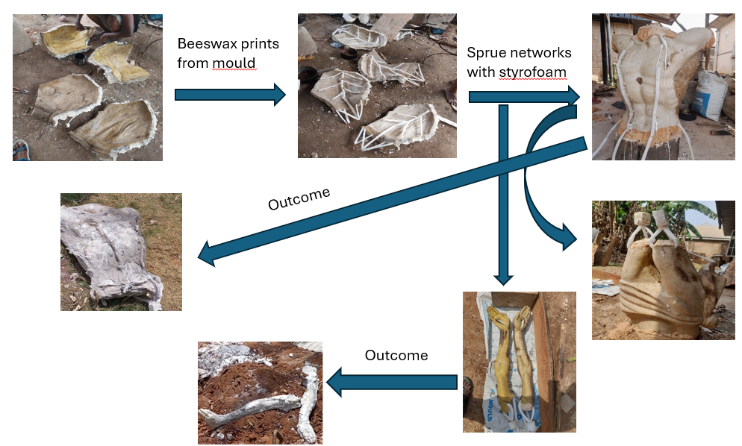
Plate 18: Sprue techniques with styrofoam
This tendency is especially interesting among emerging artists and small foundries that are subject to financial limitations or have limited access to conventional materials [8,31]. The general availability of Styrofoam in the form of used packaging, for instance, makes it highly appealing, particularly for the casting of uncomplicated and linear channel forms. Unlike wax, Styrofoam does not require heating, thus providing logistical convenience when handling, especially in settings where there is no stable supply of electricity or gas.
In contrast, the wax exhibits a slower and more stable combustion process with a controlled melting phase that minimizes thermal stress on the mould. Progressive liquefaction of wax guarantees progressive drainage prior to the accomplishment of total burnout, thereby enabling more uniform internal cavity removal. This degree of predictability renders wax as a material of choice in conventional foundries, where reduction of mould failure and enhancement of precision in casting are of paramount importance [2,32]. Despite these benefits, heightened expenses and unavailability of quality wax in Nigerian local markets have led artists to find substitutes, including paraffin, recycled candles, and most recently, Styrofoam.
A significant factor in the use of Styrofoam is the method utilized for burnout and ventilation. In normal lost-wax casting procedures, vents are designed to provide free drainage of wax and air removal. With the use of Styrofoam, however, venting design must be considered with the presence of combustion gases and volatile residues, which are more reactive than the gases resulting from wax. Foundries that successfully incorporated Styrofoam in the production of sprues often modify their firing cycles to include pre-venting apertures or staged heating, allowing for the gradual breakdown of the material [7]. Such process changes, though seemingly minor, are part of a broader pattern of applied innovation and experimentation on the part of local artisans.
It is interesting to note that the use of Styrofoam is not historically uninformed. In modern foundry engineering, especially in commercial and industrial settings, lost-foam casting has been explored as an alternative for lost-wax casting, particularly in the production of large or one-of-a-kind parts [33]. In lost-foam casting, a foam pattern is embedded in a refractory material and surrounded by sand before molten metal is directly poured onto it, causing the foam to vaporize on contact. While this process shows some similarities with the use of Styrofoam in Benin, the two methods differ significantly in terms of scale, material, and environmental regulation.
From a material culture standpoint, the replacement of wax by Styrofoam in the sprue system entails symbolic, in addition to utilitarian, ramifications. Wax has ancestral and ritualistic connotations as a traditional material, but Styrofoam is a symbol of new consumerism and material excess. Its incorporation into the casting process is not merely a utilitarian adjustment but also an adjustment of the ideological paradigm by which materials are understood. These substitutions are said by some scholars to question strict definitions of authenticity in African art, encouraging instead a processual and flexible conceptualization of tradition [13,34].
Additionally, it is necessary to recognize the environmental consequences of burning Styrofoam. The emission of harmful gases, such as styrene and benzene, poses severe health risks to workers operating in poorly ventilated workshops. The absence of regulatory supervision in most informal workshops heightens these risks. As such, any analysis of the feasibility of Styrofoam as a sprue material must also account for not just economic and technical considerations, but health, environmental, and ethical consequences [9,35].
3.0 Studio-Based Inquiry: Approach and Findings
This study utilized practice-based research in the researcher's own foundry, supplemented by bronze casters in Benin City. This innovation is yet to get to the Igun casting guild (Iguneronwon) to date. A set of casting experiments were carried out with both wax and Styrofoam sprues in controlled environments. Records were kept of:
Form integrity: Wax sprues created very slightly smoother channels, while Styrofoam occasionally caused expansion cracks during burnout.
Residue and burning: Styrofoam burned faster with no ash and soot in the mould, hence eliminating pre-casting mould cleaning.
Cost and availability: Styrofoam was easier to find and less expensive than wax, making it more attractive for small-scale or trial casters.
3.1 Cultural and Conceptual Implications
Beyond the technical, the use of Styrofoam points to larger trends within Nigerian sculptural practice. New materials are typically taken up due to economic imperatives, yet they then manifest the strength and flexibility within indigenous knowledge systems. This innovation does not supplant tried and tested custom but is instead the manner in which tradition proceeds in response to modern realities. Here, the utilization of Styrofoam must be understood not as a deviation from tradition but rather as an extension of the innovation that has always defined Benin bronze casting. These contemporary artists are not simply holding on to a method; they are actively redefining it to ensure its continued relevance, viability, and applicability considering material limitations.
4. Conclusion
Styrofoam has been found to be an adequate substitute for wax in the sprue method of Benin bronze casting with advantages of reduced cost and convenience. It is troublesome in the form of combustion by-products and mould stability. The innovation in materials is a testament to the ongoing modernization of the classic African art forms to the demands of today. As metal and artist workshops continue to innovate beyond the conventional materials, there must be a formal documentation, analysis, and contextualization of these innovations, not as aberrations from the original but as reflections of ongoing traditions. Although Styrofoam presents a viable and creative alternative to wax used in the sprue method of Benin bronze casting, its use must be considered in good faith not just its advantages but its drawbacks as well. Change is better understood in adaptive customary practice terms, where alteration is not merely needed but also unavoidable if continuity and meaning must be preserved.
5. Recommendations
Additional studio-based research and technical trials need to be conducted to improve burnout processes, mould design optimization, and removal of undesirable emissions so that material innovation enhances but does not subtract from the integrity of this ancient craft. Additional studies should focus on the environmental effects of Styrofoam application in casting. Studio Comparative studies with biodegradable or eco-friendly materials may offer more sustainable alternatives to both wax and Styrofoam.
Disclaimer (Artificial intelligence)
Option 1:
Author hereby declares that NO generative AI technologies such as Large Language Models (ChatGPT, COPILOT, etc.) and text-to-image generators have been used during the writing or editing of this manuscript.
References
[1] Dark, P. (1973). An introduction to Benin art and technology. Oxford Uni. Press.
[2] Ben-Amos, P. (2021). The art of Benin (2nd ed.). Thames & Hudson.
[3] Igbinoba, C.O. (2019). The adaptation of modern materials in traditional sculpture practices in Nigeria. Nsukka J. Humanities. 27, 88–102.
[4] Oguagha, P.A. (2020). Guilds, memory, and continuity in Benin’s Igun Street. Afr. Heritage Rev. 8, 35–48.
[5] Herbert, E.W. (1984). Red gold of Africa: Copper in precolonial history and culture. Uni. of Wisconsin Press.
[6] Adepegba, C.O. (1995). Nigerian art: Its traditions and modern tendencies. Ibadan Uni. Press.
[7] Ekpo, E. (2013). Innovations in African bronze casting: A study of contemporary Benin casters. Nigerian Field, 78, 123–134.
[8] Obinyan, A. (2022). Studio research and transformation in Benin bronze casting. Contemporary Art Res. Nig., 13, 22–41.
[9] Jansen, C. (2019). Toxic legacies: The environmental cost of informal metalwork in Nigeria. Afr. Arts, 52, 56–65.
[10] Adeola, A.A., Adebayo, T.O. (2020). Sustainable alternatives in metal casting: An experimental analysis of pattern materials in Nigerian foundries. Journal of African Material Culture, 14, 45–62.
[11] Biggs, M., Büchler, D. (2008). Eight criteria for practice-based research in the creative and cultural industries. Art, Design & Communication in Higher Education, 7,5–18. https://doi.org/10.1386/adche.7.1.5_1
[12] Barrett, E., Bolt, B. (2010). Practice as research: Approaches to creative arts enquiry. Internet Archive Books.
[13] Coote, J. (2007). Material culture and artistic practice in Benin. J. Afr. Cult. Stud., 19, 57–73. https://doi.org/10.1080/13696810701351061
[14] Blier, S.P. (2015) Art and risk in ancient Yoruba: Ife history, power, and identity, c. 1300. Cambridge Uni. Press.
[15] Steiner, C.B. (2020). African art in transit: New directions in the anthropology of art. Routledge.
[16] Ogbechie, S.O. (2022). Rethinking African modernism through material practice. Third Text, 36, 277–295. https://doi.org/10.1080/09528822.2022.2047776
[17] Ben-Amos, P. (1995). The art of Benin. British Museum Press.
[18] Bodenstein, F. (2022). Getting the Benin Bronzes back to Nigeria: The art market and the formation of national collections and concepts of heritage in Benin City and Lagos. In F. Bodenstein, & B. Savoy (Eds.), Contested holdings: Repatriation and restitution of Nazi-looted art and colonial collections in Europe (pp. 225–244). Berghahn Books.
[19] Center for Art Law. (2023). Repatriation of the Benin Bronzes: An ethical and legal discussion. https://itsartlaw.org/2023/06/19/repatriation-of-the-benin-bronzes-an-ethical-and-legal-discussion/
[20] Chuku, G. (2019). Women and the politics of cultural heritage in Africa. Palgrave Macmillan.
[21] Dark, P. (2021). An Introduction to Benin Art and Technology. Thames & Hudson.
[22] Egu, K. C., & Inneh, D. (2011). Art of the Kingdom of Benin (Exhibition Catalogue). Snoeck Publishers.
[23] Jackson, J. (2022). Cultural heritage management and international law: Restitution of the Benin Bronzes (Undergraduate thesis). Indiana University.
[24] Moiloa, M. (2022). Benin Bronzes: The long journey home. Chatham House. https://www.chathamhouse.org/publications/the-world-today/2021-06/benin-bronzes-long-journey-home
[25] Plankensteiner, B. (2007). Benin: Kings and rituals – Court arts from Nigeria. Snoeck Publishers.

[26] Ezra, K. (1992). Royal art of Benin: The perpetuation of kingship. Museum for African Art.
[27] Nevadomsky, J. (2019). Guilds and continuity in Benin art. Afr. Stud. Rev., 62, 157–174. https://doi.org/10.1017/asr.2018.89
[28] Hicks, D. (2020). The Brutish museums: The Benin bronzes, colonial violence and cultural restitution. Pluto Press.
[29] Nevadomsky, J. (1997). Art and the material culture of Nigeria: Continuity and change. Afr. Arts, 30(3), 12–25. https://doi.org/10.2307/3337526.
[30] Willet, F. (1971). Ifẹ́ in the history of West African sculpture. Thames & Hudson.
[31] Chikwendu, V.E., Pogoson, O.I. (2015). Ancient Nigerian bronze technology: Cross-cultural parallels and the question of innovation. Nig. J. Humanities, 24, 103–117.
[32] Kaplan, F. (1994). Art, artisans and patronage: Three Niger River societies. Smithsonian Institution Press.
[33] Odunlami, T.A. (2021). Sustaining cultural heritage through contemporary practice in Nigerian sculpture. J. Afr. Heritage Visual Culture, 6, 88–104.
[34] Obinyan, A. (2020). Studio research and transformation in Benin bronze casting. Contemporary Art Res. Nig., 12, 56–73.
[35] Campbell, J. (2004). Complete casting handbook: Metal casting processes, metallurgy, techniques and design. Butterworth-Heinemann publications, ISBN–13: 978-1-85617-809-9.

