Review Article

Cinnamon : A Review on the medicinal plant and its Health Benefits

Abstract
Cinnamon is a spice used daily by people as a traditional medicine for centuries all over the world. It is an evergreen plant, and its leaves and bark are good sources of oil. It belongs to the family of Lauraceae. The main species of commercially cultivated cinnamon are Cinnamomum verum, Cinnamomum burmannii, Cinnamomum cassia, and Cinnamomum loureiroi. The objective of this review is to discuss the uses, chemical composition, nutritional composition, toxicity, and the potential role of cinnamon in overall health management. For this review, extensive bibliographic research was conducted, utilising keywords such as its uses, chemical composition, nutritional composition, health benefits, and toxicity. Key findings conclude that cinnamon possesses antioxidant, antimicrobial, anti-diabetic, anti-inflammatory, Insecticidal, anti-tumour, neuroprotective, nephroprotective, anti-obesity, cardioprotective, anti-hypertensive, anti-allergic, hepatoprotective, immunomodulatory, and gastroprotective properties. Moreover, the nutrient composition revealed that it is a great source of dietary fibre and minerals. This review focuses on summarizing the most relevant literature to highlight the health benefits of cinnamon and its nutritional and chemical properties.
Graphical abstract
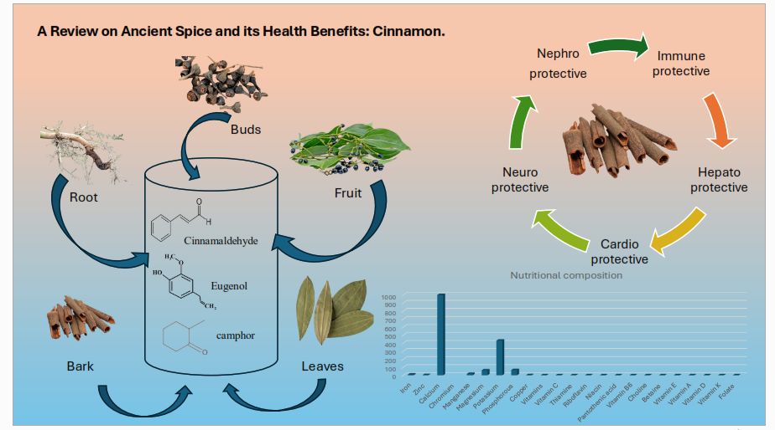

Keywords: Cinnamon, Medicinal use, Health benefits, Nutrition, Toxicity.
Introduction
1.Cinnamon a “Powerful Spice”

Plant-based products are the most common definition of spices. At first, they were mostly used to enhance the flavour and presentation of food ^{[24].} Since ancient times, people have been aware of the preservation qualities of spices. ^{[25].} Therefore, many natural spices have been used by humans to relieve diseases because of their diverse biological properties. ^{[1]} Plants are fundamental medicinal, food, fuel, and clothing sources.^{[19]} Diverse plant parts, including bark, stem, leaves, roots, flowers, seeds, and many other components, have been used for medicinal purposes since historical times. ^{[1].} Cinnamon is one of the oldest herbal drugs and the oldest spice in the world. The genes Cinnamon belong to the family of Laurancae. There are more than 250 species belonging to its family. It can be used in the form of whole or ground material, or extract or oil. ¹⁸
The main species of commercially cultivated cinnamon are Cinnamomum verum, Cinnamomum burmannii, Cinnamomum cassia, and Cinnamomum loureiroi. The main constituent compounds found in cinnamon oil namely “cinnamaldehyde and trans-cinnamaldehyde”. ^{[5,23]} Cinnamon bark is renowned worldwide for its fragrance and essence, making it a valuable ingredient in various industries like food essence, toothpaste industries, etc. ^{[19,22,25]}. It contains numerous kinds of medicinal compounds, notably essential oil from Cinnamomum, and three constituents of these essential oils, namely cinnamaldehyde (45-65%), eugenol (12-18%), and linalool (17.8-30.2%). These compounds are found to be beneficial in inhibiting processes like lipid peroxidation and peroxynitrite-induced nitration. ^{[2,3,23]}
According to several findings, cinnamon contains bioactive chemicals that have preventive qualities against oxidative stress, inflammation, and metabolic disorders like diabetes, hypertension, obesity, and high cholesterol.. Cinnamon consists of phenolic compounds such as protocatechuic acid, quercetin, p-coumaric acid, p- p-hydroxybenzoic acid, syringic acid, rosmarinic acid, caffeic acid, ferulic acid, and chlorogenic acid. ^{[5]} Its bark is also rich in catechins and procyanidin. Like green tea, it has anti-oxidant, anti-inflammatory, and anti-obesogenic qualities. Nowadays, the products made with these bioactive compounds attract the interest of industries and consumers.
This review shows the potential effective health benefits of cinnamon and its role in the treatment and prevention of many diseases, and also discusses the nutritional, biological, and bioactive properties of compounds.
- Methodology
PubMed- Medline, Scopus, Science Direct, and Google Scholar databases were searched for the following items: cinnamon and health, cinnamon and toxicology, cinnamon, and dentistry, cinnamon and diabetes, cinnamon and anti-inflammatory, cinnamon, and metabolic disease for review articles and systematic review article, clinical trials, and case reports from 2019-2023. Full-text review and titles, and keywords were used to accurately identify eligible studies. Inclusion criteria: Full-text reviews, reviewed articles, systematic review articles, and research articles are included.
- Uses of cinnamon
Cinnamon bark is used in food preparation due to its delicate aroma and sweet and spicy flavour. It can be used in Bakery and pastry, cakes, biscuits, making, use as a mouth freshener, in chewing gum, tea, and toothpaste making. It acts as a coagulant and prevents bleeding. Mosquito repellent^{[19]}. It is used for essence perfume, medicinal products, food additives, taste in chocolates, etc.^{[16]}
- Chemical composition
Cinnamon consists of various kinds of resinous compounds in different parts of the plant, as mentioned in Table 1^{[13,15,16,19]}. Cinnamaldehyde is sweet. The main flavour compound in cinnamon essential oil extracted from the bark is cinnamaldehyde, while from leaves is eugenol. Also, there is a high concentration of anti-nutritional compounds in cinnamon bark, are trypsin inhibitors, chymotrypsin inhibitors, phytic acid, and tannin. Phenolic compounds such as flavonoids, catechin, ferulic acid, epigallocatechin gallate, etc., are present in cinnamon in good amounts. ^{[20]}
Table 1: Cinnamon’s various parts and their compounds. ^{[17]}
Parts of the plant | Compounds
Leaves | Cinnamaldehyde 1.00 to 5.00%, Eugenol 70.00 to 95.00%
Bark | Cinnamaldehyde 65.00 to 80.00%, Eugenol 5.00 to 10.00%
Root | Camphor 60.00%
Fruit | Trans-cinnamyl acetate 42.00 to 54.00%, Caryophyllene 9.00-14.00%
C. zeylanicum buds | Terpene hydrocarbon 78.00%, alpha-bergamotene 27.38%, alpha- copaene 23.05%, oxygenated terpenoid 9.00%
C. zeylanicum fruits | E-cinnamyl acetate 41.98%, trans-alpha-bergamotene 7.97%, caryophyllene oxide 7.20%.

- Nutritional composition
The approximate minerals and vitamins found in cinnamon are given in Table 2. The variation in the table is given on the basis of variety, species, cultivation, harvesting, climate, origin, and environmental conditions. The nutrition, colour, and flavour can degrade in cinnamon due to high temperatures. Cinnamon provides a good amount of protein, dietary fibre, minerals, and vitamins that help in preventing disease and provide health benefits, as per the USDA. The oil extracted from cinnamon is a good source of saturated fats. According to Safdar M, Cinnamon has a high carbohydrate content and is low in fat and protein. Among the microminerals, potassium, magnesium, and calcium are the highest. Cinnamon also contains plenty of manganese and phosphorus. It contains a trace amount of iron, zinc, and chromium. ^{[20,21]}
Table 2: Nutritional Composition of Cinnamon Bark. ^{[6,15,20,21]}
Nutrient | % composition (gm/100gm) (Safdar M, 2009) | Gm/100gm  (USDA 2019)
Macro minerals
Moisture | 5.1 | 10.6
Ash | 2.4 | 3.6
Protein | 3.5 | 3.99
Dietary fiber | 33.0 | 53.1
Crude fat | 4.0 | 1.24
Energy | 258kcal /100gm | 247 kcal/100gm
Carbohydrates |  | 80.6
Sugars |  | 2.17
Micro minerals
Minerals | Amount mg/100gm | Mg/100gm
Iron | 7.0 | 8.32
Zinc | 2.6 | 1.83
Calcium | 83.8 | 1000
Chromium | 0.4
Manganese | 20.1 | 17.5
Magnesium | 85.5 | 60
Potassium | 134.7 | 431
Sodium | 0.0
Phosphorous | 42.4 | 64
Copper |  | 0.339
Vitamins |  | Mg/µg/IU100gm
Vitamin C |  | 3.8 mg
Thiamine |  | 0.022mg
Riboflavin |  | 0.041mg
Niacin |  | 1.33mg
Pantothenic acid |  | 0.358mg
Vitamin B6 |  | 0.158mg
Choline |  | 11 mg
Betaine |  | 3.9mg
Vitamin E |  | 2.32 mg
Vitamin A |  | 295 IU
Vitamin D |  | 0 IU
Vitamin K |  | 31.2 µg
Folate |  | 6µg

- Health Benefits and Pharmacology of Cinnamon:
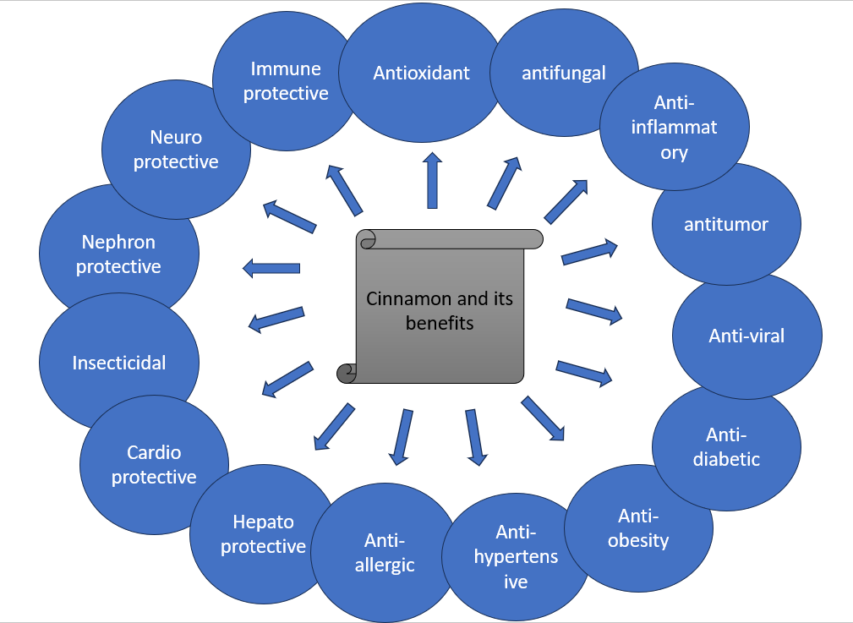
Fig 1. Cinnamon and its beneficial effects. ^{[1]}
  - Antioxidant:
The antioxidant present in the food plays a vital role in health promotion and also prevents food spoilage. The ether, aqueous, and methanolic extracts of cinnamon contain a significant amount of phenolic antioxidants and flavonoids that can scavenge free radicals and reactive oxygen species, such as hydroxyl radicals and superoxide anions. They also have the highest anti-radical properties and inhibit lipoxygenase activity. ^{[14,19]} Flavonoids obtained from the bark of Cinnamomum zeylanicum and C. cassia were observed to exhibit free radical scavenging activities. ^{[9]} A 1:1 mixture of aqueous and alcoholic cinnamon extracts has been found to effectively reduce both fatty acid oxidation and lipid peroxidation. The cinnamon flower is a free radical inhibitor. It might also act as a radioprotector that decreases radiation-induced oxidative injury. ^{[20]} In some studies, it is shown that essential oil extracted from cinnamon possesses significant antioxidant properties. In the plasma of diabetic rats, cinnamon powder may restore normal activity of some antioxidant enzymes, such as glutathione peroxidase, catalase, and superoxide dismutase. Cinnamaldehyde helps against the production of nitric oxide, and water-extracted polysaccharides from Cinnamomum zeylanicum have in vitro antioxidant capacity. ^{[19,24]} Cinnamon shows a role in superoxide anion scavenging and the strongest antioxidant superoxide formation activity. Moreover, the Leaf extract of cinnamon has free radical scavenging activity. Furthermore, different parts of cinnamon, like bark, leaf, and stem, have a significant role in the hindrance of the pathogenesis of diseases. Also, the polyphenolic compounds show significant potential antioxidant properties. The essential compounds eugenol and essential oil can inhibit lipid peroxidation. ^{[1]} In general, immunological and inflammatory processes depend heavily on oxidative processes. It is found that there is a high concentration of antioxidants in the medicinal herb cinnamomi cortex. Lipid peroxidation and copper-induced protein oxidative modification are inhibited by the medication. ^{[9]}

  - Anti-microbial:
    - Antifungal:
The inhalation of cinnamaldehyde is an ideal treatment for respiratory tract infections. Cinnamaldehyde is used as a vapour to treat respiratory tract mycoses. Cinnamon tree powder can be used to treat fungal infections caused by fungi such as Aspergillus niger, Aspergillus fumigatus, Aspergillus nidulans, Aspergillus flavus, Candida albicans, Candida tropicalis, Candida pseudotropicalis, and Histoplasma capsulatum. ^{[23]} The extracted oil from the cinnamon helps in the inhibition of fungi such as Mucor plumbeus, Penicillium roqueforti, and Eurotium sp. Etc. ^{[19]} In one of the studies, it is stated that the combination of Oregano, clove oil, and cinnamon works together to combat several Candida albicans strains, including Candida tropicalis and Candida glabatra DSM 11226. Moreover, Cinnamon essential oil can be used in mouth fresheners and antifungal medications, and it was found to be the most effective against 40 C. albicans. ^{[25]}

    - Antibacterial:
Cinnamon oil helps in the inhibition and treatment of bacteria such as pediococcus, halopphilus, and Staphylococcus aureus. Staphylococcus aureus, Escherichia coli, and Pseudomonas aeruginosa are among the germs that cinnamon oil may help fight. Gram-negative bacteria like Salmonella choleraesuis, Escherichia coli, Pseudomonas aeruginosa, and Yersinia enterocolitica, as well as gram-positive bacteria like Listeria monocytogenes, Enterococcus faecalis, Staphylococcus aureus, and Bacillus cereus, are all susceptible to the antibacterial properties of cinnamon and clove oil^{. [19]} The most common bacterium that causes failed root canal therapy, Planktonic E. faecalis ATCC 29212, is thwarted by the antimicrobial properties of cinnamon bark essential oil. ^{[25]}
    - Anti-Viral
The extract of Cinnamomum cassia bark shows potential antiviral properties against HIV 1 and HIV 2 replication by inhibiting virus-induced cytopathogenicity in MT 4 cells infected with HIV. Further, both in vitro and in vivo, cinnamonaldehyde reduces the influenza A/PR/8 virus's tendency to multiply. The reported studies demonstrate that C. cassia bark EO, aqueous, and ethanol extract exhibit highly anti-viral properties against gram-positive and gram-negative bacteria. ^{[10]} It is observed that cinnamon has similar properties to curcumin and is effective on numerous proteins contributing to viral infections. C. zeylanicum contains phenolic compounds, caffeic acid, cinnamic acid, gallic acid, and eugenol demonstrate an inhibitory effect on trypsin (a serine protease). ^{[24]}

    - Yeast infections:
Cinnamon oil helps in the inhibition and treatment of yeast such as Candida lipolytica, Pichia membranaefaciens, Debaryomyces hanseenii, and Zygosaccharomyces rouxii. Cinnamon oil has potential benefits against yeast such as Torulopsis utilis, Schizosaccharomyces pombe, Candida albicans, and Saccharomyces cerevisiae. ^{[19]}
  - Anti-Diabetic
Disturbance between free radicals and antioxidant defence results in tissue damage. This leads to insulin resistance and beta cell dysfunction, ultimately causing diabetes.^{[13]} Several studies have shown that cinnamon extract lowers blood glucose and lipid levels. Hence, the term cinnamon was created as an “insulin-potentiating factor”. Also, the HPLC-purified aqueous extract of the polyphenols found in cinnamon has insulin-like properties. Its extract also promotes GLUT 4 translocation, fulfilling its role to control insulin levels. The polyphenols like rutin, catechin, quercetin, kaempferol, and isorhamnetin. The aqueous extract decreases the absorption of alanine in the rat intestine. ^{[13,19]} Cinnamon has been shown to enhance glucose metabolism and insulin resistance both in vitro and in vivo. Moreover, cinnamon extract promotes the transportation of glucose via glucose transporter 4 in brown adipose tissue and muscles. Some clinical research also shows positive results of cinnamon extract in both diabetes type 1 and type 2 diabetes. ^{[9,23]} One study shows that cinnamon tea helps improve blood glucose levels. Vaibhavi et al. reported that cinnamon extract and polyphenols with procyanidin type A polymer can promote the growth of TTP and increase insulin resistance and GLUT4 in 3T3-L1 adipocytes. ^{[14]} Another study shows that an intake of 2 g of cinnamon helps to reduce HbA1c in Type 2 Diabetic patients. ^{[8]}
  - Anti-Inflammatory
Inflammation is reported as a link with many chronic diseases. Vaibhavi et al. have reported that E.O.C. osmophloeum twing has excellent anti-inflammatory property that suppresses the production of nitric oxide by Lipopolysaccharide macrophages. It also shows cytotoxicity against hepatocellular liver cancer cells. ^{[14]} Several studies have demonstrated that cinnamon and its various phytochemical components, such as cinnamaldehyde, eugenol, cinnamic acid, and polyphenols, exhibit notable anti-inflammatory properties. Inflammatory cytokines IL-6 and tumour necrosis factor alpha play an important role in spreading inflammation. One of the studies shows that cinnamon ethanolic extract exhibits an anti-inflammatory effect by inhibiting NF-κB/AP-1 signalling and reducing the pro-inflammatory production of cytokines, responsible for inflammation. Furthermore, cinnamon also helps in reducing the cytokine production in COVID-19 and thus helps in treating COVID-19. ^{[24]}According to Saleh A. Almatoordi et al., Cinnamon extract lowers nitric oxide, cyclooxygenase-2, prostaglandin, and tumour necrosis factor-alpha production. ^{[19]} In addition, it reduces the serum level of TNF-α and IL-6. Moreover, it is observed that there is a decrease in RNA expression of TNF-α in vitro studies. Another study revealed that E.O.C. acts as an inhibitor of IL1β and IL-6 production. ^{[1]} Yan Shen et al. proved that the aqueous extract of C. cassia at a high concentration of about 200mg/kg body weight inhibits immunological haemolysis and chemotactic migration of neutrophils.^{[23]}
  - Anti-Tumor
According to one study, cinnamon essential oil helps treat tumours and malignancies by modifying a variety of cellular communication pathways. A study based on garlic and cinnamon oil demonstrates that they help decrease the p53 protein expression level in hepatocellular carcinoma. ^{[1]} The chemical constituents “cinnamaldehyde and eugenol” found in cinnamon are found to be beneficial in treating leukaemia and lymphoma cancer cells. Furthermore, “Eugenol” is proven to be beneficial in colon cancer, whereas “Cinnamaldehyde” is beneficial for hepatic cancers. ^{[8]} Additionally, the water-soluble extract of cinnamon shows a cardioprotective effect by increasing glutathione S-transferase activity in mice administered with the cancerous substance “urethane”. Furthermore, adult promyelocytic leukaemia cells reveal a substantial apoptotic response to C. cassia powder, which stimulates caspase-3. Additionally, it exhibits cytotoxicity against SK-MEL-2 cells and HCT-15, among other cancers. [23] An aqueous extract and a particular fraction of cinnamon, as determined by HPLC, were found to efficiently inhibit the activity of vascular endothelial growth factor subtype-2 kinase in another investigation. The angiogenesis process in cancer is subsequently disturbed by this suppression. ^{[19]}
  - Cardioprotective
By inhibiting cholesteryl ester transfer protein and apoA-1 glycation, cinnamon is being shown to slow the development of atherosclerosis. Polyphenols found in cinnamon are responsible for controlling blood pressure and preventing cardiovascular diseases. In addition, it lowers systolic and diastolic blood pressure in patients with blood pressure levels greater than 130/80 mmHg by -5.39 mmHg and -2.6 mmHg, respectively. Moreover, C. cassia extract is rich in eugenol and conifer aldehyde help to improve blood circulation and inhibit platelet coagulation. The hydrophilic extract of cinnamon, containing anti-oxidant properties, plays a major cardioprotective role. It also synthesises synthetic compounds like isoproterenol, which prevents cardiotoxicity. In addition, it inhibits the release of fatty acids having inflammatory effects, like arachidonic acid. The compound cinnamaldehyde exhibits cardioprotective roles like cardiac ischemia, cardiac hypertrophy, myocardial infarction, etc. ^{[5]} Moreover, research conducted on rats has shown that cinnamic acid and cinnamaldehyde effectively lower the levels of serum creatine kinase-MB, lactate dehydrogenase, TNF-α, IL-6, and MDA in myocardial tissues. Simultaneously, they elevate serum NO activity and enhance myocardial tissue SOD activity in cases of acute myocardial infarction.^{[24]} Besides this, a compound named “cinnamophilin” also plays a cardioprotective role by acting as an antagonist, thereby inhibiting human platelet aggregation. ^{[23]} A study revealed that the intake of cinnamon in diet can decrease systolic blood pressure by of systolic blood pressure of spontaneously hypertensive rats consuming a non-sucrose-containing diet. Whereas another study indicates that the bark of C. cassia increases the level of atrial natriuretic factor in the plasma. Therefore, it reduces water, sodium, and adipose load on the circulatory system, thereby decreasing blood pressure. ^{[9]}
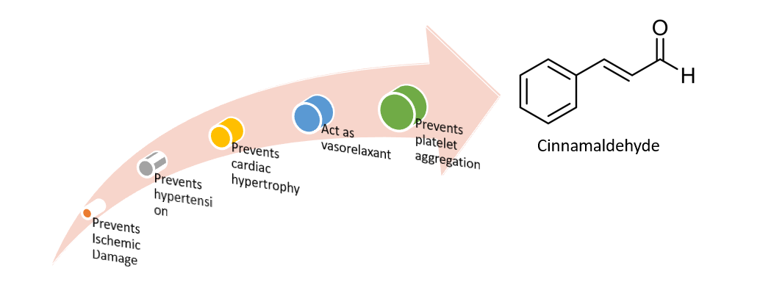
Fig. 2. Protective cardiovascular effects of cinnamon.^{[11]}
  - Immunomodulatory
According to Shankar Gautam et al., “Dalchini”, one powerful immune-boosting ingredient is cinnamon. Numerous illnesses, including the flu, cough, oedema, poisoning, etc., are treated with it. While a low dose of cinnamon (10 mg/kg) only produces beneficial effects towards immune-stimulating activity, a high dose (100 mg/kg) of cinnamon increases phagocytic index, serum immunoglobin levels, and antibody levels while reducing the percentage count of neutrophils. Furthermore, cinnamon acts as a strong regulator of macrophage-mediated immune response by inhibiting PI3K, PDK1, and NF-kB, whereas activating CD29 and CD43 suppresses the production of nitric oxide. It regulates the function of co-stimulatory molecules like CD69 and CD80 and pattern recognition receptors like TLR2 and CR3. It modifies T cells' anti-inflammatory response and reduces cell death. It lowers the proportion of necrotic to apoptotic cells. Additionally, it was discovered to be an anticoagulant, thromboxane A2 receptor antagonist, and a preventive measure against CVDs and platelet clumping.^{[7]}
  - Anti-obesity
The anti-obesity bioactive agents found in cinnamon are eugenol, cinnamaldehyde, and cinnamic acid. ^{[5]} In vitro studies have shown that cinnamon-containing polyphenolic compounds could inhibit the differentiation of adipocytes. It could also inhibit the process of lipogenesis and lipolysis. It also decreases the intestinal absorption of lipids, thereby helping in the reduction of weight. ^{[8]} Furthermore, the extract of C. verum influences the absorption of cholesterol and fatty acids by inhibiting the action of Niemann-Pick c1-like 1 and CD36 mRNA receptors. ^{[5]} In vitro studies have shown the anti-obesity effects of cinnamon. The polyphenolic chemicals could inhibit intestinal absorption of fat, lipolysis, and adipocyte differentiation, all of which aid in weight loss. Additionally, it reduces the effects of inflammation and induces the oxidation of fatty acids. ^{[8]}
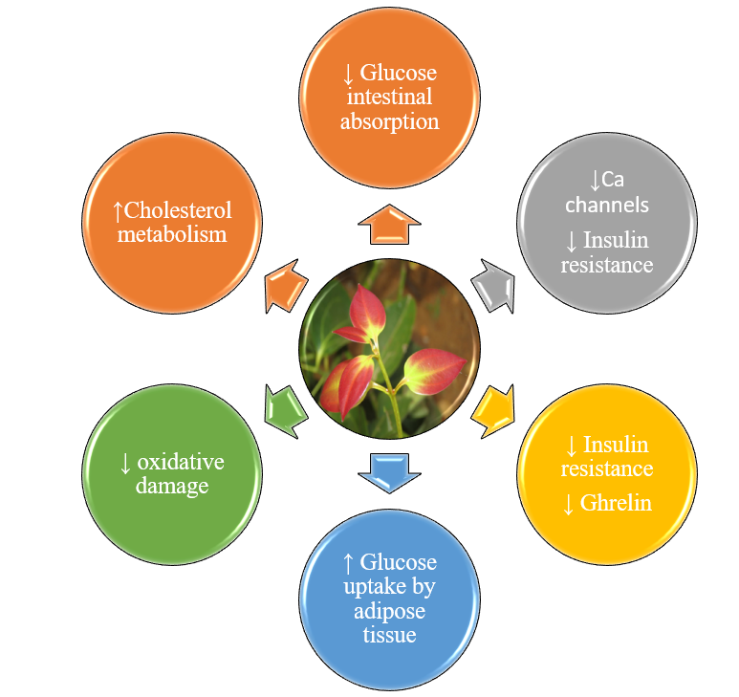
Fig. 3. Protective role of Cinnamomum Verum in Metabolic Disorders. ^{[4,8]}
  - Neuroprotective
Cinnamophilin, a thromboxane A2 receptor antagonist extracted from C. philippinensis is stated to confer a protective role in rats’ brain infarction when administered at 80 mg/day at different intervals and further enhances neurological behaviours. A study determined that cinnamon is found to be beneficial in the treatment of neurogenerative disorders like Parkinson’s and Alzheimer’s. It is observed that sodium benzoate (cinnamon metabolites) upregulates brain-derived neurotrophic factors and neurotrophin-3 in the mouse CNS. PD protein 7 is an autosomal recessive form of early-onset Parkinson’s and is a major neuroprotective protein that protects from cell damage and further prevents oxidative damage. Another study demonstrates that it helps in improving the cognitive abilities of mice. ^{[19]} There are two compounds found in cinnamon that appear to inhibit a protein called “tau” responsible for Alzheimer’s.
  - Nephroprotective
Cinnamon has a potential role in the reduction of serum creatinine, blood urea nitrogen, and an increase in serum albumin and total protein. One of the studies reflects the positive impact of Zeylancium against acetaminophen-induced apoptosis in renal tissue. Another study demonstrates that the intake of 3% cinnamon by rats helps to decrease diabetic nephropathy. Furthermore, the aqueous extract of cinnamon bark helps exhibit a hepato-renal protective effect against acetaminophen-induced toxicity in mice. ^{[24]}
  - Hepatoprotective
Food additives, including nigella, turmeric, and cinnamon, are important in the treatment of obesity and associated metabolic diseases like non-alcoholic fatty liver disease (NAFLD), according to a meta-analysis that examined the impact of supplementing with cinnamon on adult liver enzymes. Furthermore, there were significant changes in ALT levels noted on the dosage of <1500mg/day for >12 weeks in both genders. However, there was no significant effect of cinnamon on liver enzymes. ^{[22]} Another study confirms that cinnamon decreases acetaminophen (APAP) toxicity in the liver by reducing the level of lipid peroxidation (LPO), interleukins (IL-1β, IL-6), caspase-3, -9 expressions, determination of DNA fragments, and histopathological changes were reversed by administration of cinnamon oil in rats for 14 days. Moreover, it also restores the activity of antioxidative enzymes and regulates inflammatory reactions and apoptosis. Consequently, it may be said that cinnamon oil may be used as a substitute for traditional liver injury treatments.^{[12]}
- Toxicity of cinnamon
Cinnamon is a common spice used in Asia and is considered safe for human consumption. Excessive intake for a long period can show adverse effects. The most common adverse effect is shown by C. cassia, i.e., irritation and allergic reaction with mucus or the mucus membrane. ^{[8]} Nevertheless, a study indicated that cinnamon can show some negative effects such as stomach and bowel disorders, dry mouth and throat, coughing, gagging, vomiting, breathing difficulties, risk of pneumonia, and lung collapse. Furthermore, artificial cinnamon flavour can cause cinnamon contact stomatitis and oral lesions. ^{[15]} Patients may also develop white and erythematous spots with a burning sensation. However, there is acute toxicity seen in animals (rats) which is very low (benzaldehyde intake of 1300mg/kg, LD 50 orally), (cinnamaldehyde intake of 2220 mg/kg, LD 50 orally), (linalool intake of 2790 mg/kg, LD 50 orally), (salicylaldehyde intake of 520 mg/kg, LD 50 orally). ^{[14]} Furthermore, a scientific examination found that there is no acute or chronic toxicity of Zeylancium in mice. Another study done on thirty healthy adults found no notable harmful effects on anthropometric parameters from cinnamon intake. In addition, there is a decrease in systolic and diastolic blood pressure. A study on pregnant rats revealed that the intake of cinnamon can increase the quantity of resorption. One of the studies done related to diabetes and cinnamon intake discovered that intake of 3-6 gm of cinnamon per day can show a positive effect on blood sugar. Hence, it is recommended that cinnamon intake is safe and beneficial in humans and can be taken regularly. ^{[1]}
- Conclusion and Future Perspectives
For thousands of years, cinnamon has been used as an aromatic spice in everyday life. At some points, it was more valuable than gold. Currently, due to the growing side effects of oral medicines, there is a rising interest in herbal remedies. One such traditional folk product is cinnamon, which is generally recognised as safe by the USDA. Cinnamon is commonly labelled as a superfood due to its rich variety of forms, including bark, essential oils, bark powder, phenolic compounds, flavonoids, and isolated components, all of which contribute to its exceptional nutritional value. Furthermore, it has overlapping reactions including inflammation, anti-oxidant, detoxification, the immune system, and anti-microbial. The data from the above studies discussed shows that there are positive effects in the treatment of diabetes, blood clotting, hypertension, cardiovascular diseases, liver disorders, cancers, etc. As mentioned, further research is required to furnish additional clinical evidence supporting the traditional applications of cinnamon in the therapy of several diseases.
Author’s contribution:
All authors work together to complete the work. The final manuscript was read and approved by all authors.
Competing interest
No author declares competing interests.
Disclaimer (Artificial intelligence):
Author(s) hereby declare that NO generative AI technologies such as Large Language Models (ChatGPT, COPILOT, etc.) and text-to-image generators have been used during the writing or editing of this manuscript.
References:
1. Almatroodi SA, Alsahli MA, Almatroudi A, et al. Cinnamon and its active compounds: A potential candidate in disease and tumour management through modulating various genes activity. Gene Rep. 2020;21. doi:10.1016/j.genrep.2020.100966
2. Chanotiya CS, Yadav A. Enantiomeric composition of (3R)-(-)- and (3S)-(+)-linalool in various essential oils of Indian origin by enantioselective capillary gas chromatography-flame ionization and mass spectrometry detection methods. Nat Prod Commun. 2009;4(4):563-566. doi:10.1177/1934578X0900400424
3. Chericoni S, Prieto JM, Iacopini P, Cioni P, Morelli I. In Vitro Activity of the Essential Oil of Cinnamomum zeylanicum and Eugenol in Peroxynitrite-Induced Oxidative Processes. J Agric Food Chem. 2005;53(12):4762-4765. doi:10.1021/JF050183E
4. Cinnamomum verum (Ceylon cinnamon, Ceylon cinnamon tree, Cinnamon, Cinnamon bark tree, Kayu Manis, True cinnamon) | North Carolina Extension Gardener Plant Toolbox. Accessed August 18, 2023. https://plants.ces.ncsu.edu/plants/cinnamomum-verum/
5. Das G, Gonçalves S, Basilio Heredia J, et al. Cardiovascular protective effect of cinnamon and its major bioactive constituents: An update. J Funct Foods. 2022;97:105045. doi:10.1016/j.jff.2022.105045
6. FoodData Central. Accessed June 28, 2023. https://fdc.nal.usda.gov/fdc-app.html#/food-details/171320/nutrients
7. Gautam S, Gautam A, Chhetri S, and UBJ of A, 2022 undefined. Immunity against COVID-19: potential role of Ayush Kwath. Elsevier. Accessed July 13, 2023. https://www.sciencedirect.com/science/article/pii/S0975947620300668
8. Goel B, Mishra S. Medicinal and Nutritional Perspective of Cinnamon: A Mini-review. European J Med Plants. Published online February 27, 2020:10-16. doi:10.9734/EJMP/2020/V31I330218
9. Gruenwald J, Freder J, Armbruester N. Cinnamon and health. Crit Rev Food Sci Nutr. 2010;50(9):822-834. doi:10.1080/10408390902773052
10. Gruenwald J, Freder J, Armbruester N. Cinnamon and health. Crit Rev Food Sci Nutr. 2010;50(9):822-834. doi:10.1080/10408390902773052
11. Hosomi H, Ito Y, Ohba S. Crystal-to-crystal photodimerization of trans-cinnamamides. Acta Crystallogr B. 2000;56(4):682-689. doi:10.1107/S0108768100002329
12. Hussain S, Ashafaq M, Alshahrani S, et al. Cinnamon oil against acetaminophen-induced acute liver toxicity by attenuating inflammation, oxidative stress and apoptosis. Toxicol Rep. 2020;7:1296-1304. doi:10.1016/J.TOXREP.2020.09.008
13. Is Cinnamon Efficacious for Glycaemic Control in Type-2 Diabetes Mellitus? - PubMed. Accessed June 26, 2023. https://pubmed.ncbi.nlm.nih.gov/33341863/
14. Jakhetia V, Patel R, Khatri P, et al. CINNAMON: A PHARMACOLOGICAL REVIEW. J Adv Sci Res. 2010;1(02):19-23. Accessed August 7, 2023. https://sciensage.info/index.php/JASR/article/view/13
15. Kowalska J, Tyburski J, Matysiak K, Jakubowska M, Łukaszyk J, Krzymińska J. Cinnamon as a Useful Preventive Substance for the Care of Human and Plant Health. Molecules. 2021;26(17). doi:10.3390/MOLECULES26175299
16. Mishra S, Goel B, Danish Kadir S. Mini-review Article Goel and Mishra. 2020;EJMP(3):10-16. doi:10.9734/ejmp/2020/v31i330218
17. Mohammadabadi T, Jain R. Cinnamon: a nutraceutical supplement for the cardiovascular system. Arch Med Sci Atheroscler Dis. 2024;9(1):e72. doi:10.5114/AMSAD/184245
18. (PDF) Beneficial Effects of Cinnamon on the Metabolic Syndrome, Inflammation, and Pain, and Mechanisms Underlying These Effects – A Review. Accessed June 20, 2023. https://www.researchgate.net/publication/261518018_Beneficial_Effects_of_Cinnamon_on_the_Metabolic_Syndrome_Inflammation_and_Pain_and_Mechanisms_Underlying_These_Effects_-_A_Review
19. Ribeiro-Santos R, Andrade M, Madella D, et al. Revisiting an ancient spice with medicinal purposes: Cinnamon. Trends Food Sci Technol. 2017;62:154-169. doi:10.1016/j.tifs.2017.02.011
20. Safdar M. Proximate Composition and Mineral Analysis of Cinnamon Adipokines from fats View project. Article in Pakistan Journal of Nutrition. Published online 2009. doi:10.3923/pjn.2009.1456.1460
21. Shekarchizadeh-Esfahani P, Heydarpour F, Izadi F, Jalili C. The effect of cinnamon supplementation on liver enzymes in adults: A systematic review and meta-analysis of randomized controlled trials. Complement Ther Med. 2021;58. doi:10.1016/j.ctim.2021.102699
22. Shen Y, Jia LN, Honma N, Hosono T, Ariga T, Seki T. Beneficial effects of cinnamon on the metabolic syndrome, inflammation, and pain, and mechanisms underlying these effects-a review. J Tradit Complement Med. 2012;2(1):27-32. doi:10.1016/S2225-4110(16)30067-0
23. Yakhchali M, Taghipour Z, Mirabzadeh Ardakani M, Alizadeh Vaghasloo M, Vazirian M, Sadrai S. Cinnamon and its possible impact on COVID-19: The viewpoint of traditional and conventional medicine. Biomedicine and Pharmacotherapy. 2021;143. doi:10.1016/j.biopha.2021.112221
24. Yanakiev S. Effects of Cinnamon (Cinnamomum spp.) in Dentistry: A Review. Molecules. 2020;25(18). doi:10.3390/MOLECULES25184184

