Original Research Article
Evaluation of Biopesticide Potential of Rabbit Urine in the Control of Spodoptera frugiperda larvae in Maize Cultivation

ABSTRACT
The fall armyworm caterpillars (Spodoptera frugiperda larvae) poses a major threat to maize production in Burundi, where maize is a staple crop for food security. The repeated use of chemical pesticides leads to health and environmental risks, prompting the search for ecological alternatives. Among these, rabbit urine is gaining increasing interest as a biopesticide.
An experimental study was conducted in Cankuzo (Burundi) between January and June 2024 to evaluate the effect of rabbit urine against the fall armyworm. Four treatments were tested: control without urine (T0), urine diluted tenfold (T1), urine diluted fivefold (T2), and undiluted urine (T3). The urine was sprayed three times at two-week intervals, starting from the appearance of the first infestations.
The results show that urine treatments, particularly the undiluted one (T3), significantly reduced the number of caterpillars and plant damage. Treatment T3 recorded the lowest infestation rate (31.5% of plants attacked) and the highest caterpillar mortality (85 dead), compared to only 2 dead caterpillars in the control treatment. Statistical analysis confirmed a significant difference between the urine treatments and the control without urine (p < 0.05).
Undiluted rabbit urine has repellent and insecticidal properties against the fall armyworm. It enhances plant resistance and could be a sustainable and accessible solution for small-scale farmers. For optimal effectiveness, it is recommended to apply undiluted urine at least three times, starting from the detection of the first caterpillar attacks.
Keywords: Rabbit urine, biopesticide, fall armyworm, maize

1. INTRODUCTION
Maize is widely cultivated around the world and represents the highest production among all cereals. It is already the most productive cereal in terms of output volume and is expected to become the most cultivated and traded crop in the next decade (Erenstein et al., 2022). Maize is the staple food for 900 million poor people, 120 to 140 million poor farming households, and about one-third of the world's undernourished children (Murdia et al., 2016). In Burundi, it is the main cereal grown throughout the year and across the entire country, including low, medium, and high altitudes (Bizoza et al., 2022). During the harvest season, it is consumed six days a week and two days during the lean season (off-season). The average daily consumption per person is 285 grams, indicating that maize alone provides approximately 1,026 kcal per day (MINEAGRIE, 2024).
However, maize production faces many challenges, particularly pest attacks, notably the fall armyworm (Spodoptera frugiperda). This pest was first reported in Burundi in 2016 (Laminou et al, 2022). The fall armyworm continues to devastate maize fields and significantly reduces yields. If not properly managed, it can cause substantial yield losses (FAO, 2018; Desiré & Blaise, 2023). The impact of the fall armyworm on maize productivity increasingly threatens agricultural output and, consequently, livelihoods and rising food insecurity, especially in Africa (Kemunto et al., 2022). It has become the most significant pest of maize, leading farmers to overuse chemical insecticides, which are often ineffective.
In Burundi, chemical control is implemented when preventive and prophylactic measures prove insufficient. Unfortunately, for a long time, chemical control has been the immediate response whenever there is a need to treat plant diseases or pests. This presents a serious challenge and danger, as alternative methods that are less costly and less harmful to human health and the environment are often ignored. Although Burundian farmers consider chemical pesticides highly effective, they are harmful to both health and the environment (Mpawenimana, 2019).
Therefore, the experimentation and implementation of alternative methods to chemical control in plant protection should be strongly encouraged (MINEAGRIE, 2024). Several locally available substances are commonly used by smallholder farmers to try to control the fall armyworm, including the application of soil, ash, lime, salt, oils, soaps, and urine. However, their effectiveness is not well documented in scientific literature, and some should not be recommended (Hruska, 2019).
A study examined the effect of rabbit urine on the fall armyworm and found that it reduced larval feeding, increased mortality, and decreased egg hatching (Kemunto et al., 2022). In Kenya, rabbit urine is considered a valuable agricultural resource that can be used as a biofertilizer or even as a biopesticide. However, there is still limited scientific evidence supporting the effectiveness of rabbit urine as a biopesticide (Kemunto et al., 2022).
Currently, more and more Burundian farmers are becoming aware of rabbit farming and the use of rabbit urine to control crop pests, particularly the maize fall armyworm. While some farmers report the effectiveness of rabbit urine as a biopesticide, others remain unaware of its benefits. However, the optimal doses and application timings of rabbit urine are still unknown. It is in this context that the present experimental study was conducted. Its objective is to evaluate the effect of rabbit urine on controlling the maize fall armyworm, with the aim of improving agricultural yields in Burundi.

2. MATERIALS AND METHODS

2.1. Study Site and Period
The study was conducted between January and June 2024 in a real field setting located in the natural region of Buyogoma, within the agro-ecological zone of the central plateaus, under the Provincial Office of Environment, Agriculture, and Livestock (BPEAE) in Cankuzo, Burundi. This region lies at an altitude ranging from 1,200 m to 1,800 m, with annual rainfall between 1,100 mm and 1,400 mm (FEWS NET, 2021). It is an agro-ecological zone where hybrid maize cultivation is among the main agricultural productions (Ndayizeye, 2022). The experimental site is geographically located at -3°12'46.4" South latitude and 30°33'33.6" East longitude.

2.2. Plant Material
The variety RHM 1407 was used in the trial. It has a short vegetative cycle of 115 to 135 days. The RHM 1407 variety was selected for this study for several reasons. It is a variety already marketed in the region and is known for its good adaptation to altitudes ranging from 900 to 1700 meters. Since our study area is located between 1200 and 1800 meters in altitude, RHM 1407 is well-suited to the majority of this altitudinal range. Additionally, its potential yield reaching up to 7.87 tons per hectare makes it an ideal choice for the present study.

2.3. Fertilizers Used During the Experiment
Fertilization was normally carried out using farmyard manure and organo-mineral fertilizers (FOMI), according to the recommendations of the Burundi Institute of Agricultural Sciences (ISABU).

2.4. Source and Collection Method of Rabbit Urine
The rabbit urine used was obtained from a rabbit farming unit at a secondary school near the experimental site. Collection began in December 2023 and was done daily. The urine was collected directly from the rabbit hutch using a system of gutters that directed it into a collection container. Each morning, the collected quantity was transferred into 20-liter jerry cans, which were tightly sealed until use. This process ensured the quality and preservation of the urine.

2.5. Experimental Design and Trial Management

2.5.1. Experimental Design
The experimental layout followed a randomized complete block design (RCBD), comprising 4 treatments replicated 3 times and randomized. The total area of the experimental field was 13 m × 10.75 m, i.e., 139.75 m², while each elementary plot measured 2.25 m × 2 m, i.e., 4.5 m² (see Figure 1). The used traitements include:
- T0: Control (no application)
- T1: Urine diluted 10 times
- T2: Urine diluted 5 times
- T3: Undiluted urine
The elementary plots were separated by a 1-meter alley. A 1-meter buffer zone was also maintained around the edges of the experimental field.
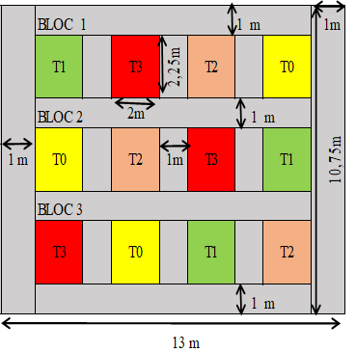 Figure 1: Experimental Design

2.5.2. Tillage, Sowing Period, and Planting Density
Tillage was carried out from January 18 to 19, 2024, at an average depth of 20 cm, with complete crushing of soil clods. Weed clearing was done immediately after tillage. Sowing was conducted on February 1st during the 2024B cropping season, with spacings of 75 cm between rows and 50 cm between planting holes, with two seeds per hole. Each elementary plot had 4 rows, and each row had 5 planting holes, making 20 planting holes per elementary plot. Each block therefore had 80 planting holes, totaling 240 planting holes for the 3 blocks, which corresponds to 480 seeds sown.

2.5.3. Application of Rabbit Urine
The application of rabbit urine against the fall armyworm (Spodoptera frugiperda) began at the first visible signs of infestation. Maize plants were sprayed three times. The first application took place three weeks after sowing (WAS), when armyworm damage was already visible on the maize leaves. This first spray did not consider the damage threshold for each treatment. The second and third applications were done respectively at the fifth and seventh weeks after sowing, with a two-week interval between applications.
The urine was diluted 10 times, 5 times, and not at all for treatments T1, T2, and T3 respectively. Tap water was used for dilution in the ratios of 1:5 (T2) and 1:10 (T1). This means 1 liter of urine was mixed with 5 liters of water for T2, and 1 liter with 10 liters of water for T1. For treatment T3, the urine was used undiluted (pure). The volume sprayed per plant was approximately 10 to 15 cl, depending on the growth stage of the plants. The control treatment (T0) received no application at all.

2.5.4. Sample Size

The sample size was calculated using the formula of Krejcie & Morgan (1970):
$$n=\frac{z^{2}p\left(1-p\right)N}{d^{2}\left(N-1\right)+z^{2}p(1-p)}$$
Where:
- n = sample size
- N = total number of maize plants = 480
- p = probability of having a characteristic = 0.50
- z = 1.96 (value from Student’s distribution for α = 5%)
- d = margin of error = 0.05
- $n=\frac{({1.96}^{2}*0,50\left(1-0.50\right)480}{{0.05}^{2}*\left(600-1\right)+{1.96}^{2}*0,50\left(1-0.50\right)}$=216
The total sample size was 216 plants. This number was divided by the number of experimental units (12) to determine the number of plants to be sampled per elementary plot, which gave 18 plants per plot (see Figure 2).
16 plants were selected using the “X” method recommended by FAO (2018). This pattern consists of two diagonals, each crossing 8 planting holes. Since each hole had 2 plants, this gave 16 plants per experimental unit. 2 additional plants were randomly selected in each unit, bringing the sample size to 18 plants per elementary plot.
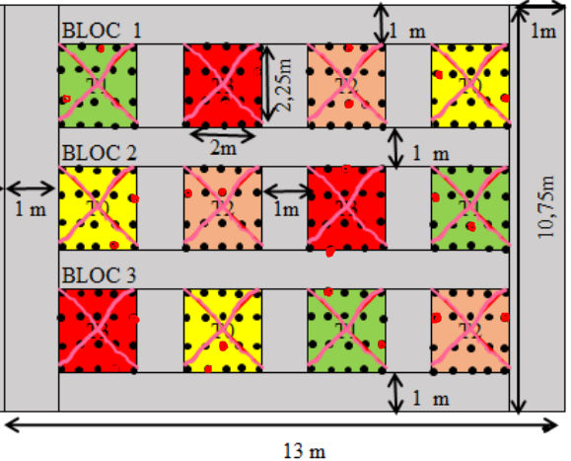
Figure 2: Diagram of Sample Selection

2.5.5. Data Collection
Data were collected on the number of healthy plants, the number of plants damaged by caterpillars, the number of fall armyworms per maize plant, and the degree of infestation of the maize plants.

2.5.5.1. Number of Healthy and Damaged Plants
The first fall armyworm attacks were observed and evaluated at the beginning of the third week after sowing. The counting of damaged plants and healthy plants was also carried out after the three urine applications, during male flowering, at a time when no new leaves were developing.
For qualitative data, a scale from 1 to 5 was used to quantify the degree of infestation, thus facilitating statistical analysis (Table 1). This leaf damage rating scale due to fall armyworm infestation was based on the Davis and Williams (1992) scale (Prasanna et al., 2018), where:
- 1 = Highly resistant
- 2 = Resistant
- 3 = Moderately resistant
- 4 = Susceptible
- 5 = Highly susceptible (see Figure 3).
The main data collected concerned damage on the leaves and the whorl (funnel). Damage on the male inflorescence and ears was not assessed in this study.

Table 1: Leaf Damage Rating Scale Due to Fall Armyworm (FAW) on Maize
Score | Damage Symptoms / Description | Plant Response
1 | No visible leaf feeding | Highly resistant
2 | Several perforation lesions on a few leaves (<5 leaves) and a small circular hole damaging the leaves | Resistant
3 | Elongated lesions (>2.5 cm long) on 8 to 10 leaves, plus a few small to medium holes of uniform to irregular shape (basal membranes consumed), found on whorled and/or rolled leaves | Moderately resistant
4 | Numerous elongated lesions of all sizes present on several whorled and rolled leaves, along with multiple large uniform to irregular holes on those leaves | Susceptible
5 | Whorled and rolled leaves are almost completely destroyed and the plant dies due to severe leaf damage | Highly susceptible
Source: Adapted from Davis and Williams (1992).
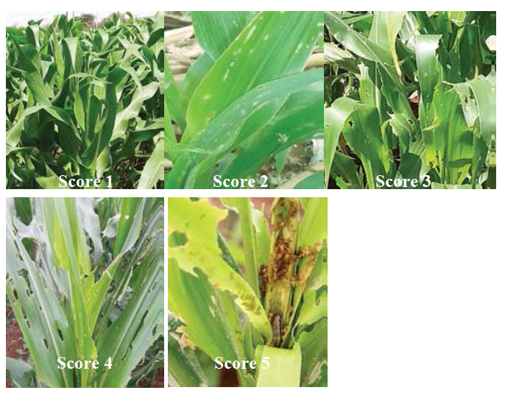
Figure 3: Classification of Maize Plants According to Leaf Damage Caused by the Fall Armyworm.
Source: Adapted from Prasanna et al., 2018

2.5.5.2. Number of Caterpillars
Before each application of urine as a biopesticide, plants were inspected to detect the presence of fall armyworm caterpillars and to count their number per plant. The number of visible caterpillars per plant (larval stage) was counted just before the first urine application. The number of caterpillars at both larval and adult stages (Figure 4) was also evaluated during the second and third applications, performed respectively at the fifth and seventh weeks after sowing. The day after each urine application, the number of dead caterpillars was recorded.

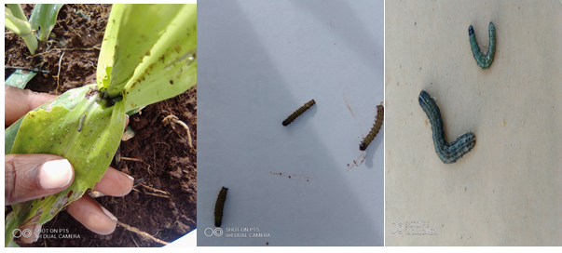Figure 4: Counting Fall Armyworm Caterpillars at Larval Stage

2.6. Data Analysis
Descriptive statistics (sum, minimum, mean, standard deviation, and maximum) and analysis of variance (ANOVA) were performed using IBM SPSS version 21. Multiple mean comparisons were done using Tukey’s test at a 5% significance level. Pearson’s chi-square test was also used to cross-tabulate the qualitative variables “type of biopesticide” and “level of infestation.”

3. RESULTS AND DISCUSSION
This study examined the potential of rabbit urine as a biopesticide for controlling the fall armyworm. For all parameters studied, application of rabbit urine had a positive effect with differences between treatments (p < 0.05). This suggests that rabbit urine possesses repellent properties against pests and can cause mortality in fall armyworm caterpillars.

3.1. Analysis of the Number of Fall Armyworm Caterpillars Counted per Visit
Results in Table 2 show a widespread and almost homogeneous presence of fall armyworm caterpillars across all treatments before the first urine application. During the second and third visits, the number of caterpillars increased in the control treatment T0 where no urine was applied. At the second visit, treatment T3 (undiluted urine) showed the lowest number of caterpillars with 28, followed by T2 with 38 caterpillars. At the third visit, treatment T2 (urine diluted 5 times) recorded the lowest number with 14 caterpillars, followed by T3 with 17 caterpillars. Overall, treatment T3 was the most effective in reducing the total number of caterpillars, followed by T2, T1, and T0 respectively.
In general, the number of caterpillars in treatments T1, T2, and T3 decreased with urine application and as maize growth progressed. For example, the number of fall armyworm caterpillars counted in T3 dropped from 28 at the second application to 17 at the third. The trend was reversed in T0 where caterpillar numbers rose from 70 to 94 at the second and third applications respectively. These results indicate that urine concentration plays a crucial role in effectiveness against the fall armyworm, corroborating findings by Said et al. (2018) emphasizing the importance of nitrogen concentration for insecticidal activity.

Table 2: Number of Caterpillars Counted per Visit Before Urine Application
Treatments | Caterpillars before 1st application | Caterpillars at 2nd application | Caterpillars at 3rd application | Total
T0 | 42 | 70 | 94 | 206
T1 | 65 | 74 | 54 | 193
T2 | 49 | 38 | 14 | 101
T3 | 50 | 28 | 17 | 95

3.2. Analysis of Number of Dead Caterpillars per Visit After Urine Application
Considering the total number of dead caterpillars after urine application, Table 3 and Figure 5 show that the “type of biopesticide” (different dilutions of rabbit urine) had a positive effect in controlling fall armyworm. Treatment T3 (undiluted urine) recorded the highest total number of dead caterpillars with 85 deaths following urine application. This was followed by treatments T2, T1, and T0 with 71, 38, and 2 dead caterpillars respectively. A preventive effect of urine was also noted, as the number of dead caterpillars decreased progressively with repeated urine applications, possibly explained by the absence of new attacks. FAO (2022) supports that multiple urine sprays have a positive effect and recommends spraying affected crops three times per week over two weeks to decimate insects.

Table 3: Number of Dead Caterpillars Counted per Visit After Urine Application
Treatments | Dead caterpillars after 1st application | Dead caterpillars after 2nd application | Dead caterpillars after 3rd application | Total dead
T0 | 0 | 2 | 0 | 2
T1 | 2 | 29 | 7 | 38
T2 | 27 | 33 | 11 | 71
T3 | 44 | 24 | 17 | 85

3.3. Descriptive and Variance Analysis of Dead Caterpillars After 3 Visits

3.3.1. Descriptive Analysis of Dead Caterpillars After 3 Visits
Descriptive statistics on table 4 show the highest average number of dead caterpillars per plant (1.57) was observed in treatment T3 (undiluted urine), followed by T2 (1.31) where urine was diluted five times. The lowest average was in T0 (no urine), with 0.04 dead caterpillars per plant.

Table 4: Descriptive Statistics of Average Number of Dead Caterpillars After 3 Visits
Treatments | Sum | Minimum | Mean | Standard Deviation | Maximum
T0 | 2 | 0 | 0.04 | 0.191 | 1
T1 | 38 | 0 | 0.70 | 0.924 | 3
T2 | 71 | 0 | 1.31 | 1.241 | 5
T3 | 85 | 0 | 1.57 | 1.644 | 6
Total | 196 | 0 | 0.91 | 1.273 | 6

3.3.2. Analysis of Variance of Dead Caterpillars After 3 Visits
ANOVA results for the number of dead caterpillars (Table 5) revealed significant differences between treatments (p < 0.05). Multiple mean comparisons showed a significant difference between the urine-treated groups (T1, T2, T3) and the untreated control (T0) (p < 0.00). However, no significant difference was observed between T2 and T3 treatments (p = 0.634).

Table 5: Analysis of Variance for Number of Dead Caterpillars
Source of Variation | Sum of Squares | Degrees of Freedom | Mean Square | F | p-value
Between Groups | 76.111 | 3 | 25.370 | 19.771 | 0.000
Within Groups | 272.037 | 212 | 1.283
Total | 348.148 | 215

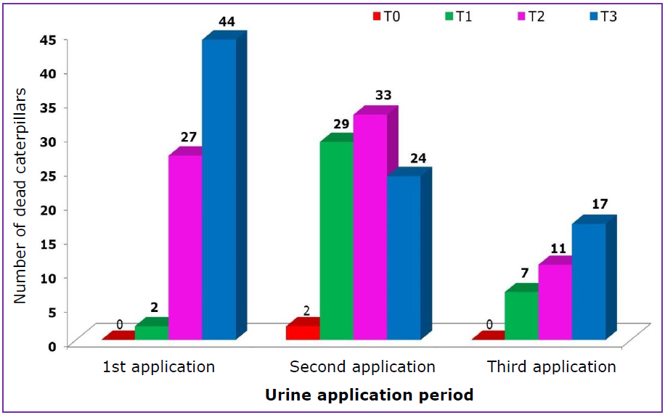

Figure 5: Variation in the Number of Dead Caterpillars According to the Type of Biopesticide and Urine Application Period.
From Figure 5, it is observed that the number of dead caterpillars collected decreased progressively with repeated urine applications. This could be explained by the fact that rabbit urine has a preventive and repellent effect against new attacks by the fall armyworm caterpillars. Treatments T2 and T3 were very sensitive regarding the number of dead caterpillars per application, ranging between 17 and 44 caterpillars for T3, and between 11 and 33 caterpillars for T2. These results agree with those of Ano and Ekefan (2023), who found that rabbit droppings enhance crop resistance by repelling pests such as aphids and fall armyworm caterpillars, among others.
3.4. Analysis of the Infestation Rate and the Infestation Level per Treatment

Results from Table 6 show that treatment T3 recorded the highest rate (68.5%) of maize plants classified as very resistant to infestation (level 1) when sprayed with undiluted rabbit urine. This was followed by treatment T2 and T1, with 63% and 3.7% of plants being very resistant, respectively, when sprayed with urine diluted five times.
Conversely, the highest number of highly susceptible plants (level 5), i.e., heavily damaged plants, was observed in treatment T0 (control), where 48 plants, or 88.9%, were devastated by the fall armyworm in the absence of any spraying (Figure 6). Kemunto et al. (2022) also demonstrated that rabbit urine acts as a repellent, causing damage reduction of 6.4% and 12.8% at the second and third larval stages, respectively, 24 hours after exposure.

Pearson’s Chi-square test crossing the two qualitative variables "type of biopesticide" and "level of infestation" indicates a significant effect, thus establishing a link between the two variables (p < 0.05).

Treatment |  | Level 1 | Level 2 | Level 3 | Level 4 | Level 5 | Total
T0 | Number | 0 | 0 | 0 | 6 | 48 | 54
T0 | % within treatment | 0.0% | 0.0% | 0.0% | 11.1% | 88.9% | 100%
T1 | Number | 2 | 46 | 6 | 0 | 0 | 54
T1 | % within treatment | 3.7% | 85.2% | 11.1% | 0.0% | 0.0% | 100%
T2 | Number | 34 | 15 | 5 | 0 | 0 | 54
T2 | % within treatment | 63.0% | 27.8% | 9.3% | 0.0% | 0.0% | 100%
T3 | Number | 37 | 16 | 1 | 0 | 0 | 54
T3 | % within treatment | 68.5% | 29.6% | 1.9% | 0.0% | 0.0% | 100%
Total | Number | 73 | 77 | 12 | 6 | 48 | 216
Total | % within treatments | 33.8% | 35.6% | 5.6% | 2.8% | 22.2% | 100%
Table 6: Treatment of Maize plants sprayed with undiluted rabbit urine at five levels

Figure 6: Infestation Levels of Maize Plants by Fall Armyworm According to Treatments

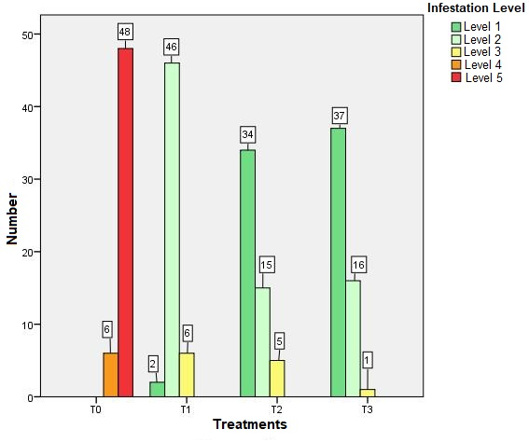

3.5. Analysis of the Rate of Healthy and Attacked Plants After Three Urine Application

Periods Table 7 summarizes the number of healthy and attacked plants after three urine applications in the different treatments. The infestation rate per treatment was calculated by adding the plants infested at levels 2, 3, 4, and 5 (Table 6).

Treatment T3 was the least infested, with 68.5% healthy plants versus 31.5% infested plants, followed by treatment T2 with 63.0% healthy plants versus 37.0% infested. Treatments T0 and T1 were overall heavily infested regardless of infestation level. Healthy plants were those classified as resistant with a score of 1 (Level 1).

Table 7: Rate of Healthy and Attacked Plants After Three Urine Applications
Treatment |  | Healthy Plants | Attacked Plants | Total
T0 | Number | 0 | 54 | 54
T0 | % within treatment | 0.0% | 100.0% | 100%
T1 | Number | 2 | 52 | 54
T1 | % within treatment | 3.7% | 96.3% | 100%
T2 | Number | 34 | 20 | 54
T2 | % within treatment | 63.0% | 37.0% | 100%
T3 | Number | 37 | 17 | 54
T3 | % within treatment | 68.5% | 31.5% | 100%
Total | Number | 73 | 143 | 216
Total | % within treatments | 33.8% | 66.2% | 100%

4. CONCLUSION
Rabbit urine used as a biopesticide showed a significant reduction in the population of fall armyworm caterpillars on maize plants, especially when used undiluted (T3). The treatment T3 resulted in the highest number of dead larvae (85) and the lowest rate of infested plants (31.5%), compared to 100% infestation in the untreated control (T0). This treatment also recorded the highest proportion of plants highly resistant to infestation (68.5% at level 1), thus demonstrating its preventive and repellent effect. Statistical analysis revealed significant differences between treatments (p<0.05), confirming that rabbit urine possesses insecticidal properties.
Furthermore, treatments T2 (urine diluted 5 times) and T3 were found to be statistically similar in terms of larval mortality (71 and 85 dead, respectively), suggesting that even moderate dilution retains considerable effectiveness.
Based on this study, it is recommended to spray maize plants with undiluted rabbit urine at least three times, at two-week intervals, starting from the onset of the first infestations by the fall armyworm.
DISCLAIMER (ARTIFICIAL INTELLIGENCE)
Author(s) hereby declare that NO generative AI technologies such as Large Language Models (ChatGPT, COPILOT, etc) and text-to-image generators have been used during writing or editing of this manuscript.
COMPETING INTERESTS
Authors have declared that no competing interests exist.
Références

1. Ano, Q. U., & Ekefan, E. (2023). Rabbit wastes and its potential to boost agricultural productivity: a synoptic review in sweet potato farming. Nigeria Agricultural Journal, 54(2), 345-353.
- Bizoza, S., Mutuo, P. K., & Leo, Y. L. (2022). Résultat d’étude sur la chaîne de valeur maïs au Burundi (pp. 1–33). https://www.researchgate.net/publication/372157367

- Erenstein, O., Jaleta, M., Sonder, K., Mottaleb, K., & Prasanna, B. M. (2022). Global maize production, consumption and trade: trends and R&D implications. Food Security, 14(5), 1295–1319. https://doi.org/10.1007/s12571-022-01288-7.

- Désiré, M. A., & Blaise, N. Y. H. (2023). Causes et Conséquences de L’Insécurité Alimentaire et Nutritionnelle des Ménages au Burundi: Approche Qualitative. International Journal of Science Academic Research, 4(10), 6375-6381.
https://scholar.google.com/scholar?hl=fr&as_sdt=0%2C5&q=D%C3%A9sir%C3%A9%2C+M.+A.%2C+%26+Blaise%2C+N.+Y.+H.+%282023%29.+Causes+et+Cons%C3%A9quences+de+L%E2%80%99Ins%C3%A9curit%C3%A9+Alimentaire+et+Nutritionnelle+des+M%C3%A9nages+au+Burundi%3A+Approche+Qualitative.+International+Journal+of+Science+Academic+Research%2C+4%2810%29%2C+6375-6381&btnG

- FAO. (2018). Integrated Management of the Fall Armyworm on Maize. A guide for Farmer Field Schools in Africa. Food and Agriculture Organization. Rome (Italy), 147 pages.

- FAO. (2022). Lutte contre la chenille légionnaire d’automne – Expériences des champs-écoles des producteurs en Afrique. Food and Agriculture Organization.Addis-Abeba. https://doi.org/https://doi.org/10.4060/cb9536fr or https://openknowledge.fao.org/server/api/core/bitstreams/b3cef400-200b-4706-9aa7-00205b8517b8/content

- FEWS NET. 2021. Livelihoods Zone Map and Descriptions for Burundi. Washington, D.C.: FEWS NET.
https://fews.net/east-africa/burundi/livelihood-description/february-2021
- Hruska, A. J. (2019). Fall armyworm (Spodoptera frugiperda) management by smallholders. CAB Reviews, 14(43), 1–11. https://doi.org/10.1079/PAVSNNR201914043

- Kemunto, D., Omuse, E. R., Mfuti, D. K., Tamiru, A., Hailu, G., Rwiza, I., Belayneh, Y. T., Subramanian, S., & Niassy, S. (2022). Effect of Rabbit Urine on the Larval Behavior , Larval Mortality , Egg Hatchability , Adult Emergence and Oviposition Preference of the Fall Armyworm ( Spodoptera frugiperda J.E. Smith ). Agriculture, 12(8), 1282. https://doi.org/https://doi.org/10.3390/ agriculture12081282
- Krejcie, & Morgan. (1970). Determining sample size for research activities: The case of organizational research. Educational and Psychological Measurement, 2(1), 20–34.

- MINEAGRIE. (2024). Plan de gestion des pestes au Burundi (PGP). Rapport final. Ministère de l’Environnement, de l’Agriculture et de l’Elevage. Bujumbura, Burundi.
https://bi.chm-cbd.net/sites/bi/files/2020-09/plan-gest-pestes-bi.pdf

- Mpawenimana, A. (2019). Conseils de lutte intégrée et suivi-évaluation des dégâts de la chenille légionnaire d’automne (CLA) Spodoptera frugiperda (J.E. Smith) (Lepidoptera: Noctuidae) dans le cadre du Programme «Amashiga»/CRS Burundi. In Bulletin trimestriel (n°22) de la recherche agronomique au Burundi. Bujumbura, Burundi. p. 2-11
https://bi.chm-cbd.net/sites/bi/files/2020-02/bulletin-recherche%20-agronomique-22-bi.pdf

- Laminou, S., Moussa, O. Z., Amadou, L., & Baoua, I. (2022). Revue des principaux résultats des travaux de recherche sur la chenille légionnaire d'automne Spodoptera frugiperda JE Smith en Afrique. International Journal of Innovation and Applied Studies, 38(2), 243-261.
https://scholar.google.com/scholar?hl=fr&as_sdt=0%2C5&q=Souleymane%2C+L.%2C+Ousmane%2C+Z.+M.%2C+Laouali%2C+A.%2C+%26+Ibrahim%2C+B.+%282022%29.+R+Revue+des+principaux+r%C3%A9sultats+des+travaux+de+recherche+sur+la+chenille+l%C3%A9gionnaire+d%E2%80%99automne+Spodoptera+frugiperda+J.E.+Smith+en+Afrique.+International+Journal+of+Innovation+and+Applied+Studies%2C+38%282%29%2C+243%E2%80%93261&btnG=#d=gs_cit&t=1753727150492&u=%2Fscholar%3Fq%3Dinfo%3AhiSL4hV5qeoJ%3Ascholar.google.com%2F%26output%3Dcite%26scirp%3D0%26hl%3Dfr

- Murdia, L. K., Wadhwani, R., Wadhawan, N., Bajpai, P., & Shekhawat, S. (2016). Maize utilization in India: an overview. American Journal of Food and Nutrition, 4(6), 169–176. https://doi.org/10.12691/ajfn-4-6-5.

- Ndayizeye, Y. (2022). Dynamique du marché des semences de maïs hybride au Burundi. Mémoire de Master. Faculté d’agronomie et de bio-ingénierie, Département de socio économie rurale, Université du Burundi.
https://repository.ub.edu.bi/handle/123456789/370
or
https://repository.ub.edu.bi/server/api/core/bitstreams/d036872a-2f17-421f-a3cc-e60e8fa0fb63/content

- Prasanna, B. M., Joseph, E. H., Regina, E., & Virginia, M. P. (2018). Fall Armyworm in Africa: A Guide for Integrated Pest Management. First edition. Mexico City: CIMMYT.

- Said, M. I., Asriany, A., Sirajuddin, S. N., Abustam, E., & Rasyid, R. (2018). Evaluation of quality of liquid organic fertilizer from rabbit’s urine waste fermented using local microorganisms as decomposers.The use of chemical fertilizers has bec. Iraqi Journal of Agricultural Sciences, 49(6), 990–1003.

