Original Research Article
Isolation and characterization of bacterial endophytes present in the plant parts of mulberry (Morus indica L.)

Abstract:
The microbes which live inside the plant tissue without causing any harm to the plants are termed as endophytes which has a positive influence on the growth of host plant. Mulberry is the sole food crop to the silkworm Bombyx mori. Growth and development of mulberry is very important in silkworm rearing. Naturally, the endophytes are present in the different plant parts of mulberry enhances the growth of mulberry plant. This study was done to isolate the endophytic bacteria present in the leaves, stem and roots of V1 and G4 varieties of mulberry (Morus indica L.). On a whole, 30 numbers of isolates were isolated and subjected to the various morphological and biochemical characterizations.
Key words:
Mulberry, Bacterial endophytes, Morphological Characterization and Biochemical Characterization

- Introduction:
Silk farming is the growing of silkworms for silk production. Mulberry cultivation, silkworm production and post-cocoon activities are all key parts in sericulture. Mulberry cultivation involves the production of mulberry leaves. The silkworm (Bombyx mori) solely feeds on the crop mulberry. So, the growth and development of the mulberry influences the growth of silkworm and cocoon yield. Healthier growth of mulberry ensures better cocoon production which increases the economic status of farmers.
Endophytes are microbial symbionts residing within the plant for the majority of their life cycle without any detrimental impact to the host plant (Kandel et al., 2017). Endophytes includes bacteria, fungi and actinomycetes. Bacterial endophytes offer more benefits and are able to interact with the host in the variable environmental conditions (Himani Chaturvedi et al. 2016). Endophytes are capable of promoting growth through direct mechanisms like nitrogen fixation, phosphate solubilization and modulating the phytohormone levels such as cytokinins, gibberellins, IAA and ethylene, Siderophore production and induced systemic resistance are all indirect way of enhancing growth promotion (Himani Chaturvedi et al., 2016).
In this study, the bacterial endophytes prevailing in the mulberry plant parts were isolated and characterized.
- Materials and Methods:
  - Sample collection:
The fresh plant parts (leaves, stem and roots) of two different varieties i.e., V1 and G4 were collected from mulberry fields and used for the isolation of bacterial endophytes.
  - Sterilization of bacterial endophytes:
The collected leaves were washed with tap water and rinsed with 0.1 percent Tween 20 for few seconds, then surface sterilized with 70 percent ethanol for one minute followed by 11 percent aqueous sodium hypochlorite for 5 minutes and finally washed with sterile water. The stem and root portions were washed with tap water and surface sterilized with 0.1 percent sodium hypochlorite for 1 minute followed by 70 percent ethanol for 1 minute, 3 percent sodium hypochlorite for 5 minutes and finally washed with sterile water. The final wash water was collected and used for the sterility test (Bacon et al. 2000 and Xianling et al. 2008).
  - Isolation of bacterial endophytes:
The endophytes were isolated using the standard protocol of Bacon et al. (2000) and Xianling et al. (2008) with certain modifications. The surface sterilized plant parts were macerated using sterile pestle and mortar with sterile water. Then it subjected to centrifugation at 3000 rpm for 30 minutes. The supernatant was collected and serially diluted up to 10⁻⁶ and used for the isolation of endophytes using Nutrient Agar (NA) medium.
  - Characterization of endophytes:
The preliminary characterizations of isolated endophytes were carried out based on morphological characterization and gram’s staining method (Cappuccino and Sherman, 1992).
The isolates were named as leaf bacteria (LB), stem bacteria (SB) and root bacteria (RB) based on the plant part from which the isolate has been isolated.
    - Morphological characterization:
After purification, the cultures were morphologically characterized based on the colony form, surface, growth, elevation, pigmentation, colour and optical features.
    - Gram staining:
The purified cultures were subjected to gram’s staining to differentiate the gram positive and gram negative nature of the bacterial endophytes (McClelland et al., 2001).
    - Biochemical characterization:
For further screening, the isolates were subjected to various biochemical characterization tests viz., Starch hydrolysis test, Citrate utilization test, Catalase test, Gelatin hydrolysis test, Hydrogen sulphide production test, Indole production test, Carbohydrate fermentation test, Motility test, Methyl Red and Voges- Proskauer test (Cappuccino and Sherman,1992).
- Results:
  - Isolation of bacterial endophytes:
A total of 30 endophytic bacterial isolates were obtained from three plant parts of two mulberry varieties.
  - Characterization of endophytic isolates:
    - Morphological characterization:
The characterization of morphological traits i.e., colony form, surface, growth, elevation, pigmentation, colour and optical features were illustrated in Table 1, 2 and 3.
The shape of the colonies of stem isolates varied such as were rhizoid, round, punctiform and spherical. The surface edge of the colonies varied from smooth to rough in the surface and some colonies were glistering with smooth and rough surface. Growth of the colonies ranged from medium to fast growth. Flat, raise and convex were the type of elevation seen in the colonies isolated from the stem parts. The chromogenesis of the isolates were non-pigmented. Colour of the colonies varied from dull white, milky white and red. With respect to opacity of the colonies, it varied between opaque to translucent (Table 1).
The isolates obtained from the mulberry leaves showed round, spherical and punctiform colonies. The surface edge of the colonies varied from smooth to rough and some colonies were glistering with smooth surfaces. Growth of the endophytes was found to be in all phases viz., slow, medium and fast. Flat, raised and slightly raised were the types of elevation observed. The isolates exhibited non-pigmented chromogenesis and the colonies showed milky white and slightly milky white colours. The observed optical features were opaque and translucent (Table 2).
The colony forms of the mulberry root isolates were round, spherical and punctiform. The surface edges of the colonies were slightly rough and smooth. The growth ranged between slow and medium. Flat elevation was found in the colonies isolated from the mulberry roots. The chromogenesis of the isolates were non-pigmented and the colour of the colonies included milky white and slightly yellowish colour. Considering the opacity, it varied between opaque to translucent (Table 3).
    - Gram’s reaction:
Among 30 isolates, nearly 57 % (17 isolates) of the cultures were gram negative bacteria and remaining 43% (13 isolates) were gram positive bacteria (Table 4).
    - Biochemical characterization:
The biochemical characterizations would facilitate more specific identification of endophytic bacterial species. The results of biochemical tests were listed in the Table 5.
Among 30 isolates, 67 % of the isolates (20 isolates) showed positive reaction for starch hydrolysis test and also showed the clearing zone around the colonies by the action of hydrolysing the starch (Plate 1). In that, majority of the root isolates showed positive reaction. For citrate utilization test, 47 % (14 isolates) exhibited positive reaction by the colour change of media from green to Prussian blue colour along with bacterial growth (Plate 2). Among these root isolates major isolates showed positivity for citrate test while lesser number of stem isolates showed positivity for citrate test (Table 5).
Nearly 87% of isolates (26 isolates) showed positive for motility test by the manifestation of colony diffusion (Plate 3). Among 30 isolates, all the isolates obtained from stem and roots exhibited positive reaction. In gelatin hydrolysis test, only 37 % (11 isolates) showed positive reaction for the hydrolysis (Plate 4). Less number of isolates obtained from all the parts i.e. leaves, stem parts and roots showed positive for this reaction (Table 5).
All the 30 isolates showed negative reaction for methyl red test. The isolates exhibited yellow layer at the top of the broth while adding methyl red after incubation of inoculated bacteria. With this, all the 30 isolates showed negative reaction for voges- proskauer test without colour change in the medium while adding VP reagents (Barrit’s A and Barrit’s B) (Table 5).
Among 30 isolates, 97 % (29 isolates) showed positive reaction for catalase activity by the production of gas bubbles, when a loop of culture stirred in a hydrogen peroxide solution (Plate 5). In this, all the isolates produced bubbles except the isolate LB3V1.
For other biochemical characterization tests such as indole production test, H₂S production and carbohydrate digestion tests all the isolates (30 isolates) obtained from the leaves, stem parts and roots exhibited negative reaction without any respective colour changes (Table 5). The positive reaction for H₂S test is identified by blackening of the medium, but blackening was not observed in 30 isolates. Carbohydrate digestion was identified by colour change from red to yellow. The isolates did not produce any colour change.
- Discussion:
Microorganisms like bacteria, fungi and actinomycetes can be a potential agent of endophytes in different plant species. (Rakholiya and Khunt 2015).Totally 30 isolates were obtained from mulberry plant parts of viz., stems, leaves and roots. Singhet al. (2017) isolated the endophytes from Morus nigra leaves. Kumaret al.(2015) used the collar region of mulberry for the isolation of endophytes. Hence, the presence of endophytes in plant parts of mulberry is in correlation with earlier studies.
The majority of the isolates acquired were from mulberry stem parts compared to other plant parts. Compared to the G4 variety, more number of bacterial endophytes (17 isolates) was isolated from the V1 variety (Figure 1). Many scientists have discussed about the sites of endophytic bacteria entering the plant part viz., endophytes enter plants include stomata, particularly on leaves and young stems (Roos and Hattingh 1983) lenticels, which usually are present in the periderm of stems and roots (Scottet al. 1996) and germinating radicles (Gagnéet al. 1987). These studies endorse the increased presence of endophytes in the stem parts of the plant.
  - Morphological characterization:
The preliminary characterization of isolates was done based on various morphological features. The colony morphology included punctiform, round and spindle-shaped colonies, with glistering and smooth surfaces, flat, convex and raised elevation, rough and smooth surface, colour ranging from dull white to milky white, red and yellow colour with the optical features of opaque, translucent. Similar observations were made by Singh et al. (2017) who stated that the isolates obtained comprised of the following colony characters, rough and smooth surfaces, flat and raised elevation with opaqueness, and the isolates obtained by
Kumaret al. (2015) included flat and convex elevation and yellow colour colonies.
4.2. Gram’s staining:
Gram’s staining was done to segregate the bacterial isolates as gram positive or gram negative. Nearly 57 % of the isolates were gram-negative and 43 % were positive to gram’s staining reaction. The results were in agreement with the findings of (Kumaret al. 2015).
According to Kumaret al. (2015), 61% were gram-positive and the rest were gram-negative isolates. Microscopic examination was done to identify the shape of the bacteria. From this study, 16 isolates were bacilli shaped and remaining were cocci shaped. Anjum and Chandra (2015) also isolated nearly 20 isolates of bacilli shaped endophytic bacteria from medicinal plants.
4.3. Biochemical characterization:
For further screening of bacterial endophytes, biochemical tests were carried out. Citrate utilization test was used to determine the ability of bacteria to utilize sodium citrate as it’s the only carbon source and inorganic ammonium di-hydrogen phosphate is the sole fixed nitrogen source. Starch is a complex polysaccharide found abundantly in plants and usually deposited in the form of large granules in the cytoplasm of the cell. The ability to degrade starch is used as a criterion for the determination of amylase production by a microbe. Starch hydrolysis test is used to test the ability of isolates to solubilize the starch.
The catalase enzyme neutralizes the bactericidal effects of hydrogen peroxide and protects them. It catalyses the decomposition of hydrogen peroxide to water and oxygen. It is a very important enzyme in protecting the cell from oxidative damage by reactive oxygen species (ROS). Motility test was done to examine the ability of endophytic isolates. Motility is the ability of an organism to move by itself by means of propeller-like flagella which is unique to bacteria. Potential benefits of motility include increased efficiency of nutrient acquisition, avoidance of toxic substances, and the ability to translocate to preferred hosts and access optimal colonization sites within them, and dispersal in the environment during the course of transmission.
Gelatin hydrolysis test was used to detect the ability of an organism to produce gelatinase (proteolytic enzyme) that liquefy gelatin. Hydrolysis of gelatin indicated the presence of gelatinases. Among 30 isolates, the certain number of isolates showed positive reaction for citrate utilization (14 isolates), starch hydrolysis test (20 isolates), motility test (26 isolates), gelatin hydrolysis test (11 isolates) and catalase test (29 isolates) and negative reaction for indole production test, MRVP test, H₂S production test and carbohydrate fermentation.
The results were similar with the isolates obtained from the plant Beta vulgaris L. (Khanam and Chandra 2015). The obtained endophytes exhibited positive for catalase and gelatin test and negative for indole production test.
Muzzamalet al. (2012) characterized the endophytic bacteria isolated from root, stem, fresh and wilted leaves of various leaves. The strains showed positive result for catalase, oxidase, citrate utilization, starch hydrolysis and motility test along with negative result for hydrogen sulphide production test. The isolates obtained from anticancer medicinal plants (Joshi and Kulkarni 2013) indicated positive reaction for catalase test and some of the strains expressed negative result for MRVP tests, carbohydrate tests.
Endophytic bacteria present in the leaves, stems and roots of Catharanthus roseus, Ocimum sanctum, Mentha aruensis and Stevia rebaudiana (Anjum and Chandra 2015) expressed positive for the motility and catalase tests. Similarly, in this study, IAA producing plant growth inducing bacterial isolates from rhizospheric soil were expressed negative reaction for H₂S production, indole production, methyl red test and voges- proskauer test along with the positive reaction of catalase and citrate utilization test (Molite 2013). These traits confirm the growth promoting ability of the endophytes.
- Conclusion:
Endophytes are the organism that helps in the promotion of plant growth without any harmful effect to the host. Thus, this study helps in plant growth promotion and helps the plants to withstand in adverse stress conditions in a environment friendly manner.

Table 1. Cultural characteristics of endophytic bacteria isolated from stem part of mulberry
Isolates | Variety | Colony form | Surface | Growth | Elevation | Pigmentation | Colour | Optical features
SB1 | V1 | Rhizoid | Glistering with rough | Medium | Flat | Non-pigmented | Dull-white | Opaque
SB2 | V1 | Round | Glistering | Fast | Raised | Non-pigmented | Milky white | Translucent
SB3 | V1 | Punctiform | Smooth | Fast | Raised | Non-pigmented | Dull-white | Opaque
SB4 | V1 | Punctiform | Rough | Medium | Convex | Non-pigmented | Dull-white | Opaque
SB5 | V1 | Rhizoid | Smooth | Fast | Flat | Non-pigmented | Milky white | Opaque
SB6 | V1 | Round | Rough | Medium | Flat | Non-pigmented | Dull-white | Translucent
SB7 | V1 | Punctiform | Rough | Fast | Convex | Non-pigmented | Milky white | Opaque
SB1 | G4 | Round | Glistering | Medium | Flat | Non-pigmented | Dull-white | Opaque
SB2 | G4 | Round | Glistering | Medium | Flat | Non-pigmented | Dull-white | Translucent
SB3 | G4 | Punctiform | Smooth | Medium | flat | Non-pigmented | Dull-white | Opaque
SB4 | G4 | Punctiform | Glistering | Fast | Convex | Non-pigmented | Milky white | Opaque
SB5 | G4 | Spindle | Rough | Medium | Flat | Non-pigmented | Dull-white | Opaque
SB6 | G4 | Spindle | Smooth& Glistering | Fast | Raised | Non-pigmented | Milky white | Translucent
SB7 | G4 | Spindle | Rough | Medium | Flat | Non-pigmented | White with red colour | Opaque

Table 2. Cultural characteristics of endophytic bacteria isolated from the mulberry leaves
Isolates | Variety | Colony form | Surface | Growth | Elevation | Pigmentation | Colour | Optical features
LB1 | V1 | Round | Smooth | Slow | Flat | Non-pigmented | Slightly milky white | Translucent
LB2 | V1 | Round | Smooth | Slow | Flat | Non-pigmented | Milky white | Opaque
LB3 | V1 | Spindle | Smooth & slightly glistering | Medium | Flat | Non-pigmented | Milky white | Opaque
LB4 | V1 | Round | Smooth | Medium | Flat | Non-pigmented | Milky white | Opaque
LB5 | V1 | Round | Smooth | Slow | Flat | Non-pigmented | Slightly milky white | Translucent
LB6 | V1 | Spherical | Smooth | Medium | Flat | Non-pigmented | Milky white | Opaque
LB7 | V1 | Punctiform | Smooth | Slow | Flat | Non-pigmented | Milky white | Translucent
LB1 | G4 | Round | Smooth | Fast | Slightly raised | Non-pigmented | Milky white | Opaque
LB2 | G4 | Punctiform | Smooth | Slow | Flat | Non-pigmented | Milky white | Translucent
LB3 | G4 | Spherical | Smooth | Medium | Flat | Non-pigmented | Milky white | Opaque

Table 3. Cultural characteristics of endophytic bacteria isolated from the mulberry roots
Isolates | Variety | Colony form | Surface | Growth | Elevation | Pigmentation | Colour | Optical features
RB1 | V1 | Round | Slightly rough | Medium | Flat | Non-pigmented | Milky white | Opaque
RB2 | V1 | Punctiform | Slightly rough | Medium | Flat | Non-pigmented | Milky white | Opaque
RB3 | V1 | Spherical | Slightly rough | Slow | Flat | Non-pigmented | Milky white | Translucent
RB1 | G4 | Round | Smooth | Slow | Flat | Non-pigmented | Milky white | Opaque
RB2 | G4 | Spherical | Smooth | Slow | Flat | Non-pigmented | Milky white | Opaque
RB3 | G4 | Round | Slightly rough | Medium | Flat | Non-pigmented | yellowish | Opaque

Table 4. Characterization of endophytes based on gram staining and shape
S.No | Isolates | Colour | Gram positive/Gram negative | Shape of the bacteria
1. | SB1- V1 | Violet | Gram Positive | Cocci
2. | SB2- V1 | Violet | Gram Positive | Cocci
3. | SB3- V1 | Red | Gram Negative | Cocci
4. | SB4- V1 | Violet | Gram Positive | Bacillus
5. | SB5- V1 | Light red | Gram Negative | Bacillus
6. | SB6- V1 | Red | Gram Negative | Bacillus
7. | SB7- V1 | Red | Gram Negative | Bacillus
8. | SB1-G4 | Violet | Gram Positive | Cocci
9. | SB2- G4 | Violet | Gram Positive | Bacillus
10. | SB3- G4 | Red | Gram Negative | Bacillus
11. | SB4- G4 | Violet | Gram Positive | Bacillus
12. | SB5- G4 | Red | Gram Negative | Bacillus
13. | SB6- G4 | Red | Gram Negative | Bacillus
14. | SB7- G4 | Red | Gram Negative | Bacillus
15. | LB1- V1 | Violet | Gram Positive | Cocci
16. | LB2- V1 | Violet | Gram Positive | Cocci
17. | LB3- V1 | Pink | Gram Negative | Cocci
18. | LB4- V1 | Red | Gram Negative | Bacillus
19. | LB5- V1 | Violet | Gram Positive | Cocci
20. | LB6- V1 | Red | Gram Negative | Bacillus
21. | LB7- V1 | Red | Gram Negative | Bacillus
22. | LB1- G4 | Violet | Gram Positive | Cocci
23. | LB2- G4 | Red | Gram Negative | Bacillus
24. | LB3- G4 | Violet | Gram Positive | Cocci
25. | RB1- V1 | Red | Gram Negative | Cocci
26. | RB2- V1 | Violet | Gram Positive | Cocci
27. | RB3- V1 | Red | Gram Negative | Cocci
28. | RB1- G4 | Violet | Gram Positive | Bacillus
29. | RB2- G4 | Light red | Gram Negative | Bacillus
30. | RB3- G4 | Red | Gram Negative | Cocci

Table 5.Biochemical characterization of bacterial endophytes
Isolates | Variety | Starch hydrolysis | Citrate utilization | Motility test | Gelatin hydrolysis | MR | VP | Catalase | Indole test | H₂S test | Carbohydrate digestion
SB1 | V1 | + | + | + | - | - | - | + | - | - | -
SB2 | V1 | + | - | + | + | - | - | + | - | - | -
SB3 | V1 | - | - | + | - | - | - | + | - | - | -
SB4 | V1 | + | - | + | + | - | - | + | - | - | -
SB5 | V1 | + | + | + | - | - | - | + | - | - | -
SB6 | V1 | - | - | + | - | - | - | + | - | - | -
SB7 | V1 | - | - | + | - | - | - | + | - | - | -
SB1 | G4 | - | - | + | - | - | - | + | - | - | -
SB2 | G4 | - | - | + | - | - | - | + | - | - | -
SB3 | G4 | - | - | + | + | - | - | + | - | - | -
SB4 | G4 | + | + | + | + | - | - | + | - | - | -
SB5 | G4 | + | - | + | - | - | - | + | - | - | -
SB6 | G4 | + | + | + | + | - | - | + | - | - | -
SB7 | G4 | + | - | + | + | - | - | + | - | - | -
LB1 | V1 | + | + | + | - | - | - | + | - | - | -
LB2 | V1 | + | - | - | + | - | - | + | - | - | -
LB3 | V1 | - | - | - | - | - | - | - | - | - | -
LB4 | V1 | - | - | + | + | - | - | + | - | - | -
LB5 | V1 | + | + | - | - | - | - | + | - | - | -
LB6 | V1 | - | - | - | - | - | - | + | - | - | -
LB7 | V1 | + | + | + | + | - | - | + | - | - | -
LB1 | G4 | + | + | + | - | - | - | + | - | - | -
LB2 | G4 | + | + | + | - | - | - | + | - | - | -
LB3 | G4 | + | + | + | + | - | - | + | - | - | -
RB1 | V1 | + | + | + | + | - | - | + | - | - | -
RB2 | V1 | + | + | + | - | - | - | + | - | - | -
RB3 | V1 | + | + | + | - | - | - | + | - | - | -
RB1 | G4 | + | - | + | - | - | - | + | - | - | -
RB2 | G4 | - | + | + | - | - | - | + | - | - | -
RB3 | G4 | + | - | + | - | - | - | + | - | - | -
(+) indicates positive reaction and (-) indicates negative reaction

Plate 1. Isolates performance for starch hydrolysis test (after flooding with iodine solution)
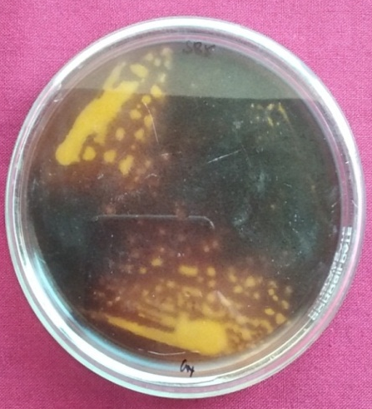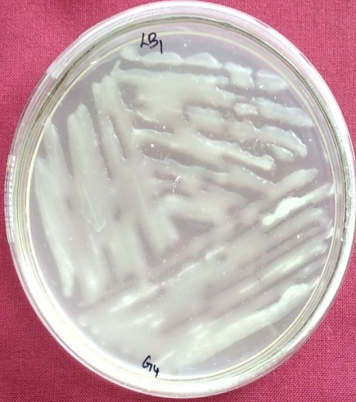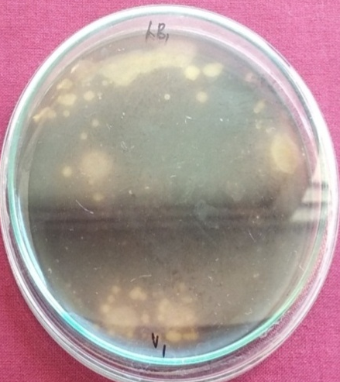

Plate 2. Isolates exhibiting positive for citrate utilization test
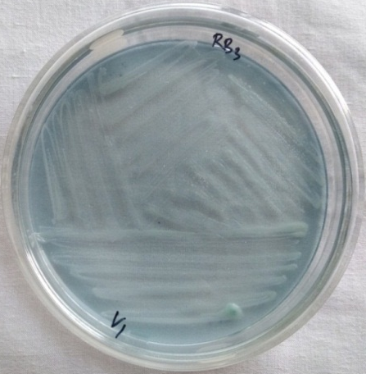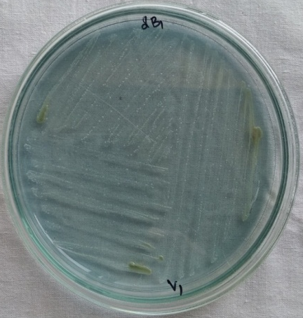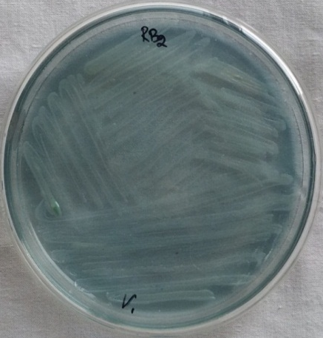

Plate 3.The isolates exhibiting positive results of motility test
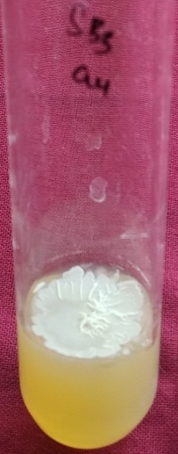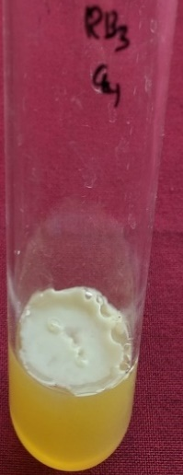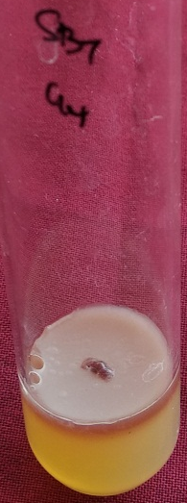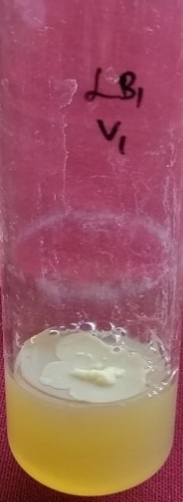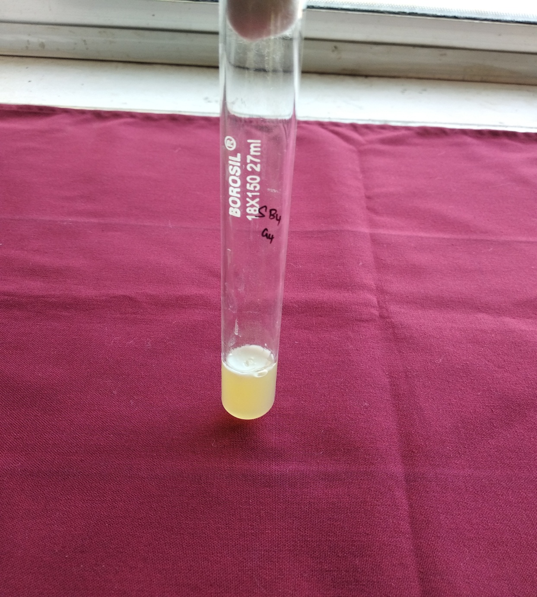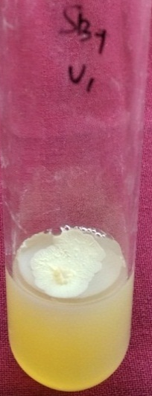
SB7V1
SB4G4
LB7V1
SB7G4
RB3G4
SB3G4
Plate 4. The endophytic isolates exhibiting liquification of gelatin
LB2V1
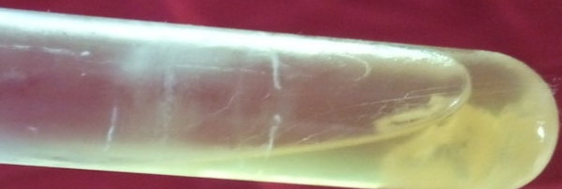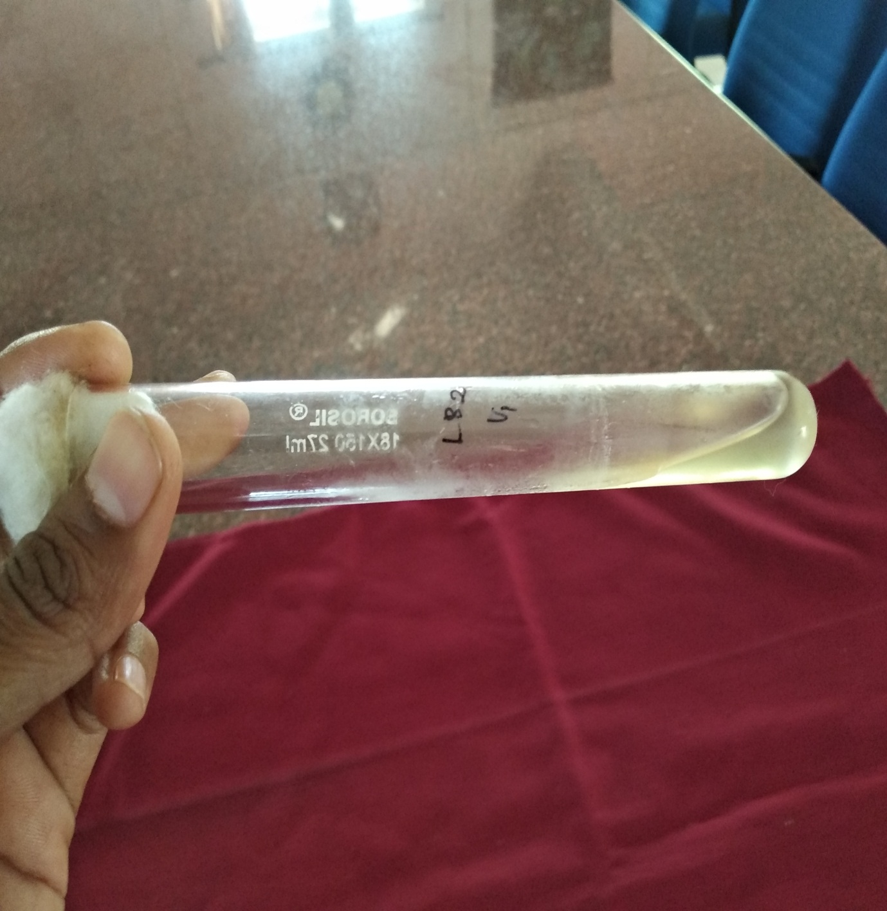
LB6V1
RB1G4
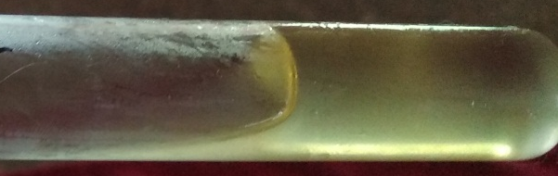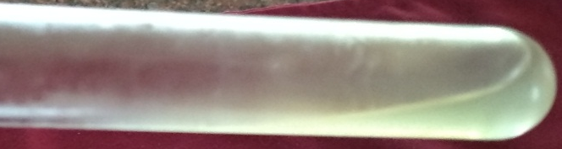
SB6G4

Plate 5. Bubbles formed by the isolates in catalase test
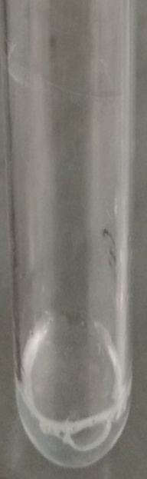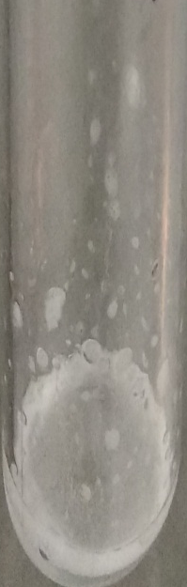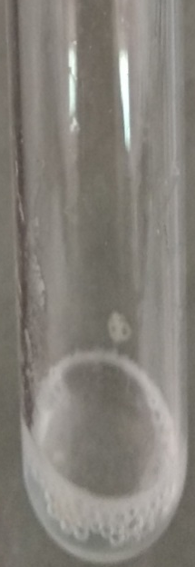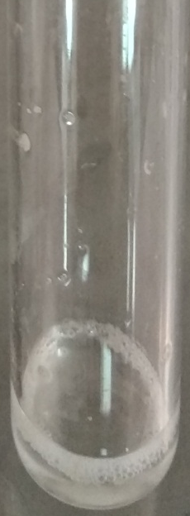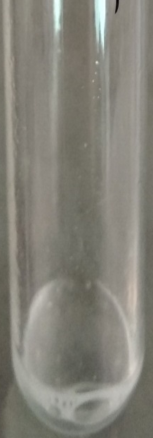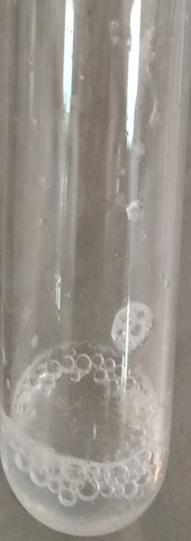
SB2G4
RB1G4
LB2V1
SB6G4
RB2V1
LB7V1

Figure 1. The number of isolates obtained from mulberry plant parts

References:
Anjum, Nawed, Ramesh Chandra. (2015). Endophytic bacteria: optimization of isolation procedure from various medicinal plants and their preliminary characterization. Asian Journal of Pharmaceutical and Clinical Research. 8 (4).
Bacon, C W, J F White. (2000). Microbial endophytes.
Cappuccino JC, N Sherman. (1992). Microbiology: A Laboratory Manual Pp. 125-79. Academic Distributors, New York.
Chaturvedi H, Singh V, G Gupta. (2016). Potential of bacterial endophytes as plant growth promoting factors. Journal of Plant Pathology and Microbiology, 7 (376):2.
Gagné, Serge, Claude Richard, Hélène Rousseau, Hani Antoun. (1987). Xylem-residing bacteria in alfalfa roots. Canadian Journal of Microbiology, 33 (11): 996-1000.
Ji, Xianling, Guobing Lu, Yingping Gai, Chengchao Zheng, and Zhimei Mu. (2008). Biological control against bacterial wilt and colonization of mulberry by an endophytic Bacillus subtilis strain.FEMS Microbiology Ecology, 65 (3):565-573.
Joshi, R D, and N S Kulkarni. (2013). Screening of Endophytic bacteria from anticancer medicinal plants. International Journal of Sciences and Research, (IJSR). 4 (5).
Kandel, Shyam, Pierre Joubert, Sharon Doty. (2017). Bacterial endophyte colonization and distribution within plants. Microorganisms, 5 (4):77.
Khanam, Bushra, Ramesh Chandra. (2015). Isolation and identification of endophytic bacteria producing bright red pigment from the dye yielding plant Beta vulgaris L. International Journal of Pharmacy and Pharmaceutical Sciences, 7 (5):220-224.
Kumar, Punathil Meethal Pratheesh, Sushma Ramesh, Thipperudraiah Thipeswamy, Venkadara Sivaprasad. (2015). Antagonistic and growth promotion potential of endophytic bacteria of mulberry (Morus spp.).International Journal of Industrial Entomology, 31 (2):107-114.
McClelland. (2001). Gram's stain: The key to microbiology. MLO Med Lab Obs, 2033:20-2.
Molite B. (2013). Isolation and characterization of indole acetic acid (IAA) producing bacteria from rhizospheric soil and its effect on plant growth. Journal of Soil Science and Plant Nutrition, 13 (3):638-649.
Muzzamal, Hira, Rabbia Sarwar, Imran Sajid, Shahida Hasnain. (2012). Isolation, identification and screening of endophytic bacteria antagonistic to biofilm formers. Pakistan Journal of Zoology, 44 (1).
Rakholiya, K B, and M D Khunt. 2015. Plant Growth promting endophytes.International Journal of Pure and Applied Biosciences, 3 (4):86-91.
Roos, Isabel MM, MJ Hattingh. 1983. Scanning electron microscopy of Pseudomonas syringae pv. morsprunorum on sweet cherry leaves.Journal of Phytopathology, 108 (1):18-25.
Scott, RI, JM Chard, MJ Hocart, JH Lennard, DC Graham. 1996. Penetration of potato tuber lenticels by bacteria in relation to biological control of blackleg disease. Potato Research, 39 (3):333-344.
Singh, A K, R K Sharma, Varsh Sharma, Tanmay Singh, Rajesh kumar, Dimple Kumari. 2017. Isolation, Morphological indentification and In vitro antibacterial activity of endophytic bacteria isolated from Morus nigra (Mulberry) leaves.Journal of Animal Research, 7 (1):155-164.

