Original Research Article
Investigation of the Relationship between Healthcare Access and Environmental Conditions in Guatemala

ABSTRACT
In various low- and middle-income countries (LMICs), lack of access to quality healthcare remains a persistent challenge. For populations living in third-world countries, the Social Determinants of Health (SDOH) — including economic stability, access to and quality of education, access to and quality of healthcare, neighborhood and built environment, and social and community context —play a pivotal role in shaping health outcomes. While the relationship between economic factors and healthcare access has been well known and has been extensively studied, there is less research on environmental contributors, particularly air quality, and their impact on healthcare access of people who live in third-world countries.
This study examines the influence of environmental conditions, particularly air quality, on healthcare access and respiratory health in Guatemala. The study focuses on fuels, including exposure to Carbon Monoxide (CO), a prevalent pollutant. The data were collected through a CO-level logger and a structured survey of individuals visiting a temporary medical facility operated by a medical volunteer team.
Findings reveal that a significant number of participants report symptoms caused by air pollution, such as coughing, headaches, dizziness, and fatigue, while exhibiting limited awareness of the relationship between household air pollution and health. More than half of the participants reported using firewood for cooking, indicating the significant burden of environmental and health effects. This paper highlights the need for public health strategies that address environmental exposures with health education and development in accessible resource settings.

INTRODUCTION
The Social Determinants of Health (SDOH) are conditions that significantly impact people’s health, well-being, and health inequities [13]. These conditions encompass economic stability, education, social and community context, healthcare access and quality, and neighborhood and built environment. The reason SDOH is so crucial is that addressing it can improve health outcomes [2], reduce health disparities [13], and ultimately lead to long-term cost savings in healthcare [1]. Among these factors, access to healthcare is a fundamental context and a basic right that should be guaranteed to everyone, regardless of race, financial status, or educational level [10]. However, many people in third-world countries face various challenges in accessing healthcare services compared to those in developed countries. This can be attributed to a shortage of healthcare professionals [6], geographical inaccessibility, or financial constraints [11]. Although the World Health Organization (WHO) prioritizes improving healthcare access globally and working to ensure that all people can obtain the necessary health services without any barriers [12], the reality of living conditions in rural or suburban areas in third-world countries is that people are still struggling to access healthcare. In third-world countries, healthcare access, neighborhood, and built environment show a significant relationship, as their living environment affects the health of people who do not have access to proper medical services [4].
Neighborhood and built environment contexts refer to environmental conditions, housing, and proximity to healthcare facilities [8]. People living in third-world countries are more prone to exposure to toxins, such as Carbon Monoxide (CO), due to their living styles and tend to travel farther than those in developed countries to visit a healthcare facility [3, 9]. Exposure and inhalation of carbon monoxide, a colorless and odorless gas, cause an oxygen shortage in individuals and eventually lead to persistent respiratory issues and migraines [7]. Due to their lifestyles at home, people in rural or suburban areas in third-world countries are more vulnerable than people in other developed countries [5].
This paper examines air quality in Guatemala, a third-world country, and the causes of poor air quality, as well as access to healthcare for people living in rural or suburban areas in Guatemala, which has a significant impact on chronic health issues. This research also suggests that individuals in certain regions are more vulnerable due to their neighborhoods and the built environment. Furthermore, it explores the practical lifestyle patterns of people in Guatemala.

METHODOLOGY & DATA COLLECTION
A pre-made survey questionnaire was used to assess various aspects of the living conditions of people in Guatemala. The survey consisted of ten questions covering topics such as proximity to healthcare facilities, lifestyle habits, knowledge of local air quality and its relation to health, and the political context of the issue. A total of 50 participants completed the questionnaire. Each question was translated into Spanish to ensure better understanding, and an interpreter was present to provide additional support. The participants came from various villages in rural and suburban regions of Guatemala and were visiting a temporary medical volunteer facility. The surveyed location and population allowed for a simultaneous assessment of both living conditions and healthcare-related challenges.
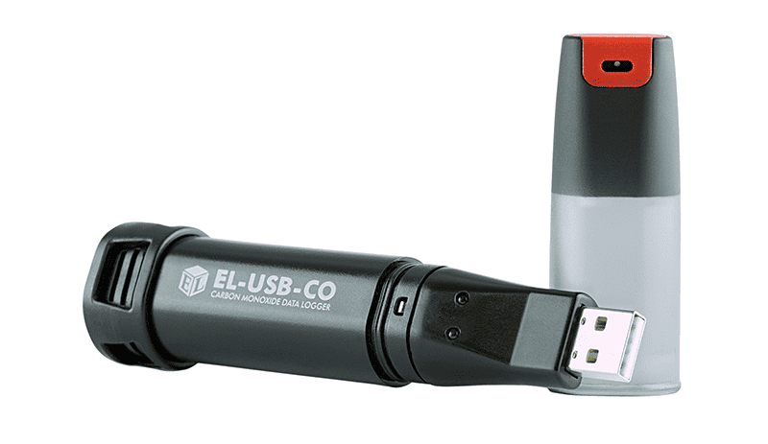
Fig 1. The Easy Log USB CO data logger used in the study
To assess the air quality of various regions in Guatemala, a machine, EasyLog USB was used, which allowed the research team to collect carbon monoxide (CO) levels. Along with the EasyLog USB, the research team logged their exposures, including locations, populations, the number of vehicles, and the presence of ventilation, to analyze and interrelate these factors with the level of CO. The machine shows CO levels in units of “ppm.” Data was gathered every 30 seconds for six days (June 18 to June 23), and levels were measured from around 8:00 AM to 10:00 PM. The research team predicted that people living in regions with higher levels of CO would be more exposed to toxins and experience more severe health issues.
These two datasets enabled the research team to collect data on living conditions and healthcare access, linking environmental conditions—especially air quality—with the health status of individuals and the factors contributing to reduced access to healthcare for people living in rural or suburban areas in Guatemala.

RESULTS
Survey Findings
The survey was conducted among people in Guatemala using ten questions aimed at collecting detailed information on access to healthcare services, distance to healthcare facilities, fire usage, knowledge of air quality and its relation to health, and the political aspect of the issue. The survey was administered at multiple medical volunteer sites and was conducted in Spanish to enhance participants' understanding.

Access to the Health Care Services
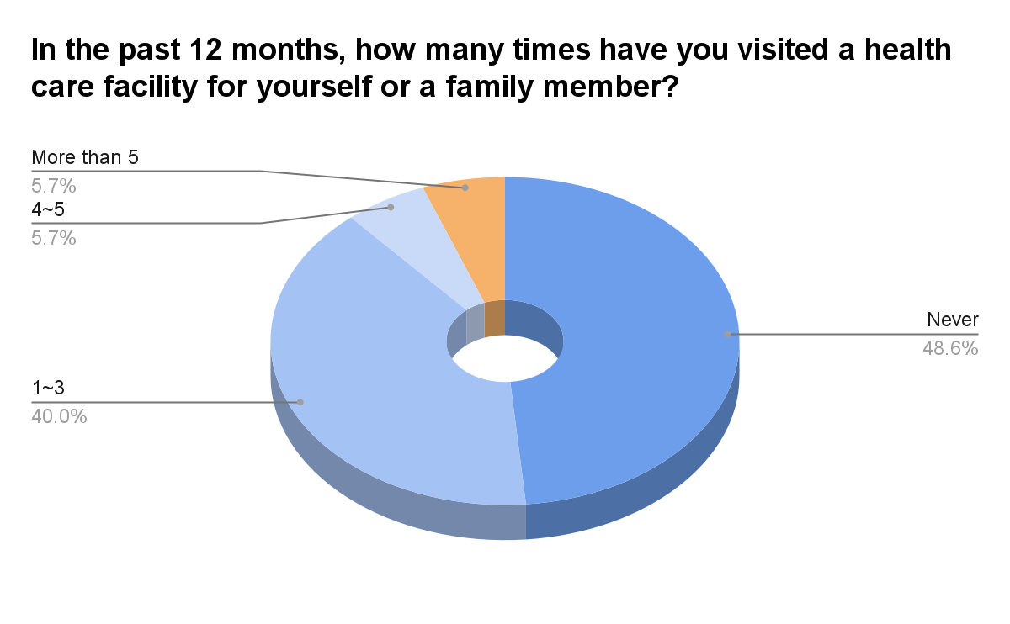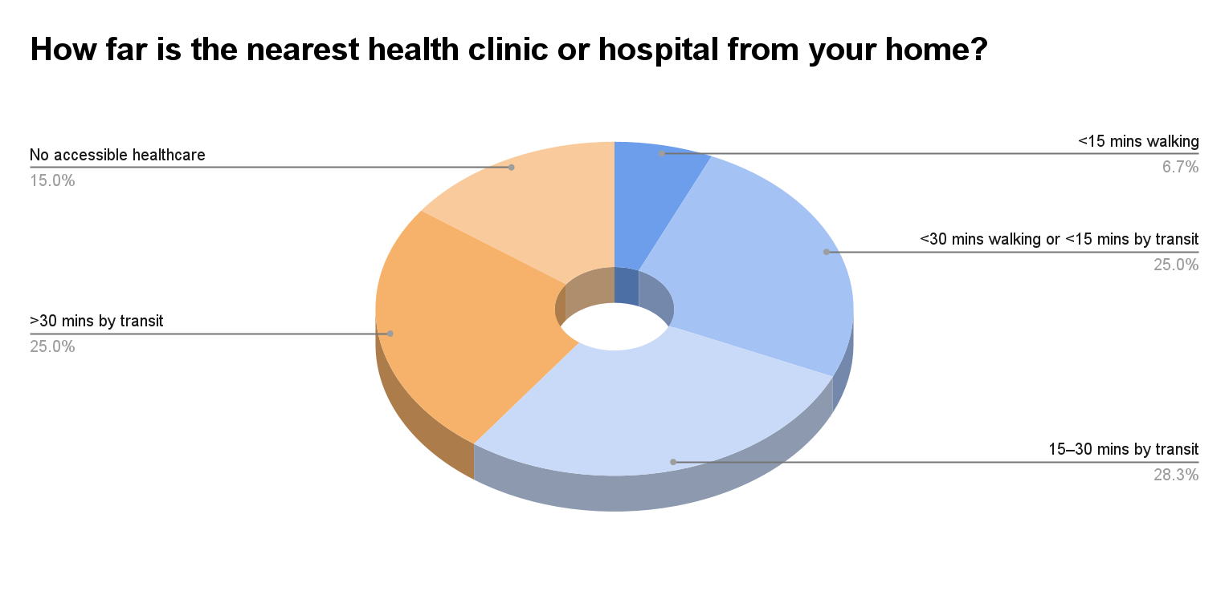
Fig 2. Result from Question 1 Fig 3. Result from Question 2
The figures represent the findings from the first two questions asked of participants. Question 1, “In the past 12 months, how many times have you visited a healthcare facility for yourself or a family member?” (¿Cuántas veces ha visitado un centro de salud en los últimos 12 meses?) and Question 2, “How far is the nearest health clinic or hospital from your home?” (¿Qué tan lejos está el centro de salud más cercano?), were designed to collect data on healthcare access for survey participants. The data shows that the majority of respondents—48.6%—reported never visiting any healthcare facility for themselves or a family member. The second-highest group, 40% of respondents, reported visiting only 1–3 times in the past 12 months. This means a total of 88.6% of participants rarely visited a healthcare facility within the last year. Furthermore, data from the second question suggests that the low number of visits may be due to the distance from healthcare facilities. Most respondents indicated that the nearest hospital is 15 to 30 minutes away by transportation, and 78.3% reported needing to take public transportation to reach it. These findings illustrate the reality of healthcare access in Guatemala: it is difficult to reach, resulting in minimal use of healthcare services.

Exposure to Household Combustion and Air Pollution
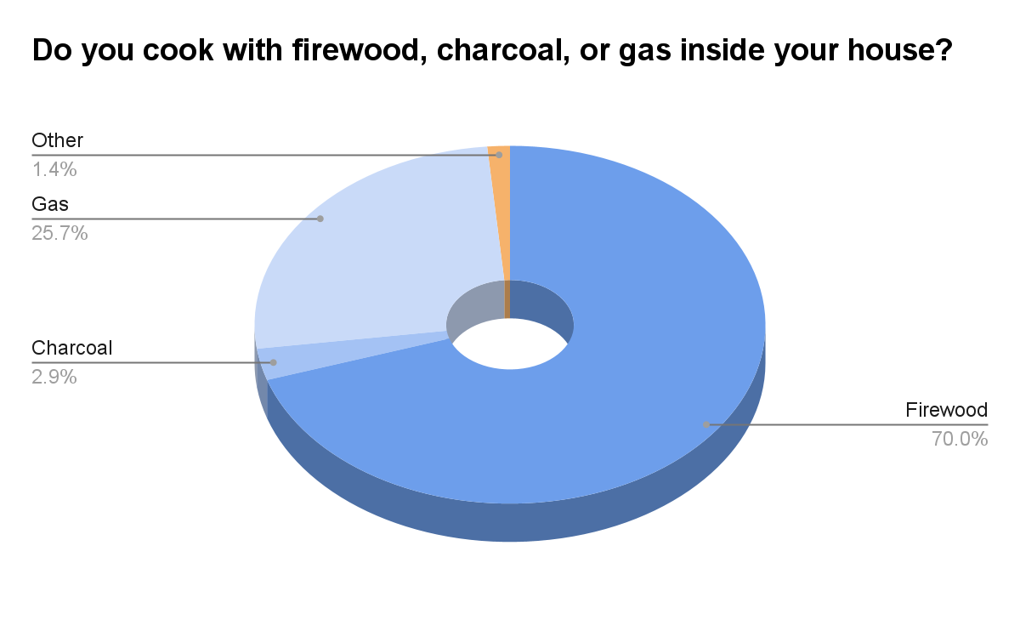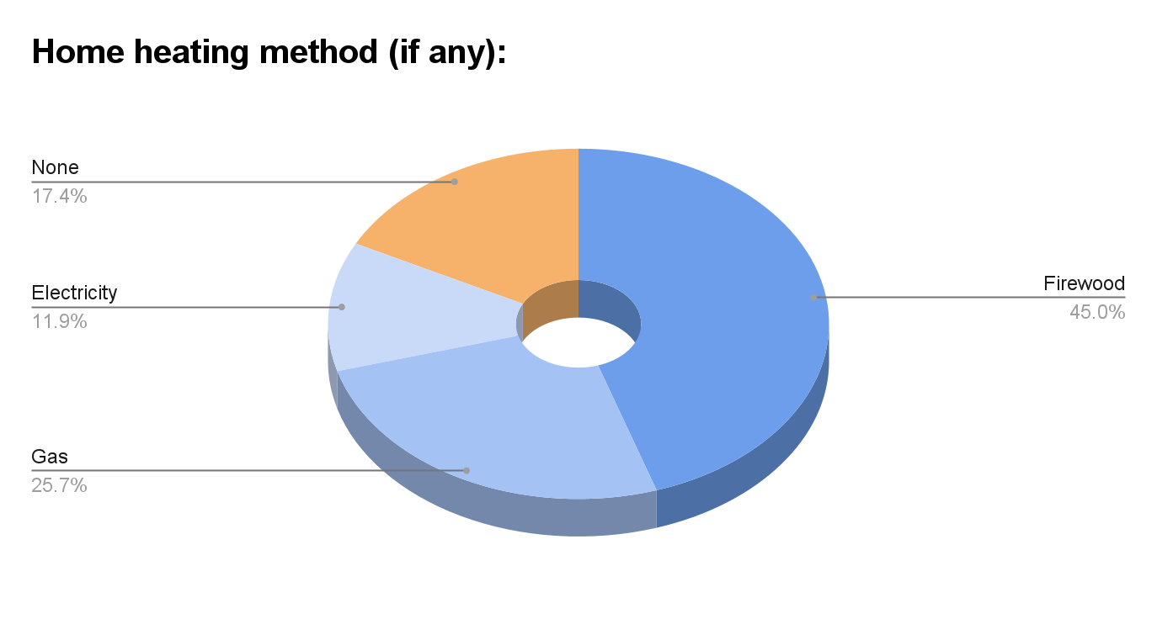
Fig 4. Result from Question 3 Fig 5. Result from Question 4
The above charts show results from questions designed to gather data on participants’ lifestyles and combustion methods. The third question was, “Do you cook with firewood, charcoal, or gas inside your house?” (¿Con qué cocina en su casa?), and the fourth question was, “Home heating method (if any)” (¿Método de calefacción (si lo tiene)?). As shown in the charts, most respondents use firewood for both cooking and heating, which generates a significant amount of smoke and fumes. Since cooking is a daily activity, and 70% of respondents reported using firewood, it can be concluded that the majority of people are consistently exposed to smoke daily. Although the questions specifically asked about combustion methods, the data indicate that people are constantly exposed to air pollution and airborne toxins, which contribute to ongoing health issues.

Awareness of Environmental Health Risks
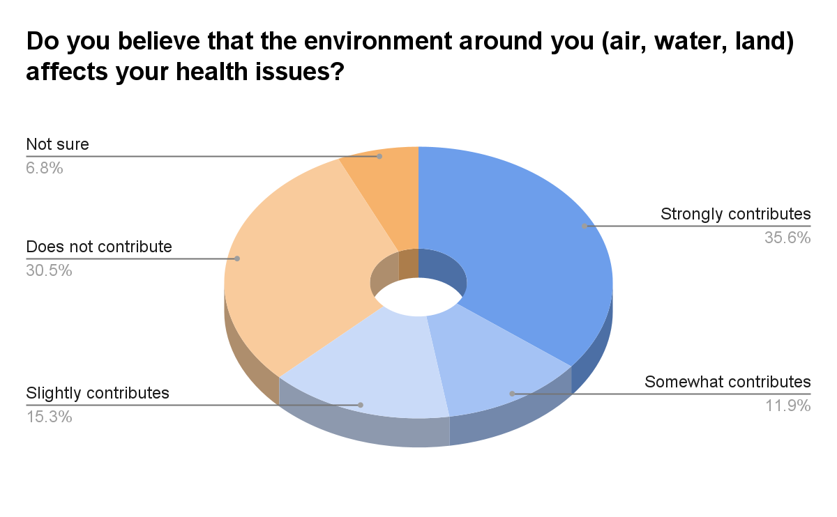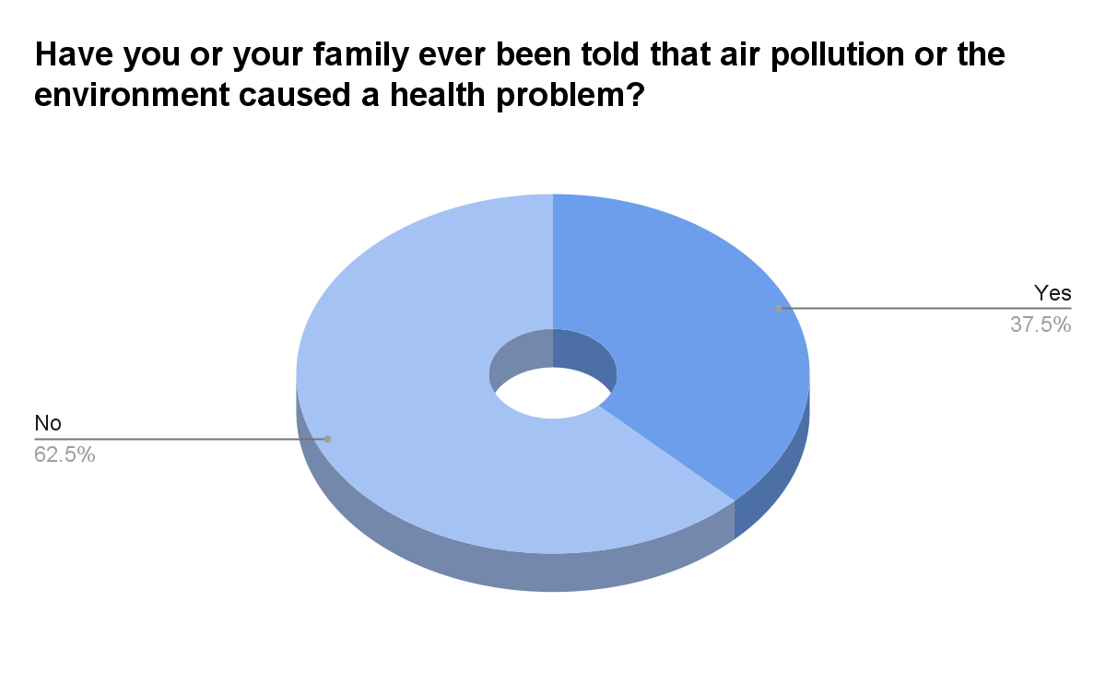
Fig 6. Result from Question 5 Fig 7. Results from Question 6
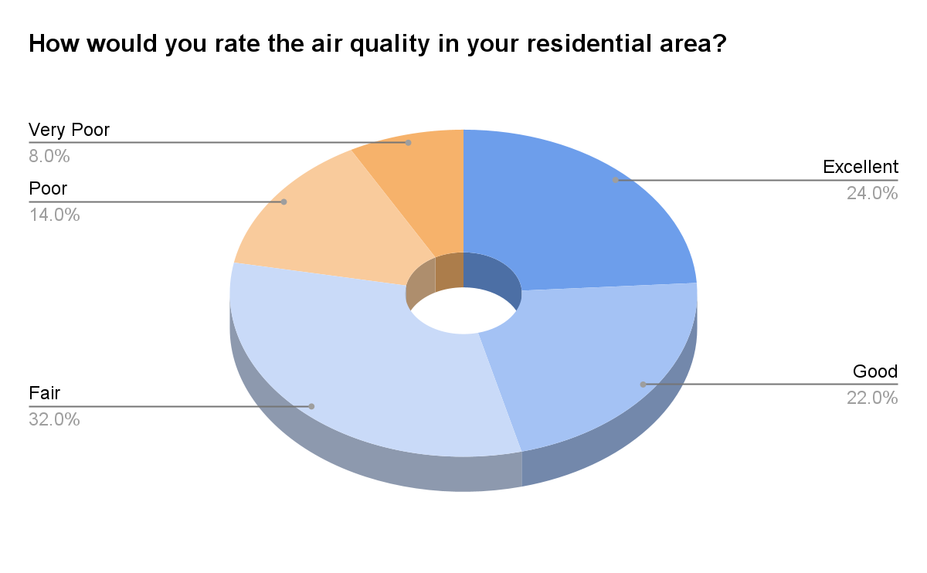
Fig 8. Results from Question 7
Figures illustrate the findings from the fifth, sixth, and seventh questions, which were asked of fifty participants. The questions were: “Do you believe that the environment around you (air, water, land) affects your health?” (¿Cree que el medio ambiente (aire, agua, tierra) afecta su salud?), “Have you or your family ever been told that air pollution or the environment caused a health problem?” (¿Alguna vez un médico le ha dicho que un problema de salud fue causado por el aire o el medio ambiente?), and “How would you rate the air quality in your residential area?” (¿Cómo calificaría la calidad del aire en su zona?). These questions were designed to gather information on participants’ awareness of their surrounding environment. As shown in Figure 6, 62.8% of participants acknowledged that the environment can affect their health. However, 62.5% reported that they had never been told by a medical professional that air pollution or environmental factors were the cause of any health issues. This result highlights a lack of education and awareness about environmental health risks among people in Guatemala. Furthermore, only 22% of respondents rated the air quality in their residential area as poor, while the rest considered it to be excellent or fair.

Health Symptoms Related to Poor Air Quality
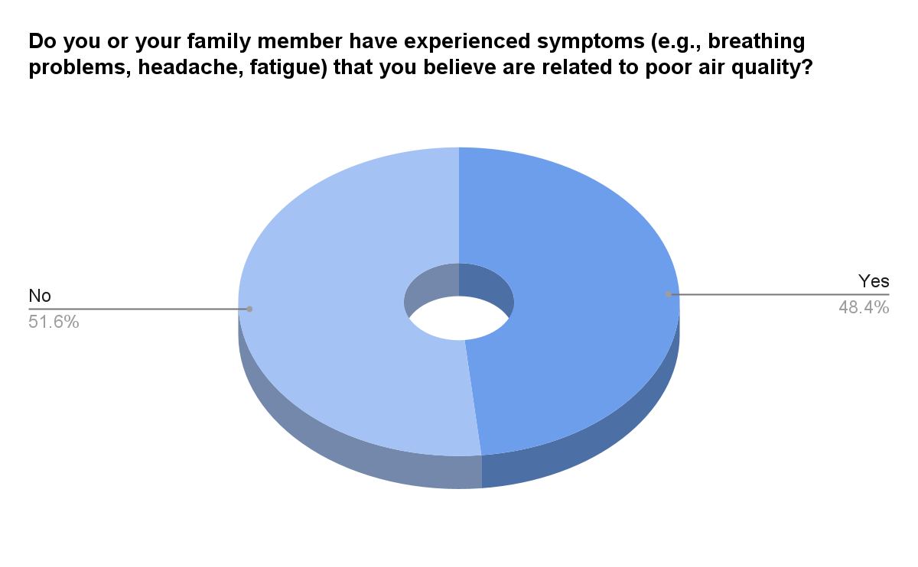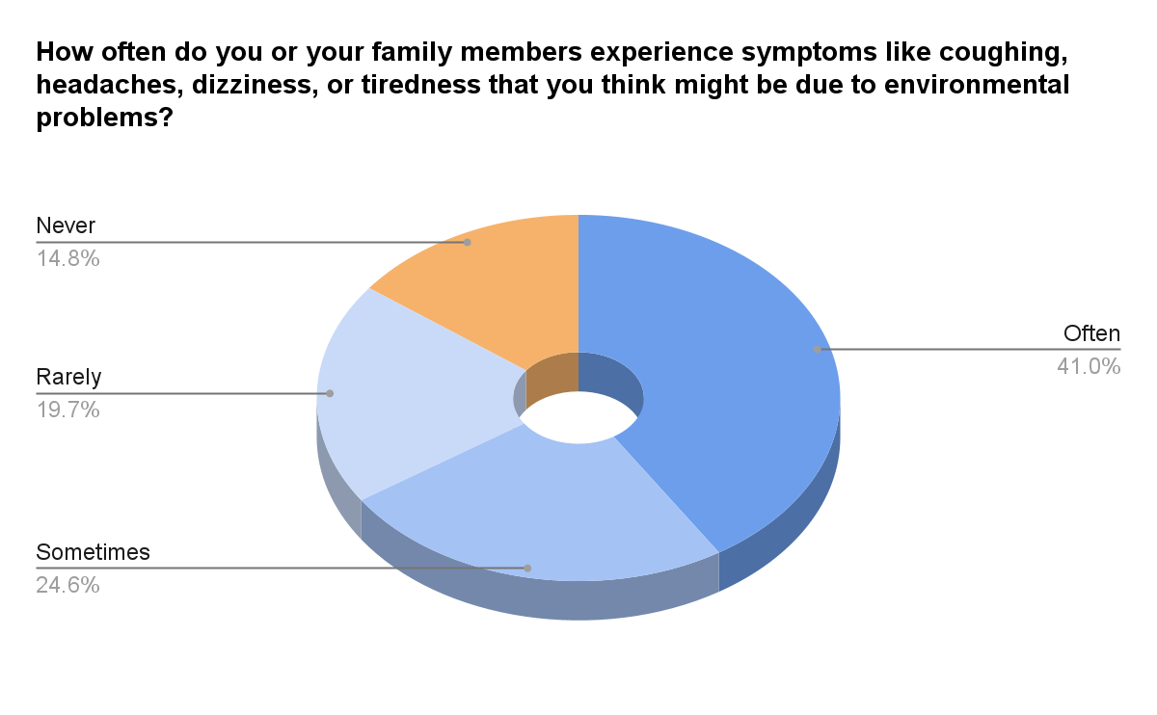
Fig 9. Result from Question 8 Fig 10. Results from Question 9
The figures above present responses to the eighth and ninth survey questions: “Have you or a family member experienced symptoms (e.g., breathing problems, headaches, fatigue) that you believe are related to poor air quality?” (¿Usted o alguien de su familia ha tenido síntomas como dificultad para respirar, dolor de cabeza o cansancio por mala calidad del aire?) and “How often do you or your family members experience symptoms like coughing, headaches, dizziness, or tiredness that you think might be due to environmental problems?” (¿Con qué frecuencia usted o su familia tienen tos, mareos, dolor de cabeza o cansancio por el ambiente?). These questions were designed to collect data on participants’ experiences with symptoms potentially linked to environmental conditions. As shown in Figure 9, nearly half of the respondents (48%) reported experiencing health symptoms, such as breathing difficulties, persistent headaches, and chronic fatigue, which they associated with poor air quality in their living environments. These symptoms are consistent with prolonged exposure to air pollutants, such as carbon monoxide, commonly emitted from fuel combustion used for cooking and heating. According to Figure 10, the frequency of these symptoms varied among participants: 41% reported experiencing symptoms often, 24.6% reported experiencing symptoms sometimes, 19.7% reported experiencing symptoms rarely, and 14.8% reported never experiencing symptoms. This data highlights a strong connection between air pollution and health issues within the surveyed population. The high prevalence and frequency of symptoms suggest chronic exposure to poor air quality, compounded by limited access to healthcare resources to address these environmentally driven conditions. These findings underscore the urgent need to increase awareness and expand treatment options for individuals experiencing pollution-related health issues in rural and suburban areas of Guatemala.

Perceptions of Government and Local Leadership
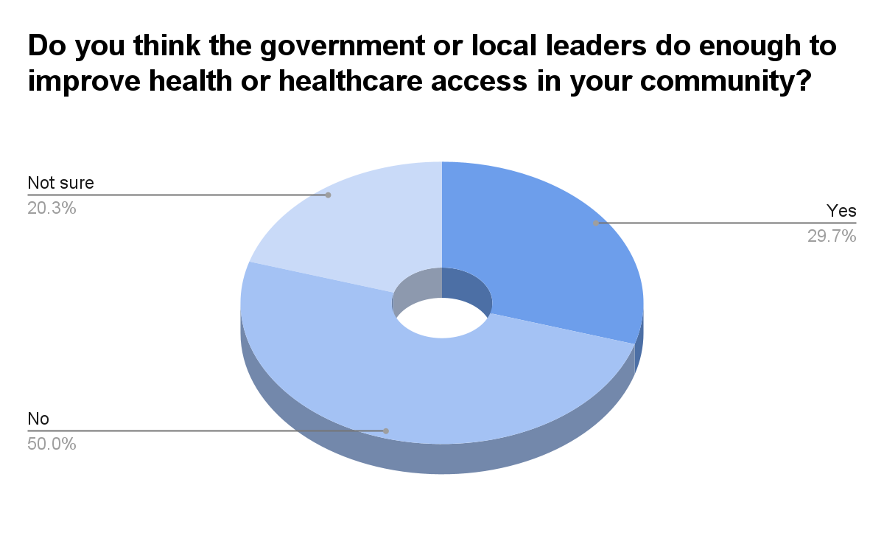
Fig 11. Results from Question 10
The above chart shows participants’ perceptions regarding the role of government and local leaders in healthcare. They were asked, “Do you think the government or local leaders do enough to improve health or healthcare access in your community?” (¿Cree que el gobierno o los líderes locales hacen suficiente para mejorar la salud en su comunidad?). Half of the participants (50%) answered no, believing that their government or local leaders do not do enough to improve health or healthcare access. Only 29.7% of respondents believe their government is doing enough, while 20.3% said they were not sure.

Air Quality in Guatemala
The research indicates that location and population density are the main factors influencing air pollution, with vehicles and kitchens requiring combustion identified as the leading causes of high carbon monoxide (CO) levels. The data shows a positive correlation between CO levels and areas with dense populations and heavy transportation. The device recorded increased CO levels when placed in public or densely populated locations with significant vehicle traffic. Conversely, the device showed low CO levels when located in enclosed spaces. Some errors in data collection caused random spikes in the measurements; for example, dropping the device during data collection led to unexpected spikes in the graphs. Additionally, the recorded times on the graphs display only hours and minutes, using Guatemala local time (which is two hours behind Eastern Standard Time, or EST).
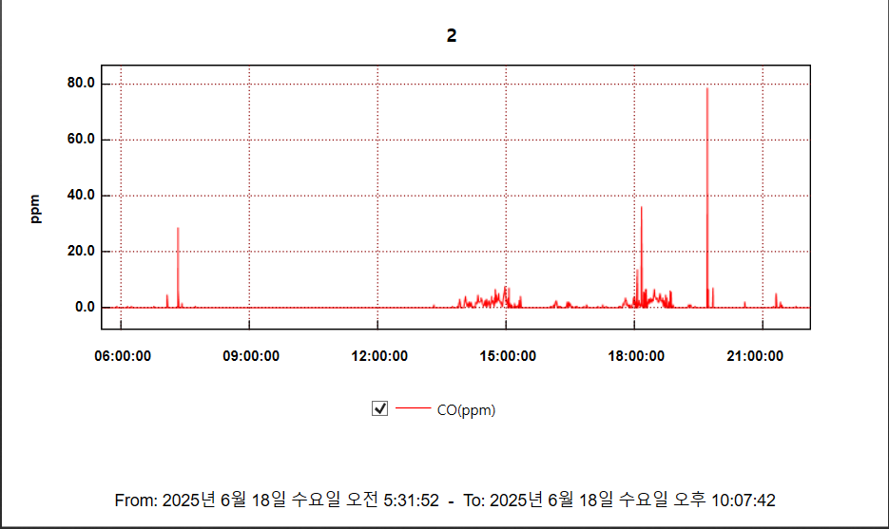
Fig 12. The CO levels on June 18
The graph above illustrates CO levels, measured in parts per million (ppm), recorded on Day 1. Several significant CO peaks were observed throughout the day at various locations. At 9:19 AM, a sharp spike reaching 28.5 ppm was recorded while the team was seated at JFK International Airport Terminal 5. Approximately 500 people were present, and poor ventilation likely contributed to elevated CO levels, possibly emitted by nearby aircraft or ground transportation. The highest level, 78.5 ppm, was recorded at 9:42 PM inside a meeting room where approximately 20 individuals were gathered. The combination of limited space, poor ventilation, high occupancy, and indoor cooking activities likely led to a significant buildup of CO in the enclosed area.
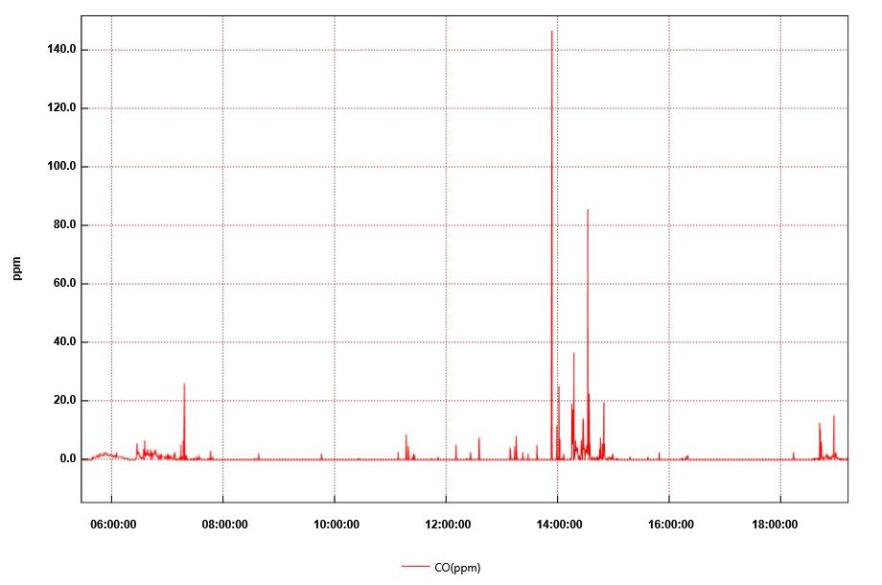
Fig 13. The CO levels on June 19
Figure 12 is the second CO data graph, recorded on June 19, with multiple spikes in a rural region of Guatemala. With several significant spikes between 1:53 PM and 2:33 PM, the graph proves both the intensity of air toxin levels. It highlights the realities of poor air quality exposure of individuals in rural communities. At 1:53 PM, the CO concentration peaked at 146.5 ppm, the highest level recorded. This spike occurred when the machine was moving along an unpaved dirt road that was dry and heavily trafficked by vehicles, which caused a significant amount of dust. Combined with emissions from the local village, this likely contributed to a sharp spike in CO levels. The second noticeable spike occurred at 2:31 PM (85.5 ppm) with recreational activity, playing soccer with local children on a dirt field. Physical activity on an unpaved field increased the amount of CO in the air. Through this finding, the research team found that the soil surface that people interact with daily also increases the air pollution risks.
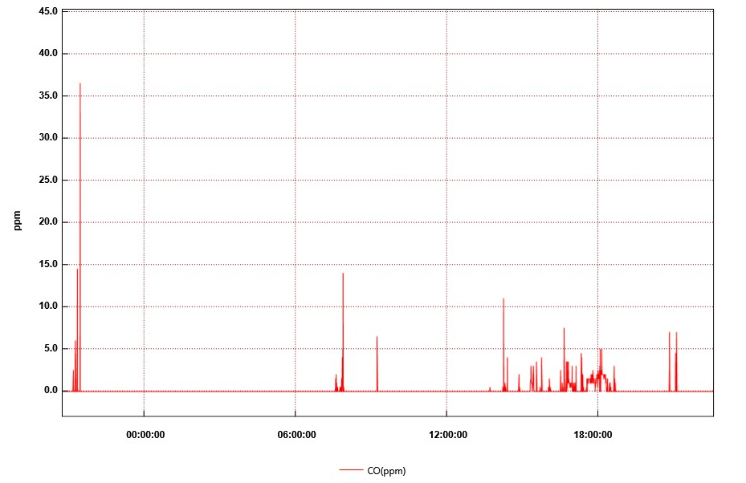
Fig 14. The CO levels on June 20
Figure 12 shows the dataset collected from the evening of June 19 to June 20, which exhibits several peaks. The highest peak occurred at 9:28 PM at the hotel where the research team held daily meetings. The level was 36.5 ppm, likely caused by commercial gas spray, which releases volatile organic compounds outdoors with poor ventilation, and this might have increased CO levels in the surrounding area. The second pike was measured at 7:53 AM as the research team was passing vehicles and unpaved roads. This peak shows how walking on dirt roads can also cause a high level of air pollutants. Between approximately 2 PM and 6:30 PM, a constant fluctuation in CO concentration was recorded, which was attributed to traveling on a dusty road in a bus with open windows. The open window allowed smoke from various vehicles to enter the bus, and the combination of dust from the unpaved road affected the CO level, contributing to constant exposure. June 20th data show that simple daily activities, such as traveling to two places, using bug spray, or gathering, can lead individuals to a low to moderate level of CO.
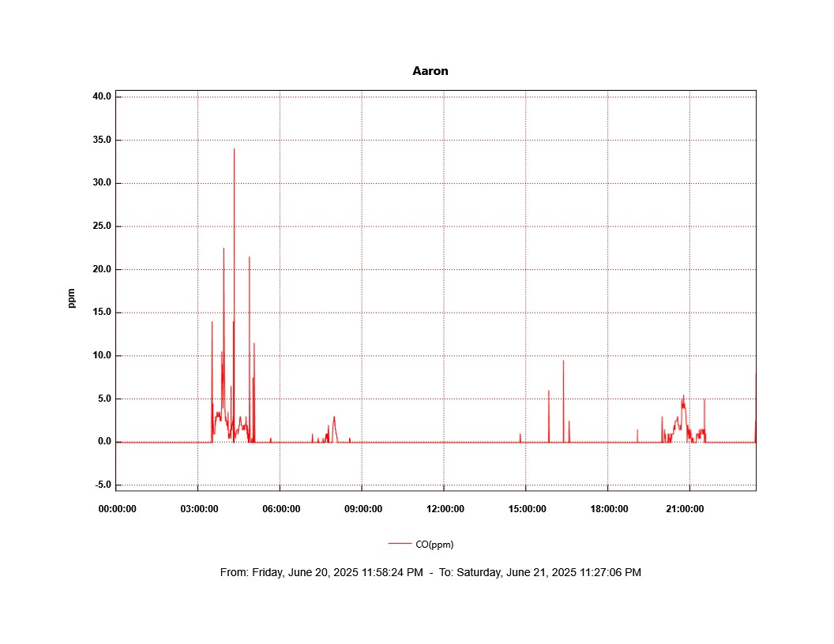
Fig 15. The CO levels on June 21
On June 21, the research team moved to a different region via aircraft and needed to move early, which caused a peak at 3:28 AM. The first peak was recorded outside the hotel and resulted from fuel combustion emitted by the bus, which had little ventilation during pre-dawn hours. This finding reflects a common exposure case of Guatemalan people, that emission from motor vehicles contributes to poor air quality. The highest peak occurred at La Aurora International Airport with readinf og 34.0 ppm at 4:20 AM. This spike is most likely due to the combination of heavy traffic, a significant number of travelers, and poor ventilation. Additional spikes were recorded at 4:53 AM in the security check area and at 5:03 AM in the boarding gate area with 21.5 ppm and 11.5 ppm consecutively. These data were caused by a high population with limited air circulation. This dataset highlights that everyday settings, such as buses, airports, and roads, contribute to constant exposure of the Guatemalan population to environmental pollution.
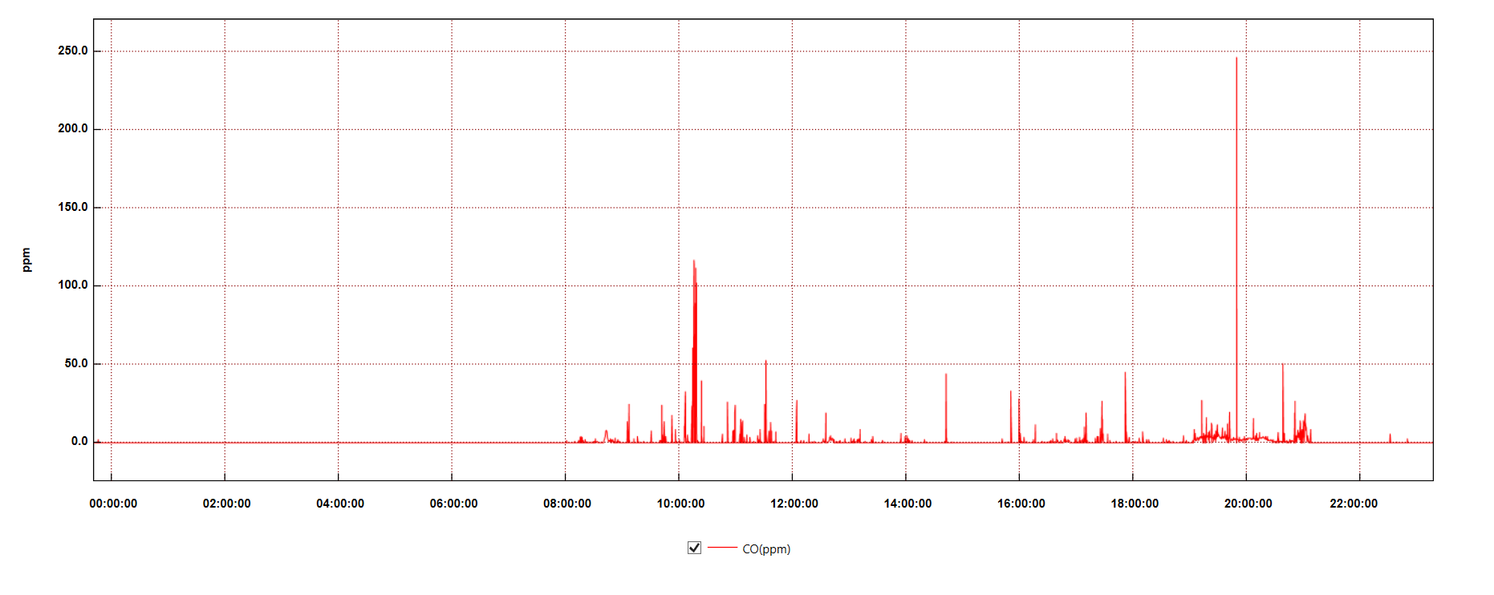
Fig 16. The CO levels on June 22
On June 22nd, several spikes were recorded from 9:41 AM to 10:24 AM. At this time period, the research team was walking around the facility and attending the Sunday mass, where around 200 people were gathered, causing increased CO levels. This data proves how crowded gatherings can raise exposure to air pollutants. More noticeable peaks were recorded throughout the day while the research team was doing physical activities in a local church with approximately 100 kids and walking around the crowded town, Anituga, where the public park and marketplace are located. The highest peak was at 7:48 PM, around 250 ppm, near a restaurant kitchen. The restaurant was small with minimal ventilation, which suggests that an indoor setting without proper ventilation can increase the air pollutant level and harm respiratory health.

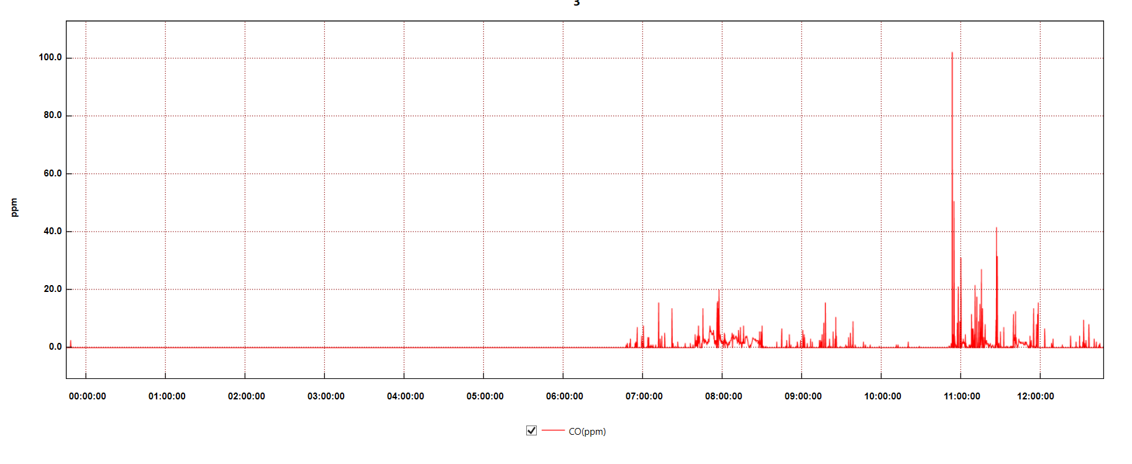
Fig 17. The CO levels on June 23
The first notable spike occurred at 7:57 AM in a moving bus, and the high CO level most likely came from vehicle emissions nearby in heavy traffic. Similar spikes happened from 11:15 AM to 11:27 AM, also on the bus. The highest peak of the day was recorded at 10:54 AM due to the strong smell of manure. Although manure itself doesn't cause CO emissions, Guatemala’s agricultural lifestyle contributes to local air pollution and shows how daily life is related to people’s exposure to pollutants. Repeated peaks in the morning highlight Guatemala’s transportation issue, as buses and public transportation in Guatemala often lack proper air ventilation, which leads to pollutants building up indoors.

DISCUSSION
The findings of this study provide information on the significant challenges faced by people in low- and middle-income countries (LMICs) with environmental and healthcare contexts, specifically focusing on air quality and healthcare access. The data from our survey and empirical data reveal several critical issues that require attention and intervention.
The findings from the survey show the relationship between air quality and the health outcomes and healthcare access of people in Guatemala. The survey and carbon monoxide (CO) measurements highlight persistent health risks that are compounded by limited healthcare facilities and poor public awareness, reinforcing systemic vulnerability shaped by the Social Determinants of Health (SDOH).
Over 70% of respondents use firewood for cooking and heating, which causes exposure to air pollution daily. This surveyed data matches the CO level graph by depicting spikes in poorly ventilated areas, such as kitchens and vehicles, where everyday life occurs and is overlooked in the air pollution context. Moreover, constant symptoms - chronic coughing, fatigue, headaches, and lightheadedness - are related to continuous exposure to CO. The majority of survey participants answered that they or their family members are experiencing those symptoms often, while showing limited awareness of the relationship between air quality and its impact on health. 62.8% recognized that the environment can impact health, 22% responded that their air quality is poor, and more than 60% said they had never been told that the environment causes health issues. These findings show people’s environmental health literacy. Furthermore, the CO data logger provides a practical concentration of air pollutants, and the relationship of exposure to CO varies based on time, activity, and location. High spikes were observed while traveling on a dusty and unpaved road on the bus with open windows; this observation highlights that even daily activities can impact the respiratory tract and health significantly.
The data gathered in this study also suggests the need for systematic support from the government, as half of the survey respondents answered that their local leaders were not doing enough to improve healthcare access. This result also emphasizes that the solution for these issues should handle both localized health education and broader governmental action to improve the healthcare system.
Lastly, the study shows how air quality caused by structural and behavioral factors contributes to poor health outcomes in underserved areas. The compound of high CO exposure, lack of awareness, and limited access to healthcare facilities proves disadvantages for the Guatemalan population.

CONCLUSION
This study investigates the relationship between environmental exposure, healthcare access, and health outcomes in various regions of Guatemala. The findings highlight a compounded vulnerability through frequent exposure to indoor air pollution, limited access to healthcare, and widespread gaps in environmental health literacy. Despite moderate awareness of environmental impacts, many individuals remain unaware of the direct connection between pollution and their health symptoms. The prevalence of firewood use in poorly ventilated homes, paired with limited health resources and perceived political inaction, underscores health disparities in these communities. Addressing these issues and pollution-related illness requires an interdisciplinary approach, such as health education, strict regulation on emissions, and accountable policy interventions strengthening healthcare delivery for Guatemala’s vulnerable populations.

REFERENCES
- Admere Health. “How Healthcare Organizations Can Tackle Social Determinants of Health.” Admere, www.admere.com/amr-blog/how-healthcare-organizations-can-tackle-social-determinants-of-health#:~:text=Healthcare%20Provider%20Investment%20Some%20healthcare%20providers%20are,downstream%20medical%20costs%20and%20maximize%20clinical%20quality.
- Centers for Disease Control and Prevention. “Why Is Addressing Social Determinants of Health Important?” CDC, www.cdc.gov/about/priorities/why-is-addressing-sdoh-important.html#:~:text=What%20to%20know,foods%20and%20physical%20health%20opportunities.
- Chen, Michael, et al. “Access to Healthcare in Developing Countries.” Nature Medicine, 2020, www.nature.com/articles/s41591-020-1059-1#:~:text=We%20find%20that%20just%208.9,by%20foot%20within%20one%20hour.
- Florida TaxWatch. “Social Determinants of Health: Neighborhood and Built Environment.” Florida TaxWatch Research Library, floridataxwatch.org/Research/Full-Library/social-determinants-of-health-neighborhood-and-built-environment#:~:text=This%20report%20explores%20how%20a,issues%20and%20potential%20solutions%20here.
- Johns Hopkins University. “Rural Health Around the World: Challenges and Solutions.” Johns Hopkins Nursing, June 2024, nursing.jhu.edu/wp-content/uploads/2024/06/Rural-health-around-the-world-challenges-and-solutions.pdf.
- Marmot, Michael, and Jessica Allen. “Social Determinants of Health Equity.” Annual Review of Public Health, vol. 37, 2016, pp. 397–414, www.annualreviews.org/content/journals/10.1146/annurev-publhealth-032315-021507.
- Minnesota Department of Health. “Carbon Monoxide (CO) Toxins.” Minnesota Health, www.web.health.state.mn.us/communities/environment/air/toxins#:~:text=Carbon%20monoxide%20(CO)%20is%20an,the%20incomplete%20combustion%20of%20fuels.
- National Center for Biotechnology Information. “Neighborhood and Built Environment.” NCBI Bookshelf, www.ncbi.nlm.nih.gov/books/NBK596398/#:~:text=The%20places%20where%20people%20live,%2C%20green%20spaces%2C%20and%20playgrounds.
- National Institute of Environmental Health Sciences. “Indoor Air Pollution.” NIEHS, www.niehs.nih.gov/health/topics/agents/indoor-air#:~:text=Low%2D%20and%20Middle%2Dincome%20Countries%20(LMICs)&text=The%20largest%20global%20source%20of,%2C%20agricultural%20residues%2C%20and%20coal.
- Ravi, Rejoice. “Healthcare Accessibility in Developing Countries: A Global Healthcare Challenge.” ResearchGate, www.researchgate.net/profile/Rejoice-Ravi/publication/365806651_Healthcare_Accessibility_in_Developing_Countries_A_Global_Healthcare_Challenge/links/63852d467b0e356feb93061e/Healthcare-Accessibility-in-Developing-Countries-A-Global-Healthcare-Challenge.pdf.
- Williams, David R., and Ruth J. Williams-Morris. “Racism and Mental Health: The African American Experience.” Annals of the New York Academy of Sciences, vol. 896, 1999, pp. 18–28, nyaspubs.onlinelibrary.wiley.com/doi/full/10.1196/annals.1425.011.
- World Health Organization. “Improving Service Access and Quality.” WHO, www.who.int/activities/improving-service-access-and-quality.
- World Health Organization. “Social Determinants of Health.” WHO, www.who.int/health-topics/social-determinants-of-health#tab=tab_1.

