Occurrence of Physaloptera praeputialis in a Stray Cat (Felis catus) in Mathura, Uttar Pradesh

Abstract
This study reports a confirmed case of Physaloptera praeputialis infection in a stray domestic cat (Felis catus) found in Mathura, Uttar Pradesh, India. A total of 11 adult nematodes (4 males and 7 females), ranging in length from 1.4 to 4.8 cm, were recovered from the cat’s stomach during necropsy conducted post-mortem after the animal was killed in a road traffic accident. Gross examination revealed gastric mucosa exhibiting congestion and edema,, with multiple worms embedded in the tunica mucosa. Morphological analysis showed that the specimens were pale pink, female worms exhibited a conspicuous brown cementing ring around the vulva, and both sexes had prepuce-like cuticular extensions at the posterior end. Microscopic examination revealed triangular lips bearing internal teeth, a well-developed muscular pharynx, and thick-shelled, oval embryonated eggs measuring 29–41 µm in length and 23–39 µm in width. These morphological characteristics definitively identified the species as P. praeputialis. Although this parasite has a cosmopolitan distribution, confirmed reports from India, particularly involving stray or feral cats are limited. These findings highlight the need for enhanced parasitological surveillance in free-roaming feline populations, improved control measures to limit access to paratenic hosts, and the implementation of routine deworming protocols to mitigate both zoonotic and veterinary health risks.

Keywords
Physaloptera praeputialis, cat stomach worm, nematode, Felis catus, Mathura, parasitology

Introduction
The genus Physaloptera comprises spirurid nematodes that parasitize the gastrointestinal tract of a wide range of vertebrates, excluding fish. These nematodes are characterized by their pathogenic potential, particularly in the stomach, where their presence may lead to chronic gastritis, vomiting, anorexia, and weight loss in infected hosts (Bowman et al., 2020). Among felids, Physaloptera praeputialis and Physaloptera rara are the two most commonly reported species, with P. praeputialis considered more prevalent in domestic cats (Tiekotter, 1981).
Despite its global distribution, reports of P. praeputialis in Indian felines are scarce. Earlier documentation includes cases from stray cats in New Delhi (Gill, 1972) and Mizoram (Borthakur & Mukherjee, 2011), as well as in wild felids such as the Royal Bengal tiger (Panthera tigris tigris) and Indian leopard (Panthera pardus fusca) in Odisha (Mahali et al., 2010; Hota et al., 2018). These sporadic reports suggest a possible underestimation of its prevalence, particularly due to the limited parasitological surveillance in stray and feral animal populations across the country.
Physaloptera spp. exhibit indirect life cycles that involve arthropod intermediate hosts (e.g., beetles, cockroaches) and small vertebrate paratenic hosts such as rodents, amphibians, or reptiles (Sprent, 1982; Little et al., 2022). Cats typically become infected through ingestion of these intermediate or paratenic hosts, allowing the larvae to mature into adults within the gastric mucosa. Adult worms attach firmly to the stomach lining, causing mechanical damage and chronic inflammation.
Given the ecological presence of such vectors and paratenic hosts in urban and peri-urban settings, stray cats are particularly vulnerable to infection. However, due to their limited access to veterinary care and the subtlety of clinical signs, such infections often go undiagnosed.
In this context, the present study reports the recovery and identification of Physaloptera praeputialis from the stomach of a stray cat (Felis catus) found in Mathura, Uttar Pradesh. A total of 11 adult nematodes were collected during necropsy of the cat, which had succumbed to road trauma. The study provides detailed morphological descriptions and emphasizes the need for routine parasitic monitoring in free-roaming feline populations to detect potential zoonotic threats and inform regional parasite control strategies.

Materials and Methods
A deceased female stray cat (Felis catus), weighing approximately 3 kg (Fig.1A), was found within the campus of the College of Veterinary Science and Animal Husbandry, DUVASU, Mathura, Uttar Pradesh. The animal exhibited signs of external trauma, suggesting death due to a vehicular accident. The carcass was promptly transported to the Department of Veterinary Parasitology for necropsy as part of an ongoing helminthological surveillance program targeting stray and feral feline populations in the region.
A systematic postmortem examination was conducted, with a special focus on the gastrointestinal tract. The stomach was carefully excised, opened along the greater curvature, and inspected for the presence of parasitic organisms. The gastric mucosa appeared congested, thickened, and oedematous. Fourteen adult nematodes, pinkish-white in color and varying in size, were found embedded in the mucosal lining and actively attached to the stomach wall.
The worms were gently removed using fine forceps and rinsed in phosphate-buffered saline (PBS; pH 7.2) to eliminate adherent debris and mucus. For preservation, all specimens were fixed in 10% neutral buffered formalin. Selected worms were subsequently cleared in lactophenol for detailed morphological analysis under light microscopy.
Morphological features including cephalic structures, oral papillae, pharyngeal musculature, reproductive anatomy, and cuticular ornamentation were examined using a compound microscope. Photomicrographs were captured with a digital camera mounted on both stereomicroscope and compound microscope systems.
Additionally, a representative fecal sample was collected directly from the intestinal lumen and processed via the standard salt flotation technique to recover and identify parasitic ova. Embryonated eggs observed under the microscope were thick-shelled and oval, with dimensions ranging from 28–39µm, consistent with the diagnostic criteria for Physaloptera praeputialis.
Nematode identification was performed based on morphological characteristics following standard parasitological keys (Anderson et al., 2009; Soulsby, 1982) and corroborated with previously published descriptions of Physaloptera spp. (Tiekotter, 1981; Borthakur & Mukherjee, 2011).

Results
Gross examination of the excised stomach revealed a thickened, congested, and oedematous gastric mucosa. Eleven actively motile nematodes were observed embedded within the mucosal lining. The recovered worms were light pink in color and measured approximately 1.4 to 4.8 cm in length. Notably, the vulvar region of fertilized female worms exhibited a characteristic brown cementing ring, a distinguishing morphological feature specific to Physaloptera praeputialis (Tiekotter, 1981; Naem et al., 2006). Both male and female nematodes also showed a distinct prepuce-like cuticular extension at the posterior end, a key taxonomic trait supporting identification at the species level (Borthakur & Mukherjee, 2011).
Microscopic examination of lactophenol-cleared specimens revealed detailed morphological features consistent with the genus Physaloptera (Fig.1B&C). The anterior end bore three prominent triangular lips, each equipped with centrally located internal teeth. These were followed by a robust, well-developed muscular pharynx (Soulsby, 1982; Anderson et al., 2009). These features are diagnostic of spirurid nematodes of the genus Physaloptera and specifically match descriptions of P. praeputialis (Tiekotter, 1981; Naem et al., 2006).
Coprological analysis using the salt flotation technique revealed the presence of parasite eggs in the intestinal contents. The eggs were thick-shelled, oval, and contained well-developed larvae. Morphometric analysis indicated that the eggs measured 29–41 µm in length and 23–39 µm in width. The egg morphology was in agreement with previous descriptions of P. praeputialis (Linstow, 1889; Tiekotter, 1981; Naem et al., 2006).
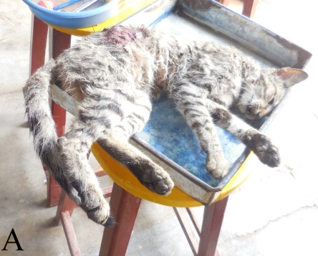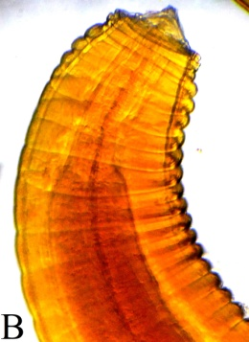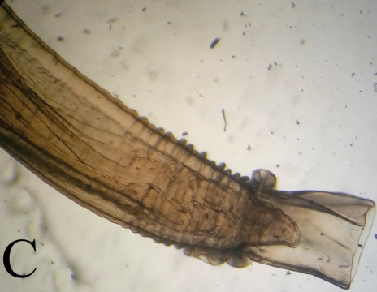
Fig.1: A- Stray domestic cat (Felis catus) found dead; B&C-Anterior and posterior end of P. praeputialis
Based on the combination of gross morphological features, detailed microscopic observations, and egg morphology, the nematodes were conclusively identified as Physaloptera praeputialis.

Discussion
Physaloptera praeputialis was first described by von Linstow in 1889 from a domestic cat in Brazil and has since been recognized as a cosmopolitan spirurid parasite (Bowman et al., 2008). Its presence has been documented across various continents, including North and South America, Southeast Asia, Australia, Europe (e.g., Greece), and Africa (particularly South Africa), reflecting a broad ecological adaptability (Soulsby, 1982; Anderson et al., 2009). Despite this widespread distribution, reports of P. praeputialis infecting domestic cats in India are sparse and sporadic.
The present study reports the confirmed case of P. praeputialis infection in a stray domestic cat (Felis catus) from Mathura, Uttar Pradesh. This finding extends the known geographic distribution of the parasite within India and adds to the few existing records, including earlier reports from stray cats in Delhi (Gill, 1972) and Mizoram (Borthakur & Mukherjee, 2011), as well as wild felids such as the Royal Bengal tiger (Panthera tigris tigris) and the Indian leopard (Panthera pardus fusca) from Odisha (Mahali et al., 2010; Hota et al., 2018). The pathological lesions in the stomach—such as mucosal thickening, congestion, and oedema observed in this case are consistent with findings reported in earlier studies (Naem et al., 2006; Hota et al., 2018), supporting the parasitic nature and tissue-invasive behavior of the nematode.
A crucial morphological hallmark aiding in the diagnosis was the brown cementing ring encircling the vulva in female worms, a unique feature of P. praeputialis (Tiekotter, 1981; Naem et al., 2006). This, along with the prepuce-like cuticular extension at the posterior end and characteristic cephalic structures (e.g., three prominent lips with internal teeth and a muscular pharynx), strongly supports species-level identification (Soulsby, 1982; Anderson et al., 2009).
The life cycle of P. praeputialis is complex, typically involving insect and small vertebrate hosts as intermediate or paratenic carriers. Documented intermediate hosts include cockroaches (Blattella germanica), crickets (Gryllus animilis), beetles (Centophilus spp.), lizards (Varanus griseus), and hedgehogs (Hemiechinus auritus) (Petri & Ameel, 1950; Bowman et al., 2008). However, such associations remain underexplored in the Indian context. The limited number of reported cases may be due to underdiagnosis, lack of routine surveillance, and limited awareness regarding parasitic infections in stray or feral cats (Moudgil et al., 2015).
Additionally, low rates of feline ownership, inadequate veterinary infrastructure, and the absence of standardized deworming practices in stray populations could contribute to the underreporting of P. praeputialis infections. Most documented cases in India have been discovered incidentally during necropsy or rescue operations rather than through systematic clinical investigation, highlighting a significant gap in parasitological surveillance among free-roaming urban and peri-urban feline populations.
Although rarely documented, P. praeputialis has substantial veterinary significance. It is known to cause chronic gastritis, vomiting, and other gastrointestinal disturbances in cats (Naem et al., 2006; Bowman et al., 2008). Furthermore, while zoonotic transmission is uncommon, the potential risk exists, particularly in areas with high stray animal densities and frequent human-cat interactions (Moudgil et al., 2015).
In conclusion, this study underscores the need for increased surveillance and routine fecal screening, particularly among stray cat populations. Implementation of targeted deworming programs and awareness campaigns could help reduce the burden of helminthic infections and improve feline health, while also mitigating potential zoonotic risks.

Conclusion

This study confirms the presence of Physaloptera praeputialis in a stray cat from Mathura, Uttar Pradesh, based on gross gastric lesions, detailed morphological traits, and coprological findings. The case expands the parasite’s known range in India and underscores its veterinary significance. It highlights the need for routine parasitological surveillance, especially in stray cats, due to potential zoonotic risks and the increasing human–animal interface in urban areas.

References
Anderson, R. C., Chabaud, A. G., & Willmott, S. (2009). Keys to the nematode parasites of vertebrates: Archival volume. CAB International.
Borthakur, S. K., & Mukherjee, S. (2011). Occurrence of Physaloptera praeputialis in a domestic cat in Mizoram. Veterinary World, 4(5), 222–223.
Bowman, D. D., Georgis, R., & Lynn, R. C. (2020). Georgis’ parasitology for veterinarians (11th ed.). Elsevier.
Bowman, D.D., Hendrix, C.M., Lindsay, D.S., and Barr, S.C. (2008). Feline Clinical Parasitology. John Wiley & Sons, New Jersey, USA.
Gill, H. S. (1972). Physaloptera praeputialis infection in domestic cats in Delhi. Indian Veterinary Journal, 49(12), 1140–1142.
Hota, A., Panda, S. K., & Das, P. (2018). Gastric helminths in Indian leopard (Panthera pardus fusca) from Odisha: A case study. Indian Journal of Wildlife Research, 64(1), 55–58.
Linstow, O. von. (1889). Beiträge zur Kenntnis der Helminthen. Archiv für Naturgeschichte, 55(1), 125–154.
Little, S. E., Saleh, M. N., & Blagburn, B. L. (2022). Veterinary parasitology: Reference manual (6th ed.). Wiley Blackwell.
Mahali, A.K., Panda, D.N., Panda, M.R., Mohanty, B.N., and Sahoo, N. (2010). Incidence and seasonal variation of gastro-intestinal parasitic infections in captive carnivores in Nandankanan zoological park, Orissa. J. Vet. Parasitol., 24(2): 111-115.
Moudgil, A. D., Gupta, D. K., Sharma, D. R., & Bansal, N. (2015). Prevalence of gastrointestinal helminths in stray cats. Journal of Parasitic Diseases, 39(1), 64–67.
Naem, S., Farshid, A.A., and Marand, V.T. (2006). Pathological findings on natural infection with Physaloptera praeputialis in cats. Vet. Arh., 76(4): 315-321.
Petri, L.H., and Ameel, D.J. (1950). Studies on the life cycle of Physaloptera rara and Physaloptera praeputialis. J. Parasitol., 36(6): 40.
Soulsby, E. J. L. (1982). Helminths, arthropods and protozoa of domesticated animals (7th ed.). Baillière Tindall.
Sprent, J. F. A. (1982). Aspects of the life history and development of Physaloptera spp. International Journal for Parasitology, 12(2), 121–130.
Tiekotter, K.L. (1981). Observations of the head and tail regions of male Physaloptera praeputialis von Linstow, 1889, and Physaloptera rara Hall and Wigdor, 1918, using scanning electron microscopy. Proc. Helminthol. Soc. Wash.48: 130-136.
Image 1 Anterior P. praeputialis

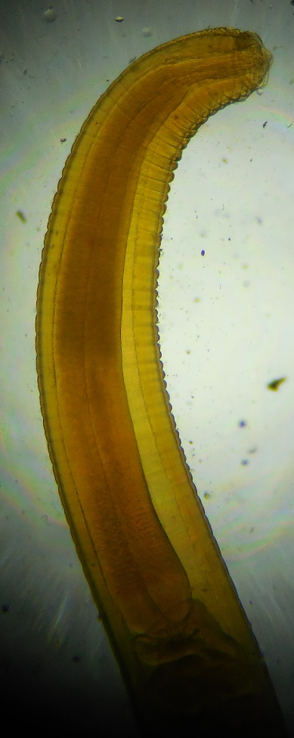

Image 2 Microscopic view of a fish scale
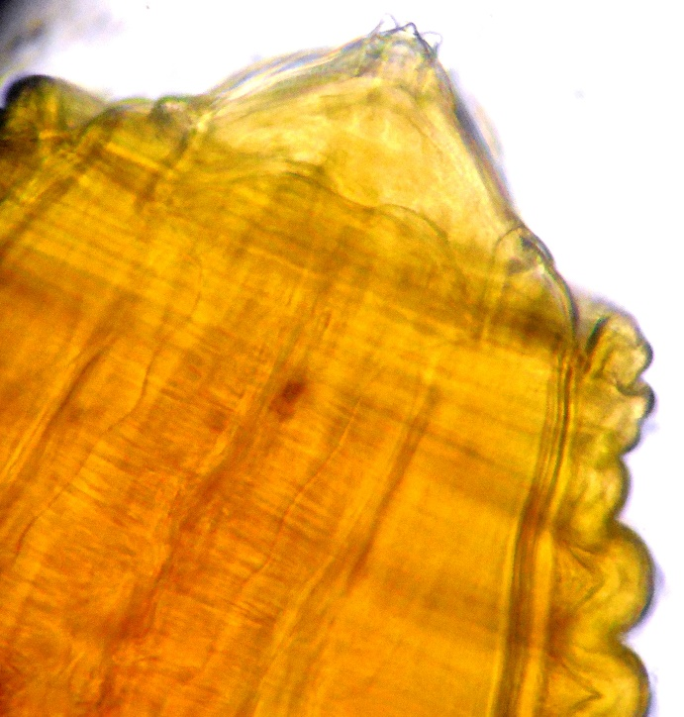

Image 3 Microscopic image of a fish scale tip
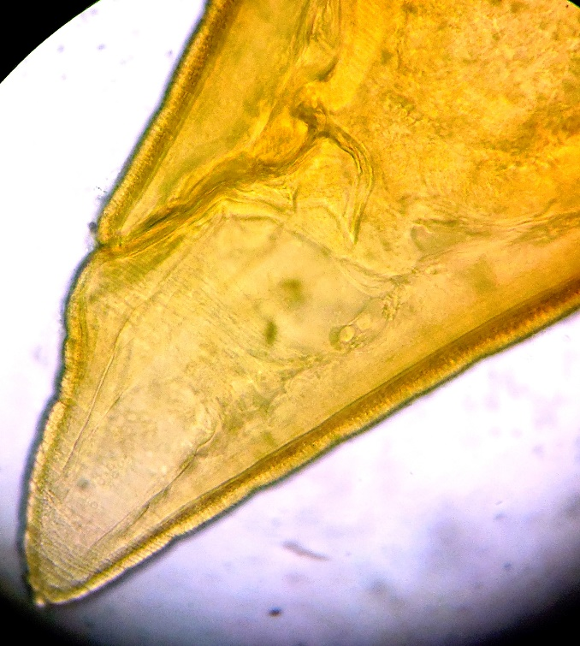

Image 4 Microscopic view of P. praeputialis
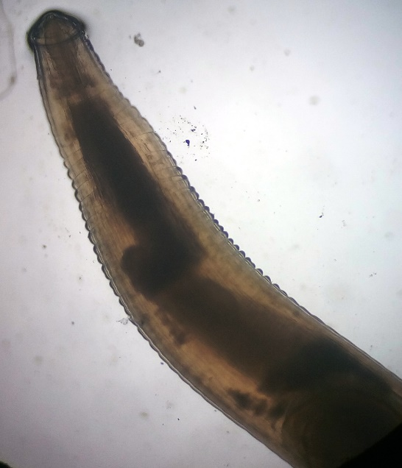

Image 5 posterior end of P. praeputialis

