Review Article
Bridging the Gap: Community-Based Healthcare as a Catalyst for Advancing Health Equity and Universal Health Coverage

.
ABSTRACT

Achieving health equity and universal health coverage remains a critical objective in global health, yet countless individuals, particularly in low- and middle-income countries, still encounter systemic obstacles to accessing essential healthcare services. This study’s objective examined the pivotal role of community healthcare access as the foundation for achieving health equity and promoting universal health coverage. Rooted in social justice and primary healthcare principles, it underscores the role of community-based health systems as accessible, culturally appropriate, and cost-efficient means to reach underserved populations. Key barriers, such as geographical distance, limited financing, sociocultural norms, and workforce limitations, are explored alongside innovative solutions, including task shifting, digital health tools, and community health insurance schemes. Policy recommendations emphasizes the need for inclusive financing, inclusion of community health workers into national health systems, investment in digital infrastructure, and cross-sectoral collaboration. The study concludes that sustainable advancement toward health equity and universal health coverage is achievable only when community healthcare systems are recognized as central actors in national health strategies. Thus, empowering communities with healthcare that is accessible and inclusive is not just an ethical obligation but also the most effective and sustainable way to ensure health for all. Thus, empowering communities with healthcare that is responsive, accessible, and inclusive is not just an ethical obligation but also the most effective and sustainable way to ensure health for everyone.

Keywords: Community Healthcare Access, Health Equity, Universal Health Coverage, Primary Healthcare, Community Health Workers, Low-and-middle Income Countries

1. INTRODUCTION

1.1 Background and Rationale
Health is a basic human right and a vital element of social and economic development. Nevertheless, a major global health challenge, particularly in low- and middle-income countries (LMICs), is unequal access to essential healthcare services, where health systems are often fragmented and under-resourced [1, 2]. To tackle this challenge, the global health community has increasingly emphasized Universal Health Coverage (UHC) as a strategic objective to ensure that all individuals and communities get the healthcare they need without experiencing financial strain [3]. A crucial aspect of achieving UHC is community healthcare access, which forms the basis of fair, people-centered, and sustainable health systems [4, 5].
1.2 Definition of Terms
1.2.1 Universal Health Coverage (UHC): The World Health Organization (WHO) defines UHC as ensuring that “all people have access to the health services they need, when and where they need them, without financial hardship” [6].
1.2.2 Health equity: This is defined as the absence of unfair and preventable differences in health among population groups categorized by economic, economic, social, demographic, or geographic factors [7]. Achieving health equity necessitates intentional approaches to address structural barriers, social injustices, and the unequal distribution of opportunities and resources.
1.2.3 Community healthcare access: This refers to the ability of individuals and households, especially those in underserved and marginalized areas, to obtain timely and affordable primary healthcare services within or near their communities. This encompasses both the physical availability of services and the socio-cultural acceptability of care [8, 9].
1.3 Global and Regional Context
Despite global commitments, progress toward UHC remains inconsistent. As of 2023, over 2 billion people still do not have access to essential health services, and nearly 1 billion faced catastrophic health expenditures annually [10]. Europe, the Americas and West Pacific have better health coverage compared to sub-Saharan Africa, parts of Latin America, South Asia, and Eastern Mediterranean which bear disproportionate burden of health inequities, with rural and peri-urban populations facing the greatest access challenges [11, 12]. This is shown in Figures 1 and 2 below.
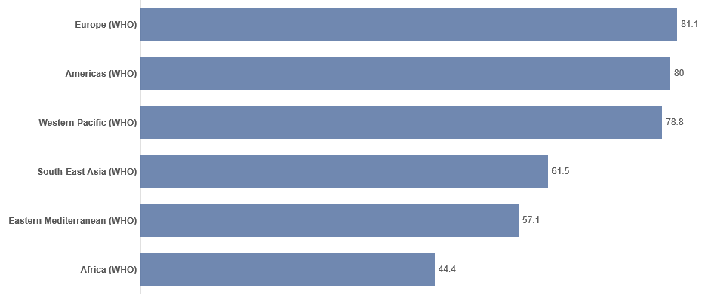
Figure 1. The Universal Health Coverage (UHC) Service Coverage Index by Region [13].

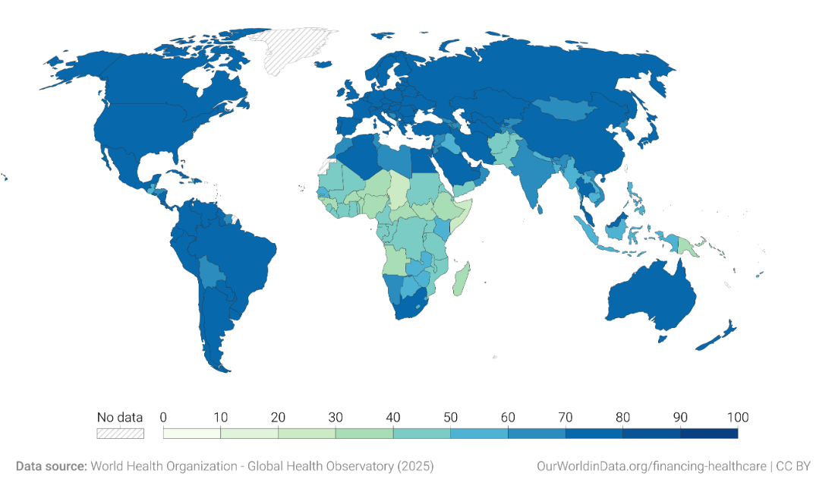
Figure 2. Showing the Universal Health Coverage (UHC) Service Coverage Index by Country [13].
(The UHC Service Coverage Index is measured on a scale from 0 (worst) to 100 (best) based on the average coverage of essential services including infectious diseases, reproductive, maternal, newborn and child health, non-communicable diseases and service capacity and access).
In sub-Sahara Africa, the UHC service coverage index was below 50 in most countries, indicating limited population coverage of essential health services. Only few countries exceeded the 60-point threshold such as Mauritius, South Africa, Cabo Verde, and Seychelles, with consolidated health systems.
Below is a chart showing UHC service coverage index in selected sub-Sahara African countries.
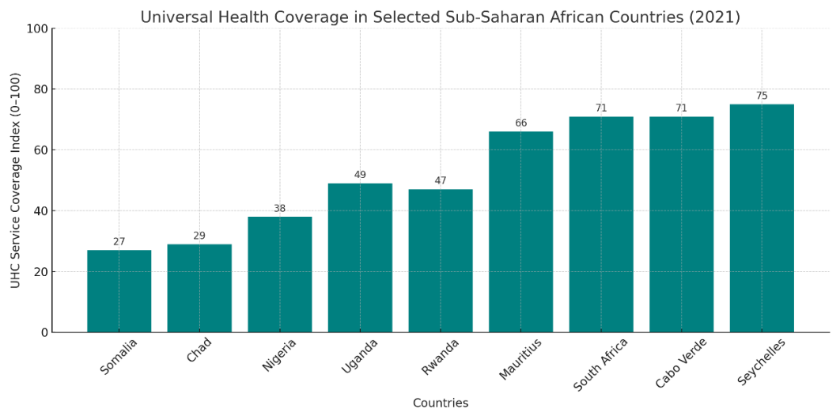
Figure 3. UHC in Selected sub-Saharan African Countries [14]
1.4 Research/Study Objectives
This study explores the crucial role of community healthcare access as a tool to advance health equity and achieving UHC. It aims to:
- Examine how community healthcare systems serve as gateways to universal health coverage and health equity;
- Analyze barriers and enablers of community health access, particularly in marginalized populations;
- Highlight best practices and policy interventions that enhance community health delivery;
- Explore how advocacy bring about health systems that prioritize equity, participation, and sustainability.

2. THEORETICAL AND CONCEPTUAL FRAMEWORK
2.1 Theoretical Frameworks
This study would be based on relevant theories and conceptual models that enables us understand the relationship between community healthcare access, UHC, and health equity. These frameworks explore how structural, policy, and grassroots elements interact to affect health access and outcomes.

2.1.1 The Right to Health and Social Justice
The principle that health is a fundamental human right is central to community healthcare access. International documents such as the Universal Declaration of Human Rights (Article 25) and the International Covenant on Economic, Social and Cultural Rights (Article 12) support this view. The right to “the highest attainable standard of physical and mental health” for all is acknowledged by these documents [15, 16].
The social justice perspective argues that health disparities reflect broader social and economic inequalities. Therefore, access to healthcare should be considered as an ethical imperative, not merely a policy option. The recognition of marginalized voices, redistribution of resources, and democratization of health systems is emphasized by this theory [17].
2.1.2 The Primary Healthcare Approach
The provision of essential, community-based services is the basic function of the Primary Health Care (PHC) system. PHC promotes accessibility, availability, and community involvement, recognizing that health systems must be grounded in the social, economic and cultural contexts of the populations they serve. They should provide services that meets the basic needs of the people [18].
2.1.3 Equity-Oriented Frameworks for Access
Achieving equity in health involves understanding the availability of services, as well as their accessibility, acceptability, affordability, and appropriateness [19]. This model illustrates that access is a dynamic interplay between the characteristics of health services and the ability of populations to seek, reach, afford, and engage with care. This involves not just addressing the physical distance it takes to access care but also cultural barriers, literacy levels, gender norms, and financial limitations that may impede service use [20].
2.2 Conceptual Framework for This Study
A hybrid conceptual framework was adopted from the models discussed above for this study. It combines the Social Justice Theory for normative equity analysis, the Primary Health Care Philosophy for community-centered service delivery, and the equity-oriented model for access.
This integrative approach enables a comprehensive examination of community healthcare access as both a practical means of delivering health services and a transformative strategy for achieving health equity and UHC.

3. COMMUNITY HEALTHCARE ACCESS: A PILLAR OF UHC
To achieve UHC, it is crucial to expand financial protection and essential service coverage and ensure that health systems are community-based, equitable, and responsive. Community healthcare access is central to this vision, serving as both the entry point and the backbone of primary healthcare systems [21, 22]. Figure 4 below is a diagram showing community healthcare access as the central player to health equity and UHC.

Availability of Health Facilities, Trained Personnel, Adequate Financing, Community Involvement

COMMUNITY HEALTHCARE ACCESS
UNIVERSAL HEALTH COVERAGE
EQUITY

Figure 4. Community Healthcare Access as the Bridge between Health Equity and UHC (Adapted from 16 & 17).
3.1 Importance of Community Healthcare in Achieving UHC
Community healthcare plays a crucial role in expanding the reach of health systems to rural, peri-urban, and marginalized populations often left out of mainstream health services [23]. The WHO highlights robust primary care rooted in the community as a fundamental aspect of UHC, focusing on continuity of care, patient-centeredness, and social accountability. By providing basic health services, community health systems reduce the burden healthcare poses on secondary and tertiary care facilities, and promote early detection and prevention [24].
3.2 Models of Community Healthcare Delivery
Various models of community healthcare delivery have been implemented across different contexts, ranging from government-led initiatives to non-governmental and hybrid systems. Notable examples include:
- Ethiopia’s Health Extension Program (HEP), which sends female health workers to rural villages
- Brazil’s Family Health Strategy, a community-based team approach to integrated care
- India’s Accredited Social Health Activist (ASHA) program which connects households to public health services [25].
Despite their contextual differences, these models share the belief that effective healthcare must be people-centered, equitable, and locally adapted.
3.3 Role of Community Health Workers (CHWs)
CHWs are frontline agents of community health systems. Trained to provide health promotion, preventive, and curative services, they serve as bridges between communities and formal health facilities. Their role is particularly crucial in resource-constrained settings, where the physician-to-population ratio is extremely low [26, 27].
3.4 Integration with National Health Systems
For community healthcare to significantly contribute to UHC, it must be systematically integrated into the national health strategies and budgets. Integration efforts should include policy alignment, where CHWs are officially recognized as part of the health workforce, facilitating seamless patient transitions between community care and higher-level facilities. Countries like Thailand and Rwanda have shown that investing in community health can lead to long-term benefits in coverage, equity, and system efficiency [28].

4. BARRIERS TO COMMUNITY HEALTHCARE ACCESS
4.1 Geographical and Infrastructural Barriers
In many LMICs, the physical distance to healthcare facilities remains a major challenge, especially in rural and hard-to-reach areas. Research indicates that populations living more than 5 km away from the nearest health center are considerably less likely to access essential health services, such as antenatal care and child immunizations [29].
Poor road infrastructure, lack of transportation options, and seasonal inaccessibility due to flooding or difficult terrain further exacerbate these challenges in rural areas. For example, in Nigeria, residents of riverine and mountainous areas have to travel for several hours or even days to access basic medical care, which often discourages them from seeking healthcare [30].
4.2 Economic and Financial Constraints
Even when healthcare services are geographically accessible, out-of-pocket expenditures or informal fees can act as barriers. According to the World Bank, nearly 1 billion people worldwide spend more than 10% of their household income on health, driving many into poverty [31].
Impoverished individuals often choose between healthcare and daily survival needs, which can result in delayed care or self-medication. Community health programs meant to alleviate these financial burdens through free or subsidized services, suffer from underfunding, irregular supplies, or informal charges [32, 33].
4.3 Sociocultural Factors and Health Literacy
Sociocultural norms, beliefs, and practices play a crucial role in influencing health-seeking behaviors. In certain communities, illnesses are perceived through traditional or spiritual perspectives, prompting individuals to consult herbalists, spiritual leaders, or family elders before seeking formal medical care. Gender norms also influence access to healthcare. In patriarchal societies, women may lack the autonomy to seek medical care without male approval or may prioritize the health of their children and husbands over their own [34].
Low levels of health literacy further exacerbates these issues. When people lack adequate knowledge of disease symptoms, treatment plans, or the importance of preventive care, they not likely to engage with community health services [35].
4.4 Human Resource Challenges
Human resource limitations represent a significant bottleneck in community health delivery. CHWs often receive insufficient training, resulting in inconsistent service quality. Additionally, CHWs experience burnout due to inadequate compensation or lack of salaries, as well as limited career advancement opportunities, which diminishes motivation and retention [36]. Addressing these challenges necessitates structural transformation, political commitment, and ongoing community involvement. The figure below illustrates the barriers to community healthcare access.
Barriers to Community Healthcare Access
Economic and Financial Constraints

Poverty
Out-of-pocket expenses
Inadequate funding
Physical distance
Geographical and Infrastructural
Poor road networks
Poor infrastructures
Sociocultural Factors and Health literacy
Gender norms
Belief systems
Low literacy
Human Resource
Inadequate training
Poor remuneration
Limited career advancements

Figure 5. Barriers to Community Healthcare Access (Source: Author, 2025)

5. INNOVATIONS AND BEST PRACTICES IN EXPANDING ACCESS
Despite the ongoing challenges in accessing community healthcare, various innovative strategies and best practices have been developed worldwide to improve equity, advance UHC, and reach underserved populations. These innovations encompass service delivery models, digital health, financing models, and community engagement strategies [37, 38]. The practices that have effectively expanded access, especially in LMICs, and offer insights for replication and scale-up are discussed below.
5.1 Task Shifting and Task Sharing
Task shifting involves the strategic redistribution of tasks among health workforce teams, and has become a cost-effective approach to addressing human resource shortages in underserved regions [39]. CHWs, nurses, and mid-level providers are increasingly trained to provide primary care, maternal and child health services, and to manage chronic diseases. In Rwanda, the CHW system incorporated task sharing with performance-based incentives, allowing CHWs to manage basic illnesses at the community level, leading to a 70% reduction in under-five mortality between 2000 and 2015 [40].
5.2 Digital Health and Mobile Technology
Community health service delivery has been transformed by mobile health (mHealth) tools, which has enhanced access, communication, data collection, and accountability. In Kenya, platforms like m-TIBA enable low-income users to save, receive, and pay for health services via mobile phones, thereby increasing access to essential care and health financing [41].
In Bangladesh, the mPower Health platform provides CHWs with real-time decision-support tools for maternal and newborn care, improving diagnostic accuracy and service delivery [42].These digital innovations help eliminate delays in care and strengthen the linkages between households and facilities.
5.3 Community-Based Health Insurance (CBHI)
Community-based health insurance schemes offer an innovative solution to out-of-pocket expenses and health financing inequity. The National Health Insurance Scheme (NHIS) in Ghana evolved from local CBHI pilots, resulting in increased service utilization and protection against catastrophic health expenditures [43].
5.4 Community Engagement and Co-production of Health
Involving communities in health planning, implementation, and monitoring enhances responsiveness, accountability, and trust in the system. In systems where community participation is encouraged, there is a wide adoption of community healthcare services [44, 45].
Participatory learning and action (PLA) cycles, in which community groups identify and address local health issues, have been shown to enhance maternal and neonatal health outcomes in countries such as India and Malawi [46], and have been replicated in other similar contexts.
5.5 Integrated Service Delivery Models
These models combine preventive, promotional, and curative services at the community level. In Liberia, the National Community Health Assistant Program delivered an integrated package that included reproductive health, malaria, tuberculosis, and child health services in remote communities. Evaluation has shown increased treatment coverage and reduced mortality [47].
Innovative approaches, whether in workforce deployment, technology, financing, or community mobilization, demonstrate that expanding access to community healthcare is feasible and effective. These strategies highlight the importance of adapting solutions to local contexts, building resilient health systems, and involving communities as co-creators of health [48].

6. POLICY RECOMMENDATIONS AND FUTURE DIRECTIONS
6.1 Policy Recommendations
To achieve health equity and UHC through community healthcare access, bold, inclusive, and evidence-informed policy measures must be implemented. Despite significant advancements through innovations and best practices, systemic challenges such as financing gaps, workforce shortages, cultural barriers, and weak governance persist in the health sector. Herein, we present actionable policy recommendations and future directions for creating sustainable, equitable, and community-centered health systems.
1. Strengthen PHC as the Foundation for UHC: Governments should prioritize and invest in comprehensive PHC. PHC systems must be people-centered, accessible, culturally sensitive, and fully integrated with referral systems [49].
2. Institutionalize and scale up Community Health Worker (CHW) Programs: Institutionalize and scale up CHW programs with adequate remuneration, career development opportunities, and integration into national health systems [50].
3. Ensure Equitable Health Financing and Social Protection: Develop inclusive financing mechanisms that reduce out-of-pocket expenses and provide financial protection for underserved populations through taxation-based systems, community-based insurance, or social health protection schemes [51].
4. Invest in Digital Health Infrastructure: Governments should implement national digital health strategies to facilitate use of mHealth, telemedicine, and health information systems, particularly in underserved areas [52, 53].
5. Promote Inclusive Governance and Community Participation: Establish mechanisms where community can be involved in health policy design, planning, and evaluation. Policies must ensure that marginalized voices, including women, people with disabilities, rural residents, are included in decision-making [54].
6. Encourage Cross-Sectoral Collaboration: Address social determinants of health through multi-sectoral collaboration, linking health with education, sanitation, housing, and nutrition. Health equity cannot be achieved by the health sector alone. Policies must coordinate with sectors that influence living conditions and health behaviors [55].
7. Monitor Progress and Foster Accountability: Develop robust monitoring, evaluation, and learning frameworks that track progress in community health access, equity, and UHC milestones. Community scorecards and health dashboards can promote citizen-led accountability [56].
6.2 Future Directions
As countries advance towards UHC, the future of community healthcare must embrace:
- Localization of Solutions: Community health strategies must be context-specific, locally led, and culturally relevant.
- Sustainable Financing: Governments must increase domestic resource mobilization and allocation for health, and reduce dependence on external aid.
- Human-Centered Technology: Digital tools must be user-friendly, inclusive, and ethically aligned.
- Climate-Responsive Health Systems: Community health must integrate climate resilience, given the growing impact of environmental change on health outcomes.
In summary, policy reforms that prioritize community healthcare access are not only essential for UHC and health equity but are non-negotiable. The desired change requires political will, sustained investment, intersectoral collaborations, and a reimagining of communities, not as passive recipients but as equal stakeholders in health. The pathway to health for all lies in the hands of those closest to the people, including community health systems that are well-funded, well-governed, and deeply rooted in social justice.

7. CONCLUSION
The quest for health equity and UHC is among the most crucial global health goals of the 21st century. However, systemic barriers to accessing essential health services are still encountered by countless individuals in LMICs. These barriers, deeply rooted in factors such as poverty, low literacy levels, geography, disability, and sociocultural norms are surmountable. An effective solution to these barriers is community healthcare access. It serve as both a gateway and foundation for equitable and inclusive healthcare. It plays a vital role in reaching marginalized groups, promoting preventive care, building trust for involvement, and enhancing health outcomes on a large scale. Long-standing disparities are eliminated when community health approaches are sufficiently funded, professionalized, and integrated into national health strategies. The strategic use of CHWs, digital health tools, and community involvement mechanisms not only expand coverage but also strengthens the resilience of health systems, especially during health emergencies.
Community healthcare has emerged as a symbol of hope and resilience, to combat the increasing health challenges, emerging diseases, demographic shifts, socioeconomic inequalities, and climate change being faced by the world. The path to health equity and UHC is not found in distant promises or abstract models. It lies in the hands of communities that are empowered and engaged, trained health personnel, local ownership, and systems that are responsive.

Ethical approval: Not applicable
REFERENCES
- Maani N, Abdalla SM, Ettman CK, Parsey L, Rhule E, Allotey P, Galea S. (2023). Global Health Equity Requires Global Equity. Health Equity. 7(1):192-196. https://doi.org/10.1089/heq.2022.0169
- Rad, J. (2025). Health inequities: a persistent global challenge from past to future. Int J Equity Health 24, 148. https://doi.org/10.1186/s12939-025-02526-y
- World Health Organization. (2019). Primary health care on the road to universal health coverage: 2019 global monitoring report. [Accessed 30 July 2025]. Available from: https://bit.ly/45nSBBp
- Effiong FB, Ogbonna CP, Agughalam PI, Okwukwu MO, Dike IC, Elebesunu EE, Uwishema O. (2023). The role of community-based approaches in achieving universal health coverage: addressing the Nigerian narrative. Ann Med Surg (Lond). 85(5):1769-1773. https://doi.org/10.1097/MS9.0000000000000443
- Sacks E, Schleiff M, Were M, Chowdhury AM, Perry HB. (2020). Communities, universal health coverage and primary health care. Bull World Health Organ. 98(11):773-780. https://doi.org/10.2471/BLT.20.252445
- World Health Organization & World Bank. (‎2015)‎. Tracking universal health coverage: first global monitoring report. World Health Organization. [Accessed 30 July 2025]. Available from: https://iris.who.int/handle/10665/174536.
- Braveman, P., Arkin, E., Orleans, T., Proctor, D., & Plough, A. (2011). What is health equity? And what difference does a definition make? Robert Wood Johnson Foundation. bit.ly/4530CN6
- Perry, H. B., Zulliger, R., & Rogers, M. M. (2017). Community health workers in low-, middle-, and high-income countries: An overview of their history, recent evolution, and current effectiveness. Annual Review of Public Health, 35(1), 399–421. https://doi.org/10.1146/annurev-publhealth-032013-182354
- Levesque, J.-F., Harris, M. F., & Russell, G. (2013). Patient-centred access to health care: Conceptualising access at the interface of health systems and populations. International Journal for Equity in Health, 12, Article 18. https://doi.org/10.1186/1475-9276-12-18
- World Health Organization & World Bank. (2023). Tracking Universal Health Coverage: 2023 Global Monitoring Report. [Accessed 30 July 2025]. Available from: https://www.who.int/publications/i/item/9789240080379.
- Oleribe OO, Momoh J, Uzochukwu BS, Mbofana F, Adebiyi A, Barbera T, Williams R, Taylor-Robinson SD (2019). Identifying Key Challenges Facing Healthcare Systems In Africa And Potential Solutions. Int J Gen Med. 12:395-403. https://doi.org/10.2147/IJGM.S223882
- Abimbola S, Olanipekun T, Schaaf M, Negin J, Jan S, Martiniuk ALC. (2017). Where there is no policy: governing the posting and transfer of primary health care workers in Nigeria. Int J Health Plann Manage. 32(4):492-508. https://doi.org/10.1002/hpm.2356
- World Health Organization (2025). Data Page: The Universal Health Coverage (UHC) Service Coverage Index”. Our World in Data (2025). [Online resource] (Archived on June 24, 2025). [Accessed 30 July 2025]. Available from: https://bit.ly/4ojfoqD
- World Health Organization. (2023). Universal health coverage (UHC) service coverage index. Global Health Observatory. (Accessed 31 July 2025). Available from: https://bit.ly/3UHVlEF
- United Nations. (2023). Universal Declaration of Human Rights. [Accessed 31 July 2025]. Available from: https://bit.ly/47fBmEP
- World Health Organization. (2023). Human Rights. [Accessed 31 July 2025]. Available from: https://tinyurl.com/e5t9ch9v
- Marmot M. (2017). The Health Gap: The Challenge of an Unequal World: the argument. Int J Epidemiol. 46(4):1312-1318. https://doi.org/10.1093/ije/dyx163
- Rai A, Khatri RB, Assefa Y. (2024). Primary Health Care Systems and Their Contribution to Universal Health Coverage and Improved Health Status in Seven Countries: An Explanatory Mixed-Methods Review. Int J Environ Res Public Health. 21(12):1601. https://doi.org/10.3390/ijerph21121601
- Richard L, Furler J, Densley K, Haggerty J, Russell G, Levesque JF, Gunn J. (2016). Equity of access to primary healthcare for vulnerable populations: the IMPACT international online survey of innovations. Int J Equity Health. 15:64. https://doi.org/10.1186/s12939-016-0351-7
- Saurman E. (2016). Improving access: modifying Penchansky and Thomas's Theory of Access. J Health Serv Res Policy. 21(1):36-9. https://doi.org/10.1177/1355819615600001
- Kodali PB. (2023) Achieving Universal Health Coverage in Low- and Middle-Income Countries: Challenges for Policy Post-Pandemic and Beyond. Risk Manag Healthc Policy.16:607-621. https://doi.org/10.2147/RMHP.S366759
- Sacks E, Schleiff M, Were M, Chowdhury AM, Perry HB. (2020). Communities, universal health coverage and primary health care. Bull World Health Organ. 98(11):773-780. https://doi.org/10.2471/BLT.20.252445
- Freeman T, Baum F, Lawless A, Javanparast S, Jolley G, Labonté R, Bentley M, Boffa J, Sanders D.(2016). Revisiting the ability of Australian primary healthcare services to respond to health inequity. Aust J Prim Health. 22(4):332-338. https://doi.org/10.1071/PY14180
- Bitton A, Ratcliffe HL, Veillard JH, Kress DH, Barkley S, Kimball M, Secci F, Wong E, Basu L, Taylor C, Bayona J, Wang H, Lagomarsino G, Hirschhorn LR. (2017). Primary Health Care as a Foundation for Strengthening Health Systems in Low- and Middle-Income Countries. J Gen Intern Med. 32(5):566-571. https://doi.org/10.1007/s11606-016-3898-5
- Scott, K., Beckham, S. W., Gross, M., Pariyo, G., Rao, K. D., & Perry, H. B. (2018). What do we know about community-based health worker programs? A systematic review of existing reviews on community health workers. Human Resources for Health, 16, Article 39. https://doi.org/10.1186/s12960-018-0304-x
- Gilmore, B., & McAuliffe, E. (2013). Effectiveness of community health workers delivering preventive interventions for maternal and child health in low- and middle-income countries: A systematic review. BMC Public Health, 13, Article 847. https://doi.org/10.1186/1471-2458-13-847
- Adebayo, A. M., Labiran, A., Sholeye, O. O., & Abayomi, A. (2021). Strengthening the community health workforce for primary healthcare delivery in Nigeria: A qualitative study. BMC Health Services Research, 21, Article 825. https://doi.org/10.1186/s12913-021-06876-z
- Cometto, G., Ford, N., Pfaffman-Zambruni, J., Akl, E. A., Lehmann, U., McPake, B., ... & Ballard, M. (2018). Health policy and system support to optimize community health worker programmes: An abridged WHO guideline. The Lancet Global Health, 6(12), e1397–e1404. https://doi.org/10.1016/S2214-109X(18)30482-0
- Noor, A. M., Amin, A. A., Gething, P. W., Atkinson, P. M., Hay, S. I., & Snow, R. W. (2019). Modelling distances travelled to government health services in Kenya. Tropical Medicine & International Health, 14(1), 33–44. https://doi.org/10.1111/j.1365-3156.2005.01555.x
- Okedo-Alex, I. N., Akamike, I. C., Ezeanosike, O. B., & Uneke, C. J. (2020). Barriers to implementation of the national health insurance scheme in Southeast Nigeria: Results from a cross-sectional study. BMJ Open, 10(10), e037517. https://doi.org/10.1136/bmjopen-2020-037517
- Sirag A, Mohamed Nor N. Out-of-Pocket Health Expenditure and Poverty: Evidence from a Dynamic Panel Threshold Analysis. Healthcare (Basel). 2021 May 3;9(5):536. https://doi.org/10.3390/healthcare9050536
- Kankeu, H. T., Saksena, P., Xu, K., & Evans, D. B. (2013). The financial burden from non-communicable diseases in low- and middle-income countries: A literature review. Health Research Policy and Systems, 11(1), Article 31. https://doi.org/10.1186/1478-4505-11-31
- Ataguba, J. E., & Akazili, J. (2019). Health care financing in South Africa: Moving towards universal coverage. Continuing Medical Education, 37(5), 338–342. https://tinyurl.com/2pvehr3u
- Ganle, J. K., Obeng, B., Segbefia, A. Y., Mwinyuri, V., Yeboah, J. Y., & Baatiema, L. (2015). How intra-familial decision-making affects women’s access to and use of maternal healthcare services in Ghana: A qualitative study. BMC Pregnancy and Childbirth, 15, Article 173. https://doi.org/10.1186/s12884-015-0590-4
- Shahid R, Shoker M, Chu LM, Frehlick R, Ward H, Pahwa P. (2022). Impact of low health literacy on patients' health outcomes: a multicenter cohort study. BMC Health Serv Res. 22(1):1148. https://doi.org/10.1186/s12913-022-08527-9
- Glenton, C., Colvin, C. J., Carlsen, B., Swartz, A., Lewin, S., Noyes, J., & Rashidian, A. (2013). Barriers and facilitators to the implementation of lay health worker programmes to improve access to maternal and child health: Qualitative evidence synthesis. Cochrane Database of Systematic Reviews, 2013(10), CD010414. https://doi.org/10.1002/14651858.CD010414.pub2
- Ahmed, M. M., Okesanya, O. J., Olaleke, N. O., Adigun, O. A., Adebayo, U. O., Oso, T. A., Eshun, G., & Lucero-Prisno, D. E., III. (2025). Integrating Digital Health Innovations to Achieve Universal Health Coverage: Promoting Health Outcomes and Quality Through Global Public Health Equity. Healthcare, 13(9), 1060. https://doi.org/10.3390/healthcare13091060
- Awosiku, O. V., Gbemisola, I. N., Oyediran, O. T., Egbewande, O. M., Lami, J. H., Afolabi, D., Okereke, M., & Effiong, F. (2025). Role of digital health technologies in improving health financing and universal health coverage in sub-Saharan Africa: A comprehensive narrative review. Frontiers in Digital Health. https://doi.org/10.3389/fdgth.2025.1391500
- Ballard, M., Westgate, C., Alban, R., Choudhury, N., Adamjee, R., Schwarz, R.K., Bishop, J., McLaughlin, M., Flood, D., Finnegan, K., Rogers, A., Olsen, H., Johnson., Palazuelos, D., Schechter, J. (2021). Compensation models for community health workers: Comparison of legal frameworks across five countries. Global Health: Science and Practice, 9(4), 766–778. https://doi.org/10.7189/jogh.11.04010
- Condo, J., Mugeni, C., Naughton, B. et al. (2014). Rwanda’s evolving community health worker system: a qualitative assessment of client and provider perspectives. Hum Resour Health 12, 71. https://doi.org/10.1186/1478-4491-12-71
- Munywoki, P., Wambugu, S., & Koseki, S. (2020). Exploring the use of mobile money in improving access to health care in Kenya. Health Systems & Reform, 6(1), e1724035. https://doi.org/10.1080/23288604.2020.1724035
- Labrique, A. B., Vasudevan, L., Kochi, E., Fabricant, R., & Mehl, G. (2018). mHealth innovations as health system strengthening tools: 12 common applications and a visual framework. Global Health: Science and Practice, 1(2), 160–171. https://doi.org/10.9745/GHSP-D-13-00031
- Aryeetey GC, Jehu-Appiah C, Spaan E, Agyepong I, Baltussen R. (2012). Costs, equity, efficiency and feasibility of identifying the poor in Ghana's National Health Insurance Scheme: empirical analysis of various strategies. Trop Med Int Health. 17(1):43-51. https://doi.org/10.1111/j.1365-3156.2011.02886.x
- Assefa, Y., Gelaw, Y. A., Hill, P. S., Taye, B. W., Van Damme, W., & Williams, O. D. (2019). Community health extension program of Ethiopia, 2003–2018: Successes and challenges toward universal coverage for primary healthcare services. Globalization and Health, 15(1), 24. https://doi.org/10.1186/s12992-019-0470-1
- Ogah, P., Uguru, N., Okeke, C. et al. Primary health care in Nigeria: best practices and quality of care in Nigeria. BMC Health Serv Res 24, 963 (2024). https://doi.org/10.1186/s12913-024-11406-0
- Prost, A., Colbourn, T., Seward, N., Azad, K., Coomarasamy, A., Copas, A., ... & Houweling, T. A. (2013). Women's groups practising participatory learning and action to improve maternal and newborn health in low-resource settings: A systematic review and meta-analysis. The Lancet, 381(9879), 1736–1746. https://doi.org/10.1016/S0140-6736(13)60685-6
- White E, Mendin S, Kolubah FR, Karlay R, Grant B, Jacobs GP, Subah M, Siedner MJ, Kraemer JD, Hirschhorn LR (2022). Impact of the Liberian National Community Health Assistant Program on childhood illness care in Grand Bassa County, Liberia. PLOS Glob Public Health. 2(6):e0000668. https://doi.org/10.1371/journal.pgph.0000668
- Truppa C, Yaacoub S, Valente M, Celentano G, Ragazzoni L, Saulnier D. (2024). Health systems resilience in fragile and conflict-affected settings: a systematic scoping review. Confl Health. 18(1):2. https://doi.org/10.1186/s13031-023-00560-7
- van Weel C, Kidd MR. (2018). Why strengthening primary health care is essential to achieving universal health coverage. CMAJ. 190(15):E463-E466. https://doi.org/10.1503/cmaj.170784
- Mupara LM, Mogaka JJO, Brieger WR, Tsoka-Gwegweni JM. (2023). Community Health Worker programmes' integration into national health systems: Scoping review. Afr J Prim Health Care Fam Med. 15(1):e1-e16. https://doi.org/10.4102/phcfm.v15i1.3204
- Jalali FS, Bikineh P, Delavari S. (2021). Strategies for reducing out of pocket payments in the health system: a scoping review. Cost Eff Resour Alloc. 19(1):47. https://doi.org/10.1186/s12962-021-00301-8
- Babatunde, A. O., Abdulkareem, A. A., Akinwande, F. O., Adebayo, A. O., Omenogor, E. T., Adebisi, Y. A., & Ilesanmi, E. B. (2021). Leveraging mobile health technology towards achieving universal health coverage in Nigeria. Public Health in Practice, 2, Article 100120. https://doi.org/10.1016/j.puhip.2021.100120
- Chika, U. E., Dike, U. P., Ahuchaogu, K.-D., Ezenri, G., Nneji, T. O., Chidoziem, C., & Chidera, M. R. (2024). Digital healthcare tools in Nigeria: Strengthening public health and pandemic preparedness—Insights from the COVID-19 crisis. Telehealth & Medicine Today, 9(1), Article 445. https://doi.org/10.30953/thmt.v8.445
- Kornelsen J, Carthew C, Lloyd-Kuzik N. (2022). Optimizing Community Participation in Healthcare Planning, Decision Making and Delivery through Rural Health Councils. Healthc Policy. 18(2):27-43. https://doi.org/10.12927/hcpol.2022.26972
- Kreuter MW, Thompson T, McQueen A, Garg R. (2021). Addressing Social Needs in Health Care Settings: Evidence, Challenges, and Opportunities for Public Health. Annu Rev Public Health. 42:329-344. https://doi.org/10.1146/annurev-publhealth-090419-102204
- Bergen N, Ruckert A, Labonté R. (2019). Monitoring Frameworks for Universal Health Coverage: What About High-Income Countries? Int J Health Policy Manag. 8(7):387-393. https://doi.org/10.15171/ijhpm.2019.21

