PHYSIOCHEMICAL AND HEAVY METAL PROFILE ANALYSIS OF WASTEWATER OF SEWAGE AND LEACHATE OBTAINED FROM THE SEWAGE WASTE TANK, UNIVERSITY OF NIGERIA NSSUKA AND FIRST MARKET MUNICIPAL DUMPSITE IFITE AWKA, ANAMBRA STATE.

ABSTRACT
This research investigated the level of contamination in sewage wastewater sample from the sewage waste water tank University of Nigeria Nsukka, Enugu state and Leachate wastewater sample from a municipal waste dump site at First Market Ifite Awka Anambra State, both located in the South-Eastern region of Nigeria. Physiochemical analysis using different parameters, identification of chemical components using gas chromatography (GC) and heavy metal analysis using atomic absorption spectrophotometer (AAS) were conducted on each sample and the results obtained were used to compare with standard result of World Health Organization (WHO) and Federal Environmental Protection Agency (FEPA). The results of physicochemical parameters used revealed that turbidity, colour, chemical oxygen demand, biological oxygen demand, chloride, total solid were significantly high compared with WHO and FEPA results, pH was moderately low for sewage (6.9) with slight acidity and leachate sample (4.3) with significant high acidity. The analysis carried out on heavy and toxic metal with reference to these metals cobalt, lead, arsenic, cadmium, chromium also revealed that none of these metals concentrations met the standard requirement; they all exceeded the permissible limits (0.05 to 0.02 mg/l). GC results revealed 62 volatile/26 non – volatile and 66 volatile / 16 non – volatile chemical components for both sewage and leachate respectively. These results show that wastewater do not meet the standard requirement to be considered fit for disposal and hence should undergo treatment before disposal. There is gross need for these waste waters to be treated to avoid public health and agricultural menace that can emanate from them.

Key words: waste water, sewage, leachate, physiochemical, parameters, heavy metal.
1.0 INTRODUCTION
Increasing industrialization is one of the culprits that have been identified as a major contributor to global trend of water pollution, as most wastewaters from these industries end up in reaching surface waters and underground aquifers. Hence industrial wastewaters or effluents into the environment, are to be monitor/supervise compliance. In Nigeria, a developing country still battling with environmental abuse by many companies, this responsibility lies with the National Environmental Standards and Regulations Enforcement Agency (NESREA), a body set up for this purpose on 30th of July 2007 by the Nigerian government [1]. Despite this proactive step by government, some industries still cut corners or do not maintain their effluent treatment plants properly to obtain minimal treatment as stated in NESREA’s guidelines. This scenario has led to unabated dumping of pollutants into our water bodies with attendant adverse effects to their biota, and also reducing the aesthetics and recreational quality of the water bodies [2].,[3]. This study seeks to determine the: physicochemical profile of sewage and leachate waste waters using different parameters, bacteriology of wastewater, chemical composition of the collected leachate and sewage wastewater samples, and the amount of selected heavy metal in the samples.
2.0 METHODOLOGY
2.1. Area of study
The leachate and sewage wastewater samples used in this study were collected from two sampling sites namely First Market Ifite-Awka Municipal Dump Site, Awka South Local Government, Anambra State (6°13′09.9′’N and 7°05′23.0′’E) and University of Nigeria Nsukka (UNN) Sewage Treatment Plant, Nsukka Local Government Enugu State, Nigeria (6°51'59.1"N 7°24'36.2"E) , between July 2023 and February 2024.
2.2. Collection of Wastewater Sample
The samples were aseptically collected randomly from five different sampling points using a sterile labeled 10 L container and mixed to have a representative sample. The samples were placed in ice packed coolers and brought to Microbiology Laboratory, Chukwuemeka OdumegwuOjukwu University. The water samples were filtered through Whatman No. 1 filter paper, the residue was discarded and the filtrate was stored in the refrigerator for subsequent processing [4].
2.3. Physicochemical and Bacteriological Analysis
The following physico-chemical and bacteriological analyses were performed on the different wastewaters:
2.3.1. Colour Determination
According to the method of [5], the sample was centrifuged at 1,000 rpm for
30 min to remove all the suspended matter. The pH wasadjusted to 7.6 with 2 M NaOH andthen used for the measurement of absorbance at 465 mm. Theabsorbance values were transformed into colour unit (CU) usingthe following relationship:
$$CU = \frac{500 ×A1}{A2}$$

Where A1 = Absorbance of 500 cu platinum cobalt standard solution and A2 = Absorbance of the effluent sample.
2.3.2. Determination of temperature, pH, conductivity and total dissolved solid
The temperature, pH, conductivity and total dissolved solids of the prepared samples were determined using multi meter analytical instrument (Model Ph-2603, China). The samples were dispensed in beakers and triplicate readings were taken after calibrations of the parameters as instructed by the manufacturer [6]).
2.3.3. Determination of total suspended solid (TSS)
According to the method of Singh et al. (2017), 100 mL of the sample was centrifuged at 2000 rpm for 10 minute. The supernatant was removed and the residue was washed three times by re-suspending it in distilled water and recollecting by centrifugation. The residue was finally transferred quantitatively to pre - weighted dish (X₁g). The dish was weighed again after drying (X₂g) to a constant weight at 105 ⁰C. TSS was calculated by using the following formula:
$$TSS = \frac{X2 -X1 ×1000}{Volume of Sample}$$
2.4.4. Turbidity
The turbidity of the samples was determined after calibrations of the turbidometer instrument with blank and standard solutions (25, 50, 100, 200 and 400 NTU) and triplicate measurements were taken [6].
2.4.5 Determination of dissolved oxygen and biochemical oxygen demand (BOD₅)
The amount of biological oxygen demand was determined using Winkler’s method according to the description of [6]. The samples were collected in a BOD bottle using D.O sampler. Then, 1 mL of MnSO₄ followed by 1 mL of alkali-iodide-azide reagent was added to a sample collected in 250 to 300 mL bottle up to the brim and mixed well by inverting the bottle 2 - 3 times and allowing the precipitate to settle down and leaving 150 mL clear supernatant. The precipitate is white if the sample is devoid of oxygen, and becomes increasingly brown with rising oxygen content. At this stage, 1 mL of concentrated H₂SO₄ was added and the stopper replaced and mixed well till the precipitate goes into solution. Thereafter, 201 mL of this solution was taken in a conical flask and titrated against standard Na₂S₂O₃ solution. Then, 2 drops of starch indicator were added and continued to titrate till the colour of the solution becomes either colourless or changes to its original sample color and the volume of 0.025N sodium thiosulfate consumed was noted down. As 1 mL of sodium thiosulfate of 0.025N equals to 1 mg/L dissolved oxygen, therefore, dissolved oxygen (D.O.) (in mg/L) = mL of sodium thiosulfate (0.025N) consumed. Finally, the BOD₅ calculation is given by the formula below:
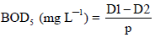

Where: D₁ = DO of diluted sample immediately after preparation (mg/L); D₂ = DO of diluted sample after 5 days incubation at 20 °C (mg/L); P = Decimal volumetric fraction of sample used (mL of the sample taken (201 mL) divided by total volume of the BOD bottle (400 mL).
2.3.6 Determination of chemical oxygen demand (COD)
The amount of chemical oxygen demand was determined according to [6]. The culture tubes and caps were washed with 20 % H₂SO₄ before using to prevent contamination. Then, 2.5 mL of the industrial effluent sample and 1.5 mL of K₂Cr₂O₇ digestion solution were placed in culture tube. Three point five (3.5 mL) of sulphuric acid reagent was carefully ran down inside of vessel so an acid layer is formed under the sample - digestion solution layer and tightly cap tubes or seal ampules and invert each several times to mix completely. The tubes were placed in water bath preheated to 100 °C and refluxed for 3 h. The culture vessels were cooled to room temperature and vessels placed in test tube rack. One to two drops of Ferroin indicator was added and stir rapidly on magnetic stirrer while titrating with standardized 0.10 M ferrous ammonium sulphate (FAS). A sharp colour change from blue - green to reddish brown will appear as end - point, although the blue green may reappear within minutes. In the same manner, a blank containing the reagents and a volume of distilled water equal to that of the sample was refluxed and titrated. The COD is given by:
$$COD (mg O2 /L) = [(A - B) × M × 8,000) / (V sample)$$
Where: A = volume of FAS used for blank (mL); B = volume of FAS used for sample (mL); M = molarity of FAS; 8,000 = milli equivalent weight of oxygen (8) ×1,000 mL/L.
2.3.7 Determination of phosphate
The amount of phosphate was determined using molybdenum blue phosphorous method in conjunction with UV - Visible spectrophotometer according to [6] and as described by [7]. In order to prepare a calibration curve for the standard, 2 mL of the standard solution concentrations of 0.5, 1.0, 1.5, 2.0, 2.5, 3.0 and 3.5 ppm, respectively, 1 mL of ammonium molybdate and 0.4 mL of hydrazine sulphate were added and was made up to the mark with double distilled water in a 10 mL standard volumetric flask. The same procedure above was repeated but with 4 mL of the industrial effluent samples. These were kept for 30 min in a water bath for heating at 60 °C. On heating, a blue colour was observed due to the formation of phosphomolybdate complex and was cooled. The absorbance was measured using UV- Visible Spectrophotometer at 860 nm. Distilled water was used as experimental blank solution. The analysis was carried out in triplicate.
2.3.8 Determination of sulphate
The sulphate concentration was determined according to the standard method of [6] and as described by [8]. The calibration curve was prepared by preparing series of standard solution of sulphate (anhydrous sodium sulphate Na₂SO₄) concentrations (5, 10, 20, 30 and 40 mg/L) by diluting stock solution of sulphate and the blank with distilled water. Reading of each standard was taken on turbidity meter/spectrophotometer and calibration curve was prepared. The industrial effluent sample was filtered through 0.45 μm if there is any turbidity and 20 mL of the water sample was taken in 100 mL conical flask. Then, 1 mL HCl and 1 mL conditioning reagent were added and mixed well for 30 seconds. After 10 minutes, the turbidity was read on turbidity meter and concentration of sulphate in sample was directly found from the curve.
2.3.9 Determination of nitrate
The method of [6] was adopted in nitrate determination. One millilitre of 1 N hydrochloric acid (HCl) solution was added to 50 mL clear filtered sample and mix thoroughly. Nitrate calibration standard curve was prepared in the range of 0 - 7.0 mg/L from 100 mg/L stock solution by diluting to 50 mL the following volumes of working nitrate solution of 0, 1, 2, 4, 7, 20 and 35 mL in 50 mL volumetric flask and 1.0 mL of 1 N HCl solution was added to all the standards and blank made up to mark and mixed thoroughly. Spectrophotometric measurements at wavelengths of 220 nm and 275 nm were set for reading of nitrate. The absorbance was set zero with blank (distilled water + HCl) and then follow by absorbance with all standard solutions and samples. Then, a standard curve was constructed by plotting absorbance due to various nitrate concentrations and blank. For sample and standards calculations, the two times the absorbance reading at 275 nm was subtracted from the absorbance at 220 nm in order to obtain the absorbance due to nitrate. The corrected sample absorbance was used by obtaining directly sample concentrations from standard curve.
2.3.10 Determination of chloride
Chloride was obtained using Argentometric titration method and as described by [9] and [10]. Potassium chromate indicator solution will be prepared by dissolving 50 g K₂CrO₄ in a distilled water and AgNO₃ solution was added until a definite red precipitate was formed. This solution was allowed to stand for 12 h, filtered and diluted to 1 L with distilled water. Then, 2.395 g AgNO₃ was dissolved in distilled water and diluted to 1000 mL and stored in a brown bottle. This is the standard silver nitrate solution. Thereafter, 50 mL of the effluent sample was measured into 250 mL conical flask followed by addition of 1 mL K₂CrO₄ solution (indicator) and will be titrated with AgNO₃ (titrant) to a pinkish yellow end point. The process was repeated for blank using 50 mL of distilled water. The chloride content was determined as follow:
$$Mg Cl-/L = (A - B) × N × 35 × 450$$
$$Volume of sample$$

Where A = mL titration for sample, B = mL titration for blank, N = Normality of AgNO₃
2.3.11 Bacteriological analysis of water
Membrane filtration technique was employed to determine bacteriological quality of the water samples in accordance with American Public Health Association [6]. A sterile filtration apparatus was put in position and connected to a vacuum pump. The apparatus was rinsed by passing small amount of sterile water and the water sample to be analyzed through the funnel using the vacuum pump. The water samples were thoroughly mixed after which one hundred milliliters (100 mL) of it was poured into the funnel containing the filter paper and slowly filtered through the membrane filter with the aid of the vacuum pump. Using sterile forceps, the membrane filters were removed from the filtration cup and transferred facing up on the surface of the Petri dishes containing the named medium for the culture of bacteria of interest. For total coliform counts, the plates were incubated at 37 ºC for 48 hr using Chromocult Agar. After incubation, number of bacterial colonies were enumerated and expressed as colony per 100 mL.

2.4. Identification of chemical constituents
Chemical compounds extracted from different extracts were identified based on GC retention time on HP-5MS column and matching of the spectra with NIST library (Replib and Mainlab data of GC–MS systems) as well as mass spectra patterns available in literature [11].
2.5. Determination of heavy metal content
The heavy metal of the wastewater samples from the different sampling areas was analyzed using atomic absorption spectrophotometer by adopting the method of [6]. The heavy metal contents were determined by digesting duplicate 5 mL of the wastewater using 17.5 mL of concentrated nitric acid (HNO₃) and 12.5 mL of concentrated hydrochloric acid (HCl). This was followed by subsequent heating of the mixture to dryness and making up the volume of the digest to 50 mL using distilled water. The suspension was filtered and filtrate was then analyzed for heavy metals using Atomic Absorption Spectrophotometer (AAS) (FS240AA- Agilent, USA).

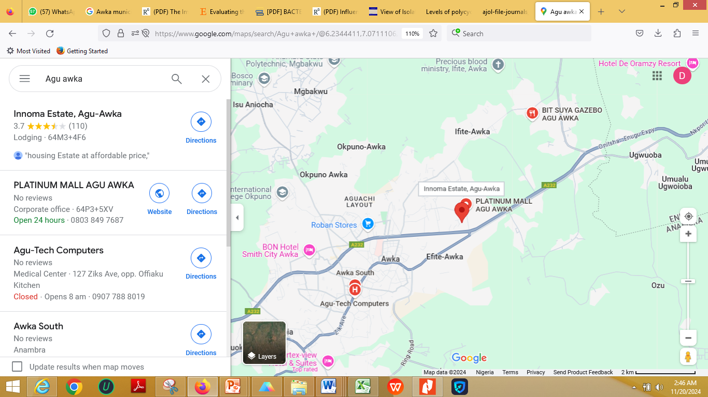
Figure 1: Google map of First Market Ifite – Awka Municipal Dump Site

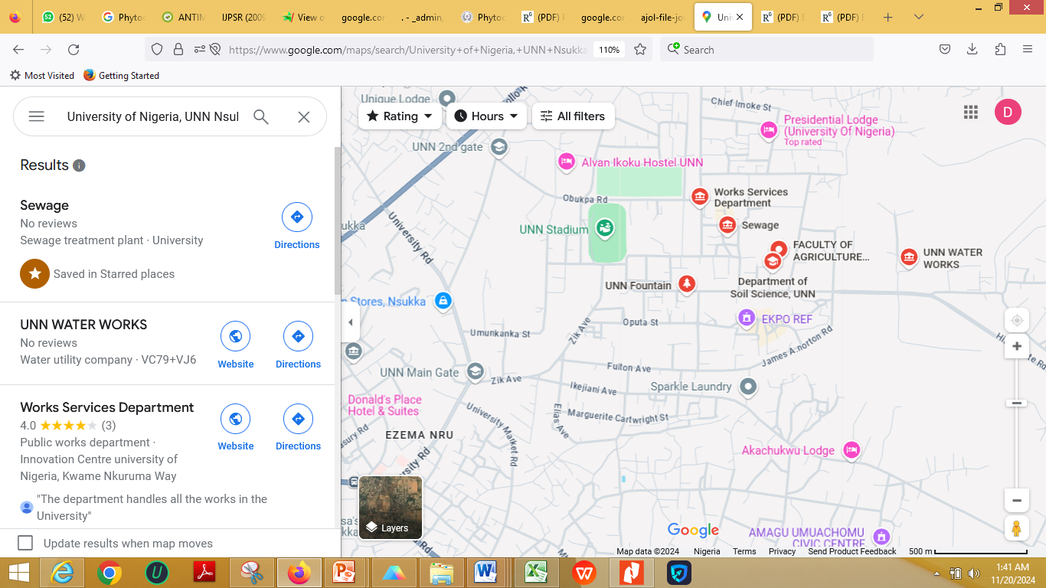
Figure. 2: Google map of University of Nigeria Nsukka sewage treatment plant

3.0 RESULTS AND DISCUSSIONS
3.1 Result of physicochemical profile
Table 1: Physicochemical profile of the sewage and Leachate waste water samples
Sample  Parameter | Sewage wastewater | Leachate  Wastewater | WHO (2004) standard | FEPA (2003) standard
Colour (Unit) | 1,431.82±1.50 | 6,208.33±2.00 | 5.13 | 7.00
Temperature (°C) | 27.73±0.03 | 28.60±0.10 | Ambient | 30.00
pH | 6.90±0.01 | 4.33±0.01 | 6.00 – 9.00 | 6.00 – 9.00
Conductivity (µS/cm) | 1,710.00±0.03 | 680.00±0.10 | 1,250.00 | 1,000.00
TDS (mg/L) | 1,284.50±3.00 | 520.00±1.00 | 2,000.00 | 2,000.00
TSS (mg/L) | 333.00±2.00 | 134.82±1.00 | 30 – 200 | 30
Turbidity (NTU) | 206.38±1.10 | 307.54±1.00 | 5.00 – 10.00 | 10.00
BOD₅ (mg/L) | 156.22±1.10 | 195.52±1.00 | 30.00 – 100.00 | 20.00
COD (mg/L) | 512.40±3.00 | 720.00±6.00 | 250.00 | 80.00 – 100.00
Phosphate (mg/L) | 5.79±0.20 | 7.58±0.10 | 5.00 | 5.00
Sulphate (mg/L) | 80.14±0.12 | 93.83±0.10 | 500.00 | 500.00
Nitrate (mg/mL) | 58.90±0.02 | 69.25±0.20 | 50.00 | 40.00
Chloride (mg/L) | 511.00±0.40 | 472.50±0.20 | 350.00 | 600.00
Colifrom (CFU/100mL) | 124 | 151 | < 1 or 0 | 0
Key: WHO = World Health Organization; FEPA = Federal Environmental Protection Agency; °C = Degree centigrade; µS/cm = Micro Siemen per centimeter; NTU = Nephelometric turbidity unit; mg/L = Milligram per litre; ppm = Part per million, µg/L = Microgram per litre; TDS = Total dissolved solid; TSS = Total suspended solids; CFU = Colony forming Unit; mL = Millilitre
The physicochemical characteristics of the sewage and leachate wastewater samples, as presented in Table 1, provide critical insight into the environmental and public health implications of these effluents when compared to the standards set by the [12] and the Federal Environmental Protection Agency [13].
The sewage wastewater recorded a value of 1,431.82 ± 1.50 colour units, while the leachate wastewater was significantly higher at 6,208.33 ± 2.00 units. Both values greatly exceeded the WHO and FEPA standards of 5.13 and 7.00 units, respectively, suggesting high levels of organic and contamination. The temperature of the sewage (27.73 ± 0.03°C) and leachate (28.60 ± 0.10°C) samples were relatively close to ambient conditions and slightly below the FEPA limit of 30°C, indicating minimal thermal pollution. The pH value of the sewage wastewater was 6.90 ± 0.01, which falls within the acceptable range of 6.00–9.00 set by both WHO and FEPA. However, the leachate exhibited a highly acidic pH of 4.33 ± 0.01, far below the permissible limit, highlighting its potential to alter the pH of receiving water bodies, thereby affecting aquatic life and chemical stability. Electrical conductivity (EC), a measure of ionic concentration, was higher in sewage (1,710.00 ± 0.03 µS/cm) than in leachate (680.00 ± 0.10 µS/cm). Notably, the sewage value exceeded both WHO (1,250.00 µS/cm) and FEPA (1,000.00 µS/cm) thresholds, suggesting a high load of dissolved salts and potential for salinity-related impacts. Similarly, total dissolved solids (TDS) followed the same trend with sewage recording 1,284.50 ± 3.00 mg/L and leachate 520.00 ± 1.00 mg/L, both remaining within the maximum permissible limit of 2,000.00 mg/L. Total suspended solids (TSS) in the sewage wastewater were 333.00 ± 2.00 mg/L, and 134.82 ± 1.00 mg/L in the leachate. The sewage sample notably exceeded both WHO and FEPA guidelines (30–200 mg/L and 30 mg/L, respectively), indicating poor clarity and high particulate matter, which may interfere with light penetration and photosynthetic activity in aquatic ecosystems. Turbidity was considerably high in both samples: 206.38 ± 1.10 NTU for sewage and 307.54 ± 1.00 NTU for leachate, far surpassing the acceptable range of 5.00–10.00 NTU by WHO and 10.00 NTU by FEPA. Such high turbidity values suggest a high presence of colloidal and organic matter, which may harbor pathogens and obstruct water treatment processes. The sewage had a BOD₅ of 156.22 ± 1.10 mg/L and COD of 512.40 ± 3.00 mg/L, while the leachate had higher values of 195.52 ± 1.00 mg/L for BOD₅ and 720.00 ± 6.00 mg/L for COD. These results indicate a heavy organic load and high potential for oxygen depletion in receiving waters, which can be detrimental to aquatic life. The permissible limits for BOD₅ are 30.00–100.00 mg/L (WHO) and 20.00 mg/L (FEPA), while those for COD are 250.00 mg/L (WHO) and 80.00–100.00 mg/L (FEPA), demonstrating substantial exceedances in both effluents. Phosphate and nitrate concentrations in both samples were above WHO and FEPA standards. The leachate had 7.58 ± 0.10 mg/L phosphate and 69.25 ± 0.20 mg/mL nitrate, while sewage recorded 5.79 ± 0.20 mg/L phosphate and 58.90 ± 0.02 mg/mL nitrate. Excessive levels of these nutrients can trigger eutrophication in surface waters, leading to algal blooms and oxygen depletion. Sulphate levels were 80.14 ± 0.12 mg/L for sewage and 93.83 ± 0.10 mg/L for leachate, which were well within the acceptable limits of 500.00 mg/L (both WHO and FEPA). Similarly, chloride concentrations of 511.00 ± 0.40 mg/L in sewage and 472.50 ± 0.20 mg/L in leachate were below the FEPA limit of 600.00 mg/L but exceeded the WHO threshold of 350.00 mg/L, indicating a potential for salinity issues, particularly in the sewage sample.

3.2 Result of heavy metal analysis
Table 2: Heavy metal profile of sewage and leachate waste water samples
Metal (mg/L) | Sewage waste water | Leachate waste water | FEPA (2003) standard
Cadmium | 0.100±0.01 | 0.121±0.02 | 0.05
Chromiun | 0.100±0.00 | 0.065±0.56 | 0.01
Lead | 0.836±0.07 | 0.648±0.05 | 0.02
Copper | 2.930±0.01 | 1.648±0.94 | 0.01
Arsenic | 0.084±0.01 | 0.065±0.02 | 0.05
Key: FEPA = Federal Environmental Protection Agency; mg/L = Milligram per litre
The heavy metal composition of the sewage and leachate wastewater samples as presented in Table 2 reveals concerning levels of toxic elements when compared to the Federal Environmental Protection Agency [14] permissible discharge limits. The metals assessed include cadmium, chromium, lead, copper, and arsenic all known for their toxicity, persistence in the environment, and bioaccumulative potential. Cadmium (Cd) concentration in the sewage wastewater was 0.100 ± 0.01 mg/L, while the leachate wastewater had a slightly higher concentration of 0.121 ± 0.02 mg/L. Both values are more than double the FEPA maximum allowable limit of 0.05 mg/L. Cadmium is highly toxic even at low concentrations and is associated with kidney damage, bone demineralization, and various forms of cancer. Its elevated levels in both effluents suggest the presence of industrial or battery-related contaminants. Chromium (Cr) levels were 0.100 ± 0.00 mg/L in sewage and 0.065 ± 0.56 mg/L in leachate wastewater. These values also significantly surpass the FEPA limit of 0.01 mg/L, indicating contamination possibly from tanning, metal plating, or dyeing industries. Chromium, especially in its hexavalent form (Cr⁶⁺), is a known carcinogen and poses severe health risks upon prolonged exposure [17]. Lead (Pb) concentrations were alarmingly high in both wastewater types. The sewage sample recorded 0.836 ± 0.07 mg/L, and the leachate sample had 0.648 ± 0.05 mg/L. These levels are drastically higher than the FEPA guideline value of 0.02 mg/L. Lead is a well-documented neurotoxin, particularly harmful to children, and can also cause reproductive and cardiovascular effects in adults. The high presence of lead in the wastewater implies contamination from paints, pipes, batteries, or industrial waste. Copper (Cu) concentrations followed a similar trend, with the sewage sample showing a remarkably high value of 2.930 ± 0.01 mg/L and the leachate recording 1.648 ± 0.94 mg/L. Both values exceed the FEPA limit of 0.01 mg/L by a substantial margin. Although copper is an essential trace element, excessive concentrations can cause gastrointestinal distress, liver and kidney damage, and harm aquatic life due to bioaccumulation. Arsenic (As) levels were also above the permissible limit of 0.05 mg/L, with sewage wastewater containing 0.084 ± 0.01 mg/L and leachate wastewater at 0.065 ± 0.02 mg/L. Arsenic is a highly toxic metalloid known for its carcinogenic properties and links to skin lesions, developmental effects, and cardiovascular diseases. Its elevated presence points to possible contributions from pesticide residues, industrial discharges, or leachates from contaminated soils [15], [16].
3.3 Result of GC analysis of sewage wastewater
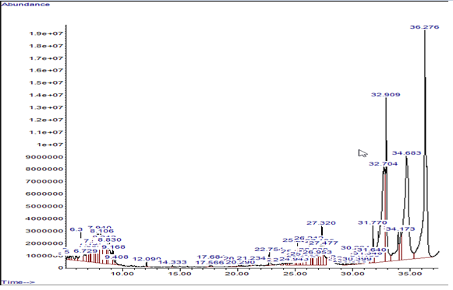
Figure 3: Gas chromatographic mass spectral profile of the sewage wastewater
Key: 1. 4-Heptafluorobutyryloxyhexadecane; 2. 3-Tridecene, (Z)-; 3. Benzene, 1-ethyl-3-methyl-; 4. Benzene, 1, 2, 3-trimethyl-; 5. Cycloheptane, methyl-; 6. Decane; 7. 5-Eicosene, (E)-; 8. Decyloctyl ether; 9. Dichloroacetic acid, 2-pentadecyl ester; 10. 4-Propylcyclohexanone; 11. 1-Fluorononane; 12. Cyanoacetic acid, tetradecyl ester; 13. Naphthalene, decahydro-, trans- 14. Decane, 1-fluoro-; 15. 2-Trifluoroacetoxytridecane; 16. Oxalic acid, allylundecyl ester; 17. Cycloheptane, methyl-; 18. Pentadec-7-ene, 7-bromomethyl-; 19. Carbonic acid, nonyl prop-1-en-2-y-l-ester; 20. Trans-4a-Methyl-decahydronaphthalene; 21. Dodecane; 22. Carbonic acid, eicosyl vinyl ester; 23. 2-Heptenal, (E)-; 24. Tetradecane; 25. 1,3-Propanediol, dodecyl ethyl ether; 26. 1-Heptanol, 2-propyl-; 27. 10-Methylnonadecane; 28. Hexadecane; 29. Epinephrine; 30. Tetrapentacontane, 1,5 - 4-dibromo-; 31. Decanoic acid, 2-propenyl ester; 32. Z-(13,14-Epoxy)tetradec-11-en-1-ol acetate; 33. Dodecane, 2-methyl-; 34. 2-methyloctacosane; 35. Oxalic acid, 3,5-difluorophenyl tetradecyl ester; 36. Octyltetracosyl ether; 37. Estra-1,3,5(10)-trien-17.beta.-ol; 38. Eicosane; 39. Dotriacontane, 1-iodo-; 40. Octadecanesulphonyl chloride; 41. 2-Methylhexacosane; 42. Heptadecane, 3-methyl-; 43. 1-Octadecene; 44. Pentadecane; 45. Cyclohexadecane; 46. Heneicosane, 11-pentyl-; 47. Octacosane; 48. 7,9-Di-tert-butyl-1-oxaspiro(4,5)d eca-6,9-diene-2,8-dione; 49. Nonane, 5-butyl-; 50. Dibutyl phthalate; 51. Pentafluoropropionic acid, pentadecyl ester; 52. E-15-Heptadecenal; 53. Cyclotetradecane, 1,7,11-trimethyl-4-(1-methylethyl)-; 54. Triacontane, 1-bromo-; 55. Tert-Hexadecanethiol; 56. 1-Docosene; 57. Palmitoleic acid; 58. Carbonic acid, but-2-yn-1-yl eicosyl ester 59. Diisooctyl phthalate; 60. Cyclohexane, 1-(1,5-dimethylhexyl)-4-(4-methylpentyl)-; 61. 9-Octadecenoic acid (Z)-, 2,3-dihydroxypropyl ester; 62. Squalene

The result of the gas chromatographic (GC-MS) analysis of the sewage wastewater, as shown in Figure 3, reveals a complex chemical profile consisting of diverse organic compounds, detected at varying retention times and abundances. This chromatogram highlights the presence of a wide range of volatile and semi-volatile organic pollutants, many of which are associated with anthropogenic activities such as industrial discharges, domestic waste inputs, and pharmaceuticals. The peaks observed in the chromatogram correspond to specific compounds identified in the sewage sample. The high-intensity peaks at retention times 32.909, 34.683, and 36.276 minutes suggest that certain compounds are present in high abundance, potentially indicating their persistence or continuous input into the sewage stream. The identified compounds, totaling over 60, span multiple chemical classes including alkanes, esters, aromatic hydrocarbons, phthalates, alcohols, acids, and steroidal compounds. Compounds such as 4-heptafluorobutyryloxyhexadecane, dibutyl phthalate, and diisooctyl phthalate point to industrial and plastic-related pollution, known for their endocrine-disrupting properties and environmental persistence [18], [19]. The detection of benzene derivatives (e.g., benzene, 1-ethyl-3-methyl-; benzene, 1,2,3-trimethyl-) is indicative of petroleum-based contamination, while compounds like epinephrine suggest pharmaceutical or hospital effluent contributions. The presence of polycyclic structures such as decahydronaphthalene and squalene reflects potential contamination from cosmetics or oil-based substances. Aliphatic hydrocarbons such as hexadecane, eicosane, dotriacontane, and triacontane are typical of petroleum products and can accumulate in aquatic sediments, affecting benthic organisms. The chromatogram shows a series of minor peaks between 5 to 30 minutes, indicating the presence of less abundant but still significant compounds such as methylated alkanes, esters of oxalic and carbonic acids, and aromatic ethers, many of which are environmentally persistent and potentially bioaccumulative [20], [21].

3.4 Result of GC analysis of Leachate wastewater
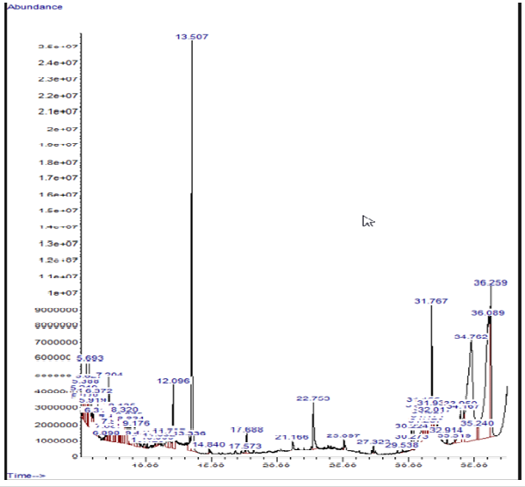
Figure 4: Gas chromatographic mass spectral profile of the leachate wastewater before treatment
Key:Z-10-Pentadecen-1-ol; 2. 3-Trifluoroacetoxytetradecane; 3. Dimethylmalonic acid, tridecyl - 2, 3, 4-trifluorophenyl ester; 4. Benzene, 1-ethyl-3-methyl-; 5. Cyclopropane, nonyl-; 6. Benzene, 1-ethyl-3-methyl-; 7. Cyclohexane, 1,3-dimethyl-, trans-; 8. Benzene, 1,2,3-trimethyl-; 9. Carbonic acid, decyl prop-1-en-2-y-l- ester; 10. 3-Heptafluorobutyroxydodecane; 11. Chloroacetic acid, 3-tridecyl ester; 12. 1-Octadecene; 13. Eucalyptol; 14. Acetic acid, 3,7,11,15-tetramethyl--hexadecyl ester; 15. 1,3-Cyclohexanediamine; 16. Cetene; 17. E-2-Octadecadecen-1-ol; 18. Silane, trichlorodocosyl-; 19. 17-Pentatriacontene; 20. Benzene, 4-ethyl-1,2-dimethyl; 21. Oxalic acid, cyclobutylheptadecyl ester; 22. Carbonic acid, decylnonyl ester; 23. ,4-Dimethyl-1,5-diazabicyclo[3.1.0]hexane (cis) 24. 3-Heptafluorobutyroxypentadecane; 25. 2,2-Dimethyl-4,6-dioxo-5-(O-phenylendiamin-N-methylidene)-1,3-dioxan; 26. Carbonic acid, decyl prop-1-en-2-y-l ester; 27. 1-Methyldecahydronaphthalene; 28. Bicyclo[3.1.1]heptane, 2,6,6-trimethyl-, [1R-(1.alpha.,2.alpha.,5.al pha.)]-; 29. 2-Octenal, (E)-; 30. 1H-Indene, 2,3-dihydro-5-methyl-; 31. Cyclohexanone, 5-methyl-2-(1-methylethyl)-, cis-; 32. Docosylnonyl ether; 33. Octane, 5-ethyl-2-methyl-; 33. Bicyclo[3.1.0]hexan-2-one, 5-(1-methylethyl)-; 34. 4-Heptafluorobutyryloxyhexadecane; 35. Tridecane; 36. 37. Pulegone; 38. D-Carvone; 39. Cyclohexanol, 5-methyl-2-(1-methyl ethyl)-, acetate; 40. Cyclotetradecane; 41. 2,4-Di-tert-butylphenol; 42. Heptadecane; 43. Tridecane, 6-propyl; 44. Octadecane; 45. Hexadecanoic acid, methyl ester; 46. 1-Docosene; 47. Carbonic acid, hexadecyl prop-1-en-2-yl ester; 48. Triacontyl acetate; 49. Heptadecyl acetate; 50. Trans-13-Octadecenoic acid; 51. cis-Vaccenic acid; 52. 11-Octadecenoic acid, methyl ester; 53. Oleic Acid; 54. 2-Piperidinone, N-[4-bromo-n-butyl]- 55. 1-Eicosene; 56. Chloropropionic acid, hexadecyl ester; 57. 1-Nonadecene; 58. Trichloroacetic acid, hexadecyl ester; 59. 2-Piperidinone, N-[4-bromo-n-butyl]; 60. Cyclotetracosane; 61. 9-Octadecenoic acid (Z)-, 2-hydroxy-1-(hydroxymethyl) ethyl ester 62. Bis(2-ethylhexyl) phthalate; 63. 17-Pentatriacontene; 64. n-Propyl 11-octadecenoate; 65. 2-Methyl-Z,Z-3,13-octadecadienol; 66. Pyridine-3-carboxamide, oxime, N-2-trifluoromethylphenyl)-

The result of the gas chromatographic mass spectral (GC-MS) analysis of the leachate wastewater sample, as shown in Figure 4, illustrates the complex chemical fingerprint of untreated landfill leachate. The chromatogram displays several well-defined peaks across a broad range of retention times, with major abundance spikes occurring at 13.507 min, 31.767 min, 36.089 min, and 36.259 min. These peaks suggest the presence of high concentrations of certain organic compounds. The GC-MS profile reveals the presence of over 60 distinct chemical compounds, spanning various classes including alcohols, esters, alkanes, aromatic hydrocarbons, phthalates, ketones, silanes, and cyclic hydrocarbons, all of which are typically associated with municipal solid waste decomposition and industrial runoff. A significant compound detected is Z-10-Pentadecen-1-ol, an unsaturated alcohol often derived from fatty acid degradation. Other notable constituents include dimethylmalonic acid, tridecyl ester and 3-trifluoroacetoxytetradecane, indicating fluorinated organic pollutants, which are environmentally persistent and can pose challenges in degradation and treatment. The presence of benzene derivatives such as benzene, 1-ethyl-3-methyl- and benzene, 1,2,3-trimethyl- at early retention times is indicative of aromatic hydrocarbon contamination, commonly linked to petrochemical and plastic wastes [22], [23]. Cyclopropane and cyclohexane derivatives, including cyclohexanol, 5-methyl-2-(1-methylethyl)-acetate, are products of synthetic chemical processing and may exhibit toxic effects in aquatic organisms. Various esters of carbonic, acetic, chloroacetic, and oxalic acids, including carbonic acid, decyl prop-1-en-2-yl ester, chloroacetic acid, 3-tridecyl ester, and oxalic acid, cyclobutylheptadecyl ester were also detected. These esters may originate from plasticizers, lubricants, or surfactant breakdown and pose potential risks to ecosystems through bioaccumulation [16]. Steroidal and biologically active compounds such as D-carvone, pulegone, and 1H-indene derivatives were also present, suggesting input from pharmaceutical or cosmetic residues. The chromatogram revealed the presence of saturated and unsaturated hydrocarbons such as heptadecane, tridecane, octadecane, 1-docosene, and 1-nonadecene, reflecting contamination from petroleum-based sources or industrial solvents. The presence of fatty acids and their esters, including cis-vaccenic acid, trans-13-octadecenoic acid, oleic acid, methyl esters of octadecenoic and hexadecanoic acids, point to organic waste degradation products commonly found in food waste or lipid-containing effluents [23], [24]. Compounds such as bis(2-ethylhexyl) phthalate and trichloroacetic acid, hexadecyl ester are notable for their toxicity and endocrine-disrupting potential, often originating from plastic leaching and industrial additives. Late retention time peaks also show triacontyl acetate, cyclotetracosane, and n-propyl 11-octadecenoate, which are long-chain hydrocarbons and esters with low biodegradability, raising environmental concerns due to their tendency to accumulate in sediments and biota [25], [26].
4.0 CONCLUSION
The comprehensive analysis of sewage and leachate wastewater samples from the University of Nigeria Nsukka and First Market Municipal Dumpsite in Awka revealed significant environmental and health concerns. Physicochemical parameters such as colour, turbidity, BOD₅, COD, and heavy metals (lead, cadmium, chromium, arsenic, and copper) all exceeded WHO and FEPA permissible limits, indicating poor effluent quality. The pH of the leachate showed high acidity, which can disrupt aquatic ecosystems. Gas chromatographic analysis further identified over 60 organic pollutants, including phthalates, alkanes, esters, and aromatic hydrocarbons, many of which are known for their toxicity, persistence, and potential to bioaccumulate. The diversity and abundance of these compounds reflect inputs from industrial, pharmaceutical, and municipal sources. These findings reveals the urgent need for effective pre-disposal treatment of such wastewaters. Without intervention, continued discharge poses serious risks to public health, agriculture, and aquatic life, emphasizing the necessity for strict regulatory enforcement and sustainable waste management practices.

COMPETING INTEREST
Authors declared no competing interests exists.
REFERENCES
[1] Akharame, M.O., Ofomata, R.C. and Olorunfemi, D.I. (2017). Physicochemical parameters and heavy metals assessment of effluent discharges from some industriesin Benin City, Nigeria. African Scientist, 18 (3): 183 – 187.
[2] Okereke, J.N., Ogidi, O.I. and Obasi, K.O. (2016). Environmental and health impact of industrial.
[3] Ezurike, C.0., Ogbuagu, J. O, Okakpu, J. O, and Okeke, A.P. (2025). “Assessment of Borehole Water Quality and Health Risks in Enugu North Local Government Area, Nigeria”. International Research Journal of Pure and Applied Chemistry 26 (4):55-76. https://doi.org/10.9734/irjpac/2025/v26i4928.
[4] Uba, B.O. (2019). Phylogenetic framework and metabolic genes expression analysis of bacteria isolated from contaminated marine environments of Niger Delta. Annual Research and Review in Biology, 30 (5): 1 – 16.
[5] Singh, P., Srivastava, N. and Singh, P. (2017). Analysis of various iron nanoparticles and compounds in pulp and paper millwaste water treatment. Integrated Research Advances, 4 (2): 24 - 28.
[6] APHA (2012). Standard Methods for Examination of Water and Wastewater. 22ndedn. American Public Health Association, Washington, DC, USA. P. 1360.
[7] Princewill, O. A.; Okechukwu, O. J.; Uche, A. R.; Stellamaris, O. A. (2024). Phthalate Esters in Water and Surface Sediments of Anambra River in Dry Season: Distribution and Human Health Risks Assessment. Journal of Global Ecology and Environment, [S. l.], v. 20, n. 4, p. 52–65, 2024. DOI: 10.56557/jogee/2024/v20i48886.
[8] Sharma, Y. and Kaur, K. (2016). Determination of nitrates and sulphates in water of Barnala (Punjab, India) region and their harmful effects on human lives. International Journal of Advanced Research in Education and Technology, 3 (3): 79 – 82.
[9] American Public Health Association (1998). Standard methods for the examination of water and waste water. 20th edition. American Public Health Association, Washington, P.1134. analysis of the water parameters quality of sewage treatment plant after rehabilitation. Journal of Computer Engineering, 16 (1): 81 – 91.
[10] Ogbuagu, J.O., Okeke, A.P., Ogbuagu A.S., Anyanwu, A.P. and Anyanwu, C.F (2024). Quality Characteristics of Groundwater Within Hostels in Nnamdi Azikiwe University, Awka. Iconic Research Engineering Journals, 8(4): 552-559.
[11] Okwuchukwu, O.E., Ekpunobi, U.E., Ekeoma, M., and Okeke, A.P. (2025). “Copper Ion Adsorption in Waste Water Using Silver Metal Nanocomposite from Avocado Pear Seed”. Asian Journal of Applied Chemistry Research 16 (1):34-47. https://doi.org/10.9734/ajacr/2025/v16i1318.
[12] World Health Organization. (2004). Guidelines for drinking-water quality (Vol. 1). World health organization.
[13] Onozeyi, D. B. (2013). Assessment of some physico-chemical parameters of River Ogun (Abeokuta, Ogun State, Southwestern Nigeria) in comparison with national and international standards. International Journal of Aquaculture, 3(15), 79-84.
[14] FEPA, (2003): Guideline and Standards for Environmental Pollution and Control in Nigeria. Federal Environmental Protection Agency, Nigeria.
[15] Oka, O.K., E.N Ojiako., A.P. Okeke, and E.N. Anagbogu. (2025). “Characterization and Risk Assessment of Heavy Metals and Hydrocarbon Sludge in the Nsisioken Environment, Rivers State Nigeria”. Journal of Global Ecology and Environment 21 (3):110-23. https://doi.org/10.56557/jogee/2025/v21i39392.
[16] Princewill, O. A.; Okechukwu, O. J.; Uche, A. R.; Stellamaris, O. A. (2024). Phthalate Esters in Water and Surface Sediments of Anambra River in Dry Season: Distribution and Human Health Risks Assessment. Journal of Global Ecology and Environment, [S. l.], v. 20, n. 4, p. 52–65, 2024. DOI: 10.56557/jogee/2024/v20i48886.
[17] Vasantharaj S. Ahmed Z., Vink P., Al-mulhu N., Subash M. Gopinath K., Kavitha C., (2021), Enhanced photocatalytic degradation of water pollutants using bio-green synthesis of zinc oxide nanoparticles (ZnO NPs). J. Environ Chem. Eng. wastewater effluents in Nigeria- A review. International Journal of Advanced Research and Biological Sciences, 3 (6): 55-67.
[18] Fouda, A., Hassan, S.E., Abdel-Rahman, M.A., Farag, M.S.A., Shehbel-deen, A.M., Mohamed, A.A., Alsharif, S.M., Saied,E., Moghannem, S.A.M. and Azab, M.S. (2021a). Catalytic degradation of wastewater from textile and tannery industry by green synthesized hematite (α-Fe2O3) / magnesium oxide (MgO) nanoparticles. Current Research in Biotechnology.doi: https://doi.org/10.1016/j.crbiot.2021.01.004.
[19] Fouda, A., Hassan, S.E., Abdel-Rahman, M.A., Farag, M.S.A., Shehbel-deen, A.M., Mohamed, A.A., Alsharif, S.M., Saied,E., Moghannem, S.A.M. and Azab, M.S. (2021a). Catalytic degradation of wastewater from textile and tannery industry by green synthesized hematite (α-Fe2O3) / magnesium oxide (MgO) nanoparticles. Current Research in Biotechnology.doi: https://doi.org/10.1016/j.crbiot.2021.01.004.
[20] Dokubo, C. U. and Uba, B. O. (2023). Assessment of the Decontamination and Disinfecting Potentials of O. gratissimum Synthesized Silver Nanoparticles on Water and Wastewater Samples. IPS Journal of Public Health, 3(2), 58–65.
[21] Fouda, A., Hassan, S.E., Saied, E. and Hamza, M.F. (2021b). Photocatalytic degradation of real textile and tannery effluent using biosynthesized magnesium oxide nanoparticles (MgO-NPs), heavy metal adsorption, phytotoxicity, and antimicrobial activity. Journal of Environmental Chemical Engineering,9: 105346.
[22] Manikandan, P., Palanisamy, P.N., Baskar, R., Sivakumar, P. and Sakthisharmila, P. (2015). Physico-chemical analysis of textile industrial effluentsfrom Tirupur city, TN, India. International Journal of Advanced Research in Science and Engineering, 4 (2):93 – 104.
[23] Prabhakar, R., Ranjan, S. and Jyotsana, S. (2017). Aquatic and terrestrial weed mediated synthesis of iron nanoparticles for possible application in wastewater remediation. Journal of Cleaner Production, 168: 1201 – 1210.
[24] Uba BO, Obiefuna GO (2023). Aerobically enhanced nanobioremediation of diesel oil contaminated soil and water using mycosynthesized silver nanoparticle as biostimulating agent. Science World Journal 18 (1): 75 – 82.
[25] Turki, N., Elghniji, K., Belhaj, D. and Bouzid, J. (2014). Effective degradation and detoxiﬁcation of landﬁll leachates using a new combination process of coagulation/ﬂocculation-Fenton and powder zeolite adsorption. Desalination and Water Treatment, 2014: 1–12.doi: 10.1080/19443994.2014.912590.
[26] Tortaja C. (2020) Contributions of recycles wastewater to clean water and sanitation sustainable Developments Goals, Nanoparticles clean water 2020, 3, 22 (Google Scholar) (Cross Red).

