Effect of Temperature and pH on the Utilization of Agro Wastes for Biogas Production

ABSTRACT
Biomass and wastes are increasingly being utilized as major energy sources not only in Nigeria, but globally. Different wastes/biomass to energy technologies have been used in the past by several researchers but anaerobic digestion seems to be the best option owing to its eco-friendliness, low cost and simplicity of its design. The work evaluated the effect of temperature and pH on the utilization of agro wastes (pig dung, goat dung, cassava peels and vegetable wastes) for biogas production using anaerobic digestion. The slurry was created in a digester by combining wastes and water in a 2:1 ratio. Under regulated environmental conditions, the anaerobic process was batched with a retention time of 21 days. On a weekly basis for three weeks, the total viable counts obtained were 8.7 × 10⁷ CFU/mL, 2.64 × 10⁷ CFU/mL, and 1.34 × 10⁷ CFU/mL. As acid was created by the bacteria in the digester, the pH dropped from 7.84 to 5.53. The average amount of gas observed from the setup ranged from 1.7 cm³ to 23.3 cm³. According to the results, there was no biogas production on days 0, 1, and 2, with the lowest gas production on day 4 and the highest increased volume of production (23.3 cm³) was observed on day 21. Statistical analysis utilizing one-way ANOVA revealed a significant difference of p < 0.05 between the biogas produced and experiment duration. The study demonstrates that agricultural wastes have great promise for the cost-effective production of biogas, emphasizing the importance of utilizing this medium to improve energy output.

- INTRODUCTION
Today’s societies demand the existence of continuous, sustainable and economic energy necessary for any economic development and growth. This demand finds its response in the use of renewable energies. Since the beginning of industrial development, human activities have contributes considerably to the increase in the concentration of Greenhouse gases (GHG) in the atmosphere [1]. The breeding sector like the animal husbandry (cattle ranch, pig manure, goat manure), and organic solid wastes are major contributors to the emission of GHG [2]. However, these environmental wastes can be converted into a form of renewable energy source, through production of biogas. Biogas is a source of renewable energy, similar to solar, wind and geothermal energy [3]. Biogas production is an excellent way to utilize organic wastes in energy production, and it is a promising renewable energy carrier because its production process combines the eradication of biological wastes with the synthesis of a versatile, low cost and environmentally friendly energy "methane" [4; 5]. As a wealth to energy technology, anaerobic digestion involves the breakdown of organic wastes through the activities of microorganisms in the absence of oxygen leading to the production of methane, carbon dioxide, as well as traces of other gases such as hydrogen, nitrogen, oxygen, ammonia and moisture [6,7,8]. Production of biogas through anaerobic digestion of animal manure and slurries as well as of a wide range of digestible organic wastes, converts these substrates into renewable energy. Furthermore, nutrients are preserved during the anaerobic digestion process, making the digestion waste appropriate as an organic fertilizer that can replace fossil energy-requiring mineral fertilizers [9]. Anaerobic digestion for full-scale biogas production has been in operation for many years [10; 11; 12], but many technological and microbiological concerns remain unanswered in order to achieve an economically viable process.

Co-digestion is the simultaneous digestion of more than one form of waste in the same unit with the aim of biogas production. Co-digestion of different materials may enhance the anaerobic digestion process due to better carbon and nutrient balance [13]. According to [14], co-digestion of more than one substrate in the same unit can establish positive synergism in biogas production and the added nutrients for microbial enrichment and growth. Furthermore, this method is currently growing to incorporate energy and nutrient recovery and the manufacture of value-added compounds via mixed culture biotechnologies [15; 16; 17].
Rapid digestion and efficient biogas production occur within limited ranges of temperature, pH, moisture, and are influenced by the composition of the raw material [18]. Optimum gas production occurs in two temperature ranges; mesophilic bacteria thrive in temperature around 35 ºC, while thermophilic bacteria thrive well in the 49 ºC to 60 ºC range [3]. Figure 2 shows that gas production decreases when the bacteria are subjected to temperatures outside of these ranges. While thermophilic bacteria produce somewhat more gas, often the gas is not worth the energy needed to raise the digester temperature from 35 ºC to 49 ºC [16]. Bacteria also thrive in a slurry with a pH around 6.8 to 7.2 and the pH of raw materials poured into the digester depends on the type of organic material [19]. Consequently, if the incoming slurry has a pH in this range, digestion should proceed smoothly. Under normal conditions, the digestion process balances excess acidity or alkalinity on its own [20; 21]. An adult pig produces around 5 kg of manure every day, comprising 90 % water and 7 % volatile solids, which can produce 4.8 cubic feet of biogas daily [22]. It is not advisable to use pig dung alone because it has high nitrogen content and low amounts of carbon, and also very alkaline. In other words, it can inhibit the growth of methane-producing bacteria [5; 8; 23;]. Methanogens prefer acidic conditions. However, one can improve pig manure biogas production by mixing it with goat dung or agro wastes as biomass. Hence, this study evaluated the effect of temperature and pH on the effectiveness of co-digestion of agricultural wastes for biogas production.

2. MATERIALS AND METHODS
2.1 Study Area

The research was conducted at the Microbiology Laboratory of Chukwuemeka Odumegwu Ojukwu University, Uli Campus, Anambra State, Nigeria. Uli is located in Southeastern part of Nigerian rainforest, with a tropical environment and mean daily temperature of 28 to 40 ºC during the majority of the year. The annual rainfall ranges from 210 to 2350 mm, with distinct wet and dry seasons in each district. Between July and August, the area has the greatest food supplies.
2.2 Sample Collection

Fresh pig and goat dungs were obtained from Vester Farms Eziama, Uli while the vegetable wastes were obtained from the school market in Umuoma Village, Uli. The samples were collected using a sterile polyethylene bag. Following collection, the vegetable wastes were chopped into smaller pieces and air-dried for two weeks. Cassava peels and vegetable debris (consisting of carrot, cabbage, pumpkin leaves and water leaf) were blended in a 2:1 ratio. The idea called for combining materials with high-caloric contents. The vegetable wastes were pulverized with a grinder, while the fresh pig and goat dung were mixed individually with water. The combination of pig and goat dungs acted as an inoculum since it contained the necessary microbes for the anaerobic digestion of organic wastes.

Based on the experimental design, 1 kg of each of the waste samples were weighed, then placed in 9 litres of water, and emptied into the digester. It was outfitted with a pH probe and a thermometer to measure pH and temperature. Following that, the digesters were placed in a remote location to produce biogas for a 21-day digestion period.
2.3 Fabrication and description of the digester for biogas production

A portable 25 kg slurry capacity digester was fabricated using dispenser gallon, rubber strip and a hose pipe tube with a diameter of 0.8 cm. A hole was made in the cap, and the valves were inserted. The hose pipe tube was then installed to conceal the valves' exit. A rubber strip was used to tighten the tube. The digesters were supplied by opening the digester covers, and the remainder was evacuated by the digester's outlet device at the bottom. A manufactured biogas burner was used to test the flammability of the gas in the digester. Biogas production was measured by the water displacement method.

A  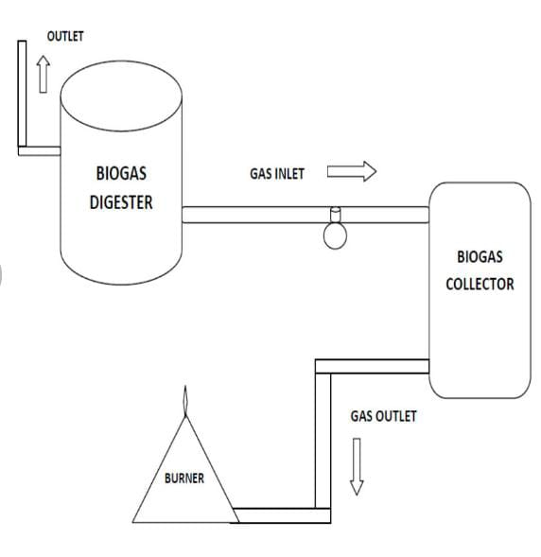 | B  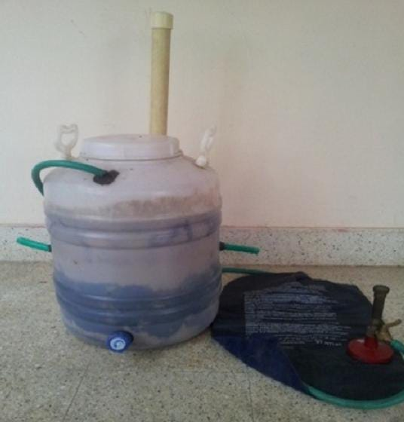

Figure 1: Block diagram of the bio-digester [A] and portable bio-digester [B]
Source: Prakash (2016)

2.4 Experimental design

A modified approach of [24] was used for the experiment. Biogas was produced in a batch technique, with the slurry added once in the digester for the duration of the process. The fermenter was fed 1 kg of Pig dung, 1 kg of Goat dung, 1 kg of vegetable wastes and 1 kg of cassava peels mixed with water in a 2:1 water-to-waste ratio in this combined wastes experiment. Feeding, gas collection, and residue-draining arrangements have been designed for the digester. The slurry fermented anaerobically for 21 days at a mesophilic temperature of 26 – 35 ºC.

2.5 Measurement of biogas produced
Biogas was measured using Gas Chromatography-Flame Ionization Detector (AOAC, 1995). The GC used in this study was produced from Buck Scientific (M910, USA) equipped with FID detector and capillary column (Elite-5, 30m*0.25mm*0.25μm). The workstation was Total Chrom Navigator used for data processing. The temperature for column chamber, inlet chamber and detector were 150 ºC, 200 ºC and 250 ºC, respectively. High purity nitrogen was used for carrier gas in this study, and the flow rate for nitrogen was 2.0 mL/min. The split ratio of gas sample in inlet chamber was 20:1, which is used to control the amount of biogas flew into column, and prevent the unconventional peak, such as flat peak, trailing peak. The flow rate was 450 mL/min for air produced by automatic air source (BCHP, SPB-300, China) and 45mL/min for hydrogen produced by hydrogen gas.
The % of each gas produced = concentration of each gas produced (ppm) x 100
Total concentration of the gas produced (ppm)

2.6 Isolation and identification of microorganisms present in the slurry

2.6.1 Sample collection

The procedure described in [25] was adopted. The substrates charged inside the digesters were collected separately using a sterile beaker through the digester arm.

2.6.2 Bacteriological examination

Total viable counts (TVC) for the slurry was performed to determine the microbial load of the samples using the modified Miles and Misra method described by [2]. This was done three times during the digestion: at the charging point (day 1), at the peak of output (day 14), and at the end of the retention period (day 21). After 24 hours of incubation at 37 ºC, visible colonies were counted and total bacterial counts were determined.
2.6.3 Determination of pH and Temperature

The pH of the slurry was determined using the modified method as described by [26]. The slurry pH was determined electrometrically using a digital pH meter whereas temperature was evaluated by a handheld thermometer at a 2-day interval.

3. RESULTS AND DISCUSSION
3.1 Bacteriological analysis

Table 1 shows the result of the total viable count recorded at weekly intervals for three weeks during the digestion period.
Digestion period | TVC (cfu/mL)
Week 1  Charging point | 8.7 × 10⁷
Week 2  Flammability and  production peak point | 26.4 × 10⁷
Week 3  Production end period | 13.4 × 10⁷
Table 1: Total viable count (TVC) during biogas production

It was observed that the plate count was at the lowest during the first week (8.7 x10⁷ cfu/mL) while the highest plate count was observed at the second week (2.64 x 10⁷ cfu/mL). There was, however, a decline in the viable count during the third week, this may be an indicator of the death phase for the microbes. This result conforms with the findings of [23], who recorded that microbial load was low during the charging period, increased towards the peak of production, and reduced towards the end of the retention period. The decrease in count towards the peak could be as result of the decrease observed in the pH of the slurry.

3.2 pH and temperature results

The pH of the slurries was recorded on a 2-day intervals starting from day 0 as presented in Figure 1 and result showed a decline in pH as digestion progressed.

Figure 2: Temperature and pH profile of the slurry during digestion
This decrease may be as a result of acids (mostly amino and fatty acids) production by the anaerobic microorganisms in the digesters. This is in agreement with the work of [20], who studied the pH variation in an anaerobic digestion process for 21-days, and [27] in their study on co-digestion of food waste with cow dung by anaerobic digestion for biogas production. From the work of [28], the low pH of the digester has an inhibiting effect on the microorganisms that are part of the digestive process, particularly the methanogenic bacteria. The results obtained from this study further conforms with the research of [29], where the pH has an effect on the activity of the bacteria that are responsible for converting organic matter into biogas. Similarly, [20] reported that
An increase in temperature from a minimum range of 15 to maximum of 26.2 ºC was recorded at the pH of 5.33 – 7.84. It was observed that on day 0, the temperature was at 15 ºC, then 24.5 ºC on day 2, with a gradual increase recorded from day 4 until stability was observed as the experiment progressed with an observable increase in the volume of biogas produced (Figure 2). This shows that mesophilic temperature of 20 ºC to 45ºC favours biogas production. Ukpaka et al. [21] opined that
3.3 Production of biogas
The anaerobic process of biogas production was batched with a retention period of 21 days and the cumulative biogas production in this study is shown in Figure 3.

Figure 3: Volume of biogas produced against time
From the result, it was observed that there was a delay in biogas production from day 0 ─ 3, until a gradual production was observed on the fourth day. This delay in gas production according to the findings of [30] and [31] can be attributed to the fact that animals consume fibrous materials and as a result, microorganisms take longer time in the digestion of fibrous materials. Furthermore, the absence of biogas production during the early stages of digestion could be attributed to numerous carbon sources in the wastes utilized as slurry for digestion, and as one carbon source is depleted due to the switch to anaerobic digestion, microbial cells redirect their energy source for growth to a new carbon supply [32].
Table 2: Percentage composition of biogas produced from agro wastes
Parameters | Composition ppm | % Composition
Carbon monoxide | 1.3570 | 8.862
Oxygen | 1.1846 | 7.736
Sulphur | 0.7671 | 5.010
Methanol | 2.9525 | 18.282
Acetic acid | 0.2587 | 1.689
Methane | 6.2687 | 40.938
Phenol | 2.5240 | 16.483
Total | 15.3126 | 100

It was also observed that biogas production was lower and slow throughout the first week of the investigation, as the microbes are in the lag phase of their growth, where acclimatization or cell adaptations occur. This also implies that the rate of biogas production dependent on the proliferation of methanogens. This report corresponds with that of [3; 33], where a gradual production of biogas was recorded in the first week. As observed from the result, there was a progressive increase in biogas production in the second week which continued through the third week. This progressive increase in biogas production is an indication that the methanogens present in the slurry are in an exponential phase of growth and therefore very active. The same result was recorded by [25; 34], but in contrast with the findings of [35] and [15], which reported a decreased in biogas production in the third week. The researchers reported that the differences observed may be due to the different breeds of cows found in the different locations. Also climatic factors, the nature or quality of feed or pasture that the cows were exposed to, are factors that could contribute to the differences in the rate of biogas production [36]. The total volume of biogas produced after the 21-day digestion period is shown in Table 3 with methane yield at 28.7 %. This agrees with the work of [37] where the slurry yielded the optimum percentage of 67.2% and 53.9% in methane gas on the 26th day. Previous studies [18; 21; 38] has also shown that the co-digestion between cow dung and food wastes has resulted in a greater amount of methane gas production.
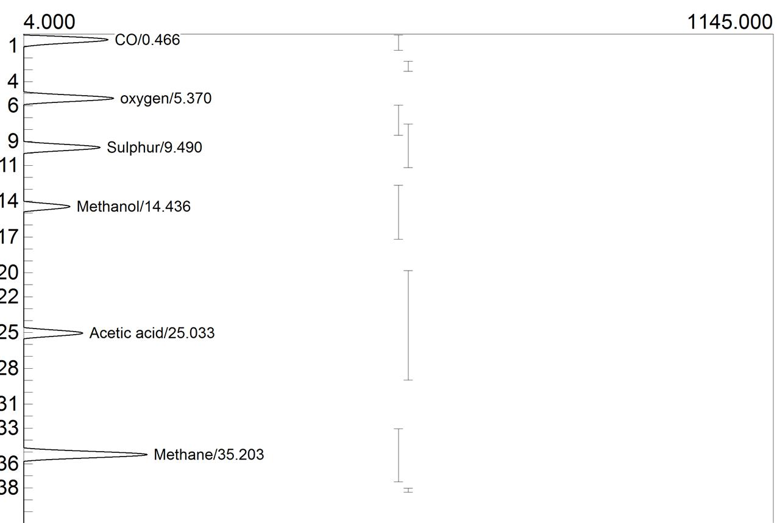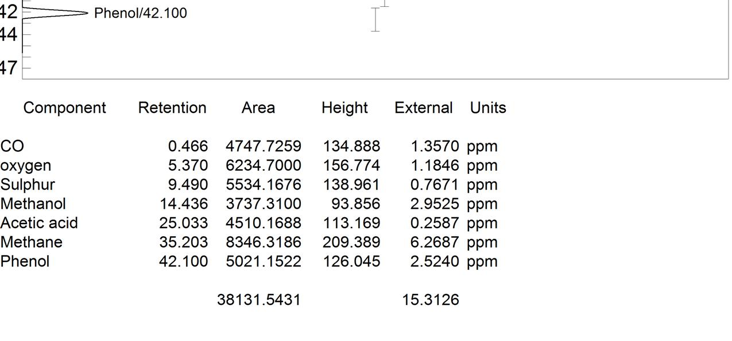
Figure 4: Components of biogas produced at various retention time in days
At the end of the 21-day batching and retention period, the produced biogas was subjected to analysis to determine the components present with the corresponding volumes. The result of this analysis is presented in Figure 4 and Table 3. It shows that the produced biogas is composed of gases and organic acids such as carbon monoxide, oxygen, methane, methanol, acetic acid, and phenol. The results corroborate the findings of [39; 40], which reported that biogas produced from cow dungs and agricultural wastes at the 21-day batch period were composed of acetic acid, phenol, methane and oxygen. Results from the statistical tool (ANOVA single factor) showed there was a significant difference of p < 0.05 between the biogas produced and the duration of the experiment.
Table 3: Composition of biogas produced
Component | Retention | % Volume
Methane | 35.203 | 28.7
Oxygen | 5.370 | 4.4
Methanol | 14.436 | 11.8
CO | 0.466 | 0.4
Acetic acid | 25.033 | 20.4
Phenol | 42.100 | 34.3

5. CONCLUSION
This study demonstrated that agro wastes hold tremendous potential for cost-effective biogas production. It is also important to note that biogas can help to potentially reduce climate change as it is environmentally friendly. Environmental and agricultural wastes should be harnessed and utilized for energy generation instead of depositing them at landfills or open dumpsites, where they would invariably constitute a nuisance to the environment. Following digestion, the slurry can be recovered as organic manure for sustainable agriculture and renewable energy. Connecting this important source of renewable energy with organic and value addition will not only be useful to meet multi-purpose energy needs of different households, but also provide organic manure, quality organic food, good human and soil health, and clean environment in Nigeria. However, there is an urgent need to create more awareness, skill development and bold policy initiatives with rewards and award systems to undertake biogas production among researchers, private sectors and different stakeholders in the country.

REFERENCES
[1] Elum, Z. and Mjimba, V. (2020). Potential and challenges of renewable energy development in promoting a green economy in Nigeria. Africa Review, 97:1–20.
[2] Sawyerr, N., Trois, C. and Workneh, T. (2019). Identification and characterization of potential feedstock for biogas production in South Africa. Journal of Ecological Engineering, 20(6):103–116.
[3] Keita, O. and Kamano, M. (2024). A biogas production model from pig manure: Comparison between modern and local pig manure in N’zerekore City, Republic of Guinea. European Journal of Advances in Engineering and Technology, 11(10):59–69.
[4] Devi, M.K., Manikandan, S., Oviyapriya, M., Selvaraj, M., Assiri, M.A., Vickram, S., Subbaiya, R., Karmegam, N., Ravindran, B., Chang, S.W. and Awasthi, M.K. (2022). Recent advances in biogas production using agro-industrial waste: A comprehensive review outlook of Techno-economic analysis. Bioresource Technology, 363:127871.
[5] Odejobi, O.J., Ajala, O.O. and Osuolale, F.N. (2022). Review on potential of using agricultural, municipal solid and industrial wastes as substrates for biogas production in Nigeria. Biomass Conversion and Biorefinery, 21(4):749–761.
[6] Abubakar, B.S.U. and Ismail, N. (2012). Anaerobic digestion of cow dung for biogas production. ARPN Journal of Engineering and Applied Sciences, 7(2):169–172.
[7] Alburquerque, J.A., Fuente, C.D., and Bernal, M.P. (2012). Chemical properties of anaerobic digestates affecting C and N dynamics in amended soils. Agriculture, Ecosystems and Environment, 160:15–22.
[8] Babatola, J.O. (2008). Comparative study of biogas yield pattern in some animal and household wastes. African Research Review, 2(4):54–68.
[9] Batstone, D.J. and Virdis, B. (2014). The role of anaerobic digestion in the emerging energy economy. Current Opinion in Biotechnology, 27:142–149.
[10] Hilmi, N.A.M., Zakarya, I.A., Gunny, A.A.N., Izhar, T.N.T., Zaaba, S.K., Samah, M.F., Daud, Z.A.A and Beson, M.R.C. (2023). Co-digestion of food waste with cow dung by anaerobic digestion for biogas production. IOP Conference Series Earth and Environmental Sciences, 1135(1):012034. https://doi.org/10.1088/1755-1315/1135/1/012034
[11] Börjesson, P. and Tufvesson, L. (2011). Agricultural crop-based biofuels - resource efficiency and environmental performance including direct land use changes. Journal of Cleaner Production, 19(2-3):108–120.
[12] Van, D.P., Fujiwara, T., Tho, B.L., Toan, P.P.S. and Minh, G.H. (2020). A review of anaerobic digestion systems for biodegradable waste: Configurations, operating parameters and current trends. Environmental Engineering Research, 25(1):1–17.
[13] Gohain, A., Gogoi, N. and Jha, R. (2022). Biogas production through anaerobic digestion of agricultural wastes: State of benefits and its future trend. In: Agriculture Waste Management and Bio-resource: The Circular Economy Perspective. Willey’s Online Library, pp. 172–186.
[14] Yang, B., Jia, W., Yu, Y. and Zhang, H. (2024). Sustainability assessment of agricultural waste biogas production system in China based on energy and carbon evaluation methods. Agriculture, 14(11):1912–1924.
[15] Li, R., Chen, S., and Li, X. (2009). Anaerobic co-digestion of kitchen waste and cattle manure production. Energy Sources, 31:1848–1856.
[16] Rattanapan, C., Sinchai, L., Suksaroj, T. T., Kantachote, D. and Ounsaneha, W. (2019). Biogas production by co-digestion of canteen food waste and domestic wastewater under organic loading rate and temperature optimization. Environment – MDPI, 6:2.
[17] Sebola, M.R., Tesfagiorgis, H.B., Muzenda, E. (2015). Methane production from anaerobic co-digestion of cow dungs, chicken manure, pig manure and sewage. Lecture Notes in Engineering and Computer Science, 2217:592-598.
Rattanapan C, Sinchai L, Suksaroj TT, Kantachote D, Ounsaneha W 2019 Biogas production by
[18] Jameel, M.K., Mustafa, M.A., Ahmed, H.S., Mohammed, A.J., Ghazy, H., Shakir, M.N., Lawas, A.M., Mohammed, S.K., Idan, A.H., Mahmoud, Z.H., Sayadi, H. and Kianfar, E. (2024). Biogas: production, properties, applications, economic and challenges: A review. Results in Chemistry, 89(6):349–358.
[19] Bharathiraja, B., Sudharsana, T., Jayamuthunagai, J., Praveenkumar, R., Chozhavendhan, S. and Iyyappan, J. (2018). Biogas production – A review on composition, fuel properties, feed stock and principles of anaerobic digestion. Renewable and Sustainable Energy Reviews, 90:570–582.
[20] Singh, G., Jain, V. and Singh, A. (2017). Effect of temperature and other factors on anaerobic digestion process, responsible for biogas production. International Journal of Theoretic and Applied Mechanics, 12(3):637–657.
[21] Ukpaka, C.P., Ben–Iwo, J. and Fakrogha, J.J. (2018). Examination of temperature and pH in anaerobic digester process. Journal of Scientific and Engineering Research, 5(3):384-393.
[22] Meggyes, A. and Nagy, V. (2012). Biogas and energy production by utilization of different agricultural wastes. Acta Polytechnica Hungarica, 9(6):65–80.
[23] Siddharth, S., Sharma, S.V. and Pandey, V.K. (2024). Isolation and characterization of microorganisms involved in biogas production from agricultural wastes. International Journal of Scientific Research in Science and Technology, 11(2):718–730.
[24] Prakash, S.V. (2016). Design, fabrication and experimentation of a small scale anaerobic biodigester for domestic biodegradable solid waste with energy recovery and sizing calculations. Procedia Environmental Sciences¸35:749–755.
[25] Sahu, N., Sharma, A., Mishra, P., Chandrashekhar, B., Sharma, G., Kapley, A. and Pandey, R.A. (2017). Evaluation of biogas production potential of kitchen waste in the presence of spices. Waste Management, 70:236–246.
[26] Ukpai, P.A. and Nnabuchi, M.N. (2012). Comparative study of biogas production from cow dung, cowpea, and cassava peeling using 45 liters biogas digester. Advances in Applied Science Research, 3:1864–1869.
[27] Ofoefule, A.U., Uzodinma, E.O. and Anyanwu, C.N. (2010). Biogas production from paper waste and its blend with cow dung. Trends in Applied Sciences Research, 5(1):39–47.
[28] Khadka, M., Bhatt, P., Sharma, A. and Pokhrel, A. (2025). Biogas production from cow-dung at low temperature by integration of microbial electrolysis system. Journey of Nepal Biotechnology Association, 6(1):37–47.
[29] Kory’s, K., Latawiec, A., Grotkiewicz, K. and Kubo’n, M. (2019). The review of biomass potential for agricultural biogas production in Poland. Sustainability, 11(6515):1–13.
[30] Lozanovski, A., Linder, J.P. and Bos, U. (2014). Environmental evaluation and comparison of selected industrial scale bio-methane production facilities across Europe. International Journal Life Cycle Assess, 19:1823–1832.
[31] Oguntoke, O., Amaefuna, B., Nwosisi, M., Oyedepo, S. and Oyatogun, M. (2019). Quantification of biodegradable household solid waste for biogas production and the challenges of waste sorting in Abeokuta Metropolis, Nigeria. International Journal of Energy and Water Resources, 3:253–261.
[32] Kuźnia, M., Magiera, A., Jerzak,W., Pielichowska, K. and Sikora, J. (2018). Biogas production from agricultural and municipal wastes. E3S Web of Conferences, 108:
[33] Ramansu, G., Pritam, C., Arunima, S., SambhuNath, B., Amit, K.C., Anil, K.M. and Shibani, C. (2016). An overview of physicochemical mechanisms of biogas production by microbial communities: a step towards sustainable waste management Biotechnology, 6(1):72–80.
[34] Sandhu, S. and Kaushal, R. (2019). Anaerobic digestion of vegetable, fruits and cafeteria wastes with cow dung by chemical pretreatment for biogas production in batch digester. IOP Conference Series, 1240:1–8.
[35] Rabah, A.B., Baki, A.S., Hassan, L.G., Musa, M. And Ibrahim, A. (2010). Production of biogas using abattoir waste at different retention. Science World Journal, 5(4):23–26.
[36] Vanholme, B., Desmet, T., Ronsse, F., Rabaey, K., Breusegem, F., de Mey M., Soetaert, W. and Boerjan, W. (2013). Towards a carbon-negative sustainable bio-based economy. Frontiers in Plant Science, 4:174–182. https://doi.org/10.3389/fpls.2013.00174.
[37] Nkoa, R. (2014) Agricultural benefits and environmental risks of soil fertilization with anaerobic digestates: A review. Agronomy for Sustainable Development, 34(2):473–492.
[38] Kiselev, A., Magaril, E., Magaril, R., Panepinto, D., Ravina, M. and Zanetti, M. (2019). Towards circular economy: Evaluation of sewage sludge biogas solutions. Resources, 8(91):1–19.
[39] Ozor, O.C., Agah, M.V., Ogbu, K.I., Nnachi, A.U., Udu-Ibiam, O.E. and Agwu, M.M. (2014). Biogas production using cow dungs from Abakaliki abattoir in South-Eastern Nigeria. International Journal of Scientific and Technology Research, 3:237–239.
[40] Weiland P. (2010). Biogas production: current state and perspectives. Applied Microbiology and Biotechnology, 85(4):849–860. https://doi.org/10.1007/s00253-009-2246-2257.
[41] Stifter, T. (2011). Prozess- und Kostenanalyse der Biogasanlage Engerwitzdorf. Master thesis. Wieselburg: Austrian Marketing University of Applied Sciences.
[42] Okorie, V.C. (2004). Laboratory Technique in Pharmaceutics. Pharmaceutical Microbiology, (2nd Ed.) Nigeria: El’ Demark Publishers, pp. 24–26.
.
rate

