Case report
Complete Remission of Severe Chronic Plaque Psoriasis Following Isoniazid Therapy for Latent Tuberculosis: A Novel Clinical Observation and Case Report

.

ABSTRACT

Background: LTBI screening is extremely crucial to initiate biological therapy among psoriasis patients as they potentially face TB activation. The lack of equal distribution of LTBI dwells on regional differences evoking a customized management.
Case Presentation: The patient is a 48-year-old man with an indication of severe chronic plaque psoriasis (PASI 36.9) that was positive on interferon-gamma release assay test (IGRA) but showed no active signs of TB on chest x-ray. He was put on isoniazid (300 mg/day, 6 months) and pyridoxine.
Results: After three months, there was a marked resolution to the psoriatic lesions which were fully cleared after six months. There was remission throughout 6 months of follow-up.
Conclusion: Possible immunomodulatory effect of isoniazid in psoriasis resolution after treating LTBI can be explained by potential inhibition of Th1/Th17 pathways. This case supports the necessity of additional studies of the association between LTBI and the pathogenesis of psoriasis.

Keywords: Latent tuberculosis infection, psoriasis, isoniazid, biological therapy, immunomodulation.

1. INTRODUCTION

Screening to detect latent tuberculosis infection (LTBI) is crucial before initiating biological therapy in patients with moderate to severe psoriasis. Contentious monitoring is also recommended during and after such treatment. The prevalence of LTBI has community and regional variation. The most recently analyzed data show that the prevalence of LTBI among psoriatic patient receiving biological therapy is approximately a 20.5% in Spain. In contrast, studies from India report significantly higher prevalence, reaching around 31%^{(1.2)}. If a patient test positive for LTBI, treatment should be initiated with isoniazid 300mg once daily for 6 months⁽³⁾. Biological therapy can be initiating after completing one month of LTBI treatment and may continue regardless of IGRA results being positive or negative, as long as active tuberculosis has been ruled out.^{(4,5)}. Here we report a case of patient with sever chronic plaque psoriasis who show significant clinical improvement following 6 months course of isoniazid therapy.
Case report
A 48 years old male patient with 20 year history of sever chronic plaque psoriasis, presenting to dermatological clinic, biology department, for evaluation prior to initiating biological therapy. His Psoriasis Area and Severity Index (PASI) score was 36.9.
The patient had no significant past medical history or comorbidities. His prior treatment history included several topical agents, such as clobetasol propionate 0.01% and/or mometasone furoate 0.1%, which yielded minimal clinical improvement. He was then started on multiple trials of immunosuppressive drugs such as methotrexate at a dose of 15 mg weekly, resulting in partial disease control. However, relapse occurred shortly after discontinuation of any form of systemic treatments.
As a part of standard pre-biological screening protocol, the patient underwent an interferon-gamma release assay (IGRA) and chest radiography. The IGRA test was positive, while the chest x-ray showed no signs of active pulmonary tuberculosis. The patient remained asymptomatic, and based on these finding, a diagnosis of LTBI was made.
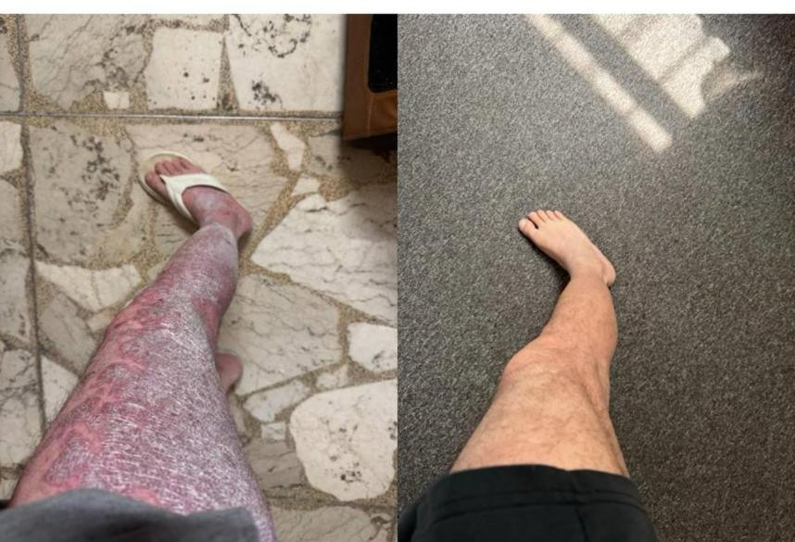
The patient was referred to internist and commenced on isoniazid therapy at a dose of 300mg daily for 6 months with pyridoxine to decrease risk of neuropathy. After three months of treatment, the patient reported noticeable improvement in his after psoriatic lesions. Remarkably, complete clearance was observed remission six months of (six isoniazid therapy. During follow up the remain until now months after anti-tuberculosis therapy cessation) (figure 1).

Figure 1 psoriatic lesions before and after isoniazid

DISCUSSION
The biological therapies offer a new revolution in psoriasis treatment, that’s improved the quality of patient’s life when compared with classical ant psoriatic therapy.
As all antitumor necrosis factor alpha therapies have been associated with risk of LTBI activation, so it’s important to concern regarding the safety of these agents.
Immune activation and inflammatory reactions are essential for host protection against mycobacteria. It is generally assumed that the outcome of mycobacteria (Mtb) infection depends on natural variations in host immune response to Mtb, in particular on the type and extent of immune activation and inflammation. Overall, the interplay between immune activation, inflammation, and TB pathogenesis is complex and not completely understood. Among different populations of T helper cells, Th1 and Th17 are the main effector populations which elevated to mediate protection during Mtb immunological response^{(6,7)}.
Over the last few years, several studies in the literature have assessed the use of anti-tuberculosis drugs for LTBI treatment in moderate to
severe psoriatic patients, showing improvement on ant-tuberculosis drugs only and no need more than an emollients thereafter^{(8,9,10)}.
Isoniazid is an antibiotic with high bactericidal effect on replicating mycobacteria and is the most commonly prescribed treatment for LTBI. Here, we report clinical improvement, possibly due to immunomodulatory effects of isoniazid, which significantly reduces Mycobacterium tuberculosis antigen-specific immune responses. Its induces apoptosis in activated CD4+ T cells, leading to decrease in Th1 and Th17⁽¹¹⁾.
Alternatively, LTBI may exacerbate psoriasis through Th1 and Th17 activation. Therefore, successful treatment oh LTBI may suppress Th1 and Th17 activity, leading to psoriasis improvement, as psoriasis considered as Th1/Th17 disease^{(6,12)}.
These cases highlight the possible role of tuberculosis infection in the pathogenesis of psoriasis, suggesting a potential link between untreated infection and skin lesions. This can lead to development of novel therapeutic strategies and new avenues of research.

Ethical approval

“All authors hereby declare that all experiments have been examined and approved by the appropriate ethics committee and have therefore been performed in accordance with the ethical standards laid down in the 1964 Declaration of Helsinki.”
Disclaimer (Artificial intelligence): Author(s) hereby declare that NO generative AI technologies such as Large Language Models (ChatGPT, COPILOT, etc.) and text-to-image generators have been used during the writing or editing of this manuscript.

Reference

- A. Martínez-Lópeza,, J. Rodriguez-Grangerb, R. Ruiz-Villaverdea. Screening for Latent Tuberculosis in the Patient With Moderate to Severe Psoriasis Who Is a Candidate for Systemic and/or Biologic Therapy. Actas Dermosifiliogr. 2016 ;107(3):207-14.
- Shekhar Neema 1, S Radhakrishnan 1, Disha Dabbas 2, Biju Vasudevan 1. Latent Tuberculosis in Psoriasis Patients Planned for Systemic Therapy - A Prospective Observational Study. Indian Dermatol Online J. 2021, 12;12(3):429-432.
- World health organization (WHO). Guidelines on the Management of Latent Tuberculosis Infection. Geneva: WHO; 2015.
- Camila Anton, Felipe Dominguez Machado, Jorge Mario Ahumada Ramirez. Latent tuberculosis infection in patients with rheumatic diseases. J Bras Pneumol. 2019 Mar-Apr;45(2).
- M G Johnson, R W Bialas, R P Hall. Should all patients undergoing treatment with biologic agents be screened annually for latent tuberculosis infection with an interferon gamma release assay?. J Dermatolog Treat. 2015 Dec 10;27(4):378–380.

- I V Lyadova, A V Panteleev. Th1 and Th17 Cells in Tuberculosis: Protection, Pathology, and Biomarkers. . 2015 Nov 10;2015:854507.
- North R. J., Jung Y.-J. Immunity to tuberculosis. Annual Review of Immunology. 2004;22:599–623. doi: 10.1146/annurev.immunol.22.012703.104635.
- Anca Chiriac, Dan Ferariu, Caius Solovan, Piotr Brzezinski. Improvement in severe psoriasis associated with isoniazid treatment. Dermatol Online J. 2014 May 16;20(5):22617.
- Felipe Partarrieu-Mejías, Pablo Hernández-Bel, Macarena Giácaman-von der Weth. Severe psoriasis entering remission after treatment for latent tuberculosis with isoniazid: Report of two cases. J Dermatol. 2019 Sep;46(9):798-801.
- Anastasiya Muntyanu, Sylvia A Martinez-Cabriales, Jensen Yeung. Case of resolution of plaque psoriasis following treatment with rifampicin for latent tuberculosis: A case report. 2023 Feb 6;11:2050313X231152054.
- Sultan Tousif, Dhiraj Kumar Singh, Shaheer Ahmad. Isoniazid Induces Apoptosis Of Activated CD4+ T Cells IMPLICATIONS FOR POST-THERAPY TUBERCULOSIS
REACTIVATION AND REINFECTION. 2014 Sep 8;289(44):30190–30195.
- Marco Diani, Gianfranco Altomare, Eva Reali. T Helper Cell Subsets in Clinical Manifestations of Psoriasis 2016 Aug 10;2016:7692024.

