Secure Telemedicine Image Encryption Using NSPSO-Optimized S-Boxes and a Hybrid Logistic–Sine Chaotic Map

Abstract

The rapid growth of telemedicine has increased the demand for secure and efficient transmission of sensitive medical data, where image encryption plays a pivotal role in protecting patient privacy. Cryptographic substitution boxes (S-boxes) are fundamental components in symmetric encryption systems, directly influencing their resistance to cryptanalytic attacks. Recent research has focused on leveraging metaheuristic algorithms and chaotic systems to enhance S-box cryptographic strength, enabling secure and real-time medical image transmission. In this paper, a multi-objective particle swarm optimization (PSO) framework integrated with chaotic map-based initialization is proposed for the evolution of cryptographically robust S-boxes. The proposed approach is rigorously evaluated using established cryptographic metrics, including nonlinearity, differential uniformity, and autocorrelation. The optimized S-boxes are subsequently employed in a secure medical image encryption scheme, and their performance is validated through comprehensive statistical and robustness analyses, demonstrating their suitability for high-security telemedicine applications.

Keywords: Hybrid Logistic–Sine map, NSPSO, S-box optimization, chaotic systems, medical image encryption, telemedicine.
- INTRODUCTION
The rapid expansion of telemedicine and digital healthcare systems has heightened the imperative for real-time security mechanisms to safeguard medical data against cyber threats, emphasizing the need for robust confidentiality, integrity, and privacy protections during the transmission of images and health records over public networks [1,2]. Encryption plays a critical role in safeguarding such data, with substitution boxes (S-boxes) being a core component in many block cipher algorithms due to their contribution to confusion, a vital property in secure encryption [3]. A strong S-box design must exhibit high nonlinearity, low differential uniformity, low autocorrelation, and strong resistance to cryptanalysis methods such as linear and differential attacks. Traditionally, S-boxes are either designed algebraically or evolved using heuristic methods. However, these methods may be limited in exploring large search spaces, especially when multi-objective optimization is required. To overcome these challenges, nature-inspired algorithms have emerged as promising tools for evolving cryptographically strong S-boxes.
In recent years, Particle Swarm Optimization (PSO) has gained attention as a powerful, population-based optimization technique for solving high-dimensional and nonlinear problems. Its ability to converge efficiently, coupled with simplicity in implementation, makes PSO a suitable candidate for cryptographic design tasks [4,5]. Additionally, integrating chaotic maps into PSO initialization can enhance randomness and diversity in the search process, thereby improving the quality of evolved S-boxes [6].
The application of PSO in cryptography, particularly in the context of secure telemedicine, is still an emerging field. Few studies have combined multi-objective PSO with chaos theory to optimize S-box parameters tailored for secure medical image encryption. This work aims to fill that gap by proposing a PSO-based framework for generating 8×8 S-boxes that meet key cryptographic criteria and evaluating their performance within a medical image encryption system designed for telemedicine platforms.

An artificial bee colony algorithm (CSABC)-based chaotic S-box is designed in [7]. The initial individuals are the S-boxes produced by the six-dimensional compound hyperchaotic map, and ABC is used to enhance their functionality. Furthermore, it takes into account differential uniformity and nonlinearity as fitness functions. Numerous cryptographic criteria of this algorithm have been compared with those of other algorithms through a series of studies. According to simulation results, the proposed algorithm satisfies several cryptographic requirements and possesses a cryptographically strong S-box.

In [8], a novel approach to creating powerful S-boxes based on Teaching–Learning-Based Optimization (TLBO) and a chaotic map is introduced. Eight cycles are presented by the approach, with two transformations—row left shifting and columnwise rotation—in each round. Two keys to the logistic map control the transformation vectors, which vary from round to round. TLBO is used to optimize these two keys to create a powerful S-box that meets the predetermined requirements. Bijectivity, nonlinearity, rigorous avalanche criteria, and equiprobable inputs/outputs XOR distribution are among the criteria that are tested for. We will also include several comparisons with different S-boxes and crucial sensitivity testing. The performance test results demonstrate that the suggested design S-boxes have strong cryptographic characteristics and are resilient to a variety of attacks.

To improve the performance of encryption algorithms, a new hybrid chaotic map and a fresh method of applying optimization techniques are suggested in [9]. The suggested chaotic map performs exceptionally well in terms of randomness and sensitivity when compared to other chaotic functions. The novel mathematical function's properties are superior than those of classical maps based on its entropy measure and Lyapunov exponents. Based on the confusion/diffusion Shannon characteristics, we suggest a novel image cipher. The chaotic Jaya optimization process was used to build S-boxes based on their nonlinearity score during the substitution phase of the suggested encryption algorithm, which relies on a new optimized substitution box. A bijective matrix with a high nonlinearity score is the aim of the optimization procedure. Additionally, a dynamic key that is dependent on the encrypted image's output is suggested. The suggested encryption technique is resistant against various cryptanalytic assaults, according to security analysis.

In [10], we suggest introducing an effective technique for the creation of highly nonlinear cryptographic substitution boxes as an alternative to random, chaotic, or algebraic-based construction approaches. A suggested technique is developed by reconnoitering the nature-inspired particle swarm optimization, in which a simple yet rich dynamic chaotic Renyi map is used to construct the initial population. The expected approach is examined under several conditions, including a linear rise in inertial weight, a change in population size, and a change in the number of repetitions. The suggested method has outstanding cryptographic properties and is determined to be superior to several recent optimization-based S-box methods, according to the performance evaluation of created S-boxes under standard criteria.

In [11], an approach based on multi-objective optimization is introduced. This approach builds 8 × 8 S-boxes that meet several requirements, including low differential uniformity, low auto-correlation, strong nonlinearity, and balancedness. By introducing the S-boxes using the chaos-assisted non-dominated sorting genetic algorithm-II, several goals are achieved. The suggested method's ability to provide noticeably better S-box solutions with good Pareto-optimal security characteristics is demonstrated by its performance evaluation and comparison with other cutting-edge algorithms and accessible optimization tools. Finally, the optimization yields S-boxes with auto-correlation function (ACF) as low as 80, differential uniformity (DU) as low as 8, and minimum nonlinearity (NL) of 110. Additionally, a medical image encryption technique is proposed for safe telemedicine services using the discovered Pareto-optimal S-box. The recommended encryption algorithm performs the necessary image diffusion and permutation using an S-box. Its efficacy in protecting medical imaging data in telemedicine networks is confirmed by the encryption performance evaluation and comparison assessments.
In this paper, we propose a novel approach for the design of cryptographically robust substitution boxes (S-boxes) using a multi-objective Particle Swarm Optimization (PSO) framework enhanced with chaotic map initialization. This hybrid method leverages the exploration capabilities of PSO and the randomness properties of chaotic sequences to effectively search the solution space for optimal S-box configurations. The generated S-boxes are rigorously evaluated using standard cryptographic metrics, including nonlinearity, differential uniformity, and autocorrelation, to ensure resistance against linear and differential cryptanalysis. Furthermore, the most optimized S-boxes are employed in a secure medical image encryption scheme tailored for telemedicine applications. The performance of this scheme is assessed through detailed statistical, entropy, and sensitivity analyses, demonstrating its effectiveness in protecting sensitive healthcare data during transmission over untrusted networks.

- BASIC TOOLS
Metaheuristic algorithms like Particle Swarm Optimization (PSO) and its variants have demonstrated notable effectiveness in solving high-dimensional, nonlinear optimization tasks, particularly when enhanced with chaotic map-based initialization to improve diversity and convergence in search processes [4], [7]. In the proposed algorithm, these principles are applied and tailored through the integration of NSPSO with hybrid chaotic maps to evolve cryptographically robust S-Boxes
- MULTI-OBJECTIVE OPTIMIZATION PROBLEM
Multi-objective problems are generally characterized as [12]:
$\min{F\left(x\right)= {(f_{1}\left(x\right), f_{2}\left(x\right), ……….{,f}_{m}\left(x\right)) }^{T}}$
s.t $x ϵ$ $Ω^{n}$ (1)

where m is the target space's size, F: $Ω^{n}$ → $R^{m}$ is the mapping from the decision space to the target space, x = (x₁, x₂,, x_{n}) is an n-dimensional decision variable, and $Ω^{n}$ is a feasible solution space for decision variables.
- PARTICLE SWARM OPTIMIZATION (PSO)

Kennedy and Eberhart introduced a set of sophisticated optimization algorithms known as Particle Swarm Optimization (PSO) [13]. Here is the particle swarm algorithm's update formula for velocity v^{t} and location x^{t} [12]:
$v_{i}^{t+1}=wv_{i}^{t}+c_{1}r_{1}\left(x_{pbest,i}^{t}-x_{i}^{t}\right)+c_{2}r_{2}(x_{gbest, i}^{t}-x_{i}^{t})$ (2)
$x_{i}^{t+1}=x_{i}^{t}+v_{i}^{t+1}$ (3)

where r₁ and r₂ are uniformly distributed between (0, 1), respectively, w is the inertia vector, c₁ and c₂ are learning factors, and $v_{i}^{t}$ and $x_{i}^{t}$ are the position and velocity of particle i in the t-th generation. Particle i's individual and global ideal positions are denoted by $x_{pbest,i}^{t}$and $x_{gbest, i}^{t}$, respectively.
- S-BOX PERFORMANCE PARAMETERS

Using S-boxes in cryptosystems is primarily intended to convert input data into ciphertext data in a very nonlinear manner. In other words, the input secret data is altered in a nonlinear way. This robustness against linear attacks or cryptanalysis is also due to the high nonlinearity score of the S-box, which is correlated with the degree of the nonlinear transformation. According to the designers, the S-box's NL is its most important feature. Thus, with the exception of a few [14], it has been mostly discussed as the determining factor when creating S-boxes in practically all S-box studies that have been looked into to date. According to Biham et al. [15], the DU is just as important as the NL in thwarting possible cryptanalysis. For an S-box to give no information or hints to the attackers, its DU score should be low. Additionally, the global Avalanche criteria (GAC) are investigated as the key indicators of cryptographic quality that result in efficient diffusion [16]. The ACF is used to measure the GAC feature of S-boxes. Another name for it is the S-box's absolute indication. In light of this rationale and drive, the multi-objective meta-heuristic NSGA-II has been used to optimize the three critical performance parameters NL, DU, and ACF in order to produce optimal S-boxes. These three parameters are specifically covered in the following.

- NONLINEARITY
If we know the lowest distance between a Boolean function f and the set of all relative affine functions, we can compute the nonlinearity of f [14]. Accordingly, nonlinearity $n_{f}$ should be defined as follows for the S-box constituent function f:

$n_{f}=\frac{1}{2}\left(2^{n}-WH_{max}\left(f\right)\right)$ (4)

In this case, WH_{max}(f ) is the Walsh-Hadamard transform of the function f [17]. In the unlikely event that an n-variable function has weak nonlinearity, it is deemed fragile. One of the desirable features that can provide strength against any kind of linearity-related assault is the modified Boolean function maximizing of nonlinearity [18].

- DIFFERENTIAL UNIFORMITY
Differential uniformity is estimated to discover the S-box's ability to resist the expected differential cryptanalysis. It is a chosen plaintext attack outlined by Biham and Shamir to attack block ciphers, who are DES-like [15]. Differential uniformity (DU) addresses the maximum likelihood of creating an output differential $△y=y_{i}⊕y_{j}$ , when the input differential is $△x=x_{i}⊕x_{j}$ . In this strategy, the XOR distribution among inputs and outputs of S is analyzed. Numerically, it is evaluated as:

$DU_{s}=\max_{△x≠0,△y}{(\#\left\{x∈X|S\left(x\right)⊕S\left(x⊕ △x\right)=△y\right\})}$ (5)

In order to withstand the Biham and Shamir potential differential cryptanalysis, its value should be as low as possible.

- AUTO-CORRELATION FUNCTION
Let $α$(t) and $β$(t) be Boolean functions, and the crosscorrelation of these two functions, denoted by ${\hat{C}}_{αβ}(S)$, be demarcated as [19]:

${\hat{C}}_{αβ}\left(S\right)=\sum_{t}{\frac{1}{2^{n}}({(-1)}^{α(t)⊕β(t⨁s)})}$ (6)

The auto-correlation of binary Boolean functions α can be written as ${\hat{C}}_{αα}\left(S\right)$, meaning that the values of the ACF spectrum are the squares of the values of the spectrum of α [19]. As for GF(2^{m})$→$GF(2^{n}), the ACF is ${\hat{r}}_{α}(s)$. The formula used in mathematics to calculate the ACF is explained as
${\hat{r}}_{α}\left(s\right)=\sum_{t}{\frac{1}{2^{n}}({(-1)}^{α(t)⊕α(t⨁s)})}$ (7)

For a strong S-box that satisfies GAC and effective diffusion, a smaller value of ACF is preferred [16].

- HYBIRD CHAOTIC MAP

Mathematical structures known as hybrid chaotic maps combine different chaotic systems or maps to create dynamical patterns that are intricate and flexible [30]. These hybrid maps exhibit increased complexity and volatility over and above what their constituent parts may offer by utilizing strategies like sequential or parallel coupling. The goal of integrating these maps is to enhance some aspects of chaotic behavior, increase randomness, or promote more complex dynamics. Our model generates the sequence used in the confusion region using the logistic-sine map. The logistic-sin map's system equation looks like this:

$x_{n+1}=rx_{n}\left(1-x_{n}\right)+4r.sin⁡(\frac{πx_{n}}{4})$ (8)

The map exhibits chaotic behavior when r fluctuates between 0.6 and 1.2. The bifurcation diagram for the hybrid map is shown in Figure 1.
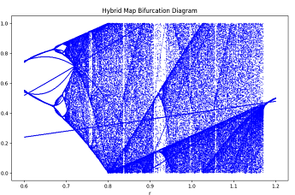
Figure 1: Hybrid Logistic-Sin Map Bifurcation diagram
- PROPOSED ALGORITHM
This section introduces the proposed image encryption scheme based on a Hybrid Logistic-Sine Map (HLSM) and a Nonlinear Self-Adaptive Particle Swarm Optimization (NSPSO) algorithm. The method enhances medical image security through chaos-driven scrambling, diffusion, and optimized S-box substitution. The proposed encryption algorithm is shown in Figure 2.
- ENCRYPTION PROCESS
Step 1. Generate a cryptographically robust S-Box SB using the proposed NSPSO optimization approach discussed in Section II. Each particle is initialized using a chaotic sequence derived from the Hybrid Logistic-Sine Map (HLSM), and the fitness function evaluates nonlinearity, differential uniformity, auto-correlation, avalanche effect, and SAC.
Step 2. Load the plain image P, and resize it to a fixed dimension of 256×256 pixels.
Step 3. If the input image is colored (RGB), convert it to a grayscale image. Normalize pixel intensities to the range [0,255] and ensure the data type is uint8.
Step 4. Generate a pseudo-random sequence using HLSM for pixel scrambling. Sort the chaotic sequence to derive the permutation indices.
Step 5. Reshape the plain image into a 1D vector and permute the pixel positions using the permutation indices from Step 4 to obtain the scrambled image S.
Step 6. Generate another chaotic sequence from HLSM, reshape it into a matrix of size 256×256, and apply pixel-wise XOR between S and the chaotic matrix. The result is the diffused image D.
Step 7. Substitute every pixel value in the diffused image D using the optimized S-box SB as follows:
$E\left(i,j\right)=SB(D\left(i,j\right)+1)$ (9)
where E(i,j) is the encrypted pixel at position (i,j), and D(i,j) ∈ [0,255].
Step 8. Obtain the final encrypted image, which exhibits high entropy, a uniform histogram, and low pixel correlation across directions.
- DECRYPTION PROCESS
The Decryption process reverses each stage of the encryption, as follows:
Step 1. Construct the inverse S-box $SB^{-1}$from the optimized S-box SB.
Step 2. Apply inverse S-box substitution on the encrypted image E to obtain the intermediate image D, where:
D (i, j) = $SB^{-1}$(E (i,j)) (10)
Step 3. Reconstruct the same HLSM-based chaotic sequence used during encryption for diffusion, and perform XOR between D and the chaotic matrix to recover the scrambled image S.
Step 4. Use the same HLSM chaotic permutation indices to descramble the image and restore the original spatial structure, resulting in the decrypted image P′.
Step 5. Compare P′ with the original image P to validate the decryption accuracy and losslessness.
- KEY SPACE ANALYSIS

The proposed system relies on secret parameters derived from the Hybrid Logistic-Sine Map (HLSM) and an optimized S-box generated via the NSPSO algorithm.

- Chaotic Keys: The HLSM utilizes two initial values x₀​ and two control parameters r, each with a precision of 10⁻¹⁴, yielding a chaotic key space of approximately:
$${({10}^{14})}^{4}≈2^{186}$$
- Optimized S-box: The S-box is generated using NSPSO with chaotic initialization. While the theoretical space of 256-entry bijective S-boxes is 256!≈ $2^{1684}$, the practical key space is constrained by cryptographic criteria (e.g., high nonlinearity).

The Total Key Space is equal to $2^{186} ×2^{k} ≫ 2^{128} ,$where k reflects the subset of feasible S-boxes ensuring robustness against brute-force attacks.
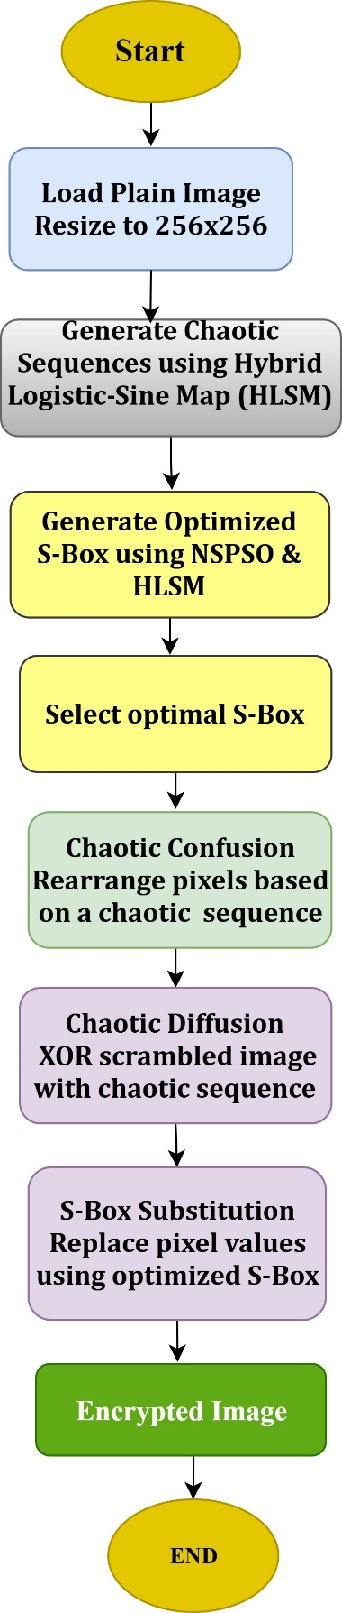

Figure 2: The Proposed Encryption Scheme.

- EXPERIMENTAL RESULTS
The tests were performed on an HP laptop with a 1TB hard drive, running Matlab R2016b. The system is equipped with 8 GB of RAM, and is running Windows 10 (64-bit). The test CT, MRI and OT images are downloaded from the internet

ANALYSIS OF OPTIMIZED S-BOX AND IMAGE ENCRYPTION PERFORMANCE
A sufficiently large number of iterations were executed to optimize the S-box using the proposed chaotic and evolutionary approach. The final optimized S-box, shown in Table 1, exhibits robust cryptographic strength with a nonlinearity (NL) of 127.75, a differential uniformity (DU) of 10, and a maximum absolute auto-correlation function (ACF) value of 0.3125 after 1000 iterations. The optimized S-box achieved a full dynamic range, spanning from 0 to 255 with 256 unique values, indicating strong bijectivity. Image encryption was performed using this S-box, and both original and encrypted images maintained consistent dimensions of 256×256 pixels, confirming format preservation. These results demonstrate that the proposed optimization technique successfully produces a cryptographically secure and structurally robust S-box suitable for secure medical image encryption applications.
Table 1: Optimized S-box
251 | 115 | 147 | 113 | 64 | 10 | 90 | 8 | 134 | 196 | 124 | 224 | 87 | 2 | 210 | 230
136 | 231 | 164 | 23 | 25 | 223 | 17 | 58 | 201 | 141 | 151 | 122 | 236 | 241 | 176 | 193
3 | 242 | 169 | 106 | 97 | 14 | 89 | 60 | 154 | 165 | 234 | 70 | 181 | 238 | 249 | 161
163 | 51 | 47 | 111 | 125 | 49 | 245 | 188 | 123 | 211 | 217 | 132 | 194 | 101 | 191 | 78
112 | 149 | 116 | 11 | 220 | 137 | 215 | 68 | 34 | 79 | 36 | 20 | 40 | 200 | 45 | 104
54 | 199 | 144 | 225 | 76 | 243 | 166 | 37 | 63 | 226 | 120 | 229 | 98 | 107 | 32 | 12
128 | 18 | 203 | 156 | 228 | 150 | 80 | 33 | 121 | 222 | 162 | 139 | 84 | 202 | 75 | 145
30 | 42 | 143 | 27 | 19 | 61 | 175 | 7 | 214 | 55 | 208 | 216 | 6 | 240 | 29 | 44
56 | 254 | 192 | 205 | 189 | 43 | 69 | 99 | 71 | 22 | 253 | 212 | 159 | 138 | 213 | 204
13 | 91 | 180 | 73 | 28 | 155 | 24 | 198 | 190 | 127 | 83 | 173 | 103 | 85 | 255 | 16
53 | 146 | 232 | 81 | 148 | 247 | 35 | 57 | 0 | 172 | 197 | 177 | 218 | 182 | 31 | 140
152 | 207 | 237 | 158 | 133 | 118 | 77 | 46 | 15 | 52 | 110 | 105 | 244 | 26 | 92 | 86
179 | 239 | 108 | 167 | 209 | 168 | 186 | 129 | 66 | 153 | 160 | 48 | 135 | 206 | 233 | 67
174 | 114 | 117 | 82 | 5 | 88 | 170 | 130 | 1 | 4 | 119 | 74 | 185 | 94 | 184 | 227
171 | 95 | 195 | 221 | 39 | 59 | 9 | 41 | 38 | 93 | 246 | 102 | 219 | 250 | 235 | 62
50 | 100 | 248 | 157 | 178 | 109 | 142 | 72 | 96 | 183 | 65 | 21 | 131 | 187 | 126 | 252

    - GEOGRAPHIC MEASUERS
- VISUAL TEST

An essential qualitative test for assessing the encryption process is looking at the encrypted image. As seen in Figure 3, the resultant cipher image seems visually random and completely unrelated to the source image. S-box replacement, chaotic diffusion, and pixel scrambling work together to guarantee that no structural patterns are preserved. All visual features are effectively hidden by this transformation, which achieves significant confusion and diffusion. Strong resilience to statistical attacks is also indicated by the encrypted image's consistently distributed histogram.

- HISTOGRAM ANALYSIS

The distribution of image pixel values is represented by a histogram. The distribution of pixel values is more consistent when the histogram is flatter. A graph that displays the quantity of pixels in an image at various intensities is called a histogram. An 8-bit grayscale image has 256 distinct intensities; hence, the horizontal axis of the histogram shows 256 numbers, while the vertical axis shows the distribution of pixels within those grayscale values. For an encryption method to be deemed effective, the grayscale distribution in the encrypted image must be reasonably uniform. Fig. 4 displays the brain CT image histograms.
The histograms of the encrypted and original plain images are shown in Figure 4. The uniform distribution of the encrypted image makes it clear that our transmitted image has no information about the original image, whose histogram is completely different from the encrypted image's. Therefore, our system's security cannot be compromised by unauthorized eavesdroppers without the encryption key examining the encrypted image's histogram.

Original Image | Optimized S-box | Encrypted Image | Decrypted Image
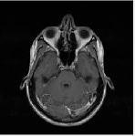 | 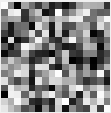 | 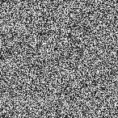
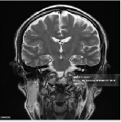 | 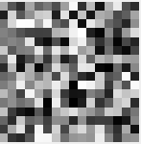 | 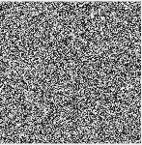
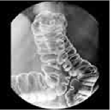 | 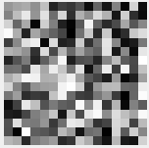 | 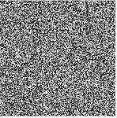

Figure 3: Original, Encrypted and Decrypted images for the CT, MRI, and OT image.

Image | Histogram
 | 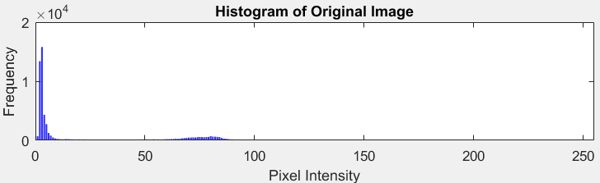
 | 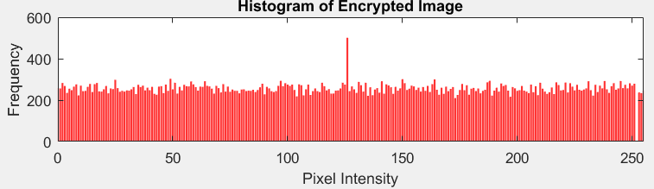
 | 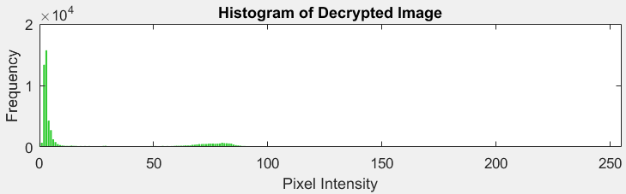
Figure 4: Histogram for the Original, Encrypted, and Decrypted for CT image.

- Scatter Diagram

The grayscale value of the pixel at (x, y) is on the horizontal axis of the scatter diagram, which measures the correlation in the horizontal direction. The grayscale value of the pixel at (x+1, y) is on the vertical axis. While there is minimal connection between neighboring pixels in the encrypted image, it is found that there is a substantial correlation between neighboring pixels in the plain image. Additionally, the vertical axis in the vertical correlation study scatter diagram shows the grayscale value of the pixel at (x, y+1), while the horizontal axis shows the grayscale value of the pixel at (x, y).
As previously mentioned, the dots in the plain image's scatter diagram are "clustered" together, whereas the same points for the encrypted image are dispersed over the plane. The grayscale value of the pixel at (x, y) is represented by the horizontal axis in a scatter diagram for the diagonal direction, while the grayscale value of the pixel at (x+1, y+1) is represented by the vertical axis.
The scatter diagrams in Figure 5 demonstrate the effectiveness of the encryption process in eliminating spatial dependencies. In the original image, adjacent pixel intensity values are highly correlated along the horizontal, vertical, and diagonal axes, with correlation coefficients of 0.9577, 0.9779, and 0.9400, respectively. After encryption, these correlations are nearly zero (–4.59×10⁻⁵, 0.0031, and –0.0058), and the points are uniformly dispersed. This confirms that the encryption scheme effectively destroys inherent statistical structures, significantly strengthening resistance against statistical and differential attacks.

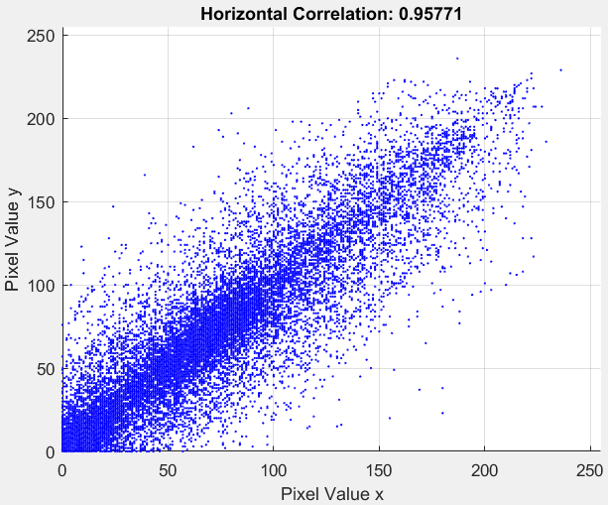 | 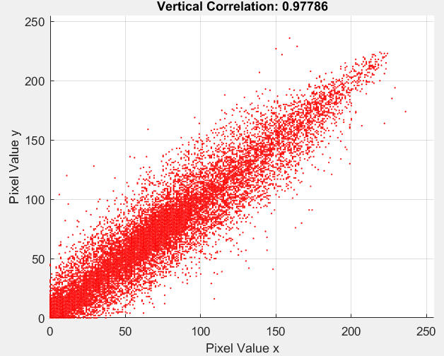 | 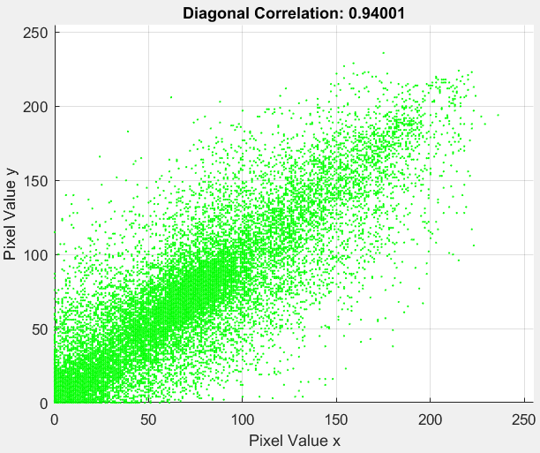
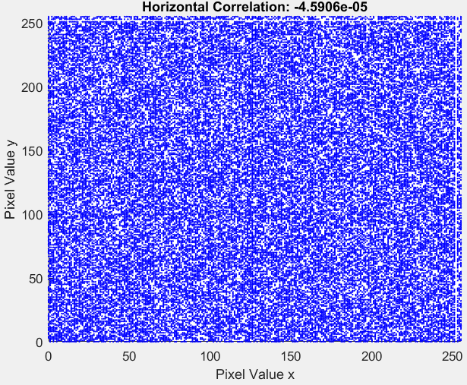 | 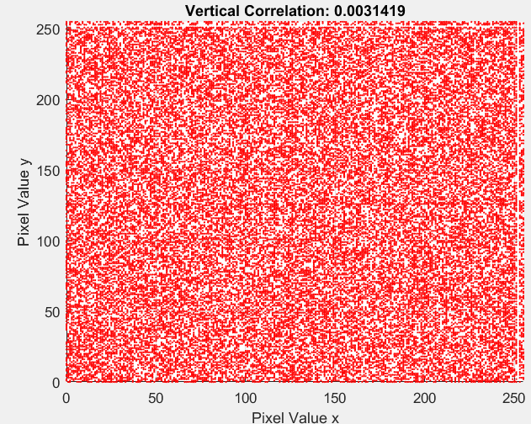 | 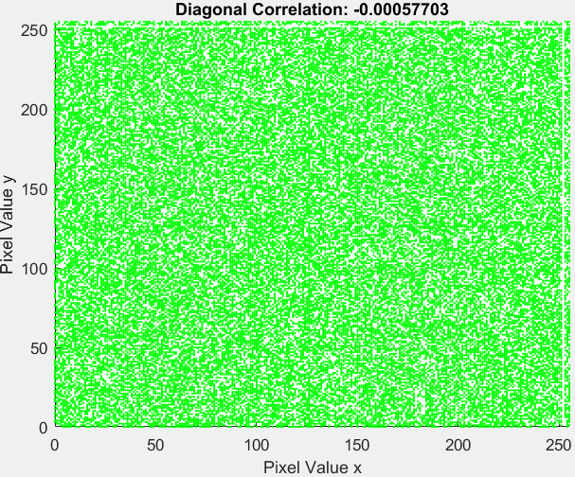

Figure 5: Scatter Diagram for Original and Encrypted CT Image.

2. NUMERICAL MEASUERS
A. Correlation Coefficient

By calculating the correlation coefficients, the correlation between neighboring pixels is further examined quantitatively; the outcomes are displayed in Table 2. The acquired results make it evident that, in contrast to the original plain image's considerable correlation between neighboring pixels, our encryption approach significantly decreased that correlation along the three directions. The encrypted image's correlation coefficients are around 0, while the plain images are near one.
Table 2: Correlation Coefficients for Different Between Image Pixels Test Images
Images | Original Image Correlation  Horz. Vert. Diag. |  |  | Encrypted Image Correlation  Horz. Vert. Diag.
CT | 0.95771 | 0.97786 | 0.94001 | -4.5906e-05 | 0.0031419 | -0.00057703
MRI | 0.94412 | 0.94426 | 0.90087 | 0.0011392 | -0.0059588 | 0.0026612
OT | 0.99155 | 0.9906 | 0.98178 | 0.0027905 | 0.0026541 | 0.0011633

B. Information Entropy
The randomness or predictability of the distribution of pixel intensity levels is evaluated numerically by the entropy [22]. Peak entropy is a uniform distribution for a collection of symbols. It is anticipated to have low entropy due to the original simple image's uneven distribution of pixel color values. A securely encrypted image should have a high entropy value because, in order to prevent information leaking, the encrypted image's pixel values should appear uniformly random. For a grayscale image with pixel values represented by a single byte, the entropy can be computed as follows:

Entropy = -$\sum_{i=1}^{2^{8}}{P(S_{i})}\log_{2}{(P(s_{i}))}$ (11)

In this case, the encrypted image is considered unpredictable for an entropy value of approximately 8, with 2⁸ different pixel values. The images encrypted with our approach have high entropy values near 8 as desired, as can be seen from the findings in Table 3.

Table 3: Entropy values for the test images.
Images | Entropy  Encrypted
CT | 7.9886
MRI | 7.9891
OT | 7.9889

- Differential measures

In this subsection, we first define the differential measures that we used in our experiments. Generally speaking, these metrics are employed to evaluate how the two images differ [22].

The mean absolute error (MAE): Evaluates how much the comparable pixel values in an image 𝐸 and an image 𝑃 differ from one another. Let 𝑊 and 𝐻 be the width and height of the image, respectively.
MAE = $\frac{1}{W*H}\sum_{i=1}^{H}{\sum_{j=1}^{W}{\left|P\left(i,j\right)-E(i,j)\right|}}$ (12)

The mean Square Error (MSE): The mean square error value provides an additional measure of the difference between an image 𝐸 and an image 𝑃. The mean square error is calculated using the following equation:
MSE = $\frac{\sum_{i=1}^{H}{\sum_{j=1}^{W}{{[P\left(i,j\right)-E (i,j)]}^{2}}}}{W*H}$ (13)
An effective encryption method should yield an image that differs significantly from the original. Therefore, both the MAE and MSE values should be high if the image 𝐸 represents the plain image and the image 𝐸 represents the encrypted image. The mean square error is inversely related to the Peak-Signal-to-Noise Ratio (PSNR), which is a logarithmic representation of it. A high PSNR value suggests that the two images are fairly similar.
Two other numerical metrics to estimate the similarity between two images are the unified averaged changed intensity (UACI) and the number of changing pixel rate (NPCR) [22].

NPCR = $\frac{\sum_{i,j}{D(i,j)}}{m*n}×100 \%$ (14)
UACI = $\frac{1}{m×n}\left(\sum_{i, j}{\frac{\left|C\left(i, j\right)-C^{'}\left(i, j\right)\right|}{255}}\right) ×100\%$ (15)

where (m, n) represent the image's width and height, respectively. Di,j is a binary variable that takes on the value "1" if the two corresponding pixels in the two photos are identical and zero otherwise. In this case, C and C′ are the two images. The value of UACI should be approximately 33% to signal that two photos are substantially distinct [22].

Table 4 presents the NPCR and UACI values for the CT, MRI, and OT encrypted images. The NPCR values for all test images exceed 99.57%, indicating that the proposed encryption algorithm is highly sensitive to small changes in the plaintext image, a desirable property for resisting differential attacks. The UACI values range between 36.51% and 42.03%, which is close to the theoretical ideal of 33%–40% for strong image encryption schemes. These results confirm that even a single-pixel change in the original medical image leads to substantial changes in the cipher image, ensuring high security against chosen-plaintext and differential cryptanalysis
Table 4: NPCR and UACI values for the different test images.
Images | NPCR% | UACI %
CT | 99.5773 | 42.0319
MRI | 99.6277 | 37.0130
OT | 99.6048 | 36.5176

As presented in Table 5, the original CT image exhibits strong adjacent pixel correlation coefficients in the horizontal (0.95771), vertical (0.97786), and diagonal (0.940010) directions. After encryption with the proposed method, these correlations are reduced to near-zero values of -4.5906e-05, 0.0031419, and -0.00057703, respectively, demonstrating a significant disruption of spatial redundancy. In comparison, the method in [23] achieves residual correlations of −0.003013, −0.004488, and 0.0006500, which are slightly higher in magnitude than those produced by the proposed scheme in certain directions. Moreover, the encrypted image entropy of 7.9886 obtained by the proposed approach is close to the ideal value of 8, comparable to the 7.999293 of [23], indicating a uniformly distributed cipher histogram and strong resistance against statistical attacks.

Table 5: Comparison between the proposed algorithm and other scheme.
Images | Original Image Correlation  Horz. Vert. Diag. |  |  | Encrypted Image Correlation  Horz. Vert. Diag. |  |  | Entropy
CT (proposed Method) | 0.95771 | 0.97786 | 0.94001 | -4.5906e-05 | 0.0031419 | -0.00057703 | 7.9886
CT[23] | 0.976088 | 0.972538 | 0.953250 | -0.003013 | -0.004488 | 0.000650 | 7.999293

- Conclusion

In this paper, a medical image encryption framework was developed by integrating a Nonlinear Self-Adaptive Particle Swarm Optimization (NSPSO) algorithm with a hybrid chaotic map for evolving cryptographically robust S-boxes. The proposed approach simultaneously optimizes multiple security metrics, including nonlinearity, differential uniformity, and autocorrelation, ensuring that the generated S-boxes exhibit strong confusion and diffusion properties. These optimized S-boxes were then embedded into a secure encryption scheme for medical images, where comprehensive statistical, entropy-based, and differential analyses were conducted. The experimental results demonstrated that the proposed method achieves NPCR values above 99.57%, UACI within the ideal range, entropy close to 8 bits, and negligible correlation between adjacent pixels, confirming high resistance to statistical and differential attacks. Furthermore, the hybrid chaotic initialization enhanced population diversity in the NSPSO, improving optimization convergence and encryption quality. Owing to its strong security guarantees, the proposed framework holds significant potential for secure telemedicine and cloud-based healthcare systems, where the protection of sensitive medical data is paramount. Future work will explore extending this approach to color images, real-time encryption scenarios, and integration with emerging lightweight cryptographic protocols for resource-constrained medical IoT devices

REFERENCES
[1] Houser, Shannon H., Cathy A. Flite, and Susan L. Foster. "Privacy and security risk factors related to telehealth services–a systematic review." Perspectives in health information management 20.1 (2023): 1f.
[2] Prabhavathi, K., and M. B. Anandaraju. "Security of Medical Images During Transmission: A Systematic Review." (2022).
[3] Yang, Sen, et al. "S-box generation algorithm based on hyperchaotic system and its application in image encryption." Multimedia Tools and Applications 82.17 (2023): 25559-25583.
[4] Hematpour, Nafiseh, and Sodeif Ahadpour. "Execution examination of chaotic S-box dependent on improved PSO algorithm." Neural Computing and Applications 33.10 (2021): 5111-5133.
[5] Poli, Riccardo, James Kennedy, and Tim Blackwell. "Particle swarm optimization: An overview." Swarm intelligence 1.1 (2007): 33-57.
[6] Alhadawi, Hussam S., et al. "A novel method of S-box design based on discrete chaotic maps and cuckoo search algorithm." Multimedia Tools and Applications 80.5 (2021): 7333-7350.
[7] Tian, Ye, and Zhimwith ao Lu. "S-box: Six-dimensional compound hyperchaotic map and artificial bee colony algorithm." Journal of Systems Engineering and Electronics 27.1 (2016): 232-241.
[8] Farah, Tarek, Rhouma Rhouma, and Safya Belghith. "A novel method for designing S-box based on chaotic map and teaching–learning-based optimization." Nonlinear dynamics 88.2 (2017): 1059-1074.
[9] Farah, MA Ben, A. Farah, and T. Farah. "An image encryption scheme based on a new hybrid chaotic map and optimized substitution box." Nonlinear Dynamics 99.4 (2020): 3041-3064.
[10] Ahmad, Musheer, et al. "Particle swarm optimization based highly nonlinear substitution-boxes generation for security applications." IEEE Access 8 (2020): 116132-116147.
[11] Ahmad, Musheer, et al. "Multi-objective evolution of strong S-boxes using non-dominated sorting genetic algorithm-II and chaos for secure telemedicine." IEEE Access 10 (2022): 112757-112775.
[12] Li, Xin, et al. "A multi-objective particle swarm optimization algorithm based on enhanced selection." IEEE Access 7 (2019): 168091-168103.
[13] Kennedy, James, and Russell Eberhart. "Particle swarm optimization." Proceedings of ICNN'95-international conference on neural networks. Vol. 4. ieee, 1995.
[14] Cusick, Thomas W., and Pantelimon Stanica. Cryptographic Boolean functions and applications. Academic Press, 2017.
[15] Biham, Eli, and Adi Shamir. "Differential cryptanalysis of DES-like cryptosystems." Journal of CRYPTOLOGY 4.1 (1991): 3-72.
[16] Kavut, Selçuk. "Results on rotation-symmetric S-boxes." Information Sciences 201 (2012): 93-113.
[17] Hayat, Umar, et al. "A truly dynamic substitution box generator for block ciphers based on elliptic curves over finite rings." Arabian Journal for Science and Engineering 46.9 (2021): 8887-8899.
[18] Dimitrov, Miroslav M. "On the design of chaos-based S-boxes." IEEE Access 8 (2020): 117173-117181.
[19] Burnett, Linda Dee. Heuristic optimization of Boolean functions and substitution boxes for cryptography. Diss. Queensland University of Technology, 2005.
[20] Xiaosong Gao and Xingbin Liu. CLSM-IEA: a novel cosine-logistic-sine map and its application in a new image encryption scheme. Signal, Image and Video Processing, 18(4):3063–3077, 6 2024.
[21] Amaithi Rajan, Arun, and Vetriselvi Vetrian. "QMedShield: a novel quantum chaos-based image encryption scheme for secure medical image storage in the cloud." Journal of Modern Optics 71.13-15 (2024): 524-542.
[22] Elkamchouchi, Hassan, Rosemarie Anton, and Yasmine Abouelseoud. "New encryption algorithm for secure image transmission through open network." Wireless Personal Communications 125.1 (2022): 45-62.
[23] Fu, Chong, et al. "A novel medical image protection scheme using a 3-dimensional chaotic system." PloS one 9.12 (2014): e115773.

