Original Research Article

Exploring Lac Infection Dynamics and Management Strategies in A J C Bose Indian Botanic Garden: A Study on Host Plant Interactions and Ecological Implications

.
ABSTRACT
Lac, a resinous secretion produced by the lac insect Kerria lacca (Kerr), plays an integral role in various ecological processes, including plant defence mechanisms and lignin degradation. However, when this insect infects host plants, it can lead to significant morphological, anatomical as well as ecological disruptions. This study explores the dynamics of lac infection within the A J C Bose Indian Botanic Garden (AJCBIBG), which serves as a critical hub for ex-situ conservation and a repository of highly significant plant germplasm, many of which are limited distribution across the country. The garden’s diverse plant communities, including endemic, threatened, and medicinal species, are vital for biodiversity conservation. The research focuses on the intricate interaction between lac insects and their host plants, the ecological consequences of lac infection, and the development of sustainable, non-chemical strategies for managing lac infestation. The study aims to establish effective protocols for pruning infected plants and preventing the spread of lac infection, specifically through regular mechanical intervention. The research highlights the negative ecological consequences of lac infection, which not only affect the health of host plants but also disrupt plant communities under the canopy, diminishing overall biodiversity in the garden. The alternative use of bio or natural insecticides, while generally safer than synthetic ones, can still pose risks to non-target insects, including beneficial ones, like pollinators and helpful soil microbes etc. By identifying optimal pruning periods and focusing on specific plant species most susceptible to infection, this study seeks to mitigate the ecological impacts while enhancing plant recovery and sustaining lac production. This research provides valuable insights into the balance between ecological conservation, the preservation of rare plant species, and the economic potential of lac, offering a pathway for sustainable management in botanical conservatories, urban plantations, and forest ecosystems.

Keywords: Lac, host plant, AJCBIBG, etc.
1. INTRODUCTION

The A J C Bose Indian Botanic Garden stands as a testament to India's rich botanical heritage, housing a diverse array of plant species crucial for ecological balance and human sustenance. It also plays a crucial role in ex situ conservation, preserving plant species outside their natural habitats, ensuring the survival of threatened species, and maintaining biodiversity (Anonymous, 2023). Amidst this botanical marvel, the intricate interplay between lac insects and their host plants presents a fascinating ecological phenomenon worthy of investigation. Lac, a resinous secretion produced by scale insects, Kerria lacca (Kerr) (Chen et al., 2011), holds significant economic and ecological importance, particularly in the context of the Indian Botanic Garden. Lac is reddish, brittle, solid, rich in resin (68-90%), wax, minerals, sugar, dye, water are also present in small amount. The quality and color of lac depend on gum and resin present in host plant. Lac is insoluble in water but soluble in alcohol. Lac infestation can negatively affect the health of host plants in the botanical conservatory, potentially disrupting the garden’s ecological balance, hindering plant growth, and threatening the survival of key species. This research endeavours to develop a protocol for manual control of Lac infection to spread over plant conservatories and forests and the impacts of Lac infection on various host plants and ensure sustainable lac production without harming the ecological health of the garden. (Kumar., 2013). Understanding these dynamics is pivotal for maintaining the garden's ecological equilibrium while harnessing the economic potential of lac production sustainably. As a non-timber forest product, Lac finds multifaceted utilization in industries ranging from paints and varnishes to traditional medicinal practices like Ayurveda. However, the proliferation of lac infection poses challenges to the health of host plants, thereby necessitating a comprehensive examination of its impacts and effective management strategies. India produces the highest amount of lac followed by Bangladesh and Myanmar and contributes about 50-60% of the world’s total lac production (Borah et al., 2020). About 113 species of host plants are found to be lac host plants, but only a few of them are found to be commercially important for lac culture in India (Sharma, K.K., 2017). The host plants of A J C Bose Indian Botanic Garden, including but not limited to Butea monosperma (Lam.) Kuntze (Palash), Schleichera oleosa (Lour.) Oken (Kusum), and Ziziphus mauritiana Lam. (Ber), serve as crucial habitats for lac insects. These host plants contribute about 90 % of total national lac production (Kerketta, 2023). Yet, the intricate relationships between these plants and lac insects are susceptible to disruption, leading to ecological imbalances and economic repercussions. By unravelling the complexities of lac infection dynamics and management strategies within the unique ecosystem (Daily., 1997) of A J C Bose Indian Botanic Garden, this study endeavours to contribute valuable insights to both ecological conservation efforts and detrimental impacts of lac infection on host plants' health. Furthermore, it seeks to explore potential remedial measures, encompassing biological interventions, to mitigate lac infestation.

2. material and methods

2.1 Study Area

The AJC Bose Indian Botanic Garden, also known as 'Company Bagan' or the 'Royal Botanic Garden,' stands as a venerable gem among the botanical wonders of Southeast Asia. Revered for its impeccable landscaping, it sprawls over a vast expanse of 110 hectares (273 acres), adorned with 26 interconnected lakes seamlessly linked to the Ganges through sluices for the regulated flow of water. This botanical marvel showcases an extensive array of flora, encompassing endemic, threatened, medicinal, economically significant, and ornamental plants across 25 meticulously curated divisions. Established in 1787 by Col. Robert Kyd with the noble aim of introducing socially and economically valuable trees from around the globe, the garden has evolved into a sanctuary for the ex-situ conservation of endemic, threatened, and economically important plant species (Chowdhery et al., 2007). Today, it stands as a living testament to nature's bounty, 1377 species within its verdant embrace (Chowdhery et al., 2007, Debnath et al., 2014) (see Fig. 1). Unlike other earlier established gardens in India which were later turned into either horticultural or fruit gardens, AJCBIBG preserves one of the best collections of native and exotic plants and a large number of curious, endemic and threatened species. Rich collections of bamboos, screw pines, palms, jasmines, bougainvilleas, legumes, water lilies, orchids etc are some of the proud possessions of this garden. AJCBIBG undoubtedly played a significant role in introducing, multiplying and distributing many endemics, threatened and commercially important plants from various parts of the world. Introduction of some of the notable species like tea, cinchona, mahogany, rubber etc. directly influenced the welfare of people and socio-economic development of the country.
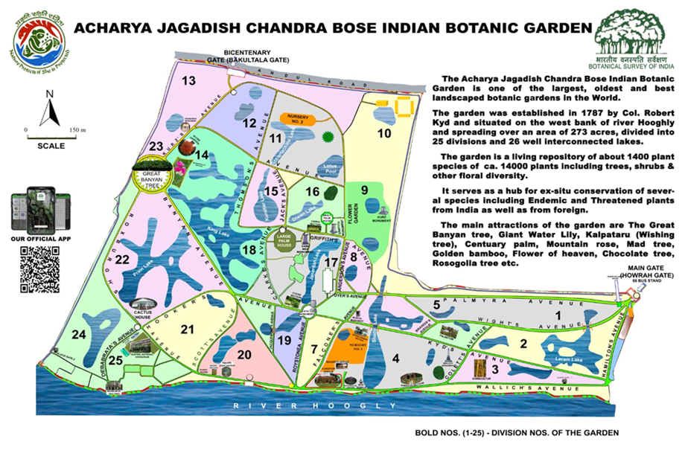
FIG. 1 Map of the AJC Bose Indian Botanic Garden
2.2 Detailed Methodology
A comprehensive survey was undertaken at different divisions and sections of the AJC Bose Indian Botanic Garden to assess the occurrence of lac and potential hosts throughout the year. Delving into various facets of each host plant species, including its source, frequency, habitat, population, and characteristics, meticulous records were kept using a predefined format (Kumar., 2013). Noteworthy specimens were carefully collected for further identification, with thorough consultation of diverse literature, pictorial guides, and taxonomic references. The plant names were meticulously cross-referenced with authoritative botanical databases for accurate identification. In parallel, systematic pruning of lac-infected branches was conducted across different seasons to observe the healthy regeneration of persistence young twigs, with detailed data logging to determine optimal pruning timings for mechanical intervention against lac infection (see Fig. 2). Furthermore, the ecological impact of different infected plants was scrutinized, particularly focusing on the understory canopy area, to gauge the broader ecological ramifications. Through this multifaceted approach, a deeper understanding of lac host plants and their ecological dynamics was achieved, paving the way for informed conservation and management strategies (see Table. 1)
Table 1: A multifaceted approach to lac host plants about their ecological dynamics, conservation and management strategies
Sl. No. | Scientific Name | Family | Common Name | Division No. | No. of infected Plants in each division | Average Length of infected branches to be pruned in each plant (in meters) | Average Weight of branches collected for lac in each plant (in Kg) | Month of pruning | Number of plants reinfected after pruning | percentage of reinfection after pruning in %
 | Adenanthera pavonina L. | Fabaceae | False Sandalwood Tree | 1 | 1 | 2-3 | 25 | March | 5 | 100
 |  |  |  | 7 | 2 | 2-3 | 25 | June | 5 | 100
 |  |  |  | 8 | 2 | 2-3 | 25 | September | 3 | 60
 |  |  |  |  | Total - 5 | 2-3 | 25 | December | 0 | 0
 | Albizia lebbeck (L.) Benth. | Fabaceae | Sirish | 1 | 2 | 4-5 | 30 | March | 11 | 91.67
 |  |  |  | 2 | 1
 |  |  |  | 4 | 1 | 4-5 | 30 | June | 11 | 91.67
 |  |  |  | 7 | 1
 |  |  |  | 9 | 1 | 4-5 | 30 | September | 8 | 66.67
 |  |  |  | 12 | 2
 |  |  |  | 21 | 1 | 4-5 | 30 | December | 1 | 8.33
 |  |  |  | 22 | 1
 |  |  |  | 24 | 2
 |  |  |  |  | Total - 12
 | Butea monosperma (Lam.) Kuntze | Fabaceae | Palash | 18 | 4 | 1-2 | 6 | March | 6 | 100
 |  |  |  |  |  |  |  | June | 6 | 100
 |  |  |  | 12 | 2 | 1-2 | 6 | September | 5 | 83.33
 |  |  |  |  | Total - 6 | 1-2 | 6 | December | 1 | 16.66
 | Samanea saman (Jacq.) Merr. | Fabaceae | Rain Tree | 1 | 4 | 4-5 | 40 | March | 24 | 92.30
 |  |  |  | 2 | 3
 |  |  |  | 4 | 3
 |  |  |  | 5 | 2 | 4-5 | 40 | June | 21 | 80.76
 |  |  |  | 7 | 1
 |  |  |  | 8 | 4
 |  |  |  | 10 | 1 | 4-5 | 40 | September | 17 | 65.38
 |  |  |  | 11 | 1
 |  |  |  | 14 | 1
 |  |  |  | 17 | 2 | 4-5 | 40 | December | 2 | 7.69
 |  |  |  | 21 | 1
 |  |  |  | 23 | 2
 |  |  |  | 24 | 1
 |  |  |  |  | Total - 26
 | Senegalia catechu (L.f.) P.J.H.Hurter & Mabb. | Fabaceae | Babul | 22 | 2 | Less than 1 | 5 | March | 2 | 100
 |  |  |  |  |  |  |  | June | 2 | 100
 |  |  |  |  | Total - 2 | Less than 1 | 5 | September | 1 | 100
 |  |  |  |  |  |  |  | December | 0 | 0
 | Cassia fistula L. | Fabaceae | Amaltash | 14 | 4 | 1-2 | 5 | March | 8 | 100
 |  |  |  |  |  |  |  | June | 6 | 75
 |  |  |  | 15 | 4 | 1-2 | 5 | September | 5 | 62.5
 |  |  |  |  | Total - 8 | 1-2 | 5 | December | 0 | 0
 | Ficus benghalensis L. | Moraceae | Bar | 1 | 1 | 1-3 | 12 | March | 7 | 100
 |  |  |  | 2 | 2
 |  |  |  | 8 | 1 | 1-3 | 12 | June | 6 | 85.71
 |  |  |  | 17 | 1 | 1-3 | 12 | September | 6 | 85.71
 |  |  |  | 20 | 1 | 1-3 | 12 | December | 1 | 14.28
 |  |  |  | 23 | 1
 |  |  |  |  | Total - 7
 | Ficus racemosa L. | Moraceae | Cluster Fig | 22 | 1 | 1-2 | 10 | March | 2 | 100
 |  |  |  |  |  |  |  | June | 2 | 100
 |  |  |  | 24 | 1 | 1-2 | 10 | September | 1 | 50
 |  |  |  |  | Total - 2 | 1-2 | 10 | December | 0 | 0
 | Ficus religiosa L. | Moraceae | Pepal | 1 | 2 | 1-3 | 10 | March | 8 | 88.88
 |  |  |  | 2 | 1
 |  |  |  | 10 | 1 | 1-3 | 10 | June | 6 | 66.67
 |  |  |  | 12 | 1 | 1-3 | 10 | September | 6 | 66.67
 |  |  |  | 22 | 1 | 1-3 | 10 | December | 1 | 11.11
 |  |  |  | 24 | 3
 |  |  |  |  | Total - 9
 | Ficus rumphii Blume | Moraceae | Pilkhan | 5 | 3 | 1-3 | 6 | March | 5 | 100
 |  |  |  |  |  |  |  | June | 5 | 100
 |  |  |  | 22 | 2 | 1-3 | 6 | September | 4 | 80
 |  |  |  |  | Total - 5 | 1-3 | 6 | December | 1 | 20
 | Ziziphus mauritiana Lam. | Rhamnaceae | Ber | 2 | 3 | Less than 1 | 5 | March | 6 | 85.71
 |  |  |  |  |  |  |  | June | 6 | 85.71
 |  |  |  | 17 | 4 | Less than 1 | 5 | September | 3 | 42.85
 |  |  |  |  | Total - 7 | Less than 1 | 5 | December | 0 | 0
 | Schleichera oleosa (Lour.) Oken | Sapindaceae | Kusum | 8 | 2 | 1-3 | 20 | March | 5 | 62.5
 |  |  |  | 14 | 2 | 1-3 | 20 | June | 5 | 62.5
 |  |  |  | 25 | 4 | 1-3 | 20 | September | 4 | 50
 |  |  |  |  | Total - 8 | 1-3 | 20 | December | 1 | 12.5
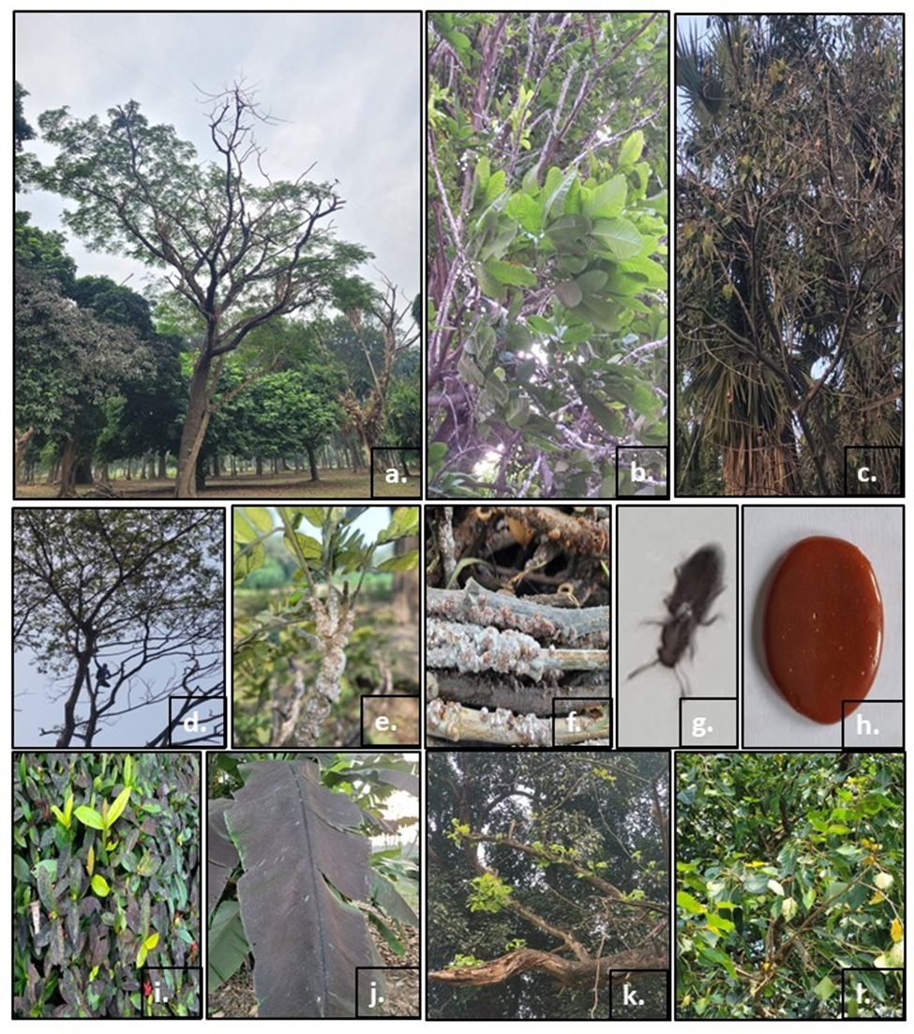
FIG. 2 a, b & c. Lac infected plants Samanea saman (Jacq.) Merr., Schleichera oleosa (Lour.) Oken, Ficus rumphii Blume d. Pruning of lac infected branches e. Lac infected twig of [Samanea saman (Jacq.) Merr.] f. Lac infected branches, g. Lac insect Kerria lacca (Kerr), h. Raw lac, i & j, Effect on other plants present under the canopy of a lac infected plants, k & l, regeneration of new healthy twigs after pruning in Samanea saman (Jacq.) Merr. & Ficus rumphii Blume

3. results and discussion

The age-old prestigious garden harbours approximately 1377 species belonging to 135 taxonomic families (Chowdhery et al., 2007, Debnath et al., 2014) of which it has been observed that 4 families predominate for insect manifestation. During the study it has been found that the plant species viz., Adenanthera pavonina L., Albizia lebbeck (L.) Benth., Butea monosperma (Lam.) Kuntze., Samanea saman (Jacq.) Merr., Senegalia catechu (L.f.) P.J.H.Hurter & Mabb., Cassia fistula L. belonging to family Fabaceae are mostly prone to infection followed by the plant species Ficus benghalensis L. Ficus racemosa L., Ficus religiosa L., Ficus rumphii Blume belonging to family Moraceae. Ziziphus mauritiana Lam. (Rhamnaceae) and Schleichera oleosa (Lour.) Oken (Sapindaceae) are least likely to be affected amongst these twelve species. Among the species, most of them have their natural habitat distribution in different biogeographic regions of India, ranging from Northern wet tropical forests, Southern wet tropical evergreen forests, Tropical Semi-Evergreen Forest, Tropical Moist Deciduous Forest, Tropical Dry Deciduous Forests, Sub-Tropical Dry Evergreen Forests, (Bhatnagar et al., 2020, Champion et al., 1968). The infection spread to all branches of the tree and it was also noticed that the plants under the canopy coverage area of the infected trees were all affected. The leaf shape of Samanea saman (Jacq.) Merr. Is shrinked due to lac infection (Sen et al., 1963). The leaves of all the plants get covered with blackish exudate of the affected tree. It is interesting to note that several microorganisms feed on this exudate. The biochemical composition of the exudate is yet to be studied. After the pruning of lac-infected twigs, healthy shoots regenerate from the same tree. The plants in divisions 1,2,3 and 4 are mostly affected amongst all the 25 divisions of the garden. Amongst all the plant species that got infected by the lac insect, it is being noticed that the species Samanea saman (Jacq.) Merr. is highly prone to lac infection. The study mainly focuses on remedial measures employing mechanical intervention against lac infection without the use of chemical/organic pesticides. Only by regular pruning we are trying to minimize the effect of infection on plants. It is also observed that the best time to prune the plant is about in the last month of the year, at that time the optimal mechanical intervention can be achieved in the repeated infection. The infected plants are pruned 4 times in a year i.e., in March, June, September, and December, and the quantitative and qualitative data was recorded. It has been found that if the pruning was done in December the healthy twigs would be regenerated in between January and those branches would get enough time to harden their epidermal layer of stem and strengthen the cuticle, that is a natural mechanism of the tree to protect themselves from lac infection.

4. Conclusion

As climate change has a lot of negative impact on biodiversity, the host (plants) interaction and their mutability can be accessed over the years through proper study. The molecular and phylogenetical study can also be done to monitor the host specific interaction with different host plant to get a clear idea on this point. Generally, insects are considered notorious based on their nature and harmful effect on several plants specially crops but some insects like lac yielding insects may be considered beneficial if their yield (lac) is considered. During the survey the special attention is given to the trees, the nature of the infection, the effect of the exudate to the plants within the canopy area are noted down as the trees get infested naturally by this insect (without any human intervention) because the garden is an experimental garden and there is no scope for commercial exploitation of any kind of plant yield. As this garden is one of the largest conservational hubs for immense number of endemics, threatened, medicinal, wild edible and economically important plants, though it is a 1st priority to protect those plants from different infections as well as adverse ecological effects spread by the infected plants. The alternative use of bio or natural insecticides, while generally safer than synthetic ones, can still pose risks to non-target insects, including beneficial ones, like pollinators and helpful soil microbes etc (Serrão et al. 2022). It is also noteworthy to address that by regular pruning the productivity of the lac can be increased (Das et al., 2013) but in the same way to get rid of lac infection and recovery of the infected as well as under canopy plants can be achieved by choosing, the right month for pruning in the year (December). The research aims to mitigate lac infection spread within botanical conservatories, urban plantations, and forest habitats by implementing a manual, cost-effective eradication method, devoid of insecticides that may induce harmful ecological repercussions.

References

Anonymous. (2023). Acharya Jagadish Chandra Bose Indian Botanic Garden. EIACP, Botanical Survey of India, Kolkata. 1-30.
Bhatnagar, P., Prajapati, S., Lodhi, B., Bhalawi, R. and Aarmo, B.S. (2020). Studies on lac host plant occurrence in different Agro-climatic zones of Madhya Pradesh. International Journal of Ecology and Environmental Sciences, 2(4), pp.197-204.
Borah, N. and Garkoti, S.C. (2020). Indigenous lac culture and local livelihood: A case study of Karbi community of Assam, North-Eastern India. International Journal of Traditional Knowledge (IJTK). 19(1). pp. 197-207
Champion, H. G., & Seth, S. K. (1968). A revised survey of the forest types of India. Manager of publications.
Chen, X., Chen, H., Feng, Y., He, R., & Yang, Z. (2011). Status of two species of lac insects in the genus Kerria from China based on morphological, cellular, and molecular evidence. Journal of Insect Science, 11(1), 106.
Chowdhery, H. J., & Pandey, D. S. (2007). Plants of Indian botanic garden. Botanical Survey of India.
Daily, G. C. (1997). Introduction: what are ecosystem services. Nature’s services: Societal dependence on natural ecosystems, 1(1).
Das, R., & Kumar, A. (2013). Lac cultivation and rural livelihood. Prospects of scientific lac cultivation in India. IFP, 217-231.
Debnath, H. S., Mahapatra, H. S., Hameed, S. S., & Sreekumar, P. V. (2014). Census of Plants in AJC Bose Indian Botanic Garden: A Report. Botanical Survey of India, Ministry of Enviornment & Forests.
Kerketta, K.R. (2023). LAC - A Good Source of Livelihood in Jharkhand. International Journal for Multidisciplinary Research (IJFMR). 5(4) 1-16.
Kumar, A., & Kumar, A. (2013). Lac insect host plants of India. Prospects of Scientific lac cultivation in India. Institute of Forest Productivity, Ranchi, 22-26.
Sen, J., & Basu, S. K. (1963). Variated Leaf Shape of Infected Plants of Samanea saman (Jacqu.) Merr. Nature, 198(4875), 103-103.
Serrão, J. E., Plata-Rueda, A., Martínez, L. C., & Zanuncio, J. C. (2022). Side-effects of pesticides on non-target insects in agriculture: A mini-review. The Science of Nature, 109(2), 17.
Sharma, K. K. (2017). Lac insects and host plants. Industrial Entomology, 157-180.

