Review Article

“Immuno-Oncology from a Chemist’s Lens: Small Molecules Modulating the Tumor Immune Microenvironment.”

Abstract
Immuno-oncology (IO) has changed the way we treat cancer by using the immune system to find and kill cancer cells. The main idea behind this method is to change the tumor immune microenvironment (TIME), which is a complicated ecosystem made up of immune, stromal, and malignant cells that are controlled by complicated signaling networks. Biologics like monoclonal antibodies and CAR-T cells have shown to be quite effective against specific malignancies, but they are not very useful in the clinic since they have trouble getting into tumors, are hard to make, are toxic to the whole body, and don't work on a wide range of immunological targets.
In this situation, tiny molecules have become important and useful instruments in IO. They are useful for changing immunological activity within the TIME because they have advantages including being able to be taken orally, being able to be made in different ways, having adjustable pharmacokinetics, and being able to affect both intracellular and allosteric targets. This study looks at the world of small molecules in IO, including immune checkpoint inhibitors (like PD-1/PD-L1 antagonists), STING and TLR agonists, metabolic reprogrammers (such IDO1 and A2A receptor inhibitors), and drugs that change the way immunosuppressive cells like TAMs and Tregs work. We also talk about new types of drugs, like covalent inhibitors, PROTACs, and delivery methods that respond to stimuli. Even if there have been some encouraging breakthroughs, there are still big problems to solve, such as systemic toxicity, immune evasion, and tumor heterogeneity. To solve these problems, chemistry, immunology, and clinical science will need to work together. With ongoing research and development, small molecules are likely to become key parts of precision immunotherapy, opening up new ways to treat cancer that last and are tailored to each patient.

1. Introduction
The tumor immune microenvironment (TIME) is a dynamic and highly organized cellular and molecular environment that plays a key role in how tumors grow, how well they respond to treatment, and how well the immune system can detect them (Figure 1). The TIME is made up of a wide range of immune cell subsets, such as T lymphocytes, regulatory T cells (Tregs), myeloid-derived suppressor cells (MDSCs), tumor-associated macrophages (TAMs), and dendritic cells (DCs). It also has a complicated network of cytokines, chemokines, and immunomodulatory metabolites. The TIME is not just a passive bystander; it is also an active participant in shaping the course of oncogenesis. Immunological "cold" cancers, which include signaling that suppresses the immune system and cells that are kept out of the tumor, are generally resistant to standard treatments[1]. On the other hand, "hot" tumors, which have a lot of immune cells in them, have a better prognosis and are more likely to respond to treatment. So, changing the TIME from a state that suppresses the immune system to one that boosts it is still a big problem and chance in modern oncology[2].
Immuno-oncology (IO) has changed cancer treatment in the last ten years, and immune checkpoint inhibitors, especially monoclonal antibodies that target PD-1, PD-L1, and CTLA-4, have had more clinical success than ever before. Biologic drugs do have several drawbacks, though, that make them less effective: they don't penetrate tumors well because their molecules are so huge, they can't be taken by mouth, they can cause immune reactions, their manufacturing procedures are complicated, and they don't spread well through tissues[3]. Also, long-lasting responses are still only seen in a small group of patients, which shows how important it is to find new or additional treatments that can change the immunological environment of tumors.
This is a one-of-a-kind and underused chance for synthetic chemistry. Small molecules have long been thought to be the key to new drugs[4]. They have some advantages over biologics, such as being modular, having configurable physicochemical qualities, being able to penetrate tissues better, and being able to be taken by mouth. Chemists are in a unique position to create and make chemicals that specifically change immunological pathways, either by directly interacting with immune checkpoints or by changing the way biological components work within the TIME[5]. Also, new chemical biology tools like bioorthogonal conjugation strategies, proteolysis-targeting chimeras (PROTACs), and photochemical activation (Figure 3) have made it possible to manipulate immune modulation in ways that were never possible before[6].
This review looks at the new area of small molecules as modulators of the tumor immune microenvironment from a chemist's point of view. We will talk about important groups of chemicals that interact with innate and adaptive immune pathways, target metabolic circuits that inhibit the immune system, or change the functional phenotype of immune and stromal cells in malignancies. We want to use this lens to show the rational design principles, synthetic obstacles, and translational prospects that make up the interface of chemistry and immuno-oncology.

2. The Tumor Immune Microenvironment (TIME): A Primer for Chemists
The tumor immune microenvironment (TIME) is a complex and spatially heterogeneous ecosystem that is very important for figuring out how tumors grow, how they avoid the immune system, and how well treatments work. At its core, the TIME is a constantly changing interaction between cancer cells and a wide range of immune and stromal cells, all controlled by a carefully tuned network of chemical signals[7]. Chemists who want to make tailored modulators of this milieu need to have a deep understanding of its cellular and biochemical structure.
The immune cells in the TIME can be divided into two main groups: effector cells and suppressor cells. The main cells that fight tumors are cytotoxic CD8⁺ T cells and helper CD4⁺ T cells[8]. But their activity is often canceled out by immunosuppressive cell types such regulatory T cells (Tregs), myeloid-derived suppressor cells (MDSCs), and tumor-associated macrophages (TAMs) (Fgure 1). These suppressive groups not only stop T cells from activating and multiplying, but they also change the metabolic and cytokine environment to make it more immune-tolerant. Dendritic cells (DCs) are important for presenting antigens and priming T cells, but they often stop working in malignancies, which makes immune surveillance even less effective[9].
At the molecular level, the TIME is controlled by a complex web of cytokines (including IL-10, TGF-β, and IFN-γ), chemokines (like CCL2 and CXCL9/10), and immunological checkpoints (like PD-1/PD-L1, CTLA-4, and LAG-3) that control how immune cells move, change, and
work. These signaling molecules could be used as "intervention points" for pharmacological regulation, which would allow for the targeted boosting or repression of immunological pathways depending on the therapeutic goal. For example, small compounds can stop immunosuppressive cytokine signaling, stop checkpoint receptor-ligand interactions, or change the way that immune receptors send signals inside cells[10].
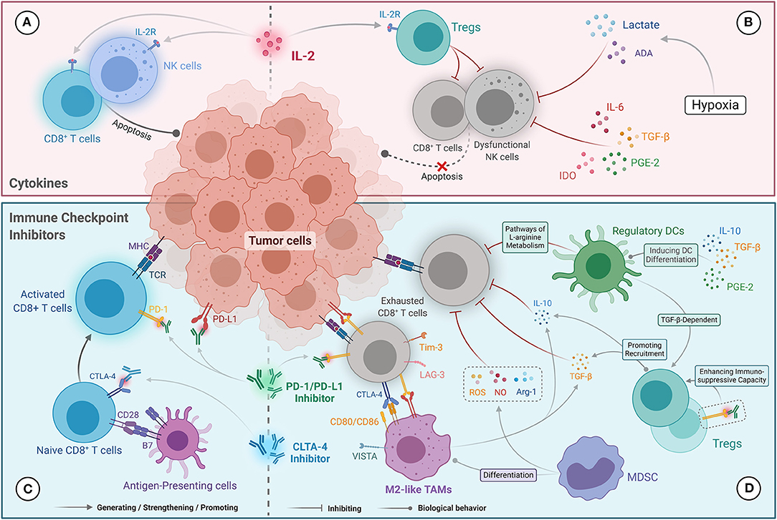
Figure 1. Potential mechanisms influencing immunotherapy response in the TIME in ccRCC. (A) The anti-tumor activity of cytokine (IL-2) therapies was primarily mediated by driving the proliferation and activation of NK cells and CD8⁺ TILs. (B) Resistance to cytokine (IL-2) therapies was correlated with the amplification of Tregs level mediated by IL-2 and NK cell dysfunction. IL-6, TGF-β, PGE2, and IDO, as well as lactate and adenosine generated under hypoxic conditions, inhibit the cytotoxic effects of NK cells. (C) The anti-tumor mechanisms of immune checkpoint inhibitors that contribute to the reactivation of CD8⁺ T cells were mediated by blocking the PD-1/PD-L1 and CTLA-4/CD28 pathways. (D) Resistance to immune checkpoint inhibitors is mainly mediated by CD8⁺ TILs anergy, which abundantly express immunosuppressive molecules (e.g., PD-1, CTLA-4, Tim-3, and LAG-3). Tregs and M2-like TAMs secrete IL-10 and TGF-β, which inhibit the cytotoxicity of CD8⁺ TILs and recruit Tregs. Tregs present a stronger immunosuppressive capacity under the action of PD-1 inhibitors. Ligands expressed on M2-like TAMs (including PD-L1/L2, CD80/86, and VISTA) can also promote exhaustion of CD8⁺ TILs. NO, ROS, and Arg-1 produced by MDSCs inhibit the anti-tumor immune function of CD8⁺ TILs, and promote differentiation into M2-like TAMs. Regulatory DCs can also inhibit CD8⁺ T-cell function via the L-arginine metabolic pathway and promote Tregs proliferation. (Lin et al., 2021)
Reference: Lin E, Liu X, Liu Y, Zhang Z, Xie L, Tian K, Liu J and Yu Y (2021) Roles of the Dynamic Tumor Immune Microenvironment in the Individualized Treatment of Advanced Clear Cell Renal Cell Carcinoma. Front. Immunol. 12:653358. doi: 10.3389/fimmu.2021.653358
The TIME is defined by its bipolar nature, which means that immunosuppressive and immunostimulatory forces exist and fight one other. Tumors can actively change this balance toward suppression by using metabolic competition (for example, by depleting glucose and tryptophan), expressing checkpoint ligands, and bringing in suppressive cells. To be successful, therapeutic modulation frequently needs two things: reducing suppressive effects and activating or restoring effector immunological activities at the same time. This "push-pull" model works well with small-molecule methods that can be fine-tuned for target selectivity and used in combination with other drugs[11,12].

Another important but frequently overlooked aspect of the TIME is how different it is in space and time. Not only can immune cells change between tumor types, but they also differ between various parts of the same tumor and as the disease progresses. Because of this, systemic regulation of the immune system may not be able to reach high enough levels in tumor niches that are immune-privileged or immunologically "cold." Chemistry has several unique answers to this problem: targeted drug delivery systems, prodrugs, and light-activated molecules can change things in a specific area, which lowers off-target toxicity and improves therapeutic precision.
To sum up, the TIME is both a problem and a chance for chemical intervention. Knowing how complex it is makes it possible to build tiny compounds that can strategically change this environment to boost anti-tumor immunity[13].

3. Small Molecule Immune Checkpoint Modulators
Immune checkpoint drugs, especially monoclonal antibodies that target programmed death receptor-1 (PD-1) and its ligand PD-L1, have shown that immune checkpoints play a key role in helping tumors avoid the immune system. These receptor-ligand interactions operate like molecular brakes on T cell activation, keeping the body from attacking itself while it is healthy but letting cancer cells escape the immune system. Biologic checkpoint inhibitors can be very effective for some patients, but they have a lot of problems[14]. For example, they are expensive to make, need to be given through an injection, don't penetrate tumors very well, have long half-lives that cause immune-related side effects to last a long time, and can be resistant to treatment. These problems have made people more interested in small molecule checkpoint inhibitors as a way to help or replace other treatments[15,16].
BMS-202 is one of the most studied small molecule inhibitors of the PD-1/PD-L1 axis (figure 2). Bristol Myers Squibb found it through high-throughput screening and it is a prototype chemical. BMS-202 doesn't bind to the PD-1 receptor; instead, it works allosterically on PD-L1 to make it dimerize and stop it from interacting with PD-1. This method is part of a larger plan to break up protein–protein interactions (PPIs), which were once thought to be "undruggable" because their flat and long interfaces made them hard to target. BMS-202 and its analogs show that it is possible to selectively and strongly disrupt PPIs with tiny compounds that have been carefully developed[17].

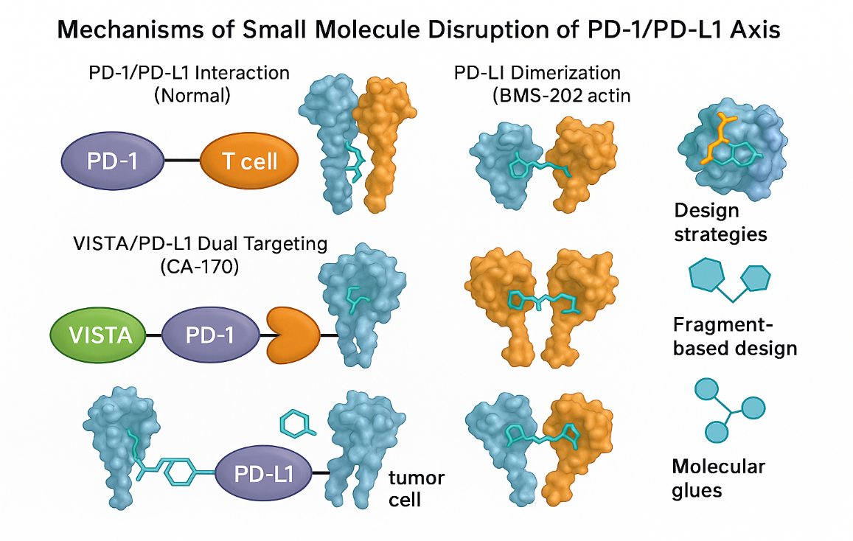

Figure 2: Mechanisms of Small Molecule Disruption of PD-1/PD-L1 Axis
showing key checkpoint-modulating strategies: normal PD-1/PD-L1 interaction between T cells and tumor cells suppresses immune activation, BMS-202 induces PD-L1 dimerization to prevent PD-1 binding allosterically, CA-170 simultaneously targets PD-L1 and VISTA to restore T cell function, while VISTA/PD-L1 dual inhibition expands checkpoint blockade beyond PD-1 for broader immunomodulation
CA-170 is another potential drug (figure 2). It is the first oral immune checkpoint modulator made by Aurigene and Curis. It is said to target both PD-L1 and VISTA (V-domain Ig suppressor of T cell activation). While the exact molecular mechanism of CA-170 is still being studied, preclinical studies show that it can restore T cell activity and stop tumor growth in syngeneic animals. The chemical has moved on to early-phase clinical trials, which gives us a look at how possible it is to suppress checkpoints orally[18].

Small molecules have many built-in benefits over monoclonal antibodies. Their oral bioavailability facilitates chronic dosing and patient compliance, while their low molecular weight ensures improved tumor penetration, particularly in solid tumors with high interstitial pressure or dense stroma. Also, they have shorter half-lives, which makes it easier to modulate immune modulation over time and may lessen the severity of immunological-related side effects.
Still, small molecule checkpoint inhibitors have some big problems to deal with. The PD-1/PD-L1 PPI interface covers a large, hydrophobic area, making it hard for things to stick to it tightly. Additionally, it is still hard to achieve selectivity over off-target immunological interactions. Even with these problems, progress in fragment-based drug design (FBDD) and computational docking has made it much easier to find and improve ligands that break up PPI interfaces. FBDD is very useful for finding low-affinity "fragments" that bind to hotspots on the PPI surface[19]. These fragments can then be turned into strong inhibitors with good pharmacokinetic features.
Molecular glues are tiny compounds that stabilize temporary protein complexes or create new interactions. This is a new idea in this field. This technique has mostly been used for targeted protein degradation, but it might also be used to change immunological checkpoints, which is a very interesting new area of research. For example, tiny compounds that help PD-L1 dimerization or internalization could have the same functional consequences as blocking receptors without having to directly compete at the canonical binding site.
Even though small molecule checkpoint inhibitors are still in the early stages of clinical development, breakthroughs in chemical biology and ideas greatly favor their future use in immuno-oncology. These drugs may make immune interventions more nuanced, scalable, and accessible when employed alone or with biologics, vaccines, or adoptive cell therapies. This is because the tumor microenvironment is so different from person to person[20].

4. STING, TLRs, and Innate Immune Modulators
Adaptive immune regulation has been the main focus of immuno-oncology, but targeting innate immune pathways has become a useful technique to boost anti-tumor immunity, especially in tumors that don't have T cell infiltration and are therefore "cold." The Stimulator of Interferon Genes (STING) pathway and Toll-like receptors (TLRs) are two important parts of the innate immune signaling network. When these sensors are turned on in the tumor immune microenvironment (TIME), they can start a chain reaction of pro-inflammatory cytokine production, dendritic cell activation, and the priming of cytotoxic T cells[21]. This is a different way to reprogram the immune system. (Table 1)
Scientists first made STING agonists based on how the body naturally responds to cytosolic DNA through cyclic dinucleotides (CDNs) such 2′3′-cGAMP. When STING is activated in antigen-presenting cells, it releases type I interferons and other inflammatory mediators, which make tumors more immunogenic[22,23]. However, CDNs are hard to transport throughout the body and into tumors because they are hydrophilic and can be broken down by enzymes. Chemists have solved these problems by making changes to the molecules themselves, such as adding phosphorothioate links, making the backbone more stiff, and using prodrug masking methods. Recently, non-nucleotide small-molecule STING agonists like diABZI and MSA-2 have demonstrated promise efficacy and drug-like qualities, which could make them suitable for oral use and provide them better pharmacokinetic profiles[24].

In the same way, TLR agonists boost innate immunity by recognizing patterns in microbial or viral motifs. Imiquimod and resiquimod are examples of TLR7/8 agonists that help dendritic cells and macrophages become active, which leads to the synthesis of cytokines and better presentation of antigens. Synthetic CpG oligonucleotides and other TLR9 agonists work by sensing DNA in endosomes to cause comparable immune-boosting effects. These drugs have been shown to work well in certain types of skin cancer and are being studied for usage inside solid tumors. But activating these pathways throughout the body could cause cytokine release syndrome and inflammation in the wrong place, which shows how important it is to deliver the drugs exactly where they are needed[25].

Different synthetic methods have been used to reduce systemic toxicity. Nanoparticle encapsulation, pH-sensitive carriers, and ligand-conjugated systems can send agonists to the tumor microenvironment more effectively. Also, new developments in prodrug chemistry and photoactivatable compounds make it possible to manage the timing and location of the drug, which reduces the amount of healthy tissue that is exposed while increasing the amount of immune activation inside the tumor.
Combining innate immune agonists with immune checkpoint inhibitors is an essential way to treat diseases[26]. When STING and TLR are turned on, they can change non-inflamed tumors into forms that have T cells in them, making them more sensitive to PD-1/PD-L1 inhibition. Preclinical studies show that certain combinations work better together, and early-phase clinical trials are looking at them in a number of different types of tumors. It is important to note that giving STING or TLR agonists locally may assist avoid systemic toxicities while establishing a pro-inflammatory milieu that encourages adaptive immune involvement[27].

on short, modifying innate immune sensors like STING and TLRs is a good area for small molecules to work on. These medicines are ready to play a big role in changing the TIME and increasing the therapeutic reach of immuno-oncology, thanks to new chemicals that make them more stable, easier to distribute, and safer.

5. Metabolic Modulation of the TIME by Small Molecules
Tumor cells change metabolic pathways in a big way, not just to help them grow but also to create an immunological microenvironment that keeps the immune system from working. Immunometabolic reprogramming is a general term for this process. It makes a hostile environment for immunological effector cells by competing for nutrients, building up toxic metabolites, and changing redox states. Immuno-oncology is moving into a new area with small medicines that target important metabolic nodes in the tumor immune microenvironment (TIME)[28,29].
The development of indoleamine 2,3-dioxygenase 1 (IDO1) inhibitors, like epacadostat, was one of the first and most sophisticated clinical methods. IDO1 breaks down tryptophan into kynurenine, a metabolite that is known to stop T cell growth and encourage the development of regulatory T cells. Preclinical studies showed that blocking PD-1 worked well with epacadostat, but a Phase III trial (ECHO-301/KEYNOTE-252) showed that it didn't work at all. This brought up some important problems, such as metabolic redundancy (for example, TDO2's compensatory activity), a lack of predictive biomarkers, and not enough inhibition inside the tumor. This case shows how important it is to have a better understanding of the mechanisms involved and to carefully group patients in future metabolic IO attempts[30].
Arginase is another immunosuppressive enzyme that is found in high amounts in tumor-associated myeloid cells, along with tryptophan metabolism. Arginase breaks down L-arginine, which is an important amino acid for T cell function. This makes it harder for T cells to grow and do their job. Researchers are testing small molecule arginase inhibitors like CB-1158 (INCB001158) in combination with checkpoint inhibitors in clinical trials to see whether they can restore T cell responses. The adenosine A2A receptor is also important for immunosuppression. It is activated by extracellular adenosine that is generated when there is low oxygen and stress. A2A receptor antagonists like CPI-444 and AZD4635 try to stop adenosine from stopping T and NK cells in the TIME. Several of these drugs are now in clinical development[31].

Lactate metabolism, hypoxia signaling, and reactive oxygen species (ROS) dynamics are some of the new areas of metabolic IO research. Tumors produce a lot of lactate, which makes the microenvironment more acidic and makes it harder for immune cells to get in and work. Researchers are looking into small compounds that block lactate transporters (such MCT1/4) or target lactate dehydrogenase (LDH) as a way to bring tumor metabolism back to normal and boost immunological function. In the same way, hypoxia-inducible factors (HIFs) control angiogenesis and metabolic adaption in the TIME. Inhibitors like PT2385 have been used to stop these survival pathways[32].
Chemical methods have been very important in figuring out the complicated metabolism of the TIME. Isotope-labeled tracers, metabolic flux analysis, and activity-based probes let you watch how metabolites and enzymes change in real time. These methods let chemists and immunologists find metabolic bottlenecks and possible weaknesses that drugs could target.
The TIME's metabolic environment has a lot of druggable targets. Even though clinical translation is still hard, more chemical innovation and a better knowledge of immunometabolism at the systems level will be very important for unlocking the full therapeutic potential of this new method[33].

6. Targeting Immunosuppressive Cells with Small Molecules
The tumor immune microenvironment (TIME) is full with immunosuppressive cell populations that stop the immune system from fighting the tumor. Regulatory T cells (Tregs), tumor-associated macrophages (TAMs), and myeloid-derived suppressor cells (MDSCs) are the most important of these. These cell types not only stop cytotoxic T lymphocyte (CTL) activity via cytokines like IL-10 and TGF-β, but they also help with angiogenesis, altering the extracellular matrix, and spreading cancer cells to other parts of the body[34,35]. Targeting these immunosuppressive cells with specific small molecules is one way to "recondition" the TIME, which makes it more receptive to therapies that activate T cells (Table 1).
Chemokine gradients commonly bring TAMs and MDSCs, which come from myeloid progenitors, into the tumor. Tumor-derived signals then teach them how to become suppressive phenotypes. The colony-stimulating factor 1 receptor (CSF1R) axis is one of the main pathways that controls their function. It is necessary for macrophage survival and polarization. Small molecule CSF1R inhibitors like pexidartinib and BLZ945 have been found to work by either killing TAMs or changing them to a pro-inflammatory (M1-like) phenotype. But completely removing macrophages can be bad because they are also important for presenting antigens and mending wounds. This shows that we need to change them in a more subtle way instead of just getting rid of them[36,37].
Another interesting path is to focus on phosphoinositide 3-kinase gamma (PI3Kγ), which is a signaling hub that controls immunosuppressive programs in myeloid cells. Researchers have found that PI3Kγ-selective inhibitors like IPI-549 can change TAMs from an M2-like state that promotes tumors to an M1-like state that stimulates the immune system. These drugs not only bring back T cell recruitment, but they also work better with immune checkpoint inhibitors in preclinical animals, showing that they could be useful in combination therapies[38].
Small medicines that target epigenetic regulators, especially histone deacetylases (HDACs) and EZH2, can change the stability and suppressive power of Tregs. Some HDAC inhibitors, such entinostat, have been shown to selectively affect Tregs in tumors without affecting peripheral regulatory populations. This keeps systemic immunological tolerance while reducing local suppression[39].
One of the biggest problems is still making chemical scaffolds that only affect immunosuppressive cells. Using distinct enzyme expression (such aldehyde dehydrogenase in MDSCs), transporter uptake, or the various redox conditions of these cell types are all good techniques. At the same time, prodrug methods that are triggered by tumor-associated enzymes (such cathepsins or β-glucuronidase) add another level of selectivity[40].
It is important to note that changing suppressive cells is rarely enough on its own. To get long-lasting responses, you often need to use many T cell-activating methods together, such as checkpoint inhibitors, cancer vaccines, and adoptive cell treatments. For example, using CSF1R or PI3Kγ inhibitors to reprogram TAMs has been demonstrated to make tumors more sensitive to PD-1 inhibition and allow CTLs to get into them more easily, even in mice that were resistant before[41].
In short, the deliberate targeting of immunosuppressive cells with tiny chemicals shows how chemistry can fine-tune cellular phenotypes inside the TIME. As we learn more about how cells might change, future methods will probably go beyond cell depletion to specific reprogramming, which will make the immune response more balanced and coordinated.

Table 1: Plethora of Small Molecules Modulating the Tumor Immune Microenvironment (TIME): classes, targets, mechanisms and translational attributes¹
Small Molecule Class | Primary Targets | Mechanism of Action | Example Compounds | Delivery Strategies | Clinical Development Stage | Therapeutic Combinations | Key Limitations/Challenges
Checkpoint Inhibitors | PD-L1, VISTA | Disrupt PD-1/PD-L1 or VISTA interactions; dimerization or allosteric modulation | BMS-202, CA-170 | Oral delivery, fragment-based design, structure-guided | BMS-202 (Preclinical), CA-170 (Phase I) | Checkpoint inhibitors (mAbs), cancer vaccines | Large flat interfaces difficult to drug; selectivity issues
STING Agonists | STING (TMEM173) | Activate type I IFN signaling in APCs, boost T cell priming | diABZI, MSA-2, cGAMP analogues | Prodrugs, phosphorothioate modification, nanoparticle encapsulation | diABZI (Preclinical) | Checkpoint blockade, radiation | Systemic toxicity; enzymatic degradation; delivery barriers
TLR Agonists | TLR7, TLR8, TLR9 | Activate innate sensing pathways, cytokine release, DC maturation | Imiquimod, Resiquimod, CpG ODNs | Intratumoral injection, pH-sensitive carriers | Imiquimod (Approved), CpG (Clinical trials) | With PD-1/PD-L1 or CTLA-4 inhibitors | Cytokine storm; poor systemic tolerability
IDO1 Inhibitors | IDO1 (Indoleamine 2,3-dioxygenase 1) | Block tryptophan metabolism to reduce immunosuppression | Epacadostat | Oral small molecules | Failed Phase III (ECHO-301) | With pembrolizumab or other CPIs | Redundancy with TDO2; poor tumor-localized activity
Arginase Inhibitors | Arginase-1 (ARG1) in MDSCs | Restore arginine availability, enhance T cell function | CB-1158 (INCB001158) | Oral, systemically dosed | Phase I/II | With CPIs and chemotherapy | Heterogeneity of ARG1 expression in tumors
A2A Receptor Antagonists | Adenosine A2A receptor | Inhibit adenosine signaling to prevent T/NK cell suppression | CPI-444, AZD4635 | Oral administration, controlled PK | Phase I/II | With IO and anti-angiogenic agents | Low tumor adenosine levels in some patients
Lactate/ROS Modulators | MCT1/MCT4, LDH, HIF-1α, ROS-related enzymes | Reverse acidosis and metabolic suppression in TIME | FX11 (LDH inhibitor), MCT blockers | Tumor-targeted prodrugs; hypoxia-activated molecules | Preclinical | Under evaluation with checkpoint blockade | Systemic pH disturbances; off-target metabolism
TAM Reprogrammers (CSF1R) | CSF1R (macrophage survival), CD163, CCR2 | Kill TAMs or shift to pro-inflammatory M1 phenotype | Pexidartinib, BLZ945 | Systemic or liposomal formulations | Pexidartinib (Approved for TGCT), BLZ945 (Trials) | With checkpoint inhibitors | TAM depletion may hinder wound healing or antigen presentation
Myeloid Modulators (PI3Kγ) | PI3Kγ in MDSCs and TAMs | Block immunosuppressive signaling pathways in myeloid cells | IPI-549 | Oral; systemically bioavailable | Phase I/II | With anti-PD-1 and vaccines | Targeting selectively in suppressive vs. inflammatory myeloid populations
Treg Epigenetic Modifiers | HDACs (e.g., HDAC1), EZH2 | Suppress intratumoral Tregs while sparing systemic tolerance | Entinostat, CPI-1205 | Oral HDAC inhibitors | Entinostat (Phase III in breast cancer) | With checkpoint inhibitors | Selectivity challenge; peripheral autoimmunity risk
Covalent Modulators | ITK, BTK, redox enzymes, E3 ligases | Irreversible inhibition of immune signaling regulators | Ibrutinib (BTK), PRN694 (ITK) | Oral; precision kinase design | Some approved, others preclinical | With IO and kinase-targeted therapies | Off-target toxicity; resistance via mutations
PROTACs / Molecular Glues | STAT3, BRD4, BCL6, HDACs | Targeted degradation of immune regulators using E3 ligases | ARV-110, dBET1, NRX-252262 | Intracellularly active, catalytic dosing | Preclinical to Phase I | Checkpoint inhibitors, radiation | Intracellular delivery complexity; E3 ligase availability
Smart Delivery Platforms | Tumor-specific enzymes, pH, ROS, or light-sensitive linkers | Controlled drug activation only in the tumor microenvironment | β-glucuronidase-triggered prodrugs, photoPROTACs | Liposomes, exosomes, light-controlled systems | Preclinical | Any small molecule class | Limited penetration depth (for light); heterogeneity in enzyme expression
¹Summarizes major classes of small molecule immuno-oncology agents and their roles in modulating the tumor immune microenvironment (TIME), highlighting their primary molecular targets, mechanisms of action, representative compounds, delivery strategies, clinical development stages, combination approaches, and key translational challenges.

7. Emerging Chemical Modalities in Immuno-Oncology
While classic small molecules have laid the framework for influencing immunological checkpoints and metabolic enzymes within the tumor immune microenvironment (TIME), current developments in chemical biology have greatly increased the functional repertoire of therapeutic medicines. New methods, such as covalent inhibitors, targeted protein degraders, supramolecular delivery systems, and spatiotemporally regulated prodrugs, are currently making immuno-oncology (IO) more accurate, powerful, and flexible[42].
When targeting immune-modulatory proteins with shallow or temporary binding pockets, like those that are part of protein–protein interactions or redox signaling, covalent inhibitors provide you a strategic edge. Covalent inhibitors can stay attached to their target for a long time, need less of the drug, and be more selective by creating an irreversible bond with a nucleophilic residue, usually a cysteine. Researchers are looking into a number of covalent modulators of T cell signaling kinases (including ITK and BTK) and E3 ligases to see how they can change the immune response in malignancies[43]. (Figure 3)
The rise of proteolysis-targeting chimeras (PROTACs) and other molecular glue degraders is a big change in how drugs are made. Instead of stopping proteins from working, these chemicals use the ubiquitin-proteasome system to break down specific proteins. This method has already been used on transcriptional regulators (such STAT3 and BET proteins) and epigenetic modifiers that are thought to play a role in immune suppression. Because they work as catalysts and may be given in small doses, PROTACs are especially useful for changing intracellular immune regulators that are hard to stop otherwise[44].
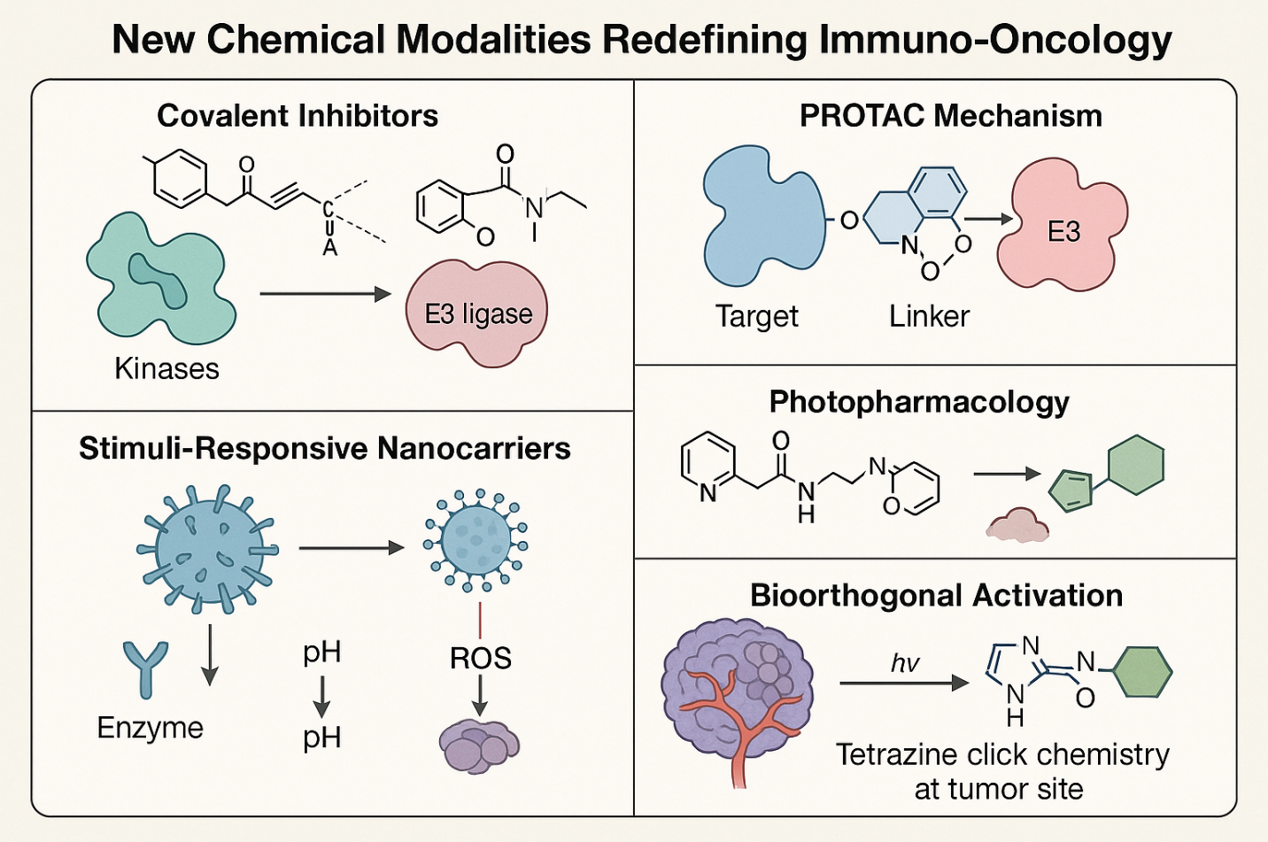
Figure 3: Innovative Chemical Modalities Expanding the Therapeutic Toolbox of Immuno-Oncology with five (5) emerging classes of chemical strategies that are redefining the precision and versatility of immuno-oncology interventions. (i) Covalent inhibitors form irreversible bonds with target proteins, often kinases, to achieve sustained immune modulation. (ii) PROTACs (proteolysis-targeting chimeras) recruit E3 ubiquitin ligases via a linker to induce selective degradation of intracellular immune regulators. (iii) Stimuli-responsive nanocarriers exploit tumor-associated cues—such as enzymes, low pH, and reactive oxygen species (ROS)—to release immune-active agents at the tumor site. (iv) Photopharmacology utilizes light to activate or transform drug structures in a spatiotemporally controlled manner. (v) Bioorthogonal activation enables site-specific release of active agents through chemical reactions like tetrazine click chemistry, initiated exclusively within the tumor microenvironment.
Supramolecular and nanomaterial-based delivery techniques are likewise becoming more popular in IO. Lipid nanoparticles, polymer-drug conjugates, and exosome mimetics can help deliver tiny chemicals, nucleic acids, or immune agonists to tumors while reducing exposure to the rest of the body. This tailored administration is especially helpful for strong innate immune modulators like STING or TLR agonists, which can have bad effects on healthy cells outside of the tumor. Nanocarriers can also be designed to respond to tumor-specific triggers like pH, enzymes, or ROS. This makes sure that the medicine is released exactly where it needs to be in the tumor microenvironment[45,46].
Photopharmacology and bioorthogonal activation techniques provide us more control over immune regulation in both time and space. Using external light sources, photoactivatable small molecules—either light-cleavable prodrugs or conformational switches—can be selectively turned on at the tumor site. This lowers systemic toxicity and off-target effects. Bioorthogonal processes, such tetrazine ligation or click chemistry, can also activate chemicals in place, turning inert precursors into active pharmaceuticals within the TIME[47] (Figure 3)
These new types of chemicals show a major change in IO therapies, moving from broad-spectrum modulators to precision-guided immune reprogrammers. As the field moves further, combining them with genomic profiling, biomarker-guided patient selection, and rational combination therapy will be key to getting around current problems and making immuno-oncology work for more types of tumors[48].

8. Challenges and Future Directions
Even though there are more and more small molecule techniques for changing the tumor immune microenvironment (TIME), there are still big problems that need to be solved before they can be used in the clinic. The most important of these is the problem of selectivity vs systemic toxicity. Small compounds that target innate immune pathways, metabolic regulators, or immunosuppressive cells might cause immunological activation in the wrong place, which can lead to cytokine release syndrome or autoimmune-like side effects. To lower these dangers, it is still very important to design chemicals that preferentially accumulate in tumors, either by local activation, prodrug methods, or selective delivery vectors[49].
Tumors also develop ways to resist and evade the immune system when it is under pressure. Tumors may turn down the machinery that presents antigens, turn up other immune checkpoints, or change the stromal and metabolic milieu to bring back immunosuppression. These adaptive responses need combinatorial regimens, which means that tiny medicines can work together with antibodies, cell treatments, or radiation to stop or get around resistance[50,51].
Another problem is that tumors are different in different patients and even in the same patient. The TIME's makeup and how it works are very different according on the type of tumor and where it is in the body. They can even change over time during treatment. This variety makes individualized immuno-oncology even more important. In this approach, immunological profile, genetic markers, and dynamic monitoring of the TIME lead the choice of small molecule treatments[52].
There is an urgent need for highly selective chemical probes that can precisely break down immunological signaling networks in space and time in order to speed up the discovery of new treatments and increase our understanding of how they work. These probes can be used to find biomarkers and validate targets, but they can also help us understand how immune modulation affects things in different situations. Next-generation probes, like activity-based sensors, real-time imaging agents, and proteomic tagging, will be very helpful in mapping the biochemical and cellular dynamics of the TIME[53].
Finally, for small molecule IO therapies to be used in the clinic, we need to develop strong biomarkers, predictive assays, and well-thought-out trial designs. To find patient groups that will respond and to make the best therapy combinations, companion diagnostics that detect target engagement, pathway activation, or immunological markers will be very important. Bringing together chemical biology, systems immunology, and clinical oncology will be very important for narrowing the translational gap.

As the field grows, small molecules are likely to work well with biologics and even beat them in certain cases by providing flexible, modular, and multi-functional ways to change the immune system. We need to keep working to connect basic chemical research with the complicated field of human cancer immunology.

9. Conclusion
The combination of synthetic chemistry with immuno-oncology has opened up a whole new world of treatment options. For the first time, tiny compounds can change the tumor immune microenvironment (TIME) with incredible ease. Small molecules have some big advantages over biologics: they can be taken by mouth, they can go deep into tissues, they are cheap to make, and they might be able to target cells inside cells. Chemically driven treatments, including as checkpoint inhibitors, innate immune agonists, metabolic regulators, and cellular reprogrammers, are changing how we think about how the immune system controls malignancies.
As this field grows, tiny compounds will not only be useful tools, but also key players in the creation of new cancer immunotherapies. Their use in rational combination techniques, along with strong biomarkers and molecular diagnostics, could help patients who don't respond to current IO methods[54].
To move forward, we will need to keep coming up with new ideas that improve selectivity, lower toxicity, and accept the complexity of the TIME through systems-level thinking. With a chemist's eye and a translational attitude, tiny compounds are ready to become essential in the search for long-lasting, customized, and curative cancer immunotherapies[55,56].

REFRENCES

1. Shen M, Du Y, Ye Y. Tumor-associated macrophages, dendritic cells, and neutrophils: biological roles, crosstalk, and therapeutic relevance. Med Rev (2021). 1(2):222–43.
2. Yang K, Lu R, Mei J, Cao K, Zeng T, Hua Y, et al. The war between the immune system and the tumor - using immune biomarkers as tracers. Biomark Res. 2024 May 30;12:51.
3. Basudan AM. The Role of Immune Checkpoint Inhibitors in Cancer Therapy. Clin Pract. 2022 Dec 27;13(1):22–40.
4. Khan SU, Fatima K, Aisha S, Malik F. Unveiling the mechanisms and challenges of cancer drug resistance. Cell Communication and Signaling : CCS. 2024 Feb 12;22:109.
5. John R, Monpara J, Swaminathan S, Kalhapure R. Chemistry and Art of Developing Lipid Nanoparticles for Biologics Delivery: Focus on Development and Scale-Up. Pharmaceutics. 2024 Jan 19;16(1):131.
6. Chen Y, Tandon I, Heelan W, Wang Y, Tang W, Hu Q. Proteolysis-Targeting Chimera (PROTAC) Delivery System: Advancing Protein Degraders towards Clinical Translation. Chem Soc Rev. 2022 Jul 4;51(13):5330–50.
7. Fu T, Dai LJ, Wu SY, Xiao Y, Ma D, Jiang YZ, et al. Spatial architecture of the immune microenvironment orchestrates tumor immunity and therapeutic response. J Hematol Oncol. 2021 Jun 25;14:98.
8. Oseghale ID, Lawal OP, Ubebe DO, Orjiewulu VC, Igunma AA, Odey OP, et al. Ethnomedicinal and Phytopharmacological Aspects of Vernonia amygdalina (Bitter Leaf) Utilized as a Traditional Medicinal Herb. Asian Journal of Research in Biochemistry. 2024 Oct 14;14(6):41–57.
9. Soto JA, Gálvez NMS, Andrade CA, Pacheco GA, Bohmwald K, Berrios RV, et al. The Role of Dendritic Cells During Infections Caused by Highly Prevalent Viruses. Front Immunol [Internet]. 2020 Jul 16 [cited 2025 Jul 19];11. Available from: https://www.frontiersin.org/journals/immunology/articles/10.3389/fimmu.2020.01513/full
10. Kumar RR, Agarwal N, Shree A, Gorain JK, Rahul E, Ganguly S, et al. Decoding the immune landscape in Ewing sarcoma pathogenesis: The role of tumor infiltrating immune cells and immune milieu. J Bone Oncol. 2025 Mar 31;52:100678.
11. Arner EN, Rathmell JC. Metabolic Programming and Immune Suppression in the Tumor Microenvironment. Cancer Cell. 2023 Mar 13;41(3):421–33.
12. Okafor CE, Egwuatu EC, Owosagba VA, Njei T, Adeyemi BI, Onuche PUO, et al. From Bench to Bedside: Medicinal Chemistry Strategies in the Development of Kinase Inhibitors for Cancer Therapy. Journal of Cancer and Tumor International. 2025 May 10;15(2):79–96.
13. Fu T, Dai LJ, Wu SY, Xiao Y, Ma D, Jiang YZ, et al. Spatial architecture of the immune microenvironment orchestrates tumor immunity and therapeutic response. J Hematol Oncol. 2021 Jun 25;14:98.
14. Ibekwe PMR, Akintayo EA, Okuku CN, Muhammed I, Jeje FM, Okun O, et al. Decoding Tumor Heterogeneity through Multi Omics: Insights into Cancer Evolution, Microenvironment and Therapy Resistance. Journal of Cancer and Tumor International. 2025 Jul 7;15(3):91–112.
15. Shiravand Y, Khodadadi F, Kashani SMA, Hosseini-Fard SR, Hosseini S, Sadeghirad H, et al. Immune Checkpoint Inhibitors in Cancer Therapy. Curr Oncol. 2022 Apr 24;29(5):3044–60.
16. Onwuemelem LA, Orobator ET, Onyedum NN, Chibueze ES, Kanu I, Christopher AA, et al. Molecular Mechanisms of Clonal Hematopoiesis in Age-Related Cardiovascular Disease and Hematologic Malignancies: Review Article. Journal of Pharma Insights and Research. 2025 Apr 5;3(2):358–72.
17. Hu Z, Yu P, Du G, Wang W, Zhu H, Li N, et al. PCC0208025 (BMS202), a small molecule inhibitor of PD-L1, produces an antitumor effect in B16-F10 melanoma-bearing mice. PLoS One. 2020;15(3):e0228339.
18. Sasikumar PG, Sudarshan NS, Adurthi S, Ramachandra RK, Samiulla DS, Lakshminarasimhan A, et al. PD-1 derived CA-170 is an oral immune checkpoint inhibitor that exhibits preclinical anti-tumor efficacy. Commun Biol. 2021 Jun 8;4(1):699.
19. Desai M, Kundu A, Hageman M, Lou H, Boisvert D. Monoclonal antibody and protein therapeutic formulations for subcutaneous delivery: high-concentration, low-volume vs. low-concentration, high-volume. mAbs. 2023 Nov 27;15(1):2285277.
20. Nada H, Choi Y, Kim S, Jeong KS, Meanwell NA, Lee K. New insights into protein–protein interaction modulators in drug discovery and therapeutic advance. Signal Transduct Target Ther. 2024 Dec 6;9:341.
21. Rameshbabu S, Labadie BW, Argulian A, Patnaik A. Targeting Innate Immunity in Cancer Therapy. Vaccines (Basel). 2021 Feb 9;9(2):138.
22. Qu S, Dai H. Conjugated STING agonists. Mol Ther Nucleic Acids. 2025 Mar 31;36(2):102530.
23. Lawal OP, Adekunle JF, Abiodun AV, Orobator ET, Agbo OS, Ugoagwu KU, et al. Modulating Gut Microbiota for Precision Medicine in Diabetes: A Paradigm Shift in Personalized Treatment Strategies. Asian Journal of Research and Reports in Endocrinology. 2025 May 21;8(1):94–109.
24. Chen S, Heendeniya SN, Le BT, Rahimizadeh K, Rabiee N, Zahra Q ul ain, et al. Splice-Modulating Antisense Oligonucleotides as Therapeutics for Inherited Metabolic Diseases. BioDrugs. 2024 Mar 1;38(2):177–203.
25. Mangla P, Vicentini Q, Biscans A. Therapeutic Oligonucleotides: An Outlook on Chemical Strategies to Improve Endosomal Trafficking. Cells. 2023 Sep 11;12(18):2253.
26. Advances and applications of nanoparticles in cancer therapy - Huang - 2024 - MedComm – Oncology - Wiley Online Library [Internet]. [cited 2025 Jul 20]. Available from: https://onlinelibrary.wiley.com/doi/full/10.1002%2Fmog2.67
27. Trujillo JA, Sweis RF, Bao R, Luke JJ. T cell–inflamed versus non-T cell–inflamed tumors: a conceptual framework for cancer immunotherapy drug development and combination therapy selection. Cancer Immunol Res. 2018 Sep;6(9):990–1000.
28. Pearce EL, Pearce EJ. Metabolic Pathways In Immune Cell Activation And Quiescence. Immunity. 2013 Apr 18;38(4):633–43.
29. Lawal OP, Adedayo OA, Dorcas SI, Akanbi OO, Okafor BC, Kanu I, et al. Biomarkers for Tuberculosis Diagnosis and Monitoring: A Review of Translational Progress. Asian Journal of Microbiology and Biotechnology. 2025 May 20;10(1):115–30.
30. Liu X, Zhang Y, Duan H, Luo Q, Liu W, Liang L, et al. Inhibition Mechanism of Indoleamine 2, 3-Dioxygenase 1 (IDO1) by Amidoxime Derivatives and Its Revelation in Drug Design: Comparative Molecular Dynamics Simulations. Front Mol Biosci. 2020 Jan 28;6:164.
31. Grzywa TM, Sosnowska A, Matryba P, Rydzynska Z, Jasinski M, Nowis D, et al. Myeloid Cell-Derived Arginase in Cancer Immune Response. Front Immunol [Internet]. 2020 May 15 [cited 2025 Jul 20];11. Available from: https://www.frontiersin.org/journals/immunology/articles/10.3389/fimmu.2020.00938/full
32. Pérez-Tomás R, Pérez-Guillén I. Lactate in the Tumor Microenvironment: An Essential Molecule in Cancer Progression and Treatment. Cancers (Basel). 2020 Nov 3;12(11):3244.
33. Wang Y, Wondisford FE, Song C, Zhang T, Su X. Metabolic Flux Analysis—Linking Isotope Labeling and Metabolic Fluxes. Metabolites. 2020 Nov 6;10(11):447.
34. LV B, Wang Y, Ma D, Cheng W, Liu J, Yong T, et al. Immunotherapy: Reshape the Tumor Immune Microenvironment. Front Immunol. 2022 Jul 6;13:844142.
35. Elechi KW, Igboaka CD, Tiamiyu BB, Ugbor MJE, Arthur C, Ezeh OM, et al. Phytochemical Screening of Ficus globosa Latex (Moraceae) as a Source of Novel Antimicrobial Compounds. Path of Science. 2025 Mar 31;11(3):9001–10.
36. Lu J, Luo Y, Rao D, Wang T, Lei Z, Chen X, et al. Myeloid-derived suppressor cells in cancer: therapeutic targets to overcome tumor immune evasion. Exp Hematol Oncol. 2024 Apr 12;13:39.
37. Lawal OP, Ahmed NK, Ilesanmi TA, Anthony GI, Nwosu SN, Ogungbemiro FO, et al. The Impact of Antimicrobial Resistance on Cancer Treatment: A Systematic Review of Current Evidence and Future Directions. Asian Journal of Research in Medical and Pharmaceutical Sciences. 2024 Sep 16;13(4):9–27.
38. Xu H, Russell SN, Steiner K, O’Neill E, Jones KI. Targeting PI3K-gamma in myeloid driven tumour immune suppression: a systematic review and meta-analysis of the preclinical literature. Cancer Immunol Immunother. 2024 Aug 6;73(10):204.
39. Hull EE, Montgomery MR, Leyva KJ. HDAC Inhibitors as Epigenetic Regulators of the Immune System: Impacts on Cancer Therapy and Inflammatory Diseases. Biomed Res Int. 2016;2016:8797206.
40. Chu X, Tian W, Ning J, Xiao G, Zhou Y, Wang Z, et al. Cancer stem cells: advances in knowledge and implications for cancer therapy. Signal Transduct Target Ther. 2024 Jul 5;9:170.
41. Kaczmarek M, Poznańska J, Fechner F, Michalska N, Paszkowska S, Napierała A, et al. Cancer Vaccine Therapeutics: Limitations and Effectiveness—A Literature Review. Cells. 2023 Aug 28;12(17):2159.
42. Wu B, Zhang B, Li B, Wu H, Jiang M. Cold and hot tumors: from molecular mechanisms to targeted therapy. Sig Transduct Target Ther. 2024 Oct 18;9(1):274.
43. Yin G, Huang J, Petela J, Jiang H, Zhang Y, Gong S, et al. Targeting small GTPases: emerging grasps on previously untamable targets, pioneered by KRAS. Sig Transduct Target Ther. 2023 May 23;8(1):212.
44. Liu Z, Hu M, Yang Y, Du C, Zhou H, Liu C, et al. An overview of PROTACs: a promising drug discovery paradigm. Mol Biomed. 2022 Dec 20;3:46.
45. Sen S, Xavier J, Kumar N, Ahmad MZ, Ranjan OP. Exosomes as natural nanocarrier-based drug delivery system: recent insights and future perspectives. 3 Biotech. 2023 Mar;13(3):101.
46. Lawal OP, Orobator ET, Dorcas SI, Ezeamii VC, Foster-Pagaebi E, Attahiru M. Orphan Drug Development for Rare Diseases: Therapeutic Challenges, Translational Strategies, and Global Health Equity. Journal of Life Science and Public Health. 2025 Jun 30;1(1):1–9.
47. Colleoni A, Galli G, Dallanoce C, De Amici M, Gorostiza P, Matera C. Light‐Activated Pharmacological Tools for Exploring the Cholinergic System. Med Res Rev. 2025 Jul;45(4):1251–74.
48. Chelliah V, Lazarou G, Bhatnagar S, Gibbs JP, Nijsen M, Ray A, et al. Quantitative Systems Pharmacology Approaches for Immuno‐Oncology: Adding Virtual Patients to the Development Paradigm. Clin Pharmacol Ther. 2021 Mar;109(3):605–18.
49. Wang Q, Shao X, Zhang Y, Zhu M, Wang FXC, Mu J, et al. Role of tumor microenvironment in cancer progression and therapeutic strategy. Cancer Med. 2023 Feb 21;12(10):11149–65.
50. Kim SK, Cho SW. The Evasion Mechanisms of Cancer Immunity and Drug Intervention in the Tumor Microenvironment. Front Pharmacol. 2022 May 24;13:868695.
51. Ayomide IT, Promise LO, Christopher AA, Okikiola PP, Esther AD, Favour AC, et al. The Impact of Antimicrobial Resistance on Co-INFECTIONS: Management Strategies for HIV, TB and Malaria. International Journal of Pathogen Research. 2024 Nov 29;13(6):117–28.
52. Anand U, Dey A, Chandel AKS, Sanyal R, Mishra A, Pandey DK, et al. Cancer chemotherapy and beyond: Current status, drug candidates, associated risks and progress in targeted therapeutics. Genes Dis. 2022 Mar 18;10(4):1367–401.
53. Jörg M, Madden KS. The right tools for the job: the central role for next generation chemical probes and chemistry-based target deconvolution methods in phenotypic drug discovery. RSC Med Chem. 12(5):646–65.
54. Stephen J, Kanu I, Onyedum NN, Orobator ET, Rono C, Ngwoke CF, et al. Role of HLA Class I Molecule in Cancer: Implications for Cancer Immunotherapy. Journal of Cancer and Tumor International. 2025 Jun 20;15(3):10–25.
55. Fabiyi TO, Oyebode MO, Fabiyi KO, Akinwale DA, Adeoye DC, Ibekwe PMR, et al. Artificial Intelligence and Machine Learning in Personalized Medicine: Emerging Technologies and Applications. Journal of Cancer and Tumor International. 2025 Jul 8;15(3):124–36.
56. Badru MD, Lawal TA, Chidimma UN, Badmus MJ, Ene FE, Anyirionye DC, et al. Why Cancer Immunotherapy Fails?: Mechanisms of Resistance and Emerging Reversal Strategies. Journal of Cancer and Tumor International. 2025 Jul 8;15(3):113–23.

