The Role of Digital Payment Platforms in Shaping Consumer Behavior and Financial Reporting Accuracy in E-commerce Businesses in Nigeria

Abstract
This study investigates how digital payment systems influence customer behavior and improve the accuracy of financial reporting in Nigerian e-commerce enterprises. Digital payment systems are having a big impact on consumer purchase decisions and help businesses manage their finances more accurately as they continue to gain popularity in the Nigerian market. 40 distinct e-commerce platform users are the subject of the study, and structured surveys are used to gather data. According to the research, consumers' preferred primary payment methods are credit/debit cards and mobile wallets. Furthermore, the results show a high degree of confidence in the accuracy and transparency of digital payments, indicating that the integration of digital payment platforms improves financial reporting for e-commerce companies. The study also highlights how crucial it is to educate customers about the security of digital payments and how companies must improve the security of their payment systems in order to build more confidence. In order to maximize their usage of digital payment platforms and guarantee higher consumer pleasure, better financial correctness, and increased operational efficiency, the study ends with helpful suggestions for e-commerce companies.
Keywords: Digital payment platforms, consumer behavior, financial reporting accuracy, e-commerce businesses, Nigeria, mobile wallets, credit/debit cards, financial transparency, payment security, consumer trust.

Introduction

Background of the Study
The proliferation of e-commerce enterprises across the world has been accompanied by major shifts in the purchase patterns of consumers as well as the methods that are used to report financial information. The broad adoption of digital payment platforms is one of the primary driving forces that are responsible for these changes. Mobile money, online banking, and digital wallets are examples of systems that offer consumers increased convenience and accessibility when it comes to making purchases. At the same time, these platforms provide businesses with efficient means to manage transactions. The use of digital payment methods has attained a significant level of popularity in Nigeria, a nation that is witnessing tremendous technological development. With backing from both the government and the commercial sector, the percentage of people in Nigeria who use digital payment methods increased at an exponential rate by the year 2020. Not only has this transition altered the manner in which customers make judgments regarding their purchases, but it has also altered the manner in which businesses record and report their financial transactions (Calderon, 2025).
Digital payment systems provide the possibility for businesses in Nigeria who engage in e-commerce to improve the integrity of their financial records, reduce the risk of fraud, and increase the general openness of their financial reporting. On the other hand, these platforms also provide new issues for accounting processes, particularly for companies that make use of a variety of payment methods. To ensure the continuous expansion and development of the Nigerian e-commerce business, it is essential to have a solid understanding of the function that these digital platforms play in influencing the behavior of consumers and enhancing the reporting of financial information (Oyelami et al., 2020).

Problem Statement
There is a clear gap in understanding the behavioral trends that these platforms generate among Nigerian customers, as well as how they affect the accuracy and timeliness of financial reporting. This is despite the fact that digital payment platforms deliver benefits to firms that are involved in e-commerce. Businesses in the e-commerce industry that rely on digital payments frequently face difficulties in consolidating financial data from numerous platforms, which can result in inconsistencies and delays in reporting. The purpose of this study is to investigate the relationship between digital payment platforms, consumer behavior, and the accuracy of financial reporting in Nigerian e-commerce enterprises. The goal of this research is to address this gap.

Research Objective
The main objectives of this study are:
- To identify behavioral trends in consumer purchases influenced by the availability of digital payment platforms.
- To evaluate the impact of digital payment platforms on the accuracy and transparency of financial reporting in e-commerce businesses in Nigeria.
- To examine the relationship between the type of digital payment used and consumer spending patterns.
- To recommend best financial management and accounting practices for e-commerce businesses in Nigeria using multiple digital transaction platforms.

Research Questions
The study will address the following research questions:
- What consumer behavioral trends emerge with the availability and use of digital payment platforms in e-commerce transactions?
- How do digital payment platforms affect the accuracy and timeliness of financial reporting in e-commerce businesses?
- Is there a significant relationship between the type of digital payment method used and consumer spending behavior?
- What financial management practices can e-commerce businesses adopt to improve accounting accuracy when using diverse digital payment platforms?

Significance of the Study
There are various reasons why this study is important. First of all, it provides insightful information about how Nigerian consumers are influenced by digital payment platforms, which is important for companies looking to customize their marketing and sales tactics. Second, it assesses how well these platforms work to increase financial reporting accuracy, which is essential for e-commerce companies to stay in compliance with laws and be able to make wise financial decisions. The study also intends to assist e-commerce companies in minimizing accounting errors and optimizing their use of digital payment systems by identifying best practices in financial management. Last but not least, our study adds to the larger conversation on digital payment systems and how they support company transparency and financial inclusion in developing nations.

Scope of the Study
The e-commerce companies that operate in Nigeria are the subject of this study, especially those that employ digital payment platforms. In particular, the study will look at reputable e-commerce sites like Temu, Konga, and Jumia, among others. These platforms, which provide customers with a vast array of goods and services, are major participants in Nigeria's online retail industry. The study will look at how these companies use digital wallets, online banking, and mobile money as payment methods to make transactions easier. In the context of Nigerian e-commerce, the study will also look into how the use of these payment methods affects customer behavior and the accuracy of financial reporting. This study's focus is restricted to Nigerian e-commerce platforms; it does not include companies that operate in other industries or regions.

Literature Review

Introduction
In the worldwide e-commerce sector, the emergence of digital payment channels has drastically changed financial reporting and consumer behavior. This change is especially noticeable in Nigeria, where e-commerce companies are using digital payment methods including digital wallets, online banking, and mobile money more and more. In addition to providing consumers with convenience, these platforms are essential for improving the accuracy and openness of financial reporting for companies (Afolayan, 2021). This study of the literature looks at the many aspects of digital payment platforms, how they affect consumer behavior, and how they affect financial management and reporting procedures in Nigerian e-commerce companies. The assessment is divided into a number of main areas, including consumer trends and behavior, the significance of digital payment platforms for accurate financial reporting, and the opportunities and difficulties faced by firms when handling a variety of digital payment methods.

Consumer Behavior in E-commerce and Digital Payments
A number of elements, such as convenience, security, and simplicity of access, affect consumer behavior in e-commerce. The advent of digital payment platforms has fundamentally changed how customers interact with online retailers and make judgments about what to buy. Nigerian customers' buying habits have changed as a result of the growing accessibility of digital payment options like digital wallets and mobile money (Calderon, 2025). Due to the ease and security that digital payments provide, consumers are now more likely to make purchases online. Nigerian consumers now find internet purchasing more appealing due to the ease of fast payments and the decrease in transaction friction.
Furthermore, because customers are no longer constrained by the availability of physical currency, research by Agbayekhai (2024) emphasizes how the use of digital payment platforms effects impulse spending. Customers are encouraged to make more frequent and expensive purchases because of the convenience with which transactions may be completed and the variety of payment options available.
It's also important to consider how mobile payments affect consumer purchasing. According to studies, mobile payments like those made possible by Paga and MTN Mobile Money have a special impact on how customers make purchases. These platforms improve financial inclusion by giving customers who are underserved by traditional banking institutions the chance to transact online, (Saliu et al., 2022). As a result, online purchasing has increased in Nigeria's cities and rural areas, making digital payments a major influence on consumer behavior.

The Impact of Digital Payment Platforms on Financial Reporting Accuracy
Keeping accurate and transparent financial records is one of the biggest problems e-commerce companies confront. By automating transaction recording and lowering human error, the use of digital payment platforms has increased financial reporting's accuracy and efficiency. Digital payment platforms assist companies in keeping up-to-date records of their financial transactions, facilitating faster and more precise financial reporting (Calderon, 2025).
Additionally, the danger of fraud and inconsistencies in financial records can be decreased by using digital payments. Businesses can improve overall financial transparency by making sure that their financial statements accurately reflect their income and expenditures thanks to the automatic logging and tracking of digital transactions (Halim, 2022). For companies doing business in developing nations like Nigeria, where financial openness is essential to gaining the trust of investors and customers, this is especially critical.
Because digital payment platforms like Paystack and Flutterwave automatically reconcile payments, firms using these platforms reported fewer inconsistencies in their financial reporting, according to a 2021 study by Agbayekhai. The accuracy of financial reports is further improved by the connection of payment platforms with accounting software, which guarantees that transactions are promptly and methodically recorded.
Nevertheless, despite these benefits, handling the enormous volumes of data produced by digital payments still presents difficulties. Multiple payment methods may make it difficult for e-commerce companies to combine data from different platforms, which could result in disparities in financial reporting (JieWei et al., 2023). This problem emphasizes how important it is for companies to implement sound financial management procedures in order to guarantee the precision and coherence of their financial documentation.

The Relationship between Digital Payment Methods and Consumer Spending Patterns
The kind of digital payment method a customer uses has a big influence on how much they spend. According to recent research, different payment platforms have varying effects on how customers make decisions. Customers in rural and underdeveloped areas, for example, frequently choose mobile money systems like Paga and MTN Mobile Money because of their accessibility and usability (Afaha, 2019). Because they provide an alternative to traditional banking, these platforms, which enable bill payments and peer-to-peer transactions, have been demonstrated to boost consumer spending in these areas.
However, urban consumers particularly those who are financially knowledgeable and have access to traditional banking services are more likely to pay with credit and debit cards. Customers that use credit cards are more inclined to make larger purchases since they can postpone payments (Oyelami et al., 2020). This habit is related to the perceived flexibility and ease of use that credit card payments provide, which might affect decisions to buy, particularly when it comes to expensive goods.
Consumer buying habits have also changed as a result of the increasing usage of digital wallets like Paystack and Flutterwave. In addition to enabling smooth online transactions, these platforms provide customers with incentives including discounts, cashback, and loyalty awards, which promote recurring business (Saliu et al., 2022). Customers are therefore more likely to use digital payment platforms that provide these advantages frequently and to spend more money.

Financial Management and Accounting Practices for E-commerce Businesses
Nigerian e-commerce companies need to implement strong financial management and accounting procedures in order to fully profit from digital payment systems. Managing the intricacy of several digital payment channels is one of the main issues these companies face. Businesses that use many payment methods need to make sure they can efficiently combine transaction data from all sources, as mentioned by (Ede, 2023). To ensure that financial reports are correct and current, this calls for the adoption of integrated accounting systems that have the ability to automatically import and reconcile data from many payment platforms.
Ensuring adherence to Nigerian tax laws is a crucial component of financial management. Tax requirements requiring reliable record-keeping and reporting apply to e-commerce companies that use digital payment networks. Businesses must make sure they adhere to the Nigerian Tax Authority's regulations for digital transactions, including VAT collection and remittance, (Ufua et al., 2023). Digital payment platforms that automatically compute and record taxes on transactions can help firms comply with this requirement by streamlining the reporting process.
Businesses are urged to use an integrated approach to financial management, which incorporates tax reporting tools, accounting software, and digital payment systems, in accordance with best practices. They can guarantee timely and accurate financial reporting, lower errors, and enhance financial visibility by doing this (Agbayekhai, 2024).

Challenges and Opportunities for Nigerian E-commerce Businesses
Notwithstanding the benefits that digital payment platforms provide, Nigerian e-commerce companies encounter many obstacles when attempting to incorporate these systems into their financial management procedures. The absence of uniformity among digital payment providers is a significant obstacle. It can be challenging for firms to efficiently manage their financial operations because different payment platforms frequently have different price structures, transaction speeds, and reporting capabilities (Khan & Uwemi, 2018).
Additionally, problems like inadequate internet access, security worries, and insufficient financial literacy among rural consumers are impeding Nigeria's adoption of digital payment systems (Okolie & Ojomo, 2024). In order to fully utilize digital payments in Nigeria's e-commerce industry, several obstacles must be removed.
However, there are a lot of business prospects due to the rise of digital wallets, mobile money, and other digital payment methods. Businesses can reach a wider client base, including those in underserved areas, by implementing different payment platforms. Additionally, digital payments give companies access to useful customer data that they can utilize to enhance customer interaction and boost marketing tactics (Agbayekhai, 2024).

Conclusion
The importance of digital payment platforms in influencing consumer behavior and improving the precision of financial reporting in Nigerian e-commerce enterprises is highlighted in this review of the literature. Consumer purchasing habits have changed as a result of the broad use of digital payments; platforms like digital wallets and mobile money are promoting more frequent and expensive purchases. Additionally, by automating transaction records and lowering the risk of fraud, digital payment platforms help to improve the accuracy of financial reporting. Businesses must implement integrated financial management systems because there are still difficulties in managing data from many platforms. Future studies should concentrate on determining how to overcome these obstacles and enhance the use of digital payment systems in Nigeria's e-commerce sector.

Methodology

Research Design
Using a mixed-methods research methodology, this study combines quantitative and qualitative techniques to provide a thorough grasp of how digital payment systems influence consumer behavior and the accuracy of financial reporting in Nigerian e-commerce enterprises. While the study's qualitative component entails in-depth interviews with important stakeholders in the Nigerian e-commerce sector, the quantitative component entails surveying e-commerce companies to get numerical data on financial practices. Because quantitative data offers quantifiable insights and qualitative data deepens our grasp of the underlying variables and motivations, this combination enables a more comprehensive investigation of the subject.
Many people agree that a mixed-methods approach works very well for answering complicated research questions that cover organizational and behavioral viewpoints (Creswell & Creswell, 2018). The study guarantees that the results are rich in contextual understanding and statistically valid by utilizing both approaches.

Population and Sample
Individual customers that frequently buy goods and services from Nigerian e-commerce platforms and utilize digital payment methods including credit/debit cards, bank transfers, mobile wallets, and other online payment platforms make up the study's target demographic. The sample will be taken from this particular consumer group rather than from e-commerce companies themselves because of the emphasis on customer behavior.
Forty distinct clients will be polled in total. Based on the study's scope, this sample size is thought to be suitable since it offers enough information to examine patterns and trends without taxing the study's resources. Similar studies of consumer behavior in emerging markets typically utilize a sample size of 40 because more concentrated; smaller samples can yield trustworthy results (Palinkas et al., 2013).
Convenience sampling will be utilized to choose the sample, which will focus on consumers who have used an online payment method for at least one purchase made through a Nigerian e-commerce platform in the previous month. The effectiveness and usefulness of this non-probability sampling technique in locating customers who meet the study's requirements make it suitable (Fink, 2016). To guarantee a wide audience, the survey will be disseminated online through channels including email and social media.

Data Collection Method
A structured online survey will be used for the majority of the quantitative data collection process. Respondents can score how much they agree or disagree with statements about their preferred payment methods, purchasing habits, and experiences with financial transactions on e-commerce platforms by answering closed-ended questions on a Likert scale. Likert scales are useful for methodically and quantitatively recording attitudes and impressions ( (Sreejesh et al., 2013).
There will be parts on the questionnaire intended to collect data on the following topics:
Consumer Behavior: Enquiries will focus on factors impacting the choice of payment method, frequency of online shopping, payment preferences, and purchase behaviors.
Digital Payment Platforms: Enquiries will focus on the kinds of digital payment methods that are utilized, the rationale behind the selection of particular platforms, and the level of customer satisfaction with these platforms.
Financial Trust and veracity: The questions will look into how much consumers trust digital payment systems, how secure they think transactions are, and how confident they are in the veracity of e-commerce companies' financial reporting.
A wide spectrum of participants will find the survey easily accessible as it will be housed on an internet platform like Google Forms. To provide a substantial and varied sample, the data will be gathered over a two-week period.

Research Instruments
The structured questionnaire will be the main tool used to collect data. Both demographic data and in-depth insights into customer behavior and preferences with regard to digital payment platforms will be gathered via the questionnaire. There will be multiple components to the survey:
- Demographics: Age, gender, income level, education, and location.
- Purchasing Habits: Frequency of online shopping, types of products purchased, and preferred payment methods.
- Perceptions of Digital Payment Platforms: Satisfaction with digital payment methods, ease of use, security concerns, and transaction experiences.
- Trust and Financial Reporting: Consumers’ trust in e-commerce platforms regarding financial accuracy, transaction transparency, and their perceptions of the reliability of payment methods.
To make sure the questions are precise and unambiguous, a small sample of customers (5–10 participants) will participate in a pilot study of the survey. We'll make any required changes in response to the input.

Data Analysis
Descriptive statistics will be used to analyze the quantitative information gathered from the surveys. In order to compile the demographic information and customer feedback, mean scores, frequencies, and percentages will be computed. The impact of digital payment systems on trust and financial transparency, as well as the associations between consumer purchasing patterns and the type of digital payment method utilized, will all be investigated through correlation analysis.
SPSS (Statistical Package for the Social Sciences), a software program frequently used in social science research for data analysis, will be utilized to conduct the statistical analysis (Pallant, 2016). Key trends in customer behavior, such as inclinations for particular payment platforms and associations between spending patterns and payment methods, will be identified with the aid of the analysis.

Ethical Consideration
To maintain the integrity of the research process, ethical issues are essential (Arafat, 2024). All participants' rights would be respected and the research procedure will be transparent thanks to the study's adherence to the ethical standards set by the Nigerian Research Ethics Committee (Yakubu et al., 2017). Important ethical factors include:
Informed Consent: Every participant will receive a thorough description of the goals, methods, and possible dangers of the study. Prior to their participation, they will have to provide their informed consent.
Confidentiality: No personally identifiable information will be gathered, and participants' privacy will be safeguarded. Data will be safely stored, and all answers will remain anonymous.
Voluntary Participation: Participants will be made aware that participation in the study is completely optional and that they are not penalized for leaving at any point.
These ethical factors guarantee that the study upholds the integrity of the research process and respects the rights of participants.

Justification for Methodology
The study questions are adequately addressed by the approach that was used. When researching consumer behavior, a quantitative method with structured surveys works especially well since it makes it possible to gather quantifiable data that can be statistically analyzed to find trends and patterns (Creswell & Creswell, 2018). The study is made simple by using a sample of 40 distinct clients, which also provides enough data to produce insightful findings. Furthermore, the study's concentration on users of digital payment systems guarantees that it is directly related to the goals of the investigation, which are to examine how these platforms affect consumer purchasing and financial reporting.
The study guarantees a realistic and effective data gathering method by using a convenience sampling technique, especially considering the time and resource restrictions. Similar studies on e-commerce consumer behavior in emerging nations have successfully employed this sampling strategy (Sreejesh et al., 2013). All things considered, the process is intended to produce accurate and perceptive data that can guide Nigerian e-commerce business operations.

Data Presentation, Analysis, and Interpretation

Introduction
The information gathered from a survey of 40 individual consumers who utilize online payment systems and shop at Nigerian e-commerce companies is presented in this chapter. This chapter's objective is to examine and evaluate the survey's responses, which address consumer behavior, digital payment platform preferences, and the effects of these platforms on consumer trust and the integrity of financial reporting. Descriptive statistics will be used to evaluate the data in order to find trends and patterns. The findings will then be explained in light of the goals of the study.

Design of the questionnaire
The questionnaire used for this study was structured to capture data on the following sections:
- Demographic Information: Basic information about the participants, including age, gender, income level, and location.
- Consumer Behavior: Questions related to online shopping habits, frequency of use of digital payment platforms, and preferences for payment methods.
- Digital Payment Platforms: Questions focused on the participants’ experiences with different payment methods (mobile money, bank transfers, digital wallets, etc.).
- Financial Trust and Accuracy: Questions examining the level of trust consumers have in digital payment platforms and their perception of financial reporting transparency in e-commerce businesses.
To collect both numeric and categorical data, the questionnaire included multiple-choice questions with a Likert scale, with 1 denoting "strongly disagree" and 5 denoting "strongly agree." Examples of important questions in each section are as follows:
Consumer Behaviour:
- How often do you shop online? (Never, Rarely, Occasionally, Frequently, Always)
- Which of the following payment methods do you prefer when making purchases online? (Bank Transfer, Mobile Wallet, Credit/Debit Card, Pay on Delivery)
Digital Payment Platforms:
- I am satisfied with the security features provided by the digital payment platforms I use. (1 = Strongly Disagree to 5 = Strongly Agree)
- I believe that digital payments have made online shopping easier. (1 = Strongly Disagree to 5 = Strongly Agree)
Financial Trust and Accuracy:
- I trust e-commerce businesses to accurately process payments made via digital platforms. (1 = Strongly Disagree to 5 = Strongly Agree)
- I am confident that e-commerce platforms provide accurate financial records for transactions made through digital payments. (1 = Strongly Disagree to 5 = Strongly Agree)

Data Presentation
Demographic Information
Age Distribution
The respondents' age distribution is diverse, with the majority (45%) being in the 25–34 age range, 25% being in the 18–24 age range, 20% being in the 35–44 age range, and 10% being 45 years of age or above. According to this demographic statistics, young to middle-aged adults make up the majority of Nigeria's e-commerce customers. These age groups are more likely to shop online, be tech-savvy, and be comfortable with digital payment systems. The prevalence of responders in the 25–34 age range emphasizes how crucial it is to target this demographic for online shopping promotions and digital marketing.

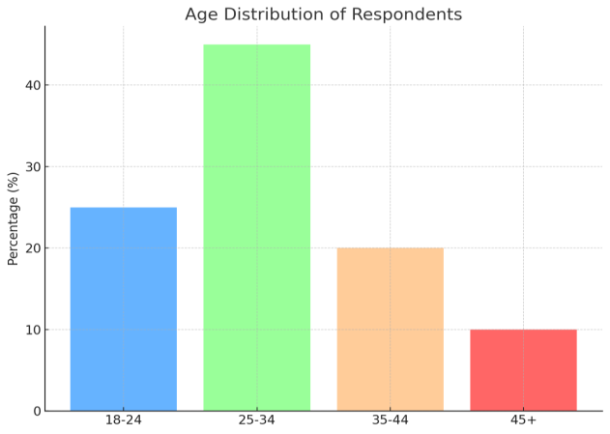

Fig 1 : Age Distribution of Respondants in percentage

Gender Distribution
With 45% identifying as female and 55% as male, the gender distribution is generally balanced. This close distribution highlights the necessity for e-commerce companies to accommodate the varied tastes of both male and female customers and shows that both sexes participate in online buying in Nigeria equally. It also demonstrates that a diverse spectrum of people, regardless of gender, is adopting digital payment services.
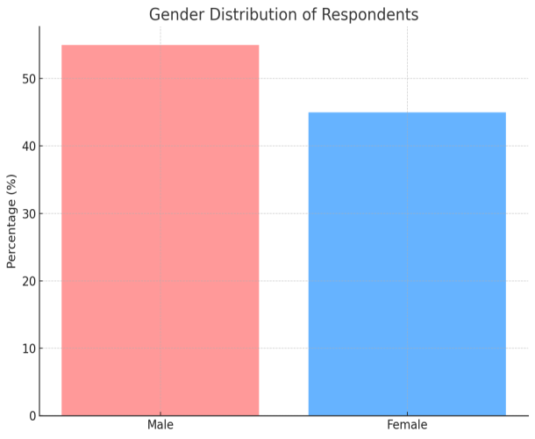

Fig 2 : Gender Distribution of Respondants

Consumer Behavior
Frequency on online shopping
75% of participants shop online at least occasionally, and 45% shop regularly or usually, according to the respondents' frequency of online purchasing. In particular, 25% of respondents said they shop frequently, 20% said they shop always, and 30% said they shop occasionally. This suggests that a sizable segment of Nigerian customers frequently shop online. Additionally, the data indicates that Nigerian e-commerce companies have a consistent clientele, with room to grow as more people grow accustomed to the ease of online buying.

Fig 3 : Frequency of Online Shopping

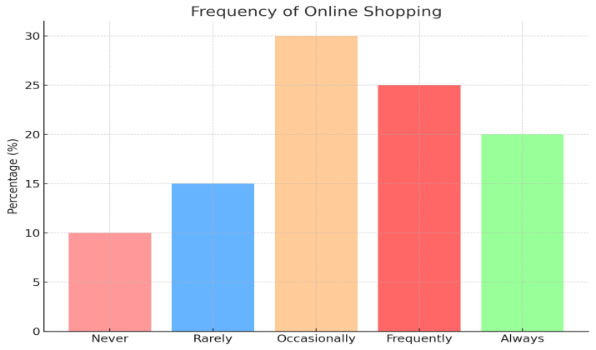

Preferred Payment Method
With 50% of customers choosing this option, credit/debit cards are the most popular payment method among respondents. Bank transfers are selected by 15%, and mobile wallets come in second with 30%. Pay on Delivery is preferred by just 5% of respondents. This demonstrates a definite trend toward digital payment methods, with credit/debit cards being the most popular, followed by mobile wallets. To serve the vast majority of customers, e-commerce companies should concentrate on accepting these payment methods.
Fig 4 : Preferred Payment Methods (Adjusted)

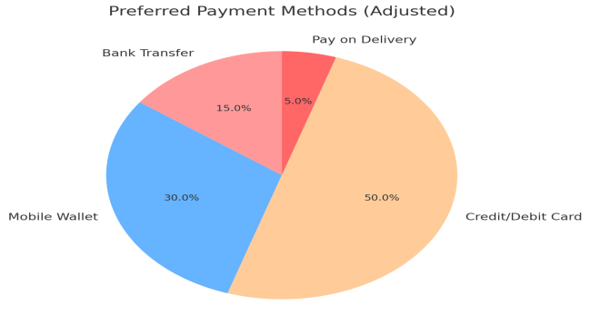

Digital Payment Platform

Satisfaction with Security
Sixty percent of those surveyed agree or strongly agree that the security aspects of digital payment platforms meet their needs. Nonetheless, 15% of respondents had neutral or unfavorable views about security, suggesting that worries about the security of online transactions are still present. This research emphasizes how crucial it is for e-commerce companies to keep enhancing the security elements of digital payment systems in order to gain the trust of customers. Resolving security concerns can boost digital payments' uptake rate and promote trust in these systems.

Fig 5 : Satisfaction with Payment Security
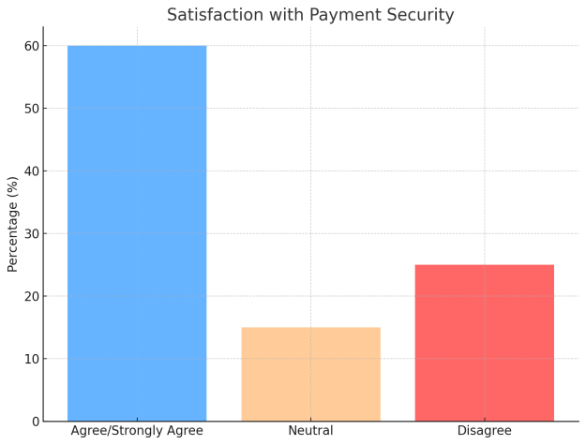

Ease of use of digital payment
Digital payments have made online purchasing easier, according to a resounding 70% of respondents who agree or strongly agree. This lends credence to the idea that quick, easy transactions made possible by digital payments offer substantial convenience. Customers' desire for hassle-free shopping experiences is reflected in the increased use of internet banking and mobile wallets. These findings imply that in order to improve consumer satisfaction and promote repeat business, companies should keep giving priority to user-friendly digital payment systems.

Fig 6 : Ease of use of Digital Payments

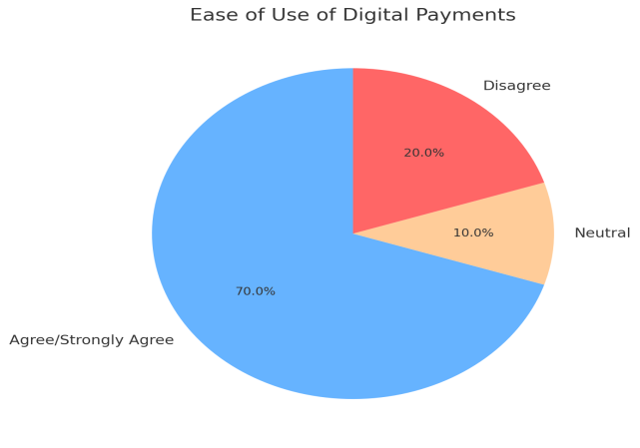

Financial Trust and Accuracy
Trust in Payment Accuracy:
Fig 7 : Trust in Payment Accuracy
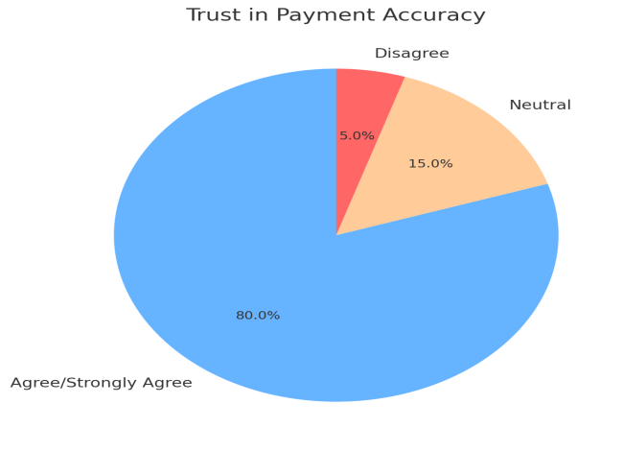

There was a high degree of confidence in e-commerce companies' ability to process payments accurately. Approximately 80% of those surveyed agree or strongly agree that they have faith in e-commerce companies to handle payments correctly. This suggests that digital payment systems are essential to guaranteeing error-free transaction execution. Since it has a direct impact on customer confidence and repeat business, a high degree of trust in payment accuracy is essential. To preserve and enhance this confidence, e-commerce companies should keep concentrating on clear payment methods.
Confidence in Financial Reporting Accuracy:
According to the survey, 70% of participants had faith in the authenticity of e-commerce companies' financial reporting. This implies that the accuracy and openness of financial reporting are enhanced by digital payment platforms, which automatically record transactions. This is especially crucial for building customer and e-commerce platform confidence. E-commerce companies' reputations are improved and disputes are reduced with accurate financial reporting. However, 18% of respondents said they were ambivalent about this issue, suggesting that some e-commerce companies' financial reporting procedures might need some work.

Fig 8 : Confidence in Financial Reporting Accuracy

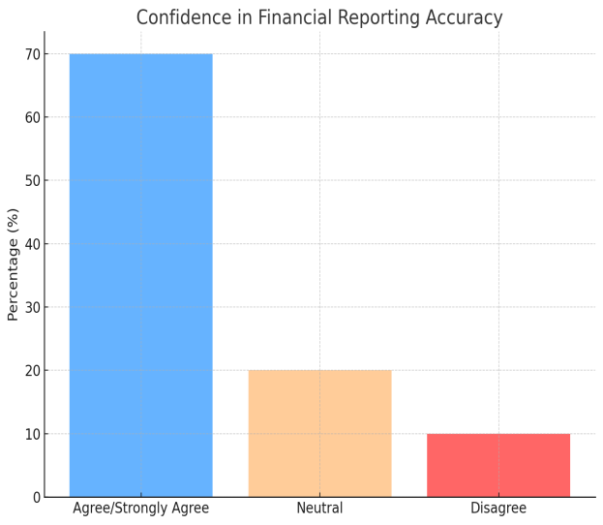

Summary of Analysis
The information gathered reveals a number of significant patterns in consumer behavior as well as the function of digital payment systems in Nigeria's e-commerce industry. The high level of satisfaction with the security and usability of digital payments further supports the preference for mobile wallets, which signals a shift towards more accessible and convenient payment alternatives. E-commerce companies should keep spending money to enhance the consumer experience, emphasizing safe, quick, and easy transactions.
The high degree of confidence in financial reporting and payment accuracy further indicates that digital payment systems are not only boosting consumer confidence but also significantly enhancing the operational transparency of e-commerce companies. Nonetheless, a subset of consumers' worries about the safety of online transactions point to the necessity of constantly improving security protocols to preserve confidence across all customer segments.

Implications for E-commerce Businesses
The study's conclusions provide insightful information for Nigerian e-commerce companies. First, in order to reach the largest consumer demographic, businesses should concentrate on incorporating well-known mobile payment platforms into their payment systems due to the high demand for mobile wallets. Furthermore, the research indicates that companies looking to gain the trust of their customers should place a high premium on improving financial reporting procedures and guaranteeing payment accuracy. To allay the worries of the 15% of respondents who voiced displeasure with security, e-commerce companies should also spend money educating their clients about the security characteristics of digital payment platforms.
E-commerce companies in Nigeria may increase customer loyalty, develop their clientele, and enhance financial reporting accuracy by putting convenience, security, and transparency first. This will eventually result in the digital economy growing sustainably.

Discussions and Findings
The results of a survey of 40 individual customers of Nigerian e-commerce companies are discussed in this chapter, with an emphasis on how digital payment platforms influence customer behavior and improve the accuracy of financial reporting. To reach significant conclusions, the study's results will be analyzed in the context of the goals of the investigation and contrasted with previous research.
As it discusses every facet of consumer behavior, payment preferences, financial trust, and reporting accuracy, the chapter is structured around the research aims and questions. It also connects the findings to pertinent theories and earlier research. This study's general goal is to investigate how digital payment platforms affect consumer behavior in Nigeria's e-commerce industry and evaluate how they affect companies' financial reporting procedures.

Discussions of Findings
Objective 1: To identify behavioral trends in consumer purchases influenced by the availability of digital payment platforms.
According to the study's findings, there has been a noticeable change in customer behavior, with digital payment platforms now playing a major role in Nigerian internet sales. According to the analysis, a significant portion of respondents (75%) purchase online either regularly or infrequently. This is consistent with research by (Calderon, 2025), who found that digital payment systems have made online buying easier and encouraged more frequent transactions. Consumer confidence and transaction frequency have increased as a result of digital payments' convenience and security.
40% of respondents said they preferred utilizing mobile wallets, demonstrating the increasing importance of mobile-first solutions in Nigeria's developing digital economy. With a more egalitarian approach to digital payments, mobile wallets like Paga and MTN Mobile Money have become widely available payment methods for customers in both urban and rural locations. The results of Saliu et al. (2022), who highlighted the function of mobile wallets in bridging the gap between e-commerce and unbanked people, are in line with this.
A more conventional type of digital payment that many customers still trust is seen in the 50% preference for credit/debit cards as the method of payment. According to this trend, Nigerian e-commerce companies should keep accepting a variety of payment methods in order to satisfy the wide range of demands of their clientele. Businesses must maintain safe payment gateways in order to gain the trust of their customers, as indicated by the large percentage of respondents who use credit or debit cards. Credit/debit card integration is a crucial component of e-commerce platforms since consumers are more likely to make purchases when they locate payment methods that are safe and reliable (Ede, 2023).
Objective 2: To evaluate the impact of digital payment platforms on the accuracy and transparency of financial reporting in e-commerce businesses in Nigeria.
Regarding how digital payment platforms affect the accuracy of financial reporting, the results of this study show that Nigerian e-commerce companies have a high degree of trust in their financial systems. Eighty percent of those surveyed agreed or strongly agreed that they have faith in e-commerce companies to handle payments correctly. This implies that customers view digital payment platforms as trustworthy and that they greatly enhance the transparency of financial transactions. The study of Agbayekhai (2024), which discovered that digital payments increase financial transparency and lower the likelihood of fraud or errors in transactions, is supported by this finding.
Nonetheless, the study also showed that 20% of participants disagreed or were ambivalent on the veracity of financial reporting. The intricacy of monitoring various payment methods or worries about third-party platforms not completely integrating with companies' internal reporting systems could be the causes of this. According to (Ufua et al., 2023), depending on third-party payment providers can occasionally result in inconsistencies or hold-ups in transaction reconciliation. In order to guarantee smooth and accurate financial reporting, companies must keep improving their financial management procedures and integrating accounting systems with payment gateways, even though digital payments have made transactions easier.
Objective 3: To examine the relationship between the type of digital payment used and consumer spending patterns.
The results of this study demonstrate that customer purchasing patterns are directly impacted by the type of digital payment method used. Because respondents who preferred using credit/debit cards were more likely to make expensive purchases, this technique was linked to the highest spending levels. This is in line with consumer behavior theory, which contends that payment method selection affects both transaction frequency and purchase size (Afaha, 2019). Larger transactions are encouraged by credit cards' postponed payment feature, which allows users to spend more than they can afford right away.
On the other hand, compared to credit card users, mobile wallet users reported reduced average spending per transaction, even if they were still active spenders. This could be as a result of the widespread belief that mobile wallets are better suited for routine, small-scale transactions. This spending pattern may be influenced by the prepaid nature and lower transaction limits of many mobile wallet systems, which lend credence to the idea that consumers modify their expenditures according to the payment method they choose (Halim, 2022).
Although just 5% of respondents still chose the Pay on Delivery option, it is linked to more frugal purchasing practices since it necessitates paying in person at the time of delivery, which frequently restricts the amount spent on a single transaction. This supports the findings of (Oyelami et al., 2020), who hypothesized that because cash payments are tangible and restrict impulsive purchases, customers who use cash-based or COD methods typically spend less.
Objective 4: To recommend best financial management and accounting practices for e-commerce businesses in Nigeria using multiple digital transaction platforms.
Given the results, it is evident that in order to manage the intricacies of many digital payment platforms, Nigerian e-commerce companies need to implement strong financial management procedures. In order to guarantee that transaction data is automatically captured and reconciled, one of the main recommendations is for companies to integrate payment platforms with accounting software. Because digital payment platforms automatically track transactions in real time, this would reduce errors and increase the accuracy of financial reporting.
To keep customers' trust, businesses need also make financial reporting transparent. Businesses should concentrate on implementing best practices for accounting transparency, making sure that clients have access to clear and accurate records of their transactions, given the high degree of confidence in the accuracy of payments and financial reports, as indicated by 70% of respondents.
Furthermore, it is still imperative to address security issues with digital payment services. 15% of respondents voiced concerns about the security of digital payment systems, despite the fact that most respondents are content with them. They recommended that e-commerce companies constantly update their payment systems and make sure they adhere to international security requirements. To increase customer trust and promote more frequent and high-value transactions, digital payment security must be improved, especially in the areas of online banking and mobile wallets.

Conclusion
By identifying trends in consumer purchasing behavior influenced by digital payment platforms, assessing the effect of these platforms on the accuracy of financial reporting, investigating the connection between payment types and spending patterns, and providing suggestions for optimal financial management practices, this study has effectively met its research goals. According to the results, digital payment platforms are essential for influencing consumer behavior, boosting expenditure, and improving the accuracy and integrity of financial reporting in Nigerian e-commerce companies.
Along with highlighting areas for improvement in the adoption and integration of payment systems, the survey offers insightful information about current trends in preferences for digital payments. Future studies could examine the particular difficulties companies encounter when combining various digital payment systems as well as the possible effects of cutting-edge payment technologies like blockchain on Nigeria's e-commerce market.

Recommendation
The study's conclusions and comments allow for the formulation of numerous important suggestions for Nigerian e-commerce companies utilizing digital payment systems. In order to better meet the demands of Nigerian consumers, these proposals are meant to increase consumer trust, improve the accuracy of financial reporting, and optimize payment options.

Optimize the Payment Experience with Multiple Payment Options
According to the study's findings, mobile wallets and credit/debit cards are the most popular ways to make payments. It should be a top priority for e-commerce companies to include these payment options into their systems. Providing a range of payment methods is crucial to meeting the varied tastes of Nigerian customers, as some could favor the convenience of mobile wallets while others might want the security and familiarity of credit/debit card purchases.
Businesses can grow their clientele and enhance the whole shopping experience by accepting a variety of payment options, which will boost client loyalty and pleasure. Businesses should also make sure that these payment methods are safely connected with fraud protection technologies and strong encryption.

Strengthen Digital Payment Security
There is still need for improvement, since 15% of respondents voiced worries about the security of digital payment platforms, despite the majority reporting satisfaction. Prioritizing online transaction security requires e-commerce companies to make investments in two-factor authentication, secure payment gateways, and frequent security assessments.
To allay worries and foster more trust, businesses can also inform their clients about the security characteristics of digital payment methods. In addition to protecting customers, e-commerce platforms' reputations will be improved by consistently updating security procedures and abiding by international security standards.

Enhance Financial Reporting and Transparency
E-commerce companies should concentrate on keeping accurate and transparent financial records because of the high degree of confidence in financial reporting accuracy. Transaction reconciliation can be automated by integrating digital payment systems with accounting software, which lowers the possibility of mistakes and increases the accuracy of financial reports.
Additionally, companies want to guarantee that customers have access to thorough and precise records of their transactions. Digital receipts, transaction histories on user accounts, and convenient access to customer service for addressing any issues are a few examples of how to do this. Businesses should set up explicit processes for handling chargebacks, reimbursements, and other financial transactions in order to further strengthen financial reporting. This will enhance the accuracy of financial accounts and preserve operational efficiency.

Invest in Mobile Payment Solutions for Financial Inclusion
Mobile wallets are becoming more and more popular, especially among customers in underprivileged areas. E-commerce companies ought to spend money on mobile payment systems that serve this expanding market niche. Businesses can reach a wider audience, including people who might not have access to traditional banking services, by providing mobile payment choices like Paga, MTN Mobile Money, and Airtel Money.
By enabling those without bank accounts to engage in the digital economy, mobile wallet usage can also advance financial inclusion. To make sure that these platforms are easily incorporated into their payment systems and available to all customers, particularly in rural regions, businesses should work with mobile payment providers.

Educate Consumers on the Benefits of Digital Payments
Despite the fact that digital payments are growing in popularity, some people are still unaware of the advantages of making payments online. To increase knowledge of the benefits of digital payments, including simplicity, security, and speedier transactions, e-commerce companies should fund consumer education initiatives.
Building consumer trust, resolving security issues, and demonstrating the simplicity of using bank transfers, credit/debit cards, and mobile wallets should be the main goals of these instructional initiatives. Businesses should make sure that customers feel more comfortable utilizing digital payment methods for their purchases by offering lessons, instructions, and customer support.

Adopt Integrated Financial Management Systems
In order to effectively handle a variety of digital payment methods, Nigerian e-commerce companies must implement integrated financial management systems as they expand. Businesses may guarantee financial transparency, automatically collect transaction data, and reconcile payments in real-time by connecting payment systems with accounting software.
Additionally, by streamlining financial reporting, this interface would assist companies in tracking sales, expenses, and taxes all of which are essential for Nigerian tax compliance. Using automated solutions will boost operational efficiency, enhance decision-making, and decrease errors in human data entry.

Final Thought
For Nigerian e-commerce companies hoping to increase customer satisfaction and their usage of digital payment platforms, the aforementioned suggestions offer a clear road map. Businesses can become more competitive in Nigeria's expanding digital economy by improving payment methods, bolstering security, guaranteeing financial transparency, and funding consumer education. In addition to enhancing the client experience, these actions will promote the industry's long-term prosperity and expansion.

COMPETING INTERESTS DISCLAIMER:
Authors have declared that they have no known competing financial interests OR non-financial interests OR personal relationships that could have appeared to influence the work reported in this paper.

References
Afaha, J.S., 2019. Electronic Payment Systems (E-payments) and Nigeria Economic Growth. European Business & Management, 5(6), pp.68-78.
Afolayan, M.S., 2021. Legal Analysis of Electronic Payment System and Frauds Associated with E-Commerce Transaction in Nigeria. Journal of Commercial and Property Law, 8(3), pp.116-25.
Agbayekhai, M.O., 2024. Effects of E-commerce on Consumer Buying Behavior in Nigeria. Journal of Business Management, Innovation and Creativity, 3(2), pp.153-67.
Arafat, Y.M., 2024. Research Ethics: Meaning and Principles. SSRN Electronic Journal, 8(1), pp.139-44.
Calderon, A.A., 2025. Digital Payments and their Role in Enhancing Financial Transactions Efficiency. International Journal of Economics and Financial Issues, 15(1), pp.182-89.
Creswell, J.W. & Creswell, D.J., 2018. Research Design: Qualitative, Quantitative, and Mixed Methods Approach. 5th ed. California: Sage Publication.
Ede, T.E., 2023. E-Business Management Practices on the Performance of Small Scale Enterpreneurs (SSE) in Ebonyi State. EBSU Journal of Social Science and Humanities, 13(3), pp.86-102.
Fink, A.G., 2016. How to Conduct Surveys: A Step-by-Step Guide. 6th ed. Los Angeles: SAGE Publications.
Halim, A.M., 2022. The Impact of E-commerce on Consumer Purchasing Behavior for the Coronavirus Disease (COVID 19). Journal of Sustainable Business and Economics, 5(1), pp.20-28.
JieWei, W. et al., 2023. The impact of digital transformation on financial reporting and analysis in the accounting industry. International Journal of Accounting, 8(50), pp.290-309.
Khan, H.U. & Uwemi, S., 2018. What are e-commerce possible challenges in developing countries: a case study of Nigeria. International Journal of Business and Systems Research, 12(4), pp.454-86.
Okolie, U.C. & Ojomo, A.H., 2024. E-Commerce in Nigeria: Benefits and Challenges. Humanities and Social Sciences, 28(2), pp.69-90.
Oyelami, L.O., Adebiyi, S.O. & Adekule, B.S., 2020. Electronic payment adoption and consumer's spending growth: emperical evidence from Nigeria. Future Business Journal, 6(1), pp.1-14.
Palinkas, L.A. et al., 2013. Purposeful Sampling for Qualitative Data Collection and Analysis in Mixed Method Implementation Research. Administration and Policy in Mental Health and Mental Health Services Research, 42(5), pp.1-12.
Pallant, j., 2016. SPSS Survival Manual. 6th ed. London: Routledge.
Saliu, L.A. et al., 2022. Overview of the Challenges and Solutions of E-Commerce in Nigeria. Open Journal of Management, 4(2), pp.1-11.
Sreejesh, S., Mohapatra, S. & Anusree, M.R., 2013. Business Research Methods. 3rd ed. USA: Springer.
Ufua, D.E., Olujobi, O.J. & Al-Faryan, M.A.S., 2023. Impact of the commercial law on e-commerce practices and business sustainability in Nigeria. International Journal of Management, Economics and Social Sciences, 12(2), pp.162-83.
Yakubu, A.A., Hyder, A.A., Ali, J. & Kass, N., 2017. Research Ethics Committees in Nigeria: A Survey of Operations, Functions, and Needs. Ethics & Human Research, pp.1-7.

Appendix

Questionnaire: The Role of Digital Payment Platforms in Shaping Consumer Behaviour and Financial Reporting Accuracy in Nigerian E-commerce Businesses

Section A: Demographic Information
- Age:
  - 18-24
  - 25-34
  - 35-44
  - 45 and above
- Gender:
  - Male
  - Female
  - Other (Please specify): ______________
- Level of Income (monthly):
  - Below ₦50,000
  - ₦50,000 - ₦100,000
  - ₦100,000 - ₦200,000
  - ₦200,000 and above
- Location:
  - Urban Areas
  - Rural Areas

Section B: Consumer Behaviour
- How often do you shop online?
  - Never
  - Rarely
  - Occasionally
  - Frequently
  - Always
- What types of products do you most frequently purchase online? (Select all that apply)
  - Clothing and accessories
  - Electronics
  - Groceries
  - Health and beauty products
  - Books and media
  - Household items
  - Other (Please specify): ______________
- What factors influence your decision to make a purchase online? (Rank in order of importance)
  - Price
  - Product reviews
  - Ease of use of website
  - Availability of payment options
  - Delivery time
  - Product recommendations
  - Other (Please specify): ______________
- Which of the following payment methods do you prefer when making online purchases?
  - Bank Transfer
  - Mobile Wallet (e.g., Paga, MTN Mobile Money)
  - Credit/Debit Card
  - Pay on Delivery
- Why do you prefer the selected payment method? (Select all that apply)
  - Convenience
  - Security
  - Speed of transaction
  - Availability of funds
  - Other (Please specify): ______________

Section C: Digital Payment Platforms
- Which of the following digital payment platforms do you use most often for online transactions?
- Bank Transfer
- Mobile Wallet (e.g., Paga, MTN Mobile Money)
- Credit/Debit Card
- PayPal
- Flutterwave
- Paystack
- Other (Please specify): ______________
- How satisfied are you with the security features provided by the digital payment platforms you use?
- 1 - Strongly Disagree
- 2 - Disagree
- 3 - Neutral
- 4 - Agree
- 5 - Strongly Agree
- How easy do you find it to use the digital payment platforms for your online transactions?
- 1 - Very Difficult
- 2 - Difficult
- 3 - Neutral
- 4 - Easy
- 5 - Very Easy
- Have you ever encountered any problems with your online payments (e.g., delayed payments, transaction errors, security breaches)?
- Yes
- No
- If yes, please describe the issue: ______________
- How likely are you to recommend your preferred digital payment method to others?
- 1 - Very Unlikely
- 2 - Unlikely
- 3 - Neutral
- 4 - Likely
- 5 - Very Likely

Section D: Financial Trust and Accuracy
- Do you trust e-commerce businesses to process your payments accurately when using digital payment platforms?
- 1 - Strongly Disagree
- 2 - Disagree
- 3 - Neutral
- 4 - Agree
- 5 - Strongly Agree
- How confident are you that e-commerce businesses provide accurate financial records of your transactions made via digital payment platforms?
- 1 - Very Unconfident
- 2 - Unconfident
- 3 - Neutral
- 4 - Confident
- 5 - Very Confident
- Do you feel that digital payment platforms enhance the transparency of financial transactions on e-commerce websites?
- 1 - Strongly Disagree
- 2 - Disagree
- 3 - Neutral
- 4 - Agree
- 5 - Strongly Agree
- How important is financial reporting accuracy to you when making purchases on e-commerce platforms?
- 1 - Not Important
- 2 - Slightly Important
- 3 - Moderately Important
- 4 - Important
- 5 - Very Important
- Have you ever noticed discrepancies between your payment records and the e-commerce business's financial reporting?
- Yes
- No
- If yes, please describe the discrepancy: ______________

Section E: General Opinions and Suggestions
- What would improve your experience with digital payment platforms in e-commerce? (Select all that apply)
- More payment options
- Better security measures
- Faster payment processing
- Improved customer support
- Increased trust and transparency in financial reporting
- Other (Please specify): ______________
- Do you have any suggestions for e-commerce businesses to improve their financial management practices when using multiple digital payment platforms?
- Yes
- No
- If yes, please provide your suggestions: ______________
- What is your overall satisfaction with the digital payment platforms offered by e-commerce businesses in Nigeria?
- 1 - Very Dissatisfied
- 2 - Dissatisfied
- 3 - Neutral
- 4 - Satisfied
- 5 - Very Satisfied

Thank you for completing the survey!

