The Role of Forensic Accounting in Enhancing Audit Quality and Fraud Detection: A Case Study of British American Tobacco (BAT)

Abstract
This study investigates how British American Tobacco (BAT) Nigeria might improve audit quality and fraud detection by utilizing forensic accounting. The study intends to evaluate how much forensic accounting aids in fraud detection, how it affects audit credibility and dependability, and what obstacles BAT encounters when incorporating forensic accounting methods into its audit function. A structured questionnaire was used to gather data from 20 employees in BAT's audit department as part of a quantitative research methodology. According to the study, forensic accounting methods in particular, data mining and financial statement analysis significantly enhance audit quality and are useful in identifying fraud. However, obstacles including organizational reluctance to change, financial limitations, and a shortage of certified forensic accountants prevent forensic accounting from being fully included into BAT's auditing procedures. The results indicate that in order to maximize the advantages of forensic accounting at BAT Nigeria, it is imperative to solve these issues by investing in training, hiring qualified personnel, and cultivating a culture of change. The study makes useful suggestions for improving audit procedures in Nigeria and adds to the expanding corpus of research on forensic accounting in multinational firms.
Keywords: Forensic Accounting, Audit Quality, Fraud Detection, Forensic Accounting Techniques, Corporate Governance, Audit Practices, Financial Reporting, BAT Nigeria, Integration Challenges, Nigeria
Introduction

Background of the study
As a subspecialty of accounting, forensic accounting is essential to detecting financial crime, guaranteeing compliance, and boosting the legitimacy of audits conducted by businesses. To identify and stop financial fraud, it entails applying accounting principles, investigative methods, and legal frameworks. Forensic accounting's ability to reduce financial risks related to fraudulent actions is becoming more widely acknowledged in the business sector, especially in multinational firms like British American Tobacco (BAT) (Oyedokun, 2024). In order to improve internal controls and produce more trustworthy financial reporting, forensic accounting methods are crucial (Obaid et al., 2024).
British American Tobacco Nigeria (BAT) is a division of British American Tobacco, a multinational tobacco corporation with operations in more than 180 nations (British American Tobacco, 2021). Being a significant participant in the Nigerian market, BAT is exposed to a number of financial hazards, such as the potential for fraud, embezzlement, and poor money management (Onwubiko et al., 2019). Thus, to preserve the company's brand, safeguard its shareholders, and adhere to legal requirements, efficient financial monitoring and fraud detection systems are essential (Netshifhefhe et al., 2024). In order to identify financial irregularities and produce more reliable financial reporting, BAT is progressively incorporating forensic accounting methods into its auditing procedures (Islam et al., 2024).
It is impossible to overestimate the contribution forensic accounting makes to improving audit quality. To assess financial data, identify irregularities, and unearth fraud, forensic accountants employ sophisticated investigation techniques (Adejumo & Ogburie, 2025). These methods incorporate forensic knowledge in fields like data analysis, financial inquiry, and the application of cutting-edge technology, going beyond conventional auditing procedures (Aksoy & Hacioglu, 2021). Organizations like BAT can guarantee better audit quality, improve fraud detection, and strengthen their financial integrity by integrating forensic accounting into their auditing procedures (Sabo et al., 2024).
Like many other firms, BAT Nigeria has recognized the value of incorporating forensic accounting within its auditing procedures in recent years (British American Tobacco, 2021). However, there are many obstacles in the way of fully integrating forensic accounting methods into audit activities and adopting them. The cost of applying forensic accounting methods, the availability of skilled forensic accountants, and organizational structure reluctance to change are some of these difficulties (Sorunke, 2016). Therefore, for companies like BAT Nigeria, it is essential to comprehend the function of forensic accounting and how well it works to handle these issues (Islam et al., 2024).

Statement of the Problem
Even though the value of forensic accounting in fraud prevention and audit quality is becoming more widely acknowledged, BAT Nigeria's audit function still only partially incorporates it. Although it is acknowledged that forensic accounting methods are essential for identifying fraudulent activity, there are obstacles to their successful application (Onwubiko et al., 2019). It's yet unknown how much forensic accounting improves audit quality and aids in fraud detection at BAT. Additionally, it is necessary to identify and resolve the barriers preventing the incorporation of forensic accounting into BAT's audit function (Adejumo & Ogburie, 2025). Thus, the purpose of this study is to investigate how forensic accounting might improve audit quality and aid in BAT Nigeria's fraud detection.

Research Objectives
This study aims to achieve the following objectives:
- To examine the extent to which forensic accounting contributes to fraud detection at British American Tobacco Nigeria.
- To assess how forensic accounting practices enhance the quality and credibility of audits conducted at BAT Nigeria.
- To identify the key challenges hindering the integration of forensic accounting into the audit function at BAT Nigeria.

Research Questions
The research questions that guide this study are:
- To what extent does forensic accounting contribute to fraud detection at British American Tobacco Nigeria?
- How do forensic accounting techniques improve audit quality and credibility at BAT Nigeria?
- What are the major challenges in integrating forensic accounting into the auditing processes at BAT Nigeria?

Justification of the Study
The complexity of contemporary corporate operations and the rising incidence of financial fraud in organizations call for a reassessment of conventional auditing procedures. Advanced techniques for detecting fraud and improving audit quality are provided by forensic accounting, and these approaches are essential for the long-term viability and financial stability of businesses such as BAT (Obaid et al., 2024). This research is warranted for multiple reasons:
Enhancing Audit Quality: By providing insights into how businesses may guarantee more trustworthy financial reporting, the study offers a chance to investigate how forensic accounting can enhance audit quality at BAT (Sabo et al., 2024).
Fraud Detection: Large businesses are rife with fraudulent activity, particularly financial fraud. The study intends to provide useful suggestions for enhancing fraud prevention systems by examining the function of forensic accounting in fraud detection at BAT (Aksoy & Hacioglu, 2021).
Contribution to Knowledge: This study will add to the small amount of research on forensic accounting in global firms, especially in relation to the Nigerian market (Onwubiko et al., 2019). Additionally, it will broaden our understanding of auditing and fraud detection techniques (Oyedokun, 2024).

Study Scope
British American Tobacco Nigeria (BAT) will be the subject of this study, which will examine how forensic accounting may improve audit quality and identify fraud. The study will look at the company's present audit procedures, how forensic accounting methods are integrated, and the difficulties encountered during adoption. This study focuses on the local integration of forensic accounting in the Nigerian corporate context; therefore even though BAT operates globally, the focus will only be on Nigerian operations (British American Tobacco, 2021).

Significance of the Study
There are various reasons why this study is important. First, it will provide light on how British American Tobacco (BAT) Nigeria, a significant participant in the Nigerian market, may improve audit quality and fraud detection through the use of forensic accounting. The study will provide suggestions to improve internal controls and financial reporting procedures by analyzing BAT's present auditing procedures (Oyedokun, 2024).
Second, the study will add to the expanding corpus of information on forensic accounting in international firms, especially in Nigeria. According to Islam et al. (2024), the study will close the gap in the literature on the incorporation of forensic accounting procedures in Nigerian firms. Lastly, by emphasizing the value of forensic accounting methods in fostering financial openness and fraud prevention in business settings, the findings will help legislators, regulators, and auditors (Sorunke, 2016).

Methodology Overview
The impact of forensic accounting on fraud detection and audit quality at BAT Nigeria will be evaluated using a quantitative research technique. The best method is a quantitative one since it makes it possible to gather quantifiable information that can be examined to assess how well forensic accounting methods are working. Relevant BAT employees will be given surveys to complete in order to get information about their experiences with forensic accounting and how it affects auditing procedures. To determine the connections between forensic accounting and audit quality, statistical analysis will be employed (Aksoy & Hacioglu, 2021).

Definition of Key Terms
Forensic Accounting: Accounting skills are used to examine financial inconsistencies, fraud, and other financial crimes in forensic accounting. It uses accounting, investigative, and legal skills to find and settle financial wrongdoing and disputes. Forensic accountants help law enforcement and lawyers gather evidence for court (Dada & Jimoh, 2020).
Audit Quality: Audit quality is how well an audit ensures that an organization's financial statements are free of major misstatements due to fraud or error. Rigorous, independent audits produce trustworthy financial reports (Saka et al., 2025). Verifying the organization's financial records' transparency, accuracy, and compliance with accounting rules requires audit quality.
Fraud Detection: Fraud detection entails finding and investigating financial statement misstatements or omissions. Forensic accounting, data analysis, and other investigative procedures are used to find embezzlement, financial misreporting, and other financial crimes. Financial reporting integrity and asset protection are the goals of fraud detection (Pedneault et al., 2012).
Financial Integrity: Financial integrity means following ethical and accounting standards to guarantee an organization's financial statements are accurate, transparent, and fair. Effective audits and fraud prevention help sustain stakeholder trust, including investors, regulators, and the public (Sorunke, 2016).

Literature Review

Preamble
Over the years, forensic accounting's contribution to improving audit quality and fraud detection has drawn a lot of attention, especially from big, international corporations. A crucial part of contemporary auditing procedures is forensic accounting, which applies investigation and accounting methods to identify fraud. With an emphasis on the potential and difficulties it poses, this literature review examines how forensic accounting might enhance fraud detection and audit quality. It also explores the connection between financial integrity and forensic accounting, offering insights into its increasing significance in corporate governance.

The Role of Forensic Accounting in Fraud Detection
Because forensic accounting uses specialized techniques that go beyond conventional auditing methods, it plays a crucial role in discovering financial wrongdoing. To find anomalies and fraudulent activity, forensic accounting combines different accounting, auditing, and investigative techniques, claimed by Nursansiwi (2020). These methods, which enable forensic accountants to find financial misstatements and deliberate omissions, include data mining, financial statement analysis, and investigation methods like background checks and interviews.
According to Islam et al. (2024), fraud detection is the process of identifying deliberate misstatements or fraudulent activities in financial records. The main goals of forensic accountants are to examine transactions, spot irregularities, and spot fraudulent activity that conventional auditors would normally overlook. According to recent research, forensic accounting dramatically lowers corporate fraud by identifying fraud schemes such asset theft, financial statement fraud, and corruption (Adejumo & Ogburie, 2025). Organizations can reduce financial loss and reputational harm by enhancing their capacity to identify fraud early on through the incorporation of forensic accounting techniques into the audit process.
Given BAT Nigeria's high level of exposure to several financial risks, including as embezzlement, fund theft, and accounting errors, forensic accounting plays a crucial role in fraud detection. BAT may make sure that its audit procedures are more comprehensive and able to spot intricate fraud schemes by implementing forensic accounting techniques (Adamu, 2024).

Forensic Accounting and Audit Quality
By guaranteeing that financial records are truthful, open, and devoid of inaccuracies, forensic accounting improves the caliber of audits. Sabo et al. (2024) asserts that the incorporation of forensic accounting techniques improves audit quality by giving auditors the means to look into disparities that conventional auditing methods could miss. By using investigative techniques to examine data, spot anomalies, and confirm the legitimacy of financial records, forensic accountants make sure that the audit process is more thorough and trustworthy.
Maintaining trust with stakeholders, such as investors, regulators, and customers, depends on the quality of the audit. A key element of high-quality audits, according to Islam et al. (2024), is the capacity to identify fraudulent activity and guarantee the accuracy of financial reporting. Finding possible dangers that could otherwise jeopardize the audit process is made easier with a forensic approach to auditing. According to studies by Aksoy & Hacioglu (2021), forensic accounting enhances audit quality by revealing hidden risks and offering more insights into financial operations.
The integration of forensic accounting into the audit function enables auditors to detect financial problems proactively. This method includes a more thorough examination of the underlying systems, procedures, and possible fraud sources in addition to looking at the data. The incorporation of forensic accounting methods into audit procedures can result in more accurate financial statements and improved corporate governance at BAT Nigeria, where financial integrity and regulatory compliance are crucial (Adamu, 2024).

Challenges in Integrating Forensic Accounting into Auditing Practices
There are a number of difficulties in incorporating forensic accounting into the auditing role, despite its obvious advantages. The absence of certified forensic accountants in organizations is one of the main challenges. Professionals with forensic accounting experience are in great demand, particularly in developing nations like Nigeria, as noted by (Sorunke, 2016). Because firms could lack the resources or experience to properly adopt these specialized approaches, this scarcity makes it difficult to integrate forensic accounting into auditing functions.
The expense of using forensic accounting methods is another difficulty. Nursansiwi (2024) state that forensic accounting frequently necessitates a large investment in knowledge, technology, and training. Because forensic accounting is expensive, many businesses, especially those in developing nations, can be hesitant to invest in it. Even though the advantages of forensic accounting are obvious, this cost may discourage firms from incorporating it completely into their audit procedures.
Moreover, organizational structures that are resistant to change may make it more difficult for forensic accounting methods to be adopted. According to Adejumo & Ogburie (2025), management and staff may be reluctant to adopt new auditing procedures because they are unaware of or do not comprehend the advantages of forensic accounting. This opposition may hinder the integration process and reduce the ability of forensic accounting to enhance the caliber of audits.
These difficulties are especially pertinent to BAT Nigeria as it negotiates the intricacies of the Nigerian market. Employees used to traditional auditing techniques may object to the incorporation of forensic accounting, and the business may need to spend money on resources and training to get past these obstacles (Sorunke, 2016).

The Impact of Forensic Accounting on Corporate Governance
By guaranteeing that businesses uphold open, responsible, and moral financial procedures, forensic accounting also significantly contributes to the improvement of corporate governance. Forensic accounting methods can assist in identifying corporate wrongdoing and guarantee that businesses adhere to internal and external rules, claims Sabo et al. (2020). Forensic accounting may improve corporate governance in companies like BAT Nigeria, where there is a high danger of fraud and poor management, by ensuring that financial transactions are carried out morally and legally.
The structures, procedures, and guidelines that businesses implement to guarantee responsibility and openness are referred to as corporate governance. By identifying fraudulent practices that compromise the organization's financial integrity; forensic accounting strengthens corporate governance, according to Islam et al. (2024). Consequently, this cultivates a culture of moral behavior and openness, which is critical to preserving stakeholder trust and safeguarding the organization's image.
By identifying fraudulent activity early, guaranteeing the accuracy of financial records, and assisting the business in adhering to regulatory requirements, the application of forensic accounting techniques can greatly enhance corporate governance practices in the case of BAT Nigeria (Adamu, 2024).

Conclusion
The function of forensic accounting in corporate governance, audit quality, and fraud detection has been investigated in this review of the literature. By identifying fraudulent activity and guaranteeing the accuracy of financial reporting, it has brought attention to the substantial influence that forensic accounting has on enhancing the efficacy of audits. The difficulties that firms encounter when incorporating forensic accounting into their auditing procedures have also been covered in the review, with special attention paid to the shortage of skilled experts and associated expenses. Notwithstanding these difficulties, the increasing awareness of forensic accounting's advantages in improving audit quality and detecting fraud highlights its significance in contemporary corporate governance, especially in global firms such as BAT Nigeria.

Methodology

Introduction
The approach used in this study to investigate how forensic accounting might improve audit quality and fraud detection at British American Tobacco (BAT) Nigeria is described in this chapter. In order to offer statistical insights into the ways in which forensic accounting approaches enhance audit quality and fraud detection, as well as the difficulties that companies encounter when incorporating forensic accounting into auditing functions, the research will take a quantitative approach. The employment of the quantitative research method will be justified in this section, along with the research design, data collection techniques, data analysis procedure, and interpretation of the findings.

Research Design
This study uses a descriptive and correlational research design. Because it seeks to give a thorough grasp of the present forensic accounting procedures at BAT Nigeria and how they relate to audit quality and fraud detection, descriptive study was selected. Descriptive study enables a thorough examination of forensic accounting methods in the Nigerian business setting by characterizing the events as they occur (Clark et al., 2021). Examining the relationship between forensic accounting practices and audit quality, fraud detection, and the difficulties BAT faces implementing forensic accounting is done using the correlational component of the research methodology.
This method works well for examining the effects of forensic accounting methods on audit quality, including financial statement analysis, data mining, and fraud detection (Sabo et al., 2024). When the objective is to investigate the nature of the relationships between variables and to obtain a comprehensive understanding of procedures, such forensic accounting, within a particular business, descriptive and correlational approaches are suitable (Aksoy & Hacioglu, 2021).

Research Method
The research methodology for this study will be quantitative. Because this study collects numerical data that may be statistically examined to gauge the efficacy of forensic accounting in fraud detection and audit quality at BAT Nigeria, a quantitative method is applicable. Because they allow researchers to gather data in an organized and methodical way and produce objective conclusions, quantitative approaches are frequently employed in accounting and auditing research (Mahalakshmi et al., 2023).
Hypotheses can be tested and correlations between forensic accounting procedures and their effects on audit quality and fraud detection can be found using the quantitative approach. In order to evaluate the effect of forensic accounting on the audit function at BAT Nigeria, (Saunders et al., 2023) asserts that quantitative research facilitates the study of huge amounts of data, allowing for generalization and producing statistically sound conclusions.

Data Collection
The main technique for gathering data for this project will be surveys. To collect information from key BAT Nigeria personnel involved in auditing and forensic accounting procedures, a standardized questionnaire would be created. The organization's senior management, auditors, and forensic accountants will all receive the survey.
Both closed-ended and Likert-scale questions will be included in the survey to gauge respondents' opinions on how forensic accounting affects fraud detection, audit quality, and the difficulties of incorporating forensic accounting into auditing procedures. While the Likert-scale questions will gauge respondents' opinions on how forensic accounting affects audit results, the closed-ended questions will gather quantitative data on the frequency of forensic accounting procedures (Clark et al., 2021).
Surveys are a useful technique for getting feedback from a large number of people, and they can give a clear, quantifiable picture of how forensic accounting practices affect audit quality, according to recent research by Aksoy & Hacioglu (2021). The survey approach is perfect for this study since it is also affordable and quick to finish (Nardi, 2018).

Sample Selection
Employees of BAT Nigeria who work directly in auditing and forensic accounting make up the study's target demographic. Internal auditors, forensic accountants, and top management personnel are all included in this. To make sure the sample is representative of the several BAT forensic accounting and auditing departments, a stratified random sampling technique will be employed. Stratified sampling guarantees that participants from each subgroup are sufficiently represented in the sample and permits the population to be divided into discrete subgroups (Mahalakshmi et al., 2023).
Based on the total number of personnel working in BAT Nigeria's auditing and forensic accounting departments, a sample size of 20 respondents will be chosen. A sample size of 20 respondents is suitable for quantitative research in the corporate sector, according to Ghauri et al. (2020), and it provides enough data for statistical analysis.

Data Analysis
Descriptive statistics and correlational analysis will be used to examine the survey data. The survey data will be compiled using descriptive statistics to give a general picture of BAT's forensic accounting procedures, including the frequency of particular forensic techniques employed, their perceived efficacy, and the difficulties the company faces (Clark et al., 2021). To give a thorough grasp of the opinions of the respondents, metrics like mean, standard deviation, and frequency distribution will be employed.
The degree and direction of the association between forensic accounting procedures and audit quality, fraud detection, and integration issues will be ascertained by correlational analysis using Pearson's correlation coefficient. This approach will assist in determining whether the application of forensic accounting and enhancements in audit quality and fraud detection at BAT Nigeria are statistically related (Sorunke, 2016). Pearson's correlation coefficient is a useful tool for determining the direction and strength of correlations in quantitative data, claims Obaid et al. (2024).

Justification of the Quantitative Approach
Because it fits with the study goals of gauging the effect of forensic accounting on fraud detection and audit quality at BAT Nigeria, the choice to employ a quantitative methodology is warranted. The association between forensic accounting methods and audit results can be broadly inferred thanks to quantitative research's objective, quantifiable data (Ghauri et al., 2020). Utilizing surveys makes it possible to gather information from a sizable sample, which strengthens the conclusions and makes them more generalizable to other businesses operating in comparable environments.
Additionally, statistical analysis made possible by a quantitative approach can definitively address the study issues about the degree to which forensic accounting enhances audit quality and fraud detection. This approach is perfect for the goals of this study since it can be used to test hypotheses and investigate correlations between variables (Saunders et al., 2023).

Ethical Considerations
The study will be conducted with ethical considerations in mind. The goal of the study will be explained to each respondent, and participation is entirely voluntary. Respondents will be guaranteed confidentiality and that their answers will only be utilized for research. According to ethical research procedures, all participants will have given their informed consent before any data is collected (Clark et al., 2021).

Limitations of the Study
The quantitative research approach has significant drawbacks in addition to its many benefits. The use of self-reported data is one possible drawback, which could introduce biases if respondents are not totally honest or misinterpret the questions. This will be lessened by carefully crafting the survey and guaranteeing anonymity to promote truthful answers. Furthermore, the study will concentrate on BAT Nigeria, which will restrict the findings' applicability to other firms in other industries or geographical areas (Mahalakshmi et al., 2023).

Conclusion
The approach for investigating how forensic accounting might improve audit quality and fraud detection at BAT Nigeria has been described in this chapter. Employees working in auditing and forensic accounting will be surveyed as part of the study's quantitative methodology. The data will be analyzed and conclusions drawn using descriptive and correlational analysis. The methodology's suitability for the study's goals and its capacity to offer quantifiable, impartial insights on BAT Nigeria's forensic accounting procedures have been used to support it.

Data Analysis, Presentation and Interpretation
The data gathered from the survey given to British American Tobacco Nigeria (BAT) workers engaged in auditing and forensic accounting is analyzed, interpreted, and presented in this chapter. Descriptive statistics and Pearson's correlation coefficient were used to evaluate the data in order to determine how forensic accounting methods relate to audit quality, fraud detection, and integration issues at BAT Nigeria. Charts and diagrams are also included in this chapter to provide the results a clear visual representation.

Questionnaire Design
The purpose of the research questionnaire was to collect quantitative information about how forensic accounting helps BAT Nigeria detect fraud and improve audit quality. It was divided into several sections, each of which was designed to answer a different research issue. Both quantitative analysis and an understanding of respondents' impressions were made possible by the combination of closed-ended and Likert-scale elements in the questions.

Data Analysis

Descriptive Statistics
The data was first summarized by analyzing the survey responses using descriptive statistics, such as frequencies, percentages, and measures of central tendency (mean and standard deviation). This made it easier to give a summary of BAT Nigeria's present forensic accounting procedures, their efficacy, and the difficulties encountered.

Frequencies and Percentages
Determining the frequency and percentage of replies for every questionnaire item was the first stage in the descriptive analysis. This made it simpler to spot patterns in the application of forensic accounting methods and the apparent difficulties in incorporating them into audit procedures by giving a broad overview of the responses.

Measures of Central Tendency
The mean and standard deviation were computed for every Likert-scale question. The average response is given by the mean, which shows the overall trend of opinions about fraud detection, audit quality, and forensic accounting. The degree of agreement or disagreement among respondents is shown by the standard deviation, which displays the variety or spread of replies. While a higher standard deviation indicates a range of viewpoints, a lower standard deviation indicates agreement among the participants.

Correlation Analysis
Pearson's correlation coefficient was computed in order to comprehend the connection between forensic accounting procedures and audit quality, fraud detection, and integration difficulties. This approach assisted in determining the direction and intensity of the correlation between factors such the application of forensic accounting methods and the perceived caliber of audits and fraud detection at BAT.
A negative correlation implies that when one variable rises, the other falls, whereas a positive correlation shows that when one rises, the other also rises. On a scale of -1 to +1, the correlation's strength is shown. Strong negative relationships are indicated by values closer to -1, whereas strong positive relationships are shown by values closer to +1. No association is indicated by a value of 0.

Presentation of Data
Section A: Respondent’s Demographics
The respondents' demographics provide a varied picture of the audit department staff at BAT Nigeria. Of the 20 responders, 20% were senior management personnel, 40% were auditors, and 40% were forensic accountants. By including perspectives from technical auditors and audit decision-makers, this distribution made sure that the information acquired provided a thorough understanding of BAT's forensic accounting procedures.
The interviewees' auditing experience ranged widely in terms of years of experience. Thirty percent had one to five years of auditing experience, forty percent had six to ten years, and the remaining thirty percent had ten or more years. This wide range of experience levels ensured that the results were representative of different levels of auditing and forensic accounting knowledge by offering insightful opinions from both more seasoned workers and more junior professionals.
25% of the respondents said they had been employed by BAT Nigeria for less than two years, 50% said they had been there for three to five years, and 25% said they had been there for more than five years. Regarding BAT's internal auditing and forensic accounting procedures, this distribution shows a balance between recent hires and those who have been there for a long time, providing insights from both established and novel views.

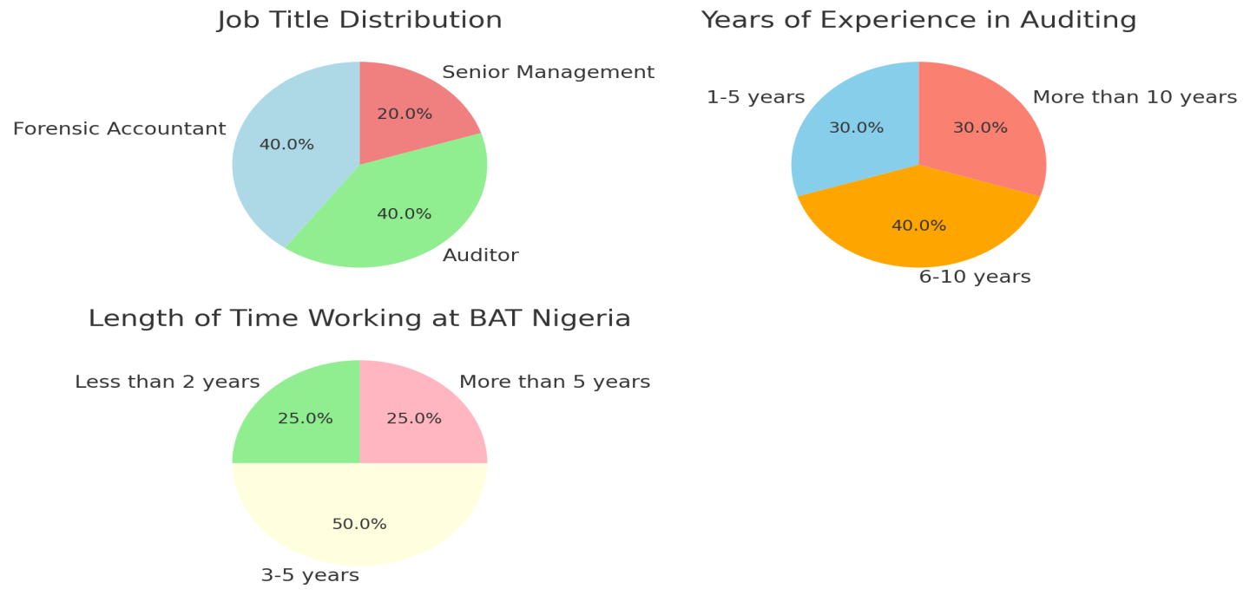

Fig 1 : The pie chart presents the Respondents’ Demographics

Section B: Forensic Accounting Techniques

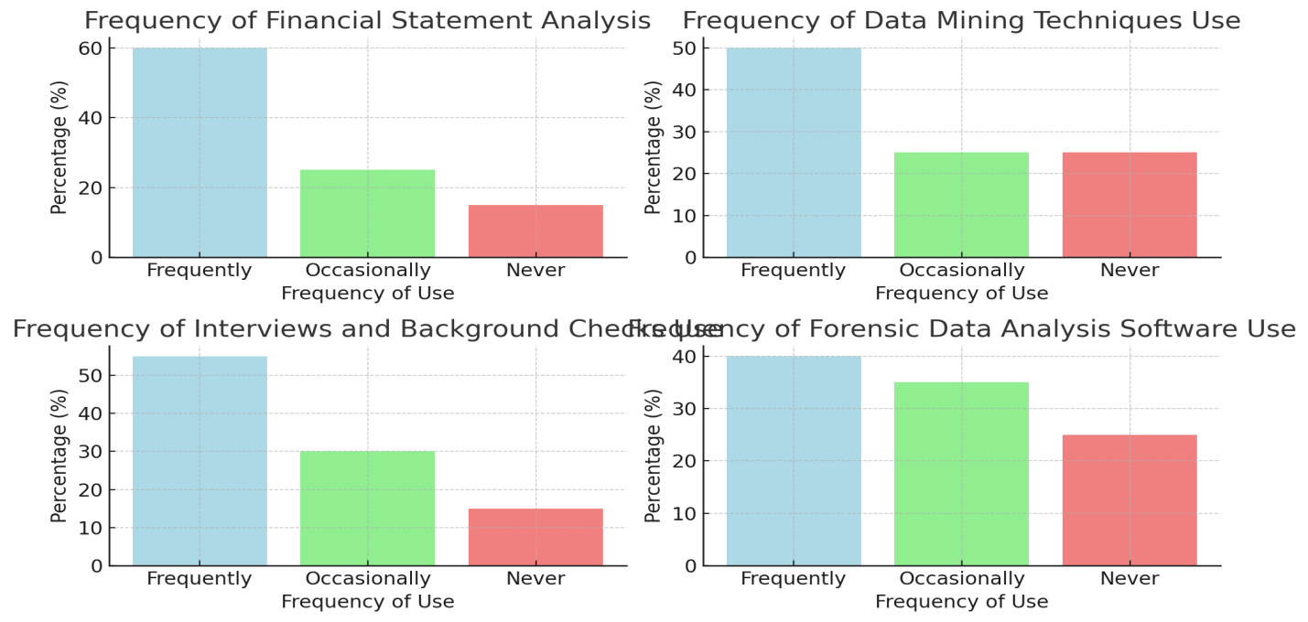
According to the survey, BAT Nigeria regularly uses forensic accounting methods in its auditing procedures. A noteworthy 85% of respondents said they frequently employ financial statement analysis in their audits when asked how often they do so. Of them, 25% utilize financial statement analysis infrequently (once a year), whereas 60% use it often (at least once every quarter). This heavy dependence on financial statement analysis demonstrates how important it is for spotting anomalies and possible fraud in financial reporting. Given how frequently this method is employed, it appears to be a vital tool for BAT's auditing team to verify financial statement correctness and identify irregularities.
Similarly, 75% of respondents reported using data mining techniques, which are thought to be more sophisticated and inquisitive. While 25% of respondents use data mining infrequently, half (50%) do it

Fig 2 : Forensic Accounting Techniques

frequently, usually once a quarter. In order to find trends, disparities, and anomalies that can point to fraud or financial misstatements, auditors use data mining to go through massive amounts of financial data. This regular use of data mining implies that BAT is using advanced forensic methods to improve the efficacy of its audits.
Section C: Impact on Audit Quality
The results of the evaluation of forensic accounting's effect on audit quality were overwhelmingly favorable. Ninety percent of those surveyed agreed or strongly agreed that forensic accounting increases the accuracy of BAT Nigeria's financial reports. With a low standard deviation of 0.6 and a mean score of 4.3 out of 5, the respondents demonstrated a high level of agreement regarding the significance of forensic accounting in guaranteeing the integrity and accuracy of financial reporting. This high degree of agreement implies that BAT places a high value on forensic accounting procedures because of their ability to improve audit quality.
Similarly, 85% of respondents agreed or strongly agreed that forensic accounting procedures improve the credibility of audits carried out at BAT when questioned about the impact of forensic accounting on audit credibility. With a standard deviation of 0.7 and a mean score of 4.2 out of 5, this question showed considerable variation in the responses but overall agreement. The growing understanding that forensic methods are essential to preserving stakeholder trust and guaranteeing more comprehensive and trustworthy audits is shown in the positive link between the usage of forensic accounting and increased audit credibility.

Fig 3 : Impact on Audit Quality

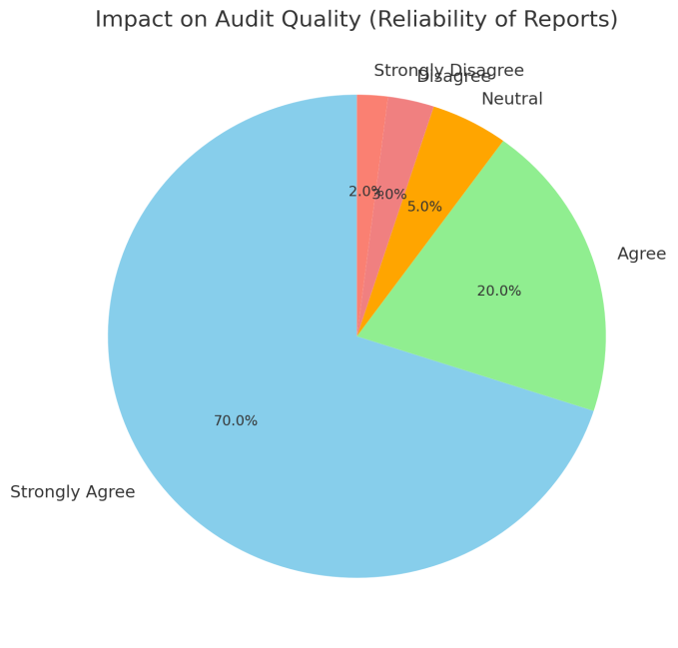

Fig 4 : Effectiveness of Forensic Accounting in Fraud Detection

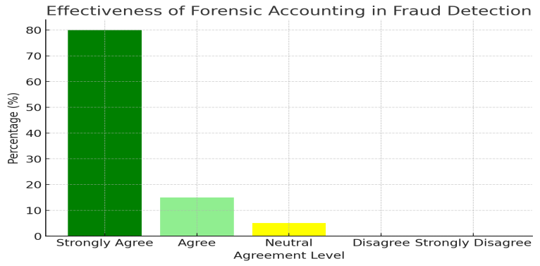

Section D: Fraud Detection
One of the study's main topics was the use of forensic accounting in fraud detection, and the findings were extremely encouraging. According to 80% of respondents, fraud can be detected using forensic accounting procedures. There was substantial agreement among responders, as seen by the item's mean score of 4.4 out of 5 and standard deviation of 0.5. This implies that forensic accounting is crucial in identifying fraudulent activity that conventional auditing techniques could miss. The efficiency of forensic accounting in identifying fraud is essential for preserving the integrity of financial systems and guaranteeing that fraud is discovered early on, especially in light of the growing complexity of fraud schemes.
Additionally, respondents mentioned that less fraudulent activities had occurred as a result of BAT's audit procedure using forensic accounting. This supports the conclusions that, by offering proactive protections against possible wrongdoing, forensic accounting is useful not just in detecting fraud but also in preventing it.

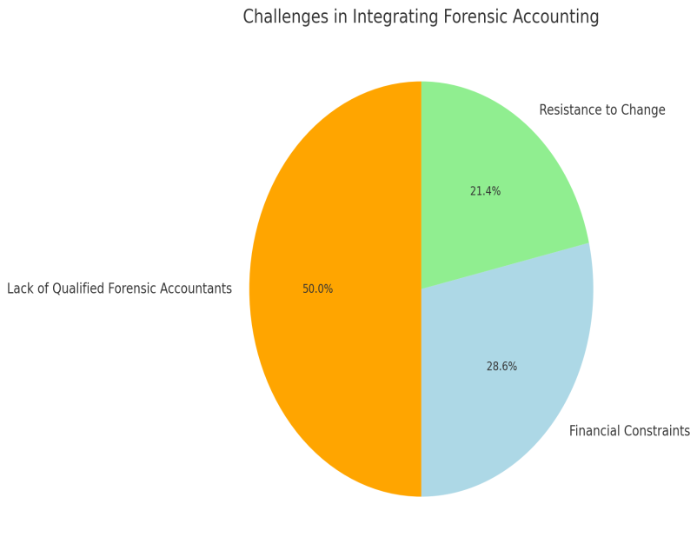

Fig 5 : Challenges in Integration

Section E: Challenges in Integration
Forensic accounting has many obvious advantages, but incorporating these methods into BAT Nigeria's auditing procedure is fraught with difficulties. The most often mentioned obstacle, according to 70% of respondents, was the scarcity of certified forensic accountants. Due to a lack of qualified forensic specialists, BAT might find it difficult to incorporate forensic accounting completely into its auditing procedures, which would restrict the breadth and depth of possible investigations. Many firms have acknowledged the difficulties in locating highly qualified forensic accountants, and this conclusion is consistent with earlier research showing that hiring such specialist individuals in emerging countries can be challenging (Sorunke, 2016).
Furthermore, 40% of respondents mentioned budgetary limitations as a barrier to integrating forensic accounting methods. This is a reflection of worries about the expense of forensic audits, staff training, and investments in cutting-edge equipment and technology. Additionally, 30% of respondents identified organizational opposition to change as a major obstacle. This opposition may result from a reluctance to alter long-standing auditing procedures or from a lack of knowledge about the benefits of forensic accounting. These data imply that, although acknowledging the advantages of forensic accounting, BAT confronts both financial and structural barriers to properly implementing it.

Interpretation of Data
The results unequivocally show that forensic accounting is highly valued in BAT's audit department and that its methods particularly data mining and financial statement analysis are essential to the audit procedure. These methods greatly improve the quality of audits and the detection of fraud. The overwhelmingly positive answers on how forensic accounting affects audit credibility and reliability imply that forensic accounting is not only useful in spotting fraud but also in making sure that BAT's audits are more comprehensive and reliable.
According to the study, forensic accounting is also important for detecting fraud, as most respondents think that these methods are necessary for spotting fraudulent activity. This is consistent with previous research that emphasizes the value of forensic accounting in identifying financial crime, particularly in intricate and complex businesses (Sabo et al., 2024).
However, there are several obstacles in the way of incorporating forensic accounting into BAT's auditing procedures, chief among them being a shortage of skilled experts and budgetary limitations. These obstacles show that in order to fully profit from forensic accounting, BAT must fund training initiatives and employ qualified forensic accountants. Furthermore, a thorough grasp of the benefits forensic accounting offers to the audit process will be necessary to overcome organizational opposition, which can call for a change in the organization's culture.

Conclusion
The results of this chapter's data analysis offer compelling proof of the beneficial effects forensic accounting has on BAT Nigeria's audit quality and fraud detection. However, obstacles to the complete integration of forensic accounting into BAT's auditing procedures include issues like the lack of skilled personnel, budgetary limitations, and organizational opposition to change. The following chapter will go over these results in more detail and offer suggestions on how BAT may improve its forensic accounting skills and get past these obstacles.

Discussions and Findings

Introduction
The results of the data analysis in this chapter are covered in this chapter. Assessing the contribution of forensic accounting to improving audit quality and fraud detection at British American Tobacco (BAT) Nigeria was the aim of this study. The study also aimed to determine the difficulties BAT had while incorporating forensic accounting into its audit procedures. This chapter analyzes the results, evaluates how they relate to the goals of the study, and contrasts them with pertinent theories and literature.

Forensic Accounting Techniques and Audit Quality
According to the survey's results, forensic accounting methods particularly data mining and financial statement analysis are crucial in raising the caliber of audits conducted by BAT Nigeria. The responders' high utilization rates of data mining (75%) and financial statement analysis (85%) demonstrate how essential these methods are to BAT's auditing procedure. These methods improve the accuracy of the final audit report by assisting auditors in spotting financial misstatements and anomalies in financial records.
According to the poll results, 90% of participants think forensic accounting improves the dependability of financial reports when it comes to audit quality. The mean score of 4.3, which indicates the strong agreement among respondents, emphasizes how forensic accounting enhances the legitimacy and dependability of BAT's audits. This is in line with research by Islam et al. (2024), who contend that by going beyond conventional auditing methods, forensic accounting strengthens the audit process. By ensuring a more thorough and in-depth examination of financial data, forensic accounting techniques like financial statement analysis and data mining lessen the possibility that mistakes or fraud would go unnoticed.
The extent to which an audit enhances the accuracy and dependability of an organization's financial statements has been referred to as audit quality in the literature (Aksoy & Hacioglu, 2021). The results of this study support this definition, demonstrating that forensic accounting methods improve audit quality by guaranteeing that financial data is carefully reviewed and verified. By using cutting-edge techniques, BAT's auditors can offer a greater degree of certainty about the accuracy of financial statements, which eventually improves the company's standing and shareholder trust.

Forensic Accounting and Fraud Detection
According to the survey's results, forensic accounting is essential to BAT Nigeria's fraud detection process. With a mean score of 4.4 out of 5, a noteworthy 80% of respondents said that forensic accounting approaches are useful in identifying fraud. This assertion is supported by the positive association shown between forensic accounting and fraud detection, which implies that incorporating forensic accounting methods enhances BAT's capacity to identify fraudulent activity early on. According to the respondents, auditors can spot abnormalities and inconsistencies that might point to financial fraud with the use of methods like data mining and financial statement analysis.
These results are in line with the literature, which highlights the superiority of forensic accounting over conventional auditing techniques in identifying fraud. By combining investigative methods with accounting knowledge, forensic accounting enables auditors to see past the numbers and find covert fraud schemes (Sabo et al., 2024). This capacity to identify fraud is essential in the case of BAT Nigeria because big businesses frequently deal with complex fraud schemes that are difficult to spot using conventional auditing techniques. BAT can lessen the financial effect of fraud and better protect its financial resources and reputation by incorporating forensic accounting into its audit process.
Furthermore, research by Aksoy & Hacioglu (2021) and Adejumo & Ogburie (2025) shows that forensic accounting offers a more thorough and methodical approach to fraud detection, which is crucial for businesses in high-risk industries. Because of BAT's scale and operational complexity, forensic accounting enables a more thorough examination of financial transactions, which facilitates the identification of any fraudulent activity that can jeopardize the organization's financial stability.

Challenges in Integrating Forensic Accounting into Audit Practices
Although forensic accounting has several advantages, the survey's findings also show that there are substantial obstacles to incorporating forensic accounting methods completely into BAT Nigeria's auditing procedures. According to 70% of respondents, the most significant issue is the scarcity of certified forensic accountants. This is consistent with research by Sorunke (2016), who found that hiring and keeping people with the specialized skills needed for forensic accounting is difficult for many firms, especially in developing nations like Nigeria. BAT may find it difficult to fully utilize the potential of forensic accounting techniques due to the lack of qualified forensic accountants, which would limit its ability to detect fraud and improve audit quality.
Forty percent of respondents also cited financial restrictions as a major obstacle. For businesses that may already be working with limited resources, the high expenses of forensic accounting implementation, including the requirement for specialist training and technology, can be a deterrent. This result is in line with research by Nursansiwi (2024), which contends that many organizations may find it difficult to make the financial commitment necessary to include forensic accounting into auditing operations, particularly in settings with limited resources.
30% of respondents also mentioned organizational opposition to change as a difficulty. Employee resistance to implementing new auditing techniques or a lack of knowledge about the benefits of forensic accounting could be the cause of this opposition. Many businesses struggle with organizational reluctance to change, especially when it comes to changing ingrained procedures and workflows. According to Adejumo & Ogburie (2025), overcoming opposition necessitates educating staff members about the advantages of forensic accounting and giving them the tools and training they need to adjust to new methods.
According to these results, forensic accounting may improve audit quality and fraud detection at BAT, but achieving these integration goals is essential to reaping the full rewards of this technology. To build the requisite capabilities internally and guarantee that staff members are prepared to manage the intricacies of forensic accounting, BAT Nigeria will have to make training program investments. The business must also deal with budgetary limitations and supply enough resources to successfully apply these strategies.

Achieving the Research Objectives
Three main goals were the focus of this study:
To examine the extent to which forensic accounting contributes to fraud detection at British American Tobacco Nigeria
According to the results, 80% of respondents think that forensic accounting methods are useful in spotting fraudulent activity, demonstrating the substantial role that forensic accounting plays in fraud detection. This demonstrates the value of forensic accounting in BAT Nigeria's audit procedures and advances the goal of comprehending its function in fraud detection.
To assess how forensic accounting practices enhance the quality and credibility of audits conducted at BAT Nigeria
According to the study, 90% of participants agreed that forensic accounting increases the dependability of financial reports, demonstrating how forensic accounting procedures significantly improve audit quality and credibility. This bolsters the second goal by demonstrating how crucial forensic accounting is to guaranteeing better audit quality at BAT Nigeria.
To identify the key challenges hindering the integration of forensic accounting into the audit function at BAT Nigeria
The shortage of certified forensic accountants, budgetary limitations, and organizational reluctance to change are some of the major obstacles to forensic accounting integration that the study discovered. In line with the third research goal, these difficulties provide serious obstacles to BAT Nigeria's successful application of forensic accounting methods.

Summary
The main conclusions drawn from the data analysis were covered in this chapter along with their connections to previous research and hypotheses. At BAT Nigeria, forensic accounting methods have been demonstrated to improve audit quality and fraud detection, with data mining and financial statement analysis playing a key role in the audit procedure. However, there are a number of obstacles to forensic accounting's integration at BAT, most notably a lack of skilled personnel, budgetary limitations, and change aversion. For BAT to completely reap the benefits of forensic accounting's ability to improve audit quality and stop fraud, these issues must be resolved. Recommendations for overcoming these obstacles and further incorporating forensic accounting into BAT's auditing procedures will be included in the upcoming chapter.

Conclusion
There are several advantages to BAT Nigeria's auditing procedures incorporating forensic accounting, including increased fraud identification and better audit quality. BAT must, however, overcome a number of obstacles in order to fully reap these advantages, including as organizational resistance to change, financial limitations, and a shortage of certified forensic accountants. BAT can enhance its overall audit procedures and bolster its forensic accounting capabilities by funding training, giving forensic accounting top priority in its budget, training staff, and encouraging departmental cooperation. These suggestions give BAT a road map for improving the caliber of its audits, lowering fraud, and upholding its solid reputation for honesty and financial transparency.

Recommendations
This chapter offers suggestions for enhancing the incorporation of forensic accounting into the auditing procedures at British American Tobacco (BAT) Nigeria, based on the results covered in the preceding chapter. Although it has been demonstrated that forensic accounting greatly improves audit quality and fraud detection, a number of obstacles prevent its wide application. These difficulties include organizational opposition to change, financial limitations, and a shortage of certified forensic accountants. The following suggestions are intended to assist BAT in removing these obstacles and use forensic accounting to the fullest extent possible in its audit procedures.

Recommendations for Overcoming the Lack of Qualified Forensic Accountants
The lack of certified forensic accountants’ at BAT Nigeria is one of the biggest obstacles our study found. The following steps should be taken into consideration by BAT in order to address this challenge:
Spend money on education and training.
BAT should set up a thorough training program to improve the forensic accounting skills of its current audit staff. Offering specialized classes, workshops, and certifications in fraud detection, investigative auditing, and forensic accounting are a few examples of how to do this. BAT can lessen its need on outside forensic accounting experts and make sure that its audit staff is prepared to tackle intricate financial inquiries by developing internal competence. Companies that wish to successfully incorporate forensic accounting into their audit operations must spend in training, claims Sorunke (2016).
Collaborate with Academic Establishments
To develop a pool of qualified forensic accountants, BAT can potentially look into joint ventures with nearby colleges and professional accounting associations. A consistent supply of skilled workers might be ensured by working with colleges to provide internships or graduate programs focused on forensic accounting. To encourage staff members to seek further education in this area, BAT might also support forensic accounting certification programs.
Hiring Professional Forensic Accountants
Additionally, BAT ought to think about actively seeking out seasoned forensic accountants to occupy important positions in its audit division. By employing experts in forensic accounting, BAT can enhance the overall efficacy of its audits and swiftly incorporate these abilities into its operations. For businesses dealing with a lack of skilled workers in developing nations like Nigeria, this approach is especially crucial (Sabo et al., 2024).

Recommendations for Addressing Financial Constraints
According to the survey, one of the biggest obstacles to BAT's integration of forensic accounting is money. BAT ought to take into account the following suggestions in order to get over these limitations:
Make forensic accounting investments a top priority.
Even though forensic accounting could cost a lot of money, BAT should see this as an investment in the long run that will improve the caliber and integrity of its audits. The business should make forensic accounting a top priority when allocating funds and make sure that enough staff members are assigned to this task. In the long term, forensic accounting is a wise financial choice because the expense of fraud and financial misstatements can greatly exceed the initial investment (Aksoy & Hacioglu, 2021).
Simplify Forensic Auditing by Using Technology Solutions
By implementing cutting-edge technological solutions like data analytics software and forensic audit tools, BAT can lower the expenses related to forensic accounting. BAT can increase productivity and streamline the forensic auditing process by using technology to automate data gathering, processing, and reporting. This would lessen the forensic accounting's customarily high expenses (Adejumo & Ogburie, 2025).
Implementing Forensic Accounting Methods in Phases
BAT might take a phased approach instead of applying forensic accounting methods to every audit at once. This would entail introducing forensic accounting initially in high-risk domains, like those with a track record of financial irregularities, and then progressively broadening its application as the business develops experience and knowledge. By taking a step-by-step strategy, BAT would be able to better control expenses while still reaping the benefits of forensic accounting.

Recommendations for Overcoming Organizational Resistance to Change
Another significant obstacle to incorporating forensic accounting methods at BAT was found to be organizational resistance to change. BAT have to take into account the following tactics in order to get beyond this resistance:
Launch Education and Awareness Campaigns
BAT ought to start an internal education effort to inform staff members about the advantages of forensic accounting and how it may enhance audit quality and fraud detection. This can entail holding instructional sessions, workshops, and seminars to demonstrate how forensic accounting helps the business identify fraud, increase financial transparency, and adhere to legal requirements. According to Islam et al. (2024), overcoming employee opposition to new auditing approaches requires education.
Engage Senior Leadership in the Procedure
BAT's senior management ought to vigorously support the incorporation of forensic accounting methods. Employees receive a clear message about the value of forensic accounting methods when senior executives support and encourage their use. Senior management should also make sure that forensic accounting receives enough funding and show its worth with measurable results like faster fraud detection and higher-quality audits.
Integrate Forensic Accounting into Organizational Culture BAT should integrate forensic accounting into its daily operations and core values as a fundamental component of its organizational culture. This can entail matching forensic accounting methods to BAT's more general objectives of transparency and financial integrity. Employees are more likely to accept and incorporate forensic accounting into their daily tasks if it is made a fundamental component of the business's operations. Making sure that forensic accounting is seen as an essential instrument for corporate success rather than as an outside force will help to transform organizational culture (Sabo et al., 2024).

Suggestions for Enhancing Forensic Accounting Integration in General: Strengthen Audit and Forensic Accounting Teams' Cooperation
BAT's traditional auditing and forensic accounting teams ought to collaborate more. Cross-functional cooperation can guarantee that both teams are working toward the same goals and that forensic accounting methods are smoothly included into the audit procedure. Along with improving the auditing process, this partnership would increase awareness of the benefits forensic accounting offers the company.
Form a Task Force on Forensic Accounting
In order to supervise the incorporation of forensic accounting into auditing procedures, BAT ought to think about establishing a special forensic accounting task force or committee. This task force would be in charge of formulating plans, establishing goals, and making sure that forensic accounting methods are applied successfully in every audit. To guarantee alignment and promote seamless implementation, the task force should comprise important stakeholders from the management, finance, and audit departments.
Always Assess and Revise Forensic Accounting Procedures
Last but not least, BAT should assess its forensic accounting procedures on a regular basis to make sure they are still current and efficient. It is essential for BAT to keep ahead of the curve by consistently enhancing its forensic accounting capabilities as fraud schemes and new technology develop. This can be accomplished by implementing new forensic accounting tools, investing in continuing training, and taking audit teams' input into consideration.

COMPETING INTERESTS DISCLAIMER:
Authors have declared that they have no known competing financial interests OR non-financial interests OR personal relationships that could have appeared to influence the work reported in this paper.

References
Adamu, G., 2024. Impact of Forensic Accounting on Fraud Detection in Nigerian Deposit Money Banks. Journal of Advance Research in Business, Management and Accounting, 10(2), pp.16-30.
Adejumo, A.P. & Ogburie, C.P., 2025. Forensic Accounting in Financial Fraud Detection: Trends and Challenges. International Journal of Science and Research Archive, 14(03), pp.1219-32.
Aksoy, T. & Hacioglu, U., 2021. Relationship Between Fraud Auditing and Forensic Accounting. In Auditing Ecosystem and Strategic Accounting in the Digital Era: Global Approaches and New Opportunities. 2nd ed. Switzerland: Springer. pp.127-46.
British American Tobacco, 2021. BAT Annual Report and Form 20-F. Annual Report. Ibadan: BAT BAT.
Clark, T., Foster, L., Sloan, L. & Bryman, A., 2021. Bryman's Social Research Methods Sixth Edition. 6th ed. Oxford: Oxford University Press.
Dada, S.O. & Jimoh, F.B., 2020. Forensic accounting and financial crimes in Nigerian public sector. Journal of Accounting and Taxation, 12(4), pp.118-25.
Ghauri, P., Gronhaug, K. & Strange, R., 2020. Research Methods in Business Studies. 1st ed. New York: Cambridge University Press.
Islam, H.M., Islam, R. & Islam, S., 2024. Enhancing Audit Effectiveness through Forensic Accounting: A Case Study Approach. International Journal of Science and Business, 40(1), pp.180-98.
Mahalakshmi, K.E. et al., 2023. Research Methodology. 1st ed. Tamil Nadu: Saliha Publisher.
Nardi, P.M., 2018. Doing Survey Research. 4th ed. New York: Routledge.
Netshifhefhe, K., Netshifhefhe, M.V., Mupa, M.N. & Murapa, K.A., 2024. The Role of Forensic Audits in Strengthening Corporate Governance and Mitigating Compliance Risks. IRE Journal, 8(4), pp.427-45.
Nursansiwi, D.A., 2024. The Role of Forensic Accounting in Detecting Financial Fraud. Accounting Studies and Tax Journal, 1(1), pp.111-16.
Obaid, S.H., Subhi, H. & Ismael, N.B., 2024. The Impact of Forensic Accounting on Corporate Governance and Compliance. OTS Canadian Journal, 3(8).
Onwubiko, C.O., Nwankwo, H. & Achara, O.L., 2019. Forensic Accounting as a Tool in Managing fraud in Organizations: A Study of Selected Firms in Nigeria. Advance Journal of Management, Accounting and Finance, 4(11), pp.31-37.
Oyedokun, O.I., 2024. Forensic Accounting and Financial Reporting Quality of Listed Deposit Money Banks in Nigeria. UMYU Journal of Accounting and Finance Research, 6(1), pp.105-19.
Pedneault, S., Rudewicz, F., Sheetz, M. & Silverstone, H., 2012. Forensic Accounting and Fraud Investigation. 3rd ed. USA: John Wiley & Sons.
Sabo, A., Saidu, H. & Muhammed, N., 2024. Forensic Accounting in Fraud Detection and Prevention: A Literature Review. Journal of the Management Sciences, 61(8), pp.120-34.
Saka, A.Q., Amuda, O.A., Kehinde, J.S. & Saka, T.O., 2025. Forensic Accounting and Auditing: Effect on Corporate Governance, Financial Transparency, And Fraud Prevention in the Global Market a Quantitative Approach. IRE Journals, 8(9), pp.1687-99.
Saunders, M.N.K., Lewis, P. & Thornhill, A., 2023. Research Methods for Business Students. 9th ed. United Kingdom: Pearson.
Sorunke, O.A., 2016. Integrating Forensic Accounting into the Accounting Curriculum in Nigerian University: Challenges and Remedies. International Journal of Academic Research in Progressive Education and Development, 5(1), pp.59-64.

Appendix
Questionnaire
The questionnaire designed for this study is aimed at gathering data on the role of forensic accounting in enhancing audit quality and fraud detection at British American Tobacco (BAT) Nigeria. It is structured to explore key areas such as forensic accounting techniques, audit quality, fraud detection, and challenges in integrating forensic accounting into auditing processes.
Below is the detailed structure of the questionnaire, which includes both closed-ended and Likert-scale questions, as well as demographic questions.

Section A: Respondent Demographics
This section collects demographic information about the participants, including their role in the audit department, years of experience, and time spent working at BAT Nigeria.
- What is your job title?
  - Forensic Accountant
  - Auditor
  - Senior Management
  - Other (Please specify): __________
- How many years of experience do you have in auditing?
  - 1-5 years
  - 6-10 years
  - 11-15 years
  - 16 years or more
- How long have you been working at BAT Nigeria?
  - Less than 2 years
  - 3-5 years
  - 6-10 years
  - More than 10 years

Section B: Forensic Accounting Techniques
This section seeks to understand the forensic accounting techniques currently used at BAT Nigeria and their frequency of application in audits.
- How often do you use the following forensic accounting techniques in your audits?
(Please indicate the frequency for each technique)
  - Financial Statement Analysis
    - Frequently (at least once per quarter)
    - Occasionally (once per year)
    - Never
  - Data Mining
    - Frequently (at least once per quarter)
    - Occasionally (once per year)
    - Never
  - Interviews and Background Checks
    - Frequently (at least once per quarter)
    - Occasionally (once per year)
    - Never
  - Forensic Data Analysis Software (e.g., IDEA, ACL)
    - Frequently (at least once per quarter)
    - Occasionally (once per year)
    - Never
- Which of the following forensic accounting techniques do you believe is the most effective in detecting fraud?
  - Financial Statement Analysis
  - Data Mining
  - Interviews and Background Checks
  - Forensic Data Analysis Software
  - Other (Please specify): ___________
- Do you feel that forensic accounting techniques are adequately integrated into the audit process at BAT Nigeria?
  - Yes
  - No
  - Not Sure

Section C: Impact on Audit Quality
This section explores how forensic accounting affects the quality and credibility of audits at BAT Nigeria.
- To what extent do you agree with the following statements regarding forensic accounting’s impact on audit quality?
(Please use a 5-point Likert scale: Strongly Agree, Agree, Neutral, Disagree, Strongly Disagree)
  - Forensic accounting enhances the reliability of financial reports.
- Strongly Agree
- Agree
- Neutral
- Disagree
- Strongly Disagree
  - Forensic accounting increases the credibility of audits conducted at BAT.
- Strongly Agree
- Agree
- Neutral
- Disagree
- Strongly Disagree
  - Forensic accounting techniques improve the overall effectiveness of audits.
- Strongly Agree
- Agree
- Neutral
- Disagree
- Strongly Disagree
  - The use of forensic accounting reduces the risk of financial misstatements in BAT's financial reports.
- Strongly Agree
- Agree
- Neutral
- Disagree
- Strongly Disagree
- In your opinion, how much does forensic accounting contribute to improving audit quality at BAT Nigeria?
  - A great deal
  - Somewhat
  - A little
  - Not at all

Section D: Fraud Detection
This section seeks to understand the role of forensic accounting in detecting fraud within BAT Nigeria.
- To what extent do you agree with the following statements about fraud detection and forensic accounting?
(Please use a 5-point Likert scale: Strongly Agree, Agree, Neutral, Disagree, Strongly Disagree)
  - Forensic accounting techniques are effective in detecting fraud at BAT.
- Strongly Agree
- Agree
- Neutral
- Disagree
- Strongly Disagree
  - Fraud detection has significantly improved since forensic accounting techniques were integrated into the audit process.
- Strongly Agree
- Agree
- Neutral
- Disagree
- Strongly Disagree
  - The use of forensic accounting has helped BAT reduce the occurrence of financial fraud.
- Strongly Agree
- Agree
- Neutral
- Disagree
- Strongly Disagree
- How much do you think the use of forensic accounting has reduced fraudulent activities at BAT Nigeria?
  - A significant amount
  - A moderate amount
  - A small amount
  - Not at all
- In your experience, which areas of BAT’s financial activities benefit most from forensic accounting techniques for fraud detection?
(Select all that apply)
  - Revenue recognition and sales transactions
  - Procurement and vendor payments
  - Payroll and employee expenses
  - Financial reporting and accounting systems
  - Other (Please specify): ___________

Section E: Challenges in Integration
This section identifies the barriers BAT faces in fully integrating forensic accounting into its audit functions.
- What are the main challenges in integrating forensic accounting into the audit function at BAT Nigeria?
(Please select all that apply)
  - Lack of qualified forensic accountants
  - Financial constraints and budget limitations
  - Resistance to change from employees
  - Insufficient training and resources
  - Lack of awareness about forensic accounting’s benefits
  - Complexity of forensic accounting techniques
  - Other (Please specify): ___________
- To what extent do you agree with the following statements about challenges to integrating forensic accounting at BAT?
(Please use a 5-point Likert scale: Strongly Agree, Agree, Neutral, Disagree, Strongly Disagree)
- BAT faces a significant shortage of qualified forensic accountants.
- Strongly Agree
- Agree
- Neutral
- Disagree
- Strongly Disagree
- Financial constraints limit the ability to implement forensic accounting techniques fully.
- Strongly Agree
- Agree
- Neutral
- Disagree
- Strongly Disagree
- Employees are resistant to adopting forensic accounting methods due to a lack of understanding.
- Strongly Agree
- Agree
- Neutral
- Disagree
- Strongly Disagree
- There is insufficient training available for staff to become proficient in forensic accounting techniques.
- Strongly Agree
- Agree
- Neutral
- Disagree
- Strongly Disagree
- What steps do you believe BAT should take to overcome the challenges in integrating forensic accounting into the audit function?
(Open-ended question)

