GREEN SYNTHESIS OF NANOPARTICLES FROM CALCIUM COMPOSITE FOR WASTE WATER TREATMENT

ABSTRACT
The green synthesis of nanoparticle from calcium composite for waste water treatment was carried out to bio synthesize CaO nanocomposite using leaf extracts of Newbouldialaevis (Ogilisi) and Alternantherabettzicktiana (blood tonic). Phytochemical analyses were carried out on the leaf extract to determine active biomolecules present. The substances synthesized were characterized using UV/Visible spectroscopy, Fourier Transformed Infrared Spectroscopy (FTIR), Scanning Electron Microscopy (SEM) and X- Ray Diffraction (XRD) techniques to ascertain validity and confirm product. On the whole, two different types of nanocomposites were produced which include: Calcium nanocomposite of Ogilisi Leachate treated (CaNPOL) from Newbouldialaevis (Ogilisi) leaf extract and Calcium nano composite blood tonic leachate treated CANPTL of Alternantherabettzicktiana (blood tonic) leaf extract. Result from phytochemical analysis conducted on leaf extracts revealed presence of anthraquinones, protein, amino acids, cardiac glycoside, tannins, saponins. phenolics. terpenoids, flavonoids, and alkaloids, among others were found. Results from characterization include: result from UV/Vis spectral profile showing that spectral absorption was at 260nm and 300nm indicating the presence of CaO/CaONPs. FTIR result revealed 880.427/cm/870.00cm stretching for CaO NPS Neubouldialeavis (Ogilisi) and Alternantherabettzicktiana, (Blood tonic). XRD result, of x-ray after a monocratic beam indicated crystal feature, intense peaks from the spectrum which revealed two–degree theta shifts data ranging of 14.2648 were obtained for CaO NPS. SEM analysis revealed agglomerates structure identyfing CaO. Thus all these analysis conducted on the sample under investigation proved that nano composite made from calcium was produced and can be used for safe water treatment because, it is eco-friendly.

Key words: Green synthesis, nano composites, phytochemical, analysis, characterization
1.0 INTRODUCTION
1.1 Background of the Study
The eradication of harmful toxicants is an exhaustive process, but it is essential for promoting sustainable development. Various strategies have been promulgated, yet the incorporation of nanomaterials has provided a low-cost, efficient, and simple method for the removal of contaminants through adsorption. The contemporary application of nanoparticles, due to their added advantages, has emerged as a significant and effective approach to enhancing synthesis efficiency. By manipulating material properties at the nanoscale such as size, shape, inherent defects, and chemical composition scientists have been able to generate a wide range of nanostructures with exceptionally favorable characteristics (Jeevanandam et al., 2018; Shrivastava and Dash, 2009; Sanchez and Sobolev, 2010). Advances in nanotechnology have enabled the use of various nanomaterials as adsorbents for wastewater remediation, owing to their high efficiency. As a result, numerous nano-adsorbents have been developed for the removal of pollutants from water, including heavy metals, wastewater effluents, and organic waste. These nanomaterials are considered ideal adsorbents due to their simple structural properties, which offer enhanced surface area and high absorption capacity. Green-synthesized nano-adsorbents, in particular, present unique advantages through eco-friendly fabrication techniques that yield high surface areas and increased adsorption capacities. They also exhibit strong affinities for both organic and inorganic contaminants (Aguilar-Perez et al., 2020). The eco-friendly synthesis of nanoparticles promotes clean, non-toxic, cost-effective, and environmentally sustainable procedures. Nanotechnology provides an upgraded and innovative platform for the fabrication and analysis of novel formulations based on metallic nanoparticles, which hold immense potential across diverse fields. Several procedures exist for the green synthesis of metallic nanoparticles, utilizing a variety of solvents, reacting agents, and capping agents. Biomolecules present in plants such as flavones, terpenoids, ketones, alkaloids, aldehydes, vitamins, proteins, amino acids, tannins, phenolics, saponins, and polysaccharides play a crucial role in metal reduction (Vijayaraghavan and Ashokkumar, 2017). In this method of green synthesis, plant-based phytochemicals reduce precursor salts to form nanostructures while simultaneously serving as stabilizing agents for the synthesized nanomaterials. The study aims to extract and determine the phytochemical composition of the methanolic extracts obtained from the plant samples, biologically synthesize kaolin-stabilized calcium and magnesium oxide nanocomposites using aqueous extracts derived from the aforementioned plants, characterize the structural properties of the synthesized nanoscale calcium-based nanocomposites and elucidate using a combination of analytical techniques, including colour change observation, ultraviolet-visible (UV-VIS) spectral analysis, Fourier Transform Infrared Spectroscopy (FTIR), X-ray Diffraction (XRD), and Scanning Electron Microscopy (SEM).
2.0. Materials and Methods
2.1 Sources of Plant Materials
The fresh leave samples of the two test plants namely Ogilisi and Blood tonic used in this study were cultivated in Awka metropolis, Anambra State . The two plants leaves were sent to the Department of Botany, Nnamdi Azikiwe University, Awka for taxonomic identification and authentication as Newbouldialaevis and Alternantherabettzicktiana, by Mr. Iroka Finian under the herbarium numbers: NAUTH – 022B and NAUTH – 055B, respectively.
2.2 Plant Extract Preparation
The fresh leaves of Newbouldialaevis and Amaranthaceae were washed with clean water, and then air dried for 14 days at room temperature. The leaves were destalked and pulverized into coarse powder using industrial blender. Twenty-five (25 g) of the powdered leaves of Newbouldialaevis and Alternantherabettzickiana were then weighed and put into a 1000 ml conical flask containing 500 mL distilled water and methanol, mixed and boiled for 25 min. The aqueous and methanolic extracts were double filtered using a muslin cloth and then through a filter paper (Whatman no. 1). The filtrates were used for the biosynthesis of silver nanoparticles or kept in a refrigerator at 4 °C when needed (Shittu and Ihebunna, 2017).

2.3. Qualitative Phytochemical Screening
The qualitative phytochemical screening for alkaloids, tannins, anthraquinones, terpenoids, glycoside, saponins, flavonoids, steroids, protein and carbohydrate of the methanolic leave extracts of Newbouldialaevis and Alternantherabettzicktiana, were performed by the following standard methods as reported by Okaiyetoet al. (2019) and Karthigaiselvi and Rameshwari (2016) with slight modifications. The obtained results were qualitatively expressed as positive (+) or negative (-) as follow:
2.3.1 Test for alkaloid
50 mg of extract was added to Mayer’s reagent (0.68 g of HgCl₂ in 30 mL of distilled water, 2.5 g of KI in 5 mL of distilled water) solution. Formation of whitish yellow (or) cream coloured precipitate indicates the absence of alkaloids.
2.3.2 Test for tannin
50 mg of extract was transferred in test tube, and 2 drops of 5 % FeCl₃ solution was added thereafter. Dirty green precipitate indicated the presence of tannin.
2.3.3 Test for flavonoid
50 mg of extract was transferred into a test tube and 3 mL of Pb(C₂H₃O₂)₂ solution was added. A bulky white Lead precipitate indicated the test was positive.
2.3.4 Test for saponin
100 mg of extract was mixed with 5 mL of distilled water in a test tube, and it was shaken vigorously. The formation of stable foam indicated the presence of saponins.
2.3.5 Test for glycoside
2 mL glacial CH₃COOH containing one drop of FeCl₃ solution was added to50 mg of extract. Thereafter, a 1 mL volume of concentrated H₂SO₄ was poured along the sides of the tube. Formation of a brown ring at the interface indicated the presence of glycosides.
2.3.6 Test for terpenoid
50 mg of extract was added with chloroform and H₂SO₄. Red violet colour indicated the presence of terpenoids.
2.3.7 Test for protein and amino acid
2 mL of ninhydrin solution (two drops of 10 mg of Ninhydrin in 200 mL of acetone) was added to 50 mg of extract. A characteristic purple colour indicated the presence of amino acid.
2.3.8 Test for carbohydrate
50 mg of extract was mixed with 2 mL of iodine solution. A dark blue or purple coloration indicated the presence of the carbohydrate.
2.3, 9 Test for anthraquinone
50 mg of extract was boiled with 10 mL of H₂SO₄ and filtered while hot. The filtrate was shaken with 5 mL of chloroform. The chloroform layer was transferred into another test tube. The resulting solution was observed for colour changes to violet indicating the presence of anthraquinone.
2.3.10 Test for steroids
50 mg of extract was taken in a test tube and dissolved with chloroform (10 mL), then had added an equal volume of concentrated H₂SO₄ to the test tube by sides. The upper layer in the test tube turned into a red and sulphuric acid layer showing yellow with green fluorescence, showing the presence of steroids.

2.3.11 Test for phenol
5 mL of alcohol was added to fifty milligrams of extract and treated separately with a few drops of neutral FeCl₃ (NH₄OH + FeCl₃) solution. The sudden change in colour to blue-green or black coloration indicates the presence of phenols.
2.4 Substrate Preparation
The locally available and natural kaolin as a stabilizing and supporting material was used to coat the calcium oxide and magnesium oxide nanoparticles. The natural kaolin (Qualikem, China) was conditioned by preparing in a 500 mL solution of NaCl followed by stirring at 28 °C for 36 hr. The solid – liquid mixture was separated by centrifuging at 3,000 rpm for 15 min. Liquids were discarded and the solids were washed with deionized water three times, and then oven dried at 55 °C for 16 hr (Mpenyana – Monyatsiet al. 2012).
2.5 Preparation of Calcium Nitrate solution
Accurate concentration of 15 mMcalcium nitrate(Ca(NO₃)₂) and 4 mM of magnesium nitrate (MgNO₃) were prepared in 100 mL of sterile deionized water contained in 250 mL conical flask (Alamet al., 2019).
2.6. Coating of Calcium Nitrate Solution with Stabilizer
The method of Mpenyana – Monyatsiet al. (2012) was adopted for the kaolin coating of calcium and magnesium. The substrate (20 g) was separately immersed in aqueous solutions containing 15 mM sodiumcalcium and4 mM of magnesium nitrate for 24 hr. They were incubated in a rotary shaker at a speed of 250 rpm inthe dark at room temperature for 24 hr. Substrates containing calciumand magnesium were separated from the mixture by centrifuging at 3,000 rpm for 15 min and washed with deionized water and then oven dried for 24 hr at 55 °C.
2.7. Biosynthesis of CalciumOxide Nanocomposite
Calciumoxide and magnesium oxide nanocomposites were synthesized in the ratio of 1:1 by drop -wise addition of aqueous extracts of Newbouldialaevis and Alternantherabettzickianato calcium nitrate and magnesium nitrate solutions and purified kaolin containing selenium and magnesium in 250 mL Erlenmeyer flasks on magnetic stirrer at 70 °C and 200 rpm for 300 min until the colour change. The sample was purified by centrifugation at 9,000 rpm followed by subsequent washing with sterile deionized water (Alamet al. 2019).
2.8. Physical and Chemical Characterization of CalciumOxide Nanocomposite (CaONC)
2.8.1 UV-VIS spectrophotometric analysis
UV-visible spectrophotometric analysis was conducted atSpringboard Research Laboratory Awka, Anambra State Nigeria on the nanoparticle samples using a UV-visible spectrophotometer (Apel 3000UV) with a slit width of 2nm, using a 10-mm cell at room temperature. The produced CaONCs was examined under visible and UV light in the wavelength ranging from 200-1100nm (Fazlzadehet al. 2016; Okaforet al., 2023; Uba and Genevieve, 2023).
2.8.2 Fourier transform- infra Red (FTIR) spectroscopic analysis
The Fourier transform infrared (FTIR) spectroscopic analysis carried out at Springboard Research Laboratory Awka, Anmbra State Nigeria to determine the functional groups of produced CaO NCs using Buck scientific M530 USA FTIR for the analysis. This instrument was equipped with a detector of deuteratedtriglycinesulphate and beam splitter of potassium bromide. The software of the Gram A1 was used to obtain the spectra and to manipulate them. Zero point five mililitres (0.5 mL) was approximately of 1.0 g of samples, mixed properly and placed on the salt pellet. During measurement, FTIR spectra was obtained at frequency regions of 4,000 – 600 cm⁻¹ and co-added at 32 scans and 4 cm⁻¹ resolution. FTIR spectra were displayed as transmitter values (Fazlzadehet al. 2016; Okaforet al., 2023; Uba and Genevieve, 2023).
2.8.2. X-ray diffraction (XRD) analysis
The phase purity and crystalline nature as well as the X-ray diffraction patterns of the produced CaONCswas determined at Center for Energy Research and Training (CERT) Zaria, Nigeria using an X-ray diffractometer (Philips X-ray Analytical, Amsterdam, The Netherlands). The samples for analysis were prepared by pressing the powder into the cavity of a sample holder and smoothing with a glass slide. They were scanned from 5° to 70° 2θ with a Cu anode X-ray operated at 40 kV and 40 mA in combination with a Ni filter to give a monochromatic Cu-Kα radiation (λ = 1.5418 Å) (Fazlzadehet al. 2016; Okaforet al., 2023; Uba and Genevieve, 2023). The average nanocomposite sizes were calculated using Equation 1 below.
D = Kλ /βCosθ ----------------Equation (1)

where D is average particle size, K is the Scherrer’s constant (0.9), λ is the wavelength of X-ray radiation (0.1542 nm), and β and θ are the half of maximum intensity and Bragg’s angle, respectively.
2.8.3 Scanning electron microscopic (SEM) analysis
The sizes and morphologies of the produced CaO NCs was determined at Center for Energy Research and Training (CERT) Zaria, Nigeria using scanning electron microscope (SEM) Quanta FEG 450 (FEI) (APOLLO X - EDAX). Zero-point five-gram samples were coated with Au/Pd film and the SEM images were obtained using a secondary electron detector. Point chemical analysis was performed in 2 independently selected particles (Fazlzadehet al. 2016; Okaforet al., 2023; Uba and Genevieve, 2023).
3.0. RESULTS AND DISCUSSION
3.1 Results
The result of the qualitative phytochemical profile of the different plant methanolic extracts is presented in Table 1. From the result, the methanolic extract of Newbouldialaevis had higher presence of anthraquinones, protein and amino acids and cardiac glycoside while the methanolic extract of Alternantherabettzickiana had higher presence of tannins, saponins and phenolics. Both extracts had similar presence of terpenoids, flavonoids, alkaloids and absence of glycoside, respectively.
Table 1: Qualitative phytochemical profile of the different plant methanolic extracts

Component | Newbouldialaevis | Alternantherabettzickiana
Anthraquinone | ++ | +
Tannins | + | ++
Terpenoids | + | +
Flavonoids | + | +
Carbohydrate | - | -
Alkaloids | + | +
Protein and amino acid | ++ | +
Cardiac glycoside | ++ | -
Saponins | - | +
Glycoside | - | -
Phenol | + | ++

The results of the UV/Vis spectrals of calcium oxide nanocomposites of A) Newbouldialaevis(Ogilisi) and B Alternantherabettzickiana(Blood tonic) aqueous leave extracts are shown in Figures 1A – B and 2A - B. From the Figure 1A result, the absorption peak of 5.14132 absorbance was found to be at 260 nm while from the Figure 1B, the absorption peaks of 10.00 were found at 291, 296, 299, 302 and 308 nm, respectively. From the Figure 2A result, the absorption peaks of 10.00 were found at 252, 259, 262, 266, 268 and 277 nm while from the Figure 2B, the absorption peaks of 5.231337 were found at 261 nm, respectively.

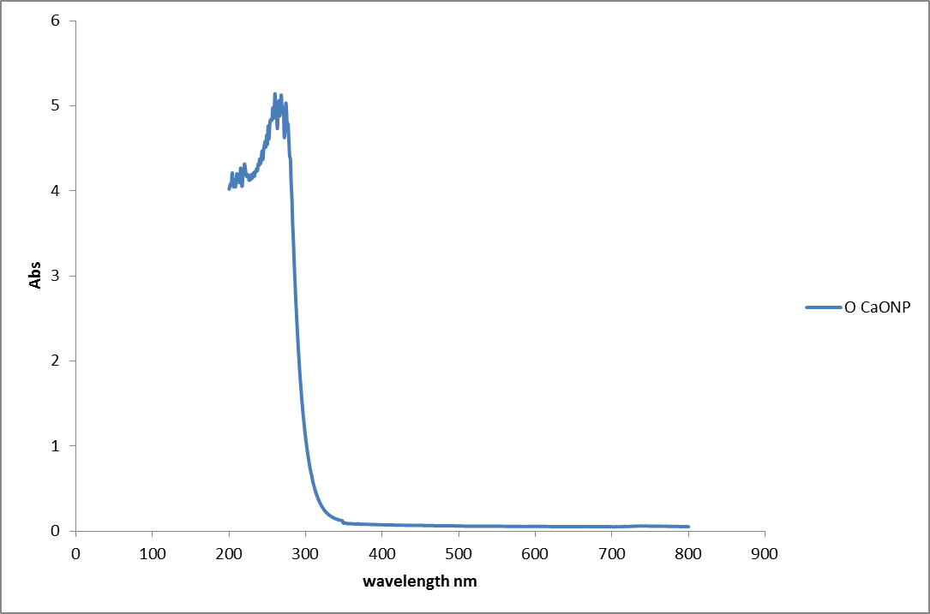
A

Fig 1: UV/Vis spectrals of calcium oxide nanocomposites of A) Newbouldialaevis(Ogilisi)
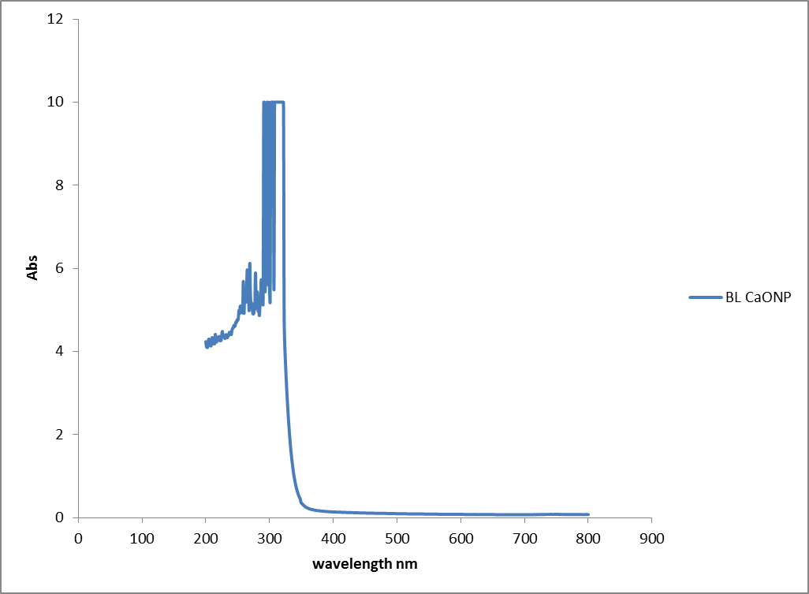
B

Fig 2: UV/Vis spectrals of calcium oxide nanocomposites of B)Alternantherabettzickiana (Blood tonic) aqueous leave extracts

The result of the FTIR spectral profile and functional groups of calcium oxide nanocomposites of A) Newbouldialaevis(Ogilisi) and B) Alternantherabettzicktiana, (Blood tonic) aqueous leave extracts are shown and presented in Figure 3A – B and Table 2. From the results, the peak wave number 3434.116 cm⁻¹ depicts medium band O-H stretching of alcohol, 2833.708 cm⁻¹ represents medium band C-H stretching of alkane, 2216.267 cm⁻¹ represents strong band O=C=O stretching of carbon dioxide, 1915.205 cm⁻¹represents strong band C=O stretching of anhydride, 1378.726 cm⁻¹represents medium band O-H stretching of alcohol, and 880.4271cm⁻¹represents medium band Ca-O stretching of calcium oxide for Newbouldialaevis(Ogilisi) CaONPs; while 3651.674 cm⁻¹represents strong band O-H stretching of hydroxyl, 2602.77 cm⁻¹represents small band O=C=O stretching of carbon dioxide, 1944.342 cm⁻¹represents strong band C=O stretching of anhydride, 1322.236 cm⁻¹represents small band O-H stretching of hydroxyl and 870 cm⁻¹ represents strong band Ca-O stretching of calcium oxide forAlternantherabettzicktiana, (Blood tonic) CaONPs, respectively.

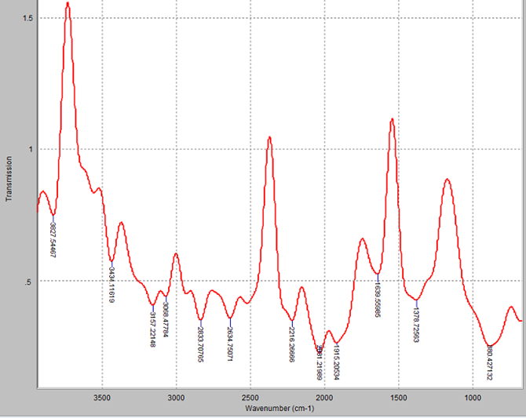
A

Fig 3: FTIR spectral profile of calcium oxide nanocomposites of A) Newbouldialaevis(Ogilisi)

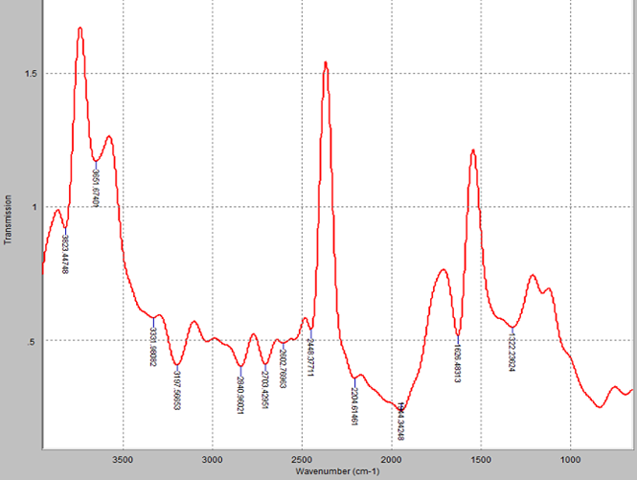
B
Fig 4: FTIR spectral profile of calcium oxide nanocomposites B) Alternantherabettzicktiana, (Blood tonic) aqueous leave extracts

Table 2: Functional groups of calcium oxide nanocomposites of (A) Newbouldialaevis(Ogilisi) and (B) Alternantherabettzicktiana, (Blood tonic) aqueous leave extracts
Band Assignment | Wave number (cm⁻¹) | Appearance | Compound class
Newbouldialaevis(Ogilisi) CaONPs
O-H stretching | 3434.116 | Medium | Alcohol
C-H stretching | 2833.708 | Medium | Alkane
O=C=O stretching | 2216.267 | Strong | Carbon dioxide
C=O stretching | 1915.205 | Strong | Anhydride
O-H stretching  Ca-O stretching | 1378.726  880.4271 | Medium  Strong | Alcohol  Calcium oxide
Alternantherabettzicktiana, (Blood tonic) CaONPs
O-H stretching | 3651.674 | Strong | Hydroxyl
O=C=O stretching | 2602.77 | Small | Carbon dioxide
C=O stretching | 1944.342 | Strong | Anhydride
C–O bond | 1322.236 | Small | Hydroxyl
Ca-O stretching | 870 | Strong | Calcium oxide

The results of the XRD patterns of calcium oxide of A) Newbouldialaevis(Ogilisi) and B) Alternantherabettzicktiana, (Blood tonic) aqueous leave extracts are shown in Figures 5A – B and Figures 6A – B. From the results, Several diffraction intense peaks in the whole spectrum of two-degree theta shift data ranging from 14.2648° to 22.0203°, respectively were obtained.
A

B
Figure 5: XRD patterns of calcium oxide nanocomposites of A) Newbouldialaevis(Ogilisi) and B) Alternantherabettzicktiana, (Blood tonic) aqueous leave extracts

The results of the scanning electron micrographs (SEM) of calcium oxide nanocomposites of A) Newbouldialaevis(Ogilisi) and B) Alternantherabettzicktiana, (Blood tonic) aqueous leave extracts are shown in Plate 1A – B.

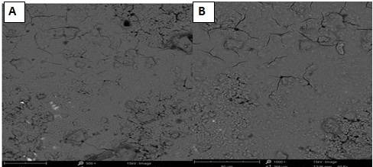

Plate 1.A –B: Scanning electron micrographs of calcium oxide nanoparticles of A) Newbouldialaevis(Ogilisi) and B) Alternantherabettzicktiana, (Blood tonic)

3.2 Discussion
The phytochemical ingredient of the methanolic extract of Newbouldialaevis had higher presence of anthraquinones, protein and amino acids and cardiac glycoside while the methanolic extract of Alternantherabettzickianahad higher presence of tannins, saponins and phenolics. Both extracts had similar presence of terpenoids, flavonoids, alkaloids and absence of glycoside, respectively. Elucidation of biomolecules with these phytochemical ingredients as stated by Vijayaraghavan and Ashokkumar, (2017) have confirmed that these biomolecules have potential for metal ion reduction and capping of the newly formed particles during their growth process.
The results of the UV/Vis spectral profile as demonstrated in Figure 1A –B and Figure 2A-B revealed that their spectral absorption peak was found to be at 260nm, between 291-308, 255-277nm and 261nm respectively. This peak as recorded shows the presence of CaO/CaONPs at 260nm. These results is in conformity with several scientific reports using these aqueous extract whose SPR peaks were found to be 200 – 300 nm, respectively.
From the FTIR results released, a lot of functional group were discovered and this showed that the synthesized nanocomposites are stuffed with different elements and as such different peaks observed indicating their presence at different wave number. However, the interest is at (Figure 3A – B and Table 2) which reveal that 880.4271cm⁻¹ representing medium band Ca-O stretching of calcium oxide for Newbouldialaevis (Ogilisi) CaONPs; and 870 cm⁻¹ representing strong band Ca-O stretching of calcium oxide for Alternantherabettzicktiana, (Blood tonic) CaONPs, respectively. Confirming the presence of the nanocomposites formed.
This results obtained is in line with other literature proving the product (Okwuchukwu et al., 2025).
In this study, interpreting X – ray diffraction (XRD) analysis which is widely used to demonstrate the specific and crystalline nature of the particles. Figures 5A – B and 6A – B. shows different patterns of XRD which were produced when a monochromatic beam of X-rays were absorbed by crystal samples, and results analyzed using Bragg’s equation in order to reveal the exceptional crystal features of the produced CaONPs. From the results, Several diffraction intense peaks in the whole spectrum of two-degree theta shift data range of 14.2648° was obtained. The obtained XRD patterns were in conformity with the known reference data. The mean diameter of the CaONPs was calculated from the XRD patterns and the average size of the particle was determined using Debye- Scherrer Equation. It is hence discovered from the calculation of equation that the synthesized nanoparticles had an average particle size of 35.03 nm. The definitive nanoscale has been reported to range from 1 nm to 100 nm for nano - synthesized materials as stated by Faunce et al. (2008) and upholds the result obtained in this study.
Plate 1 A – B: show the results for the SEM analysis which revealed the agglomerates of calcium oxide nano composites. The agglomerates used represent linear, chain-like structure which can be loosely dense or small but dust powder form The shape obtained in this study is similar to the observations of M. Sengani (2007), andMittali et al (2013), confirming the product.
4.1 Conclusion
The study has revealed that calcium nanocomposite was successfully synthesized by green synthesis using leaf extract of (A) Newbouldialaevis(Ogilisi) and B) Alternantherabettzicktiana (Blood tonic)respectively, then having on the whole two different species of nanocomposite, these are : CaNPOL, calcium nanocomposite using (A) NewbouldiaLeavis (Ogilisi) and CaNPTL, calcium nanocomposite using(B)Alternantherabettzicktiana, Their formation could be as a result of the element contained in the compound and different biomolecule from the leaf extractsof Newbouldialaevis(Ogilisi) andAlternantherabettzicktiana.CaNPOL calcium nanocomposite withleaf extractof Newbouldialaevis(Ogilisi) and CaNPTL, calcium nanocomposite using(B)Alternantherabettzicktiana, formedas shown after characterization indicates that these products cannow be used forbio-absorbents and hence water treatment.

REFERENCES
Aguilar-Perez K.M. Ariles-Castriller I.J., Ruiz-Publich, (2020). Nano-sorbent Materials for pharmaceutical based waste water effluent an Overview. Aribscassillo in Chemical and Environmental Engineering Vol.2,
Ahmed F., Lyon D., Hubler A., (2016). "Gap size dependence of the dielectric strength in nano vacuum gaps". IEEE Transactions on Dielectrics and Electrical Insulation. 20 (4): 1467–1471. Vol 20 issue: 4 eee.explore.eee.org
Alam, H., Khatoon, N., Khan, M.A., Husain, S.A., Saravanan, M. and Sardar, M. (2019). Synthesis of selenium nanoparticles using probiotic bacteria Lactobacillus acidophilus and their enhanced antimicrobial activity against resistant bacteria. Journal of Cluster Science, 24 (3): https://doi.org/10.1007/s10876-019-01705-6.(0123456789().,-volV)(0123456789,-().volV)
Dokubo, C. U. and Uba, B. O. (2023). Assessment of the Decontamination and Disinfecting Potentials of O. gratissimum Synthesized Silver Nanoparticles on Water and Wastewater Samples. IPS Journal of Public Health, 3(2), 58–65.
Fazlzadeh, M., Rahmani, K., Zarei, A., Abdoallahzadeh, H., Nasiri, F. and Khosravi, R. (2016).A novel green synthesis of zero valent iron nanoparticles (NZVI) using three plant extracts and their efficient application for removal of Cr (VI) from aqueous solutions. Advanced Powder Technology, Article in Press: http://dx.doi.org/10.1016/j.apt.2016.09.003.
Ijaz R., Saini. R., Saini .S., Sharma (2020). Nanotechnology: The Future Medicine”. Journal of Cutaneous and Aesthetic surgery. 3 (1): ncb.nlm.nih.gov.
Jeevanadar S., Shinn E., Hubler A., Lyon D., Pendikamp M. G., (2018). "Nuclear Energy Conversion with Stacks of GrapheneNanocapacitors". Complexity. 18 (3):24-27. Boicode: 2013Cmplx...18c...24S. researchgate.net.
Mpenyana-Monyatsi, L., Mthombeni, N. H., Onyango, M. S. and Momba, M. N. B. (2012). Cost - effective filter materials coated with silver nanoparticles for the removal of pathogenic bacteria in groundwater. International Journal of Environmental Research and Public Health, 9: 244 – 271.
Okafor CA, Uba BO, DokuboCU (2023) Application of myco-fabricated silver nanoparticle in the adsorption of malachite green and trypan blue from aqueous solution. Nigerian Journal of Life Sciences12 (2): 8 – 15.
Okwuchukwu, O.E., Ekpunobi, U.E., Ekeoma, M., and Okeke, A.P. (2025). “Copper Ion Adsorption in Waste Water Using Silver Metal Nanocomposite from Avocado Pear Seed”. Asian Journal of Applied Chemistry Research 16 (1):34-47. https://doi.org/10.9734/ajacr/2025/v16i1318.
Shittu, K.O. and Ihebunna, O. (2017). Purification of simulated waste water using green synthesized silver nanoparticles of Piliostigmathonningii aqueous leave extractAdvanced Natural Science: Nanoscience and Nanotechnology, 8: 045003.
Singh, P., Srivastava, N. and Singh, P. (2017). Analysis of various iron nanoparticles and compounds in pulp and paper millwaste water treatment. IntegratedResearch Advances, 4 (2): 24 - 28.
Tortaja C. (2020) Contributions of recycles wastewater to clean water and sanitation sustainable Developments Goals, Nanoparticles clean water 2020, 3, 22 (Google Scholar) (Cross Red)
Uba BO, Obiefuna GO (2023) Aerobically enhanced nano-bioremediation of diesel oil contaminated soil and water using myco-synthesized silver nanoparticle as biostimulating agent. Science World Journal 18 (1): 75 – 82.
Vijaya Kumar P., Mary Jelastin Kala S., Prakash K.S. (2019).Green synthesis of gold nanoparticles using Croton Caudatus Geisel leaf extract and their biological studies. Mater. Lett., 236 (2019), pp. 19-22. View PDFViewarticleView in ScopusGoogle Scholar
Vinayam R., Salvara R. Arivalagan P., Varadavenkatsan T., (2020) synthesis, characterization and photocalytic dye degradation capability of Calliandrahaematocephala-mediated zinc oxide nanoflowers. J. Photochem. Photobiol., B Biol.

