COMPERATIVE ANALYSIS OF THE BULK PROPERTIES OF CRUDE OIL SAMPLES FROM FOUR PRODUCING FIELDS IN NIGER DELTA

Abstract
Twelve different crude oil samples were collected from four oil fields in the Niger Delta Nigeria. The bulk properties of these crude oils which include API gravity, specific gravity, reid vapour pressure, kinematic viscosity, dynamic viscosity, moisture, cloud point, pour point, gum content and Sulphur content were analysed, using standard procedures of American Society for Testing and Materials (ASTM). The results show API gravity values ranged from 30.54 to 42.46, Specific gravity 0.8134 to 0.8733, reid vapour pressure as NA, Kinematic viscosities 2.001 to 5.5472cSt, Dynamic viscosities 1.6307cP to 5.057cP at 0°C, Gum content 4.68 to 87.35mg/100ml, flash point 15°C to 27°C, Pour point -16°C to 14°C, Cloud point as NA and Sulphur content as NA. These physicochemical properties play a crucial role in determining the crude oil's suitability for refining, transportation, and its environmental impact. The data highlights the need for tailored handling and processing strategies based on the specific characteristics of each crude oil sample.

Key word: API and Specific gravity; pour point; kinematic viscosity; moisture Content; reid vapour pressure and dynamic viscosity; Niger Delta
INTRODUCTION
The Niger Delta is important in crude oil correlation studies because it is one of the major hydrocarbon provinces of the world, with an estimated reserve of about 23 billion barrels of oil and 183 trillion cubic feet of natural gas (Sonibare, 2008). Defining and evaluating exploration are helpful to characterise the hydrocarbon source rocks, their range of thermal maturities and types of products generated (Muhammad, 2010). Hydrocarbons within the basin have been found to occur at different productive horizons at very great depth apart, The migration processes that determined the pooling of the hydrocarbons at different depths are yet to be clearly understood but it is known that the properties and composition of any petroleum systems are controlled by complex geological, physicochemical and biological processes during generation as well as accumulation in reservoirs. Crude oil or Petroleum, is a naturally occurring yellowish-black liquid mixture of mainly hydrocarbons, and is found in geological formations (EIA, 2017). The word petroleum comes from Medieval Latin petroleum (literally 'rock oil'), which comes from Latin petra 'rock' and oleum 'oil' .The origin of the term started from monasteries in southern Italy where it was in use by the end of the first millennium as an alternative for the older term "naphtha"(Petroleum, 2017; Petroleum, 2020). Over the years the chemical utilization of crude oil and its refined products has been used on the increasing globally (Udeme et al., 2012). It has been mentioned that the ever increasing chemical utilization of crude oils and petroleum products call for a better knowledge of the composition, structure and properties of the fractions (Olajire and Oderinde, 1992; Odebunmi et al., 2001). As a result, concerted effort are being made to understand its composition, structures and properties. This understanding guides in processing method and condition to improve the yield and the quality of products. Composition of crude oil determines their characteristics (Carey, 2003). These characteristics in turn for any crude oil depend on the particular source of oil field. There are different multiple sand reservoirs of tertiary sedimentary deposits in each of oil field, resulting in a unique character of crude oil content. The oil fields are characterised by these differences. As a result, different proportions of the various hydrocarbons of different molecular types, sizes and other elemental constituents in the samples of the crude oil. Therefore there is need to characterize the oil to ascertain their properties, to design the precaution modality, refining procedure and assess its potential as a source of environmental contaminants (Udeme et al., 2012). It has also been established that the quality of the petroleum products plays the major role in consumer demand and the performance of the refineries (Oyekunle et al., 2004).
MATERIALS AND METHODS
Sample location and collection
Crude oil samples were collected from four producing fields in the Niger Delta region of Nigeria: Warri (Delta State), Imo River (Imo State), Nembe/Brass (Bayelsa State), and Bonny/Bonga Offshore Fields (Rivers State). The Warri area is located in the western Niger Delta and is associated with the Agbada Formation. The Imo River Field is an onshore location bordering the Anambra Basin. Samples from Nembe and Brass were obtained near Wilberforce Island, a swampy region rich in oil and gas deposits. Bonny and Bonga are deep offshore fields that produce crude oil from marine reservoirs.
Crude oil samples were obtained from flow stations and storage terminals using sterilized, airtight glass bottles. Sample containers were labeled with field code, date, and well information. GPS coordinates were recorded at each site. To preserve sample integrity, they were stored in cool, dark conditions and transported promptly for analysis. Collection procedures followed Tissot and Welte (1984) to avoid contamination or alteration of crude properties. The sample locations and collection points are presented in Figure 1, which illustrates the spatial distribution of the fields across the Niger Delta basin.

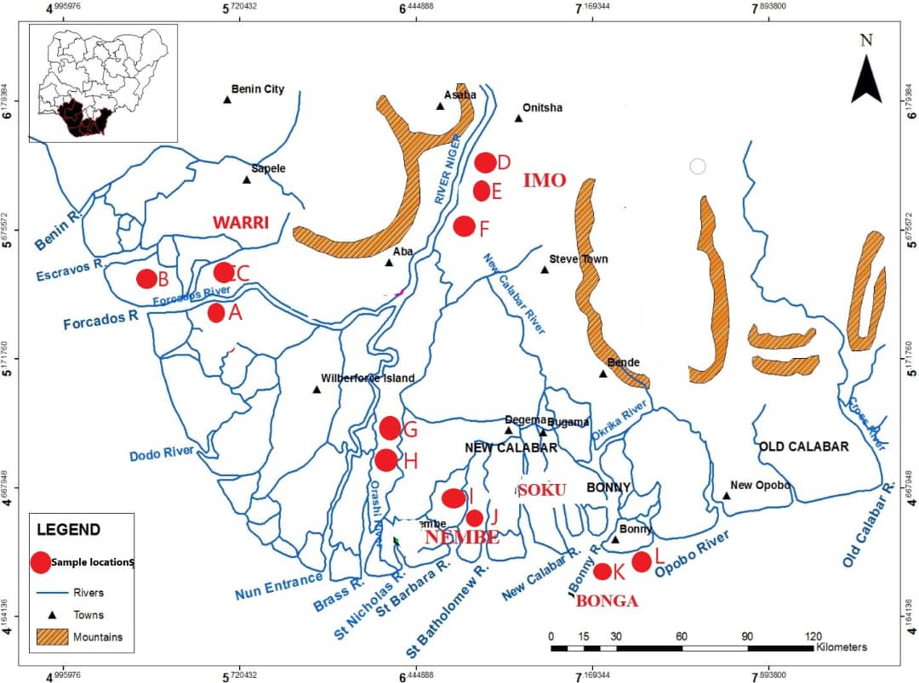
Figure 1: Map showing the study location and sample location of crude oil of the four producing field in Niger Delta.

Sample preparation
A 50 g portion of each crude oil sample was dissolved in 50 mL dichloromethane and left undisturbed for 30 minutes. The mixture was filtered through Whatman No.1 paper into a 100 mL volumetric flask and brought to volume with petroleum ether. The resulting solution was stored in 120 mL glass sample bottles for laboratory analysis.

Analytical methods
Analyses were carried out at Indorama-Eleme Petrochemical Company Ltd., Port Harcourt, using standard procedures recommended by the American Society for Testing and Materials (ASTM). Parameters analyzed included API gravity, specific gravity, kinematic viscosity, moisture content, gum content, flash point, pour point, cloud point, and sulphur content.
API gravity and specific gravity
Specific gravity and API gravity were determined using a digital density meter in accordance with ASTM D4052. The crude oil was injected into the cell at 15.6°C, ensuring no air bubbles were present. API gravity was calculated using the equation:
$$API Gravity=\frac{141.3}{Specific gravity of the oil at 60°F}-131.4$$
Reid vapour pressure
Reid vapour pressure was measured according to ASTM D323. Samples were cooled below 0°C, sealed in the apparatus, and immersed in a water bath at 37.8°C. After agitation, vapour pressure was recorded at equilibrium.

Kinematic and dynamic viscosity
Viscosity measurements were performed following ASTM D445. A clean viscometer was filled with crude oil, placed in a 40°C bath, and flow time between calibrated marks was recorded. Kinematic viscosity was calculated as:
Kinematic Viscosity (V) = c x t (c=0.009933)
Dynamic viscosity was obtained using the formula:
µ = p x v

Moisture content
Moisture content was determined by Karl Fischer titration following ASTM D1744. A known volume of crude oil (2–5 mL) was injected into the titration vessel, and the moisture content (%) was displayed on the coulometer.
Gum content
Existent gum content was evaluated according to ASTM D381. Pre-weighed beakers were filled with 10 mL of crude oil and exposed to heated air jets at 160–165°C for 30 minutes. After cooling, beakers were reweighed, and gum content was calculated:
Gum (mg/100 mL) =10,000×(A−C)
Flash point
The flash point was measured using the Cleveland open cup method, following ASTM D92. Samples were heated, and the temperature at which vapour ignited with a test flame was recorded.
Pour point
Pour point was determined according to ASTM D97. Crude oil samples were preheated, then allowed to cool under controlled conditions. The pour point was recorded as the temperature at which flow ceased in the tilted jar.
Cloud point
Cloud point was measured in accordance with ASTM D2500. Samples were cooled incrementally by 1°C and inspected for the appearance of cloudiness. The lowest temperature showing haze formation was recorded.
Sulphur content
Sulphur content was determined using the classical bomb method in line with ASTM D129. A 1.5 g crude oil sample was fused with sodium, acidified with acetic acid, and tested with lead acetate. Formation of black lead sulphide confirmed the presence of sulphur.

RESULTS AND DISCUSSION
The physicochemical properties of twelve crude oil samples collected from the Niger Delta were analyzed to determine their suitability for refining and transport. Parameters evaluated included API gravity, specific gravity, kinematic and dynamic viscosities, moisture content, gum content, flash point, and pour point.
The results of the analysis are summarized in Table 1. Crude oil samples exhibited varying physical characteristics across locations, reflecting differences in reservoir origin and maturity.

Tables 1: Results of the bulk properties of crude oil samples

PARAMETERS | Sample | Sample | Sample | Sample | Sample | Sample | Sample | Sample | Sample | Sample | Sample | Sample
 | A | B | C | D | E | F | G | H | I | J | k | L
API@15°C | 42.05 | 39.23 | 30.54 | 35.95 | 42.46 | 34.4 | 40.15 | 37.2 | 32.9 | 32.2 | 41.4 | 31.5
SG@15°C | 0.8153 | 0.829 | 0.8733 | 0.845 | 0.8134 | 0.8529 | 0.8153 | 0.829 | 0.845 | 0.8529 | 0.8134 | 0.8733
RVP@37.7°C(psi) | NA | NA | NA | NA | NA | NA | NA | NA | NA | NA | NA | NA
KV@40°C(cSt) | 2.001 | 2.775 | 5.5472 | 2.5595 | 3 | 2.6531 | 2.011 | 2.875 | 2.5805 | 2.7531 | 3 | 5.447
Dynamic Viscosity @0°C(cP) | 1.6307 | 2.3005 | 4.757 | 2.1628 | 2.1565 | 2.2628 | 2.63 | 2.4005 | 2.2626 | 2.3628 | 2.355 | 5.057
Moisture Content(V/V) | <0.05 | 0.5 | 0.06 | <0.05 | 0.02 | <0.00.05 | <0.05 | 0.55 | <0.05 | <0.00.05 | 0.022 | 0.07
Gum Content  (Mg/100ml) | 4.7757 | 21.26 | 87.35 | 7.52 | 7.42 | 6.92 | 4.6757 | 20.26 | 8.52 | 7 | 6.42 | 82.35
Flash Point(°C) | 17 | 16 | 27 | 21 | 19 | 15 | 16 | 16 | 20 | 17 | 19 | 25
Pour Point(°C) | -8 | 14 | -9 | -16 | 14 | -5 | -6 | 13 | -15 | -5 | 10 | -8
Cloud Point(°C) | NA | NA | NA | NA | NA | NA | NA | NA | NA | NA | NA | NA
Sulphur Content(Ppm) | NA | NA | NA | NA | NA | NA | NA | NA | NA | NA | NA | NA

4.2 DISCUSSION
The bulk properties of crude oil and compositions for the studied oils are presented in Table 1, classification on the basis of physical characteristics (Sun et al., 2009; Odebunmi et al., 2002), which are commonly called commercial parameters has remained with the oil industry for the quality evaluation and pricing purposes. The results indicated that the crude oil from which the test samples were obtained are all comparable with crude oil of good or acceptable qualities from other locations in the world (Odebunmi et al., 2002).
API gravity measures how heavy or light crude oil is compared to water. Higher API values mean lighter oil, which is easier and cheaper to refine into high-demand products like gasoline and diesel and ranges from 30.54 - 42.05. The American Petroleum Institute (API) classifies crude oil as light if API > 31°, medium between 22.3°–31.1°, and heavy if < 22.3° (Speight, 2014; U.S EIA, 2020). All but one of my samples exceed 31.1° API, classifying them as light crudes. Even the lowest 30.54 (Sample F) sit just at the medium boundary. Light crudes command higher prices and require less severe cracking than medium or heavy oils (Speight, 2014).
The density of crude oil compared to water. It correlates inversely with API gravity.
Specific gravity ranges from 0.8134 – 0.8733. Commercial crude typically fall between 0.82-0.93 (Speight, 2006). My samples all lie within this range. Lower specific gravity (0.81-0.83) correlate with the highest API gravity (40-42° API), confirming that the oils are very light. Higher specific (0.86-0.87) matches the 31.1° API sample, indicating slightly dense crude. All samples lies within the normal commercial range and lower density crude oils flow easily in pipelines and require less heating (Speight, 2006).
Kinematic Viscosity (at 40°C) describes how easily oil flows at room temperature. Kinematic Viscosity ranges from 2.011-5.5472 cSt. Sample G (2.011) is thin and easy-flowing, while Sample F (5.5472) is thick and sluggish. Lower viscosity means the crude can flow through pipelines more easily and needs less heating during refining. Viscosity directly affects pumping costs and equipment wear (Speight, 2014). Light crude oils generally range from 1-10 cSt at 40⁰C (ASTM D445, 2015). Most of your samples (2-4 cSt) sit in the easy flow zone typically of light crudes. Two samples at 5.5 cSt are still well below heavy oil levels (hundreds of cSt for tar-like bitumen), but would require modest heating or dilution to pump in colder pipeline (Riazi, 2005). These crude oils are relatively easy to pump and refine with minimal heating or blending.
Dynamic Viscosity (at 80°C) measures internal resistance to flow at higher temperature. Dynamic Viscosity ranges from 1.6307- 4.757cP. Most samples fall between 1.600- 2.500 cP, with the thickest around 4.700 cP. At refining temperatures, higher viscosity increases operational stress and energy use. Viscosity directly affects pumping costs and equipment wear (Speight, 2014). No absolute limit exists for crude, but value over 3.000 cP at 0⁰C can hinder pipeline flow without heating. Only the single outlier (4.700 cP) would challenge cold-weather transport, the rest remain pumpable with minimal heating (ASTM D5293, 2016).
Moisture Content (% v/v) water present in crude oil, which can cause rust and interfere with refining. Moisture content ranges from <0.00.05% to 0.55%. Six samples < 0.05% and five samples below 0.5% and one at 0.55%. Water is undesirable. Industry typically requires ≤ 0.5-1.0% BS&W (ASTM D4928, 2017). All of my samples easily meet the strictest 0.5% target.
Gum Content (mg/100ml) is the nonvolatile residue from oxidation or heavy hydrocarbons, a poxy for stability and fouling potential. Indicates quality degradation potential. Gum content ranges from 4.7757 - 87.35. High gum is more deposits in engines and refineries. Sample F (87.35) and sample L (82.3) may require pretreatment. Finished fuels target ≤ 5-7mg/100 mL (ASTM D381, 2014); crude feed ideally as low as possible (Gary, Handwerk, and Kaiser, 2007). Three samples (4.7-6.9 mg/100 mL) are comparable to refined fuels. Others (21-82 mg 100 mL) exceed that guideline, indicating potential heater /catalyst fouling and need for pre-treatment (Gary et al., 2007).
Flash Point (°C) lowest temperature at which oil vapours ignite. Flash point ranges from 15°C to 27°C. NFPA classifies flash < 23⁰C as extremely flammable; < 38⁰C as flammable (NFPA, 2018). Every sample falls in the flammable or extremely flammable class, requiring closed-vessel handling, vapour recovery, and explosion-prof equipment.
Pour Point is the lowest temperature oil still flows (ASTM international, 2016). Pour point ranges from –16°C (Sample G) to +14°C. Oils with pour ≥ 0⁰C risk gelling in cool climates. In my data, five samples pour below -5°C which is excellent for cold weather flow, while four exceed +5 °C and two exceed +10 °C, meaning they would need heating or pour point depressant additives in temperature zones (ASTM D97, 2016).

CONCLUSION
This study provides a comparative analysis of the bulk properties of crude oil samples from four producing fields in the Niger Delta. The results show that the majority of the samples fall within acceptable industry standards for light crude oils, with favorable values of API gravity, viscosity, and moisture content. However, variations in gum content and pour point suggest the need for selective pre-treatment and handling. These findings contribute to a better understanding of the commercial quality and processing requirements of Niger Delta crudes, aiding in field-specific refining, transport, and pricing strategies.

REFERNCE

ASTM International. (2014). Standard test method for gum content of inhibited mineral oils (ASTM D381). West Conshohocken, PA: ASTM.
ASTM International. (2016a). Standard test method for pour point of crude oils (ASTM D97). West Conshohocken, PA: ASTM.
ASTM International. (2016b). Standard test method for measurement of low temperature viscosity of petroleum distillates between −20°C and −55°C using a Stabinger viscometer (ASTM D5293). West Conshohocken, PA: ASTM.
ASTM International. (2017). Standard test method for water in crude oil by Karl Fischer reagent (ASTM D4928). West Conshohocken, PA: ASTM.
Carey, F. A. (2003). Organic chemistry (5th ed., pp. 89–99). McGraw-Hill Press.
Doust, H., & Omatsola, E. (1990). Niger Delta. In D. Edwards & P. Santogrossi (Eds.), Divergent/passive margin basins (AAPG Memoir 48, pp. 239–248). American Association of Petroleum Geologists.
EIA. (2017). Energy kids: Oil (petroleum). U.S. Energy Information Administration. https://web.archive.org/web/20170707183134/https://www.eia.gov/KIDS/energy.cfm?page=oil_home-basics-k.cfm
Gary, J. H., Handwerk, G. E., & Kaiser, M. J. (2007). Petroleum refining: Technology and economics (5th ed.). CRC Press.
Muhammad, I. J., Fazeelat, T., & Hina, S. (2010). Characterization of Pakistani crude oils. Chinese Journal of Geochemistry, 29(1), 82.
National Fire Protection Association. (2018). NFPA 30: Flammable and combustible liquids code. NFPA.
Nwajide, C. S. (2013). Geology of Nigeria's sedimentary basins. CSS Bookshops Limited.
Odebunmi, E. O., Ogunsakin, E. A., & Ilkhor, P. E. P. (2002). Characterization of crude oils and petroleum products: (I) Elution liquid chromatographic separation and gas chromatographic analysis. Journal of the Chemical Society of Ethiopia, 16(2), 115–132.
Odebunmi, E. O., Ogunsakin, E. A., & Ilukhor, P. E. P. (2001). Characterization of crude oil and petroleum products: Elution liquid chromatographic separation and gas chromatographic analysis. Bulletin of the Chemical Society of Ethiopia, 16(2), 115–132.
Olajire, A. A., & Oderinde, R. A. (1992). Characterisation of Nigerian crude, middle distillate and heavy residual oils by infrared spectrophotometry. Journal of Chemistry, 1(6), 324–333.
Oyekunle, L. O., & Famakin, O. A. (2004). Studies of Nigerian crude oils: Characterization of crude oil mixtures. Petroleum Science and Technology, 22(5–6), 665–675.
Petroleum. (2017). In The Free Dictionary. https://web.archive.org/web/20170110024856/http://www.thefreedictionary.com/petroleum
Petroleum. (2020). In American Heritage Dictionary. https://web.archive.org/web/20200516164428/https://www.ahdictionary.com/word/search.html?q=petroleum
Reijers, T. J. A. (1996). Selected chapters on geology: Sedimentary geology, sequence stratigraphy and paleontology. Shell Petroleum Development Company.
Riazi, M. R. (2005). Characterization and properties of petroleum fractions. ASTM International.
Short, K. C., & Stauble, A. J. (1967). Outline of geology of Niger Delta. AAPG Bulletin, 51(5), 761–779.
Sonibare, O., Alimi, H., Jarvie, D., & Ehinola, O. A. (2008). Chemical composition and geochemical evaluation of Niger Delta crude oils. Journal of Petroleum Science and Engineering, 61(1), 99–105.
Speight, J. G. (2006). The chemistry and technology of petroleum (4th ed.). CRC Press.
Speight, J. G. (2014). The chemistry and technology of petroleum (5th ed.). CRC Press.
Sun, X., Hwang, J. Y., Huang, X., & Li, B. (2009). Petroleum coke particle size effect on the treatment of EAF dust through microwave heating. Journal of Materials Characterization Engineering, 8(4), 249–259.
Tissot, B. P., & Welte, D. H. (1984). Petroleum formation and occurrence (2nd ed.). Springer-Verlag.
U.S. Energy Information Administration. (2020). Petroleum & other liquids: Definitions. https://www.eia.gov
Udeme, M., John, D., & Etim, I. U. (2012). Physicochemical studies of Nigeria’s crude oil blends. Petroleum and Coal, 54(3), 243–251.

