Original Research Article

Comprehensive Analysis of Mycoflora Associated with Soybean Seeds and Its Implications for Seed Health

Abstract
A comprehensive study was conducted to characterize the seed-borne mycoflora associated with soybean (Glycine max (L.) Merrill) and to evaluate their impact on seed health. Seed samples of three soybean cultivars-Palam Soya, Shivalik, and Hara Soya-were collected from field plots subjected to either fungicide treatment (tebuconazole) or left untreated at the experimental farm of CSKHPKV, Palampur. Detection and identification of seed-borne fungi were performed using both the agar plate and blotter paper methods, following ISTA protocols. A total of thirteen fungal species were isolated, with Fusarium proliferatum, Colletotrichum truncatum, and Alternaria alternata being the most prevalent across all cultivars and treatments. The agar plate method demonstrated higher sensitivity in detecting fungal contaminants compared to the blotter paper method. Pathogenicity assays revealed that Aspergillus niger significantly reduced seed germination, root length, shoot length, and seedling vigour index, indicating its high pathogenic potential. These findings highlight the critical need for regular monitoring and effective management of seed-borne mycoflora to safeguard soybean seed quality and enhance crop productivity.
Keywords: Soybean, Seed borne fungi, Seedling vigour
INTRODUCTION
Soybean (Glycine max (L.) Merrill), often referred to as the "golden bean," is one of the world’s most important oilseed crops, ranking highest among legume crops due to its high protein (42–45%), oil (20–22%), and starch (21%) content, as well as its rich lysine amino acid profile (Rao et al. 2015). However, soybean cultivation is frequently challenged by a wide spectrum of biotic and abiotic stresses that adversely affect yield and quality. Among these, seed-borne fungal pathogens are of particular concern, as they not only reduce seed germination and seedling vigour but also serve as primary inoculum sources for field epidemics (Hamman et al. 1996; Dawson and Bateman 2001). The transmission of pathogens through seeds can result in significant crop losses, malformed seedlings, and compromised seed coats, ultimately threatening food security and the sustainability of soybean production (Hartman et al. 2015). Early and accurate detection of seed mycoflora is therefore essential for several reasons: it facilitates the identification of pathogenic and toxigenic fungi, guides the implementation of effective seed treatment and storage practices, and ensures the production and distribution of healthy, disease-free seeds (ISTA 2023; Batzer and Mueller 2020). Moreover, understanding the diversity of seed-associated fungi, including both harmful pathogens and potentially beneficial endophytes, is critical for developing integrated disease management strategies and for complying with phytosanitary regulations in seed trade (Johnston-Monje et al. 2021; Fernandes et al. 2015). Despite the recognized importance of seed-borne fungi, comprehensive studies on the mycoflora associated with soybean seeds, particularly under different management regimes, remain limited. In this context, the present investigation was undertaken to isolate and identify the mycoflora associated with soybean seeds from different cultivars and to assess their impact on seed health, thereby contributing to the development of effective seed health management strategies.
Material and methods
Collection of seed sample
To procure experimental material, seeds of three soybean varieties-Palam Soya, Shivalik, and Hara Soya-were multiplied at the experimental farm of the Department of Plant Pathology, CSK Himachal Pradesh Agricultural University, Palampur (Latitude 32°06′39.1″ N, Longitude 76°32′10.51″ E). In order to evaluate the influence of fungicide application on seed health, a foliar spray of tebuconazole (1 mL/L) was administered to designated plots of each soybean cultivar during the growing season. At physiological maturity, seeds were harvested separately from both fungicide-treated and untreated plots for all varieties. Each sample was meticulously labeled to indicate the variety and treatment status (sprayed or unsprayed), thereby enabling precise comparative analyses of the effects of chemical intervention on seed-borne mycoflora.
Detection of Seed-Borne Mycoflora
Seed samples were analyzed for the presence of seed-borne fungi in accordance with the International Rules for Seed Health Testing (ISTA 2023), with minor methodological modifications as described below.
Agar Plate Method
Sterilized glass Petri plates (9 cm diameter) containing potato dextrose agar (PDA) were employed for seed incubation. For each treatment-surface-sterilized and unsterilized seeds-four replicates were prepared. Surface sterilization was achieved by immersing seeds in 1% sodium hypochlorite solution for three minutes, followed by three thorough rinses with sterile distilled water. Subsequently, ten seeds were aseptically placed equidistantly in each Petri plate using sterilized forceps. The plates were incubated at 25 ± 1°C for seven days (Fig.1a). After incubation, fungal growth was assessed by preparing temporary mounts and examining them under a compound microscope at 40× magnification. Fungal colonies were enumerated, and the frequency of each species was calculated using the formula:

Total fungal colonies (%) = $\frac{No. of seeds colonized in each plate by a particular species }{Total no. of seed in each plate}×100$

Blotter Paper Method
In the blotter paper method, three layers of blotter paper, moistened with sterile distilled water, were placed at the bottom of 9 cm diameter Petri dishes. As with the agar plate method, four replicates were prepared for both sterilized and unsterilized seed samples. Seeds were surface-sterilized as described above. Ten seeds were then placed on the moist filter paper in each Petri dish. The dishes were incubated at 25 ± 1°C for seven days (Fig.1b). After incubation, seeds were examined under a microscope for the presence of seed-borne fungal infections.
Identification of Mycoflora
The isolated fungi were identified based on their morphological and cultural characteristics, including colony colour, conidial morphology, and fruiting structures, following the taxonomic keys described by Barnett and Hunter (1972) and Booth (1971).
Molecular identification of the F. prolifeartum
Preliminary identification was performed based on colony and spore morphology. For molecular confirmation, genomic DNA was extracted from pure cultures by Cetyltrimethylammonium bromide (CTAB) method. The ITS region and were amplified using universal primers ITS1 (5′-TCCGTAGGTGAACCTGCGG-3′) and ITS4 (5′-TCCTCCGCTTATTGATATGC-3′). For gene sequencing analysis, the PCR products were sent to Eurofins Genomics India Private Limited, Bangalore (India) under refrigerated conditions using gel packs and thermocol box. The generated sequences were accessed by Basic Local Alignment Search Tool (BLAST) analysis against previously deposited sequences in the National Centre for Biotechnology Information (NCBI) database.

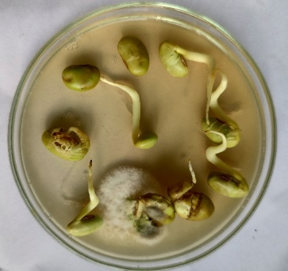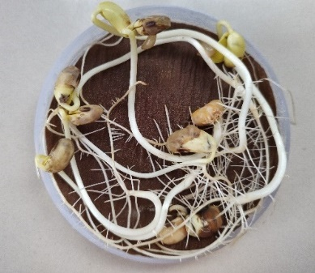
b
a
Fig. 1 Detection of mycoflora by using (a) agar plate method and (b) blotter paper method
Pathological significance
The pathogenic potential of individual seed-borne fungal isolates was evaluated using the standard towel paper method. For each fungal species, one hundred seeds of the soybean variety Shivalik were inoculated with a spore suspension and then arranged in a single layer on a double-fold of moist towel paper lined with butter paper. The seeds were subsequently covered with an additional layer of moist towel paper of identical dimensions to maintain optimal humidity. The prepared packets were incubated at 25 ± 1°C to facilitate germination. Each treatment was replicated three times to ensure statistical reliability. After a seven-day incubation period, the percentage of seed germination, as well as root and shoot lengths, were recorded from randomly selected seedlings. The seedling vigour index was calculated according to the method described by Baki and Anderson (1973), providing a comprehensive assessment of the impact of each fungal isolate on seedling health and development.
The Germination percentage were calculated by using formula:
% of seed germination = $\frac{Germinated seed }{Total seed} ×100$

Seedling vigour index
To assess the seedling vigour index, ten normal seedlings were randomly selected from each germination test. The root length of each seedling was measured from the collar region to the tip of the primary root, and the mean root length was calculated and expressed in centimeters. Similarly, shoot length was measured from the tip of the shoot to the point of cotyledonary junction, with the mean shoot length also recorded in centimeters. The seedling vigour index was then determined according to the formula proposed by Baki and Anderson (1973):
Vigour index = % seed germination x (mean root length + mean shoot length).
Results
Detection and Frequency of Seed Mycoflora by Agar Plate Method
The spectrum and frequency of seed-borne mycoflora isolated from both sterilized and unsterilized soybean seed samples across the three varieties-Palam Soya, Shivalik, and Hara Soya-are summarized in Table 1. A total of thirteen fungal species were identified, namely: Aspergillus niger (0.75–21.50%), A. flavus (0.25–13.25%), Rhizopus sp. (0.00–10.75%), Alternaria alternata (0.25–35.50%), Penicillium sp. (0.25–11.25%), Colletotrichum truncatum (4.00–34.00%), Trichoderma sp. (0.00–4.50%), Curvularia sp. (0.00–24.50%), Fusarium proliferatum (18.50–37.00%), F. equiseti (0.00–23.00%), Phoma sp. (0.50–14.25%), Cladosporium sp. (0.75–13.75%), and Pestalotiopsis sp. (0.00–14.00%) (Fig.2 and 3).
In unsterilized seed samples from fungicide-sprayed plots, the greatest diversity was observed in Shivalik, with thirteen fungal species detected, followed by Palam Soya and Hara Soya, each harboring twelve species. Conversely, sterilized seed samples from these plots exhibited a reduced mycoflora spectrum, ranging from eight to eleven species. Notably, F. proliferatum was consistently present in all seed samples, with a mean frequency of 24.04%.
Similarly, in unsterilized seeds from unsprayed plots, Shivalik again exhibited the highest diversity with thirteen fungal species, while Palam Soya and Hara Soya each yielded twelve species. Sterilized seeds from unsprayed plots contained between twelve and thirteen species. Among the various mycoflora, F. proliferatum was universally detected, with its frequency reaching up to 30.00% in some samples.
Seed Mycoflora Detected by Blotter Paper Method
The spectrum and frequency of seed-borne mycoflora isolated from both sterilized and unsterilized soybean seed samples using the blotter paper method are presented in Table 2. Across all tested varieties-Palam Soya, Shivalik, and Hara Soya-a total of eleven fungal species were identified: Aspergillus niger (1.25–8.50%), Rhizopus sp. (0.00–10.50%), Alternaria alternata (4.50–24.00%), Penicillium sp. (0.00–8.50%), Colletotrichum truncatum (4.50–28.25%), Trichoderma sp. (0.00–3.50%), Curvularia sp. (0.00–14.25%), Fusarium proliferatum (0.50–14.00%), F. equiseti (0.75–10.25%), Phoma sp. (0.25–16.00%), and Cladosporium sp. (0.50–12.50%) (Fig.2 and 3).
In unsterilized seed samples from fungicide-sprayed plots, Shivalik exhibited the highest diversity, with eleven fungal species detected, followed by Palam Soya (nine species) and Hara Soya (eight species). In contrast, sterilized seed samples from these plots harbored a reduced mycoflora spectrum, ranging from seven to nine species. Notably, C. truncatum was consistently present in all seed samples, with a mean frequency of 13.13%.
Similarly, in unsterilized seeds from unsprayed plots, Shivalik and Palam Soya each harbored eleven fungal species, while Hara Soya yielded nine species. Sterilized seeds from unsprayed plots contained between eight and eleven species. Among the mycoflora, A. alternata was universally detected, with a frequency of 13.13% in all samples.
Molecular identification of the F. prolifeartum
Molecular characterization of the most predominant pathogen was done utilizing ITS (Internal Transcribed Spacer) region-based sequence analysis which is the most recommended universal fungal barcode sequence. The ITS region was amplified from genomic DNA and subsequently sequenced by using primer pairs ITS1 and ITS4. The isolate exhibited desired product size ranges b/w 500-600 bp (Fig.4). The PCR product was outsourced for nucleotide sequencing and sequences obtained were then submitted to GeneBank (NCBI) (Accession number: OR701832). BLASTn search showed that the ITS1 and ITS4 of F. proliferatum attained 93% similarity to the corresponding sequence of F. proliferatum strains (MK594074, MH857322, MH379109, KX130601 and KP266980) (Fig.5).

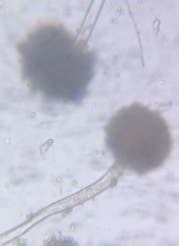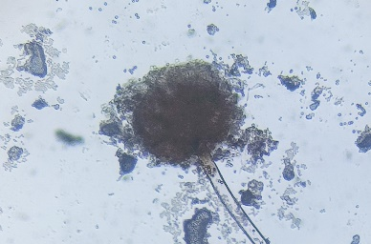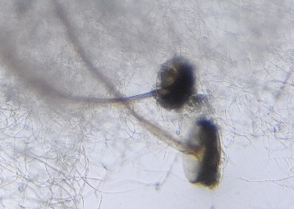
C
B
A
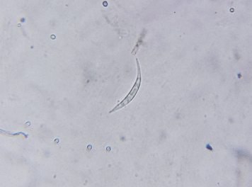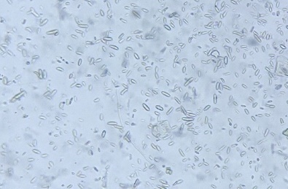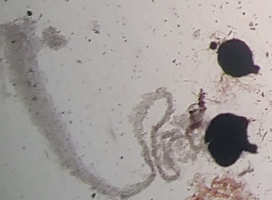
E
D
F
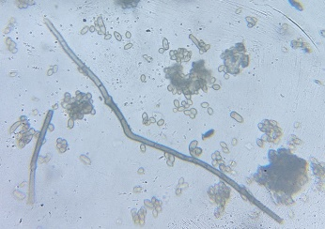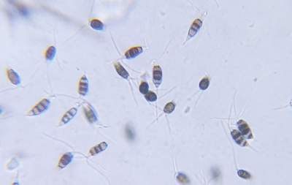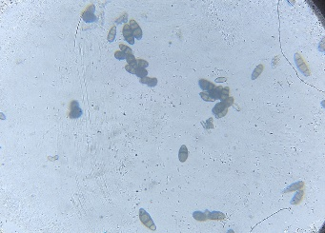
I
H
G
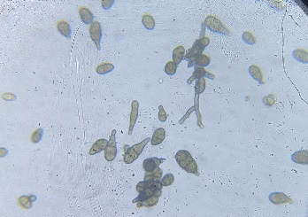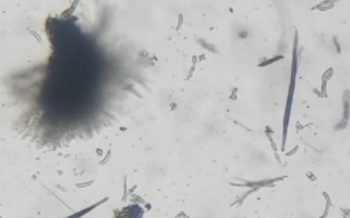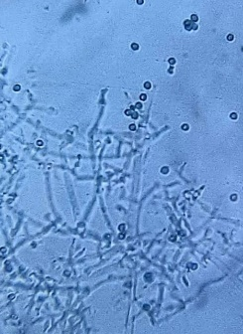
L
K
J
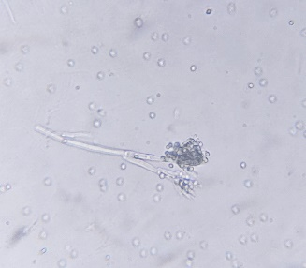
M
Fig. 2 Microscopic structure of different fungi isolated from soybean seeds observed under compound microscope (40X): A- Aspergillus niger, B- Aspergillus flavus, C- Rhizopus sp., D- Fusarium equiseti, E- Fusarium proliferatum, F- Phoma sp., G- Cladosporium sp., H- Pestalotiopsis, I- Curvularia sp., J- Alternaria alternata, K- Colletotrichum truncatum, L- Trichoderma sp., M- Penicillium sp.

Table 1. Frequency (%) of seed mycoflora in soybean detected by agar plate method
Fungal spp. | Seed obtained from sprayed plot |  |  |  |  |  | Mean | Seed obtained from unsprayed plot |  |  |  |  |  | Mean
Fungal spp. | Palam Soya |  | Shivalik |  | Hara Soya |  | Mean | Palam Soya |  | Shivalik |  | Hara Soya |  | Mean
Fungal spp. | S | Un | S | Un | S | Un | Mean | S | UN | S | UN | S | UN | Mean
Aspergillus niger | 4.25 | 10.00 | 6.50 | 14.50 | 0.75 | 7.00 | 7.17 | 8.00 | 16.25 | 18.00 | 21.50 | 1.50 | 10.00 | 12.54
Aspergillus flavus | 0.50 | 0.50 | 0.50 | 14.75 | 0.25 | 1.00 | 2.92 | 5.25 | 7.25 | 8.50 | 13.25 | 0.75 | 6.50 | 6.92
Rhizopus sp. | 0.50 | 6.50 | 1.25 | 7.00 | 0.00 | 4.00 | 3.21 | 0.75 | 8.00 | 2.75 | 10.75 | 0.50 | 6.00 | 4.79
Alternaria alternata | 0.50 | 6.00 | 16.50 | 22.00 | 0.25 | 5.00 | 8.38 | 26.00 | 34.25 | 32.00 | 35.50 | 4.00 | 12.75 | 24.08
Penicillium sp. | 0.75 | 2.25 | 4.00 | 6.75 | 0.25 | 0.50 | 2.42 | 1.25 | 6.25 | 7.25 | 11.25 | 0.50 | 5.25 | 5.29
Colletotrichum truncatum | 6.25 | 13.75 | 8.50 | 24.50 | 4.00 | 12.25 | 11.54 | 23.00 | 30.00 | 27.50 | 34.00 | 14.50 | 27.75 | 26.13
Trichoderma sp. | 0.50 | 0.75 | 0.00 | 0.5 | 0.00 | 0.25 | 0.33 | 1.50 | 3.75 | 4.50 | 2.75 | 0.25 | 1.50 | 2.38
Curvularia sp. | 0.00 | 0.00 | 0.00 | 0.75 | 0.00 | 0.00 | 0.13 | 0.00 | 0.00 | 16.00 | 24.50 | 0.00 | 0.25 | 6.79
Fusarium proliferatum | 18.75 | 24.25 | 27.25 | 32.50 | 18.50 | 23.00 | 24.04 | 27.00 | 36.00 | 32.50 | 37.00 | 21.00 | 26.50 | 30.00
Fusarium equiseti | 3.25 | 5.25 | 6.00 | 17.00 | 0.00 | 0.75 | 5.38 | 3.50 | 5.75 | 16.75 | 23.00 | 0.25 | 2.25 | 8.58
Phoma sp. | 4.5 | 10.5 | 8.25 | 10.75 | 0.5 | 8.75 | 7.21 | 10.75 | 12.00 | 12.25 | 14.25 | 6.50 | 11.25 | 11.17
Cladosporium sp. | 4.25 | 6.25 | 6.00 | 7.75 | 0.75 | 2.50 | 4.58 | 2.75 | 5.50 | 10.50 | 13.75 | 1.25 | 3.75 | 6.25
Pestalotiopsis sp. | 0.25 | 4.50 | 0.75 | 8.50 | 0.00 | 0.75 | 2.46 | 0.75 | 8.75 | 3.50 | 14.00 | 0.50 | 2.75 | 5.04
S=sterilized seeds, Un=Unsterilized seeds; Mean of four replications

Table 2. Frequency (%) of seed mycoflora in soybean detected by blotter paper method
Fungal spp. | Seed obtained from sprayed plot |  |  |  |  |  | Mean | Seed obtained from unsprayed plot |  |  |  |  |  | Mean
Fungal spp. | Palam Soya |  | Shivalik |  | Hara Soya |  | Mean | Palam Soya |  | Shivalik |  | Hara Soya |  | Mean
Fungal spp. | S | Un | S | Un | S | Un | Mean | S | UN | S | UN | S | UN | Mean
Aspergillus niger | 2.75 | 5.25 | 4.75 | 6.50 | 1.25 | 4.50 | 4.17 | 3.75 | 7.25 | 6.75 | 8.50 | 5.50 | 6.25 | 6.33
Rhizopus sp. | 0.25 | 0.50 | 0.75 | 4.50 | 0.00 | 0.25 | 1.04 | 0.75 | 7.25 | 3.25 | 10.50 | 0.00 | 5.00 | 4.46
Alternaria alternata | 0.75 | 10.25 | 6.50 | 9.00 | 0.50 | 8.25 | 5.88 | 6.00 | 10.50 | 8.50 | 14.00 | 4.25 | 7.25 | 8.42
Penicillium sp. | 0.00 | 0.25 | 1.25 | 3.50 | 0.00 | 0.00 | 0.83 | 0.00 | 6.50 | 0.25 | 8.50 | 0.00 | 0.00 | 2.54
Colletotrichum truncatum | 6.25 | 18.00 | 16.50 | 23.00 | 4.50 | 10.50 | 13.13 | 8.50 | 24.00 | 18.00 | 28.25 | 6.00 | 12.00 | 16.13
Trichoderma sp. | 0.00 | 0.00 | 0.00 | 0.25 | 0.00 | 0.00 | 0.04 | 0.75 | 2.75 | 2.75 | 3.50 | 0.50 | 1.50 | 1.96
Curvularia sp. | 0.00 | 0.00 | 0.00 | 0.75 | 0.00 | 0.00 | 0.13 | 0.00 | 0.75 | 8.00 | 14.25 | 0.00 | 0.00 | 3.83
Fusarium proliferatum | 8.50 | 17.00 | 9.50 | 18.00 | 4.50 | 14.50 | 12.00 | 11.25 | 18.00 | 14.50 | 24.00 | 7.50 | 13.25 | 14.75
Fusarium equiseti | 3.75 | 4.50 | 4.75 | 7.50 | 0.75 | 2.75 | 4.00 | 4.50 | 8.00 | 6.75 | 10.25 | 1.25 | 3.50 | 5.71
Phoma sp. | 0.50 | 5.00 | 4.50 | 13.25 | 0.25 | 2.00 | 4.25 | 4.75 | 10.50 | 6.50 | 16.00 | 0.50 | 10.25 | 8.08
Cladosporium sp. | 0.25 | 1.50 | 2.00 | 5.75 | 0.50 | 4.25 | 2.38 | 3.25 | 5.50 | 4.75 | 12.50 | 0.75 | 2.50 | 4.88

S=sterilized seeds, Un=Unsterilized seeds; Mean of four replications

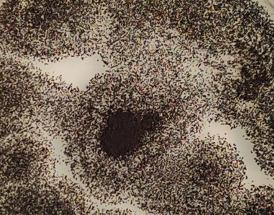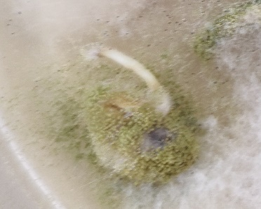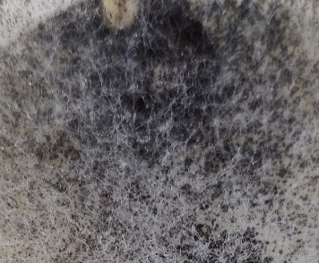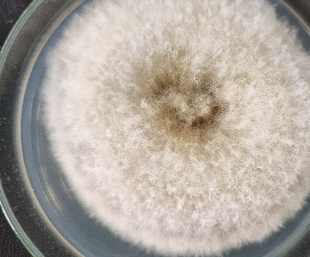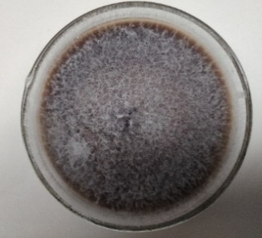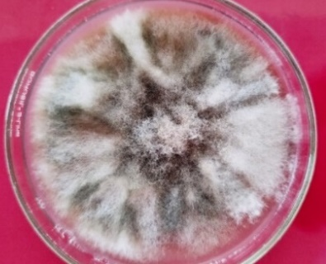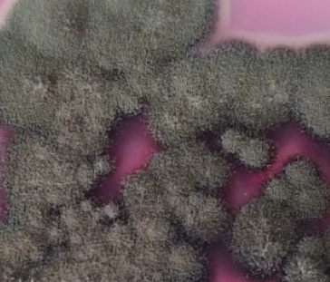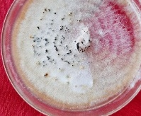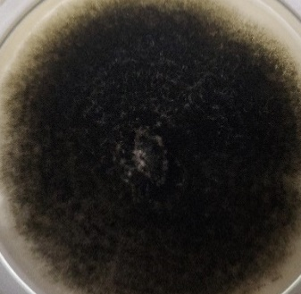
I
H
G
F
E
D
C
B
A
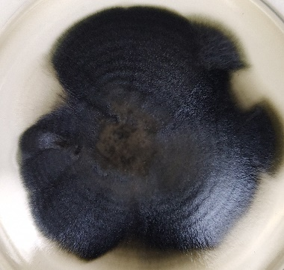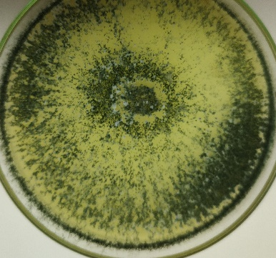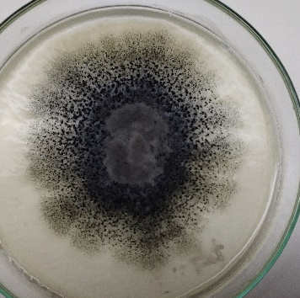
L
K
J
Fig. 3 Culture growth of different fungi isolated from soybean seeds:
A- Aspergillus niger; B- Aspergillus flavus; C- Rhizopus sp.; D- Fusarium equiseti; E-Fusarium proliferatum; F- Phoma sp.; G- Cladosporium sp.; H- Pestalotiopsis sp.; I-Alternaria alternata; J-Curvularia sp.; K-Trichoderma sp.; L- Colletotrichum truncatum

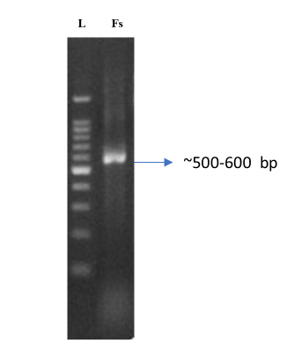
Fig. 4 Amplification of DNA region coding for Internal Transcribed Spacer (ITS) region of isolates of F. proliferatumby using primer pair ITS1 and ITS4 (L= Ladder; Fs =Fusarium sp.)
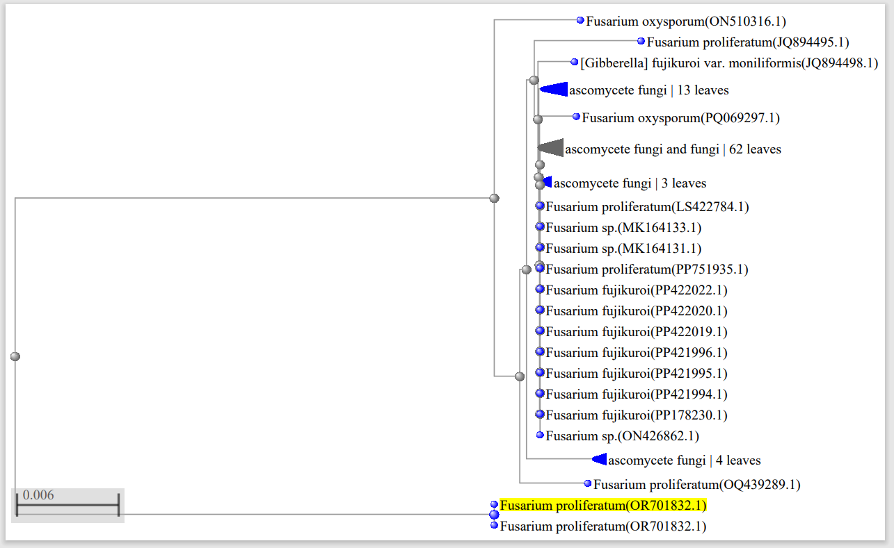
Fig. 5 Maximum-likelihood tree for Fusarium proliferatum and isolate inferred from a combined dataset of ITS1 and ITS4 using BLAST analyses. The phylogenetic tree was constructed by maximum likelihood method with 1000 bootstrapping replications. The position of the Fusarium proliferatum isolate is indicated in yellow

Table 3. Effect of isolated mycoflora on seed health parameters of soybean cultivar Shivalik
Fungal species | Seed germination  (%)* | Root length  (cm) | Shoot length  (cm) | Seedling vigour index
Aspergillus niger | 56.19  (48.54) | 5.27 | 3.14 | 473
Aspergillus flavus | 58.54  (49.90) | 5.48 | 3.26 | 512
Rhizopus sp. | 68.25  (55.69) | 6.54 | 4.08 | 725
Alternaria alternata | 76.50  (60.98) | 7.32 | 4.57 | 910
Penicillium sp. | 81.29  (64.36) | 8.16 | 4.78 | 1052
Colletotrichum truncatum | 65.47  (54.00) | 6.13 | 4.02 | 664
Trichoderma sp. | 93.00  (74.89) | 9.78 | 4.83 | 1358
Curvularia sp. | 86.25  (68.22) | 8.34 | 4.45 | 1103
Fusarium proliferatum | 67.31  (55.12) | 6.45 | 4.24 | 720
Fusarium equiseti | 68.10  (55.59) | 6.38 | 4.05 | 710
Phoma sp. | 63.42  (52.77) | 5.76 | 3.56 | 591
Cladosporium sp. | 72.58  (58.40) | 7.38 | 4.62 | 871
Pestalotiopsis sp. | 76.00  (60.65) | 8.67 | 4.32 | 987
Control | 97.29  (80.51) | 13.33 | 5.42 | 1824
CD (p=0.05) |  | 0.61 | 0.22
  2.37
*Figures within parentheses are arc sine transformed values
Effect of Seed Inoculation with Isolated Fungi on Soybean Seed Health Parameters
The impact of seed inoculation with various isolated fungal species on key seed health parameters of soybean (cv. Shivalik) is summarized in Table 3. The experiment revealed significant variation in seed germination, root length, shoot length, and seedling vigour index depending on the fungal species used for inoculation.
Among the seed-borne fungi tested, Aspergillus niger exhibited the most deleterious effect, resulting in the lowest seed germination percentage (56.19%). This was closely followed by A. flavus (58.54%), Phoma sp. (63.42%), Colletotrichum truncatum (65.47%), Fusarium proliferatum (67.31%), F. equiseti (68.10%), and Rhizopus sp. (68.25%). In contrast, relatively higher germination rates were observed in seeds inoculated with Cladosporium sp. (72.58%), Pestalotiopsis sp. (76.00%), Alternaria alternata (76.50%), Penicillium sp. (81.29%), Curvularia sp. (86.25%), and Trichoderma sp. (93.00%).
A similar trend was observed for root and shoot lengths, as well as seedling vigour index. Seeds inoculated with A. niger recorded the lowest mean root length (5.27 cm), shoot length (3.14 cm), and seedling vigour index (473), indicating a pronounced negative impact on early seedling development. Conversely, seeds inoculated with Trichoderma sp. maintained the highest values for these parameters, suggesting either a non-pathogenic or potentially beneficial interaction.
Discussion
Seed-borne mycoflora infect various parts of soybean seeds and promote seed-borne diseases (Prom 2004; Tufail et al. 2020). The stages of seed sprouting and endosperm development are particularly vulnerable to such infections (Gupta et al. 2017). The production of toxins and other harmful compounds resulting from these infections significantly impair seed quality and inhibit germination (Kakde and Chavan 2011). Consequently, this adversely affects the physical standards and overall quality of seeds, leading to substantial farm losses (Bishaw et al. 2013). Notably, several diseases in soybean are seed-borne, including purple seed stain, leaf spot, bacterial pustule, brown spot, and frogeye spot.
The impact of seed-borne mycoflora on soybean health is a critical aspect of agricultural productivity, particularly in the context of increasing global food demands. The findings from our study align with previous research indicating that seed-borne fungi can significantly affect germination rates and seedling vigor (Hamman et al. 1996; Dawson and Bateman 2001). The presence of pathogens such as Aspergillus niger, Fusarium proliferatum, and Colletotrichum truncatum in soybean seeds underscores the necessity for comprehensive monitoring of seed health.
Consistent with observations from the agar plate method, the overall frequency and diversity of mycoflora were notably higher in unsterilized seed samples compared to sterilized ones, highlighting the effectiveness of surface sterilization in reducing externally associated fungal contaminants (Cram and Fraedrich 2010; Dawar et al. 2007). Among the fungi recovered, A. alternata, C. truncatum, and F. proliferatum were the most predominant across almost all varieties, whereas Trichoderma sp. and Penicillium sp. were detected only in a subset of samples.
Although a diverse array of seed-borne fungi was isolated from soybean seeds in this study, Fusarium proliferatum was selected for molecular identification because it was consistently the most predominant and frequently occurring pathogen across all tested varieties and treatments. The high isolation frequency of F. proliferatum-as evidenced by both agar plate and blotter paper methods-suggested its significant role in seed contamination and potential impact on seed health. Prioritizing the molecular identification of the most dominant fungus allowed for accurate species-level confirmation of the principal pathogen, which is critical for targeted disease management strategies and for understanding the epidemiological importance of this species in soybean seed pathology. This approach is consistent with established practices in seed health research, where molecular tools are often applied to predominant or epidemiologically significant isolates to ensure precise identification and to inform effective control measures (Leslie and Summerell 2006; Levic et al. 2012b).
The present study thus revealed that F. proliferatum, C. truncatum, and A. alternata were predominant among the mycoflora associated with unsterilized soybean seeds, a finding consistent across both agar plate and blotter paper detection methods. The detection of Fusarium proliferatum in soybean seeds in the present study is consistent with previous reports documenting its occurrence in soybean seed lots from various geographic regions (Levic et al. 2012b; Munkvold and O’Mara 2002; Toghueo et al. 2017). Furthermore, Kunjum and Sidar (2019) observed a higher occurrence of Aspergillus sp. and Curvularia sp. on untreated seeds, with surface sterilization effectively reducing mycoflora presence.
The efficacy of sodium hypochlorite in virtually eliminating seed coat contamination and reducing seed infection has been corroborated by Cram and Fraedrich (2010) and Dawar et al. (2007). Other species such as Penicillium sp. and Fusarium sp., isolated in this study, have also been reported as seed-borne pathogens in soybean by Levic et al. (2012a) and Shovan et al. (2008). The detection of additional fungi, including A. flavus, Rhizopus sp., Curvularia sp., Alternaria sp., and Cladosporium sp., is in agreement with earlier findings by Rao et al. (2015).
When comparing the two mycoflora detection methods employed in this study, it was evident that the agar plate method yielded a higher frequency and diversity of fungal isolates than the blotter paper method (Fig.1). This observation is supported by previous studies, which reported that the agar plate method is more sensitive for the detection of seed-borne fungi in soybean (Dhawan et al. 2019; Khattak et al. 1993; Solanke et al. 1997).
These findings are consistent with previous reports highlighting the pathogenic potential of A. niger and related fungi. Sadhu (2014) demonstrated that A. niger significantly reduced seedling emergence and growth in green gram, while Chaudhari et al. (2017) reported a similar reduction in seed germination (56.00%) in pigeon pea inoculated with A. niger. The detrimental effects of Colletotrichum and Fusarium species on seedling health have also been well documented in soybean and other legumes (Levic et al. 2012a; Shovan et al. 2008).
The marked reduction in seedling vigour observed with pathogenic fungi can be attributed to their ability to colonize and degrade seed tissues, impair nutrient mobilization, and produce phytotoxic metabolites that inhibit germination and seedling growth (Bateman and Kwasna 1999). In contrast, the relatively benign effect of Trichoderma sp. may reflect its well-known antagonistic properties and potential as a biocontrol agent, which has been reported to enhance seedling vigour by suppressing pathogenic fungi (Hartman et al. 2015).
Conclusion
This study provides a comprehensive assessment of the diversity and pathological significance of seed-borne mycoflora associated with soybean seeds in different cultivars and management regimes. Thirteen fungal species were identified, with Aspergillus niger, Colletotrichum truncatum, and Alternaria alternata emerging as the most prevalent and detrimental to seed health. The agar plate method proved more sensitive than the blotter paper method for detecting a broad spectrum of mycoflora. Pathogenicity assays highlighted the profound negative impact of certain fungi, particularly A. niger, on seed germination, seedling growth, and overall vigour, underscoring the threat posed by seed-borne pathogens to soybean productivity.
These findings emphasize the critical importance of rigorous seed health testing and effective management strategies, including seed treatment and disinfection, to mitigate the risks associated with seed-borne fungi. Furthermore, the study underscores the necessity of integrating both conventional and advanced detection techniques for comprehensive seed health surveillance. By illuminating the complex interactions between soybean seeds and their associated mycoflora, this research contributes valuable insights for the development of integrated disease management approaches, ultimately supporting sustainable soybean production and food security.
Data Availability The dataset used in this study is available in the National Centre for Biotechnology Information (NCBI) database under accession number OR701832.
Declarations
Ethical statement The current study does not involve any experiments on humans, or animals at any level. Therefore, ethical approval is not required.
Conflict of Interest The authors declare that they have no conflict of interests regarding the publication of this paper.
Competing interests The authors declare that they have no known competing financial interests or personal relationships that could have appeared to influence the work reported in this paper.
Informed Consent: All participants were informed about the study's purpose, potential risks and benefits, confidentiality, and their right to withdraw.
References
Baki AAA, Anderson JD (1973) Vigour determination in soybean seed by multiple criteria. Crop Sci 73:630–633
Barnett HL, Hunter BB (1962) Illustrated genera of imperfect fungi. Burgress Publishing Company, USA
Bateman GL, Kwasna H (1999) Effects of number of winter wheat crops grown successively on fungal communities on wheat roots. Appl Soil Ecol 13(3): 271–282
Batzer JC, Mueller DS (2020) Seed health: A critical component of integrated disease management. Plant Disease 104(10): 2521-2531
Bishaw Z, Struik PC, van Gastel AJG (2013) Seed quality, sowing environment and farmer practices in wheat production in Ethiopia. J New Seeds 14(3): 281–308
Booth C (1971) The genus Fusarium. Commonwealth Mycological Institute, Kew, Survey, England, pp 179–181
Chaudhari AK, Sharma H, Jehani M, Sharma JK (2017) Seed mycoflora associated with pigeonpea [Cajanus cajan (L.) Mill.], their significance and the management. J Pure Appl Microbiol 11(1):567–575
Cram MM, Fraedrich SW (2010) Seed diseases and seed borne pathogens of North America. Tree Plant Notes 53(2):35–44
Dawar S, Syed F, Ghaffar A (2007) Seed borne fungi associated with chickpea in Pakistan. Pak J Bot 39(2):637–643
Dawson WAM, Bateman GL (2001) Fungal communities on roots of wheat and barley and effects of seed treatments containing fluquinconazole applied to control take all. Plant Pathol 50:575–582
Dhawan SS, Magar SJ, Rothe AS, Mulekar VG, Jaiswal KL (2019) Detection of seed mycoflora of soybean by seed health testing methods. Int J Univ Sci Technol 5(1):26–31
Fernandes EG, Pereira OL, da Silva CN, Bento CBP, de Queiroz MV (2015) Diversity of seed-borne fungi in soybean and their pathogenicity. Trop Plant Pathol 40(1): 31–39
Gupta VK, Misra AK, Gaur RK (2017) Impact of seed-borne fungi on seed germination and seedling vigor of soybean. Arch Phytopathol Plant Protect 50(11–12): 495–507
Hamman BG, Koning Venter HA (1996) Germination of South African soya bean seed lots. S Afr J Plant Soil 13:5–8
Hartman GL, Rupe JC, Sikora EJ, Domier LL, Davis JA, Steffey KL (2015) Compendium of soybean diseases and pests, 5th edn. APS Press, St. Paul, Minnesota, USA
ISTA (2023) International Rules for Seed Testing. International Seed Testing Association
Johnston-Monje D, Gutiérrez JP, Becerra Lopez-Lavalle LA (2021) The seed microbiome: Origins, transmission, composition, and function. Ann Rev Phytopathol 59: 445-463
Kakde RB, Chavan AM (2011) Impact of seed mycoflora on seed germination and seedling vigour of soybean. J Exp Sci 2(3): 87–89
Khattak I, Hussain S, Ali A, Shah SJA (1993) Efficacy of various methods employed for the study of seed borne microflora of soybean. Sarhad J Agric 9:45–48
Kunjum S, Sidar A (2019) Seed mycoflora of soybean and their management. Int J Curr Microbiol App Sci 8(1): 1239–1245
Leslie JF, Summerell BA (2006) The Fusarium Laboratory Manual. Blackwell Publishing.
Levic J, Stankovic S, Krnjaja V, Bočarov-Stančić A and Ivanović D (2012a) Fusarium species: Occurrence and mycotoxin production in wheat, maize and soybean seeds in Serbia. Bulletin Insectol 65(2): 257-262
Levic J, Stankovic S, Krnjaja V, Bocarov-Stancic A, Ivanovic D (2012b) Distribution and frequency and incidence of seed-borne pathogen of some cereals and industrial crops in Serbia. Pestic Phytomed 27(1):33–40
Munkvold GP, O’Mara JK (2002) Laboratory and field evaluations of fungicidal seed treatments for control of seed-borne Fusarium species on soybean. Plant Dis 86(6): 731–736
Prom LK (2004) Seed-borne mycoflora of soybean and their pathogenicity. Mycopathologia 157: 303–311
Rao TV, Rajeswari B, Keshavulu K, Verma VS (2015) Studies on seedborne fungi of soybean. SSRG Int J Agric Environ Sci 2(1):16–24
Sadhu KA (2014) Seed-borne fungi and their effect on seed health of green gram. Biosci Discov 5(2):251–255
Shovan LR, Bhuiyan MKA, Sultana N, Begum JA, Pervez Z (2008) Prevalence of fungi associated with soybean seeds and pathogenicity tests of the major seed-borne pathogens. Int J Sustain Crop Prod 4:24–33
Solanke RB, Koe SS, Sudewad SM (1997) Detection of soybean seed borne pathogens and effects of fungicides. J Maharashtra Agric Univ 22:168–170
Toghueo RMK, Boyom FF, Kuate J (2017) Diversity and pathogenicity of Fusarium species associated with soybean seeds in Cameroon. Arch Phytopathol Plant Protect 50(19–20): 1012–1022
Tufail A, Shahzad R, Khan AL, Imran QM, Iqbal N, Khan AR, Yun BW, Lee IJ (2020) Seed-borne fungi associated with soybean and their impact on seed germination and seedling vigor. Pak J Bot 52(2): 577–584

