Review Article

A Review on Ancient Spice and its Health Benefits: Cinnamon.

Abstract
Background: Cinnamon is a spice used daily by people as a traditional medicine for centuries all over the world. It is an evergreen plant and its leaves and bark are good sources of oil. It belongs to the family of Laurancae. The main species of commercially cultivated cinnamon are Cinnamomum verum, Cinnamomum burmannii, Cinnamomum cassia, and Cinnamomum loureiroi. For this review, extensive bibliographic research was carried out, using key words including its uses, chemical composition, nutritional composition, health benefits, and toxicity. Key findings conclude that it has Antioxidants, Antifungal, Antibacterial, Anti-microbial, Anti-diabetic, Anti-inflammatory, Anti-viral, Insecticidal, Anti-tumor, Neuroprotective, Nephroprotective, Anti-obesity, Cardioprotective, Anti-hypertensive, Anti-allergic, Hepatoprotective, Immunomodulatory, and Gastroprotective properties. The nutrient composition revealed that it is a great source of dietary fiber and micro and macro minerals. Moreover, the oil obtained from the leaf of the cinnamon is effective against dental plaque formation.
Graphical abstract
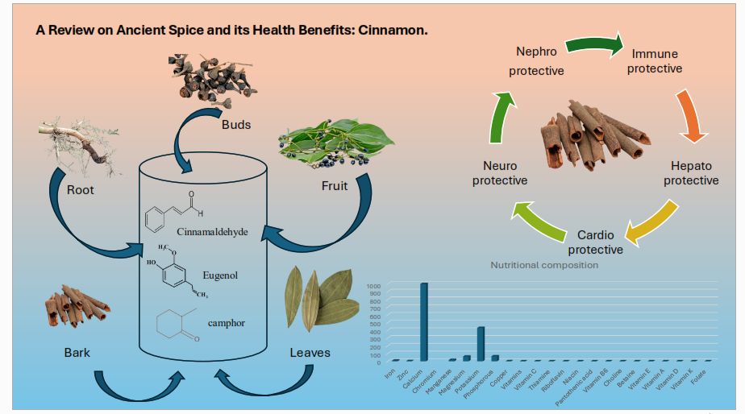

Keywords: Cinnamon, Medicinal use, Health benefits, Nutrition, Toxicity.

Introduction
Spices are most often defined as products of plant origin. Initially, their use was mainly combined with flavoring and improving the appearance of food [26]. The preservative properties of spices have been known to mankind since ancient times [27].
- Cinnamon a “Powerful Spice”
Since ancient times, natural spices have been used by humans to relieve diseases because of their diverse biological properties. ¹ Plants are fundamental medicinal, food, fuel, and clothing sources. ²⁰ Diverse plant parts, including bark, stem, leaves, roots, flowers, seeds, and many other components, have been used for medicinal purposes since historical times¹. Cinnamon is one of the important herbal drugs and the oldest spices in the world. The genes cinnamon belongs to the family of Laurancae. There are about more than 250 species belonging to its family. It can be used in the form of whole or ground material, or extract or oil. ¹⁸ The main species of commercially cultivated cinnamon are Cinnamomum verum, Cinnamomum burmannii, Cinnamomum cassia, and Cinnamomum loureiroi. The main constituent compounds found in cinnamon oil namely cinnamaldehyde and trans-cinnamaldehyde.^{7,23} Cinnamon bark is renowned worldwide for its fragrance and essence making it a valuable ingredient in various industries like food essence, toothpaste industries, etc. ^{19,22,25}. It contains numerous kinds of medicinal compounds, notably essential oil from Cinnamomum, and three constituents of these essential oils namely cinnamaldehyde (45-65%), eugenol (12-18%), and linalool (17.8-30.2%). These compounds are found to be beneficial in inhibiting processes like lipid peroxidation and peroxynitrite-induced nitration. ^{3,4,23}
Some reports pointed out that cinnamon is a source of bioactive compounds with protective properties against inflammation, oxidative stress metabolic diseases such as hypertension, diabetes, obesity, hypercholesterolemia, and CVDs. Its bark is a rich source of catechins and procyanidin. It attributes properties similar to green tea like anti-oxidant, anti-inflammatory, and anti-obesogenic. Cinnamon consists of phenolic compounds such as protocatechuic acid, quercetin, p-coumaric acid, p- p-hydroxybenzoic acid, syringic acid, rosmarinic acid, caffeic acid, ferulic acid, and chlorogenic acid. ⁷. Nowadays, the products made with these bioactive compounds attract the interest of industries and consumers.
This review shows the potential effective health benefits of cinnamon and its role in the treatment and prevention of many diseases and also discusses the nutritional, biological, and bioactive properties of compounds. It also discusses the potential function of cinnamon in the treatment of COVID-19 infection.
- Methodology
PubMed- Medline, Scopus, Science Direct, and Google Scholar databases were searched for the following items: cinnamon and health, cinnamon and toxicology, cinnamon, and dentistry, cinnamon and diabetes, cinnamon and anti-inflammatory, cinnamon, and metabolic disease for review articles and systematic review article, clinical trials, and case reports from 2019-2023. Full-text review and titles and keywords were used to accurately identify eligible studies. Inclusion criteria: Full-text reviews, reviewed articles, systematic review articles, and research articles are included.
- Uses of cinnamon
Cinnamon bark is used in food preparation due to its delicate aroma, and sweet and spicy flavor. It can be used in Bakery and pastry, cakes, biscuits, making, use as mouth fresher, chew gum, tea, and toothpaste making. It acts as a coagulant and prevents bleeding. Mosquito repellent¹⁹. It is used for essence perfume, medicinal products, food additives, taste in chocolates, etc.¹⁷
- Chemical composition
Cinnamon consists of various kinds of resinous compounds in different parts of the plant as mentioned in Table 1. ^{14,16,17,19}. Cinnamaldehyde is sweet in taste. The main flavor compound in cinnamon Essential oil extracted from the bark is cinnamaldehyde, while from leaves is eugenol. There is a high concentration n of anti-nutritional compounds in cinnamon bark are trypsin inhibitors, chymotrypsin inhibitors, phytic acid, and tannin. Phenolic compounds such as flavonoids, catechin, ferulic acid, epigallocatechin gallate, etc. are present in cinnamon in good amounts. ²⁰

Table 1: Cinnamon’s various parts and its compounds.
Parts of the plant | Compound
Leaves | Cinnamaldehyde 1.00 to 5.00%, Eugenol 70.00 to 95.00%
Bark | Cinnamaldehyde 65.00 to 80.00%, Eugenol 5.00 to 10.00%
Root | Camphor 60.00%
Fruit | Trans-cinnamyl acetate 42.00 to 54.00%, Caryophyllene 9.00-14.00%
C. zeylanicum buds | Terpene hydrocarbon 78.00%, alpha-bergamotene 27.38%, alpha- copaene 23.05%, oxygenated terpenoid 9.00%
C. zeylanicum fruits | E-cinnamyl acetate 41.98%, trans-alpha-bergamotene 7.97%, caryophyllene oxide 7.20%.

- Nutritional composition
The approximate minerals and vitamins found in cinnamon are given in Table 2. The variation in the table is given on the basis of variety, species, cultivation, harvesting, climate, origin, and environmental conditions. The nutrition, color, and flavor can degrade in cinnamon due to high temperatures. Cinnamon provides a good amount of protein, dietary fiber, minerals, and vitamins that help in preventing disease and provide health benefits as per USDA. The oil extracted from cinnamon is a good source of saturated fats. According to Safdar M, Cinnamon has a high carbohydrate content and is low in fat and protein. Among the microminerals’ potassium, magnesium and calcium are the highest. Cinnamon also contains plenty amount of manganese and phosphorous. It contains a trace amount of iron, zinc, and chromium. ^{20,21}
Table 2: Nutritional Composition of Cinnamon Bark. ^{8,16,20,21}
Nutrient | % composition (gm/100gm) (Safdar M, 2009) | Gm/100gm  (USDA 2019)
Macro minerals
Moisture | 5.1 | 10.6
Ash | 2.4 | 3.6
Protein | 3.5 | 3.99
Dietary fiber | 33.0 | 53.1
Crude fat | 4.0 | 1.24
Energy | 258kcal /100gm | 247 kcal/100gm
Carbohydrates |  | 80.6
Sugars |  | 2.17
Micro minerals
Minerals | Amount mg/100gm | Mg/100gm
Iron | 7.0 | 8.32
Zinc | 2.6 | 1.83
Calcium | 83.8 | 1000
Chromium | 0.4
Manganese | 20.1 | 17.5
Magnesium | 85.5 | 60
Potassium | 134.7 | 431
Sodium | 0.0
Phosphorous | 42.4 | 64
Copper |  | 0.339
Vitamins |  | Mg/µg/100gm
Vitamin C |  | 3.8 mg
Thiamine |  | 0.022mg
Riboflavin |  | 0.041mg
Niacin |  | 1.33mg
Pantothenic acid |  | 0.358mg
Vitamin B6 |  | 0.158mg
Choline |  | 11 mg
Betaine |  | 3.9mg
Vitamin E |  | 2.32 mg
Vitamin A |  | 295 IU
Vitamin D |  | 0 IU
Vitamin K |  | 31.2 µg
Folate |  | 6µg

- Health Benefits and Pharmacology of Cinnamon:
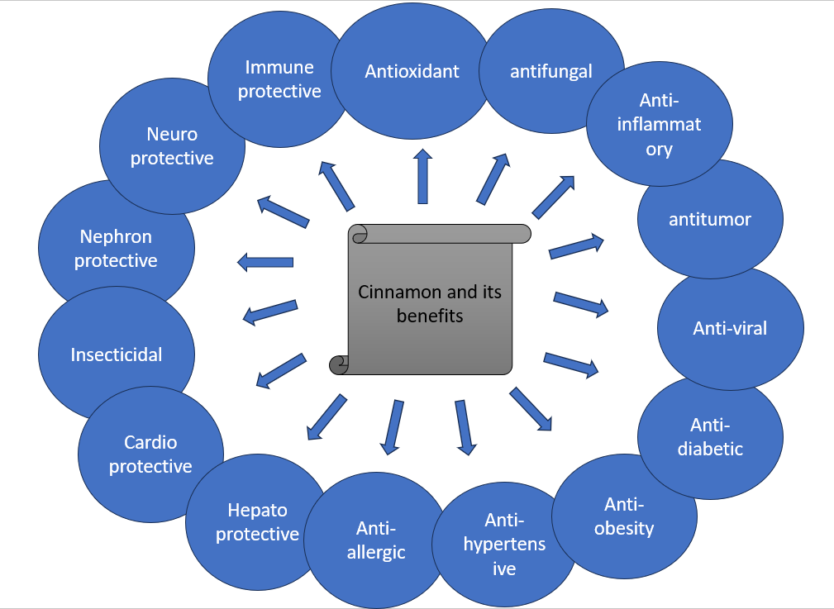
Fig 1. Cinnamon and its beneficial effects. [1]
  - Antioxidant:
The antioxidant present in the food plays a vital role in health promotion and also prevent food spoilage. The extract of cinnamon such as ether, aqueous, and methanolic extracts contains a considerable number of phenolic antioxidants and flavonoids having free radical scavenging activities, effective scavenging reactive oxygen species including superoxide anions and hydroxyl radicals as well as free radicals, and has the highest anti-radical properties and inhibited lipoxygenase activity. ^{15,19} Flavonoids obtained from the bark of Cinnamomum zeylanicum and C. cassia were observed to exhibit free radical scavenging activities. ¹¹ A 1:1 mixture of aqueous and alcoholic cinnamon extracts has been found to effectively reduce both fatty acid oxidation and lipid peroxidation. The cinnamon flower is a free radical inhibitor. It might also act as a radioprotector that decreases radiation-induced oxidative injury. ²⁰ COVID-19 is characterized by viral infection accompanied by heightened inflammation and an excessive production of reactive oxygen species. In some studies, it is shown that essential oil extracted from cinnamon possess significant antioxidant property. Cinnamon powder has the potential to normalize the functioning of certain antioxidant enzymes, including glutathione peroxidase, catalase, and superoxide dismutase, in the plasma of diabetic rats. Cinnamaldehyde helps against the production of nitric oxide, water-extracted polysaccharides from Cinnamomum zeylanicum have invitro antioxidant capacity. Hence, it shows positive results in the treatment of COVID-19. ^{19,24} Cinnamon shows a role in superoxide anion scavenging and the strongest antioxidant superoxide formation activity. Leaf extract has free radical scavenging activity. Different parts of cinnamon like bark, leaf, and stem have a significant role in the hindrance of the pathogenesis of diseases. The polyphenolic compounds show significant potential antioxidant properties. The essential compounds eugenol and essential oil have the capacity to inhibit lipid peroxidation. ¹ Oxidative processes generally play an important role in inflammatory and immune processes. It is found that there is a high concentration of antioxidants in the medicinal herb cinnamomi cortex. The medicine has an inhibitory effect on lipid peroxidation and protein oxidative modification by copper. ¹¹
  - Anti-microbial:
- Antifungal:
Cinnamaldehyde is used as a vapor to treat respiratory tract mycoses. Cinnamon tree powder can be used to treat fungal infections caused by fungi such as Aspergillus niger, Aspergillus fumigatus, Aspergillus nidulans, Aspergillus flavus, Candida albicans, Candida tropicalis, Candida pseudotropicalis, Histoplasma capsulatum. The inhalation of cinnamaldehyde is an ideal treatment for respiratory tract infection. ²³ Oil helps in the inhibition of fungi such as Mucor plumbeus, Penicillium roqueforti, and Eurotium sp. Etc. ¹⁹ combination of cinnamon, clove oil, and oregano serves against several C. albicans strains, Candida tropicalis and candida glabatra DSM 11226. Cinnamon essential oil proved to be most effective against 40 C. albicans and be used in mouth fresher and antifungal drugs. ²⁵
- Antibacterial:
Cinnamon oil helps in the inhibition and treatment of bacteria such as pediococcus, halopphilus, and Staphylococcus aureus. Cinnamon oil has potential benefits against bacteria such as Pseudomonas aeruginosa, Staphylococcus aureus, and Escherichia coli. The combination of the cinnamon and clove oil shows antibacterial activity against gram-negative bacteria such as Salmonella choleraesuis, Escherichia coli, Pseudomonas aeruginosa, and Yersinia enterocolitica and gram-positive bacteria such as Listeria monocytogenes, Enterococcus faecalis, staphylococcus aureus, and bacillus cereus. ¹⁹ The antimicrobial effect of cinnamon bark essential oil helps against Planktonic E. faecalis ATCC 29212, which is the most prevalent bacteria responsible for unsuccessful root canal treatments. ²⁵
- Yeast infections:
Cinnamon oil helps in the inhibition and treatment of yeast such as Candida lipolytica, Pichia membranaefaciens, Debaryomyces hanseenii, and Zygosaccharomyces rouxii. Cinnamon oil has potential benefits against yeast such as Torulopsis utilis, Schizosaccharomyces pombe, Candida albicans, and Saccharomyces cerevisiae. ¹⁹
  - Anti-Diabetic
Disturbance between free radicals and antioxidant defense results in tissue damage. This leads to insulin resistance, and beta cell dysfunction, ultimately causing diabetes. ¹⁴ Cinnamon has been coined as an “insulin-potentiating factor”. Several studies have shown that cinnamon extract lowers blood glucose and lipid levels. The aqueous extract of the cinnamon-containing polyphenols purified by HPLC (see glossary) shows insulin-like activity. Its extract also promotes GLUT 4 translocation, fulfilling its availability to control insulin levels. The polyphenol like rutin, catechin, quercetin, kaempferol, and isorhamnetin. The aqueous extract decreases the absorption of alanine in the rat intestine. ^{14,19} It is been found that cinnamon improves insulin resistance and glucose metabolism in vitro and in vivo. Moreover, cinnamon extract promotes the transportation of glucose-by-glucose transporter 4 in brown adipose tissue and muscles. Some clinical research also shows positive results of cinnamon extract in both diabetes type 1 and 2. ^{11,23} One of the studies shows that cinnamon tea helps improve blood glucose levels. ² Vaibhavi et al. reported that cinnamon extract and polyphenol with procyanidin type A polymer have the capacity to promote the growth of TTP and increase insulin resistance and GLUT4 in 3T3-L1 adiposities. ¹⁵ Another study shows that an intake of 2 gm of cinnamon helps to reduce HbA1c in Type 2 Diabetic patients. ¹⁰
  - Anti-Inflammatory
Inflammation is reported as a link with many chronic diseases. Vaibhavi et al. have reported that E.O.C. osmophloeum twing has excellent anti-inflammatory property that suppresses the production of nitric oxide by Lipopolysaccharide macrophages. It also shows cytotoxicity against hepatocellular liver cancerous cells. ¹⁵ Several studies have demonstrated that cinnamon and its various phytochemical components, such as cinnamaldehyde, eugenol, cinnamic acid, and polyphenols, exhibit notable anti-inflammatory properties. Inflammatory cytokine IL-6 and tumor necrotic factor alpha play a major role in spreading inflammation. One of the studies shows that cinnamon ethanolic extract exhibits an anti-inflammatory effect by inhibiting NF-κB/AP-1 signalling and reducing the pro-inflammatory production of cytokine, responsible for inflammation. Furthermore, cinnamon also helps in reducing the cytokine production in COVID-19 and thus helps in treating COVID-19. ²⁴ According to Saleh A. Almatoordi et al., the extract of cinnamon reduces the production of nitric oxide and tumour necrosis factor-alpha, cyclooxygenase-2, and prostaglandin. ¹⁹ In addition, it reduces the serum level of TNF-α and IL-6. Moreover, it is observed that there is a decrease in RNA expression of TNF-α in vitro studies. Another study revealed that E.O.C. acts as an inhibitor of IL1β and IL-6 production. ¹ Yan Shen et al., proved that the aqueous extract of C. cassia at a high concentration of about 200mg/kg body weight inhibits immunological haemolysis and chemotactic migration of neutrophils. ²³
  - Anti-Viral
The extract of Cinnamomum cassia bark shows potential antiviral properties against HIV 1 and HIV 2 replication by inhibiting virus-induced cytopathogenicity in MT 4 cells infected by HIV. In addition, cinnamaldehyde has a repressive effect on the growth of influenza A/PR/8 virus in both vitro and in vitro. The reported studies demonstrate that C. cassia bark EO, aqueous, and ethanol extract exhibit highly anti-viral properties against gram-positive and gram-negative bacteria. ¹² It is observed that cinnamon has similar properties to curcumin and is effective on numerous proteins contributing to viral infections. C. zeylanicum contains phenolic compounds, caffeic acid, cinnamic acid, gallic acid, and eugenol exhibited an inhibitory effect on trypsin (a serine protease). ²⁴
  - Anti-Tumor
One of the studies showed that cinnamon oil helps in the treatment of cancers, and tumors through modulation of various cell signaling pathways. A study based on garlic and cinnamon oil demonstrates that they help decrease the p53 protein expression level in hepatocellular carcinoma. ¹ The chemical constituents “cinnamaldehyde and eugenol” found in cinnamon are found to be beneficial in treating leukemia and lymphoma cancer cells. Furthermore, “Eugenol” is proven to be beneficial in colon cancer whereas “Cinnamaldehyde” is beneficial for hepatic cancers. ¹⁰ Additionally, the water-soluble extract of cinnamon shows a cardioprotective effect by increasing glutathione S-transference activity in mice administrated with the cancerous substance “urethane”. Moreover, C. cassia powder is a significant inducer of apoptosis in human promyelocytic leukemia cells leading to the activation of caspase- 3. It also shows cytotoxicity against many tumors such as HCT-15 and SK-MEL-2 cells. ²³ In another study, it was observed that an aqueous extract and a specific fraction of cinnamon, as identified through HPLC, effectively inhibit the activity of vascular endothelial growth factor subtype-2 kinase. This inhibition subsequently disrupts the process of angiogenesis in cancer. ¹⁹
  - Cardioprotective
Cinnamon is found to inhibit the atherosclerosis process by preventing apoA-1 glycation and inhibiting cholesteryl ester transfer protein. Polyphenols found in cinnamon are responsible for controlling blood pressure and preventing cardiovascular diseases. A meta-analysis on the effect of cinnamon in type 2 diabetes Mellitus indicated that there is a potential role of cinnamon in controlling blood glucose and in addition to that it also helps in reducing the systolic and diastolic blood pressure of -5.39 mmHg and -2.6 mmHg respectively in patient having blood pressure of >130/ 80 mmHg. Moreover, C. cassia extract is rich in eugenol and conifer aldehyde helps to improve blood circulation and inhibit platelet coagulation. The hydrophilic extract of cinnamon containing anti-oxidant properties plays a major cardioprotective role. It also synthesizes synthetic compounds like isoproterenol which prevents cardiotoxicity. In addition, it inhibits the release of fatty acids having inflammatory effects like arachidonic acid. The compound cinnamaldehyde exhibits cardioprotective roles like cardiac ischemia, cardiac hypertrophy, myocardial infarction, etc. ⁷ Moreover, research conducted on rats has shown that cinnamic acid and cinnamaldehyde effectively lowers the levels of serum creatine kinase-MB, lactate dehydrogenase, TNF-α, IL-6, and MDA in myocardial tissues. Simultaneously, they elevate serum NO activity and enhance myocardial tissue SOD activity in cases of acute myocardial infarction.²⁴ Besides this, a compound named “cinnamophilin” also plays a role cardioprotective role by acting as an antagonist thereby inhibiting human platelet aggregation. ²³ A study revealed that the intake of cinnamon in diet can decrease systolic blood pressure by of systolic blood pressure of spontaneously hypertensive rats consuming a non-sucrose-containing diet. Whereas another study indicates that the bark of C. cassia increases the level of atrial natriuretic factor in the plasma mica. Therefore, it reduces water, sodium, and adipose load on the circulatory system thereby decreasing blood pressure. ¹¹
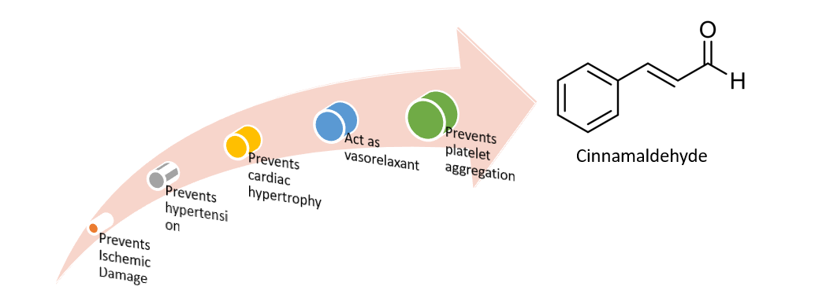
Fig. 2. Protective cardiovascular effects of cinnamon.⁵
  - Immunomodulatory
According to Shankar Gautam et al., “Dalchini” “Cinnamon” is a potent immune booster. It is used for various ailments like flu, cough, edema, ingestion, etc. Consuming cinnamon at a high dose (100 mg/kg) shows immune stimulant activity by enhancing phagocytic index, serum immunoglobin levels, and antibody titer and reducing the percentage count of neutrophils whereas a low intake of cinnamon (10mg/kg) only shows positive results toward immune-stimulating activity. Furthermore, cinnamon acts as a strong regulator of macrophage-medicated immune response by inhibiting PI3K, PDK1, and NF-kB whereas activating CD29 and CD43 suppresses the production of nitric oxide. It regulates the function of co-stimulatory molecules like CD69 and CD80 and pattern recognition receptors like TLR2 and CR3. It helps to decrease cell death and alter the anti-inflammatory response in T cells. It decreases the ratio of apoptotic cells to necrotic cells. It was also found to be a thromboxane A2 receptor antagonist, anti-coagulate, and prevents platelet clumping and CVDs.⁹
  - Anti-obesity
The anti-obesity bioactive agents found in cinnamon are eugenol, cinnamaldehyde, and cinnamic acid. ⁷ Invitro studies have shown that cinnamon-containing polyphenolic compounds could inhibit the differentiation of adiposities. It could also inhibit the process of lipogenesis and lipolysis. It also decreases the intestinal absorption of lipids thereby helping in the reduction of weight. ¹⁰ Furthermore, the extract of C. verum influences the absorption of cholesterol and fatty acids by inhibiting the action of Niemann-Pick c1-like 1 and CD36 mRNA receptors. ⁷ In vitro studies have shown the anti-obesity effects of cinnamon. Also, the polyphenolic compounds could inhibit the differentiation of adipocytes, lipolysis, and intestinal lipid absorption which helps in weight reduction. Furthermore, it acts as an inducer of fatty acid oxidation and decreases inflammatory effects. ¹⁰
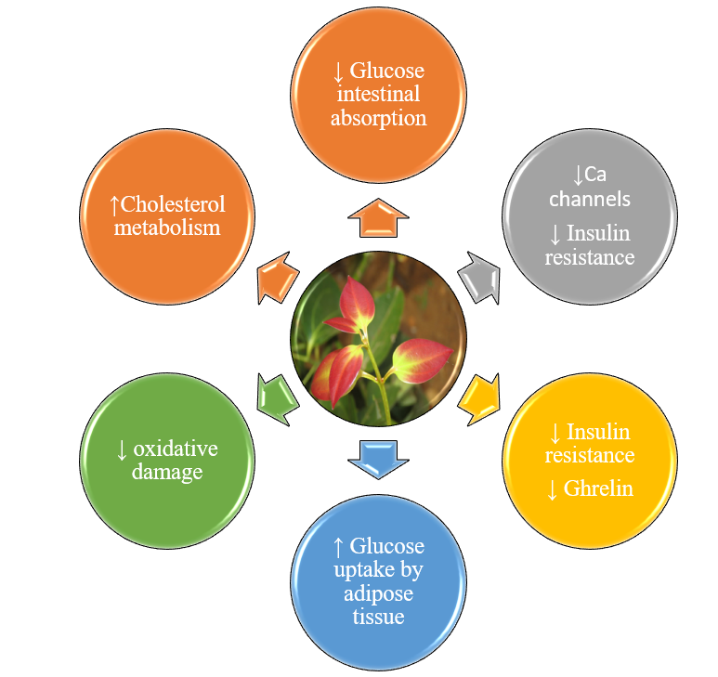
Fig. 3. Protective role of Cinnamomum Verum in Metabolic Disorders. ^{6,10}
  - Neuroprotective
Cinnamophilin, a thromboxane A2 receptor antagonist extracted from C. philippinensis is reported to confer a protective role in rats’ brain infraction when administrated at 80 mg/day at different intervals and further enhance neurological behaviors. A study determined that cinnamon is found to be beneficial in the treatment of neurogenerative disorders like Parkinson’s and Alzheimer’s. it is observed that sodium benzoate (cinnamon metabolites) upregulates brain-derived neurotrophic factors and neurotrophin-3 in mouse CNS. PD protein 7 is an autosomal recessive form of early-onset Parkinson’s and is a major neuroprotective protein that protects from cell damage and further prevents oxidative damage. Another study demonstrates that it helps in improving the cognitive abilities of mice. ¹⁹ There are two compounds found in cinnamon that appear to inhibit a protein called “tau” responsible for Alzheimer’s.
  - Nephroprotective
Cinnamon has a potential role in the reduction of serum creatinine, blood urea nitrogen, and increment in serum albumin, and total protein. One of the studies reflects the positive impact of Zeylancium against acetaminophen-induced apoptosis, in renal tissue. Another study demonstrates that the intake of 3% cinnamon by rats helps to decrease diabetic nephropathy. Furthermore, the aqueous extract of cinnamon bark helps exhibit a hepato-renal protective effect against acetaminophen-induced toxicity in mice. ²⁴
  - Hepatoprotective
A meta-analysis to study the effect of cinnamon supplementation on liver enzymes in adults concludes that food additives such as nigella, turmeric, and cinnamon play a major role in the management of obesity and related metabolic disorders such as Non-alcoholic fatty liver disease (NAFLD). Furthermore, there were significant changes in ALT levels were noted on the dosage of <1500mg/day for >12 weeks in both genders. However, there was no significant effect of cinnamon on liver enzymes. ²² Another study confirms that cinnamon decreases acetaminophen (APAP) toxicity in the liver by reducing the level of lipid peroxidation level (LPO), interleukins (IL-1β, IL-6), caspase-3, -9 expressions, determination of DNA fragments, and histopathological changes were reversed by administration of cinnamon oil in rats for 14 days. Moreover, it also restores the activity of antioxidative enzymes and regulates inflammatory reactions and apoptosis. Therefore, it can be concluded that cinnamon oil can be an alternative treatment for liver injury. ¹³
- Toxicity of cinnamon
Cinnamon is a common spice used in Asia and is considered as safe for human consumption. Excessive intake for a long period can show adverse effects. The most common adverse effect is shown by C. cassia i.e., irritation and allergic reaction with mucus or mucus membrane. ¹⁰ Nevertheless, a study indicated that cinnamon can show some negative effects such as stomach and bowel disorders, dry mouth and throat, coughing, gagging, vomiting, breathing difficulties, risk of pneumonia, and lung collapse. Furthermore, artificial cinnamon flavor can cause cinnamon contact stomatitis and oral lesions. ¹⁶ Patients may also develop white and erythematous spots with a burning sensation. However, there is acute toxicity seen in animals (rats) which is very low (benzaldehyde intake of 1300mg/kg, LD 50 orally), (cinnamaldehyde intake of 2220 mg/kg, LD 50 orally), (linalool intake of 2790 mg/kg, LD 50 orally), (salicylaldehyde intake of 520 mg/kg, LD 50 orally). ¹⁵ Furthermore, a scientific examination found that there is no acute or chronic toxicity of Zeylancium in mice. Another study done on healthy thirty adults found no notable harmful effects on anthropometric parameters on cinnamon intake. In addition, there is a decrease in systolic and diastolic blood pressure was noticed. A study on pregnant rats revealed that the intake of cinnamon can increase the quantity of resorption. One of the studies done related to diabetes and cinnamon intake discovered that intake of 3-6 gm of cinnamon per day can show a positive effect on blood sugar. Hence, it is recommended that cinnamon intake is safe and beneficial in humans and can be taken regularly. ¹
- Concluding remarks and Future perspectives
Cinnamon has been used as a spice in everyday life for thousands of years. At some points, it was more valuable than gold. Currently, due to the growing side effects of oral medicines, there is a rising interest in herbal remedies. One such traditional folk product is cinnamon, which is generally recognized as safe by USDA. Cinnamon is commonly labelled as a superfood due to its rich variety of forms, including bark, essential oils, bark powder, phenolic compounds, flavonoids, and isolated components, all of which contribute to its exceptional nutritional value. Furthermore, it has overlapping reactions including inflammation, anti-oxidant, detoxification, immune system, and anti-microbial. The data from the above studies discussed shows that there are positive effects in the therapeutic treatment of diabetes, blood clotting, hypertension, cardiovascular diseases, liver disorders, cancers, etc. As mentioned, further research is required to furnish additional clinical evidence supporting the traditional applications of cinnamon in the treatment of various diseases.

References:
1. Almatroodi SA, Alsahli MA, Almatroudi A, et al. (2020)Cinnamon and its active compounds: A potential candidate in disease and tumour management through modulating various genes activity. Gene Rep.;21. doi:10.1016/j.genrep.2020.100966
2. Bernardo MA, Silva ML, Santos E, et al. (2015) Effect of Cinnamon Tea on Postprandial Glucose Concentration. J Diabetes Res.; doi:10.1155/2015/913651
3. Chanotiya CS, Yadav A. (2009) Enantiomeric composition of (3R)-(-)- and (3S)-(+)-linalool in various essential oils of Indian origin by enantioselective capillary gas chromatography-flame ionization and mass spectrometry detection methods. Nat Prod Commun.;4(4):563-566. doi:10.1177/1934578X0900400424
4. Chericoni S, Prieto JM, Iacopini P, Cioni P, Morelli I. (2005) In Vitro Activity of the Essential Oil of Cinnamomum zeylanicum and Eugenol in Peroxynitrite-Induced Oxidative Processes. J Agric Food Chem.;53(12):4762-4765. doi:10.1021/JF050183E
5. cinnamaldehyde molecule structure 3d model. Accessed August 18, (2023). https://www.turbosquid.com/3d-models/cinnamaldehyde-molecule-structure-3d-model/445787
6. Cinnamomum verum (Ceylon cinnamon, Ceylon cinnamon tree, Cinnamon, Cinnamon bark tree, Kayu Manis, True cinnamon) | North Carolina Extension Gardener Plant Toolbox. Accessed August 18, (2023). https://plants.ces.ncsu.edu/plants/cinnamomum-verum/
7. Das G, Gonçalves S, Basilio Heredia J, et al. (2022) Cardiovascular protective effect of cinnamon and its major bioactive constituents: An update. J Funct Foods.;97:105045. doi:10.1016/j.jff.2022.105045
8. FoodData Central. (2023). https://fdc.nal.usda.gov/fdc-app.html#/food-details/171320/nutrients
9. Gautam S, Gautam A, Chhetri S, and UBJ of A, (2023). Immunity against COVID-19: potential role of Ayush Kwath. Elsevier. Accessed July 13, 2023. https://www.sciencedirect.com/science/article/pii/S0975947620300668
10. Goel B, Mishra S. (2020) Medicinal and Nutritional Perspective of Cinnamon: A Mini-review. European J Med Plants.10-16. doi:10.9734/EJMP/2020/V31I330218
11. Gruenwald J, Freder J, Armbruester N. (2010) Cinnamon and health. Crit Rev Food Sci Nutr.;50(9):822-834. doi:10.1080/10408390902773052
12. Gruenwald J, Freder J, Armbruester N. (2010) Cinnamon and health. Crit Rev Food Sci Nutr. ;50(9):822-834. doi:10.1080/10408390902773052
13. Hussain S, Ashafaq M, Alshahrani S, et al. (2020) Cinnamon oil against acetaminophen-induced acute liver toxicity by attenuating inflammation, oxidative stress and apoptosis. Toxicol Rep.;7:1296-1304. doi:10.1016/J.TOXREP.2020.09.008
14. Is Cinnamon Efficacious for Glycaemic Control in Type-2 Diabetes Mellitus? - PubMed. Accessed June 26, 2023. https://pubmed.ncbi.nlm.nih.gov/33341863/
15. Jakhetia V, Patel R, Khatri P, et al. (2010) CINNAMON: A PHARMACOLOGICAL REVIEW. J Adv Sci Res.;1(02):19-23. Accessed August 7, 2023. https://sciensage.info/index.php/JASR/article/view/13
16. Kowalska J, Tyburski J, Matysiak K, Jakubowska M, Łukaszyk J, Krzymińska J. (2021) Cinnamon as a Useful Preventive Substance for the Care of Human and Plant Health. Molecules.;26(17). doi:10.3390/MOLECULES26175299
17. Mishra S, Goel B, Danish Kadir S. Mini-review Article Goel and Mishra. (2020);EJMP(3):10-16. doi:10.9734/ejmp/2020/v31i330218
18. Shen Y, Jia L, Honma N, et al. (2023) Beneficial Effects of Cinnamon on the Metabolic Syndrome, Inflammation, and Pain, and Mechanisms Underlying These Effects – A Review. Journal of Traditional and contemporary Medicine. https://doi.org/10.1016/S2225-4110(16)30067-0
19. Rao P, SGEBC. (2023) Cinnamon: a multifaceted medicinal plant. hindawi.com. https://www.hindawi.com/journals/ECAM/2014/642942/
20. Ribeiro-Santos R, Andrade M, Madella D, et al. (2017) Revisiting an ancient spice with medicinal purposes: Cinnamon. Trends Food Sci Technol.;62:154-169. doi:10.1016/j.tifs.2017.02.011
21. Safdar M. (2009) Proximate Composition and Mineral Analysis of Cinnamon Adipokines from fats View project. Article in Pakistan Journal of Nutrition. doi:10.3923/pjn.2009.1456.1460
22. Shekarchizadeh-Esfahani P, Heydarpour F, Izadi F, Jalili C. (2021) The effect of cinnamon supplementation on liver enzymes in adults: A systematic review and meta-analysis of randomized controlled trials. Complement Ther Med.;58. doi:10.1016/j.ctim.2021.102699
23. Shen Y, Jia LN, Honma N, Hosono T, Ariga T, Seki T. (2012) Beneficial effects of cinnamon on the metabolic syndrome, inflammation, and pain, and mechanisms underlying these effects-a review. J Tradit Complement Med.;2(1):27-32. doi:10.1016/S2225-4110(16)30067-0
24. Yakhchali M, Taghipour Z, Mirabzadeh Ardakani M, Alizadeh Vaghasloo M, Vazirian M, Sadrai S. (2021) Cinnamon and its possible impact on COVID-19: The viewpoint of traditional and conventional medicine. Biomedicine and Pharmacotherapy.;143. doi:10.1016/j.biopha.2021.112221
25. Yanakiev S. (2020) Effects of Cinnamon (Cinnamomum spp.) in Dentistry: A Review. Molecules.;25(18). doi:10.3390/MOLECULES25184184
26. Embuscado, M.E. Spices and herbs: Natural sources of antioxidants—A mini review. J. Funct. Foods 2015, 18, 811–819.
27. Newerli-Guz, J., & Śmiechowska, M. (2022). Health benefits and risks of consuming spices on the example of black pepper and cinnamon. Foods, 11(18), 2746.

