Next-Gen Sequencing-Driven Trait Mapping for Sustainable Crop Improvement
Abstract
Understanding a diverse range of biological functions depends on identifying the genetic mutations and genes that underlie phenotypic changes. Several high-throughput, novel NGS-based genetic techniques have been created and utilized in a variety of crops to hasten crop improvement. Due to the flexibility of growing and screening thousands of individuals, these techniques are extremely effective for crop plants. By using these techniques, it is now easier to detect quantitative trait loci (QTL) positions or point mutations and to identify the gene variants that are functionally causal. The mapping and cloning of a desired gene have become simple, rapid and comparatively easy due to the speed and the plummeting costs of NGS-based technologies. In this context, next-generation sequencing (NGS) has clearly revolutionised the way phenotypic traits are assigned to genes. NGS-based bulk segregant analysis and their variants have been extensively utilized across a wide range of crop plants such as chickpea, rice, wheat, maize, sorghum, soybean, and cucumber for the identification and mapping of both qualitative and quantitative traits.
Keywords: High-throughput, Mapping, Next Generation Sequencing and Quantitative trait loci.
Introduction:
The fundamental requirement for breeding programmes of any crop species is the availability of enormous genetic diversity and variability in the gene pool (Viejobueno et al., 2022; Sheeba et al., 2023). Traditional plant breeding is totally dependent on the availability of enough genetic variation to enhance crop yields (Rahman et al., 2023). However, it's possible that the necessary genetic variants aren't always present in their ideal state (Cassells et al. 2003; Chaudhary et al. 2019). Nowadays, the allocation of phenotypic traits to genes has been drastically transformed by the use of next-generation sequencing (NGS) (Satam et al., 2023; Hu et al., 2021). With the development of high-throughput techniques, the cost of sequencing has been decreased considerably, making it possible to employ genomics to improve agricultural production and other valuable economic qualities. As a result, whole genome resequencing-based gene mapping is more advantageous and trustworthy than conventional gene isolation techniques in locating and fine-tuning the candidate genomic region, as well as in detecting a high number of polymorphic variants. In these aspects, this manuscript intends to provide the details of next generation sequencing based mapping approaches such as Bulked Segregant Analysis (BSA), SHORE map, MutMap, MutMap⁺, MutMap-gap and QTL-seq.

Bulked Segregant Analysis (BSA)
Genotyping of the large populations with large number of markers poses a challenging for the researchers with respect to its time consuming, costly and tedious job which you can observe in the conventional linkage/ QTL mapping. A technique, Bulked Segregant Analysis approach overcomes these difficulties by employing genotyping of the selected groups of high or low trait expression.
It is a rapid method of identifying genomic loci controlling target traits and it was first developed by Michelmore et al. (1991) by screening RAPD markers in the two extreme bulks for downy mildew disease resistance trait in Lettuce. It is a technique for discovering molecular markers which are tightly linked to the traits of interest by genotyping the two extreme bulks of the target trait (Giovannoni et al.1991; Michelmore et al. 1991; Zuo et al. 2016. Here, DNA from the selected lines is bulked to obtain two extreme bulks for the trait. Within each bulk all the individuals are exhibiting same phenotype and are having identical for the loci of interest and arbitrory for rest of the genes. Therefore, the two DNA pools differ only for the target region and are monomorphic and heterozygous for other non-target genes. Two contrasting bulks (e.g., high yield and low yield) are compared to identify differentiating markers. Only those markers differentiated the two parents and two bulks are considered as putatively linked markers for the gene/QTL of interest.
This approach was initially applied in an F₂ population to spot genetic markers linked to specific phenotypes by employing RFLP and RAPD genetic markers. The method is promising, particularly when there aren't enough SSR markers present in the target genomic region and it is difficult to find polymorphic markers because some legumes, like groundnut and pigeon pea, have no or very little genetic variation.

Principle of BSA
It is based on the principle of near-isogenic lines (NILs). Generally, near isogenic lines are genetically identical with the exception of one or few genes that govern any target trait. If there is a marker that distinguishes near-isogenic lines, the target genes are likely linked. In BSA, the two contrasting DNA bulks are constituted by pooling the equimolar DNA concentration from selected plants of mapping population expressing either low or high phenotype. Hence, these two bulks are identical in gene content except for the target genomic region for which two parents are differentiated. Similar to NILs, those markers which are found to be polymorphic between two bulks are likely to be considered as putatively linked markers.
Nowadays, it is easy to identify genomic regions for candidate regions by comparing two DNA bulks with the advancements in next-generation sequencing methods and the development of biotechnological tools (Zegeye et al., 2018).
Major steps involved in BSA
- Choosing parents with contrasting and extreme phenotypes
Each parent should have an extreme phenotypic expression that may distinguish them from one another for any trait (for example, tall and dwarf, disease resistance and susceptibility, etc.). Selection of parents depends on objectives of the study.
- Development of suitable mapping population
After choosing the parents, the following step is to cross the selected parents to generate the appropriate mapping population. Most commonly used mapping populations are F₂, RILs, and Doubled haploid populations. These segregating mapping populations are hence utilized for the calculation of recombination frequencies, gene order and genetic distance between the genetic markers.
- Development of two extreme DNA bulks
The mapping population is screened for the trait that will be mapped. In order to ensure the accuracy of the phenotypic data, it is preferable to obtain data from multiple locations or seasons. After phenotyping the entire population, select the individuals with the most extreme phenotypes and then pool the DNA from each of the selected lines for each extreme to create two DNA bulks.
- Genotyping and identification of linked markers
Genotyping the two bulks along with their parents by using large set of molecular markers uniformly distributed over the entire genome. Those molecular markers which are showing polymorphism between the two bulks and parents are considered as putatively linked markers to the gene/QTL of interest for which parents differ.
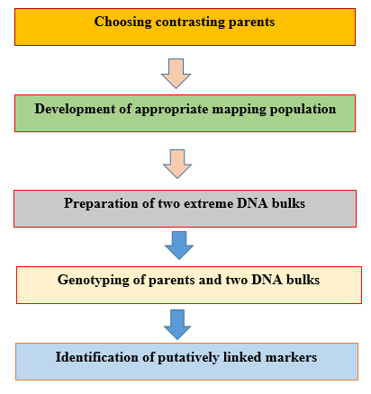
Figure 1: General steps involved in BSA
The key benefit of this method over traditional QTL analysis is the elimination of the necessity to genotyping for each individual of the mapping populations. Therefore, it is less time consuming, costly and rapid method of trait mapping. In particular, it is quick and shortcut method of gene mapping especially for simply inherited traits.The technique is popular for species with genomes smaller than 1 Gb, but it is insufficiently beneficial for plants with larger genomes since whole genome sequencing is expensive and there is a problem with assembling large amounts of sequencing data. Additionally, BSA is more sensitive to uncommon phenotypic errors and frequently fails to detect epistatic interactions. The fundamental limitation of bulked segregant analysis of genes or quantitative trait loci is the inability to quantify the proportion of phenotypic variation explained by the genes or QTLs. Availability of DNA markers was the main factor limiting effectiveness of this method. Furthermore, genotyping of each marker for the two bulked DNAs is still takes time and expensive. As a result, it is very crucial to think about using an alternative strategy.
Next generation sequencing
Although first-generation sequencing was widely employed in the 1980s and 1990s, NGS has rendered it obsolete. When compared to first generation sequencing techniques, these methods need less time and labour. NGS, which is regarded as a "high-throughput technology," generates exponentially huge sequence data at a faster rate and at a substantially lower cost than sanger sequencing. With the advent of high-throughput techniques, the cost of sequencing has recently declined dramatically, making it feasible to use genomics to enhance crop production and other valuable economic qualities. As an outcome, whole genome resequencing-based gene mapping is more advantageous and reliable than traditional gene isolation techniques in identifying a large number of polymorphic variants as well as in the localization and refinement of the candidate genomic region (Zou et al., 2016). This is due to no engagement of marker development, phenotyping or genotyping, which are time-consuming, ineffective and expensive approaches for conventional gene/QTL mapping. One of the main applications of whole genome resequencing is to identify the genes that are responsible for mutations in the target traits. In this regard, a plethora of techniques have been used, including SHORE map, X-QTL, Next-generation Mapping, MutMap, MutMap-gap, MutMap⁺ and QTL-seq (Austin et al., 2011).
SHOREmap
A novel gene mapping approach was developed by Schneeberger et al. (2009) while studying to pinpoint the causal mutation in the gene controlling pale green leaf colour and slow growth phenotype in Arabidopsis thaliana. The acronym for SHORE is SHOrt Read, is an NGS-based gene tagging pipeline. It makes use of NGS short reads to assemble the genome using reference genome. The A. thaliana Col-0 seeds were mutagenized by treating with ethyl methane sulfonate. M₀ population was thus obtained and subjected to selfing to obtain mutant lines homozygous for mutant loci and mutants with slow growth and pale green leaves were isolated. To develop an F₂ mapping population, the identified mutant was crossed with the genetically distinct A. thaliana Ler-1 ecotype. DNA from selected 500 mutant individuals of F₂ population was isolated and are pooled. The bulked mutant DNA was subjected to sequencing and the resultant reads assembled to reference genome to obtain SNPs. Progeny derived from the Col-0/Ler-1 hybrid and exhibiting Col-0 like phenotypes are expected to have SNP distributions comparable to Col-0 parent at the loci controlling Col-0 phenotype whereas all other non-linked loci display random SNP distribution. This method was employed to locate the causal mutation on the chromosome and to identify causal SNPs in the mapped locus.
Mutmap
It was first developed by Abe et al., (2012) in rice and demonstrated in rice by locating the mutant loci governing change in leaf colour from dark green to pale green. It rapidly determines the nucleotide differences that are causal by combining DNA from mutant F₂ individuals, which were produced by mating mutants with the parental line (Abe et al., 2012; Fekih et al., 2013). Theoretically, the SHOREmap method and the MutMap method are comparable since both rely on bulked segregant analysis of mutant progenies produced in F₂ populations (Etherington et al., 2014). In order to find the genes using SHOREmap, distantly related parental lines are used which result in a highly dense distribution of SNPs between the parent and the mutant bulk (Jiao et al., 2018). The MutMap approach, in comparison, uses a cross between the mutant and its wild type and thus directly identifies the causal SNPs created during mutagenesis and accountable for phenotypic expression.
Procedure of Mutmap
The principle and procedure of MutMap is discussed below.
Let us take rice cultivar as X, which have a reference genome and is treated with Ethyl methane sulfonate (EMS) mutagen. The resulted mutant (M₀) is selfed to generate first mutant generation (M₁) and again self-pollinated to obtain homozygous mutant individuals. Then recessive mutants were identified with changed phenotypic expression in plant height, tiller number, and grain number per spike by observing phenotypes in the M₂ lines. Single-nucleotide polymorphisms (SNPs) and insertion-deletions (indels) between the mutant and wild type are found to represent every nucleotide change introduced into the mutant through mutagenesis. Following the identification of the mutant, wild-type of cultivar X is crossed with it. The generated F₁ plant subjected to self-pollination and the obtained F₂ progenies (>100) are grown in the field for phenotypic evaluation. Typically, only one or few segregating loci responsible for the phenotypic change in these F₂ progeny obtained from a cross between the mutant and its wild-type parent. As a result, segregation of phenotypes can be clearly seen even when the phenotypic difference is slight.
DNA of selected 20 mutant individuals was isolated using standard protocol and equimolar concentration of DNA from all the 20 lines are pooled to obtain mutant bulk. Pooled DNA are subjected to sequencing at >10 coverage and sequencing reads thus generated are aligned to the parental reference genome for SNP calling using appropriate software. Following the identification of SNPs, SNP index for all the SNP positions was calculated as the ratio between the number of reads of a mutant SNP to the total number of reads corresponding to the SNP in a sliding window approach. All SNPs segregate in a 1:1 wild type and mutant ratio among the F2 progeny. Therefore, those SNPs that are not associated with the mutant phenotype shows 50% wild-type and 50% mutant reads, whereas those SNPs that were associated with the mutant phenotype of interest showed 0% wild-type reads and 100% mutant reads. SNPs that are associated to causative mutations have an SNP index of 1 or close to 1, while those that are unlinked to the trait in question have an SNP index of close to 0.5.
Successful examples of gene mapping by mutmap
A mutation in gene OsCAO1 (Chlorophyllide A oxygenase) in rice that causes a change from a dark green to a pale green leaf has been successfully mapped using MutMap approach. In rice, many genes that are responsible for causative mutation have been effectively isolated by the MutMap method, with the combination of BSA and whole genome resequencing. Pii, the gene responsible for blast resistance; OsRR22, responsible for the salinity tolerance; sm11, a gene controlling the small grain size and LUP gene, gene to cause loose upper panicle are some of the gene examples that mutmap method successfully mapped.

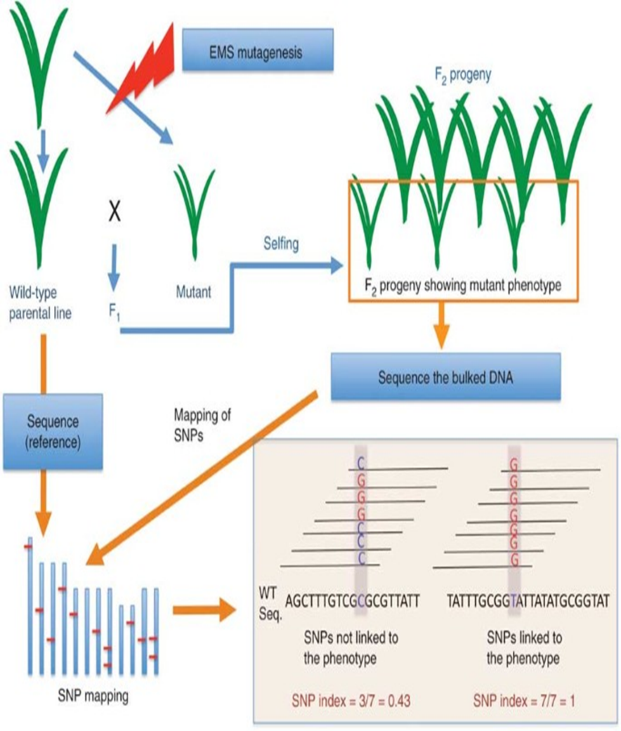
Figure 2: General methodology of mutmap

MutMap⁺
Fekih et al. (2013) was the pioneer in Mutmap⁺ methodology of gene mapping and demonstrated this method by mapping a NAP6 gene controlling pale green leaf colour, dwarf stature and lethal phenotype within three weeks after germination in rice. This method commonly used for mapping recessive lethal mutations by comparing SNP index graphs of both wild and mutant bulk. The mutmap⁺ approach is utilized when the lethality or sterility of the mutant generated by recessive mutations prevents the development of F₂ population.
In spite of the following differences, development of mutant population and mapping is comparable to MutMap: (1) Mendelian segregation is still observed even when there is no hybridization involved (2) Progeny testing is crucial since it is the sole way to distinguish between homozygous and surviving heterozygous wild type plants.
Procedure of MutMap⁺
The principle and procedure of mutmap⁺ is described in Figure 3. Soon after fertilization, immature embryos or seeds were selected and subjected to EMS mutagenesis and the embryos were allowed to mature into seeds. These seed are sown to yield M₁ population, where mutations are likely to be in heterozygous condition. For screening dominant mutations, M₁ generation itself is enough need not to advance to M₂ while the focus is on mapping recessive mutations it is mandatory to have homozygous mutant lines which can be seen in M₂ generation. Then selected the M₂ progeny exhibiting 3:1 wild and mutant type phenotype, respectively. It was expected that 2 out of 3 wild-type siblings are heterozygous for mutation causing change in phenotype. These wild types were carefully grown to obtain enough M₃ seeds, which were collected separately from M₂ individuals. For additional investigation, M₃ families that segregated for both the wild-type and mutant phenotypes were chosen. Two bulks were generated; one from pooling DNA from 20-40 M₃ plants showing mutant phenotype and another from 20-40 M₃ individuals displaying wild type phenotype provided that both bulks prepared from single M₂ individual heterozygous for causal mutation. Two bulks then subjected to sequencing by Illunina GAIIx sequencer which generates huge sequencing reads. Reference sequence of parental line obtained by aligning the sequencing reads of parent with wild reference genome. As soon as the reference sequence of parent prepared, these sequences are utilized for comparing the sequencing reads of both mutant and wild type bulk with it for SNP calling.
SNP index for all SNP positions for both bulks are calculated and also SNP index graphs were plotted for both wild and mutant bulk. ∆ SNP index was calculated by subtracting wild type SNP index from mutant SNP index. Positive ∆ SNPs index values indicate the causal mutation for desired phenotypic variation.
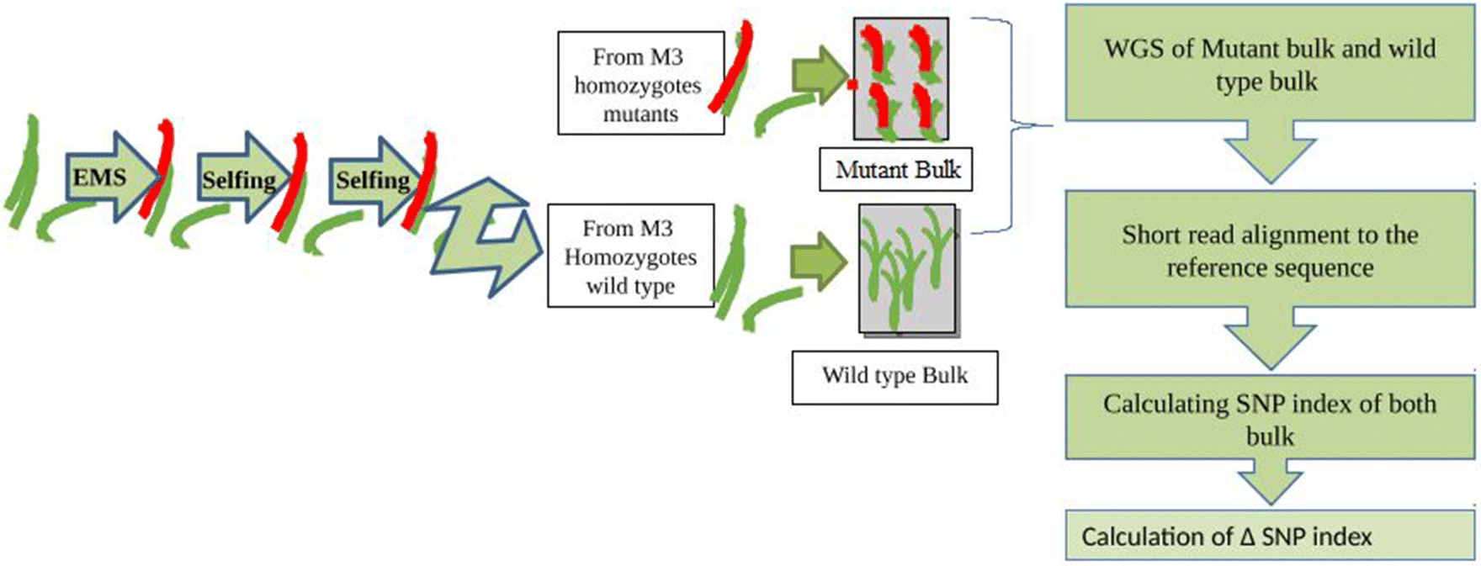
Figure 3: Schematic representation of Mutmap⁺ approach
MutMap-Gap
MutMap-Gap was developed specifically to find mutations in the reference genome's gap region. De novo assembly of the gap region in conjunction with the MutMap analysis is done to determine which mutations are present in the region. Takagi et al., (2013a, b) developed this technique in Oryza sativa cv. Hitomebore by locating the mutation controlling blast resistance in rice, which is mapped in the gap region of reference genome O. sativa cv. Nipponbare.
Procedure:
- Preparation of a ‘reference sequence’ for the cultivar P (cv P)
The rice cv. Nipponbare reference genome, which is publicly available (shown in green in Fig 4), indicated as Ref, was used for alignment of the sequencing reads of cultivar P generated by the Illumina sequencer. The reads obtained from P-specific genomic areas (shown as red in Fig 4) cannot be aligned to the Ref. genome even though most of the P short reads are aligned to it and therefore, unaligned reads left as unmapped reads. A P "reference sequence" is created by replacing the nucleotides of Ref. at all SNP locations with nucleotides of P, after the alignment and detection of the SNPs between cv. P and Ref.
- Mutmap analysis
Cultivar P are treated with EMS mutagen to generate mutant line M displaying desired phenotype, for example, dwarfism (yellow squares indicates EMS induced mutations whereas yellow star depicts mutation causing change in phenotype). Mutmap analysis can be performed by hybridizing the resultant mutants with cv. P to generate F₁’s and then selfing of these F₁’s to yield F₂ mapping population. Equimolar concentration of DNA from selected 20 or more F₂ mutant individuals are pooled to obtain mutant bulk. Then the mutant pools are sequenced by using appropriate platform and the obtaining reads are aligned to ‘reference sequence’ of P. To make it easier to identify the target genomic region containing the causal mutation, an SNP index is computed for each SNP position and SNP index plot is graphed. MutMap analysis cannot find the causal mutation if it is resided in a P-specific genomic region.
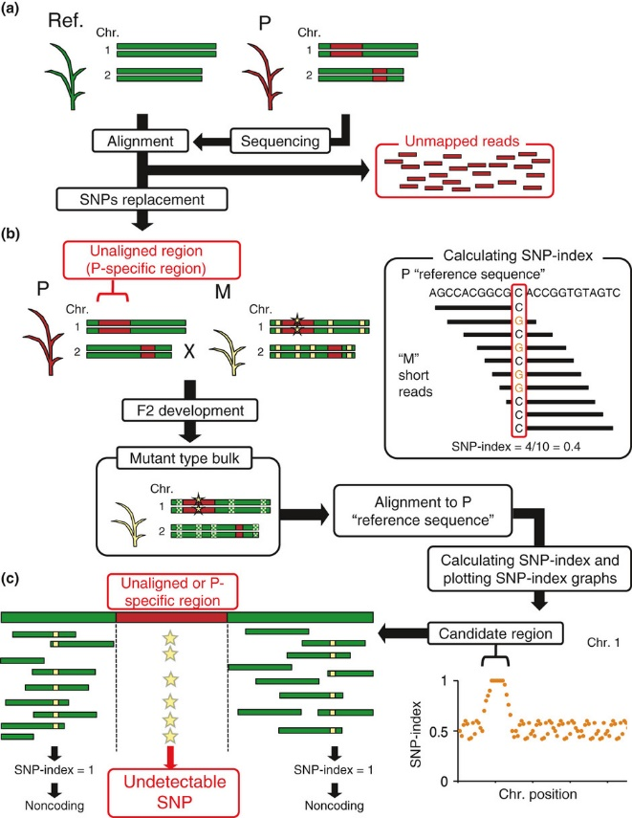
Figure 4: (a) Generation of a ‘reference sequence’ for the cultivar P used for mutagenesis
(b) Generation of F₂ population by crossing mutant with cultivar P and pooling of DNA
(c) SNP index calculation for defining target genomic interval causing mutation by mutmap analysis (Source: Takagi et al. (2013)
- De novo assembly
De novo assembly performed to reconstruct the “reference sequence” of P within the target interval defined by the original MutMap step in order to map a mutation that is present in the gap region. It requires two types of sequences; sequence reads which aligned to the target interval region as defined by MutMap and reads unmapped to the Ref genome. Software such as SSPACE and CLC (http://www.clcbio.com) tools are used to perform de novo assembly by utilizing these two sequences reads to obtain scaffolds, which is likely to be placed in the target interval delineated by mutmap (Boetzer et al., 2011).
Sequence reads of the F₂ mutant bulk are aligned to the combined sequences of scaffolds and P reference sequence to identify the causal SNPs located in the newly formed scaffold region and for this SNP index is calculated for all SNPs residing in scaffold region. The SNPs with an SNP index of 1 are the most likely candidates for the mutation that causes the mutant phenotype.
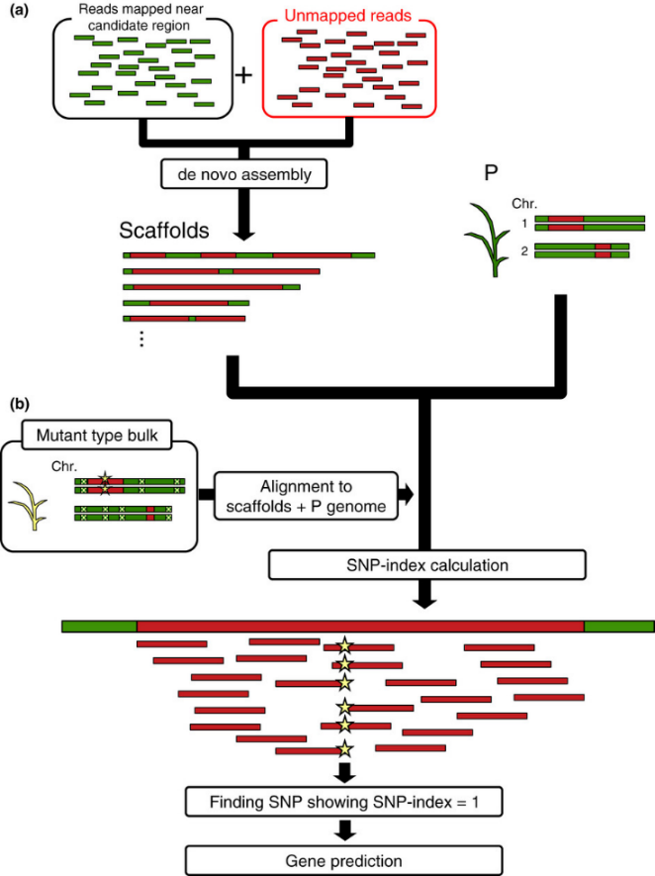
Figure 5: MutMap in conjunction with de novo assembly fills the gap present in the unmapped region (a) scaffolds are produced by de novo assembly (b) Short reads generated from the mutant bulk are aligned to the reference sequence of P and scaffolds. The causative nucleotide change underlying the mutant phenotype is probably present in the scaffolds with SNPs having a SNP index value of 1 (Source: Takagi et al. (2013)
All these sequence-based mapping methods namely Mutmap, Mutmap-gap and Mutmap⁺ are applicable only for simply inherited traits governed by oligo genes and are less informative for quantitative traits. Since majority of economic traits controlled by polygenes, it is essential to have strategy to map these traits effectively. QTL mapping approach does this job of locating QTLs and estimating their effects. However, traditional QTL analysis demand more time, cost and is a tedious process. An alternate to QTL mapping, QTL-seq emerged out to be a successful in detection of quantitative trait loci (QTL) by cut down the time and large genotyping of mapping population by employing whole genome resequencing tool.
QTL-seq:
QTL-Seq was developed by Takagi et al. (2013) and is an extension of MutMap and Bulked Segregant Analysis (BSA) approach and the main goal is to map main effect QTLs by using NGS methods. BSA and MutMap approaches that are now in use can only address qualitative characters that are regulated by a single gene that results in distinct classes of phenotype. Almost all agronomic traits are quantitative in inheritance and are governed by polygenes, each having small and cumulative effect on phenotype development. Classical QTL mapping uses DNA markers covering whole genome and a suitable mapping population to address these traits, but the process is time-consuming, labour-intensive and expensive.
The creation of the mapping population is the very first step in adapting the QTL-Seq approach. For detecting QTLs with small effects, mapping populations such as doubled haploids and recombinant inbred lines possessing highest homozygosity are thought to be more appropriate.
Procedure of QTL-seq:
The procedure of QTL-seq are briefly described below as per the Takagi et al. (2013)
- Selection of parents contrasting for the trait to be mapped (for example, one parent having high yield and other have low yield).
- Selected parents are hybridized to obtain F₁, which upon selfing results in generating F₂ mapping population.
- Evaluation of all the individuals of the mapping population for concerned phenotypic trait.
- Equimolar concentration of DNA from 10 to 20 individuals from each extremity are bulked to produce ‘Highest’ bulk and ‘Lowest’ bulk.
- Sequencing of each bulk and then aligning the sequence reads thus obtained separately to the reference genome for SNP calling.
- Computation of SNP index for each SNP positions and SNP index graph is plotted separately for both the bulks respectively.
- Δ (SNP-index) is calculated by subtracting the SNP-index value of lowest bulk from the highest bulk.
- Genomic region where Δ (SNP-index) value 1 or -1 and SNP-indices of these regions for ‘Highest’ and ‘Lowest’ bulks would appear as mirror images with respect to the line of SNP-index = 0.5
Software / Bioinformatics tools used for mutmap methodologies
• Pair-end sequencing with an Illumina Genome Analyzer IIx machine
• Reads from the sequenced individuals aligned to reference genome with the BWA aligner software
• SNP-calling was performed by SAM tools
• SNP index measured by QTL-seq pipeline
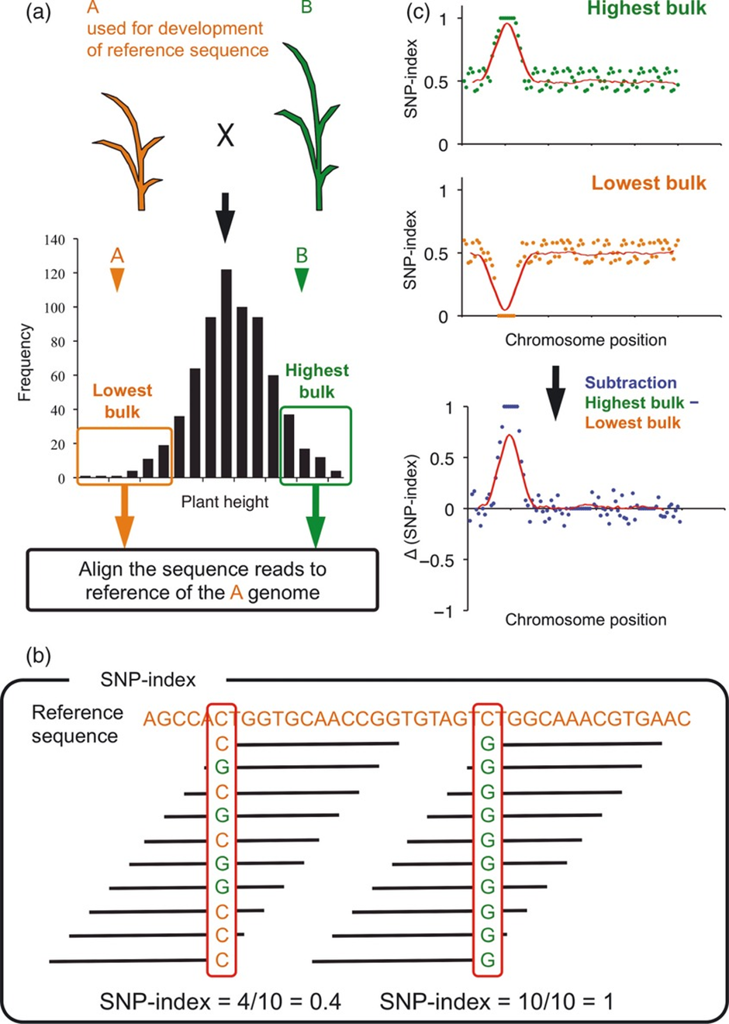
Figure 6: A schematic view of QTL-seq procedure (Source: Takagi et al., 2013)
Conclusion:
Bulked Segregant Analysis (BSA) offers a rapid and efficient strategy for pinpointing molecular markers that are tightly associated with the gene controlling a particular trait. Advances in next-generation sequencing have significantly enhanced BSA techniques, allowing for much faster and more efficient identification of mutant genes. BSA techniques and their variants have been extensively applied across a wide range of crop plants such as chickpea, rice, wheat, maize, sorghum, soybean, and cucumber for the identification and mapping of both qualitative and quantitative traits. Although these approaches have wide applications for their rapid discovery of gene and QTLs their exploitation is still not up to the mark in crops with large genome size owing its sequencing costs.

Table 1: Comparison between NGS based gene/QTL mapping techniques
Features | SHOREmap | MutMap | MutMap+ | MutMap-Gap | QTL-Seq
First gene identified | AT4G35090 in A. thaliana for slow growth and pale green leaves | CAO1 in O. sativa for leaf color | NAP6 in O. sativa for pale green leaves and dwarfism and lethality within 3 weeks after germination | Pii for blast resistance gene in O. sativa | QTLs O. sativa for partial resistance to rice blast
Developed by | (Schneeberger et al. 2009) | (Abe et al. 2012) | (Fekih et al. 2013) | (Takagi et al. 2013a, b) | (Takagi et al. 2013a, b)
Number of plants to be included in bulk | 500 | ~ 20 | 20–40 plants | ~ 20 plants | 10–20 for each extreme
Number of bulks | One mutant bulk | One mutant bulk | One mutant bulk | One mutant bulk and one wild type bulk | Two bulks for two extremes phenotypes of F2 population
Detection of SNPs is between | Mutant bulk and distant line | F2 mutant and wild-type parent | wild-type and mutant bulk | F2 mutant and wild-type parent | Two extreme bulks for the trait of interest
De novo assembly required | No | No | No | Yes | No
Mapping of QTLs | Not possible | Not possible | Not possible | Not possible | possible
Mapping of genes causing lethality/sterility | Not possible | Not possible | possible | Not possible | Not possible
Principle behind mapping of mutant/QTL loci | SNP pattern variation between mutant and wild-type samples using sliding window analysis to identify the location of the causative mutation | Calculation of genome-wide SNP Index and sliding window analysis | Calculation of SNP index for two extreme bulk followed by calculation of ΔSNP index | Calculation of SNP Index after creating scaffolds for gap regions | Calculation of SNP index for both extreme bulks followed by calculation of ΔSNP index
Source: Tribhuvan et al. (2018)
Table 2: List of genes mapped using MutMap and its variants
Tools  MutMap+ | Crop | Mutant phenotype | Mapped gene | Trait | References
Tools  MutMap+ | Rice (O. sativa cv Hitomebore) | Pale green color leaf | CAO1 | Leaf color | Abe et al. (2012)
Tools  MutMap+ | Cucumber | Dwarf phenotype with short internodes (Csdw) | CLAVATA1-type receptor-like kinase CsCLAVATA1 | Dwarfism | Xu et al. (2018
Tools  MutMap+ | Sorghum | Devoid epi-cuticular wax (EW)  (bm40-1) and (bm40-2) | GDSL-like lipase/acyl hydrolase | Drought tolerance | Jiao et al. (2018)
Tools  MutMap+ | Rice (Japonica cultivar) | altered gelatinization (age)1 and age2 | Starch branching enzyme IIb (BEIIb) gene | Rice grain texture | Nakata et al. (2018)
Tools  MutMap+ | Rice | Rice small grain (sg2) | 08SG2/OsBAK1 | Grain size and number | Yuan et al. (2017)
MutMap+ | Rice | Pale green leaves and dwarfism followed by lethality in 3 week | Os01g0127300 (NAP6) | Leaf colour | Fekih et al. (2013)
MutMap+ | Chenopodium quinoa | Green hypocotyl mutant (ghy) | CqCYP76AD1-1 | Hypocotyl color | Imamura et al. (2018)
MutMap-Gap | Rice | Rice blast (M. oryzae isolate TH68-126) susceptible phenotype | Os09t0327600-01 (Pii) | Rice blast resistance gene | Takagi et al. (2013b)
QTL-Seq | Cucumber | Aphid resistance | QTL locus with 16 putative genes including MYB 59 like F box protein, glucan binding proteins etc. | QTL for resistance to aphid resistance | Liang et al. (2016)
QTL-Seq | Oil seed rape (Brassica napus) | Change in branch angle | Major QTL branch angle 1 containing 82 genes | Branch angle | Wang et al. (2016a)
QTL-Seq | Groundnut  (Arachis hypogea) | Rust and leaf spot resistance | SNPs in 25 genes conferring rust resistance and 9 genes conferring leaf spot resistance | Rust and leaf spot resistance | Pandey et al. (2017)
QTL-Seq | Rice | Nitrogen use efficiency | qNUE6 | Nitrogen use efficiency | Yuan et al. (2017)
Source: Tribhuvan et al. (2018)

Disclaimer (Artificial intelligence)
Option 1:
Author(s) hereby declare that NO generative AI technologies such as Large Language Models (ChatGPT, COPILOT, etc.) and text-to-image generators have been used during the writing or editing of this manuscript.

References:
Abe, A., Kosugi, S., Yoshida, K., Natsume, S., Takagi, H., Kanzaki, H., Matsumura, H., Yoshida, K., Mitsuoka, C., Tamiru, M. and Innan, H., 2012. Genome sequencing reveals agronomically important loci in rice using MutMap. Nature biotechnology, 30(2), pp.174-178.
Austin, R.S., Vidaurre, D., Stamatiou, G., Breit, R., Provart, N.J., Bonetta, D., Zhang, J., Fung, P., Gong, Y., Wang, P.W. and McCourt, P., 2011. Next‐generation mapping of Arabidopsis genes. The Plant Journal, 67(4), pp.715-725.
Boetzer, M., Henkel, C.V., Jansen, H.J., Butler, D. and Pirovano, W., 2011. Scaffolding pre-assembled contigs using SSPACE. Bioinformatics, 27(4), pp.578-579.
Cassells, A.C.; Doyel, B.M., 2003. Genetic engineering and mutation breeding for tolerance to abiotic and biotic stresses. Bulg. J. Plant Physiol. SI, 52–82.
Chaudhary, J.; Deshmukh, R.; Sonah, H., 2019. Mutagenesis approaches and their role in crop improvement. Plants. 8, 467.
Etherington, G.J., Monaghan, J., Zipfel, C. and MacLean, D., 2014. Mapping mutations in plant genomes with the user-friendly web application CandiSNP. Plant methods, 10(1), pp.1-11.
Fekih, R., Takagi, H., Tamiru, M., Abe, A., Natsume, S., Yaegashi, H., Sharma, S., Sharma, S., Kanzaki, H., Matsumura, H. and Saitoh, H., 2013. MutMap+: genetic mapping and mutant identification without crossing in rice. PloS one, 8(7), p.e68529.
Giovannoni, J.J., Wing, R.A., Ganal, M.W. and Tanksley, S.D., 1991. Isolation of molecular markers from specific chromosomal intervals using DNA pools from existing mapping populations. Nucleic acids research, 19(23), pp.6553-6568.
Hu, T., Chitnis, N., Monos, D., & Dinh, A. (2021). Next-generation sequencing technologies: An overview. Human immunology, 82(11), 801-811.
Jiao, Y., Burow, G., Gladman, N., Acosta-Martinez, V., Chen, J., Burke, J., Ware, D. and Xin, Z., 2018. Efficient identification of causal mutations through sequencing of bulked F 2 from two allelic bloomless mutants of Sorghum bicolor. Frontiers in plant science, 8, p.2267.
Michelmore, R.W., Paran, I. and Kesseli, R., 1991. Identification of markers linked to disease-resistance genes by bulked segregant analysis: a rapid method to detect markers in specific genomic regions by using segregating populations. Proceedings of the national academy of sciences, 88(21), pp.9828-9832.
Rahman, S. U., McCoy, E., Raza, G., Ali, Z., Mansoor, S., & Amin, I. (2023). Improvement of soybean; A way forward transition from genetic engineering to new plant breeding technologies. Molecular Biotechnology, 65(2), 162-180.
Satam, H., Joshi, K., Mangrolia, U., Waghoo, S., Zaidi, G., Rawool, S., ... & Malonia, S. K. (2023). Next-generation sequencing technology: current trends and advancements. Biology, 12(7), 997.
Schneeberger, K., Ossowski, S., Lanz, C., Juul, T., Petersen, A.H., Nielsen, K.L., Jørgensen, J.E., Weigel, D. and Andersen, S.U., 2009. SHOREmap: simultaneous mapping and mutation identification by deep sequencing. Nature methods, 6(8), pp.550-551.
Sheeba, A., Yogameenakshi, P., Aananthi, N., Sasikumaran, S., & Vimala, G. (2023). Studies on genetic diversity and variability in rice (Oryza sativa L.) Genotypes. International Journal of Plant & Soil Science, 35(20), 1237-1243.
Takagi, H., Abe, A., Yoshida, K., Kosugi, S., Natsume, S., Mitsuoka, C., Uemura, A., Utsushi, H., Tamiru, M., Takuno, S. and Innan, H., 2013. QTL‐seq: rapid mapping of quantitative trait loci in rice by whole genome resequencing of DNA from two bulked populations. The Plant Journal, 74(1), pp.174-183.
Takagi, H., Uemura, A., Yaegashi, H., Tamiru, M., Abe, A., Mitsuoka, C., Utsushi, H., Natsume, S., Kanzaki, H., Matsumura, H. and Saitoh, H., 2013. M ut M ap‐G ap: whole‐genome resequencing of mutant F 2 progeny bulk combined with de novo assembly of gap regions identifies the rice blast resistance gene Pii. New Phytologist, 200(1), pp.276-283.
Tribhuvan, K.U., Kumar, K., Sevanthi, A.M. and Gaikwad, K., 2018. MutMap: a versatile tool for identification of mutant loci and mapping of genes. Indian Journal of Plant Physiology, 23(4), pp.612-621.
Viejobueno, J., de Los Santos, B., Camacho-Sanchez, M., Aguado, A., Camacho, M., & Salazar, S. M. (2022). Phenotypic variability and genetic diversity of the pathogenic fungus Macrophomina phaseolina from several hosts and host specialization in strawberry. Current Microbiology, 79(7).
Zegeye, W.A., Zhang, Y., Cao, L. and Cheng, S., 2018. Whole Genome Resequencing from bulked populations as a rapid QTL and gene identification method in rice. International Journal of Molecular Sciences, 19(12), p.4000.
Zou, C., Wang, P. and Xu, Y., 2016. Bulked sample analysis in genetics, genomics and crop improvement. Plant biotechnology journal, 14(10), pp.1941-1955.

