**Unlocking Safflower’s Potential: A Comparative Study of Red (Carthamin) and Yellow (Carthamidin) Dyes for Pharmaceutical, Food and Cosmetic Industrial Applications**

Safflower (*Carthamus tinctorius* L.) is a member of the Asteraceae family, and is an important oilseed crop which is cultivated in different geographical regions of Asia, including China and India.This study explores the extraction, identification, and quantification of safflower's red (carthamin) and yellow (carthamidin) pigments, important for use in food, textiles, cosmetics, and pharmaceuticals. Carthamin forms from its yellow precursor, precarthamine, through oxidation during flower maturation. Yellow pigment was extracted with distilled water, and red pigment with Sodium carbonate solution. Pigments were characterised spectrophotometrically, quantified using a Rutin standard curve, and identified via thin-layer chromatography (TLC) by comparing Rf values with standards of flavonoids. Petals of thirty safflower genotypes exhibiting colour variations were collected for pigment extraction and quantification. The concentration of yellow pigment ranges between 6.9 to 28.9 mg/ml, and red 2.2 to 4.3 mg/ml. Two genotypes with the highest pigment yields were identified as GMU-7923, which has 27.6 mg/ml and 3.3mg/ml and GMU-7931-1, which has 28.9mg/ml and 4.3 mg/ml of yellow and red content, respectively. The Rf value for yellow pigment ranges from 0.32-0.80 and 0.93-0.96 for Red. GMU-7923 has Rf values of 0.8 and 0.96, and GMU-7931-1 has 0.8 and 0.96 for yellow and red pigment, respectively. Therefore, these genotypes can be exploited for their pigments as valuable dyes. The novelty of this study lies in exploring safflower florets as a source of natural, non-allergenic, and non-carcinogenic colourants, with the aim of identifying and extracting key pigments for use in various fields/industries. This study demonstrates that the 30 different safflower genotypes exhibit significant potential for the production of both safflower yellow and red pigments. Among the 30 genotypes studied, two genotypes, GMU-7923 for yellow pigment and GMU-7931-1for red pigment, showed the highest levels of pigment content and paved its way for commercial pigment extraction and their utilisation in food, dying and medicinal industries.

**ABSTRACT:**

Keywords**:** Pigment, Red, Rf value, Safflower, , Yellow, thin-layer chromatography

**1. INTRODUCTION:**

Safflower (*Carthamus tinctorius* L.) is a herbal plant with a long history of clinical application worldwide, such as coronary heart disease, hypertension, dysmenorrhea and amenorrhea. It has also been extensively used as an important oilseed plant for hundreds of years in some countries, like China, India, Mexico and the United States. Therefore, safflower is believed as a crop with dual values of medicine and economy as well (Wu et al., 2021). It is a member of the Asteraceae family, and is an important [oilseed crop](https://www.sciencedirect.com/topics/agricultural-and-biological-sciences/oilseed-crops) which is cultivated in different geographical regions of Asia, including China and India (Singh, 2007). Oilseeds are the second major agricultural commodity after cereals in India. Safflower (*Carthamus tinctorius L.*) is one of the important edible oilseed crops (Sathwik et al., 2023). Iran is considered one of the major origins of safflower in the Old World (Golkar, 2014).In recent years, India's oilseed production has demonstrated some fluctuations, with safflower production reflecting a notable trend. Safflower seeds, composed of 33–60% shell and 40–67% kernel, are used as animal feed and for the extraction of an oil used in food, cosmetic and pharmaceutical products (Muscalu et al., 2024). According to the Economic Survey of Maharashtra 2023-24, India's safflower production during the fiscal year 2023 was estimated at approximately 57,000 metric tons (Economic Survey of Maharashtra, 2023-24). However, by the end of fiscal year 2024, India's safflower production was estimated to decrease to about 50,000 metric tons, marking a reduction from the previous year's levels ([statista.com](https://www.statista.com/statistics/937047/india-procurement-price-of-safflower/?utm_source=chatgpt.com) [apps.fas.usda.gov](https://apps.fas.usda.gov/newgainapi/api/Report/DownloadReportByFileName?fileName=Oilseeds+and+Products+Annual_New+Delhi_India_IN2024-0005.pdf&utm_source=chatgpt.com) accessed on 05 March 2025).

The medicinal properties of safflower have been widely accepted. Safflower, which originates from Ethiopia, Afghanistan, and Arab countries, has a long history of cultivation and is widely distributed worldwide. Besides, the flowers and seeds of safflower are rich in oils, which makes it a dryland oilseed crop yielding high-quality edible oil. In some Asian countries, the plant’s petals and oil are used as medicine to treat diseases, including coronary heart disease, hypertension, dysmenorrhoea, and amenorrhoea (Cheng et al., 2024). Safflower is an important industrial crop containing yellow and red colour pigments from C glucosylquinochalcone flavonoids in the petals (Kazuma *et al.,*2000). Due to their well-known roles in cardio-cerebrovascular health, safflower flavonoids are considered the main active product among the safflower metabolites. So far, over 60 kinds of flavonoids have been identified and characterised in safflower (Xian *et al.* 2022). According to the differential flavonoid components compared with other plants, safflower flavonoids can be divided into unique and common categories. The unique flavonoids are only identified in safflower, containing most quinochalcones, such as SR-derived carthamin, YR-derived safflor yellow A, HSYA, safflor yellow B, and anhydrosafflor yellow B (AHSYB). Most of these unique flavonoids belong to C-glycosides. In contrast, safflower common flavonoids are also identified in many other species and mainly consist of naringenin, kaempferol, hyperoside, luteolin and quercetin, glycosylation products of which belong to O-glycosides (Wang *et al*., 2021). Flavonoids are mainly composed of the glycosides derived from shannesol and quercetin, safflower yellow A, hydroxysafflor yellow A, red pigment, apigenin, quercetin, rutin, myricetin, etc. (Li *et al*. 2012). The safflower pigments include 3-6% red (carthamin), insoluble in water, and 24-30% water-soluble yellow (carthamidin) (Machewad *et al.,* 2012). These pigments, particularly flavonoids such as safflower yellow, which contains a mixture of carthamin, have garnered significant interest due to their vibrant colour properties, safety, and versatility.

*C. tinctorius* L. also contains a considerable amount of soluble polysaccharides that show immunomodulatory, anti-diabetic, anti-cancer, and anti-tumour activities (Lin et al., 2022). *.*It has recently been shown to have antioxidant, anti-inflammatory and antidiabetic activities (Asgarpanah and Kazemivash 2013). Eco-friendly and biodegradable dyes derived from natural resources have emerged as an important alternative to synthetic dyes (Jadhav and Joshi, 2015). Improvement in the chemical characteristics of ice cream is reported by the addition of carthamidin extract (Machewad *et al.* 2012) and to improve the therapeutic value of food products (Al-Snafi 2015). Safflower carthamin is widely used as stain in foods such as ice cream, jelly, soup, and as an additive in beverages and cosmetics (Singh 2007; Machewad *et al.* 2012). China has manufactured and produced carthamin as a red paint for cosmetics (Yue *et al.* 2013). The extracts of florets are used in the treatment of many illnesses such as menstrual problems, cardiovascular diseases, pain, and swelling associated with trauma, heart attack and renal thrombosis, circulatory system disorders (Singh, 2007). In recent years, safflower petals have been used as herbal tea in India and China (Sultana and Anwer 2014; Al-Snafi 2015).

Considering the economic importance of safflower petals, it could be worthwhile to explore these florets for the extraction of colourants that would be used in different food products with medicinal properties. It was therefore deemed valuable to explore the potential of safflower florets for the extraction of natural colourants, which can be utilised across a variety of industries, including food, textiles, and pharmaceuticals. In this study, a detailed examination was conducted to extract and identify the key pigments present in safflower florets. The research aimed not only to isolate these pigments but also to analyse their chemical composition, quantification, and potential applications in different sectors, offering an environmentally friendly alternative to synthetic dyes. This study contributes to a deeper understanding of the biochemical properties of safflower pigments and their possible commercial use.

**2. MATERIALS AND METHODS:**

Petals of 30 different Safflower genotypes showing variation in the flower colours from yellow to orange, brown and red were collected from the field of All India Coordinated Research Project (AICRP) on Safflower, VNMKV, Parbhani and used for pigment extraction and characterisation (Plate 1).

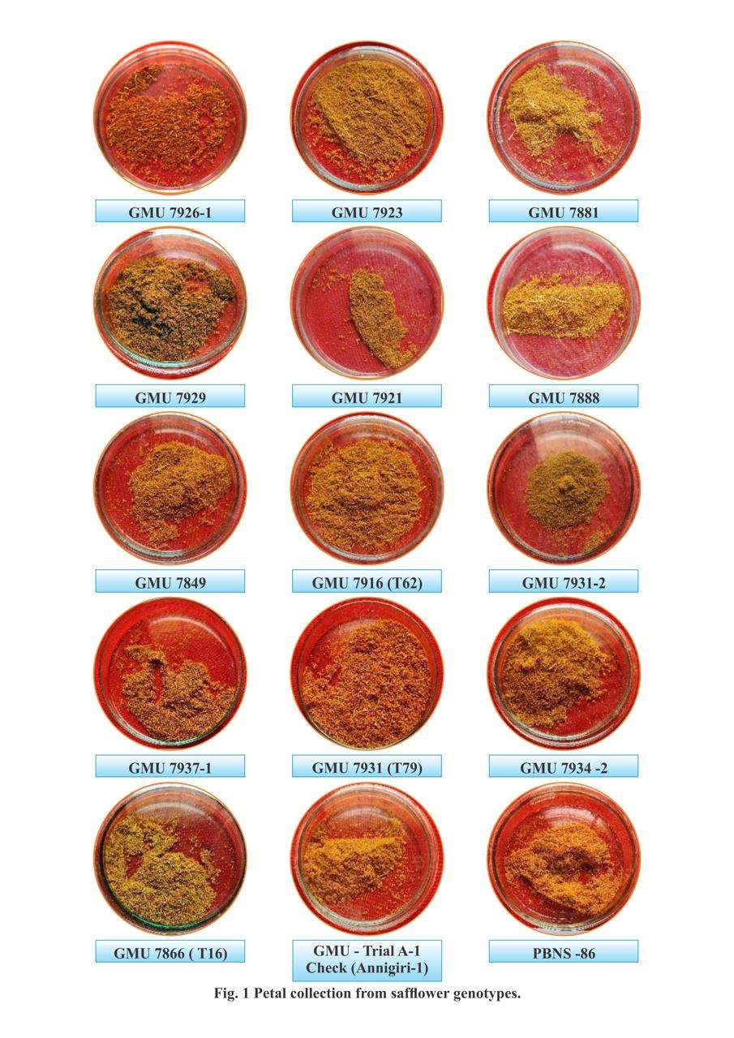

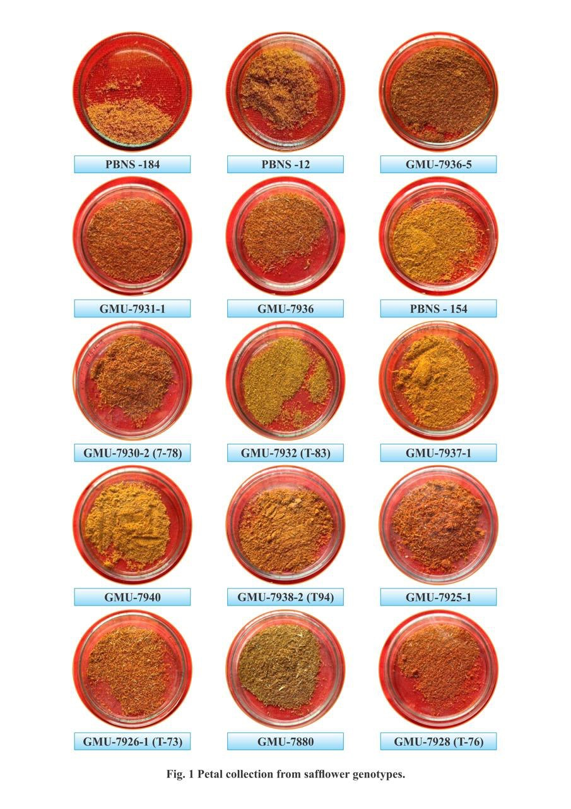

Plate 1. Petals collected from Safflower genotype

**2.1UV spectrophotometry**:

The total flavonoids in safflower exhibit distinct UV absorption peaks within a certain wavelength range. At 330 nm, there are distinctive absorption peaks. The standard flavonoid, rutin, is detected at a wavelength of 500 nm. To determine the yellow and red pigment content of safflower genotypes, a standard curve was created (Zhou *et al*., 2015).

**2.2Preparation of reference and test samples:**

The Rutin curve, a standard flavonoid, was created using Ji *et al*. (2018)'s methodology and utilised to quantitatively estimate the amount of yellow and red pigment in safflower.

**2.3Safflower Yellow Colour Extraction**:

To isolate safflower yellow, 1 g of fine dry floret powder was suspended in 15 mL of distilled water. The mixture was stirred and soaked twice, each for 30 minutes. After soaking, the extracts were combined and filtered through a 200-mesh nylon filter. The resulting solution was centrifuged at 2000 rpm for 10 minutes. The supernatant was filtered to remove residual particles, yielding the safflower yellow extract (Jadhav and Joshi, 2015).(Plate 4)

**2.4Safflower Red Colour Extraction:**

The safflower residue, post-yellow pigment extraction, was thoroughly rinsed and subsequently immersed in a 1% Sodium carbonate solution at 20-25°C. The suspension was stirred and soaked twice for 30 minutes each. The extracts were combined and filtered through a 200-mesh nylon filter. The filtrate was centrifuged at 2000 rpm for 10 minutes. To the clear supernatant, a stoichiometric amount of 1% Citric acid was added, and allowed to stand for 30 minutes to facilitate sedimentation. The clarified liquid was treated with 0.5% Cellulose, promoting the adsorption of the red carthamin pigment. The resulting material was rapidly dried, yielding the final red pigment powder (Jadhav and Joshi, 2015). (Plate 4 and 5)

**2.5Spectrophotometric Measurement**:

Spectrophotometric measurements were performed to determine the absorbance of yellow and red pigment content. The measurements for each pigment were conducted over specific wavelength ranges, 385 to 500 nm for safflower yellow and 380 to 600 nm for red. Spectrophotometric analysis of safflower pigments from 30 distinct genotypes revealed that the maximum absorbance for safflower yellow occurred at a wavelength of 400 nm, corresponding to its characteristic absorption profile. In contrast, the red pigment exhibited a peak absorbance at 500 nm, reflecting its distinct spectral properties (Table no.1). These absorbance maxima are indicative of the specific molecular structures of yellow and red pigments, facilitating their quantification and comparison across the different genotypes.

**2.6Thin-Layer Chromatography**   
The Rf values of yellow and red pigments were examined on Silica gel G with two standard flavonoids, Rutin and Quercetin. The mobile phase consisted of Chloroform, Methanol, and Water (4:3:1) (Rudometova *et al*. 2001). The TLC plates were visualised under a UV Trans illuminator. (Plate 6)

**3. RESULT AND DISCUSSION**

The safflower plant is known for its brilliantly colored petals. Thirty different compounds have a diverse array of applications in the medicinal, food and textile industries. Safflower yellow has absorption maxima at wavelength 400 nm and pH 3.55, and is water-soluble, whereas red pigment had at 500 nm and pH 8.82 and soluble in alkaline solutions, particularly Sodium carbonate (Table no.1). The characteristics of safflower yellow and red pigments described by Jadhav and Joshi (2015) include the absorption maxima, which were found to be 400 nm for the yellow pigment and 520 nm for the red pigment with pH values 3.53 and 8.73, respectively. Sultana and Anwer (2014) showed a maximum peak of absorbance between 380-440 nm for carthamin extract with a specific peak at 380 nm. This peak is characteristic of carthamin extract, as reported in earlier studies by Satio *et al*. (1985). In contrast, the maximum peak for safflower yellow was observed at 385 nm. However, Kulkarni *et al*. (1997) found the optical density for safflower yellow pigment at 480 nm, while Wu and Fu (1993) reported it at 400 nm. These differences in optical density for the yellow pigment may be attributed to varietal differences. To confirm these differences, the extracts used for spectrophotometric analysis were further subjected to chromatographic separation by TLC.

**Table 1.** Characteristics of safflower yellow and red colour.

|  |  |  |  |
| --- | --- | --- | --- |
| **Sr no.** | **Characteristics** | **Yellow colour** | **Red colour** |
| 1. | Absorption maxima | 400nm | 500nm |
| 2. | pH | 3.55 | 8.82 |
| 3. | Solubility | Water | Alkaline solution |

Among the 30 genotypes examined in the current study, the yellow pigment ranged from 6.9 to 28.9 mg/ml, and GMU-7923 exhibited the highest concentration of 27.6 mg/ml of yellow pigment, suggesting significant potential of GMU-7923 for high-quality yellow pigment production. However, red pigment content ranged from 2.2 to 4.3 mg/ml. GMU-7931-1 demonstrated the highest concentration of red pigment, 4.3 mg/ml (Figure 1). Jadhav and Joshi (2015) reported concentration of safflower yellow pigments ranged from 24% to 28%, while carthamin, the red pigment, exhibited a concentration range between 0.3% and 0.8%. Concentration of yellow and red pigment is notably higher than reported in the earlier studies, indicating the genotype's potential for enhanced pigment production.

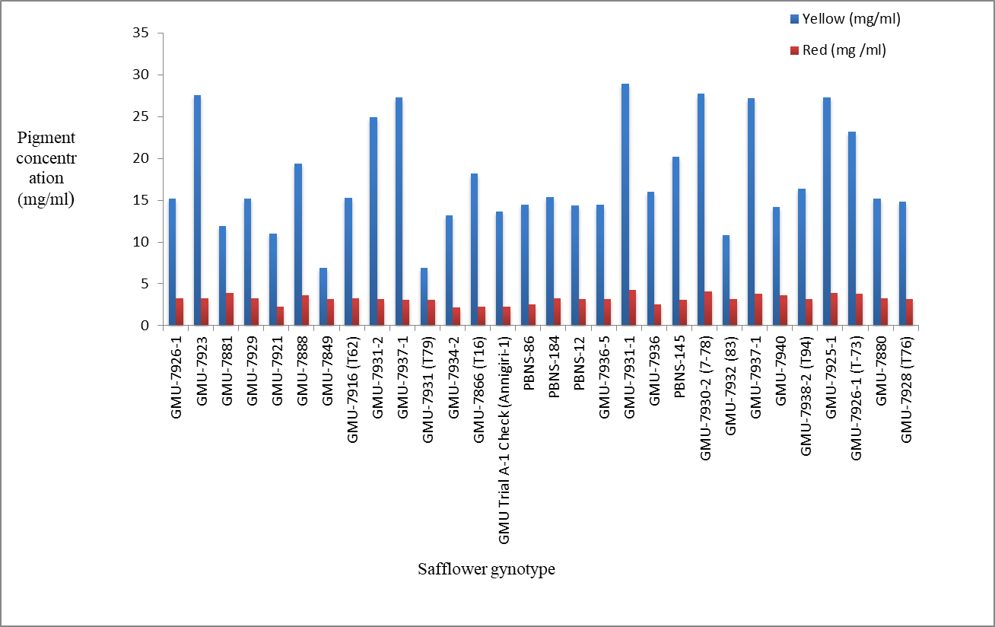

Fig1.: Concentration of yellow pigment and red pigment in safflower genotypes.

The nature of the extracted yellow (carthamidin) and red (carthamin) pigments was analysed to assess the varietal differences among the safflower petal extracts for pigment content. The chromatographic separation was conducted using TLC, and the resulting Rf values were compared to those of standard flavonoids, specifically Rutin and Quercetin, to aid in pigment identification. The Rf value for yellow pigment ranged from 0.32 to 0.80, and red pigment between 0.93 and 0.96. These findings align with the thin-layer chromatographic identification reported by Rudometova *et al*. (2001); the Rf values of safflower yellow and carthamin were observed in specific ranges on silica gel G, which corroborates the results obtained in the current study. Chavan and Nikam (2015) reported Rf values for carthamidin and carthamin as 0.81 and 0.90, respectively, which align with the findings for most of our genotypes, including the two varieties with the highest pigment content. Specifically, the Rf values for GMU-7923 were observed to be 0.80 for the yellow pigment and 0.96 for the red pigment, while GMU-7931-1 exhibited Rf values of 0.80 for the yellow pigment and 0.96 for the red pigment (Figure 2).

These values further support the correlation between pigment concentration and the observed Rf values in these genotypes. Further comparison with the findings of Sultana and Anwer (2014) revealed that Rf values for carthamin ranged from 0.9 to 2.0, while for carthamidin, 0.1 to 2.1. These differences in Rf values can be attributed to the variation in experimental conditions, including the type of solvent system used, the quality of the silica gel, and possibly the genotype-specific composition of pigments in safflower. Despite these differences, the Rf values obtained in our study fall within the expected ranges for both pigments, confirming their identification as yellow (carthamidin) and red (carthamin) pigments.

|  |  |  |  |  |  |  |  |  |  |  |  |  |  |
| --- | --- | --- | --- | --- | --- | --- | --- | --- | --- | --- | --- | --- | --- |
| |  | | --- | |  | |  |  |  |  |  |  |  |  |  |  |  |  |

Fig 2: Rf values of safflower genotypes.

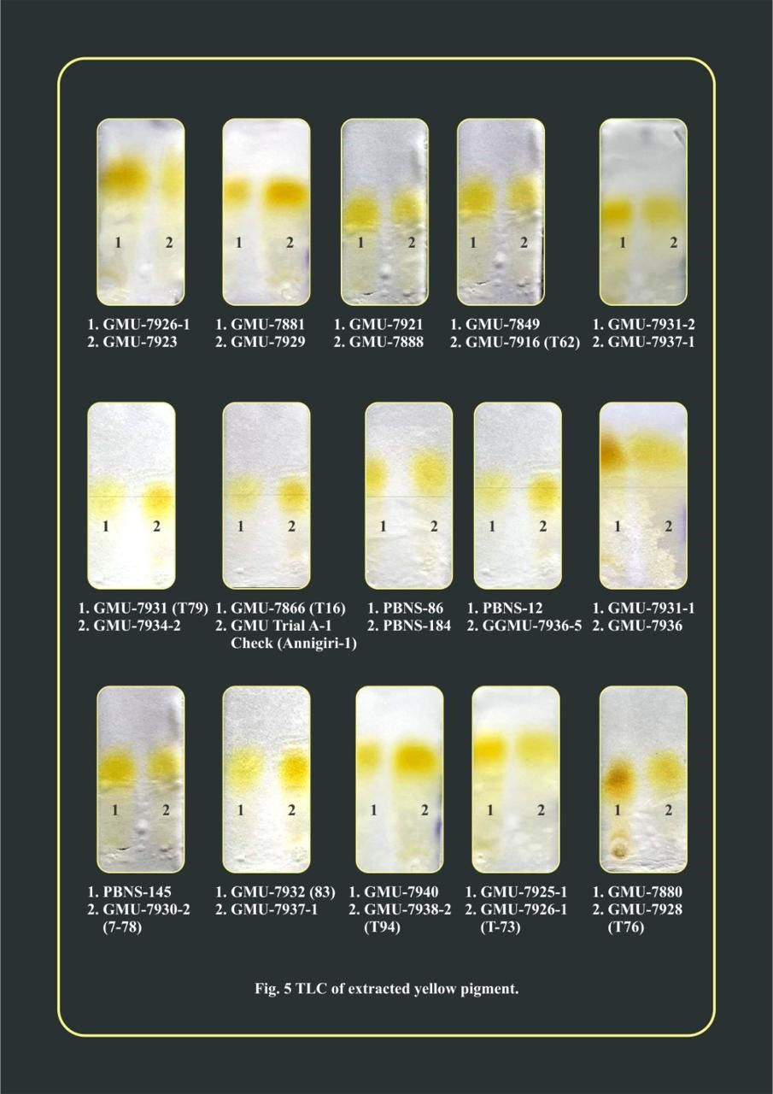

Plate 2: TLC of extracted yellow pigment from safflower.

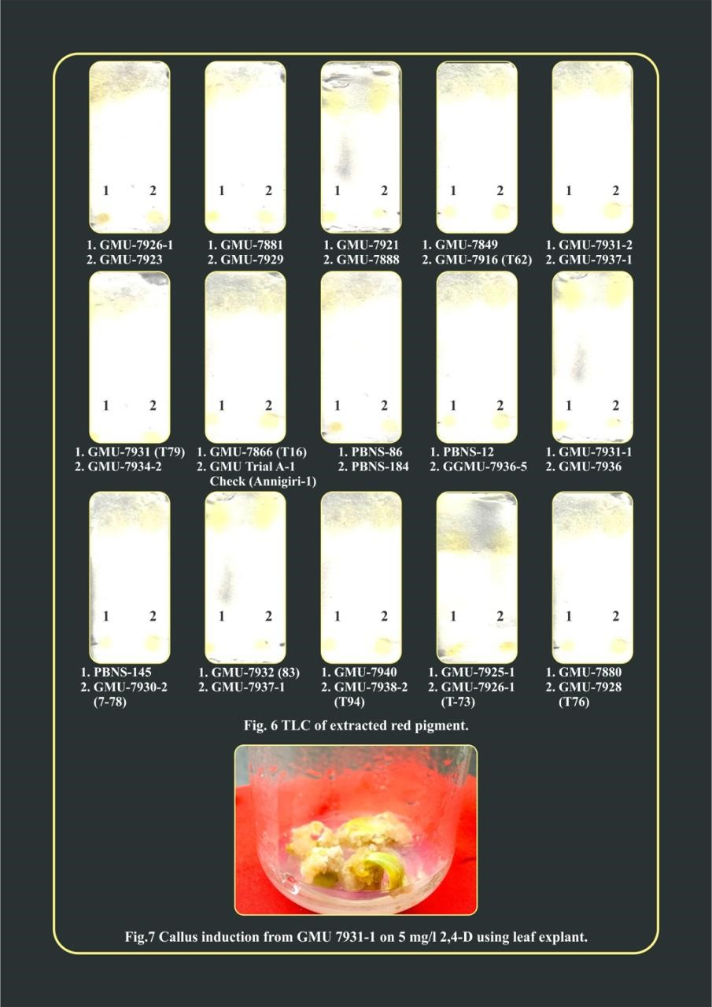

Plate 3: TLC of extracted red pigment from safflower.

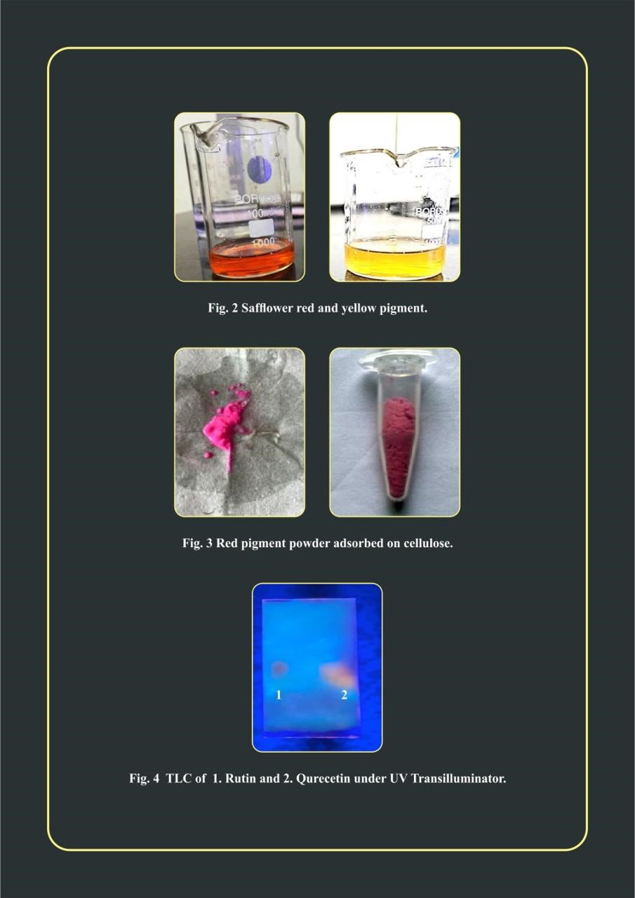

Plate 4: Safflower Red and Yellow Pigment



Plate 5: Red Pigment Powder Adsorbed on Cellulose



Plate 6: TLC of 1.Rutin and 2. Qurecetine under UV transilluminator

**4. CONCLUSION**

The carthamidin water-soluble yellow pigment, and carthamin alkaline-soluble red pigment, can be extracted from safflower petals, which have the capability as food colourants and natural yellow and red dyes. In the future, this breakthrough in natural food colorant is expected to gain widespread acceptance, especially as today’s world increasingly seeks natural, non allergenic, non-carcinogenic and non-synthetic food alternative with properties such as enhanced stability across the varying pH level, temperature, and solute concentrations, as well as in the presence of polar solvent. This study demonstrates that the 30 different safflower genotypes exhibit significant potential for the production of both safflower yellow and red pigments. Among the 30 genotypes studied, two genotypes, GMU-7923for yellow pigment and GMU-7931-1for red pigment, showed the highest levels of pigment content and paved its way for commercial pigment extraction and their utilisation in food, dying and medicinal industries.

**DISCLAIMER (ARTIFICIAL INTELLIGENCE)**

Authors hereby declare that NO generative artificial intelligence tools including large language models (e.g., ChatGPT, Google Gemini, Microsoft Copilot) or text-to-image generators were used in the writing, editing, data analysis, or figure preparation for this manuscript. All content is the original work of the authors.

**REFERENCE**

Al-Snafi, A.E. (2015). The chemical constituents and pharmacological importance of *Carthamus tinctorius* - an overview. *J. Pharm. Biol.* 5(3): 143-166.

Asgarpanah, J. and Kazemivash, N. (2013). Photochemistry, pharmacology and medicinal properties of *Carthamus tinctorius L. Chin.* *J. Integr. Med.* 19: 153-159.

Chavan, S., & Nikam, T. (2015). Influence of some precursors supplement on growth and production of alphatocopherol and pigments in callus and cell suspension cultures of *Carthamus tinctorius* L. *World J. Pharm. Res.*, 4:1734-1742.

Golkar, P. (2014). Breeding improvements in safflower (*Carthamus tinctorius* L.): a review. *Australian Journal of Crop Science*, *8*(7), 1079-1085.

Jadhav, B.A. and Joshi, A.A. (2015). Extraction and quantitative estimation of bioactive component (yellow and red carthamin) from dried safflower petals. *Indian* *J. Sci. Technol,* 8(16): 1-5.

Ji, Y., Guo, S., Wang, B., & Yu, M. (2018). Extraction and determination of flavonoids in Carthamus tinctorius. *Open Chemistry*, *16*(1), 1129-1133.

Kazuma, K., Takahashi, T., Sato, K., Takeuchi, H., Matsumoto, T., & Okuno, T. (2000). Quinochalcones and flavonoids from fresh florets in different cultivars of *Carthamus tinctorius* L. *Bioscience, Biotechnology, and Biochemistry*, *64*(8), 1588-1599.

Kulkarni, D. N., Revanwar, S. M., Kulkarni, K. D., & Deshpande, H. W. (1997). Extraction and uses natural pigments from safflower florets 4th Intl. In *Safflower conf*.  pp. 2-7.

Li, X., Hu, X., Dai, Z., Zhang, Y., Liang, H., & Lin, R. (2012). Study on chemical constituents of *Carthamus tinctorius, Chin. Med. Herb,* 35:1616-1619.

Machewad, G.M., Ghatge, P., Chappalwar, V., Jadhav, B. & Chappalwar, A. (2012) Studies on extraction of safflower pigments and its utilization in ice cream. *J. Food Process. Technol,* 3(8):172.

Rudometova, N.V., Pasovskij, A.P., & Blohina, E.A. (2001) Method of isolation and identification of carthamin from safflower. Application’s perspectives in Russian food products. 5th Int. Safflower Conf. Williston, N.D., U.S.A., 23-27.

Saito, K., & Takahashi, Y. (1985). Studies on the formation of carthamin in buffer solutions containing precarthamin and oxidizing agents. *Acta Societatis Botanicorum Poloniae*, *54*(3): 231-240.

Singh, R. J. (2007). Genetic resources, chromosome engineering and crop improvement, Oilseedcrops, Vol, 2, CRC Press Inc. *Boca Raton, Florida, USA*, pp. 308.

Sultana, A. & Anwer, S.Y. (2014). Studied on valuable pigments from florets of safflower (*C. tinctorius* L*.)* and their identification by TLC method. *Biosci. Biotechnol. Res. Asia* 11(2):839-843.

[statista.com](https://www.statista.com/statistics/937047/india-procurement-price-of-safflower/?utm_source=chatgpt.com) [apps.fas.usda.gov](https://apps.fas.usda.gov/newgainapi/api/Report/DownloadReportByFileName?fileName=Oilseeds+and+Products+Annual_New+Delhi_India_IN2024-0005.pdf&utm_source=chatgpt.com) accessed on dated 05 March, 2025.

Wang, S., Cao, J., Deng, J., Hou, X., Hao, E., et al. (2021). Chemical characterization of flavonoids and alkaloids in safflower (*Carthamus tinctorius* L.) by comprehensive two-dimensional hydrophilic interaction chromatography coupled with hybrid linear ion trap Orbitrap mass spectrometry. *Food Chemistry*: X 12:100143

Wu, S., & Fu, J. (1993). The research and production of carthamin. *Conf. proc. Safflower in china,* 881-889.

Xian, B., Wang, R., Jiang, H., Zhou, Y., Yan, J., et al. (2022). Comprehensive review of two groups of flavonoids in *Carthamus tinctorius* L. *Biomedicine & Pharmacotherapy* 153:113462

Yue, S.J., Tang, Y.P., Li, S.J. & Duan, J.A. (2013). Chemical and biological properties of quinochalcone Cglycosides from the florets of *Carthamus tinctorius*. *Molecules,* 18:15220–15254.

Zhou, H., Zhao, Ch., Sun, P., Tong, W., Ye, X., & Xiao, Y., (2015) Study on extraction technology, white variation of total safflower flavone, *J. Chengdu Univ. Trad. Chin. Med.*, 38: 27-31.

Wu, X., Cai, X., Ai, J., Zhang, C., Liu, N., & Gao, W. (2021). Extraction, structures, bioactivities and structure-function analysis of the polysaccharides from safflower (Carthamus tinctorius L.). Frontiers in pharmacology, 12, 767947.

Cheng, H., Yang, C., Ge, P., Liu, Y., Zafar, M. M., Hu, B., ... & Ren, M. (2024). Genetic diversity, clinical uses, and phytochemical and pharmacological properties of safflower (Carthamus tinctorius L.): an important medicinal plant. Frontiers in Pharmacology, 15, 1374680.

Lin, D., Xu, C. J., Liu, Y., Zhou, Y., Xiong, S. L., Wu, H. C., ... & Lu, Y. (2022). Chemical structures and antioxidant activities of polysaccharides from Carthamus tinctorius L. Polymers, 14(17), 3510.

Muscalu, A., Tudora, C., Sorica, C., Anghelache, D., Ionescu, A., Mîrzan, O., & Gonzalez, P. H. (2024). THE IMPORTANCE OF SAFFLOWER (CARTHAMUS TINCTORIUS L., ASTERACEAE FAM.). Annals of the Faculty of Engineering Hunedoara, 22(4), 79-84.

Sathwik , G. P., Rajanikanth , E., Sampath , O., & Chaitanya , K. K. (2023). Evaluation of Safflower (Carthamus tinctorius L.) Cultivars under Different Sowing Dates on Yield and Yield Attributes in Non-Traditional Area of Northern Telangana Zone (NTZ). International Journal of Environment and Climate Change, 13(9), 3461–3466.