Minireview Article

A Concise Analysis of Advancements in Diabetes Management: The Emerging Paradigms of Non-Invasive Glycemic Monitoring

.
ABSTRACT

Aims: To provide efficient, painless alternatives for glucose monitoring by reviewing noninvasive, needle-free methods aimed at enhancing user convenience through continuous and wireless technologies.
Study design: The study focuses on a critical review of the instruments used to measure glucose levels in human blood without the need for needle insertion.
Place and Duration of Study: School of Biomolecular Engineering and Biotechnology, Rajiv Gandhi Proudyogiki Vishwavidyalaya, Bhopal, between December 2023 and May 2025.
Methodology: It includes noninvasive techniques such as optical, electrochemical, and electromagnetic methods. Innovations like reverse iontophoresis are highlighted. Spectroscopy is emphasized as the most significant technique, using light absorption, transmittance, reflection index, and light scattering at specific wavelengths. Electromagnetic sensing is also examined, using radio frequency signals to assess glucose levels.
Results: Recent advancements in noninvasive glucose monitoring, including optical and electromagnetic sensing, allow for accurate and painless detection from fluids such as blood and tears. Methods like NIR/MIR spectroscopy, fluorescence sensors, and graphene-based devices facilitate continuous and portable monitoring, enhancing diabetes care beyond traditional methods.
Conclusion: The study highlights advancements in pain-free, non-invasive glucose monitoring techniques, including reverse iontophoresis, spectroscopy, and electromagnetic sensing. These include optical, microwave, and electrochemical methods, often combined for improved accuracy. Wearable glucometers enhance continuous monitoring by accounting for physiological variations, eliminating the need for needle-based detection.

Keywords: Electromagnetic sensing, Glycemic monitoring, lacrimal fluid, Spectroscopy, Pulse-oximeter, Reverse Iontophoresis

INTRODUCTION

Uncontrolled blood sugar levels, also known as glycemia, can result in significant health complications for individuals. In healthy people, blood sugar levels naturally vary before and after meals. The concentration of glucose in the bloodstream ranges from 70 to 100 mg/dL when fasting. A diabetes diagnosis is made when blood glucose levels reach approximately 126 mg/dL (7 mmol/L) after a period of fasting or 200 mg/dL two hours after eating(Poznyak et al., 2022). Optimization of diabetes management and regular monitoring of glucose levels are needed for proper glucose measurements. Since 1970, the commercial sector has developed various analytical systems for capturing accurate readings of glucose concentrations from capillary blood samples taken from areas other than the fingertips. The innovative idea of a “non-invasive” device to measure blood glucose for diabetic patients without pricking has created the “dream of decades.” Innovations in glucose monitoring are set to enhance the effectiveness of the “Glucose Monitoring System,” continuously providing significant benefits for developing the “control of glycemia.” A glucose monitoring system measures the blood sugar level based on day and night variations. A proper glucose level monitoring system helps develop a specific pattern and trend for "empowering diabetic patients to prioritize their health and well-being."

- A brief overview of non-invasive monitoring of glucose

Non-invasive technologies for monitoring blood glucose levels are a less painful and straightforward way to develop a “Glycemic monitoring system.” This technological innovation helps control Glycemic levels to reduce the potential for worsening conditions in patients with high glucose levels. In 1962, advancements in glucometer technology were made through the use of electrodes that measure enzyme levels. After that, in 1965, a glucometer was used to measure the glucose rate(Shang et al., 2022). The noninvasive process measures glucose monitoring without inserting any devices into the human body, rather than passing radiation into a “vascular region” of the human body, which is recognized as the “optical monitoring of glucose in a noninvasive way” (Agrawal et al., 2022). The result is collected from the chemical composition of the “interstitial fluid” from the upper matrix level of the human body.
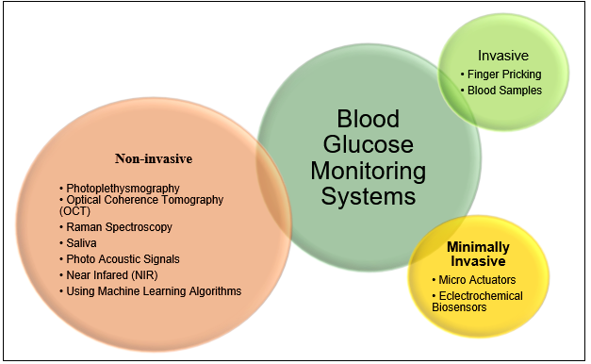
Figure 1: Various techniques for monitoring blood glucose. Source: (Agrawal et al., 2022)

The sensor used in the measurement process is the crucial component of the “Pulse Oximeter,” a vital tool in non-invasive glucose monitoring. There are various scientific techniques for blood glucose monitoring systems. Among the non-invasive methods, “Raman spectroscopy,” “acoustic signal of photos,” “near-infrared spectroscopy,” and “photoplethysmography” are essential for measuring glucose levels(Xue et al., 2022). Raman spectroscopy facilitates non-invasive glucose detection by analyzing molecular interactions within biological tissues. Additionally, glucose estimation through photoacoustic spectroscopy involves pulsed laser diode excitation, converting optical energy into acoustic signals that reflect glucose concentration. Saliva-based monitoring is also explored using nanomaterial-enhanced sensing platforms.(Laha et al., 2022). All these techniques are used to lower the rate of specificity and sensitivity, and short NIR spectroscopy is used to measure blood glucose levels.

METHODOLOGY

This study employed qualitative research to explore and evaluate recent innovations and procedures in non-invasive glucose monitoring. Qualitative methods include gathering preexisting information from secondary sources regarding glucose monitoring and emerging innovative solutions. These secondary sources include existing and published journal articles and other accessible sources of existing studies. This research implemented secondary data collection to gather secondary qualitative information from different open-access research articles from verified SCI journals. These include journal articles from journal publishers, including Sage, MDPI, and Springer.
The research has focused on applying an exploratory research design for the suitability of this secondary qualitative research study. This study explored the different forms of literature available concerning non-invasive glucose monitoring innovations. Exploratory research is suitable for examining various perspectives of the studied phenomenon (Al-Ababneh, 2020). Moreover, the study uses a secondary qualitative data analysis method by thematically elaborating on non-invasive glucose monitoring methods and procedures. The study also prioritized elaborating on the criteria that needed to be maintained for the genuineness of determining findings and exploring knowledge. The study has ensured that information from openly accessible scientific papers, journals, and articles published within the past five years, from 2020 to the present, will be used to gather current information for the relevant development of the results and their progressive discussions.

RESULTS AND DISCUSSION

With the help of the development of different tools and processes, modern technological innovation has initiated improvements in glucose monitoring systems in the blood. Blood glucose levels can be assessed through various techniques, including “near-infrared (NIR) and mid-infrared spectroscopy.” Both procedures are enforced for their ideology of the “detection spectrum” (Tang et al., 2020). In the near-infrared system, light has a robust penetration system within the body's soft tissues and blood fluids. This process involves transmitting and reflecting ultraviolet rays and detecting glucose concentrations within the human body. The mid-level denotes the lower level of light penetration power in the reflective mood to penetrate the tissues, not the fluid (Bamgboje et al., 2021). In the “aqueous glucose solution,” both spectroscopies help measure the dependence level of the light wavelength after glucose absorption within the blood.

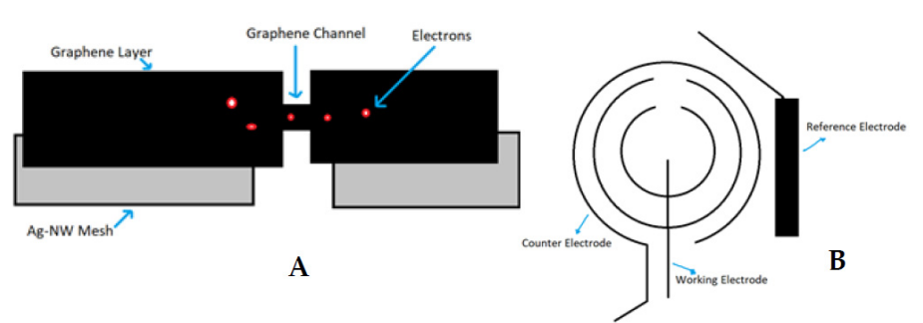
Figure 2: Principles of glucose-sensing and atmosphere-based glucose sensors. Source: (Bamgboje et al., 2021)

Different devices are used to monitor glucose concentration levels, and the “Graphene Hybrid Glucose Sensor” is widely used for glucose monitoring systems. The atmosphere-based sensor of the glucose monitoring system investigates the generation of electrodes within the “lacrimal fluid” (Huang, 2020). This is a sensor-based detection process that transforms the properties of the “sol-gel” to satisfy the lower detection rate of the glucose rate of the lacrimal fluid. Different optical sensing methods are used to obtain the glucose level within the blood, and the “fluorescent sensor” is the most crucial technique for glucose detection (Peng et al., 2022). Other optical sensors are used to measure the “optical coherence tomography” with the help of a lower rate of the laser system. Various optical techniques are used to investigate blood glucose levels, and recent portable instruments and measurements have been used to detect glucose levels.
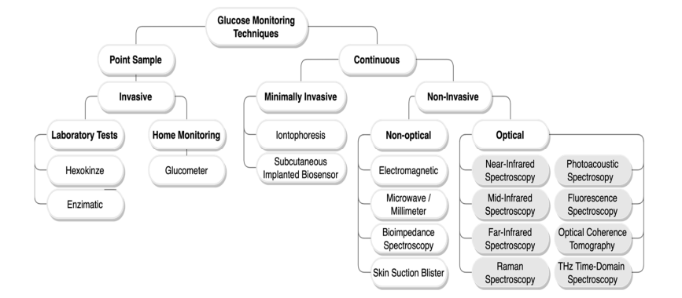
Figure 3: Classification of the glucose monitoring system. Source: (Alsunaidi et al., 2021)

The conventional method of “self-monitoring” glucose level detection is substituted with technologically innovative ways of continuously monitoring glucose levels in the blood. Electrochemical biosensors are the basis of continuous glucose monitoring systems. The point sample invasive process amalgamated lab-based testing and home-monitoring processes. The lab-based process was based on hexokinase and enzymes, and the home-based process was based on the working process of the “glucometer” (Alsunaidi et al., 2021). Non-invasive processes include “non-optical” and “optical” processes. Among all non-invasive techniques, optical methods provide the best results for measuring glucose levels within blood fluids. The recent development of the “light beam process” of the fingertips of the human body is the most developed technology without picking and causing less pain to the human body (Yang et al., 2025). The “silicon photodiode PIN” is used to detect the glucose level within the blood fluid and analyze the interconnection between the voltage of the “sensor output” and the glucose concentration. Electromagnetic sensing is the process of interconnecting carbohydrate levels and electromagnetic wavelengths within the fluid level of the human body. A distinct level of RF is conducted in the body to analyze the implemented glucose level within the human blood.

- Reverse Iontophoresis and spectroscopy

Non-invasive blood glucose monitoring includes the use of technologically integrated medical interventions, including spectroscopy techniques for monitoring through electrochemical and optical methods. Reverse iontophoresis (RI) technology is often adopted as an instrumental method for glucose monitoring through transdermal biofluid extraction. RI has been identified as a “needle-free technique” used for biomolecular extraction without dermal invasion for blood glucose monitoring (Leung et al., 2023). RI, as an electrochemical innovation, includes electromigration and electroosmosis; the former uses direct interactions between charged ions and the electric field, and the latter uses the combined flow of solvents from the anode to the cathode. Spectroscopy is included in implementing optical methods for conducting non-invasive glucose detection.
Spectroscopy is an effective optical method for monitoring diverse forms of glucose. This includes the use of a combination of optical, microwave, and electromagnetic techniques for spectroscopic monitoring. Spectroscopy uses different approaches, often “based on absorption by, emission from, or scattering by the analyte” (Todaro et al., 2022). This includes low penetration of electromagnetic radiation in tissues via glucose monitoring devices by backscattering. Among these techniques, there are separate spectroscopic methods, including infrared spectroscopy through absorption spectroscopy, Raman spectroscopy, measurement of the vibration spectrum of glucose, light scattering based on a biofluid refractive index via optical coherence tomography, and devices employing multiple technologies for measuring quantities that are different from glycemia.
RI includes integrating electrochemical procedures for testing and monitoring blood glucose through non-invasive methods. The electromigration mechanisms of iontophoresis implement the use of interstitial fluid (ISF) by applying current to the skin to attract ions to move to oppositely charged electrodes, with special attention given to sodium and chlorine ions as the number of major ions (Tang et al., 2020). The changes in physiological pH and sodium content become significant current carrier ions on the skin, with the ion concentration gradient creating osmotic pressure, leading the ISF to shift to the cathode with dissolved compounds that include glucose, which involves electroosmosis. The effective ISF extraction of traditional glucose sensors for glucose detection and monitoring through reverse iontophoresis from the skin to the cathode is pursued by using glucose inside the ISF, which is evaluated through iontophoresis.

- Electromagnetic Sensing: Advancements in Non-invasive Glucose Monitoring

Electromagnetic methods are among the newer and more effective non-invasive methods for measuring glucose(Kandwal et al., 2024). Accuracy is highly essential for managing diabetes, and non-invasive monitoring includes the use of sensors that implement electrochemical approaches, among other methods (Davison et al., 2022). Continuous glucose monitoring (CGM) solutions are used through wearable technologies for pain-free and needle-free monitoring procedures. Electromagnetic sensors are used for sensing glucose differences within the bloodstream “instantaneously, continuously, and wirelessly” (Hanna et al., 2022). The use of electromagnetic sensors is identified to be effective for continuous glucose monitoring through non-invasive wearable technology that primarily uses electrochemical and electromagnetic measures that are efficient for continuous Glycemic monitoring of patients, additionally managing diabetes progression and delays.
Electromagnetic sensing includes diverse non-invasive glucose monitoring methods involving the use of electromagnetic frequencies for electromagnetic sensor systems(Martins et al., 2025). Electromagnetic waves are often used for deep penetration within a highly absorbing environment comprising human biological tissues (Gorst et al., 2021). The use of sensors is identified for implementation as a device capable of addressing non-invasive measures by identifying diverse factors that interfere with accurate glucose measurements through electromagnetic signal reflections. The thickness and effect of skin layers on electromagnetic waves and the concentrations of tissue and blood components, including glucose and cutaneous blood perfusion, are essentially connected with the innovation of electromagnetic sensors.
The variations in these factors are included in the evaluation and development of electromagnetic systems capable of making non-invasive systems. Electromagnetic sensing also considers temperature as a biomarker of individuals (Rajaguru Jayanthi et al., 2023). The development of electromagnetic sensors is an overall connected aspect concerning the use of electromagnetic signals through devices capable of reflecting electromagnetic waves as a medium for wearable, innovative, non-invasive glucose monitoring.

CONCLUSION

The above study provides an insightful overview of innovation in glucose monitoring through pain-free and non-invasive methods for gathering information on glucose levels using glycemic measures. There are diverse types of non-invasive methods used for continuous and wireless glucose monitoring through different methods involving reverse iontophoresis, spectroscopy, and electromagnetic sensors, and combinations of sensors are being used. These methods, including optical, microwave, electromagnetic, and electrochemical techniques, support innovating continuous glucose monitoring. Wearable, non-invasive glucometers enhance glucose monitoring by considering various physiological aspects to ensure accurate blood glucose detection without the need for pricking.

FUTURE SCOPE

Non-invasive glucose monitoring helps medical professionals investigate the level of diabetes in an individual's body. The gradual advancement of technology has improved the application of spectroscopy in evaluating the passage of light and the dispersion of glucose molecules at their incidence. In the future, infrared and other electromagnetic rays might be refined for comparison with non-invasive waves, which can potentially disturb the glucose regulatory mechanism of the human body. By assessing the longitudinal movements of molecules, one can gain valuable insights into their deviations from normal glucose levels, contributing to a deeper understanding of diabetes management. Additionally, comprehensive studies can be initiated to explore the limitations of non-invasive glucose monitoring methods and their potential impact on human health.

Disclaimer (Artificial intelligence)

Author(s) hereby declares that NO generative AI technologies such as Large Language Models (ChatGPT, COPILOT, etc.) and text-to-image generators have been used during the writing or editing of this manuscript.

REFERENCES

Agrawal, H., Jain, P., & Joshi, A. M. (2022). Machine learning models for non-invasive glucose measurement: towards diabetes management in smart healthcare. Health and Technology, 12(5), 955–970. https://doi.org/10.1007/s12553-022-00690-7
Al-Ababneh, M. M. (2020). Linking Ontology, Epistemology and Research Methodology. Science & Philosophy, 8(1), 75–91. https://doi.org/10.23756/sp.v8i1.500
Alsunaidi, B., Althobaiti, M., Tamal, M., Albaker, W., & Al-Naib, I. (2021). A review of non-invasive optical systems for continuous blood glucose monitoring. In Sensors (Vol. 21, Issue 20). MDPI. https://doi.org/10.3390/s21206820
Bamgboje, D., Christoulakis, I., Smanis, I., Chavan, G., Shah, R., Malekzadeh, M., Violaris, I., Giannakeas, N., Tsipouras, M., Kalafatakis, K., & Tzallas, A. (2021). Continuous non-invasive glucose monitoring via contact lenses: Current approaches and future perspectives. Biosensors, 11(6). https://doi.org/10.3390/bios11060189
Davison, N. B., Gaffney, C. J., Kerns, J. G., & Zhuang, Q. D. (2022). Recent Progress and Perspectives on Non-Invasive Glucose Sensors. In Diabetology (Vol. 3, Issue 1, pp. 56–71). MDPI. https://doi.org/10.3390/diabetology3010005
Gorst, A., Zavyalova, K., & Mironchev, A. (2021). Non-invasive determination of glucose concentration using a near-field sensor. Biosensors, 11(3). https://doi.org/10.3390/bios11030062
Hanna, J., Tawk, Y., Azar, S., Ramadan, A. H., Dia, B., Shamieh, E., Zoghbi, S., Kanj, R., Costantine, J., & Eid, A. A. (2022). Wearable flexible body matched electromagnetic sensors for personalized non-invasive glucose monitoring. Scientific Reports, 12(1). https://doi.org/10.1038/s41598-022-19251-z
Huang, J. Z. Y. and W. J. (2020). Review of non-invasive continuous glucose monitoring based on impedance spectroscopy. Sensors and Actuators A: Physical. https://doi.org/10.1016/j.sna.2020.112103
Kandwal, A., Sharma, Y. D., Jasrotia, R., Kit, C. C., Lakshmaiya, N., Sillanpää, M., Liu, L. W., Igbe, T., Kumari, A., Sharma, R., Kumar, S., & Sungoum, C. (2024). A comprehensive review on electromagnetic wave based non-invasive glucose monitoring in microwave frequencies. In Heliyon (Vol. 10, Issue 18). Elsevier Ltd. https://doi.org/10.1016/j.heliyon.2024.e37825
Laha, S., Rajput, A., Laha, S. S., & Jadhav, R. (2022). A Concise and Systematic Review on Non-Invasive Glucose Monitoring for Potential Diabetes Management. In Biosensors (Vol. 12, Issue 11). MDPI. https://doi.org/10.3390/bios12110965
Leung, H. M. C., Forlenza, G. P., Prioleau, T. O., & Zhou, X. (2023). Noninvasive Glucose Sensing In Vivo. In Sensors (Vol. 23, Issue 16). Multidisciplinary Digital Publishing Institute (MDPI). https://doi.org/10.3390/s23167057
Martins, A. J. L., Velásquez, R. J., Gaillac, D. B., Santos, V. N., Tami, D. C., Souza, R. N. P., Osorio, F. C., Fogli, G. A., Soares, B. S., Rego, C. G. do, Medeiros-Ribeiro, G., Drummond, J. B., Mosquera-Lopez, C. M., & C. Ramirez, J. (2025). A comprehensive review of non-invasive optical and microwave biosensors for glucose monitoring. Biosensors and Bioelectronics, 271. https://doi.org/10.1016/j.bios.2024.117081
Peng, Z., Xie, X., Tan, Q., Kang, H., Cui, J., Zhang, X., Li, W., & Feng, G. (2022). Blood glucose sensors and recent advances: A review. In Journal of Innovative Optical Health Sciences (Vol. 15, Issue 2). World Scientific. https://doi.org/10.1142/S1793545822300038
Poznyak, A. V., Litvinova, L., Poggio, P., Sukhorukov, V. N., & Orekhov, A. N. (2022). Effect of Glucose Levels on Cardiovascular Risk. In Cells (Vol. 11, Issue 19). MDPI. https://doi.org/10.3390/cells11193034
Rajaguru Jayanthi, R. K., Virdee, B. S., Lubangakene, I., Ganguly, P., & Mariyanayagam, D. (2023). The effect of temperature on permittivity measurements of aqueous solutions of glucose for the development of non-invasive glucose sensors based on electromagnetic waves. Results in Engineering, 20, 101506. https://doi.org/https://doi.org/10.1016/j.rineng.2023.101506
Shang, T., Zhang, J. Y., Thomas, A., Arnold, M. A., Vetter, B. N., Heinemann, L., & Klonoff, D. C. (2022). Products for Monitoring Glucose Levels in the Human Body With Noninvasive Optical, Noninvasive Fluid Sampling, or Minimally Invasive Technologies. Journal of Diabetes Science and Technology, 16(1), 168–214. https://doi.org/10.1177/19322968211007212
Tang, L., Chang, S. J., Chen, C. J., & Liu, J. T. (2020). Non-invasive blood glucose monitoring technology: A review. In Sensors (Switzerland) (Vol. 20, Issue 23, pp. 1–32). MDPI AG. https://doi.org/10.3390/s20236925
Todaro, B., Begarani, F., Sartori, F., & Luin, S. (2022). Is Raman the best strategy towards the development of non-invasive continuous glucose monitoring devices for diabetes management? Frontiers in Chemistry, Volume 10-2022. https://www.frontiersin.org/journals/chemistry/articles/10.3389/fchem.2022.994272
Xue, Y., Thalmayer, A. S., Zeising, S., Fischer, G., & Lübke, M. (2022). Commercial and Scientific Solutions for Blood Glucose Monitoring—A Review. In Sensors (Vol. 22, Issue 2). MDPI. https://doi.org/10.3390/s22020425
Yang, M., Dhanabalan, S. S., Robel, M. R., Thekkekara, L. V., Mahasivam, S., Rahman, M. A., Borkhatariya, S., Sen, S., Walia, S., Sriram, S., & Bhaskaran, M. (2025). Miniaturized Optical Glucose Sensor Using 1600–1700 nm Near-Infrared Light. Advanced Sensor Research, 4(3), 2300160. https://doi.org/https://doi.org/10.1002/adsr.202300160

