**The Role of Performance Arts in Acquiring Language Skills and Developing Social-Emotional Learning in Young Learners**

**Abstract**

**Background:** Performance arts in early childhood education can help children learn languages and develop social-emotional skills. However, we need better understanding of how these arts-based methods work in practice.

**Aim:** This review examines how performance arts support children's language learning and social-emotional development by analysing existing research and classroom experiences.

**Methodology:** We reviewed recent studies (2021-2025) including research articles, case studies, and classroom observations. This study used theories of Social Development Theory by Vygotsky and CASEL framework to understand how performance arts work.

**Results:** Performance arts create effective learning environments through real social interaction and hands-on activities. Studies show clear improvements in student confidence, grades, communications, and cultural awareness. Music helps language processing, while visual arts strengthen vocabulary learning. Drama and storytelling reduce speaking anxiety and build empathy. However, challenges include limited funding, inadequate teacher training, and system barriers.

**Conclusions:** Performance arts are essential, not optional, for language education. They support complete child development by combining language and social-emotional learning. Success requires better teacher training, adequate resources, and educational system changes to ensure all students benefit from these effective teaching methods.

**Keywords:** Performance arts, language acquisition, social-emotional learning, early childhood education, constructivist pedagogy, CASEL framework

# **Introduction**

Performance arts have become one of the most influential tools in education that transform language teaching and child development processes. This review examines literature on performance arts approaches that enhance language acquisition while developing critical social and emotional attributes. We consider theories, research studies, and real classroom experiences to explain why performance arts are important tools in learning, and not just additional activities. Our focus encompasses various performance arts including drama, music, visual arts, storytelling, and digital media, and their applications in early childhood and primary education. Through research integrating linguistics, psychology, education, and cultural studies, we demonstrate how performance arts form the most efficient learning conditions that respect diverse cultures while developing essential 21st-century skills.

Applying performance arts in language teaching transforms how children communicate and develop holistically. This practice establishes a powerful connection between language learning and creative expression which conventional method struggle to achieve. Performance arts are creative processes that develop language skills in enriched learning environments where every student can succeed (Corbisiero-Drakos et al., 2021). This teaching approach primarily benefits students of varying language and cultural backgrounds who have alternative means of achieving academic and social success. The ability to express oneself is crucial in shaping the personalities of the students, and art subjects provide the students with control to express themselves freely while building interests and confidence (Santana et al., 2022).

Current society requires preparing students for a complex global environment where traditional teaching methods are insufficient. The use of performance arts integration might be considered fascinating and original, where various approaches can be adopted to teach learners, which are of paramount importance in modern communication (Burke & Field, 2023). Teaching drama and music is currently mainstreamed as a creative means of enhancing the learning of a language in early childhood education worldwide (Wu, 2022). Experiments consistently revealed that creativity and innovation are one of the main motors that spur economic and social growth in the world. Art was a crucial component of education to Dewey since it fosters creativity, self-expression, and ideas about other people (Tiley, 2022). The advantages of performance arts are essential in preparing learners to face the challenges of the future in the interconnected world.

# **Methodology**

This study employed a narrative literature review approach to examine the role of performance arts in children's language acquisition and social-emotional learning. The review synthesised existing research to understand how arts-based pedagogical practices enhance linguistic competencies while fostering critical social and emotional skills in early childhood and primary education settings.

## **Search Strategy**

Literature was searched across multiple academic databases including ERIC (Education Resources Information Center), Google Scholar, SAGE Education Collection, Taylor & Francis Online, and ResearchGate. Search terms included "performance arts," "language acquisition," "drama-based approach," "music-based pedagogy," "visual arts," "storytelling," "digital storytelling," "social-emotional learning," "arts integration," "CASEL framework," "constructivist pedagogy," and "early childhood education." The search focused on publications from 2021-2025 to ensure current relevance, with foundational theoretical works included for grounding.

## **Inclusion and Exclusion Criteria**

Studies were included if they focused on children aged 3-12 years in early childhood and primary education settings, examined performance arts activities including drama, music, visual arts, storytelling, and digital media, and addressed language acquisition or social-emotional learning outcomes. Included materials comprised empirical studies, case studies, observational studies, theoretical papers, and review articles published in English. Studies were excluded if they focused solely on adult populations or secondary education, examined arts activities without clear connection to language or SEL outcomes, were published before 2021 (except seminal theoretical works), or lacked clear research methodology.

## **Selection and Analysis Process**

The selection process resulted in 32 peer-reviewed sources that met inclusion criteria, representing current scholarship from 2021-2024. Sources included journal articles from Education Sciences, International Journal of Education & the Arts, Language Testing in Asia, Frontiers in Psychology, Arab World English Journal, and conference proceedings. Analysis focused on theoretical frameworks, implementation strategies, empirical findings, and practical applications.

## **Analytical Framework**

Findings were synthesised using thematic analysis organised according to Vygotsky's Social Development Theory, constructivist learning theory, the CASEL framework for social-emotional learning, and Maslow's hierarchy of needs. This theoretical integration enabled comprehensive understanding of how performance arts create optimal learning conditions through authentic social interaction, multisensory engagement, and culturally responsive practices in educational settings.

# **Theoretical Frameworks**

Several theories explain why performance arts serve as effective tools for language learning. According to Vygotsky’s Social Development Theory, children learn language meaningfully through social interaction, as language development requires interpersonal engagement (Ghani et al., 2022). With the assistance of adults, i.e. parents and teachers, children learn to connect with their world in a more meaningful way. Vygotsky observed that social interaction is crucial for child development. Performance-based activities such as school plays require children to negotiate roles, rehearse lines collectively, and solve problems creatively, creating ideal environments for spontaneous problem-solving and actual social intermingling that leads to the clarity of language.

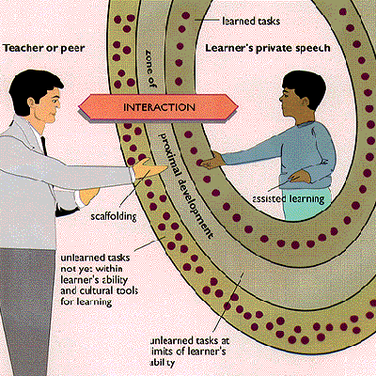

**Figure 1. Picture showing Social Development Theory by Vygotsky**

Source : <https://www.learning-theories.org/doku.php?id=learning_theories:social_development_theory>

Constructivist theory, particularly Bruner’s work, claims that we do not merely receive the information but instead construct knowledge. Learning refers to the direct experience of the active construction of personal knowledge and teaching is not a form of knowledge delivery (Cunningham, 2024). This strategy is demonstrated in performance arts because children make meaning using drama, storytelling, as well as music. Group dynamics are highly influential on the success of learning foreign languages with group environments able to assist or detriment the performance of students (Atmowardoyo & Sakkir, 2021). Performance arts can change group dynamics by reducing anxiety that negatively impacts thinking, particularly among students with motivation challenges. Children are actively involved in developing language skills and this happens through creation and their own performance of the stories as opposed to imitating the teacher models.

The CASEL framework allows the comprehension of social-emotional learning in terms of five interconnected domains catering to the skills, knowledge, attitudes, and behaviours involved in establishing goals, behavioural management, relationship-building, and interpreting information under favourable conditions (Levin & Segev, 2023). The theories of Maslow demonstrate why creativity is critical in learning- the healthiest individuals are the most creative, and when they express their creativity; they feel content and joyful (Teems, 2021). Education is not possible unless the basic needs of children are taken care of such as in terms of safety, love, belonging, and respect. Performance arts help students learn language and build important life skills like confidence, teamwork, and self-control. They use hands-on activities and fun experiences that boost creativity and support overall child growth. This makes using arts in education both smart and effective.

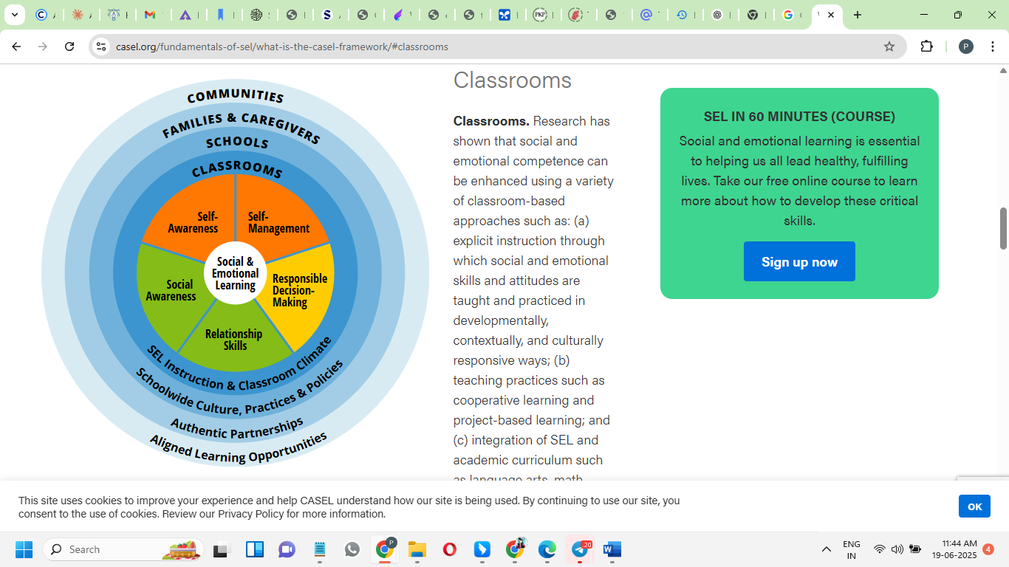

Figure 2. CASEL Framework

Source: <https://casel.org/fundamentals-of-sel/what-is-the-casel-framework/>

## **Language Learning Through Arts**

Performance arts provide language learning through various interrelated approaches that engage different cognitive and developmental processes. Music and rhythm are particularly powerful in language teaching, and research has revealed strong neural connections between music and language processing. Babies naturally perceive word boundaries in speech through rhythm, demonstrating the fundamental connection between rhythm and language comprehension (Pino et al., 2023). This relationship between language and music implies that they evolved together in early human communication development as both music and language use pitch, rhythm, and melody to convey ideas and feelings. These connections make music effective in language teaching because pitch and rhythm sensitivity facilitate grammar development and enhance neural pathways during language study.

Visual arts can assist in language acquisition because both parts of a person’s brain are involved simultaneously: left-brain processing of language and right-brain visual thinking (Marosi, 2021). When children draw story characters and explain them using new words, they form memories comprising both visual information and language information. Like the language symbols, art symbols facilitate naming perceptions and enabling imaginative experiences as well as thinking skills. Fairy tales can be used to tell stories, which present excellent backgrounds to learn natural vocabulary and cultures (Eshkobilova & Ruziyeva, 2025). Fairy tales contain a lot of conversation which expose children to phrases of conversation, formal language, and expressions of emotions in interesting tales. The role-playing allows the students to emulate the role of a fairy tale with a certain vocabulary, and the retelling of stories will contribute to retention and sentence construction.

A performance assessment allows educators to observe the effectiveness of children in using language in real communication when they are required to apply the knowledge and skills of separate fields in solving tasks (Heydarnejad et al., 2022). Recent studies show that students who speak more than one language can do very well in school. Filippi et al. (2024) looked at 3213 pupils and found that at first, multilingual students may find school harder. But by age 16, they do just as well as students who speak only one language. Some who grew up learning multiple languages at the same time even do better than others later. Šifrar Kalan et al. (2024) also found that students who know more languages have better vocabulary, especially for difficult or less common words. These findings show that using things like drama, music, and art in the classroom can really help students who speak many languages. These methods are based on Vygotsky's Social Development Theory, which places importance on the process of social interaction by using cooperative activity. The story of Paimin demonstrates the success of a person by means of performance arts: he succeeded at mastering the English language by audio options like voice recording, copying native speakers, reading aloud, and practising monologues (Atmowardoyo & Sakkir, 2021). Intelligence, motivation, good attitudes, and good teaching made him succeed. Digital storytelling re-invents the old storytelling and combines it with the use of digital technology, such as images, graphics, music, and narrations (Nair & Yunus, 2021). In the process of enhancing English pronunciation and fluency, students use various resources to exercise their voices, identities, and domains.

# **SEL Benefits**

Performance arts not only support language learning but also promote holistic social-emotional development. One of the greatest challenges to second language learning is speaking anxiety, which usually prevents students from participating in communication activities that are necessary in learning a language (Rianti et al., 2022). However, when working collectively on art assignments, children focus on the common artistic project rather than personal anxieties, which decreases tension and encourages spontaneous communication. The collaboration in the form of working in pairs using the arts allows establishing favourable conditions under which students can experiment with language without any fear and thus practice more frequently gaining confidence. Art production in a partnership will enable confidence to take shape gradually and be ready to take higher risks with their language, as well as enhance cooperation and engagement.

Theatre activities are comprehensive platforms for building several skills in social- emotional skills. When students perform in front of audiences, they obtain confidence and self-esteem and learn how to overcome stage fright and take the risk in favourable conditions (Jain & Sharma, 2024). Theatre productions require much teamwork by the cast and the crew members, which also develops a sense of teamwork, cooperation, and respect, whilst teaching empathy and emotional intelligence through multifaceted characters and narratives. Theatre instruction provides interest and curiosity and makes learning engaging since it is a student-based practice. Classroom educators view teaching theatre positively, and understand how it enhances student involvement, comprehension, and retention while improving participation, communication, and confidence.

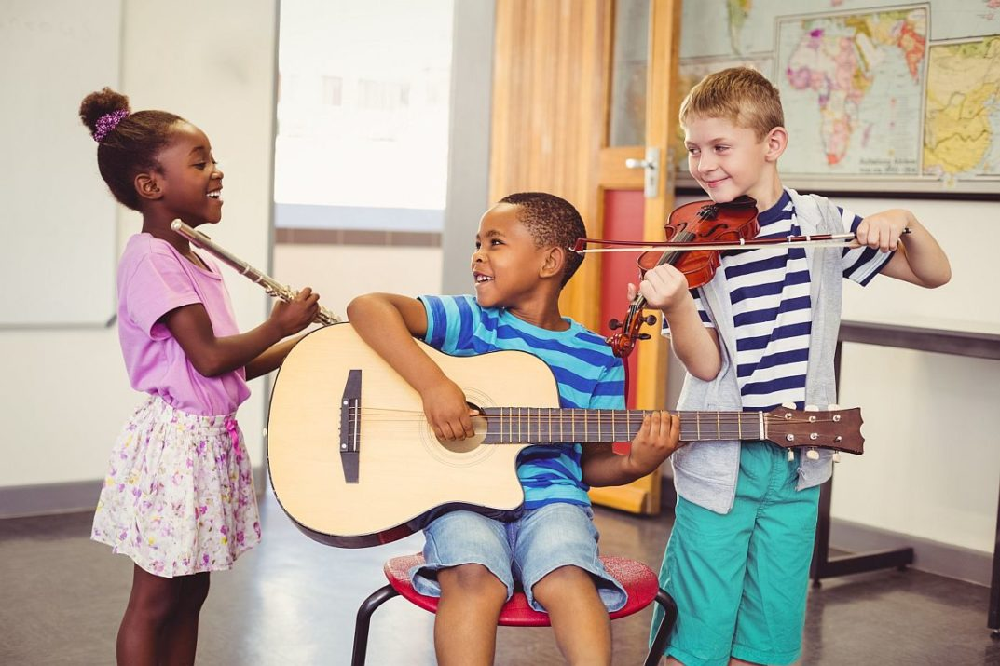

**Figure 3.** Music and Performance Arts Improve Social-Emotional Skills

**Source:** [**https://blog.planbook.com/improve-social-emotional-skills/**](https://blog.planbook.com/improve-social-emotional-skills/)

Cases of public speaking anxiety are common in language learning and the inability to practise English is due to both the language and the non-language factors (Martiningsih et al., 2024). Role-playing helps to build empathy and emotional intelligence because children get a chance to understand various character angles in a simulated way and allow students to build empathy based on the character portrayed in groups (Jannah et al., 2024). Emotion management and appropriate response to interpersonal challenges come into the domain of teaching students, which would be of use in communicating with other cultures and languages. Performance art is inherently able to handle anxiety by use of various techniques such as practice, relaxation and thinking positively, encouraging one another, and acceptance. Drama targets several attributes of student involvement through direct situation-based learning, as drama involves listening, talking, thinking, exploring, and body development (Bessadet, 2022). Learning English through theatre is useful in helping students overcome their fear of expressing themselves and making their active participation in learning stronger.

# **Curriculum Integration Strategies**

Incorporating performance arts in language teaching requires extensive planning to achieve optimal learning outcomes. The puppet storytelling demonstrates the way in which the traditional art of storytelling may be enhanced by using the tools of interactive media to establish the experience to target various goals. Puppets enable children to experience the conflict and emotions of a character without being threatened personally (Syafii et al., 2021). This safety allows for a further exploration of the language without getting bored. This can be implemented in six sessions: three for reading and discussing stories, three for teaching puppet storytelling methods, and three for students’ performance.

The concept of digital storytelling is an upgrade to conventional storytelling for modern learners. It transforms traditional storytelling by integrating digital elements such as author voices, images, graphics, music, and sound (Rahiem, 2021). As much as digital storytelling is emerging globally, the educators in different parts of the world have been implementing it by incorporating technology to take their students through the areas of learning such as speaking skills massively. Educators may change the old way of telling stories by redefining these performances as theatrical performances to attract the learners and encourage their advanced thinking. Dramatic tales among young children are highly effective and enable deeper thoughts as compared to basic instruction. Teachers carefully designed these activities to align with curriculum requirements while selecting familiar programs they can implement effectively.

Play-based learning naturally integrates social-emotional skills into regular lessons as this activity promotes active teacher roles in developing children’s thinking and learning (Larsen et al., 2023). Teachers watch and detect the SEL needs of the children during playtime and on that basis, they come up with the activity which offers them some practice. Evidence of effective integration is the programme by the name Tools of the Mind where dramatic play is facilitated by teachers and results in the enhancement of attention, self-regulation and cooperation, as teachers assist the children develop so-called play plans and take on games that have been designed to help the children establish skills in self-regulation. Including cultural content in community language preservation programs demonstrates effective integration beyond singular purposes (Watimelu, 2024). They are language courses, video-based educational materials, mobile applications, and neighbourhood events through which people encourage each other to use the language.

Cross-cultural views emphasise incorporating the conventional aspects with the new procedures. Local teachers are interested in the links between language development with thinking and interpersonal skills and pay attention to the fact that confident language expression influences the willingness of children to report their needs (Fu et al., 2024). Culture-specific ways of improving language, by means of performance-related activities cross-culturally, are demonstrated in the case of "duikou" (structured dialogue). The use of these strategies demonstrates the ability of performance arts to pay tribute to traditions and have contemporary goals, producing inclusive atmospheres about heritage and developing vital strengths in being a global citizen.

# **Practice-Based Observations**

Real-world experience demonstrates the effectiveness of performance arts. At Wenshang School, organising performances and exhibitions engaged students of various academic years, increased attendance, and enhanced students’ participation. This corroborates studies that demonstrated that the involvement in the arts promotes self-esteem, confidence, and academic grades and creates possibilities of leadership (Teems, 2021). The Years 1–3 multilingual program showed how performance arts can meet different student needs while staying respectful of cultures. Older students helped younger ones learn through cultural activities, improving both their language and leadership skills. In the "Star of Reading" talent show, students used performance to bring old poems to life, showing that traditional literature can be fun and engaging. Success in contests also showed that performing can help students do better in school.

Training provided by Zhongge Arts Group highlighted the effect of progressive performance education on the confidence levels of the learners and their grades. This responded to the research results in relation to the role of music and movement in developing the confidence to speak and integration and communication within the social setting (Wu, 2022). Parent-teacher communication also demonstrated the effectiveness of family involvement for enhancing the performance of students since it forms support networks even outside the classroom. Experience working in Chinese environments suggests that educational processes must balance several aspects: integrating traditional and new strategies, understanding local values, and correlating language with social skills (Fu et al., 2024). This will ensure that education becomes effective and culturally appropriate to various learners.

# **Challenges**

The problem in the implementation of performance arts-integrated language education is serious and requires comprehensive reform. The most important impediment is financial limitations because of lack of funds (Bland, 2024). This issue affects primarily the rural and low-income areas and deprives students of opportunities. Reduced COVID-19 relief funding revealed unreliable financing sources. Both sports and arts programs are weakening, as funding typically favors athletics over arts programs. The preparation of teachers is another complicated matter because teachers have difficulties with teaching several subjects and attaining the skills that are not in the sphere of their main interest (Milara & Orduña, 2024). Teachers face challenges including inadequate planning time and limited resources. Performance arts require teachers to be well trained in the arts as well as pedagogy, which would require an educational change in culture, and curriculum to respect the value of interdisciplinary skills.

The implementation is also limited by systemic barriers, as many teachers consider equity practices as supplementary components of the instruction but not as necessary ones (Peercy et al., 2024). This forms gaps between the research and implementation in schools since the teacher might not be provided with sufficient practical directions. Arts education has certain hurdles associated with it, such as time restrictions and capacity issues (Archibald et al., 2024), and professional artists are concerned about the representation of cultures when these artists do not fall into the same background, which is why cultural competency is an issue, and the framework should be more definite regarding its implementation.

# **Recommendations**

To overcome the problems, significant adjustments are needed such as improvement in professional development, resources, and support of the institutions. It includes more active training and less theory as a source of professional development with references to community language maintenance without relying on the performance arts skills and interdisciplinary learning (Watimelu, 2024). To achieve meaningful classroom changes, teachers need efficient tools and resources, including interactive applications, cultural resources, and videos to apply them to the classroom (Milara & Ordua, 2024). Community learning models can transfer the effect outside the classroom so that people can unite to generate cultural support. Education with the use of performance arts-integrated models can imply the creation of networks of resources, knowledge, and validation. The formations such as awareness campaigns and cultural events are one of the strategies to create support and connect learning at school with community-based actions. Reform must impact the structural blocks and ensure fairness that would ensure that all students enjoy the benefits by advocating critical thinking and teamwork in the areas of fairness, justice, and social issues (Ramirez et al., 2021). It must develop confidence in the students through establishing environments where harmony is respected as the culture of all people. Practice, clear routines, positive relationships, and possibilities to create self-regulation are a must. The resource strategies are supposed to employ long-term solutions to respond to the needs both now and in the future.

# **Conclusion**

The combination of performance arts as a form of language pedagogy addresses both linguistic and social-emotional growth in any context. Convergence theories in Vygotsky, constructivism, Maslow, and CASEL give a scientific foundation to know the effectiveness of the arts in different settings. These insights indicate how performance arts establish the ideal practice in terms of language and development in the form of authentic, engaging, and culturally responsive experiences. The signs have been consistent on how the arts cut across borders and remain effective, evidenced by Paimin’s success and communities’ preservation efforts. Performance arts place children into organic situations in which they learn language but also foster empathy, confidence, collaboration, and cultural awareness to succeed throughout life, whether they use puppets, digital stories, theatre, or music. Practices in Wenshang School, Zhongge Arts Group, and “Star of Reading” have documentation to show quantifiable results such as better attendance, performance, involvement, and associations. These were successful despite the barriers of funding, training, and adoption among others. Based on that, to proceed, systems should accept arts as a language teaching essential in respect to traditions and training students to be global citizens as these may demand applying long-term commitment to reform such as professional development, resource allocations, and policies to achieve responsiveness and fairness.

**Disclaimer (Artificial intelligence)**

**Option 1:**

**Author(s) hereby declare that NO generative AI technologies such as Large Language Models (ChatGPT, COPILOT, etc.) and text-to-image generators have been used during the writing or editing of this manuscript.**

**Option 2:**

**Author(s) hereby declare that generative AI technologies such as Large Language Models, etc. have been used during the writing or editing of manuscripts. This explanation will include the name, version, model, and source of the generative AI technology and as well as all input prompts provided to the generative AI technology**

**Details of the AI usage are given below:**

**1.**

**2.**

**3.**

# **References**

Archibald, M. M., Sharifat Makinde, & Tongo, N. (2024). Arts-Based Approaches to Priority Setting: Current Applications and Future Possibilities. *International Journal of Qualitative Methods*, *23*. <https://journals.sagepub.com/doi/full/10.1177/16094069231223926>

Atmowardoyo, H., & Sakkir, G. (2021, November 30). *The Development of Language Learning Theory Based on Best Practice: A Literature Review*. Www.atlantis-Press.com; Atlantis Press. <https://www.atlantis-press.com/proceedings/icla-21/125964918>

Bessadet, L. (2022). Drama-Based Approach in English Language Teaching. *Arab World English Journal*, *13*(1), 525–533. <https://files.eric.ed.gov/fulltext/EJ1336524.pdf>

Bland, T. (2024). What Determines Investment into Fine Arts Programs in Public High Schools? <https://griffinshare.fontbonne.edu/cgi/viewcontent.cgi?article=1670&context=all-etds>

Burke, R., & Field, R. S. (2023). Arts-Based Approaches to Languages Education with Refugee-Background Learners in the Early Years: Co-Creating Spaces of Hope. *Education Sciences*, *13*(1), 85. <https://doi.org/10.3390/educsci13010085>

Corbisiero-Drakos, L., Reeder, L. K., Ricciardi, L., Zacharia, J., & Harnett, S. (2021). Arts integration and 21st century skills: A study of learners and teachers. *International Journal of Education & the Arts*, *22*(2). <http://www.ijea.org/v22n2/v22n2.pdf>

Cunningham, T. M. D. D. J. (2024). 7. Constructivism: Implications for the Design and Delivery of Instruction. *Accessed: Mar*, *12*. <https://people.potsdam.edu/betrusak/621/Duffy%20and%20Cunningham%20(1996)-constructivism.pdf>

Filippi, R., Ceccolini, A., Perry, R. C., & Thomas, M. S. C. (2024). The impact of multilingualism and socio-economic status on academic performance: evidence from the SCAMP and the national pupil databases. *International Journal of Bilingual Education and Bilingualism*, *28*(1), 1–20. https://doi.org/10.1080/13670050.2024.2397445

Fu, Q., Zhao, F., & Qin, J. (2024). Perspectives on early childhood development in China: key dimensions and contextual contributions. *Frontiers in Psychology*, *15*. <https://doi.org/10.3389/fpsyg.2024.1370641>

Ghani, N., Jamian, A. R., & Jobar, N. A. (2022). The Relationship Between Language Acquisition and Theory of Social Interactionist. *ICCCM Journal of Social Sciences and Humanities*, *1*(4), 54–59. <https://doi.org/10.53797/icccmjssh.v1i4.9.2022>

Heydarnejad, T., Tagavipour, F., Patra, I., & Farid Khafaga, A. (2022). The impacts of performance-based assessment on reading comprehension achievement, academic motivation, foreign language anxiety, and students’ self-efficacy. *Language Testing in Asia*, *12*(1). <https://doi.org/10.1186/s40468-022-00202-4>

Jain, D. K., & Sharma, R. (2024). Examine The Trainee Teachers' Viewpoints Regarding Theater-Based Teaching (TBT). *ShodhKosh: Journal of Visual and Performing Arts*, 675-690. <https://www.researchgate.net/publication/380355395_EXAMINE_THE_TRAINEE_TEACHERS'_VIEWPOINTS_REGARDING_THEATER-BASED_TEACHING_TBT>

Jannah, A. R., Chasanah, I. M., & Musnandar, A. (2024, December). ROLE-PLAY AND SIMULATION METHODS IN STRENGTHENING EMPATHY AND STUDENT LEARNING OUTCOMES: A CASE STUDY OF STUDENTS'MORALS IN ELEMENTARY SCHOOL. In *International Seminar On Islamic Education & Peace* (Vol. 4, pp. 273-284). <https://ejournal.uniramalang.ac.id/isiep/article/view/5971/3569>

Larsen, N., Pyle, A., Danniels, E., Marzouca, M., & Nazeem, R. (2023). Kindergarten teachers’ facilitation of social and emotional learning in classroom play contexts. *Education Inquiry*, 1–22. <https://doi.org/10.1080/20004508.2023.2192900>

Levin, O., & Segev, Y. (2023). The Missing Piece in the CASEL Model: The Impact of Social–Emotional Learning on Online Literature Teaching and Learning. *Education Sciences*, *13*(11), 1123–1123. <https://doi.org/10.3390/educsci13111123>

Šifrar Kalan, Muñoz-Basols, J., Robles-García, P., Strawbridge, T., & Sánchez-Gutiérrez, C. (2024). The impact of multilingualism and proficiency on L2 vocabulary knowledge: contrasting high and low multilinguals. *International Journal of Multilingualism/the International Journal of Multilingualism*, 1–24. https://doi.org/10.1080/14790718.2024.2314626

Marosi, R. (2021). Developing cognitive and language skills through visual arts. *Opus et Educatio*, *8*(1). <https://doi.org/10.3311/ope.420>

Martiningsih, I., Susilawati, E., & Rezeki, Y. S. (2024). Students’ Strategies to Overcome Public Speaking Anxiety. *Inspiring: English Education Journal*, *7*(1), 66–86. <https://doi.org/10.35905/inspiring.v7i1.8766>

Milara, Iván Sánchez, & Orduña, M. C. (2024). *Possibilities and challenges of STEAM pedagogies*. ArXiv.org. <https://arxiv.org/abs/2408.15282>

Nair, V., & Yunus, M. M. (2021). A Systematic Review of Digital Storytelling in Improving Speaking Skills. *Sustainability*, *13*(17), 9829. <https://doi.org/10.3390/su13179829>

Ozoda Eshkobilova, & Sevinch Ruziyeva. (2025). IMPROVING VOCABULARY THROUGH STORYTELLING WITH FAIRY TALES. *Modern Education and Development*, *18*(5), 32–37. <https://scientific-jl.com/mod/article/view/93>

Peercy, M. M., Troyan, F. J., Fredricks, D. E., & Hardy‐Skeberdis, M. (2024). Calling for a Humanizing Turn in Language Teacher Education: Problematizing Content and Language Instruction. *TESOL Quarterly*, *59*(1), 421–447. <https://doi.org/10.1002/tesq.3319>

Pino, M. C., Giancola, M., & D’Amico, S. (2023). The Association between Music and Language in Children: A State-of-the-Art Review. *The Association between Music and Language in Children: A State-of-The-Art Review*, *10*(5), 801–801. <https://doi.org/10.3390/children10050801>

Rahiem, M. D. H. (2021). Storytelling in early childhood education: Time to go digital. *International Journal of Child Care and Education Policy*, *15*(1), 1–20. <https://doi.org/10.1186/s40723-021-00081-x>

Ramirez, T., Brush, K., Raisch, N., Bailey, R., & Jones, S. M. (2021). Equity in Social Emotional Learning Programs: A Content Analysis of Equitable Practices in PreK-5 SEL Programs. *Frontiers in Education*, *6*. <https://doi.org/10.3389/feduc.2021.679467>

Rianti, R., Syahid, A., & Qamariah, Z. (2022). The Effectiveness of Pair Work Activities on Students’ Speaking Anxiety and Speaking Ability. *Jurnal Educatio FKIP UNMA*, *8*(4), 1471–1477. <https://doi.org/10.31949/educatio.v8i4.3760>

Santana, F. D. T., Hartono, H., Narawati, T., Cahyono, A., & Hapidzin, R. I. (2022). Self-Expression Art Education Orientation: Art Education for Early Childhood in the Independent Learning Curriculum. *International Conference on Science, Education, and Technology*, *8*, 683–691. <https://proceeding.unnes.ac.id/ISET/article/view/1822>

Syafii, M. L., Santoso, S., & Hartono, S. (2021). Story-Telling Technique Utilizing Puppets to Enhance the Learners’ Speaking Competence. *International Journal on Social and Education Sciences*, *3*(2), 304–341. <https://eric.ed.gov/?id=EJ1294678>

Teems, H. (2021). The Benefits and Barriers To Arts Integration: Arts Accessibility In Public Montessori. *All Theses and Dissertations*. <https://dune.une.edu/theses/363/>

Tiley, W. (2022). Modern Art in the Language Classroom: Cultivating Interests, Building Confidence. *KOTESOL Proceedings 2022*, 35. <https://www.researchgate.net/publication/365851841_Modern_Art_in_the_Language_Classroom_Cultivating_Interests_Building_Confidence>

Watimelu, W. O. S. (2024). Community-Led Initiatives in Language Preservation: Strategies for Endangered Language Documentation and Revitalization. *LIER: Language Inquiry & Exploration Review*, *1*(1), 1-9. <https://pppii.org/index.php/lier/article/view/10>

Wu, Z. (2022, February 1). *A Review of Drama-based and Music-based Pedagogy in Early Childhood Language Learning and Development*. Www.atlantis-Press.com; Atlantis Press. <https://doi.org/10.2991/assehr.k.220131.129>