**Phosphate Removal from Water: A Comparison of Adsorbents**

**Abstract**

Phosphate contamination in water systems continues to pose serious environmental challenges, primarily due to its role in eutrophication and degradation of aquatic ecosystems. Among the various treatment strategies, adsorption has emerged as an effective and versatile method for phosphate removal, even at low concentrations. This review critically examines the performance, mechanisms, and practical applicability of three promising adsorbents: lanthanum-modified bio-ceramisite (La@BC), layered zinc hydroxide (LZH), and bottom ash (BA)—an industrial by-product. Each adsorbent is evaluated based on its synthesis method, adsorption efficiency, interaction with competing anions, and regeneration potential.

La@BC, synthesized via co-precipitation, exhibits high selectivity for phosphate and strong performance under acidic conditions. LZH, with its high surface area and structural integrity, supports efficient phosphate uptake and recovery from both synthetic and real wastewater. BA, a low-cost material rich in metal oxides, shows considerable adsorption capacity, as confirmed through Langmuir isotherm modeling (Qₒ = 6.522 mg/g; Rₗ = 0.417). Comparative analysis highlights the trade-offs between cost, environmental impact, and operational efficiency.

This review also contrasts these adsorbents with conventional biological and emerging nanomaterial-based treatments, noting that while biological methods offer high removal rates, they require long treatment times and produce excessive sludge. Nanomaterials like nano-alumina offer rapid removal but are expensive and may pose ecological risks. The review concludes by identifying current research gaps and proposing directions for developing scalable, sustainable, and low-cost phosphate removal technologies.

**Keywords:** Phosphate removal, adsorption process, Lanthanum-modified bio-ceramisite (La@BC), Layered zinc hydroxide (LZH), Bottom ash (BA), Adsorption isotherms, Desorption efficiency, Water purification.

Key words :

**1. INTRODUCTION**

The extraction of phosphate from water poses a significant environmental danger since elevated phosphate levels cause pollution, leading to harmful algal blooms, oxygen depletion, and a reduction in aquatic biodiversity. An exhaustive evaluation of the various absorbents employed for eliminating phosphates is the goal of this research., including their modes of action, efficacy, benefits, and drawbacks. The proliferation of plants and algae is dependent upon phosphorus, a vital ingredient. Phosphate ions are present in rocks and minerals, organophosphorus pesticides, domestic wastewater, industrial effluents, and agricultural fertilizer runoff. Phosphate ions enter aquatic systems by soil erosion, rock degradation, and the excretion of animals and wildlife. Unmanaged runoff from farming operations and waste from residential and commercial establishments are the primary contributors to the elevated phosphate levels in water sources. Lanthanum (La) is a rare metal that exhibits chemical stability and is environmentally benign. Significant attention has been devoted to it because of the high binding of La3+ to phosphate.

La can generate a consistently weakly soluble precipitate upon interaction with PO3 [1]. The effectiveness of lanthanum-based adsorbents in removing phosphates from wastewater and avoiding excessive mineral formation in aquatic ecosystems has led to their increased popularity. These adsorbents include zeolite, carbon fiber, mesoporous silica, and lanthanum-modified bentonite [2-6].

In various weather conditions, La-based adsorbents are more effective in eliminating phosphates than Al and Fe elements. [7,8]. It did not have a substantially detrimental impact on people or other species present in the environment [9]. Numerous varieties of stacked sheet-like materials exist. Under this broad heading, Both layered single-metal hydroxides (LSHs) and layered double-metal hydroxides (LDHs) is found under this broad heading.

The latter has two metal cations embedded within its host layer. Natural crystal brucite is an architectural inspiration for LMHs. It is composed of layers of metal hydroxyls interspersed with anions that balance the charges. The simplicity of LMHs in terms of creation, modification, and organization has led to their meteoric rise in popularity over the last decade [10]. Because of their malleability, they find use in a wide variety of products, including those that prevent fires, thin film electronics, energy storage and conversion, catalysis, magnetism, and adsorption/ion exchange [10, 11].

As an intercalated ion like sulfate, carbonate, nitrate, or carboxylate, the formula is Zn5(OH)8(A)2$nH2O [12]. In its entirety, the structure is made up of zinc hydroxide layers that contain zinc ions arranged in octahedral and tetrahedral patterns [13]. To counteract the laminates' positive charge, the interlayer anions are exchangeable anions. For this reason, LZHs are very good in exchanging anions [13,14]. With the addition of Zn and other metals, LZHs may be transformed into LDH salts; they are easy to synthesis, have a higher anion-exchange capacity than LDHs, and [15]. Bottom ash, or BA, mostly consists of solid and non-combustible particles that remain at the base of the combustion chamber due to their weight and size. Despite the abundance of iron and aluminum oxides in BA, the majority is relegated to landfills, incurring substantial expenses in terms of land use and transportation [16,17].

Owing to its advantageous chemical composition and accessibility, BA has been attempted to be recycled in some contexts, such as the concrete industry [18,19]. Nonetheless, pure BA in power plants has not yet been used for water purification. Little is known about the efficacy of BA Nano powder for water purification. Additionally, the production of nano powders is prohibitively costly and presents safety concerns, rendering them applicable in only a few scenarios. BA served as an economical phosphate adsorbent for our study. Two significant considerations justify the selection of the BA in this context: Initially, the BA had a considerable capacity for phosphate absorption due to its high content of iron and aluminum oxides, as shown in the study's findings [20,21]. **Figure-1 and** **Figure-2 shows the** phosphorus Cycle Illustrating Transport and Algal bloom

Furthermore, the BA is an industrial byproduct detrimental to the environment, often necessitating costly operational strategies [22-26]. Utilizing this waste product for water treatment is advantageous for both the environment and the economy. The primary objectives of this study are to (1) perform an extensive characterization of an anion removal adsorbent utilizing diverse characterization techniques; (2) investigate the adsorption efficacy of phosphate using artificial water, including deposition rates, the effect of acidity, isotherms during desorption, and the impact of co-existing ions; (3) evaluate various phosphate removal techniques and methodologies; and (4) propose potential mechanisms for phosphate removal. This paper will discuss several phosphate-based adsorbents.



**Figure-1:** Phosphorus Cycle Illustrating Transport (Input and Uptake) Between Terrestrial and Aquatic Ecosystems [10].

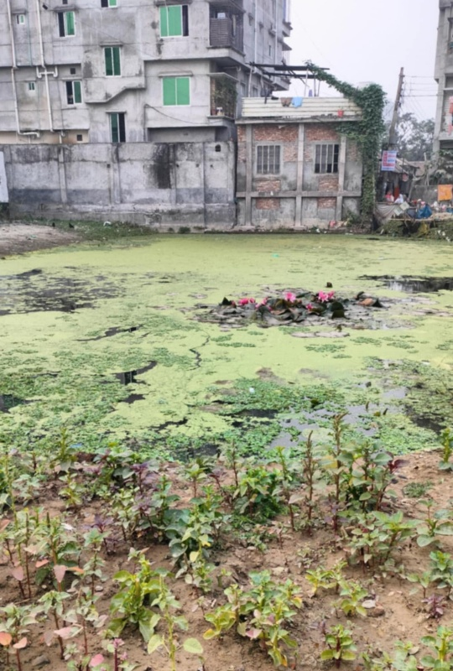

**Figure-2:** Algal bloom, caused by phosphorus pollution of water.

**2. MATERIALS & METHODS**

**2.1 Materials**  
Biochar is a solid material which is generated through the pyrolysis of sewage sludge. The process involves the use of zinc acetate (Zn(OAc)2) and sodium hydroxide (NaOH).

**2.2 Adhesion of La-modified granular adsorbent (La@BC)**

**(1) Formulation of Granular Bio-Ceramisite (BC):** Here, an assortment of biochar fly ash (100 g, in a 2:8 mass ratio) was used to form approximately spherical pellets which have a diameter of 8-12 mm. This was achieved by adding 80mL of distilled water and granulating the mixture. The pellets were made moisture less at 105ºC in an oven until a constant weight was reached. Subsequently, the dried pellets were fired at 1100ºC for 30 minutes in a laboratory-scale electric furnace, resulting in the formation of BCs [27].

**(2) Adhesion of La@BC:** La@BC adsorbents were synthesized through a co-precipitation method. To prepare a 2 wt% La solution, 5.347 g of LaCl₃·7H₂O (analytical grade) was dissolved in 100 mL of distilled water in a 200 mL beaker. Subsequently, 100 g of BCs were soaked in the LaCl₃ solution and stirred continuously at 120 rpm for 4 hours. Subsequently, a NaOH solution (0.1 mol/L) was gradually added to the mixture to adjust the pH to 10. The solution was stirred for an additional 2 hours, after which the modified La(OH)­3 products were rinsed with distilled water until no chloride ions were detected (confirmed by the AgNO3 titration method). Finally, the material was dried at 60ºC for 4 hours and then heated at 300ºC for 30 minutes in an electric furnace to produce the La@BC adsorbents [28-32].

**2.3 Synthesis of LZH (Layered zinc hydroxide)**

LZHs were synthesized via a precipitation process using zinc acetate and NaOH. A solution of zinc acetate (20 g in 600 mL deionized water) was mixed with a NaOH solution (5g in 100 mL deionized water) and added dropwise until the pH stabilized at 7. The mixture was stirred at 45ºC and 400 rpm for 24 hours. The obtained slurry passed through a 0.45 mm filter, thoroughly washed with deionized water, and dried at 90°C [33-35].

**2.4. Batch Experiments**

Within this study, reagents were of analytical grade. The preparation of Phosphate stock solutions with 1g P/L was done by using KH2PO4 and distilled water and as well as the working solutions of varying phosphate concentrations were obtained via dilution. Initial pH adjustments were made with 0.1 mol/L HCL or NaOH. The residual phosphate concentrations in the solutions were analyzed using the ammonium molybdate spectrometric method. Batch experiments were conducted in triplicate to ensure accuracy and reliability. The reusability of La@BC for phosphate removal was examined through five sequential adsorption-desorption cycles. Given the strong dependence of desorption efficiency on pH, a 1 mol/L NaOH solution was utilized as the regenerating agent.

Collection of La@BC adsorbents

The sample was transferred to a 200 mL Erlenmeyer flask containing 100 mL of NaOH regenerant and stirred continuously at 120 rpm / 350 rpm24h

The reusable adsorbents were regenerated. Constant stirring of 120 rpm/350rpm 24h

**Figure-3:** Flow chart about phosphate removal by Batch process using La@BC adsorbents

0.5 g L1 adsorbent +5 mg L1 phosphate solution

pH was modified using 0.1–1 mg L1 HCl or NaOH solutions.

transferred in polyethylene centrifuge tubes as well as shaken at a rate of 350 rpm using a mechanical shaker table.

**Figure-4:** Flow chart about phosphate removal by Batch process using LZH adsorbents

Mixing of the BA, along with phosphate-humic acid solution at diverse ratios (40 to 60 g/L)

Shaking, using a bench-top shaking incubator 100 rpm speed 24hours.

Measuring phosphate concentration by filtering

**Figure-5:** Flow chart about phosphate removal by Batch process using BA adsorbents.

The effects of contact time, pH, phosphate concentration, and other ions on the adsorption process has been studied. All the experiments were conducted at room temperature and repeated twice to get reliable results. For the initial tests, different amounts of LZH, from 0.5 to 200 g/L has been tried. Based on the findings, a dosage of 0.5 g/L was determined to offer the optimal balance between effectiveness and cost; therefore, this concentration was used in all subsequent experiments. Core-level spectra were recorded and energy positions were calibrated using a standard C–C signal for accurate analysis. The measurement of the zeta potential of the material with a Malvern Zetasizer Ultra, and for phosphate and other anions has also been done, a Dionex Ion Chromatography System was used. The effect of pH by varying it between 3 and 10 was tested and once the ideal pH of 7 was found, the experiment moved on to experiments with phosphate density varying between 0.5 mg/L to 1000 mg/L. The phosphate solution was made by dissolving potassium monobasic phosphate in deionized water. Humic acid in concentrations between 10 and 50 mg/L, using its sodium salt form as the competing ion was also added. For every analysis, the phosphate-humic acid solution with BA adsorbent in different ratios (40–60 g/L) was mixed. These mixtures were shaken for 24 hours in a shaker at 100 rpm. Afterward, the solutions were processed through a 0.45 μm filter, and measured the phosphate levels with a spectrophotometer using standard phosphate tests. Humic acid concentration in the range of 0–50 mg/L was determined using a calibration curve.

Here the following equations have been used to determine the qt, at a specific time t, adsorption capacity as well as the percent removal of phosphate.

|  |
| --- |
| Where,  Ct= equilibrium phosphate concentrations (mg/L),  Co­= initial phosphate concentrations (mg/L),  V= volume of the solution (L) |

$q_{t}=\frac{\left(C_{o}-C_{t}\right)V}{W}$--------------- (1)

% removal= × 100% -------------- (2)

* 1. **Characterization**

The surface and elements of the samples were studied through the use of Scanning Electron Microscopy (SEM) along with Energy-dispersive X-ray spectroscopy (EDX). Potentiometric titration was done to serve the purpose of zero charge (pHzpc) of the adsorbent.

* 1. **Adsorption Isotherm**

The balance between adsorbed phosphate and residual concentration at equilibrium is crucial for understanding adsorption efficiency. To evaluate this, adsorption isotherm models are commonly used. In this study, the Langmuir model was selected due to its strong theoretical basis and widespread acceptance in adsorption research. It assumes monolayer adsorption on a homogeneous surface, which aligns well with the characteristics of the adsorbents used. The model also provides key parameters such as maximum adsorption capacity (qₘ) and binding affinity (Kₗ). These parameters allow for quantitative comparison between adsorbents. Overall, the Langmuir model offers clear insights into adsorption performance and potential scalability. One of these parameters is the separation factor (Rᵥ), which can be calculated with the following equations. This factor shows how well the adsorbent and adsorbate interact. If Rᵥ is over 1, the adsorption isn’t favorable. When it’s exactly 1, the process is linear. If it falls between 0 and 1, it’s favorable, and when it hits 0, it’s irreversible.

|  |
| --- |
| Where,  Qo= theoretical mono-layer adsorption (mg/g),  b= the energy of adsorption (L/mg) |

$$\frac{C_{e}}{q_{e}}= \frac{1}{Q_{o}×b}+ \frac{C_{e}}{Q_{o}}$$

$$R_{L}=\frac{1}{1+b×C_{i}}$$

From the Langmuir model plot ( $\frac{C_{e}}{q_{e}}$ versus Ce), the values for Qo​ and b are determined; where the slope and intercept provide these parameters. In the current investigation, by combining 100 mL of phosphate solution with different amounts of BA (ranging from 1.5 to 6.5 g/L) in sealed containers, the Langmuir model was examined. These mixtures were agitated at 100 rpm for 24 hours to reach equilibrium. The data collected was then used to create the plot and calculate RL.

**3. RESULTS AND DISCUSSION**

**3.1 Batch experiments**

It is common practice to test many solutions' bonding behavior and stability in a single batch exposure experiment. It involves adding a known amount of sample to a set amount of liquid with a certain quantity.

**3.2 Adsorption Isotherm:**

In order to determine the effect of beginning phosphate level on the binding capabilities of Lanthanum modified granular bio-ceramicist, we conducted isotherm tests with liquids containing varied amounts of phosphate ranging from 1 to 100 mg P/L.

Figure 6 shows that the capacity of lanthanum-modified granular bio-ceramicists to take in phosphate increased rapidly from 1 mg P/L to 10 mg P/L, after which it remained constant from 10 mg P/L to 50 mg P/L. Compared to the Freundlich model, which failed to adequately describe the adsorption process, the Langmuir model performed better in terms of regression (R2 =0.987). The surface of the granular bio-ceramicist treated with lanthanum underwent a monolayer adsorption process. Additionally, the Langmuir model demonstrated that lanthanum-modified granular bio-ceramicist adheres very well to phosphate. The greatest adsorption capacity of 2.719 mg P/g is somewhat lower than other La-based adsorbents, according to the Langmuir model. The most important factor is that our 2% concentration of La modification agent was much lower compared to previous La-changed materials. This is in contrast to the 10–70% that have been reported. Since there were fewer La ions accessible, the adsorption capacity of the lanthanum-modified granular bio-ceramicist adsorbent was reduced. Lanthanum-modified granular bio-ceramicist outperformed other La-based adsorbents in terms of removal capacity (136 mg P/g La) when adsorbent capacities were calculated according to La concentration. To circumvent the major issues that powder adsorbents encounter while attempting to separate solids and liquids, the grainy lanthanum-modified granular bio-ceramicist adsorbent is superior at removing substances and separating liquids and solids.

**Figure 6:** Adsorption isotherms of phosphate onto La@BC

(Initial phosphate concentrations: 1–100 mg P/L; adsorbent dose: 20 g/L; pH: 7.0 ± 0.2; contact time: 24 h).

Adsorption isotherms of phosphate on LZH are shown in Figure 7

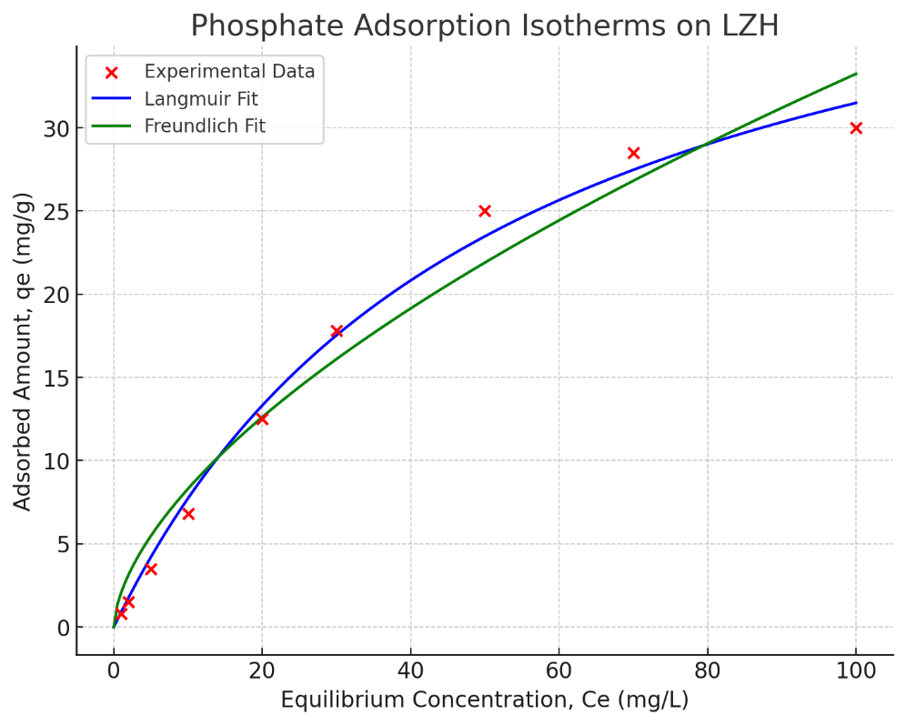

Figure 7: Phosphate Adsorption isotherms on LZH.

Based on the findings, it was found that the Freundlich model (R² = 0.983) was more accurate in representing the isotherm data than the Langmuir model (R² = 0.938). This indicates that, instead of a single homogeneous layer, phosphate adsorption onto LZH is probably the result of multilayer interactions at diverse active sites. Also, once the first monolayer was formed, the electrostatic interactions between the negatively charged phosphate species and the LZH surface were less important in the adsorption process, according to the results.   
Phosphate adsorption seems to have permeated the interstices between the layers of the structure, suggesting that it went beyond the surface itself. The synthesized LZH stood out from other adsorbents described in the literature due to its much greater phosphate adsorption capability. It also has other advantages, such as working well at room temperature, with a reduced amount of adsorbent, and in settings of neutral pH.

Table 1 summarizes the model parameters and Pearson coefficients for the adsorption isotherm that were derived by fitting the experimental data to the Freundlich and Langmuir models.

The characteristics of the Freundlich and Langmuir isotherms for phosphate adsorption on LZH are recorded in Table 1.

Table 1: The recorded characteristics of the Freundlich and Langmuir isotherms for phosphate adsorption on LZH

|  |  |
| --- | --- |
| **Equilibrium Adsorption Models** | **LZH** |
| **Langmuir** |  |
| *Xm(mg.g-1)* | 135.4 |
| *b* | 0.0175 |
| *R2* | 0.938 |
| **Equilibrium Adsorption Models** | **LZH** |
| **Freundlich** |  |
| *Kf (mg/g(dm3/g-1) n)* | 18.19 |
| *1/n* | 0.299 |
| *R2* | 0.983 |

As highlighted earlier, a key aspect of adsorption studies involves examining the relationship between the concentration of the adsorbed and aqueous phases. In this study, the Langmuir model was applied to explore this relationship for phosphate adsorption. To further evaluate the interaction between phosphate and BA particles, the separation factor was calculated. A plot of Ce/qe vs Ce was used to estimate the Langmuir isotherm constants, Qo and bb. This process is shown in Figure 8.

Figure 8: Langmuir isotherm for phosphate adsorption on BA particles.

Phosphate adsorption parameters were determined using the Langmuir isotherm model. The maximum adsorption capacity (Qₒ) was found to be 6.522 mg/g, and the Langmuir constant (b) was 0.14 L/mg. The separation factor (Rₗ) for the BA particles was calculated as 0.417, using Equation (8), indicating favorable adsorption. These results confirm that phosphate adsorption onto BA particles was effective and promising. The findings suggest that this method offers significant advantages over many traditional phosphate removal techniques: it requires shorter treatment times, generates minimal sludge, utilizes industrial waste in an eco-friendly manner, and conserves natural resources.

Biological reactors are among the most widely used methods for phosphate removal, achieving efficiencies up to 99%. However, these biological systems require long treatment durations and produce large volumes of water-laden sludge, which demands costly handling and disposal processes. Additionally, they require continuous monitoring to maintain microbial activity and prevent system failure. In contrast, recent studies have explored advanced materials like nano-alumina for rapid and efficient phosphate removal. While nanomaterials show high removal efficiencies, their high cost and potential environmental risks—such as the release of nanoparticles into treated water—pose significant challenges to their widespread adoption. Therefore, low-cost adsorbents like BA present a more sustainable and practical alternative for phosphate remediation.

**4. CONCLUSION**

A co-precipitation method was employed to synthesize a novel spherical adsorbent known as lanthanum-modified granular bio-ceramisite (La@BC). La@BC demonstrated excellent phosphate (PO₄³⁻) removal efficiency, even under acidic conditions, and its fine particle size allowed for effective solid–liquid separation. Compared to powdered adsorbents, the granular form showed superior performance in phosphate elimination. The presence of competing anions such as Cl⁻, NO₃⁻, HCO₃⁻, and SO₄²⁻ had no significant effect on phosphate removal, indicating La@BC's high selectivity for PO₄³⁻.

Layered zinc hydroxide (LZH) was also synthesized using a simple co-precipitation technique, which enabled scalable production. LZH exhibited high phosphate adsorption capacity in both synthetic solutions and real treated sewage effluent. Structural analysis before and after phosphate adsorption and recovery confirmed that phosphate could be efficiently adsorbed and desorbed while maintaining LZH’s structural integrity. This makes LZH a promising candidate for phosphate removal and recovery from wastewater.

In parallel, industrial by-product bottom ash (BA) from power plants was evaluated as a low-cost adsorbent. Initial characterization revealed significant concentrations of Fe, Al, and Mn oxides, contributing to phosphate removal capacity. Batch adsorption experiments under various conditions demonstrated that BA performed best in acidic environments with higher dosages and moderate temperatures (up to 35 °C). The adsorption behavior was well described by the Langmuir isotherm model, indicating a strong affinity between phosphate ions and the active sites on BA particles. Overall, this study highlights the potential of La@BC, LZH, and BA as effective adsorbents for phosphate removal and recovery from water and wastewater systems.

**Data availability:** The authors declare that the data supporting the findings of this study are available within the article. No new data were generated during the study.

Disclaimer (Artificial intelligence)

Author(s) hereby declare that NO generative AI technologies such as Large Language Models (ChatGPT, COPILOT, etc.) and text-to-image generators have been used during the writing or editing of this manuscript.

**References:**

[1] P. Koilraj, K. Sasaki (2017). Selective removal of phosphate using La-porous carbon composites from aqueous solutions: batch and column studies. Chem. Eng. J. 317, 1059–1068 DOI: <https://doi.org/10.1016/j.cej.2017.02.075>.

[2] D.D. Lucena-Silva, J. Molozzi, J.D.S. Severiano, V. Becker, J.E.D. Lucena Barbosa (2019). Removal efficiency of phosphorus, cyanobacteria and cyanotoxins by the “flock & sink” mitigation technique in semi-arid eutrophic waters. Water Res. 159, 262–273 DOI: <https://doi.org/10.1016/j.watres.2019.04.057>.

[3] M. Slaný, ˇL. Jankoviˇc, J. Madejov ́(2019), Structural characterization of organo-montmorillonites prepared from a series of primary alkylamines salts: mid-IR and near-IR study. Appl. Clay Sci. 176, 11–20

DOI: <https://doi.org/10.1016/j>.

[4] W. Shi, Y. Fu, W. Jiang, Y. Ye, J. Kang, D. Liu, Y. Ren, D. Li, C. Luo, Z. Xu (2019) Enhanced phosphate removal by zeolite loaded with Mg-Al-La ternary (hydr)oxides from aqueous solutions: performance and mechanism, Chem. Eng. J. 357 (2019) 33–44, <https://doi.org/10.1016/j.cej.2018.08.003>.

[5] W. Xia, L. Guo, L. Yu, Q. Zhang, J. Xiong, X. Zhu, X. Wang, B. Huang, R. Jin (2021). Phosphorus removal from diluted wastewaters using a La/C nanocomposite-doped membrane with adsorption-filtration dual functions, Chem. Eng. J. 405, DOI: <https://doi.org/10.1016/j.cej.2020.126924>.

[6] L. Chen, Y. Li, Y. Sun, Y. Chen, J. Qian (2019). La(OH)3 loaded magnetic mesoporous nanospheres with highly efficient phosphate removal properties and superior pH stability. Chem. Eng. J. 360, 342–348. DOI: <https://doi.org/10.1016/j.cej.2018.11.234>.

[7] X. Li, J. Chen, Z. Zhang, Y. Kuang, R. Yang, D. Wu (2020). Interactions of phosphate and dissolved organic carbon with lanthanum modified bentonite: Implications for the inactivation of phosphorus in lakes, Water Res. 181. DOI: <https://doi.org/10.1016/j.watres.2020.115941>.

[8] S. Dong, Y. Wang, Y. Zhao, X. Zhou, H. Zheng (2017). La3+/La(OH)3 loaded magnetic cationic hydrogel composites for phosphate removal: Effect of lanthanum species and mechanistic study, Water Res. 126, 433–441 DOI: <https://doi.org/10.1016/j.watres.2017.09.050>.

[9] P.C. D’Haese, G. Douglas, A. Verhulst, E. Neven, G.J. Behets, B.A. Vervaet, K. Finsterle, M. Lürling, B. Spears (2019). Human health risk associated with the management of phosphorus in freshwaters using lanthanum and aluminium. Chemosphere 220,286–299, DOI: <https://doi.org/10.1016/j.chemosphere.2018.12.093>.

## [10] H. Yin and Z. Tang (2016). Ultrathin two-dimensional layered metal hydroxides: an emerging platform for advanced catalysis, energy conversion, and storage. Chemical Society Reviews, 45, 4873–4891. DOI: <https://doi.org/10.1039/C6CS00343E>

## [11] G. Rogez, C. Massobrio, P. Rabu and M. Drillon (2011). Layered hydroxide hybrid nanostructures: a route to multifunctionality. Chemical Society Reviews, 40, 1031–1058. DOI: <https://doi.org/10.1039/C0CS00159G>

## [12] A. H. Leung, S. D. Pike, A. J. Clancy, H. C. Yau, W. J. Lee, K. L. Orchard, M. S. Shaffer and C. K. Williams (2018). Layered zinc hydroxide monolayers by hydrolysis of organozincs. Chem. Sci., 9, 2135–2146. DOI: <https://doi.org/10.1039/C7SC04256F>

## [13] (a) A. Gordeeva, Y.-J. Hsu, I. Z. Jenei, P. H. Brant Carvalho, S. I. Simak, O. Andersson and U. H ̈aussermann, Layered Zinc Hydroxide Dihydrate, Zn5(OH)10·2H2O, from Hydrothermal Conversion of ε-Zn(OH)2 at Gigapascal Pressures and its Transformation to Nanocrystalline ZnO (2020). ACS Omega, 5, 17617–17627;

## DOI: <https://doi.org/10.1021/acsomega.0c02075>

## (b) T. Shinagawa, M. Watanabe, T. Mori, J.-i. Tani, M. Chigane and M. Izaki, Inorg (2018). Oriented Transformation from Layered Zinc Hydroxides to Nanoporous ZnO: A Comparative Study of Different Anion Types. Inorganic Chemistry, 57, 13137–13149.

## DOI: <https://doi.org/10.1021/acs.inorgchem.8b01242>

## [14] (a) H. N. Tran, C.-C. Lin and H.-P. Chao (2018). Amino acids-intercalated Mg/Al layered double hydroxides as dual-electronic adsorbent for effective removal of cationic and oxyanionic metal ions, Seperation and Purification Technology, 192, 36–45;

## DOI: <https://doi.org/10.1016/j.seppur.2017.09.060>

## (b) J. Miao, M. Xue, H. Itoh and Q. Feng (2006). Hydrothermal synthesis of layered hydroxide zinc benzoate compounds and their exfoliation reactions. Journal of Materials Chemistry, 16, 474–480. DOI: <https://doi.org/10.1039/B511110B>

## [15] Hore, R., Hossain, M.Z., Hore, S. et al. A Comparative Seismic Study of Wrap-Faced Retaining Wall Embankment Using Sands of Bangladesh. Iran J Sci Technol Trans Civ Eng (2024). https://doi.org/10.1007/s40996-024-01600-9.

[16] Kirk, D. W., Jia, C. Q., Yan, J. & A. L Torrenueva (2003). Wastewater remediation using coal ash. Integrated Management of Hazardous Waste 5. DOI: [10.1007/s101630300001](http://dx.doi.org/10.1007/s101630300001)

[17] Hjelmar, O., Johnson, A. & Comans (2010). Incineration: Solid Residues. In: Solid Waste Technology and Management, Volume 1 and 2 (T. H. Christensen, ed.).

DOI: <https://www.researchgate.net/publication/230532051_Incineration_Solid_Residues>

[18] Zhang, B. & Poon, C. S. (2015) Use of furnace bottom ash for producing lightweight aggregate concrete with thermal insulation properties. Journal of Cleaner Production 99, 94–100. DOI: <https://doi.org/10.1016/j.jclepro.2015.03.007>

[19] Shubbar, A. A., Jafer, H., Dulaimi, A., Hashim, K., Atherton, W. & Sadique, M (2018). The development of a low carbon binder produced from the ternary blending of cement, ground granulated blast furnace slag and high calcium fly ash: an experimental and statistical approach. Construction and Building Materials 187, 1051–1060. DOI: <https://doi.org/10.1016/j.conbuildmat.2018.08.021>

[20] Alwash, R. S. M (2017). Treatment of Highly Polluted Water with Phosphate Using BAPPP-Nanoparticles. MSc thesis, Environmental Engineering, University of Technology, Iraq, Baghdad, Iraq.

[21] Tyagi, S., Rawtani, D., Khatri, N. & Tharmavaram, M (2018). Strategies for nitrate removal from aqueous environment using nanotechnology: a review. Journal of Water Process Engineering 21, 84–95 DOI: <https://doi.org/10.1016/j.jwpe.2017.12.005>

[22] Jamaludin, S. S., Rani, N. A. & Mohamad, N (2019). Investigation of water absorption and strength performances on concrete bricks containing Malaysian thermal power plant coal bottom ash (CBA). Journal of Physics: Conference Series, IOP Publishing 1349, 1–6 DOI: 10.1088/1742-6596/1349/1/012107

[23 ] Hore, S. Assessment of soil chemical characteristics in the context of Bangladesh: A comprehensive review, Community and Ecology, 2(1), 2024.

[24] Hasan, M.M., Hore, S., Al Alim, M. et al. Numerical modeling of seismic soil-pile-structure interaction (SSPSI) effects on tall buildings with pile mat foundation. Arab J Geosci 18, 10 (2025). <https://doi.org/10.1007/s12517-024-12155-4>

[25] Kumar, S., Kaushik, G., Dar, M. A., Nimesh, S., Lopez-Chuken, U. J. & Villarreal-Chiu, J. F (2018). Microbial degradation of organophosphate pesticides: a review. Pedosphere 28, 190–208. DOI: <https://doi.org/10.1016/S1002-0160(18)60017-7>

[26] Samreen, S. & Kausar, S (2019). Phosphorus fertilizer: the original and commercial sources. In: Phosphorus-Recovery and Recycling (H. Ohtake, & S. Tsuneda, eds.). Springer, Singapore, pp. 1–14. DOI: <https://www.intechopen.com/chapters/64614>

[27] Md Monir Hossain, Md Tanvir Hasan, Shoma Hore, Ripon Hore, Stability analysis of rainfall-induced landslides: A case study of a hilly area in Bangladesh, Earthquake, vol1, no, 1, 2023.

[28] Reddy, S., Nagaraddy, N., Ramesh Bashetty, D. & Mise, S. R (2020). Adsorption of phosphate using laterite soil, black cotton soil and fuller’s earth as adsorbents. International Research Journal of Engineering and Technology (IRJET) 07 (08), 5091–5095. DOI: <https://www.irjet.net/archives/V7/i8/IRJET-V7I8871.pdf>

[29] Shoma Hore. (2023). Review of Phosphate Removal From Water by Various Sorbents. Web of Technology: Multidimensional Research Journal, 1(1), 15–24.

[30] Curran, D. T. (2015). Phosphate Removal and Recovery From Wastewater by Natural Materials for Ecologically Engineered Wastewater Treatment Systems. Graduate College Dissertations and Theses. DOI: <https://scholarworks.uvm.edu/graddis/455>

[31] Mosharof Al Alim, Shoma Hore, Fatematuz Zohora, Dipankar Ghosh, Ripon Hore. (2025). Advances in Smart Polymeric Materials for Sustainable and Next-generation Applications. Civil Engineering & Building Science, 2(1), 1-8.

[32] Almanassra, I. W., Kochkodan, V., Mckay, G., Atieh, M. A. & Al-Ansari, T. (2021). A Review of phosphate removal from water by carbonaceous sorbents. Journal of Environmental Management 287, 112245. DOI: <https://doi.org/10.1016/j.jenvman.2021.112245>

[33] Ownby, M., Desrosiers, D. A. & Vaneeckhaute, C (2021). Phosphorus removal and recovery from wastewater via hybrid ion exchange nanotechnology: a study on sustainable regeneration chemistries. Clean Water 4, 1–8.

DOI: [10.1038/s41545-020-00097-9](http://dx.doi.org/10.1038/s41545-020-00097-9)

[34] Hossain, M., Hasan, T., Hore, S. et al. Integrating unsaturated soil mechanics for sustainable landslide mitigation strategies. Arab J Geosci 18, 114 (2025). <https://doi.org/10.1007/s12517-025-12259-5>

[35] Mu D, Ruan R, Addy M, Mack S, Chen P, Zhou Y. (2017). Life cycle assessment and nutrient analysis of various processing pathways in algal biofuel production. Bioresour Technol. 230:33-42. DOI: <https://doi.org/10.1016/j.biortech.2016.12.108>