***Original Research Article***

**Characterization and Resource Potential of Household Solid Waste in Dhaka, Bangladesh: A Pathway to 3R Optimization and Sustainable Energy Recovery**

**ABSTRACT**

In the face of rapid urbanization and escalating environmental challenges, effective household solid waste (HSW) management has become a critical priority for climate-vulnerable megacities such as Dhaka, Bangladesh. This research presents a comprehensive characterization of HSW generated across diverse socio-economic zones in Dhaka, aiming to assess its composition, quantify its energy potential, and identify scalable pathways for 3R (Reduce, Reuse, Recycle) optimization and sustainable energy recovery. Employing a stratified sampling framework, household waste samples were collected and analyzed from high-, middle-, and low-income communities across both Dhaka North and South City Corporations. Complementary qualitative data were gathered through semi-structured interviews with key stakeholders, including municipal officials, waste workers, and informal recyclers, to triangulate findings and inform context-responsive recommendations. The compositional analysis revealed that biodegradable and organic waste accounted for approximately 69.1% of the total waste stream, followed by plastics (11.3%), paper (7.4%), metals (1.5%), and inert materials (10.7%). Proximate and ultimate analyses confirmed that the calorific value of the combustible fraction averaged 3,850–4,400 kcal/kg, indicating significant energy recovery potential via thermal or bioenergy routes. However, high moisture content in biodegradable fractions necessitates pre-treatment or segregation strategies to enhance processing efficiency. The findings underscore both the environmental burden and the latent resource potential embedded within Dhaka's HSW. Spatial and socio-economic disparities in waste generation patterns highlight the need for decentralized and equity-focused 3R frameworks. Integrating community-based sorting mechanisms, digital monitoring systems, and AI-enhanced material recovery could substantially boost recycling rates and reduce landfill dependency. The study proposes a multi-tiered intervention model combining behavioral change, policy incentives, and technology-enabled waste valorization, aligning with national circular economy goals and international climate resilience agendas. This research provides actionable insights for policymakers, municipal planners, and development agencies seeking to transition Dhaka toward a circular and low-carbon waste economy. It also establishes a replicable methodology for waste characterization in other Global South megacities grappling with similar sustainability challenges.

**KEYWORDS**

3R Hierarchy, Bangladesh, Dhaka City, Energy Recovery Potential, Household Solid Waste Management (HSWM), Integrated Waste Management, Solid Waste Management, Urban Waste Management, Waste Composition, Waste Valorization.

**INTRODUCTION**

Waste is created by a variety of human endeavors, including urbanization, industrialization, and the raising of living standards. A major obstacle to sustainable growth is the rapid increase in urban population and industrialization, which is seriously taxing our natural resources (Samiul, 2023). One obvious factor contributing to the environmental degradation of most cities is the careless handling and disposal of waste. Dhaka's municipal corporation is working to address this issue, but they are unable to regulate waste management (Islam, 2025). Three thousand tons of household trash are produced daily in Dhaka (Ahmed and Rownok, 2006). However, Dhaka also generates more waste in a variety of ways, including hospitals, tanneries, small businesses, and other heavy industries. Bangladesh is the twelfth most densely inhabited country in the world and the ninth most populous. Specifically, the urban population is expected to rise at a rate of 3% between 2010 and 2015. A UNFPA report claims that Dhaka is currently among the most polluted cities in the world, with municipal waste management being one of the problems. Dhaka Metropolitan's population was 6,487,459 in 1991, 9,672,763 in 2001, and 14,543,124 in 2011, according to the Bangladesh Bureau of Statistics. Rapid industry growth, a lack of funding, a shortage of skilled labor, outdated technology, and a lack of community awareness are the main obstacles to solid waste management in Dhaka, a rapidly expanding metropolis. Since the municipality has historically received funding for solid waste services from the municipal tax system for waste collection and disposal, the logical needs of city people are a healthier lifestyle, a cleaner city, and a better environment. It has been extremely challenging for the municipality to guarantee the effective and suitable provision of solid waste collection and disposal services to the whole population because of a lack of funding and organizational capability. The majority of people don't care about waste management. Mismanagement of waste is largely caused by this. Household rubbish is dumped on the sides of the highways and in open spaces in the Dhaka metropolis. Solid waste is produced by industry, hospitals, or domestic activities in the community. It comes from rubbish, refuse, sludge, and waste. A strategy for collecting waste from a variety of sources, including recycling and material reuse, is waste management.

Solid waste management is a major concern in many cities, especially in developing nations, and trash management is a major development issue worldwide (Boateng et al. 2019; Ali and Rahitashw, 2019). From local forums to summits and conferences, it has been the focus of intensive discussion at several international events in recent years (Habib et al., 2021; Chowdhury et al. 2014). It destroys ecosystems, destroys the environment, endangers all life, and disregards the rights of future generations (Ali and Rahitashw, 2019). Over the next 30 years, it is anticipated that the amount of rubbish generated globally would rise from 2.01 billion tons to 3.4 billion tons due to increasing urbanization and population development (World Bank, 2018). For cities, particularly those in developing countries, solid waste management poses a variety of challenges. In the residential sector, socioeconomic status and housing characteristics can influence the elements of an environmentally friendly solid waste management system, which in turn can influence the amount of municipal rubbish created and how it is managed (Fadhullah et al., 2022). Poor waste disposal methods are impeding families' transition to integrated solid waste management. Understanding present HSWM practices and views is necessary for making informed decisions in the transition to a more sustainable approach (Fadhullah et al., 2022). Due to the increasing diversity of home waste characteristics, the failure to successfully implement consistent waste legislation, and the rate of urbanization, household solid waste management (HSWM) is a significant concern worldwide, but especially in developing nations like Bangladesh. With 167 million inhabitants and a population density of 1265 persons per square kilometer, Bangladesh is currently the most populous nation in South Asia, according to UN estimates. Bangladesh's landfills are all open, uncontrolled dumps where a large amount of solid waste is thrown, causing a large amount of methane (CH4) gas to be emitted into the atmosphere (Chowdhury et al., 2014). Lack of expertise, poor technological selection, inadequate funding, and a lack of uniform waste disposal legislation limit waste management in this nation. Over 8000 tons of solid waste are produced daily in Bangladesh's six largest cities- Dhaka, Chittagong, Rajshahi, Khulna, Barisal, and Sylhet- with Dhaka producing roughly 70% of the country's total solid waste (Abedin and Jahiruddin, 2015; Rahman et al., 2017). Of all the cities in Bangladesh, Dhaka is the one most impacted by the rapid urbanization of the nation (Abedin and Jahiruddin, 2015). Due to its unplanned and unregulated growth, the city is facing serious issues such as a lack of housing and housing facilities (Hasan et al., 2015; Urme et al., 2021). Every location in Dhaka city and the surrounding municipalities can benefit from the implementation and enhancement of community-based solid waste management strategies if the government and other national and international organizations work closely together (Hasan et al., 2015; Islam, 2016). The involvement of the public and private sectors in providing solid waste management, such as household solid waste management (HSWM), is a crucial component of recent innovations to improve solid waste management systems in emerging economies. Consequently, environmentalists and researchers are becoming increasingly concerned about household solid waste management.

**LITERATURE REVIEW**

In the academic and policy arenas around the world, the growing problem of household solid waste management (HSWM), especially in light of the fast urbanization and population growth, has attracted a lot of attention (Abegaz et al., 2021). With an emphasis on developing nations like Bangladesh and the megacity of Dhaka, this overview of the literature summarizes the body of knowledge regarding HSWM. It investigates the motivations, difficulties, effects, and possible approaches to enhancing HSWM systems.

* **Drivers and Characteristics of Solid Waste Generation:** Numerous studies demonstrate the close relationship between trash generation and urbanization, industry, and improving living standards. The issue is made worse by the fast urban population expansion, as demonstrated by the sharp rise in Dhaka's population over the previous few decades (UNFPA). Furthermore, the type and amount of household trash produced can be greatly influenced by socioeconomic conditions and housing characteristics within residential sectors. Effective management is made more difficult by the growing diversity of residential waste streams in urban areas.
* **Challenges in Household Solid Waste Management:** Many obstacles to efficient HSWM are continuously identified in the literature, especially in underdeveloped countries (Teferi, 2022). The incapacity of current resources and infrastructure to handle the growing amounts of trash is a recurrent subject (Sohel et al., 2024). This involves the usage of antiquated technologies, a lack of finance, and a manpower scarcity. These constraints are highlighted in the context of Dhaka by the municipal corporation's difficulty regulating trash management in spite of its efforts. Furthermore, a commonly mentioned primary hurdle to waste management projects is a lack of public participation and community knowledge. The finding that the "majority of people don't care about trash management" in Dhaka is consistent with other research showing how crucial public participation is to the effectiveness of waste management initiatives. The effects of this ignorance are best seen by the widespread indiscriminate dumping of domestic rubbish in Dhaka's open areas and along roadways. The issue is also greatly exacerbated by institutional and regulatory flaws. It is challenging to enforce efficient and uniform waste management procedures in developing nations like Bangladesh due to the inability to successfully implement consistent trash legislation. The environmental effects of insufficient waste disposal laws and practices are highlighted by Bangladesh's reliance on open, unregulated dumpsites, which result in significant methane emissions (Roy et al., 2022).
* **Effects of Poor Solid Waste Management on the Environment and Society:** Poor solid waste management has serious negative effects on the environment and society, according to the research. According to Ali and Rahitashw (2019), improper waste management is a major cause of environmental deterioration, threatening ecosystems and all living forms. Communities face major health concerns when incorrect disposal pollutes the air, water, and land (Abubakar et al., 2022). In addition, the social effects—like the development of filthy living conditions and the exclusion of informal trash workers—are also serious issues.
* **Innovations and Techniques in Solid Waste Management:** The literature examines numerous tactics and technologies for enhancing solid waste management systems in recognition of the problem's urgency. Moving toward integrated solid waste management (ISWM) strategies, which include a hierarchy of techniques such as trash reduction, reuse, recycling, treatment, and ecologically responsible disposal, is a major area of focus (Fadhullah et al., 2022). It is becoming more widely acknowledged that improving the effectiveness and sustainability of waste management services in emerging economies requires the participation of both the public and private sectors (Hasan et al., 2015). Additionally emphasized as potentially useful methods for enhancing garbage collection and encouraging source separation are community-based solid waste management (CBSWM) initiatives, especially in highly populated urban areas like Dhaka (Hasan et al., 2015). Strong cooperation between local communities, non-governmental organizations, and government agencies is frequently essential to the success of such efforts. Additionally, the literature emphasizes how crucial it is to comprehend current HSWM practices and public attitudes to build and execute more sustainable strategies (Fadhullah et al., 2022). For waste management techniques to be successful over the long term, they must be customized to the unique socioeconomic and cultural circumstances of various communities.

The substantial obstacles that home solid waste management presents are well shown by the literature currently in publication, especially in emerging nations that are quickly urbanizing, such as Bangladesh and its capital, Dhaka. Rapid population increase, poor infrastructure, low public awareness, and lax regulatory frameworks all combine to create a dire scenario with serious social and environmental repercussions (Islam, 2025). The literature does, however, also provide information on possible avenues for advancement, highlighting the necessity of context-specific solutions, public-private partnerships, integrated approaches, and community involvement. The goal of this research is to expand on the body of current knowledge.

**METHODOLOGY**

This research employed a mixed-methods approach to comprehensively analyze the household solid waste management (HSWM) system within Dhaka City, Bangladesh. The methodology integrated both primary data collection across various zones of the capital and a thorough review of existing literature to provide a holistic understanding of the current practices, challenges, and potential improvements within the city-wide context. A flow chart of the study's work process is shown in Figure 01 below.

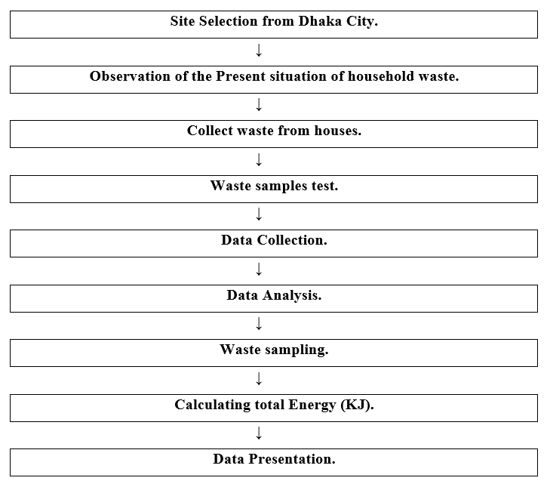

Figure 01: Flow Chart of the Work Process (Created by the Author).

1. **Study Area:** The research focused on Dhaka City, the capital of Bangladesh. Recognizing the heterogeneity of the city, data collection was strategically conducted across different zones and socio-economic areas within Dhaka to capture the diverse characteristics of its HSWM system. This stratified approach aimed to provide a representative understanding of the challenges and practices prevalent throughout the capital.
2. **Primary Data Collection:** To gather firsthand information on the existing HSWM system in Dhaka City, the following primary data collection methods were employed:
3. **Household Surveys:** A structured questionnaire was administered to a representative sample of households across different zones and socio-economic strata within Dhaka City. The questionnaire aimed to collect data on:

* Household waste generation rates and composition.
* Current waste storage and handling practices at the household level.
* Awareness and practices related to waste segregation, recycling, and composting.
* Perceptions of the existing waste collection services provided by relevant authorities.
* Willingness to participate in improved waste management initiatives.
* Socio-economic characteristics of the households to identify potential influencing factors. A multi-stage sampling technique, incorporating stratified and random sampling, was utilized to ensure representation from various residential areas and socio-economic groups across Dhaka City.

1. **Key Informant Interviews:** In-depth, semi-structured interviews were conducted with key stakeholders involved in HSWM in Dhaka City. These included:

* Officials from the Dhaka South City Corporation (DSCC) and Dhaka North City Corporation (DNCC) responsible for waste management across the capital.
* Representatives from any private waste management service providers operating within Dhaka City.
* Community leaders and representatives from local community groups or associations within different areas of Dhaka.
* Informal waste workers involved in waste collection, sorting, or recycling activities throughout the city. These interviews aimed to gather insights into the operational aspects of waste collection, transportation, treatment, and disposal, as well as the challenges, policies, and future plans related to HSWM within Dhaka City.

1. **Direct Observation:** Systematic field visits and direct observation were conducted in various residential areas, commercial zones, public spaces, and waste storage and transfer points across Dhaka City. This method allowed for the assessment of:

* The state of waste storage containers and collection infrastructure.
* The efficiency of waste collection processes.
* Instances of illegal dumping or improper waste handling.
* The presence and activities of informal waste workers.
* The overall cleanliness and environmental conditions related to waste management in different parts of the city.

1. **Secondary Data Collection:**

A comprehensive literature review was undertaken to synthesize existing knowledge relevant to household solid waste management systems, particularly in the context of Dhaka and similar urban environments in developing countries. This involved a systematic search across prominent academic and research platforms, including but not limited to Scopus, Google Scholar, PubMed, ResearchGate, and Academia.edu. The search terms utilized were carefully chosen to encompass a wide range of pertinent publications, and the resulting literature was thoroughly examined for relevant information. Furthermore, the reference lists of identified articles and related scholarly works were explored to identify additional sources through citation tracking. The secondary data analyzed in this research were exclusively derived from existing scholarly materials, reports from governmental and international organizations, peer-reviewed scientific journals, and reputable online publications. The information extracted from these secondary sources was critically evaluated, compared, and synthesized to:

* Provide a theoretical framework for understanding HSWM principles and best practices.
* Contextualize the challenges and issues identified in the primary data within broader national and international trends related to urban waste management.
* Identify potential strategies and innovations for improving HSWM systems based on experiences in other megacities and developing urban settings.
* Understand the policy and regulatory landscape governing solid waste management in Bangladesh, specifically within the context of Dhaka City.

1. **Data Analysis:**

The collected data were analyzed using both quantitative and qualitative methods:

1. **Quantitative Data:** Data from the household surveys were statistically analyzed using appropriate software (e.g., SPSS). Descriptive statistics (frequencies, percentages, means, standard deviations) were used to summarize household waste generation, practices, and perceptions across Dhaka City. Inferential statistics (e.g., chi-square tests, t-tests, ANOVA) were employed to identify significant relationships between socio-economic factors, geographical zones, and HSWM practices and attitudes within the capital.
2. **Qualitative Data:** Data from the key informant interviews and direct observations were analyzed using thematic analysis. Transcripts of the interviews and detailed field notes were reviewed to identify recurring themes, patterns, and insights related to the operational aspects, challenges, and perspectives on HSWM across different stakeholders and areas within Dhaka City.
3. **Integration of Data:**

The findings from the quantitative and qualitative data analyses were integrated with the insights gained from the literature review to provide a comprehensive understanding of the HSWM system in Dhaka City. This triangulation of data sources allowed for a more robust and nuanced analysis of the current situation, the identification of key challenges and opportunities at a city-wide level, and the formulation of informed recommendations for potential improvements applicable across the capital.

**SOLID WASTE MANAGEMENT BY DHAKA CITY CORPORATION**

1. DCC sweeps roads & drains daily.
2. Accumulate wastes from the roadside.
3. Cleaners collect & transfer to the nearest dustbin/container.
4. DCC’s truck dump to the dumping depots.
5. Dressing by bulldozers, tire dozers, pay loaders & excavators.

**IMPACT OF SOLID WASTE DISPOSAL ON THE ENVIRONMENT**

1. Open-air dumping creates an unhygienic environment and poses an enormous threat to the people.
2. Causes aesthetic problems and nuisance due to nauseating, pungent odor.
3. Promotes the spreading of diseases.
4. The situation is further aggravated by the indiscriminate disposal of Hospital and Clinical Waste.
5. Presence of extremely high levels of Total and Facial coliform.
6. Pollute water bodies.
7. Carbon dioxide and Methane produced from solid waste are extremely harmful to the environment.
8. Gases are produced in the landfills through aerobic and anaerobic decomposition of organic compounds, which are a threat to the environment

**PROCESS OF HOUSEHOLD WASTE MANAGEMENT**

The household waste management process is depicted in Figure 02 below.

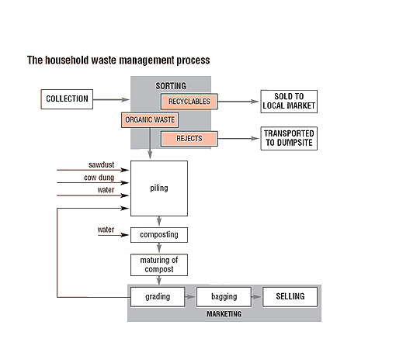

Figure 02: Process of Household Waste Management.

**EVALUATION OF HOUSEHOLD WASTE COLLECTION SYSTEMS**

There are numerous facets involved in collecting domestic waste. Stakeholders, such as waste management companies, local authorities, the national environmental protection agency, waste researchers, environmentalists, and the general public, all have various viewpoints on what is important. Waste collection systems can be evaluated for a variety of reasons. The reasons for assessing the effectiveness of waste collection systems are displayed in Figure 03 below.



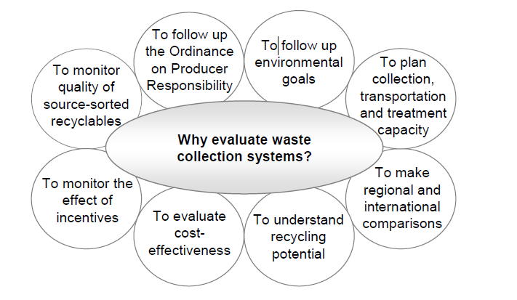



Figure 03: Reasons for evaluating the function of waste collection systems (Figure Source: F. A. Samiul Islam, 2023).

The evaluation of collection systems depends on the system boundaries and will always be site-specific to some degree. However, it is possible to considerably improve the potential for comparisons through stratified investigations and the use of simple, consistent indicators.

**HOUSEHOLD WASTE**

Anything that is thrown away because it has outlived its usefulness is considered waste. What one person throws out can occasionally be reused by another. All garbage is especially dangerous because, if it is not disposed of properly, it will affect the environment by contaminating the air, soil, or water, or leaving unsightly litter on the streets (Islam, 2025). The fact that garbage is recyclable, however, is just as significant. For instance, we wouldn't require inorganic fertilizers to sustain the high crop yields if all solid, animal, and human waste were recycled back into the soil. Waste is defined as something that is both a nuisance and anything that belongs somewhere else yet has no worth. Waste is never formed by nature; it is always the direct outcome of human activities. societal technologies are needed to address the societal problem of waste. In reality, waste is just the stuff that is discarded, overlooked, or left over from all of our activities, including eating, playing, and working (Islam, 2025). It is, in short, content that its creator does not want. Trash, garbage, or rubbish are other terms for waste. Trash, garbage, and sludge from our everyday activities that are non-liquid, non-gaseous, fresh, organic or non-organic, non-biodegradable, and useless are all considered solid waste (SW). It is the most evident and detrimental consequence of a resource-intensive, consumer-driven economic way of life. Residential areas account for around 80% of municipal garbage, which comprises organic waste, paper, plastic, metal, glass, ceramic, wood, and cardboard. Domestic, commercial, industrial, institutional, demolition and construction, municipal services, process, and agricultural are the eight types of solid waste generators. Four types of trash are frequently encountered in poor nations like Bangladesh: medical, industrial, municipal, and home waste. Biodegradable and non-biodegradable household trash are separated (Figure 04) (Sultana et al., 2023).

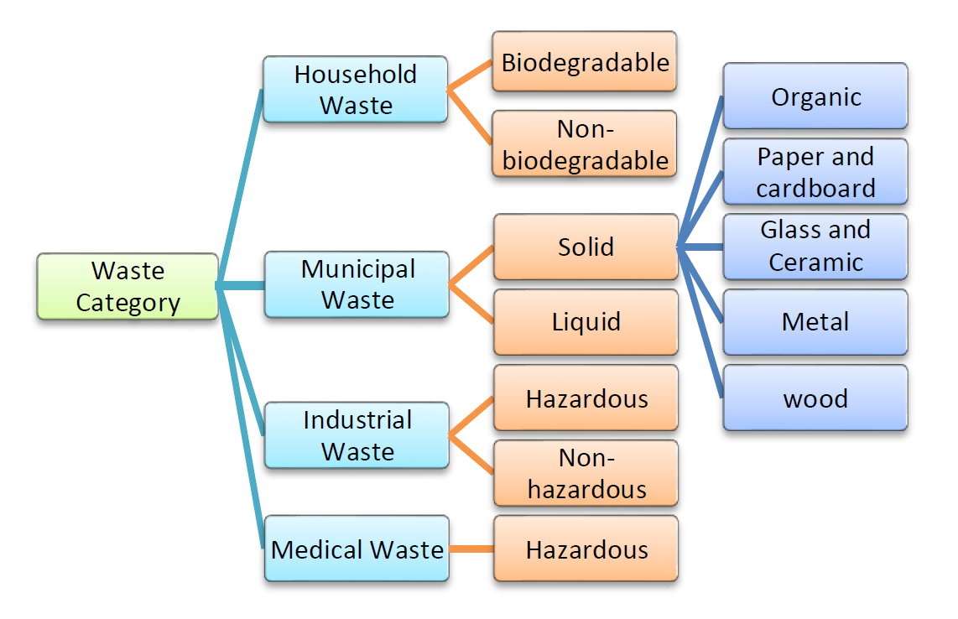

Figure 04: General Types of Waste in Developing Nations (Figure Source: Sultana et al., 2023).

Glass and ceramics, paper, plastic and polythene, kitchen and food waste, wood and cardboard, metal, and other wastes are the six main categories into which household solid wastes are divided, as shown in Figure 05 below.

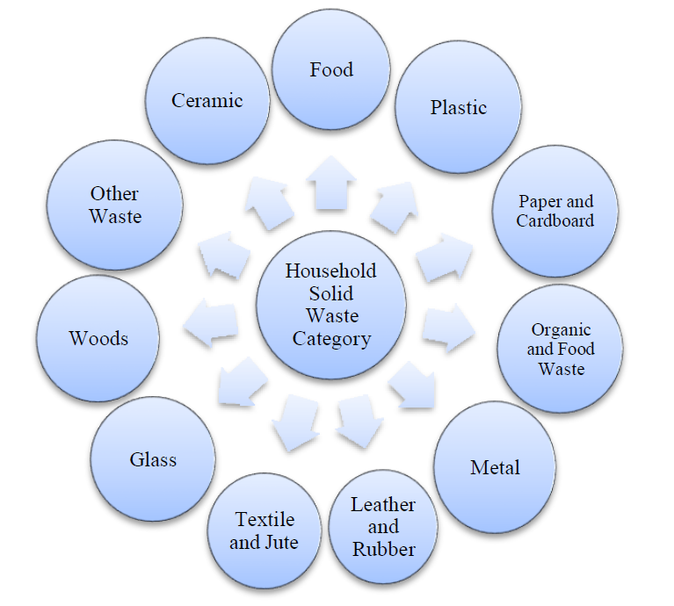

Figure 05: Household Solid Waste Category (Figure Source: Sultana et al., 2023).

According to Burke and Napawan (2020), food waste accounts for the majority of home garbage. It is collected from kitchen waste and effectively transported from metropolitan areas to landfills and other places, whose construction and location are planned to disguise the waste.

The problem with waste is twofold:

1. How to dispose of it
2. How to extract its recycling wealth.
3. **Disposal:**

The disposal system has four aspects.

(a) Control of waste at source

(b) Segregation of waste at source

(c) Collection and transportation system

(d) Final disposal.

Their explanation is given below.

**(a) Control of Waste at Source:** The volume of solid waste will be greatly reduced if conscious people compost and utilize the daily organic waste in their kitchen garden as manure.

**(b) Segregation of Waste at Source:** If conscious people do not use the organic waste in their kitchen-garden, the least they can do is to segregate the inorganic waste i.e., fused bulbs, blades, razors, old shoes, tooth paste tubes, glass wares, empty battles etc. at source Municipalities should create a bank or a dumping point where inorganic waste can be sent by a simple and effective collection system. For example, a municipal official can visit each street after every fortnight to collect such waste from each house. In Western countries, waste banks have been formed where people can sell empty glass bottles or deposit other inorganic wastes. Fortunately, in our country, a lot of inorganic waste is already being recycled.

**(c) Collection and Transportation:** The Municipality will have to design a simple and effective system of waste collection for each street. At this stage, the local eco-club, Mohalla, or sanitation committees can be very effective through cooperation and motivation. The primary collection can be through a wheelbarrow system. This waste can be dumped at a transit dump site. The municipal trucks can pick up this waste from these transit dump sites and transport it to the final disposal site.

**(d) The Final Disposal:** The final disposal site can be one or more, depending upon the size of the city. But one disposal site in each direction of the city will certainly reduce the cost of transportation. The disposal site will also provide another opportunity for segregation of waste by the rag-pickers (informal Sector). The final disposal of organic waste has three easy options.

(i) Composting;

(ii) Sanitary landfills;

(iii) Incineration.

Their explanation is given below.

1. **Composting:** The composting period is 6 to 8 months. Therefore, the size of the composting pits has to be sufficient to contain the solid waste volume accumulated over six months. The disposal site should be surrounded by a row of trees to prevent air pollution from fugitive emissions. The decomposition of organic waste will be carried out by anaerobic microorganisms, and gases like methane and carbon dioxide may be produced during the process of decomposition. The composted waste should be sent to agricultural fields to be used as manure. Mechanical compositing plants have not been found economically viable. However, Research is going to accelerate the rate of decomposition with the use of warmth.
2. **Sanitary Landfills:** It is another method of dumping solid organic waste in land depressions. The landfills are finally covered with a layer of soil. Grass and trees are grown, and the site can be developed into a beautiful tourist spot, as in the case of Delhi along the Ring Road. But during the dumping process, the waste material causes a lot of pollution by generating fugitive emissions and nauseating some people.
3. **Incineration:** Incineration is the burning of waste material at high temperatures. This reduces the weight of the waste by two-thirds and its volume by 90%. But incineration causes a lot of air pollution and releases poisonous chemicals into the atmosphere. This method is rarely employed in India except in some hospital installations. Some power plants were developed to generate electricity by burning solid waste. But such plants have not been found economically viable.
4. **Recycling and Re-use:**

As previously said, solid waste is divided into two categories: recyclable inorganic trash and decomposable organic waste. One method of recycling is the process of turning organic waste into soil manure. After being completely separated at the final disposal location, the inorganic waste can be recycled for various uses. However, if the right technologies are made accessible, the inorganic waste will be completely recycled. Nowadays, recycling paper and cardboard waste is not a problem because many manufacturers use these wastes as their only raw material to make recycled paper. However, there is currently no technology that can be used with the old shoes (Islam, 2025). If original product makers are likewise held accountable for creating appropriate methods to recycle their waste, the issue will be resolved. For instance, a facility in Delhi uses plastic garbage to create new plastic chappals. Similarly, the bulb sector ought to be tasked with creating a technology that will allow used electrical bulbs to be recycled. Given the importance and scarcity of raw resources, it is the responsibility of every person to regard all waste as recyclable and to utilize its potential. The government ought to establish a distinct division for garbage recycling. These procedures will also greatly enhance the environment in which we live. Waste disposal should be viewed as an opportunity rather than a problem.

**HOUSEHOLD SOLID WASTE MANAGEMENT OPTIONS**

In many cities in developing nations, household solid waste management poses a major threat to the environment and human health. Except hazardous waste from industry, it comprises processed biomedical wastes as well as waste produced by homes, businesses, or other designated areas in any form, including solid, semi-solid, or liquid (Islam, 2025). It refers to measures intended to efficiently collect, transport, process, and dispose of waste because of worries about aesthetics, public health, the preservation of natural resources, and other environmental conditions. Effective environmental management is achieved through the steps of generation, storage, collection, transportation, and final disposal (Figure 06). Preserving natural resources, protecting the environment, and advancing public health are the primary objectives. Sadly, a lot of cities are having trouble controlling their high solid waste levels, particularly those in emerging countries. These nations frequently suffer from low waste collection coverage, ineffective collection techniques, a lack of solid waste management infrastructure and technologies, a lack of financial and technological resources, poor handling, pollution from open dumping, and a lack of data on waste production (Islam, 2025). Lack of participation in trash management and public knowledge are further characteristics. Between 30% and 50% of waste is collected in underdeveloped countries, and it is then dumped in uncontrolled landfills (Sultana et al., 2023).

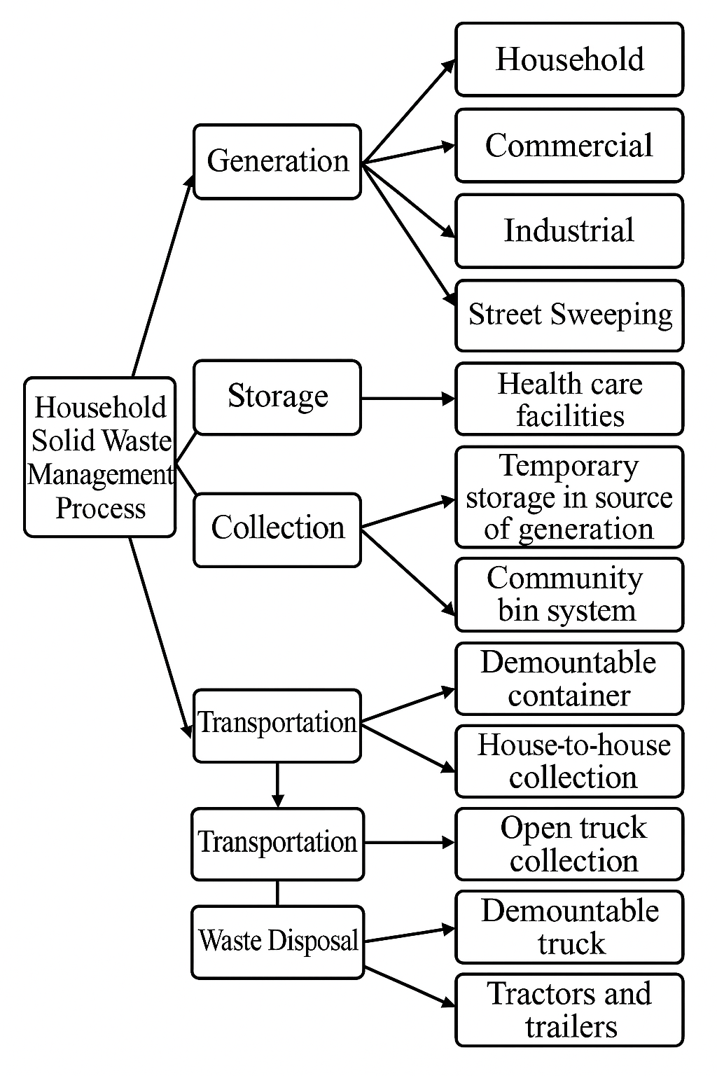

Figure 06: Household Solid Waste Management Process (Figure Source: Sultana et al., 2023).

There are several approaches to managing solid waste in the home. However, first and foremost, it is crucial to be conscious of the locals. They must comprehend that, with the right handling of home waste, waste may become profit. Locals may be interested in managing and minimizing home waste in many ways, such as recycling, reducing, and reusing, if they are aware that waste can be reused in various ways. Household waste can be controlled and decreased if it is collected methodically. Different waste may be collected and managed quickly if each householder uses a different colored bucket or bag for different types of waste. Three different colored bins are available for the collection of domestic waste. These are:

1. **Blue color bin:** Glass bottles and jars, drink cans, food cans, tins, aerosols, plastic containers, cartons, and other items are all disposed of in blue bins or bags. Certain things, such as carrier bags, film, polystyrene, toys for kids, big plastic objects, aluminum foil, etc., are also not used in the blue color bin.
2. **Black color bin:** The primary purpose of the black color bin is to collect cat litter and dog feces. Additionally, the black color bin also contains additional elements. However, building materials, dirt, and stones are not disposed of in the black bin.
3. **Orange color bin:** Brown cardboard, pizza boxes, cereal boxes, frozen or chilled food boxes, egg boxes, toilet/kitchen roll tubes, shoe boxes, washing powder boxes, brown envelopes, etc., are all collected in an orange bin. However, before collecting these items, people must remove all plastic wrapping and sticky tape from the cardboard.

**SOLID WASTE MANAGEMENT IN DEVELOPED COUNTRIES**

One of the primary topics of discussion in environmental policy in recent years has been the issue of solid waste, particularly MSW, in industrialized nations (Samiul, 2023). However, there are currently questions regarding the economic feasibility and environmental acceptability of the current waste-disposal procedures due to the increase in waste volumes and the environmental effects of previous disposal practices (Samiul, 2025). Waste is one of the biggest environmental issues in Europe and the Baltic states. Because more things are being packaged, the quantity of waste produced in households is probably going to increase during the next few years. A revolution in waste management is taking place in the majority of developed nations when comparing the management of urban solid trash in the late 1970s to that of today. There are four ways to look at this revolution.

1. A revolution in management practices, moving away from landfills and toward energy recovery and material recycling. There is a shift away from landfills and toward energy recovery and material recycling.
2. Many existing facilities have been closed or upgraded as a result of the stricter environmental regulations governing waste management facilities.
3. A shift in the general public's perception of waste in almost every developed nation. All disposal techniques are now seen by the public as carrying intolerable dangers.
4. A significant shift in perceptions on the appropriate function of producing industries. This is demonstrated by the application of the polluters' pays concept and the growing demands made on businesses by governments to take on greater accountability for the waste that results from the use of their goods.

Recycling has increased more than energy recovery in Europe, yet both have increased at the expense of landfills in the US. Material recovery was more than doubled in the 1990s and accounted for 30% of all waste management in the 2000s, according to U.S. EPA projections. With a 21% increase in energy recovery, just 49% of municipal garbage is left for land disposal. North America's waste management strategy has changed throughout time, moving from open dump disposal until the 1960s, to sanitary landfills becoming the preferred option in the 1970s, and finally to integrated waste management. The goal of this waste management concept is to treat all garbage as a resource, some of which can be recycled and some of which can be turned into compost. Just 10% of the land in Japan is suitable for residential use. The main factor influencing Japan's waste management policy is the lack of land in easily accessible places, which restricts the number of acceptable disposal sites. Japan generates about 52 million tons of municipal waste annually, of which 16.7% is recycled, 5.9% is landfilled, and 77.4% is burned. Household garbage is traditionally separated into recyclable elements like glass, metal cans, newspapers, and so on, as well as combustible and non-combustible wastes.

**THE PRESENT STATUS OF HOUSEHOLD AND SOLID WASTE IN BANGLADESH**

The tremendous burden of solid and household trash is causing Dhaka, a megacity brimming with life and activity, to struggle with an increasingly pressing dilemma. The city's already overburdened waste management infrastructure is being pushed to the limit by the sheer amount of garbage produced by its growing population and fast urbanization, posing serious risks to the environment and public health. Thousands of tons of solid trash are produced every day in Dhaka at the moment, and this amount is rising due to population increase and shifting consumption habits (UN, Bangladesh, 2024). The majority is household waste, which is made up of a complicated mixture of inorganic materials (plastics, polythene, glass, metals), organic matter (food scraps, paper), and a small but alarming portion of hazardous waste (batteries, technological waste). The city's solid waste stream is further influenced by businesses, industries, medical facilities, and construction projects, which makes its management more difficult. Inefficiencies and antiquated methods are the main features of Dhaka's current garbage management system (Andaleeb, 2022). Despite being required to collect and dispose of rubbish, the Dhaka South City Corporation (DSCC) and Dhaka North City Corporation (DNCC) find it difficult to keep up with the constantly rising amount of waste being produced. In many places, especially in low-income communities with a high population density, collection coverage is still lacking. Waste usually builds up in open bins or along roadsides before being carried, and the techniques used generally include crude door-to-door collection or reliance on community-arranged systems.

Another major obstacle is getting waste to the appropriate disposal locations. The few authorized landfills, which are frequently found on the outskirts of the city, are quickly filling up (Urme et al., 2021). Without adequate liner or leachate control, garbage is dumped openly at these locations, seriously polluting the environment and harming water and soil resources. Additionally, large volumes of methane, a powerful greenhouse gas that contributes to climate change, are released during the breakdown of organic waste in these open dumps (Islam, 2025). The quality of life in the surrounding communities is also negatively impacted by the sickening smells coming from these locations. The informal sector plays an important role in Dhaka's waste management landscape (Akther et al., 2024). Waste pickers, who frequently work in hazardous conditions, scavenge through collected waste and at disposal sites to recover recyclable materials. Although their efforts aid in resource recovery, they frequently function without proper protection or recognition within the formal system. In Dhaka, initiatives to promote the 3Rs (Reduce, Reuse, Recycle) and other more environmentally friendly trash management techniques are still in their infancy. Effective recycling programs are hampered by the lack of widespread household source separation practices (Jerin et al., 2022). Although there are some recycling initiatives, most of which are led by the unorganized sector, their total impact is constrained by a lack of public awareness and organized infrastructure. Although organic waste composting has the potential to drastically cut down on the amount of garbage dumped in landfills, it is still not widely practiced at the home and community levels (Rahman et al., 2022).

This insufficient waste management system has far-reaching effects. The unsanitary conditions brought about by open dumping and uncollected waste seriously jeopardize public health and promote the spread of vector-borne illnesses. Environmental pollution affects ecosystems and human health by deteriorating the city's air, water, and land resources. The aesthetic deterioration brought on by overflowing trash cans and dirty streets further lowers the standard of living in cities. The management of solid trash and households in Dhaka City is currently in dire straits. There are serious environmental and public health issues as a result of the excessive waste volumes and an inadequately funded and frequently ineffective management system. Government agencies, businesses, communities, and private persons must work quickly and cooperatively to address this catastrophe (Aktar, 2024). To guarantee a cleaner, healthier, and more sustainable future for Dhaka, it is imperative to move towards a more integrated and sustainable waste management system, prioritize waste reduction, encourage widespread reuse and recycling, implement efficient organic waste treatment, and investigate environmentally sound disposal techniques. Before Dhaka is submerged in its waste, immediate action must be taken.

Dhaka city has been struggling with a major solid waste management issue in recent days. Estimates place the daily generation at several thousand tons, which is nevertheless significant and mostly consists of organic household trash. Although they span a large region, the Dhaka North and South City Corporations' collection activities encounter logistical challenges in the heavily inhabited districts. Concerns over future disposal are raised by the fact that the current landfill sites at Amin Bazar and Matuail are getting close to capacity. The "New Clean Dhaka Master Plan (2018-2032)," which encourages garbage treatment, including reduction, reuse, and recycling (3R techniques), highlights the growing emphasis on switching to more sustainable practices. Anaerobic digestion, composting, recycling, and waste-to-energy (WtE) technologies are being investigated as ways to lessen the environmental impact and landfill load. One major barrier is still the broad application of source separation at the household level. Recycling is, nevertheless, greatly aided by the informal trash sector, albeit frequently in unstable circumstances. Although the high moisture content of the waste presents a barrier, recent conversations and proposals explore the possibility of using WtE incineration for the generation of power. Overall, Dhaka's solid waste management system still needs major improvements to promote long-term sustainability and reduce threats to the environment and public health, even though there is a recognized need for reform and some planned efforts.

**SOLID WASTE MANAGEMENT IN DEVELOPING COUNTRIES**

One of the main duties of local governments is MSWM. The work is complicated by the need for cooperation between multiple stakeholders in the public and private sectors, as well as the need for adequate organizational capabilities. Most cities in developing nations have very poor solid waste management, even though trash management is crucial for protecting the environment and public health. When the WHO gave African nations the chance to rank their environmental health issues, the findings showed that, although solid waste was ranked as the second most significant issue (after water quality), less than 30% of urban dwellers had access to "proper and regular garbage removal." The solid waste capacity development is displayed in Table 01 below.

|  |  |  |
| --- | --- | --- |
| **Economic levels of countries** | **Low-income countries** | **Middle-income countries** |
| **Waste minimization** | No organized programs, but reuse and low per capita waste generation rates are common. | Some discussions on waste minimization, but rarely incorporated into any organized program. |
| **Collection** | Service is limited to high-visibility areas, the wealthy, and businesses willing to pay. | Expanded collection areas. Trucks are used for collection. |
| **Recycling** | Recycling activities are performed by the informal sector (scrap dealers and waste pickers). Localized markets for recycling are common. | While the informal sector is still involved, relatively large machinery is sometimes used for sorting and recycling. Materials are often hauled out of the city as recyclables. |
| **Composting** | No organized programs. Wastes, including organic matter, are not put to good use. | Efforts toward composting are made in many parts of the city. Large composting plants are generally unsuccessful. Small-scale composting projects tend  to become more successful. |
| **Incineration** | Not common or successful because of high operational costs. A high percentage of moisture and inorganic matter calls for supplemental fuel and has a smaller impact on volume reduction. | Incinerators are sometimes used, but not commonly, due to economic reasons. |
| **Land filling** | Usually, open dumping occurs with virtually no environmental controls. | Some controlled and sanitary landfills with some environmental controls. Open dumping is still common. |
| **Costs** | Collection costs represent 80- 90% of the SWM budget. Collection fees are regulated by some municipalities, but the quality of collection service is low. | Collection costs represent 50-80% of the SWM budget. Some municipalities regulate collection and disposal fees. Innovative arrangements are in place for fee collection. |

Table 01: Capacity Development in Solid Waste.

**SOLID WASTE MANAGEMENT IN ASIAN DEVELOPING COUNTRIES**

The population growth, urbanization, and industrialization of Asian developing nations all contribute to the production of solid waste (SW). For instance, in India, where there were 217 million people, it ranged from 0.2 to 0.5 kilogram per capita each day. Urbanization, income, and population are all rising in Asian developing nations. The volume and kind of SW are increasing as a result of this circumstance. Residential neighborhoods, businesses, and other sources account for the majority of municipal solid waste. Table 02 describes the types and sources of SW in Southeast Asian nations.

|  |  |  |
| --- | --- | --- |
| **Sources** | **Typical Waste Generators** | **Types of solid waste** |
| **Domestics** | Single houses and apartments | Food scraps, paper, corrugated boxes, plastics, clothing, glass, metals, ashes, and domestic hazardous waste |
| **Shopping and commercial areas** | Shopping centers, hotels, restaurants, markets, and offices | Paper, corrugated boxes, plastics, wood, food scraps, glass, metals, special wastes, hazardous waste |
| **Institutional** | Schools, government offices, medical care centers, prisons | As mentioned above, in shopping and commercial areas |
| **Public facilities** | Street cleaning, landscaping, parks, beaches, and recreation areas | Street cleaning, landscape and yard trimming, and general waste from recreation areas |

Table 02: Sources and types of municipal waste in Southeast Asia.

Decomposable organic waste, which makes up 42% to 80.2% of solid waste, is its primary component. Paper, plastic, cloth, metals, glass, ash, and other materials are other SW components that are less common. Paper is the second most common waste material in Pondicherry, India, Kuala Lumpur, Malaysia, and Dhaka, Bangladesh. Plastic comes in second. Among other materials, the remnants include leather, rubber, glass, metal, and textiles.

**THE FINDINGS OF THIS RESEARCH**

In the study, the following prospects have been identified, and the necessary discussions are included.

|  |  |  |  |  |  |
| --- | --- | --- | --- | --- | --- |
| **Reducible** | | **Reusable** | | **Recyclable** | |
| Item | Weight(kg) | Item | Weight(kg) | Item | Weight(kg) |
| Taka (Coin) | 0.018 | Paper | 1.566 | Food | 1.358 |
| Rope | 0.034 | Cloth | 2.474 | Plastic | 0.808 |
| - | - | Foam | 0.028 | Tissue | 0.601 |
| - | - | - | - | Rubber | 0.013 |
| - | - | - | - | Cast Iron | 0.004 |
| - | - | - | - | Polythene | 1.968 |
| - | - | - | - | Head Phone | 0.014 |
| - | - | - | - | Glass | 0.186 |
| - | - | - | - | Packet | 0.07 |
| - | - | - | - | Hanger | 0.006 |
| - | - | - | - | Plastic Rope | 0.145 |
| - | - | - | - | Coffee Cup | 0.128 |
| **Total Weight** | **0.052** |  | **4.068** |  | **5.301** |
| **% of Weight** | **0.55%** |  | **43.18%** |  | **56.27%** |

Table 03: 3R Application.

According to Table 03, the overall weight of the reusable items is 4.068 kg, and their weight percentage is 43.18%. Once more, it demonstrates that the combined weight of the reducible item is 0.052 kg, with a weight percentage of 0.55%. Additionally, it indicates that the overall weight of recyclable items is 5.301 kg, with a weight percentage of 56.27%.

Figure 07: Pie Chart of 3R Application.

Figure 07 shows the percentage of total weight with reducible, reusable, and recyclable items.

|  |  |  |  |  |  |
| --- | --- | --- | --- | --- | --- |
| **Organic** | | **Inorganic** | | **Hazardous** | |
| Item | Weight(kg) | Item | Weight(kg) | Item | Weight(kg) |
| Food | 1.358 | Plastic | 0.808 | Head Phone | 0.014 |
| Paper | 1.566 | Rubber | 0.013 | Cast Iron | 0.004 |
| Tissue | 0.601 | Taka (Coin) | 0.018 | Battery | 0.118 |
| Cloth | 2.474 | Dust | 0.206 | Foam | 0.028 |
| Hair | 0.19 | Cloth | 2.474 | - | - |
| Rope | 0.034 | Polythene | 1.968 | - | - |
| Tea Bag | 0.366 | Glass | 0.186 | - | - |
| Lemon | 0.116 | Packet | 0.07 | - | - |
| Tamarind | 0.72 | Hanger | 0.006 | - | - |
| Leafy Vegetable | 0.785 | Plastic Rope | 0.145 | - | - |
| Fruit Shuck | 0.21 | Coffee Cup | 0.128 | - | - |
| **Total Weight** | **8.420** |  | **6.022** |  | **0.164** |
| **% of Weight** | **57.64%** |  | **41.28%** |  | **1.12%** |

Table 04: Organic, Inorganic and Hazardous Items.

The total weight and percentage of total weight of organic, inorganic, and hazardous items are displayed in Table 04. Because some elements are addressed in both organic and inorganic categories, the total weight in the above table is more than the total weight calculated. The overall weight of organic goods is 8.420 kg, according to the table. The combined weight of the hazardous and inorganic materials is 0.164 kg and 6.022 kg, respectively. Additional information in this table indicates that the overall weight percentages of organic, inorganic, and hazardous materials are 57.64%, 41.28%, and 1.12%, respectively. The total weight and percentage of weight of organic, inorganic, and hazardous items are displayed in Figure 08 below.

Figure 08: Weight of all organic, inorganic, and hazardous items combined, as well as weight percentage.

|  |  |  |
| --- | --- | --- |
| **Energy Analysis** | | |
| **Material types according to energy content** | **Energy (Kilojoules/Kg)** | **Total Energy (Kilojoules)** |
| Food | 4652 | 16537.86 |
| Plastic | 32564 | 100850.7 |
| Paper | 16747.2 | 37463.49 |
| Rubber | 23260 | 302.38 |
| Textile | 17445 | 43752.06 |
| Ferrous | 697.8 | 15.35 |
| Glass | 139.56 | 25.96 |
| Dirt’s | 6978 | 1437.47 |
| Leather | 17445 | 3314.55 |
|  |  | 203699.8 |

Table 05: Energy Analysis.

Based on energy content, Table 05 indicates the following: Food has an energy content of 4652 Kilojoules per kilogram, and the total energy derived from the food sample is 16537.86 Kilojoules. Plastic has an energy content of 32564 Kilojoules per kilogram, yielding a total of 100850.7 Kilojoules. Paper contains 16747.2 Kilojoules per kilogram, with a total energy of 37463.49 Kilojoules. Textiles have an energy content of 17445 Kilojoules per kilogram, resulting in a total energy of 43752.06 Kilojoules. Ferrous materials contain 697.8 Kilojoules per kilogram, and the total energy found is 43752.06 Kilojoules. Glass has an energy content of 139.56 Kilojoules per kilogram, with a total energy of 25.96 Kilojoules. Dirt's energy content is 6978 Kilojoules per kilogram, and the total energy derived is 1437.47 Kilojoules. Leather has an energy content of 17445 Kilojoules per kilogram, providing a total energy of 3314.55 Kilojoules.

The total energy found across all these materials is 203699.8 Kilojoules.

Figure 09: Energy Content (%).

Figure 09 shows that the energy content of glass is zero percent. Out of 100%, the energy content is as follows: 50% plastic, 18% paper, 0% rubber, 2% leather, 1% dirt, 8% food, and 21% textile. This illustrates that plastic has the highest energy content.

Figure 10: Number of Waste Items.

The quantity of waste materials gathered for this investigation is displayed in Figure 10. Coffee cup 1, vegetable waste 4, tea bag 4, plastic rope 3, hanger 1, jute rope 2, hair 1, foam 3, packet 1, glass 1, battery 2, head phone 1, polythene 17, canvas 1, dust 17, rubber 2, tissue 14, paper 26, plastic 15, and food 5. The paper item is the most items that could be found for this investigation.

Figure 11: Percentages of collected waste items.

Figure 11 illustrates the weight percentages of various items within the collected waste sample. Food items constitute 11.19% of the sample's weight. Plastic items represent 6.66%, while paper items account for 11.91%. Tissue paper makes up 4.95% of the sample's weight. Rubber has a weight percentage of 0.11%, and coins (taka) contribute 0.15%. Dust accounts for 1.70% of the sample's weight. Cloth items form a significant portion at 20.39%. Cast iron constitutes a very small fraction at 0.03%. Polythene represents 16.22% of the sample's weight. Headphones have a weight percentage of 0.12%, and batteries account for 0.97%. Glass items make up 1.53% of the sample's weight. Packets represent 0.58%, and foam constitutes 0.23%. Hair accounts for 1.57% of the sample's weight. Jute rope has a weight percentage of 0.28%, and hangers represent 0.05%. Plastic rope makes up 1.20% of the sample's weight. Tea bags account for 3.02%, vegetable waste constitutes 15.09%, and coffee cups represent 1.06% of the collected waste sample's weight.

|  |  |  |  |  |  |  |  |  |
| --- | --- | --- | --- | --- | --- | --- | --- | --- |
| **Serial No** | **Item**  **type** | **Total Wt. (gm)** | **% (wt.)** | **Total number of items** | **% of items** | **Total Wt. (Kg)** | **Energy**  **(KJ/Kg)** | **Total Energy**  **(KJ)** |
| **1** | Kitchen waste | 16692.00 | 79.56 | 21 | 15.67 | 16.692 | 4652.00  food | 77651.18 |
| **2** | Paper | 1137.00 | 5.42 | 16 | 11.94 | 1.137 | 16747.20  Paper | 19041.57 |
| **3** | polythene | 1057.00 | 5.04 | 20 | 14.93 | 1.057 | 16747.20  Paper | 17701.79 |
| **4** | Plastic | 456.00 | 2.17 | 9 | 6.72 | 0.456 | 32564.00  Plastic | 14849.18 |
| **5** | Bottle | 459.00 | 2.19 | 8 | 5.97 | 0.459 | 32564.00  Plastic | 14946.88 |
| **6** | Tissue | 135.00 | 0.64 | 7 | 5.22 | 0.135 | 16747.20  Paper | 2260.87 |
| **7** | Foil | 276.00 | 1.32 | 11 | 8.21 | 0.276 | 697.80  Ferrous | 192.59 |
| **8** | Dust | 35.00 | 0.17 | 13 | 9.70 | 0.035 | 6978.00  Dirt’s | 244.23 |
| **9** | cloth | 114.00 | 0.54 | 4 | 2.99 | 0.114 | 17445.00  Textile | 1988.73 |
| **10** | Nylon Net | 65.00 | 0.31 | 7 | 5.22 | 0.065 | 32564.00  Plastic | 2116.66 |
| **11** | Medicine strip | 36.00 | 0.17 | 7 | 5.22 | 0.036 | 32564.00  Plastic | 1172.30 |
| **12** | Dry wood | 141.00 | 0.67 | 3 | 2.24 | 0.141 | 18608.00  Wood | 2623.73 |
| **13** | Fruit skin | 276.00 | 1.32 | 2 | 1.49 | 0.276 | 4652.00  Food | 1283.95 |
| **14** | Racket Cork | 6.00 | 0.03 | 1 | 0.75 | 0.006 | 23260.00  Rubber | 139.56 |
| **15** | Fire box | 22.00 | 0.10 | 2 | 1.49 | 0.022 | 16282.00  Cardboard | 358.20 |
| **16** | G.I. wire | 40.00 | 0.19 | 1 | 0.75 | 0.040 | 697.80  Ferrous | 27.91 |
| **17** | Cock can | 34.00 | 0.16 | 2 | 1.49 | 0.034 | 697.80  Tin Can | 23.73 |
|  | Total | 20981.00 | 100.00 | 134 |  | **20.981** |  | **156,623.07** |

Table 06: Percentage (weight) in composition.

Table 06 presents the total energy content of various components found in the collected waste sample. Kitchen waste exhibits a total energy of 77651.18 Kilojoules. Paper contributes a total energy of 19041.57 Kilojoules, while polythene contains a total energy of 17701.79 Kilojoules. The total energy associated with plastic is 14849.18 Kilojoules, and bottles account for a total energy of 14946.88 Kilojoules. Tissue paper has a total energy of 2260.87 Kilojoules, and foil contributes 192.59 Kilojoules. Dust exhibits a total energy of 244.23 Kilojoules, and cloth contains a total energy of 1988.73 Kilojoules. Nylon net has a total energy of 2116.66 Kilojoules, and medicine strips possess a total energy of 1172.30 Kilojoules. Dry wood contributes a total energy of 2623.73 Kilojoules, and fruit skin contains a total energy of 1283.95 Kilojoules. Racket cork exhibits a total energy of 139.56 Kilojoules, and fire boxes account for 358.20 Kilojoules. G.I. wire has a total energy of 27.91 Kilojoules, and cock cans contribute 23.73 Kilojoules to the total energy content of the sample.

Figure 12: Percentage (weight) in composition.

Figure 12 presents the percentage composition by weight of various components within the analyzed waste sample. Kitchen waste constitutes the largest proportion at 79.56%. Paper represents 5.42% of the total weight, followed closely by polythene at 5.04%. Plastic accounts for 2.17%, and bottles make up 2.19%. Tissue paper comprises 0.64% of the sample's weight, while foil and fruit skin each represent 1.32%. Dust and medicine strips each constitute 0.17%. Cloth accounts for 0.54%, and nylon net represents 0.31%. Dry wood makes up 0.67%, racket cork 0.03%, and fire boxes 0.10%. G.I. wire and cock cans contribute 0.19% and 0.16% to the total weight of the waste sample, respectively.

**RESULT**

The analysis of the collected waste sample revealed several key findings regarding its composition, potential for the 3Rs (Reduce, Reuse, Recycle), and energy content.

1. **3R Application Potential:**

Table 03 and Figure 07 illustrate the applicability of the 3R principles to the collected waste. Reusable items, with a total weight of 4.068 kilograms, constituted the largest fraction amenable to the 3Rs, representing 43.18% of the total sample weight. These items, such as paper, cloth, foam, and plastic, suggest a significant potential for extending their lifespan through reuse. Encouraging reuse practices at the household level and establishing collection mechanisms for reusable items could significantly divert waste from final disposal.

The recyclable fraction of the waste stream, weighing 5.301 kilograms and accounting for an even larger 56.27% of the total weight, further emphasizes the potential for resource recovery. This diverse category includes food waste (amenable to composting), various types of plastic (recyclable depending on their resin code), paper (for repulping), tissue paper (potentially compostable or recyclable under specific conditions), rubber (recyclable in specialized facilities), cast iron (highly recyclable), polythene (film and bags that can be recycled), electronic waste like headphones (containing valuable metals), glass (infinitely recyclable), packets (depending on material composition), metal hangers (recyclable), plastic rope (depending on the type of plastic), and even coffee cups (some are recyclable or compostable). Implementing effective source separation programs and ensuring access to appropriate recycling infrastructure are crucial to capitalize on this substantial recyclable potential.

In contrast, the reducible items, represented by a minimal 0.052 kilograms and a mere 0.55% of the total weight (primarily coins and rope), indicate a limited direct opportunity for weight reduction within the composition of this specific sample. While encouraging mindful consumption to minimize the presence of such items in the waste stream remains important, the focus for significant impact should be directed towards promoting reuse and recycling of the more prevalent waste categories.

1. **Waste Stream Composition (Organic, Inorganic, and Hazardous):**

Table 04 and Figure 08 categorize the waste sample into organic, inorganic, and hazardous components. Organic materials, with a total weight of 8.420 kilograms, formed the dominant portion of the waste stream (57.64%). This category included food, paper, tissue, cloth, hair, rope, tea bags, lemon, tamarind, leafy vegetables, and fruit shuck, highlighting the significant contribution of biodegradable materials to the overall waste. This substantial fraction can be transformed into valuable soil amendments or biogas through biological treatment methods such as composting or anaerobic digestion, thereby reducing the volume of waste requiring landfilling and recovering valuable resources.

The inorganic fraction, weighing 6.022 kilograms and representing 41.28% of the sample, encompasses a wide array of materials with varying recycling potentials. This category includes different types of plastics, rubber, coins (metals), dust (inert materials), cloth (categorized in both due to potential for reuse/recycling and material composition), polythene, glass, various packaging materials, metal hangers, and plastic rope. Effective management of this fraction necessitates source separation to isolate recyclable materials from non-recyclable ones, thereby maximizing resource recovery and minimizing the burden on landfills.

The hazardous waste component, although representing a relatively small proportion of the total weight (0.164 kilograms and 1.12%), demands particular attention due to its potential environmental and health implications. Items such as headphones (containing heavy metals and plastics), cast iron (potential for leaching if improperly disposed), and batteries (containing corrosive chemicals and heavy metals) require specialized collection, treatment, and disposal methods to prevent contamination of soil and water resources and to ensure public safety. Establishing dedicated collection points and raising public awareness about the proper handling of hazardous household waste are critical. The overlapping categorization of cloth highlights the complexity of waste characterization, where an item can possess characteristics of both organic (natural fibers) and inorganic (synthetic components or its potential for reuse/recycling as a non-degradable item).

1. **Energy Content Analysis:**

The energy content analysis, presented in Table 05 and Figures 09, reveals the inherent energy potential within different fractions of the waste stream, suggesting opportunities for energy recovery through thermal treatment technologies. Plastic stands out as the material with the highest energy content per unit mass (32564 Kilojoules per kilogram) and consequently contributes the largest share to the total estimated energy of the analyzed materials (100850.7 Kilojoules, approximately 50%). This high calorific value makes plastic a prime candidate for waste-to-energy processes such as incineration with energy recovery or pyrolysis. Similarly, textiles (17445 Kilojoules per kilogram, total 43752.06 Kilojoules, ~21%) and paper (16747.2 Kilojoules per kilogram, total 37463.49 Kilojoules, ~18%) also possess significant energy content, making them suitable feedstocks for thermal treatment technologies.

While food waste constitutes a substantial portion of the waste stream by weight (as detailed in Table 06), its relatively lower energy content per unit mass (4652 Kilojoules per kilogram) results in a smaller contribution to the overall energy potential (16537.86 Kilojoules, ~8%). However, anaerobic digestion of food waste can still be a viable energy recovery pathway, producing biogas (primarily methane) that can be used for electricity generation or heating. Other materials like rubber, leather, dirt, and ferrous items have varying, generally lower, energy contents compared to plastics, textiles, and paper. Notably, glass has a negligible energy content and is primarily considered for recycling. The total estimated energy content of 203699.8 Kilojoules across the analyzed materials underscores the potential for harnessing the energy value embedded within the waste stream, which can contribute to reducing reliance on fossil fuels and mitigating greenhouse gas emissions associated with landfill decomposition.

1. **Detailed Waste Composition (Weight and Energy):**

The detailed breakdown of waste composition by weight and the corresponding energy content of individual items in Table 06 and Figure 12 provides a granular understanding of the waste stream. The dominance of kitchen waste by weight (79.56%, 16.692 kilograms) highlights the need for effective management strategies for this significant organic fraction, such as promoting home composting or establishing centralized composting facilities. The substantial energy contribution of kitchen waste (77651.18 Kilojoules), despite its lower energy density compared to plastics, further supports the exploration of anaerobic digestion as a treatment option.

Paper (5.42%, 1.137 kilograms, 19041.57 Kilojoules) and polythene (5.04%, 1.057 kilograms, 17701.79 Kilojoules) represent significant fractions that can be targeted for recycling and potential energy recovery if recycling is not feasible. The relatively lower weight percentages of plastic and bottles (2.17% and 2.19% respectively) belie their substantial energy contributions (14849.18 Kilojoules and 14946.88 Kilojoules), emphasizing the importance of their proper management for both material and energy recovery. The data on the number of waste items (Figure 10) indicates that paper was the most frequently discarded item, suggesting a focus on paper recycling initiatives. The detailed item-wise breakdown provides valuable data for designing targeted collection schemes, sorting processes, and treatment technologies tailored to the specific characteristics of the waste stream.

The detailed analysis of the household waste sample reveals a complex composition with significant potential for the application of the 3R principles, resource recovery through recycling and biological treatment of the substantial organic fraction, and energy recovery from high-calorific value materials like plastics, textiles, and paper. The findings underscore the need for integrated waste management strategies that prioritize waste reduction, promote widespread reuse and recycling, implement appropriate treatment methods for organic waste, and explore waste-to-energy technologies for non-recyclable high-energy content materials. A comprehensive approach that considers the specific characteristics of each waste fraction is crucial for achieving sustainable and environmentally sound household solid waste management.

**DISCUSSION**

A common aspiration in Bangladesh is to achieve a society that is neat, clean, and free from poverty, and the process of waste recycling can contribute to realizing this vision. However, this is a shared responsibility that extends beyond the government alone, requiring collaborative efforts from all stakeholders. City corporations have initiated organized waste collection services to maintain the cleanliness of their respective areas, typically operating based on community-arranged systems. Waste materials are collected from households and transported to nearby municipal roadside containers. The community-managed, door-to-door waste collection service is gaining traction in Dhaka City and is progressively evolving into a significant environmental movement. Currently, over 170 communities of varying sizes, ranging from fewer than 50 to more than 300 households, have adopted this participatory approach. This system has already achieved a 20 percent increase in garbage collection coverage of the total waste generated and has created approximately 500 employment opportunities, demonstrating its suitability for addressing local waste management challenges. Through concerted efforts, we can safeguard our environment and also gain financial benefits.

Furthermore, waste recycling contributes to the reduction of greenhouse gases. By recycling waste, the energy requirements for new production are decreased, which in turn lowers the emissions of carbon dioxide into the atmosphere. Therefore, it is imperative to enhance waste recycling activities and help to maximize environmental benefits for future generations. With its current resources and approach to waste management, the Dhaka City Corporation (DCC) is struggling to provide satisfactory services. Experts have proposed that a community-based solid waste management system, incorporating recycling and composting alongside sanitary landfilling and potentially transfer stations for distant landfill sites, could be a viable solution to the current inefficient system. To mitigate the negative impacts of overflowing waste bins and accumulated waste on roadsides, stringent regulations must be enforced on management-related activities, and public awareness levels should be elevated. Waste management is an issue that demands renewed and urgent attention. In our country, this problem is particularly severe. Extensive research is necessary in this field to discover methods for alleviating the challenges arising from inadequate solid waste management.

**FUTURE RESEARCH DIRECTIONS IN HOUSEHOLD SOLID WASTE MANAGEMENT IN DHAKA CITY**

This paper provides a thorough examination of the household solid waste management (HSWM) system in Dhaka City, Bangladesh, providing important insights into the system's existing condition, obstacles, and areas for development. Although the waste composition, 3R application, and energy recovery potential are fundamentally understood in this study, a number of research directions should be investigated further to improve the sustainability and effectiveness of HSWM in this quickly expanding megacity.

1. **Longitudinal Research on the Dynamics of Waste Generation and Composition: This research offers a glimpse of the features of household garbage at a particular moment in time. To monitor variations in trash generation rates and composition over time, future research might take a longitudinal approach, taking into account variables including socioeconomic development, urbanization patterns, consumption trends, and the effects of any waste management solutions that have been put in place. Long-term planning and the creation of flexible waste management techniques depend on an understanding of these processes.**
2. **Comprehensive Examination of the Integration of the Informal Waste Sector:** In Dhaka, the informal garbage industry contributes significantly to resource recovery. The socioeconomic facets of this industry, such as garbage pickers' earnings, their role in recycling rates, their interactions with the official waste management system, and possible tactics for their formal inclusion and empowerment, should be the focus of future studies. In order to enhance their working circumstances and optimize their contribution to a circular economy, this may entail evaluating the effectiveness of unofficial recycling networks, identifying obstacles to their operation, and investigating legislative actions.
3. **Enhancement of Transportation and Collection Systems:** The current trash collection and transportation methods have logistical inefficiencies, according to this study. Future studies should concentrate on improving these systems by using geographic information systems (GIS), route optimization algorithms, and investigating different forms of collection, such community-based projects or decentralized collection stations. It is also crucial to evaluate the financial and environmental effects of various scenarios for collecting and transportation.
4. **Advanced Waste Treatment Technology Feasibility and Implementation: Future research should carry out thorough feasibility assessments of particular advanced waste treatment technologies appropriate for the setting of Dhaka, even if this study briefly discussed the energy recovery possibilities of several waste fractions. Anaerobic digestion for the production of biogas from organic waste, pyrolysis or gasification for the recovery of energy from non-recyclable plastics, and the creation of integrated biorefineries are a few examples of technologies that could be investigated for their economic, environmental, and social feasibility. The transfer of technology, infrastructural needs, and possible environmental effects of such technologies in the local setting should all be covered in research.**
5. **Evaluation of Interventions for Behavior Change, Public Awareness, and Attitudes:** The public's involvement is crucial to the success of sustainable waste management. Future studies should examine the public's awareness, attitudes, and behaviors regarding garbage segregation, the three Rs, and their willingness to pay for better waste management services in Dhaka across various socioeconomic classes. To encourage more responsible waste management practices at the household level, research might also concentrate on creating and assessing the efficacy of educational initiatives and targeted behavior change communication techniques.
6. **Analysis of the Policy and Regulatory Framework: The current regulatory and legislative environment has a big impact on how effective HSWM is. Future studies should examine the institutional and legislative structure that now governs solid waste management in Dhaka critically in order to find any holes, contradictions, or obstacles to the adoption of sustainable techniques. This could entail examining the possibility of more stringent enforcement measures, creating financial incentives for recycling and trash reduction, and establishing precise rules and regulations for the handling and disposal of waste.**
7. **Economic Assessment of Health and Environmental Effects:** Inadequate waste management has significant environmental and public health costs. Future research could focus on quantifying these costs in the context of Dhaka City, including the impacts of pollution on water resources, air quality, and public health outcomes. Economic valuation studies can provide compelling evidence to support investments in improved waste management infrastructure and sustainable practices.
8. **The potential for better household solid waste management to mitigate climate change: Future studies should explicitly look into the possibilities of better HSWM techniques, including organic waste diversion and anaerobic digestion, to reduce greenhouse gas emissions, especially methane, given the sizeable organic portion of Dhaka's household waste. National climate action plans can benefit by quantifying the advantages of various waste management scenarios for mitigating climate change.**

A more thorough and fact-based understanding of Dhaka City's HSWM system can be created by pursuing these future research avenues. This will open the door for the development and application of more efficient, environmentally friendly, and sustainable waste management solutions for the capital and other quickly urbanizing Bangladeshi cities.

**CONCLUSION**

This research has provided a comprehensive and integrated analysis of the household solid waste management (HSWM) system in Dhaka City, Bangladesh, employing a mixed-methods approach that combined quantitative assessments of waste characteristics with qualitative explorations of socio-operational dynamics across the metropolis. The study's objectives, to understand current household waste practices, evaluate the applicability of the 3R hierarchy (Reduce, Reuse, Recycle), and assess the energy recovery potential of household waste, have been thoroughly addressed through systematic waste audits, detailed energy content analysis, and insightful interviews with key stakeholders, including representatives from the private sector, community leaders, and the often-overlooked informal waste workers. Direct observations conducted across various zones of Dhaka further enriched the findings, providing a nuanced and detailed picture of the challenges and opportunities inherent within the city's complex HSWM landscape. A substantial organic fraction (79.56% by weight) formed the primary component of the collected household waste sample, according to the quantitative analysis, which showed a varied makeup. With biological treatment techniques like composting and anaerobic digestion, this sizable biodegradable portion, mostly kitchen waste, offers a significant chance to be diverted from landfills. Significant fractions of paper (5.42%), polythene (5.04%), and plastic (4.36%) were also found in the sample, underscoring the possibility of material recovery through successful recycling programs. Depending on their energy content and capacity for recycling, the remaining fractions- such as tissue, foil, dust, cloth, nylon net, medicine strips, dry wood, fruit skin, racket cork, fire box, G.I. wire, and cock can- all add to the overall waste stream and need to be managed appropriately.

It was clear that the 3R hierarchy applied to the home trash stream in Dhaka. Although the final findings table did not specifically break down this particular sample into reducible, reusable, and recyclable categories, the composition analysis indicates a significant potential for each of the three. Composting is a viable method of recycling the substantial organic fraction. There is a lot of potential for recycling paper and different types of plastic. Cloth and certain plastic containers might be reused, and waste output could be reduced by focusing source reduction efforts on high-volume items like kitchen garbage and superfluous packaging. The inherent energy potential in various waste stream fractions was discovered by the energy content analysis, indicating possibilities for energy recovery using thermal treatment technology. The high energy content per mass of plastic and bottles suggested that they could be used as feedstocks for waste-to-energy systems. Other materials with substantial energy value include paper, cotton, polythene, and dry wood. Despite having a lower energy density, the significant organic percentage offers a chance to produce biogas by anaerobic digestion. The potential for utilizing the energy value present in the waste stream is highlighted by the total estimated energy content of the examined sample (156,623.07 KJ), which can help lessen dependency on fossil fuels and reduce greenhouse gas emissions related to landfill decomposition.

The intricacies of Dhaka's current HSWM system were brought to light by the qualitative insights obtained from stakeholder interviews and firsthand observations. One encouraging trend toward localized solutions is the growing uptake of community-based rubbish collection programs. However, there are still many obstacles to overcome, including the need for better infrastructure, disparities in public awareness and engagement, and logistical inefficiencies in collecting and transportation. Enhancing resource recovery and guaranteeing a more equitable waste management system also depend on acknowledging and incorporating the informal waste sector's critical role. For the purpose of developing and putting into practice sustainable household solid waste management policies, this research offers policymakers and stakeholders in Dhaka a useful body of evidence. Dhaka can move toward a future where waste is managed in an environmentally sound, economically viable, and socially equitable manner, contributing to a cleaner, healthier, and more sustainable urban environment. This can be achieved by comprehending the unique characteristics of the city's waste stream, identifying the potential for resource and energy recovery, and addressing the main issues within the current system. The results highlight that in order to turn the present waste management issues into chances for resource recovery and environmental stewardship, a comprehensive and integrated strategy that is adapted to the unique circumstances of Dhaka City is necessary.

**Disclaimer (Artificial intelligence):**

The author hereby declares that no generative AI technologies such as Large Language Models (ChatGPT, COPILOT, etc.) and text-to-image generators have been used during the writing or editing of this manuscript.

**REFERENCES**

Abedin, M. A., and Jahiruddin, M. (2015). Waste Generation and Management in Bangladesh: An overview. *Asian Journal of Medical and Biological Research*, *1*(1), 114-120.

Abegaz, S. B., Molla, K. A., & Ali, S. E. (2021). Practices and challenges of household solid waste management in Woldia Town, northeastern Ethiopia. *Journal of Health and Pollution*, *11*(30). <https://doi.org/10.5696/2156-9614-11.30.210605>

Abubakar, I. R., Maniruzzaman, K. M., Dano, U. L., AlShihri, F. S., AlShammari, M. S., Ahmed, S. M. S., Al-Gehlani, W. a. G., & Alrawaf, T. I. (2022). Environmental sustainability: Impacts of solid waste management practices in the global South. *International Journal of Environmental Research and Public Health*, *19*(19), 12717. <https://doi.org/10.3390/ijerph191912717>

Akther, S., Evans, J., & Millington, N. (2024). Why do cities in the global South pursue waste incineration rather than source segregation and recycling? Insights from Bangladesh. *Frontiers in Sustainability*, *5*. <https://doi.org/10.3389/frsus.2024.1496075>

Aktar, N. (2024). Dhaka’s dual crisis: a call for collective action on waste contamination and homeless animal welfare. *International Journal of Research and Innovation in Social Science*, *VII*(XII), 1931–1938. <https://doi.org/10.47772/ijriss.2023.7012148>

Ali, S. R., & Kumar, R. (2019). Strategic framework and phenomenon of zero waste for sustainable future. Contaminants in Agriculture and Environment: Health Risks and Remediation, 1, 200

Andaleeb, S. S. S. a. S. S. (2022, July 25). Dhaka has a waste management problem. *The Daily Star*. <https://www.thedailystar.net/opinion/views/news/dhaka-has-waste-management-problem-3079156>

Boateng, K. S., Agyei-Baffour, P., Boateng, D., Rockson, G. N. K., Mensah, K. A., & Edusei, A. K. (2019). Household willingness- to-pay for improved solid waste management services in four major metropolitan cities in Ghana. Journal of environmental and public health, 2019.

Bukari, F. I. M., Doke, D. A., Kendie, S. B., & Anokye, N. A. (2017). Examination of household solid waste management in Nadowli Township in Ghana: A Waste Management Hierarchy approach. *Ghana Journal of Development Studies*, *14*(2), 184. <https://doi.org/10.4314/gjds.v14i2.10>

Burke, E., & Napawan, N. C. (2020). Between kitchen sink and city sewer: a socio-ecological approach to food waste in environmental design. In *Food Waste Management* (pp. 169-191). Palgrave Macmillan, Cham.

Chowdhury, A. H., Mohammad, N., Haque, M. R. U., and Hossain, T. (2014). Developing 3Rs (Reduce, Reuse and Recycle) Strategy for Waste Management in the Urban Areas of Bangladesh: Socio-economic and Climate Adoption Mitigation *Option. IOSR Journal of Environmental Science, Toxicology and Food Technology (IOSR-JESTFT)*, 8(5), 9-18.

Fadhullah, W., Imran, N. I. N., Ismail, S. N. S., Jaafar, M. H., & Abdullah, H. (2022). Household solid waste management practices and perceptions among residents in the East Coast of Malaysia. BMC public health, 22(1), 1-20.

**Fang, B., Yu, J., Chen, Z., Osman, A. I., Farghali, M., Ihara, I., Hamza, E. H., & Yap, P.-S. (2023).** Artificial intelligence for waste management in smart cities: a review. Environmental Chemistry Letters.

<https://doi.org/10.1007/s10311-023-01604-3>

**Frontiers (2025).** Solid waste disposal site selection using GIS and the Analytic Hierarchy Process: A replicable framework. Frontiers in Sustainability.

<https://doi.org/10.3389/frsus.2025.1528851>

Habib, M., Ahmed, M. M., Aziz, M., Beg, M., Alam, R., & Hoque, M. (2021). Municipal solid waste management and waste-to- energy potential from rajshahi city corporation in Bangladesh. *Applied Sciences*, *11*(9), 3744.

Hasan, M., and Iqbal, S. S. (2015). State of Urban Solid Waste Administration: A GIS Based Analysis of Dhaka South City Corporation (DSCC). *GEOGRAFIA Online TM Malaysian Journal of Society and Space*, 11(13).

**IEEE Xplore Editorial Team. (2024, January 25).** Garbage in, data out: 4 ways AI can transform waste management. IEEE Transmitter. Retrieved June 2025, from [https://transmitter.ieee.org/garbage-in-data-out-4‑ways‑ai‑can‑transform‑waste‑management/](https://transmitter.ieee.org/garbage-in-data-out-4%E2%80%91ways%E2%80%91ai%E2%80%91can%E2%80%91transform%E2%80%91waste%E2%80%91management/)

Islam, F. S. (2016). Solid waste management system in Dhaka City of Bangladesh. *Journal of Modern Science and Technology*, *4*(1), 192-209.

<https://www.researchgate.net/profile/F-A-Samiul-Islam/publication/309790226_Solid_Waste_Management_System_in_Dhaka_City_of_Bangladesh/links/582393b108aeb45b58896084/Solid-Waste-Management-System-in-Dhaka-City-of-Bangladesh.pdf>

Islam, F. S. (2023). Solid Waste Management System through 3R Strategy with Energy Analysis and Possibility of Electricity Generation in Dhaka City of Bangladesh. *Am. J. Environ. Clim*, *2*(2), 23-32. <https://doi.org/10.54536/ajec.v2i2.1767>

Islam, F. A. S. (2025). The Role of Artificial Intelligence in Environmental Monitoring for Sustainable Development and Future Perspectives. *Journal of Global Ecology and Environment*, *21*(2), 164–179. <https://doi.org/10.56557/jogee/2025/v21i29272>

Islam, N. F. a. S. (2025c). The impact of plastic waste on ecosystems and human health and strategies for managing it for a sustainable environment. *International Journal of Latest Technology in Engineering Management & Applied Science*, *14*(3), 706–723. <https://doi.org/10.51583/ijltemas.2025.140300075>

Islam, F. A. S. (2025). Global Impact of Climate Change: Glacial Melt, Sea Level Rise, Water Salinization and Emergent Pathogen Risks. *Asian Journal of Environment & Ecology*, *24*(5), 91–113. <https://doi.org/10.9734/ajee/2025/v24i5697>

Islam, F. A. S., & Islam, M. (2016). Case Study: An investigation on sanitation and waste management problem among the slum dwellers on Uttara, Dhaka. International Journal of Scientific Engineering and Applied Science (IJSEAS), 2(1), 24–33. <http://ijseas.com/volume2/v2i1/ijseas20160104.pdf>

Islam, F. A. S. (2025). Assessment of the Global Climatic Impacts due to El Nino and La Nina Events. *Journal of Global Ecology and Environment*, *21*(3), 1–26. <https://doi.org/10.56557/jogee/2025/v21i39333>

Islam, F. A. S. (2025). The Effects of Plastic and Microplastic Waste on the Marine Environment and the Ocean. *European Journal of Environment and Earth Sciences*, *6*(3), 1–9. <https://doi.org/10.24018/ejgeo.2025.6.3.508>

IslamP FS, AlamP MMI. Evaluation of some significant water quality parameters of the turag river during wet season. Available from:

<https://ijiset.com/vol3/v3s1/IJISET_V3_I1_25.pdf>.

Islam, F. A. S. (2025). The Convergence of AI and Nature: Advancing Carbon Dioxide Capture, Removal, and Storage Technologies through Integrated Ecosystem-Based Strategies. *International Journal of Applied and Natural Sciences*, *3*(1), 90–130. <https://doi.org/10.61424/ijans.v3i1.296>

Islam, F. A. S. (2025). Advanced Wastewater Treatment Technologies in Addressing Future Water Scarcity through Resource Recovery and Reuse. *Journal of Engineering Research and Reports*, *27*(5), 370–398. <https://doi.org/10.9734/jerr/2025/v27i51513>

Islam, F. A. S. (2025). Synergistic Integration of Artificial Intelligence for Advanced Desalination and Sustainable Water Reclamation in Addressing Global Water Scarcity. *Journal of Basic and Applied Research International*, *31*(3), 111–136. <https://doi.org/10.56557/jobari/2025/v31i39353>

Islam, F. A. S. (2025). A Multi-dimensional AI Framework for Sustainable Drinking Water Management: Integrating Federated Learning, Digital Twins, and Blockchain. *Journal of Engineering Research and Reports*, *27*(6), 466–492. <https://doi.org/10.9734/jerr/2025/v27i61558>

Islam, F. A. S. (2025). Artificial Intelligence-Driven Optimization and Decision Support for Integrated Waste-to-Energy Systems in Climate-Vulnerable Megacities: A Case Study of Dhaka, Bangladesh. *International Journal of Applied and Natural Sciences*, *3*(2), 01–34. <https://doi.org/10.61424/ijans.v3i2.315>

Islam, F. A. S. (2025). Groundwater Pollution and Contamination: Sources, Impacts, Management, and the Integration of AI/ML for Future Solutions. *Research Journal in Civil, Industrial and Mechanical Engineering*, *2*(2), 01–52. <https://doi.org/10.61424/rjcime.v2i2.307>

Islam, F. A. S. (2025). A Comprehensive Analysis of Air Pollution in Dhaka City, Bangladesh, and the Application of Artificial Intelligence and Machine Learning for Enhanced Management and Forecasting. *International Journal of Applied and Natural Sciences*, *3*(1), 131–167. <https://doi.org/10.61424/ijans.v3i1.303>

Jerin, D. T., Sara, H. H., Radia, M. A., Hema, P. S., Hasan, S., Urme, S. A., Audia, C., Hasan, M. T., & Quayyum, Z. (2022). An overview of progress towards implementation of solid waste management policies in Dhaka, Bangladesh. *Heliyon*, *8*(2), e08918. <https://doi.org/10.1016/j.heliyon.2022.e08918>

**Jerin, et al. (2024).** Household waste management woes in Dhaka City: current challenges and policy directions. ResearchGate. <https://www.researchgate.net/publication/379306416>

**Link Springer (2025).** Environmental life cycle assessments of decentralized municipal organic waste composting in Dhaka North City Corporation, Bangladesh. Sustainable Production and Consumption.

<https://doi.org/10.1007/s43621-025-00923-5>

**Nafiz, M. S., Das, S. S., Morol, M. K., Al Juabir, A., & Nandi, D. (2023).** ConvoWaste: An automatic waste segregation machine using deep learning. arXiv.

<https://doi.org/10.48550/arXiv.2302.02976>

**Onyeaka, H., Tamasiga, P., Nwauzoma, U. M., Miri, T., Juliet, U. C., Nwaiwu, O., & Akinsemolu, A. A. (2023).** Using artificial intelligence to tackle food waste and enhance the circular economy: Maximising resource efficiency and minimising environmental impact: A review. Sustainability, 15(13), 10482.

<https://doi.org/10.3390/su151310482>

Rahman, A., Ping, T. A., Mubeen, S. K., Mahmud, I., & Abbasi, G. A. (2022). What influences home gardeners’ food waste composting intention in High-Rise buildings in Dhaka Megacity, Bangladesh? An integrated model of TPB and DMP. *Sustainability*, *14*(15), 9400. <https://doi.org/10.3390/su14159400>

Rahman, M. Z., Siwar, C., and Begum, R. A. (2017). Achieving Sustainable Livelihood through Solid Waste Management in Dhaka City. *International Journal*, *12*(30), 19-27.

Rani, V. U., Lakshmi, V. V., RatnaKumari, D., Reddy, R. G., & Meena, A. (2022). Households’ Waste Disposal Practices and Its Impact on Health. International Journal of Environment and Climate Change, 12(12), 252–260. <https://doi.org/10.9734/ijecc/2022/v12i121461>

Roy, H., Alam, S. R., Bin-Masud, R., Prantika, T. R., Pervez, M. N., Islam, M. S., & Naddeo, V. (2022). A review on Characteristics, Techniques, and Waste-to-Energy aspects of Municipal Solid Waste Management: Bangladesh Perspective. *Sustainability*, *14*(16), 10265. <https://doi.org/10.3390/su141610265>

Samiul Islam, F. A. (2025). Impact of Climate Change and Sea Level Rise on Coastal Zone of Bangladesh. *American Journal of Innovation in Science and Engineering*, *4*(1), 112–122. <https://doi.org/10.54536/ajise.v4i1.4556>

Samiul Islam, F. A. (2025). Enhancing Indoor Environmental Air Quality through Smoke Ventilation in Buildings. *American Journal of Civil Engineering and Constructions*, *1*(1), 1–15. Retrieved from <https://journals.e-palli.com/home/index.php/ajcec/article/view/4739>

Samiul Islam, F. A. (2025). Clean Coal Technology: The Solution to Global Warming by Reducing the Emission of Carbon Dioxide and Methane. *American Journal of Smart Technology and Solutions*, *4*(1), 8–15. <https://doi.org/10.54536/ajsts.v4i1.4021>

Samiul Islam, F. A. (2023). “The Samiul Turn”: An Inventive Roadway Design Where No Vehicles Have to Stop Even for a Second and There is No Need for Traffic Control. *European Journal of Engineering and Technology Research*, *8*(3), 76–79. <https://doi.org/10.24018/ejeng.2023.8.3.3063>

Samiul Islam, F. A. (2025). Future Aspects and Environmental Benefits of Renewable Energy in Bangladesh. *Journal of Sustainable Engineering & Renewable Energy*, *1*(1), 1–17. Retrieved from <https://journals.e-palli.com/home/index.php/jsere/article/view/4771>

**Shiraj, T. B., Nishat, S. T., Chowdhury, F. H., & Easha, U. H. (2024).** Sustainable waste‑management system using artificial intelligence and satellite communication: A case study. In Proceedings of the 2024 3rd International Conference on Advancement in Electrical and Electronic Engineering (ICAEEE). IEEE.

<https://doi.org/10.1109/ICAEEE62219.2024.10561816>

Sohel, M. S., Alam, S., Adnan, Z. H., Hossain, M. A., Sifullah, M. K., & Happy, A. N. (2024). Household waste management woes in Dhaka City: current challenges and policy directions. *International Journal of Community Well-Being*, *7*(2), 237–264. <https://doi.org/10.1007/s42413-024-00208-1>

Sultana, Dr & Rokis, Rohaiza & Al-Attas, Fatimah. (2023). An Overview of Women's Empowerment Efforts through Household Solid Waste Management in Bangladesh. Journal of Emerging Technologies and Innovative Research. 10. e290-e301.

Teferi, S. C. (2022). The Status of Household Solid Waste Management and its Associated Factors in Fiche Town, North Shewa Zone, Ethiopia. *Environmental Health Insights*, *16*. <https://doi.org/10.1177/11786302221117007>

United Nations Bangladesh. 03 October 2024. A Roundtable Discussion on ‘Solid Waste Management- Challenges and Solutions for Bangladesh’.

Urme, S. A., Radia, M. A., Alam, R., Chowdhury, M. U., Hasan, S., Ahmed, S., Sara, H. H., Islam, M. S., Jerin, D. T., Hema, P. S., Rahman, M., Islam, A. M., Hasan, M. T., & Quayyum, Z. (2021). Dhaka landfill waste practices: addressing urban pollution and health hazards. *Buildings and Cities*, *2*(1), 700–716. <https://doi.org/10.5334/bc.108>

World Bank. (2018). What a waste 2.0: a global snapshot of solid waste management to 2050. *Urban Development*.