Impact of Earthworm Infestation on Tank-Irrigated Paddy Cultivation

Abstract:
Earthworms, traditionally known as "friends of farmers" for enhancing soil fertility, can pose challenges in paddy cultivation, particularly under tank-fed irrigation systems in Uthiramerur Block, Kancheepuram District. This study highlights their adverse effects, locally termed “Ukkirikatti,” where excessive earthworm populations create boreholes, leading to water drainage and weed growth. Their castings around paddy hills hinder tillering in early stages, and during mechanical harvesting, vermicast contamination reduces grain marketability. Farmers often rely on Carbofuran granules for control, which poses environmental and biodiversity risks. Field visits, farmer interactions, and soil and water analyses were conducted to understand the issue’s extent and identify conditions promoting earthworm proliferation. The study concludes that while earthworms benefit aerobic ecosystems, in partially flooded paddy fields, they can become a pest, necessitating eco-friendly management strategies to mitigate losses and prevent environmental harm.
Keywords: Earthworms, Paddy cultivation, Ukkirikatti, Tank-fed irrigation, Soil fertility, Vermicast
Introduction:
Earthworms are valuable biological resources with diverse commercial and environmental applications such as vermicomposting, vermiculture, vermimeal production, vermiceuticals, and vermiremediation. They serve as indicators of agroecosystem health and play a vital role in soil improvement and nutrient cycling. However, earthworms can also have negative impacts, especially in paddy cultivation under tank-fed irrigation. Dense earthworm infestations alter soil structure and water quality, making conditions unfavorable for rice seedling establishment. Unlike regular pests, earthworms harm paddy fields by changing the environment, not by eating the plants, which can cause losses for farmers. This phenomenon, locally known as "Ukkirikatti," demands further research to understand its causes and develop effective management strategies. This study aims to explore the disadvantages of earthworms in paddy fields and address the challenges faced by farmers in managing their populations under tank-fed irrigation conditions. Earthworms play a vital role in this process, consuming organic matter and excreting nutrient-rich castings. This study shows their adverse effects, locally termed “Ukkirikatti,” where large earthworm populations is responsible for creating boreholes, that leads to water drainage and weed growth.
Materials and Methods:
The study on “Ukkirikatti – its nature and damage to agricultural crops” was taken in Uthiramerur Block, Kancheepuram District, Tamil Nadu. Information was collected from farmers, Farmers Club leaders, and agriculture officials about the problem’s nature, causes, losses, and current management practices. Indirect effects of Ukkirikatti were also documented. Soil samples from infested and non-infested fields were analyzed for organic carbon content, as higher organic matter supports earthworm multiplication. Irrigation water samples were tested for organic matter presence by detecting coliform bacteria, indicating conditions favoring earthworm population growth. This comprehensive approach helped assess the magnitude of the problem and factors encouraging earthworm infestations in paddy fields under tank-fed irrigation. Earthworms are generally known for their beneficial roles in agriculture, particularly in improving soil structure, aeration, and nutrient cycling. However, in certain agro-ecological situations such as tank-fed paddy fields, their population explosion can lead to severe agronomic challenges. One such problem, locally known as “Ukkirikatti” or “Naangu,” has been increasingly reported in paddy fields of Uthiramerur Block, Kancheepuram District, Tamil Nadu. This study investigated the nature, causes, impacts, and farmer responses to Ukkirikatti infestations. The analysis focused on understanding the earthworm-induced damage in paddy fields under tank-fed irrigation and identifying sustainable solutions.

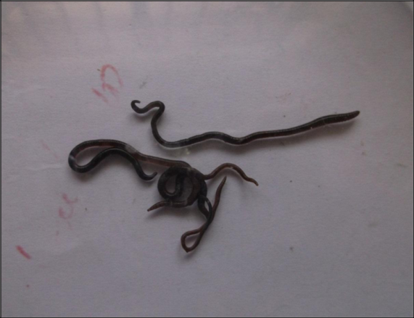
Fig .1 Earthworms responsible for Ukkirikatti

Results and Discussion:

Identification and Nature of the Problem
Surveys conducted in affected villages revealed that tank-fed irrigation fields were heavily infested with a specific type of aquatic or semi-aquatic earthworm. Unlike traditional pests that damage crops through feeding, these earthworms cause indirect and mechanical damage due to their burrowing activity. Farmers reported the following major issues i) Multiple vertical boreholes caused by burrowing, leading to leaching and drainage of irrigation water, ii) Weed seed germination due to exposure of moist soil surfaces after water drains, iii) Mechanical damage to roots due to setae (bristle-like structures) on the earthworm's body, which cause abrasions and root severing as the worm burrows, iv) Reduced tillering due to the accumulation of vermicastings around paddy hills, particularly during early transplanting stages, v) Hindered seed germination in nurseries as castings smother seeds and vi) Contamination of grains during mechanical harvesting, reducing grain quality and market value due to admixture with dark vermicastings. Farmers reported that traders deducted ₹100 per 70 kg bag of contaminated paddy or demanded an additional 5–10 kg per bag as compensation for inferior grain quality. Another research details fertilization schedules and the impact of drainage control on maintaining ecological water levels, which is directly relevant to issues like water loss from earthworm burrowing and the importance of optimized irrigation in mitigating such problems (Yu, Y., et al., 2021). Another study also provides detailed data on soil properties, fertilization, and water management, helping to contextualize the environmental and agronomic impacts of altered soil conditions—such as those caused by excessive earthworm activity in tank-fed paddy fields (Xu, X., et al., 2021). In Tundra soils, changes in the soil bulk density and healthy soil symptoms have been reported by simple soil ingestion by endogeic Earthworms.

Table.1 Analysis of soil samples

S.No. | Parameters | Sample from Kattupakkam | Sample from Penalur
1. | pH | 7.20 | 7.84
2. | EC mS/cm | 0.38 | 0.15
3. | Organic matter (%) | 1.93 | 0.74
4. | CECmeq/100g soil | 14.50 | 10.67

Table.2 Analysis of water samples

S.No. | Parameters | Sample from Kattupakkam
1. | Total aerobic count Cfu/ml | 92
2. | Escherichia coli Cfu/100 ml | Nil
3. | Total coliform / 100 ml (MPN) - Cfu/100 ml | 50

Scientific Understanding of Earthworm-Induced Damage in Paddy Fields

Nature of the Damage
Earthworm-related damage in tank-fed paddy fields is classified as environmental or mechanical pest activity rather than biological feeding. This is because earthworms lack sclerotised mouthparts and do not consume healthy plant tissue. The primary mechanism of injury arises from the setae—bristle-like structures along each body segment—used for locomotion. When earthworm densities are high, these setae cause repeated abrasive damage to young rice roots, leading to wilting, stunting, and seedling mortality, particularly in seedlings with shallow root systems. In Tundra soils, changes in the soil bulk density and healthy soil symptoms have been reported by simple soil ingestion by endogeic earthworms (Larsbo et al., 2024).

Soil and Seedbed Alteration
Earthworm tunneling and casting activity significantly alter seedbed conditions. Seeds may be buried 6–10 cm deep in the mud, which exceeds their energy reserves for successful emergence, resulting in failed germination or weak, etiolated seedlings. Additionally, the sludge-like vermicastings destabilize the topsoil, increase water turbidity, and reduce light penetration and water temperature—factors that further hinder seedling establishment and growth. Another study discusses about how earthworm burrowing can break soil hardpan but may also damage soil structure and disrupt seedling development in paddy fields, supporting the classification of damage as mechanical and environmental rather than biological feeding (Zhang et al., 2022). Di Carlo et al., (2020) have evolved the utility of Eisenia fetida in reclamation of soil with bauxite ores and reported to colonise naturally in revegetated bauxite residues.

Indirect Effects
The abundance of earthworms attracts predatory birds, especially in regions near bird sanctuaries such as Vedanthangal. These birds trample seedlings while foraging, compounding the initial mechanical damage and further disturbing water clarity, which is detrimental to rice seedlings. In response, some farmers apply Carbofuran (Furadan), a broad-spectrum insecticide, to control earthworm populations.

However, this practice leads to environmental contamination and bioaccumulation in birds, threatening local avian biodiversity (Edwards & Bohlen, 1996).

Causes of Infestation
The root cause of earthworm outbreaks (Ukkirikatti) is high organic content in both tank water and soil, which fosters earthworm proliferation. Empirical data from affected villages show that infested fields had significantly higher organic carbon (1.93%) compared to non-infested fields (0.74%). Water samples from the Uthiramerur tank also revealed elevated coliform counts, indicating organic and fecal contamination—conditions that provide ample food resources for earthworms. This aligns with established research showing that earthworm density increases with organic matter availability (Lavelle & Spain, 2001)

Impact on Crops
Paddy, especially during the vegetative stage, suffers the most. The earthworm activity leads to missing hills, uneven crop stand, stunted plants, and poor tillering. Infestation during the vegetative stage reduced plant height, root number, and root length significantly, while reproductive stage infestations were less damaging. Yield decline was pronounced at medium to high worm densities. In sugarcane, castings on the lodged cane induce adventitious rooting at nodes, reducing sucrose content. Castings also affect the cleanliness of harvested cane, an important criterion for sugar factories. Crops like ragi, groundnut, black gram, gingelly, and vegetables such as radish and bhendi showed no significant impact, indicating the problem is crop-specific and most damaging to semi-aquatic crops like paddy.

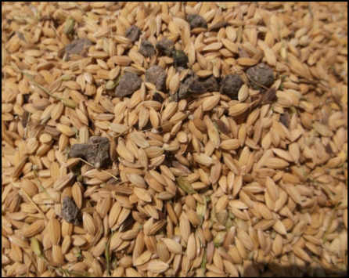
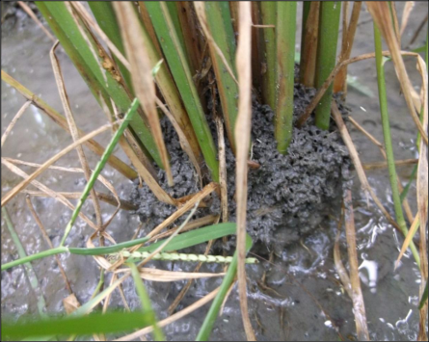
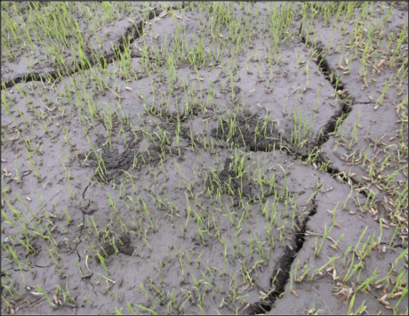

Fig .2a Earthworm mounds in seedlings | Fig .2b Earthworm mounds in matured crop | Fig .3 Admixtures of  Ukkirikatti in paddy grains

Current Farmer Practices to manage earthworm infestations:

Carbofuran and Thimet (Phorate) granules are the most commonly used chemicals by farmers to control earthworm infestations. Application causes earthworms to die and float, providing short-term relief. Both Carbofuran and Thimet are highly toxic, non-selective insecticides. They contaminate soil and groundwater and are hazardous to beneficial soil fauna, aquatic organisms, and birds (Edwards & Bohlen, 1996). Their broad-spectrum toxicity also leads to bioaccumulation in the food chain, threatening biodiversity. Some farmers have tried neem cake as a safer alternative. While it has limited repellent or toxic effects on earthworms, its efficacy is inconsistent and generally insufficient for severe infestations. Farmers with mild infestations recognize the soil benefits of earthworms and avoid aggressive control. However, those facing severe outbreaks emphasize the urgent need for eco-friendly and effective alternatives.

Conclusion
The study highlights the complex role of earthworms in agriculture—beneficial in upland systems but problematic in flooded paddy fields. The Ukkirikatti problem in Kancheepuram district reflects the need to consider ecosystem-specific pest management approaches. There is an urgent requirement for eco-friendly and effective control measures to mitigate economic loss without compromising environmental health. Future research must explore integrated and sustainable methods to manage this unique issue.

Recommendations for Sustainable Management

Cultural Methods

Crop Rotation disrupts earthworm life cycles and reduces buildup (Lavelle & Spain, 2001). Field Leveling prevents water stagnation, making conditions less favorable for aquatic earthworms. Lower Water Levels in Early Crop Stages limits earthworm activity during critical seedling establishment. Transplanting Older Seedlings (45–55 days) are less vulnerable to abrasive damage. Closer Plant Spacing (20 cm) compensates for reduced tillering due to root injury.

Mechanical and Preventive Measures
Avoid Organic Residue Addition: Reduces food sources for earthworms (Kruapukdee et al., 2013). Holding Ponds with Screens helps filters out earthworms from tank water before irrigation. Prolonged Flooding (>14 cm for 2–3 months) which is extended submergence can suppress earthworm populations (Chutinan et al., 2010). Understanding species composition and population dynamics is crucial for targeted management (Lavelle & Spain, 2001).

Disclaimer (Artificial intelligence)
Author(s) hereby declare that generative AI technologies such as Large Language Models, etc. have been used during the writing or editing of manuscripts. This explanation will include the name, version, model, and source of the generative AI technology and as well as all input prompts provided to the generative AI technology
Details of the AI usage are given below:
ChatGPT was used to edit the text.

References

Chutinan, C., et al. (2010). "Effects of earthworms on soil properties and rice production in the rainfed paddy fields of Northeast Thailand."
Di Carlo, E., Boullemant, A., Poynton, H. and Courtney, R. (2020). Exposure of earthworm (Eisenia fetida) to bauxite residue: Implications for future rehabilitation programmes, Science of The Total Environment, 716,137126
Edwards, C.A., & Bohlen, P.J. (1996).Biology and Ecology of Earthworms (3rd ed.). Chapman & Hall.

Kruapukdee, A., et al. (2013). "The Influence of Earthworm and Rice Stubble on Soil Aggregate, Carbon Sequestration and Soil Fertility in Sandy Loam Paddy Soil in Northeast Thailand."
Larsbo, M., Koestel, J., Krab, E.J. and J. Klaminder (2024). Quantifying earthworm soil ingestion from changes in vertical bulk density profiles. European Journal of Soil Biology, 120: 103574.
Lavelle, P., & Spain, A.V. (2001).Soil Ecology.Springer.

Xu, X., et al. (2021). "Comparison of N₂O Emissions From Cold Waterlogged and Normal Paddy Fields in South China."

Yu, Y., Xu, J., Zhang, P., Meng, Y., & Xiong, Y. (2021). Controlled irrigation and drainage reduce rainfall runoff and nitrogen loss in paddy fields. International Journal of Environmental Research and Public Health, 18(7), 3348.

Zhang, Y., Guan, M., Chen, C., Wang, R., Lv, G., Huang, H., & Guan, C. (2022). A Symbiotic system of irrigated rice–earthworm improves soil properties and rice growth in Southern China. Sustainability, 14(11), 6448.

Muruganantham, M., & Krishnaveni, M. (2015). Water delivery performance evaluation of a tank irrigated system and best management practices for paddy agriculture. Indian Journal of Science and Technology, 8(15), 1-12.

