Prevalence Of Esherichia Coli Mediated Diarrhea Among Children Under Five Years In Enugu State University Teaching Hospital, Parklane , Nigeria

Abstract
Diarrhoegenic Escherichia coli (DEC) is a significant cause of diarrhea particularly in infants and young children under five years. This study was conducted to determine the prevalence and antimicrobial susceptibility of DEC in ESUT Teaching Hospital Enugu State. This is a cross sectional study conducted among under five years children presenting with diarrhea within the month of May to November 2024. Stool samples were collected using sterile swab stick and universal container; samples were cultured on chromogenic agar (chromatic E.coli 0157). Antimicrobial susceptibility test were carried out on all the E.coli isolated using nutrient agar. Of 150 children, 11(7.33% ) was positive to E.coli, with a higher proportion in females 7 (4.67%) than males 4 (2.67%), children 0-1 year exhibited the highest prevalence 6 (4.00%) followed by those aged 2-3 years 4 (2.67%). E.coli was slightly higher among rural residence 7 (4.67%) than in urban 4 (2.67%), E.coli for feeding pattern is higher in children consuming other food daily 4(2.67%), E.coli prevalence associated with source of drinking water is observed among those using well water 6 (4.00%), similarly shared/public facilities were significantly associated with higher E.coli 9 (6.00%), the lower socio-economic group have the highest prevalence 7 (4.67%). The antimicrobial susceptibility pattern revealed that Ofloxacin 9 (81.8%) and Gentamycin 8 (72.7%) had the highest sensitivity against E.coli. This study identified crucial risk factors like inadequate breast feeding emphasizing the importance of strengthening public health program and promotes optimal infants feeding practices, hygiene education and safe water access. Future research can pave way for the development of effective diagnostics and targeted interventions.
Key Words: Prevalence, diarrhoeagenic Escherichia coli, diarrhoea, healthy, children

Introduction
“The World Health Organization (WHO) defined diarrhea as the passage of three or more loose or liquid stools per day” (WHO, 2018). “Due to the complex interplay of the environment, food, water, and sanitation with poverty and deprivation, diarrhea remains as a high health burden, especially to children in the world. Diarrhea was one of the top ten causes of death, ninth globally, sixth in lower-middle-income countries, and the second in low-income countries in 2020” (WHO, 2021). Diarrhea could be caused by different enteric pathogens which include bacteria, viruses, and parasites (Huang et al., 2022). “DiarrheagenicEscherichia coli, Campylobacter, Shigella, Vibrio cholerae, Salmonella, and Clostridium difficile are the common bacterial agents of diarrhea. DiarrheagenicE. coli have been predominantly associated as bacterial pathogens causing diarrheal disease among children in developing countries” (Craneet al., 2021).
“Infections due to faecal-water contamination are caused by a host of enteric infectious agents including bacteria, viruses, fungi and parasites. Among the bacteria, at least six pathogenic of diarrhoeagenic Escherichia coli (DEC strains) are frequently detected worldwide. These pathotypes have been described based on the genes mediating the virulence factors associated with the diarrhoeal disease caused by them: EnteropathogenicE.coli (EPEC), EnterotoxigenicE. coli (ETEC), Shiga toxin-producing E. coli (STEC) or EnterohaemorrhagicE. coli (EHEC), EnteroaggregativeE. coli (EAEC), EnteroinvasiveE. coli (EIEC) and diffusely adherent E. coli (DAEC)” (Rice et al., 2020).
“EnteropathogenicE. coli (EPEC) is a major cause of infantile diarrhea in developing countries. EPEC strains were epidemiologically associated with outbreaks in 1940s and 1950s and were first described in 1955. These strains currently account for 1.3 million deaths every year” (Craneet al., 2021). “The incidence is now being noted more accurately since the development of molecular diagnostic methods. In poor nations, diarrhea considered as a primary morbidity and mortality causes in children under age five (Huang et al., 2022). In some locations, Escherichia coli, a frequent cause of gastroenteritis, contributes for 30% of the whole type bacteria that cause diarrhea”(Alikhaniet al., 2020).
METHODOLOGY
Study Design
This is a cross sectional study involving qualitative and quantitative design conducted among under five years children presenting with diarrhea within the month of May to November 2024. This hospital based study was conducted at the three children wards at ESUTH, Demographic Information, symptoms, awareness, was gathered using semi- structured questionnaires.
Sample Size Determination
The sample size for this study will be calculated using cochran formula.
n = Z^2 × P(1-P) / d^2
Where:
n = the desired sample size
Z = the standard normal deviate, set at 1.96 for a 95% confidence interval
P = the expected proportion of patients with E. coli, estimated at 0.50 (based on previous studies)(Garbaet.al, 2022).
d = the desired level of precision, set at 0.05
Substituting the values, the sample size is calculated as:
n = (1.96)^2 × 0.50(1-0.50) / (0.05)^2
n = 140 participants
Accounting for a 10% non-response rate, the final sample size for the study was calculated at 150 participants.
Sampling and Sample Size
A systematic random sampling technique was used to select participants from the wards. Data was collected using structured questionnaires, which was included on socio-demographic characteristics, hygiene, and treatment of E coli, knowledge, attitudes, and practices regarding E coli prevention and management, as well as utilization of E coli prevention interventions were collected from parents of the children.
Microbial Analysis
Fresh stool samples were collected by the researcher, the samples was collected in the morning and after a new pampers have been worn by the child, and early morning stool samples for children not on pampers. Diarrheaic children were given priority. After collection of the samples into the universal stool container, It was be taken immediately to the Microbiology laboratory of ESUTH for analysis, culturewas done on HiChrome Chromogenic Coliform Agar (CCA), followed by antimicrobial susceptibility test.
Culture and Antimicrobial Susceptibility Examination
At the laboratory, the culture media was prepared by reconstituting the commercial powder in distilled water and sterilized by boiling to 100⁰C according to the manufacturer’s instructions and poured in petri dishes up to a depth of 4mm then allowed to cool. The inoculums were applied to a small area then spread by streaking out using a sterile wire loop to give single colonies. HiChrome Chromogenic Coliform Agar (Chromatic E.coli 0157 produced by Liofilchem) which was a differential media for E. coli was used. All inoculated plates were labelled and incubated at 37°C for 24 hours for the organisms to grow. Identification of the bacteria was done using the recommended standard procedures. A sterile wire loop was used to sub-culture the isolated colonies on nutrient agar for antimicrobial susceptibility at 37°C for 24hours.
Identification of Microorganisms Isolated
Preliminary identification of bacteria was based on the colonial characteristics of the organism considering colonial morphology, changes in the physical appearance of the differential media.
Statistical Analysis
Data obtained was analyzed using the statistical package for social science (SPSS Inc., Chicago, IL, USA) for windows software version 21. Continuous variables were presented as means and standard deviations while categorical variables were presented as numbers (percentages). Comparison between means was carried out using the student's t-test while comparison between percentages was carried out using chi square test. One-way Analysis of variance (ANOVA). The level of statistical significance was set at a P value less than 0.05.

Result
TABLE 1: Demographic Representation of the Study Population and Associated Risk Factors
Category | Frequency (%) N=150 | Positive Case | Negative Case | Χ² | P value
SEX |  |  |  | 0.0301 | 0.863
Male | 59 (39.33%) | 4 (2.67%) | 55 (36.67%)
Female | 91 (60.67%) | 7 (4.67%) | 84 (56.00%)
AGE (Years)
0-1 year | 80 (53.33%) | 6 (4.00%) | 74 (49.33%) | 6.175 | 0.046
2-3 years | 49 (32.67%) | 4 (2.67%) | 45 (30.00%)
4-5 years | 21 (14.00%) | 1 (0.67%) | 20 (13.33%)
Residence
Rural | 133 (88.67%) | 7 (4.67%) | 126 (84.00%) | 0.163 | 0.686
Urban | 17 (11.33%) | 4 (2.67%) | 13 (8.67%)
Feeding Pattern
Exclusive breastfeeding | 19 (12.67%) | 2 (1.33%) | 17 (11.33%) | 0.405 | 0.522
Breast milk + other food | 35 (23.33%) | 3 (2.00%) | 32 (21.33%)
Formula + other food | 28 (18.67%) | 2 (1.33%) | 26 (17.33%)
Other food daily | 68 (45.33%) | 4 (2.67%) | 64 (42.67%)
Source of Drinking Water
Stream | 8 (5.33%) | 1 (0.67%) | 7 (4.67%)
Pipes into the house | 1 (0.67%) | 0 (0.00%) | 1 (0.67%)
From well/Public tap | 13 (8.67%) | 6 (4.00%) | 7 (4.67%) | 12.441 | 0.002
Borehole | 28 (18.67%) | 1 (0.67%) | 27 (18.00%)
Sachet water | 75 (50.00%) | 3 (2.00%) | 72 (48.00%)
Water dispenser | 25 (16.67%) | 0 (0.00%) | 25 (16.67%)
Toilet Facilities
Shared/Public | 40 (26.67%) | 9 (6.00%) | 31 (20.67%) | 15.55 | 0.000
Private | 110 (73.33%) | 2 (1.33%) | 108 (72.00%)
Household Economic Status
Single | 5 (3.33%) | 0 (0.00%) | 5 (3.33%)
Married | 132 (88.00%) | 10 (6.67%) | 122 (81.33%) | 5.371 | 0.042
Divorced | 3 (2.00%) | 0 (0.00%) | 3 (2.00%)
Separated | 8 (5.33%) | 1 (0.67%) | 7 (4.67%)
Widowed | 2 (1.33%) | 0 (0.00%) | 2 (1.33%)
Socio-Economic Status
Lowest | 31 (20.67%) | 7 (4.67%) | 24 (16.00%) | 13.53 | 0.001
Middle | 110 (73.33%) | 4 (2.67%) | 106 (70.67%)
Highest | 9 (6.00%) | 0 (0.00%) | 9 (6.00%)

In table 1:The study population comprised 150 children, with a higher proportion of females (60.67%) compared to males (39.33%). E. coli prevalence was slightly higher among females (4.67%) than males (2.67%), but this difference was not statistically significant (χ² = 0.0301, p = 0.863). Regarding age, children aged 0–1 year exhibited the highest prevalence (4.00%), followed by those aged 2–3 years (2.67%). A significant association was observed between age and E. coli prevalence (p = 0.046).Urban residents formed the majority of the population (88.67%), but E. coli prevalence was higher among rural residents (4.67%) compared to urban residents (4.00%), though this was not statistically significant (p = 0.686). Feeding patterns showed no significant relationship with E. coli prevalence, with the highest frequency observed in children consuming "other food daily" (2.67%).The source of drinking water was significantly associated with E. coli prevalence (p = 0.002), with the highest prevalence observed among those using water from wells/public taps (4.00%). Similarly, shared/public toilet facilities were significantly associated with higher E. coli prevalence (p = 0.000), as 6.00% of cases were recorded among users of shared/public toilets. Socio-economic status showed a strong association with E. coli prevalence (p = 0.001), with the lowest socio-economic group having the highest prevalence (4.67%).

Table 2: Number of Isolated E. coli and Negative Samples
Category | Frequency (%) | Positive Samples | Negative Samples | Total Samples (N=150)
Isolated E. coli | 11 (7.33%) | 11 | - | 150
Negative Samples | 139 (92.67%) | - | 139 | 150

This table shows that out of the 150 samples, 11 tested positive for E. coli (7.33%), while 139 samples were negative (92.67%).

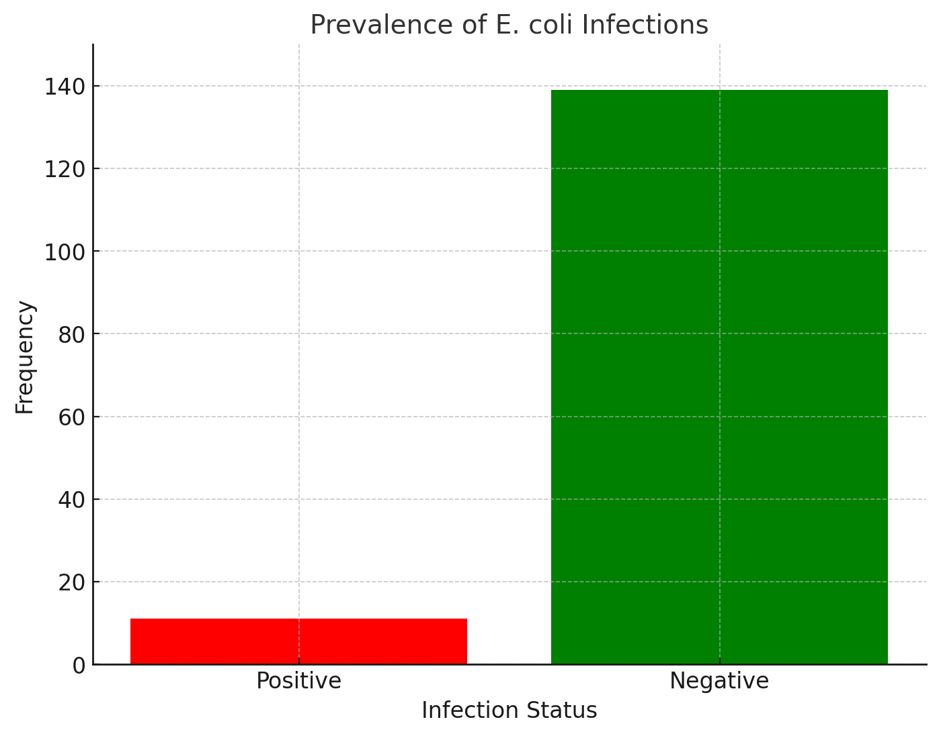

FIGURE 1: PREVALENCE OF ESCHERICHIA COLI AMONG THE STUDY POPULATION

Figure 1 illustrates the overall prevalence of E. coli in the study population, which was 7.33% (11 positive cases out of 150). This indicates that the majority of the population (92.67%) tested negative for E. coli.

TABLE 3: Antimicrobial Susceptibility Pattern of E. coli
Antibiotic | Sensitive Isolates (S) | Resistant Isolates (R)
Ofloxacin (20 µg) | 9 (81.8%) | 2 (18.2%)
Gentamicin (10 µg) | 8 (72.7%) | 3 (27.3%)
Ciprofloxacin (10 µg) | 7 (63.6%) | 4 (36.4%)
Augmentin (30 µg) | 6 (54.5%) | 5 (45.5%)
Sparfloxacin (10 µg) | 6 (54.5%) | 5 (45.5%)
Cefotaxime (10 µg) | 5 (45.5%) | 6 (54.5%)
Pefloxacin (30 µg) | 4 (36.4%) | 7 (63.6%)
Tarivid (10 µg) | 4 (36.4%) | 7 (63.6%)
Azithromycin (12 µg) | 3 (27.3%) | 8 (72.7%)
Amoxicillin (30 µg) | 2 (18.2%) | 9 (81.8%)

In table 3:The antimicrobial susceptibility pattern revealed that Ofloxacin (81.8%) and Gentamicin (72.7%) had the highest sensitivity against E. coli isolates. Ciprofloxacin (63.6%) also showed moderate sensitivity. Conversely, Amoxicillin (18.2%) and Azithromycin (27.3%) demonstrated the highest resistance rates, with the majority of isolates being resistant to these antibiotics. Augmentin, Sparfloxacin, and Cefotaxime displayed intermediate sensitivity, with approximately half of the isolates being resistant. The data suggest that Ofloxacin and Gentamicin are the most effective antibiotics for treating E. coli infections in this population.
Discussion
“Diarrhoeagenic Escherichia coli strains are pathogens of public health importance affecting both adults and children worldwide. Most diarrhoeal cases in children under 5 years of age have been shown to be due to diarrhoeagenic E. coli in which ETEC, EAEC and EPEC strains are the most prevalent in the developing countries” (Abdullahiet al., 2020).Acute diarrhea due to Escherichia coli infections is an important cause of Morbidity and mortality in infants and young children in most developing countries including Nigeria (Adegunloye, 2018). “Classification of Escherichia coli involved in diarrheal disease in the country is an essential step towards the implementation of effective primary health care activities against the disease” (Oloweet al., 2023). “The aetiology of diarrhea in young children could be attributed to wide range of factors, but one of the main aetiology of the diarrhea is related to Escherichia coli bacterium” (Abdullahiet al., 2020).
“As in other studies, Escherichia coli were most predominantly recovered from childrenunder one year of age. This age group represents a particularly vulnerable population to DEC infections due to factors such as immature immune systems and increased susceptibility to environmental pathogens” (Oloweet al., 2023). Additionally, our study highlighted the significance of inadequate breastfeeding (less than 6 months) as another notable risk factor for Escherichia coli infection. This is comparable to what Ali et al., (2021) and Akinlabi et al., (2019) observed in northern and southwestern Nigeria. Breastfeeding provides infants with essential nutrients and antibodies that bolster their immune defences against infections, including DEC-related ones (Korieet al., 2022). “Therefore, the absence or early cessation of breastfeeding may leave infants more susceptible to diarrhoeal illnesses, including those caused by DEC. Our finding and similar reports from elsewhere emphasize the importance of promoting exclusive breastfeeding for the first six months of life as an infectious diarrhoea prevention measure” (Ali et al., 2021).
A prevalence of 7.33% was found in diarrheagenic children aged1-5years. In a similar study in Abuja, Nigeria Ifeanyi et al., (2019) reported a prevalence of 65.8%, 63.3% -71.83% in Tanzania and 50-60% in other developing countries (Vargas et al., 2014). The variation in prevalence among the Nigerian cities might be attributed to differences in infrastructural and socioeconomic indices. Of the 150 stool samples collected 139 (92.67%) had no Escherichia coli suggesting other bacteria such as Shigella, Salmonellae, viral, protozoan or nonpathogenic strains. A prevalence of 53.33% was observed in the patients age group 0-1 year. This finding is in contrast to the findings of Adegunloye, (2016) who reported the most isolates from age range 37-60months but is in agreement with finding by Korie et al., (2022) in Enugu, Nigeria suggesting an association between age and E. coli associated diarrhea. A prevalence of 32.6% was observed in the age group 2-3 years which is attributable to the tendency of this group to eat and drink from sources considered contaminated because at this age children tend to move around in the surroundings and in the process consume whatever they come across including soil.
Antimicrobial drug resistance in bacteria that cause diarrhoeal disease is a serious and growing problem. Antimicrobials are not indicated for the treatment of most childhood diarrhoea diseases but should be administered to children with invasive or protracted infections. Moreover, resistance in enteric isolates provides a picture of the gut reservoir of resistance genes, which can be transmitted to enteric organisms causing infections in other niches (Oloweet al., 2023).The antibiogram profile of Escherichia coli in this study showed resistant to Amoxicillin (81.8%) and Azithromycin (72.7%) which is in agreement with the findings by Suleet al., (2018) in Kaduna, Nigeria who reported 100% resistant to the commonly used β- lactam antibiotics especially penicillins. Resistance of E. coli to Amoxicillin and Azithromycin observed in this study is consistent with study by Al-Abri, et al., (2019) in Italy who reported resistance of Escherichia coli to Amoxicillin and Azithromycin 81.2% and 76% respectively..Similarly a study in New York showed that more than 95% of diarrheagenic children (1-5years) do not respond to first line antibiotics treatment such as penicillin and Ampicillin. The highest sensitivity was observed to Ofloxacin (81.8%), Gentamicin (72.7%) and Ciprofloxacin (63.6%) which is attributable to their broad spectrum of activity, this finding is in consonance with a work by Anguza and Olila, (2017) who reported high sensitivity for Ciprofloxacin 82%. Increased in bacterial resistance to drugs is due to either genetic or non genetic acquired resistance. Indiscriminate used of these antibiotics, Substitution of dose without finishing the initial dose also can lead to increased bacterial antibiotics resistance.
5.2 Conclusion
The results of this study suggest that diarrhoeagenic Escherichia coli is strongly associated with childhood diarrhoea within the study environment. The prevalence of Escherichia coli underscores the need for routine surveillance and targeted interventions to curb their spread. Notably, the study identified crucial risk factors like inadequate breast feeding emphasizing the importance of strengthening public health programs that promote optimal infant feeding practices, hygiene education, and safe water access. Furthermore, the substantial antibiotic resistance observed among Escherichia coli isolates necessitates the judicious use of antimicrobials and the exploration of alternative treatment strategies. Such transmission could however be prevented through the widespread application of hygienic practices, the training for which should be carried out by appropriately trained public health workers.
Consent
As per international standards or university standards, Participants’ written consent has been collected and preserved by the author(s).

Disclaimer (Artificial intelligence)
Option 1:
Author(s) hereby declare that NO generative AI technologies such as Large Language Models (ChatGPT, COPILOT, etc.) and text-to-image generators have been used during the writing or editing of this manuscript.

References
Alikhani, M.Y.; A. Mirsalehian; B. Fatollahzadeh; M.R. Pourshafie and M.M. Aslani.(2020) Prevalence ofEnteropathogenic and Shiga Toxine-producing Escherichia coli among Children With and Without Diarrhea inIran. Journal of Health Population and Nutrition. 25 (1):88-93.
Ansaruzzaman, M.; J. Albert; S. Nahar; R. Byun; M. Katouli; I. Kühn and R. Möllby. (2020). Colonel groups of enteropathogenic Escherichia coli isolated in case –control studies of diarrhea in Bangladesh. Journal of Medical Microbiology. 49:177-185.
Bradley, G. A.; K. Orr; C. Reggiard and R.D. Glock. (2021) Enterotoxigenic Escherichia coli Infection in captiveblack –footed ferrets. Journal of wild life disease., 73 (3); 617-620.
Braun, V. and M. Braun. (2022) Iron transport and signaling in Escherichia coli.FEBS Letters. 529: 78-85.
Chart, H.; H.R. Smith; R.M. LaRagione and M.J. Wood ward. (2020). An investigation in the pathogenicproperties of Escherichia coli strains BLR, BL21, DH5α and EQ1. Journal of Applied Microbiology. 89:1048-1058.
Eckburg PB, Bik EM, Bernstein CN, Purdom E, Dethlefsen L, Sargent M. (2024). "Diversity of thehuman intestinal microbial flora".Science. 308(5728):1635–1638.
Elias, W.P.; A.P. Uber; S. Tomita; L.R. Trabulsi, and T.A.T. Gomes.(2022). Combinations of putative virulencemarkers in typical and variant enteroaggregative Escherichia coli strains from children with and without diarrhea.Epidemiology of Infection. 129:49-55.
Oswald, E.; H. Schmidt; S. Morabito; H. Karch; O. Marchệs and A. Caprioli.(2020).Typing of intimin genes inhuman and animals enterohemorrhagic Escherichia coli: characterization of a new Intimin variant. Infection and Immunity., 68:64-71.
Rice, A.L.; L. Sacco; A. Hyder and N. DreBlack.(2020) Malnutrition as an underlying cause of childhood deathsassociated with infection disease in developing countries. Infection and Immunity. 78:1207-1221.
Roxa, J.L.; Koutsouris and V.K. Viswanthan. (2023).Enteropahogenic Escherichia coli –induced epidermalgrowth factor receptor activation contributes to physiological alteration in intestinal epithelial cells. Infection and Immunity.75: 2316-2324.
Scaletsky, I.C.; S.H. Fabbricotti and R.L. Carvalho.(2022) Diffusely adherent Escherichia coli as a cause ofacute diarrhea in young children in Northeast Brazil: An case- control study. Journal of Clinical.Microbiology. 40:645-658.
Souse, C.P and Dubreuil. J.D. (2021).Distribution and expression of the astA gene (EAST1 toxin) in Escherichiacoli and Salmonella.International Journal of Medical Microbiology. 291: 15-20.
Velayati, A.; K. Ghazi Saidi and M.R. Travati. (2019) A study of Salmonella, Shigella and enteropathogenic Escherichia coli serotypes in acute gastroenteritis children under the age of five. Medical Journal of Iran.1:22-31.

